**Experiment 04**

**Aim:** Time Series analysis in Python.

**Tools:** Jupyter Notebook

**Theory:**

Time Series Data Analysis is a way of studying the characteristics of the response variable with respect to time as the independent variable. To estimate the target variable in the name of predicting or forecasting, use the time variable as the point of reference. A Time-Series represents a series of time-based orders. It would be Years, Months, Weeks, Days, Horus, Minutes, and Seconds. It is an observation from the sequence of discrete time of successive intervals.

The time variable/feature is the independent variable and supports the target variable to predict the results. Time Series Analysis (TSA) is used in different fields for time-based predictions – like Weather Forecasting models, Stock market predictions, Signal processing, Engineering domain – Control Systems, and Communications Systems. Since TSA involves producing the set of information in a particular sequence, this makes it distinct from spatial and other analyses.

**Code & Output:**

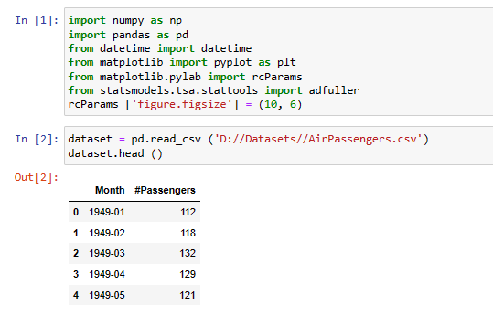

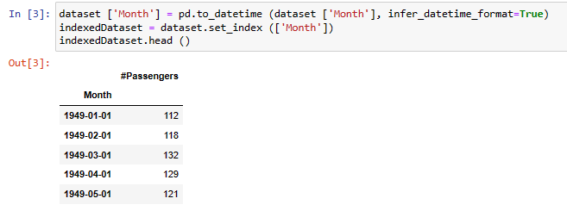

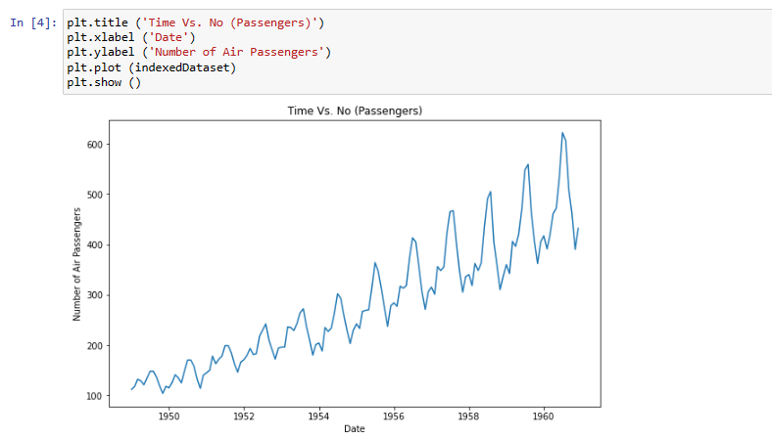

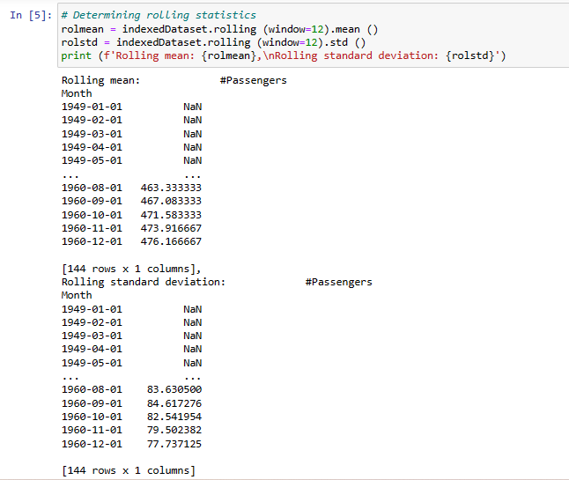

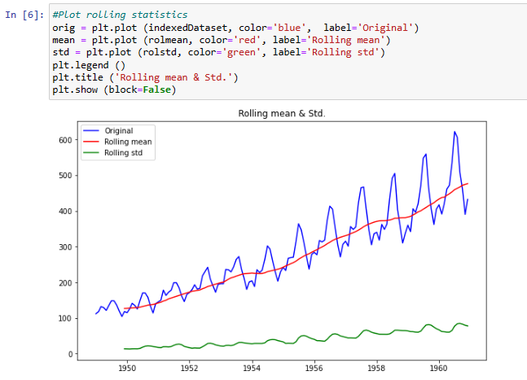

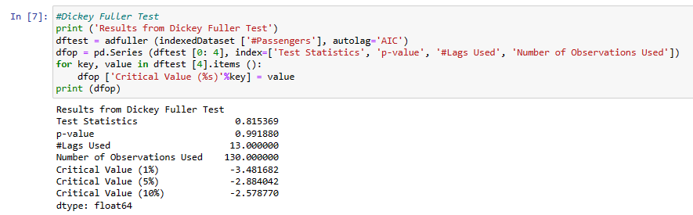

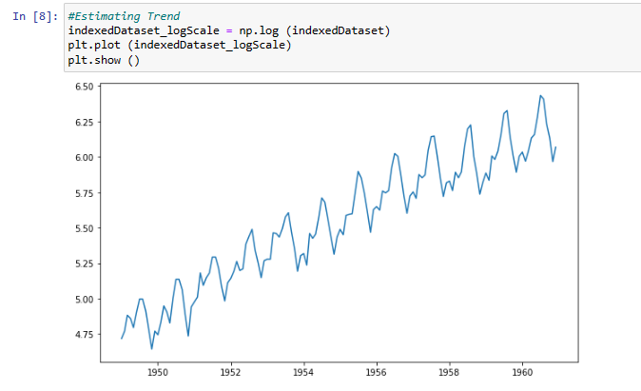

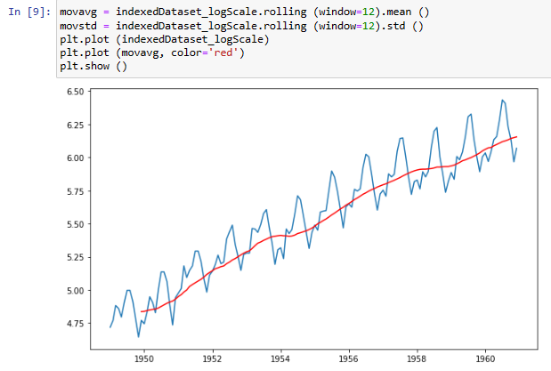

**Conclusion:** We have performed the given experiment successfully and learned about TSA also implement it to analyze the used dataset.