**Experiment 05**

**Aim:** Implementation of ARIMA model in Python

**Tools:** Jupyter Notebook

**Theory:**

Time Series Forecasting is generally used in many manufacturing companies as it drives the primary business planning, procurement, and production activities. Any forecasts' errors will undulate throughout the chain of the supply or any business framework, for that stuff. Thus, it is significant in order to get accurate predictions saving the costs, and is critical to success.

The Concepts and Techniques behind Time Series forecasting can also be applied in any business, including manufacturing.

The Time Series forecasting can be broadly classified into two categories:

1. Univariate Time Series Forecasting: The Univariate Time Series Forecasting is a forecasting of time series where we utilize the former values of the time series only in order to guess the forthcoming values.
2. Multi-Variate Time Series Forecasting: The Multi-Variate Time Series Forecasting is a forecasting of time series where we utilize the predictors other than the series, also known as exogenous variables, in order to forecast.

In the following tutorial, we will understand the specific type of method known as ARIMA modeling.

Auto Regressive Integrated Moving Average, abbreviated as ARIMA, is an Algorithm for forecasting that is centered on the concept that the data in the previous values of the time series can alone be utilized in order to predict the future values.

**Code & Output:**

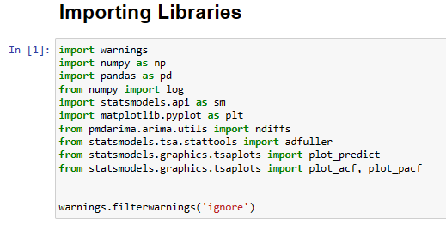

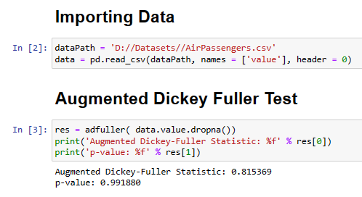

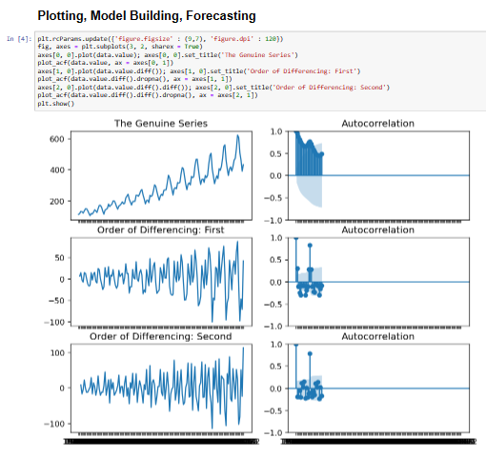

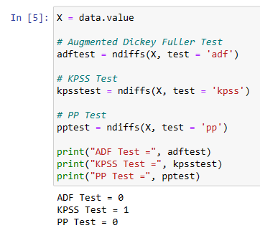

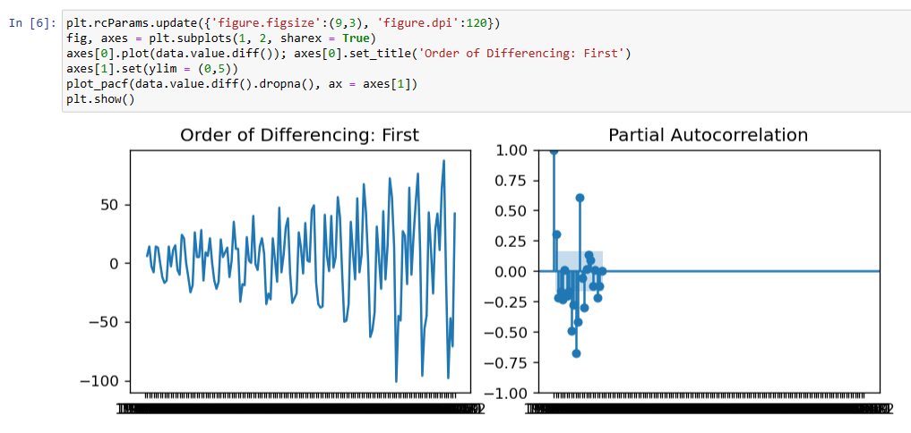

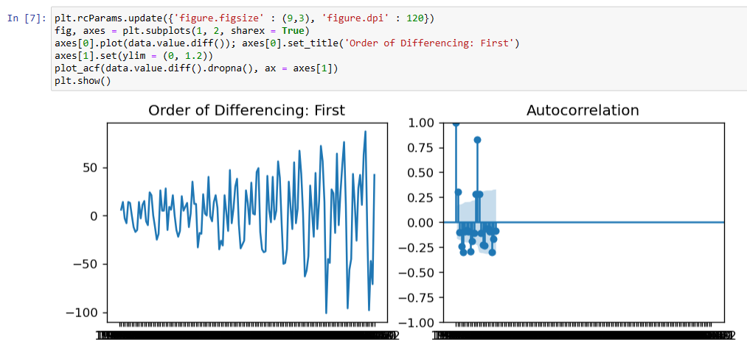

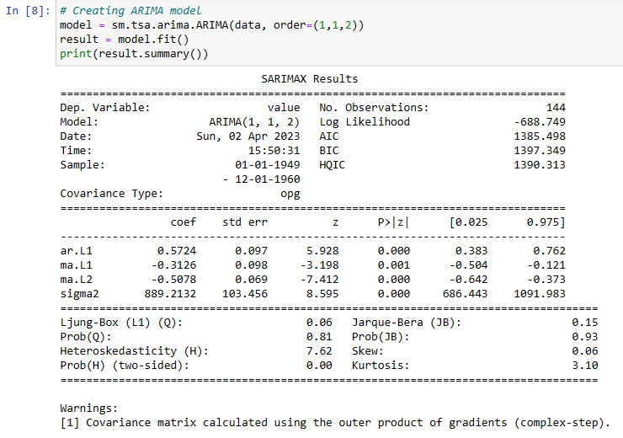

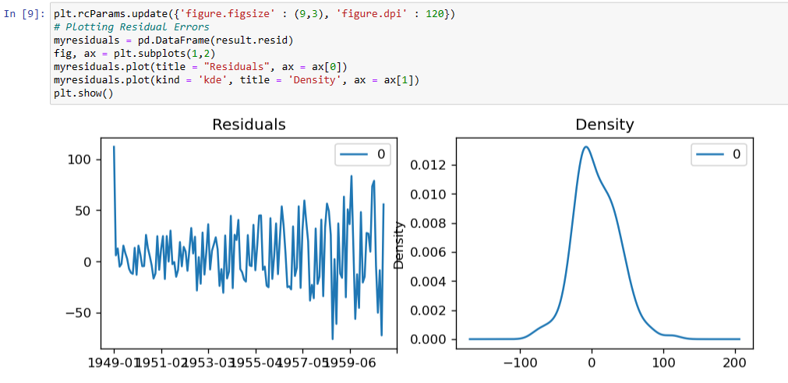

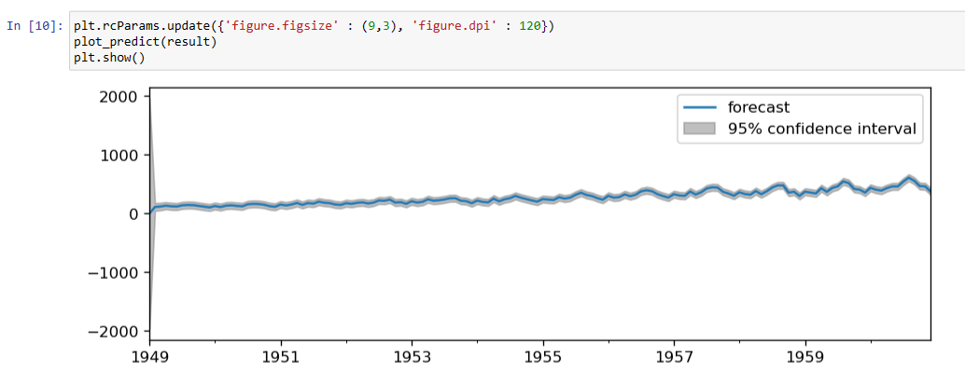

**Conclusion:** We have performed the given experiment successfully also we have used ARIMA model and used Time Series Analysis.