**Experiment 06**

**Aim:** Text Analysis: Implementation of Sentiment analysis in Python **Tools:** Jupyter Notebook

**Theory:**

Sentiment analysis, also referred to as opinion mining, is an approach to natural language processing (NLP) that identifies the emotional tone behind a body of text. This is a popular way for organizations to determine and categorize opinions about a product, service or idea.

As for the model we will be using LSTM model which is a neural network based model which will help in prediction.

The dataset used contain tweets of more than 30K tweets. Dataset is skewed and might give inappropriate output.

We have created the neural network on the other hand with 10 neurons. And have in total 3 epoch (complete iteration over a dataset for training) which gives a good enough accuracy which might be produced due to skewness in dataset.

About LSTM:

Long short-term memory is an artificial neural network used in the fields of artificial intelligence and deep learning. Unlike standard feedforward neural networks, LSTM has feedback connections. Such a recurrent neural network can process not only single data points, but also entire sequences of data

**Code & Output:**

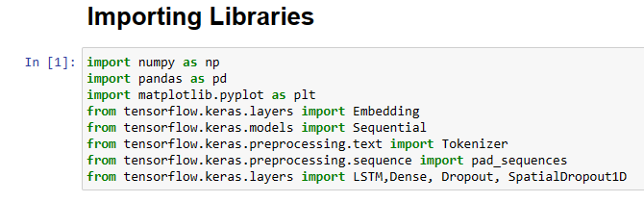

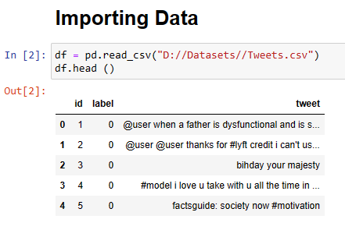

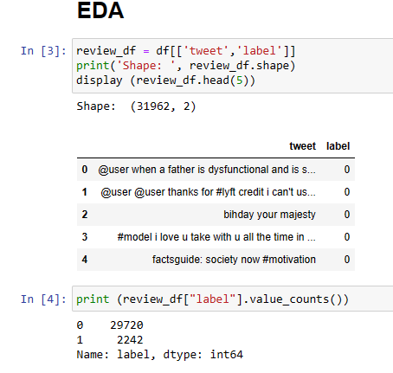

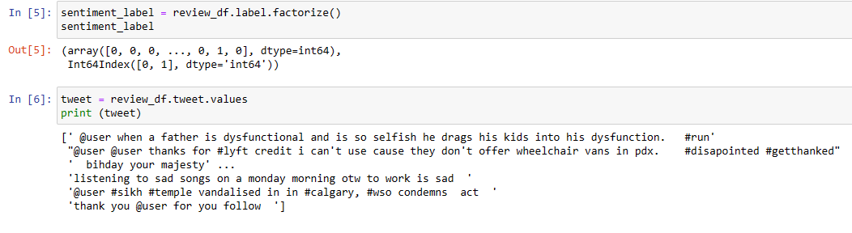

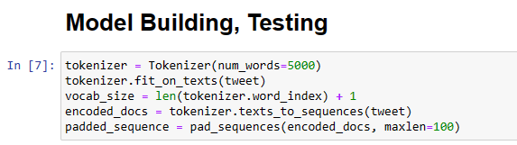

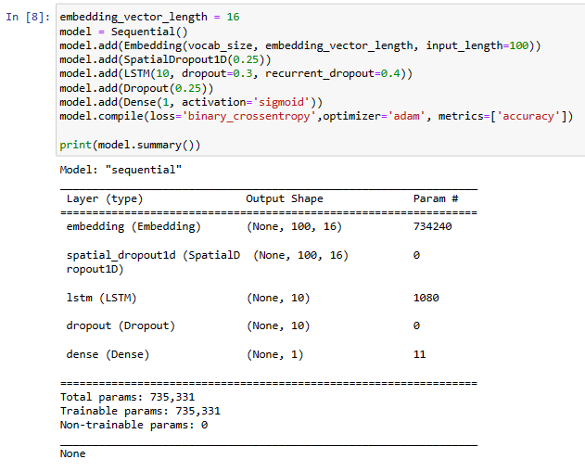

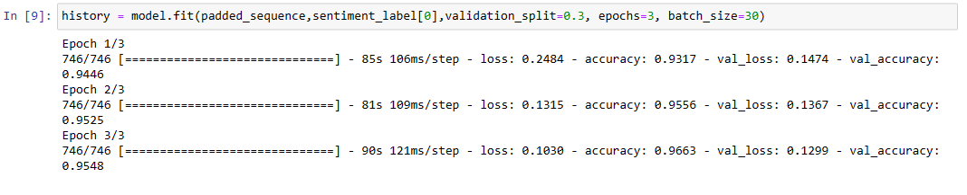

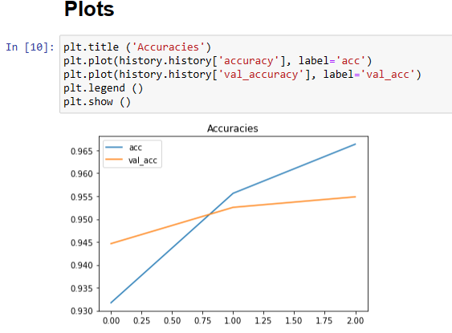

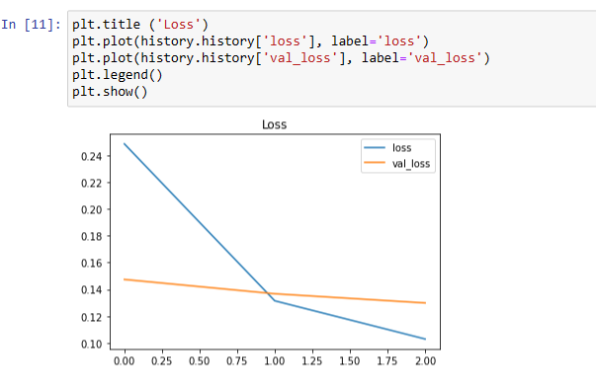

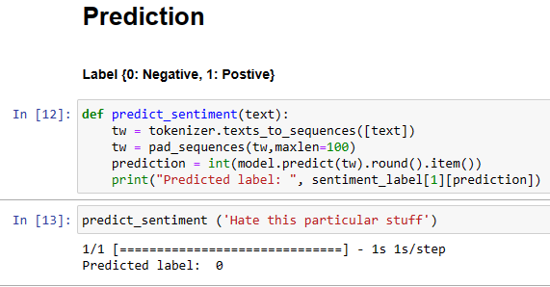

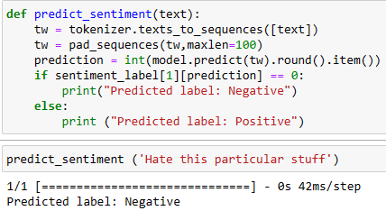

**Conclusion:** We have implement the following given experiment successfully also we have learned about sentiment analysis.