**Experiment 07**

**Aim:** To study data visualization using Seaborn library in Python.

**Theory:** Seaborn is a library for making statistical graphics in Python. It builds on top of [matplotlib](https://matplotlib.org/) and integrates closely with [pandas](https://pandas.pydata.org/) data structures.

Seaborn helps you explore and understand your data. Its plotting functions operate on dataframes and arrays containing whole datasets and internally perform the necessary semantic mapping and statistical aggregation to produce informative plots. Its dataset-oriented, declarative API lets you focus on what the different elements of your plots mean, rather than on the details of how to draw them.

**Overview of seaborn plotting functions**

Most of your interactions with seaborn will happen through a set of plotting functions. Later chapters in the tutorial will explore the specific features offered by each function. This chapter will introduce, at a high-level, the different kinds of functions that you will encounter.

**Similar functions for similar tasks**

The seaborn namespace is flat; all of the functionality is accessible at the top level. But the code itself is hierarchically structured, with modules of functions that achieve similar visualization goals through different means. Most of the docs are structured around these modules: you’ll encounter names like “relational”, “distributional”, and “categorical”.

**Code & Output:**

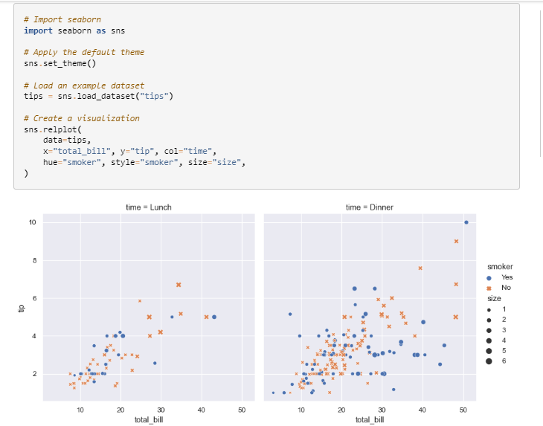

Figure 1: Data points plotting from tips dataset

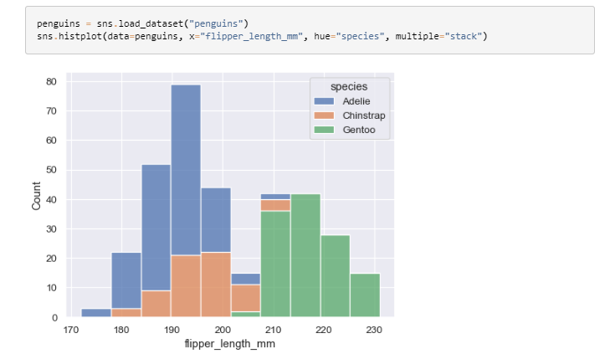

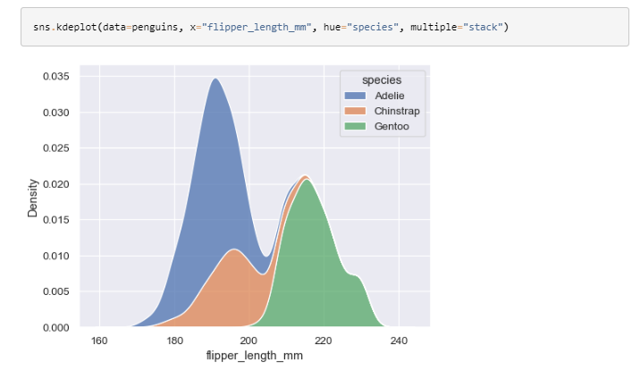

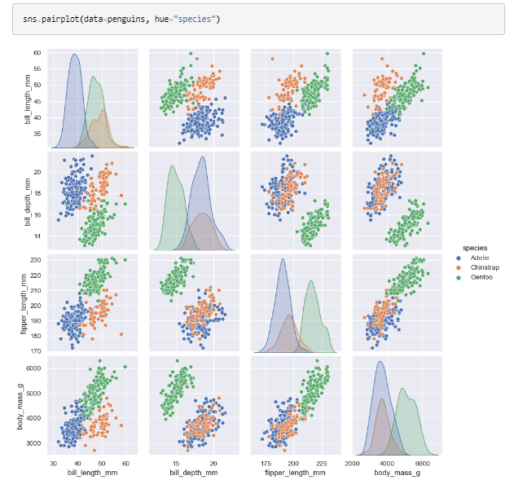

**Conclusion:** We have performed the given experiment successfully. In this we learned about data visualization using Seaborn library in python. In this we have seen distribution of data and how scatter the data is.