**Experiment 08**

**Aim:** To study data visualization using Matplotlib library in Python.

**Theory:** Matplotlib is a [plotting](https://en.wikipedia.org/wiki/Plotter) [library](https://en.wikipedia.org/wiki/Library_(computer_science)) for the [Python](https://en.wikipedia.org/wiki/Python_(programming_language)) programming language and its numerical mathematics extension [NumPy](https://en.wikipedia.org/wiki/NumPy" \o "NumPy). It provides an [object-oriented](https://en.wikipedia.org/wiki/Object-oriented_programming) [API](https://en.wikipedia.org/wiki/API) for embedding plots into applications using general-purpose [GUI toolkits](https://en.wikipedia.org/wiki/GUI_toolkit) like [Tkinter](https://en.wikipedia.org/wiki/Tkinter" \o "Tkinter), [wxPython](https://en.wikipedia.org/wiki/WxPython" \o "WxPython), [Qt](https://en.wikipedia.org/wiki/Qt_(software)" \o "Qt (software)), or [GTK](https://en.wikipedia.org/wiki/GTK). There is also a [procedural](https://en.wikipedia.org/wiki/Procedural_programming) "pylab" interface based on a [state machine](https://en.wikipedia.org/wiki/State_machine) (like [OpenGL](https://en.wikipedia.org/wiki/OpenGL)), designed to closely resemble that of [MATLAB](https://en.wikipedia.org/wiki/MATLAB), though its use is discouraged. [SciPy](https://en.wikipedia.org/wiki/SciPy" \o "SciPy) makes use of Matplotlib.

Matplotlib was originally written by [John D. Hunter](https://en.wikipedia.org/wiki/John_D._Hunter). Since then it has had an active development community and is distributed under a [BSD-style license](https://en.wikipedia.org/wiki/BSD_licenses). Michael Droettboom was nominated as matplotlib's lead developer shortly before John Hunter's death in August 2012 and was further joined by Thomas Caswell. Matplotlib is a [NumFOCUS](https://en.wikipedia.org/w/index.php?title=NumFOCUS&action=edit&redlink=1) fiscally sponsored project.

Matplotlib 2.0.x supports Python versions 2.7 through 3.10. Python 3 support started with Matplotlib 1.2. Matplotlib 1.4 is the last version to support Python 2.6. Matplotlib has pledged not to support Python 2 past 2020 by signing the Python 3 Statement.

Comparison with MATLAB

Pyplot is a Matplotlib module that provides a MATLAB-like interface. Matplotlib is designed to be as usable as MATLAB, with the ability to use Python, and the advantage of being free and open-source.

**Code & Outputs:**

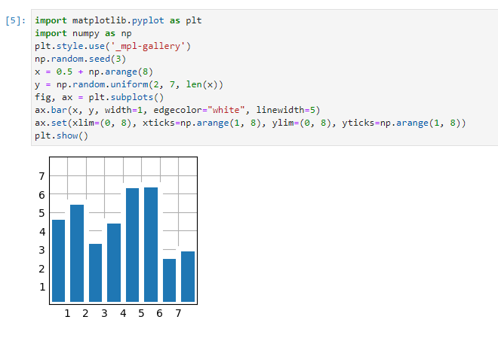

Figure : Bar plot

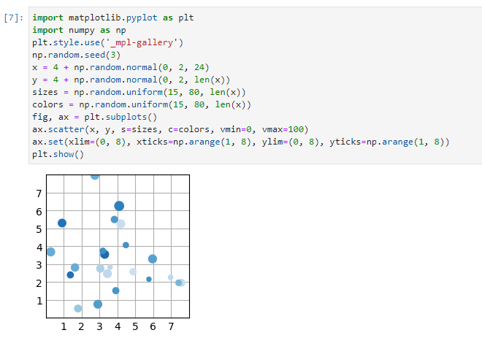

Figure : Scatter plot

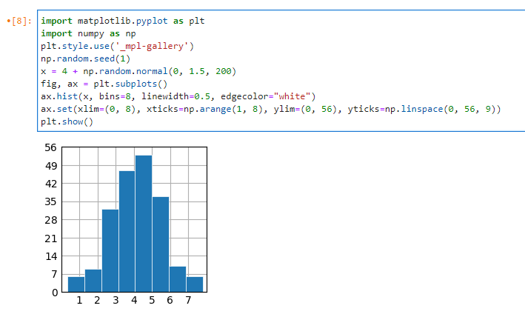

Figure : Histogram

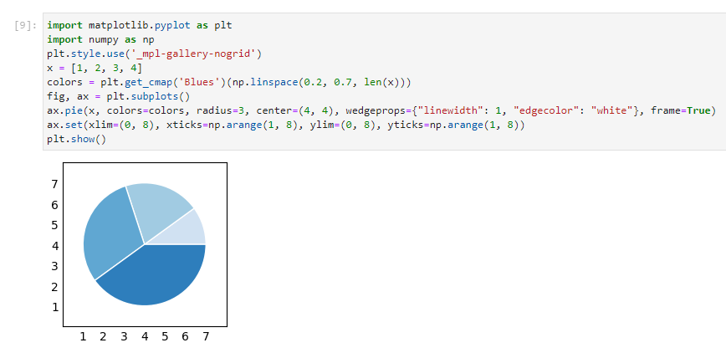

Figure : Pie chart

**Conclusion:** We have performed the given experiment successfully. We learned how to use Matplotlib for data visualization like distribution of the data.