**DYNAMIC ROUTE OPTIMIZATION WITH TRAVELLER PRIORITIZATION**

**(SOFTWARE REQUIREMENT SPECIFICATION REPORT)**

**DYNAMIC ROUTE OPTIMIZATION WITH TRAVELLER PRIORITIZATION**

**Abstract**

In modern urban transportation, although ride-booking services are widely available, several key challenges persist—particularly in terms of dynamic route adaptability, traveler prioritization, and efficient resource usage. Common issues include:

* Lack of Priority-based Routing: Existing systems often fail to differentiate routing based on user urgency, which is critical in emergencies.
* Static Route Planning: Traditional systems do not adapt routes dynamically based on real-time traffic or road conditions, leading to delays.
* Inefficient Resource Allocation: Without user prioritization, high-priority travelers may experience unnecessary delays, and vehicles may not be optimally utilized.
* Generic User Experience: All users receive a one-size-fits-all routing, lacking personalization based on their travel needs.

To overcome these issues, this project proposes a Dynamic Route Optimization with Traveller Prioritization system, which integrates real-time traffic data and user-defined priority levels into route selection. Algorithms such as Dijkstra’s are leveraged to compute shortest and alternative routes, while priority levels (e.g., Normal, High/Emergency) influence vehicle dispatch and route assignment. High-priority users are assigned faster, more direct routes, whereas normal users benefit from ride-sharing or fuel-optimized paths.

### ****Motivation****

### Traveller Prioritization for Emergency Scenarios: Traditional routing systems treat all travelers equally, which can lead to critical delays during emergencies. Our system allows users to set priority levels (e.g., Normal, High), enabling faster route allocation and timely vehicle dispatch for high-priority travelers. This ensures life-critical scenarios receive appropriate urgency in routing.

### Real-Time Dynamic Routing: Static route planning often ignores live traffic conditions, leading to inefficient travel and delays. This system integrates real-time traffic and road data with intelligent algorithms to select the most optimal path dynamically. Travelers benefit from minimized delays and better adaptability during transit.

### Personalized Travel Experience: One-size-fits-all route solutions do not cater to individual needs.

### ****Project Objective****

The primary objective of this project is to develop a web-based route optimization system that dynamically adjusts travel paths based on user-defined priorities (e.g. normal,high). The system will intelligently compute optimal routes using advanced algorithms and render them visually on an interactive map. Users can submit trip details through a user-friendly interface, while the backend efficiently handles priority-driven logic and database management. The system aims to minimize travel time for high-priority users, improve routing accuracy, and ensure a scalable, responsive solution that can be extended to ride-sharing, logistics, and emergency response scenarios.

**Literature Survey**

Modern routing platforms rely on algorithms such as Dijkstra’s, A*, and other heuristic-based approaches to identify optimal paths under dynamic traffic conditions. APIs such as Google Maps [1], OpenStreetMap with OSRM [2], and Mapbox Directions API enable developers to build custom routing applications, while visualization tools like LeafletJS [3] and Leaflet Routing Machine [4] assist with rendering and navigation.

However, these systems generally lack the capacity to adjust routing based on individual urgency or context. Studies by Mahajan and Sharma [5] and Kaur and Singh [6] suggest that adaptive algorithms, when combined with real-time environmental and user data, can make transportation systems smarter and more empathetic. Priority-based routing is widely employed in Emergency Medical Services (EMS), granting vehicles precedence at signals and access to optimized paths. For instance, Chien et al. [7] demonstrated that integrating vehicle prioritization with adaptive traffic control can dramatically reduce emergency response times. Inspired by such implementations, recent systems have proposed civilian versions that allow users to categorize their travel urgency (e.g., emergency, standard commute), enabling the system to dynamically allocate faster or less-congested paths.

Ride-hailing services such as Uber, Ola, and Rapido [8] use real-time matching and optimization algorithms to assign drivers to passengers efficiently. However, their primary focus remains on minimizing cost and maximizing driver utility rather than addressing the urgency or intent of the ride. As highlighted by Ramya and Rani [9], existing ride-matching frameworks are largely context-agnostic.

Additionally, while emerging smart mobility systems—including shared shuttle networks and micro-transit—use predictive algorithms to streamline traffic and improve transportation equity, they often lack real-time responsiveness to changing road conditions or user-specific time constraints [5]. Some systems incorporate dynamic feedback loops that monitor traffic updates, ride context, and traveler urgency, thereby increasing the system’s responsiveness in real-world scenarios. Integrating contextual data such as time of day, road congestion, ride purpose, and urgency can significantly improve travel experience and route reliability.

Overcoming above issues in the literature survey this project entitled “DYNAMIC ROUTE OPTIMIZATION WITH TRAVELLER PRIORITIZATION(DRO-TP)” is proposed.

**Inference From Literature Survey**

Existing routing systems primarily use static or heuristic algorithms, such as Dijkstra’s and A*, which fail to account for user-specific urgency or dynamic context. Ride-hailing services focus mainly on cost and utility, neglecting the urgency of a ride. Additionally, emerging smart mobility models lack real-time responsiveness to user-specific needs and environmental changes. Priority-based routing models, like those in Emergency Medical Services, are not yet adapted for civilian use, limiting the ability to prioritize travel urgency. Overall, current systems lack real-time, context-aware adjustments, highlighting the need for a more adaptive routing system that considers both traveler urgency and dynamic road conditions.

**Pitfalls In The Existing Systems**

The current route optimization and ride allocation platforms—such as those used in ride-hailing and micro-mobility services—lack the necessary adaptability and intelligence to respond to diverse travel needs, especially under time-sensitive conditions. The key limitations identified in existing systems are as follows:

1. Lack of Priority Handling  
   Existing systems treat all ride requests equally, without distinguishing between high-urgency scenarios (e.g., medical emergencies) and casual travel. This one-size-fits-all approach limits the effectiveness of the service when rapid response is crucial.
2. No Dynamic Response to Road Conditions or User Context  
   Most platforms fail to dynamically adapt routes based on real-time road situations such as accidents, traffic jams, or temporary blockages. Additionally, they ignore the context of the user’s request (e.g., urgent ride vs. regular commute), which could influence routing strategies.
3. Limited Personalization Based on Ride Purpose  
   Current systems do not offer personalized routing or prioritization based on the purpose of travel. There is no mechanism to allow users to specify travel urgency or importance, which could help allocate faster routes or prioritized vehicles.
4. Inefficient Resource Allocation  
   Vehicles are assigned without considering the urgency or priority level of the traveler. As a result, resources may be underutilized or misallocated, delaying critical trips while serving low-priority ones more quickly.
5. Unreliable Estimated Arrival Times (ETA)  
   Similar to food delivery systems, current ride platforms often provide inaccurate ETAs due to poor integration of real-time traffic conditions, ride urgency, and pickup delays. This can result in user dissatisfaction, especially in time-critical scenarios.
6. Poor User Experience in High-Stress Scenarios  
   The lack of priority-awareness, contextual understanding, and responsive routing makes current systems ill-suited for travelers facing emergencies or time constraints. This often leads to frustration, uncertainty, and diminished trust in the platform.

### DRO-TP Project Proposal

### By overcoming the limitations outlined in the literature survey, the proposed project, Dynamic Route Optimization with Traveller Prioritization (DRO-TP), aims to develop an adaptive route optimization system that not only provides efficient travel routes but also prioritizes users based on the urgency of their travel needs. This system will dynamically adjust routes using real-time data on traffic, road conditions, and user urgency, making it more responsive than current systems. By incorporating priority-based routing and integrating real-time contextual awareness, DRO-TP will allow users to specify their travel urgency (e.g., emergency, standard commute), ensuring they are assigned the fastest or least-congested routes.The system will leverage existing routing algorithms like Dijkstra’s and A*, along with custom prioritization logic, to enable the system to respond more effectively to varying levels of urgency. Additionally, the project will integrate a user-friendly interface, allowing travelers to input their priority levels and receive optimized route suggestions in real time. The expected outcome is a robust, flexible routing platform that enhances travel efficiency, reduces congestion, and improves the overall user experience by addressing both time-critical and routine travel needs.

**DRO-TP High-Level Architecture Diagram**

The proposed system, titled **"Priority-Aware Dynamic Ride Allocation and Routing System,"** enhances on-demand ride services by intelligently assigning vehicles and dynamically optimizing routes based on user-defined urgency levels and real-time traffic data. The primary actors include **riders**, **drivers**, and **system administrators**, all of whom interact with the system through a secure and intuitive interface.

The system is modularized into the following components:

* **User Management and Priority Selection**  
  Handles registration, login, and user-defined travel priority (Normal, High, Emergency).
* **Traffic and Route Optimization Module**  
  Continuously fetches live traffic data to calculate the optimal route using algorithms like Dijkstra’s, dynamically adjusting paths mid-trip as conditions change.
* **Vehicle Allocation Engine**  
  Assigns drivers based on proximity, rider priority level, and expected traffic conditions.
* **Dynamic Ride Monitoring and Re-routing**  
  Tracks ride progress in real-time, re-optimizing if traffic or road closures affect travel time.
* **Notification and Alert System**  
  Sends real-time updates to riders and drivers regarding trip status, delays, and reroutes.
* **Secure Billing and Feedback**  
  Processes payments securely, and collects feedback after each ride to enhance service quality.

**Core Functionalities of the System**

1. **Priority-Based Route Assignment**  
   Riders can select their urgency level (Normal, High, Emergency), and the system allocates the fastest or most efficient route accordingly.
2. **Live Traffic-Responsive Routing**  
   The system responds in real time to traffic congestion, road accidents, or weather disruptions to recalculate optimal paths.
3. **Smart Vehicle Allocation**  
   Vehicles are allocated not just by proximity but by rider priority, ensuring that emergency riders are served first without disrupting normal operations.
4. **Trip Monitoring and Re-Optimization**  
   During the ride, the system monitors progress and can automatically redirect drivers for improved timing or safety.
5. **Real-Time Notifications and Trip Updates**  
   Riders and drivers receive instant updates through the app regarding arrival time, rerouting decisions, and ride status.
6. **Secure Booking and Billing**  
   Ensures encrypted transactions, provides digital receipts, and offers a transparent breakdown of fare calculation based on route, time, and priority.
7. **User Feedback and Rating System**  
   After each ride, riders and drivers can rate the experience and provide feedback to continuously improve the system’s performance.

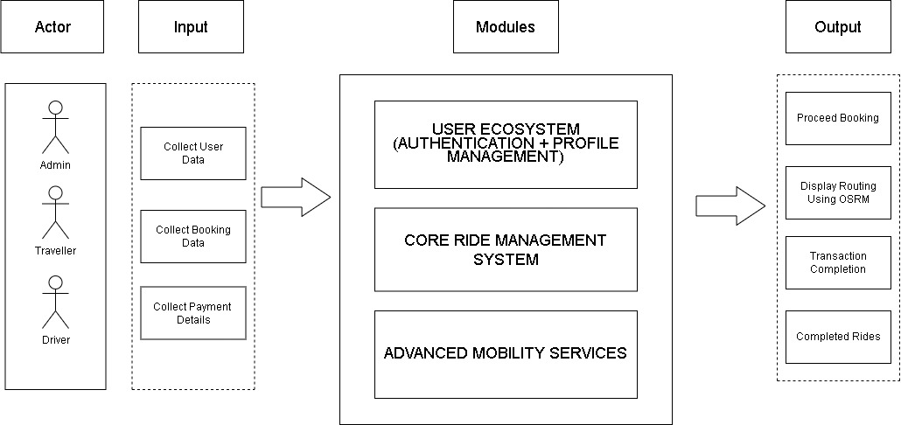

**Fig 1.1:** **DRO-TP** High-Level Architecture Diagram

**INPUT AND OUTPUT SCREENSHOTS:**

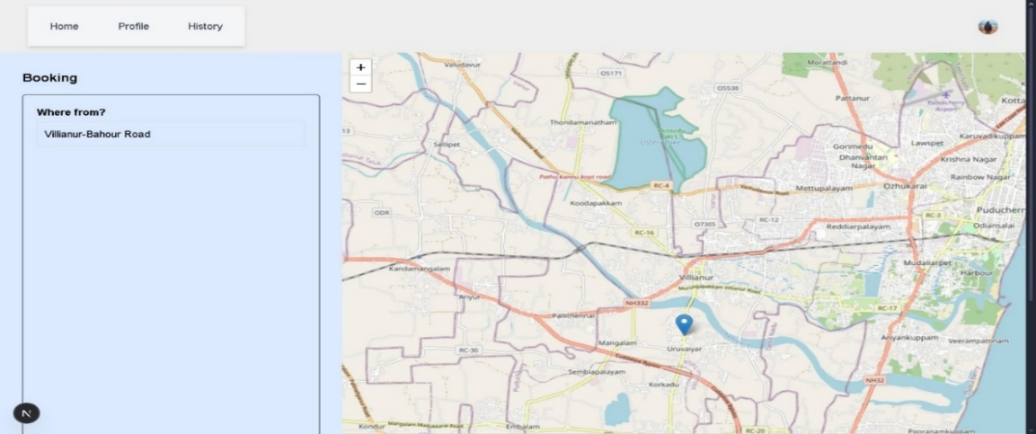

**Fig 1.2:** User Selects Pickup And Destination Locations

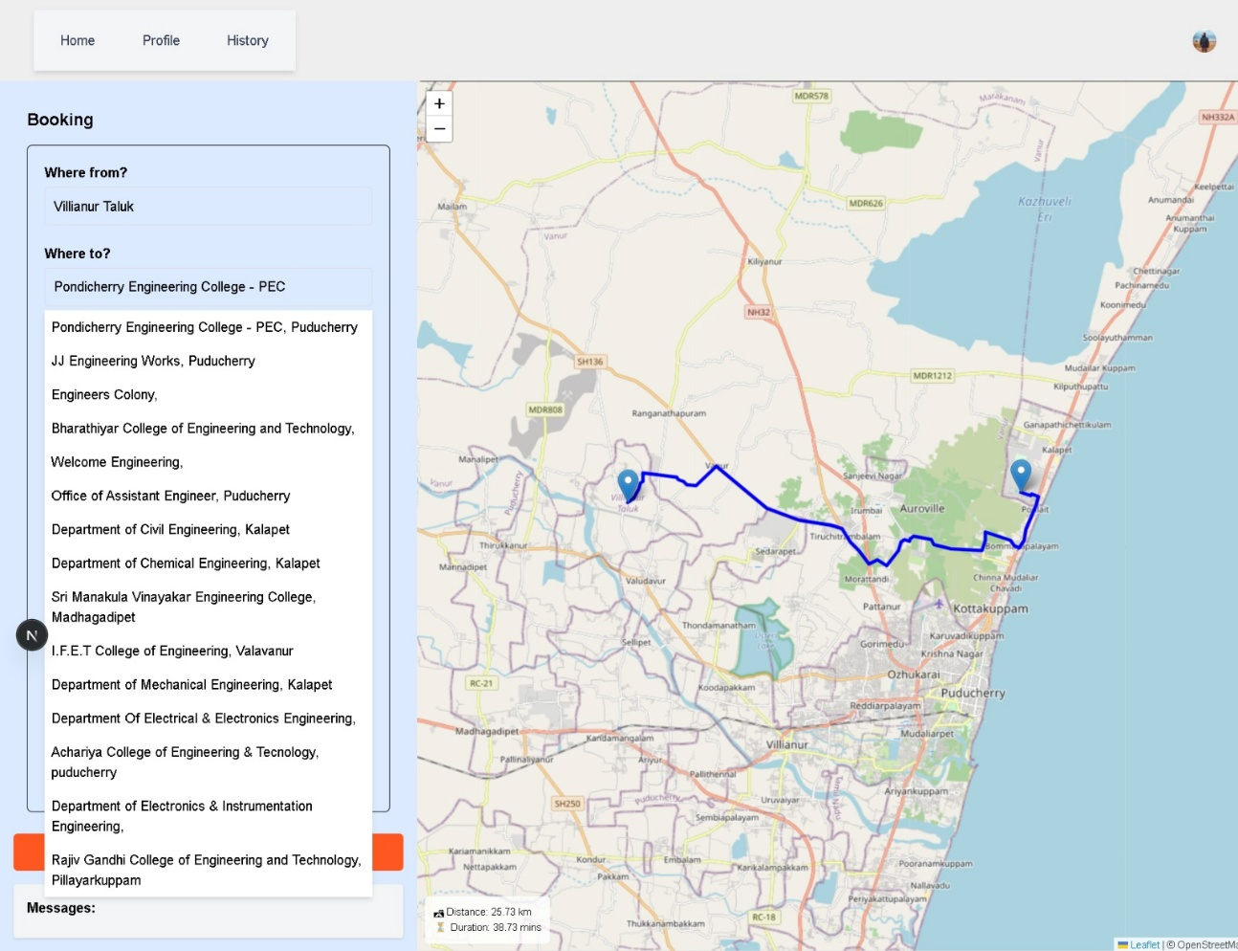

**Fig 1.3:** System displays optimized route, estimated distance, duration, and driver assignment.

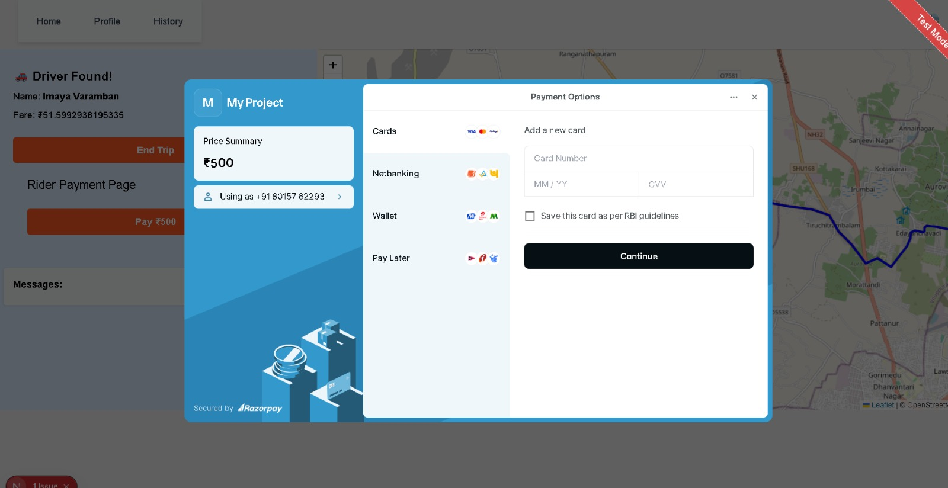

**Fig 1.4:** Payment Gateway Using Razorpay

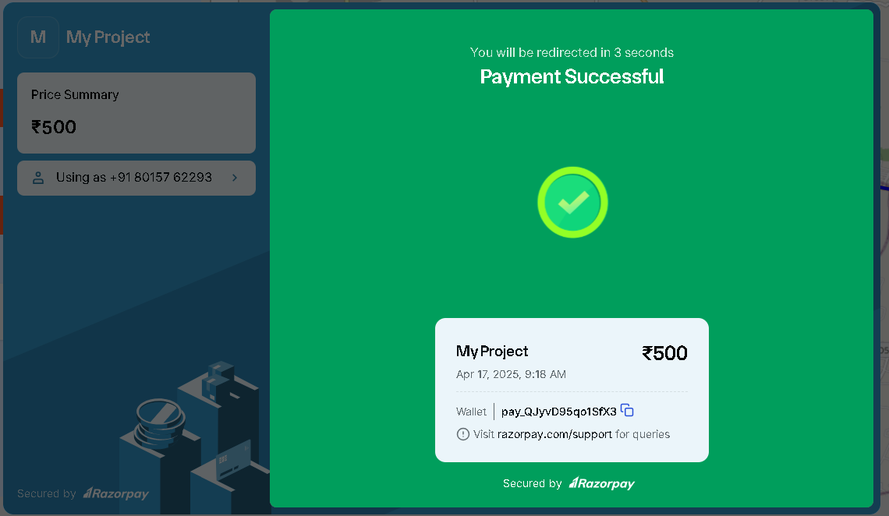

**Fig 1.5:** Payment Successful

**Hardware/Software Requirements**

**Hardware Requirements**

* **Server:** Real-time backend server (e.g., AWS EC2 or local node server)
* **GPS-enabled Devices:** For tracking and navigation (drivers and users)
* **Mobile Devices:** For frontend applications

**Software Requirements**

* **Frontend:** Next.js
* **Backend:** SpringBoot
* **Database:** MangoDB
* **Mapping API:** Leaflet PhotonAPI
* **Traffic Feed Integration:** OpenStreetMap + Real-time traffic services

**ENTITY RELATIONSHIP DIAGRAM**

**SCHEMA**

**1.TRAVELLER**

|  |  |  |  |  |
| --- | --- | --- | --- | --- |
| Traveller_ID | Name | Destination | Ride_Preference | Priority_  Level |

|  |  |
| --- | --- |
| Current_Location | Phone_Number |

**2.** **STRATEGIES**

|  |  |  |  |
| --- | --- | --- | --- |
| Strategy_ID | Strategy_Name | Strategy_layer | Parameters_Used |

**3.** **PAYMENT**

|  |  |  |  |
| --- | --- | --- | --- |
| Payment_ID | Trip_ID | Payment_Mode | Payment_Status |

**4.TRIP**

|  |  |  |  |  |  |
| --- | --- | --- | --- | --- | --- |
| Trip_ID | Request_ID | Rating | Fare | Start_Time | End_Time |

**5.** **TRIP_REQUEST**

|  |  |  |  |
| --- | --- | --- | --- |
| Request_ID | Traveller_ID | Driver_ID | Route_Optimized |

|  |  |  |
| --- | --- | --- |
| Ride_Status | Requested_Time | Destination_Location |

**6.** **TRIP_METADATA**

|  |  |  |  |  |  |
| --- | --- | --- | --- | --- | --- |
| Source_Location | tripTime | isPeakHour | cityCode | Distance | Cost |

|  |  |
| --- | --- |
| vehicleType | Estimated_Time |

**7. DRIVER**

|  |  |  |  |
| --- | --- | --- | --- |
| Vehicle_Type | Name | Driver_ID | Phone_Number |

|  |  |  |  |
| --- | --- | --- | --- |
| Current_Location | Availability_  Status | Rating | Loyalty_rate |

ER DIAGRAM

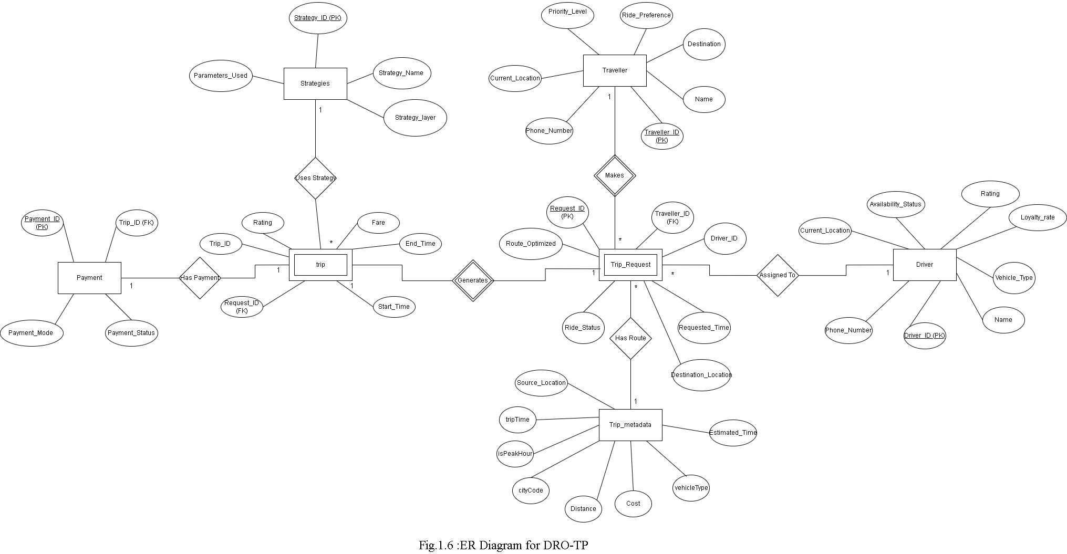

### ****Conclusion And Future Enhancement****

**Conclusion**  
The Dynamic Route Optimization with Traveller Prioritization system effectively addresses the need for intelligent, real-time routing tailored to user priority levels. By integrating technologies like Next.js, Spring Boot, MongoDB, and Leaflet, the system offers an efficient, user-friendly interface that dynamically calculates and visualizes optimal travel paths. High-priority travellers receive the most time-sensitive routes, ensuring timely arrivals in critical situations. The project demonstrates how smart routing can improve transport services, reduce delays, and enhance the user experience, especially for emergency and urgent travel cases.

**FutureEnhancement**  
Future improvements can include the integration of live traffic APIs (like Google Maps or TomTom) to enhance route accuracy under current conditions. Additionally, implementing AI/ML algorithms could allow the system to learn from past traffic patterns and user behavior for predictive route planning. Multi-modal transport support (e.g., combining walking, public transit, or rideshares) and voice-assisted navigation could further increase system usability. Expanding user roles (e.g., admin dashboards, driver interfaces) and adding multilingual support would make the application more versatile and accessible on a global scale.

**References**

1. Bhavsar, R., & Patel, D. (2021). Dynamic Route Optimization Using Real-Time Traffic Data. International Journal of Computer Applications, 182(45), 30–35. [Journal Article]
2. Chavan, A., & Thakur, S. (2021). Design and Development of Smart Cab Booking System with Real-Time Location Tracking. International Research Journal of Engineering and Technology (IRJET), 8(6), 1234–1238. [Conference Paper]
3. Chien, S., Ding, Y., & Wei, C. (2021). Enhancing Emergency Response through Priority Routing and Traffic Signal Control. IEEE International Conference on Smart Transportation. [Conference Paper]
4. Google Developers. (n.d.). Google Maps Platform Documentation. Retrieved from <https://developers.google.com/maps/documentation> [Official Documentation]
5. IFTTT. (n.d.). Connect Your Apps and Devices. Retrieved from <https://ifttt.com> [Website]
6. Kaur, G., & Singh, R. (2020). Traffic-Aware Route Optimization Using Real-Time Data in Smart Cities. International Journal of Advanced Research in Computer Science, 11(2), 88–92. [Journal Article]
7. LeafletJS. (n.d.). Leaflet: An Open-Source JavaScript Library for Interactive Maps. <https://leafletjs.com> [Official Documentation]
8. Leaflet Routing Machine. (n.d.). Routing in Leaflet. <https://www.liedman.net/leaflet-routing-machine/> [Official Documentation]
9. Mahajan, A., & Sharma, R. (2019). Real-Time Path Planning Using Dijkstra and A Algorithm for Smart Navigation*. Procedia Computer Science, 152, 561–568. [Journal Article]
10. MDN Web Docs. (n.d.). JavaScript and Web APIs. <https://developer.mozilla.org> [Web Documentation]
11. MongoDB Inc. (n.d.). MongoDB Documentation. <https://www.mongodb.com/docs> [Official Documentation]
12. Next.js Documentation. (n.d.). Next.js by Vercel. <https://nextjs.org/docs> [Official Documentation]
13. OpenStreetMap Contributors. (n.d.). OpenStreetMap. <https://www.openstreetmap.org> [Website / Community Map API]
14. Ramya, S., & Rani, P. (2022). A Survey on Location-Based Services and Route Optimization in Urban Mobility. Journal of Intelligent Transportation Systems. [Journal Article]
15. Rapido. (n.d.). How Rapido Works. <https://rapido.bike> [Website]
16. Spring Boot Documentation. (n.d.). Spring Framework Reference Documentation. <https://spring.io/projects/spring-boot> [Official Documentation]