**Domain:Ride sharing app**

**Usecase diagram:**

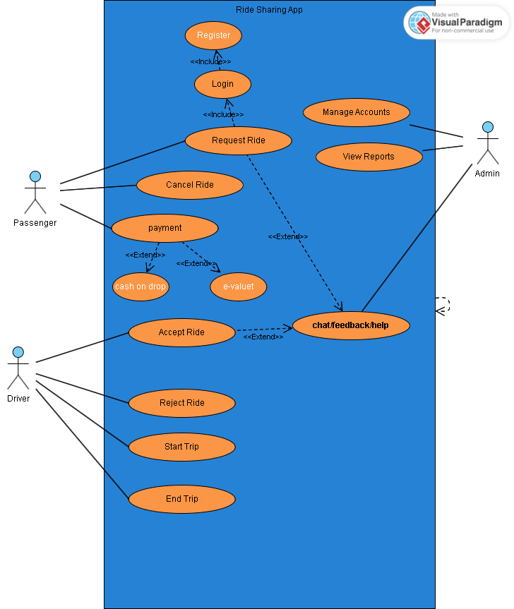

**Activity diagram:**

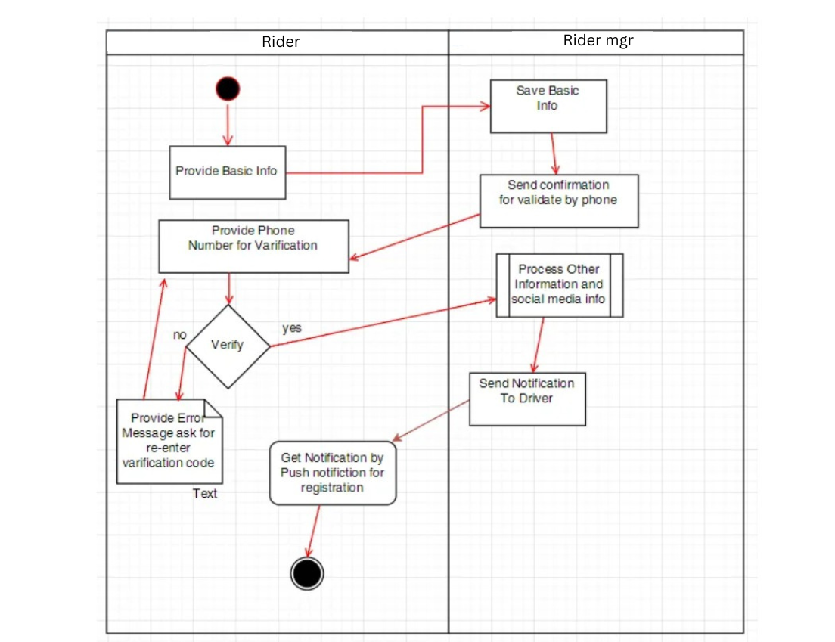

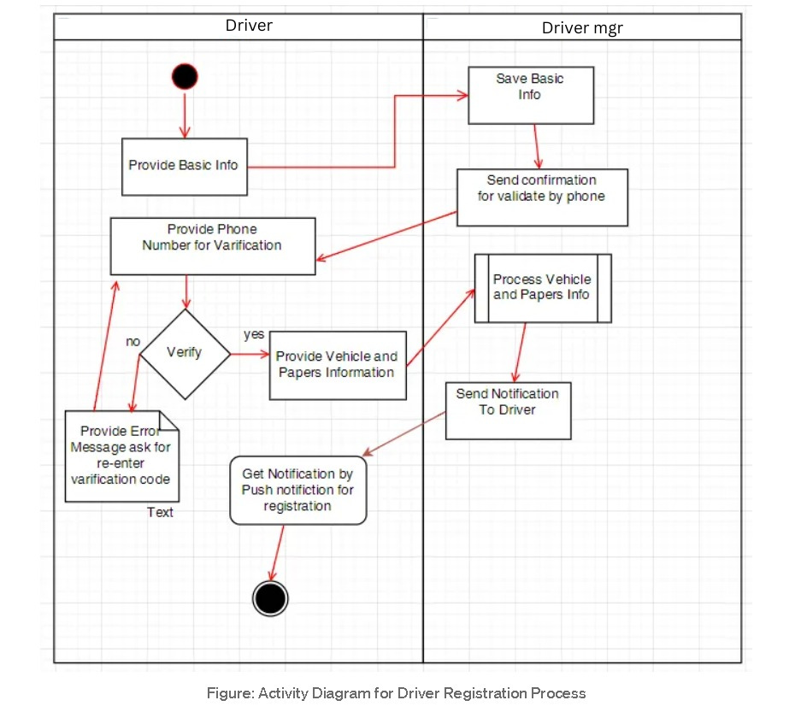

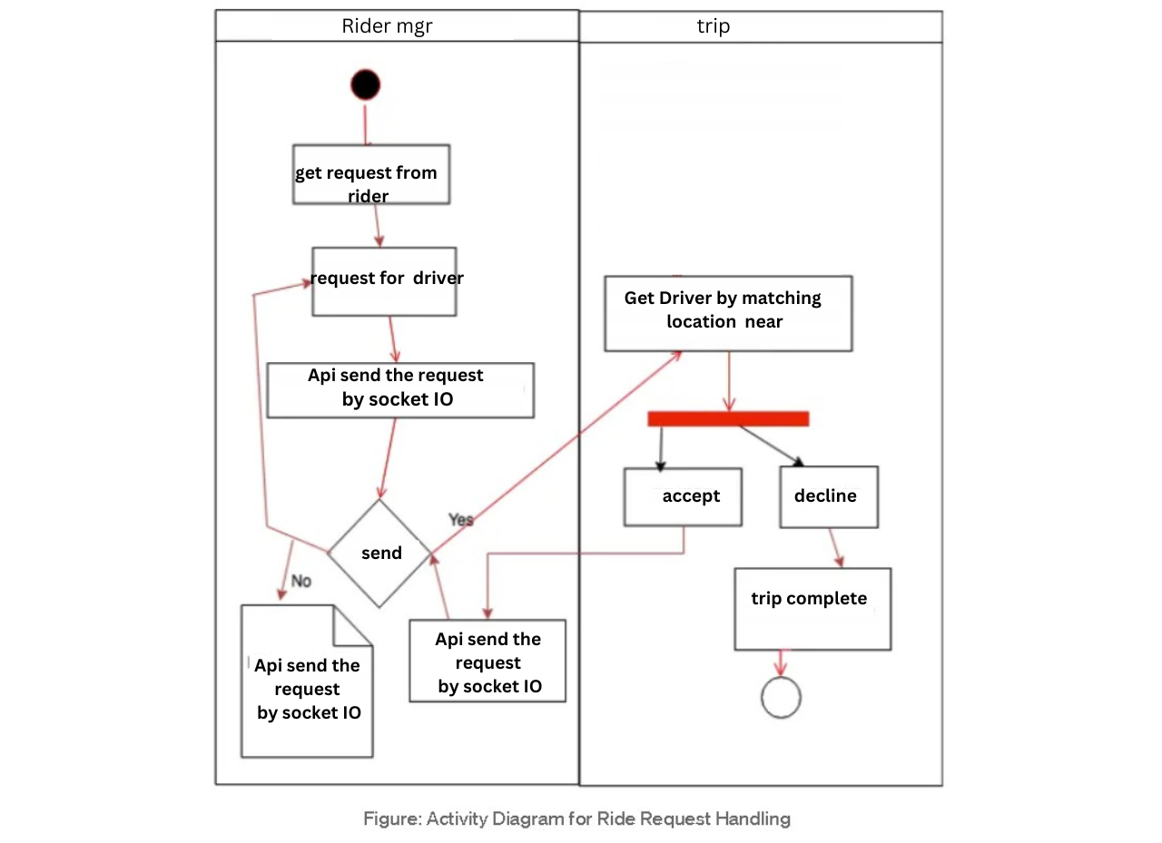 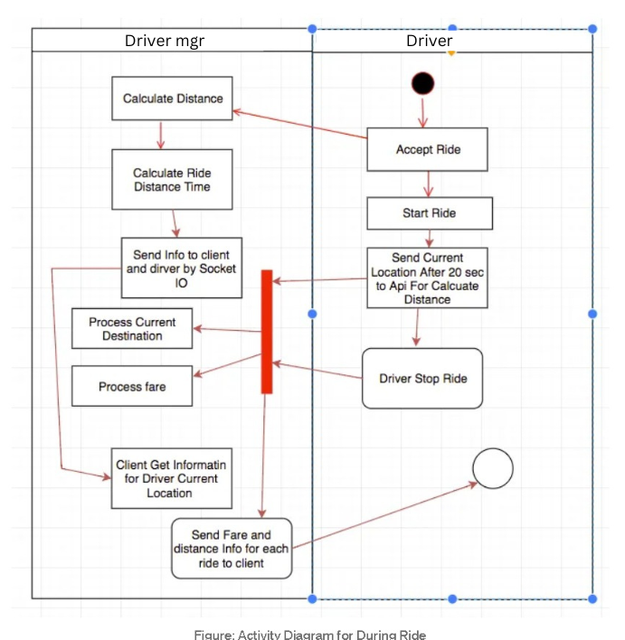

**Detailed class diagram:**

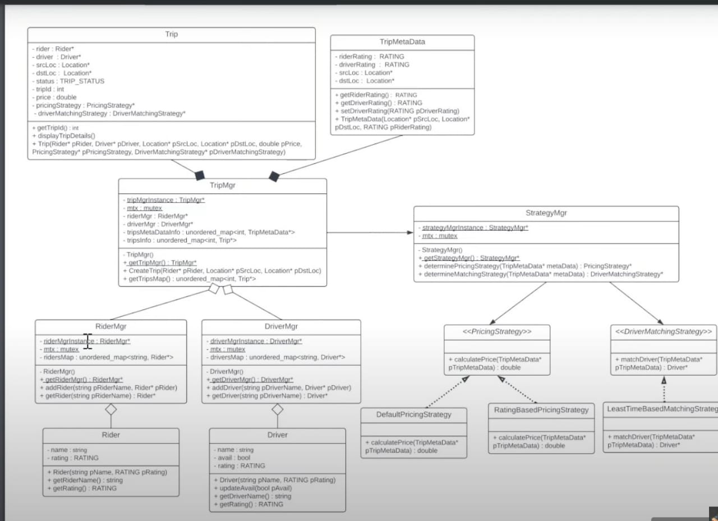

**OCL for class digram:**

**For Trip:**

{self.rider <> null and self.driver <> null and self.srcLoc <> null and self.dstLoc <> null}

**For TripMgr Singleton:**

{TripMgr::tripMgrInstance->size() = 1}

**For Driver Availability:**

{self.avail = true implies DriverMgr.getDriver(self.name).avail = true}

**For Ratings (Rider and Driver):**

{self.rating >= 1 and self.rating <= 5}

**For Pricing Strategy:**

{self.calculatePrice(tripMetaData) >= 0}

**Sequence diagram:**

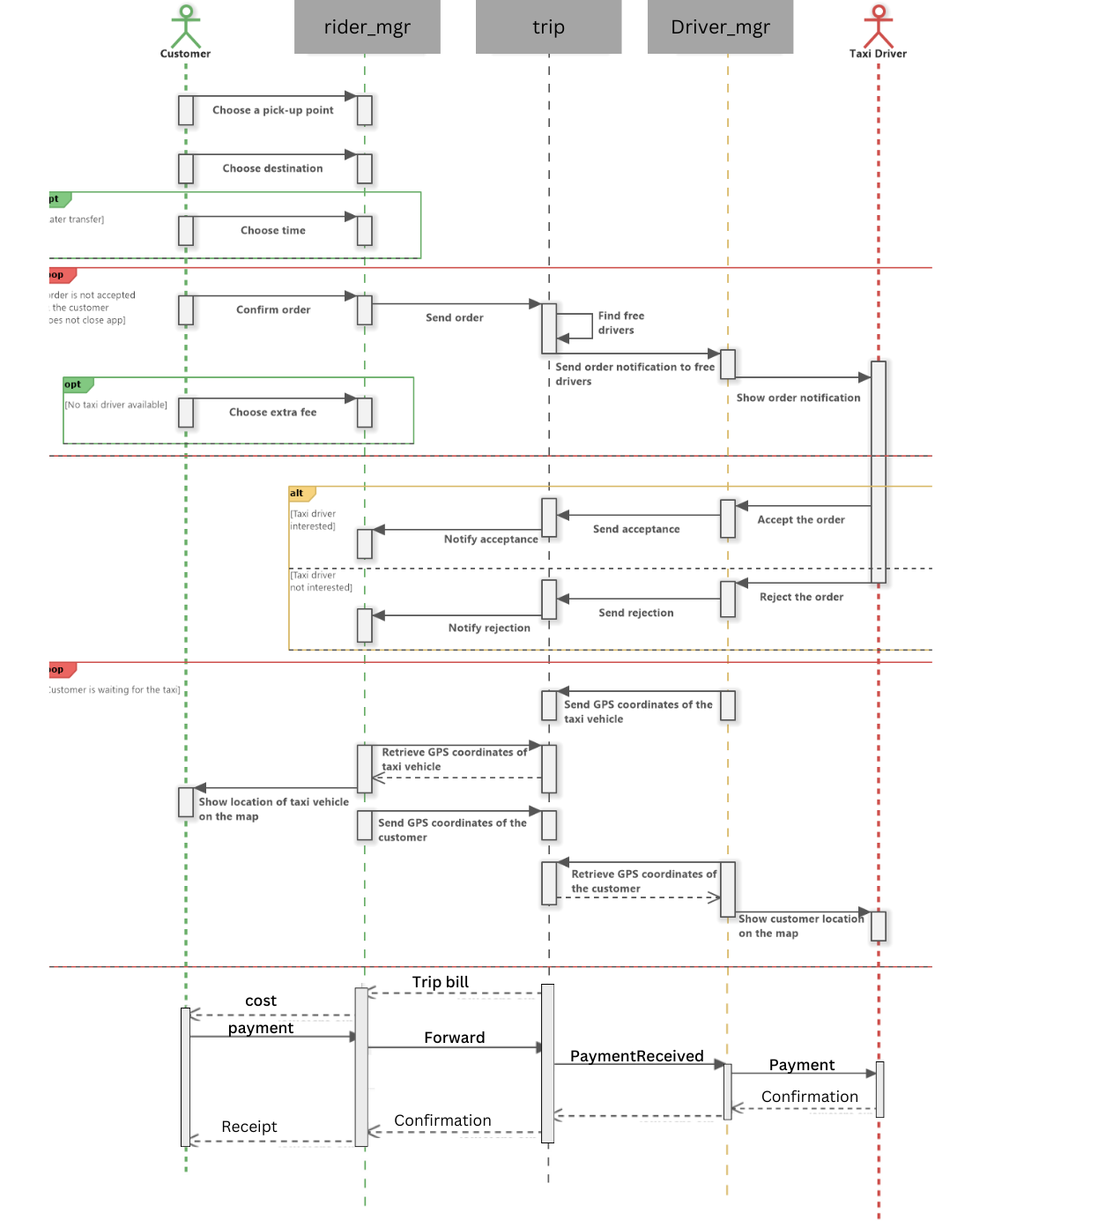

**State diagram:**

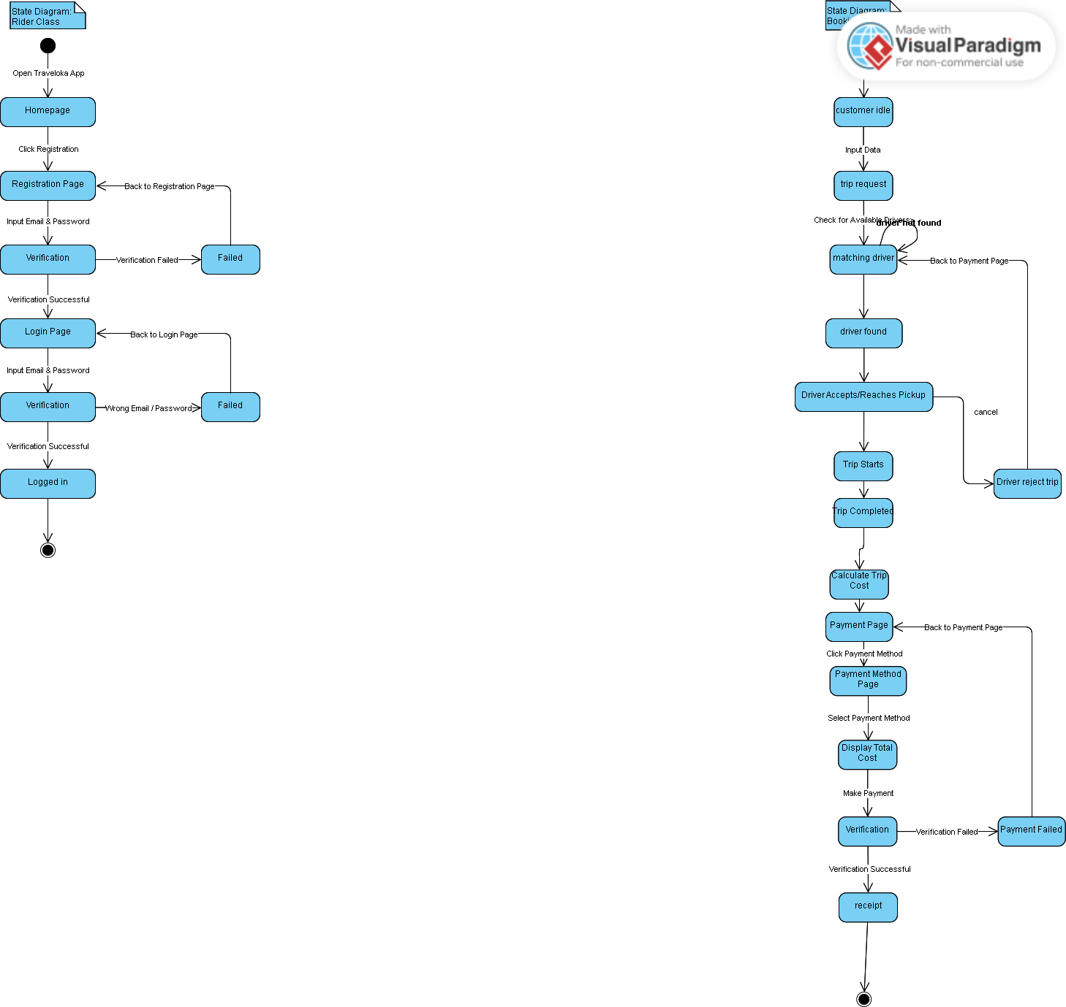

**Package diagram:**

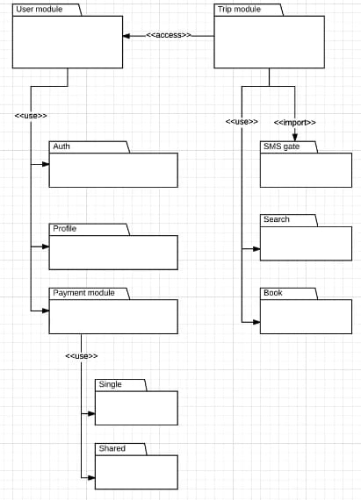

**Interaction diagram:**

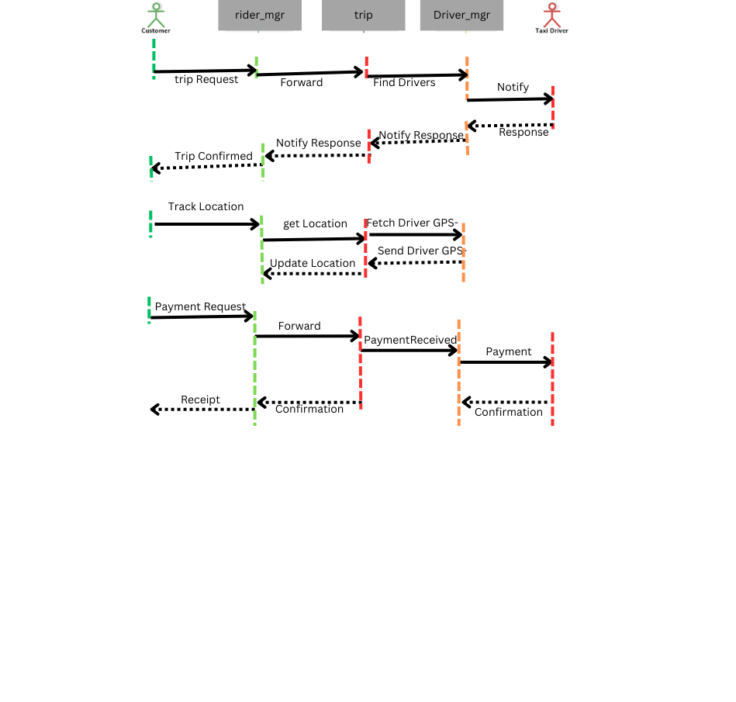

**Tools used:**

* Lucid chart
* Creatly.com
* Canva
* Visiual paradigm