Chess Problems
Australian Junior Problem Solving

All problems sourced from Chess Wizardry The New ABC of Chess Problems by John Rice (unless noted)

Position | Solution | Notes
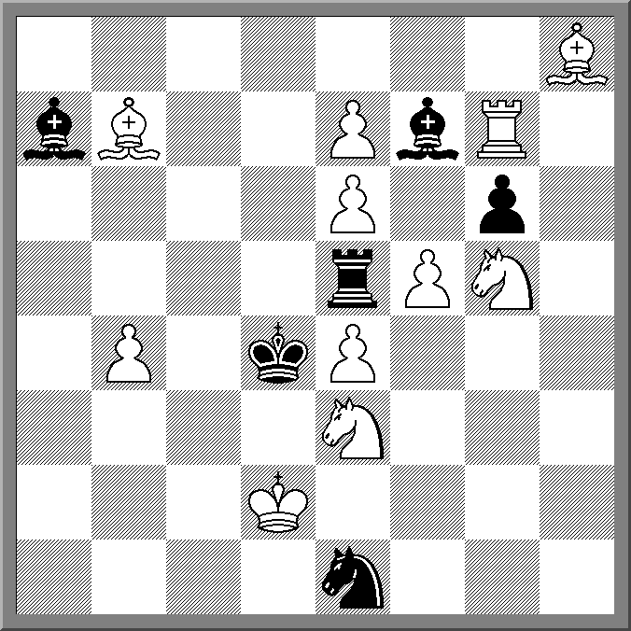  Mate in 3 (V.F. Rudenko 1961) | 1.Bd5 > 2.Nc2 Nxc2 3.Nf3 | Rook moves all met by discovered checks and then pin mates eg 1. … Rxd5 2.Rg8+ Re5 3.Rd8# (Battery play and pin mates)
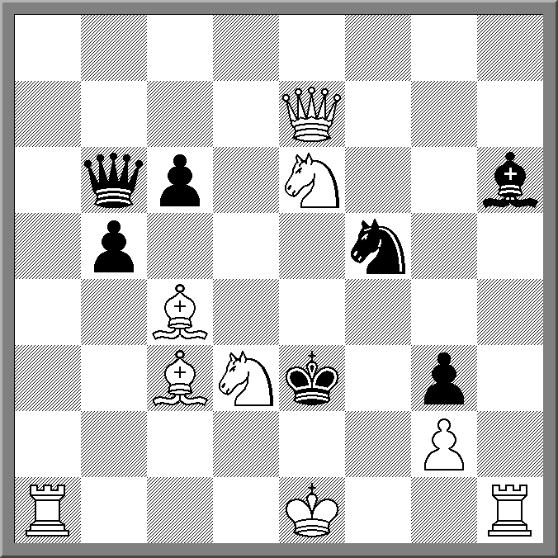  Mate in 2 (M.Lipton 1961) | 1. O-O-O > 2.Rde1  1 … Ke4+ 2,Ng5#  2… Ke2+ 2.Nef4# | 1.O-O fails to 1. … bxc4!  Castling key with cross check mates!
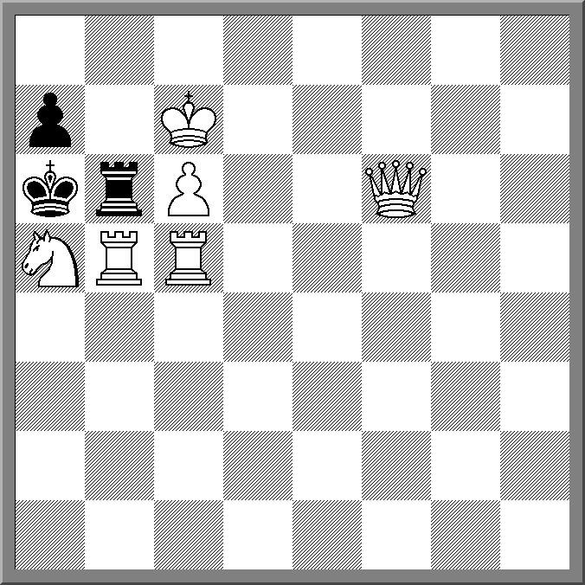  Mate in 2 (C.Goldschemeding 1957) | 1.Qf1! Rb7 2.Rxb7# | Set play 1 … Rb7+ cxb7# 1. … Rxc6 2.Qxc6#  1.Qa1?Rxb5!  Suitable as a trial problem
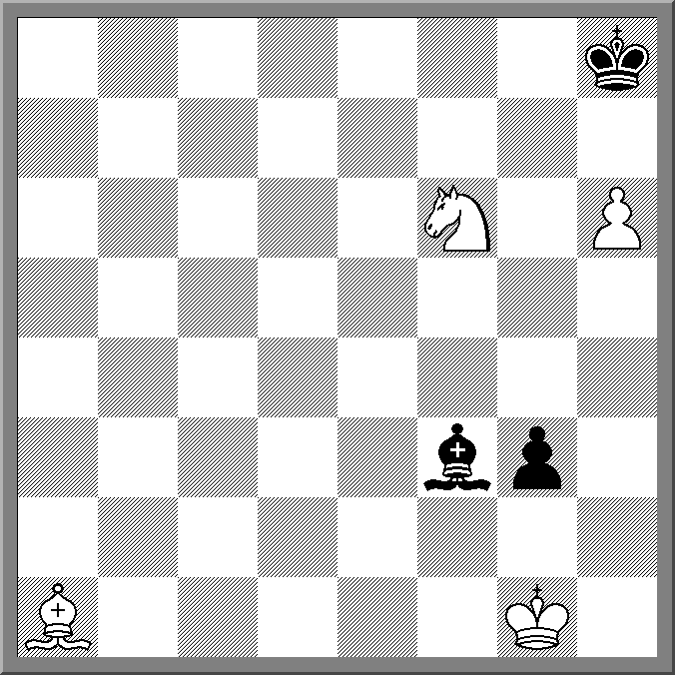  Mate in 5 (Kohtz and Kockelkorn 1875) | 1.Be5 Bh1 2.Bxg3 > 3.Bd6 4.Bf8 5.Bg7# | Other bishop moves are met by 1. … Bh1! > 2. … g2=  Not sure if this is hard or easy! Might be suitable as Under 12 hard!
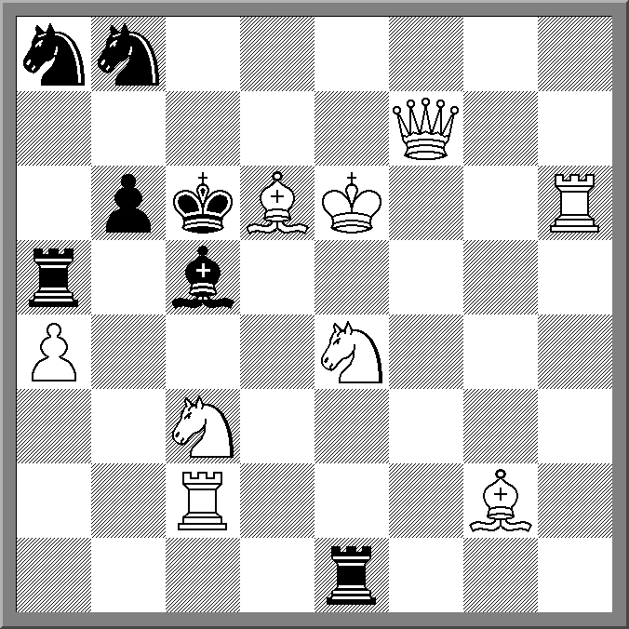  Mate in 2 (C. Manfield 1935) | 1.Kf5 > 2.Bxc5 | All checking defences are met by checkmates. Another cross-check composition
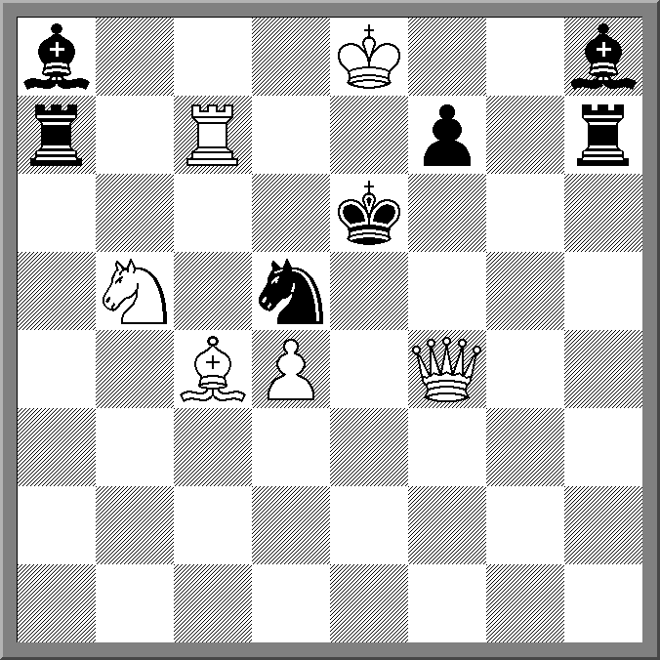  Mate in 2 (L.I. Loshinsky 1930) | 1. Bb3! | Every Black defence is met by a mate but White needs to find the correct waiting move.
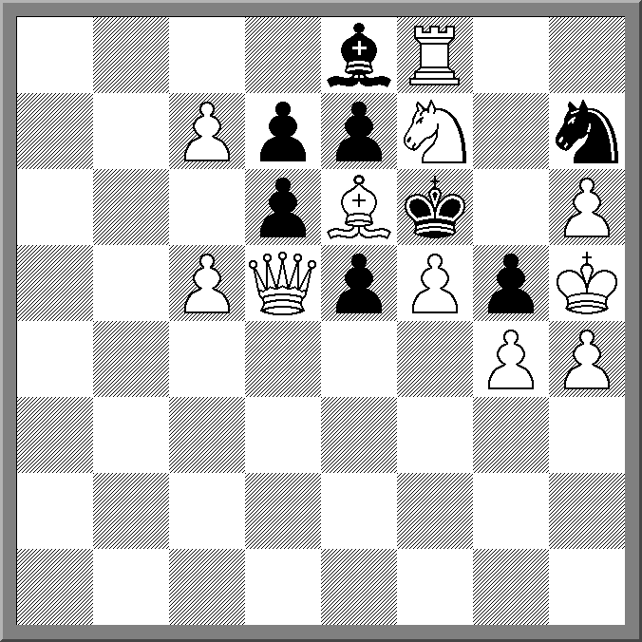  Mate in 2 (K.S. Animista 1974) | 1.fxg6 ep | 1. c8(Q)? gxh4  Harder if players have to work out that the key is legal, based on what move did Black play last.
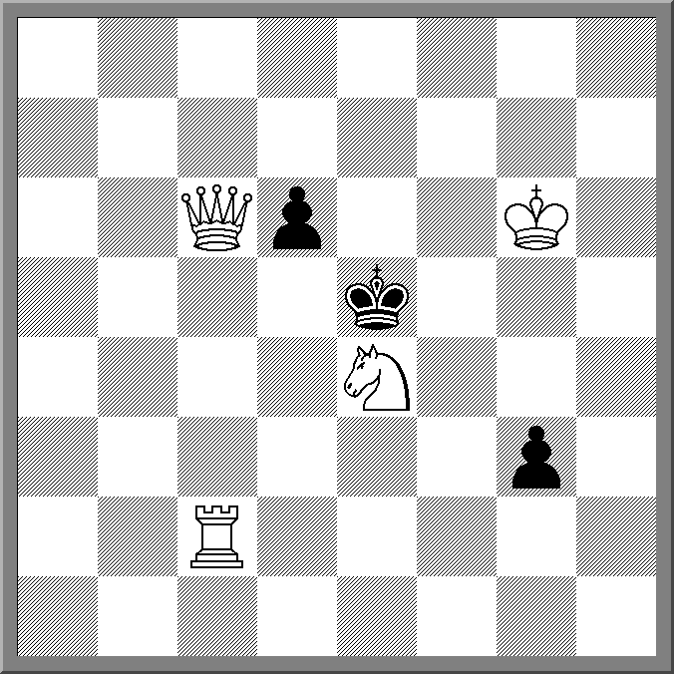  Mate in 2 (G.Latzel 1956) | 1. Ng5! | 7 of the 8 knight tries have a different refutation. Ng5 works by elimination!
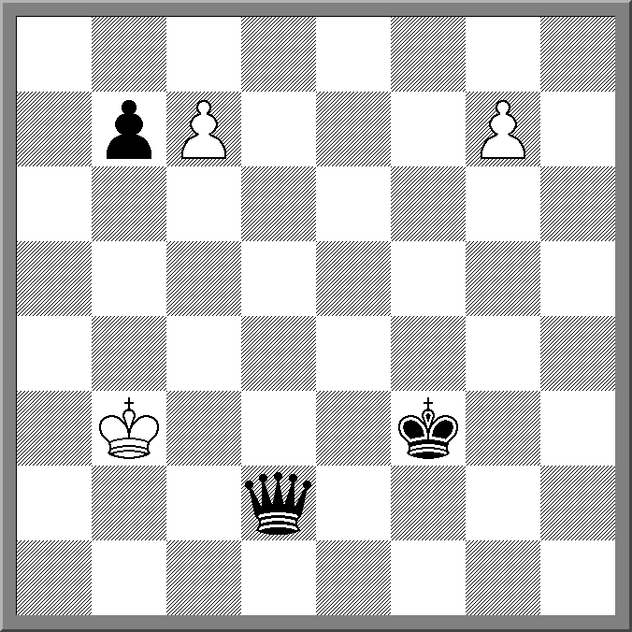  Selfmate in 6 Maximummer (P. Raincan 1991) | 1.c8 ( R ) Qd8 2.Rc3+ Qd3 3.g8 ( R ) b5 4.Re8 Kg2 5.Ra8 Qh7 6.Ra3 Qb1# | Black is required to play the longest available move (NB Diagonal moves are 1.41 squares per square). White is free to play any move. Selfmate in 6,  Possibly to confusing without a long explanation
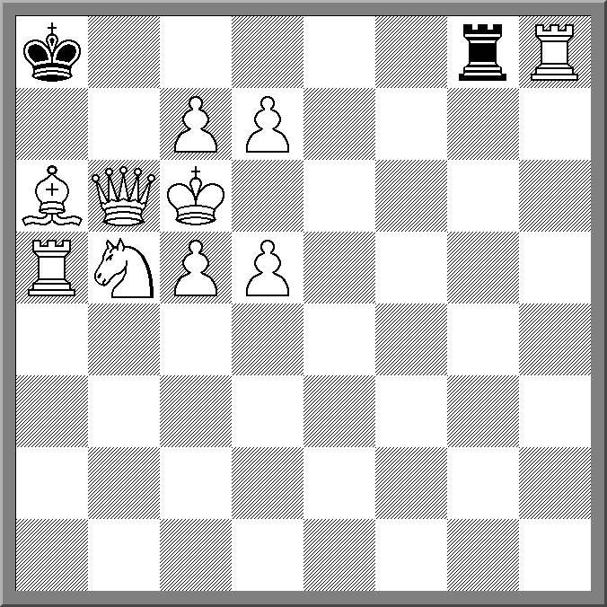  Selfmate in 10 (E.Holladay 1965) | 1.Na7! Rf8 2.Rg8 Re8 3.Rf8 Rd8 4.Re8 Rc8 5.Rd8 Rb8 6.Rc8 Rxc8 7.Qb8+ Rxb8 8.Bb7+ Rxb7 9.Nb5+ Ra7 10.Ra6! Rxa6# | A direct selfmate. Earlier rook captures lead to the same outcome after Qb8+ Could be a good final problem
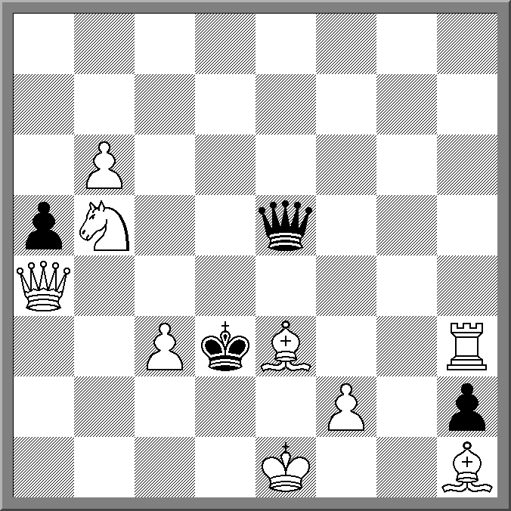  Mate in 2 (C.J Morse 1962) | 1.c4 | Zugzwang. All queen moves that prevent Qb3# are met by Bishop moves# (except Qxe3+ 2.Rxe3#)
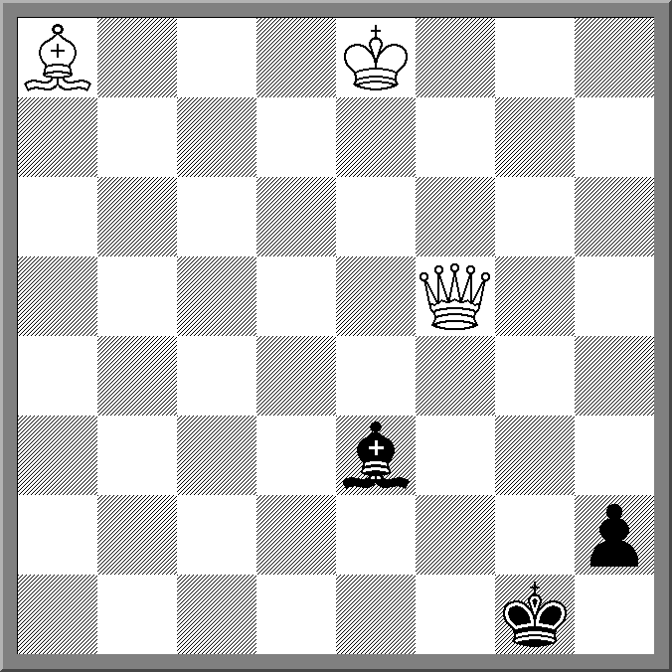  Mate in 3 (S.P Tsirulik 1956) | 1.Bh1! Kxh1 2.Qf1+ Bg1 3.Qf3#  1.Qf3? h1 (Q) | Might be obvious. Possibly a good example problem for Mate in 3

