Name: RWASIBO Elie
ID: 28286

Question 1 — Variables, %TYPE & DBMS_OUTPUT
Task 1.1
SET SERVEROUTPUT ON;
DECLARE
v_course_name VARCHAR2(100) := 'Database Management Systems';
v_credits NUMBER(1) := 4;
v_start_date DATE := DATE '2024-09-01';
v_heavy_course BOOLEAN;
BEGIN
-- Assign BOOLEAN value based on credits
v_heavy_course := (v_credits >= 3);

-- Print values
DBMS_OUTPUT.PUT_LINE('Course: ' || v_course_name);
DBMS_OUTPUT.PUT_LINE('Credits: ' || v_credits);
DBMS_OUTPUT.PUT_LINE('Semester Start: ' ||
TO_CHAR(v_start_date, 'DD-MON-YY'));

DBMS_OUTPUT.PUT_LINE('Heavy Course: ' ||
CASE
WHEN v_heavy_course THEN 'TRUE'
ELSE 'FALSE'
END);
END;
/
Output: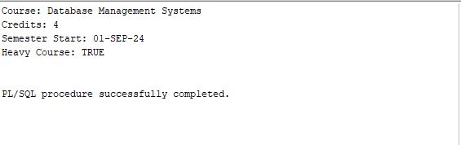
Task 1.2
SET SERVEROUTPUT ON;
DECLARE
v_course_name VARCHAR2(100);
v_instructor VARCHAR2(50);
v_credits NUMBER;
v_max_students NUMBER;
BEGIN
SELECT course_name, instructor, credits, max_students
INTO v_course_name, v_instructor, v_credits, v_max_students
FROM courses
WHERE course_id = 110;
DBMS_OUTPUT.PUT_LINE('Course Name: ' || v_course_name);
DBMS_OUTPUT.PUT_LINE('Instructor: ' || v_instructor);
DBMS_OUTPUT.PUT_LINE('Credits: ' || v_credits);
IF v_max_students < 20 THEN
DBMS_OUTPUT.PUT_LINE('Limited seats available!');
END IF;
EXCEPTION
WHEN NO_DATA_FOUND THEN
DBMS_OUTPUT.PUT_LINE('Course not found.');
WHEN TOO_MANY_ROWS THEN
DBMS_OUTPUT.PUT_LINE('Multiple courses found.');
END;
/
Output: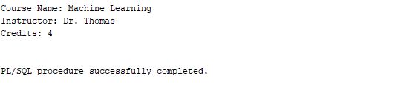
Task 1.3
SET SERVEROUTPUT ON;

DECLARE
v_emp employees%ROWTYPE;
v_hire_year NUMBER;
v_years_worked NUMBER;
BEGIN
-- Fetch full row into %ROWTYPE variable
SELECT *
INTO v_emp
FROM employees
WHERE employee_id = 22;

-- Extract hire year
v_hire_year := EXTRACT(YEAR FROM v_emp.hire_date);

-- Calculate years worked
v_years_worked := EXTRACT(YEAR FROM SYSDATE) - v_hire_year;

-- Print required information
DBMS_OUTPUT.PUT_LINE('Full Name: ' ||
v_emp.first_name || ' ' || v_emp.last_name);

DBMS_OUTPUT.PUT_LINE('Department: ' || v_emp.department);

DBMS_OUTPUT.PUT_LINE('Salary: ' || v_emp.salary);

DBMS_OUTPUT.PUT_LINE('Hire Year: ' || v_hire_year);

DBMS_OUTPUT.PUT_LINE('Years Worked: ' || v_years_worked);

EXCEPTION
WHEN NO_DATA_FOUND THEN
DBMS_OUTPUT.PUT_LINE('Employee not found.');
WHEN TOO_MANY_ROWS THEN
DBMS_OUTPUT.PUT_LINE('Multiple employees found.');
END;
/
Output: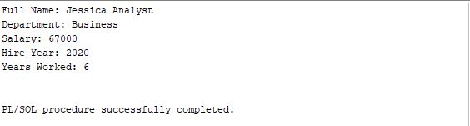
Question 2 — IF / ELSIF / ELSE Conditions
Task 2.1 — Employee Commission Checker
SET SERVEROUTPUT ON;

DECLARE
v_emp employees%ROWTYPE;
v_total_earnings NUMBER(12,2);
BEGIN
-- Fetch employee record
SELECT *
INTO v_emp
FROM employees
WHERE employee_id = 1;

-- Conditional evaluation
IF v_emp.commission_pct IS NOT NULL
AND v_emp.salary > 80000 THEN

DBMS_OUTPUT.PUT_LINE('High-value manager with commission');

ELSIF v_emp.commission_pct IS NOT NULL
AND v_emp.salary <= 80000 THEN

DBMS_OUTPUT.PUT_LINE('Manager with commission — standard tier');

ELSIF v_emp.commission_pct IS NULL
AND v_emp.salary > 90000 THEN

DBMS_OUTPUT.PUT_LINE('Senior employee — consider adding commission incentive');

ELSE
DBMS_OUTPUT.PUT_LINE('Standard employee profile');
END IF;

-- Calculate total potential earnings
v_total_earnings := v_emp.salary +
(v_emp.salary * NVL(v_emp.commission_pct, 0));

DBMS_OUTPUT.PUT_LINE('Total Potential Earnings: ' || v_total_earnings);

EXCEPTION
WHEN NO_DATA_FOUND THEN
DBMS_OUTPUT.PUT_LINE('Employee not found.');
END;
/
Output: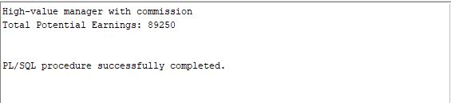
Task 2.2 — Course Availability Check
SET SERVEROUTPUT ON;
DECLARE
v_course_name VARCHAR2(100);
v_max_students NUMBER;
v_enrolled_count NUMBER;
v_status VARCHAR2(50);
BEGIN
-- Fetch course details
SELECT course_name, max_students
INTO v_course_name, v_max_students
FROM courses
WHERE course_id = 103;
-- Count enrolled students
SELECT COUNT(*)
INTO v_enrolled_count
FROM enrollments
WHERE course_id = 103
AND status = 'Active';
-- Determine availability
IF v_enrolled_count < v_max_students * 0.5 THEN
v_status := 'Open — plenty of seats available';
ELSIF v_enrolled_count BETWEEN
v_max_students * 0.5 AND v_max_students * 0.8 THEN
v_status := 'Filling up — limited seats';
ELSIF v_enrolled_count > v_max_students * 0.8
AND v_enrolled_count < v_max_students THEN
v_status := 'Almost full — enroll soon';
ELSE
v_status := 'FULL — enrollment closed';
END IF;
-- Print results
DBMS_OUTPUT.PUT_LINE('Course Name: ' || v_course_name);
DBMS_OUTPUT.PUT_LINE('Max Capacity: ' || v_max_students);
DBMS_OUTPUT.PUT_LINE('Current Enrollment: ' || v_enrolled_count);
DBMS_OUTPUT.PUT_LINE('Availability Status: ' || v_status);
EXCEPTION
WHEN NO_DATA_FOUND THEN
DBMS_OUTPUT.PUT_LINE('Course not found.');
END;
/
Output: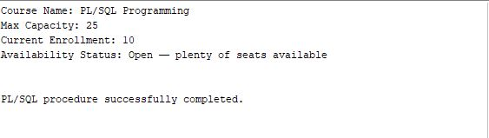
Task 2.3 — Student Age Eligibility
SET SERVEROUTPUT ON;
DECLARE
v_student students%ROWTYPE;
v_age NUMBER;
v_note VARCHAR2(100);
BEGIN
-- Fetch student record
SELECT *
INTO v_student
FROM students
WHERE student_id = 1020;

-- Calculate age in years
v_age := FLOOR(MONTHS_BETWEEN(SYSDATE,
v_student.date_of_birth) / 12);

-- Age classification
IF v_age < 18 THEN
DBMS_OUTPUT.PUT_LINE('Minor student — parental consent required');

ELSIF v_age BETWEEN 18 AND 25 THEN
DBMS_OUTPUT.PUT_LINE('Traditional student age');

ELSE
DBMS_OUTPUT.PUT_LINE('Mature student — eligible for evening program');
END IF;

-- Check enrollment year
IF EXTRACT(YEAR FROM v_student.enrollment_date) = 2023 THEN
v_note := 'First-year cohort (2023)';
DBMS_OUTPUT.PUT_LINE(v_note);
END IF;

-- Print details
DBMS_OUTPUT.PUT_LINE('Student Name: ' ||
v_student.first_name || ' ' ||
v_student.last_name);

DBMS_OUTPUT.PUT_LINE('Age: ' || v_age);

EXCEPTION
WHEN NO_DATA_FOUND THEN
DBMS_OUTPUT.PUT_LINE('Student not found.');
END;
/
Output: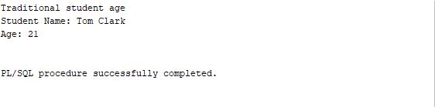
Question 3 — CASE Statement
Task 3.1 — Score to Grade Conversion
SET SERVEROUTPUT ON;

DECLARE
v_score enrollments.score%TYPE;
v_stored_grade enrollments.grade%TYPE;
v_computed_grade VARCHAR2(20);
BEGIN
-- Fetch score and stored grade
SELECT score, grade
INTO v_score, v_stored_grade
FROM enrollments
WHERE enrollment_id = 5;

-- Convert numeric score to letter grade using searched CASE
v_computed_grade :=
CASE
WHEN v_score IS NULL THEN 'Not yet graded'
WHEN v_score >= 90 THEN 'A'
WHEN v_score >= 80 THEN 'B'
WHEN v_score >= 70 THEN 'C'
WHEN v_score >= 60 THEN 'D'
ELSE 'F'
END;

-- Print comparison
IF v_computed_grade = v_stored_grade THEN
DBMS_OUTPUT.PUT_LINE('Grade match: YES');
ELSE
DBMS_OUTPUT.PUT_LINE('Grade match: NO — stored '
|| v_stored_grade
|| ', computed '
|| v_computed_grade);
END IF;

EXCEPTION
WHEN NO_DATA_FOUND THEN
DBMS_OUTPUT.PUT_LINE('Enrollment not found.');
END;
/
Output: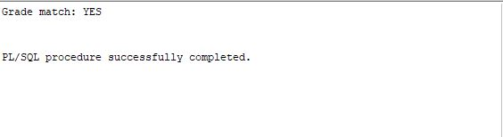
Task 3.2 — Department Location Codes
SET SERVEROUTPUT ON;

DECLARE
v_dept departments%ROWTYPE;
v_building VARCHAR2(50);
BEGIN
-- Fetch Computer Science department
SELECT *
INTO v_dept
FROM departments
WHERE department_name = 'Computer Science';

-- Simple CASE for building code
v_building :=
CASE v_dept.department_name
WHEN 'Computer Science' THEN 'BLD-CS | ICT Wing'
WHEN 'Mathematics' THEN 'BLD-MT | Science Wing'
WHEN 'Business' THEN 'BLD-BS | Commerce Wing'
WHEN 'Engineering' THEN 'BLD-EN | Technical Wing'
WHEN 'Psychology' THEN 'BLD-PS | Humanities Wing'
ELSE 'BLD-GN | General Wing'
END;

-- Print department details
DBMS_OUTPUT.PUT_LINE('Department: ' || v_dept.department_name);
DBMS_OUTPUT.PUT_LINE('Building Code: ' || v_building);

DBMS_OUTPUT.PUT_LINE('Budget: ' || v_dept.budget);

DBMS_OUTPUT.PUT_LINE('Budget Status: ' ||
CASE
WHEN v_dept.budget > 600000 THEN 'Well Funded'
WHEN v_dept.budget BETWEEN 400000 AND 600000 THEN
'Adequately Funded'
ELSE 'Underfunded'
END);

EXCEPTION
WHEN NO_DATA_FOUND THEN
DBMS_OUTPUT.PUT_LINE('Department not found.');
END;
/
Output: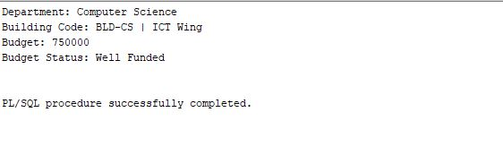
Task 3.3 — Job Title Rank
SET SERVEROUTPUT ON;

DECLARE
v_first_name employees.first_name%TYPE;
v_last_name employees.last_name%TYPE;
v_job_title employees.job_title%TYPE;
v_salary employees.salary%TYPE;
v_rank_number NUMBER;
v_rank_title VARCHAR2(30);
BEGIN
-- Fetch employee details
SELECT first_name, last_name, job_title, salary
INTO v_first_name, v_last_name, v_job_title, v_salary
FROM employees
WHERE employee_id = 14;

-- Assign rank using CASE
CASE
WHEN v_job_title = 'Full Professor' THEN
v_rank_number := 1; v_rank_title := 'Senior Academic';
WHEN v_job_title = 'Associate Professor' THEN
v_rank_number := 2; v_rank_title := 'Mid Academic';
WHEN v_job_title = 'Assistant Professor' THEN
v_rank_number := 3; v_rank_title := 'Junior Academic';
WHEN v_job_title LIKE '%Developer%' OR v_job_title LIKE '%Engineer%' THEN
v_rank_number := 4; v_rank_title := 'Technical Staff';
WHEN v_job_title LIKE '%Admin%' OR v_job_title LIKE '%Coordinator%' THEN
v_rank_number := 5; v_rank_title := 'Administrative Staff';
ELSE
v_rank_number := 6; v_rank_title := 'General Staff';
END CASE;

-- Print employee details
DBMS_OUTPUT.PUT_LINE('Employee: ' || v_first_name || ' ' || v_last_name);
DBMS_OUTPUT.PUT_LINE('Job Title: ' || v_job_title);
DBMS_OUTPUT.PUT_LINE('Rank Number: ' || v_rank_number);
DBMS_OUTPUT.PUT_LINE('Rank Title: ' || v_rank_title);
DBMS_OUTPUT.PUT_LINE('Salary: ' || v_salary);

-- Promotion eligibility check
IF v_rank_number <= 2 AND v_salary < 100000 THEN
DBMS_OUTPUT.PUT_LINE('Promotion eligible');
ELSE
DBMS_OUTPUT.PUT_LINE('Not eligible for promotion');
END IF;
END;
/
Output: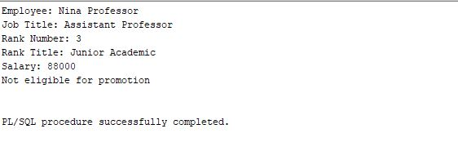
Question 4 — Loops
Task 4.1 — Basic LOOP: Tuition Fee Calculator
SET SERVEROUTPUT ON;

DECLARE
v_course_id courses.course_id%TYPE := 101; -- start from course_id 101
v_course_name courses.course_name%TYPE;
v_credits courses.credits%TYPE;
v_total_credits NUMBER := 0;
v_total_tuition NUMBER := 0;
v_cost_per_credit CONSTANT NUMBER := 150000; -- tuition per credit
BEGIN
LOOP
-- Fetch course details
SELECT course_name, credits
INTO v_course_name, v_credits
FROM courses
WHERE course_id = v_course_id;

-- Accumulate totals
v_total_credits := v_total_credits + v_credits;
v_total_tuition := v_total_tuition + (v_credits * v_cost_per_credit);

-- Print iteration details
DBMS_OUTPUT.PUT_LINE(
'Added: ' || v_course_name || ' (' || v_credits || ' credits) | ' ||
'Running Total: ' || v_total_credits || ' credits | ' ||
'Tuition So Far: RWF ' || v_total_tuition
);

-- Exit condition
IF v_total_credits >= 15 THEN
EXIT;
END IF;

-- Move to next course
v_course_id := v_course_id + 1;
END LOOP;

-- Final summary
DBMS_OUTPUT.PUT_LINE('----------------------------------');
DBMS_OUTPUT.PUT_LINE('Final Total Credits: ' || v_total_credits);
DBMS_OUTPUT.PUT_LINE('Final Tuition: RWF ' || v_total_tuition);
DBMS_OUTPUT.PUT_LINE('Average Cost per Credit: RWF ' || ROUND(v_total_tuition / v_total_credits, 2));
END;
/
Output: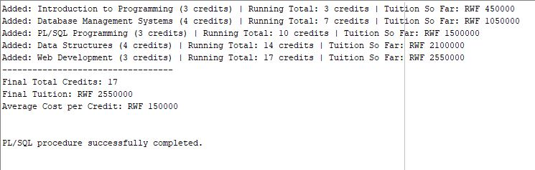
Task 4.2 — WHILE Loop: Department Salary Budget
SET SERVEROUTPUT ON;

DECLARE
-- Cursor for Computer Science employees
CURSOR cs_emp_cur IS
SELECT employee_id, first_name, last_name, salary
FROM employees
WHERE department = 'Computer Science';

-- Variables
v_emp_id employees.employee_id%TYPE;
v_first_name employees.first_name%TYPE;
v_last_name employees.last_name%TYPE;
v_salary employees.salary%TYPE;

v_total_employees NUMBER := 0;
v_total_salary NUMBER := 0;
v_high_earners NUMBER := 0;
v_low_earners NUMBER := 0;

v_max_salary NUMBER := 0;
v_max_name VARCHAR2(100);

BEGIN
OPEN cs_emp_cur;
FETCH cs_emp_cur INTO v_emp_id, v_first_name, v_last_name, v_salary;

WHILE cs_emp_cur%FOUND LOOP
-- Count employee
v_total_employees := v_total_employees + 1;

-- Accumulate salary
v_total_salary := v_total_salary + v_salary;

-- High earners (>75k)
IF v_salary > 75000 THEN
v_high_earners := v_high_earners + 1;
END IF;

-- Low earners (<65k)
IF v_salary < 65000 THEN
v_low_earners := v_low_earners + 1;
END IF;

-- Track highest paid
IF v_salary > v_max_salary THEN
v_max_salary := v_salary;
v_max_name := v_first_name || ' ' || v_last_name;
END IF;

-- Fetch next employee
FETCH cs_emp_cur INTO v_emp_id, v_first_name, v_last_name, v_salary;
END LOOP;

CLOSE cs_emp_cur;

-- Print report
DBMS_OUTPUT.PUT_LINE('===== Computer Science Salary Report =====');
DBMS_OUTPUT.PUT_LINE('Total Employees: ' || v_total_employees);
DBMS_OUTPUT.PUT_LINE('Total Salary Bill: RWF ' || v_total_salary);
DBMS_OUTPUT.PUT_LINE('Average Salary: RWF ' || ROUND(v_total_salary / v_total_employees, 2));
DBMS_OUTPUT.PUT_LINE('High Earners (>75k): ' || v_high_earners);
DBMS_OUTPUT.PUT_LINE('Low Earners (<65k): ' || v_low_earners);
DBMS_OUTPUT.PUT_LINE('Highest Paid: ' || v_max_name || ' — RWF ' || v_max_salary);
DBMS_OUTPUT.PUT_LINE('==========================================');
END;
/
Output: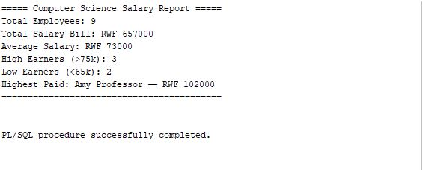
Task 4.3 — FOR Loop: Academic Performance Table
SET SERVEROUTPUT ON;

DECLARE
v_first_name students.first_name%TYPE;
v_last_name students.last_name%TYPE;
v_gpa students.gpa%TYPE;
v_enroll_count NUMBER;
v_perf_label VARCHAR2(30);
v_load_label VARCHAR2(20);

-- Counters
v_total_students NUMBER := 0;
v_summa NUMBER := 0;
v_magna NUMBER := 0;
v_cum NUMBER := 0;
v_satisfactory NUMBER := 0;
v_probation NUMBER := 0;
BEGIN
FOR i IN 1001..1010 LOOP
-- Fetch student details
SELECT first_name, last_name, gpa
INTO v_first_name, v_last_name, v_gpa
FROM students
WHERE student_id = i;

-- Count enrollments
SELECT COUNT(*)
INTO v_enroll_count
FROM enrollments
WHERE student_id = i;

-- GPA performance label
CASE
WHEN v_gpa >= 3.9 THEN v_perf_label := 'Summa Cum Laude'; v_summa := v_summa + 1;
WHEN v_gpa >= 3.7 THEN v_perf_label := 'Magna Cum Laude'; v_magna := v_magna + 1;
WHEN v_gpa >= 3.3 THEN v_perf_label := 'Cum Laude'; v_cum := v_cum + 1;
WHEN v_gpa >= 2.5 THEN v_perf_label := 'Satisfactory'; v_satisfactory := v_satisfactory + 1;
ELSE v_perf_label := 'Probation'; v_probation := v_probation + 1;
END CASE;

-- Enrollment load label
CASE
WHEN v_enroll_count <= 1 THEN v_load_label := 'Under-enrolled';
WHEN v_enroll_count BETWEEN 2 AND 3 THEN v_load_label := 'Normal Load';
ELSE v_load_label := 'Full Load';
END CASE;

-- Print formatted row
DBMS_OUTPUT.PUT_LINE(
'ID:' || i || ' | ' || v_first_name || ' ' || v_last_name ||
' | GPA:' || v_gpa ||
' | ' || RPAD(v_perf_label, 20) ||
' | ' || v_load_label
);

v_total_students := v_total_students + 1;
END LOOP;

-- Final summary
DBMS_OUTPUT.PUT_LINE('--------------------------------------------');
DBMS_OUTPUT.PUT_LINE('Total Students Printed: ' || v_total_students);
DBMS_OUTPUT.PUT_LINE('Performance Counts:');
DBMS_OUTPUT.PUT_LINE(' Summa Cum Laude: ' || v_summa);
DBMS_OUTPUT.PUT_LINE(' Magna Cum Laude: ' || v_magna);
DBMS_OUTPUT.PUT_LINE(' Cum Laude: ' || v_cum);
DBMS_OUTPUT.PUT_LINE(' Satisfactory: ' || v_satisfactory);
DBMS_OUTPUT.PUT_LINE(' Probation: ' || v_probation);
END;
/
Output: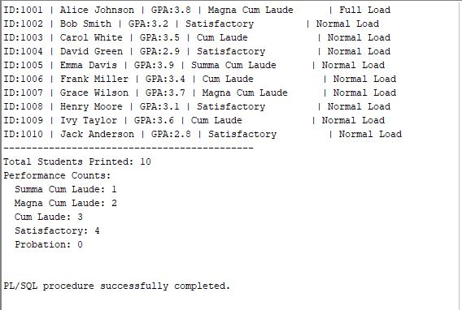
Question 5 — Combined Challenge
SET SERVEROUTPUT ON;

DECLARE
-- Step 1: Employee Profile
v_emp employees%ROWTYPE;
v_years_service NUMBER;
v_service_status VARCHAR2(20);

-- Step 2: Salary Analysis
v_pay_grade NUMBER;
v_raise_status VARCHAR2(30);
v_new_salary NUMBER;

-- Step 3: Department Summary
v_total_colleagues NUMBER := 0;
v_highest_salary NUMBER := 0;
v_colleagues_more NUMBER := 0;
BEGIN
-- Fetch employee row
SELECT *
INTO v_emp
FROM employees
WHERE employee_id = 5;

-- Calculate years of service
v_years_service := ROUND(MONTHS_BETWEEN(SYSDATE, v_emp.hire_date) / 12, 1);

-- Service classification
IF v_years_service < 2 THEN
v_service_status := 'Probationary';
ELSIF v_years_service BETWEEN 2 AND 5 THEN
v_service_status := 'Confirmed';
ELSE
v_service_status := 'Senior Staff';
END IF;

-- Salary Pay Grade (custom ranges)
CASE
WHEN v_emp.salary < 60000 THEN v_pay_grade := 1;
WHEN v_emp.salary BETWEEN 60000 AND 69999 THEN v_pay_grade := 2;
WHEN v_emp.salary BETWEEN 70000 AND 79999 THEN v_pay_grade := 3;
WHEN v_emp.salary BETWEEN 80000 AND 89999 THEN v_pay_grade := 4;
ELSE v_pay_grade := 5;
END CASE;

-- Raise eligibility
IF v_years_service > 3 AND v_emp.salary < 85000 THEN
v_raise_status := 'Raise recommended';
v_new_salary := v_emp.salary * 1.10;
ELSE
v_raise_status := 'No raise';
v_new_salary := v_emp.salary;
END IF;

-- Department summary
FOR rec IN (
SELECT first_name, last_name, salary
FROM employees
WHERE department = v_emp.department
AND employee_id <> v_emp.employee_id
) LOOP
v_total_colleagues := v_total_colleagues + 1;

IF rec.salary > v_highest_salary THEN
v_highest_salary := rec.salary;
END IF;

IF rec.salary > v_emp.salary THEN
v_colleagues_more := v_colleagues_more + 1;
END IF;
END LOOP;

-- Final Report Output
DBMS_OUTPUT.PUT_LINE('========================================');
DBMS_OUTPUT.PUT_LINE('EMPLOYEE PROFILE REPORT');
DBMS_OUTPUT.PUT_LINE('AUCA — HR Department System');
DBMS_OUTPUT.PUT_LINE('========================================');
DBMS_OUTPUT.PUT_LINE('Employee: ' || v_emp.first_name || ' ' || v_emp.last_name ||
' (ID: ' || v_emp.employee_id || ')');
DBMS_OUTPUT.PUT_LINE('Department: ' || v_emp.department);
DBMS_OUTPUT.PUT_LINE('Job Title: ' || v_emp.job_title);
DBMS_OUTPUT.PUT_LINE('Hire Date: ' || TO_CHAR(v_emp.hire_date, 'DD-MON-YY') ||
' | Years of Service: ' || v_years_service);
DBMS_OUTPUT.PUT_LINE('Service Status: ' || v_service_status);
DBMS_OUTPUT.PUT_LINE('----------------------------------------');
DBMS_OUTPUT.PUT_LINE('Salary: RWF ' || v_emp.salary || ' | Pay Grade: ' || v_pay_grade);
DBMS_OUTPUT.PUT_LINE('Raise Status: ' || v_raise_status);
DBMS_OUTPUT.PUT_LINE('Proposed Salary: RWF ' || v_new_salary);
DBMS_OUTPUT.PUT_LINE('----------------------------------------');
DBMS_OUTPUT.PUT_LINE('Dept. Colleagues: ' || v_total_colleagues);
DBMS_OUTPUT.PUT_LINE('Dept. Highest Salary: RWF ' || v_highest_salary);
DBMS_OUTPUT.PUT_LINE('Colleagues Earning More: ' || v_colleagues_more);
DBMS_OUTPUT.PUT_LINE('========================================');
END;
/
Output: