**Lab Test -01: C# Basics**

**Question Set: A**

**Web Programming using .Net**

**Time: 1 Hr. Score: 20**

**Make a Simple Interest Calculator**

User will enter principal amount, then give interest rate and finally (s)he will enter the time period for which (s)he wants to keep the principal amount in a bank. When *Calculate* button will be clicked Total amount will be shown in Total Amount (Result) textbox.

Here, interest will be calculated using Compound formula, that means every year the calculated interest amount will be added with principal amount and consider it as the part of principal amount for next year interest calculation.

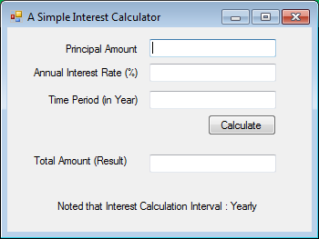

Sample Test Data Set is given below:

|  |  |  |  |
| --- | --- | --- | --- |
| **Principal Amount** | **Annual Interest Rate** | **Time Period (in Year)** | **Total Amount (Result)** |
| 100 | 10 | 1 | 110 |
| 100 | 10 | 2 | 121 |
| 100 | 10 | 5 | 161.051 |
| 1000 | 15 | 3 | 1520.875 |
| 100000 | 12.5 | 10 | 324732.1025 |

Judgment Criteria of this lab Test: Functional, Naming convention, Code quality, Indentation, UI layout.