**Lab Test -01: C# Basics**

**Question Set: B**

**Web Programming using .Net**

**Time: 1 Hr 45 Min. Score: 20**

**Make a simple Email keeper**

User will enter an email in textbox and press Add button to add it in the list below. Email address must be valid: Email must have one ‘@’ sign and at least one ‘.’. During add, this logic must be checked. User could add as many email addresses as (s)he wants.

In search part, user will enter email and press search button, all the matches email will be shown in the list below:

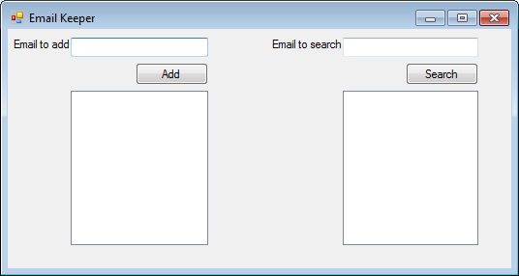

Judgment Criteria of this lab Test: Functional, Naming convention, Code quality, Indentation, UI layout.