**JAVA FSE WEEK 1**

**Data Structures and Algorithms**

**Mandatory Hands-on Excercises**

**Exercise 2: E-commerce Platform Search Function**

SearchDemo.java:

class Product {

    int productId;

    String productName;

    String category;

    public Product(int productId, String productName, String category) {

        this.productId = productId;

        this.productName = productName;

        this.category = category;

    }

}

public class SearchDemo {

    public static int linearSearch(Product[] arr, String name) {

        for (int i = 0; i < arr.length; i++) {

            if (arr[i].productName.equals(name)) return i;

        }

        return -1;

    }

    public static int binarySearch(Product[] arr, String name) {

        int low = 0, high = arr.length - 1;

        while (low <= high) {

            int mid = (low + high) / 2;

            int cmp = arr[mid].productName.compareTo(name);

            if (cmp == 0) return mid;

            else if (cmp < 0) low = mid + 1;

            else high = mid - 1;

        }

        return -1;

    }

    public static void main(String[] args) {

        Product[] products = {

            new Product(101, "Mouse", "Electronics"),

            new Product(102, "Keyboard", "Electronics"),

            new Product(103, "Charger", "Accessories")

        };

        int index1 = linearSearch(products, "Keyboard");

        System.out.println("Linear Search: Found at index = " + index1);

        // Binary search requires sorted input

        java.util.Arrays.sort(products, (a, b) -> a.productName.compareTo(b.productName));

        int index2 = binarySearch(products, "Keyboard");

        System.out.println("Binary Search: Found at index = " + index2);

    }

}

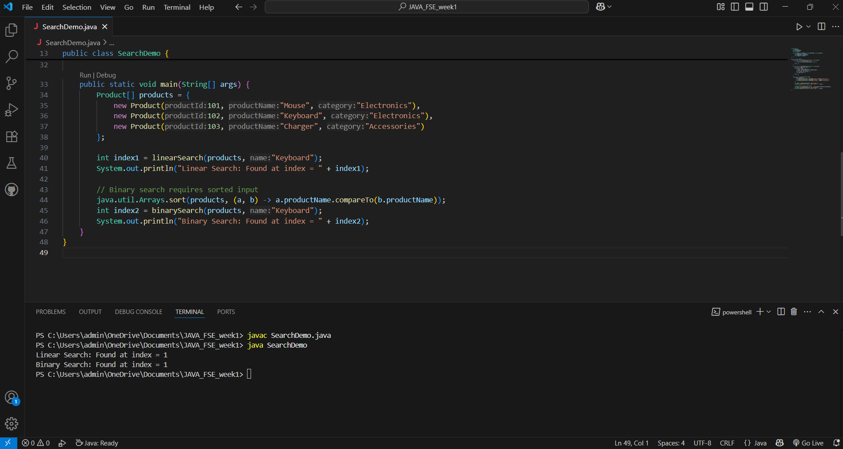

**Exercise 7: Recursive Forecasting**

public class Forecasting {

    public static int forecast(int month) {

        if (month <= 1) return 100; // base case: assume initial sales 100

        return forecast(month - 1) + forecast(month - 2); // simplified model

    }

    public static void main(String[] args) {

        int months = 6;

        for (int i = 1; i <= months; i++) {

            System.out.println("Month " + i + ": " + forecast(i));

        }

    }

}

