**JAVA FSE WEEK 1**

**Design patterns and principles**

**Mandatory Hands-on Excercises**

**Exercise 1: Implementing the Singleton Pattern**

Logger.java:

public class Logger {

    private static Logger instance;

    private Logger() {}

    public static Logger getInstance() {

        if (instance == null) {

            instance = new Logger();

        }

        return instance;

    }

    public void log(String message) {

        System.out.println("Log: " + message);

    }

}

TestSingleton.java:

public class TestSingleton {

    public static void main(String[] args) {

        Logger logger1 = Logger.getInstance();

        Logger logger2 = Logger.getInstance();

        logger1.log("First");

        logger2.log("Second");

        System.out.println(logger1 == logger2);

    }

}

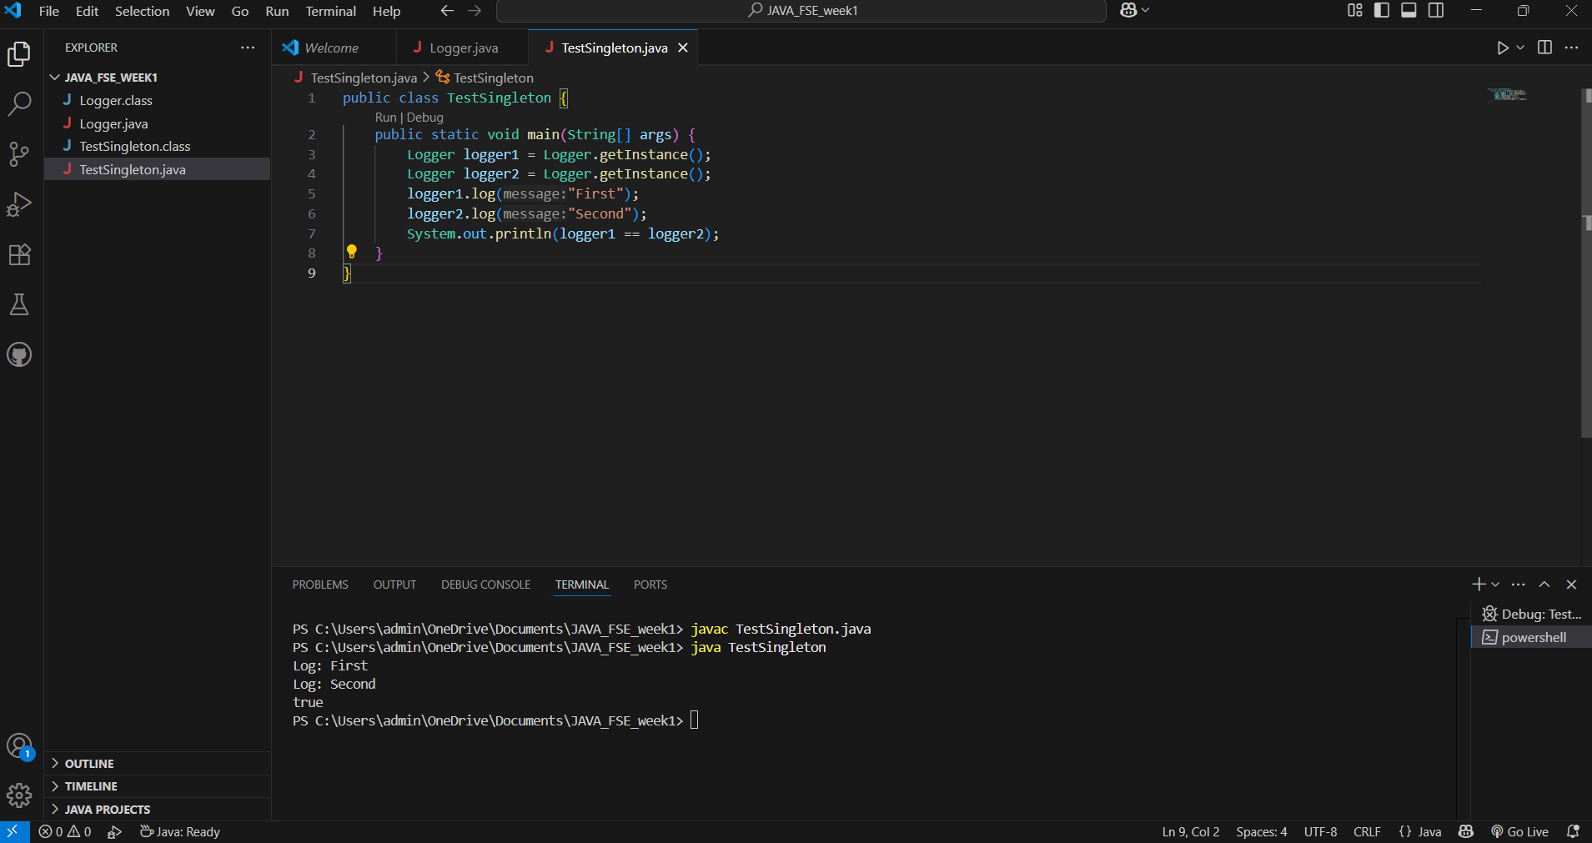

**Exercise 2: Implementing the Factory Method Pattern**

TestFactory.java:

interface Document {

    void open();

}

class WordDocument implements Document {

    public void open() {

        System.out.println("Opening Word Document");

    }

}

class PdfDocument implements Document {

    public void open() {

        System.out.println("Opening PDF Document");

    }

}

class ExcelDocument implements Document {

    public void open() {

        System.out.println("Opening Excel Document");

    }

}

abstract class DocumentFactory {

    abstract Document createDocument();

}

class WordFactory extends DocumentFactory {

    public Document createDocument() {

        return new WordDocument();

    }

}

class PdfFactory extends DocumentFactory {

    public Document createDocument() {

        return new PdfDocument();

    }

}

class ExcelFactory extends DocumentFactory {

    public Document createDocument() {

        return new ExcelDocument();

    }

}

public class TestFactory {

    public static void main(String[] args) {

        DocumentFactory wordFactory = new WordFactory();

        Document wordDoc = wordFactory.createDocument();

        wordDoc.open();

        DocumentFactory pdfFactory = new PdfFactory();

        Document pdfDoc = pdfFactory.createDocument();

        pdfDoc.open();

        DocumentFactory excelFactory = new ExcelFactory();

        Document excelDoc = excelFactory.createDocument();

        excelDoc.open();

    }

}

