**JAVA FSE WEEK 2**

**PLSQL**

**Mandatory Hands-On Exercises**

**Exercise 1: Control Structures**

**Solution:**

**Step 1- Creating the Customers and Loans table:**

CREATE TABLE customers (

customer_id NUMBER PRIMARY KEY,

name VARCHAR2(50),

age NUMBER,

balance NUMBER,

is_vip VARCHAR2(5)

);

CREATE TABLE loans (

loan_id NUMBER PRIMARY KEY,

customer_id NUMBER REFERENCES customers(customer_id),

interest_rate NUMBER(5,2),

due_date DATE

);

**Step 2 : Inserting Rows :**

* Inserting into Customers:

INSERT INTO customers VALUES (1, 'Alice', 65, 15000, 'FALSE');

INSERT INTO customers VALUES (2, 'Bob', 45, 8000, 'FALSE');

INSERT INTO customers VALUES (3, 'Charlie', 70, 12000, 'FALSE');

INSERT INTO customers VALUES (4, 'Diana', 35, 10500, 'FALSE');

* Inserting into Loans:

INSERT INTO loans VALUES (101, 1, 7.5, SYSDATE + 10); -- Due soon

INSERT INTO loans VALUES (102, 2, 8.0, SYSDATE + 40); -- Not due soon

INSERT INTO loans VALUES (103, 3, 6.5, SYSDATE + 25); -- Due soon

INSERT INTO loans VALUES (104, 4, 7.0, SYSDATE + 5); -- Due very soon

**Senario1: Applying 1% Discount to Interest for Customers Over 60 :**

BEGIN

FOR cust_rec IN (SELECT customer_id FROM customers WHERE age > 60) LOOP

UPDATE loans

SET interest_rate = interest_rate - 1

WHERE customer_id = cust_rec.customer_id;

END LOOP;

COMMIT;

END;

**OUTPUT:**

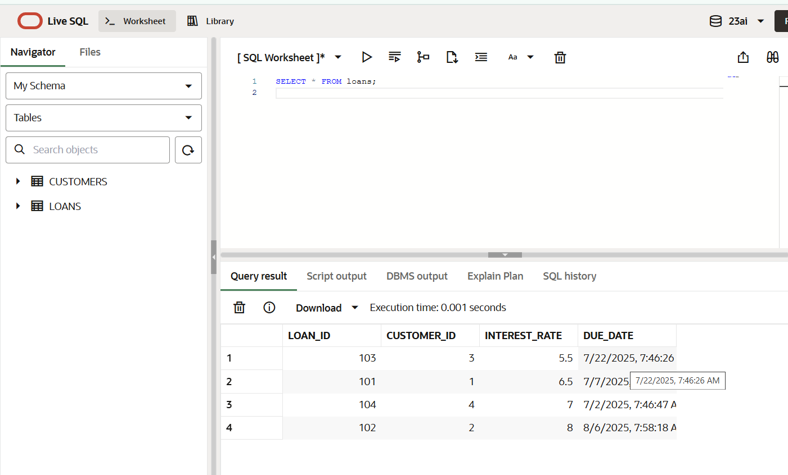**Scenario 2:** A customer can be promoted to VIP status based on their balance.

BEGIN

FOR cust_rec IN (

SELECT customer_id FROM customers WHERE balance > 10000

) LOOP

UPDATE customers

SET is_vip = 'TRUE'

WHERE customer_id = cust_rec.customer_id;

END LOOP;

COMMIT;

END;

**Output:**

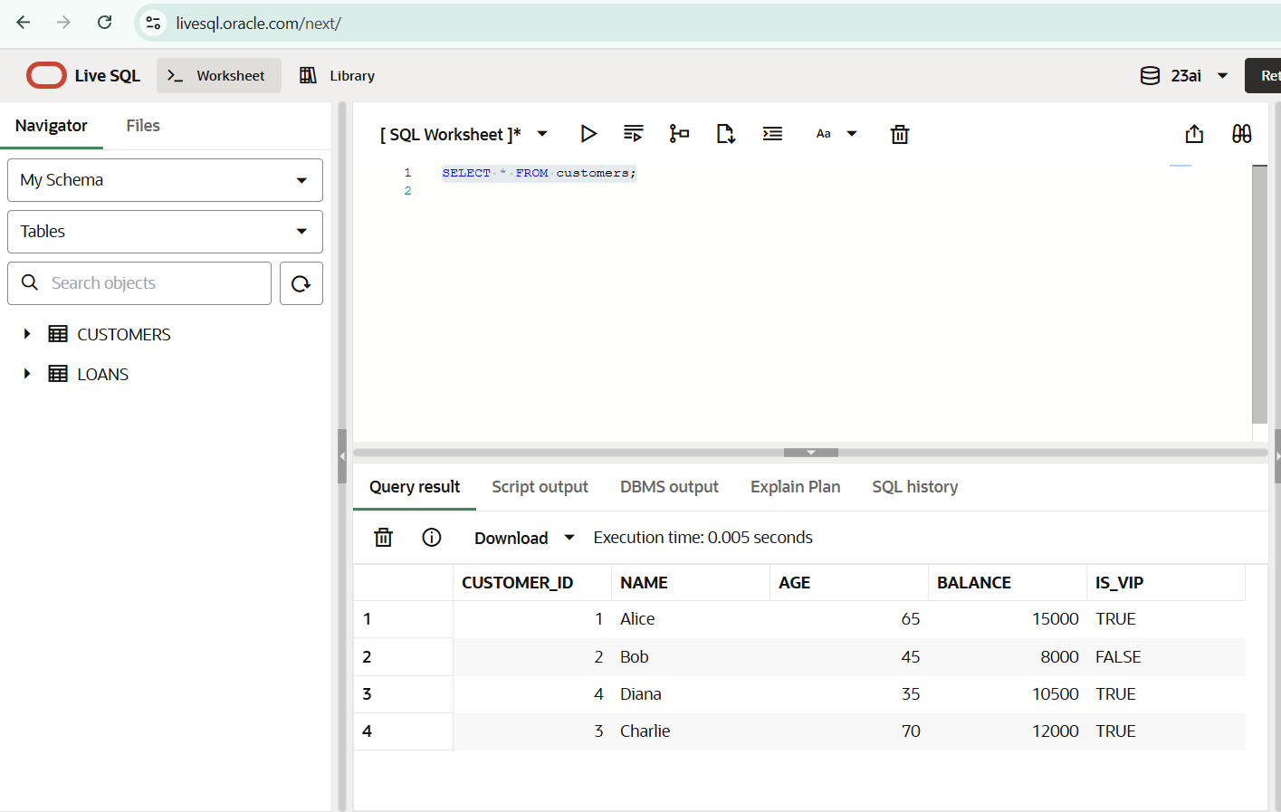

**Scenario 3:** The bank wants to send reminders to customers whose loans are due within the next 30 days.

SET SERVEROUTPUT ON;

BEGIN

FOR loan_rec IN (

SELECT loan_id, customer_id, due_date

FROM loans

WHERE due_date <= SYSDATE + 30

) LOOP

DECLARE

v_name VARCHAR2(50);

BEGIN

SELECT name INTO v_name

FROM customers

WHERE customer_id = loan_rec.customer_id;

DBMS_OUTPUT.PUT_LINE('Reminder: Dear ' || v_name ||

', your loan (ID: ' || loan_rec.loan_id ||

') is due on ' || TO_CHAR(loan_rec.due_date, 'DD-MON-YYYY'));

END;

END LOOP;

END;

**Output:**

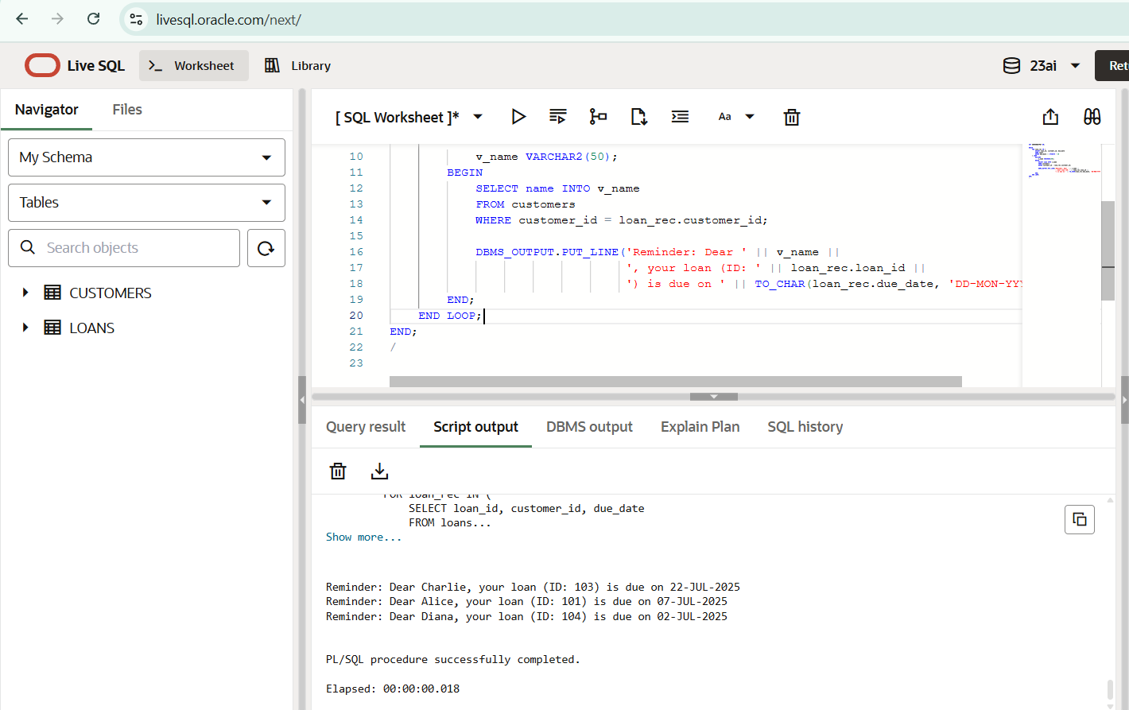

**Exercise 3: Stored Procedures**

**Solution :**

**Step 1: Create Tables:**

CREATE TABLE accounts (

account_id NUMBER PRIMARY KEY,

customer_id NUMBER,

account_type VARCHAR2(20),

balance NUMBER

);

CREATE TABLE employees (

emp_id NUMBER PRIMARY KEY,

name VARCHAR2(50),

department_id NUMBER,

salary NUMBER

);

**Step 2: Inserting rows :**

-- Insert accounts

INSERT INTO accounts VALUES (101, 1, 'savings', 10000);

INSERT INTO accounts VALUES (102, 2, 'savings', 8000);

INSERT INTO accounts VALUES (103, 3, 'current', 5000);

-- Insert employees

INSERT INTO employees VALUES (1, 'Alice', 101, 50000);

INSERT INTO employees VALUES (2, 'Bob', 102, 60000);

INSERT INTO employees VALUES (3, 'Charlie', 101, 55000);

**Senario 1: Applying 1% interest to all Savings accounts:**

CREATE OR REPLACE PROCEDURE ProcessMonthlyInterest IS

BEGIN

UPDATE accounts

SET balance = balance + (balance * 0.01)

WHERE account_type = 'savings';

COMMIT;

END;

EXEC ProcessMonthlyInterest;

**Output:**

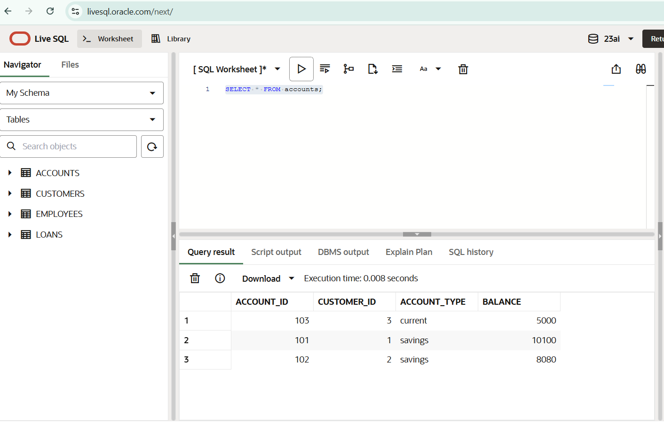

**Scenario 2:** The bank wants to implement a bonus scheme for employees based on their performance.

CREATE OR REPLACE PROCEDURE UpdateEmployeeBonus (

p_dept_id IN NUMBER,

p_bonus_pct IN NUMBER -- e.g. pass 0.10 for 10%

) IS

BEGIN

UPDATE employees

SET salary = salary + (salary * p_bonus_pct)

WHERE department_id = p_dept_id;

COMMIT;

END;

EXEC UpdateEmployeeBonus(101, 0.10);

**Output :**

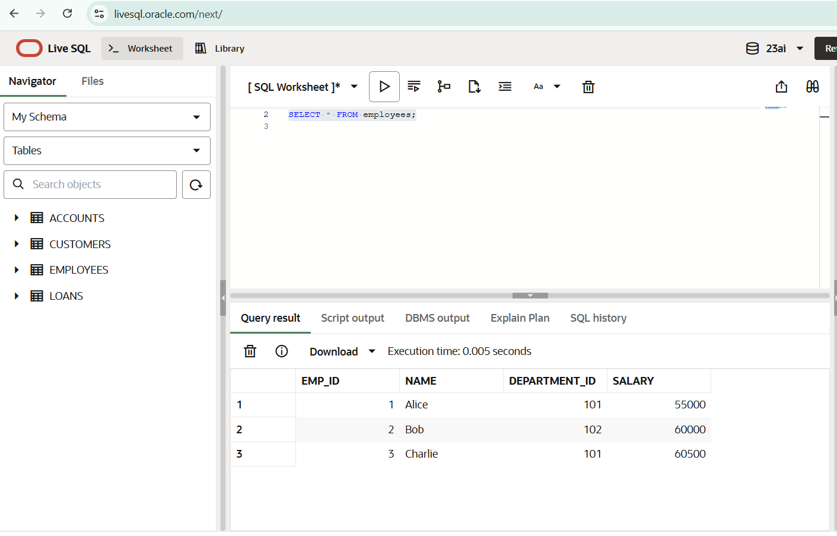

**Scenario 3:** Customers should be able to transfer funds between their accounts.

CREATE OR REPLACE PROCEDURE TransferFunds (

p_from_account IN NUMBER,

p_to_account IN NUMBER,

p_amount IN NUMBER

) IS

v_balance NUMBER;

BEGIN

-- Check if source account has enough balance

SELECT balance INTO v_balance

FROM accounts

WHERE account_id = p_from_account;

IF v_balance < p_amount THEN

RAISE_APPLICATION_ERROR(-20001, 'Insufficient balance in source account.');

END IF;

-- Deduct from source account

UPDATE accounts

SET balance = balance - p_amount

WHERE account_id = p_from_account;

-- Add to destination account

UPDATE accounts

SET balance = balance + p_amount

WHERE account_id = p_to_account;

COMMIT;

END;

EXEC TransferFunds(101, 102, 1000);

**Output:**

