**JAVA FSE WEEK 3**

**Spring Core Maven**

**Mandatory Hands-on Excercises**

**Exercise 1: Configuring a Basic Spring Application**

**Scenario:**

Your company is developing a web application for managing a library. You need to use the Spring Framework to handle the backend operations.

**Step 1: Set Up a Spring Project**

**pom.xml:**

<dependencies>

<!-- Spring Core Context -->

<dependency>

<groupId>org.springframework</groupId>

<artifactId>spring-context</artifactId>

<version>5.3.34</version>

</dependency>

</dependencies>

**Step 2: Configure the Application Context**

**applicationContext.xml:**

<?xml version="1.0" encoding="UTF-8"?>

<beans xmlns="http://www.springframework.org/schema/beans"

xmlns:xsi="http://www.w3.org/2001/XMLSchema-instance"

xsi:schemaLocation="

http://www.springframework.org/schema/beans

http://www.springframework.org/schema/beans/spring-beans.xsd">

<bean id="bookRepository" class="com.library.repository.BookRepository"/>

<bean id="bookService" class="com.library.service.BookService">

<property name="bookRepository" ref="bookRepository"/>

</bean>

</beans>

**Step 3: Define Service and Repository Classes**

**BookRepository.java:**

package com.library.repository;

public class BookRepository {

public void saveBook(String bookName) {

System.out.println("Book saved: " + bookName);

}

}

**BookService.java:**

package com.library.service;

import com.library.repository.BookRepository;

public class BookService {

private BookRepository bookRepository;

public void setBookRepository(BookRepository bookRepository) {

this.bookRepository = bookRepository;

}

public void addBook(String name) {

bookRepository.saveBook(name);

}

}

**Step 4: Run the Application**

**LibraryManagementApplication.java:**

package com.library;

import com.library.service.BookService;

import org.springframework.context.support.ClassPathXmlApplicationContext;

public class LibraryManagementApplication {

public static void main(String[] args) {

ClassPathXmlApplicationContext context = new ClassPathXmlApplicationContext("applicationContext.xml");

BookService bookService = context.getBean("bookService", BookService.class);

bookService.addBook("Spring in Action");

context.close();

}

}

**Output:**

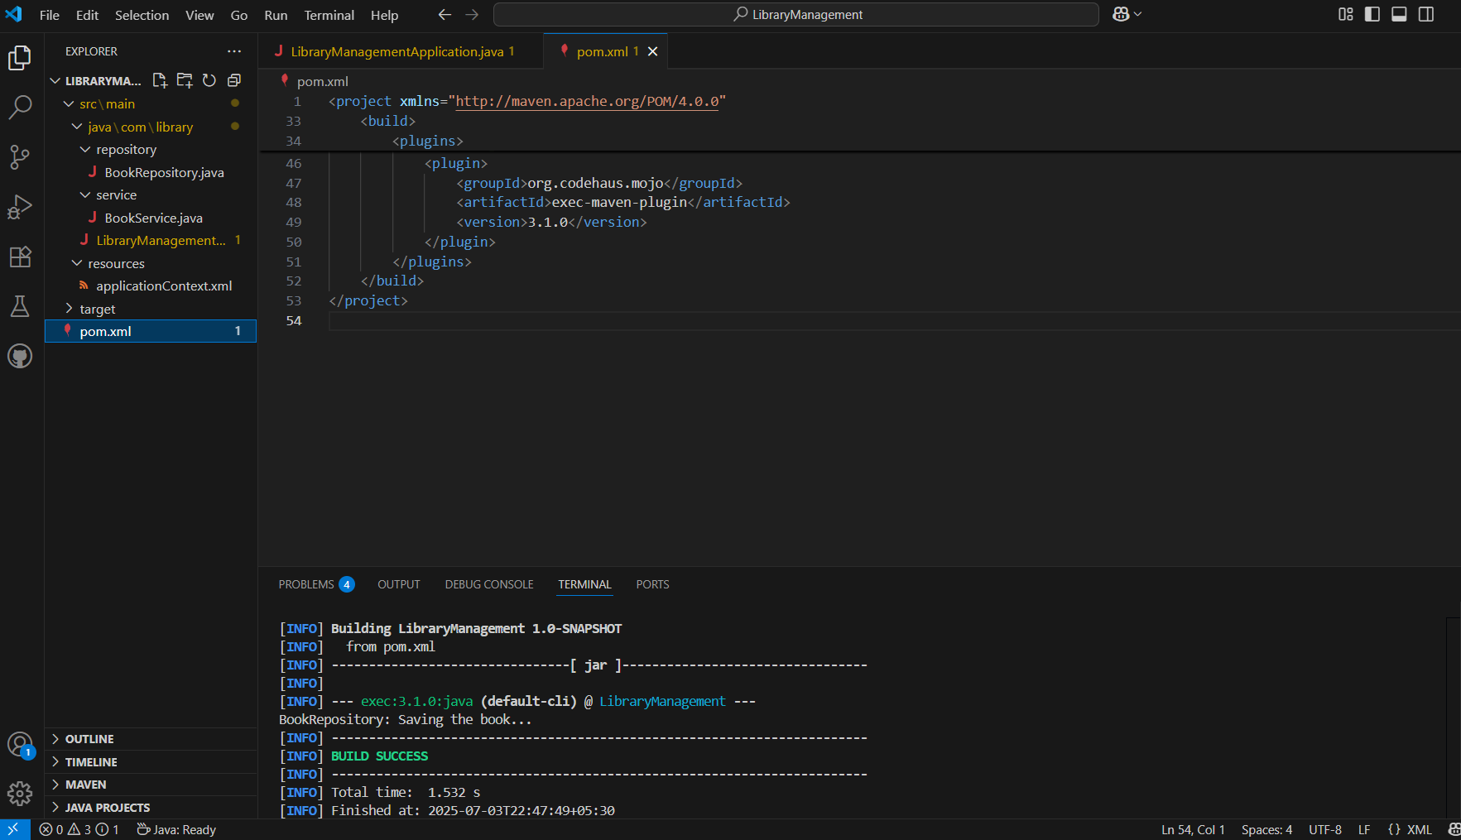

**Exercise 2: Implementing Dependency Injection**

**Scenario:**

In the library management application, you need to manage the dependencies between the BookService and BookRepository classes using Spring's IoC and DI.

**Step 1: Modify the XML Configuration**

**applicationContext.xml:**

<?xml version="1.0" encoding="UTF-8"?>

<beans xmlns="http://www.springframework.org/schema/beans"

xmlns:xsi="http://www.w3.org/2001/XMLSchema-instance"

xsi:schemaLocation="http://www.springframework.org/schema/beans

http://www.springframework.org/schema/beans/spring-beans.xsd">

<!-- Define BookRepository bean -->

<bean id="bookRepository" class="com.library.repository.BookRepository" />

<!-- Define BookService bean and inject dependency -->

<bean id="bookService" class="com.library.service.BookService">

<property name="bookRepository" ref="bookRepository"/>

</bean>

</beans>

**Step 2: Update the BookService Class**

**BookService.java:**

package com.library.service;

import com.library.repository.BookRepository;

public class BookService {

private BookRepository bookRepository;

// Setter-based Dependency Injection

public void setBookRepository(BookRepository bookRepository) {

this.bookRepository = bookRepository;

}

public void saveBook() {

bookRepository.save();

}

}

**Step 3: Main Class to Test**

**LibraryManagementApplication.java**

package com.library;

import org.springframework.context.ApplicationContext;

import org.springframework.context.support.ClassPathXmlApplicationContext;

import com.library.service.BookService;

public class LibraryManagementApplication {

public static void main(String[] args) {

ApplicationContext context = new ClassPathXmlApplicationContext("applicationContext.xml");

BookService bookService = context.getBean("bookService", BookService.class);

bookService.saveBook();

}

}

**Output:**

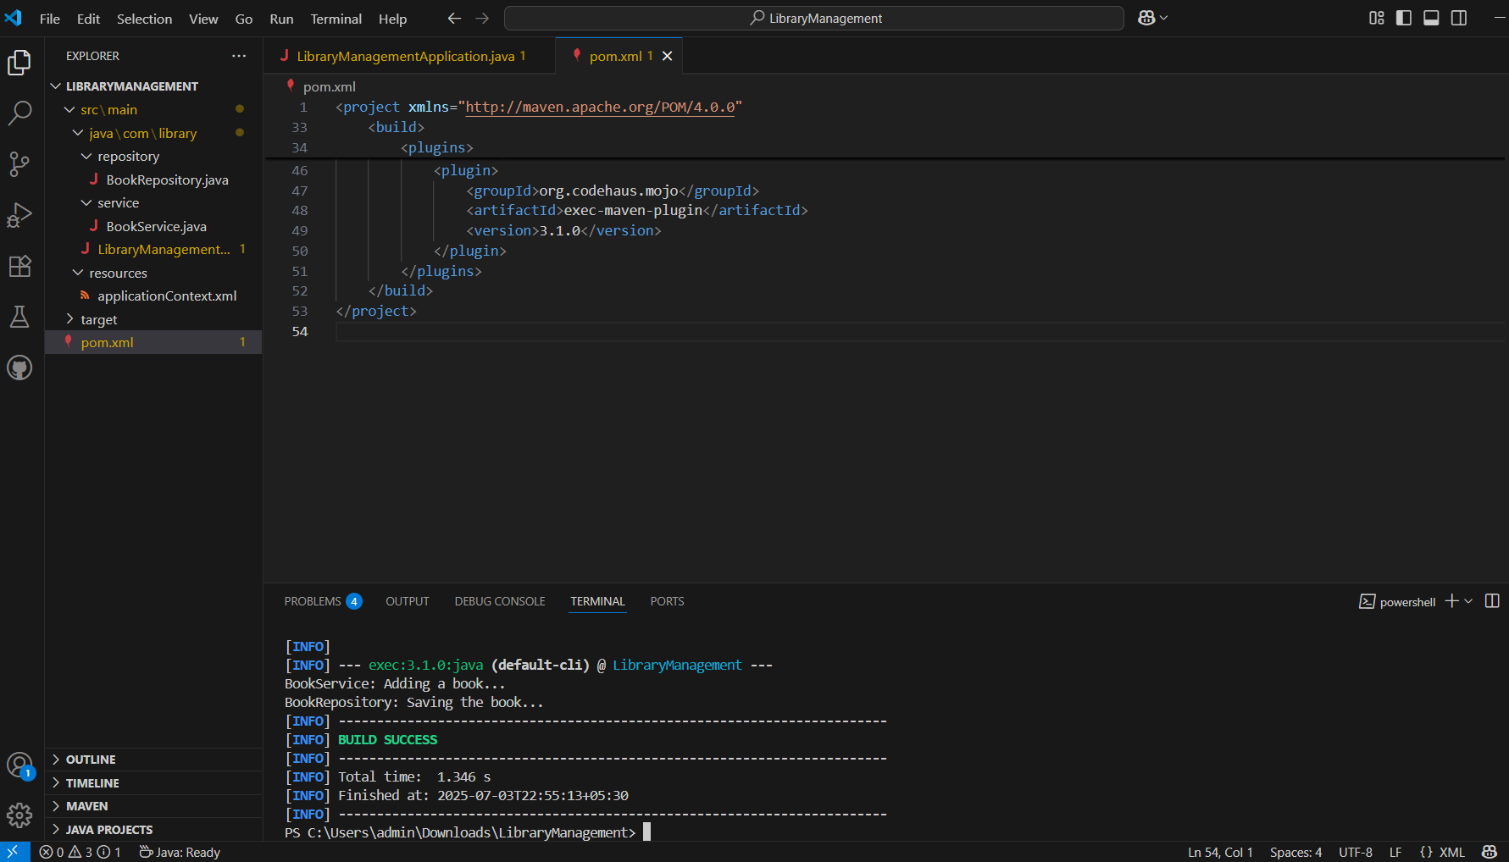

**Exercise 4: Creating and Configuring a Maven Project**

**Scenario:**

You need to set up a new Maven project for the library management application and add Spring dependencies.

**Step 1: Create a New Maven Project**

created a Maven project named **LibraryManagement**

**Step 2: Add Spring Dependencies to pom.xml**

<dependencies>

<!-- Spring Core Context -->

<dependency>

<groupId>org.springframework</groupId>

<artifactId>spring-context</artifactId>

<version>5.3.34</version>

</dependency>

<!-- Spring AOP -->

<dependency>

<groupId>org.springframework</groupId>

<artifactId>spring-aop</artifactId>

<version>5.3.34</version>

</dependency>

<!-- Spring Web MVC -->

<dependency>

<groupId>org.springframework</groupId>

<artifactId>spring-webmvc</artifactId>

<version>5.3.34</version>

</dependency>

</dependencies>

**Step 3: Configure Maven Compiler Plugin**

**pom.xml: (added)**

<build>

<plugins>

<!-- Java Compiler Plugin -->

<plugin>

<groupId>org.apache.maven.plugins</groupId>

<artifactId>maven-compiler-plugin</artifactId>

<version>3.10.1</version>

<configuration>

<source>1.8</source>

<target>1.8</target>

</configuration>

</plugin>

<!-- Plugin to run Java main class -->

<plugin>

<groupId>org.codehaus.mojo</groupId>

<artifactId>exec-maven-plugin</artifactId>

<version>3.1.0</version>

</plugin>

</plugins>

</build>

**Output:**

**Maven commands used:**

mvn compile

mvn exec:java -Dexec.mainClass=com.library.LibraryManagementApplication

**Folder structure:**

