**JAVA FSE WEEK 4**

**Spring Rest**

**Mandatory Hands-on Excercises**

**Hands on 1**

**Create a Spring Web Project using Maven**

Project Name: spring-learn  
Group ID: com.cognizant  
Artifact ID: spring-learn

**Pom.xml:**

<project xmlns="http://maven.apache.org/POM/4.0.0"

xmlns:xsi="http://www.w3.org/2001/XMLSchema-instance"

xsi:schemaLocation="http://maven.apache.org/POM/4.0.0

http://maven.apache.org/xsd/maven-4.0.0.xsd">

<modelVersion>4.0.0</modelVersion>

<groupId>com.cognizant</groupId>

<artifactId>spring-learn</artifactId>

<version>0.0.1-SNAPSHOT</version>

<name>spring-learn</name>

<description>Spring Learn Hands-on 1</description>

<parent>

<groupId>org.springframework.boot</groupId>

<artifactId>spring-boot-starter-parent</artifactId>

<version>2.7.0</version>

<relativePath/>

</parent>

<dependencies>

<dependency>

<groupId>org.springframework.boot</groupId>

<artifactId>spring-boot-starter-web</artifactId>

</dependency>

<dependency>

<groupId>org.springframework.boot</groupId>

<artifactId>spring-boot-devtools</artifactId>

<scope>runtime</scope>

</dependency>

</dependencies>

</project>

**SpringLearnApplication.java:**

package com.cognizant.springlearn;

import org.slf4j.Logger;

import org.slf4j.LoggerFactory;

import org.springframework.boot.SpringApplication;

import org.springframework.boot.autoconfigure.SpringBootApplication;

@SpringBootApplication

public class SpringLearnApplication {

private static final Logger LOGGER = LoggerFactory.getLogger(SpringLearnApplication.class);

public static void main(String[] args) {

LOGGER.info("START");

SpringApplication.run(SpringLearnApplication.class, args);

LOGGER.info("END");

}

}

**File structure:**

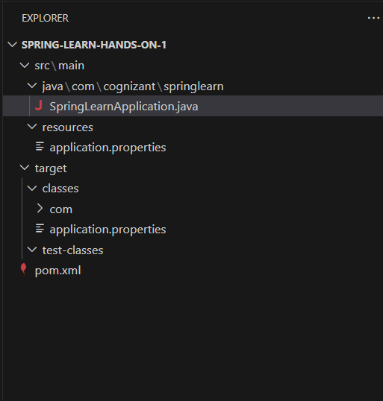

**OUTPUT:**

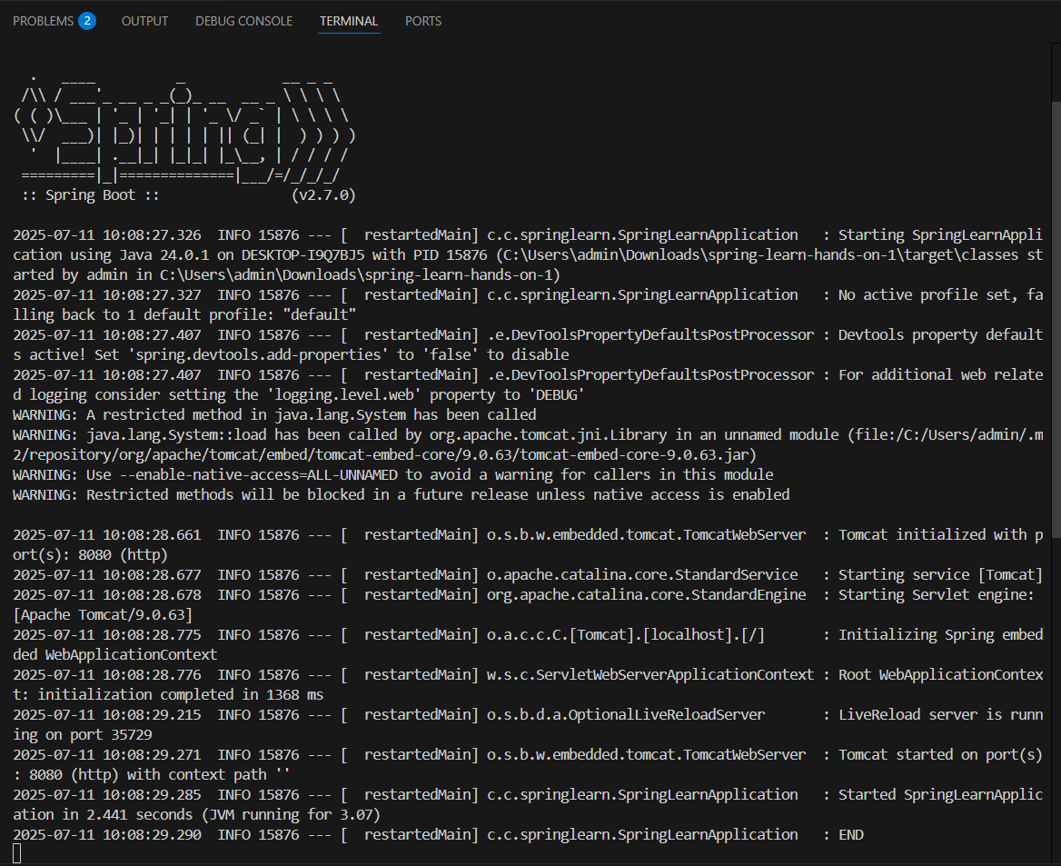

**Hands on 4**

**Spring Core – Load Country from Spring Configuration XML**

**Country.java:**

package com.cognizant.springlearn;

import org.slf4j.Logger;

import org.slf4j.LoggerFactory;

public class Country {

private static final Logger LOGGER = LoggerFactory.getLogger(Country.class);

private String code;

private String name;

public Country() {

LOGGER.debug("Inside Country Constructor.");

}

public String getCode() {

LOGGER.debug("Inside getCode()");

return code;

}

public void setCode(String code) {

LOGGER.debug("Inside setCode()");

this.code = code;

}

public String getName() {

LOGGER.debug("Inside getName()");

return name;

}

public void setName(String name) {

LOGGER.debug("Inside setName()");

this.name = name;

}

@Override

public String toString() {

return "Country [code=" + code + ", name=" + name + "]";

}

}

**Country.xml:**

<?xml version="1.0" encoding="UTF-8"?>

<beans xmlns="http://www.springframework.org/schema/beans"

xmlns:xsi="http://www.w3.org/2001/XMLSchema-instance"

xsi:schemaLocation="http://www.springframework.org/schema/beans

http://www.springframework.org/schema/beans/spring-beans.xsd">

<bean id="country" class="com.cognizant.springlearn.Country">

<property name="code" value="IN"/>

<property name="name" value="India"/>

</bean>

</beans>

**SpringLearnApplication.java:**

package com.cognizant.springlearn;

import org.slf4j.Logger;

import org.slf4j.LoggerFactory;

import org.springframework.boot.SpringApplication;

import org.springframework.boot.autoconfigure.SpringBootApplication;

import org.springframework.context.ApplicationContext;

import org.springframework.context.support.ClassPathXmlApplicationContext;

@SpringBootApplication

public class SpringLearnApplication {

private static final Logger LOGGER = LoggerFactory.getLogger(SpringLearnApplication.class);

public static void main(String[] args) {

LOGGER.info("START");

SpringApplication.run(SpringLearnApplication.class, args);

displayCountry();

LOGGER.info("END");

}

public static void displayCountry() {

ApplicationContext context = new ClassPathXmlApplicationContext("country.xml");

Country country = context.getBean("country", Country.class);

LOGGER.debug("Country : {}", country.toString());

}

}

**OUTPUT:**

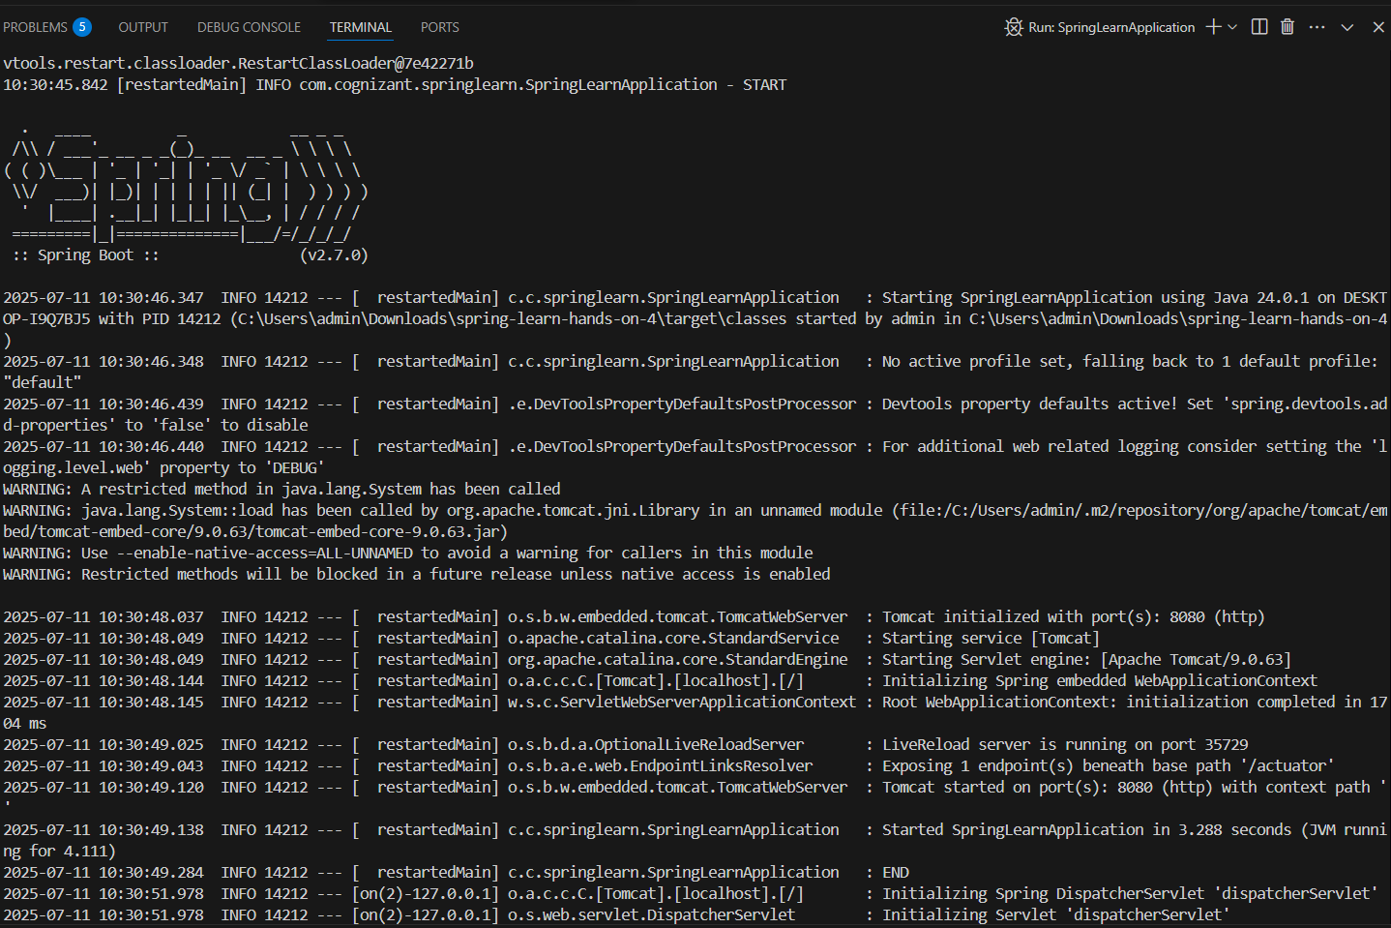

**1. Hello World RESTful Web Service**

**Objective:**

Create a RESTful GET endpoint /hello that returns the plain text "Hello World!!" using Spring Web.

**Controller: HelloController.java**

package com.cognizant.springlearn.controller;

import org.slf4j.Logger;

import org.slf4j.LoggerFactory;

import org.springframework.web.bind.annotation.GetMapping;

import org.springframework.web.bind.annotation.RestController;

@RestController

public class HelloController {

private static final Logger LOGGER = LoggerFactory.getLogger(HelloController.class);

@GetMapping("/hello")

public String sayHello() {

LOGGER.info("START");

LOGGER.info("END");

return "Hello World!!";

}

}

**OUTPUT:**

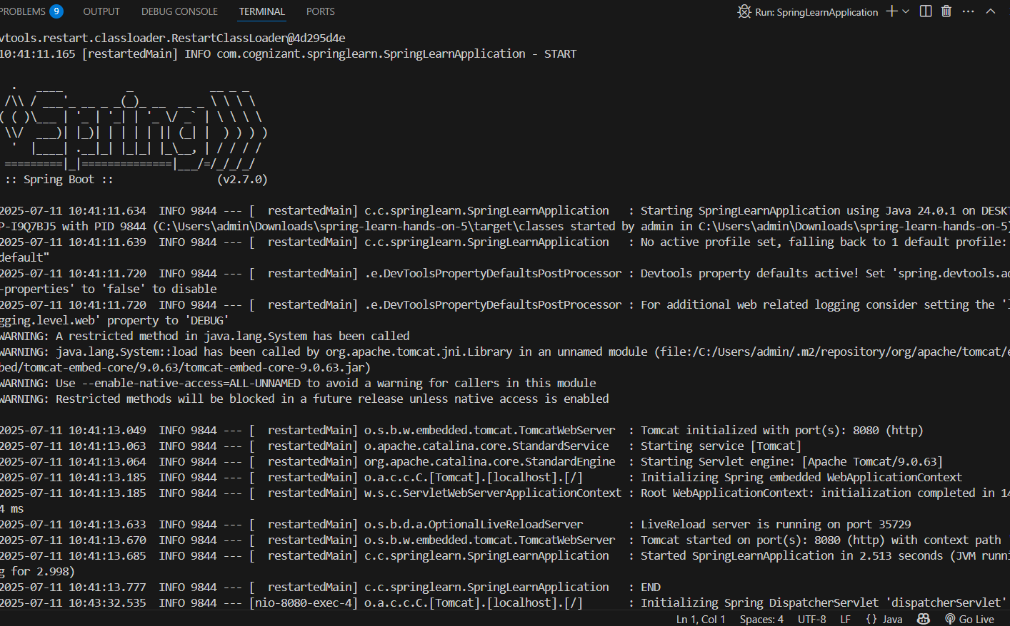

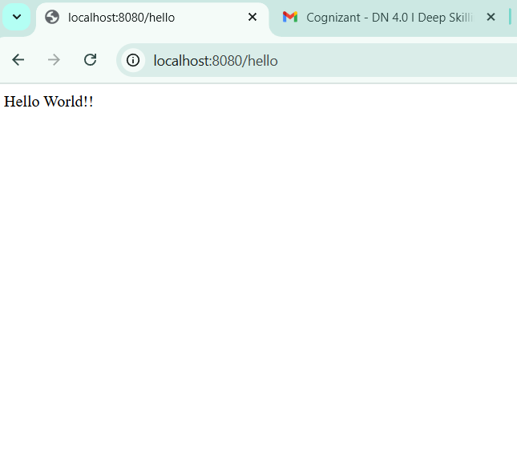

**2.REST - Country Web Service**

**Objective:**

**Build a REST service that returns India country details in the earlier created spring-learn application.**

* URL: <http://localhost:8083/country>
* Controller Class: com.cognizant.springlearn.controller.CountryController
* Method Annotation: @RequestMapping
* Method Name: getCountryIndia()
* Bean Source: Loaded from country.xml using ClassPathXmlApplicationContext
* Server Port: 8083
* Response Format: JSON

**SpringLearnApplication.java:**

@SpringBootApplication

public class SpringLearnApplication {

public static void main(String[] args) {

SpringApplication.run(SpringLearnApplication.class, args);

}

}

**CountryController.java:**

@RestController

public class CountryController {

@RequestMapping("/country")

public Country getCountryIndia() {

ApplicationContext context = new ClassPathXmlApplicationContext("country.xml");

return context.getBean("country", Country.class);

}

}

**country.xml**

<beans xmlns="http://www.springframework.org/schema/beans"

xmlns:xsi="http://www.w3.org/2001/XMLSchema-instance"

xsi:schemaLocation="http://www.springframework.org/schema/beans

http://www.springframework.org/schema/beans/spring-beans.xsd">

<bean id="country" class="com.cognizant.springlearn.model.Country">

<property name="code" value="IN"/>

<property name="name" value="India"/>

</bean>

</beans>

**OUTPUT:**

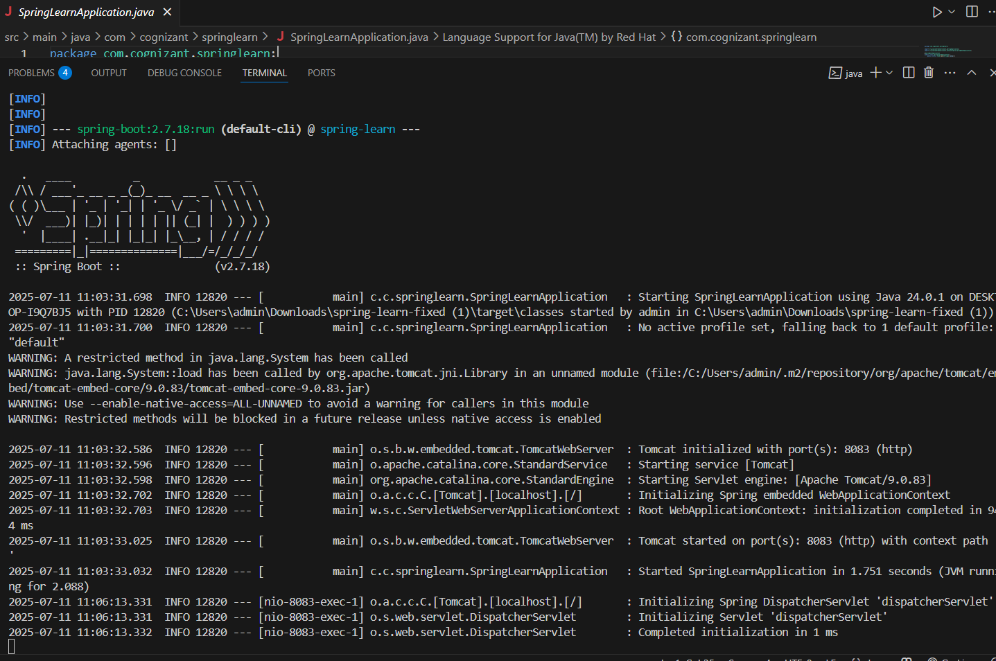

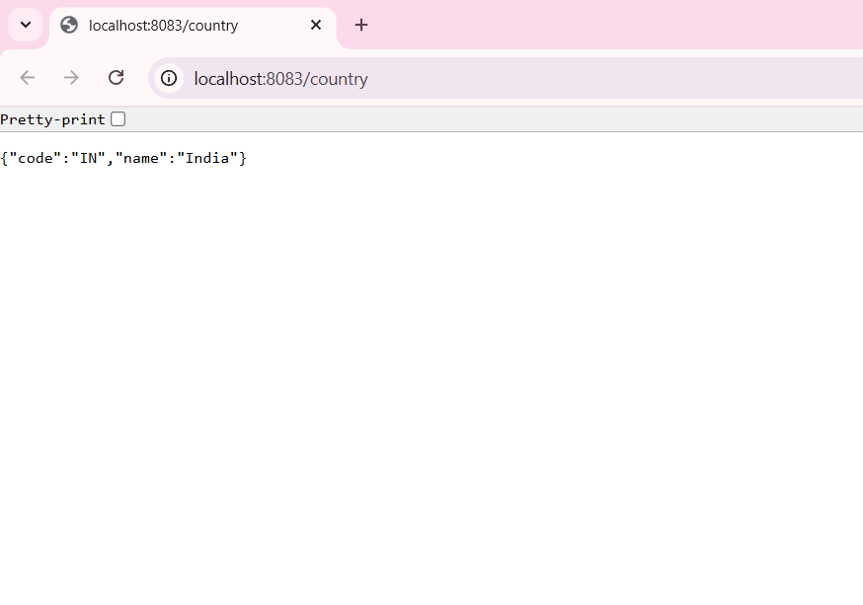

**3.REST - Get Country Based on Country Code**

**Objective**

**Build a REST service that returns a specific country based on the given country code (case-insensitive).**

* URL: Visit: <http://localhost:8083/countries/in>
* Controller Class: com.cognizant.springlearn.controller.CountryController
* Method Annotation: @GetMapping("/countries/{code}")
* Method Name: getCountry(String code)
* Service Method: com.cognizant.springlearn.service.CountryService.getCountry(String code)
* Bean Source: Loaded from country.xml using ClassPathXmlApplicationContext
* Server Port: 8083
* Response Format: JSON

**SpringLearnApplication.java:**

@SpringBootApplication

public class SpringLearnApplication {

public static void main(String[] args) {

SpringApplication.run(SpringLearnApplication.class, args);

}

}

CountryController.java

@RestController

public class CountryController {

@Autowired

private CountryService countryService;

@GetMapping("/countries/{code}")

public Country getCountry(@PathVariable String code) {

return countryService.getCountry(code);

}

}

**CountryService.java**

@Service

public class CountryService {

public Country getCountry(String code) {

ApplicationContext context = new ClassPathXmlApplicationContext("country.xml");

List<Country> countries = context.getBean("countryList", List.class);

return countries.stream()

.filter(c -> c.getCode().equalsIgnoreCase(code))

.findFirst()

.orElse(null);

}

}

**country.xml**

<beans xmlns="http://www.springframework.org/schema/beans"

xmlns:xsi="http://www.w3.org/2001/XMLSchema-instance"

xsi:schemaLocation="http://www.springframework.org/schema/beans

http://www.springframework.org/schema/beans/spring-beans.xsd">

<bean id="countryList" class="java.util.ArrayList">

<constructor-arg>

<list>

<bean class="com.cognizant.springlearn.model.Country">

<property name="code" value="IN"/>

<property name="name" value="India"/>

</bean>

<bean class="com.cognizant.springlearn.model.Country">

<property name="code" value="US"/>

<property name="name" value="United States"/>

</bean>

<bean class="com.cognizant.springlearn.model.Country">

<property name="code" value="CN"/>

<property name="name" value="China"/>

</bean>

</list>

</constructor-arg>

</bean>

</beans>

**OUTPUT:**