**JAVA FSE WEEK 8**

**GIT-HOL**

**Mandatory Hands-on Excercises**

**Hands-on 1 – Git Basics  
Objective:**  
Familiar with Git commands like git init, git status, git add, git commit, git push, and git pull.

**Step 1 – Verify Git Installation**

Command:  
 git --version  
  
 Output:  
 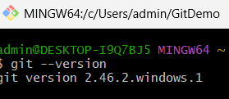  
**Step 2 – Configure Git**

Command:  
 git config --global user.name "studentnewbie"  
 git config --global user.email "shivanivuyyala@gmail.com"  
 git config --list  
  
Output:

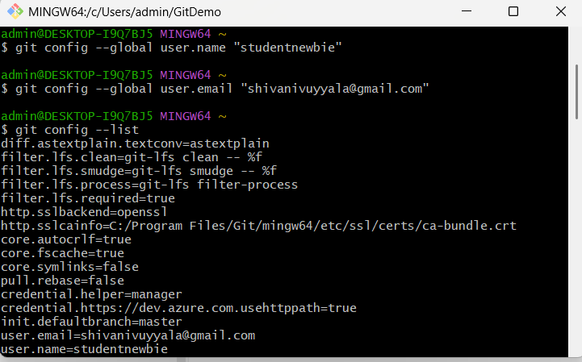  
**Step 3 – Set Notepad as Default Git Editor**

Command:  
 git config --global core.editor "notepad"  
 git config --global -e  
  
Output:  
 Opens Git config in Windows Notepad.  
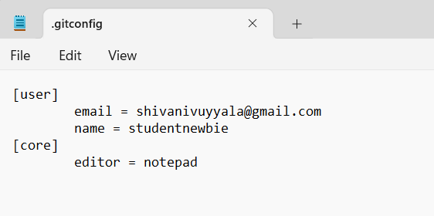

**Step 4 – Create Local Repository**

Command:  
 mkdir GitDemo  
 cd GitDemo  
 git init  
  
Output:  
 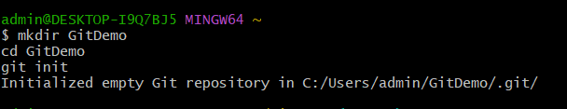

**Step 5 – Create and View File**

Command:  
 echo "Welcome to Git Demo" > welcome.txt  
 cat welcome.txt

**Step 6 – Stage and Commit File**

Command:  
 git status  
 git add welcome.txt  
 git commit -m "Added welcome.txt file"  
 git status  
  
Output:  
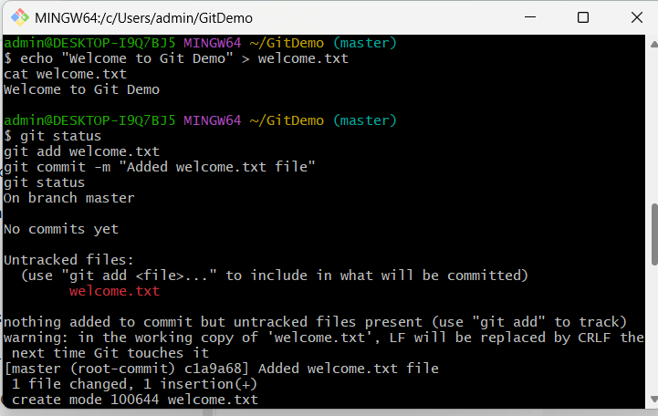

**Step 7 – Link Local Repo to GitHub**

Command:  
 git remote add origin https://github.com/studentnewbie/GitDemo.git

**Step 8 – Push to GitHub**

Command:  
 git branch -M master  
 git push -u origin master  
  
Output:  
 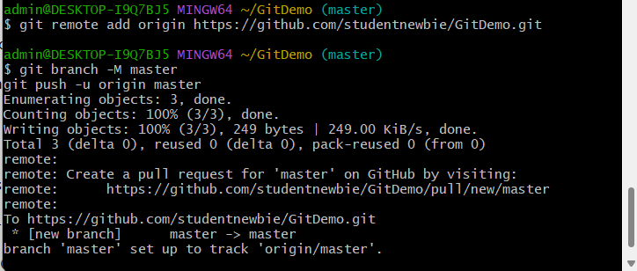

**Step 9 – Verify on GitHub**

Action:  
 Open https://github.com/studentnewbie/GitDemo in your browser.  
Output:  
 