**JAVA FSE WEEK 8**

**GIT-HOL**

**Mandatory Hands-on Excercises**

# Hands-on 2 – Git Ignore

Objective:  
Explain git ignore  
Explain how to ignore unwanted files using git ignore

## Step 1 – Open Existing Git Repository

Command:  
 cd ~/GitDemo

## Step 2 – Create Files to Ignore

Command:  
 echo "This is a log file" > test.log  
 mkdir log  
 echo "Inside log folder" > log/log1.txt  
Output:

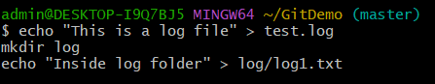

**Step 3 – Create/Edit .gitignore**

Command:  
 echo "*.log" > .gitignore  
 echo "log/" >> .gitignore  
 cat .gitignore  
Output:  
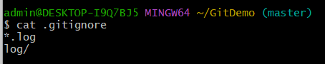

## Step 4 – Check Git Status

Command:  
 git status  
Output:

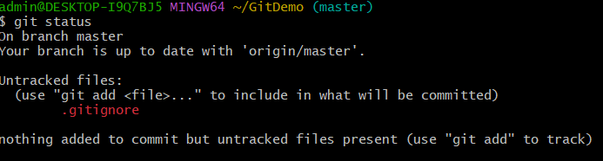

## Step 5 – Stage & Commit .gitignore

Command:  
 git add .gitignore  
 git commit -m "Added .gitignore to ignore .log files and log folder"  
**Step 6 – Push to GitHub**

Command:  
 git push  
Output:

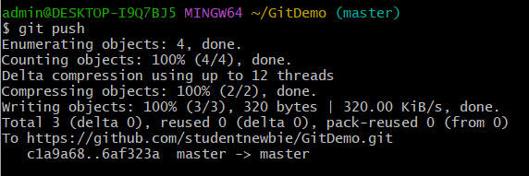

## Step 7 – Verify on GitHub

Action:  
 Open the GitHub repository page.  
Output:  
 