**JAVA FSE WEEK 8**

**GIT-HOL**

**Mandatory Hands-on Excercises**

**Hands-on 3 – Branching and Merging**

**Objective:**  
Explain branching and merging  
Explain about creating a branch request in GitLab  
Explain about creating a merge request in GitLab

**Step 1 – Open Existing Git Repository**

**Command:**  
cd ~/GitDemo

**Step 2 – Create New Branch**

**Command:**  
git checkout -b GitNewBranch  
git branch

**Output:**

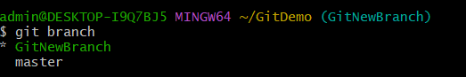

**Step 3 – Add Files to Branch**

**Command:**  
echo "This is a new branch file" > branch_file.txt  
git add branch_file.txt  
git commit -m "Added branch_file.txt in GitNewBranch"

**Output:**  
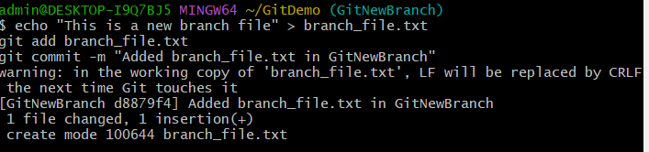

**Step 4 – Switch to Master**

**Command:**  
git checkout master

**Output:**  
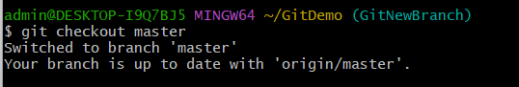

**Step 5 – See Differences**

**Command:**  
git diff GitNewBranch

**Output:**  
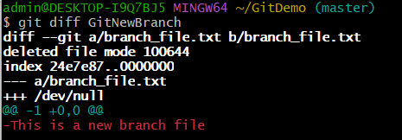

**Step 6 – Merge Branch into Master**

**Command:**  
git merge GitNewBranch

**Step 7 – View Log**

**Command:**  
git log --oneline --graph --decorate

**Step 8 – Delete Branch**

**Command:**  
git branch  
git branch -d GitNewBranch  
git branch

**Output:**  
