**JAVA FSE WEEK 8**

**GIT-HOL**

**Mandatory Hands-on Excercises**

**Hands-on 4 – Conflict Resolution**

**Objective:**  
Explain how to resolve the conflict during merge.

**Step 1 – Verify Master is in Clean State**

**Command:**  
git status

**Output:**  
Working tree clean.

**Step 2 – Create a Branch and Add File**

**Command:**  
git checkout -b GitWork  
echo "Hello from GitWork branch" > hello.xml  
git add hello.xml  
git commit -m "Added hello.xml in GitWork"

**Step 3 – Switch to Master and Add Same File with Different Content**

**Command:**  
git checkout master  
echo "Hello from master branch" > hello.xml  
git add hello.xml  
git commit -m "Added hello.xml in master with different content"

**Step 4 – View Commit Log**

**Command:**  
git log --oneline --graph --decorate --all

**Output :**

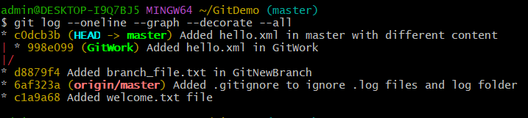

**Step 5 – Check Differences**

**Command:**  
git diff GitWork

**Output:**  
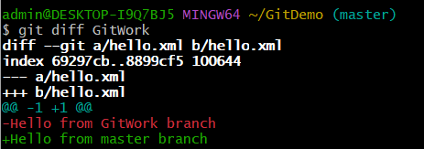

**Step 6 – Merge Branch into Master (Cause Conflict)**

**Command:**  
git merge GitWork

**Output:**  
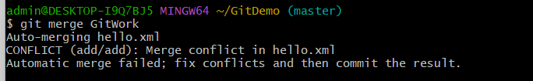

**Step 7 – Resolve Conflict**

**Action:**  
Open hello.xml in an editor, manually keep the correct content, remove conflict markers (<<<<<<<, =======, >>>>>>>).

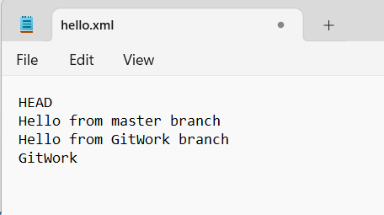  
**command:**  
git add hello.xml  
git commit -m "Resolved merge conflict in hello.xml"

cat hello.xml

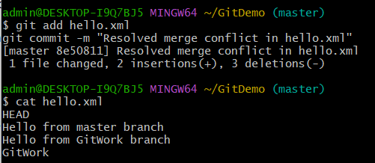

**Step 8 – Add Backup File to .gitignore (If Any)**

**Command:**  
echo "*~" >> .gitignore  
git add .gitignore  
git commit -m "Added backup file pattern to .gitignore"

**Step 9 – View Final Status**

**Command:**  
git status

**Output:**  
Working tree clean.

**Step 10 – Delete Merged Branch**

**Command:**  
git branch  
git branch -d GitWork  
git branch

**Output:**  
