**JAVA FSE WEEK 8**

**GIT-HOL**

**Mandatory Hands-on Excercises**

**Hands-on 5 – Clean Up and Push to Remote**

**Objective:**  
Explain how to clean up and push back to remote Git.

**Step 1 – Verify Master is in Clean State**

**Command:**  
git status

**Output:**  
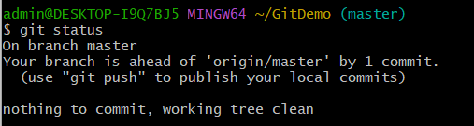

**Step 2 – List All Available Branches**

**Command:**  
git branch

**Output :**

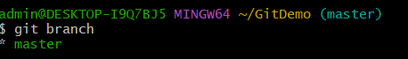

**Step 3 – Pull Latest from Remote**

**Command:**  
git pull origin master

**Output:**  
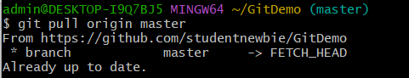

**Step 4 – Push Pending Changes**

**Command:**  
git push origin master

**Output:**  
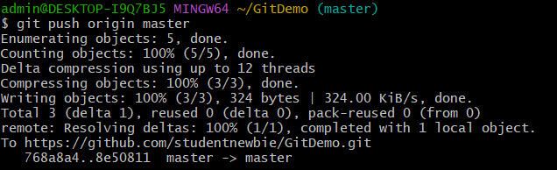

**Step 5 – Verify on GitHub**

