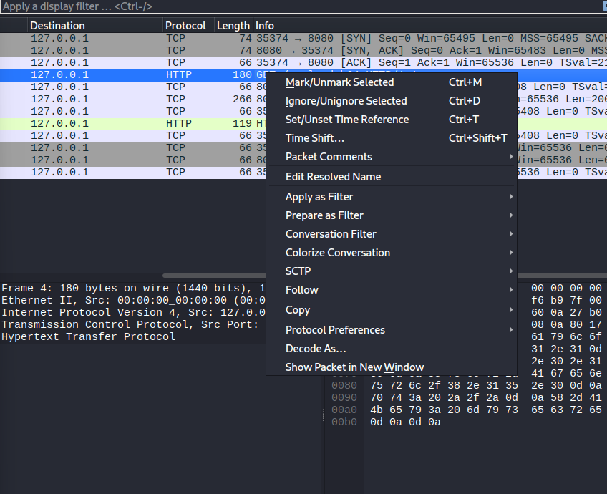

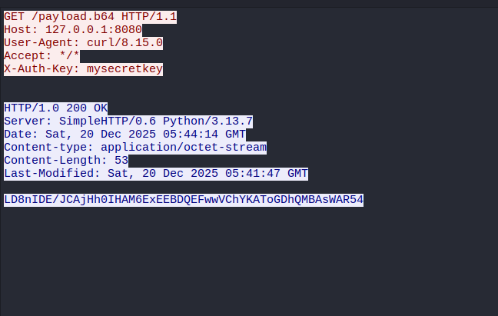

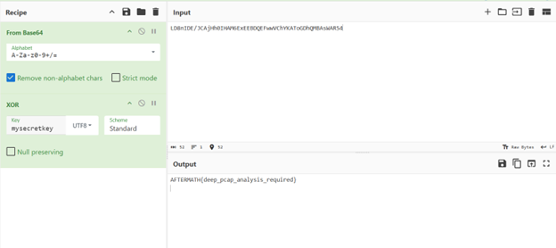

I started by scanning the Wireshark capture and immediately noticed a suspicious GET request for /payload.b64, so I right-clicked to "Follow HTTP Stream" to see what was really going on. Inside the stream, I found two critical clues: a scrambled block of text in the response body and a header explicitly named X-Auth-Key with the value mysecretkey. Realizing this was likely an XOR puzzle, I took that scrambled string to CyberChef, decoded it from Base64, and then applied the XOR function using the mysecretkey I found in the header. Once I ran that recipe, the mess of characters instantly resolved into the final flag: AFTERMATH{deep_pcap_analysis_required}.

