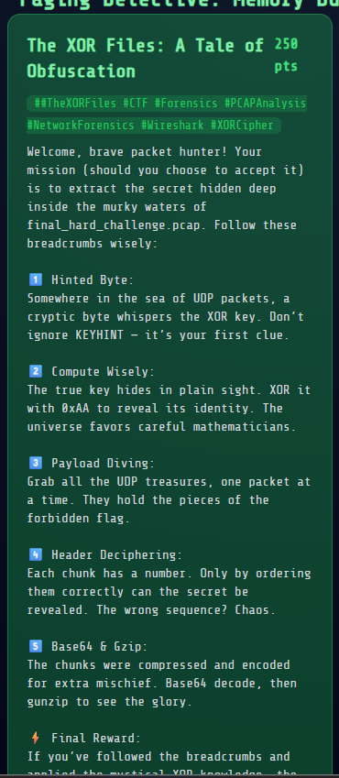

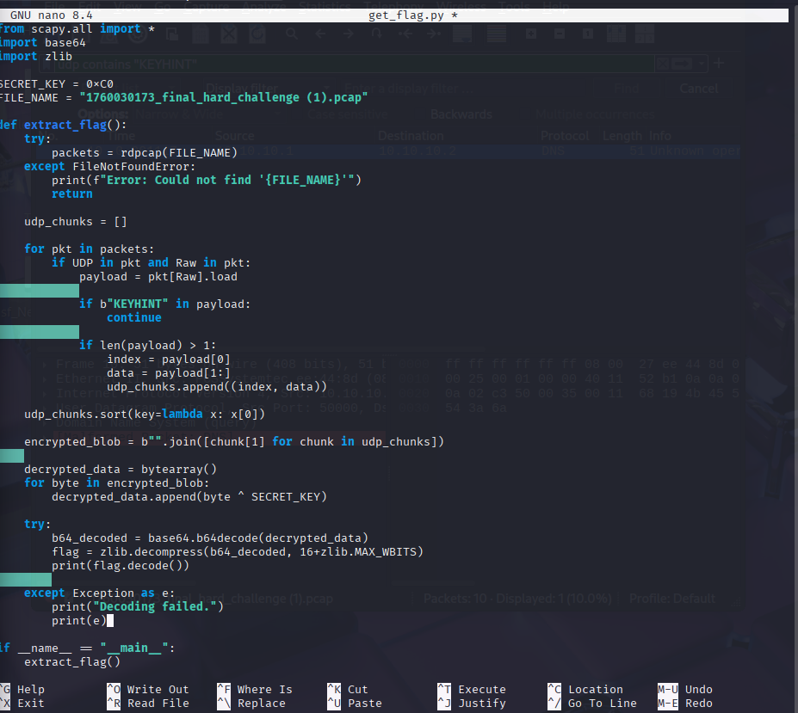

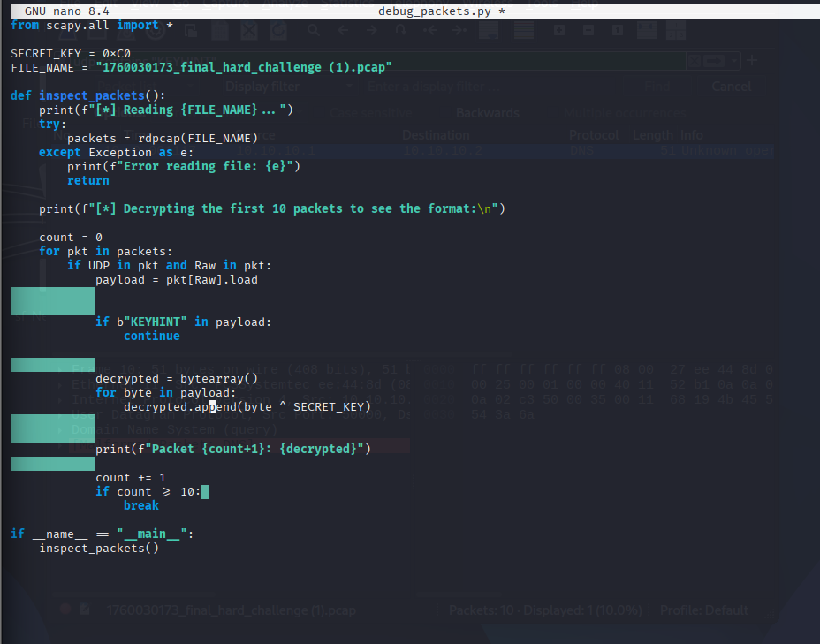

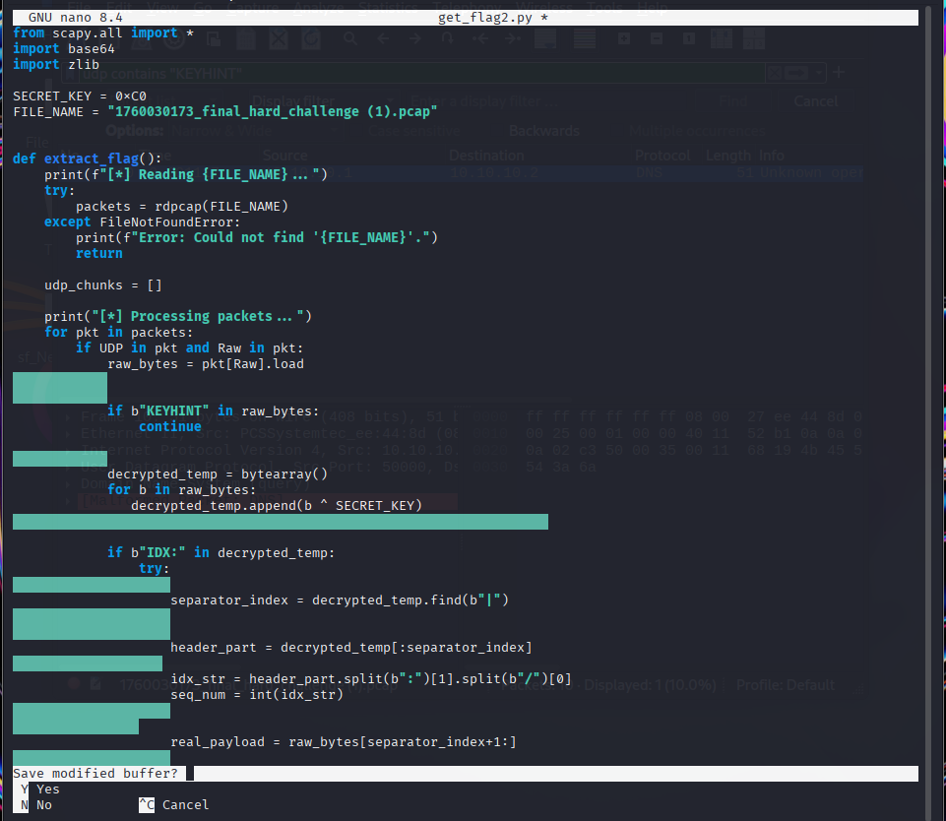

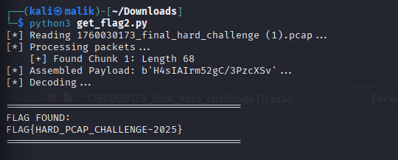
I began by reading the challenge clues, which pointed me toward a "hidden secret" split across multiple UDP packets and obfuscated with an XOR cipher. After analyzing the traffic and solving the hint, I identified the secret key as 0xC0 and wrote a Python script to automate the recovery. My script captured the UDP packets, XOR-decrypted the payloads, and used the "IDX" headers found inside to stitch the scrambled chunks back into the correct order. Finally, I followed the last instruction to Base64 decode and decompress the reassembled data, which cleanly revealed the flag: FLAG{HARD_PCAP_CHALLENGE-2025}.

