Courses landscape painting
Courses take place all weeks of July and august. You can subscribe per week only.
Classes take approximately 4 hours per day. There is time to work for you, relax or to make tours or endless walks, etc... In the weekend there are no classes but the studios, materials and facilities remain at the disposition of our guests.
You bring your own materials or pay for those you use from our stock. Charcoal, pastels, pencil and ink, watercolors gouache-, acrylics- or oils and other techniques as well as a wide range of supports are available. Focus is to work ‘plein air’ in the landscape. Style, artistic approach and choice of techniques are yours.
Each day we choose a different location that will provide subjects for the day.
In case of bad weather we will work from sheds or in the studio with sketches etc.
Residence for two weeks in a row is advised.
We have plenty of equipment and studio space for printmaking , sculpture, painting and drawing. Some experiences artists may want to come to work for themselves and not take part in any classes. Please ask us for more information on how we can further facilitate your residency

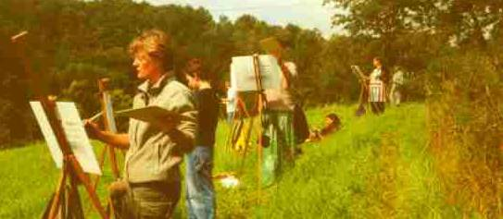

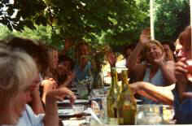

Information, prices, housing
Participation to the courses is at € 275 per week. This includes a picnic or meal at midday, the use of studio-facilities and hardware such as easels and boards etc.
Studio Gouttières offers full board in rooms for 1 to 3 persons. Also some places are available for those that prefer to camp in our facilities. The courtyard, a garden and parcel of land with trees and grass, the studios and ‘salle de reunion’ provide you with all room you need.
Arrival and departures are in the weekends.
Prices for full board are 550 € per week courses included Sundays till Saturdays.
Extra days for early arrival or late depart and single rooms are available at 50€.
Reduction of 150€ per week is available for those that prefer to stay with us without taking part in our courses. Group rates ( from 6 persons on ) on demand.

After your inscription we sent you details for travel routes, material and technical facilities, payments etc.

Inscriptions and additional information: http://www.studio-gouttieres.com
E-mail: desk@studio-gouttieres.com

Wouter Verrips (Amsterdam 1956) has started Studio Gouttieres in 1993. He is your host and teaches painting courses.
Wouter studied painting and sculpture at ‘Rijksakademie van Beeldende Kunsten’ in Amsterdam. 1983-1998 he was teacher and chair of the department of fine arts at the cultural organization of the University of Amsterdam.
Wouter has a studio in The Netherlands and is active as an artist in several countries. 1997 he was awarded the ‘Prix des Volcans’ the most important award for fine arts in the region Auvergne.
At the moment he works on an extensive art project about the landscape in the Combrailles assigned by French government.

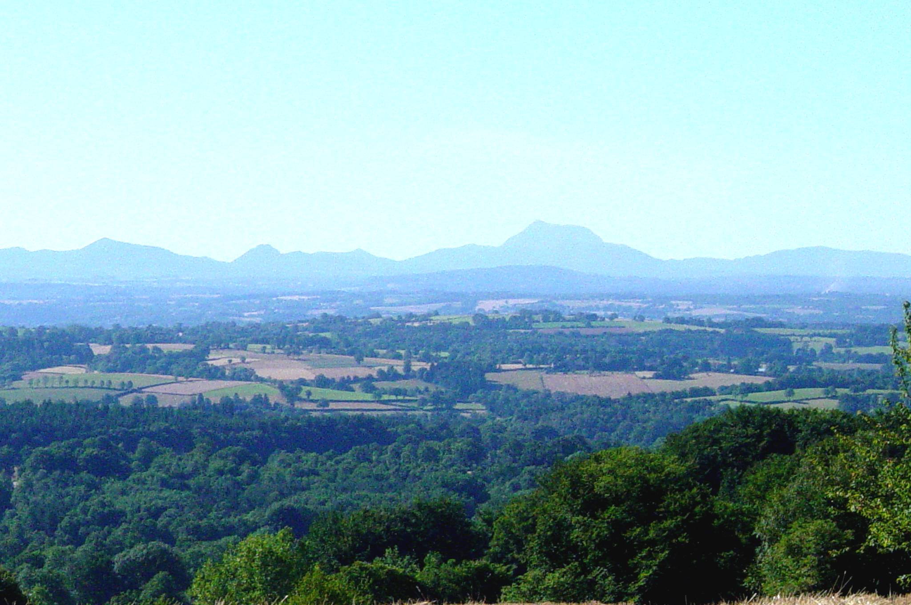

Studio Gouttières
Center for the arts

Studio Gouttières is situated in the village Gouttières, in ‘Les Combrailles’, between Montluçon en Clermont-Ferrand in the French region l’ Auvergne.
The village is situated about 40 km from the freeway A73 in a very rural area.
It has a station connecting it to Montluçon and Clermont-Ferrand from where you can reach the rest of the world.
The studio offers courses in the arts by active artists that are experienced teachers.
Studio Gouttieres can house up to 20 guests and has some room for camping.
You can also choose it as a residence to spend your holydays, simply join your partner that has subscribed to one of our courses an make tours in the beautiful landscape and nature or decide to not join our courses but use our facilities to write your book, to realize your theater, dance, or music projects etc.
We offer housing and facilities to groups as well as individuals that want to spend one or more weeks in a creative setting. The studio is equipped for painting sculpture drawing and graphics and offers many more possibilities.
Do not hesitate to contact us to see if we can host and facilitate your projects.

