DXSAS Sample Implementation 0.8

Instructions
This code sample demonstrates how to implement a DirectX Semantics and Annotations (DXSAS) ScriptExecute parser for your engine. The sample is written in C# using managed DirectX, and supports HLSL shaders in .fx files that conform to the 0.8 version of the DXSAS standard. Several shaders are included with this sample. Hundreds of additional shaders are distributed with FX Composer and in the NVIDIA SDK.
Several commercial DCC applications also support creating/exporting shaders compliant with the DXSAS specification. You can find the specification for DXSAS 0.8 on the DirectX9c SDK.
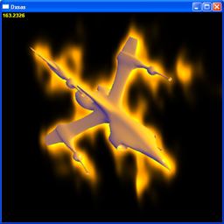
To run the sample you will need to have installed the managed DirectX libraries, and to compile it you will need the C# components of Visual Studio 2003.
Full source is provided for the ScriptExecute parser and the sample application.
At startup the sample will scan the media directory and find all scene and model .fx files. The list boxes on the right enable you to change the selection of effects displayed in the scene. Table 1 lists the control keys.

Applying Shader Effects:
- Scene Effect
Enables selection of a different scene effect, which is applied to the whole scene. CTRL+Click on the scene box enables multiple scene effects (try corona.fx + edgedetect.fx to get a feel for this).
- Model Effect
Chooses an alternative effect for the model. This box will be removed if the current scene effect doesn’t refer to the geometry in the scene.
- Model
Offers a choice of 3 models – the ship, a sphere and the head
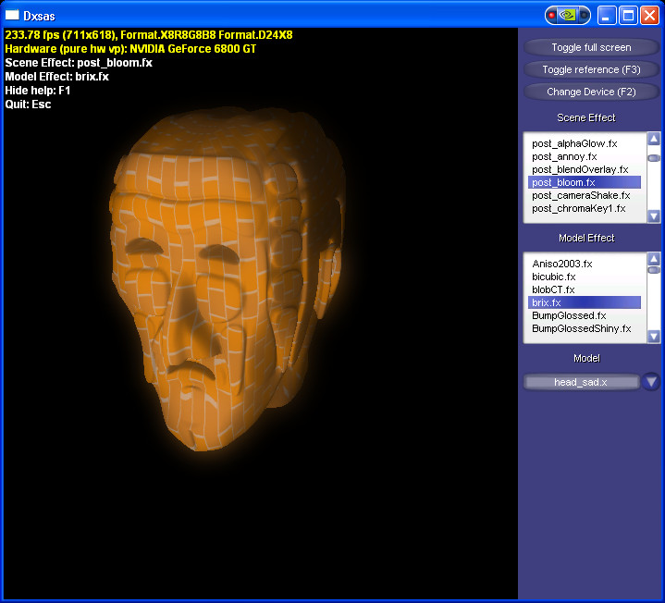
Table 1. List of Control Keys
Key | Description
F1 | Display/Hide controls
Left-Drag | Rotate around the object in the scene
Right-Drag | Dolly the camera towards/away from the object.
CTRL+Click scene list | Add additional scene effects
H | Show/Hide the control panel
Click in scene/object list | Choose different scene/object effects
Esc | Exit

Notice
ALL NVIDIA DESIGN SPECIFICATIONS, REFERENCE BOARDS, FILES, DRAWINGS, DIAGNOSTICS, LISTS, AND OTHER DOCUMENTS (TOGETHER AND SEPARATELY, “MATERIALS”) ARE BEING PROVIDED “AS IS." NVIDIA MAKES NO WARRANTIES, EXPRESSED, IMPLIED, STATUTORY, OR OTHERWISE WITH RESPECT TO THE MATERIALS, AND EXPRESSLY DISCLAIMS ALL IMPLIED WARRANTIES OF NONINFRINGEMENT, MERCHANTABILITY, AND FITNESS FOR A PARTICULAR PURPOSE.
Information furnished is believed to be accurate and reliable. However, NVIDIA Corporation assumes no responsibility for the consequences of use of such information or for any infringement of patents or other rights of third parties that may result from its use. No license is granted by implication or otherwise under any patent or patent rights of NVIDIA Corporation. Specifications mentioned in this publication are subject to change without notice. This publication supersedes and replaces all information previously supplied. NVIDIA Corporation products are not authorized for use as critical components in life support devices or systems without express written approval of NVIDIA Corporation.

Trademarks
NVIDIA and the NVIDIA logo are trademarks or registered trademarks of NVIDIA Corporation. Other company and product names may be trademarks of the respective companies with which they are associated.

Copyright
© 2004 NVIDIA Corporation. All rights reserved

