An Introduction to Measuring and Managing Shader Performance with FX Composer
FX Composer does more than provide you with a way to view, edit, and test shaders on models and scenes. By using FX Composer’s performance tools and ShaderPerf Panel display, you can assess and modify the efficiency and performance of your shaders – not just in general terms, but even for running on various different specific GPUs.
In this brief tutorial, we’ll look at a sample shader file and make some changes to see how they affect the performance of that shader.

Sources of Performance Info
FX Composer provides performance information through two major sources: the ShaderPerf Panel and the Scene or Render panel. These panels are visible by default – the Render Panel displays your model with the currently-assigned shader(s), and the ShaderPerf Panel will be hidden under the Properties Panel (tap the Shader Perf tab to reveal it). Both panels are dockable anywhere on screen or can be their own windows. If you don’t see these panels, you can enable them from the “View” menu – select “View»Panels»ShaderPerf Panel” or “View»Panels»Render Panel” to see them.
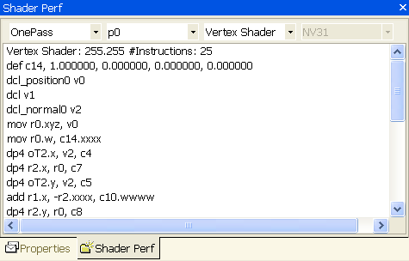
The ShaderPerf Panel, shown above, contains a large text area showing you the compiled DirectX9 assembly-language instructions that are executed for your HLSL shader. The pulldown menus at the top of the ShaderPerf Panel allow you to select each part of the selected HLSL FX shader – the technique, pass within that technique, vertex or pixel shaders, and (for pixel shaders) specific profiling based upon the GPU used (DirectX 9 driver will consider this aspect at runtime). This last pulldown allows you to evaluate shader performance against a wide range of GPUs, from low-end consumer to the high-end workstation, to assess their specific problems or “sweet spots.”
Performance analysis is presented in the main body of the Shader Perf text window, first with an instruction count before the shader begins, and then (for pixel shaders) with an assessment of its scheduling efficiency at the bottom of the listing.
The Render Window can give you further assessment of the efficiency of your shader, by displaying a frames-per-second number for the render. This number will be visible for supported GPUs (that is, those with scheduling info available) when the “Draw Always” option is active – select “Tools»Options»Draw Always” from the menu.

Trying it Yourself: The PerfTutor.fx Shader
To try the Performance Tools yourself, let’s try a shader called “PerfTutor.fx” – this is a very generic shader using per-pixel lighting, two different kinds of lamps, and with a variety of options (set by #define flags) that permit you to try different methods to get the same or nearly-the-same results and see the effects on final image and scene performance.
Follow these steps to create the scene in the example illustrations:
- Start FXComposer
- 2. Make sure that the Render Panel is visible, and the ShaderPerf Panel is available.
- 3. In the Render Panel (marked “Scene”) use the right mouse button menu to select “New Scene From Shape»Teapot”
- From the “File” menu, load “PerfTutor.fx” – “File»Load Material” (or hit Ctrl-O).
- Select the teapot in the Render Panel.
- Select the “PerfTutor” material in the Materials Panel.
- Press the “Apply Material” button in the Materials Panel to assign “PerfTutor.fx” to the teapot. Your display should look something like the one below.
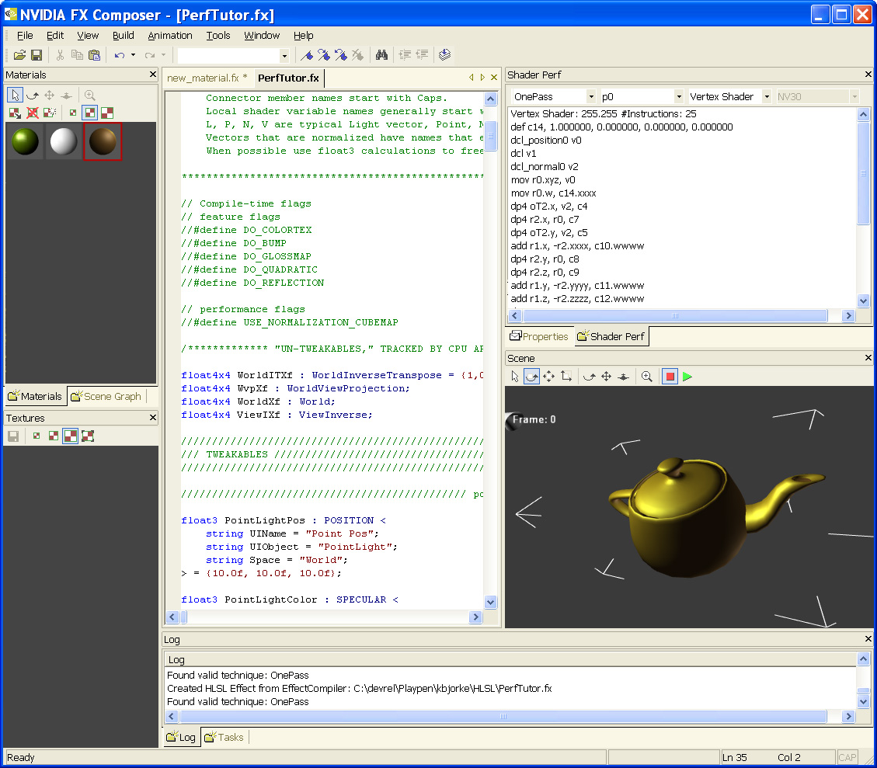
As you can see, “PerfTutor.fx” contains a number of compile-time #define flags that let you change the way the code functions with a minimum of typing. These flags can turn on and off specific features of the shader, or control the way shading is calculated. The flags are right at the head of the shader code:
// Compile-time flags
// feature flags
//#define DO_COLORTEX
//#define DO_BUMP
//#define DO_GLOSSMAP
//#define DO_QUADRATIC
//#define DO_REFLECTION

// performance flags
//#define USE_NORMALIZATION_CUBEMAP
By default, these flags are all commented-out. We’ll change them later to see their effects on final shader performance.

Looking at the ShaderPerf Panel
For now, let’s look at the ShaderPerf panel. Playing with the pulldowns, we can see that we can select any of the available techniques within PerfTutor.fx (OnePass, MultiPass, AmbiOnly, DirOnly, PtOnly). Let’s select “AmbiOnly,” the pass “ambiPass” (the only pass in this particular technique), “Pixel Shader,” and “NV30.” The display of the shader panel will fill with NV30-specific information about this particular (a deliberately very short) pixel shader:
Pixel Shader: 255.255 #Instructions: 7
def c2, 1.000000, 0.000000, 0.000000, 0.000000
mov r0.rgb, c1
mul r0.rgb, r0, c0
mov r0.a, c2.r
mov oC0, r0
end
Scheduling:
This shader has a general efficiency rating of 100%
Passes: 3 Effective Passes: 3.00
--- # of R register: 2 ---

GPU Efficiency
Switching the hardware profile to NV36 will change the lines at the bottom slightly:
Scheduling:
This shader has a general efficiency rating of 33%
Passes: 2 Effective Passes: 2.00
--- # of R register: 2 ---
What does this mean? Will the shader run slower on the faster NV36 GPU?
Fortunately not – what it does mean is that NV36 could potentially run three times faster, if the shader exploited all of NV36’s greater resources (which can execute some shader operations in parallel). For such a small pixel shader, the code doesn’t leave a lot of “slack” for the driver to schedule parallel operations. For a larger shader, the compiler will be clever enough to adjust things on the fly for maximum performance. Efficiency numbers rate the shader against what the maximum possible throughput of the specific GPU might be – a shader perfectly-fitted to the NV36 could potentially run three times faster than this one.
In fact, the number of passes has reduced – so (as described in more detail below) the NV36 will run faster on this shader, given chips of the same frequency.
The Shader Perf Panel has also analyzed the shader for register usage – it’s determined, in the case, that both GPUs need only two temporary registers to execute the shader. In general, the fewer temporaries used, the better the performance. One way to reduce the number of registers used (though not shown in the example) is to use the “half” data type, which can be stored in half the space.

Shader Passes
Let’s switch to a more complex example. Select “OnePass” and the Pixel Shader. The compiled code for NV30 is now much longer – 48 instructions. At the bottom, we’ll see:
Scheduling:
This shader has a general efficiency rating of 100%
Passes: 67 Effective Passes: 67.00
--- # of R register: 4 ---
Switching profiles to the NV36:
Scheduling:
This shader has a general efficiency rating of 48%
A large number of registers are being used which are causing register file stalls
Passes: 40 Effective Passes: 40.00
--- # of R register: 4 ---
While the efficiency rating of resource usage on the NV36 has dropped, look at the number of passes. On NV30, this shader would require 68 cycles through the shader core to execute – but on NV36, with its improved floating-point performance, only 40 passes are needed. This equates to an automatic improvement of around 30%, even at the same clock speed, over the older NV30 architecture.
The “Effective Passes” measures the number of actual passes required, if there had been register contention or texture-latency issues that might have slowed-down the shader (in this case, none).

Tweaking the Code
Now, let’s set a compile-time flag and see its results on shader performance.
In the Editing Panel, let’s un-comment the definition of USE_NORMALIZATION_CUBEMAP – that is, remove the leading “//” marks so the line appears as:
#define USE_NORMALIZATION_CUBEMAP
You’ll see the color shift immediately from green to blue and black, showing that FX Composer recognizes these instructions.
Now press “Ctrl-S” or select “File»Save” to save our changes, and press the “Build” button to recompile the shader (or select “Build»Compile,” or press “Ctrl-F7”). The displays will update – a new texture will appear in the Textures Panel (if displayed), showing us a normalization cube map. This cube map is generated by “PerfTutor.fx,” using the DirectX9 virtual machine, whenever this option is enabled (the specific functions are defined in the header file “normalization.fxh”). “PerfTutor.fx” is written to replace all calls to normalize() in the pixel shaders with texCUBE() calls when this texture is present.
What effect does this have on our shader performance numbers? We can check in the Shader Perf Panel.
The newly-compiled shader actually has more assembly-language instructions – 59 instructions, versus the previous 48 – but checking the efficiency and pass counts tell us that instruction counts can be deceptive.
For NV30, still at 100% efficient use of the GPU, the number of shader passes – that is, the count of clock cycles needed to execute this shader – has declined from 68 to 60, a 13% improvement. So though the shader itself is longer, the execution of the shader on NV30 is faster.
The story for NV36 is even stronger – the GPU efficiency rises slightly, and the number of passes drops from 40 to 30 – a 33% speed increase for this high-end GPU.

Frames Per Second
For GPUs that the performance analyzer knows about, a frames-per-second counter can be displayed in the render window. To see the counter, turn on the “Tools»Options»Draw Always” menu checkmark, and then either wiggle the model in the render window using the transform tools (e.g., rotate the scene) or press the green “Run Animation” button (you can use Ctrl-G and Ctrl-H to toggle animation on and off).
A few things to remember when using this frame counter:
- The frame counter is showing you the speed of FX Composer, in this window, on this model. It’s not showing you the frame rate of your model in your game engine. The frame counter is there as a means for you to evaluate relative performace between shader methods within FX Composer on your computer with your GPU – not as an absolute counter of efficiency and speed. Use the Shader Perf Panel numbers to create those estimates, and calibrate them against your game engine’s own characteristics.
- The technique used in the Render Panel is the one specified in the “Properties” Panel for this shader – not the technique specified in the Shader Perf Panel.
- Similarly, the frame counter can’t let you dial-up a GPU profile using the Shader Perf Panel. While the Shader Perf Panel can evaluate many different GPUs, the Render Panel will show you the value for just one – your computer’s GPU.
- When “Draw Always” is engaged, FX Composer will be using the CPU to the maximum. When “Draw Always” is turned off, FX Composer will only draw the scene when something changes. If you’re multitasking (say, running Visual Studio™ or a game engine simultaneously with FX Composer) you may see resource fighting. Turn off “Draw Always” to get best performance from external applications.

Moving Forward
That’s It! From here, you can experiment with setting other ”PerfTutor” options, checking the characteristics of other GPUs, editing the code, examining the relationships between “float” and “half” usage and precision, and more importantly, applying these same lessons to your own .fx shaders. Bon App!
KB, January 2004

