A handful of pixels of blood

Decoding early video game graphics

What is the purpose of blood splattering onto the screen in a video game? Does it serve functional value or is it mere decoration, intended to shock the user? Video game graphics are not only narrative and aesthetic devices comparable to films, but also hold functional information for players and are of an interactive nature (Fizek 2022; Gerling, Möring, and De Mutiis 2022). Traditional image analysis struggles to encompass images from video games due to their focus on analogue or passively consumed media. How then to analyse blood spurting from a body?

In my dissertation project, I’m researching graphics programming in 1980s and 1990s video games. Besides critical analysis of source code, I also extensively research formal aspects of the video game images. For the latter, I depend on the *Framework for the Analysis of Visual Representation in Video Games* (FAVR) for the proper description and annotation of the image corpus. FAVR (Arsenault, Côté, and Larochelle 2015) explicitly deals with problems of analysing video game graphics and guides annotation of game graphics by their functional, material, and formal aspects and aids in analysing narrativity and the rhetoric of aesthetic aspects.

To streamline and support image annotation of extensive corpora, I rely on automation. So far, FAVR has only been applied in formal or discourse analysis, limiting its scope. Based on my approach, I need to research to what extent FAVR can be leveraged to applications of distant viewing of larger video game image corpora.

This project thus inquires into the viability of translating the FAVR model into a linked open data ontology which can be applied in Tropy or other image-annotation tools. The ontology will be applied in case studies of early Swiss video games and annotated images serve as training material to test building automatic image annotation models.

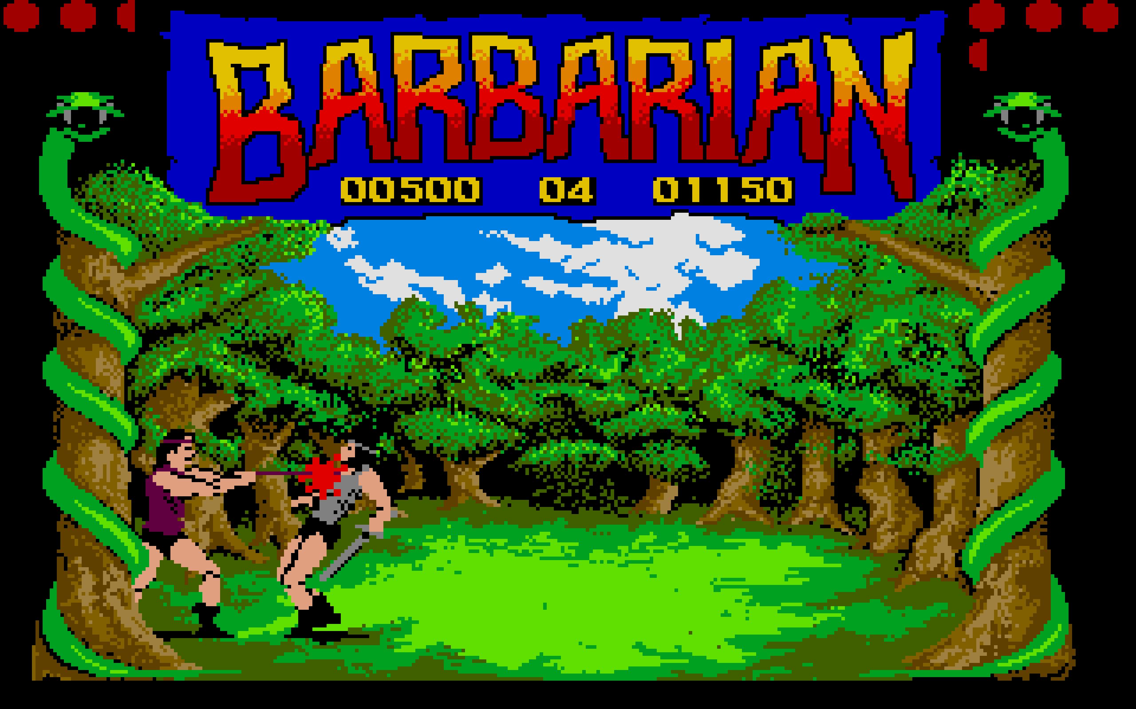

*Why does blood spurt? Does the blood serve functional value, informing the player about a game event or internal state, or is it decoration?*

## Bibliography

Arsenault, Dominic, Pierre-Marc Côté, and Audrey Larochelle. 2015. “The Game FAVR: A Framework for the Analysis of Visual Representation in Video Games.” *Loading...* 9 (14, 14). <https://journals.sfu.ca/loading/index.php/loading/article/view/155>.

Fizek, Sonia. 2022. “Through the Ludic Glass: Making Sense of Video Games as Algorithmic Spectacles.” Game Studies 22 (2). <http://gamestudies.org/2202/articles/gap_fizek>.

Gerling, Winfried, Sebastian Möring, and Marco De Mutiis. 2022. *Screen Images In-Game Photography, Screenshot, Screencast*. 1. Auflage. Reihe Des Brandenburgischen Zentrums Für Medienwissenschaften - ZeM. Berlin: Kulturverlag Kadmos Berlin.

# Biography

Adrian Demleitner is a design researcher at the Institute of Design Research HKB and is active at the intersection of visuality, digital humanities and video game studies. Working on his dissertation, he is part of the research project Confederatio Ludens, which investigates the history of Swiss video games. His specific focus is on the visuality, – the visual material and culture – present in and around those games. The dissertation project inquires the complex interplay of code and visuality in video games with a focus on designerly practices in early video games.

* [adrian.demleitner@hkb.bfh.ch](mailto:adrian.demleitner@hkb.bfh.ch)
* [ORCID Profile](https://orcid.org/0000-0001-9918-7300)
* [Personal Website](http://thgie.ch/)
* [Dissertation Wiki](https://phd.thgie.ch/)