

**Media pack for advertisers**

**African Arguments** is the Royal African Society’s well-regarded pan-African magazine. It publishes high quality news analysis, opinion and investigative journalism.

Contributors include leading politicians and diplomats; award-winning commentators and journalists; and thought leaders from business to civil society to culture. A few recent high-profile writers and interviewees include:

* **Hakainde Hichilema**, Zambia’s main opposition leader
* **Carlos Lopes**, former Executive Secretary of the United Nations Economic Commission for Africa
* **Olusegun Obasanjo**, former President of Nigeria
* **Zainab Bangura**, former United Nations Special Representative on Sexual Violence in Conflict and Sierra Leone Foreign Minister
* **Moïse Katumbi**, Democratic Republic of Congo’s main opposition leader

**Our articles are republished in several outlets, including:**









Image result for the conversation

**We have received grants from foundations, including:**

******Key stats**

* **100,000** unique users per month on site
  + **45%** Africa; **25%** Europe; **25%** Americas
* **60,000** followers on social media
  + **4.6 million** impressions per month on Twitter
  + **100,000** reach per month on Facebook
  + **12%** aged 18-24**; 57%** aged 25-34**;**

**18%** aged 35-44; **13%** aged 45+

* **7,000** newsletter subscribers
* **300+** contributors (two thirds of whom are African)
* **50%** mobile traffic

**Rates**

* Billboard (970x250px) 🡪 £1,500 per month
* Leaderboard (728x90px) 🡪 1,200 per month
* Double MPU (300x500px) 🡪 £900 per month
* MPU (300x250px) 🡪 £600 per month

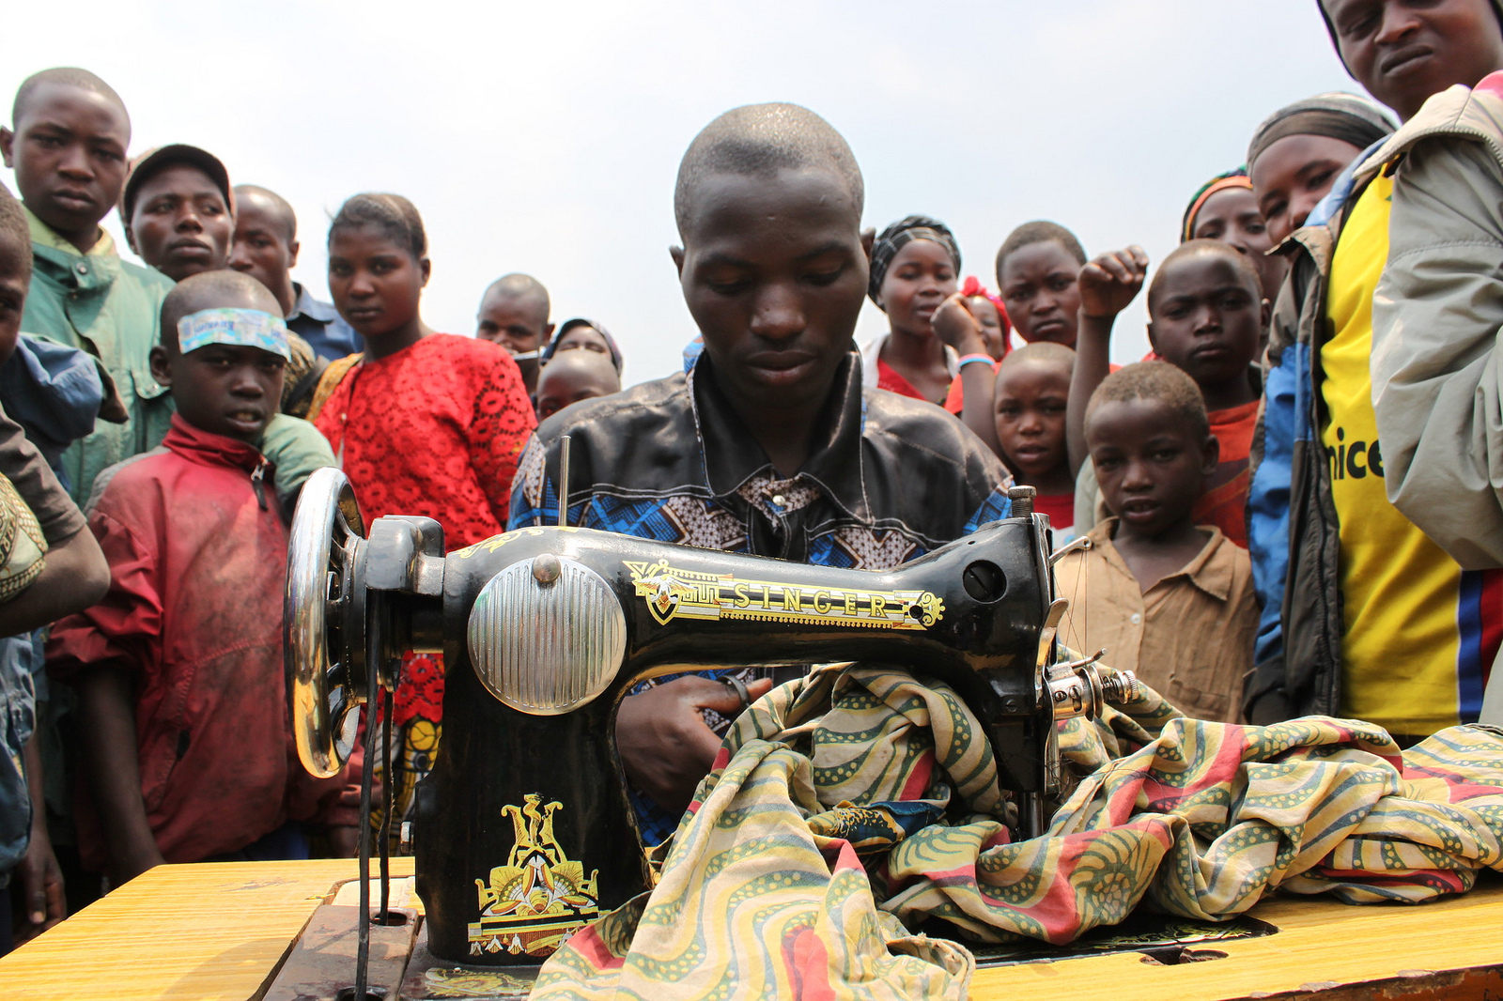



**For further information, please contact:**

**James Wan**

**Editor, African Arguments**

**editor@africanarguments.org | +44 203 073 8338**