## Flow Diagram - Revision 0

* main page has links to all major functions
* complex functions (i.e. enrolling) contain multiple steps, and link back to main page at the end
* exam schedule similar to weekly, but uses month view (separate page)
* link to undergraduate calendar where students read about course descriptions & requirements etc.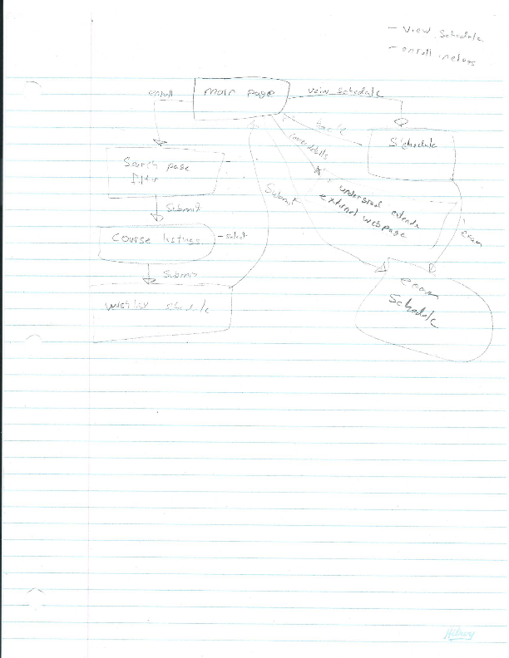

## Main Page - Revision 0

* 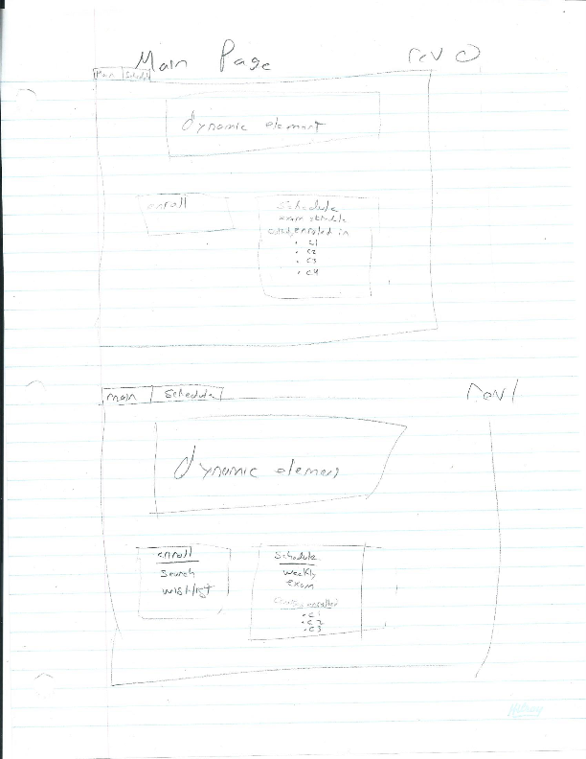

## Search for Courses - Revision 0

* 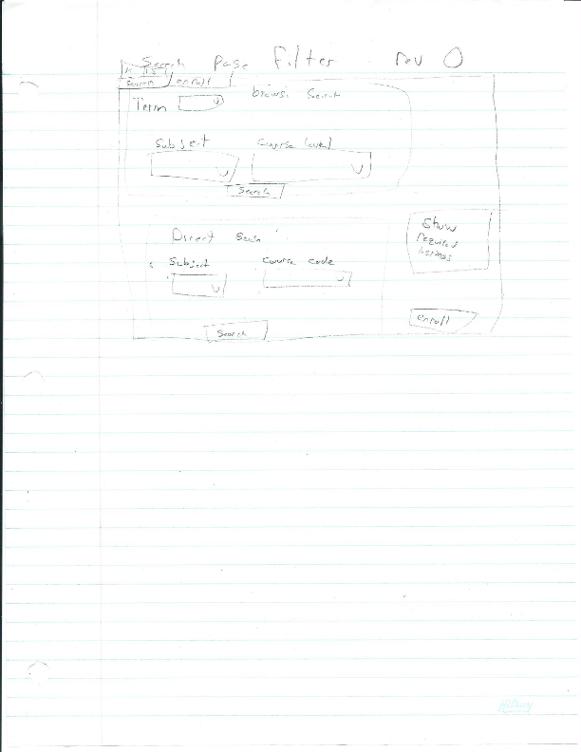

## Search Courses Results - Revision 0

* 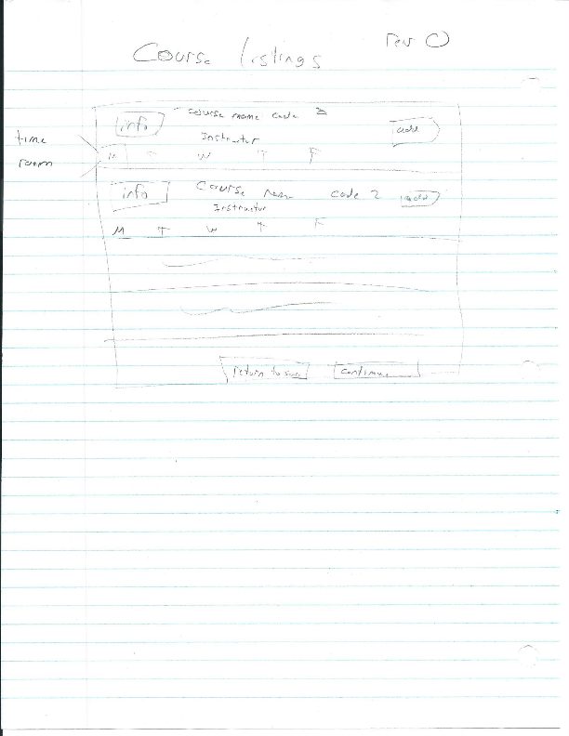

## Enroll from Wishlist - Revision 0

* 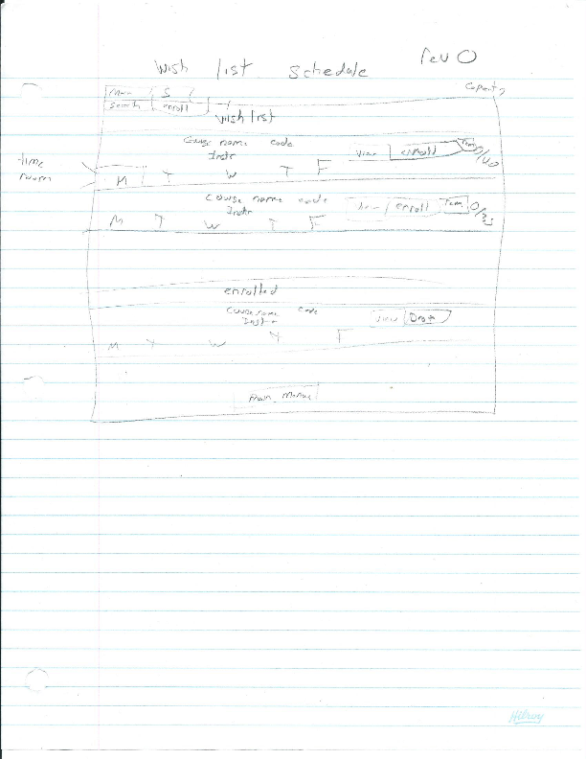

## View Weekly Schedule - Revision 0

* 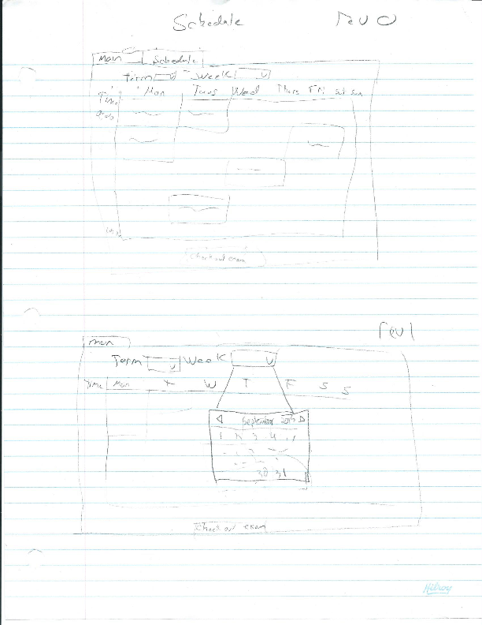

## View Exam Schedule - Revision 0

* 