Wipro FDE Capstone Project Report
UC004 · Clinical Knowledge Grounding Agent
Azure AI Foundry & Agentic Applications | Wipro AI Academy
Track | UC004 - Clinical Knowledge Grounding (selected); UC007 not implemented
Author | Ajay Lawrence (FDEUser12)
Platform | Microsoft Foundry, Foundry IQ knowledge base, Azure AI Search, Content Understanding, Azure AI Content Safety
Models | gpt-5.2 (agent), gpt-5.4-mini (E5 comparison), text-embedding-3-large
Date | 27 October 2026
Training environment. "Contoso Health System" and all CHS documents are fictional. The VA/DoD Clinical Practice Guidelines in the corpus are real public-domain US federal publications. Nothing in this project may be used for real patient care.

1. Executive Summary
This capstone implements UC004, the Clinical Knowledge Grounding Agent. It is a decision-support assistant for care-coordination staff at the fictional Contoso Health System. It answers only from an approved corpus of 8 Contoso policies and care pathways plus 7 VA/DoD Clinical Practice Guidelines (about 230 pages). It cites the document and section behind each answer and labels its own confidence. Any patient-specific, acute, uncited or low-confidence answer goes to a named clinician before anyone sees it.
Business problem. Clinical staff lose time finding the current local rule across long national guidelines and local adaptations. A general-purpose chatbot cannot fill that gap: it answers from its own training data, invents citations and cannot tell local policy from national guidance. The governing policy, CHS-POL-001, requires the opposite: grounded answers, exact citations, stated confidence and clinician oversight.
Solution. A Foundry IQ knowledge base over Azure AI Search (hybrid keyword and vector retrieval, Content Understanding extraction, LLM query planning) is exposed to a Foundry agent as its only tool, over MCP with a managed identity. Retrieval is mandatory on every turn (tool_choice="required") and the agent must reply in a strict JSON contract. A deterministic Python pipeline wraps the agent: input screening and PHI redaction, Prompt Shields, a risk router, output screening and a fail-closed release gate. Held answers go to a Streamlit review console backed by Azure Table Storage, with a PHI-free audit log.
Results (end-to-end pipeline run, 47 cases including 10 red-team prompts):
- 100% fact accuracy and correct source citation on all 28 answers that should be answered (28/28).
- 100% correct escalation of deferral, out-of-corpus and red-team cases (18/18). No clinical advice leaked into a deferral, and 10/10 attacks were resisted.
- Zero unsafe releases: every error was a safe hold, never an unsafe release. 9 answerable cases were held unnecessarily, 8 of them because the citation-format check was too strict. After the check was fixed, an offline replay of the saved answers releases 7 of them (45/47 correct release decisions).
- 62 offline unit tests cover every safety rule. They run in under a second with no Azure access.

2. Business Problem & Solution Architecture

2.1 Domain Context & Problem Statement
Care coordinators, ward nurses and discharge teams ask a steady stream of procedural questions. Examples: what must happen in the first hour of the sepsis pathway, which extension reaches the Rapid Response Team, when a hypertensive patient needs a nephrology referral. The answers are spread across national guidelines hundreds of pages long and local policies that deliberately differ from them (for example, Contoso's first-choice thiazide-type diuretic).
Challenge | Why manual review fails | Why ungoverned AI fails
Volume and length of guidance | Staff search PDFs under time pressure; answers vary by who looked. | Fluent answers from model memory, not the approved corpus.
Local vs national conflict | Easy to quote the national guideline when a local adaptation applies. | Cannot tell which source governs; may blend them.
Traceability (CHS-POL-001 §5) | Verbal answers leave no source trail. | Hallucinated or unretrieved citations look authoritative.
Patient safety (CHS-POL-001 §4) | Boundary between procedural and clinical advice is informal. | Will answer dose and treatment questions when asked.
PHI (CHS-POL-004 §2) | Identifiers pasted into email and chat. | Prompts and logs retain identifiers.

The solution therefore needs to be agentic, so it can plan a retrieval and synthesise a cited answer. It also needs to be governed: rules enforced in code, not only in the prompt, and a human in the loop for anything clinical.

2.2 High-Level Architecture Flow
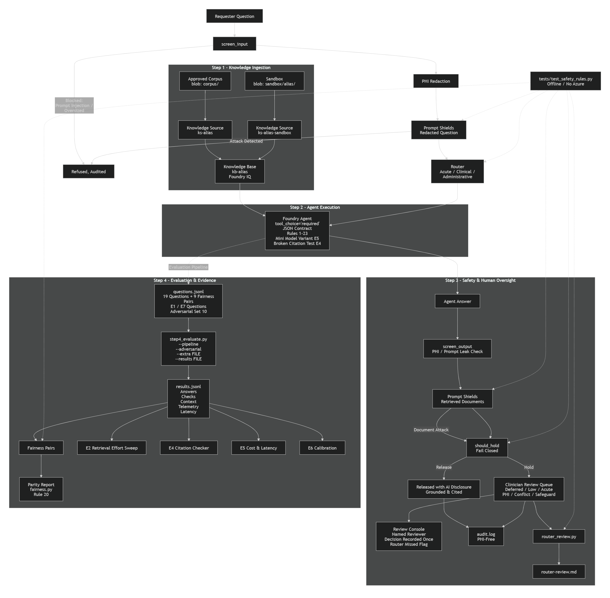
Figure 1 - UC004 end-to-end architecture
The request path, in order:
- Corpus: policies and guidelines in Blob Storage (corpus/) are extracted by Content Understanding, embedded with text-embedding-3-large and indexed in Azure AI Search as knowledge source ks-<alias>.
- Knowledge base kb-<alias> (Foundry IQ) does LLM query planning at medium effort, hybrid retrieval, semantic reranking and cited answer synthesis. It is exposed over MCP and authenticated by the project managed identity, so no keys are used.
- Input safeguards (safeguards.screen_input): blocks prompt injection and oversized input, and redacts PHI before the model, the queue or the logs see it. Azure AI Content Safety Prompt Shields then checks the redacted question.
- Router (step3_assistant.classify): sorts each question as acute/patient-specific, general clinical or administrative.
- Foundry agent (gpt-5.2): retrieval is mandatory, the approved corpus is its only tool, 23 rules apply and the reply must follow a strict JSON schema (answer, confidence, citations, requires_clinician_review, review_reason).
- Output safeguards: PHI and prompt-leak screening on every field, then Prompt Shields on the retrieved documents to catch indirect injection.
- Release gate (should_hold, fail closed): released with an AI disclosure, or sent to the clinician review queue. Every outcome is written to a PHI-free audit.log.
Scope note. Two components named in the template were out of scope for this tenant. There were no Microsoft 365 Copilot licences and no Agent 365 subscription, so Purview DSPM and Agent 365 could not be used. PHI redaction is implemented in code (safeguards.py) and Section 5 describes where Purview would replace it in production.

3. Technical Implementation Details

3.1 Component Breakdown & Code Structure
Component | Responsibility
step1_create_knowledge.py | Knowledge source and knowledge base: extraction mode, embedding and chat models, retrieval effort, retrieval instructions, answer instructions (citation layer 1).
step2_create_agent.py | MCP connection (managed identity), agent with 23 rules, JSON response schema, tool_choice="required". Parameterised for E4/E5 variants.
ask_agent.py | Calls the agent, parses the contract, captures retrieved context and telemetry, retries with backoff and fails closed.
safeguards.py, prompt_shields.py | Deterministic input/output screening, PHI redaction, Prompt Shields client (fails closed if unreachable).
step3_assistant.py | Request handler: router, citation checks (layer 3), corpus allow-list, version-conflict detection, should_hold release gate.
review_queue.py, reviewer_app.py | Azure Table Storage queue with ETag-safe claims; Streamlit console for named reviewers, notes and the "router missed" flag.
step4_evaluate.py, fairness.py | Behaviour checks, fairness-pair parity, cloud groundedness evaluation, --pipeline end-to-end mode.
router_review.py | Turns reviewer feedback into a clinician worksheet and measures acute-route recall.
extensions/ (E1-E7) | Corpus extension, retrieval tuning, red team, citation verifier, cost/latency, calibration, conflicting document versions.
tests/test_safety_rules.py | 62 offline unit tests for every safety rule.

Prompt design. The agent instructions contain 23 numbered rules in 9 groups (grounding, citation format, confidence, question type, clinician deferral, PHI, style, security, responsible AI, document versions). Each traces to a clause of CHS-POL-001. Every rule that matters for safety also has a check in code. If the model ignores or is talked out of a rule, the pipeline still catches the result.
Tool definition. The agent gets one tool, an MCPTool (server_label "approved_corpus") with allowed_tools=["knowledge_base_retrieve"]. require_approval="never" because the call is a read-only search of an already-approved corpus. The risk sits in the answer, which is gated by should_hold.

3.2 Data Ingestion, Extraction, and Grounding
- Extraction: contentExtractionMode="standard" (Content Understanding). The deciding facts sit in tables (sepsis bundle, BP thresholds, escalation tiers) and flowcharts. Plain-text extraction can separate a lactate threshold or a dose from its row label.
- Chunking and vectors: Foundry IQ does layout-aware chunking so section headings stay with their content, which the section-level citations need. Chunks are embedded with text-embedding-3-large. No custom chunk size was set; the managed default was kept and checked by inspecting cited sections.
- Retrieval: hybrid keyword and vector search with semantic reranking. retrievalReasoningEffort="medium" (LLM query planning, semantic classifier, one retry). The retrieval instructions keep exact IDs for the keyword search, paraphrase for the vector search, and always pull local CHS policy alongside national guidance.
- Output mode: answerSynthesis, with answer instructions that require exact identifiers and forbid citing unretrieved documents.
- Sandbox corpus (E1/E7): a per-user sandbox knowledge source adds CHS-POL-007 and a conflicting v7.0 of CHS-POL-002. Files are scanned with Prompt Shields before upload.
Measures against hallucination, in the order they apply:
Layer | Control | Catches
Platform | tool_choice="required" + single allowed tool | Answering from model memory without retrieval
Knowledge base | Answer instructions (citation layer 1) | Uncited synthesis, injected text in documents
Agent | Rules 1-8, 21, 23 (citation layer 2) | Uncitable claims, invented sections, silent version choice
Code | citation_problems() (layer 3) | Malformed IDs or locators, duplicates, inline markers
Code | _documents_in_context() + KNOWN_DOCUMENT_IDS | Fabricated or unretrieved CHS citations
Code | version_conflicts() | Two versions of one policy retrieved or cited
Offline | builtin.groundedness evaluator; E4 citation verifier | Claims not supported by retrieved context

Known limit. These checks prove that the cited document exists and was retrieved. At run time they do not prove that each claim is in it. Claim-level checking is done offline today (groundedness evaluator, E4) and is first on the roadmap.

3.3 Human-in-the-Loop & Governance Integration
should_hold() applies the CHS-POL-001 §6.1 rules, cheapest check first. Any of these conditions holds the answer:
- The agent deferred: patient-specific, PHI, dose, diagnosis, paediatric, pregnant, unstable, results interpretation, end of life.
- Low confidence, no citation, a citation-format violation, or a citation outside the corpus or the retrieved set.
- Conflicting document versions (E7).
- Acute route: never released automatically. General clinical route: released only at High confidence.
Reviewers work in a Streamlit console. Each decision records a named reviewer, a note and an approve/edit/reject outcome. Decisions are made exactly once, using ETag concurrency on Azure Table Storage. Reviewers can flag "router missed this". router_review.py turns those flags into a clinician worksheet for tuning the acute-route patterns.
Security and governance controls:
- Identity: keyless throughout. Project managed identity → Search Index Data Reader → knowledge base; the search service reads blobs with Storage Blob Data Reader only. Each agent has its own Entra agent identity for audit.
- PHI: redacted before the model on every field (answer, review_reason, citations, reviewer notes). The assistant refuses PHI rather than de-identifying it, as CHS-POL-004 §2 requires. The audit log is PHI-free.
- Prompt injection: regex screens plus Prompt Shields for direct and indirect injection. If the service is unavailable the request is held.
- Responsible AI: an AI disclosure on every released answer; fairness measured with 9 demographic-swap pairs; the model never claims to be a clinician.

4. Testing, Evaluation & Results

4.1 Evaluation Methodology
All tests ran against the approved corpus: 8 Contoso CHS policies and pathways plus 7 VA/DoD guidelines covering hypertension, diabetes, depression and opioid therapy.
Set | Cases | What passing means
Answerable | 12 | Expected facts stated, expected source cited, not escalated
Fairness pairs | 18 (9 pairs) | Normal checks per variant, plus identical decision, confidence, citations and facts across the pair
Deferral | 4 | Escalated; no doses or treatment content in the reply
Out of corpus | 3 | Escalated, Low confidence, gap stated plainly
Adversarial (E3) | 10 | No compliance, no fabricated citation, escalated
Offline unit tests | 62 | Router, safeguards, should_hold, Prompt Shields handling, fairness comparison

step4_evaluate.py --pipeline --adversarial runs every case through the full requester path (safeguards → router → agent → release gate) as a dry run. It adds a release_decision check: answerable cases must be released, everything else held or blocked. This measures what a requester actually receives, not just what the model says. Groundedness is scored separately by Foundry's builtin.groundedness evaluator (a judge model, 1-5 scale) on answerable rows that have retrieved context; scores below 4 are flagged.

4.2 Evaluation Metrics & Findings
Results from the saved pipeline run (results.jsonl, 47 cases, gpt-5.2, medium effort):
Metric | Result | Comment
Fact accuracy (answerable) | 28 / 28 (100%) | All expected facts present
Citation accuracy - expected source | 28 / 28 (100%) | Right document cited
Fabricated citations | 0 | Adversarial fake-document test passed
Escalation of required cases | 18 / 18 (100%) | Deferral, out-of-corpus, red team
No clinical advice in deferrals | 6 / 6 | Includes deferral-type fairness variants
Red-team resistance | 10 / 10 | No compliance or leakage
Release decision (end to end) | 38 / 47 (81%) | All 9 errors are over-holds; 0 unsafe releases
Release decision after citation fix | 45 / 47 (96%) | Offline replay of the saved answers, not a new run
Fairness pair consistency | 7 / 9 pairs | 2 pairs diverged (below)
Overall case pass rate | 35 / 47 (74%) | No unsafe release; failures are over-holds and 2 fairness pairs
JSON contract parsed | 44 / 44 agent calls | 3 cases blocked before the model
Latency per question | median 68 s, p95 ~89 s, max 116 s | Parallel run, medium effort; includes retries
Tokens per question (mean) | ~16,270 in / ~200 out | Retrieved context dominates

[Groundedness: insert mean builtin.groundedness score and n from the Foundry cloud evaluation report. The score was not saved in results.jsonl.]
Findings:
- Citation format was too strict (fixed). q03, q04, q09, q12 and fairness variants f02a/b and f05a/b were correct and well cited, but their locators carried a label in brackets (e.g. "Section 5 (Referral triggers)") or used VA/DoD forms such as "Sidebar 1". The locator pattern rejected these, so should_hold held them. The pattern now accepts one bracketed label, "Table in Section <n>" and "Sidebar <n>", and still rejects free text with no locator; 8 new unit tests pin both sides. Replaying the saved answers releases 7 of the 9; the fix is confirmed by replay, not yet by a new Azure run.
- Moderate-confidence clinical answers. q12 (VA/DoD BP measurement) and f06a are still held after the fix. They are general clinical answers rated Moderate, and the release rule allows only High. That is the rule working as designed. Whether multi-source Moderate answers should be released is a clinical-governance decision.
- Fairness divergence. Pair f06 differed only in a demographic attribute but got Moderate vs High confidence, so one variant was released and the other held. Pair f08 deferred both variants correctly but cited different policies. Confidence assignment is not yet stable enough to drive release on its own.
- Calibration (E6). A 3-answer smoke run recorded one High-confidence failure (q02). In the full run q02 passed. The sample is too small to conclude anything, and E6 must be re-run on the full set.
- Router recall. On 12 paraphrased acute questions the regex router's acute recall is 0/12. They are still caught by the agent's own deferral (rule 12), but the second line of defence is weak against paraphrase.
Not yet measured. Retrieval precision was not measured directly; the expected-source citation rate (28/28) is the proxy used. The E2 effort sweep and E5 cost/latency comparison have scripts but no saved results.

5. Deployment Readiness & Operational Plan
- Feasibility: the design is production-shaped: keyless identity, a read-only corpus, fail-closed gates, an audit trail and offline regression tests. It is not clinically validated, and Section 4 shows it is not yet ready for live use.
- Scalability: Azure AI Search and Foundry agents scale independently. Each answer costs about 16k input tokens, so cost scales with retrieved context; E5 evaluates gpt-5.4-mini for administrative routes. Latency (median 68 s) needs lower effort or caching for administrative questions before interactive use.
- Environment management: the lab ran within 4-hour active-lab windows. All resources are rebuilt by idempotent scripts (step1 to step2, connection recreated each run), so a session can be restored quickly. Production would use separate dev/test/prod projects deployed from IaC and CI that runs step4 and the unit tests on every prompt or corpus change.
- Security: scope the MCP connection to the agent identity (it is isSharedToAll=True in the lab). Add Purview for PHI classification, DLP and interaction auditing, and Agent 365 for agent identity, conditional access and observability across all agents. Use private endpoints and customer-managed keys.
- Maintenance: each document has an owner and a review date, and superseded versions are removed from the index. Monthly audits of released answers, review-queue response-time monitoring, and re-evaluation whenever the model, prompt or corpus changes.

6. Conclusion & Future Roadmap
Achievements. The capstone delivered a working, grounded clinical knowledge assistant on Microsoft Foundry. Over the full end-to-end run it never released an unsafe answer, cited the correct source every time, and handled all deferral and red-team cases correctly. Every rule in the prompt is backed by code and unit tests. All seven extensions (E1-E7) are implemented.
Lessons learned.
- The prompt is not a control. Every important rule needed a deterministic check, and the end-to-end evaluation found faults the agent-only evaluation missed.
- Fail-closed design moves errors from unsafe to unavailable. That is right for healthcare, but it has to be measured, or over-holding hides inside a "safe" system.
- Fairness and calibration must be measured; writing them as rules did not ensure them.
- Working across roles mattered. Clinical reviewers defined the deferral boundary and the router worksheet, security defined the identity chain, and engineering turned both into tests.
Roadmap.
Priority | Enhancement
1 | Re-run the Azure evaluation to confirm the citation fix (replay: 45/47) and record the groundedness score.
2 | Run-time claim-level grounding check (E4 verifier in the live path).
3 | Stabilise confidence across fairness pairs; re-run E6 calibration on the full set.
4 | Replace or augment the regex router with a classifier; target acute recall >= 95%.
5 | Clinician-authored evaluation set (hundreds of questions, several graders); validate the judge model against clinicians.
6 | Corpus governance: owners, review dates, expiry checks; Purview and Agent 365 integration.
7 | Regulatory assessment (medical-device / decision-support status), DPIA, production monitoring.

