定制CHCT6302通信协议转换器说明
- 综述：
实现定制串口协议和标准modbus RTU协议的转换（以下简称定制侧和RTU侧）。上位机读写定制侧，RTU侧读写PLC（常用03 06 10功能码都支持）。两侧硬件接口为标准RS485。硬件上，定制侧一侧要具备良好的抗干扰，防浪涌和光电隔离等功能。
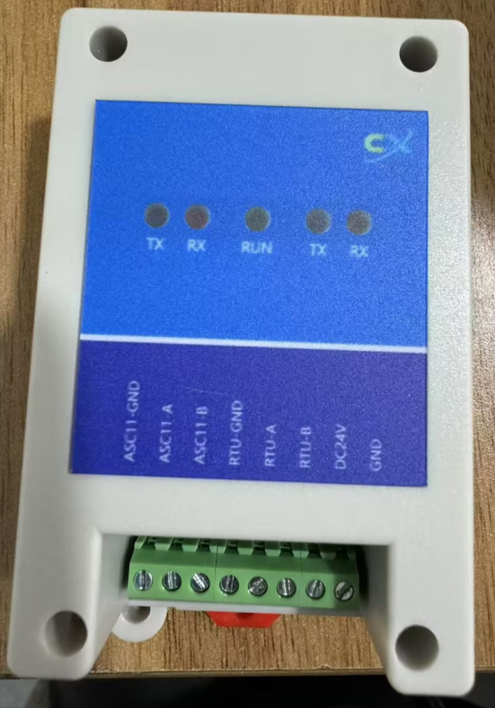

- RS-485
- 通信参数，RUT和定制侧一致：
通讯方式：RS485
波特率：9600
数据位长度：8位
停止位：1位
奇偶校验：无
RUT通信地址为1.定制侧一对一不需要通信地址通信参数修改

- 定制侧Register Map
- 地址
定制侧通信分3个组CH1~CH3，CH1对应地址D5000~5019, CH2对应地址D5020~5039, CH3对应地址D5040~5059.3组内容完全一致,各组对应RTU侧地址如下,仅用保持寄存器。
CH1 | RTU(0X) | CH2 | RTU(0X) | CH3 | RTU(0X) | content
“D05000” | 0000 | “D05020” | 0014 | “D05040” | 0028 | 温度设定,上位机写定制侧
“D05001” | 0001 | “D05021” | 0015 | “D05041” | 0029 | 预留。上位机写定制侧
“D05002” | 0002 | “D05022” | 0016 | “D05042” | 002A | 预留。上位机写定制侧
“D05004” | 0004 | “D05024” | 0018 | “D05044” | 002C | 启停。上位机读定制侧。
…… |  | …… |  | …… |  | ……。上位机读定制侧。
- 内容详解，以CH1为例，RTU侧只使用保持寄存器。
对应RTU通信地址 | 定制侧  CH1 | Contents | WORD | Explaination
0000 | D5000 | Set Temperature Value | 1 | Bit15：+ / - (0 with plus, 1 with minus)  Bit 0~14: Value of the set temperature (℃)  (The values 1 or 0 of each digit from Bit 0 to Bit 14 mean the 10 times of the PV temperature figure that is onverted into the binary digit.  ex. +50.1℃ becomes +501 and it is converted into the binary  digit ’0000 0001 1111 0101’.)  工业常用负数表示方式为补码形式表示，此设计与常用不同，对于负数需要特别验证与上位机是否一致。
0001 | D5001 | Temp High Warning Set Point | 1 | 工业常用负数表示方式为补码形式表示，此设计与常用不同，对于负数需要特别验证与上位机是否一致。
0002 | D5002 | Temp Low Warning Set Point | 1 | 工业常用负数表示方式为补码形式表示，此设计与常用不同，对于负数需要特别验证与上位机是否一致。
0003 | D5003 | Spare | 1 | Spare
0004 | D5004 | Status | 1 | Bit 2~15: Spare  Bit1: REMOTE/LOCAL (Inputs the operation mode) (1 : Remote Mode, 0 : Local Mode)  Bit0: RUN/STOP (Inputs the operation status) (1 : Run, 0 : Stop)
0005 | D5005 | Present Temperature Value | 1 | Bit15: + / - (0 with plus, 1 with minus)  Bit0~14: Value of the present temperature(℃)  (The values 1 or 0 of each digit from Bit 0 to Bit 14 mean the 10 times of the PV temperature figure that is converted into the binary digit.  ex. +50.1℃ becomes +501 and it is converted into the binary digit ’0000 0001 1111 0101’.)  工业常用负数表示方式为补码形式表示，此设计与常用不同，对于负数需要特别验证与上位机是否一致。
0006 | D5006 | Coolant Flow Rate | 1 | Bit 15: (0 all the time)  Bit0~14: Value of the coolant flow rate (L/min)  (The values 1 or 0 of each digit from Bit 0 to Bit 14 mean the 10 times of the PV temperature figure that is converted into the binary digit.  ex. 15.1L/min becomes 151 and it is converted into the binary digit ’0000 0000 1001 0111.)
0007 | D5007 | Resistivity | 1 | Bit15: (0 all the time)  Bit0~14: Value of the resisitivity (MΩcm) (1 all the time for Fluorinert and GALDEN specification)  暂时按照20 MΩcm转换为数字量+200处理。
0008 | D5008 | Spare | 1 | Spare
0009 | D5009 | Spare | 1 | Spare
000A | D5010 | Total Operation Status  (Status 1) | 1 | Bit4~15: Spare  Bit3: TOTAL ALARM (Outputs the alarm status that stops running) (1 : Alarm, 0 : Normal)  Bit2: TOTAL WARNING (Outputs the warning status that continues running) (1 : Warning, 0 : Normal)  Bit1: REMOTE/LOCAL (Outputs the operation mode) (1 : Remote Mode, 0 : Local Mode)  Bit0: RUN/STOP (Outputs the operation status) (1 : Run, 0 : Stop)
000B | D5011 | Alarm Status  (Status 2) | 1 | Bit10~15 Spare  Bit9: System_Alarm(Outputs the sequencer error)(1: Alarm, 0 : Normal)  Bit8: Cooling Water_Alarm(Outputs the cooling water condition)(1: Alarm, 0 : Normal)  Bit7: Temp．H_Alarm(Outputs the coolant temperature high alarm)(1: Alarm, 0 : Normal)  Bit6: Temp．L_Alarm(Outputs the coolant temperature low alarm)(1: Alarm, 0 : Normal)  Bit5: Ref．_Alarm(Outputs the refrigeration cycle alarm)(1: Alarm, 0 : Normal) 删除，无此故障命名。  Bit4: Pump O.L_Alarm(Outputs the pump over load alarm)(1: Alarm, 0 : Normal)  Bit3: Press Low_Alarm(Outputs the coolant pressure low alarm)(1: Alarm, 0 : Normal)  Bit2: Press High_Alarm(Outputs the coolant pressure high alarm)(1: Alarm, 0 : Normal)  Bit1: Coolant Low_Alarm(Outputs the coolant level low alarm)(1: Alarm, 0 : Normal)  Bit0: Coolant Full_Alarm(Outputs the coolant level high alarm) (1: Alarm, 0 : Normal)
000C | D5012 | Warning Status  (Status 3) | 1 | Bit9~15: Spare  Bit8: CW．Temp．Hi_Warning(Outputs the cooling water temperature high warning)(1: Warning, 0 : Normal 0 all the time for the dual channnel specification)  Bit7: CW．Temp．Low_Warning(Outputs the cooling water temperature low warning)(1: Warning, 0 : Normal 0 all the time for the dual channel specification)  Bit6: Leak／Fun_Warning(Outputs the coolant, cooling water leak and dewdrop warning)(1: Warning, 0 : Normal) 删除，漏液为严重故障不应该放到警告位，有警告汇总位告知机台，不影响通信。  Bit5: Ion EX．Press_Warning(Outputs the pressure of the ion exchanger inside warning)(1: Warning, 0 : Normal 0 all the time for Fluorinert and GALDEN specification)  Bit4: Resistivity L_Warning(Outputs the coolant resisitivity low warning)(1: Warning, 0 : Normal 0 all the time for Fluorinert and GALDEN specification)  Bit3: Coolant Flow L_Warning(Outputs the coolant flow low warning)(1: Warning, 0 : Normal)  Bit2: Temp．L_Warning(Outputs the coolant temperature low warning)(1: Warning, 0 : Normal)  Bit1: Temp．H_Warning(Outputs the coolant temperature high warning)(1: Warning, 0 : Normal)  Bit0: Coolant L_Warning(Outputs the coolant level low warning)(1: Warning, 0 : Normal)

- 定制侧命令格式

功能码 | 格式字符串
读 | “WRD”
写 | “WWR”
启停命令
启停命令
关 | 0x2
开 | 0x3

3.1 读数据：
命令字符串长度20字节。注意红色标注引号内数字为字符串格式。
起始符 | 从机地址 | waittime | 功能码 | 起始地址 | 分割符 | 读取数量 | 结束符高字节 | 结束符低字节 | 字符串结束
0x02 | “0101” | “A” | “WRD” |  | “,” | “13” | 0x03 | 0x0D | 0
1字节 | 4字符 | 1字符 | 3字符 | 6字符 | 1字符 | 2字符 | 1字符 | 回车符，1字符

例：从地址为”D05000”开始读取13个WORD的内容，命令字符串为"\x20101AWRDD05000,13\x3\r"

响应：
字符串长度61字节
索引 | 内容
0 | 0x02
1-4 | “0101”
5-6 | “OK”
7-10 | Temperature Set Point | D5000
11-14 | Temp High Warning Set Point | D5001
15-18 | Temp Low Warning Set Point | D5002
19-22 | Spare | D5003
23-26 | Status | D5004
27-30 | Present Temperature Value | D5005
31-34 | Coolant Flow Rate | D5006
35-38 | Resistivity | D5007
39-42 | Spare | D5008
43-46 | Spare | D5009
47-50 | Total Operation Status | D5010
51-54 | Alarm | D5011
55-58 | Warning | D5012
59 | 0x03
60 | 0x0D

3.2 写数据：
命令字符串长度25字节。注意红色标注引号内数字为字符串格式。

起始符 | 从机地址 | waittime | 功能码 | 起始地址 | 分割符 | 写入数量 | 分隔符 | 写入值 | 结束符高字节 | 结束符低字节 | 字符串结束
0x02 | “0101” | “A” | “WRD” |  | “,” | “01” | “,” | data | 0x03 | 0x0D | 0
1字节 | 4字符 | 1字符 | 3字符 | 6字符 | 1字符 | 2字符 | 1字符 | 4字符 | 1字符 | 回车符，1字符

例：
1设温20度，命令串如下
"\x20101AWWRD05020,01,00C8\x3\r"
2关ch1，命令串如下
"\x20101AWWRD05004,01,0002\x3\r"

响应：
命令字符串长度9
索引 | 内容
0 | 0x02
1-4 | “0101”
5-6 | “OK”
7 | 0x03
8 | 0x0D

