- If the straight line is outside the circle 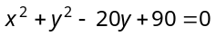, then [Roorkee 1999]
(a) (b)
(c) 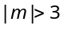 (d) 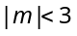
- Equation of radical axis of the circles 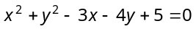, 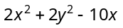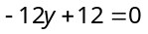 is [RPET 2003]
(a) 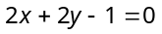 (b) 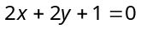
(c) 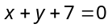 (d) 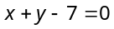
- ABCD is a square, the length of whose side is a. Taking AB and AD as the coordinate axes, the equation of the circle passing through the vertices of the square, is
[MP PET 2003]
(a) 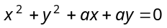 (b) 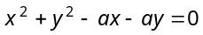
(c) 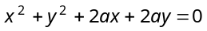 (d) 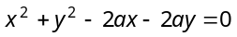
- The two points A and B in a plane are such that for all points P lies on circle satisfied 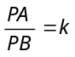, then k will not be equal to [IIT 1982]
(a) 0 (b) 1
(c) 2 (d) None of these
- The abscissae of A and B are the roots of the equation 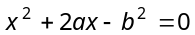 and their ordinates are the roots of the equation 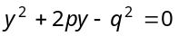. The equation of the circle with AB as diameter [IIT 1984]
(a) 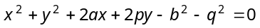
(b) 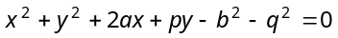
(c) 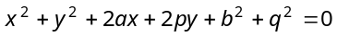
(d) None of these
- If 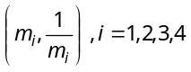are con-cyclic points, then the value of 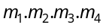is [Karnataka CET 2002]
(a) 1 (b) – 1
(c) 0 (d) None of these
- Tangents are drawn from the point (4, 3) to the circle 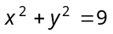. The area of the triangle formed by them and the line joining their points of contact is
[MP PET 1991; IIT 1981, 87]
(a) 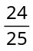 (b) 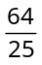
(c) 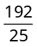 (d) 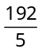
- If the tangent to the circle 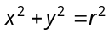at the point (a, b) meets the coordinate axes at the point A and B, and O is the origin, then the area of the triangle OAB is
(a) 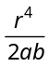 (b) 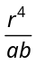
(c) 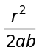 (d) 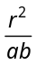
- The co-ordinates of the point from where the tangents are drawn to the circles 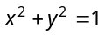, 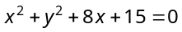 and 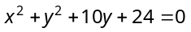 are of same length, are
[Roorkee 1982]

(a) 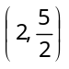 (b) 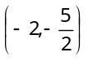
(c) 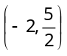 (d) 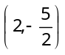
- The tangents are drawn from the point (4, 5) to the circle 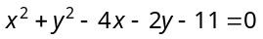. The area of quadrilateral formed by these tangents and radii, is
[IIT 1985]
(a) 15 sq. units (b) 75 sq. units
(c) 8 sq. units (d) 4 sq. units
- The number of common tangents to the circles 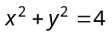and 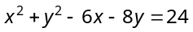is [IIT 1998]
(a) 0 (b) 1
(c) 3 (d) 4
- Line 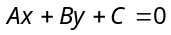 cuts circle 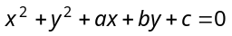 in P and Q and the line 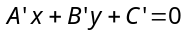 cuts the circle 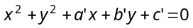 in R and S. If the four points P, Q, R and S are con-cyclic, then 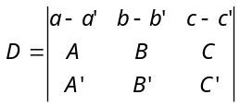=
[Roorkee 1986]
(a) 1 (b) 0
(c) – 1 (d) None of these
- The equation of the circle which touches the circle 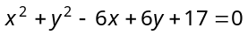externally and to which the lines 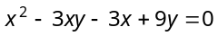are normals, is [Roorkee 1994]
(a) 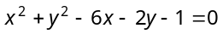
(b) 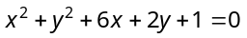
(c) 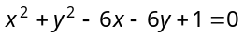
(d) 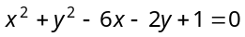
- If the line 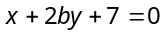 is a diameter of the circle 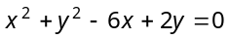, then [MP PET 1991]
(a) 3 (b) – 5
(c) –1 (d) 5
- If the circle 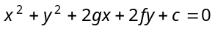 touches x-axis, then
(a) 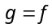 (b) 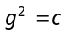
(c) 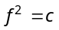 (d) 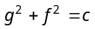
- The equation of the circle which passes through the points (2, 3) and (4, 5) and the centre lies on the straight line 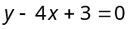, is [RPET 1985; MP PET 1989]
(a) 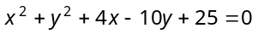
(b) 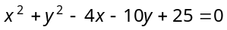
(c) 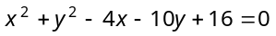
(d) 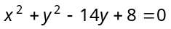
- The equation of the circle concentric with the circle 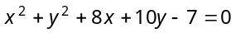 and passing through the centre of the circle 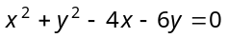 is
(a) 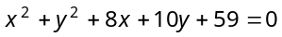
(b) 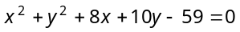
(c) 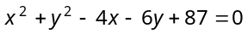
(d) 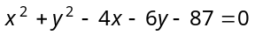
- The equation 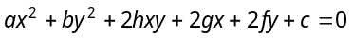 will represent a circle, if
[MNR 1979; MP PET 1988; RPET 1997, 2003]
(a) and (b) 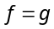 and
(c) and (d) and
- A circle passing through 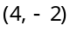 is concentric to the circle 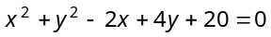, then the value of c will be
[RPET 1984, 86]
(a) – 4 (b) 4
(c) 0 (d) 1
- The line 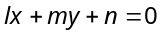will be a tangent to the circle 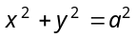iff [MNR 1974; AMU 1981]
(a) 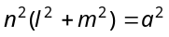 (b) 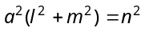– 4
(c)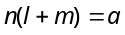 (d) 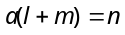
- The condition of the curves 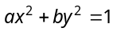and 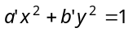to intersect each other orthogonally, is
(a) 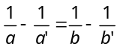 (b) 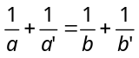
(c) 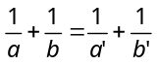 (d) None of these
- If two circles 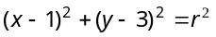 and 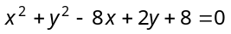 intersect in two distinct points, then [IIT 1989; Karnataka CET 2002;
DCE 2000, 01; AIEEE 2003; MP PET 2004]
(a) (b)
(c) (d)
- If circles 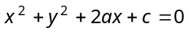and 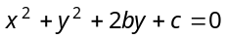 touch each other, then [MNR 1987]
(a) 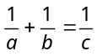 (b) 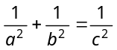
(c) 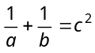 (d) 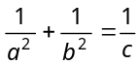
24. The equation 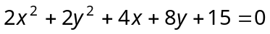
represents
(a) A pair of straight lines (b) A circle
(c) An ellipse (d) None of these
- The equation of a circle passing through the point (4, 5) having the centre at (2, 2) is
(a) 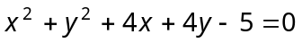
(b) 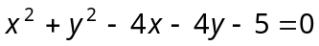
(c) 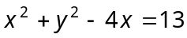
(d) 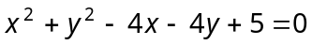
- The equation of circle whose centre lies on 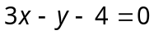 and 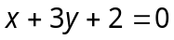 and has an area 154 square units is
(a) 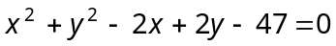
(b) 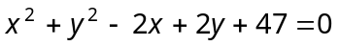
(c) 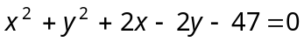
(d) None of these
- The centre of a circle is 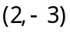 and the circumference is 10π. Then the equation of the circle is
(a) 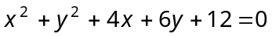
(b) 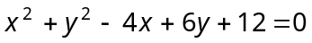
(c) 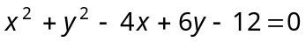
(d) 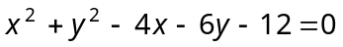
- The circle 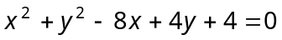 touches
(a) x-axis only
(b) y-axis only
(c) Both x and y-axis
(d) Does not touch any axis
- The length of the chord joining the points in which the straight line 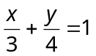 cuts the circle 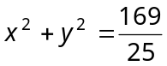 is
(a) 1 (b) 2
(c) 4 (d) 8
- The length of the common chord of the circles 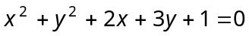 and 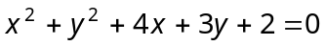 is
(a) 9/2 (b) 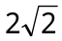
(c)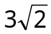 (d) 3/2
- The equation of the circle which passes through the intersection of 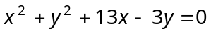 and 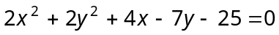 and whose centre lies on 13x + 30y = 0
(a) 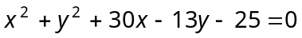
(b) 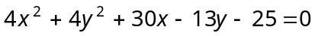
(c) 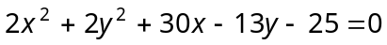
(d) 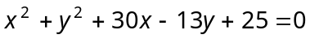
- If the two circles 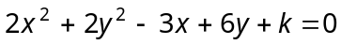 and 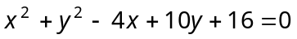 cut orthogonally, then the value of k is
(a) 41 (b) 14
(c)4 (d) 0
- The square of the length of the tangent from 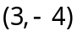 on the circle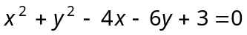 is
(a) 20 (b) 30
(c) 40 (d) 50
- The equation of three circles are 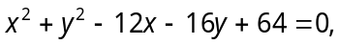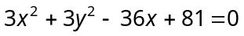 and 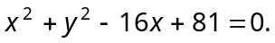 The coordinates of the point from which the length of tangent drawn to each of the three circle is equal to
(a) (33/4, 2) (b) (2, 2)
(c) (2, 33/4) (d) None of these
- The two circles 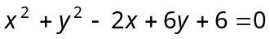 and 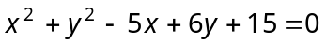 touch each other. The equation of their common tangent is
(a) x = 3 (b) y = 6
(c)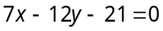 (d) 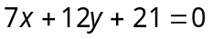
- If the circles 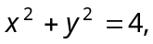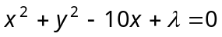 touch externally, then is equal to
(a) – 16 (b) 9
(c) 16 (d) 25
- The centre of circle inscribed in square formed by the lines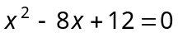 and 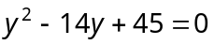, is
(a) (4, 7) (b) (7, 4)
(c) (9, 4) (d) (4, 9)
- Position of the point (1, 1) with respect to the circle 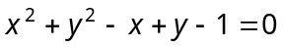 is
(a) Outside the circle (b) Upon the circle
(c) Inside the circle (d) None of these
- The equation of circle passes through the points of intersection of circles 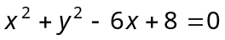 and 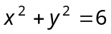 and point (1, 1) is
(a) 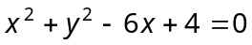
(b) 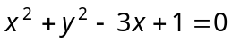
(c) 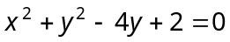
(d) None of these
- The intercept on the line 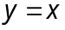 by the circle 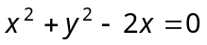 is AB. Equation of the circle with AB as a diameter is
(a) 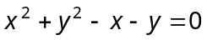
(b) 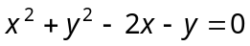
(c) 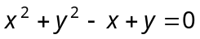
(d) 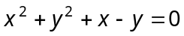
- The two points A and B in a plane such that for all points P lies on circle satisfied 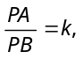 then k will not be equal to [IIT 1982]
(a) 0 (b) 1
(c) 2 (d) None of these
- A circle has radius 3 units and its centre lies on the line 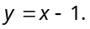 Then the equation of this circle if it passes through point (7, 3), is
[Roorkee 1988]
(a) 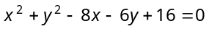
(b) 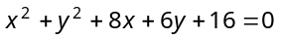
(c) 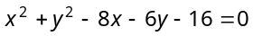
(d) None of these
- The area of the circle whose centre is at (1, 2) and which passes through the point (4, 6) is
[MNR 1982; IIT 1980; Karnataka CET 1999; MP PET 2002; DCE 2000]
(a) 5π (b) 10π
(c) 25π (d) None of these
- If a circle passes through the point (0, 0), (a, 0), (0, b), then its centre is [MNR 1975]
(a) (a, b) (b) (b, a)
(c) 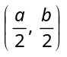 (d) 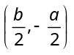
- If 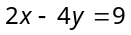 and 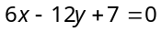 are the tangents of same circle, then its radius will be [Roorkee 1995]
(a) 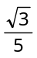 (b) 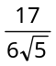
(c) 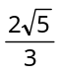 (d) 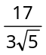
Ansewer sheet
1 | 2 | 3 | 4 | 5 | 6 | 7 | 8 | 9 | 10
d | a | b | b | a | a | c | a | b | c
11 | 12 | 13 | 14 | 15 | 16 | 17 | 18 | 19 | 20
b | b | d | d | b | b | b | c | a | b
21 | 22 | 23 | 24 | 25 | 26 | 27 | 28 | 29 | 30
a | a | d | d | b | a | c | b | b | b
31 | 32 | 33 | 34 | 35 | 36 | 37 | 38 | 39 | 40
b | c | c | d | a | a | a | a | b | a
41 | 42 | 43 | 44 | 45
b | a | c | c | b

