1 Dinari sells fruit and vegetables.
(a) One day the mass of fruit and vegetables he sells is in the ratio fruit : vegetables = 9 : 8.
He sells 48 kg of vegetables.
Find the mass of the fruit he sells.
............................................ kg [2]
(b) On another day he receives $280 for the fruit and vegetables he sells.
The $280 is in the ratio fruit : vegetables = (c + 3) : (c – 1).
Find the amount he receives from selling the fruit.
$ ................................................. [3]
(c) In one week Dinari buys fruit and vegetables for $1620.
He sells the fruit and vegetables for $1750.
Calculate his percentage profit.
.............................................. % [2]
(d) In another week Dinari sells fruit and vegetables for $1738.
He makes a profit of 10%.
Calculate the amount he paid for the fruit and vegetables in that week.
$ ................................................. [2]

2 (a) A is the point (3, 7) and B is the point ( – 1, 5).
(i) Find the coordinates of the midpoint of the line AB.
( ...................... , ...................... ) [2]
(ii) Write as a column vector.
(iii)
Find the coordinates of C.
( ...................... , ...................... ) [2]
(b)
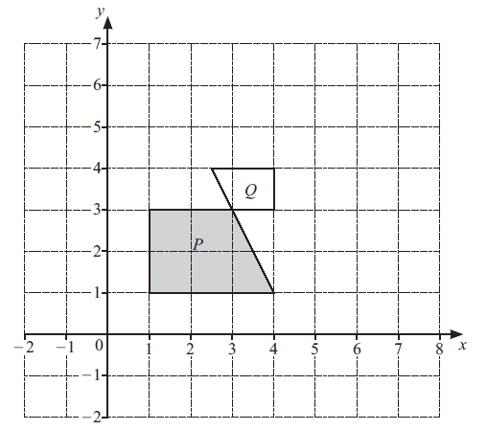

(i) Rotate shape P through 180° about the point (4, 1). [2]
(ii) Reflect shape P in the line y = x + 2.
(iii) Describe fully the single transformation that maps shape P onto shape Q.
.............................................................................................................................................
............................................................................................................................................. [3]

3 (a) Ed invests $500 in an account paying r % per year simple interest.
At the end of 14 years the total amount in Ed’s account is $675.
Find the value of r.
r = ................................................ [3]
(b) Eva invests $400 at a rate of 2.2% per year compound interest.
Calculate the total interest earned at the end of 11 years.
$ ................................................. [3]
(c) Erin invests $700 at a rate of p% per month compound interest.
At the end of 21 years the value of Erin’s investment is $1074, correct to the nearest dollar.
Calculate the value of p.
p = ................................................ [3]
4 (a) A box contains 50 cuboids.
Each cuboid has a mass of 135 g.
The total mass of the cuboids and the box is 7 kg.
Calculate the mass of the box.
Give your answer in grams.
............................................... g [2]
(b) A solid cube of side 4 cm is fixed to the base inside an empty cube of side 6 cm.
Water is poured into the larger cube until it reaches the top of the smaller cube.
Calculate the amount of water poured into the larger cube.
.......................................... cm³ [2]
(c)
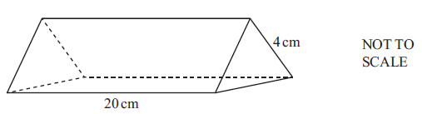

The diagram shows a solid triangular prism of length 20 cm.
The cross – section is an equilateral triangle with side length 4 cm.
The prism is made of wood with a density of 0.85 g/cm3 .
Calculate the mass of the prism.
[Density = mass ÷ volume]
............................................... g [4]

(d)
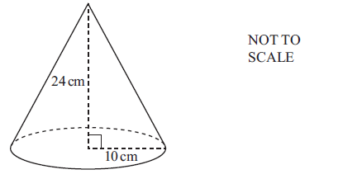
The diagram shows a solid cone with base radius 10 cm and height 24 cm.
(i) Show that the total surface area of the cone is 1131 cm2 , correct to the nearest cm² .
[The curved surface area of a cone with base radius r and slant height l is
(ii) The total surface area of the cone is painted.
(a) The cost to paint the cone is $1.71 .
Calculate the cost to paint 1 cm2 of the cone.
Give your answer in cents.
........................................ cents [1]
(b) One tin of paint has enough paint to cover 2.5 m².
Calculate the number of these cones that can be painted completely using one tin of paint.
................................................. [2]

5 (a) Naomi runs 100 m in 15 seconds.
Calculate Naomi’s average speed in kilometres per hour.
......................................... km/h [2]
(b) Olav runs for 45 minutes at a speed of 9.5 km/h.
He then runs 8.1 km at a speed of 7.5 km/h.
Calculate Olav’s average speed for the whole run.
.......................................... km/h [3]
(c) A train has length p metres.
The train passes through a station of length q metres.
The speed of the train is v kilometres per hour.
Find an expression for the time the train takes to completely pass through the station.
Give your answer in seconds, in terms of p, q and v.
............................................... s [3]
6 (a) Simplify $\frac{24u}{5y}×\frac{10}{3u}$
................................................. [2]
(b) Expand and simplify (x – 1) (x + 2) (x + 3) .
................................................. [3]
(c) Solve the equation 2x² + x – 5 = 0 .
You must show all your working and give your answers correct to 2 decimal places.
x = ............................ or x = ............................ [4]

7 (a) (i)
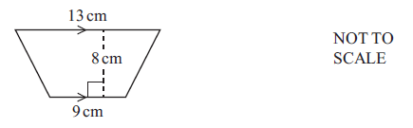

Calculate the area of the trapezium.
.......................................... cm² [2]
(ii)
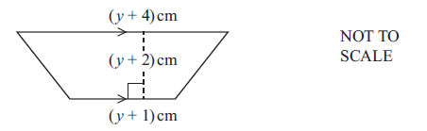
The area of this trapezium is 264 cm² .
(a) Show that 2y² + 9y – 518 = 0 .
(b) Solve 2y² + 9y – 518 = 0 by factorisation to find the value of y.
y = ................................................ [3]
(b)
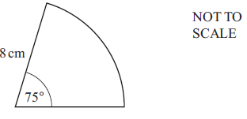
The diagram shows a sector of a circle with radius 8 cm and angle 75°.
Find the perimeter of the sector.
............................................ cm [3]
(c)
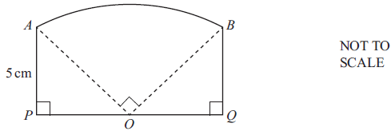
The diagram shows a shape ABQP made from three straight lines and an arc of a sector of a circle.
The sector has centre O and angle 90°.
POQ is a straight line and AP = PO = OQ = QB = 5 cm.
Find the area of ABQP.
Give your answer in the form a + kπ.
.......................................... cm² [4]

8 Guillaume measures the speed of each of 100 cars.
The results are shown in the table.

Speed (v km/h)
Frequency | 15 | 20 | 35 | 30

(a) Guillaume draws a pie chart for this data.
Calculate the angle for the interval
................................................. [2]
(b) Calculate an estimate of the mean speed.
......................................... km/h [4]
(c) Complete the histogram to show the data in the table.
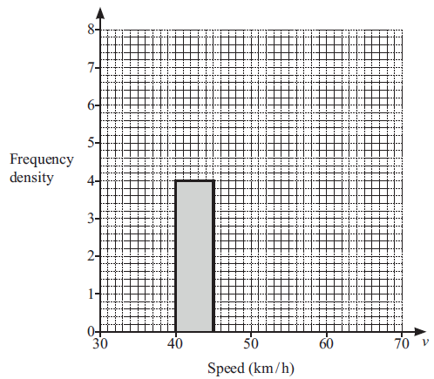
9
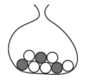
A bag contains 5 white balls and 3 black balls.
(a) (i) Marwan picks a ball from the bag at random and then replaces it.
Find the probability that the ball is white.
................................................. [1]
(ii) Naomi picks a ball from the bag at random and then replaces it.
She repeats this 120 times.
Find the number of times the ball is expected to be white.
................................................. [1]
(b) Oscar picks a ball from the bag at random.
He replaces it and then picks a second ball from the bag at random.
(i) Find the probability that the balls are the same colour.
................................................. [3]
(ii) Find the probability that the balls are not the same colour.
................................................. [1]
(c) Priya picks 3 of the 8 balls from the bag at random without replacement.
Find the probability that she picks two white balls and one black ball.
................................................. [3]

10.
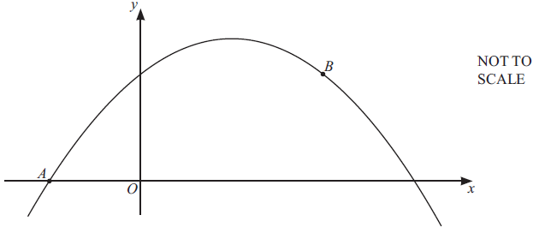
The diagram shows a sketch of the graph of y = 3 + 2x – x² .
A is the point ( – 1, 0) and B is the point (2, 3).
(a) Find the derivative of 3 + 2x – x² .
................................................. [2]
(b) (i) Show that the equation of the tangent at A is y = 4x + 4 .
(ii) The line L is perpendicular to the line y = 4x + 4 .
The line L passes through the point B.
Find the equation of the line L.
Give your answer in the form y = mx+c.
y = ..............................................
(c) Find the coordinates of the maximum point on the graph of y = 3 + 2x – x² .
( ...................... , ...................... ) [3]
11
(a) Find g( – 3).
................................................. [1]
(b) Find f (x) g(x) + fg(x) +1.
Give your answer in its simplest form.
................................................. [4]
(c) Find g^{–1} (x).
g^{–1} (x) = ................................................ [2]
(d) Find hh(1).
................................................. [2]
(e) Simplify
Give your answer as a single fraction in its simplest form.
................................................. [3]
(f) Find x when
x = ................................................ [1]
(g) Find x when j^{–1} (x) = 0.
x = ................................................ [1]

12
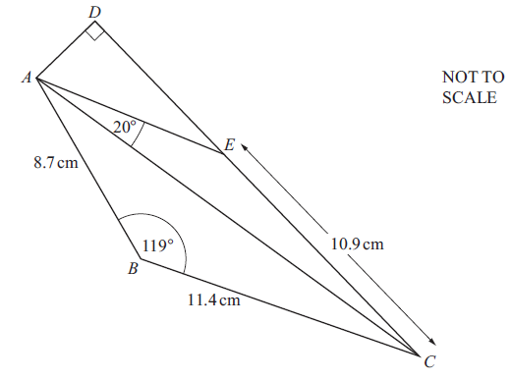

ABCD is a quadrilateral and E is a point on CD.
AB = 8.7 cm, BC = 11.4 cm and CE = 10.9 cm.
Angle ADE = 90°, angle ABC = 119° and angle CAE = 20°.
(a) Show that AC = 17.37 cm, correct to 2 decimal places.
(b) Angle AEC is obtuse.
Calculate angle ACE.
Angle ACE = ................................................ [4]
(c) Calculate the perimeter of quadrilateral ABCD.
............................................ cm [3]

