CPS209 Assignment 1:

Daily Appointment Calendar

Due Date: Mon., Mar. 20 11:59pm

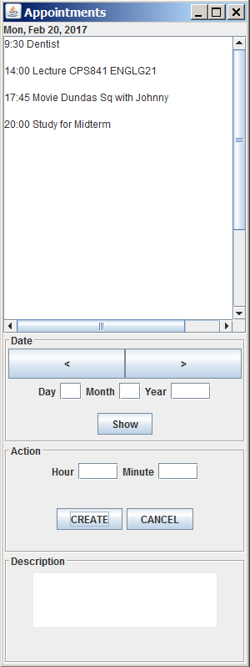

You are to write a Daily Appointment Calendar program. This programming assignment will increase your knowledge of objects and classes, inheritance, interfaces, and GUIs. You must do this assignment alone – no groups. Do not attempt to find source code on the web for this assignment. It will not help you and you risk extremely serious consequences. Your program will be checked for plagiarism. Begin designing and programming early! This assignment is worth 10 percent of your mark. If there is some part of the assignment you do not understand, please see me (or email me) or ask me in the lecture as soon as possible and I will clarify the issue.

Program Functionality Requirements:

I am posting two example programs along with the assignment. One is the FontViewer GUI program we studied in class. It is also presented in chapter 11 of the textbook. The other is the InvestmentViewer3 Program. I strongly urge you to use these programs as a guide, especially for building the GUI of your appointment calendar program. I am also providing the main viewer class for your program called AppointmentViewer. Finally, I am posting a program CalendarTester that shows you how to use the Java Calendar class and the SimpleDateFormat class.

Create a class Appointment. Class Appointment should contain instance variables date (of type Calendar) and description (of type String). Don’t forget to make an object of type GregorianCalendar in the constructor method and set date to point to it. Here are some suggested methods for class Appointment:

A constructor method that takes a year, month, day, hour, minute and description parameters and sets the date and description instance variables. See the of CalendarTester program.

Get and Set methods for the instance variables (i.e. getDescription() etc.)

A print method that returns a string containing the appointment time (hour and minute) and the appointment description.

A method occursOn that takes a year, month, day, hour, minute as parameters and checks to determine if this appointment is on the same day and time. Returns true or false.

Class Appointment should implement the Comparable interface. You should be able to compare two appointment object based on their calendar date.

Create a custom JFrame for your program called AppointmentFrame. Your frame should have 3 main panels (I suggest you use a Border Layout):

Create a JLabel component and put it in the NORTH part of the frame. This is where you will display the current date using the Calendar class and the SimpleDateFormat class. I suggest you create a calendar instance variable in class AppointmentFrame as well as a SimpleDateFormat instance variable. Create objects of Calendar and SimpleDateFormat in the constructor method of AppointmentFrame. See the CalendarTester example.

Create a reference instance variable called appointments that refers to an ArrayList of Appointment objects (see class Appointment below). Don’t forget to create the ArrayList object in the constructor method. This array list will hold all your appointment objects.

Create a JTextArea object and add it to the CENTER part of the frame. Make it scrollable. This is where the appointments for the current day will be displayed.

Make a control panel (JPanel) object and add it to the SOUTH part of the frame. Details of the control panel are described below:

Control Panel: the control panel should consist of 3 subpanels. See the figure above.

The date subpanel has buttons “>” and “<”. When these buttons are pressed, the date should change to the next day or the previous day, respectively, and the appointments for that day printed. You’ll need to create JButton objects and create helper classes that implement the ActionListener interface, where the action perfomed methods update the current date and display it in the date JLabel. The date subpanel also contains 3 JTextFields, one for for entering the day, one for entering the month and one for year. The user types in the day, month, year and then presses the SHOW button to change (and display) the current date and appointments.

An action subpanel contains JTextFields for entering the hour and minute of the appointment. If the user doesn’t enter a minute, assume 0 minutes. The hour is entered as a 24 hour clock (i.e. 0 to 23). Once the user has entered the hour and minute, they can press the CREATE button and a new appointment object is created (using the appointment description entered in the JTextArea of the description subpanel). Or they can press the CANCEL button to cancel an existing appointment for the current day at the time entered (if one exists). You will need to create helper classes that implement the ActionListener interface for the CREATE and CANCEL buttons.

For some of your subpanels, you may want to use layouts like the Grid layout. Use nested panels to put your components into (buttons, labels etc) and add these panels to your subpanels. See the FontViewer program.

Other suggested methods for class AppointmentFrame:

printAppointments: uses the current day, month, year and goes through the arraylist of appointments. If one of the appointment objects occurs on the current day,month,year then print it in the main textArea

findAppointment: is passed a year, month, day, hour and minute and goes through the list of appointments to find one that has the same date and time. If one is found, return it otherwise return null. Or return true/false instead.

createAppointment: takes the current year, month, day, and the hour, minute entered by the user and checks to see if an appointment already exists at this time. If so, prints “CONFLICT!!” in the description textarea. If not, then creates a new appointment object, adds it to the appointments arraylist, sorts the arraylist and prints it.

cancelAppointment: determines if an appointment exists for the current day,month,year and entered hour, minute. If so, removes it from the appointments arraylist, sorts the arraylist and prints the arraylist.

Make sure you comment your code. I strongly urge you to use JavaDoc.

Grading (Out of 10 marks)

Current date label, appointment text area, and date subpanel working (user can use “>” and “<” to advance to the next or previous day’s appointments or user can enter a date and press SHOW). Several random appointment objects are created by you and added to the appointments array list. These are printed in the main text area. | Maximum 5 marks
Everything above plus the Action and Description subpanels. User can enter an hour and minute and press CREATE. The new appointment appears in the main text area. The user can view other days and see the appointments. The array list of appointments is used correctly. | Maximum 7 marks
Everything above plus the appointments are sorted by time correctly for the current day (using Collections.sort of the appointments array list). If the user attempts to make an appointment that conflicts with an existing appointment on the current day, “CONFLICT!!” is printed in the description text area. | Maximum 8 marks
Everything above plus the user can cancel appointments. Array list of appointments used correctly. | Maximum 10 marks

Submitting Your Assignment
- Use D2L to submit your assignment.
- Inside each of your “.java” files have your name and student id as comments at the top of the file. Make sure your files can be compiled as is without any further modification!!
- Include a README.txt file that describes what aspects of your program works and what doesn't work (or partially works). If your program does not compile, state this.
- Place all your “.java” file(s) and README.txt file into an archive (zip or rar archiving format only).
- Open your archive and make sure your all your files are there.
- Do not include ".class" files!!!!
- Once everything is ready, submit it.

