WC-1 in encoder init
if wc == 1 : # 3 conv channels with wc
wc_net = Convolution2D(3, [nb_row, nb_col], padding='same', strides=conv_stride)(inp)
_,w,h,c = wc_net.shape
wc_net = get_wc_model(in_shape=[w,h,c])(wc_net)
nb_filter -= 3
merged += [wc_net]

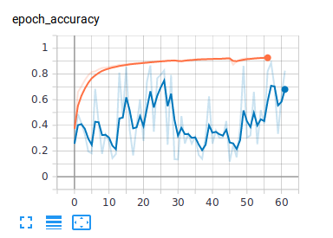
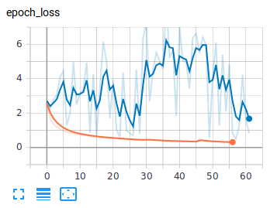

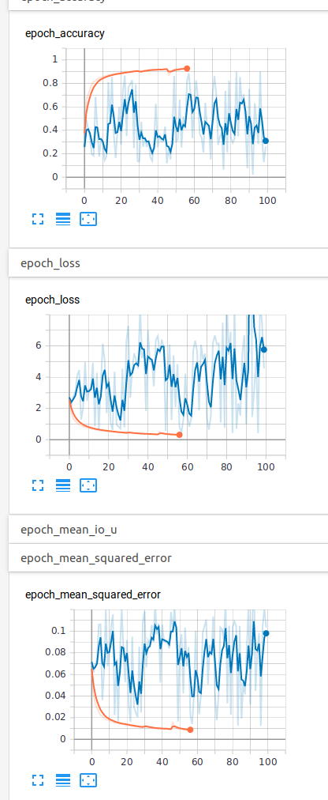



As a regularization added spetial drop_out (20%) after WC_1 layer:
Epoch 34/100
2126/11829 [====>.........................] - ETA: 24:36 - loss: 0.6004 - accuracy: 0.8297 - mean_squared_error: 0.0184 - mean_io_u: 0.4618 - precision: 0.8981

def initial_block(inp, nb_filter=13, nb_row=3, nb_col=3, conv_stride=(2, 2), wc=None):
merged = []
#---- WC 1 added ----------
if wc == 1 : # 3 conv channels with wc
wc_net = Convolution2D(3, [nb_row, nb_col], padding='same', strides=conv_stride)(inp)
_,w,h,c = wc_net.shape
wc_net = get_wc_model(in_shape=[w,h,c])(wc_net)
dropout_rate = 0.2
wc_net = SpatialDropout2D(dropout_rate)(wc_net)

nb_filter -= 3
merged += [wc_net]

#-----------
conv = Convolution2D(nb_filter, [nb_row, nb_col], padding='same', strides=conv_stride)(inp)
max_pool = MaxPooling2D()(inp)

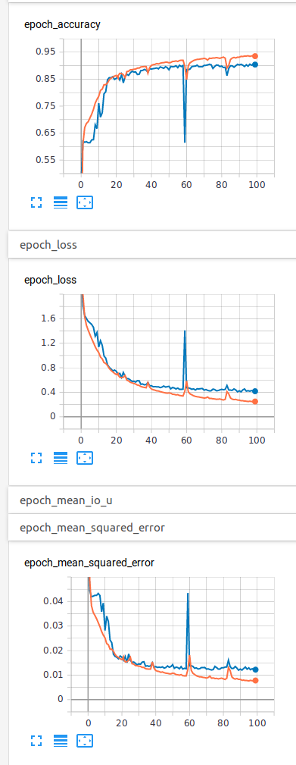

WC_2 without drop_out:

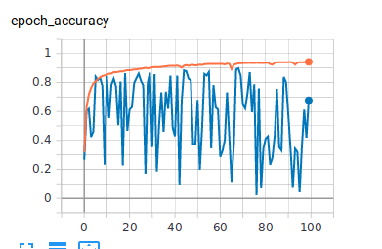
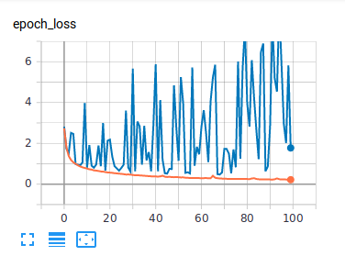

#---- WC 2 added ----------
if wc == 2 : # 3 maxpull channels with wc
wc_net = max_pool
_,w,h,c = wc_net.shape
wc_net = get_wc_model(in_shape=[w,h,c])(wc_net)
max_pool = wc_net
#-----------
merged += [conv, max_pool]
merged = Concatenate(axis=3)(merged)

101/101 [==============================] - 10s 99ms/step - loss: 0.3728 - accuracy: 0.9104 - mean_squared_error: 0.0113

test loss, test acc: [0.37284947356375137, 0.9103516, 0.011265197]

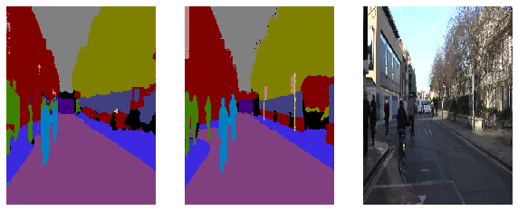
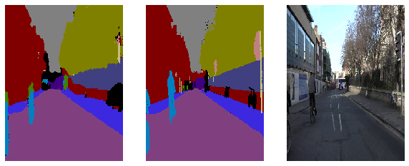
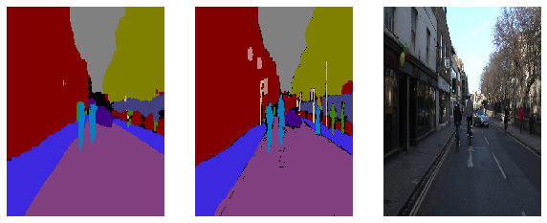
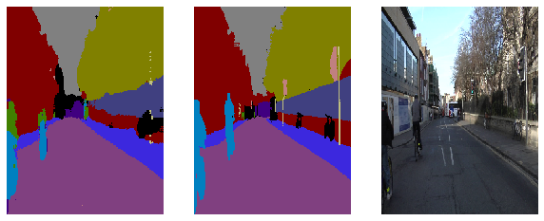

Enet without WC:

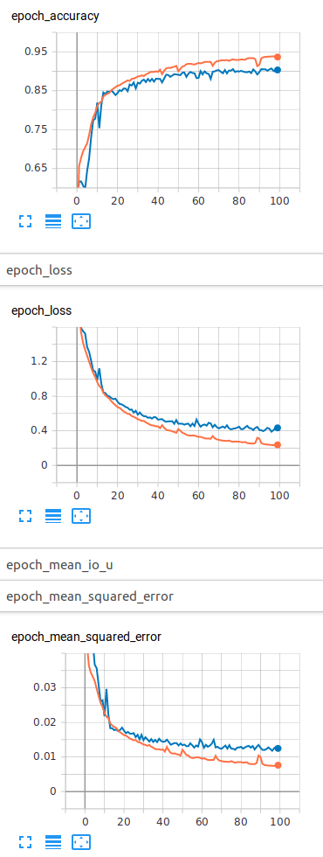

Epoch 00100: val_loss did not improve from 0.37801
100/100 [==============================] - 49s 493ms/step - loss: 0.2257 - accuracy: 0.9413 - mean_squared_error: 0.0071 - mean_io_u: 0.4583 - precision: 0.9521 - val_loss: 0.4355 - val_accuracy: 0.8942 - val_mean_squared_error: 0.0137 - val_mean_io_u: 0.4583 - val_precision: 0.9053

1/1 [==============================] - 1s 1s/step - loss: 0.4571 - accuracy: 0.8881 - mean_squared_error: 0.0145 - mean_io_u: 0.4583 - precision: 0.8994

test loss, test acc: [0.45710012316703796, 0.88805926, 0.014455681, 0.45833507, 0.89940727]

Laplace matrix:
MemoryError: Unable to allocate array with shape (246, 45756, 186) and data type float64

GForce 1080 succeeded with:
lpl shape is (12096, 12096)

python enet_keras_wc_train_camvid.py --model_name enet_wc_in_decoder_1_lpl --wc_in_decoder 1 --wc_lpl_mat 1 --wc_activation "tanh"

Epoch 00100: val_loss did not improve from 0.38489
100/100 [==============================] - 82s 818ms/step - loss: 0.3019 - accuracy: 0.9186 - mean_squared_error: 0.0098 - mean_io_u: 0.4583 - precision: 0.9356 - val_loss: 0.5247 - val_accuracy: 0.8718 - val_mean_squared_error: 0.0162 - val_mean_io_u: 0.4583 - val_precision: 0.8941

coco dataset:
Epoch 34/100
2126/11829 [====>.........................] - ETA: 24:36 - loss: 0.6004 - accuracy: 0.8297 - mean_squared_error: 0.0184 - mean_io_u: 0.4618 - precision: 0.8981

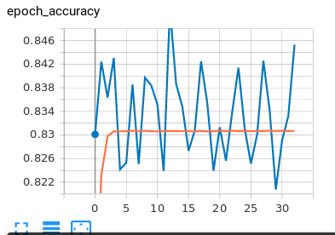
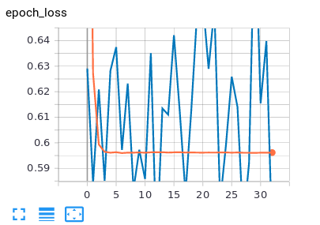
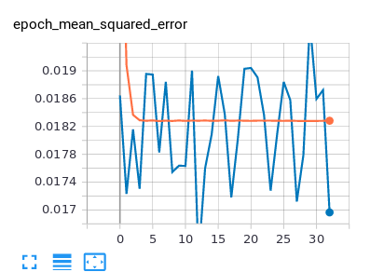

adam optimizer 37 epochs with weighted calsses enet_best2
cw_d = {0: 0.0, 1: 0.05, 2: 0.1, 3: 0.05, 4: 0.05, 5: 0.1, 6: 0.3, 7: 0.1, 8: 0.1, 9: 0.6, 10: 0.05, 11: 0.05, 12: 0.2 }

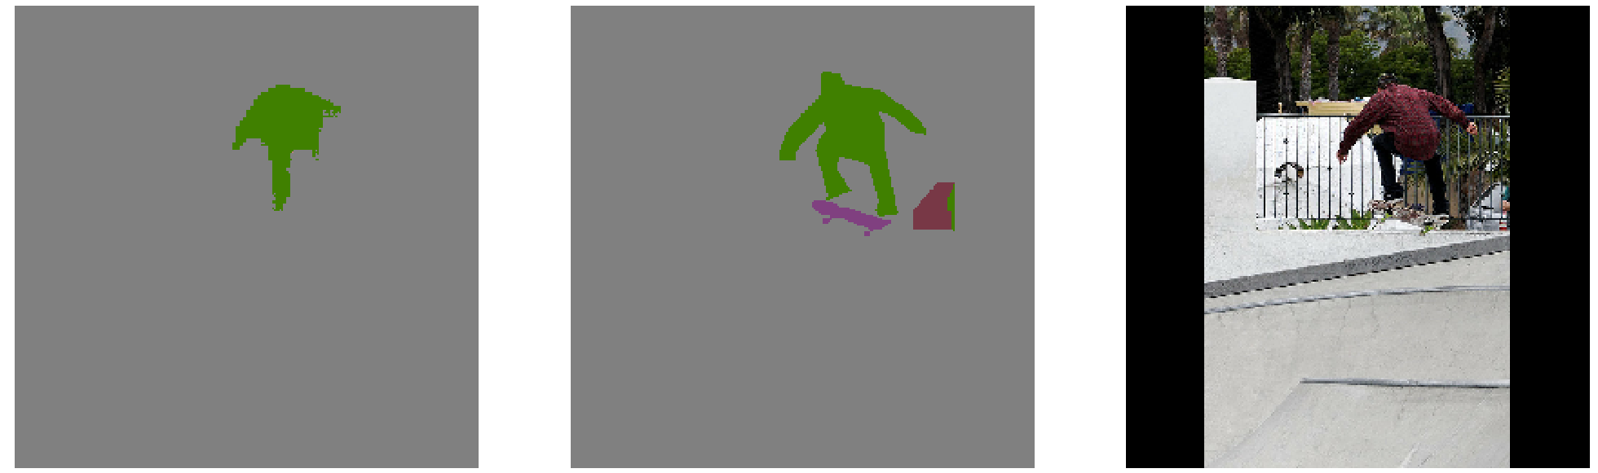


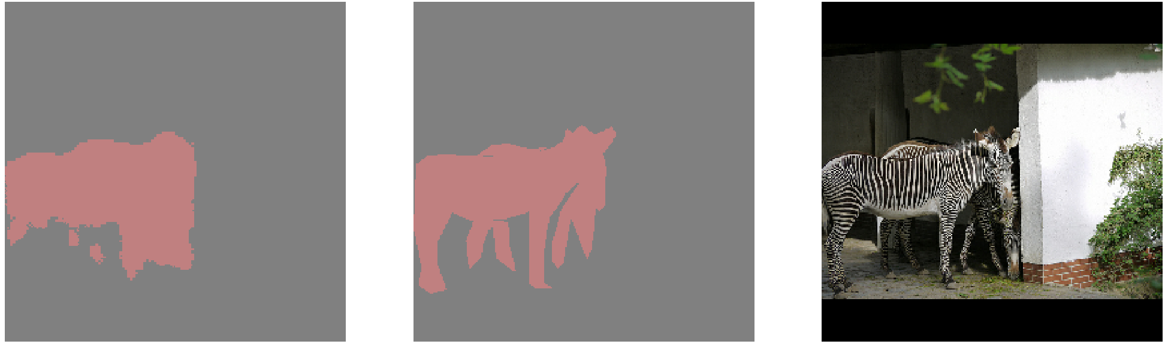
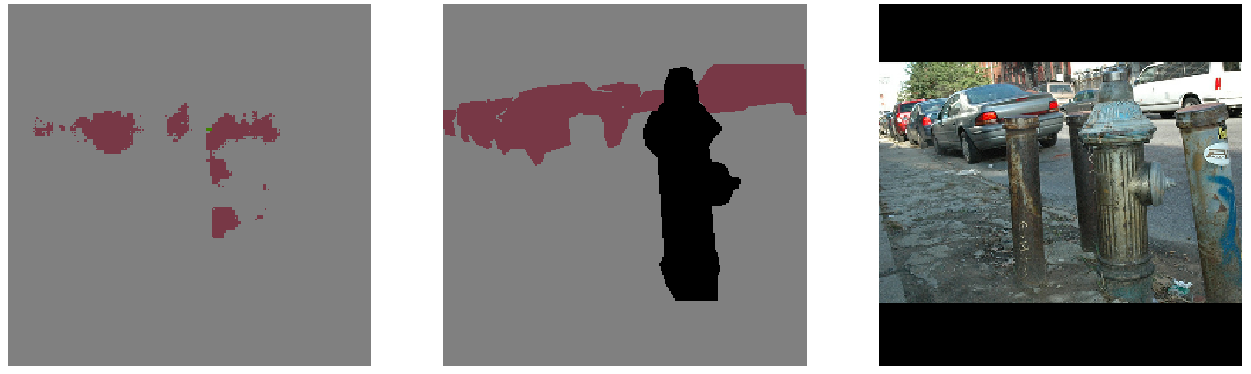

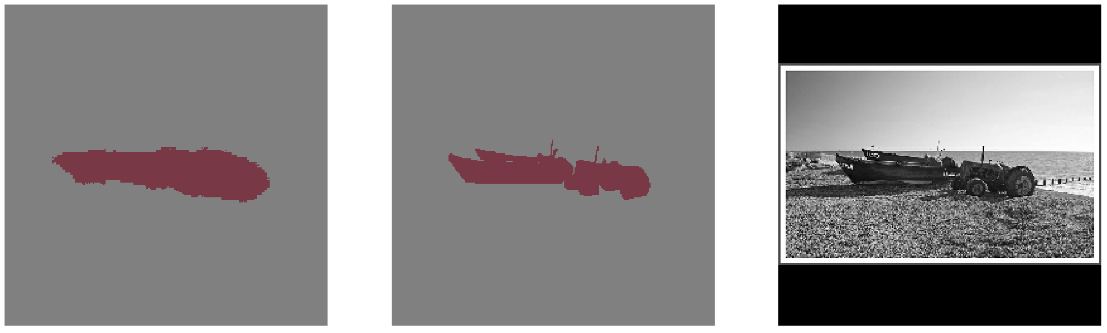

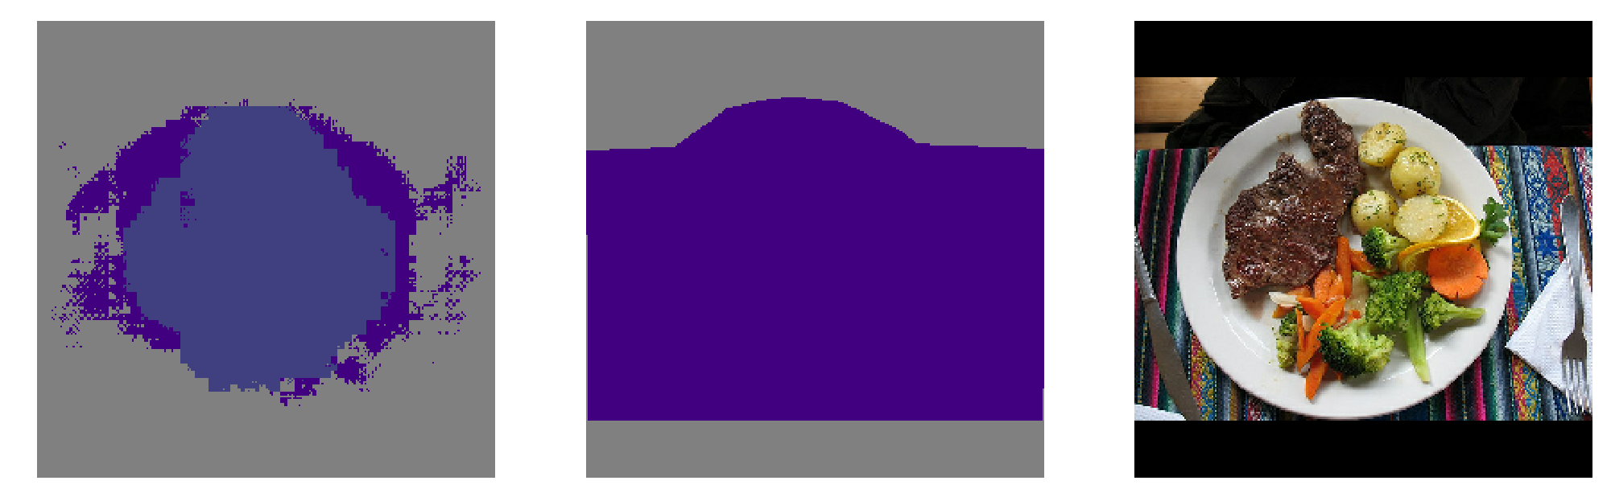

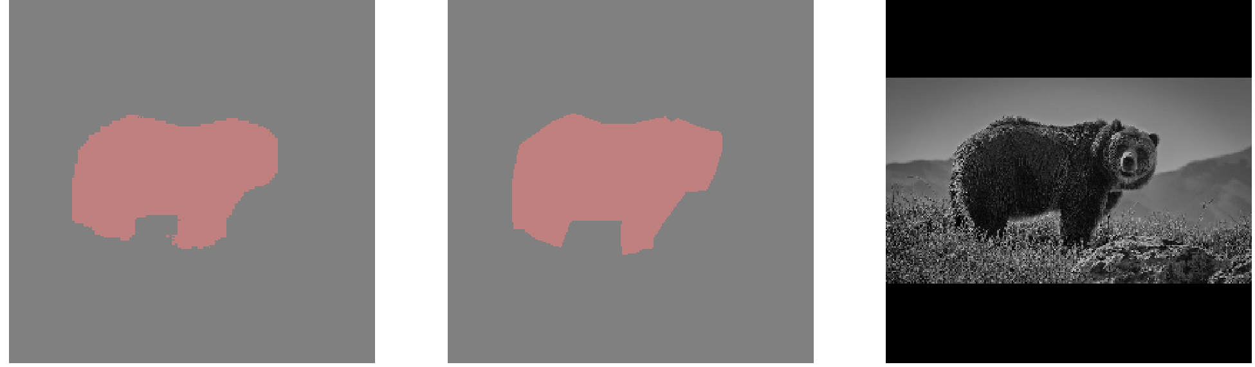



batche 10 -> 30 val batch 25 -> 100
optimizer (adam _expDecay) -> adadelta

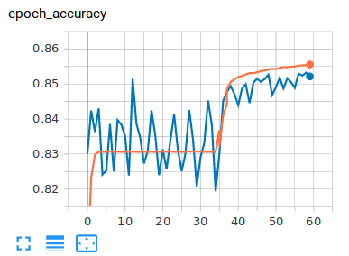
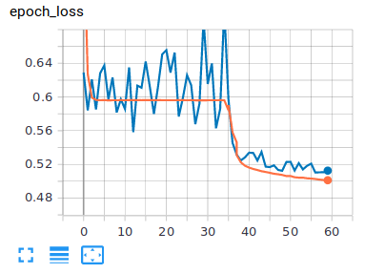
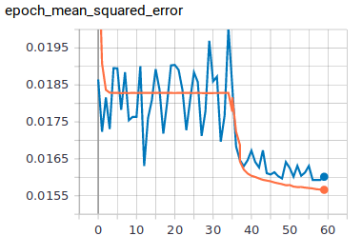

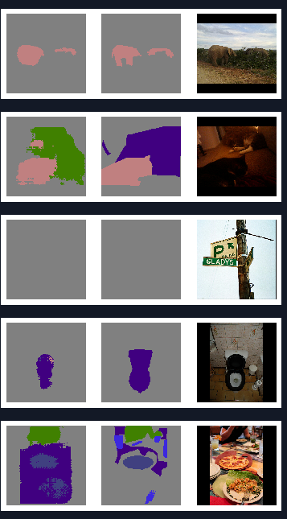
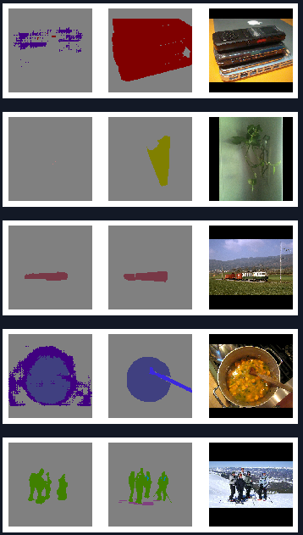

======================
Total params: 2,246,881
Trainable params: 2,238,561
Non-trainable params: 8,320

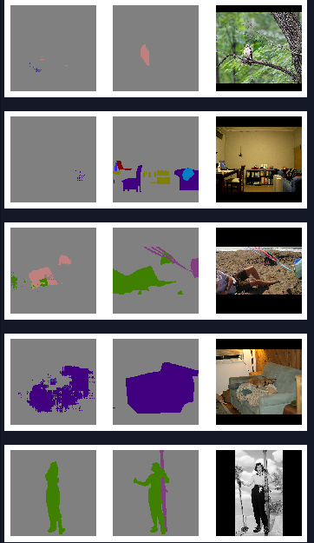

======== ENet clean model ==============

Total params: 2,246,881
Trainable params: 2,238,561
Non-trainable params: 8,320
________________________________________________________________________________
---------- len(model.trainable_variables) ------
trainable_variables #: 365
layers #: 316

======== Encoder WC = 1==============
Total params: 2,247,094
Trainable params: 2,238,774
Non-trainable params: 8,320
________________________________________________________________________________
---------- len(model.trainable_variables) ------
trainable_variables #: 384
layers #: 319

========== Encoder WC = 2 ============
Total params: 2,247,094
Trainable params: 2,238,774
Non-trainable params: 8,320
________________________________________________________________________________
---------- len(model.trainable_variables) ------
trainable_variables #: 382
layers #: 319

=========== Encoder WC = 3 ===========
Total params: 2,247,242
Trainable params: 2,238,922
Non-trainable params: 8,320
________________________________________________________________________________
---------- len(model.trainable_variables) ------
trainable_variables #: 386
layers #: 322

========= Decoder WC = 1 =============
Total params: 2,509,890
Trainable params: 2,501,436
Non-trainable params: 8,454
________________________________________________________________________________
---------- len(model.trainable_variables) ------
trainable_variables #: 389
layers #: 323

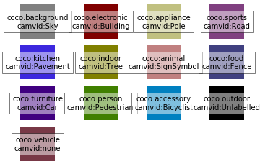

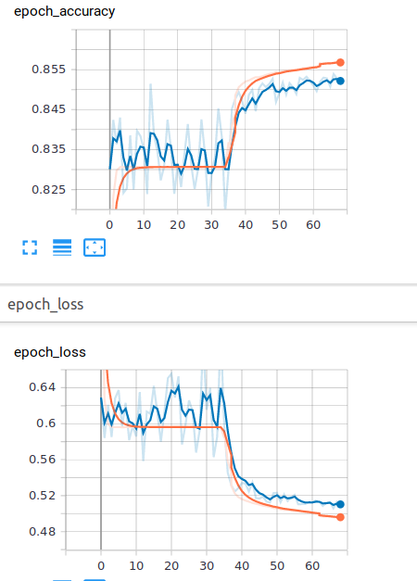

wc1 after weights shairing:
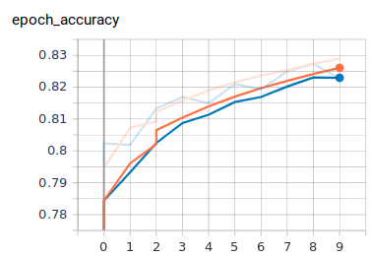
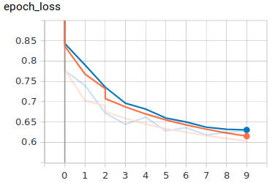

camvid training after pre-training on coco dataset: (no visible improvment of perloading coco tarining )
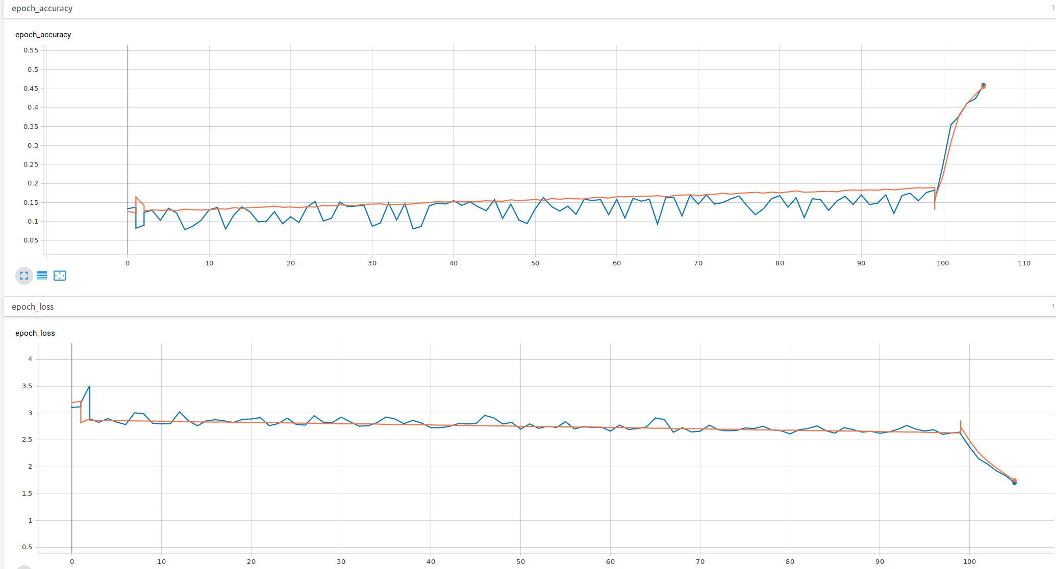

compare models camvid wc1:

no WC WC1
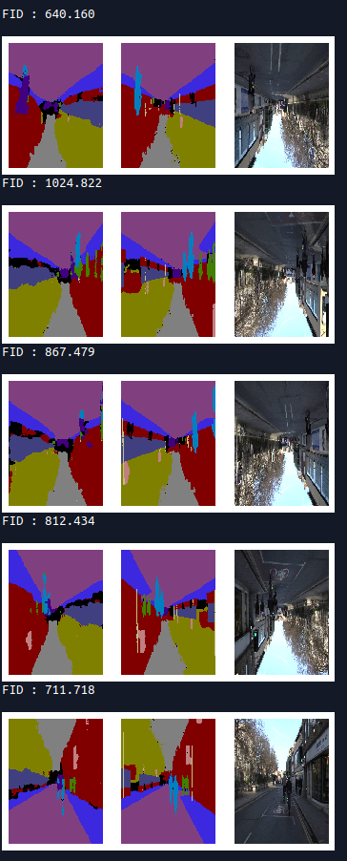
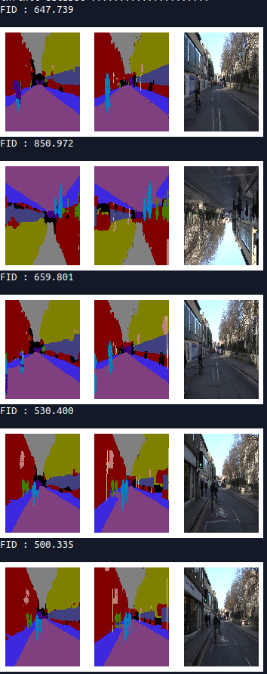

91.6 train acc
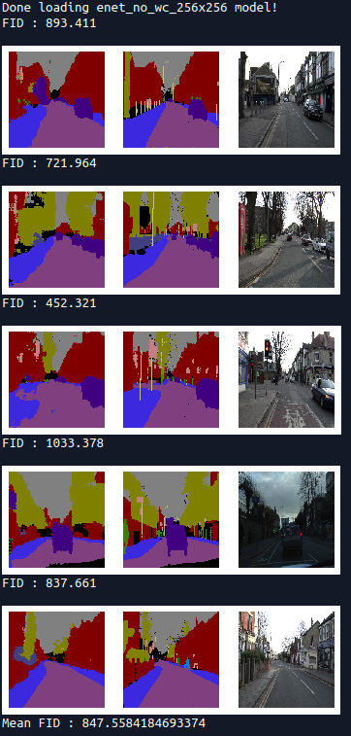

wc_1_256x256 no WC camvid 256x256
enet_wc_in_encoder_1_256x256
Mean FID : 813.0477580472987 on test set Mean FID : 725.607652218166

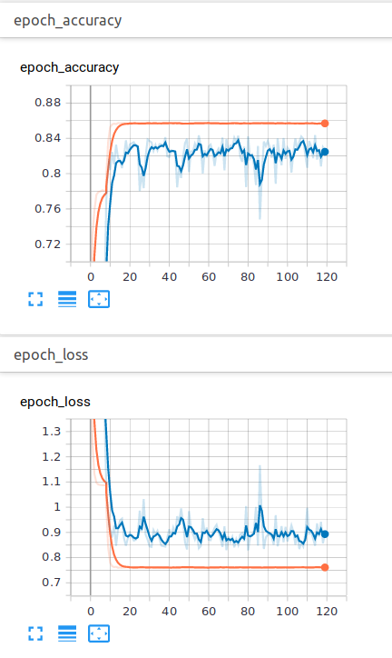
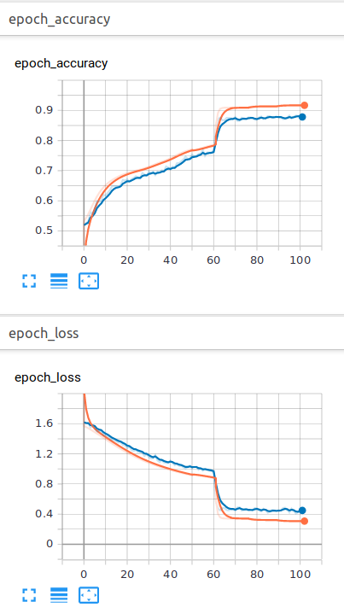
coco enet_no_wc_256x256
TEST Evaluete:
[ Loss , Accuracy, Mean Square Error, Precision:
[0.5008393999934196, 0.8545855, 0.015722591, 0.9017278]
Mean FID : 1782.0117263846887
Enet input + first bottle neck :
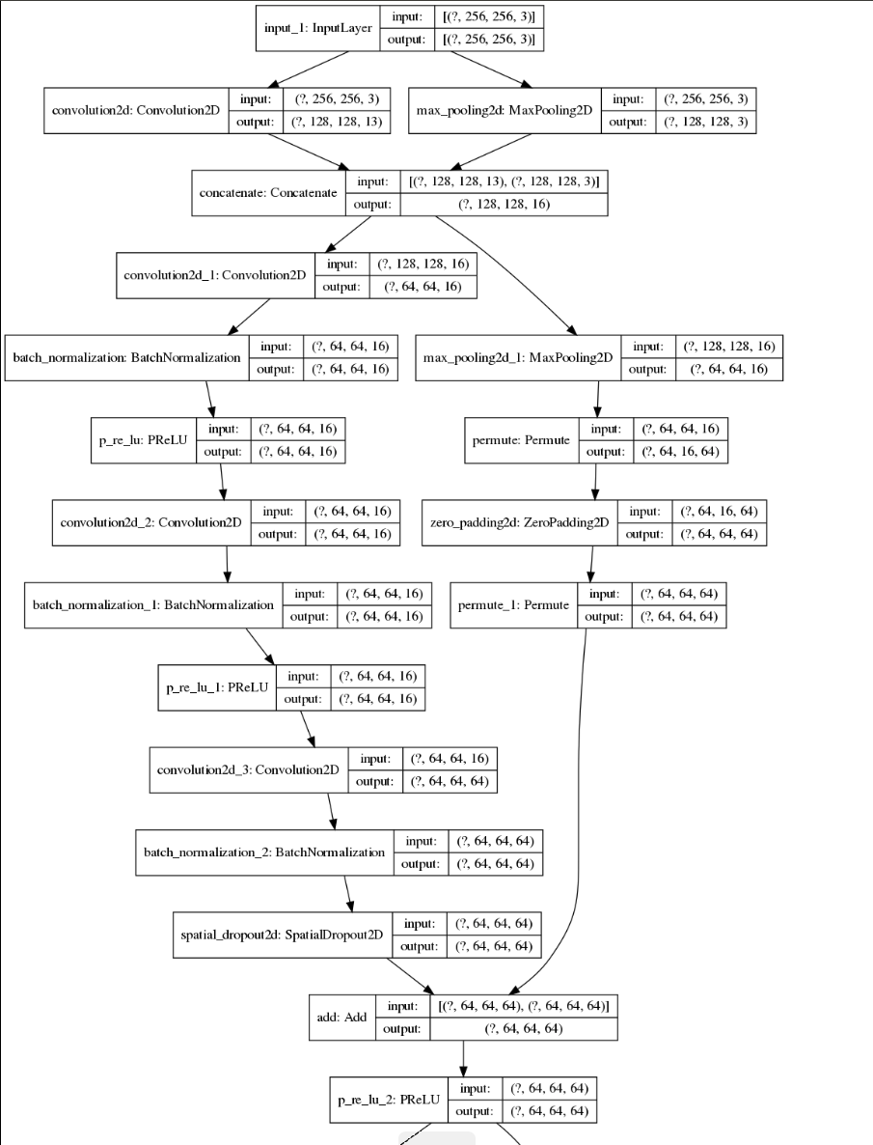
WC-1 model:
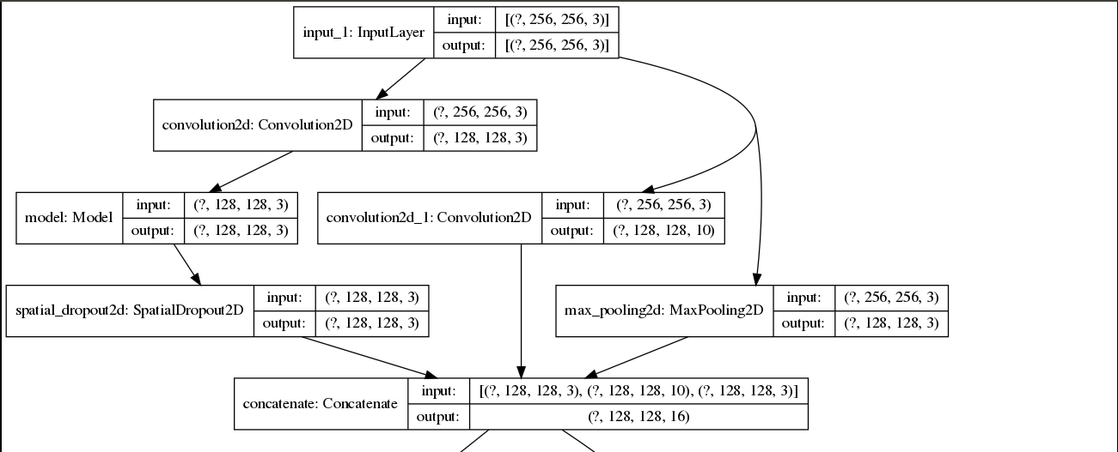
WC-2 model:
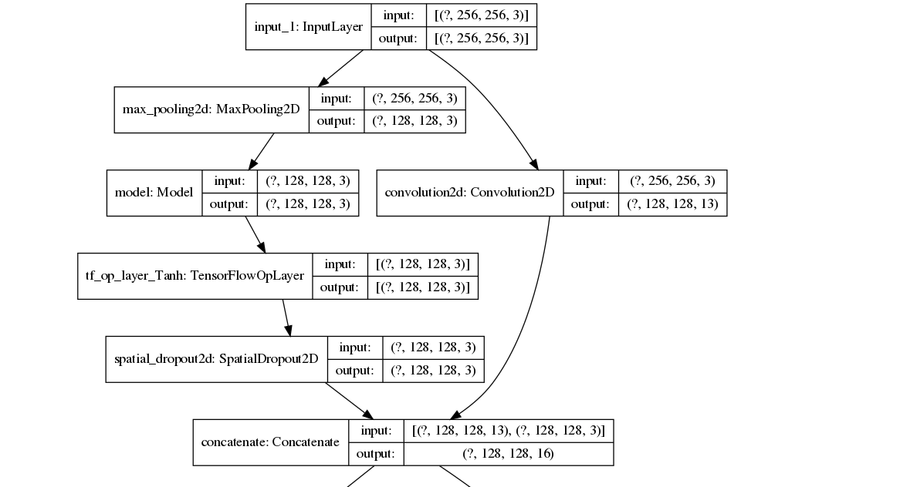
WC-3 model:

Enet decoder second pull up:
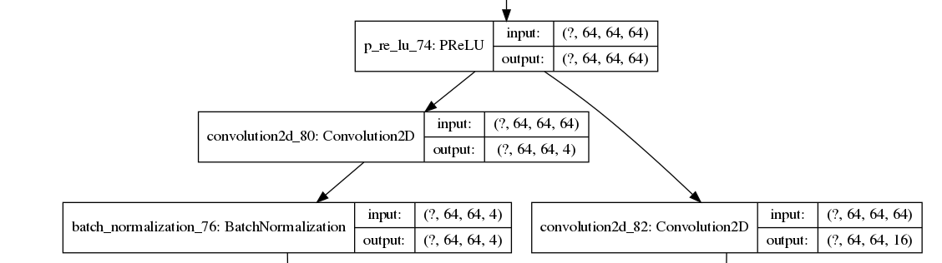

WC-Dec-1 model:

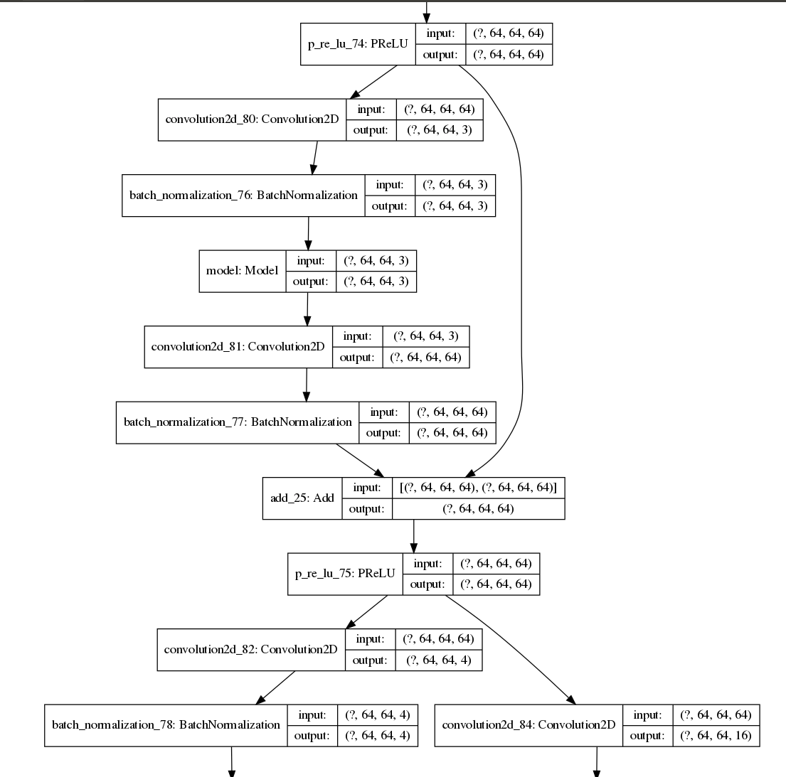

96% val accuracy with enet on CAMVID ds.
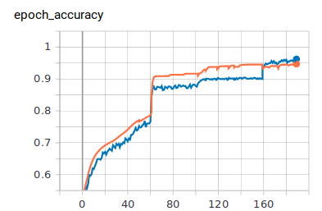
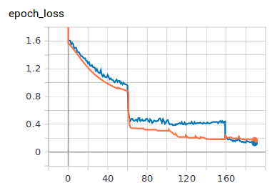

COAMVID WC-1 ~84% val accuracy
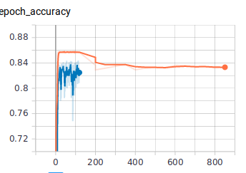

Enet no WC on COCO

