APPENDIX
GHANA FIELD CHAPTER
Appendix 1. Bioassay data from Bendiocarb selection time determination. Male and female percentage mortality and 95% Confidence Intervals (CI) with continuity correction calculated using VassarStats included
Exposure time (minutes)
Exposure time (minutes) | ALIVE |  | DEAD |  | % Mortality
Exposure time (minutes) | F | M | F | M | F | 95 % CI | M | 95% CI | total
15 | 12 | 16 | 3 | 1 | 20.0 | 5.31-48.63% | 5.9 | 0.31-30.76% | 12.5
30 | 12 | 30 | 26 | 26 | 68.4 | 51.21-81.96% | 46.4 | 33.2-60.15% | 55.3
45 | 23 | 15 | 48 | 30 | 67.6 | 55.34-77.96% | 66.7 | 50.92-79.56% | 67.2
60 | 11 | 11 | 29 | 19 | 72.5 | 55.86-84.86% | 63.3 | 43.9-79.45% | 68.6
.
Appendix 2. Bioassay data from DDT selection time determination. Male and female percentage mortality and 95% Confidence Intervals (CI) with continuity correction calculated using VassarStats included
Exposure time (minutes)
Exposure time (minutes) | ALIVE |  | DEAD |  | % Mortality
Exposure time (minutes) | F | M | F | M | F | 95 % CI | M | 95 % CI | total
60 | 14 | 15 | 0 | 1 | 0 | 0.00 -26.76% | 6.25 | 0.33-32.29% | 3.3
90 | 15 | 15 | 1 | 0 | 6.25 | 0.33-32.29% | 0 | 0-25.35% | 3.2
360 | 9 | 1 | 6 | 10 | 40 | 17.46-67.11% | 90.9 | 57.12-99.52% | 61.5

Appendix 3. selections 1 hour exposure to 0.1% bendiocarb
AREA | alive |  | dead |  | % MORTALITY
 | F | M | F | M | Total | F | M
ONE | 68 | 25 | 157 | 55 | 69.5 | 69.8 | 68.8
TWO | 143 | 26 | 92 | 42 | 44.2 | 39.1 | 61.8
THREE | 1 | 0 | 59 | 27 | 98.9 | 98.3 | 100.0
FOUR | 11 | 11 | 29 | 19 | 68.6 | 72.5 | 63.3
Total | 223 | 62 | 337 | 143 | 62.7 | 60.2% | 69.8%

Appendix 4. selection data 6 hours exposure to 4% DDT
AREA | Alive |  | Dead |  | % MORTALITY
 | F | M | F | M | Total | F | M
ONE | 160 | 28 | 58 | 47 | 35.8 | 26.6 | 62.7
TWO | 81 | 7 | 21 | 9 | 25.4 | 20.6 | 56.3
THREE | 91 | 17 | 20 | 17 | 25.5 | 18.0 | 50.0
FOUR | 9 | 1 | 6 | 10 | 61.5 | 40.0 | 90.9
Total | 341 | 53 | 105 | 83 | 32.3 | 23.5% | 61.0%

Appendix 5. Distribution of Anopheles gambiae molecular forms in collection sites of four major areas samples in Ghana, West Africa. Total mosquito numbers collected, raised and used for selections shown.
AREA | SITE | M | S | M/S
 | ALAJO ONLY | 16 | 5 | 0
 | DZORWULU | 18 | 81 | 0
ONE | KOTOBABI ONLY | 79 | 17 | 0
 | KOTOBABI & ALEJO MIX | 72 | 27 | 2
 | ROMAN RIDGE | 11 | 25 | 0
TWO | LABADI | 12 | 162 | 0
THREE | KORLE BU | 102 | 9 | 0
FOUR | MADINA | 0 | 30 | 1 | TOTAL
 | Totals | 310 | 356 | 3 | 669

Appendix 6. Total numbers and molecular form of bendiocarb phenotyped female mosquitoes chosen for molecular characterisation from four collection areas in Ghana, West Africa. Site two was initially selected to provide test mosquitoes and site three for controls however due to miss match in molecular form numbers controls were subsequently selected from all four collection sites (see table ?? above).

 | Bendiocarb
Area | Control |  |  | Test |  |  | total
 | M | S | M/S | M | S | M/S
ONE | 30 | 13 |  | 2 | 42 |  | 87
TWO | 10 | 22 |  | 2 | 140 |  | 174
THREE | 101 | 9 |  | 1 |  |  | 111
FOUR | 0 | 30 | 1 |  |  |  | 31
Total | 141 | 74 | 1 | 5 | 182 |  | 403

Appendix 7. Total numbers and molecular form of DDT phenotyped female mosquitoes chosen for molecular characterisation from four collection areas in Ghana, West Africa. Note site one was selected for DDT molecular characterisation as this collection provided the most matched numbers of control and tested individuals (see table ?? above).
 | DDT
AREA | Control |  |  | Test |  |  | Total
 | M | S | M/S | M | S | M/S
ONE | 64 | 41 | 1 | 99 | 60 | 1 | 266
TWO | n/a | n/a | n/a | n/a | n/a | n/a
THREE | n/a | n/a | n/a | n/a | n/a | n/a
FOUR | n/a | n/a | n/a | n/a | n/a | n/a
Total | 64 | 41 | 1 | 99 | 60 | 1 | 266

Appendix 8. results from a limited number of pyrethroid WHO bioassays performed on samples from areas four and three.
Pyrethroid | AREA | Alive |  | Dead
 |  | Females | Male | Females | Male | % MORTALITY
Permethrin | FOUR | 6 | 11 | 0 | 4 | 19.0%
Deltamethrin | THREE | 11 | 3 | 27 | 18 | 76.3%

Appendix 9. TaqMan assay conditions G119S and kdr West L1014F and East L1014S.
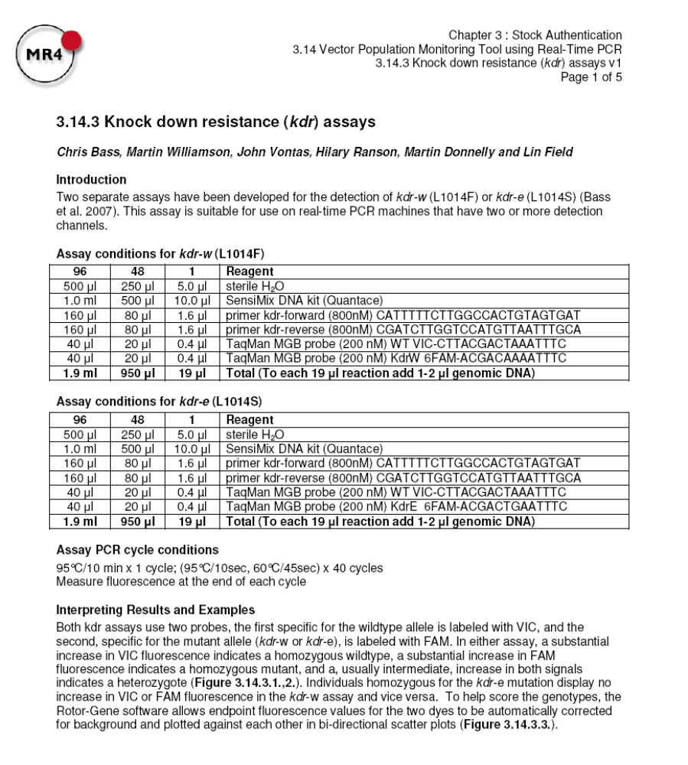
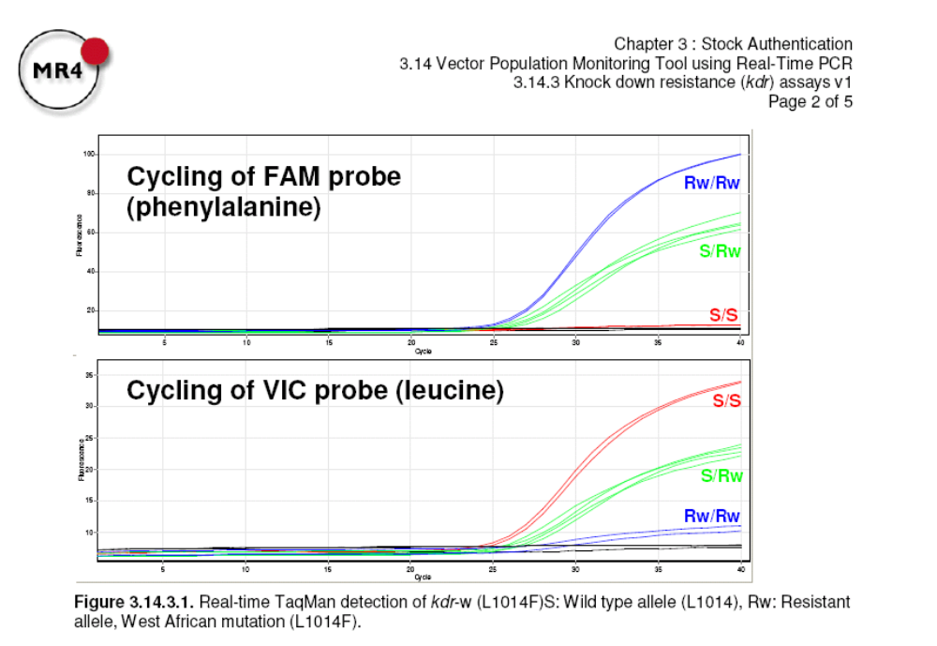
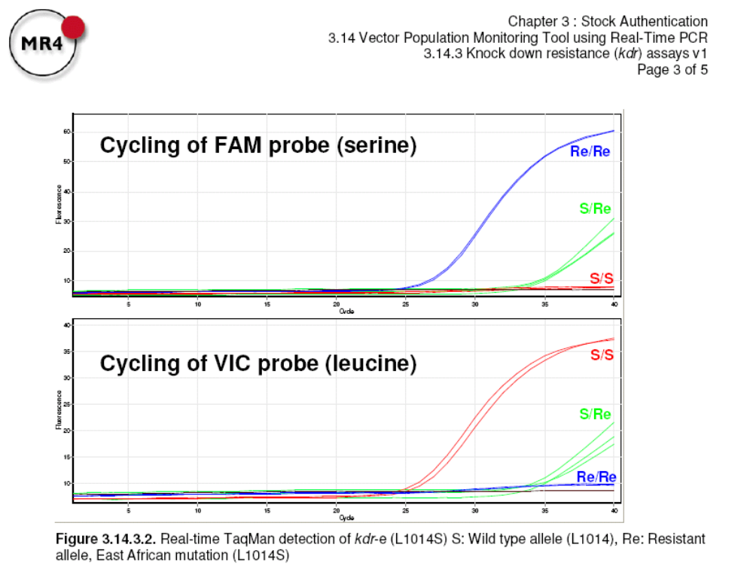
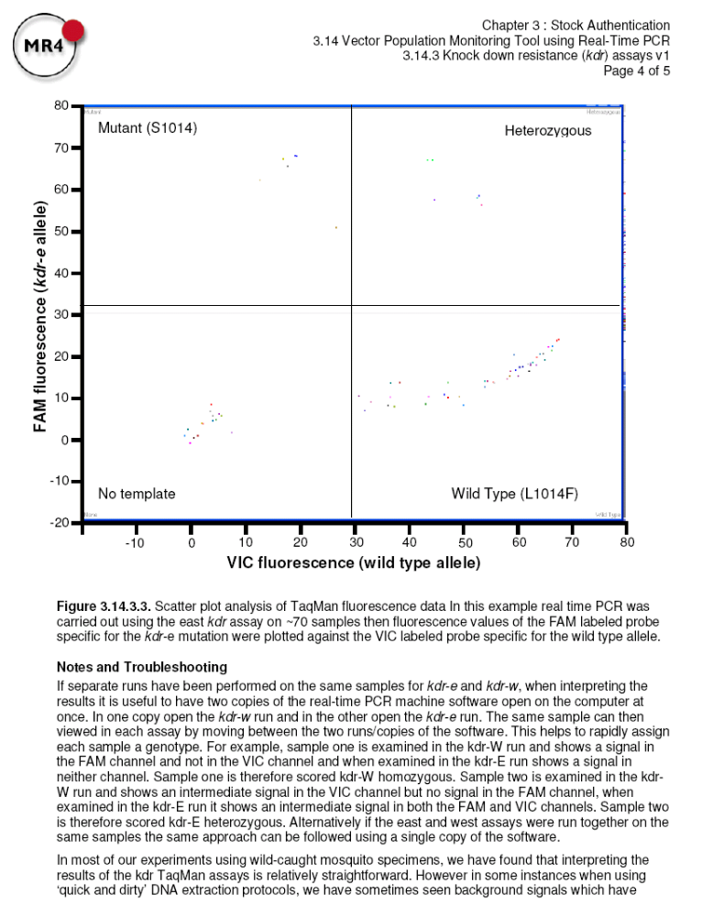
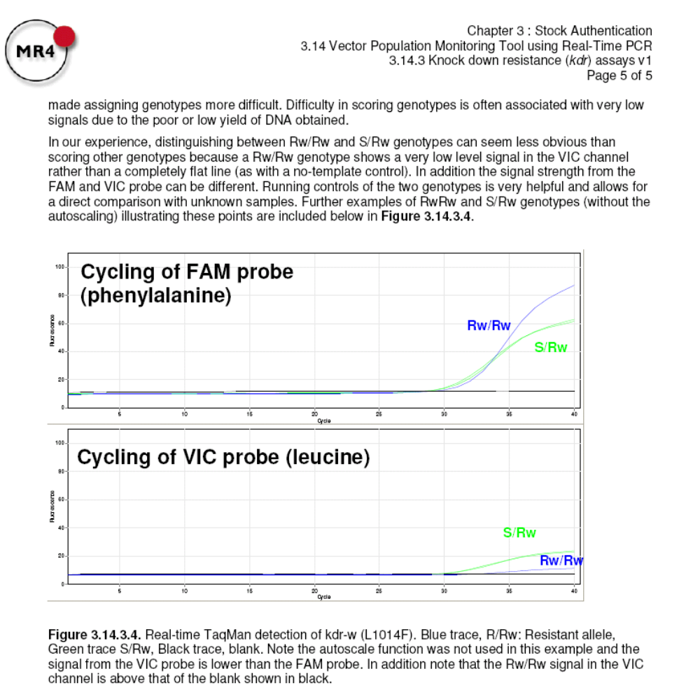
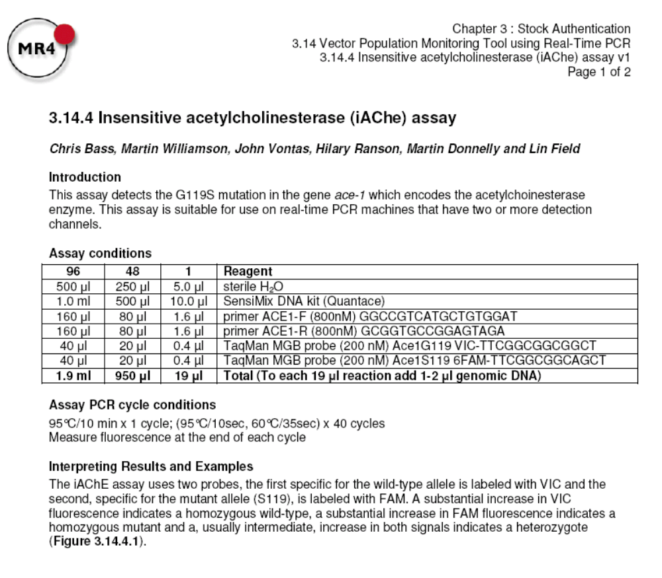
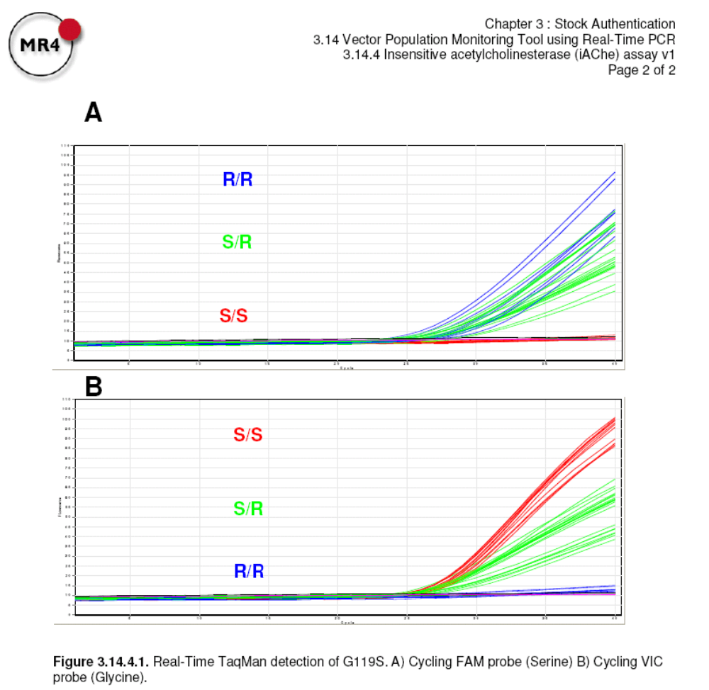

APPENDIX
BENDIO MICROARRAY CHAPTER
Appendix 10. Agilent descriptions of design parameters in eArray.
Base composition method: This is the standard method used for the Agilent custom microarray platform. Candidate probes are selected based upon empirically determined base-composition profiles that have been shown to perform optimally on the Agilent platform. This method works best with Agilent protocols, and most eukaryotic organisms

Vector masking: Target sequence may contain contaminant segments not actually found in the sample being studied. These segments are often artifacts from cloning vectors (e.g. plasmid, phage, BAC, YAC) used in cloning and amplification processes. Vector masking identifies and removes these segments from consideration during probe design
Repeat masking: The genome of any given organism contains interspersed repeats and low complexity DNA sequences. These sequences, which are unique at a species level, are replicated many times throughout genome sequence, and hence are found in the transcriptome as well. Replicate regions are are poor candidates for unique probes. Repeating masking identifies and removes these segments from consideration during the probe design process.
Sense orientation: Probes in the ´sense´ or ´coding strand´ orientation represent a substring of the mRNA target molecule. Use this option if the sample preparation methodology yields cDNA or cRNA molecules.
Designed with 3’ bias: Using a linear amplification methodology during sample preparation requires probes that are 3´ biased. As the amplification reaction attenuates, the product material will contain mostly cDNA molecules that represent only about 1,000 bp from the 3´ end. It is important to make sure that the probes be selected in this region.
Best probe methodology: When selecting multiple probes per target sequence, the ´best probe´ selection methodology will weight toward selecting the best available probe more than making sure that the probes are distributed evenly across the probe selection window

Appendix 11. Bendiocarb phenotyped RNA pools from S form An. gambiae heterozygous for ace-1R mutation. NanoDrop readings pre and post DNase treatment and indication of quality from Bioanalyzer traces included.
Sample |  |  |  | tot. RNA nanodrop |  |  | nanodrop post DNAse |  |  | Bioanalyzer
ID | Pool | Phenotype | Area | 260:280 | 230:260 | ng/µl | 260:280 | 230:260 | ng/µl | quality
3 | 1 | CONTROL | FOUR | 1.88 | 0.58 | 726.6 | 1.94 | 0.48 | 603.2 | good
5 |  | CONTROL | FOUR
10 |  | CONTROL | FOUR
12 |  | CONTROL | FOUR
13 |  | CONTROL | FOUR
14 | 2 | CONTROL | FOUR | 1.94 | 0.8 | 680.4 | 1.92 | 0.45 | 591.8 | good
18 |  | CONTROL | FOUR
21 |  | CONTROL | FOUR
51 |  | CONTROL | FOUR
55 |  | CONTROL | FOUR
60 | 3 | CONTROL | FOUR | 2 | 1.08 | 397.1 | 1.99 | 1.01 | 278.8 | good
95 |  | CONTROL | ONE
98 |  | CONTROL | ONE
100 |  | CONTROL | ONE
101 |  | CONTROL | ONE
258 | 4 | CONTROL | TWO | 1.97 | 0.92 | 459.6 | 1.96 | 0.88 | 347 | good
262 |  | CONTROL | TWO
263 |  | CONTROL | TWO
269 |  | CONTROL | TWO
276 |  | CONTROL | TWO
284 | 5 | CONTROL | TWO | 1.92 | 1.05 | 452.1 | 1.97 | 0.93 | 324.8 | good
286 |  | CONTROL | TWO
287 |  | CONTROL | TWO
288 |  | CONTROL | TWO
355 |  | CONTROL | THREE
109 | 1 | TEST | TWO | 1.86 |  | 469 | 1.93 | 1.12 | 353.6 | v.good
113 |  | TEST | TWO
115 |  | TEST | TWO
134 |  | TEST | TWO
135 |  | TEST | TWO
138 | 2 | TEST | TWO | 1.98 | 1.31 | 444.5 | 1.93 | 0.85 | 318.2 | v good
141 |  | TEST | TWO
142 |  | TEST | TWO
143 |  | TEST | TWO
146 |  | TEST | TWO
247 | 5 | TEST | TWO | 2 | 1.17 | 419.9 | 2 | 0.78 | 306.2 | good
162 |  | TEST | TWO
164 |  | TEST | TWO
165 |  | TEST | TWO
166 |  | TEST | TWO
172 | 7 | TEST | TWO | 1.97 | 1.35 | 466.3 | 1.99 | 1.25 | 336.8 | good
174 |  | TEST | TWO
175 |  | TEST | TWO
176 |  | TEST | TWO
177 |  | TEST | TWO
178 | 8 | TEST | TWO | 1.96 | 0.63 | 452.8 | 1.93 | 0.46 | 342.8 | good
222 |  | TEST | TWO
223 |  | TEST | TWO
225 |  | TEST | TWO
227 |  | TEST | TWO

Appendix 12. Full R script for the analysis of the 4x44K AGAMIMMUNODETOX microarray looped experiment comparing bendiocarb insecticide selected female An. gambiae with non-exposed controls from the same region of Ghana.
############################################################################LIMMA NORMALISATION OF RAW DATA_ 4x44K ARRAY LOOPED DESIGN #
###########################################################################

# set working directory – in R using LIMMA & MAANOVA
setwd("e:/data file ")
getwd()

#open limma package
source("http://bioconductor.org/biocLite.R")
biocLite("limma")
library(limma)

#read in target file
targets<- readTargets ("Targets.txt", row.names="arraynumber")
targets

#weight spots i.e. remove spots which signal is below background using #boolean agilent column "rIsWellAboveBG" 1=yes 0=no, R&G sig=1 R+G>1
myfun<-function (x) {
a=x[,"rIsWellAboveBG"] == 1
b=x[,"gIsWellAboveBG"] == 1
as.numeric(a+b >= 1)
}
#read in array files using weight function, take default Limma setting for #Agilent arrays i.e. foreground mean signal, background median signal used #in analysis.
RG<- read.maimages(targets, source="agilent", wt.fun=myfun)
#show(RG)
summary(RG)
#summary(RG$R)
#check all genes and arrays read correctly, this will list number of genes #and number of arrays
#dim(RG)
#names(RG$genes)

#order genes so duplicates are next to eachother therefore order according #to 'RG$genes$ProbeName'
index=order(RG$genes$ProbeName)
RG=RG[index,]

#read in SpotType file providing info on different spots i.e. control type, #targets etc
spottypes<- readSpotTypes("SpotTypes.txt")
spottypes
#match spot types to genes in the RG (read array)list ('status'=character #vector giving the control status of each spot on the array)
RG$genes$Status<- controlStatus(spottypes,RG)
#Create an MA-plot with color coding for control spots
#plotMA(RG)
#or to create png images to file
plotMA3by2(RG, prefix=”prenormalisationMA”)

#prenorm dye density plot
jpeg('prenormdensityplot.jpg')
plotDensities(RG) or command to produce the plot
dev.off()

#background correction none offset 50 to increase low intensity values
#implements the background correction methods reviewed #or developed in Ritchie et al (2007) and Silver at al (2009). If #method="none" then no correction is done, i.e., the background intensities #are treated as zero. Other methods are all designed to produce positive #corrected intensities. If method="half" then any intensity which is less #than 0.5 after background subtraction is reset to be equal to 0.5. The #offset can be used to add a constant to the intensities before log-#transforming, so that the log-ratios are shrunk towards zero at the lower #intensities. This may eliminate or reverse the usual 'fanning' of log-#ratios at low intensities associated with local background subtraction. #Background correction (background subtraction) is also performed by the #normalizeWithinArrays method for RGList objects, so it is not necessary to #call backgroundCorrect directly unless one wants to use a method other #than simple subtraction. Calling backgroundCorrect before #normalizeWithinArrays will over-ride the default background correction

RG.b<- backgroundCorrect(RG, method="none", offset=50)
plotMA(RG)
plotMA(RG.b)
#plotMA3by2(RG.b, prefix="backgroundnoneoffset50MA")

#saving plot image of background corrected densities
#jpeg('backgroundcorrecteddensities.jpg')
#plotDensities(RG.b)
#dev.off()

#weighting different spots to be more/less important during normalisation #i.e. weight differentially expressed genes 0 and genes not meant to be #differentially expressed 1? “weighting simply multiplies the existing weights with either 1 #or 0. c(rep(1,4),rep(0,4))”

RG$weights=modifyWeights(RG$weights, RG$genes$Status, spottypes$SpotType, c (rep(1,4), rep(0,4)))
#within array normalisation method loess suggested
#DEF: smoothing function LOESS in the R open-source software package, we #then fit a regression line to this data plot. LOESS is derived from the S #statistical function LOWESS¹, which uses a locally weighted least squares #estimate of a regression fit. In simple terms, we take continuous sections #of the data and fit a linear (or quadratic) regression line to that area #of data. The function is then applied in continuity to the rest of the #data set, using a moving window of local data points to derive a fit line, #the result being a smoothed curvilinear regression line. The amount of #fitting and smoothing that takes place is governed by the span parameter #of the LOESS function which sets the proportion of the total data set to #be used in each window for local fitting. #http://www.obgyn.cam.ac.uk/genearray/loess-normalisation.htm
#Cleveland WS, Robust Locally Weighted Regression and Smoothing #Scatterplots, Journal of the American Statistical Association #1979;74:829-836
#Workman C, Jensen LJ et al. A new non-linear normalization method for #reducing variability in DNA microarray experiments. Genome Biol #2002;3(9):research0048

MA=normalizeWithinArrays(RG.b, method="loess")

plotMA3by2(MA,prefix="bendio_bkgrdnone_offset50_loess_MA", col=spottypes$colour, zero.weights=TRUE, common.lim=TRUE)

#BOXPLOT – check the distribution of the red and green ratios for each #array to check they are similar in distribution; i.e. the median is #centred around zero and the distribution is of a similar size. If arrays #are not similar then a BETWEEN array normalisation may be required….

boxplot(MA$M[MA$weights==1]~col(MA$M)[MA$weights==1], names=colnames(MA$M), las=2, main="bendio_bkgrdnone_offset50_loess_BOX", ylab="M", xaxt="none", ylim=c(-10,10))
axis(1, at=c(1:length(targets[,1])), label=targets$Name, las=2)
#PLOT DENSITIES – check that the red and green dye distribution are similar. If they are not the dye correction within MAANOVA should correct for this but will need to check this later on…
jpeg('densities_bkgrdnone_offset50_loess.jpg')
plotDensities(MA)
dev.off()

#between array normalisation (remove the variations resulted from multiple #microarray experiments) Pie uses method scale? QUANTILE
#DEF: The scale normalization method was proposed by Yang et al (2001, #2002) and is further explained by Smyth and Speed (2003). The idea is #simply to scale the log-ratios to have the same median-absolute-deviation #(MAD) across arrays. This idea has also been implemented by the #maNormScale function in the marrayNorm package. The implementation here is #slightly different in that the MAD scale estimator is replaced with the #median-absolute-value and the A-values are normalized as well as the M-#values.
#Quantile normalization was proposed by Bolstad et al (2003) for #Affymetrix-style single-channel arrays and by Yang and Thorne (2003) for #two-color cDNA arrays. method="quantile" ensures that the intensities have #the same empirical distribution across arrays and across channels. #method="Aquantile" ensures that the A-values (average intensities) have #the same empirical distribution across arrays leaving the M-values (log-#ratios) unchanged. These two methods are called "q" and "Aq" respectively #in Yang and Thorne (2003). method="Tquantile" performs quantile #normalization separately for the groups indicated by targets. targets may #be a target matrix such as read by readTargets or can be a vector #indicating green channel groups followed by red channel groups.

#NO between array norm as recommended by Agilent and Zahurak et al. 2007

############################################################################CONVERSION TO MAANOVA FORMAT AND RUNNING MAANOVA #
###########################################################################

RG.corrected<- RG.MA(MA)
MetaRow=1
MetaCol=1
#bind all the arrays together horizontally i.e. probe id running down #column 1 and each array red signal-green signal-weighting for probe #running horizontally for each of the 20 arrays..
ghanabendio1.raw=as.data.frame(cbind(RG.corrected[,1]$genes[c(7:11, 4)], MetaRow, MetaCol,RG.corrected[,1]$genes[1:2], RG.corrected[,1]$R, RG.corrected[,1]$G, 1-RG.corrected[,1]$weights))
ghanabendio1.raw.new=as.data.frame(cbind(RG.corrected[,2]$R, RG.corrected[,2]$G, 1-RG.corrected[,2]$weights))
ghanabendio1.raw=cbind(ghanabendio1.raw, ghanabendio1.raw.new)
ghanabendio1.raw.new=as.data.frame(cbind(RG.corrected[,3]$R, RG.corrected[,3]$G, 1-RG.corrected[,3]$weights))
ghanabendio1.raw=cbind(ghanabendio1.raw, ghanabendio1.raw.new)
ghanabendio1.raw.new=as.data.frame(cbind(RG.corrected[,4]$R, RG.corrected[,4]$G, 1-RG.corrected[,4]$weights))
ghanabendio1.raw=cbind(ghanabendio1.raw, ghanabendio1.raw.new)
ghanabendio1.raw.new=as.data.frame(cbind(RG.corrected[,5]$R, RG.corrected[,5]$G, 1-RG.corrected[,5]$weights))
ghanabendio1.raw=cbind(ghanabendio1.raw, ghanabendio1.raw.new)
ghanabendio1.raw.new=as.data.frame(cbind(RG.corrected[,6]$R, RG.corrected[,6]$G, 1-RG.corrected[,6]$weights))
ghanabendio1.raw=cbind(ghanabendio1.raw, ghanabendio1.raw.new)
ghanabendio1.raw.new=as.data.frame(cbind(RG.corrected[,7]$R, RG.corrected[,7]$G, 1-RG.corrected[,7]$weights))
ghanabendio1.raw=cbind(ghanabendio1.raw, ghanabendio1.raw.new)
ghanabendio1.raw.new=as.data.frame(cbind(RG.corrected[,8]$R, RG.corrected[,8]$G, 1-RG.corrected[,8]$weights))
ghanabendio1.raw=cbind(ghanabendio1.raw, ghanabendio1.raw.new)
ghanabendio1.raw.new=as.data.frame(cbind(RG.corrected[,9]$R, RG.corrected[,9]$G, 1-RG.corrected[,9]$weights))
ghanabendio1.raw=cbind(ghanabendio1.raw, ghanabendio1.raw.new)
ghanabendio1.raw.new=as.data.frame(cbind(RG.corrected[,10]$R, RG.corrected[,10]$G, 1-RG.corrected[,10]$weights))
ghanabendio1.raw=cbind(ghanabendio1.raw, ghanabendio1.raw.new)
ghanabendio1.raw.new=as.data.frame(cbind(RG.corrected[,11]$R, RG.corrected[,11]$G, 1-RG.corrected[,11]$weights))
ghanabendio1.raw=cbind(ghanabendio1.raw, ghanabendio1.raw.new)
ghanabendio1.raw.new=as.data.frame(cbind(RG.corrected[,12]$R, RG.corrected[,12]$G, 1-RG.corrected[,12]$weights))
ghanabendio1.raw=cbind(ghanabendio1.raw, ghanabendio1.raw.new)
ghanabendio1.raw.new=as.data.frame(cbind(RG.corrected[,13]$R, RG.corrected[,13]$G, 1-RG.corrected[,13]$weights))
ghanabendio1.raw=cbind(ghanabendio1.raw, ghanabendio1.raw.new)
ghanabendio1.raw.new=as.data.frame(cbind(RG.corrected[,14]$R, RG.corrected[,14]$G, 1-RG.corrected[,14]$weights))
ghanabendio1.raw=cbind(ghanabendio1.raw, ghanabendio1.raw.new)
ghanabendio1.raw.new=as.data.frame(cbind(RG.corrected[,15]$R, RG.corrected[,15]$G, 1-RG.corrected[,15]$weights))
ghanabendio1.raw=cbind(ghanabendio1.raw, ghanabendio1.raw.new)
ghanabendio1.raw.new=as.data.frame(cbind(RG.corrected[,16]$R, RG.corrected[,16]$G, 1-RG.corrected[,16]$weights))
ghanabendio1.raw=cbind(ghanabendio1.raw, ghanabendio1.raw.new)
ghanabendio1.raw.new=as.data.frame(cbind(RG.corrected[,17]$R, RG.corrected[,17]$G, 1-RG.corrected[,17]$weights))
ghanabendio1.raw=cbind(ghanabendio1.raw, ghanabendio1.raw.new)
ghanabendio1.raw.new=as.data.frame(cbind(RG.corrected[,18]$R, RG.corrected[,18]$G, 1-RG.corrected[,18]$weights))
ghanabendio1.raw=cbind(ghanabendio1.raw, ghanabendio1.raw.new)
ghanabendio1.raw.new=as.data.frame(cbind(RG.corrected[,19]$R, RG.corrected[,19]$G, 1-RG.corrected[,19]$weights))
ghanabendio1.raw=cbind(ghanabendio1.raw, ghanabendio1.raw.new)
ghanabendio1.raw.new=as.data.frame(cbind(RG.corrected[,20]$R, RG.corrected[,20]$G, 1-RG.corrected[,20]$weights))
ghanabendio1.raw=cbind(ghanabendio1.raw, ghanabendio1.raw.new)
names(ghanabendio1.raw)[seq(11,length(names(ghanabendio1.raw)),3)]=paste(names(ghanabendio1.raw)[seq(11,length(names(ghanabendio1.raw)),3)],"R",sep=".")
names(ghanabendio1.raw)[seq(12,length(names(ghanabendio1.raw)),3)]=paste(names(ghanabendio1.raw)[seq(12,length(names(ghanabendio1.raw)),3)],"G",sep=".")
names(ghanabendio1.raw)[seq(13,length(names(ghanabendio1.raw)),3)]=paste(names(ghanabendio1.raw)[seq(13,length(names(ghanabendio1.raw)),3)],"W",sep=".")
ghanabendio1.raw$ProbeName=substr(ghanabendio1.raw$ProbeName, 1, 13)
write.csv(ghanabendio1.raw, file="ghanabendio1raw_bkgrd_none_offset50_loess.csv")
#import array experimental design
design=read.table("bendio1designfile.txt", header=TRUE)
write.table(ghanabendio1.raw, "ghanabendio1_bkgrd_none_offset50_loess.data.txt", row.names=FALSE, sep="\t", quote=FALSE)
#import data.txt and design file j/MAANOVA or continue in R and MAANOVA
#Note – can remove control spots at this point manually from the data file #are they are no longer required in analysis…
#Note – ensure order of arrays and dyes in the design file EXACTLY match the ordering in the data file
#JMAANOVA COMMANDS:
#read in data and Log transform (as recommended). Specify no. of reps if #want to collapse them(4x44K has n rep=2) and where each bit of info is #stored in the data file as below.

#FIT MIXED EFFECT MODEL(restricted maximum likelihood method used to fit #linear model as default setting) Given the data and formula, this function #fits the regression model for each gene and calculates the ANOVA #estimates, variance components for random terms, fitted values, etc. For a #mixed effect models, the output estimates will be BLUE and BLUP.
BENDIO_bkgrdnone_off50_loess_GENEPROBESonly.bendiobkgrdnon50loessgenesonly <- fitmaanova(madata=BENDIO_bkgrdnone_off50_loess_GENEPROBESonly, formula=~Array+Dye+Sample+Group, random=~Array+Sample, method="REML", verbose=TRUE, subCol=FALSE)
#F-TEST UNIVERSAL– tests all combinations of groups. As the experimental #size is small (<5 pools per group) permutation testing in not viable or #recommended therefore we will rely on tabulated pvalues hence n.perm=1.
BENDIO_bkgrdnone_off50_loess_GENEPROBESonly.bendio_ftest_perm_1_bkgrdnone50loess_genes_only <-matest(data=BENDIO_bkgrdnone_off50_loess_GENEPROBESonly, anovaobj=BENDIO_bkgrdnone_off50_loess_GENEPROBESonly.bendiobkgrdnon50loessgenesonly, term="Group", test.type="ftest", MME.method="REML", n.perm=1, verbose=TRUE)
#pairwise T test: defined
BENDIObkgrdnoneoff50loessGENESonly.bendiobkgrdnoneoff50_loess_genes_only_T_test<- matest(data=ghanabendio1, anovaobj= ghanabendio1.fit, term="Group", test.type="ttest", Contrast=PairContrast(2), MME.method="REML", n.perm=1, verbose=TRUE)
#ADJUST P-VALUE - Benjamini and Hochberg False discovery rate (FDR. The #FDR is the expected false positive rate; for example, if 1000 observations #were experimentally predicted to be different, and a maximum FDR for these #observations was 0.10, then 100 of these observations would be expected to #be false positives. The q value is defined to be the FDR analogue of the #p-value. The q-value of an individual hypothesis test is the minimum FDR #at which the test may be called significant. One approach is to directly #estimate q-values rather than fixing a level at which to control the FDR.
#load required packages for p-value adjustment
source("http://bioconductor.org/biocLite.R")
biocLite("qvalue")
#perform FDR
Bendio_genes_190510_ttest_FDR=adjPval(Bendio_genes_190510.ttest, method="jsFDR")
#CREATE A RESULTS TABLE from pairwise or F test as there are only two #treatment groups here (create one before and after FDR. ENTER EACH LINE #ONE AT A TIME!
ind=seq(1, length(DATAFILEINPUTTED$probeid))
BENDIO.tab=as.data.frame(cbind(ProbeID= TESTFILECREATED.test$obsAnova$probeid[ind], Gene= DATAFILEINPUTTED$genename[ind], Description= DATAFILEINPUTTED$description[ind], Status= DATAFILEINPUTTED$status[ind]))
BENDIO.tab$logFC= B TESTFILECREATED.test$obsAnova$Group[,2]- BendionobkgrdloessGenesonly230310.ttestControlminus1test1$obsAnova$Group[,1]
BENDIO.tab$Pval= TESTFILECREATED.test$Fs$Ptab
BENDIO.tab$adjPval= TESTFILECREATED.test$Fs$adjPtab
BENDIO.tab$Flag= TESTFILECREATED.test$obsAnova$flag
write.table(BENDIO.tab, row.names=F, file="TOPTABLE_ TESTFILECREATED.txt", sep="\t", quote=F)
# plot volcano and save to file (options in GUI to do this)
jpeg('volcano bendio1 perm 50')
plot(bendio1.tab$logFC, -log10(bendio1.tab$adjPval)
Appendix 13. Example QC report from 4x44K AGAMIMMUNODETOX microarray feature extraction.
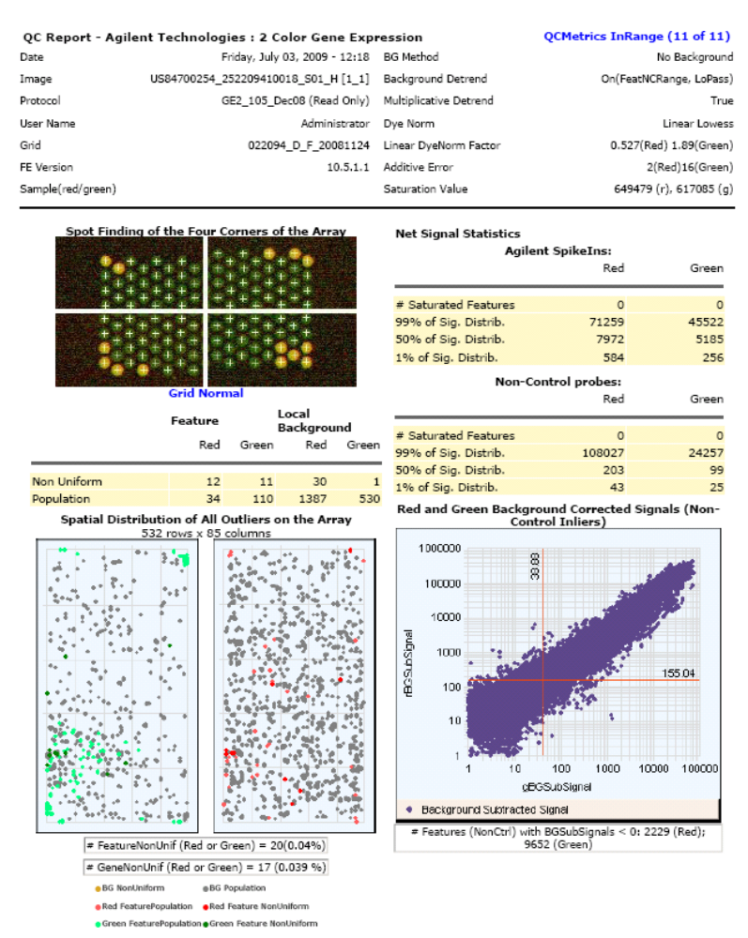

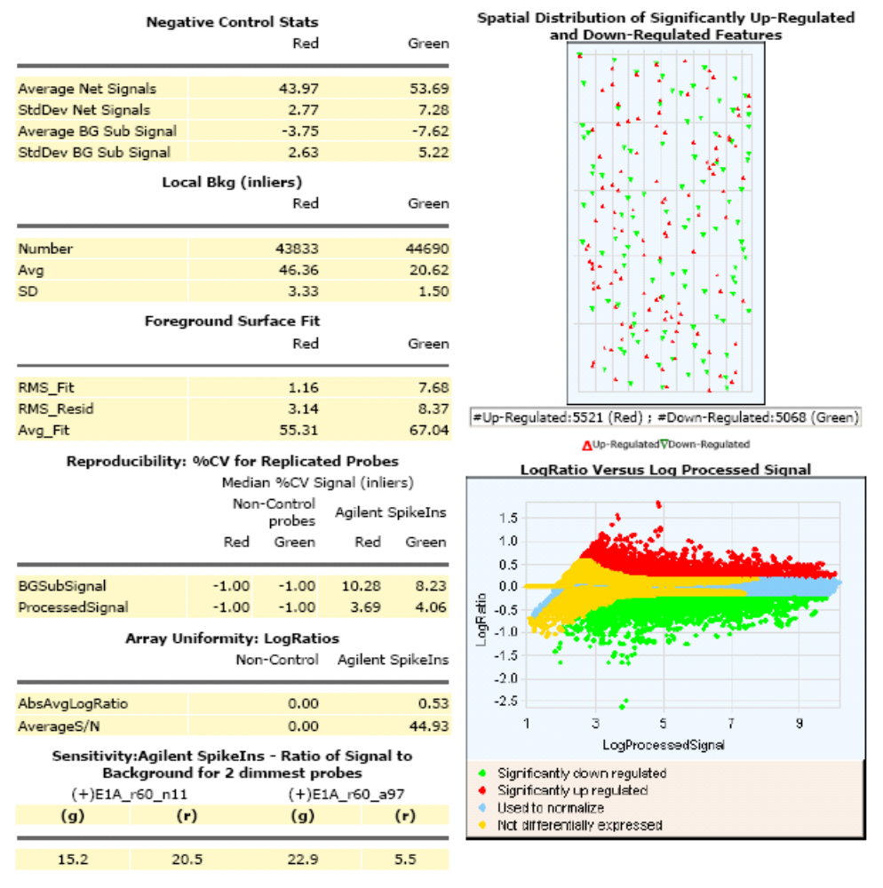
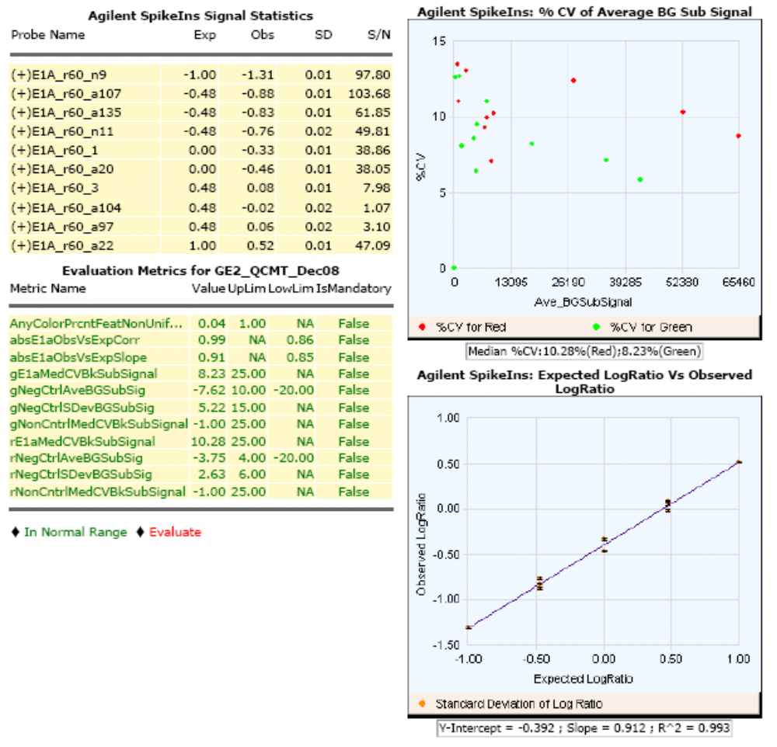

Appendix 14. Bendiocarb microarray top-table (genes over 2 fold (>0.95 log₂ fold) over expressed in test group sorted according to p-values (unadjusted and FDR adjusted)
Gene name | Probe ID | Accession no. | Description | logFC | Pval | adjPval
CYP325C1 | AG_DETOX_P457 | AGAP002207-RA | Cytochrome P450 monooxygenase; | 1.123905 | 0.000472 | 0.170321
CYP325C1 | AG_DETOX_P457 | AGAP002207-RA | Cytochrome P450 monooxygenase; | 1.126268 | 0.000624 | 0.173082
CYP325C2 | AG_DETOX_P460 | AGAP002205-RA | Cytochrome P450 monooxygenase; | 1.041016 | 0.000759 | 0.173706
CYP325C3 | AG_DETOX_P461 | AGAP009696-RA | Cytochrome P450 monooxygenase; | 0.962387 | 0.001048 | 0.177791
CYP325C2 | AG_DETOX_P460 | AGAP002205-RA | Cytochrome P450 monooxygenase; | 1.050270 | 0.001248 | 0.184960
CYP325C2 | AG_DETOX_P459 | AGAP002205-RA | Cytochrome P450 monooxygenase; | 1.181876 | 0.001391 | 0.184960
BX050330 | A_90_P082266. | AGAP010404 | Glutathion S-transferase; | 1.075603 | 0.001596 | 0.188937
CX819818 | A_90_P086003. | AGAP010701-RA | membrane prot. male salivary glands 0-2 days after emergence | 1.295254 | 0.001808 | 0.188937
CYP325C2 | AG_DETOX_P459 | AGAP002205-RA | Cytochrome P450 monooxygenase; | 1.179208 | 0.001961 | 0.188937
CX819818 | A_90_P086003. | AGAP010701-RA | membrane prot. male salivary glands 0-2 days after emergence | 1.303520 | 0.002020 | 0.188937
BX050330 | A_90_P082266. | AGAP010404 | Glutathion S-transferase; | 1.038753 | 0.002042 | 0.188937
COEJHE2E | AG_DETOX_P400 | AGAP005834-RA | Carboxylesterase; | 1.692454 | 0.003548 | 0.193737
COEJHE2E | AG_DETOX_P400 | AGAP005834-RA | Carboxylesterase; | 1.640734 | 0.004200 | 0.193737
CPLC4 | A_90_P125986. | AGAP003334-RA | Cuticular Protein 4 | 0.960730 | 0.004589 | 0.193737
CPLC4 | A_90_P125986. | AGAP003334-RA | Cuticular Protein 5 | 0.962685 | 0.004950 | 0.193737
AgaP_AGAP000356 | A_90_P033026. | XM_310756 | AGAP000356-PA extracellular prot | 1.096859 | 0.005357 | 0.193737
AgaP_AGAP000356 | A_90_P033026. | XM_310756 | AGAP000356-PA extracellular prot | 1.101636 | 0.005895 | 0.193737
GSTS1_1 | AG_DETOX_P704 | AGAP010404-RA | Glutathion S-transferase; | 2.203507 | 0.006264 | 0.193737
GSTS1_1 | AG_DETOX_P704 | AGAP010404-RA | Glutathion S-transferase; | 2.169640 | 0.006323 | 0.193737
HPX3 | AG_IDB_P0449. | AGAP003714-RA | response to oxidative stress | 1.091016 | 0.006700 | 0.193737
COEJHE2E | AG_DETOX_P064 | AGAP005834-RA | Carboxylesterase; | 1.694172 | 0.006867 | 0.193737
COEJHE2E | AG_DETOX_P399 | AGAP005834-RA | Carboxylesterase; | 1.692569 | 0.006971 | 0.193737
COEJHE2E | AG_DETOX_P399 | AGAP005834-RA | Carboxylesterase; | 1.682724 | 0.007220 | 0.193737
AgaP_AGAP012394 | A_90_P014238. | XM_320164 | oxidoreductase activity | 1.321114 | 0.007223 | 0.193737
HPX3 | AG_IDB_P1022. | AGAP003714-RA | response to oxidative stress | 0.998624 | 0.007261 | 0.193737
AgaP_AGAP005848 | A_90_P020836. | XM_315874 | vasopressin receptor activity/binding | 1.329072 | 0.007319 | 0.193737
COEJHE2E | AG_DETOX_P064 | AGAP005834-RA | Carboxylesterase; | 1.679861 | 0.007368 | 0.193737
HPX3 | AG_IDB_P0449. | AGAP003714-RA | response to oxidative stress | 1.072313 | 0.007539 | 0.193737
AgaP_AGAP012394 | A_90_P014238. | XM_320164 | oxidoreductase activity | 1.314153 | 0.007606 | 0.193737
AgaP_AGAP005848 | A_90_P020836. | XM_315874 | vasopressin receptor activity/binding | 1.351997 | 0.007940 | 0.193737
PX14 | AG_DETOX_P238 | AGAP003714-RA | Peroxidase; | 0.975655 | 0.009336 | 0.193737
PX14 | AG_DETOX_P238 | AGAP003714-RA | Peroxidase; | 0.979591 | 0.010228 | 0.193737
GSTS1_1 | AG_DETOX_P216 | AGAP010404-RA | Glutathion S-transferase; | 2.340593 | 0.010592 | 0.193737
GSTS1_1 | AG_DETOX_P216 | AGAP010404-RA | Glutathion S-transferase; | 2.337719 | 0.010737 | 0.193737
AgaP_AGAP012395 | A_90_P001781. | XM_320163 | AGAP012395-PA | 1.122503 | 0.011752 | 0.193737
AgaP_AGAP012395 | A_90_P001781. | XM_320163 | AGAP012395-PA | 1.122262 | 0.014566 | 0.193737
AgaP_AGAP005009 | A_90_P025801. | XM_315115 | AGAP005009-PA | 1.077490 | 0.014893 | 0.193737
AgaP_AGAP005009 | A_90_P025801. | XM_315115 | AGAP005009-PA | 1.058412 | 0.015736 | 0.195002
BX008814 | A_90_P091076. | BX008814 | unknown | 0.956982 | 0.015885 | 0.195002
BX467419 | A_90_P038422. | BX467419 | sphingomyelin phosphodiesterase activity | 1.287226 | 0.021836 | 0.195136
BX467419 | A_90_P038422. | BX467419 | sphingomyelin phosphodiesterase activity | 1.243855 | 0.022287 | 0.195136
CPLC17 | A_90_P056541. | AGAP006149-RA | Cuticular Protein 17 | 1.062739 | 0.023097 | 0.195136
AgaP_AGAP008487 | A_90_P062948. | XM_316957 | sphingomyelin phosphodiesterase activity | 1.528561 | 0.023882 | 0.195136
AgaP_AGAP010404 | A_90_P043882. | AGAP010404-RA | Glutathione S-transferase (GST class-sigma) | 1.191245 | 0.025153 | 0.195136
AgaP_AGAP008487 | A_90_P062948. | XM_316957 | sphingomyelin phosphodiesterase activity | 1.534486 | 0.025685 | 0.195136
CPLC17 | A_90_P056541. | AGAP006149-RA | Cuticular Protein 17 | 1.012803 | 0.026909 | 0.195136
AgaP_AGAP004156 | A_90_P053637. | XM_313040 | AGAP004156-PA | 1.104350 | 0.027135 | 0.195136
AgaP_AGAP005717 | A_90_P022831. | AGAP005717-RA | Lysozyme c-6. | 1.027081 | 0.027275 | 0.195136
LRR | AG_IDB_P0367. | IDB_LRR11930 | leucine rich repeat | 1.203953 | 0.027377 | 0.195136
AgaP_AGAP010404 | A_90_P043882. | AGAP010404-RA | Glutathione S-transferase (GST class-sigma) | 1.187725 | 0.027569 | 0.195136
AgaP_AGAP004156 | A_90_P053637. | XM_313040 | AGAP004156-PA | 1.097736 | 0.028178 | 0.195136
AgaP_AGAP011930 | A_90_P111579. | XM_320603 | AGAP011930-PA | 1.085135 | 0.028699 | 0.195136
FREP50 | AG_IDB_P0746. | IDB_FREP50 | FREP; | 0.950243 | 0.030076 | 0.195180
LRR | AG_IDB_P0940. | IDB_LRR11930 | leucine rich repeat | 1.132678 | 0.030242 | 0.195180
AgaP_AGAP011930 | A_90_P111579. | XM_320603 | AGAP011930-PA | 1.095208 | 0.031993 | 0.195238
LRR | AG_IDB_P0367. | IDB_LRR11930 | leucine rich repeat | 1.201423 | 0.032884 | 0.195238
LRR | AG_IDB_P0940. | IDB_LRR11930 | leucine rich repeat | 1.117254 | 0.034917 | 0.195453
AgaP_AGAP005717 | A_90_P022831. | AGAP005717-RA | Lysozyme c-6. | 1.008956 | 0.036029 | 0.196061
PGRPS3 | AG_IDB_P0424. | IDB_PGRP11 | PGRPS | 0.994085 | 0.037423 | 0.196735
CX819209 | A_90_P017536. | CX819209 | Adult female salivary glands 0-2 days after emergence | 1.172806 | 0.038392 | 0.197386
PGRPS3 | A_90_P056646. | AGAP006342-RA | peptidoglycan recognition protein short class | 0.984581 | 0.038965 | 0.197607
CX819209 | A_90_P017536. | CX819209 | Adult female salivary glands 0-2 days after emergence | 1.164914 | 0.042524 | 0.199151
AgaP_AGAP006177 | A_90_P029446. | XM_316238 | AGAP006177-PA | 1.057057 | 0.045041 | 0.200913
AgaP_AGAP002588 | A_90_P065676. | XM_312350 | AGAP002588-PA | 1.039845 | 0.047537 | 0.201323
AgaP_AGAP002588 | A_90_P065676. | XM_312350 | AGAP002588-PA | 1.023045 | 0.047829 | 0.201323
ML1 | AG_IDB_P0984. | AGAP012352-RA | ML; | 1.155170 | 0.050024 | 0.201788
OBP3 | A_90_P006636. | AGAP001409-RA | odorant binding protein; antennal | 1.454097 | 0.051484 | 0.202562
AgaP_AGAP006177 | A_90_P029446. | XM_316238 | AGAP006177-PA | 1.047825 | 0.052535 | 0.202830
ML1 | AG_IDB_P0984. | AGAP012352-RA | ML; | 1.138231 | 0.052656 | 0.202830
ML1 | AG_IDB_P0411. | AGAP012352-RA | ML | 1.134249 | 0.053961 | 0.202984
AgaP_AGAP012352 | A_90_P132717. | XM_320203 | AGAP012352-PA | 1.137674 | 0.054465 | 0.203220
AgaP_AGAP008290 | A_90_P027685. | AGAP008290-RA | Trypsin-6 precursor | 1.087701 | 0.054882 | 0.203443
ML1 | AG_IDB_P0411. | AGAP012352-RA | ML | 1.130491 | 0.055137 | 0.203443
AgaP_AGAP012352 | A_90_P132717. | XM_320203 | AGAP012352-PA ( | 1.126062 | 0.055793 | 0.203707
AgaP_AGAP005752 | A_90_P048361. | XM_556403 | AGAP005752-PA | 0.992882 | 0.061261 | 0.205433
OBP3 | A_90_P006636. | AGAP001409-RA | odorant binding protein; antennal | 1.469911 | 0.061408 | 0.205433
AgaP_AGAP008290 | A_90_P027685. | AGAP008290-RA | Trypsin-6 precursor (EC 3.4.21.4). | 1.075444 | 0.062787 | 0.205433
GSTS1_1 | AG_DETOX_P705 | AGAP010404-RA | Glutathion S-transferase; | 1.035916 | 0.063870 | 0.205433
AgaP_AGAP005752 | A_90_P048361. | XM_556403 | AGAP005752-PA ( | 0.969653 | 0.066569 | 0.205979
CR532400 | A_90_P113566. | CR532400 | CR532400 Normalized Anopheles Head | 0.967337 | 0.077396 | 0.211649
CR532400 | A_90_P113566. | CR532400 | CR532400 Normalized Anopheles Head | 0.969524 | 0.078194 | 0.211984
GSTS1_1 | AG_DETOX_P705 | AGAP010404-RA | Glutathion S-transferase; t | 1.007434 | 0.079066 | 0.212361
no_name | AG_IDB_P0387. | IDB_LRR18 | LRR | 1.121604 | 0.095472 | 0.220134
no_name | AG_IDB_P0387. | IDB_LRR18 | LRR | 1.111603 | 0.098923 | 0.221213
BX065938 | A_90_P102503. | BX065938 |  | 0.951201 | 0.101025 | 0.222714
AgaP_AGAP005458 | A_90_P029354. | XM_001688611 | AGAP005458-PA | 0.957280 | 0.112487 | 0.229390
AgaP_AGAP007039 | A_90_P096236. | XM_308726 | AGAP007039-PA protein binding | 1.494538 | 0.116444 | 0.231250
AgaP_AGAP005458 | A_90_P029354. | XM_001688611 | AGAP005458-PA | 0.962834 | 0.116586 | 0.231316
AgaP_AGAP007039 | A_90_P096236. | XM_308726 | AGAP007039-PA protein binding | 1.463510 | 0.118180 | 0.232283
AgaP_AGAP007990 | A_90_P061141. | XM_317477 | AGAP007990-PA | 1.032764 | 0.124689 | 0.235398
BM622379 | A_90_P106044. | BM622379 |  | 0.976986 | 0.140508 | 0.243675
AgaP_AGAP011709 | A_90_P005346. | XM_001689239 | AGAP011709-PA | 0.956825 | 0.143960 | 0.245301
AgaP_AGAP007990 | A_90_P061141. | XM_317477 | AGAP007990-PA | 0.999885 | 0.144229 | 0.245494
BM622379 | A_90_P106044. | BM622379 |  | 0.973078 | 0.146997 | 0.246714
AgaP_AGAP001352 | A_90_P103852. | XM_321793 | AGAP001352-PA | 1.335113 | 0.157649 | 0.251397
AgaP_AGAP007711 | A_90_P031936. | XM_308165 | AGAP007711-PA | 1.044018 | 0.162029 | 0.253990
AgaP_AGAP008293 | A_90_P027700. | AGAP008293-RA | Trypsin-7 precursor | 1.068297 | 0.163303 | 0.254782
AgaP_AGAP008293 | A_90_P027700. | AGAP008293-RA | Trypsin-7 precursor | 1.053821 | 0.165390 | 0.255955
AgaP_AGAP001352 | A_90_P103852. | XM_321793 | AGAP001352-PA catalytic activity | 1.305416 | 0.167429 | 0.257256
AgaP_AGAP007711 | A_90_P031936. | XM_308165 | AGAP007711-PA | 1.036987 | 0.167678 | 0.257336
BM637383 | A_90_P122041. | BM637383 |  | 0.984123 | 0.189315 | 0.268626
BM637383 | A_90_P122041. | BM637383 |  | 0.975307 | 0.190477 | 0.269262
BX067400 | A_90_P133831. | BX067400 |  | 1.101988 | 0.215440 | 0.282702
AgaP_AGAP008281 | A_90_P027662. | AGAP008281-RA | D7r4 protein precursor (D7-related 4 protein) | 0.951336 | 0.218068 | 0.283588
BX067400 | A_90_P133831. | BX067400 |  | 1.104416 | 0.222110 | 0.285633
AgaP_AGAP008281 | A_90_P027662. | AGAP008281-RA | D7r4 protein precursor (D7-related 4 protein). | 0.955194 | 0.226442 | 0.287741
AgaP_AGAP001989 | A_90_P003111. | XM_001238422 | AGAP001989-PA | 1.110210 | 0.243089 | 0.295925
AgaP_AGAP001989 | A_90_P003111. | XM_001238422 | AGAP001989-PA | 1.090421 | 0.245052 | 0.296923
AgaP_AGAP004917 | A_90_P061212. | XM_001231036 | AGAP004917-PA | 1.027529 | 0.292620 | 0.321280
BM648782 | A_90_P017661. | BM648782 |  | 1.037082 | 0.293323 | 0.321351
AgaP_AGAP004917 | A_90_P061212. | XM_001231036 | AGAP004917-PA | 1.025200 | 0.303574 | 0.326325
BM648782 | A_90_P017661. | BM648782 |  | 1.005620 | 0.313781 | 0.331286

Appendix 15. CYP325C1-3 microarray probe results
GeneName | ProbeID | Accession | logFC | Pval | adjPval | Fold Change | Mean | STD Dev.
CYP325C1 | AG_DETOX_P458 | AGAP002207-RA | 0.682654 | 0.004572 | 0.193737 | 1.605089 | 1.781839 | 0.309942
 | AG_DETOX_P458 | AGAP002207-RA | 0.681342 | 0.004129 | 0.193737 | 1.60363
 | AG_DETOX_P094 | AGAP002207-RA | 0.643146 | 0.002123 | 0.188937 | 1.561731
 | AG_DETOX_P094 | AGAP002207-RA | 0.639965 | 0.002605 | 0.193737 | 1.558291
 | AG_DETOX_P457 | AGAP002207-RA | 1.123905 | 0.000472 | 0.170321 | 2.17936
 | AG_DETOX_P457 | AGAP002207-RA | 1.126268 | 0.000624 | 0.173082 | 2.182934
CYP325C2 | A_90_P025286. | AGAP002205-RA | 0.769843 | 0.00131 | 0.18496 | 1.705084 | 1.974887 | 0.227499
 | A_90_P025286. | AGAP002205-RA | 0.761536 | 0.001259 | 0.18496 | 1.695295
 | AG_DETOX_P460 | AGAP002205-RA | 1.041016 | 0.000759 | 0.173706 | 2.057677
 | AG_DETOX_P460 | AGAP002205-RA | 1.05027 | 0.001248 | 0.18496 | 2.070918
 | AG_DETOX_P095 | AGAP002205-RA | 0.928138 | 0.00324 | 0.193737 | 1.902818
 | AG_DETOX_P095 | AGAP002205-RA | 0.875044 | 0.004358 | 0.193737 | 1.834064
 | AG_DETOX_P459 | AGAP002205-RA | 1.179208 | 0.001961 | 0.188937 | 2.264524
 | AG_DETOX_P459 | AGAP002205-RA | 1.181876 | 0.001391 | 0.18496 | 2.268715
CYP325C3 | AG_DETOX_P461 | AGAP009696-RA | 0.962387 | 0.001048 | 0.177791 | 1.948531 | 1.376127 | 0.350895
 | AG_DETOX_P461 | AGAP009696-RA | 0.93241 | 0.000978 | 0.175714 | 1.908462
 | AG_DETOX_P462 | AGAP009696-RA | 0.708562 | 0.005906 | 0.193737 | 1.634174
 | AG_DETOX_P462 | AGAP009696-RA | 0.632597 | 0.007647 | 0.193737 | 1.550354
 | AG_DETOX_P096 | AGAP009696-RA | 0.140399 | 0.009604 | 0.193737 | 1.10221
 | AG_DETOX_P096 | AGAP009696-RA | 0.1555 | 0.02399 | 0.195136 | 1.113807
 | AG_DETOX_P463 | AGAP009696-RA | 0.211284 | 0.037266 | 0.196579 | 1.157718
 | AG_DETOX_P463 | AGAP009696-RA | 0.225791 | 0.044816 | 0.200913 | 1.169419
 | A_90_P003766. | XM_318754 | 0.108386 | 0.055988 | 0.203803 | 1.078022
 | A_90_P003766. | XM_318754 | 0.135628 | 0.008656 | 0.193737 | 1.098571

Appendix 16. Bendiocarb microarray top-table (genes over 2 fold (>0.95 log₂ fold) over expressed in control group sorted according to p-values (unadjusted and FDR adjusted)

Gene name | Probe ID | Accession no. | Description | logFC | Pval | adjPval
AgaP_AGAP009052 | A_90_P083066. | XM_001689160 | ? | -1.23406 | 0.000472 | 0.170321
AgaP_AGAP009052 | A_90_P083066. | XM_001689160 | ? | -1.24344 | 0.000568 | 0.173082
AgaP_AGAP009985 | A_90_P017915. | XM_319122 | hydrolase activity | -1.07062 | 0.000902 | 0.175714
BX627228 | A_90_P135851. | AGAP010510-RA | nucleotide binding | -1.43621 | 0.001029 | 0.176562
AgaP_AGAP005808 | A_90_P126761. | XM_001688681 | tubulin complex assembly | -0.99529 | 0.001307 | 0.18496
AgaP_AGAP005808 | A_90_P126761. | XM_001688681 | tubulin complex assembly | -0.97595 | 0.001417 | 0.186609
BX615216 | A_90_P064922. | BX615216 | BX615216 Normalized Anopheles Head | -0.99154 | 0.00143 | 0.186609
AgaP_AGAP009985 | A_90_P017915. | XM_319122 | hydrolase activity | -1.10808 | 0.001542 | 0.188937
BX615216 | A_90_P064922. | BX615216 | BX615216 Normalized Anopheles Head | -0.98181 | 0.001634 | 0.188937
BX627228 | A_90_P135851. | BX627228 | BX627228 NAP1 | -1.40581 | 0.001652 | 0.188937
AgaP_AGAP000605 | A_90_P009456. | XM_001688234 | DNAbinding/response to freezing | -1.50968 | 0.00168 | 0.188937
AgaP_AGAP000605 | A_90_P009456. | XM_001688234 | DNAbinding/response to freezing | -1.50072 | 0.00196 | 0.188937
TEP2 | AG_IDB_P1119. | IDB_TEP2 | TEP; | -1.14221 | 0.002006 | 0.188937
AgaP_AGAP005504 | A_90_P061338. | XM_001688617 | receptor protein | -1.05171 | 0.002148 | 0.189467
AgaP_AGAP005504 | A_90_P061338. | XM_001688617 | receptor protein | -1.04436 | 0.002284 | 0.193434
TEP2 | AG_IDB_P1119. | IDB_TEP2 | TEP; | -1.15562 | 0.002745 | 0.193737
TubulinB | AG_DETOX_P830 | AGAP010510-RA | House-keeping gene; | -1.34529 | 0.002928 | 0.193737
BM617949 | A_90_P083683. | BM617949 | ? | -1.55878 | 0.002946 | 0.193737
BM617949 | A_90_P083683. | BM617949 | ? | -1.56279 | 0.003237 | 0.193737
BX020696 | A_90_P033856. | BX020696 |  | -1.14888 | 0.003438 | 0.193737
TubulinB | AG_DETOX_P830 | AGAP010510-RA | House-keeping gene; | -1.3331 | 0.00355 | 0.193737
AL934918 | A_90_P002766. | AL934918 | AL934918 NAP1 | -0.95828 | 0.00365 | 0.193737
BX020696 | A_90_P033856. | BX020696 |  | -1.15971 | 0.003798 | 0.193737
CASPS3 | AG_IDB_P0617. | IDB_CASP7 | CASPS; | -1.56583 | 0.003835 | 0.193737
TubulinB | AG_DETOX_P829 | AGAP010510-RA | House-keeping gene; | -1.46646 | 0.003952 | 0.193737
CASPS3 | AG_IDB_P0617. | IDB_CASP7 | CASPS; | -1.58046 | 0.004352 | 0.193737
TubulinB | AG_DETOX_P829 | AGAP010510-RA | House-keeping gene; | -1.43365 | 0.004403 | 0.193737
AgaP_AGAP012625 | A_90_P101958. | CR529284 |  | -1.06203 | 0.005339 | 0.193737
AgaP_AGAP012625 | A_90_P101958. | CR529284 |  | -1.07138 | 0.005365 | 0.193737
CASPS3 | AG_IDB_P0048. | IDB_CASP7 | CASPS | -1.66182 | 0.005829 | 0.193737
CASPS3 | AG_IDB_P0048. | IDB_CASP7 | CASPS | -1.65768 | 0.006381 | 0.193737
AgaP_AGAP005246 | A_90_P022663. | AGAP005246-RA | Serpin. | -1.35066 | 0.007286 | 0.193737
AgaP_AGAP003051 | A_90_P104433. | XM_311819 |  | -1.27123 | 0.007514 | 0.193737
AgaP_AGAP006398 | A_90_P113981. | XM_316431 |  | -1.67627 | 0.007732 | 0.193737
BX028769 | A_90_P133546. | BX028769 |  | -1.62766 | 0.007818 | 0.193737
AL934916 | A_90_P042471. | AL934916 | AL934916 NAP1 | -1.3597 | 0.008366 | 0.193737
AgaP_AGAP005766 | A_90_P127421. | XM_001237709 | oxygen transport activity | -2.77063 | 0.008458 | 0.193737
AgaP_AGAP005246 | A_90_P022663. | AGAP005246-RA | Serpin. | -1.34413 | 0.008475 | 0.193737
BX028769 | A_90_P133546. | BX028769 |  | -1.58826 | 0.008568 | 0.193737
AgaP_AGAP006398 | A_90_P113981. | XM_316431 |  | -1.6328 | 0.008578 | 0.193737
AgaP_AGAP003051 | A_90_P104433. | XM_311819 |  | -1.32518 | 0.008924 | 0.193737
AgaP_AGAP002643 | A_90_P125557. | AGAP002643-RA | Hypothetical protein. | -1.74861 | 0.009155 | 0.193737
AgaP_AGAP002643 | A_90_P125557. | AGAP002643-RA | Hypothetical protein. | -1.76555 | 0.009888 | 0.193737
BX031056 | A_90_P097689. | BX031056 |  | -0.98536 | 0.010103 | 0.193737
AL934916 | A_90_P042471. | AL934916 | AL934916 NAP1 | -1.42688 | 0.010262 | 0.193737
AgaP_AGAP006367 | A_90_P035362. | XM_001237799 |  | -1.40319 | 0.010293 | 0.193737
AgaP_AGAP006367 | A_90_P035362. | XM_001237799 |  | -1.36404 | 0.010378 | 0.193737
AgaP_AGAP008365 | A_90_P094451. | XM_001237882 |  | -1.0445 | 0.010427 | 0.193737
TEP2 | AG_IDB_P0546. | IDB_TEP2 | TEP | -1.02271 | 0.010555 | 0.193737
TPX2 | AG_IDB_P1035. | IDB_PRDX4 | TPX; | -1.17442 | 0.010609 | 0.193737
AgaP_AGAP005766 | A_90_P127421. | XM_001237709 | oxygen transport activity | -2.74127 | 0.010631 | 0.193737
GALE7 | AG_IDB_P0199. | IDB_GALE6 | GALE; x-hyb with CD745786 | -1.05294 | 0.010856 | 0.193737
AgaP_AGAP008365 | A_90_P094451. | XM_001237882 |  | -1.03629 | 0.011023 | 0.193737
AgaP_AGAP004529 | A_90_P132031. | XM_313829 |  | -1.30456 | 0.011208 | 0.193737
GALE7 | AG_IDB_P0769. | IDB_GALE6 | GALE; x-hyb with CD745786; | -1.04763 | 0.01149 | 0.193737
AgaP_AGAP012194 | A_90_P003996. | XM_320338 |  | -1.15028 | 0.011524 | 0.193737
GALE7 | A_90_P052676. | AGAP004807-RA | GALECTIN | -1.04636 | 0.011646 | 0.193737
CYP6M1 | AG_DETOX_P146 | AGAP008209-RA | Cytochrome P450 monooxygenase; | -2.30232 | 0.011655 | 0.193737
AgaP_AGAP012194 | A_90_P003996. | XM_320338 |  | -1.16329 | 0.011655 | 0.193737
CYP6M1 | AG_DETOX_P146 | AGAP008209-RA | Cytochrome P450 monooxygenase; | -2.30701 | 0.011685 | 0.193737
AgaP_AGAP007364 | A_90_P039873. | XM_001687897 |  | -1.06525 | 0.0117 | 0.193737
AgaP_AGAP004880 | A_90_P019440. | XM_001688504 |  | -1.16637 | 0.011725 | 0.193737
AgaP_AGAP004529 | A_90_P132031. | XM_313829 |  | -1.29836 | 0.011845 | 0.193737
GSTO1 | AG_DETOX_P702 | AGAP005749-RA | Glutathion S-transferase; | -0.97471 | 0.012042 | 0.193737
GALE7 | AG_IDB_P0769. | IDB_GALE6 | GALE; | -1.05426 | 0.012099 | 0.193737
AgaP_AGAP003331 | A_90_P039977. | XM_314226 |  | -0.99147 | 0.01224 | 0.193737
AgaP_AGAP006710 | A_90_P005751. | XM_565496 |  | -2.11061 | 0.012266 | 0.193737
TPX2 | AG_IDB_P0462. | IDB_PRDX4 | TPX | -1.1919 | 0.01247 | 0.193737
AgaP_AGAP006710 | A_90_P005751. | XM_565496 |  | -2.12794 | 0.012482 | 0.193737
AgaP_AGAP003331 | A_90_P039977. | XM_314226 |  | -0.99464 | 0.012596 | 0.193737
BX031056 | A_90_P097689. | BX031056 |  | -0.96704 | 0.013119 | 0.193737
GALE7 | AG_IDB_P0199. | IDB_GALE6 | GALE; | -1.05021 | 0.013318 | 0.193737
AgaP_AGAP003904 | A_90_P055353. | AGAP003904-RA | Ferredoxin reductase | -1.34465 | 0.013707 | 0.193737
GSTO1 | AG_DETOX_P702 | AGAP005749-RA | Glutathion S-transferase; | -0.97894 | 0.013874 | 0.193737
TPX2 | AG_IDB_P1035. | IDB_PRDX4 | TPX; | -1.15192 | 0.013881 | 0.193737
AgaP_AGAP003904 | A_90_P055353. | AGAP003904-RA | Ferredoxin reductase | -1.32771 | 0.014105 | 0.193737
GALE7 | A_90_P052676. | AGAP004807-RA | GALECTIN | -1.04102 | 0.014308 | 0.193737
AgaP_AGAP004880 | A_90_P019440. | XM_001688504 |  | -1.08166 | 0.014346 | 0.193737
TPX2 | AG_IDB_P0462. | IDB_PRDX4 | TPX | -1.17141 | 0.014466 | 0.193737
BM604747 | A_90_P095248. | BM604747 |  | -0.97044 | 0.014876 | 0.193737
BX624006 | A_90_P008267. | BX624006 |  | -1.07186 | 0.014908 | 0.193737
SRPN10A | AG_IDB_P0502. | IDB_SRPN11 | SRPN-INHIB; | -1.19429 | 0.015074 | 0.194273
SRPN10A | AG_IDB_P0502. | IDB_SRPN11 | SRPN-INHIB; | -1.16378 | 0.01554 | 0.194738
BM604747 | A_90_P095248. | BM604747 |  | -0.96478 | 0.015626 | 0.194958
AgaP_AGAP007364 | A_90_P039873. | XM_001687897 |  | -1.03714 | 0.015796 | 0.195002
TEP2 | AG_IDB_P0546. | IDB_TEP2 | TEP | -1.00909 | 0.016 | 0.195002
SRPN10A | AG_IDB_P1075. | IDB_SRPN11 | SRPN-INHIB; | -1.17873 | 0.016038 | 0.195002
AgaP_AGAP006400 | A_90_P051751. | XM_316433 |  | -1.02684 | 0.016085 | 0.195002
BX066087 | A_90_P065313. | BX066087 |  | -1.05508 | 0.016238 | 0.195002
BM614512 | A_90_P044810. | BM614512 |  | -1.34133 | 0.016445 | 0.195002
SRPN10A | AG_IDB_P1075. | IDB_SRPN11 | SRPN-INHIB; | -1.16057 | 0.016851 | 0.195002
AgaP_AGAP006709 | A_90_P005736. | AGAP006709-RA | Chymotrypsin-1 precursor | -1.89595 | 0.016887 | 0.195002
AgaP_AGAP006400 | A_90_P051751. | XM_316433 |  | -1.01171 | 0.016969 | 0.195002
AgaP_AGAP006709 | A_90_P005736. | AGAP006709-RA | Chymotrypsin-1 precursor | -1.89317 | 0.017332 | 0.195002
TPX2 | A_90_P011407. | AGAP011054-RA | Thioredoxin Dependent Peroxidase | -1.11152 | 0.017384 | 0.195002
AgaP_AGAP003720 | A_90_P021516. | XM_001688226 |  | -1.16043 | 0.017726 | 0.195063
BM614512 | A_90_P044810. | BM614512 |  | -1.34093 | 0.017746 | 0.195063
BX624006 | A_90_P008267. | BX624006 |  | -1.06378 | 0.017781 | 0.195063
BX066087 | A_90_P065313. | BX066087 |  | -1.04859 | 0.017967 | 0.195063
SRPN10B | AG_IDB_P1076. | IDB_SRPN12 | SRPN-INHIB; | -1.11842 | 0.018006 | 0.195085
SRPN10B | AG_IDB_P0503. | IDB_SRPN12 | SRPN-INHIB; | -1.12634 | 0.018114 | 0.195136
AgaP_AGAP002629 | A_90_P036147. | XM_563520 | AGAP002629-PA | -1.14601 | 0.018541 | 0.195136
AgaP_AGAP010642 | A_90_P003091. | XM_559145 | AGAP010642-PA | -1.33371 | 0.018568 | 0.195136
SRPN10B | AG_IDB_P0503. | IDB_SRPN12 | SRPN-INHIB; | -1.11462 | 0.018907 | 0.195136
TPX2 | A_90_P011407. | AGAP011054-RA | Thioredoxin Dependent Peroxidase | -1.09869 | 0.019532 | 0.195136
AgaP_AGAP007767 | A_90_P070536. | XM_317748 |  | -1.55045 | 0.01965 | 0.195136
AgaP_AGAP003720 | A_90_P021516. | XM_001688226 |  | -1.16679 | 0.020178 | 0.195136
AgaP_AGAP007767 | A_90_P070536. | XM_317748 |  | -1.49823 | 0.020298 | 0.195136
BM639121 | A_90_P112146. | BM639121 |  | -1.13334 | 0.020418 | 0.195136
SRPN10B | AG_IDB_P1076. | IDB_SRPN12 | SRPN-INHIB; | -1.09874 | 0.020435 | 0.195136
AgaP_AGAP003545 | A_90_P055267. | AGAP003545-RA | OSKAR. | -1.13496 | 0.020676 | 0.195136
AgaP_AGAP002629 | A_90_P036147. | XM_563520 |  | -1.14535 | 0.020768 | 0.195136
BM602010 | A_90_P098708. | BM602010 |  | -0.95336 | 0.020894 | 0.195136
PX11 | AG_DETOX_P742 | AGAP004038-RA | Peroxidase; | -1.15906 | 0.021075 | 0.195136
AgaP_AGAP006690 | A_90_P124789. | XM_316728 |  | -1.54696 | 0.021288 | 0.195136
AgaP_AGAP006690 | A_90_P124789. | XM_316728 |  | -1.51544 | 0.022116 | 0.195136
PX11 | AG_DETOX_P742 | AGAP004038-RA | Peroxidase; | -1.18149 | 0.02218 | 0.195136
PX11 | AG_DETOX_P741 | AGAP004038-RA | Peroxidase; | -1.13314 | 0.02228 | 0.195136
AgaP_AGAP008204 | A_90_P027589. | AGAP008209-RA | Cytochrome P450 CYP6M1. | -1.93449 | 0.022466 | 0.195136
HPX8 | AG_IDB_P0446. | IDB_PRDX13 | HPX | -1.1034 | 0.023474 | 0.195136
BX059168 | A_90_P023926. | BX059168 |  | -1.14777 | 0.024445 | 0.195136
PX11 | AG_DETOX_P234 | AGAP004038-RA | Peroxidase; | -1.04547 | 0.02486 | 0.195136
AgaP_AGAP008204 | A_90_P027589. | AGAP008209-RA | Cytochrome P450 CYP6M1. | -1.94531 | 0.02492 | 0.195136
BX059168 | A_90_P023926. | BX059168 |  | -1.10263 | 0.024927 | 0.195136
AgaP_AGAP010642 | A_90_P003091. | XM_559145 |  | -1.13917 | 0.025121 | 0.195136
HPX8 | AG_IDB_P1019. | IDB_PRDX13 | HPX; | -1.04614 | 0.025182 | 0.195136
PX11 | AG_DETOX_P741 | AGAP004038-RA | Peroxidase; | -1.10782 | 0.025211 | 0.195136
BX041342 | A_90_P077356. | BX041342 |  | -1.53429 | 0.025412 | 0.195136
BM639121 | A_90_P112146. | BM639121 |  | -1.11467 | 0.025875 | 0.195136
PX11 | AG_DETOX_P234 | AGAP004038-RA | Peroxidase; | -1.06352 | 0.025887 | 0.195136
BX041342 | A_90_P077356. | BX041342 |  | -1.52641 | 0.025967 | 0.195136
AgaP_AGAP003545 | A_90_P055267. | AGAP003545-RA | OSKAR. | -1.12312 | 0.02626 | 0.195136
HPX8 | AG_IDB_P1019. | IDB_PRDX13 | HPX; | -1.05043 | 0.026658 | 0.195136
GALE8 | AG_IDB_P0767. | IDB_GALE4 | GALE; | -1.05221 | 0.026839 | 0.195136
HPX8 | AG_IDB_P0446. | IDB_PRDX13 | HPX | -1.0856 | 0.027702 | 0.195136
GALE8 | A_90_P052536. | AGAP012529-RA | GALECTIN | -1.04281 | 0.028034 | 0.195136
AgaP_AGAP011282 | A_90_P003383. | XM_564217 |  | -1.14147 | 0.028218 | 0.195136
AgaP_AGAP011282 | A_90_P003383. | XM_564217 |  | -1.12308 | 0.028328 | 0.195136
COEAE2G | AG_DETOX_P368 | AGAP006723-RA | Carboxylesterase; | -1.18325 | 0.028459 | 0.195136
COEAE2G | AG_DETOX_P368 | AGAP006723-RA | Carboxylesterase; | -1.18099 | 0.028614 | 0.195136
GSTD1_5 | AG_DETOX_P657 | AGAP004164-RA | Glutathion S-transferase; | -1.26726 | 0.029773 | 0.19518
GALE8 | A_90_P052536. | AGAP012529-RA | GALECTIN | -1.03331 | 0.030169 | 0.19518
BX469517 | A_90_P008325. | BX469517 | BX469517 NAP1 | -1.12659 | 0.030184 | 0.19518
GALE8 | AG_IDB_P0767. | IDB_GALE4 | GALE; | -1.02861 | 0.030484 | 0.195238
BX033495 | A_90_P121936. | BX033495 |  | -0.96335 | 0.031037 | 0.195238
AgaP_AGAP009053 | A_90_P064291. | XM_319805 |  | -1.42261 | 0.031427 | 0.195238
GSTD1_5 | AG_DETOX_P192 | AGAP004164-RA | Glutathion S-transferase; | -1.23865 | 0.032037 | 0.195238
AgaP_AGAP001659 | A_90_P078371. | XM_321434 |  | -2.56914 | 0.03257 | 0.195238
GSTD1 | A_90_P055446. | AGAP004164-RA | glutathione transferase, delta class | -1.29438 | 0.033607 | 0.195453
COEAE2G | AG_DETOX_P367 | AGAP006723-RA | Carboxylesterase; | -1.33342 | 0.033847 | 0.195453
CYP9J3 | AG_DETOX_P604 | AGAP012291-RA | Cytochrome P450 monooxygenase; | -1.10642 | 0.033963 | 0.195453
CYP9J3 | AG_DETOX_P604 | AGAP012291-RA | Cytochrome P450 monooxygenase; | -1.09778 | 0.034288 | 0.195453
GSTD1 | A_90_P055446. | AGAP004164-RA | glutathione transferase, delta class | -1.28211 | 0.034348 | 0.195453
BM636086 | A_90_P008399. | BM636086 |  | -1.1288 | 0.034614 | 0.195453
AgaP_AGAP006023 | A_90_P000473. | XM_316061 |  | -0.97754 | 0.034641 | 0.195453
BM636086 | A_90_P008399. | BM636086 |  | -1.0792 | 0.034976 | 0.195517
AgaP_AGAP001659 | A_90_P078371. | XM_321434 |  | -2.57436 | 0.035298 | 0.195524
COEAE2G | AG_DETOX_P367 | AGAP006723-RA | Carboxylesterase; | -1.32877 | 0.035299 | 0.195524
AgaP_AGAP001657 | A_90_P097416. | XM_321436 |  | -2.36621 | 0.036138 | 0.196149
GSTD1_5 | AG_DETOX_P192 | AGAP004164-RA | Glutathion S-transferase; | -1.26948 | 0.0364 | 0.196419
AgaP_AGAP009053 | A_90_P064291. | XM_319805 |  | -1.39756 | 0.037037 | 0.196419
BX469517 | A_90_P008325. | BX469517 | BX469517 NAP1 | -1.07546 | 0.037073 | 0.196419
AgaP_AGAP006023 | A_90_P000473. | XM_316061 |  | -0.97773 | 0.037729 | 0.196837
GSTD1_5 | AG_DETOX_P656 | AGAP004164-RA | Glutathion S-transferase; | -1.27589 | 0.037766 | 0.196837
CYP9J3 | AG_DETOX_P605 | AGAP012291-RA | Cytochrome P450 monooxygenase; | -1.06463 | 0.038113 | 0.196997
GSTD1_5 | AG_DETOX_P657 | AGAP004164-RA | Glutathion S-transferase; | -1.25498 | 0.038641 | 0.197469
CYP9J3 | AG_DETOX_P605 | AGAP012291-RA | Cytochrome P450 monooxygenase; | -1.06295 | 0.039533 | 0.197846
GSTD1_5 | AG_DETOX_P656 | AGAP004164-RA | Glutathion S-transferase; | -1.24805 | 0.04182 | 0.198794
CYP6M1 | AG_DETOX_P563 | AGAP008209-RA | Cytochrome P450 monooxygenase; | -1.49659 | 0.042413 | 0.199105
COEAE2G | AG_DETOX_P048 | AGAP006723-RA | Carboxylesterase; | -1.38176 | 0.042425 | 0.199105
AgaP_AGAP005901 | A_90_P101366. | XM_001688695 |  | -1.31904 | 0.042483 | 0.199105
AgaP_AGAP001544 | A_90_P025686. | XM_001238505 |  | -1.31398 | 0.043169 | 0.199716
AgaP_AGAP001657 | A_90_P097416. | XM_321436 |  | -2.27077 | 0.044052 | 0.200662
CYP6M1 | AG_DETOX_P563 | AGAP008209-RA | Cytochrome P450 monooxygenase; | -1.4969 | 0.044368 | 0.200903
BX044637 | A_90_P096917. | BX044637 |  | -1.13069 | 0.045073 | 0.200913
AgaP_AGAP005901 | A_90_P101366. | XM_001688695 |  | -1.30318 | 0.045258 | 0.200913
BM608934 | A_90_P097701. | BM608934 |  | -1.59426 | 0.045287 | 0.200913
AgaP_AGAP012217 | A_90_P092457. | XM_320320 |  | -1.20523 | 0.045317 | 0.200913
COEAE2G | AG_DETOX_P048 | AGAP006723-RA | Carboxylesterase; | -1.31609 | 0.046024 | 0.200913
AgaP_AGAP004962 | A_90_P047557. | XM_315059 |  | -1.40622 | 0.046484 | 0.201039
CASPS3 | A_90_P052301. | AGAP011952-RA | CASPASE SHORT CLASS | -1.2491 | 0.047227 | 0.201323
BX060122 | A_90_P084767. | BX060122 |  | -1.67849 | 0.047241 | 0.201323
AgaP_AGAP005246 | A_90_P022656. | AGAP005246-RE | Serpin. | -1.02929 | 0.047662 | 0.201323
AgaP_AGAP004963 | A_90_P110707. | XM_315060 |  | -1.55351 | 0.048029 | 0.201323
BX624123 | A_90_P023792. | BX624123 | BX624123 NAP1 | -0.97513 | 0.04846 | 0.201454
AgaP_AGAP007300 | A_90_P111661. | XM_308522 |  | -1.17329 | 0.048767 | 0.201683
BX060122 | A_90_P084767. | BX060122 |  | -1.64814 | 0.04881 | 0.201683
BX624123 | A_90_P023792. | BX624123 | BX624123 NAP1 | -0.95469 | 0.049363 | 0.201788
BM608934 | A_90_P097701. | BM608934 |  | -1.5696 | 0.049707 | 0.201788
AgaP_AGAP012217 | A_90_P092457. | XM_320320 |  | -1.22251 | 0.050083 | 0.201788
BX064017 | A_90_P067976. | BX064017 |  | -1.48591 | 0.050477 | 0.201788
AgaP_AGAP007300 | A_90_P111661. | XM_308522 |  | -1.18599 | 0.050868 | 0.202041
TPX2 | AG_DETOX_P810 | AGAP011054-RA | Thioredoxin dependent peroxidase; | -1.18685 | 0.051035 | 0.202041
CASPS3 | A_90_P052301. | AGAP011952-RA | CASPASE SHORT CLASS | -1.26201 | 0.051395 | 0.202485
AgaP_AGAP001544 | A_90_P025686. | XM_001238505 |  | -1.28175 | 0.051776 | 0.202748
AgaP_AGAP005246 | A_90_P119236. | AGAP005246-RC | Serpin. | -0.95678 | 0.052202 | 0.20283
AgaP_AGAP004962 | A_90_P047557. | XM_315059 |  | -1.41207 | 0.052401 | 0.20283
AgaP_AGAP004963 | A_90_P110707. | XM_315060 |  | -1.54253 | 0.052407 | 0.20283
AgaP_AGAP005246 | A_90_P022656. | AGAP005246-RE | Serpin. | -0.98552 | 0.053369 | 0.20283
BX044637 | A_90_P096917. | BX044637 |  | -1.08732 | 0.053723 | 0.202851
BX064017 | A_90_P067976. | BX064017 |  | -1.37938 | 0.056107 | 0.203803
AgaP_AGAP008638 | A_90_P047844. | XM_557774 |  | -0.97561 | 0.057726 | 0.204017
SRPN10D | AG_IDB_P0505. | IDB_SRPN14 | SRPN-INHIB | -1.00616 | 0.057979 | 0.204189
CASPS6 | AG_IDB_P0043. | IDB_CASP2 | CASPS | -1.20633 | 0.058416 | 0.204554
AgaP_AGAP008638 | A_90_P047844. | XM_557774 |  | -0.95022 | 0.059174 | 0.204898
AgaP_AGAP009682 | A_90_P034361. | XM_318739 |  | -1.17968 | 0.060123 | 0.205051
SRPN10D | AG_IDB_P0505. | IDB_SRPN14 | SRPN-INHIB | -0.98896 | 0.060275 | 0.205261
CYP6M1 | AG_DETOX_P564 | AGAP008209-RA | Cytochrome P450 monooxygenase; | -1.26206 | 0.060364 | 0.205363
TPX2 | AG_DETOX_P810 | AGAP011054-RA | Thioredoxin dependent peroxidase; | -1.18181 | 0.06038 | 0.205365
CYP6M1 | AG_DETOX_P564 | AGAP008209-RA | Cytochrome P450 monooxygenase; | -1.25706 | 0.060466 | 0.205394
BX012038 | A_90_P010019. | BX012038 |  | -1.19846 | 0.060613 | 0.205433
SRPN10D | AG_IDB_P1078. | IDB_SRPN14 | SRPN-INHIB; | -0.99439 | 0.060701 | 0.205433
AgaP_AGAP008648 | A_90_P054516. | XM_314745 |  | -1.37434 | 0.061317 | 0.205433
CASPS6 | AG_IDB_P0043. | IDB_CASP2 | CASPS | -1.19172 | 0.06139 | 0.205433
AgaP_AGAP007959 | A_90_P030020. | XM_317512 |  | -1.3362 | 0.061829 | 0.205433
AgaP_AGAP007959 | A_90_P030020. | XM_317512 |  | -1.35057 | 0.063259 | 0.205433
CYP9J3 | AG_DETOX_P166 | AGAP012291-RA | Cytochrome P450 monooxygenase; | -1.14373 | 0.063622 | 0.205433
AgaP_AGAP009682 | A_90_P034361. | XM_318739 |  | -1.16311 | 0.064372 | 0.205461
AgaP_AGAP005829 | A_90_P074418. | XM_315854 |  | -1.06194 | 0.064424 | 0.205461
AgaP_AGAP011220 | A_90_P034974. | XM_309424 |  | -0.95768 | 0.064476 | 0.205461
SRPN10D | AG_IDB_P1078. | IDB_SRPN14 | SRPN-INHIB; | -0.98406 | 0.064849 | 0.205745
AGAP005024-RA | A_90_P022569. | AGAP005024-RA | Histone H3 | -1.05947 | 0.065298 | 0.205917
AgaP_AGAP005829 | A_90_P074418. | XM_315854 |  | -1.08455 | 0.065445 | 0.205917
CASPS6 | AG_IDB_P0612. | IDB_CASP2 | CASPS; | -1.12118 | 0.065816 | 0.205979
BX012038 | A_90_P010019. | BX012038 |  | -1.25504 | 0.065873 | 0.205979
CYP9J3 | AG_DETOX_P166 | AGAP012291-RA | Cytochrome P450 monooxygenase; | -1.19899 | 0.066242 | 0.205979
CASPS6 | AG_IDB_P0612. | IDB_CASP2 | CASPS; | -1.14593 | 0.067121 | 0.205979
AgaP_AGAP012291 | A_90_P048750. | XM_320246 |  | -1.16745 | 0.068781 | 0.207069
AgaP_AGAP008648 | A_90_P054516. | XM_314745 |  | -1.32966 | 0.069712 | 0.207543
TPX2 | AG_DETOX_P269 | AGAP011054-RA | Thioredoxin dependent peroxidase; | -1.00542 | 0.070249 | 0.207836
BX621330 | A_90_P134646. | BX621330 | BX621330 NAP1 | -1.147 | 0.071682 | 0.20892
AgaP_AGAP012291 | A_90_P048750. | XM_320246 |  | -1.18601 | 0.072514 | 0.208965
AgaP_AGAP006404 | A_90_P051966. | XM_316437 |  | -1.01975 | 0.074065 | 0.20964
TPX2 | AG_DETOX_P269 | AGAP011054-RA | Thioredoxin dependent peroxidase; | -0.97265 | 0.075084 | 0.20998
AgaP_AGAP006404 | A_90_P051966. | XM_316437 |  | -1.02367 | 0.075931 | 0.210559
BX029336 | A_90_P040656. | BX029336 |  | -1.18589 | 0.076449 | 0.210978
AgaP_AGAP010197 | A_90_P074879. | XM_319376 |  | -1.13105 | 0.078711 | 0.212234
TPX2 | AG_DETOX_P809 | AGAP011054-RA | Thioredoxin dependent peroxidase; | -0.95001 | 0.078782 | 0.212235
BX621330 | A_90_P134646. | BX621330 | BX621330 NAP1 | -1.13737 | 0.079069 | 0.212361
AgaP_AGAP010197 | A_90_P074879. | XM_319376 |  | -1.12262 | 0.080785 | 0.213364
BX029336 | A_90_P040656. | BX029336 |  | -1.16032 | 0.081053 | 0.213477
AgaP_AGAP012107 | A_90_P117746. | XM_320422 |  | -1.02749 | 0.081328 | 0.213477
AgaP_AGAP012107 | A_90_P117746. | XM_320422 |  | -1.02386 | 0.086633 | 0.215741
BX011244 | A_90_P011559. | BX011244 |  | -1.11057 | 0.087178 | 0.216188
AgaP_AGAP006711 | A_90_P005741. | AGAP006711-RA | Chymotrypsin-2 precursor | -1.69173 | 0.094143 | 0.219822
AgaP_AGAP009097 | A_90_P058786. | XM_001689164 |  | -0.98314 | 0.094706 | 0.219822
AgaP_AGAP006711 | A_90_P005741. | AGAP006711-RA | Chymotrypsin-2 precursor | -1.68752 | 0.096376 | 0.22033
AgaP_AGAP006368 | A_90_P036906. | XM_316397 |  | -1.14694 | 0.096384 | 0.22033
AgaP_AGAP004935 | A_90_P007429. | XM_557569 |  | -1.04209 | 0.096487 | 0.220346
BX011244 | A_90_P011559. | BX011244 |  | -1.08771 | 0.096581 | 0.220346
AgaP_AGAP009097 | A_90_P058786. | XM_001689164 |  | -0.981 | 0.104242 | 0.22438
AgaP_AGAP001345 | A_90_P131926. | XM_321800 |  | -1.42076 | 0.107061 | 0.226079
AgaP_AGAP011806 | A_90_P132105. | XM_320709 |  | -1.76412 | 0.108755 | 0.226879
BM594032 | A_90_P009650. | BM594032 |  | -1.19327 | 0.10937 | 0.227525
AgaP_AGAP011806 | A_90_P132105. | XM_320709 |  | -1.75482 | 0.11031 | 0.228133
AgaP_AGAP001345 | A_90_P131926. | XM_321800 |  | -1.37585 | 0.114835 | 0.230793
AgaP_AGAP011845 | A_90_P042642. | XM_320674 |  | -0.97582 | 0.116599 | 0.231322
AgaP_AGAP006368 | A_90_P036906. | XM_316397 |  | -1.09678 | 0.11774 | 0.231973
AgaP_AGAP011845 | A_90_P042642. | XM_320674 |  | -0.98812 | 0.119514 | 0.233155
AgaP_AGAP004935 | A_90_P007429. | XM_557569 |  | -1.02725 | 0.119533 | 0.233155
AgaP_AGAP010789 | A_90_P005466. | XM_318519 |  | -0.9723 | 0.12171 | 0.23402
GSTD10 | A_90_P055608. | AGAP004383-RA | glutathione transferase | -1.12458 | 0.12206 | 0.23402
BM594032 | A_90_P009650. | BM594032 |  | -1.11614 | 0.122914 | 0.23402
AgaP_AGAP003757 | A_90_P122807. | XM_559533 |  | -1.06471 | 0.125596 | 0.235785
GSTD10 | AG_DETOX_P660 | AGAP004383-RA | Glutathion S-transferase; | -1.09501 | 0.125746 | 0.235849
AgaP_AGAP010789 | A_90_P005466. | XM_318519 |  | -0.96646 | 0.127735 | 0.237356
AgaP_AGAP003713 | A_90_P125321. | XM_001230949 |  | -0.9619 | 0.129935 | 0.238444
AgaP_AGAP003757 | A_90_P122807. | XM_559533 |  | -1.04656 | 0.130978 | 0.238833
AgaP_AGAP003713 | A_90_P125321. | XM_001230949 |  | -0.95809 | 0.132226 | 0.23953
AgaP_AGAP006196 | A_90_P083369. | XM_316261 |  | -1.33258 | 0.134767 | 0.240888
GSTD10 | AG_DETOX_P194 | AGAP004383-RA | Glutathion S-transferase; | -1.06151 | 0.136262 | 0.241746
AgaP_AGAP006196 | A_90_P083369. | XM_316261 |  | -1.29285 | 0.138346 | 0.242747
GSTD10 | AG_DETOX_P661 | AGAP004383-RA | Glutathion S-transferase; | -1.04247 | 0.13844 | 0.242785
GSTD10 | AG_DETOX_P194 | AGAP004383-RA | Glutathion S-transferase; | -1.03171 | 0.139309 | 0.243151
GSTD10 | AG_DETOX_P660 | AGAP004383-RA | Glutathion S-transferase; | -1.04438 | 0.141869 | 0.24415
BX066224 | A_90_P098104. | BX066224 |  | -0.96863 | 0.141874 | 0.24415
GSTD10 | A_90_P055608. | AGAP004383-RA | glutathione transferase | -1.02204 | 0.150799 | 0.248002
GSTD10 | AG_DETOX_P661 | AGAP004383-RA | Glutathion S-transferase; ta | -1.00521 | 0.151543 | 0.248081
BX066224 | A_90_P098104. | BX066224 |  | -0.95591 | 0.156751 | 0.25123
BX608545 | A_90_P105576. | BX608545 | BX608545 Normalized Anopheles Head | -1.0261 | 0.157483 | 0.25132
BX608545 | A_90_P105576. | BX608545 | BX608545 Normalized Anopheles Head | -1.00862 | 0.15907 | 0.252407
AgaP_AGAP005241 | A_90_P078515. | XM_314145 |  | -0.95644 | 0.18906 | 0.268546
AgaP_AGAP006385 | A_90_P035533. | XM_316419 |  | -1.0957 | 0.217697 | 0.283505
AgaP_AGAP006385 | A_90_P035533. | XM_316419 |  | -1.09191 | 0.224176 | 0.286607
AgaP_AGAP001508 | A_90_P003089. | XM_321612 |  | -1.01505 | 0.331327 | 0.339551
AgaP_AGAP001508 | A_90_P003089. | XM_321612 |  | -0.99034 | 0.333815 | 0.340522
AgaP_AGAP008410 | A_90_P087151. | XM_317040 |  | -1.00772 | 0.355155 | 0.350767
AgaP_AGAP008410 | A_90_P087151. | XM_317040 |  | -0.9897 | 0.368261 | 0.356477

Appendix 16. GeXP results in full.
 |  |  |  |  |  |  |  | mean | mean | std dev | std dev
Gene | Sample | Rep_#1 | Rep_#2 | Rep_#3 | Mean | Std Dev | %CV | test | control | test | control | FC | LOG FC
trypsin-7 | c1 | 0.29 | 0.406 | 0.13 | 0.275 | 0.139 | 72.6 | 0.5992 | 0.3199 | 0.2477 | 0.1880 | 1.87 | 0.9053
trypsin-7 | c2 | 0.215 | 0.176 | 0.29 | 0.227 | 0.058 | 34.51
trypsin-7 | c3 | 0.079 | 0.094 | 0.112 | 0.095 | 0.017 | 12.42
trypsin-7 | c4 | 0.336 | 0.39 | 0.494 | 0.407 | 0.080 | 16.49
trypsin-7 | c5 | 0.623 | 0.563 | 0.601 | 0.596 | 0.030 | 4.611
trypsin-7 | t1 | 0.199 | 0.257 | 0.267 | 0.241 | 0.037 | 2.627
trypsin-7 | t2 | 0.433 | 0.477 | 0.45 | 0.453 | 0.022 | 4.179
trypsin-7 | t5 | 0.622 | 0.778 | 0.653 | 0.684 | 0.083 | 12.42
trypsin-7 | t7 | 0.908 | 0.904 | 0.778 | 0.863 | 0.074 | 10.58
trypsin-7 | t8 | 0.834 | 0.9 | 0.528 | 0.754 | 0.198 | 36.87
AD28229 | c1 | 0.077 | 0.104 | 0.024 | 0.068 | 0.041 | 87.93 | 0.0629 | 0.037733 | 0.024679 | 0.024156 | 1.67 | 0.738
AD28229 | c2 | 0.04 | 0.013 | 0.03 | 0.028 | 0.014 | 58.38
AD28229 | c3 | 0.02 | 0.017 | 0.026 | 0.021 | 0.005 | 29.08
AD28229 | c4 | 0.029 | 0.032 | 0.036 | 0.032 | 0.004 | 8.046
AD28229 | c5 | 0.032 | 0.031 | 0.055 | 0.039 | 0.014 | 39.98
AD28229 | t1 | 0.048 | 0.072 | 0.053 | 0.058 | 0.013 | 21.47
AD28229 | t2 | 0.031 | 0.051 | 0.033 | 0.038 | 0.011 | 31.14
AD28229 | t5 | 0.05 | 0.11 | 0.051 | 0.07 | 0.034 | 51.25
AD28229 | t7 | 0.065 | 0.078 | 0.046 | 0.063 | 0.016 | 36.78
AD28229 | t8 | 0.087 | 0.112 | 0.057 | 0.085 | 0.028 | 46.31
DH31 | c1 | 0.139 | 0.188 | 0.066 | 0.131 | 0.061 | 67.54 | 0.1811 | 0.152267 | 0.024679 | 0.024156 | 1.19 | 0.2505
DH31 | c2 | 0.12 | 0.094 | 0.165 | 0.126 | 0.036 | 38.96
DH31 | c3 | 0.099 | 0.126 | 0.129 | 0.118 | 0.017 | 1.801
DH31 | c4 | 0.13 | 0.178 | 0.191 | 0.166 | 0.032 | 5.056
DH31 | c5 | 0.214 | 0.205 | 0.24 | 0.22 | 0.018 | 11.12
DH31 | t1 | 0.094 | 0.132 | 0.131 | 0.119 | 0.022 | 0.78
DH31 | t2 | 0.178 | 0.222 | ND | 0.2 | 0.031 | ND
DH31 | t5 | 0.111 | 0.194 | 0.133 | 0.146 | 0.043 | 26.32
DH31 | t7 | 0.25 | 0.286 | 0.174 | 0.237 | 0.057 | 34.46
DH31 | t8 | 0.216 | 0.287 | 0.128 | 0.21 | 0.080 | 54.12
COEJHE2E | c1 | 0.084 | 0.145 | 0.043 | 0.091 | 0.051 | 76.5 | 0.1209 | 0.0492 | 0.055785 | 0.036772 | 2.46 | 1.2967
COEJHE2E | c2 | 0.027 | 0.026 | 0.047 | 0.033 | 0.012 | 40.45
COEJHE2E | c3 | 0 | 0.008 | 0.014 | 0.007 | 0.007 | 39.86
COEJHE2E | c4 | 0.031 | 0.043 | 0.053 | 0.042 | 0.011 | 13.75
COEJHE2E | c5 | 0.066 | 0.07 | 0.081 | 0.072 | 0.008 | 10.69
COEJHE2E | t1 | 0.073 | 0.11 | 0.1 | 0.094 | 0.019 | 6.868
COEJHE2E | t2 | 0.155 | 0.19 | 0.157 | 0.167 | 0.020 | 13.65
COEJHE2E | t5 | 0.041 | 0.098 | 0.053 | 0.064 | 0.030 | 42.91
COEJHE2E | t7 | 0.196 | 0.223 | 0.117 | 0.179 | 0.055 | 43.8
COEJHE2E | t8 | 0.09 | 0.152 | 0.058 | 0.1 | 0.048 | 63.44
CX819818 | c1 | 0.15 | 0.219 | 0.062 | 0.144 | 0.079 | 79.13 | 0.2053 | 0.162533 | 0.062773 | 0.047964 | 1.26 | 0.3368
CX819818 | c2 | 0.144 | 0.115 | 0.188 | 0.149 | 0.037 | 34.07
CX819818 | c3 | 0.104 | 0.143 | 0.149 | 0.132 | 0.024 | 2.85
CX819818 | c4 | 0.128 | 0.195 | 0.203 | 0.175 | 0.041 | 2.913
CX819818 | c5 | 0.217 | 0.205 | 0.216 | 0.213 | 0.007 | 3.944
CX819818 | t1 | 0.177 | 0.239 | 0.214 | 0.21 | 0.031 | 7.725
CX819818 | t2 | 0.203 | 0.254 | 0.22 | 0.226 | 0.026 | 9.886
CX819818 | t5 | 0.214 | 0.368 | 0.242 | 0.275 | 0.082 | 29.19
CX819818 | t7 | 0.187 | 0.213 | 0.143 | 0.181 | 0.035 | 27.73
CX819818 | t8 | 0.126 | 0.181 | 0.098 | 0.135 | 0.042 | 42.22
CYP15B1 | c1 | 1.134 | 0.007 | 0.893 | 0.678 | 0.593 | 139.1 | 0.7775 | 0.914364 | 0.505777 | 0.308684 | 0.85 | -0.234
CYP15B1 | c2 | 1.048 | 1.016 | ND | 1.032 | 0.023 | ND
CYP15B1 | c3 | 0.918 | 1.07 | ND | 0.994 | 0.107 | ND
CYP15B1 | c4 | 0.97 | ND | 1.045 | 1.008 | 0.053 | ND
CYP15B1 | c5 | 0.983 | ND | 0.974 | 0.979 | 0.006 | ND
CYP15B1 | t1 | 0.953 | 0.009 | 1.073 | 0.678 | 0.583 | 139
CYP15B1 | t2 | 0.97 | 0.015 | 1.073 | 0.686 | 0.583 | 137.5
CYP15B1 | t5 | 0.984 | ND | 1.039 | 1.012 | 0.039 | ND
CYP15B1 | t7 | 1.207 | 0.028 | 1.152 | 0.796 | 0.665 | 134.7
CYP15B1 | t8 | 1.192 | 0.014 | 1.176 | 0.794 | 0.676 | 138.1
CYP9J5 | c1 | 0.085 | 0.093 | 0.032 | 0.07 | 0.033 | 68.58 | 0.0808 | 0.063 | 0.037923 | 0.02188 | 1.28 | 0.359
CYP9J5 | c2 | 0.059 | 0.048 | 0.081 | 0.063 | 0.017 | 36.66
CYP9J5 | c3 | 0.031 | 0.035 | 0.048 | 0.038 | 0.009 | 22.29
CYP9J5 | c4 | 0.062 | 0.08 | 0.101 | 0.081 | 0.020 | 16.18
CYP9J5 | c5 | 0.063 | 0.06 | 0.067 | 0.063 | 0.004 | 7.937
CYP9J5 | t1 | 0.029 | 0.039 | 0.042 | 0.037 | 0.007 | 5.205
CYP9J5 | t2 | 0.097 | 0.104 | 0.098 | 0.1 | 0.004 | 4.05
CYP9J5 | t5 | 0.046 | 0.072 | 0.043 | 0.054 | 0.016 | 34.9
CYP9J5 | t7 | 0.111 | 0.116 | 0.069 | 0.099 | 0.026 | 35.51
CYP9J5 | t8 | 0.117 | 0.162 | 0.067 | 0.115 | 0.048 | 58.42
GSTO1 | c1 | 0.703 | 0.773 | 0.318 | 0.598 | 0.245 | 58.98 | 0.414 | 0.4936 | 0.095452 | 0.141403 | 0.84 | -0.254
GSTO1 | c2 | 0.562 | 0.415 | 0.709 | 0.562 | 0.147 | 36.98
GSTO1 | c3 | 0.406 | 0.434 | 0.479 | 0.44 | 0.037 | 6.948
GSTO1 | c4 | 0.288 | 0.379 | 0.442 | 0.37 | 0.077 | 10.89
GSTO1 | c5 | 0.511 | 0.485 | 0.5 | 0.499 | 0.013 | 2.171
GSTO1 | t1 | 0.357 | 0.448 | 0.422 | 0.409 | 0.047 | 4.093
GSTO1 | t2 | 0.381 | 0.431 | 0.36 | 0.391 | 0.036 | 12.79
GSTO1 | t5 | 0.371 | 0.564 | 0.354 | 0.43 | 0.117 | 32.34
GSTO1 | t7 | 0.448 | 0.491 | 0.291 | 0.41 | 0.105 | 36.25
GSTO1 | t8 | 0.454 | 0.602 | 0.236 | 0.431 | 0.184 | 61.82
GSTs1_1 | c1 | 0.181 | 0.238 | 0.079 | 0.166 | 0.081 | 70.89 | 0.3135 | 0.1334 | 0.163782 | 0.053788 | 2.35 | 1.2326
GSTs1_1 | c2 | 0.122 | 0.103 | 0.168 | 0.131 | 0.033 | 33.63
GSTs1_1 | c3 | 0.062 | 0.079 | 0.083 | 0.075 | 0.011 | 3.694
GSTs1_1 | c4 | 0.086 | 0.122 | 0.148 | 0.119 | 0.031 | 13.37
GSTs1_1 | c5 | 0.164 | 0.144 | 0.222 | 0.177 | 0.041 | 29.93
GSTs1_1 | t1 | 0.157 | 0.198 | 0.193 | 0.183 | 0.022 | 1.604
GSTs1_1 | t2 | 0.336 | 0.387 | 0.322 | 0.348 | 0.034 | 13.06
GSTs1_1 | t5 | 0.297 | 0.492 | 0.338 | 0.376 | 0.103 | 26.23
GSTs1_1 | t7 | 0.58 | 0.602 | 0.438 | 0.54 | 0.089 | 22.36
GSTs1_1 | t8 | 0.115 | 0.163 | 0.084 | 0.121 | 0.040 | 45.64
GSTS1_2 | c1 | 0.804 | 0.827 | 0.376 | 0.669 | 0.254 | 52.99 | 0.7147 | 0.620467 | 0.113696 | 0.137692 | 1.15 | 0.2041
GSTS1_2 | c2 | 0.68 | 0.498 | 0.787 | 0.655 | 0.146 | 31.87
GSTS1_2 | c3 | 0.648 | 0.576 | 0.707 | 0.644 | 0.066 | 14.54
GSTS1_2 | c4 | 0.415 | 0.477 | 0.605 | 0.499 | 0.097 | 16.62
GSTS1_2 | c5 | 0.707 | 0.627 | 0.573 | 0.636 | 0.067 | 6.358
GSTS1_2 | t1 | 0.655 | 0.702 | 0.72 | 0.692 | 0.034 | 1.868
GSTS1_2 | t2 | 0.808 | 0.776 | 0.784 | 0.789 | 0.017 | 0.676
GSTS1_2 | t5 | 0.723 | 0.758 | 0.58 | 0.687 | 0.094 | 18.83
GSTS1_2 | t7 | 0.866 | 0.818 | 0.63 | 0.771 | 0.125 | 18.4
GSTS1_2 | t8 | 0.736 | 0.761 | 0.404 | 0.634 | 0.199 | 43.37
Kan(r) | c1 | 0.08 | 0.193 | 0.069 | 0.114 | 0.069 | 66.83 | 0.0923 | 0.086067 | 0.041391 | 0.041241 | 1.07 | 0.1004
Kan(r) | c2 | 0.058 | 0.064 | 0.134 | 0.085 | 0.042 | 49.81
Kan(r) | c3 | 0.035 | 0.086 | 0.095 | 0.072 | 0.032 | 7.021
Kan(r) | c4 | 0.031 | 0.084 | 0.106 | 0.074 | 0.039 | 16.39
Kan(r) | c5 | 0.046 | 0.101 | 0.109 | 0.085 | 0.034 | 5.041
Kan(r) | t1 | 0.036 | 0.1 | 0.102 | 0.079 | 0.038 | 0.817
Kan(r) | t2 | 0.048 | 0.102 | 0.098 | 0.083 | 0.030 | 2.917
Kan(r) | t5 | 0.048 | 0.126 | 0.077 | 0.084 | 0.039 | 34.03
Kan(r) | t7 | 0.068 | 0.152 | 0.079 | 0.1 | 0.046 | 44.75
Kan(r) | t8 | 0.07 | 0.194 | 0.084 | 0.116 | 0.068 | 55.74
PX14 | c1 | 0.291 | 0.206 | 0.068 | 0.188 | 0.113 | 71.2 | 0.3582 | 0.196333 | 0.126619 | 0.068241 | 1.82 | 0.8675
PX14 | c2 | 0.185 | 0.122 | 0.275 | 0.194 | 0.077 | 54.57
PX14 | c3 | 0.141 | 0.172 | 0.177 | 0.163 | 0.020 | 1.948
PX14 | c4 | 0.092 | 0.218 | 0.238 | 0.183 | 0.079 | 6.161
PX14 | c5 | 0.266 | 0.228 | 0.266 | 0.253 | 0.022 | 10.76
PX14 | t1 | 0.244 | 0.329 | 0.392 | 0.322 | 0.074 | 12.18
PX14 | t2 | 0.197 | 0.251 | 0.224 | 0.224 | 0.027 | 8.028
PX14 | t5 | 0.358 | 0.572 | 0.389 | 0.44 | 0.116 | 26.91
PX14 | t7 | 0.614 | 0.417 | 0.266 | 0.432 | 0.175 | 31.34
PX14 | t8 | 0.437 | 0.449 | 0.234 | 0.373 | 0.121 | 44.51
tryp 4 | c1 | 0.656 | 0.769 | 0.31 | 0.578 | 0.239 | 60.13 | 0.7161 | 0.5284 | 0.163661 | 0.236968 | 1.36 | 0.4385
tryp 4 | c2 | 0.434 | 0.324 | 0.571 | 0.443 | 0.124 | 38.97
tryp 4 | c3 | 0.161 | 0.165 | 0.218 | 0.181 | 0.032 | 19.61
tryp 4 | c4 | 0.622 | 0.64 | 0.819 | 0.694 | 0.109 | 17.34
tryp 4 | c5 | 0.744 | 0.723 | 0.77 | 0.746 | 0.024 | 4.498
tryp 4 | t1 | 0.472 | 0.587 | 0.618 | 0.559 | 0.077 | 3.577
tryp 4 | t2 | 0.713 | 0.722 | 0.728 | 0.721 | 0.008 | 0.607
tryp 4 | t5 | 0.543 | 0.702 | 0.551 | 0.599 | 0.090 | 16.96
tryp 4 | t7 | 0.955 | 0.875 | 0.605 | 0.812 | 0.183 | 25.81
tryp 4 | t8 | 0.968 | 0.987 | 0.715 | 0.89 | 0.152 | 22.57
tryp 6 | c1 | 0.036 | 0.05 | 0.015 | 0.034 | 0.018 | 77.52 | 0.0518 | 0.029167 | 0.019005 | 0.015919 | 1.78 | 0.8286
tryp 6 | c2 | 0.015 | 0.01 | 0.021 | 0.015 | 0.006 | 51.63
tryp 6 | c3 | ND | ND | ND | ##### | ###### | ND
tryp 6 | c4 | 0.015 | 0.019 | 0.025 | 0.02 | 0.005 | 20.11
tryp 6 | c5 | 0.049 | 0.041 | 0.054 | 0.048 | 0.007 | 19.24
tryp 6 | t1 | 0.059 | 0.072 | 0.066 | 0.066 | 0.007 | 6.195
tryp 6 | t2 | 0.03 | 0.032 | 0.028 | 0.03 | 0.002 | 7.737
tryp 6 | t5 | 0.045 | 0.06 | 0.032 | 0.046 | 0.014 | 42.47
tryp 6 | t7 | 0.069 | 0.074 | 0.036 | 0.06 | 0.021 | 48.48
tryp 6 | t8 | 0.068 | 0.077 | 0.029 | 0.058 | 0.026 | 64.53
AgRS7 | c1 | 1 | 1 | 1 | 1 | 0.000 | ND
AgRS7 | c2 | 1 | 1 | 1 | 1 | 0.000 | ND
AgRS7 | c3 | 1 | 1 | 1 | 1 | 0.000 | ND
AgRS7 | c4 | 1 | 1 | 1 | 1 | 0.000 | ND
AgRS7 | c5 | 1 | 1 | 1 | 1 | 0.000 | ND
AgRS7 | t1 | 1 | 1 | 1 | 1 | 0.000 | ND
AgRS7 | t2 | 1 | 1 | 1 | 1 | 0.000 | ND
AgRS7 | t5 | 1 | 1 | 1 | 1 | 0.000 | ND
AgRS7 | t7 | 1 | 1 | 1 | 1 | 0.000 | ND
AgRS7 | t8 | 1 | 1 | 1 | 1 | 0.000 | ND

Appendix 17. GSTS1_1 plasmid standard curve. Standard curve was generated by running a ten fold dilution series of plasmid containing GSTS1 splice variant 1 from 100pg to 1fg. Standards were run in duplicate and amplified on the MiniOpticon Real-Time PCR detection system (Biorad) using reagents from KAPA™SYBR® FAST kit. The equation for the regression line and R2 values are shown on the graph along with calculated percentage amplification efficiency.

Appendix 18. CYP325C1-3 plasmid standard curve. Standard curve was generated by running a ten fold dilution series of plasmid containing CYP325C expressed variant from 100pg to 1fg. Standards were run in duplicate and amplified on the MiniOpticon Real-Time PCR detection system (Biorad) using reagents from KAPA™SYBR® FAST kit. The equation for the regression line and R2 values are shown on the graph along with calculated percentage amplification efficiency.

