**Rules for Bees, Flowers, and the System**

Bee Simulator User Stories

Bee:

* As a bee, I want to move a distance so that I can interact with other entities and move reasonably quickly across the screen.
* As a bee, if I collide with a good flower, I want to replenish my energy when I land on a flower with nectar so that I can stay alive.
* As a bee, if I collide with bad flower, I want to lose energy so that I eventually die and ensure natural selection.
* As a bee, if I collide with another bee, I want to lose energy or gain no energy from the collision so that I can fight with chivalry with the other bee and ensure proper natural selection.
* As a bee, I want to check if I collide with a flower so that I can interact with flowers.

TargetedMoveBee

* As a targeted moving bee, I want to choose a flower so that I can move directly towards that flower.

RectangularMoveBee

* As a rectangularly moving bee, I want to move in a rectangular pattern so that I can have the possibility of interacting with other entities.

NectarFlower

* As a NectarFlower, if a bee collides with me, I want to “give” energy to that bee so that I can lose my nectar.
* As a NectarFlower, if a bee collides with me, I want to lose my energy so that I can be a NectarFlower without energy.

VenusFlower

* As a VenusFlower, if a bee collides with me, I want to “drain” energy from that bee so that I can be a VenusFlower.

Domain Classes

Entity (Stuart Harley)

* The Entity class is responsible to provide the position of an entity.

Bee (Stuart Harley)

* The Bee class is responsible to provide a bee with an energy level as well as be responsible to check its position for a flower to determine if it gains energy level.

RectangularMoveBee (Paul Rinaldi)

* The RectangularMoveBee class is responsible to provide a bee with a rectangular pattern of movement.

TargetedMoveBee (Paul Rinaldi)

* The TargetedMoveBee class is responsible to provide a bee with a targeted pattern of movement towards a random flower.

Flower (Paul Rinaldi)

* The Flower class is responsible to provide a flower that a bee can land on to gain energy or gain nothing depending on if it has nectar.

NectarFlower (Stuart Harley)

* The NectarFlower class is responsible to provide a flower that provides energy from bees that collide with it.

VenusFlower (Stuart Harley)

* The VenusFlower class is responsible to provide a flower that “drains” energy from bees that collide with it.

FlowerBed (Stuart Harley)

* The FlowerBed class is responsible to provide a collection of flowers and bees for which to update per “tick”.

Other Non-Domain Classes:

FXML (both) (instructions)

FXMLController (both)

Main (done, both)

Domain Diagram:

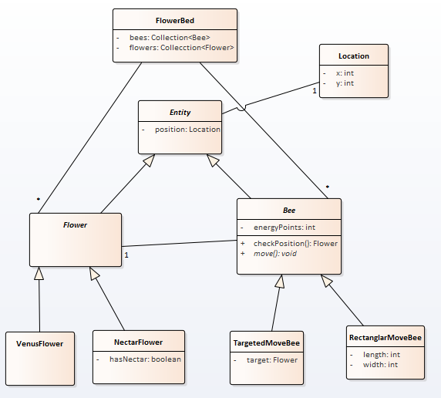

We plan to modify the design of the FlowerBed as a Singleton, the entity may contain an energy level, and the bees may use a strategy pattern for movement behavior.

Screenshot 12/17/2019:

