ZigZag Ball

**Quick start guide:**

* Download Construct 2 from the official Web Site:

<https://www.scirra.com>

* Official Construct 2 Manual :

<https://www.scirra.com/manual/1/construct-2>

* Top Tutorials:

<https://www.scirra.com/tutorials/top>

**Ad plugin to your construct 2 program file:**

Before Opening the project you must Ad “lunarray.litetween” behavior to your construct 2 program file and restart the program.

Extract to:

C:\Program Files\Construct 2\exporters\html5\behaviors

How to Open Project:

Add “spritefont plus plugin” if you need it. Drag and drop it on construct 2 and click install.

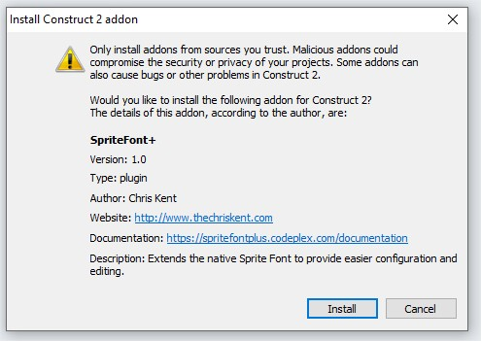

**Ad plugin to your construct 3 program file:**

Menu 🡺 view 🡺 Addon manager

**Open the Project:**

* Run the Construct 2, go to FILE / OPEN.

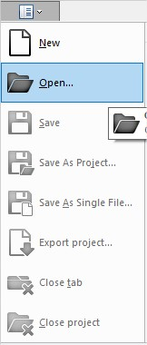

* Select “ ZigZag” file
* At the top of the desktop we have the "tabs" of the project.



**How to reskin the app:**

Double click on the image, then click “Load an image from a file”



**AdMob:**

* If you want to export your project to mobile (Android or IOS)

Go to projects / AdmobAds

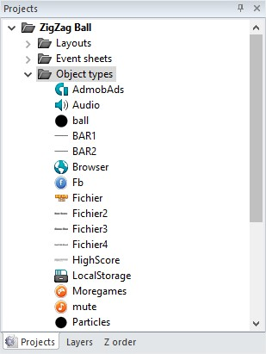

On the left side, we have AdMob properties, Ad your Banner and Interstitial ID, change Test Mode to False.

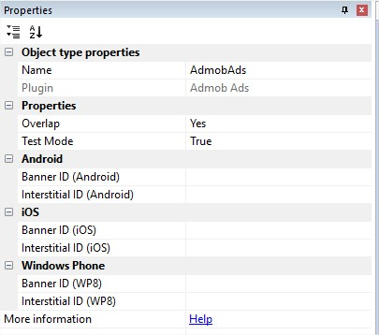

You can change the setting from “AdMob” event sheet.

**Export Files:**

**If you don’t have construct 2 or construct 3, you can use export files to build APK.**

**AdMob:**

ZigZag Mobile_phonegap.zip:

To change Admob ads, Open www/data.js and search for :  
Banner: ca-app-pub-3940256099942544/6300978111  
Interstitial: ca-app-pub-3940256099942544/1033173712

ZigZag Mobile_cordovaCLI.zip:

To change Admob ads, Open www/data.js and search for :  
Banner: 🡺 ca-app-pub-3940256099942544/6300978111  
Interstitial: 🡺 ca-app-pub-3940256099942544/1033173712

admob app ID: 🡺 ca-app-pub-3940256099942544~3347511713

Publisher ID: 🡺 My_publisher_ID

Privacy policy URL: 🡺 My_privacy.link

**Rate link:**

To change links, Open www/data.js and search for:   
facebook share link: 🡺 https://www.facebook.com/sharer/sharer.php?u=https%3A//codecanyon.net/user/linbeck/portfolio  
more games link: 🡺 https://codecanyon.net/user/linbeck/portfolio   
rate link: 🡺 https://codecanyon.net/user/linbeck/portfolio

**I'd be glad to help you if you have any questions relating to this app.**

**THANK YOU**

**☺**