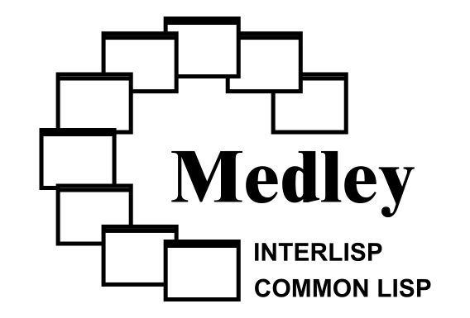

2025 Medley Annual Report *OUTLINE*

Overview
Overview.

Key Accomplishments

Lowered Barriers to Entry
We continue working to make it easier to try out Medley Interlisp.
Work on building IRM from source to update it.
New Medley Primer.

Work on Platforms, Releases, Builds, Automation, Installers
Added -info and -timer options to Maiko.
Added arrow keys support to Maiko.
Improved support for WSL1.
Improved loadup scripts to support names to go into subdirectories according to branch/pr.
Improved Medley Online with direct URLs, noVNC file manager access from Lisp, buttons for import/export of files, museum mode.

Medley Tool Enhancements
Merged Ron’s TEdit 5th round. Commands with OUTPUT TEDIT go to Tedit window.
Reworked loadups build process, also to accommodate LFG.
Added tools for creating NoteCards Masterscope database.
Reworked NoteCards access to TEdit menus.
Improved Meta-O and Meta-D warnings in TEdit.
Added option to send Masterscope output to TEdit.
Adding support for keyboard commands in MAN’s TEdit window.
Added support for viewing PDF files with the host OS viewer.
New TAB-WINDOWS LispUsers module.
Made LOGOUT more versatile.
Added EXAMINEDEFS tool.
Added multi ALIST macros.
Enhanced PSEUDOHOST to support creating commands.
Improved SEE-PDF.
Changed TEdit charlooks menu to support specifying different fonts for different devices.
Improved REGIONMANAGER.
New LispUsers module MULTI-ALIST.
Enhanced FONTSAMPLER to display DISPLAYFONT glyphs on NON-DISPLAY streams and optionally use HEX vs OCTAL on page info.
Added support for arrow keys in TEdit and other system facilities.
New architecture for TEdit keybindings, better suggestions for initial window regions.
Added to PRC middle-click option of menu to bring up the issue’s web page.
Obsoleted some LispUsers modules for D-machine keybindings.
Added LispUsers module CHARCODEUTILS.
Implemented BDF font support.
Rewritten TEdit window splitting to make it easier to use and more robust.
Enhanced LispUsers JSON to access array elements.
Added support for MCCS and other font character codes.
Released HTMLSTREAM.
Reorganized font hierarchy and files.
Started LispUsers cleanup.
Improved loadup and medley scripts.
Lafite -> mbox converted for use with the ePAD email forensics tool.
Worked to make old BBN Lisp/Interlisp applications run on modern Medley (ELIZA, AM/EURISKO, Truckin, LFG Grammar Writer’s Workbench, Trillium, STRADS/DADM).
Improved Maiko handling of file names and versions.
Improved TEdit heuristics for the initial window size when opening a file.
Improved GITFNS.
Slightly improved ANSI Common Lisp compliance by supporting :IMPORT-FROM in DEFPACKAGE.
Initial work on XNS support.

Variety of Issues Closed and PRs Merged
We closed XX GitHub Issues and merged XX Medley pull requests and xx Maiko pull requests in 2025 (through XXX).

Community Engagement
Larry Masinter was a guest of the Lispy Gopher show at aNONradio.
Created official project accounts on Mastodon and Bluesky.
Ryan Burnside entered the Autumn Lisp Game Jam 2025 with Interlisp Hungarian Rings.

Website Enhancements (Bill to write)
Added RSS feed to status and news page.
Expanded In memoriam page.
Added support for direct access URLs for applications on Medley Online.
Simplified access to the file manager on Medley Online.
Arranged for bibliography entries to have their own web pages.
Added new entries and Improved the glossary.

Publications and Presentations
Eleanor Young applied for the ACM History and Archiving Fellowship, submitted a paper to and gave a talk at IEEE CCECE 2025. Later this year she gave a virtual talk at World Digital Preservation Day 2025.
Revised the bibliography.

Awards
Awards

Project and Organization
Abhik Hasnain rewrote the Medley primer.

Submitted paper to HICSS but track got cancelled.

Credits
[see issue #1029]
Established and documented a bibliography intake process.
Added many entries to the bibliography.
Published several videos on YouTube.
Collaborated with the Interim Computer Museum for an Interlisp exhibition.
New contributor: Ryan Burnside (tutorial videos, color themes, Lisp Game Jam)

Looking Ahead
We plan to continue with our work on Medley, emphasizing outreach, documentation, modernization, and education.
Thank you to our contributors, supporters, and the wider community for making this journey possible.

