Sol's Labyrinth: Geometry — question pool
Virginia 2023 Geometry Standards of Learning · game version 5.19.0 · 52 question sets · 312 questions

How to read this list
Every question in the Geometry game is here, grouped by strand and standard. A question set is one figure and its given facts, then six questions about it. In the game, students see the figure before each question and keep it in the side panel while they play.
The correct answer is in bold with a check mark (✔). Under each question: its standard, its skill (from the game's standards list, at the end of this document) and whether that skill is lower-order (LOTS) or higher-order (HOTS) thinking.
Level 1 sets are one-step problems, level 2 two-step, level 3 multistep, proof or modeling problems. The game picks questions by level to match how each student is doing, and never asks a question again until the student has seen the rest.
The review line under each question is for checking: tick the boxes and write notes, then send the changes back to be made in the game. The standard statements are short summaries of the 2023 Geometry SOL; please check them and the skills against the VDOE document too.

What is in the pool
Strand | Standard | Question sets | Questions
Logic, lines and transformations | G.RLT.1 · Translate logic statements, identify conditional statements, and use and interpret Venn diagrams. | 4 | 24
 | G.RLT.2 · Analyze, prove, and justify the relationships of parallel lines cut by a transversal. | 4 | 24
 | G.RLT.3 · Solve problems, including contextual problems, involving symmetry and transformation. | 4 | 24
Triangles | G.TR.1 · Determine the relationships between the measures of angles and lengths of sides in triangles, including problems in context. | 4 | 24
 | G.TR.2 · Prove two triangles are congruent, using direct and indirect proofs, and solve problems involving measured attributes of congruent triangles. | 4 | 24
 | G.TR.3 · Prove two triangles are similar, using direct and indirect proofs, and solve problems involving measured attributes of similar triangles. | 4 | 24
 | G.TR.4 · Model and solve problems, including those in context, involving trigonometry in right triangles and applications of the Pythagorean Theorem. | 4 | 24
Polygons and circles | G.PC.1 · Prove and justify theorems and properties of quadrilaterals, and verify and use properties of quadrilaterals to solve problems, including the relationships between the sides, angles, and diagonals. | 4 | 24
 | G.PC.2 · Verify relationships and solve problems involving the number of sides and measures of angles of convex polygons. | 4 | 24
 | G.PC.3 · Solve problems, including contextual problems, by applying properties of circles. | 4 | 24
 | G.PC.4 · Solve problems involving equations of circles. | 4 | 24
3-D figures | G.DF.1 · Create models and solve problems, including those in context, involving surface area and volume of rectangular and triangular prisms, cylinders, cones, pyramids, and spheres. | 5 | 30
 | G.DF.2 · Determine how changes in one or more dimensions affect perimeter, area, surface area, and volume, and solve problems with similar two- and three-dimensional figures. | 3 | 18

Logic, lines and transformations (G.RLT)

G.RLT.1 · Translate logic statements, identify conditional statements, and use and interpret Venn diagrams.

Vertical Angles, in Logic
Level 1 · Logic · G.RLT.1 · ID geo-rlt1-vertical
Let p be “Two angles are vertical angles.”
Let q be “The two angles are congruent.”
The Vertical Angles Theorem says that the conditional p → q is true.
1. Which sentence is p → q?
A. If two angles are congruent, then they are vertical angles.
B. Two angles are vertical angles and they are congruent.
C. If two angles are vertical angles, then they are congruent. ✔
D. Two angles are vertical angles if and only if they are congruent.
G.RLT.1 · skill G.RLT.1.1 (LOTS): Translate statements into symbols and words: negation (~p), conjunction (p ∧ q), disjunction (p ∨ q), conditional (p → q) and biconditional (p ↔ q)
☐ Answer key correct ☐ Wording clear Notes: ________________________________
2. Which is the sentence “Two angles are not vertical angles, or they are congruent” written in symbols?
A. ~p ∨ q ✔
B. ~p ∧ q
C. ~(p ∨ q)
D. p ∨ ~q
G.RLT.1 · skill G.RLT.1.1 (LOTS): Translate statements into symbols and words: negation (~p), conjunction (p ∧ q), disjunction (p ∨ q), conditional (p → q) and biconditional (p ↔ q)
☐ Answer key correct ☐ Wording clear Notes: ________________________________
3. Which is the converse of p → q, written in symbols?
A. ~p → ~q
B. ~q → ~p
C. p ↔ q
D. q → p ✔
G.RLT.1 · skill G.RLT.1.2 (LOTS): Identify the converse, inverse and contrapositive of a conditional statement and decide whether each is true
☐ Answer key correct ☐ Wording clear Notes: ________________________________
4. Which sentence is the inverse of p → q?
A. If two angles are not congruent, then they are not vertical angles.
B. If two angles are not vertical angles, then they are not congruent. ✔
C. If two angles are congruent, then they are vertical angles.
D. If two angles are vertical angles, then they are not congruent.
G.RLT.1 · skill G.RLT.1.2 (LOTS): Identify the converse, inverse and contrapositive of a conditional statement and decide whether each is true
☐ Answer key correct ☐ Wording clear Notes: ________________________________
5. Of p → q, its converse, its inverse and its contrapositive, which are true?
A. p → q and its contrapositive only ✔
B. p → q and its converse only
C. p → q and its inverse only
D. All four of the statements
G.RLT.1 · skill G.RLT.1.2 (LOTS): Identify the converse, inverse and contrapositive of a conditional statement and decide whether each is true
☐ Answer key correct ☐ Wording clear Notes: ________________________________
6. Which example shows that the converse, q → p, is false?
A. Two vertical angles that each measure 50°
B. A 50° angle and a 130° angle that form a linear pair
C. A 30° angle and a 60° angle that are complementary
D. The two 50° base angles of an isosceles triangle ✔
G.RLT.1 · skill G.RLT.1.2 (LOTS): Identify the converse, inverse and contrapositive of a conditional statement and decide whether each is true
☐ Answer key correct ☐ Wording clear Notes: ________________________________

Soccer and Band
Level 2 · Logic · G.RLT.1 · ID geo-rlt1-clubs
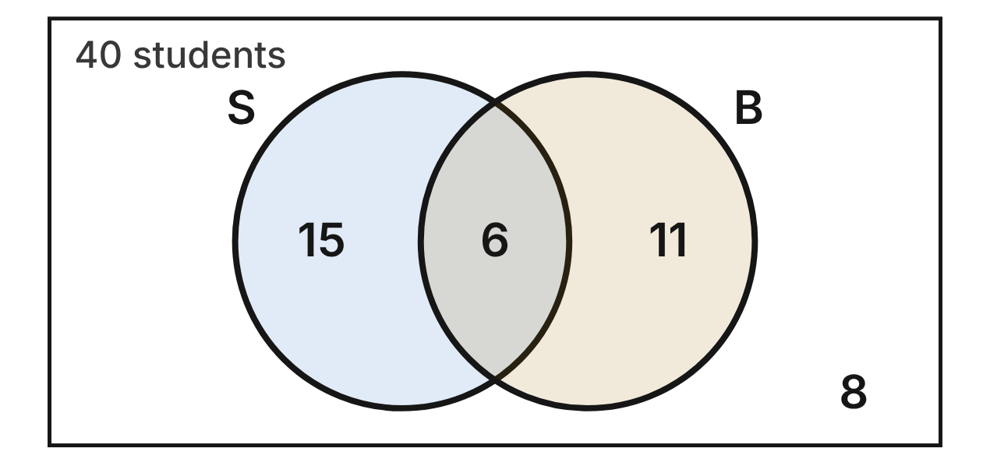
The Venn diagram shows all 40 students in one homeroom. S is the set of students who play soccer, and B is the set of students in the band. Each number is the number of students in that region.
7. How many students are in S ∩ B?
A. 32
B. 6 ✔
C. 21
D. 17
G.RLT.1 · skill G.RLT.1.4 (LOTS): Use and interpret Venn diagrams: union, intersection, subset and negation, including in context
☐ Answer key correct ☐ Wording clear Notes: ________________________________
8. How many students are in S ∪ B?
A. 38
B. 40
C. 26
D. 32 ✔
G.RLT.1 · skill G.RLT.1.4 (LOTS): Use and interpret Venn diagrams: union, intersection, subset and negation, including in context
☐ Answer key correct ☐ Wording clear Notes: ________________________________
9. How many students are in ~S (students who do not play soccer)?
A. 19 ✔
B. 11
C. 8
D. 25
G.RLT.1 · skill G.RLT.1.4 (LOTS): Use and interpret Venn diagrams: union, intersection, subset and negation, including in context
☐ Answer key correct ☐ Wording clear Notes: ________________________________
10. How many students are in exactly one of the two groups?
A. 32
B. 6
C. 26 ✔
D. 38
G.RLT.1 · skill G.RLT.1.4 (LOTS): Use and interpret Venn diagrams: union, intersection, subset and negation, including in context
☐ Answer key correct ☐ Wording clear Notes: ________________________________
11. Consider the statement “If a student is in the band, then the student plays soccer.” How many students in this homeroom are counterexamples to it?
A. 17
B. 8
C. 11 ✔
D. 6
G.RLT.1 · skill G.RLT.1.2 (LOTS): Identify the converse, inverse and contrapositive of a conditional statement and decide whether each is true
☐ Answer key correct ☐ Wording clear Notes: ________________________________
12. Which expression names the region with 8 students?
A. ~(S ∩ B)
B. ~(S ∪ B) ✔
C. ~S ∩ B
D. S ∩ ~B
G.RLT.1 · skill G.RLT.1.4 (LOTS): Use and interpret Venn diagrams: union, intersection, subset and negation, including in context
☐ Answer key correct ☐ Wording clear Notes: ________________________________

The Quadrilateral Family
Level 2 · Logic · G.RLT.1 · ID geo-rlt1-quads
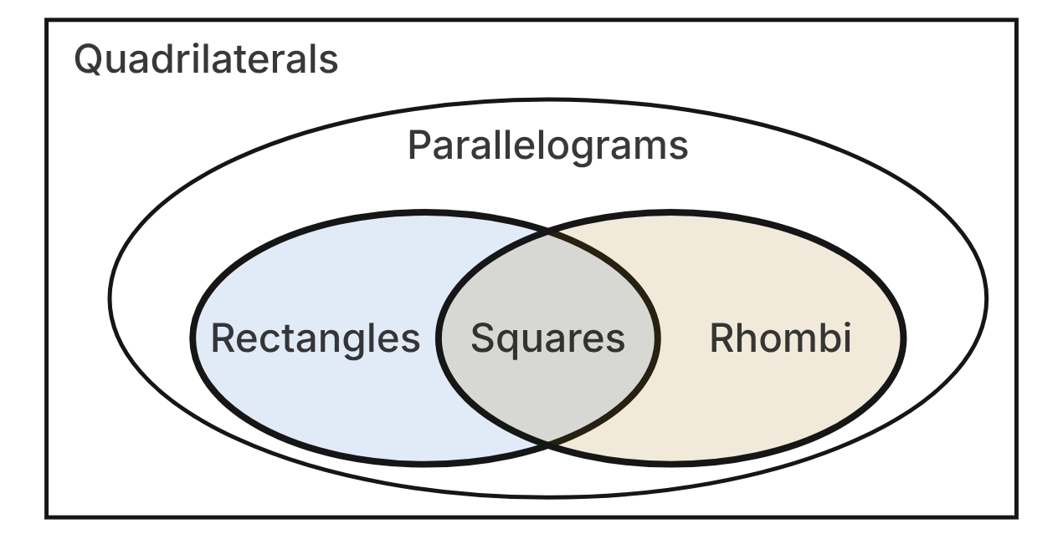
The diagram shows how some sets of quadrilaterals are related. A set drawn inside another set is a subset of it.
13. Which conditional does the diagram show is true?
A. If a quadrilateral is a square, then it is a rhombus. ✔
B. If a quadrilateral is a rhombus, then it is a square.
C. If a quadrilateral is a parallelogram, then it is a rectangle.
D. If a quadrilateral is a rectangle, then it is a rhombus.
G.RLT.1 · skill G.RLT.1.4 (LOTS): Use and interpret Venn diagrams: union, intersection, subset and negation, including in context
☐ Answer key correct ☐ Wording clear Notes: ________________________________
14. Statement 1: If a quadrilateral is a square, then it is a rectangle. Statement 2: If a quadrilateral is a rectangle, then it is a parallelogram. Which conclusion follows by the Law of Syllogism?
A. If a quadrilateral is a parallelogram, then it is a square.
B. If a quadrilateral is a rectangle, then it is a square.
C. If a quadrilateral is a square, then it is a parallelogram. ✔
D. If a quadrilateral is not a square, then it is not a parallelogram.
G.RLT.1 · skill G.RLT.1.3 (HOTS): Use deductive reasoning (the Law of Detachment and the Law of Syllogism) to decide whether a conclusion is valid
☐ Answer key correct ☐ Wording clear Notes: ________________________________
15. If a quadrilateral is a rhombus, then it is a parallelogram. Quadrilateral WXYZ is a rhombus. What must be true, by the Law of Detachment?
A. WXYZ is a square.
B. WXYZ is a parallelogram. ✔
C. WXYZ is a rectangle.
D. WXYZ is not a rectangle.
G.RLT.1 · skill G.RLT.1.3 (HOTS): Use deductive reasoning (the Law of Detachment and the Law of Syllogism) to decide whether a conclusion is valid
☐ Answer key correct ☐ Wording clear Notes: ________________________________
16. Ana argues: “If a quadrilateral is a square, then it is a rectangle. ABCD is a rectangle. So ABCD is a square.” Which describes her argument?
A. Valid, by the Law of Detachment
B. Valid, by the Law of Syllogism
C. Invalid, because the conditional is false
D. Invalid; it reasons from the converse ✔
G.RLT.1 · skill G.RLT.1.3 (HOTS): Use deductive reasoning (the Law of Detachment and the Law of Syllogism) to decide whether a conclusion is valid
☐ Answer key correct ☐ Wording clear Notes: ________________________________
17. In the diagram, which set is Rectangles ∩ Rhombi?
A. Squares ✔
B. Parallelograms
C. Quadrilaterals
D. The empty set
G.RLT.1 · skill G.RLT.1.4 (LOTS): Use and interpret Venn diagrams: union, intersection, subset and negation, including in context
☐ Answer key correct ☐ Wording clear Notes: ________________________________
18. Which statement is true?
A. If a quadrilateral is not a square, then it is not a rectangle.
B. If a quadrilateral is not a parallelogram, then it is not a rhombus. ✔
C. If a quadrilateral is a parallelogram, then it is a rhombus.
D. If a quadrilateral is not a rhombus, then it is not a parallelogram.
G.RLT.1 · skill G.RLT.1.2 (LOTS): Identify the converse, inverse and contrapositive of a conditional statement and decide whether each is true
☐ Answer key correct ☐ Wording clear Notes: ________________________________

Three After-School Activities
Level 3 · Logic · G.RLT.1 · ID geo-rlt1-activities
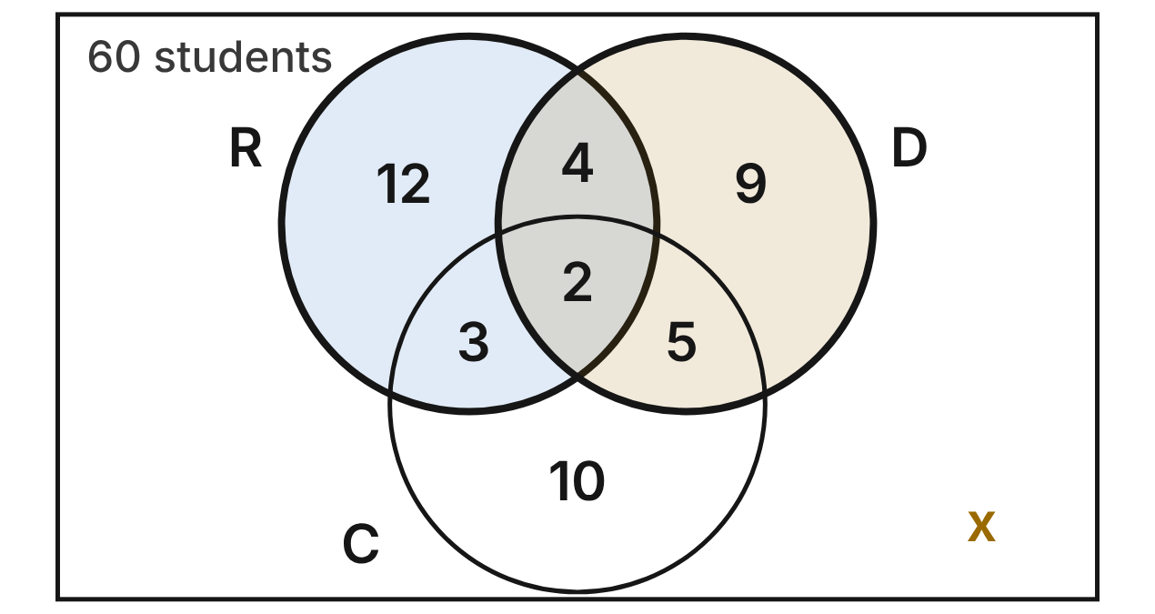
A survey asked 60 ninth graders about three activities: R is robotics, D is drama and C is chorus. Each number is the number of students in that region, and x students are in none of the three.
19. What is the value of x?
A. 45
B. 17
C. 13
D. 15 ✔
G.RLT.1 · skill G.RLT.1.4 (LOTS): Use and interpret Venn diagrams: union, intersection, subset and negation, including in context
☐ Answer key correct ☐ Wording clear Notes: ________________________________
20. How many students are in R ∩ D?
A. 4
B. 6 ✔
C. 2
D. 35
G.RLT.1 · skill G.RLT.1.4 (LOTS): Use and interpret Venn diagrams: union, intersection, subset and negation, including in context
☐ Answer key correct ☐ Wording clear Notes: ________________________________
21. How many students are in exactly two of the three activities?
A. 14
B. 2
C. 12 ✔
D. 31
G.RLT.1 · skill G.RLT.1.4 (LOTS): Use and interpret Venn diagrams: union, intersection, subset and negation, including in context
☐ Answer key correct ☐ Wording clear Notes: ________________________________
22. How many students are in C ∩ ~R (chorus but not robotics)?
A. 15 ✔
B. 10
C. 20
D. 17
G.RLT.1 · skill G.RLT.1.4 (LOTS): Use and interpret Venn diagrams: union, intersection, subset and negation, including in context
☐ Answer key correct ☐ Wording clear Notes: ________________________________
23. Kai is in robotics and in chorus. Sam concludes that Kai must also be in drama. Is Sam's conclusion valid?
A. Yes; the center region is inside all three circles.
B. Yes; the robotics circle overlaps the drama circle.
C. No; 3 students are in robotics and chorus but not drama. ✔
D. No; no student can be in all three activities.
G.RLT.1 · skill G.RLT.1.3 (HOTS): Use deductive reasoning (the Law of Detachment and the Law of Syllogism) to decide whether a conclusion is valid
☐ Answer key correct ☐ Wording clear Notes: ________________________________
24. How many students are in (R ∪ C) ∩ ~D, that is, in robotics or chorus but not in drama?
A. 36
B. 40
C. 27
D. 25 ✔
G.RLT.1 · skill G.RLT.1.4 (LOTS): Use and interpret Venn diagrams: union, intersection, subset and negation, including in context
☐ Answer key correct ☐ Wording clear Notes: ________________________________

G.RLT.2 · Analyze, prove, and justify the relationships of parallel lines cut by a transversal.

Stripes in the Parking Lot
Level 1 · Lines · G.RLT.2 · ID geo-rlt2-parking
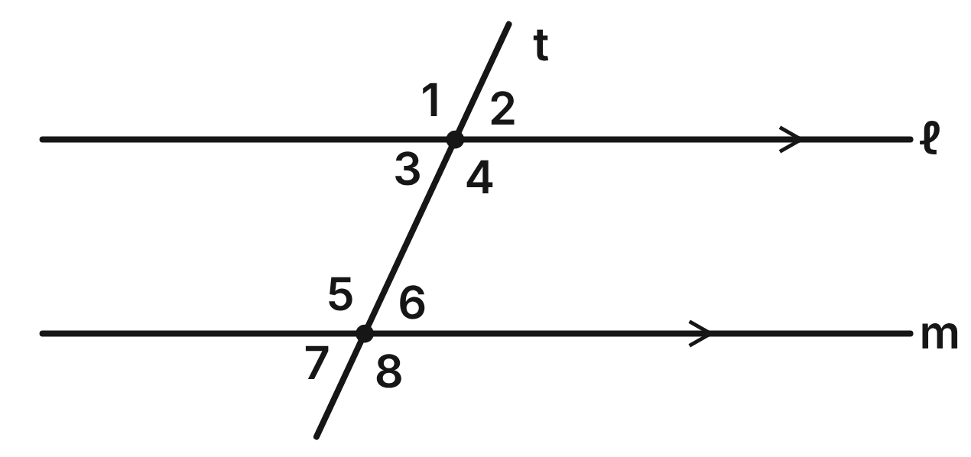
Parking stripes ℓ and m are parallel. A lane line, t, crosses both of them. m∠1 = 115°.
25. ∠3 and ∠6 are what kind of angle pair?
A. Corresponding angles
B. Alternate interior angles ✔
C. Same-side interior angles
D. Alternate exterior angles
G.RLT.2 · skill G.RLT.2.1 (LOTS): Identify angle pairs formed by a transversal: corresponding, alternate interior, alternate exterior, same-side interior, vertical and linear pairs
☐ Answer key correct ☐ Wording clear Notes: ________________________________
26. Which angle corresponds to ∠2?
A. ∠6 ✔
B. ∠7
C. ∠3
D. ∠4
G.RLT.2 · skill G.RLT.2.1 (LOTS): Identify angle pairs formed by a transversal: corresponding, alternate interior, alternate exterior, same-side interior, vertical and linear pairs
☐ Answer key correct ☐ Wording clear Notes: ________________________________
27. What is m∠5?
A. 65°
B. 25°
C. 245°
D. 115° ✔
G.RLT.2 · skill G.RLT.2.3 (LOTS): Solve problems, including algebraic ones, using the angles formed by parallel lines and a transversal
☐ Answer key correct ☐ Wording clear Notes: ________________________________
28. Which angle measures 65°?
A. ∠4
B. ∠5
C. ∠6 ✔
D. ∠8
G.RLT.2 · skill G.RLT.2.3 (LOTS): Solve problems, including algebraic ones, using the angles formed by parallel lines and a transversal
☐ Answer key correct ☐ Wording clear Notes: ________________________________
29. Which two angles are same-side interior angles?
A. ∠3 and ∠6
B. ∠3 and ∠5 ✔
C. ∠1 and ∠5
D. ∠2 and ∠7
G.RLT.2 · skill G.RLT.2.1 (LOTS): Identify angle pairs formed by a transversal: corresponding, alternate interior, alternate exterior, same-side interior, vertical and linear pairs
☐ Answer key correct ☐ Wording clear Notes: ________________________________
30. A painter measures ∠4 and ∠6. What is m∠4 + m∠6?
A. 180° ✔
B. 130°
C. 230°
D. 90°
G.RLT.2 · skill G.RLT.2.3 (LOTS): Solve problems, including algebraic ones, using the angles formed by parallel lines and a transversal
☐ Answer key correct ☐ Wording clear Notes: ________________________________

The Railroad Crossing
Level 2 · Lines · G.RLT.2 · ID geo-rlt2-railroad
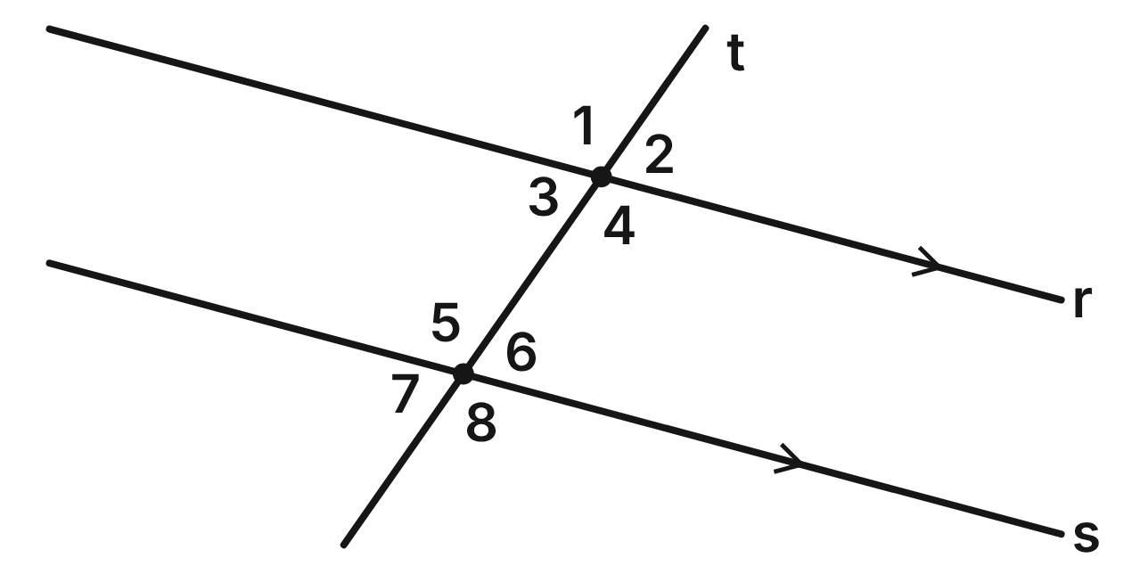
Rails r and s are parallel. Road t crosses both rails. m∠3 = (3x + 16)° and m∠6 = (5x − 20)°.
31. Find the value of x.
A. 23
B. −2
C. 18 ✔
D. 36
G.RLT.2 · skill G.RLT.2.3 (LOTS): Solve problems, including algebraic ones, using the angles formed by parallel lines and a transversal
☐ Answer key correct ☐ Wording clear Notes: ________________________________
32. What is m∠3?
A. 110°
B. 85°
C. 54°
D. 70° ✔
G.RLT.2 · skill G.RLT.2.3 (LOTS): Solve problems, including algebraic ones, using the angles formed by parallel lines and a transversal
☐ Answer key correct ☐ Wording clear Notes: ________________________________
33. What is m∠8?
A. 110° ✔
B. 70°
C. 20°
D. 290°
G.RLT.2 · skill G.RLT.2.3 (LOTS): Solve problems, including algebraic ones, using the angles formed by parallel lines and a transversal
☐ Answer key correct ☐ Wording clear Notes: ________________________________
34. Why is the equation (3x + 16) = (5x − 20) the right one to solve?
A. ∠3 and ∠6 are corresponding angles.
B. ∠3 and ∠6 are alternate interior angles. ✔
C. ∠3 and ∠6 are vertical angles.
D. ∠3 and ∠6 are same-side interior angles.
G.RLT.2 · skill G.RLT.2.1 (LOTS): Identify angle pairs formed by a transversal: corresponding, alternate interior, alternate exterior, same-side interior, vertical and linear pairs
☐ Answer key correct ☐ Wording clear Notes: ________________________________
35. For the same crossing, m∠2 = (y + 40)° and m∠7 = (3y − 20)°. What is the value of y?
A. 10
B. 40
C. 70
D. 30 ✔
G.RLT.2 · skill G.RLT.2.3 (LOTS): Solve problems, including algebraic ones, using the angles formed by parallel lines and a transversal
☐ Answer key correct ☐ Wording clear Notes: ________________________________
36. Suppose you did not know that the rails are parallel. Which fact would prove that r ∥ s?
A. m∠1 = m∠4
B. m∠3 + m∠4 = 180°
C. m∠1 = m∠5 ✔
D. m∠3 = m∠5
G.RLT.2 · skill G.RLT.2.2 (HOTS): Prove or justify that two lines are parallel, or are not, from angle measures
☐ Answer key correct ☐ Wording clear Notes: ________________________________

The Garden Trellis
Level 2 · Lines · G.RLT.2 · ID geo-rlt2-trellis
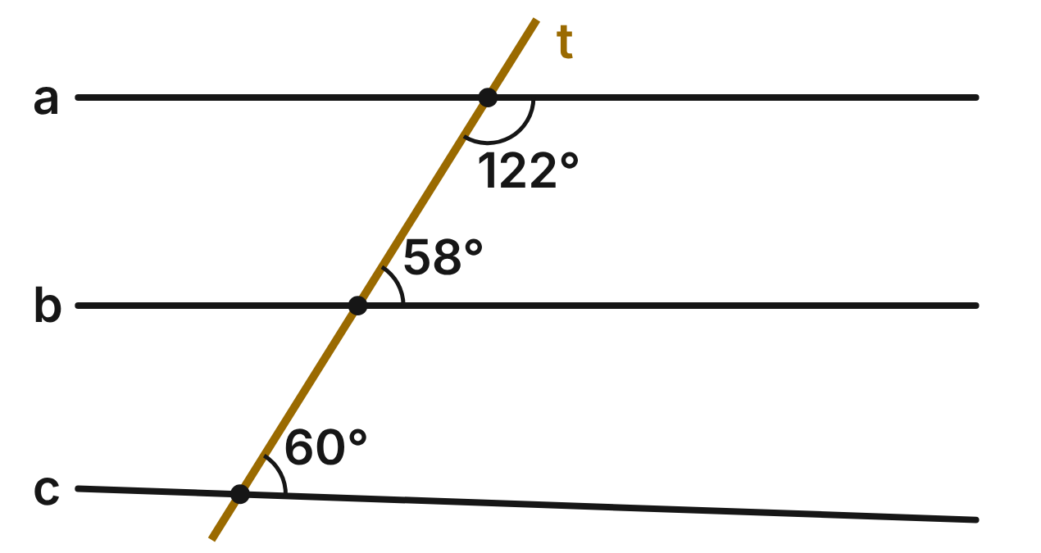
Boards a, b and c of a garden trellis are crossed by a straight brace, t. The figure shows the angle measured at each board.
37. The 122° angle at board a and the 58° angle at board b are what kind of angle pair?
A. Corresponding angles
B. Alternate interior angles
C. Alternate exterior angles
D. Same-side interior angles ✔
G.RLT.2 · skill G.RLT.2.1 (LOTS): Identify angle pairs formed by a transversal: corresponding, alternate interior, alternate exterior, same-side interior, vertical and linear pairs
☐ Answer key correct ☐ Wording clear Notes: ________________________________
38. Is board a parallel to board b, and why?
A. Yes; same-side interior angles are supplementary. ✔
B. No; the two angles are not congruent.
C. No; same-side interior angles must be congruent.
D. Cannot tell without a third angle measure.
G.RLT.2 · skill G.RLT.2.2 (HOTS): Prove or justify that two lines are parallel, or are not, from angle measures
☐ Answer key correct ☐ Wording clear Notes: ________________________________
39. Is board c parallel to board b, and why?
A. Yes; both angles are acute, so they match.
B. Yes; boards b and c are both cut by t.
C. No; corresponding angles are not congruent. ✔
D. Yes; both angles are on the same side of t.
G.RLT.2 · skill G.RLT.2.2 (HOTS): Prove or justify that two lines are parallel, or are not, from angle measures
☐ Answer key correct ☐ Wording clear Notes: ________________________________
40. What should the 60° angle measure for board c to be parallel to board b?
A. 122°
B. 58° ✔
C. 32°
D. 120°
G.RLT.2 · skill G.RLT.2.3 (LOTS): Solve problems, including algebraic ones, using the angles formed by parallel lines and a transversal
☐ Answer key correct ☐ Wording clear Notes: ________________________________
41. Which theorem justifies the conclusion that a ∥ b?
A. Converse of the Same-Side Interior Angles Theorem ✔
B. Same-Side Interior Angles Theorem
C. Converse of the Corresponding Angles Postulate
D. Vertical Angles Theorem
G.RLT.2 · skill G.RLT.2.2 (HOTS): Prove or justify that two lines are parallel, or are not, from angle measures
☐ Answer key correct ☐ Wording clear Notes: ________________________________
42. What is the measure of the angle above board a, on the left of t?
A. 58°
B. 238°
C. 122° ✔
D. 32°
G.RLT.2 · skill G.RLT.2.3 (LOTS): Solve problems, including algebraic ones, using the angles formed by parallel lines and a transversal
☐ Answer key correct ☐ Wording clear Notes: ________________________________

Proving Lines Parallel
Level 3 · Lines · G.RLT.2 · ID geo-rlt2-proof
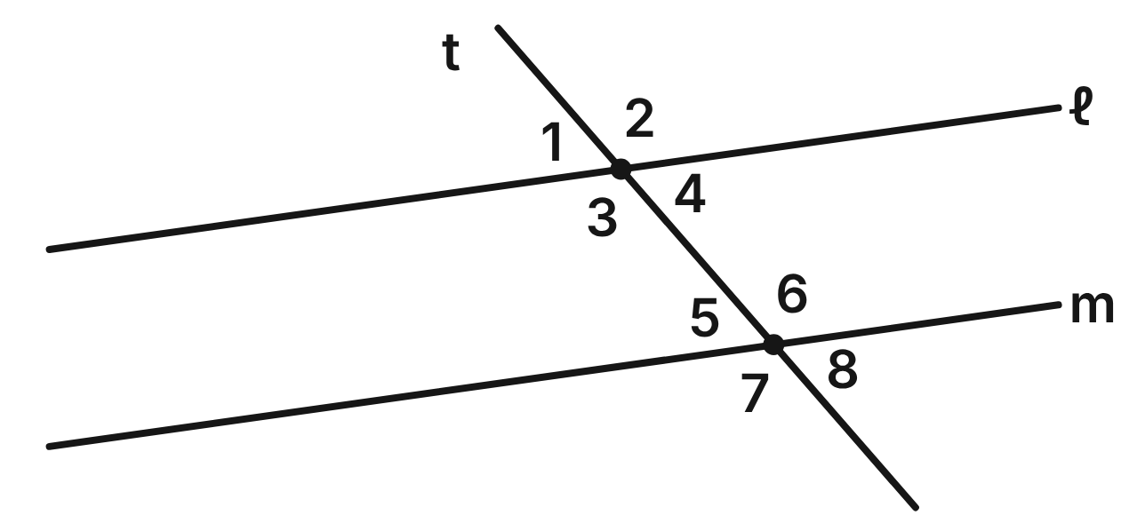
Lines ℓ and m are cut by transversal t. Given: ∠1 and ∠7 are supplementary. Prove: ℓ ∥ m.
Statement | Reason
1. ∠1 and ∠7 are supplementary. | Given
2. ∠5 and ∠7 form a linear pair. | Definition of a linear pair
3. ∠5 and ∠7 are supplementary. | Linear Pair Postulate
4. ∠1 ≅ ∠5 | ____ (a)
5. ℓ ∥ m | ____ (b)

43. Which reason belongs in blank (a)?
A. Congruent Supplements Theorem ✔
B. Vertical Angles Theorem
C. Linear Pair Postulate
D. Corresponding Angles Postulate
G.RLT.2 · skill G.RLT.2.2 (HOTS): Prove or justify that two lines are parallel, or are not, from angle measures
☐ Answer key correct ☐ Wording clear Notes: ________________________________
44. Which reason belongs in blank (b)?
A. Corresponding Angles Postulate
B. Converse of the Corresponding Angles Postulate ✔
C. Converse of the Alternate Interior Angles Theorem
D. Converse of the Same-Side Interior Angles Theorem
G.RLT.2 · skill G.RLT.2.2 (HOTS): Prove or justify that two lines are parallel, or are not, from angle measures
☐ Answer key correct ☐ Wording clear Notes: ________________________________
45. Suppose m∠1 = (2x + 31)° and m∠7 = (8x + 19)°. For what value of x is ℓ ∥ m?
A. 2
B. 4
C. 31
D. 13 ✔
G.RLT.2 · skill G.RLT.2.3 (LOTS): Solve problems, including algebraic ones, using the angles formed by parallel lines and a transversal
☐ Answer key correct ☐ Wording clear Notes: ________________________________
46. Suppose m∠1 = (2x + 31)° and m∠7 = (8x + 19)°, and ℓ ∥ m. What is m∠2?
A. 57°
B. 33°
C. 123° ✔
D. 237°
G.RLT.2 · skill G.RLT.2.3 (LOTS): Solve problems, including algebraic ones, using the angles formed by parallel lines and a transversal
☐ Answer key correct ☐ Wording clear Notes: ________________________________
47. In step 4, ∠1 and ∠5 are what kind of angle pair?
A. Alternate interior angles
B. Corresponding angles ✔
C. Same-side exterior angles
D. Vertical angles
G.RLT.2 · skill G.RLT.2.1 (LOTS): Identify angle pairs formed by a transversal: corresponding, alternate interior, alternate exterior, same-side interior, vertical and linear pairs
☐ Answer key correct ☐ Wording clear Notes: ________________________________
48. Which given would NOT be enough to prove that ℓ ∥ m?
A. ∠3 ≅ ∠6
B. ∠2 ≅ ∠7
C. ∠4 and ∠6 are supplementary
D. ∠1 ≅ ∠4 ✔
G.RLT.2 · skill G.RLT.2.2 (HOTS): Prove or justify that two lines are parallel, or are not, from angle measures
☐ Answer key correct ☐ Wording clear Notes: ________________________________

G.RLT.3 · Solve problems, including contextual problems, involving symmetry and transformation.

Symmetry in Designs
Level 1 · Transformations · G.RLT.3 · ID geo-rlt3-symmetry
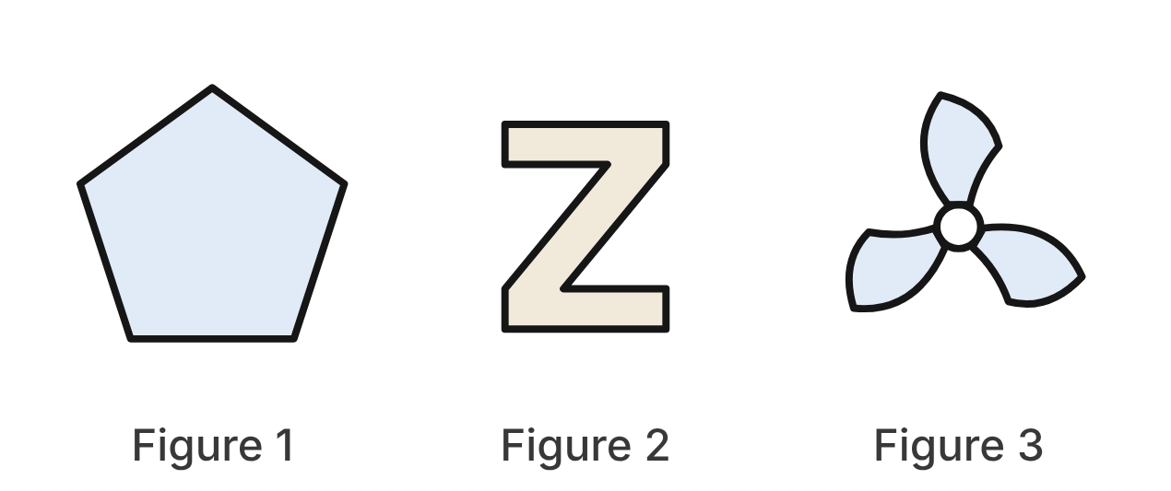
Figure 1 is a regular pentagon. Figure 2 is the letter Z on a sign. Figure 3 is a fan with three identical curved blades that all sweep the same way, like a pinwheel.
49. How many lines of symmetry does Figure 1 have?
A. 10
B. 1
C. 5 ✔
D. 0
G.RLT.3 · skill G.RLT.3.1 (LOTS): Identify line symmetry and rotational symmetry of a figure
☐ Answer key correct ☐ Wording clear Notes: ________________________________
50. What is the smallest angle of rotation, about its center, that maps Figure 1 onto itself?
A. 108°
B. 72° ✔
C. 36°
D. 60°
G.RLT.3 · skill G.RLT.3.1 (LOTS): Identify line symmetry and rotational symmetry of a figure
☐ Answer key correct ☐ Wording clear Notes: ________________________________
51. Which describes the symmetry of Figure 2?
A. Rotational symmetry of order 2, no line symmetry ✔
B. One line of symmetry, no rotational symmetry
C. Two lines of symmetry and rotational symmetry
D. No line symmetry and no rotational symmetry
G.RLT.3 · skill G.RLT.3.1 (LOTS): Identify line symmetry and rotational symmetry of a figure
☐ Answer key correct ☐ Wording clear Notes: ________________________________
52. What is the order of rotational symmetry of Figure 3?
A. 6
B. 1
C. 120
D. 3 ✔
G.RLT.3 · skill G.RLT.3.1 (LOTS): Identify line symmetry and rotational symmetry of a figure
☐ Answer key correct ☐ Wording clear Notes: ________________________________
53. How many lines of symmetry does Figure 3 have?
A. 3
B. 6
C. 0 ✔
D. 1
G.RLT.3 · skill G.RLT.3.1 (LOTS): Identify line symmetry and rotational symmetry of a figure
☐ Answer key correct ☐ Wording clear Notes: ________________________________
54. Figure 1 is enlarged for a poster by a dilation with scale factor 3. Which is true of the enlarged pentagon?
A. It still has 5 lines of symmetry. ✔
B. It has 15 lines of symmetry.
C. It is congruent to Figure 1.
D. Each of its angles is 3 times as large.
G.RLT.3 · skill G.RLT.3.3 (HOTS): Determine the transformation or composition that maps a preimage to an image, and whether it preserves size and shape
☐ Answer key correct ☐ Wording clear Notes: ________________________________

Moving a Triangle
Level 2 · Transformations · G.RLT.3 · ID geo-rlt3-triangle
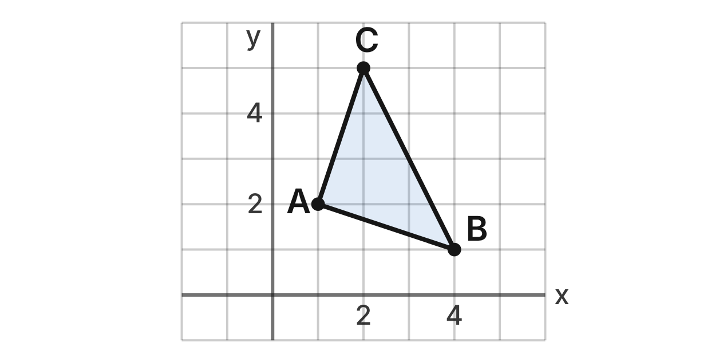
Triangle ABC has vertices A(1, 2), B(4, 1) and C(2, 5).
55. Under the translation (x, y) → (x − 5, y + 1), what is the image of A?
A. (6, 3)
B. (−4, 3) ✔
C. (−4, 1)
D. (6, 1)
G.RLT.3 · skill G.RLT.3.2 (LOTS): Find the image of a figure on the coordinate plane under a translation, reflection, rotation or dilation
☐ Answer key correct ☐ Wording clear Notes: ________________________________
56. What is the image of B after a reflection over the y-axis?
A. (4, −1)
B. (−4, −1)
C. (1, 4)
D. (−4, 1) ✔
G.RLT.3 · skill G.RLT.3.2 (LOTS): Find the image of a figure on the coordinate plane under a translation, reflection, rotation or dilation
☐ Answer key correct ☐ Wording clear Notes: ________________________________
57. What is the image of C after a reflection over the line y = x?
A. (−2, 5)
B. (2, −5)
C. (5, 2) ✔
D. (−5, −2)
G.RLT.3 · skill G.RLT.3.2 (LOTS): Find the image of a figure on the coordinate plane under a translation, reflection, rotation or dilation
☐ Answer key correct ☐ Wording clear Notes: ________________________________
58. What is the image of B after a rotation of 90° counterclockwise about the origin?
A. (−1, 4) ✔
B. (1, −4)
C. (−4, −1)
D. (−4, 1)
G.RLT.3 · skill G.RLT.3.2 (LOTS): Find the image of a figure on the coordinate plane under a translation, reflection, rotation or dilation
☐ Answer key correct ☐ Wording clear Notes: ________________________________
59. Triangle A′B′C′ has vertices A′(−1, −2), B′(−4, −1) and C′(−2, −5). Which single transformation maps △ABC to △A′B′C′?
A. Reflection over the x-axis
B. Reflection over the y-axis
C. Rotation of 90° clockwise about the origin
D. Rotation of 180° about the origin ✔
G.RLT.3 · skill G.RLT.3.3 (HOTS): Determine the transformation or composition that maps a preimage to an image, and whether it preserves size and shape
☐ Answer key correct ☐ Wording clear Notes: ________________________________
60. Which transformation would NOT give an image congruent to △ABC?
A. (x, y) → (−y, x)
B. (x, y) → (2x, 2y) ✔
C. (x, y) → (x + 3, y − 4)
D. (x, y) → (y, x)
G.RLT.3 · skill G.RLT.3.3 (HOTS): Determine the transformation or composition that maps a preimage to an image, and whether it preserves size and shape
☐ Answer key correct ☐ Wording clear Notes: ________________________________

Shrinking a Logo
Level 2 · Transformations · G.RLT.3 · ID geo-rlt3-logo
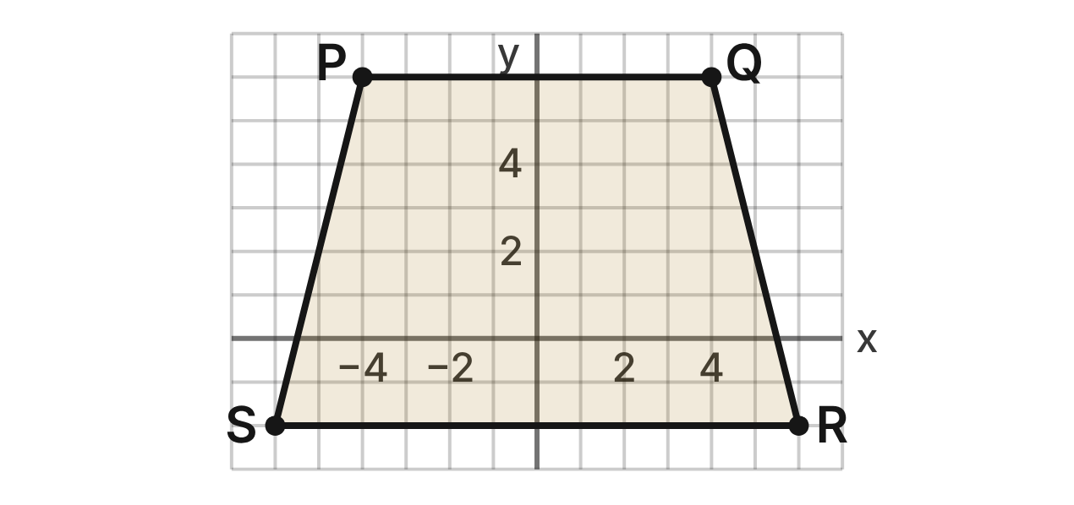
A designer draws a logo, trapezoid PQRS, with P(−4, 6), Q(4, 6), R(6, −2) and S(−6, −2). She dilates it about the origin to make a smaller app icon, P′Q′R′S′.
61. Under a dilation with scale factor 1/2 centered at the origin, what is the image of R?
A. (3, −1) ✔
B. (12, −4)
C. (6.5, −1.5)
D. (3, −2)
G.RLT.3 · skill G.RLT.3.2 (LOTS): Find the image of a figure on the coordinate plane under a translation, reflection, rotation or dilation
☐ Answer key correct ☐ Wording clear Notes: ________________________________
62. PQ is 8 units long. After the dilation with scale factor 1/2, how long is P′Q′?
A. 16 units
B. 2 units
C. 4 units ✔
D. 8 units
G.RLT.3 · skill G.RLT.3.2 (LOTS): Find the image of a figure on the coordinate plane under a translation, reflection, rotation or dilation
☐ Answer key correct ☐ Wording clear Notes: ________________________________
63. The area of PQRS is 80 square units. What is the area of P′Q′R′S′ after the dilation with scale factor 1/2?
A. 40 square units
B. 80 square units
C. 320 square units
D. 20 square units ✔
G.RLT.3 · skill G.RLT.3.2 (LOTS): Find the image of a figure on the coordinate plane under a translation, reflection, rotation or dilation
☐ Answer key correct ☐ Wording clear Notes: ________________________________
64. After the dilation with scale factor 1/2, how does P′Q′R′S′ compare with PQRS?
A. Same side lengths, same angle measures
B. Same angle measures, sides half as long ✔
C. Same side lengths, angles half as large
D. Angles and sides both half as large
G.RLT.3 · skill G.RLT.3.3 (HOTS): Determine the transformation or composition that maps a preimage to an image, and whether it preserves size and shape
☐ Answer key correct ☐ Wording clear Notes: ________________________________
65. A different dilation centered at the origin maps P(−4, 6) to (−10, 15). What is its scale factor?
A. 0.4
B. 6
C. 2.5 ✔
D. 9
G.RLT.3 · skill G.RLT.3.3 (HOTS): Determine the transformation or composition that maps a preimage to an image, and whether it preserves size and shape
☐ Answer key correct ☐ Wording clear Notes: ________________________________
66. The designer dilates PQRS by scale factor 1/2 about the origin, then translates the image 3 units right. Where does S end up?
A. (0, −1) ✔
B. (−1.5, −1)
C. (−3, −1)
D. (−3, 2)
G.RLT.3 · skill G.RLT.3.2 (LOTS): Find the image of a figure on the coordinate plane under a translation, reflection, rotation or dilation
☐ Answer key correct ☐ Wording clear Notes: ________________________________

The Game Sprite
Level 3 · Transformations · G.RLT.3 · ID geo-rlt3-sprite
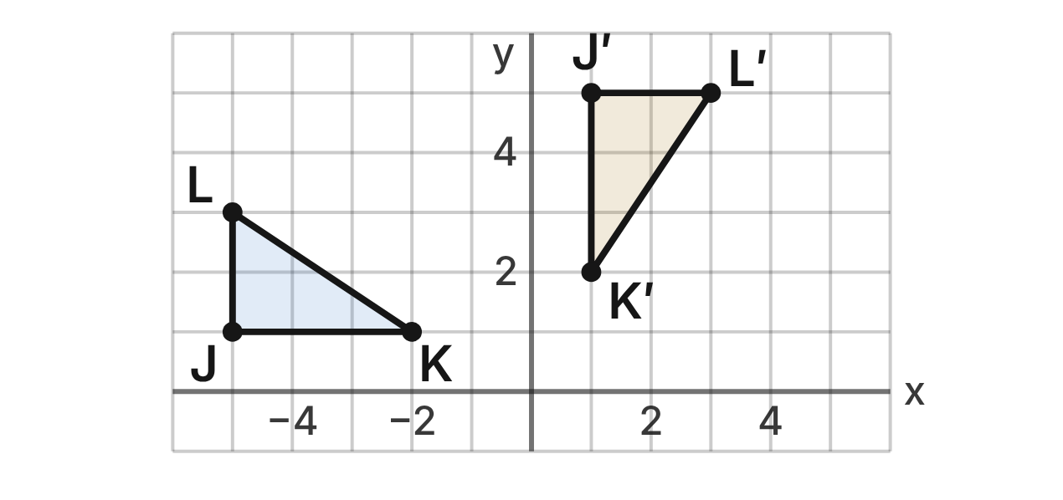
In a video game, a flag, △JKL, with J(−5, 1), K(−2, 1) and L(−5, 3), moves to △J′K′L′, with J′(1, 5), K′(1, 2) and L′(3, 5).
67. Which single transformation maps △JKL to △J′K′L′?
A. Rotation of 90° counterclockwise about the origin
B. Reflection over the line y = x
C. Rotation of 180° about the origin
D. Rotation of 90° clockwise about the origin ✔
G.RLT.3 · skill G.RLT.3.3 (HOTS): Determine the transformation or composition that maps a preimage to an image, and whether it preserves size and shape
☐ Answer key correct ☐ Wording clear Notes: ________________________________
68. Which composition also maps △JKL to △J′K′L′?
A. Reflect over the x-axis, then over the line y = x
B. Reflect over the line y = x, then over the x-axis ✔
C. Reflect over the y-axis, then over the x-axis
D. Reflect over the line y = x, then over the y-axis
G.RLT.3 · skill G.RLT.3.3 (HOTS): Determine the transformation or composition that maps a preimage to an image, and whether it preserves size and shape
☐ Answer key correct ☐ Wording clear Notes: ________________________________
69. A rotation of 270° counterclockwise about the origin has the same effect as which rotation about the origin?
A. 90° clockwise ✔
B. 90° counterclockwise
C. 180°
D. 270° clockwise
G.RLT.3 · skill G.RLT.3.3 (HOTS): Determine the transformation or composition that maps a preimage to an image, and whether it preserves size and shape
☐ Answer key correct ☐ Wording clear Notes: ________________________________
70. Where does L(−5, 3) go after a reflection over the line y = 2?
A. (−5, −3)
B. (9, 3)
C. (−5, 1) ✔
D. (−5, −1)
G.RLT.3 · skill G.RLT.3.2 (LOTS): Find the image of a figure on the coordinate plane under a translation, reflection, rotation or dilation
☐ Answer key correct ☐ Wording clear Notes: ________________________________
71. △JKL is reflected over the line x = −1 and then translated 4 units down. What is the image of K?
A. (2, −3)
B. (0, −3) ✔
C. (0, 1)
D. (0, 5)
G.RLT.3 · skill G.RLT.3.2 (LOTS): Find the image of a figure on the coordinate plane under a translation, reflection, rotation or dilation
☐ Answer key correct ☐ Wording clear Notes: ________________________________
72. For a power-up, △J′K′L′ is then dilated by scale factor 2 about the origin. How does the new flag compare with △JKL?
A. It is congruent to △JKL.
B. Angles doubled; sides doubled
C. Area doubled; angles unchanged
D. Sides doubled; angles unchanged ✔
G.RLT.3 · skill G.RLT.3.3 (HOTS): Determine the transformation or composition that maps a preimage to an image, and whether it preserves size and shape
☐ Answer key correct ☐ Wording clear Notes: ________________________________

Triangles (G.TR)

G.TR.1 · Determine the relationships between the measures of angles and lengths of sides in triangles, including problems in context.

Three Towns, Three Roads
Level 1 · Triangles · G.TR.1 · ID geo-tr1-towns
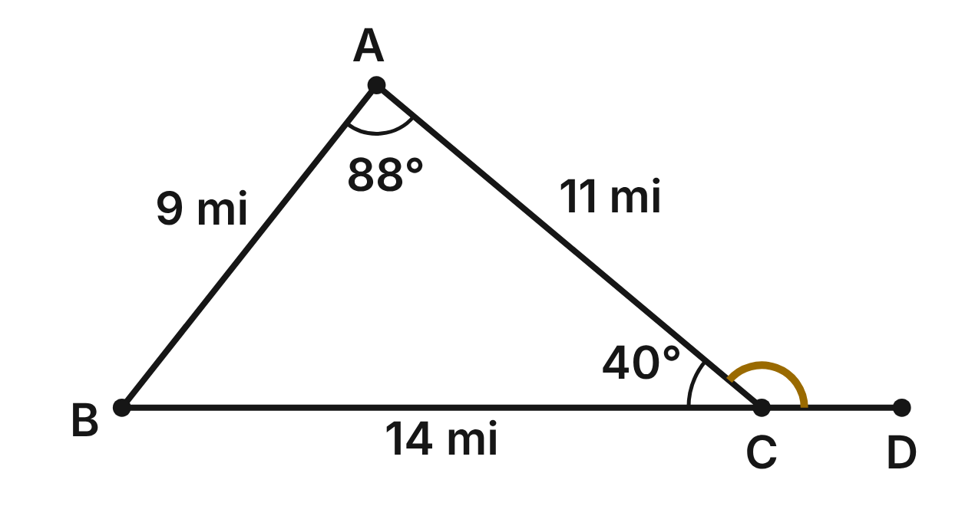
Straight roads join the towns A (Ashby), B (Bell) and C (Carver): AB = 9 mi, BC = 14 mi and AC = 11 mi. A surveyor finds m∠A ≈ 88° and m∠C ≈ 40° (to the nearest degree). The road from Bell through Carver goes straight on to the town D.
73. Using only the three road lengths, which angle of the triangle must be the largest?
A. ∠B
B. ∠C
C. ∠A ✔
D. ∠B and ∠C are equal
G.TR.1 · skill G.TR.1.1 (LOTS): Order the sides of a triangle by length given its angles, or its angles by size given its sides
☐ Answer key correct ☐ Wording clear Notes: ________________________________
74. Which list orders the angles of the triangle from smallest to largest?
A. ∠C, ∠B, ∠A ✔
B. ∠A, ∠B, ∠C
C. ∠B, ∠C, ∠A
D. ∠C, ∠A, ∠B
G.TR.1 · skill G.TR.1.1 (LOTS): Order the sides of a triangle by length given its angles, or its angles by size given its sides
☐ Answer key correct ☐ Wording clear Notes: ________________________________
75. To the nearest degree, what is m∠B?
A. 128°
B. 92°
C. 140°
D. 52° ✔
G.TR.1 · skill G.TR.1.3 (LOTS): Solve problems using the triangle angle sum and the exterior angle theorem
☐ Answer key correct ☐ Wording clear Notes: ________________________________
76. What is m∠ACD, the angle between road CA and the road on to D?
A. 40°
B. 140° ✔
C. 128°
D. 92°
G.TR.1 · skill G.TR.1.3 (LOTS): Solve problems using the triangle angle sum and the exterior angle theorem
☐ Answer key correct ☐ Wording clear Notes: ________________________________
77. A new town, Eden, is 6 mi from Carver. Eden, Ashby and Carver are not on one straight line. Which could be the distance from Ashby to Eden?
A. 4 mi
B. 5 mi
C. 17 mi
D. 12 mi ✔
G.TR.1 · skill G.TR.1.2 (LOTS): Decide whether three lengths can form a triangle and find the range of possible lengths of the third side
☐ Answer key correct ☐ Wording clear Notes: ________________________________
78. What is the shortest whole number of miles that Eden could be from Ashby?
A. 5 mi
B. 6 mi ✔
C. 11 mi
D. 17 mi
G.TR.1 · skill G.TR.1.2 (LOTS): Decide whether three lengths can form a triangle and find the range of possible lengths of the third side
☐ Answer key correct ☐ Wording clear Notes: ________________________________

The Corner Garden Bed
Level 2 · Triangles · G.TR.1 · ID geo-tr1-garden
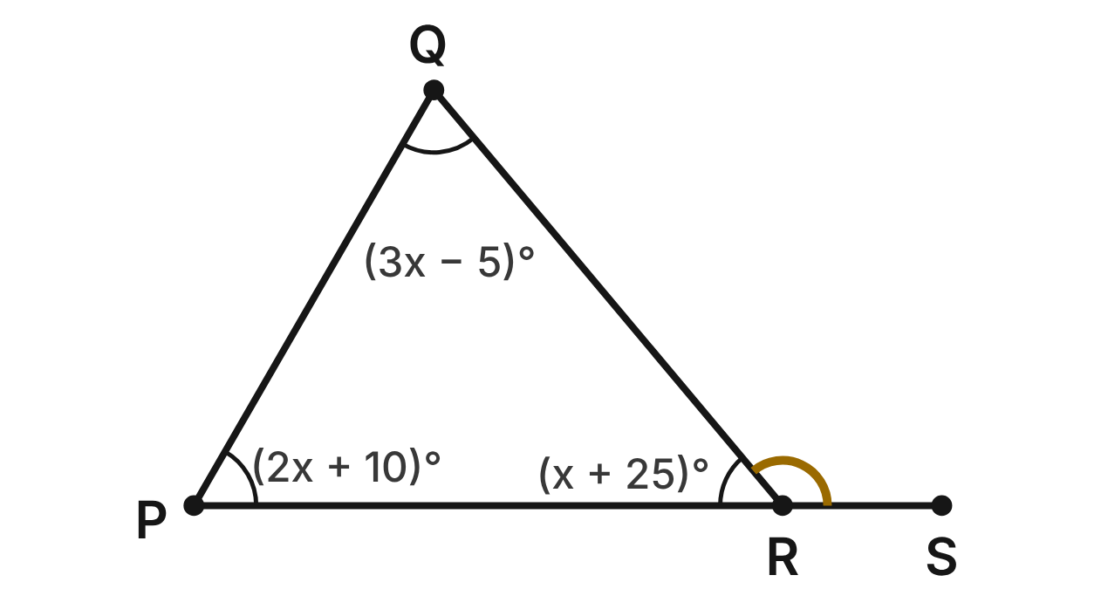
A garden bed is the triangle PQR, with m∠P = (2x + 10)⁠°, m∠Q = (3x − 5)⁠° and m∠R = (x + 25)⁠°. The edge PR runs straight on past R to a gate post S.
79. What is the value of x?
A. 30
B. 25 ✔
C. 55
D. 35
G.TR.1 · skill G.TR.1.3 (LOTS): Solve problems using the triangle angle sum and the exterior angle theorem
☐ Answer key correct ☐ Wording clear Notes: ________________________________
80. What is m∠Q?
A. 110°
B. 60°
C. 75°
D. 70° ✔
G.TR.1 · skill G.TR.1.3 (LOTS): Solve problems using the triangle angle sum and the exterior angle theorem
☐ Answer key correct ☐ Wording clear Notes: ________________________________
81. Which list orders the edges of the bed from shortest to longest?
A. PQ, QR, PR ✔
B. PR, QR, PQ
C. QR, PQ, PR
D. PR, PQ, QR
G.TR.1 · skill G.TR.1.1 (LOTS): Order the sides of a triangle by length given its angles, or its angles by size given its sides
☐ Answer key correct ☐ Wording clear Notes: ________________________________
82. What is m∠QRS?
A. 50°
B. 110°
C. 130° ✔
D. 120°
G.TR.1 · skill G.TR.1.3 (LOTS): Solve problems using the triangle angle sum and the exterior angle theorem
☐ Answer key correct ☐ Wording clear Notes: ________________________________
83. The gardener will build a second bed from three straight boards. Which set of board lengths could form a triangle?
A. 3 ft, 8 ft, 10 ft ✔
B. 4 ft, 5 ft, 10 ft
C. 6 ft, 6 ft, 12 ft
D. 2 ft, 7 ft, 9.5 ft
G.TR.1 · skill G.TR.1.2 (LOTS): Decide whether three lengths can form a triangle and find the range of possible lengths of the third side
☐ Answer key correct ☐ Wording clear Notes: ________________________________
84. A third bed will have edges of 6 ft and 13 ft. What is the greatest whole number of feet the third edge could be?
A. 13 ft
B. 19 ft
C. 18 ft ✔
D. 7 ft
G.TR.1 · skill G.TR.1.2 (LOTS): Decide whether three lengths can form a triangle and find the range of possible lengths of the third side
☐ Answer key correct ☐ Wording clear Notes: ________________________________

The Shade Sail
Level 2 · Triangles · G.TR.1 · ID geo-tr1-sail
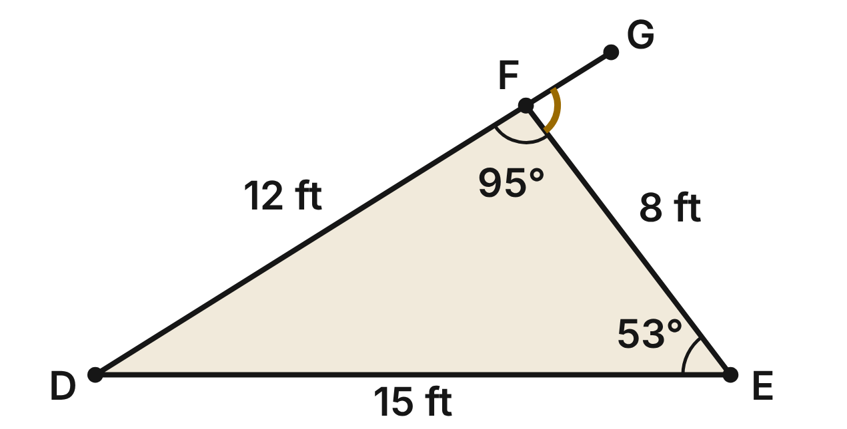
A shade sail is the triangle DEF with DE = 15 ft, EF = 8 ft and DF = 12 ft. With a protractor, m∠E ≈ 53° and m∠F ≈ 95°. Edge DF is extended past F to G.
85. Before choosing DF, the sailmaker knew only that DE = 15 ft and EF = 8 ft. Which inequality gives all possible lengths x of DF, in feet?
A. 7 < x < 23 ✔
B. 8 < x < 15
C. x < 23
D. 7 ≤ x ≤ 23
G.TR.1 · skill G.TR.1.2 (LOTS): Decide whether three lengths can form a triangle and find the range of possible lengths of the third side
☐ Answer key correct ☐ Wording clear Notes: ________________________________
86. How many whole-number lengths of DF, in feet, were possible?
A. 17
B. 22
C. 15 ✔
D. 16
G.TR.1 · skill G.TR.1.2 (LOTS): Decide whether three lengths can form a triangle and find the range of possible lengths of the third side
☐ Answer key correct ☐ Wording clear Notes: ________________________________
87. Using the side lengths, which list orders the sail's angles from smallest to largest?
A. ∠F, ∠E, ∠D
B. ∠D, ∠E, ∠F ✔
C. ∠E, ∠D, ∠F
D. ∠D, ∠F, ∠E
G.TR.1 · skill G.TR.1.1 (LOTS): Order the sides of a triangle by length given its angles, or its angles by size given its sides
☐ Answer key correct ☐ Wording clear Notes: ________________________________
88. Using the protractor readings, what is m∠D?
A. 148°
B. 127°
C. 85°
D. 32° ✔
G.TR.1 · skill G.TR.1.3 (LOTS): Solve problems using the triangle angle sum and the exterior angle theorem
☐ Answer key correct ☐ Wording clear Notes: ________________________________
89. Using the protractor readings, what is m∠EFG?
A. 95°
B. 148°
C. 85° ✔
D. 53°
G.TR.1 · skill G.TR.1.3 (LOTS): Solve problems using the triangle angle sum and the exterior angle theorem
☐ Answer key correct ☐ Wording clear Notes: ________________________________
90. Why could no sail have edges of 15 ft, 8 ft and 23 ft?
A. 15 + 8 = 23, so the edges lie flat ✔
B. 23 is longer than 15
C. 23 − 15 is less than 8
D. 8² + 15² does not equal 23²
G.TR.1 · skill G.TR.1.2 (LOTS): Decide whether three lengths can form a triangle and find the range of possible lengths of the third side
☐ Answer key correct ☐ Wording clear Notes: ________________________________

The Skate Ramp Brace
Level 3 · Triangles · G.TR.1 · ID geo-tr1-brace
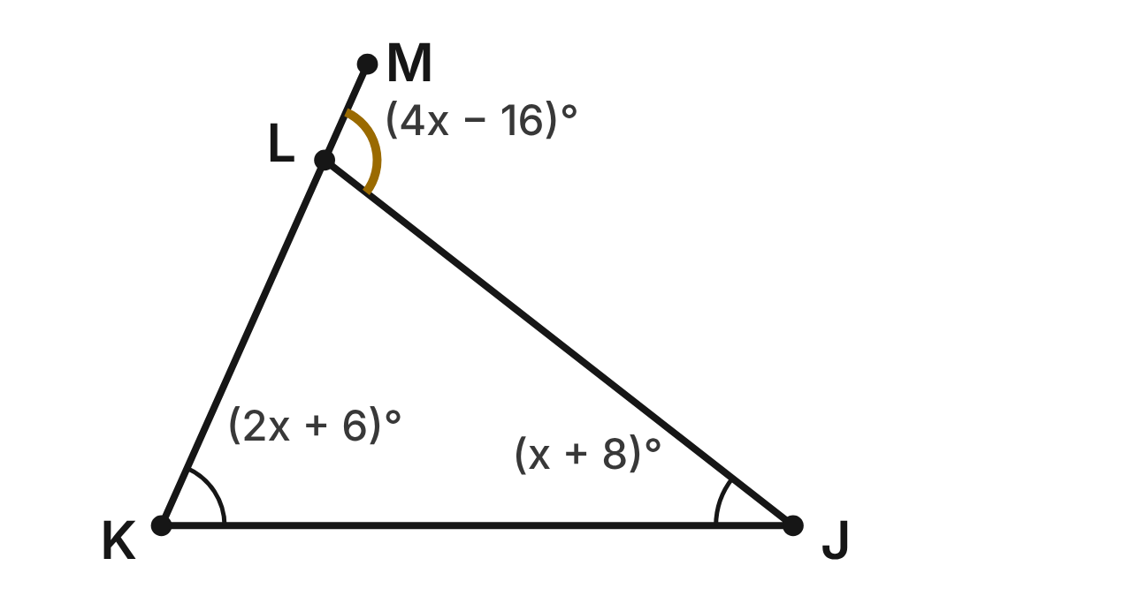
A side brace for a skate ramp is the triangle JKL. Side KL is extended past L to M. m∠J = (x + 8)⁠°, m∠K = (2x + 6)⁠° and m∠JLM = (4x − 16)⁠°.
91. Solve for x.
A. 26
B. 38
C. 104
D. 30 ✔
G.TR.1 · skill G.TR.1.3 (LOTS): Solve problems using the triangle angle sum and the exterior angle theorem
☐ Answer key correct ☐ Wording clear Notes: ________________________________
92. What is m∠JLK, the angle inside the brace at L?
A. 104°
B. 76° ✔
C. 14°
D. 66°
G.TR.1 · skill G.TR.1.3 (LOTS): Solve problems using the triangle angle sum and the exterior angle theorem
☐ Answer key correct ☐ Wording clear Notes: ________________________________
93. Which list orders the sides of the brace from shortest to longest?
A. JK, JL, KL
B. JL, KL, JK
C. KL, JL, JK ✔
D. KL, JK, JL
G.TR.1 · skill G.TR.1.1 (LOTS): Order the sides of a triangle by length given its angles, or its angles by size given its sides
☐ Answer key correct ☐ Wording clear Notes: ________________________________
94. Which equation is true for every triangle drawn like this one?
A. m∠J + m∠K = m∠JLM ✔
B. m∠J + m∠K = m∠JLK
C. m∠JLM + m∠J = 180°
D. m∠JLM = m∠K + m∠JLK
G.TR.1 · skill G.TR.1.3 (LOTS): Solve problems using the triangle angle sum and the exterior angle theorem
☐ Answer key correct ☐ Wording clear Notes: ________________________________
95. The builder has scrap boards 2 ft, 3 ft, 4 ft and 5 ft long. Which three boards can NOT be joined at their ends to make a triangle?
A. 2 ft, 3 ft, 4 ft
B. 2 ft, 3 ft, 5 ft ✔
C. 2 ft, 4 ft, 5 ft
D. 3 ft, 4 ft, 5 ft
G.TR.1 · skill G.TR.1.2 (LOTS): Decide whether three lengths can form a triangle and find the range of possible lengths of the third side
☐ Answer key correct ☐ Wording clear Notes: ________________________________
96. Another brace has sides of 7 ft and 10 ft, and its third side is (2y + 1) ft. Which inequality gives all possible values of y?
A. 3 < y < 17
B. 2 < y < 16
C. 1.5 < y < 8.5
D. 1 < y < 8 ✔
G.TR.1 · skill G.TR.1.2 (LOTS): Decide whether three lengths can form a triangle and find the range of possible lengths of the third side
☐ Answer key correct ☐ Wording clear Notes: ________________________________

G.TR.2 · Prove two triangles are congruent, using direct and indirect proofs, and solve problems involving measured attributes of congruent triangles.

Matching Marks
Level 1 · Triangles · G.TR.2 · ID geo-tr2-marks
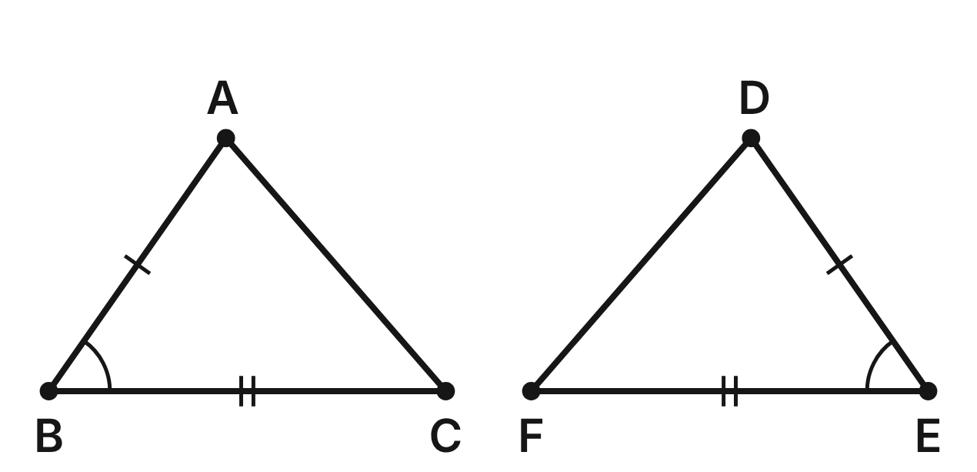
Matching tick marks show congruent sides and matching arcs show congruent angles: AB ≅ DE, ∠B ≅ ∠E and BC ≅ EF.
97. Which criterion proves △ABC ≅ △DEF?
A. SSA
B. SAS ✔
C. ASA
D. SSS
G.TR.2 · skill G.TR.2.1 (LOTS): Identify the congruence criterion (SSS, SAS, ASA, AAS, HL) that the given information supports, and recognize when none does
☐ Answer key correct ☐ Wording clear Notes: ________________________________
98. Suppose the marks showed AB ≅ DE, BC ≅ EF and ∠A ≅ ∠D instead. What could you conclude?
A. SSA does not prove congruence ✔
B. They are congruent by SAS
C. They are congruent by ASA
D. They are congruent by SSS
G.TR.2 · skill G.TR.2.1 (LOTS): Identify the congruence criterion (SSS, SAS, ASA, AAS, HL) that the given information supports, and recognize when none does
☐ Answer key correct ☐ Wording clear Notes: ________________________________
99. Keep AB ≅ DE and ∠B ≅ ∠E. Which one more fact would prove the triangles congruent by ASA?
A. ∠C ≅ ∠F
B. AC ≅ DF
C. BC ≅ EF
D. ∠A ≅ ∠D ✔
G.TR.2 · skill G.TR.2.1 (LOTS): Identify the congruence criterion (SSS, SAS, ASA, AAS, HL) that the given information supports, and recognize when none does
☐ Answer key correct ☐ Wording clear Notes: ________________________________
100. Since △ABC ≅ △DEF, which segment is congruent to AC?
A. EF
B. DE
C. DF ✔
D. BC
G.TR.2 · skill G.TR.2.3 (LOTS): Solve problems, including algebraic ones, using corresponding parts of congruent triangles
☐ Answer key correct ☐ Wording clear Notes: ________________________________
101. m∠A = 76° and m∠E = 55°. What is m∠F?
A. 55°
B. 76°
C. 104°
D. 49° ✔
G.TR.2 · skill G.TR.2.3 (LOTS): Solve problems, including algebraic ones, using corresponding parts of congruent triangles
☐ Answer key correct ☐ Wording clear Notes: ________________________________
102. Ana finds that the three angles of △ABC are congruent to the three angles of another triangle, △GHJ. What can she conclude?
A. They are congruent by AAA
B. Only that they are similar ✔
C. They are congruent by ASA
D. They are not similar
G.TR.2 · skill G.TR.2.1 (LOTS): Identify the congruence criterion (SSS, SAS, ASA, AAS, HL) that the given information supports, and recognize when none does
☐ Answer key correct ☐ Wording clear Notes: ________________________________

The Bridge Cross-Brace
Level 2 · Triangles · G.TR.2 · ID geo-tr2-bowtie
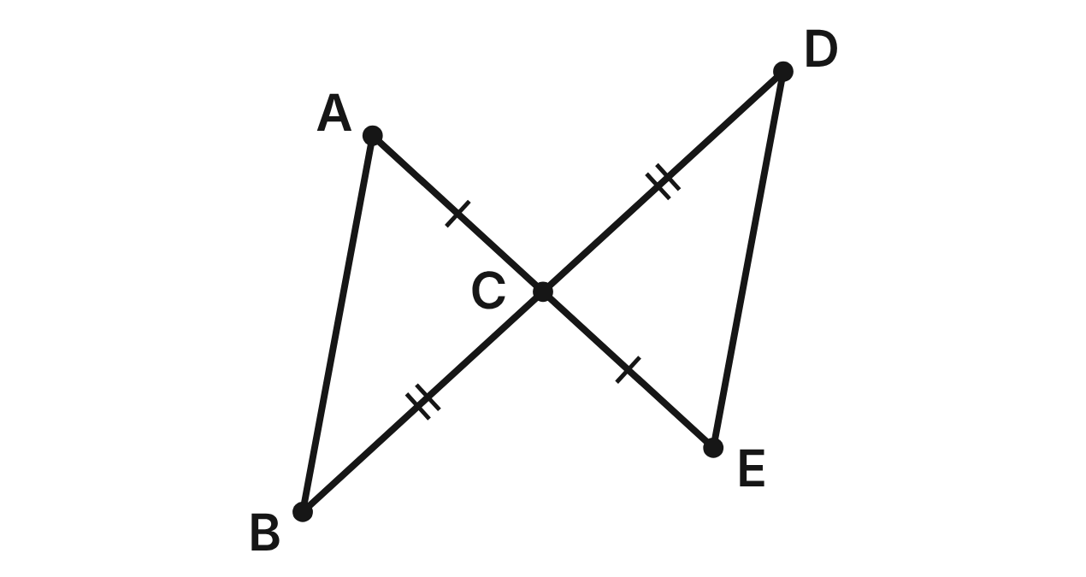
Two straight braces, AE and BD, cross at C, with AC ≅ EC and BC ≅ DC. Prove that AB ≅ ED.
Statement | Reason
1. AC ≅ EC; BC ≅ DC | Given
2. ∠ACB ≅ ∠ECD | (a) ____
3. △ABC ≅ △EDC | (b) ____
4. AB ≅ ED | (c) ____

103. Which reason justifies step 2, ∠ACB ≅ ∠ECD (blank a)?
A. Alternate interior angles are congruent
B. Reflexive property
C. Vertical angles are congruent ✔
D. Definition of midpoint
G.TR.2 · skill G.TR.2.2 (HOTS): Complete or justify a direct or indirect proof that two triangles are congruent
☐ Answer key correct ☐ Wording clear Notes: ________________________________
104. Which reason justifies step 3, △ABC ≅ △EDC (blank b)?
A. ASA
B. SSS
C. HL
D. SAS ✔
G.TR.2 · skill G.TR.2.2 (HOTS): Complete or justify a direct or indirect proof that two triangles are congruent
☐ Answer key correct ☐ Wording clear Notes: ________________________________
105. Which reason justifies step 4, AB ≅ ED (blank c)?
A. CPCTC ✔
B. Given
C. SAS
D. Vertical angles are congruent
G.TR.2 · skill G.TR.2.2 (HOTS): Complete or justify a direct or indirect proof that two triangles are congruent
☐ Answer key correct ☐ Wording clear Notes: ________________________________
106. AB = 3x − 2 and ED = x + 10, in feet. How long is AB?
A. 6 ft
B. 16 ft ✔
C. 10 ft
D. 4 ft
G.TR.2 · skill G.TR.2.3 (LOTS): Solve problems, including algebraic ones, using corresponding parts of congruent triangles
☐ Answer key correct ☐ Wording clear Notes: ________________________________
107. Suppose you knew AC ≅ EC and AB ∥ ED, but not BC ≅ DC. Which criterion would prove △ABC ≅ △EDC?
A. ASA ✔
B. SAS
C. SSS
D. HL
G.TR.2 · skill G.TR.2.1 (LOTS): Identify the congruence criterion (SSS, SAS, ASA, AAS, HL) that the given information supports, and recognize when none does
☐ Answer key correct ☐ Wording clear Notes: ________________________________
108. m∠A = 58° and m∠ACB = 85°. What is m∠D?
A. 58°
B. 85°
C. 37° ✔
D. 95°
G.TR.2 · skill G.TR.2.3 (LOTS): Solve problems, including algebraic ones, using corresponding parts of congruent triangles
☐ Answer key correct ☐ Wording clear Notes: ________________________________

The Tent and Its Pole
Level 2 · Triangles · G.TR.2 · ID geo-tr2-tent
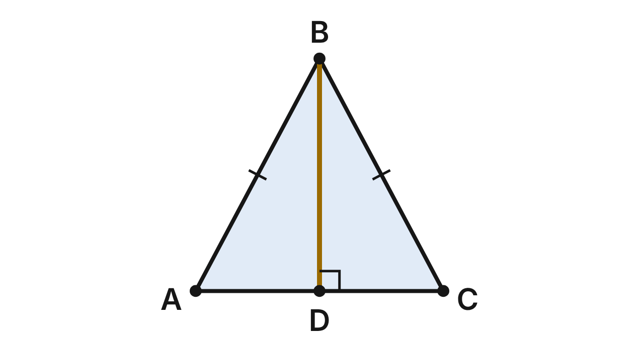
The end of a tent is the triangle ABC with AB ≅ CB. The center pole BD is perpendicular to the floor AC. Prove that AD ≅ CD.
Statement | Reason
1. AB ≅ CB; BD ⊥ AC | Given
2. ∠ADB and ∠CDB are right angles | Definition of perpendicular lines
3. BD ≅ BD | (a) ____
4. △ABD ≅ △CBD | (b) ____
5. AD ≅ CD | CPCTC

109. Which reason justifies step 3, BD ≅ BD (blank a)?
A. Reflexive property ✔
B. Vertical angles are congruent
C. Definition of perpendicular lines
D. CPCTC
G.TR.2 · skill G.TR.2.2 (HOTS): Complete or justify a direct or indirect proof that two triangles are congruent
☐ Answer key correct ☐ Wording clear Notes: ________________________________
110. Which reason justifies step 4, △ABD ≅ △CBD (blank b)?
A. SSA
B. HL ✔
C. AAA
D. SAS
G.TR.2 · skill G.TR.2.2 (HOTS): Complete or justify a direct or indirect proof that two triangles are congruent
☐ Answer key correct ☐ Wording clear Notes: ________________________________
111. AD = (x + 3) ft and CD = (3x − 5) ft. How wide is the tent floor, AC?
A. 7 ft
B. 4 ft
C. 8 ft
D. 14 ft ✔
G.TR.2 · skill G.TR.2.3 (LOTS): Solve problems, including algebraic ones, using corresponding parts of congruent triangles
☐ Answer key correct ☐ Wording clear Notes: ________________________________
112. Suppose you did not know AB ≅ CB, but you knew BD ⊥ AC and ∠ABD ≅ ∠CBD. Which criterion would prove △ABD ≅ △CBD?
A. HL
B. SAS
C. ASA ✔
D. SSS
G.TR.2 · skill G.TR.2.1 (LOTS): Identify the congruence criterion (SSS, SAS, ASA, AAS, HL) that the given information supports, and recognize when none does
☐ Answer key correct ☐ Wording clear Notes: ________________________________
113. m∠ABD = 28°. What is m∠ABC, the angle at the top of the tent?
A. 28°
B. 56° ✔
C. 62°
D. 124°
G.TR.2 · skill G.TR.2.3 (LOTS): Solve problems, including algebraic ones, using corresponding parts of congruent triangles
☐ Answer key correct ☐ Wording clear Notes: ________________________________
114. Which set of facts is NOT enough to prove two triangles congruent?
A. Two sides and a non-included angle ✔
B. Three pairs of sides
C. Two angles and the included side
D. A hypotenuse and a leg of right triangles
G.TR.2 · skill G.TR.2.1 (LOTS): Identify the congruence criterion (SSS, SAS, ASA, AAS, HL) that the given information supports, and recognize when none does
☐ Answer key correct ☐ Wording clear Notes: ________________________________

The Gate Brace
Level 3 · Triangles · G.TR.2 · ID geo-tr2-frame
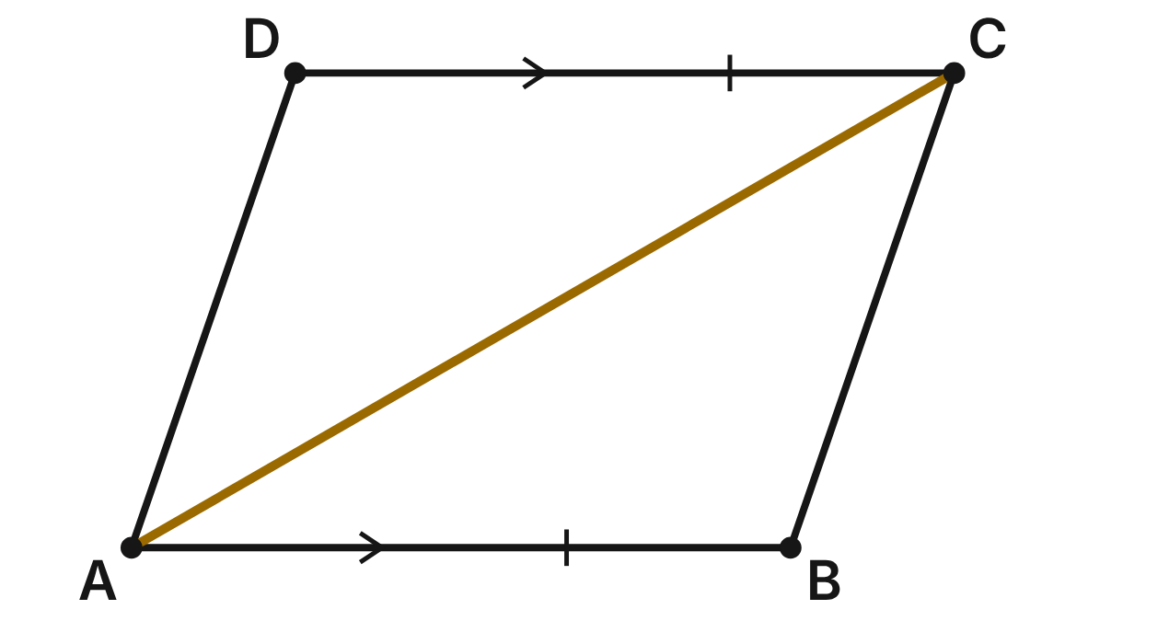
A gate frame ABCD has a diagonal brace AC, with AB ∥ DC and AB ≅ DC. Prove that △ABC ≅ △CDA.
Statement | Reason
1. AB ∥ DC; AB ≅ DC | Given
2. ∠BAC ≅ ∠DCA | (a) ____
3. AC ≅ CA | Reflexive property
4. △ABC ≅ △CDA | (b) ____
5. BC ≅ DA | CPCTC

115. Which reason justifies step 2, ∠BAC ≅ ∠DCA (blank a)?
A. Corresponding angles are congruent
B. Vertical angles are congruent
C. Reflexive property
D. Alternate interior angles are congruent ✔
G.TR.2 · skill G.TR.2.2 (HOTS): Complete or justify a direct or indirect proof that two triangles are congruent
☐ Answer key correct ☐ Wording clear Notes: ________________________________
116. Which reason justifies step 4, △ABC ≅ △CDA (blank b)?
A. ASA
B. SSA
C. SAS ✔
D. AAS
G.TR.2 · skill G.TR.2.2 (HOTS): Complete or justify a direct or indirect proof that two triangles are congruent
☐ Answer key correct ☐ Wording clear Notes: ________________________________
117. BC = (4x − 7) in. and DA = (2x + 9) in. How long is BC?
A. 8 in.
B. 25 in. ✔
C. 16 in.
D. 50 in.
G.TR.2 · skill G.TR.2.3 (LOTS): Solve problems, including algebraic ones, using corresponding parts of congruent triangles
☐ Answer key correct ☐ Wording clear Notes: ________________________________
118. m∠BCA = (3y + 5)⁠° and m∠DAC = (5y − 19)⁠°. What is m∠BCA?
A. 41° ✔
B. 12°
C. 26°
D. 82°
G.TR.2 · skill G.TR.2.3 (LOTS): Solve problems, including algebraic ones, using corresponding parts of congruent triangles
☐ Answer key correct ☐ Wording clear Notes: ________________________________
119. A second frame, also named ABCD with brace AC, has BC = 9 in. and DA = 11 in. Lena will prove indirectly that △ABC is not congruent to △CDA. What should she assume first?
A. △ABC ≇ △CDA
B. BC = DA
C. △ABC ≅ △CDA ✔
D. AB ∥ DC
G.TR.2 · skill G.TR.2.2 (HOTS): Complete or justify a direct or indirect proof that two triangles are congruent
☐ Answer key correct ☐ Wording clear Notes: ________________________________
120. Which statement gives the contradiction that finishes Lena's proof?
A. AC = CA by the reflexive property.
B. Alternate interior angles are congruent.
C. SAS gives △ABC ≅ △CDA.
D. CPCTC gives BC = DA, but 9 ≠ 11. ✔
G.TR.2 · skill G.TR.2.2 (HOTS): Complete or justify a direct or indirect proof that two triangles are congruent
☐ Answer key correct ☐ Wording clear Notes: ________________________________

G.TR.3 · Prove two triangles are similar, using direct and indirect proofs, and solve problems involving measured attributes of similar triangles.

Two Triangles, One Shape
Level 1 · Triangles · G.TR.3 · ID geo-tr3-twins
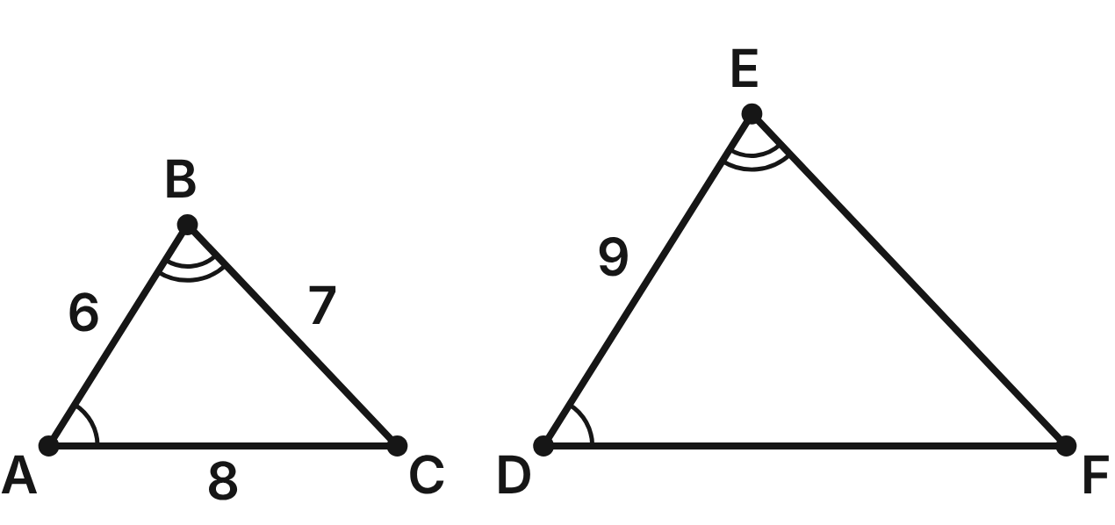
In △ABC and △DEF, ∠A ≅ ∠D and ∠B ≅ ∠E (matching arcs). AB = 6 cm, BC = 7 cm, AC = 8 cm and DE = 9 cm.
121. Which criterion shows that △ABC ∼ △DEF?
A. SSS∼
B. AA ✔
C. SAS∼
D. ASA
G.TR.3 · skill G.TR.3.1 (LOTS): Identify the similarity criterion (AA, SSS, SAS) that the given information supports
☐ Answer key correct ☐ Wording clear Notes: ________________________________
122. Which similarity statement is correct?
A. △ABC ∼ △EDF
B. △CAB ∼ △DEF
C. △BCA ∼ △EDF
D. △CAB ∼ △FDE ✔
G.TR.3 · skill G.TR.3.1 (LOTS): Identify the similarity criterion (AA, SSS, SAS) that the given information supports
☐ Answer key correct ☐ Wording clear Notes: ________________________________
123. What is the scale factor from △ABC to △DEF?
A. 2/3
B. 3
C. 3/2 ✔
D. 1/2
G.TR.3 · skill G.TR.3.3 (LOTS): Solve problems, including contextual ones, using proportional sides of similar triangles
☐ Answer key correct ☐ Wording clear Notes: ________________________________
124. What is EF?
A. 10.5 cm ✔
B. about 4.7 cm
C. 10 cm
D. 13.5 cm
G.TR.3 · skill G.TR.3.3 (LOTS): Solve problems, including contextual ones, using proportional sides of similar triangles
☐ Answer key correct ☐ Wording clear Notes: ________________________________
125. What is the perimeter of △DEF?
A. 21 cm
B. 30 cm
C. 47.25 cm
D. 31.5 cm ✔
G.TR.3 · skill G.TR.3.3 (LOTS): Solve problems, including contextual ones, using proportional sides of similar triangles
☐ Answer key correct ☐ Wording clear Notes: ________________________________
126. △GHI has sides of 12 cm, 14 cm and 15 cm. Is △GHI similar to △ABC?
A. No, because 15/8 ≠ 12/6 ✔
B. Yes, because 12/6 = 14/7
C. Yes, because each side is longer
D. No, because the sizes differ
G.TR.3 · skill G.TR.3.2 (HOTS): Justify that two triangles are similar, or are not, using angle measures or side ratios
☐ Answer key correct ☐ Wording clear Notes: ________________________________

The Flagpole's Shadow
Level 2 · Triangles · G.TR.3 · ID geo-tr3-shadow
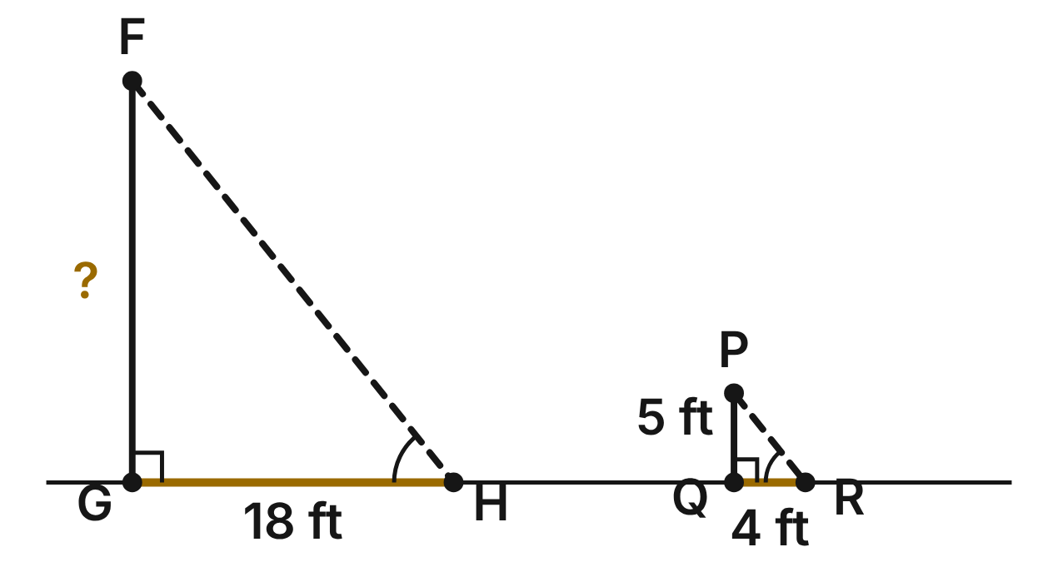
At the same moment, a 5-ft student PQ casts a 4-ft shadow QR, and a flagpole FG casts an 18-ft shadow GH. Both stand straight up on level ground, and the sun's rays FH and PR are parallel.
127. Why is △FGH ∼ △PQR?
A. SSS∼: all three side lengths are known
B. SAS∼: GH/QR = 18/4 with the right angles
C. AA: right angles at G and Q, equal angles at H and R ✔
D. HL: both are right triangles
G.TR.3 · skill G.TR.3.1 (LOTS): Identify the similarity criterion (AA, SSS, SAS) that the given information supports
☐ Answer key correct ☐ Wording clear Notes: ________________________________
128. How tall is the flagpole?
A. 22.5 ft ✔
B. 14.4 ft
C. 19 ft
D. 90 ft
G.TR.3 · skill G.TR.3.3 (LOTS): Solve problems, including contextual ones, using proportional sides of similar triangles
☐ Answer key correct ☐ Wording clear Notes: ________________________________
129. What scale factor maps △PQR onto △FGH?
A. 2/9
B. 4.5 ✔
C. 14
D. 3.6
G.TR.3 · skill G.TR.3.3 (LOTS): Solve problems, including contextual ones, using proportional sides of similar triangles
☐ Answer key correct ☐ Wording clear Notes: ________________________________
130. Which post and shadow, measured at the same moment, fit these similar triangles?
A. a 6-ft post, a 7.5-ft shadow
B. a 10-ft post, a 9-ft shadow
C. a 4-ft post, a 5-ft shadow
D. a 6-ft post, a 4.8-ft shadow ✔
G.TR.3 · skill G.TR.3.2 (HOTS): Justify that two triangles are similar, or are not, using angle measures or side ratios
☐ Answer key correct ☐ Wording clear Notes: ________________________________
131. Later, the student's shadow is 6 ft long. How long is the flagpole's shadow then?
A. 27 ft ✔
B. 20 ft
C. 33.75 ft
D. 21.6 ft
G.TR.3 · skill G.TR.3.3 (LOTS): Solve problems, including contextual ones, using proportional sides of similar triangles
☐ Answer key correct ☐ Wording clear Notes: ________________________________
132. Which similarity statement matches the vertices correctly?
A. △PQR ∼ △HGF
B. △PQR ∼ △FGH ✔
C. △QPR ∼ △FGH
D. △PRQ ∼ △FGH
G.TR.3 · skill G.TR.3.1 (LOTS): Identify the similarity criterion (AA, SSS, SAS) that the given information supports
☐ Answer key correct ☐ Wording clear Notes: ________________________________

The Shelf Bracket
Level 2 · Triangles · G.TR.3 · ID geo-tr3-bracket
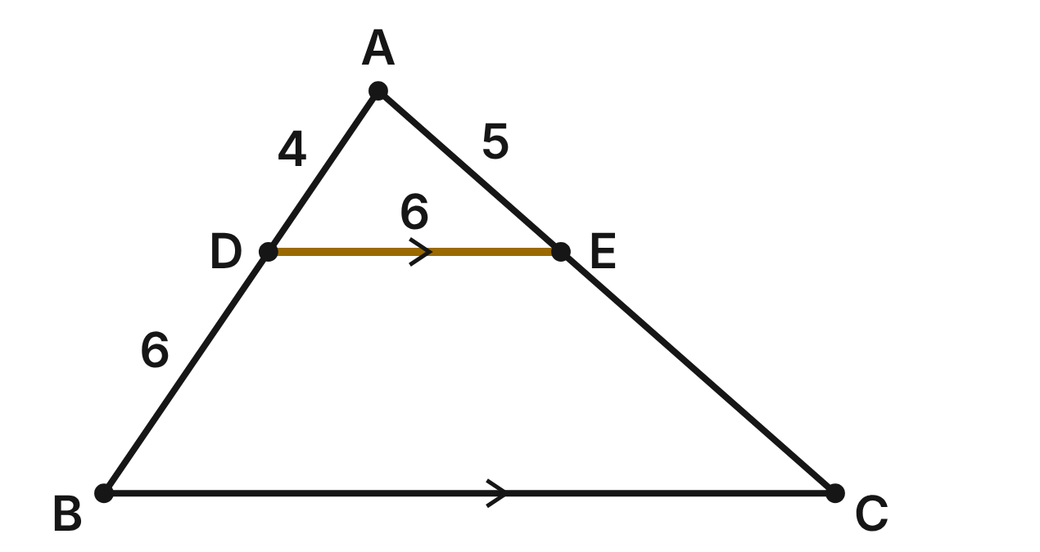
A shelf bracket is the triangle ABC. A crossbar DE joins D on AB to E on AC, and DE ∥ BC. AD = 4 in., DB = 6 in., AE = 5 in. and DE = 6 in.
133. Why is △ADE ∼ △ABC?
A. SAS∼: AD/DB = AE/EC
B. SSS∼: all sides are proportional
C. ASA: DE ∥ BC
D. AA: ∠A is shared and ∠ADE ≅ ∠ABC ✔
G.TR.3 · skill G.TR.3.1 (LOTS): Identify the similarity criterion (AA, SSS, SAS) that the given information supports
☐ Answer key correct ☐ Wording clear Notes: ________________________________
134. How long is BC?
A. 9 in.
B. 15 in. ✔
C. 2.4 in.
D. 12 in.
G.TR.3 · skill G.TR.3.3 (LOTS): Solve problems, including contextual ones, using proportional sides of similar triangles
☐ Answer key correct ☐ Wording clear Notes: ________________________________
135. How long is EC?
A. 7.5 in. ✔
B. about 3.3 in.
C. 12.5 in.
D. 7 in.
G.TR.3 · skill G.TR.3.3 (LOTS): Solve problems, including contextual ones, using proportional sides of similar triangles
☐ Answer key correct ☐ Wording clear Notes: ________________________________
136. What is the scale factor of the dilation centered at A that maps △ADE onto △ABC?
A. 2/5
B. 3/2
C. 5/2 ✔
D. 2/3
G.TR.3 · skill G.TR.3.3 (LOTS): Solve problems, including contextual ones, using proportional sides of similar triangles
☐ Answer key correct ☐ Wording clear Notes: ________________________________
137. On another bracket, AD = 2, DB = 3, AE = 3 and EC = 4.4 (inches). Marco says DE ∥ BC. Is he right?
A. Yes; both ratios round to 0.7
B. No; 2/3 ≠ 3/4.4 ✔
C. Yes; D and E are nearer to A
D. No; AD ≠ AE
G.TR.3 · skill G.TR.3.2 (HOTS): Justify that two triangles are similar, or are not, using angle measures or side ratios
☐ Answer key correct ☐ Wording clear Notes: ________________________________
138. Which proportion is NOT true for this bracket?
A. AD/AB = DE/BC
B. AD/DB = AE/EC
C. AE/AC = DE/BC
D. AD/DB = DE/BC ✔
G.TR.3 · skill G.TR.3.3 (LOTS): Solve problems, including contextual ones, using proportional sides of similar triangles
☐ Answer key correct ☐ Wording clear Notes: ________________________________

Across the Pond
Level 3 · Triangles · G.TR.3 · ID geo-tr3-pond
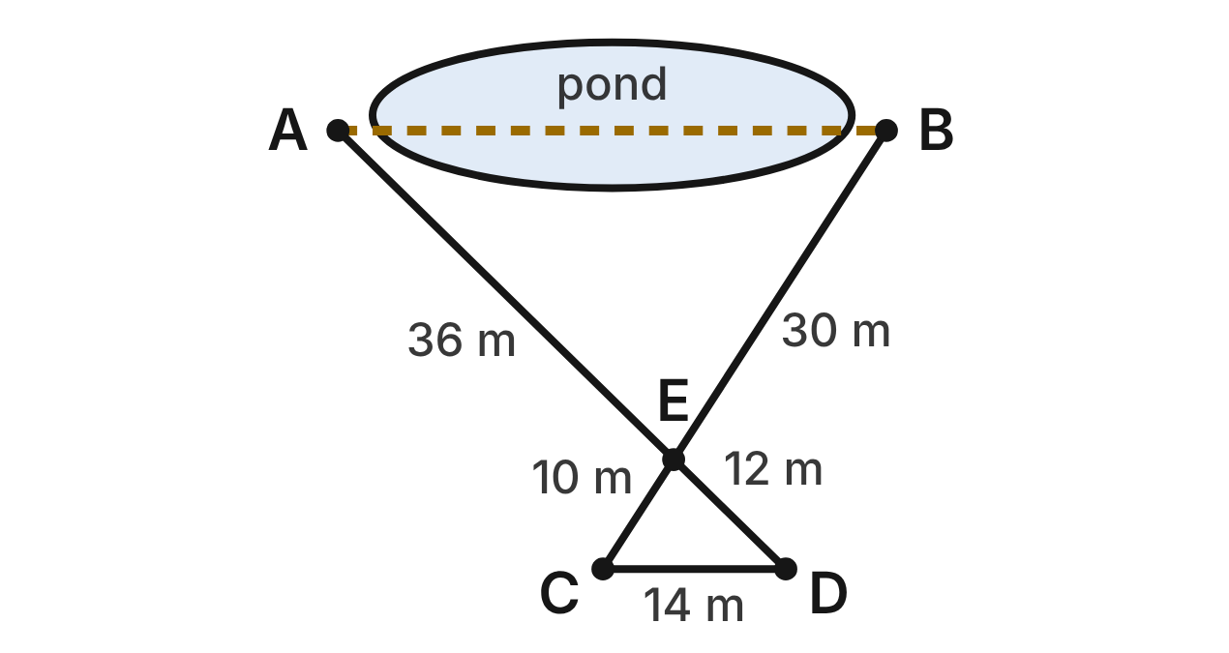
To find the distance AB across a pond, a crew stakes out C and D so that AD and BC are straight and cross at E. AE = 36 m, ED = 12 m, BE = 30 m, EC = 10 m and DC = 14 m.
139. Which criterion shows that △AEB ∼ △DEC?
A. SAS∼ ✔
B. AA
C. SSS∼
D. SAS
G.TR.3 · skill G.TR.3.1 (LOTS): Identify the similarity criterion (AA, SSS, SAS) that the given information supports
☐ Answer key correct ☐ Wording clear Notes: ________________________________
140. Along with the vertical angles at E, which fact justifies the similarity?
A. AE/EC = BE/ED
B. AE − ED = BE − EC
C. AE/DE = BE/CE = 3 ✔
D. AB/DC = 3
G.TR.3 · skill G.TR.3.2 (HOTS): Justify that two triangles are similar, or are not, using angle measures or side ratios
☐ Answer key correct ☐ Wording clear Notes: ________________________________
141. How far is it across the pond from A to B?
A. about 4.7 m
B. 38 m
C. 56 m
D. 42 m ✔
G.TR.3 · skill G.TR.3.3 (LOTS): Solve problems, including contextual ones, using proportional sides of similar triangles
☐ Answer key correct ☐ Wording clear Notes: ________________________________
142. Which statement lists the similar triangles with matching vertices in order?
A. △AEB ∼ △CED
B. △BEA ∼ △CED ✔
C. △ABE ∼ △CDE
D. △EBA ∼ △EDC
G.TR.3 · skill G.TR.3.1 (LOTS): Identify the similarity criterion (AA, SSS, SAS) that the given information supports
☐ Answer key correct ☐ Wording clear Notes: ________________________________
143. Another crew's stakes give AE = 20 m, ED = 8 m, BE = 15 m and EC = 5 m. Can they use the same method?
A. Yes; the vertical angles give AA
B. No; SAS∼ needs a right angle
C. No; 20/8 ≠ 15/5, so not similar ✔
D. Yes; AE is still the longest
G.TR.3 · skill G.TR.3.2 (HOTS): Justify that two triangles are similar, or are not, using angle measures or side ratios
☐ Answer key correct ☐ Wording clear Notes: ________________________________
144. Because △AEB ∼ △DEC, ∠A ≅ ∠D. What else must be true?
A. AB ∥ DC ✔
B. AB ≅ DC
C. AE ≅ ED
D. ∠A ≅ ∠B
G.TR.3 · skill G.TR.3.3 (LOTS): Solve problems, including contextual ones, using proportional sides of similar triangles
☐ Answer key correct ☐ Wording clear Notes: ________________________________

G.TR.4 · Model and solve problems, including those in context, involving trigonometry in right triangles and applications of the Pythagorean Theorem.

A Square Tile and a Triangle Sign
Level 1 · Triangles · G.TR.4 · ID geo-tr4-sign
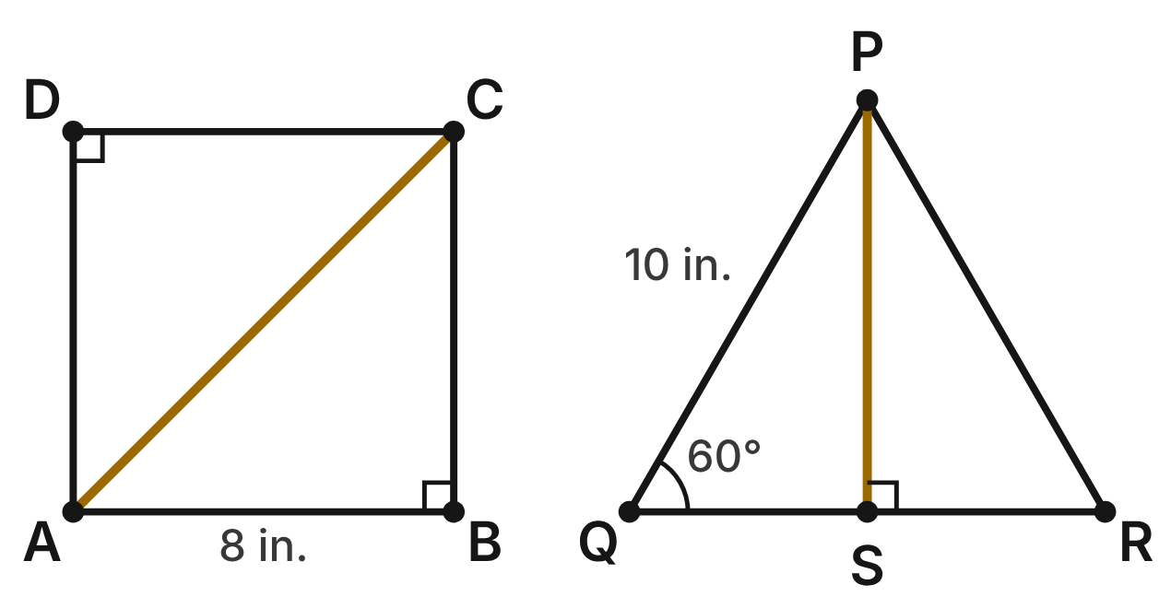
Square tile ABCD has 8-in. sides and a diagonal AC. Triangle sign PQR is equilateral with 10-in. sides; its altitude PS meets QR at its midpoint S.
145. How long is the diagonal AC?
A. 16 in.
B. 8√2 in. ✔
C. 8√3 in.
D. 4√2 in.
G.TR.4 · skill G.TR.4.2 (LOTS): Use the relationships in 45°-45°-90° and 30°-60°-90° triangles
☐ Answer key correct ☐ Wording clear Notes: ________________________________
146. How long is the altitude PS?
A. 5 in.
B. 5√2 in.
C. 10√3 in.
D. 5√3 in. ✔
G.TR.4 · skill G.TR.4.2 (LOTS): Use the relationships in 45°-45°-90° and 30°-60°-90° triangles
☐ Answer key correct ☐ Wording clear Notes: ________________________________
147. A 45°-45°-90° triangle has a hypotenuse of 12 cm. How long is each leg?
A. 6√2 cm ✔
B. 12√2 cm
C. 6 cm
D. 6√3 cm
G.TR.4 · skill G.TR.4.2 (LOTS): Use the relationships in 45°-45°-90° and 30°-60°-90° triangles
☐ Answer key correct ☐ Wording clear Notes: ________________________________
148. A 30°-60°-90° triangle has a hypotenuse of 14 cm. How long is its longer leg?
A. 7 cm
B. 14√3 cm
C. 7√3 cm ✔
D. 7√2 cm
G.TR.4 · skill G.TR.4.2 (LOTS): Use the relationships in 45°-45°-90° and 30°-60°-90° triangles
☐ Answer key correct ☐ Wording clear Notes: ________________________________
149. In right triangle PSQ, what is tan Q?
A. √3/2
B. 1/2
C. √3/3
D. √3 ✔
G.TR.4 · skill G.TR.4.3 (LOTS): Use sine, cosine and tangent ratios to find a side length or an angle measure
☐ Answer key correct ☐ Wording clear Notes: ________________________________
150. A triangle has sides of 9 cm, 12 cm and 16 cm. Which describes it?
A. Acute, because 16² > 9² + 12²
B. Obtuse, because 16² > 9² + 12² ✔
C. Right, because 9 + 12 > 16
D. Acute, because 16 is less than 9 + 12
G.TR.4 · skill G.TR.4.1 (LOTS): Use the Pythagorean Theorem and its converse, including to classify a triangle as right, acute or obtuse
☐ Answer key correct ☐ Wording clear Notes: ________________________________

The Ladder on the Gym Wall
Level 2 · Triangles · G.TR.4 · ID geo-tr4-ladder
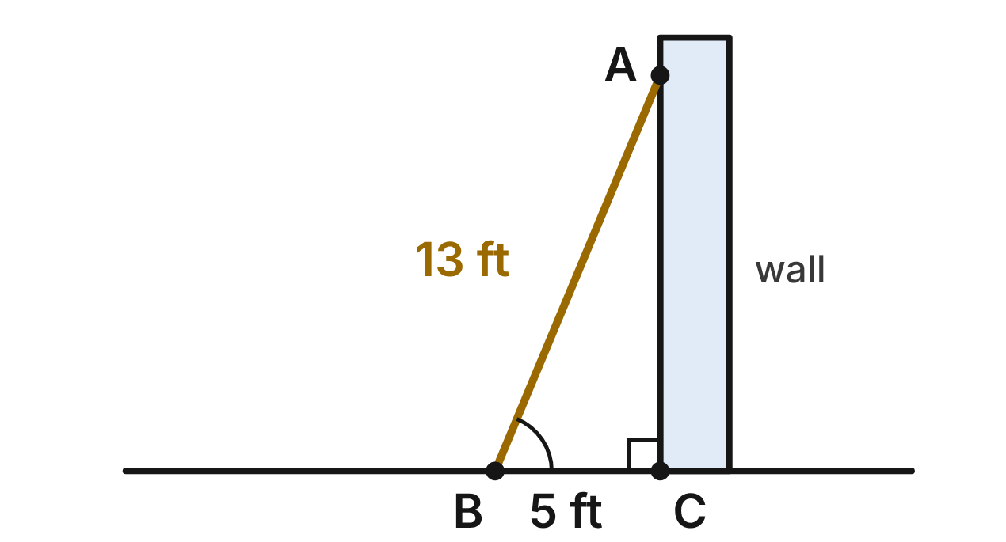
A 13-foot ladder AB leans against the gym wall. Its foot B is 5 feet from C, the base of the wall, on level ground. The wall is perpendicular to the ground.
151. How high up the wall does the ladder reach (the length of AC)?
A. 8 ft
B. 12 ft ✔
C. about 13.9 ft
D. 18 ft
G.TR.4 · skill G.TR.4.1 (LOTS): Use the Pythagorean Theorem and its converse, including to classify a triangle as right, acute or obtuse
☐ Answer key correct ☐ Wording clear Notes: ________________________________
152. Which ratio is equal to cos B?
A. 12/13
B. 5/12
C. 5/13 ✔
D. 13/5
G.TR.4 · skill G.TR.4.3 (LOTS): Use sine, cosine and tangent ratios to find a side length or an angle measure
☐ Answer key correct ☐ Wording clear Notes: ________________________________
153. To the nearest degree, what angle does the ladder make with the ground (m∠B)?
A. 23°
B. 45°
C. 79°
D. 67° ✔
G.TR.4 · skill G.TR.4.3 (LOTS): Use sine, cosine and tangent ratios to find a side length or an angle measure
☐ Answer key correct ☐ Wording clear Notes: ________________________________
154. A safety rule says the ladder should make a 75° angle with the ground. How far from the wall should the foot of the same 13-foot ladder be, to the nearest tenth of a foot?
A. 3.4 ft ✔
B. 12.6 ft
C. 48.5 ft
D. 50.2 ft
G.TR.4 · skill G.TR.4.4 (HOTS): Model a contextual problem (angles of elevation and depression, ramps, ladders, distances) with a right triangle and solve it
☐ Answer key correct ☐ Wording clear Notes: ________________________________
155. If the same ladder is set at a 75° angle with the ground instead, about how much higher up the wall does it reach than it does in the figure?
A. 1.6 ft
B. 0.6 ft ✔
C. 3.4 ft
D. 12.6 ft
G.TR.4 · skill G.TR.4.4 (HOTS): Model a contextual problem (angles of elevation and depression, ramps, ladders, distances) with a right triangle and solve it
☐ Answer key correct ☐ Wording clear Notes: ________________________________
156. To check another corner, a painter measures 6 ft along the floor, 8 ft up the wall, and 10.2 ft between those two marks. What can she conclude about the corner?
A. It is a right angle, because 6 + 8 > 10.2.
B. It is less than 90°, because 10.2² > 6² + 8².
C. It is more than 90°, because 10.2² > 6² + 8². ✔
D. It is a right angle, because 10.2 is close to 10.
G.TR.4 · skill G.TR.4.1 (LOTS): Use the Pythagorean Theorem and its converse, including to classify a triangle as right, acute or obtuse
☐ Answer key correct ☐ Wording clear Notes: ________________________________

The Skate Park Ramp
Level 2 · Triangles · G.TR.4 · ID geo-tr4-ramp
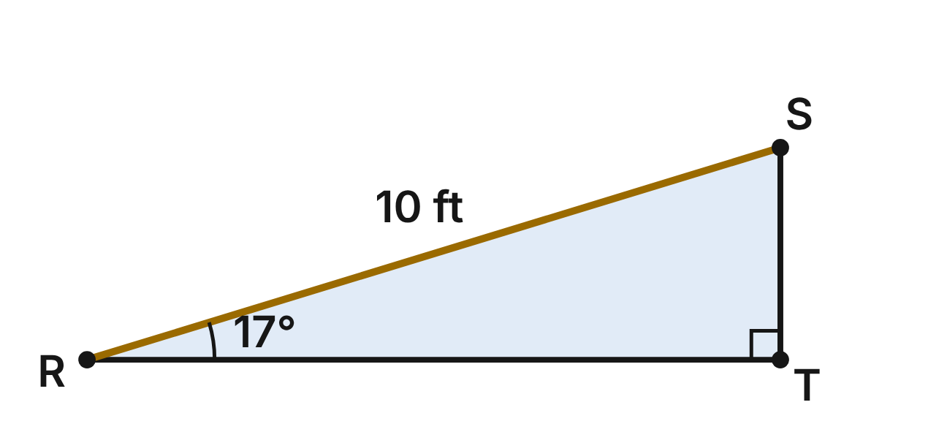
The side of a skate ramp is the right triangle RST, with the right angle at T. The ramp surface RS is 10 ft long and makes a 17° angle with the level ground at R.
157. Which ratio is equal to sin R?
A. RT/RS
B. ST/RT
C. ST/RS ✔
D. RS/ST
G.TR.4 · skill G.TR.4.3 (LOTS): Use sine, cosine and tangent ratios to find a side length or an angle measure
☐ Answer key correct ☐ Wording clear Notes: ________________________________
158. To the nearest tenth of a foot, how tall is the ramp (ST)?
A. 2.9 ft ✔
B. 9.6 ft
C. 3.1 ft
D. 34.2 ft
G.TR.4 · skill G.TR.4.3 (LOTS): Use sine, cosine and tangent ratios to find a side length or an angle measure
☐ Answer key correct ☐ Wording clear Notes: ________________________________
159. To the nearest tenth of a foot, how long is the ramp's base (RT)?
A. 10.5 ft
B. 9.6 ft ✔
C. 2.9 ft
D. 32.7 ft
G.TR.4 · skill G.TR.4.3 (LOTS): Use sine, cosine and tangent ratios to find a side length or an angle measure
☐ Answer key correct ☐ Wording clear Notes: ________________________________
160. A second ramp rises 3 ft over a horizontal run of 8 ft. To the nearest degree, what angle does it make with the ground?
A. 22°
B. 68°
C. 69°
D. 21° ✔
G.TR.4 · skill G.TR.4.4 (HOTS): Model a contextual problem (angles of elevation and depression, ramps, ladders, distances) with a right triangle and solve it
☐ Answer key correct ☐ Wording clear Notes: ________________________________
161. A beginner ramp must make an angle of at most 12° with the ground. If it is 2.5 ft tall, what is the shortest horizontal run it can have, to the nearest tenth of a foot?
A. 11.8 ft ✔
B. 0.5 ft
C. 12.0 ft
D. 2.4 ft
G.TR.4 · skill G.TR.4.4 (HOTS): Model a contextual problem (angles of elevation and depression, ramps, ladders, distances) with a right triangle and solve it
☐ Answer key correct ☐ Wording clear Notes: ________________________________
162. A third ramp has a rise of 5 ft and a run of 12 ft. How long is its sloped surface?
A. 17 ft
B. about 10.9 ft
C. 13 ft ✔
D. 7 ft
G.TR.4 · skill G.TR.4.1 (LOTS): Use the Pythagorean Theorem and its converse, including to classify a triangle as right, acute or obtuse
☐ Answer key correct ☐ Wording clear Notes: ________________________________

The Lighthouse and the Boat
Level 3 · Triangles · G.TR.4 · ID geo-tr4-lighthouse
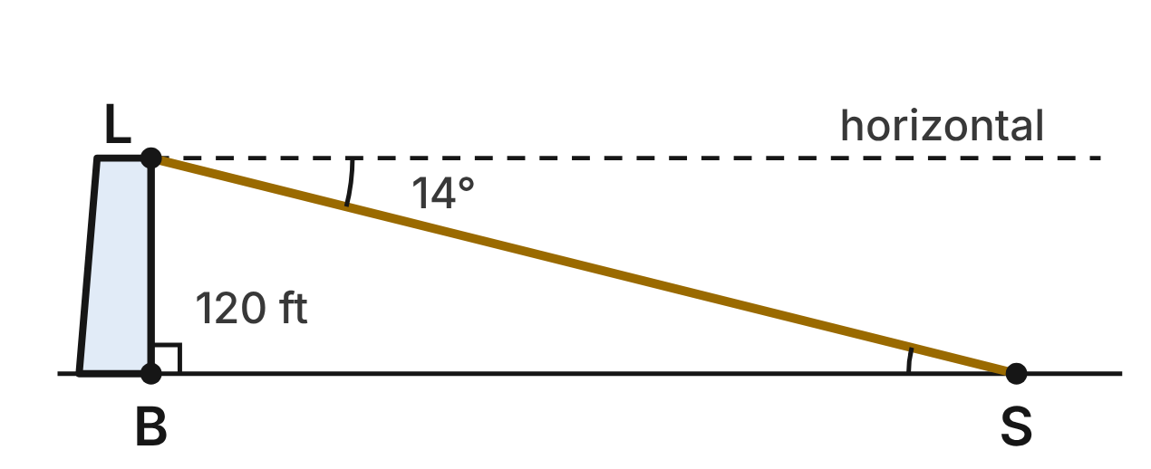
The light L is 120 ft above B, the base of the lighthouse at sea level. From L, the angle of depression to a boat S is 14°. Treat LB as perpendicular to the water.
163. Which angle of △LBS has the same measure as the 14° angle of depression?
A. ∠BLS
B. ∠LBS
C. None of its angles
D. ∠LSB ✔
G.TR.4 · skill G.TR.4.4 (HOTS): Model a contextual problem (angles of elevation and depression, ramps, ladders, distances) with a right triangle and solve it
☐ Answer key correct ☐ Wording clear Notes: ________________________________
164. To the nearest foot, how far is the boat from the base of the lighthouse (BS)?
A. 30 ft
B. 481 ft ✔
C. 496 ft
D. 116 ft
G.TR.4 · skill G.TR.4.4 (HOTS): Model a contextual problem (angles of elevation and depression, ramps, ladders, distances) with a right triangle and solve it
☐ Answer key correct ☐ Wording clear Notes: ________________________________
165. To the nearest foot, how long is the line of sight LS?
A. 481 ft
B. 124 ft
C. 496 ft ✔
D. 29 ft
G.TR.4 · skill G.TR.4.3 (LOTS): Use sine, cosine and tangent ratios to find a side length or an angle measure
☐ Answer key correct ☐ Wording clear Notes: ________________________________
166. Later, the angle of depression to the boat is 8°. To the nearest foot, how much farther from B is the boat now?
A. 373 ft ✔
B. 854 ft
C. 366 ft
D. 13 ft
G.TR.4 · skill G.TR.4.4 (HOTS): Model a contextual problem (angles of elevation and depression, ramps, ladders, distances) with a right triangle and solve it
☐ Answer key correct ☐ Wording clear Notes: ________________________________
167. A second boat is 300 ft from B. To the nearest degree, what is the angle of depression from L to that boat?
A. 68°
B. 22° ✔
C. 24°
D. 66°
G.TR.4 · skill G.TR.4.3 (LOTS): Use sine, cosine and tangent ratios to find a side length or an angle measure
☐ Answer key correct ☐ Wording clear Notes: ________________________________
168. How far from B is a boat when the angle of depression is 30°? Give an exact answer.
A. 40√3 ft
B. 240 ft
C. 60 ft
D. 120√3 ft ✔
G.TR.4 · skill G.TR.4.2 (LOTS): Use the relationships in 45°-45°-90° and 30°-60°-90° triangles
☐ Answer key correct ☐ Wording clear Notes: ________________________________

Polygons and circles (G.PC)

G.PC.1 · Prove and justify theorems and properties of quadrilaterals, and verify and use properties of quadrilaterals to solve problems, including the relationships between the sides, angles, and diagonals.

The Festival Kite
Level 1 · Quadrilaterals · G.PC.1 · ID geo-pc1-kite
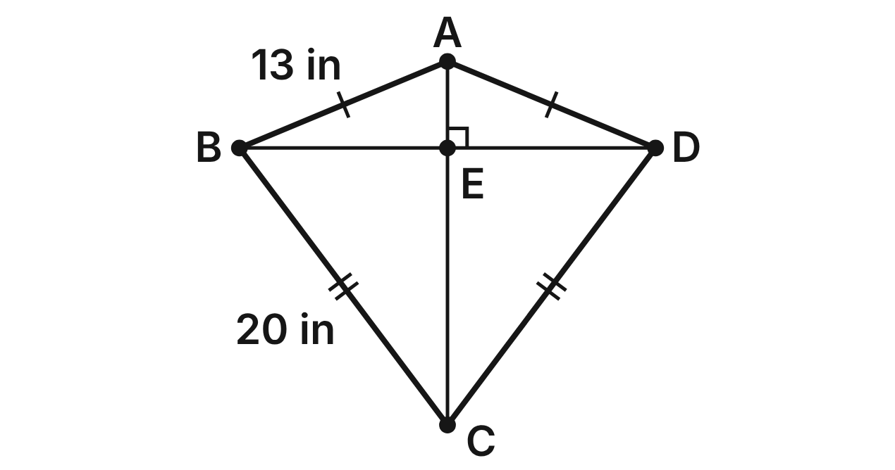
Kite ABCD has AB = AD = 13 in and CB = CD = 20 in. Its crossbars are the diagonals AC and BD, which meet at E. BD = 24 in.
169. Which statement about the diagonals of kite ABCD is true?
A. AC ≅ BD
B. BD bisects AC
C. AC ⊥ BD ✔
D. AC and BD bisect each other
G.PC.1 · skill G.PC.1.1 (LOTS): Identify the properties of parallelograms, rectangles, rhombi, squares, trapezoids and kites (sides, angles, diagonals)
☐ Answer key correct ☐ Wording clear Notes: ________________________________
170. Which pair of angles of the kite must be congruent?
A. ∠ABC and ∠ADC ✔
B. ∠BAD and ∠BCD
C. ∠ABC and ∠BAD
D. ∠BCD and ∠ADC
G.PC.1 · skill G.PC.1.1 (LOTS): Identify the properties of parallelograms, rectangles, rhombi, squares, trapezoids and kites (sides, angles, diagonals)
☐ Answer key correct ☐ Wording clear Notes: ________________________________
171. How long is BE?
A. 24 in
B. 12 in ✔
C. 6 in
D. 13 in
G.PC.1 · skill G.PC.1.3 (LOTS): Solve problems, including algebraic ones, using the properties of quadrilaterals
☐ Answer key correct ☐ Wording clear Notes: ________________________________
172. Use right triangle BEC to find EC.
A. 8 in
B. about 23.3 in
C. 12 in
D. 16 in ✔
G.PC.1 · skill G.PC.1.3 (LOTS): Solve problems, including algebraic ones, using the properties of quadrilaterals
☐ Answer key correct ☐ Wording clear Notes: ________________________________
173. Suppose m∠BCD = 74°. What is m∠BCE?
A. 37° ✔
B. 74°
C. 53°
D. 106°
G.PC.1 · skill G.PC.1.3 (LOTS): Solve problems, including algebraic ones, using the properties of quadrilaterals
☐ Answer key correct ☐ Wording clear Notes: ________________________________
174. Which property does every rhombus have that kite ABCD does NOT have?
A. The diagonals are perpendicular.
B. Opposite sides are congruent. ✔
C. One diagonal bisects the other.
D. Two pairs of adjacent sides are congruent.
G.PC.1 · skill G.PC.1.1 (LOTS): Identify the properties of parallelograms, rectangles, rhombi, squares, trapezoids and kites (sides, angles, diagonals)
☐ Answer key correct ☐ Wording clear Notes: ________________________________

The Leaning Bookshelf
Level 2 · Quadrilaterals · G.PC.1 · ID geo-pc1-shelf
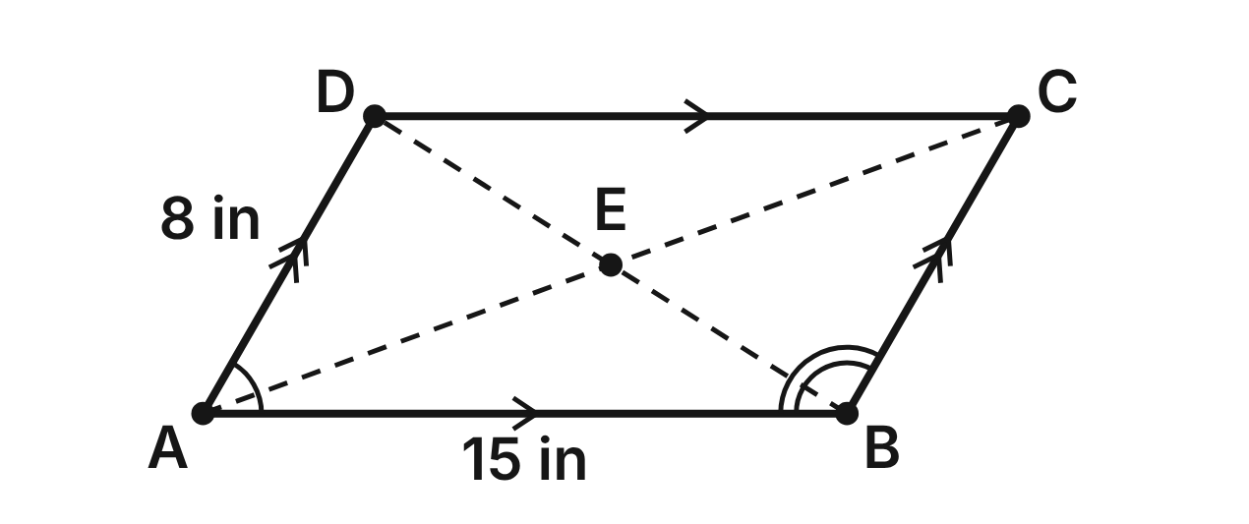
A bookshelf frame ABCD came loose and leaned into a parallelogram. AB = 15 in, AD = 8 in, m∠DAB = (2y − 10)° and m∠ABC = (3y + 15)°. The diagonals meet at E.
175. What is the value of y?
A. 71
B. 17
C. −25
D. 35 ✔
G.PC.1 · skill G.PC.1.3 (LOTS): Solve problems, including algebraic ones, using the properties of quadrilaterals
☐ Answer key correct ☐ Wording clear Notes: ________________________________
176. What is m∠BCD?
A. 120°
B. 90°
C. 60° ✔
D. 35°
G.PC.1 · skill G.PC.1.1 (LOTS): Identify the properties of parallelograms, rectangles, rhombi, squares, trapezoids and kites (sides, angles, diagonals)
☐ Answer key correct ☐ Wording clear Notes: ________________________________
177. Which two segments must be congruent in the leaning frame?
A. AE and EC ✔
B. AC and BD
C. AE and BE
D. AB and BC
G.PC.1 · skill G.PC.1.1 (LOTS): Identify the properties of parallelograms, rectangles, rhombi, squares, trapezoids and kites (sides, angles, diagonals)
☐ Answer key correct ☐ Wording clear Notes: ________________________________
178. The frame is still a parallelogram. Which single fact would be enough to prove it is a rectangle?
A. AC ⊥ BD
B. AC ≅ BD ✔
C. AB ∥ DC
D. AC bisects ∠DAB
G.PC.1 · skill G.PC.1.1 (LOTS): Identify the properties of parallelograms, rectangles, rhombi, squares, trapezoids and kites (sides, angles, diagonals)
☐ Answer key correct ☐ Wording clear Notes: ________________________________
179. Ana squares the frame into a rectangle. Now AC = (2x + 5) in and BD = (4x − 7) in. How long is each diagonal?
A. 6 in
B. 8.5 in
C. 17 in ✔
D. 34 in
G.PC.1 · skill G.PC.1.3 (LOTS): Solve problems, including algebraic ones, using the properties of quadrilaterals
☐ Answer key correct ☐ Wording clear Notes: ________________________________
180. Ana says that because AC ≅ BD, the frame is now a square. Is she right?
A. Yes: congruent diagonals make it a square.
B. No: a square's diagonals are not congruent.
C. Yes: every rectangle is a square.
D. No: AB ≠ AD, so it is not a square. ✔
G.PC.1 · skill G.PC.1.1 (LOTS): Identify the properties of parallelograms, rectangles, rhombi, squares, trapezoids and kites (sides, angles, diagonals)
☐ Answer key correct ☐ Wording clear Notes: ________________________________

The Raised Garden Bed
Level 2 · Quadrilaterals · G.PC.1 · ID geo-pc1-garden
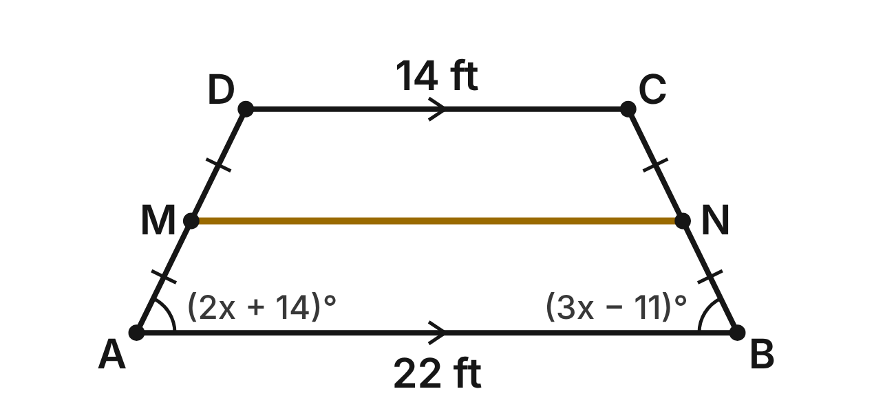
A garden bed ABCD is an isosceles trapezoid with bases AB = 22 ft and DC = 14 ft. A path MN (gold) joins the midpoints of the legs. m∠A = (2x + 14)° and m∠B = (3x − 11)°.
181. What is the value of x?
A. 64
B. 25 ✔
C. 35.4
D. 5
G.PC.1 · skill G.PC.1.3 (LOTS): Solve problems, including algebraic ones, using the properties of quadrilaterals
☐ Answer key correct ☐ Wording clear Notes: ________________________________
182. What is m∠C?
A. 64°
B. 26°
C. 52°
D. 116° ✔
G.PC.1 · skill G.PC.1.1 (LOTS): Identify the properties of parallelograms, rectangles, rhombi, squares, trapezoids and kites (sides, angles, diagonals)
☐ Answer key correct ☐ Wording clear Notes: ________________________________
183. How long is the path MN?
A. 18 ft ✔
B. 36 ft
C. 8 ft
D. 4 ft
G.PC.1 · skill G.PC.1.3 (LOTS): Solve problems, including algebraic ones, using the properties of quadrilaterals
☐ Answer key correct ☐ Wording clear Notes: ________________________________
184. Which statement is true of every isosceles trapezoid, including ABCD?
A. Its diagonals bisect each other.
B. Its diagonals are perpendicular.
C. Its diagonals are congruent. ✔
D. Its opposite angles are congruent.
G.PC.1 · skill G.PC.1.1 (LOTS): Identify the properties of parallelograms, rectangles, rhombi, squares, trapezoids and kites (sides, angles, diagonals)
☐ Answer key correct ☐ Wording clear Notes: ________________________________
185. A second trapezoid bed has a midsegment of 20 ft and one base of 26 ft. How long is its other base?
A. 14 ft ✔
B. 23 ft
C. 6 ft
D. 46 ft
G.PC.1 · skill G.PC.1.3 (LOTS): Solve problems, including algebraic ones, using the properties of quadrilaterals
☐ Answer key correct ☐ Wording clear Notes: ________________________________
186. Why are ∠A and ∠D supplementary?
A. AD ≅ BC, so they are base angles.
B. They are opposite angles of the trapezoid.
C. The diagonals of ABCD are congruent.
D. AB ∥ DC, so they are same-side interior angles. ✔
G.PC.1 · skill G.PC.1.1 (LOTS): Identify the properties of parallelograms, rectangles, rhombi, squares, trapezoids and kites (sides, angles, diagonals)
☐ Answer key correct ☐ Wording clear Notes: ________________________________

Four Points on a Grid
Level 3 · Quadrilaterals · G.PC.1 · ID geo-pc1-grid
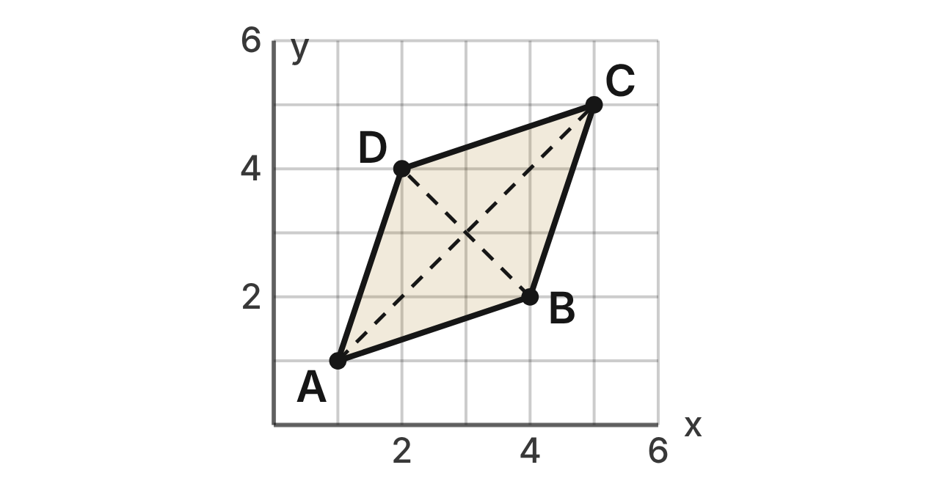
Quadrilateral ABCD has vertices A(1, 1), B(4, 2), C(5, 5) and D(2, 4). The dashed segments are its diagonals.
187. What is the slope of side AB?
A. 1/3 ✔
B. 3
C. −3
D. −1/3
G.PC.1 · skill G.PC.1.2 (HOTS): Use coordinate methods (slope, distance, midpoint) to classify a quadrilateral or justify a property
☐ Answer key correct ☐ Wording clear Notes: ________________________________
188. How long is side AB?
A. 10
B. 4
C. √10 ✔
D. 2√2
G.PC.1 · skill G.PC.1.2 (HOTS): Use coordinate methods (slope, distance, midpoint) to classify a quadrilateral or justify a property
☐ Answer key correct ☐ Wording clear Notes: ________________________________
189. What is the midpoint of diagonal BD?
A. (6, 6)
B. (3, 3) ✔
C. (−1, 1)
D. (1, 1)
G.PC.1 · skill G.PC.1.2 (HOTS): Use coordinate methods (slope, distance, midpoint) to classify a quadrilateral or justify a property
☐ Answer key correct ☐ Wording clear Notes: ________________________________
190. The diagonals share a midpoint, so ABCD is a parallelogram. The slope of AC is 1 and the slope of BD is −1. What do the slopes show?
A. AC ≅ BD, so ABCD is a rectangle.
B. AC ∥ BD, so ABCD is a trapezoid.
C. AC ⊥ BD, so ABCD is a rectangle.
D. AC ⊥ BD, so ABCD is a rhombus. ✔
G.PC.1 · skill G.PC.1.2 (HOTS): Use coordinate methods (slope, distance, midpoint) to classify a quadrilateral or justify a property
☐ Answer key correct ☐ Wording clear Notes: ________________________________
191. What is the most specific name for ABCD?
A. square
B. rhombus ✔
C. rectangle
D. parallelogram
G.PC.1 · skill G.PC.1.2 (HOTS): Use coordinate methods (slope, distance, midpoint) to classify a quadrilateral or justify a property
☐ Answer key correct ☐ Wording clear Notes: ________________________________
192. Which result shows that ABCD is NOT a square?
A. AB = BC = √10
B. slope of AC × slope of BD = −1
C. AC = 4√2 but BD = 2√2 ✔
D. AC and BD have the same midpoint
G.PC.1 · skill G.PC.1.2 (HOTS): Use coordinate methods (slope, distance, midpoint) to classify a quadrilateral or justify a property
☐ Answer key correct ☐ Wording clear Notes: ________________________________

G.PC.2 · Verify relationships and solve problems involving the number of sides and measures of angles of convex polygons.

The Stop Sign
Level 1 · Polygons · G.PC.2 · ID geo-pc2-stopsign
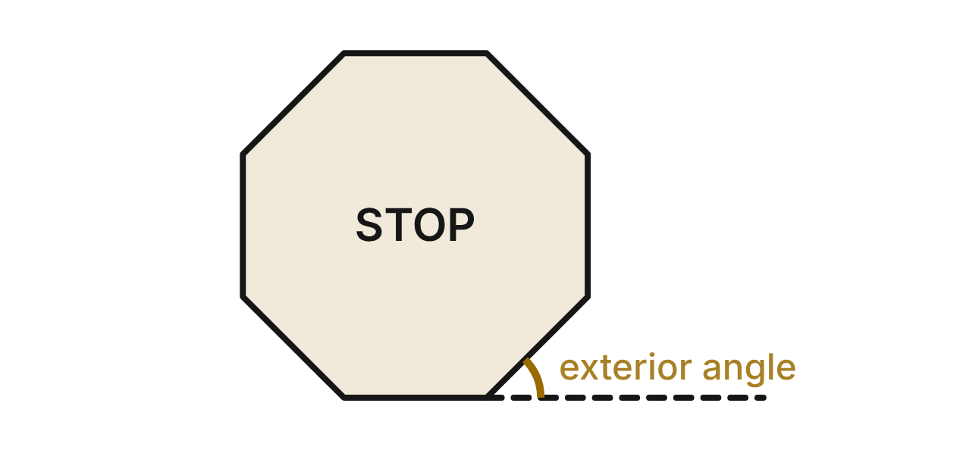
A stop sign is a regular octagon: 8 congruent sides and 8 congruent angles. One side is extended (dashed) to show an exterior angle, in gold.
193. What is the sum of the interior angles of the stop sign?
A. 1440°
B. 1080° ✔
C. 1260°
D. 360°
G.PC.2 · skill G.PC.2.1 (LOTS): Find the sum of the interior angles, and the measure of each interior and exterior angle, of a convex or regular polygon
☐ Answer key correct ☐ Wording clear Notes: ________________________________
194. What is the measure of each interior angle of the stop sign?
A. 45°
B. 180°
C. 157.5°
D. 135° ✔
G.PC.2 · skill G.PC.2.1 (LOTS): Find the sum of the interior angles, and the measure of each interior and exterior angle, of a convex or regular polygon
☐ Answer key correct ☐ Wording clear Notes: ________________________________
195. What is the measure of the gold exterior angle?
A. 135°
B. 22.5°
C. 45° ✔
D. 51.4°
G.PC.2 · skill G.PC.2.1 (LOTS): Find the sum of the interior angles, and the measure of each interior and exterior angle, of a convex or regular polygon
☐ Answer key correct ☐ Wording clear Notes: ________________________________
196. Picture one exterior angle at each of the 8 corners. What is the sum of those 8 exterior angles?
A. 360° ✔
B. 1080°
C. 2880°
D. 180°
G.PC.2 · skill G.PC.2.1 (LOTS): Find the sum of the interior angles, and the measure of each interior and exterior angle, of a convex or regular polygon
☐ Answer key correct ☐ Wording clear Notes: ________________________________
197. Another sign is a regular polygon whose exterior angles each measure 72°. How many sides does it have?
A. 7
B. 3
C. 2.5
D. 5 ✔
G.PC.2 · skill G.PC.2.2 (LOTS): Find the number of sides of a regular polygon given the measure of an interior or exterior angle
☐ Answer key correct ☐ Wording clear Notes: ________________________________
198. Diagonals drawn from one corner of the octagon split it into triangles. How many triangles?
A. 8
B. 7
C. 6 ✔
D. 5
G.PC.2 · skill G.PC.2.1 (LOTS): Find the sum of the interior angles, and the measure of each interior and exterior angle, of a convex or regular polygon
☐ Answer key correct ☐ Wording clear Notes: ________________________________

Octagon and Square Tiles
Level 2 · Polygons · G.PC.2 · ID geo-pc2-tiles
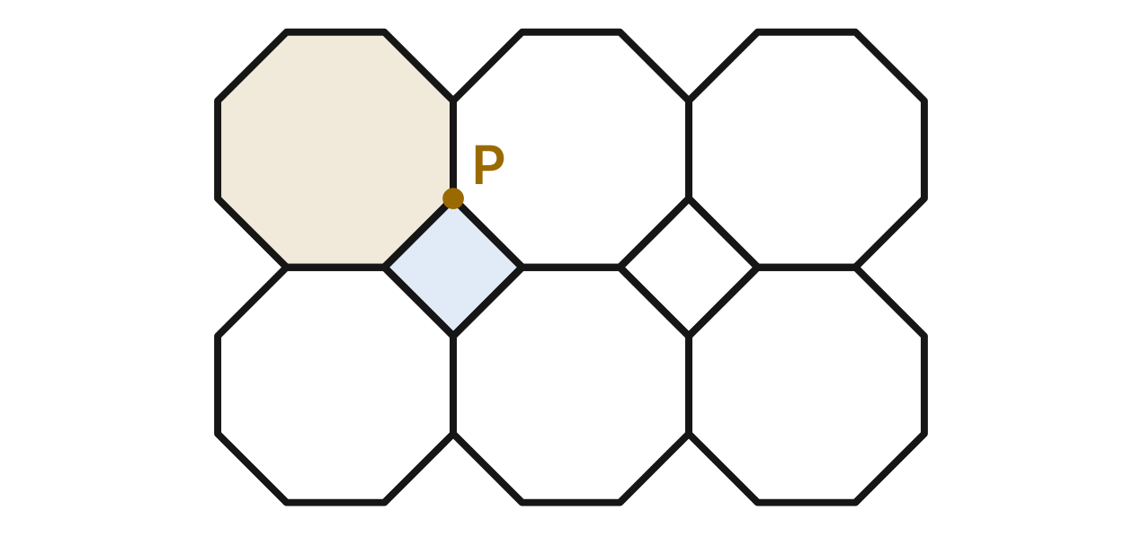
A floor is covered with regular octagons and squares, with no gaps or overlaps. At point P, two octagons (one shaded gold) and one square (shaded blue) meet.
199. Each angle of a square is 90°. What must each angle of an octagon be so that the three angles at P make 360°?
A. 135° ✔
B. 270°
C. 120°
D. 180°
G.PC.2 · skill G.PC.2.1 (LOTS): Find the sum of the interior angles, and the measure of each interior and exterior angle, of a convex or regular polygon
☐ Answer key correct ☐ Wording clear Notes: ________________________________
200. Which regular polygon can NOT cover a floor by itself, with no gaps or overlaps?
A. equilateral triangle
B. regular pentagon ✔
C. square
D. regular hexagon
G.PC.2 · skill G.PC.2.1 (LOTS): Find the sum of the interior angles, and the measure of each interior and exterior angle, of a convex or regular polygon
☐ Answer key correct ☐ Wording clear Notes: ________________________________
201. A tile maker wants a regular polygon whose interior angles each measure 150°. How many sides will it have?
A. 14
B. 6
C. 2.4
D. 12 ✔
G.PC.2 · skill G.PC.2.2 (LOTS): Find the number of sides of a regular polygon given the measure of an interior or exterior angle
☐ Answer key correct ☐ Wording clear Notes: ________________________________
202. Can a regular polygon have interior angles that each measure 155°?
A. Yes: it has 14 sides
B. Yes: it has 15 sides
C. No: 360 ÷ 25 = 14.4 sides ✔
D. No: no angle can be more than 150°
G.PC.2 · skill G.PC.2.2 (LOTS): Find the number of sides of a regular polygon given the measure of an interior or exterior angle
☐ Answer key correct ☐ Wording clear Notes: ________________________________
203. What is the sum of the interior angles of a 12-sided regular polygon?
A. 2160°
B. 1800° ✔
C. 1980°
D. 150°
G.PC.2 · skill G.PC.2.1 (LOTS): Find the sum of the interior angles, and the measure of each interior and exterior angle, of a convex or regular polygon
☐ Answer key correct ☐ Wording clear Notes: ________________________________
204. A floor is covered with equilateral triangles only. How many triangles meet at each corner?
A. 6 ✔
B. 3
C. 4
D. 2
G.PC.2 · skill G.PC.2.1 (LOTS): Find the sum of the interior angles, and the measure of each interior and exterior angle, of a convex or regular polygon
☐ Answer key correct ☐ Wording clear Notes: ________________________________

The Park Gazebo
Level 2 · Polygons · G.PC.2 · ID geo-pc2-gazebo
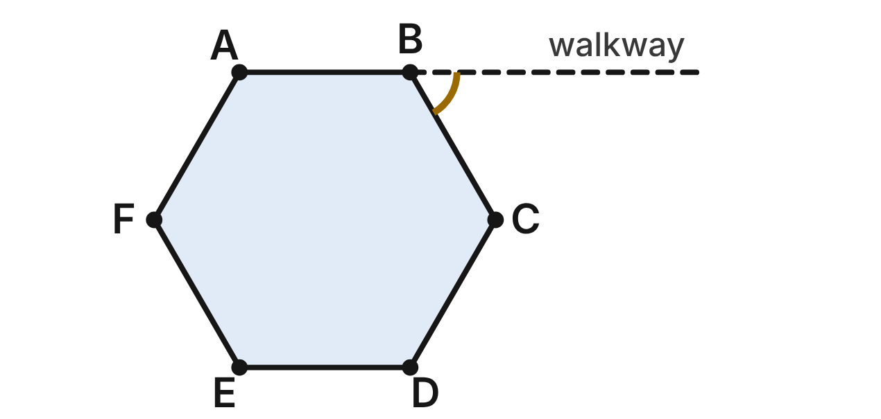
The floor of a park gazebo is a regular hexagon ABCDEF. A straight walkway (dashed) continues side AB past corner B.
205. What is the sum of the interior angles of the gazebo floor?
A. 1080°
B. 360°
C. 720° ✔
D. 900°
G.PC.2 · skill G.PC.2.1 (LOTS): Find the sum of the interior angles, and the measure of each interior and exterior angle, of a convex or regular polygon
☐ Answer key correct ☐ Wording clear Notes: ________________________________
206. What is the measure of each interior angle of the gazebo floor, such as ∠ABC?
A. 120° ✔
B. 60°
C. 180°
D. 144°
G.PC.2 · skill G.PC.2.1 (LOTS): Find the sum of the interior angles, and the measure of each interior and exterior angle, of a convex or regular polygon
☐ Answer key correct ☐ Wording clear Notes: ________________________________
207. What is the measure of the gold angle between the walkway and side BC?
A. 120°
B. 30°
C. 72°
D. 60° ✔
G.PC.2 · skill G.PC.2.1 (LOTS): Find the sum of the interior angles, and the measure of each interior and exterior angle, of a convex or regular polygon
☐ Answer key correct ☐ Wording clear Notes: ________________________________
208. The town's next gazebo will be a regular polygon with interior angles of 140°. How many sides will it have?
A. 11
B. 9 ✔
C. 4.5
D. about 2.6
G.PC.2 · skill G.PC.2.2 (LOTS): Find the number of sides of a regular polygon given the measure of an interior or exterior angle
☐ Answer key correct ☐ Wording clear Notes: ________________________________
209. At each corner of a larger regular gazebo, the railing turns 30° (an exterior angle). How many sides does that gazebo have?
A. 6
B. 12 ✔
C. 14
D. 10
G.PC.2 · skill G.PC.2.2 (LOTS): Find the number of sides of a regular polygon given the measure of an interior or exterior angle
☐ Answer key correct ☐ Wording clear Notes: ________________________________
210. Lee walks once around the edge of the hexagon floor, turning at each corner. How many degrees does he turn in all?
A. 720°
B. 60°
C. 360° ✔
D. 120°
G.PC.2 · skill G.PC.2.1 (LOTS): Find the sum of the interior angles, and the measure of each interior and exterior angle, of a convex or regular polygon
☐ Answer key correct ☐ Wording clear Notes: ________________________________

The Five-Sided Garden Plot
Level 3 · Polygons · G.PC.2 · ID geo-pc2-plot
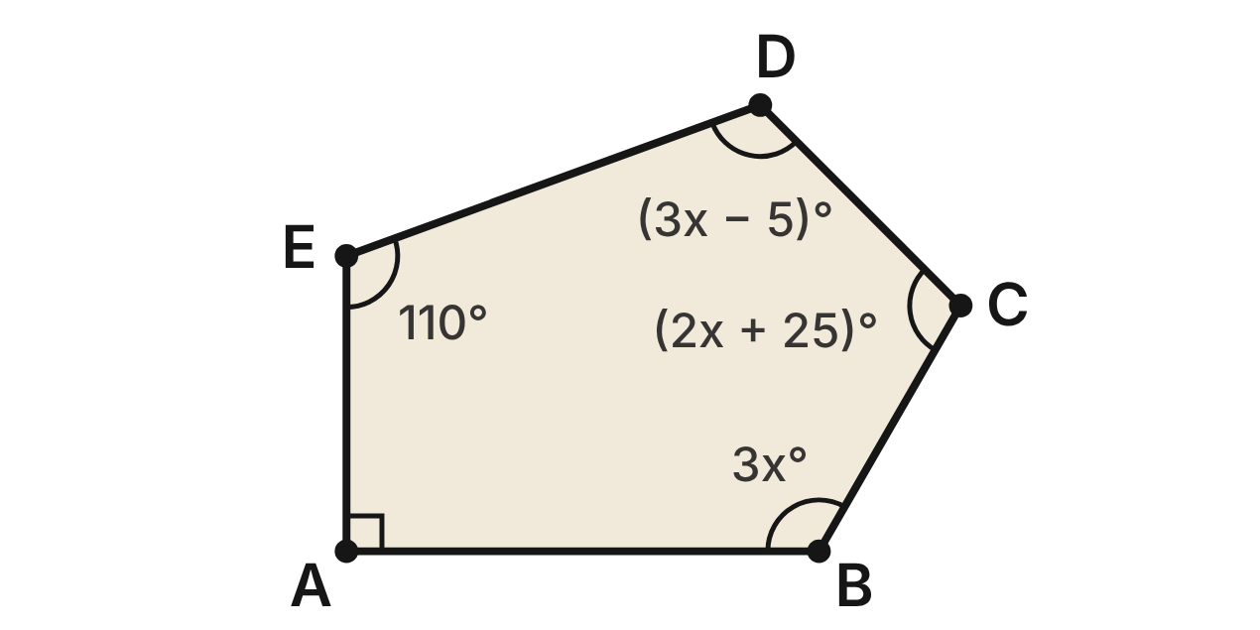
A community garden ABCDE is a convex pentagon. ∠A is a right angle, m∠E = 110°, and the other three angles are given in terms of x.
211. What is the sum of the interior angles of the garden?
A. 900°
B. 720°
C. 360°
D. 540° ✔
G.PC.2 · skill G.PC.2.1 (LOTS): Find the sum of the interior angles, and the measure of each interior and exterior angle, of a convex or regular polygon
☐ Answer key correct ☐ Wording clear Notes: ________________________________
212. Use the angle sum to find x.
A. 62.5
B. 40 ✔
C. 17.5
D. 65
G.PC.2 · skill G.PC.2.1 (LOTS): Find the sum of the interior angles, and the measure of each interior and exterior angle, of a convex or regular polygon
☐ Answer key correct ☐ Wording clear Notes: ________________________________
213. Which angle of the garden is the largest?
A. ∠B ✔
B. ∠C
C. ∠D
D. ∠E
G.PC.2 · skill G.PC.2.1 (LOTS): Find the sum of the interior angles, and the measure of each interior and exterior angle, of a convex or regular polygon
☐ Answer key correct ☐ Wording clear Notes: ________________________________
214. What is the measure of an exterior angle at corner E?
A. 110°
B. 250°
C. 70° ✔
D. 72°
G.PC.2 · skill G.PC.2.1 (LOTS): Find the sum of the interior angles, and the measure of each interior and exterior angle, of a convex or regular polygon
☐ Answer key correct ☐ Wording clear Notes: ________________________________
215. A new straight fence cuts off corner A, so the garden becomes a hexagon. What is the new sum of its interior angles?
A. 540°
B. 630°
C. 900°
D. 720° ✔
G.PC.2 · skill G.PC.2.1 (LOTS): Find the sum of the interior angles, and the measure of each interior and exterior angle, of a convex or regular polygon
☐ Answer key correct ☐ Wording clear Notes: ________________________________
216. A second garden will be a regular polygon whose exterior angles each measure 24°. How many sides will it have?
A. 15 ✔
B. 7.5
C. 17
D. 156
G.PC.2 · skill G.PC.2.2 (LOTS): Find the number of sides of a regular polygon given the measure of an interior or exterior angle
☐ Answer key correct ☐ Wording clear Notes: ________________________________

G.PC.3 · Solve problems, including contextual problems, by applying properties of circles.

Slicing the Pizza
Level 1 · Circles · G.PC.3 · ID geo-pc3-pizza
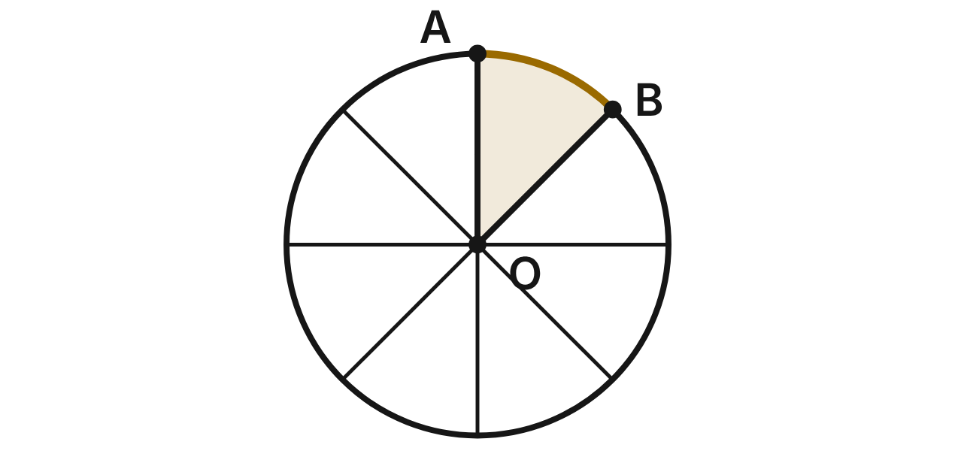
A 16-inch pizza (16 in is its diameter) is cut through its center O into 8 equal slices. The crust of the shaded slice AOB is arc AB (gold).
217. What is m∠AOB, the central angle of one slice?
A. 45° ✔
B. 90°
C. 22.5°
D. 135°
G.PC.3 · skill G.PC.3.1 (LOTS): Use the angles formed by chords, secants and tangents (central, inscribed, and angles inside and outside a circle) and their arcs
☐ Answer key correct ☐ Wording clear Notes: ________________________________
218. How long is the crust of one slice, in terms of π?
A. 4π in
B. 8π in
C. π in
D. 2π in ✔
G.PC.3 · skill G.PC.3.3 (LOTS): Find arc length and the area of a sector, or use them to find a radius or a central angle
☐ Answer key correct ☐ Wording clear Notes: ________________________________
219. What is the area of one slice, to the nearest tenth of a square inch?
A. 100.5 in²
B. 25.1 in² ✔
C. 6.3 in²
D. 201.1 in²
G.PC.3 · skill G.PC.3.3 (LOTS): Find arc length and the area of a sector, or use them to find a radius or a central angle
☐ Answer key correct ☐ Wording clear Notes: ________________________________
220. Mia cuts a bigger slice from another 16-inch pizza. Its crust is 3π in long. What is its central angle?
A. 135°
B. 33.75°
C. 67.5° ✔
D. 16.9°
G.PC.3 · skill G.PC.3.3 (LOTS): Find arc length and the area of a sector, or use them to find a radius or a central angle
☐ Answer key correct ☐ Wording clear Notes: ________________________________
221. Another shop cuts a 12-inch pizza into 6 equal slices. How much more area does one slice here have than one slice there?
A. 2π in² ✔
B. 8π in²
C. 0 in²
D. 28π in²
G.PC.3 · skill G.PC.3.4 (HOTS): Model and solve a contextual problem with the properties of circles
☐ Answer key correct ☐ Wording clear Notes: ________________________________
222. One of 8 equal slices of a different pizza has an area of 18π in². What is that pizza's diameter?
A. 12 in
B. 24 in ✔
C. 144 in
D. about 8.5 in
G.PC.3 · skill G.PC.3.3 (LOTS): Find arc length and the area of a sector, or use them to find a radius or a central angle
☐ Answer key correct ☐ Wording clear Notes: ________________________________

The Ferris Wheel
Level 2 · Circles · G.PC.3 · ID geo-pc3-ferris
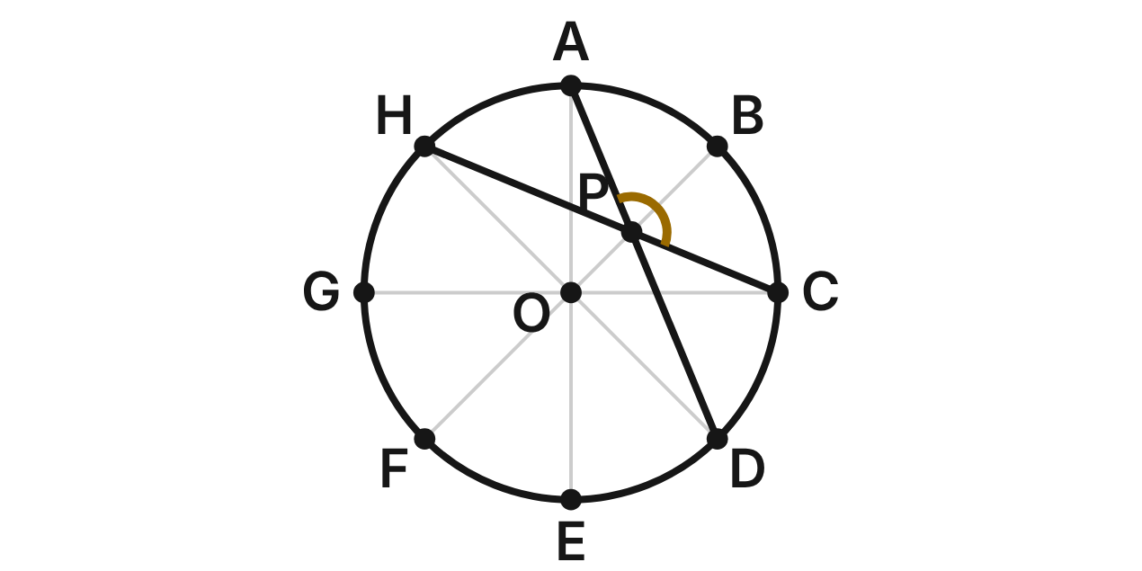
A Ferris wheel has radius 20 m and 8 cars, A to H, equally spaced on the circle around hub O. Light strings run straight from car A to car D and from car C to car H; they cross at P.
223. What is m∠AOB, the angle between the spokes to two cars next to each other?
A. 22.5°
B. 135°
C. 45° ✔
D. 90°
G.PC.3 · skill G.PC.3.1 (LOTS): Use the angles formed by chords, secants and tangents (central, inscribed, and angles inside and outside a circle) and their arcs
☐ Answer key correct ☐ Wording clear Notes: ________________________________
224. How far apart are two cars next to each other, measured along the circle? Round to the nearest tenth of a meter.
A. 7.9 m
B. 15.7 m ✔
C. 157.1 m
D. 125.7 m
G.PC.3 · skill G.PC.3.3 (LOTS): Find arc length and the area of a sector, or use them to find a radius or a central angle
☐ Answer key correct ☐ Wording clear Notes: ________________________________
225. A rider in car C looks at car A and car E. What is m∠ACE?
A. 180°
B. 45°
C. 60°
D. 90° ✔
G.PC.3 · skill G.PC.3.1 (LOTS): Use the angles formed by chords, secants and tangents (central, inscribed, and angles inside and outside a circle) and their arcs
☐ Answer key correct ☐ Wording clear Notes: ________________________________
226. The light strings cross at P. What is m∠APC, marked in gold?
A. 135° ✔
B. 45°
C. 270°
D. 90°
G.PC.3 · skill G.PC.3.1 (LOTS): Use the angles formed by chords, secants and tangents (central, inscribed, and angles inside and outside a circle) and their arcs
☐ Answer key correct ☐ Wording clear Notes: ________________________________
227. Strings also join cars A, B, C and E to form an inscribed quadrilateral ABCE, with m∠ABC = 135°. What is m∠AEC?
A. 135°
B. 67.5°
C. 45° ✔
D. 225°
G.PC.3 · skill G.PC.3.1 (LOTS): Use the angles formed by chords, secants and tangents (central, inscribed, and angles inside and outside a circle) and their arcs
☐ Answer key correct ☐ Wording clear Notes: ________________________________
228. The wheel makes one full turn every 6 minutes. How far does car A travel in 2 minutes, to the nearest tenth of a meter?
A. 20.9 m
B. 418.9 m
C. 125.7 m
D. 41.9 m ✔
G.PC.3 · skill G.PC.3.4 (HOTS): Model and solve a contextual problem with the properties of circles
☐ Answer key correct ☐ Wording clear Notes: ________________________________

Two Tangents and a Secant
Level 2 · Circles · G.PC.3 · ID geo-pc3-tangents
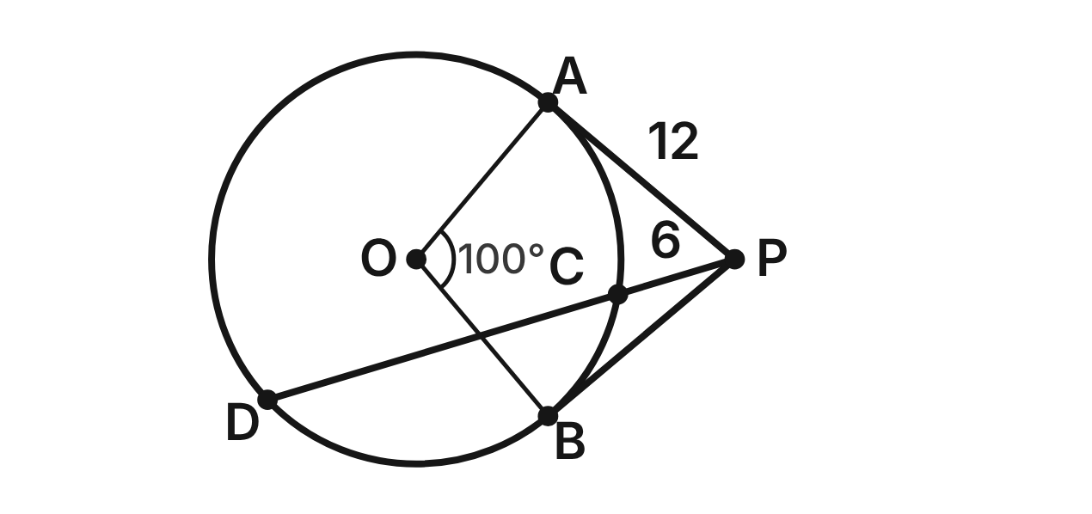
PA and PB are tangent to circle O at A and B. A secant from P meets the circle at C and D. PA = 12, PC = 6, and minor arc AB measures 100°.
229. What is m∠OAP?
A. 50°
B. 90° ✔
C. 80°
D. 100°
G.PC.3 · skill G.PC.3.1 (LOTS): Use the angles formed by chords, secants and tangents (central, inscribed, and angles inside and outside a circle) and their arcs
☐ Answer key correct ☐ Wording clear Notes: ________________________________
230. Which segment must be congruent to PA?
A. PC
B. PO
C. PB ✔
D. AB
G.PC.3 · skill G.PC.3.2 (LOTS): Use the lengths of segments formed by intersecting chords, secants and tangents
☐ Answer key correct ☐ Wording clear Notes: ________________________________
231. How long is chord CD?
A. 18 ✔
B. 24
C. 6
D. about 10.4
G.PC.3 · skill G.PC.3.2 (LOTS): Use the lengths of segments formed by intersecting chords, secants and tangents
☐ Answer key correct ☐ Wording clear Notes: ________________________________
232. What is m∠APB?
A. 50°
B. 100°
C. 180°
D. 80° ✔
G.PC.3 · skill G.PC.3.1 (LOTS): Use the angles formed by chords, secants and tangents (central, inscribed, and angles inside and outside a circle) and their arcs
☐ Answer key correct ☐ Wording clear Notes: ________________________________
233. Why must m∠AOB + m∠APB = 180°?
A. OAPB is a parallelogram, so consecutive angles are supplementary.
B. ∠OAP and ∠OBP are 90°, and the angles of OAPB add to 360°. ✔
C. ∠AOB and ∠APB form a linear pair, so they add to 180°.
D. ∠APB is an inscribed angle, so it is half of the major arc.
G.PC.3 · skill G.PC.3.1 (LOTS): Use the angles formed by chords, secants and tangents (central, inscribed, and angles inside and outside a circle) and their arcs
☐ Answer key correct ☐ Wording clear Notes: ________________________________
234. From a point Q, a tangent segment to a circle with radius 5 cm is 12 cm long. How far is Q from the center?
A. 17 cm
B. about 10.9 cm
C. 13 cm ✔
D. 7 cm
G.PC.3 · skill G.PC.3.2 (LOTS): Use the lengths of segments formed by intersecting chords, secants and tangents
☐ Answer key correct ☐ Wording clear Notes: ________________________________

The Broken Plate
Level 3 · Circles · G.PC.3 · ID geo-pc3-plate
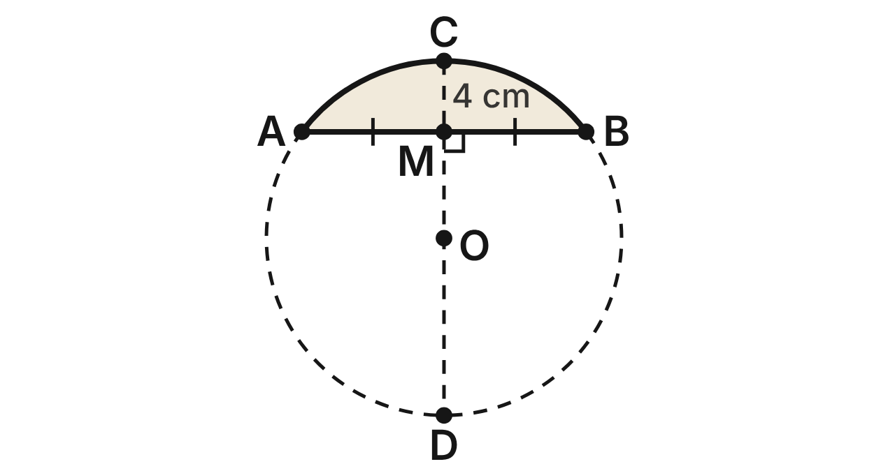
An archaeologist finds a piece of a round plate (shaded). She draws chord AB = 16 cm with midpoint M. Along the line perpendicular to AB at M, MC = 4 cm to the edge at C. Line CM continues across the full plate to D.
235. Chords AB and CD cross at M. How long is MD?
A. 2 cm
B. 12 cm
C. about 8.9 cm
D. 16 cm ✔
G.PC.3 · skill G.PC.3.2 (LOTS): Use the lengths of segments formed by intersecting chords, secants and tangents
☐ Answer key correct ☐ Wording clear Notes: ________________________________
236. What was the radius of the whole plate?
A. 10 cm ✔
B. 20 cm
C. 8 cm
D. 16 cm
G.PC.3 · skill G.PC.3.4 (HOTS): Model and solve a contextual problem with the properties of circles
☐ Answer key correct ☐ Wording clear Notes: ________________________________
237. Use right triangle AMO, where OM = 6 cm, to find m∠AOB to the nearest degree.
A. 53°
B. 74°
C. 106° ✔
D. 127°
G.PC.3 · skill G.PC.3.1 (LOTS): Use the angles formed by chords, secants and tangents (central, inscribed, and angles inside and outside a circle) and their arcs
☐ Answer key correct ☐ Wording clear Notes: ________________________________
238. Use m∠AOB ≈ 106°. How long is the curved edge of the piece, arc ACB, to the nearest tenth of a cm?
A. 37.0 cm
B. 18.5 cm ✔
C. 9.3 cm
D. 92.5 cm
G.PC.3 · skill G.PC.3.3 (LOTS): Find arc length and the area of a sector, or use them to find a radius or a central angle
☐ Answer key correct ☐ Wording clear Notes: ________________________________
239. A museum makes a metal ring to fit around the rim of the whole plate. To the nearest tenth of a cm, how long is the ring?
A. 62.8 cm ✔
B. 31.4 cm
C. 314.2 cm
D. 125.7 cm
G.PC.3 · skill G.PC.3.4 (HOTS): Model and solve a contextual problem with the properties of circles
☐ Answer key correct ☐ Wording clear Notes: ________________________________
240. Why must line CD pass through the center of the plate?
A. Any line through the midpoint of a chord passes through the center.
B. C is the midpoint of chord AB, so CD is a diameter.
C. Two chords that cross always cross at the center.
D. The perpendicular bisector of a chord passes through the center. ✔
G.PC.3 · skill G.PC.3.4 (HOTS): Model and solve a contextual problem with the properties of circles
☐ Answer key correct ☐ Wording clear Notes: ________________________________

G.PC.4 · Solve problems involving equations of circles.

A Circle on the Grid
Level 1 · Equations of circles · G.PC.4 · ID geo-pc4-grid
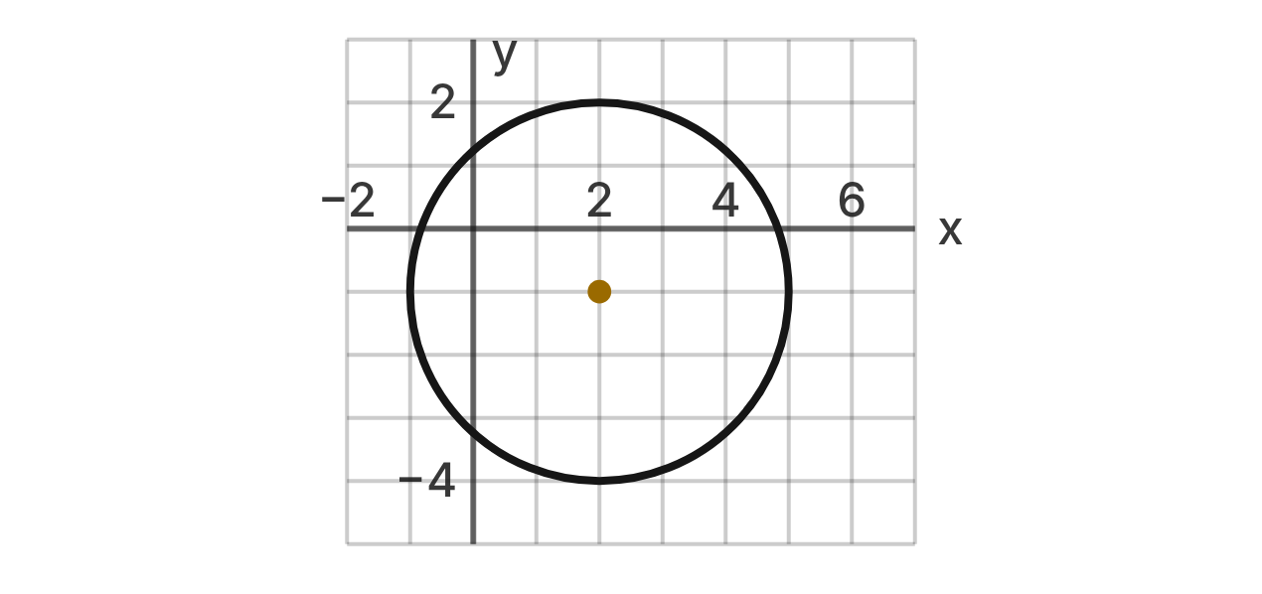
A circle is graphed on the coordinate grid. Its center is the gold point, and it passes through grid points.
241. What is the center of the circle?
A. (−2, 1)
B. (2, −1) ✔
C. (−1, 2)
D. (2, 1)
G.PC.4 · skill G.PC.4.1 (LOTS): Identify the center and radius of a circle from its graph or from its equation in standard form
☐ Answer key correct ☐ Wording clear Notes: ________________________________
242. What is the radius of the circle?
A. 3 ✔
B. 6
C. 9
D. √3
G.PC.4 · skill G.PC.4.1 (LOTS): Identify the center and radius of a circle from its graph or from its equation in standard form
☐ Answer key correct ☐ Wording clear Notes: ________________________________
243. Which equation describes this circle?
A. (x + 2)² + (y − 1)² = 9
B. (x − 2)² + (y + 1)² = 3
C. (x − 2)² + (y − 1)² = 9
D. (x − 2)² + (y + 1)² = 9 ✔
G.PC.4 · skill G.PC.4.2 (LOTS): Write the equation of a circle from its center and radius, its center and a point, or the endpoints of a diameter
☐ Answer key correct ☐ Wording clear Notes: ________________________________
244. Which point is inside the circle?
A. (5, 1)
B. (−1, 1)
C. (3, 0) ✔
D. (4, 2)
G.PC.4 · skill G.PC.4.1 (LOTS): Identify the center and radius of a circle from its graph or from its equation in standard form
☐ Answer key correct ☐ Wording clear Notes: ________________________________
245. A different circle has the equation (x + 4)² + (y − 5)² = 20. What are its center and radius?
A. (4, −5); r = 2√5
B. (−4, 5); r = 2√5 ✔
C. (−4, 5); r = 20
D. (−4, 5); r = 10
G.PC.4 · skill G.PC.4.1 (LOTS): Identify the center and radius of a circle from its graph or from its equation in standard form
☐ Answer key correct ☐ Wording clear Notes: ________________________________
246. The circle in the graph is moved 4 units left. Its radius does not change. What is the new equation?
A. (x − 6)² + (y + 1)² = 9
B. (x − 2)² + (y + 5)² = 9
C. (x + 2)² + (y − 1)² = 9
D. (x + 2)² + (y + 1)² = 9 ✔
G.PC.4 · skill G.PC.4.2 (LOTS): Write the equation of a circle from its center and radius, its center and a point, or the endpoints of a diameter
☐ Answer key correct ☐ Wording clear Notes: ________________________________

Ends of a Diameter
Level 2 · Equations of circles · G.PC.4 · ID geo-pc4-diameter
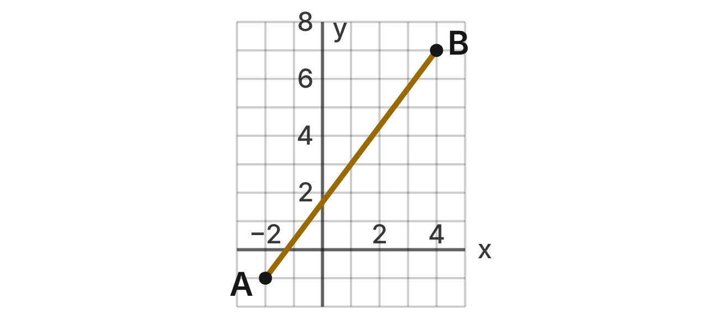
Segment AB is a diameter of a circle. Its endpoints are A(−2, −1) and B(4, 7).
247. What is the center of the circle with diameter AB?
A. (3, 4)
B. (2, 6)
C. (1, 3) ✔
D. (−1, −3)
G.PC.4 · skill G.PC.4.2 (LOTS): Write the equation of a circle from its center and radius, its center and a point, or the endpoints of a diameter
☐ Answer key correct ☐ Wording clear Notes: ________________________________
248. How long is the radius of this circle?
A. 10
B. 25
C. 7
D. 5 ✔
G.PC.4 · skill G.PC.4.2 (LOTS): Write the equation of a circle from its center and radius, its center and a point, or the endpoints of a diameter
☐ Answer key correct ☐ Wording clear Notes: ________________________________
249. Which equation describes the circle?
A. (x − 1)² + (y − 3)² = 25 ✔
B. (x + 1)² + (y + 3)² = 25
C. (x − 1)² + (y − 3)² = 100
D. (x − 1)² + (y − 3)² = 5
G.PC.4 · skill G.PC.4.2 (LOTS): Write the equation of a circle from its center and radius, its center and a point, or the endpoints of a diameter
☐ Answer key correct ☐ Wording clear Notes: ________________________________
250. Which point is also on this circle?
A. (2, 1)
B. (5, 0) ✔
C. (6, 7)
D. (4, 3)
G.PC.4 · skill G.PC.4.1 (LOTS): Identify the center and radius of a circle from its graph or from its equation in standard form
☐ Answer key correct ☐ Wording clear Notes: ________________________________
251. Which expression gives the radius, using the distance formula from the center to A?
A. √((−2 − 1)² + (−1 − 3)²) ✔
B. √((−2 + 1)² + (−1 + 3)²)
C. (−2 − 1)² + (−1 − 3)²
D. √((4 + 2)² + (7 + 1)²)
G.PC.4 · skill G.PC.4.3 (HOTS): Derive the equation of a circle with the Pythagorean Theorem or the distance formula
☐ Answer key correct ☐ Wording clear Notes: ________________________________
252. A second circle has the same center and passes through the origin. What is its equation?
A. (x − 1)² + (y − 3)² = √10
B. (x + 1)² + (y + 3)² = 10
C. (x − 1)² + (y − 3)² = 10 ✔
D. (x − 1)² + (y − 3)² = 16
G.PC.4 · skill G.PC.4.2 (LOTS): Write the equation of a circle from its center and radius, its center and a point, or the endpoints of a diameter
☐ Answer key correct ☐ Wording clear Notes: ________________________________

The Wi-Fi Router
Level 2 · Equations of circles · G.PC.4 · ID geo-pc4-wifi
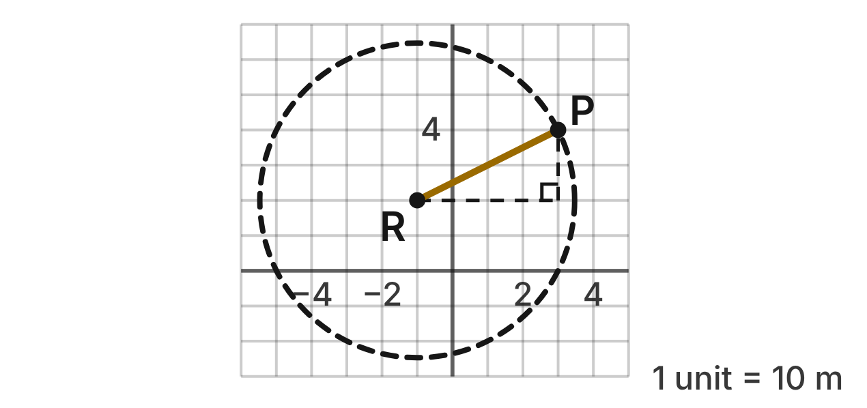
On a school map, each grid unit is 10 m. A Wi-Fi router at R(−1, 2) reaches exactly as far as point P(3, 4) in every direction, so the edge of its signal is a circle.
253. Which equation describes the edge of the signal?
A. (x − 1)² + (y + 2)² = 20
B. (x + 1)² + (y − 2)² = 2√5
C. (x − 3)² + (y − 4)² = 20
D. (x + 1)² + (y − 2)² = 20 ✔
G.PC.4 · skill G.PC.4.2 (LOTS): Write the equation of a circle from its center and radius, its center and a point, or the endpoints of a diameter
☐ Answer key correct ☐ Wording clear Notes: ________________________________
254. What is the radius in grid units, in simplest radical form?
A. 2√5 units ✔
B. 20 units
C. 4√5 units
D. 10 units
G.PC.4 · skill G.PC.4.1 (LOTS): Identify the center and radius of a circle from its graph or from its equation in standard form
☐ Answer key correct ☐ Wording clear Notes: ________________________________
255. To the nearest meter, how far does the signal reach?
A. 200 m
B. 45 m ✔
C. 4 m
D. 60 m
G.PC.4 · skill G.PC.4.1 (LOTS): Identify the center and radius of a circle from its graph or from its equation in standard form
☐ Answer key correct ☐ Wording clear Notes: ________________________________
256. Which building is outside the signal circle?
A. Library at (2, −1)
B. Cafeteria at (−5, 1)
C. Gym at (−4, 6) ✔
D. Office at (1, 5)
G.PC.4 · skill G.PC.4.1 (LOTS): Identify the center and radius of a circle from its graph or from its equation in standard form
☐ Answer key correct ☐ Wording clear Notes: ________________________________
257. Which equation applies the Pythagorean theorem to the dashed right triangle?
A. 4² + 2² = r² ✔
B. 4 + 2 = r
C. 3² + 4² = r²
D. 4² − 2² = r²
G.PC.4 · skill G.PC.4.3 (HOTS): Derive the equation of a circle with the Pythagorean Theorem or the distance formula
☐ Answer key correct ☐ Wording clear Notes: ________________________________
258. The router is upgraded to reach 60 m from the same spot. What is the new equation?
A. (x + 1)² + (y − 2)² = 60
B. (x + 1)² + (y − 2)² = 36 ✔
C. (x + 1)² + (y − 2)² = 3600
D. (x + 1)² + (y − 2)² = 6
G.PC.4 · skill G.PC.4.2 (LOTS): Write the equation of a circle from its center and radius, its center and a point, or the endpoints of a diameter
☐ Answer key correct ☐ Wording clear Notes: ________________________________

Deriving the Circle Equation
Level 3 · Equations of circles · G.PC.4 · ID geo-pc4-derive
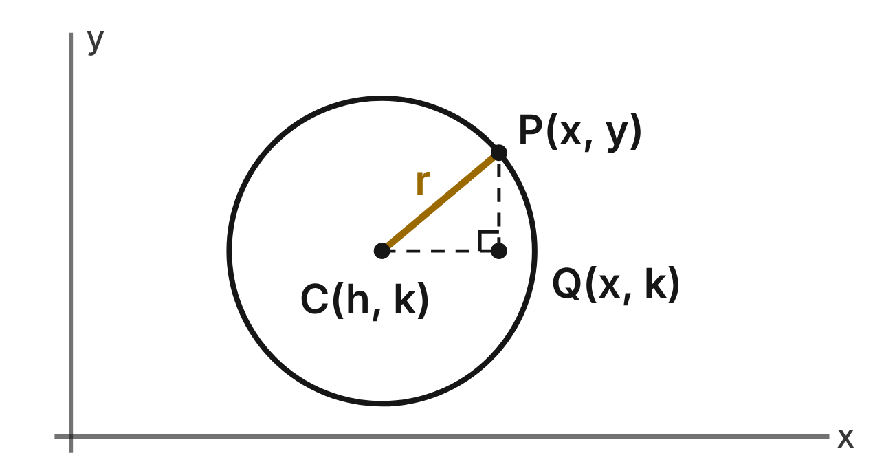
A circle has center C(h, k) and radius r. P(x, y) is any point on the circle, and Q(x, k) makes right triangle CQP.
259. Which expression gives the length of leg CQ?
A. |x + h|
B. |y − k|
C. |x − h| ✔
D. |x − k|
G.PC.4 · skill G.PC.4.3 (HOTS): Derive the equation of a circle with the Pythagorean Theorem or the distance formula
☐ Answer key correct ☐ Wording clear Notes: ________________________________
260. Which equation does the Pythagorean theorem give for triangle CQP?
A. (x − h) + (y − k) = r
B. (x + h)² + (y + k)² = r²
C. (x − h)² + r² = (y − k)²
D. (x − h)² + (y − k)² = r² ✔
G.PC.4 · skill G.PC.4.3 (HOTS): Derive the equation of a circle with the Pythagorean Theorem or the distance formula
☐ Answer key correct ☐ Wording clear Notes: ________________________________
261. The distance formula gives r = √((x − h)² + (y − k)²). What is the next step to reach the equation of the circle?
A. Take the square root of both sides.
B. Square both sides. ✔
C. Subtract (y − k)² from both sides.
D. Add h and k to both sides.
G.PC.4 · skill G.PC.4.3 (HOTS): Derive the equation of a circle with the Pythagorean Theorem or the distance formula
☐ Answer key correct ☐ Wording clear Notes: ________________________________
262. If P is to the left of C, then x − h is negative. Does the equation still work?
A. Yes: (x − h)² is the same as |x − h|². ✔
B. No: a leg cannot have a negative length.
C. No: use (x + h)² when P is on the left.
D. Yes, but only if y − k is negative too.
G.PC.4 · skill G.PC.4.3 (HOTS): Derive the equation of a circle with the Pythagorean Theorem or the distance formula
☐ Answer key correct ☐ Wording clear Notes: ________________________________
263. Which point is on the circle (x − 3)² + (y + 2)² = 25?
A. (1, 5)
B. (3, 7)
C. (8, 3)
D. (−1, 1) ✔
G.PC.4 · skill G.PC.4.1 (LOTS): Identify the center and radius of a circle from its graph or from its equation in standard form
☐ Answer key correct ☐ Wording clear Notes: ________________________________
264. Which is the equation of the circle with center (−1, 4) that passes through (2, −2)?
A. (x + 1)² + (y − 4)² = 3√5
B. (x − 1)² + (y + 4)² = 45
C. (x + 1)² + (y − 4)² = 45 ✔
D. (x + 1)² + (y − 4)² = 5
G.PC.4 · skill G.PC.4.2 (LOTS): Write the equation of a circle from its center and radius, its center and a point, or the endpoints of a diameter
☐ Answer key correct ☐ Wording clear Notes: ________________________________

3-D figures (G.DF)

G.DF.1 · Create models and solve problems, including those in context, involving surface area and volume of rectangular and triangular prisms, cylinders, cones, pyramids, and spheres.

Three Balls in a Can
Level 1 · 3-D figures · G.DF.1 · ID geo-df1-ballcan
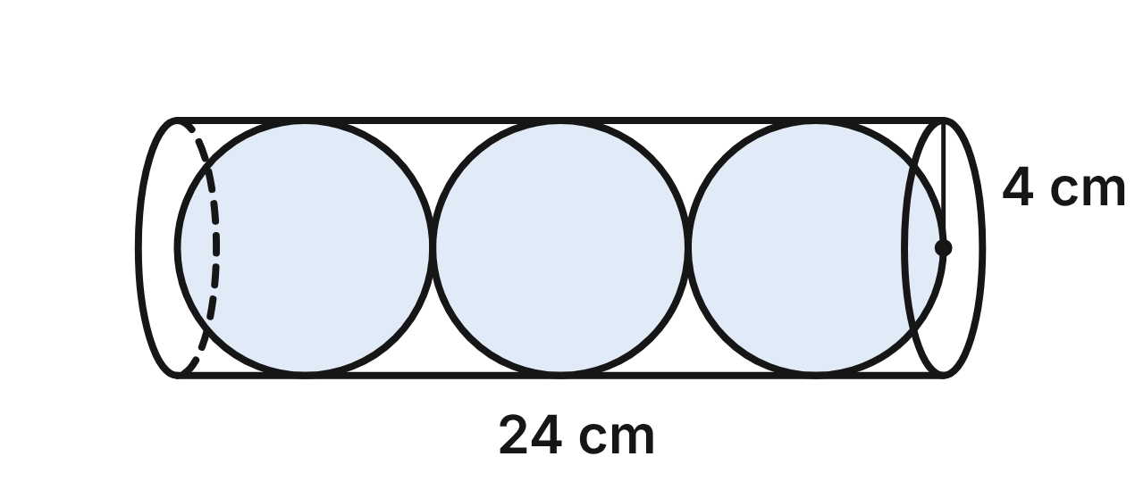
A clear can is a cylinder with radius 4 cm and height 24 cm (shown lying on its side). It holds three balls in a row. Each ball is a sphere with radius 4 cm, and the balls touch each other, the ends and the side of the can.
265. What is the volume of the can, in terms of π?
A. 96π cm³
B. 384π cm³ ✔
C. 192π cm³
D. 1536π cm³
G.DF.1 · skill G.DF.1.2 (LOTS): Find the surface area and volume of prisms, cylinders, cones, pyramids and spheres
☐ Answer key correct ☐ Wording clear Notes: ________________________________
266. What is the volume of one ball, to the nearest tenth of a cubic centimeter?
A. 201.1 cm³
B. 67.0 cm³
C. 2144.7 cm³
D. 268.1 cm³ ✔
G.DF.1 · skill G.DF.1.2 (LOTS): Find the surface area and volume of prisms, cylinders, cones, pyramids and spheres
☐ Answer key correct ☐ Wording clear Notes: ________________________________
267. A paper label covers the curved side of the can but not its two ends. What is the area of the label, in terms of π?
A. 192π cm² ✔
B. 224π cm²
C. 96π cm²
D. 384π cm²
G.DF.1 · skill G.DF.1.2 (LOTS): Find the surface area and volume of prisms, cylinders, cones, pyramids and spheres
☐ Answer key correct ☐ Wording clear Notes: ________________________________
268. A net of the can is a rectangle with a circle attached to each of two opposite sides. One side of the rectangle is 24 cm. How long is the other side, the one that wraps around a circular end?
A. 4π cm
B. 8 cm
C. 8π cm ✔
D. 16π cm
G.DF.1 · skill G.DF.1.1 (LOTS): Identify the two-dimensional cross sections and nets of three-dimensional figures
☐ Answer key correct ☐ Wording clear Notes: ________________________________
269. A plane parallel to the circular ends cuts the can halfway along its length. What is the cross section of the can?
A. a circle with radius 4 cm ✔
B. a circle with radius 8 cm
C. a rectangle 8 cm by 24 cm
D. a circle with radius 2 cm
G.DF.1 · skill G.DF.1.1 (LOTS): Identify the two-dimensional cross sections and nets of three-dimensional figures
☐ Answer key correct ☐ Wording clear Notes: ________________________________
270. A plane perpendicular to the circular ends cuts the can along its center line, the long way. What is the cross section of the can?
A. a rectangle 4 cm by 24 cm
B. a rectangle 8 cm by 24 cm ✔
C. a circle with radius 4 cm
D. a triangle with base 8 cm and height 24 cm
G.DF.1 · skill G.DF.1.1 (LOTS): Identify the two-dimensional cross sections and nets of three-dimensional figures
☐ Answer key correct ☐ Wording clear Notes: ________________________________

The Waffle Cone
Level 2 · 3-D figures · G.DF.1 · ID geo-df1-waffle
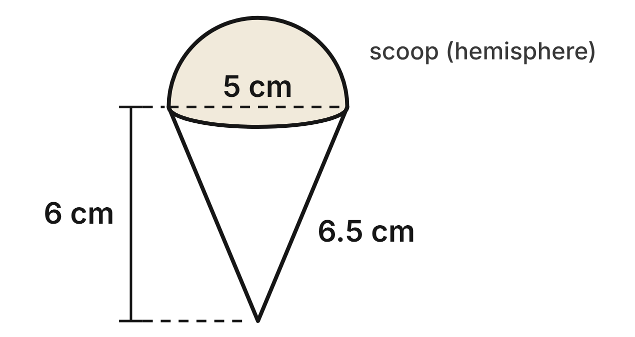
A waffle cone has a circular rim with diameter 5 cm. The cone is 6 cm tall and its slant height is 6.5 cm. The scoop of ice cream on top is a hemisphere with the same 5 cm diameter.
271. What is the volume of the cone, to the nearest tenth of a cubic centimeter?
A. 117.8 cm³
B. 157.1 cm³
C. 39.3 cm³ ✔
D. 42.5 cm³
G.DF.1 · skill G.DF.1.2 (LOTS): Find the surface area and volume of prisms, cylinders, cones, pyramids and spheres
☐ Answer key correct ☐ Wording clear Notes: ________________________________
272. What is the volume of the hemisphere scoop, to the nearest tenth of a cubic centimeter?
A. 32.7 cm³ ✔
B. 65.4 cm³
C. 261.8 cm³
D. 13.1 cm³
G.DF.1 · skill G.DF.1.2 (LOTS): Find the surface area and volume of prisms, cylinders, cones, pyramids and spheres
☐ Answer key correct ☐ Wording clear Notes: ________________________________
273. The cone is packed full of ice cream and the scoop sits on top. How much ice cream is there in all, to the nearest tenth of a cubic centimeter?
A. 104.7 cm³
B. 150.5 cm³
C. 75.3 cm³
D. 72.0 cm³ ✔
G.DF.1 · skill G.DF.1.3 (HOTS): Solve multistep contextual problems with surface area and volume, including composite figures
☐ Answer key correct ☐ Wording clear Notes: ________________________________
274. A paper sleeve covers the curved surface of the cone. What is its area, to the nearest tenth of a square centimeter?
A. 47.1 cm²
B. 51.1 cm² ✔
C. 70.7 cm²
D. 102.1 cm²
G.DF.1 · skill G.DF.1.2 (LOTS): Find the surface area and volume of prisms, cylinders, cones, pyramids and spheres
☐ Answer key correct ☐ Wording clear Notes: ________________________________
275. A plane parallel to the rim cuts the cone halfway between its tip and its rim. What is the cross section of the cone?
A. a circle with radius 2.5 cm
B. a triangle with base 2.5 cm and height 3 cm
C. a square with side 2.5 cm
D. a circle with radius 1.25 cm ✔
G.DF.1 · skill G.DF.1.1 (LOTS): Identify the two-dimensional cross sections and nets of three-dimensional figures
☐ Answer key correct ☐ Wording clear Notes: ________________________________
276. A vertical plane cuts the cone through its tip and the center of its rim. What is the area of the cross section of the cone?
A. 30 cm²
B. 16.25 cm²
C. 15 cm² ✔
D. 7.5 cm²
G.DF.1 · skill G.DF.1.1 (LOTS): Identify the two-dimensional cross sections and nets of three-dimensional figures
☐ Answer key correct ☐ Wording clear Notes: ________________________________

Plaster Solids in the Art Room
Level 2 · 3-D figures · G.DF.1 · ID geo-df1-artsolids
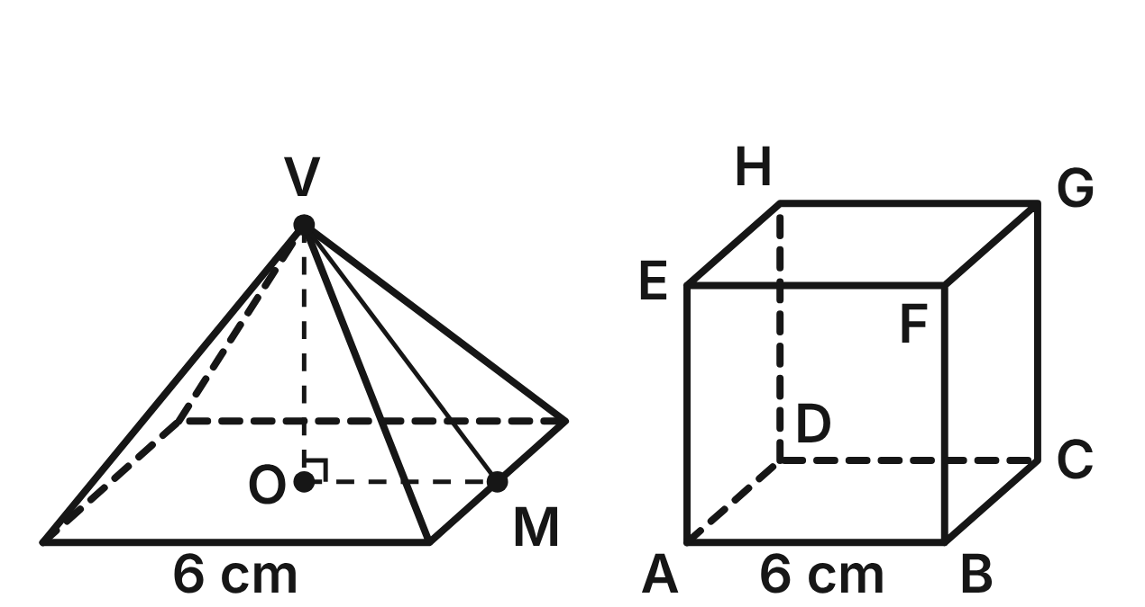
Not drawn to scale
A plaster square pyramid has base edges of 6 cm. V is its tip, O the center of its base and M the midpoint of a base edge: the height VO is 4 cm and the slant height VM is 5 cm. Beside it is a plaster cube ABCDEFGH with edges of 6 cm.
277. What is the volume of the pyramid?
A. 144 cm³
B. 60 cm³
C. 72 cm³
D. 48 cm³ ✔
G.DF.1 · skill G.DF.1.2 (LOTS): Find the surface area and volume of prisms, cylinders, cones, pyramids and spheres
☐ Answer key correct ☐ Wording clear Notes: ________________________________
278. What is the total surface area of the pyramid, including its base?
A. 60 cm²
B. 96 cm² ✔
C. 84 cm²
D. 156 cm²
G.DF.1 · skill G.DF.1.2 (LOTS): Find the surface area and volume of prisms, cylinders, cones, pyramids and spheres
☐ Answer key correct ☐ Wording clear Notes: ________________________________
279. Which shapes make up a net of the pyramid?
A. a 6 cm square and 4 triangles with base 6 cm and height 4 cm
B. a 6 cm square and 4 rectangles, each 6 cm by 5 cm
C. a 6 cm square and 4 triangles with base 6 cm and height 5 cm ✔
D. a 6 cm square and 3 triangles with base 6 cm and height 5 cm
G.DF.1 · skill G.DF.1.1 (LOTS): Identify the two-dimensional cross sections and nets of three-dimensional figures
☐ Answer key correct ☐ Wording clear Notes: ________________________________
280. A plane perpendicular to the base passes through V, O and M. What is the cross section of the pyramid?
A. a triangle with base 6 cm and height 4 cm ✔
B. a triangle with base 6 cm and height 5 cm
C. a square with side 6 cm
D. a triangle with base 3 cm and height 4 cm
G.DF.1 · skill G.DF.1.1 (LOTS): Identify the two-dimensional cross sections and nets of three-dimensional figures
☐ Answer key correct ☐ Wording clear Notes: ________________________________
281. A plane cuts the cube through the three vertices B, D and E. What is the cross section?
A. a right triangle with legs of 6 cm
B. an equilateral triangle with sides of 6√2 cm ✔
C. an equilateral triangle with sides of 6 cm
D. a rectangle 6 cm by 6√2 cm
G.DF.1 · skill G.DF.1.1 (LOTS): Identify the two-dimensional cross sections and nets of three-dimensional figures
☐ Answer key correct ☐ Wording clear Notes: ________________________________
282. A plane cuts the cube through the four vertices A, C, G and E. What is the area of the cross section, to the nearest tenth of a square centimeter?
A. 50.9 cm² ✔
B. 36.0 cm²
C. 72.0 cm²
D. 62.4 cm²
G.DF.1 · skill G.DF.1.1 (LOTS): Identify the two-dimensional cross sections and nets of three-dimensional figures
☐ Answer key correct ☐ Wording clear Notes: ________________________________

The Barn and the Silo
Level 3 · 3-D figures · G.DF.1 · ID geo-df1-farm
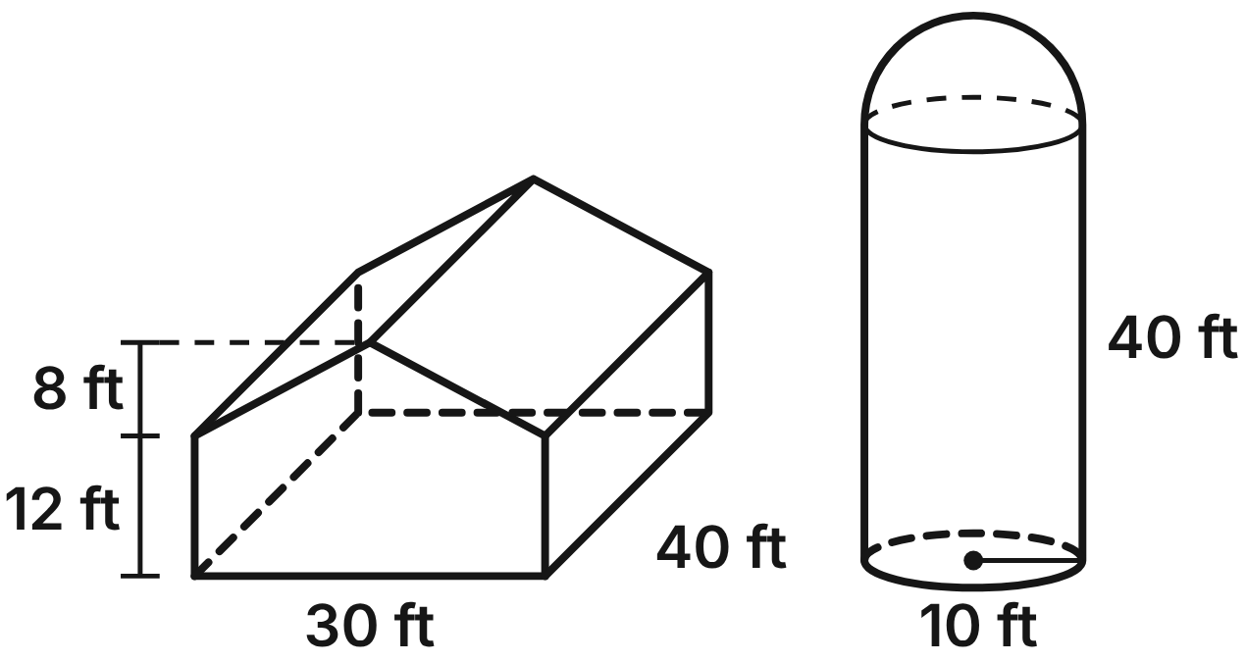
The barn is a prism. Its front wall is a 30 ft by 12 ft rectangle topped by a triangle that rises 8 ft to the peak, and the barn is 40 ft long. The silo is a cylinder with radius 10 ft and height 40 ft, topped by a hemisphere dome.
283. How much space is inside the silo, cylinder and dome together, to the nearest cubic foot?
A. 14,661 ft³ ✔
B. 16,755 ft³
C. 12,566 ft³
D. 67,021 ft³
G.DF.1 · skill G.DF.1.3 (HOTS): Solve multistep contextual problems with surface area and volume, including composite figures
☐ Answer key correct ☐ Wording clear Notes: ________________________________
284. What is the volume of the barn, including the space under the roof?
A. 24,000 ft³
B. 14,400 ft³
C. 19,200 ft³ ✔
D. 24,600 ft³
G.DF.1 · skill G.DF.1.3 (HOTS): Solve multistep contextual problems with surface area and volume, including composite figures
☐ Answer key correct ☐ Wording clear Notes: ________________________________
285. What is the area of the barn's front wall, the five-sided face?
A. 360 ft²
B. 480 ft² ✔
C. 600 ft²
D. 615 ft²
G.DF.1 · skill G.DF.1.2 (LOTS): Find the surface area and volume of prisms, cylinders, cones, pyramids and spheres
☐ Answer key correct ☐ Wording clear Notes: ________________________________
286. The two slanted sides of the roof are covered with metal that costs $3.25 per square foot. The roof does not hang over the walls. What does the metal cost?
A. $2,080
B. $2,210
C. $3,900
D. $4,420 ✔
G.DF.1 · skill G.DF.1.3 (HOTS): Solve multistep contextual problems with surface area and volume, including composite figures
☐ Answer key correct ☐ Wording clear Notes: ________________________________
287. The curved wall and the dome of the silo will be painted, but not the floor. One gallon of paint covers 350 square feet. How many whole gallons must be bought?
A. 8 gallons
B. 10 gallons
C. 9 gallons ✔
D. 11 gallons
G.DF.1 · skill G.DF.1.3 (HOTS): Solve multistep contextual problems with surface area and volume, including composite figures
☐ Answer key correct ☐ Wording clear Notes: ________________________________
288. A plane parallel to the front wall cuts through the middle of the barn. What is the cross section of the barn?
A. a rectangle 30 ft by 12 ft
B. a triangle with base 30 ft and height 8 ft
C. a rectangle 40 ft by 12 ft
D. a pentagon congruent to the front wall ✔
G.DF.1 · skill G.DF.1.1 (LOTS): Identify the two-dimensional cross sections and nets of three-dimensional figures
☐ Answer key correct ☐ Wording clear Notes: ________________________________

The Garden Water Tank
Level 3 · 3-D figures · G.DF.1 · ID geo-df1-tank
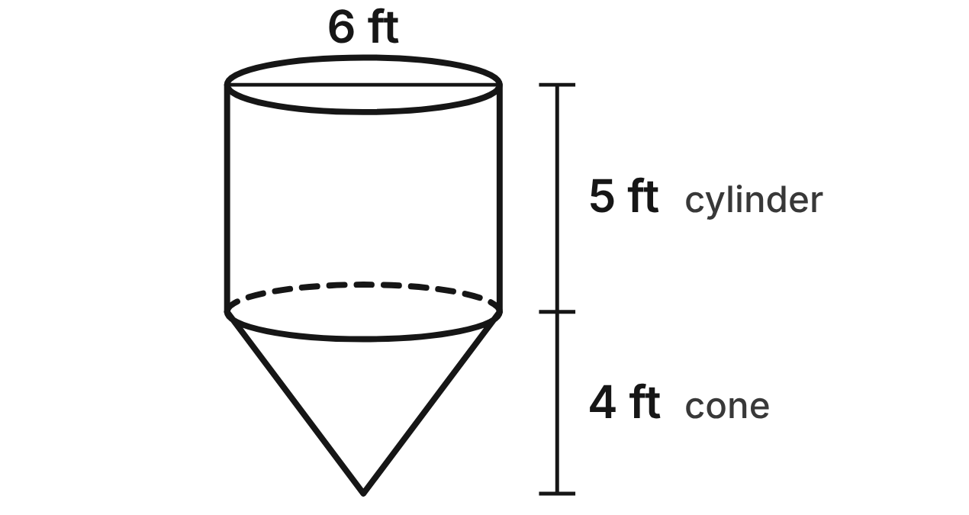
A garden water tank is a cylinder with diameter 6 ft and height 5 ft, closed by a flat lid. Under it is a cone with the same diameter and a height of 4 ft. Use 1 ft³ ≈ 7.48 gallons.
289. What is the volume of the cone part of the tank, in terms of π?
A. 36π ft³
B. 12π ft³ ✔
C. 15π ft³
D. 48π ft³
G.DF.1 · skill G.DF.1.2 (LOTS): Find the surface area and volume of prisms, cylinders, cones, pyramids and spheres
☐ Answer key correct ☐ Wording clear Notes: ________________________________
290. What is the volume of the whole tank, to the nearest cubic foot?
A. 179 ft³ ✔
B. 254 ft³
C. 188 ft³
D. 716 ft³
G.DF.1 · skill G.DF.1.3 (HOTS): Solve multistep contextual problems with surface area and volume, including composite figures
☐ Answer key correct ☐ Wording clear Notes: ________________________________
291. About how many gallons does the full tank hold, to the nearest gallon?
A. 24 gal
B. 1,057 gal
C. 1,903 gal
D. 1,339 gal ✔
G.DF.1 · skill G.DF.1.3 (HOTS): Solve multistep contextual problems with surface area and volume, including composite figures
☐ Answer key correct ☐ Wording clear Notes: ________________________________
292. A hose fills the empty tank at 8 gallons per minute. To the nearest minute, how long does it take to fill?
A. 132 min
B. 22 min
C. 167 min ✔
D. 238 min
G.DF.1 · skill G.DF.1.3 (HOTS): Solve multistep contextual problems with surface area and volume, including composite figures
☐ Answer key correct ☐ Wording clear Notes: ________________________________
293. The lid, the curved side of the cylinder and the curved side of the cone are made of sheet metal that costs $6 per square foot. To the nearest dollar, what does the metal cost?
A. $1,018 ✔
B. $961
C. $848
D. $1,188
G.DF.1 · skill G.DF.1.3 (HOTS): Solve multistep contextual problems with surface area and volume, including composite figures
☐ Answer key correct ☐ Wording clear Notes: ________________________________
294. A vertical plane cuts the tank through its center line, from the lid to the tip of the cone. What is the cross section?
A. a rectangle 6 ft by 9 ft
B. a circle with radius 3 ft
C. a pentagon: a rectangle above a triangle ✔
D. a triangle with base 6 ft and height 9 ft
G.DF.1 · skill G.DF.1.1 (LOTS): Identify the two-dimensional cross sections and nets of three-dimensional figures
☐ Answer key correct ☐ Wording clear Notes: ________________________________

G.DF.2 · Determine how changes in one or more dimensions affect perimeter, area, surface area, and volume, and solve problems with similar two- and three-dimensional figures.

Bigger Paint Cans
Level 1 · Changing dimensions · G.DF.2 · ID geo-df2-paintcan
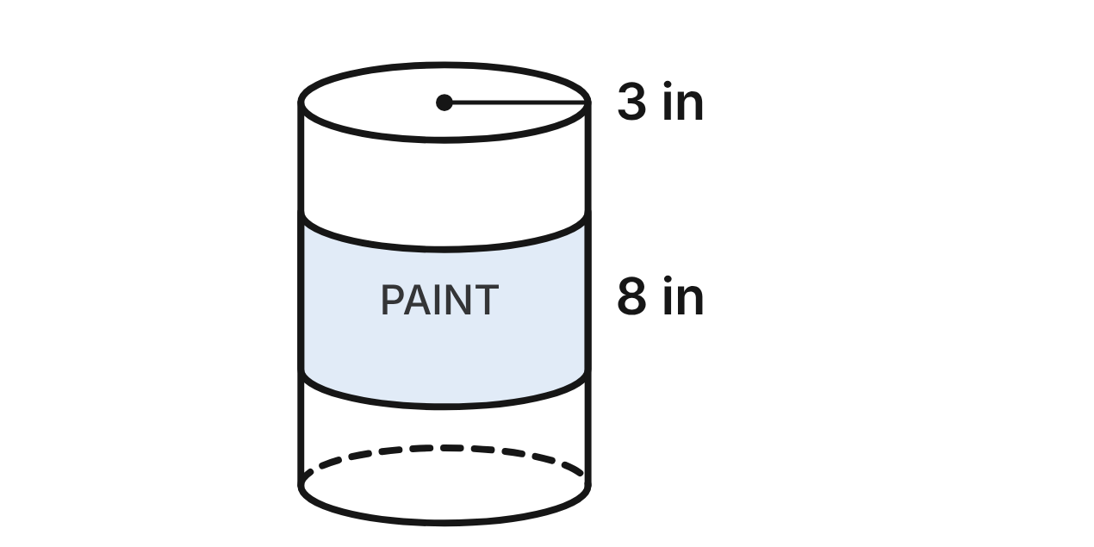
A paint can is a cylinder with radius 3 in and height 8 in. It holds 72π in³ of paint, and its total surface area (both ends and the side) is 66π in².
295. A new can has twice the radius and the same 8 in height. What is its volume?
A. 144π in³
B. 288π in³ ✔
C. 576π in³
D. 1152π in³
G.DF.2 · skill G.DF.2.1 (LOTS): Describe how changing one or more dimensions of a figure changes its perimeter, area, surface area or volume
☐ Answer key correct ☐ Wording clear Notes: ________________________________
296. A new can has twice the height and the same 3 in radius. What is its total surface area?
A. 132π in²
B. 264π in²
C. 96π in²
D. 114π in² ✔
G.DF.2 · skill G.DF.2.1 (LOTS): Describe how changing one or more dimensions of a figure changes its perimeter, area, surface area or volume
☐ Answer key correct ☐ Wording clear Notes: ________________________________
297. If both the radius and the height of the can are doubled, how do its surface area and volume change?
A. surface area × 4, volume × 8 ✔
B. surface area × 2, volume × 2
C. surface area × 8, volume × 4
D. surface area × 4, volume × 4
G.DF.2 · skill G.DF.2.1 (LOTS): Describe how changing one or more dimensions of a figure changes its perimeter, area, surface area or volume
☐ Answer key correct ☐ Wording clear Notes: ________________________________
298. A larger lid has three times the diameter of this can's lid. What is the area of the larger lid?
A. 27π in²
B. 243π in²
C. 81π in² ✔
D. 324π in²
G.DF.2 · skill G.DF.2.1 (LOTS): Describe how changing one or more dimensions of a figure changes its perimeter, area, surface area or volume
☐ Answer key correct ☐ Wording clear Notes: ________________________________
299. A tall, thin can has half the radius and twice the height of this can. How does its volume compare?
A. It is the same, 72π in³.
B. It is 1/4 as much, 18π in³.
C. It is twice as much, 144π in³.
D. It is half as much, 36π in³. ✔
G.DF.2 · skill G.DF.2.1 (LOTS): Describe how changing one or more dimensions of a figure changes its perimeter, area, surface area or volume
☐ Answer key correct ☐ Wording clear Notes: ________________________________
300. A larger can is similar to this one and is 12 in tall. What is its volume?
A. 108π in³
B. 243π in³ ✔
C. 162π in³
D. 588π in³
G.DF.2 · skill G.DF.2.2 (LOTS): Use the ratios k, k² and k³ of similar figures to find lengths, areas and volumes
☐ Answer key correct ☐ Wording clear Notes: ________________________________

Pizza Night
Level 2 · Changing dimensions · G.DF.2 · ID geo-df2-pizza
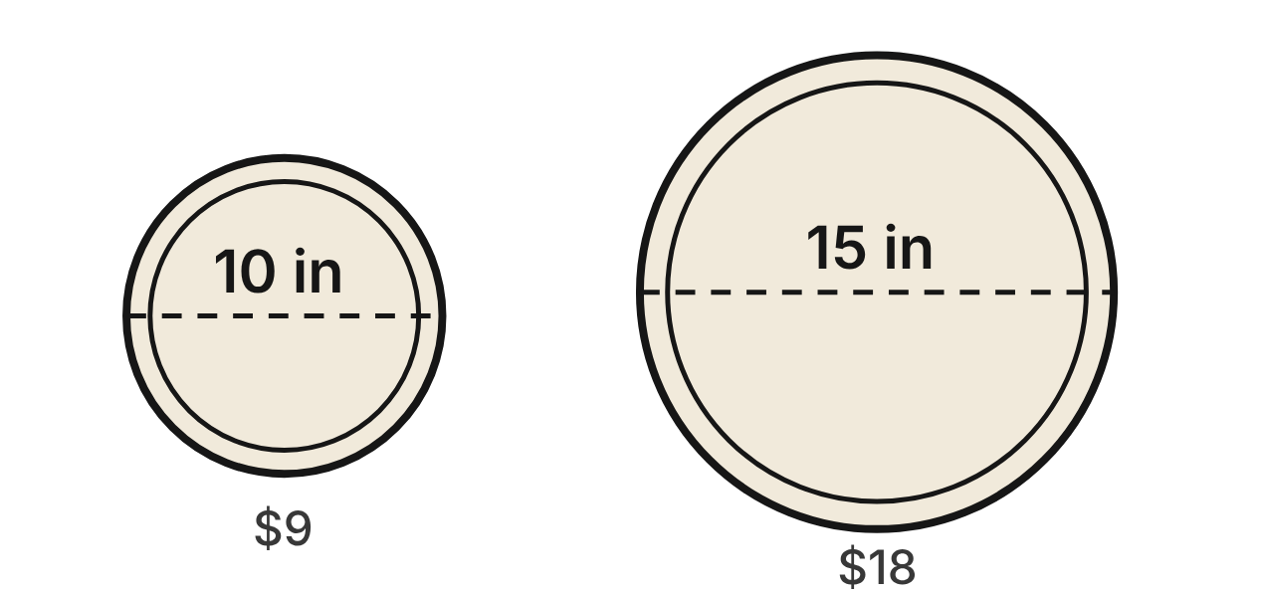
A pizza shop sells a 10-inch pizza for $9 and a 15-inch pizza for $18 (the sizes are diameters). The small pizza comes in a box 10 in by 10 in by 2 in, and the large one in a box 15 in by 15 in by 2 in.
301. What is the ratio of the large pizza's circumference (its crust) to the small pizza's circumference?
A. 3 : 2 ✔
B. 9 : 4
C. 27 : 8
D. 2 : 3
G.DF.2 · skill G.DF.2.2 (LOTS): Use the ratios k, k² and k³ of similar figures to find lengths, areas and volumes
☐ Answer key correct ☐ Wording clear Notes: ________________________________
302. The small pizza's top has an area of 25π in². What is the area of the large pizza's top?
A. 37.5π in²
B. 225π in²
C. 56.25π in² ✔
D. 84.375π in²
G.DF.2 · skill G.DF.2.2 (LOTS): Use the ratios k, k² and k³ of similar figures to find lengths, areas and volumes
☐ Answer key correct ☐ Wording clear Notes: ________________________________
303. Which pizza gives more pizza for the money, and why?
A. The small: the large costs 2 times as much but is only 1.5 times as wide.
B. The large: it costs 2 times as much but has 2.25 times the area. ✔
C. Neither: price and size grow together, so the cost per square inch is the same.
D. The small: it has 4/9 of the large pizza's area for 1/2 of the price.
G.DF.2 · skill G.DF.2.2 (LOTS): Use the ratios k, k² and k³ of similar figures to find lengths, areas and volumes
☐ Answer key correct ☐ Wording clear Notes: ________________________________
304. Are the two pizza boxes similar solids?
A. Yes: both boxes are square prisms.
B. Yes: the pizzas are similar, so their boxes are too.
C. Yes: their volumes have ratio 2.25, which is 1.5².
D. No: the side lengths have ratio 15/10, but the heights 2/2. ✔
G.DF.2 · skill G.DF.2.3 (HOTS): Decide whether two figures are similar and justify the decision with ratios of corresponding measures
☐ Answer key correct ☐ Wording clear Notes: ________________________________
305. The small box has a volume of 200 in³. What is the volume of the large box?
A. 450 in³ ✔
B. 300 in³
C. 675 in³
D. 225 in³
G.DF.2 · skill G.DF.2.1 (LOTS): Describe how changing one or more dimensions of a figure changes its perimeter, area, surface area or volume
☐ Answer key correct ☐ Wording clear Notes: ________________________________
306. A party pizza has 4 times the area of the 10-inch pizza. What is its diameter, to the nearest tenth of an inch?
A. 40.0 in
B. 20.0 in ✔
C. 15.9 in
D. 10.0 in
G.DF.2 · skill G.DF.2.2 (LOTS): Use the ratios k, k² and k³ of similar figures to find lengths, areas and volumes
☐ Answer key correct ☐ Wording clear Notes: ________________________________

The Statue and Its Model
Level 3 · Changing dimensions · G.DF.2 · ID geo-df2-statue
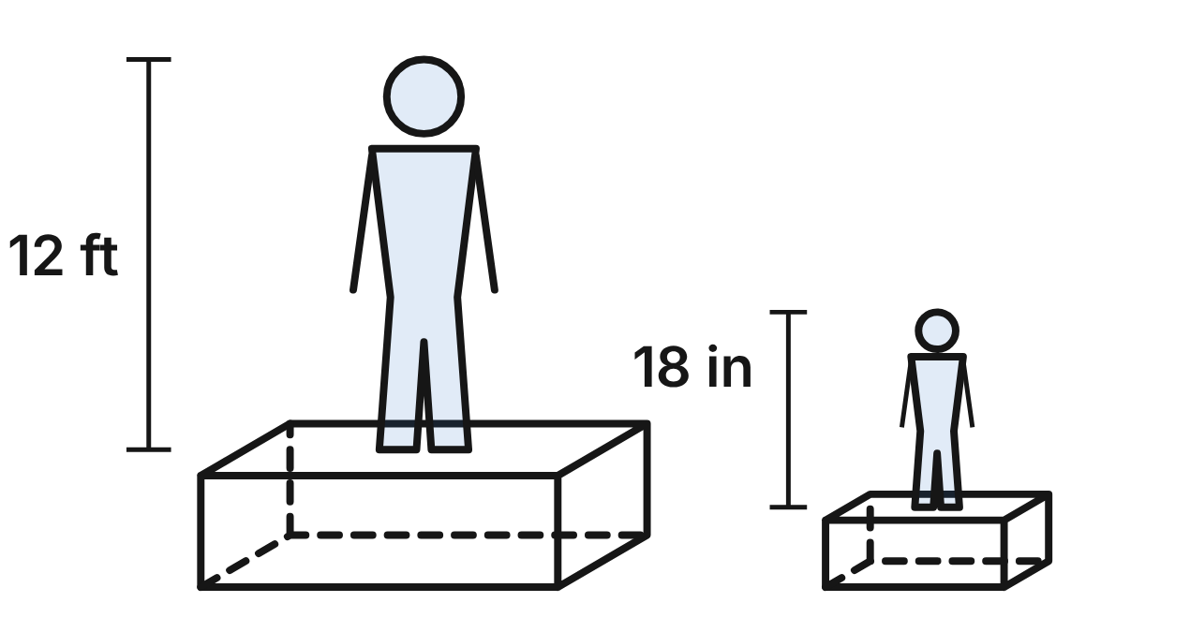
Not drawn to scale
An art class makes a scale model of the park's concrete statue, cast in the same concrete. The statue is 12 ft tall and the model, similar to it, is 18 in tall (not counting pedestals). The statue's pedestal is 6 ft long, 4 ft wide and 3 ft tall; the model's pedestal is 9 in long, 6 in wide and 4 in tall.
307. An arm of the model is 3 in long. How long is the same arm on the statue?
A. 0.375 in
B. 192 in
C. 24 in ✔
D. 1,536 in
G.DF.2 · skill G.DF.2.2 (LOTS): Use the ratios k, k² and k³ of similar figures to find lengths, areas and volumes
☐ Answer key correct ☐ Wording clear Notes: ________________________________
308. The model's surface area is 90 in². The statue's surface will be coated with sealer. What is the statue's surface area in square feet? (1 ft² = 144 in²)
A. 5 ft²
B. 320 ft²
C. 480 ft²
D. 40 ft² ✔
G.DF.2 · skill G.DF.2.2 (LOTS): Use the ratios k, k² and k³ of similar figures to find lengths, areas and volumes
☐ Answer key correct ☐ Wording clear Notes: ________________________________
309. Both figures are solid concrete, and the model weighs 4 lb. What does the statue weigh?
A. 32 lb
B. 256 lb
C. 2,048 lb ✔
D. 6,912 lb
G.DF.2 · skill G.DF.2.2 (LOTS): Use the ratios k, k² and k³ of similar figures to find lengths, areas and volumes
☐ Answer key correct ☐ Wording clear Notes: ________________________________
310. A souvenir copy, also similar, uses 1/27 as much concrete as the 18-inch model. How tall is the souvenir?
A. 6 in ✔
B. 2 in
C. about 0.7 in
D. about 3.5 in
G.DF.2 · skill G.DF.2.2 (LOTS): Use the ratios k, k² and k³ of similar figures to find lengths, areas and volumes
☐ Answer key correct ☐ Wording clear Notes: ________________________________
311. Is the model's pedestal similar to the statue's pedestal?
A. Yes: both are rectangular prisms.
B. Yes: the tops are similar, since 6/4 = 9/6.
C. Yes: the scale factor is 8 for the statues, so it is 8 for the pedestals.
D. No: the length and width ratios are 8, but the height ratio is 9. ✔
G.DF.2 · skill G.DF.2.3 (HOTS): Decide whether two figures are similar and justify the decision with ratios of corresponding measures
☐ Answer key correct ☐ Wording clear Notes: ________________________________
312. Keeping its 9 in length and 6 in width, how tall should the model's pedestal be to make it similar to the statue's pedestal?
A. 4 in
B. 4.5 in ✔
C. 0.375 in
D. 0.5625 in
G.DF.2 · skill G.DF.2.3 (HOTS): Decide whether two figures are similar and justify the decision with ratios of corresponding measures
☐ Answer key correct ☐ Wording clear Notes: ________________________________

Answer key
Pack | Question | Standard | Skill | Level | Answer
rlt1-vertical | 1 | G.RLT.1 | G.RLT.1.1 LOTS | 1 | C
rlt1-vertical | 2 | G.RLT.1 | G.RLT.1.1 LOTS | 1 | A
rlt1-vertical | 3 | G.RLT.1 | G.RLT.1.2 LOTS | 1 | D
rlt1-vertical | 4 | G.RLT.1 | G.RLT.1.2 LOTS | 1 | B
rlt1-vertical | 5 | G.RLT.1 | G.RLT.1.2 LOTS | 1 | A
rlt1-vertical | 6 | G.RLT.1 | G.RLT.1.2 LOTS | 1 | D
rlt1-clubs | 7 | G.RLT.1 | G.RLT.1.4 LOTS | 2 | B
rlt1-clubs | 8 | G.RLT.1 | G.RLT.1.4 LOTS | 2 | D
rlt1-clubs | 9 | G.RLT.1 | G.RLT.1.4 LOTS | 2 | A
rlt1-clubs | 10 | G.RLT.1 | G.RLT.1.4 LOTS | 2 | C
rlt1-clubs | 11 | G.RLT.1 | G.RLT.1.2 LOTS | 2 | C
rlt1-clubs | 12 | G.RLT.1 | G.RLT.1.4 LOTS | 2 | B
rlt1-quads | 13 | G.RLT.1 | G.RLT.1.4 LOTS | 2 | A
rlt1-quads | 14 | G.RLT.1 | G.RLT.1.3 HOTS | 2 | C
rlt1-quads | 15 | G.RLT.1 | G.RLT.1.3 HOTS | 2 | B
rlt1-quads | 16 | G.RLT.1 | G.RLT.1.3 HOTS | 2 | D
rlt1-quads | 17 | G.RLT.1 | G.RLT.1.4 LOTS | 2 | A
rlt1-quads | 18 | G.RLT.1 | G.RLT.1.2 LOTS | 2 | B
rlt1-activities | 19 | G.RLT.1 | G.RLT.1.4 LOTS | 3 | D
rlt1-activities | 20 | G.RLT.1 | G.RLT.1.4 LOTS | 3 | B
rlt1-activities | 21 | G.RLT.1 | G.RLT.1.4 LOTS | 3 | C
rlt1-activities | 22 | G.RLT.1 | G.RLT.1.4 LOTS | 3 | A
rlt1-activities | 23 | G.RLT.1 | G.RLT.1.3 HOTS | 3 | C
rlt1-activities | 24 | G.RLT.1 | G.RLT.1.4 LOTS | 3 | D
rlt2-parking | 25 | G.RLT.2 | G.RLT.2.1 LOTS | 1 | B
rlt2-parking | 26 | G.RLT.2 | G.RLT.2.1 LOTS | 1 | A
rlt2-parking | 27 | G.RLT.2 | G.RLT.2.3 LOTS | 1 | D
rlt2-parking | 28 | G.RLT.2 | G.RLT.2.3 LOTS | 1 | C
rlt2-parking | 29 | G.RLT.2 | G.RLT.2.1 LOTS | 1 | B
rlt2-parking | 30 | G.RLT.2 | G.RLT.2.3 LOTS | 1 | A
rlt2-railroad | 31 | G.RLT.2 | G.RLT.2.3 LOTS | 2 | C
rlt2-railroad | 32 | G.RLT.2 | G.RLT.2.3 LOTS | 2 | D
rlt2-railroad | 33 | G.RLT.2 | G.RLT.2.3 LOTS | 2 | A
rlt2-railroad | 34 | G.RLT.2 | G.RLT.2.1 LOTS | 2 | B
rlt2-railroad | 35 | G.RLT.2 | G.RLT.2.3 LOTS | 2 | D
rlt2-railroad | 36 | G.RLT.2 | G.RLT.2.2 HOTS | 2 | C
rlt2-trellis | 37 | G.RLT.2 | G.RLT.2.1 LOTS | 2 | D
rlt2-trellis | 38 | G.RLT.2 | G.RLT.2.2 HOTS | 2 | A
rlt2-trellis | 39 | G.RLT.2 | G.RLT.2.2 HOTS | 2 | C
rlt2-trellis | 40 | G.RLT.2 | G.RLT.2.3 LOTS | 2 | B
rlt2-trellis | 41 | G.RLT.2 | G.RLT.2.2 HOTS | 2 | A
rlt2-trellis | 42 | G.RLT.2 | G.RLT.2.3 LOTS | 2 | C
rlt2-proof | 43 | G.RLT.2 | G.RLT.2.2 HOTS | 3 | A
rlt2-proof | 44 | G.RLT.2 | G.RLT.2.2 HOTS | 3 | B
rlt2-proof | 45 | G.RLT.2 | G.RLT.2.3 LOTS | 3 | D
rlt2-proof | 46 | G.RLT.2 | G.RLT.2.3 LOTS | 3 | C
rlt2-proof | 47 | G.RLT.2 | G.RLT.2.1 LOTS | 3 | B
rlt2-proof | 48 | G.RLT.2 | G.RLT.2.2 HOTS | 3 | D
rlt3-symmetry | 49 | G.RLT.3 | G.RLT.3.1 LOTS | 1 | C
rlt3-symmetry | 50 | G.RLT.3 | G.RLT.3.1 LOTS | 1 | B
rlt3-symmetry | 51 | G.RLT.3 | G.RLT.3.1 LOTS | 1 | A
rlt3-symmetry | 52 | G.RLT.3 | G.RLT.3.1 LOTS | 1 | D
rlt3-symmetry | 53 | G.RLT.3 | G.RLT.3.1 LOTS | 1 | C
rlt3-symmetry | 54 | G.RLT.3 | G.RLT.3.3 HOTS | 1 | A
rlt3-triangle | 55 | G.RLT.3 | G.RLT.3.2 LOTS | 2 | B
rlt3-triangle | 56 | G.RLT.3 | G.RLT.3.2 LOTS | 2 | D
rlt3-triangle | 57 | G.RLT.3 | G.RLT.3.2 LOTS | 2 | C
rlt3-triangle | 58 | G.RLT.3 | G.RLT.3.2 LOTS | 2 | A
rlt3-triangle | 59 | G.RLT.3 | G.RLT.3.3 HOTS | 2 | D
rlt3-triangle | 60 | G.RLT.3 | G.RLT.3.3 HOTS | 2 | B
rlt3-logo | 61 | G.RLT.3 | G.RLT.3.2 LOTS | 2 | A
rlt3-logo | 62 | G.RLT.3 | G.RLT.3.2 LOTS | 2 | C
rlt3-logo | 63 | G.RLT.3 | G.RLT.3.2 LOTS | 2 | D
rlt3-logo | 64 | G.RLT.3 | G.RLT.3.3 HOTS | 2 | B
rlt3-logo | 65 | G.RLT.3 | G.RLT.3.3 HOTS | 2 | C
rlt3-logo | 66 | G.RLT.3 | G.RLT.3.2 LOTS | 2 | A
rlt3-sprite | 67 | G.RLT.3 | G.RLT.3.3 HOTS | 3 | D
rlt3-sprite | 68 | G.RLT.3 | G.RLT.3.3 HOTS | 3 | B
rlt3-sprite | 69 | G.RLT.3 | G.RLT.3.3 HOTS | 3 | A
rlt3-sprite | 70 | G.RLT.3 | G.RLT.3.2 LOTS | 3 | C
rlt3-sprite | 71 | G.RLT.3 | G.RLT.3.2 LOTS | 3 | B
rlt3-sprite | 72 | G.RLT.3 | G.RLT.3.3 HOTS | 3 | D
tr1-towns | 73 | G.TR.1 | G.TR.1.1 LOTS | 1 | C
tr1-towns | 74 | G.TR.1 | G.TR.1.1 LOTS | 1 | A
tr1-towns | 75 | G.TR.1 | G.TR.1.3 LOTS | 1 | D
tr1-towns | 76 | G.TR.1 | G.TR.1.3 LOTS | 1 | B
tr1-towns | 77 | G.TR.1 | G.TR.1.2 LOTS | 1 | D
tr1-towns | 78 | G.TR.1 | G.TR.1.2 LOTS | 1 | B
tr1-garden | 79 | G.TR.1 | G.TR.1.3 LOTS | 2 | B
tr1-garden | 80 | G.TR.1 | G.TR.1.3 LOTS | 2 | D
tr1-garden | 81 | G.TR.1 | G.TR.1.1 LOTS | 2 | A
tr1-garden | 82 | G.TR.1 | G.TR.1.3 LOTS | 2 | C
tr1-garden | 83 | G.TR.1 | G.TR.1.2 LOTS | 2 | A
tr1-garden | 84 | G.TR.1 | G.TR.1.2 LOTS | 2 | C
tr1-sail | 85 | G.TR.1 | G.TR.1.2 LOTS | 2 | A
tr1-sail | 86 | G.TR.1 | G.TR.1.2 LOTS | 2 | C
tr1-sail | 87 | G.TR.1 | G.TR.1.1 LOTS | 2 | B
tr1-sail | 88 | G.TR.1 | G.TR.1.3 LOTS | 2 | D
tr1-sail | 89 | G.TR.1 | G.TR.1.3 LOTS | 2 | C
tr1-sail | 90 | G.TR.1 | G.TR.1.2 LOTS | 2 | A
tr1-brace | 91 | G.TR.1 | G.TR.1.3 LOTS | 3 | D
tr1-brace | 92 | G.TR.1 | G.TR.1.3 LOTS | 3 | B
tr1-brace | 93 | G.TR.1 | G.TR.1.1 LOTS | 3 | C
tr1-brace | 94 | G.TR.1 | G.TR.1.3 LOTS | 3 | A
tr1-brace | 95 | G.TR.1 | G.TR.1.2 LOTS | 3 | B
tr1-brace | 96 | G.TR.1 | G.TR.1.2 LOTS | 3 | D
tr2-marks | 97 | G.TR.2 | G.TR.2.1 LOTS | 1 | B
tr2-marks | 98 | G.TR.2 | G.TR.2.1 LOTS | 1 | A
tr2-marks | 99 | G.TR.2 | G.TR.2.1 LOTS | 1 | D
tr2-marks | 100 | G.TR.2 | G.TR.2.3 LOTS | 1 | C
tr2-marks | 101 | G.TR.2 | G.TR.2.3 LOTS | 1 | D
tr2-marks | 102 | G.TR.2 | G.TR.2.1 LOTS | 1 | B
tr2-bowtie | 103 | G.TR.2 | G.TR.2.2 HOTS | 2 | C
tr2-bowtie | 104 | G.TR.2 | G.TR.2.2 HOTS | 2 | D
tr2-bowtie | 105 | G.TR.2 | G.TR.2.2 HOTS | 2 | A
tr2-bowtie | 106 | G.TR.2 | G.TR.2.3 LOTS | 2 | B
tr2-bowtie | 107 | G.TR.2 | G.TR.2.1 LOTS | 2 | A
tr2-bowtie | 108 | G.TR.2 | G.TR.2.3 LOTS | 2 | C
tr2-tent | 109 | G.TR.2 | G.TR.2.2 HOTS | 2 | A
tr2-tent | 110 | G.TR.2 | G.TR.2.2 HOTS | 2 | B
tr2-tent | 111 | G.TR.2 | G.TR.2.3 LOTS | 2 | D
tr2-tent | 112 | G.TR.2 | G.TR.2.1 LOTS | 2 | C
tr2-tent | 113 | G.TR.2 | G.TR.2.3 LOTS | 2 | B
tr2-tent | 114 | G.TR.2 | G.TR.2.1 LOTS | 2 | A
tr2-frame | 115 | G.TR.2 | G.TR.2.2 HOTS | 3 | D
tr2-frame | 116 | G.TR.2 | G.TR.2.2 HOTS | 3 | C
tr2-frame | 117 | G.TR.2 | G.TR.2.3 LOTS | 3 | B
tr2-frame | 118 | G.TR.2 | G.TR.2.3 LOTS | 3 | A
tr2-frame | 119 | G.TR.2 | G.TR.2.2 HOTS | 3 | C
tr2-frame | 120 | G.TR.2 | G.TR.2.2 HOTS | 3 | D
tr3-twins | 121 | G.TR.3 | G.TR.3.1 LOTS | 1 | B
tr3-twins | 122 | G.TR.3 | G.TR.3.1 LOTS | 1 | D
tr3-twins | 123 | G.TR.3 | G.TR.3.3 LOTS | 1 | C
tr3-twins | 124 | G.TR.3 | G.TR.3.3 LOTS | 1 | A
tr3-twins | 125 | G.TR.3 | G.TR.3.3 LOTS | 1 | D
tr3-twins | 126 | G.TR.3 | G.TR.3.2 HOTS | 1 | A
tr3-shadow | 127 | G.TR.3 | G.TR.3.1 LOTS | 2 | C
tr3-shadow | 128 | G.TR.3 | G.TR.3.3 LOTS | 2 | A
tr3-shadow | 129 | G.TR.3 | G.TR.3.3 LOTS | 2 | B
tr3-shadow | 130 | G.TR.3 | G.TR.3.2 HOTS | 2 | D
tr3-shadow | 131 | G.TR.3 | G.TR.3.3 LOTS | 2 | A
tr3-shadow | 132 | G.TR.3 | G.TR.3.1 LOTS | 2 | B
tr3-bracket | 133 | G.TR.3 | G.TR.3.1 LOTS | 2 | D
tr3-bracket | 134 | G.TR.3 | G.TR.3.3 LOTS | 2 | B
tr3-bracket | 135 | G.TR.3 | G.TR.3.3 LOTS | 2 | A
tr3-bracket | 136 | G.TR.3 | G.TR.3.3 LOTS | 2 | C
tr3-bracket | 137 | G.TR.3 | G.TR.3.2 HOTS | 2 | B
tr3-bracket | 138 | G.TR.3 | G.TR.3.3 LOTS | 2 | D
tr3-pond | 139 | G.TR.3 | G.TR.3.1 LOTS | 3 | A
tr3-pond | 140 | G.TR.3 | G.TR.3.2 HOTS | 3 | C
tr3-pond | 141 | G.TR.3 | G.TR.3.3 LOTS | 3 | D
tr3-pond | 142 | G.TR.3 | G.TR.3.1 LOTS | 3 | B
tr3-pond | 143 | G.TR.3 | G.TR.3.2 HOTS | 3 | C
tr3-pond | 144 | G.TR.3 | G.TR.3.3 LOTS | 3 | A
tr4-sign | 145 | G.TR.4 | G.TR.4.2 LOTS | 1 | B
tr4-sign | 146 | G.TR.4 | G.TR.4.2 LOTS | 1 | D
tr4-sign | 147 | G.TR.4 | G.TR.4.2 LOTS | 1 | A
tr4-sign | 148 | G.TR.4 | G.TR.4.2 LOTS | 1 | C
tr4-sign | 149 | G.TR.4 | G.TR.4.3 LOTS | 1 | D
tr4-sign | 150 | G.TR.4 | G.TR.4.1 LOTS | 1 | B
tr4-ladder | 151 | G.TR.4 | G.TR.4.1 LOTS | 2 | B
tr4-ladder | 152 | G.TR.4 | G.TR.4.3 LOTS | 2 | C
tr4-ladder | 153 | G.TR.4 | G.TR.4.3 LOTS | 2 | D
tr4-ladder | 154 | G.TR.4 | G.TR.4.4 HOTS | 2 | A
tr4-ladder | 155 | G.TR.4 | G.TR.4.4 HOTS | 2 | B
tr4-ladder | 156 | G.TR.4 | G.TR.4.1 LOTS | 2 | C
tr4-ramp | 157 | G.TR.4 | G.TR.4.3 LOTS | 2 | C
tr4-ramp | 158 | G.TR.4 | G.TR.4.3 LOTS | 2 | A
tr4-ramp | 159 | G.TR.4 | G.TR.4.3 LOTS | 2 | B
tr4-ramp | 160 | G.TR.4 | G.TR.4.4 HOTS | 2 | D
tr4-ramp | 161 | G.TR.4 | G.TR.4.4 HOTS | 2 | A
tr4-ramp | 162 | G.TR.4 | G.TR.4.1 LOTS | 2 | C
tr4-lighthouse | 163 | G.TR.4 | G.TR.4.4 HOTS | 3 | D
tr4-lighthouse | 164 | G.TR.4 | G.TR.4.4 HOTS | 3 | B
tr4-lighthouse | 165 | G.TR.4 | G.TR.4.3 LOTS | 3 | C
tr4-lighthouse | 166 | G.TR.4 | G.TR.4.4 HOTS | 3 | A
tr4-lighthouse | 167 | G.TR.4 | G.TR.4.3 LOTS | 3 | B
tr4-lighthouse | 168 | G.TR.4 | G.TR.4.2 LOTS | 3 | D
pc1-kite | 169 | G.PC.1 | G.PC.1.1 LOTS | 1 | C
pc1-kite | 170 | G.PC.1 | G.PC.1.1 LOTS | 1 | A
pc1-kite | 171 | G.PC.1 | G.PC.1.3 LOTS | 1 | B
pc1-kite | 172 | G.PC.1 | G.PC.1.3 LOTS | 1 | D
pc1-kite | 173 | G.PC.1 | G.PC.1.3 LOTS | 1 | A
pc1-kite | 174 | G.PC.1 | G.PC.1.1 LOTS | 1 | B
pc1-shelf | 175 | G.PC.1 | G.PC.1.3 LOTS | 2 | D
pc1-shelf | 176 | G.PC.1 | G.PC.1.1 LOTS | 2 | C
pc1-shelf | 177 | G.PC.1 | G.PC.1.1 LOTS | 2 | A
pc1-shelf | 178 | G.PC.1 | G.PC.1.1 LOTS | 2 | B
pc1-shelf | 179 | G.PC.1 | G.PC.1.3 LOTS | 2 | C
pc1-shelf | 180 | G.PC.1 | G.PC.1.1 LOTS | 2 | D
pc1-garden | 181 | G.PC.1 | G.PC.1.3 LOTS | 2 | B
pc1-garden | 182 | G.PC.1 | G.PC.1.1 LOTS | 2 | D
pc1-garden | 183 | G.PC.1 | G.PC.1.3 LOTS | 2 | A
pc1-garden | 184 | G.PC.1 | G.PC.1.1 LOTS | 2 | C
pc1-garden | 185 | G.PC.1 | G.PC.1.3 LOTS | 2 | A
pc1-garden | 186 | G.PC.1 | G.PC.1.1 LOTS | 2 | D
pc1-grid | 187 | G.PC.1 | G.PC.1.2 HOTS | 3 | A
pc1-grid | 188 | G.PC.1 | G.PC.1.2 HOTS | 3 | C
pc1-grid | 189 | G.PC.1 | G.PC.1.2 HOTS | 3 | B
pc1-grid | 190 | G.PC.1 | G.PC.1.2 HOTS | 3 | D
pc1-grid | 191 | G.PC.1 | G.PC.1.2 HOTS | 3 | B
pc1-grid | 192 | G.PC.1 | G.PC.1.2 HOTS | 3 | C
pc2-stopsign | 193 | G.PC.2 | G.PC.2.1 LOTS | 1 | B
pc2-stopsign | 194 | G.PC.2 | G.PC.2.1 LOTS | 1 | D
pc2-stopsign | 195 | G.PC.2 | G.PC.2.1 LOTS | 1 | C
pc2-stopsign | 196 | G.PC.2 | G.PC.2.1 LOTS | 1 | A
pc2-stopsign | 197 | G.PC.2 | G.PC.2.2 LOTS | 1 | D
pc2-stopsign | 198 | G.PC.2 | G.PC.2.1 LOTS | 1 | C
pc2-tiles | 199 | G.PC.2 | G.PC.2.1 LOTS | 2 | A
pc2-tiles | 200 | G.PC.2 | G.PC.2.1 LOTS | 2 | B
pc2-tiles | 201 | G.PC.2 | G.PC.2.2 LOTS | 2 | D
pc2-tiles | 202 | G.PC.2 | G.PC.2.2 LOTS | 2 | C
pc2-tiles | 203 | G.PC.2 | G.PC.2.1 LOTS | 2 | B
pc2-tiles | 204 | G.PC.2 | G.PC.2.1 LOTS | 2 | A
pc2-gazebo | 205 | G.PC.2 | G.PC.2.1 LOTS | 2 | C
pc2-gazebo | 206 | G.PC.2 | G.PC.2.1 LOTS | 2 | A
pc2-gazebo | 207 | G.PC.2 | G.PC.2.1 LOTS | 2 | D
pc2-gazebo | 208 | G.PC.2 | G.PC.2.2 LOTS | 2 | B
pc2-gazebo | 209 | G.PC.2 | G.PC.2.2 LOTS | 2 | B
pc2-gazebo | 210 | G.PC.2 | G.PC.2.1 LOTS | 2 | C
pc2-plot | 211 | G.PC.2 | G.PC.2.1 LOTS | 3 | D
pc2-plot | 212 | G.PC.2 | G.PC.2.1 LOTS | 3 | B
pc2-plot | 213 | G.PC.2 | G.PC.2.1 LOTS | 3 | A
pc2-plot | 214 | G.PC.2 | G.PC.2.1 LOTS | 3 | C
pc2-plot | 215 | G.PC.2 | G.PC.2.1 LOTS | 3 | D
pc2-plot | 216 | G.PC.2 | G.PC.2.2 LOTS | 3 | A
pc3-pizza | 217 | G.PC.3 | G.PC.3.1 LOTS | 1 | A
pc3-pizza | 218 | G.PC.3 | G.PC.3.3 LOTS | 1 | D
pc3-pizza | 219 | G.PC.3 | G.PC.3.3 LOTS | 1 | B
pc3-pizza | 220 | G.PC.3 | G.PC.3.3 LOTS | 1 | C
pc3-pizza | 221 | G.PC.3 | G.PC.3.4 HOTS | 1 | A
pc3-pizza | 222 | G.PC.3 | G.PC.3.3 LOTS | 1 | B
pc3-ferris | 223 | G.PC.3 | G.PC.3.1 LOTS | 2 | C
pc3-ferris | 224 | G.PC.3 | G.PC.3.3 LOTS | 2 | B
pc3-ferris | 225 | G.PC.3 | G.PC.3.1 LOTS | 2 | D
pc3-ferris | 226 | G.PC.3 | G.PC.3.1 LOTS | 2 | A
pc3-ferris | 227 | G.PC.3 | G.PC.3.1 LOTS | 2 | C
pc3-ferris | 228 | G.PC.3 | G.PC.3.4 HOTS | 2 | D
pc3-tangents | 229 | G.PC.3 | G.PC.3.1 LOTS | 2 | B
pc3-tangents | 230 | G.PC.3 | G.PC.3.2 LOTS | 2 | C
pc3-tangents | 231 | G.PC.3 | G.PC.3.2 LOTS | 2 | A
pc3-tangents | 232 | G.PC.3 | G.PC.3.1 LOTS | 2 | D
pc3-tangents | 233 | G.PC.3 | G.PC.3.1 LOTS | 2 | B
pc3-tangents | 234 | G.PC.3 | G.PC.3.2 LOTS | 2 | C
pc3-plate | 235 | G.PC.3 | G.PC.3.2 LOTS | 3 | D
pc3-plate | 236 | G.PC.3 | G.PC.3.4 HOTS | 3 | A
pc3-plate | 237 | G.PC.3 | G.PC.3.1 LOTS | 3 | C
pc3-plate | 238 | G.PC.3 | G.PC.3.3 LOTS | 3 | B
pc3-plate | 239 | G.PC.3 | G.PC.3.4 HOTS | 3 | A
pc3-plate | 240 | G.PC.3 | G.PC.3.4 HOTS | 3 | D
pc4-grid | 241 | G.PC.4 | G.PC.4.1 LOTS | 1 | B
pc4-grid | 242 | G.PC.4 | G.PC.4.1 LOTS | 1 | A
pc4-grid | 243 | G.PC.4 | G.PC.4.2 LOTS | 1 | D
pc4-grid | 244 | G.PC.4 | G.PC.4.1 LOTS | 1 | C
pc4-grid | 245 | G.PC.4 | G.PC.4.1 LOTS | 1 | B
pc4-grid | 246 | G.PC.4 | G.PC.4.2 LOTS | 1 | D
pc4-diameter | 247 | G.PC.4 | G.PC.4.2 LOTS | 2 | C
pc4-diameter | 248 | G.PC.4 | G.PC.4.2 LOTS | 2 | D
pc4-diameter | 249 | G.PC.4 | G.PC.4.2 LOTS | 2 | A
pc4-diameter | 250 | G.PC.4 | G.PC.4.1 LOTS | 2 | B
pc4-diameter | 251 | G.PC.4 | G.PC.4.3 HOTS | 2 | A
pc4-diameter | 252 | G.PC.4 | G.PC.4.2 LOTS | 2 | C
pc4-wifi | 253 | G.PC.4 | G.PC.4.2 LOTS | 2 | D
pc4-wifi | 254 | G.PC.4 | G.PC.4.1 LOTS | 2 | A
pc4-wifi | 255 | G.PC.4 | G.PC.4.1 LOTS | 2 | B
pc4-wifi | 256 | G.PC.4 | G.PC.4.1 LOTS | 2 | C
pc4-wifi | 257 | G.PC.4 | G.PC.4.3 HOTS | 2 | A
pc4-wifi | 258 | G.PC.4 | G.PC.4.2 LOTS | 2 | B
pc4-derive | 259 | G.PC.4 | G.PC.4.3 HOTS | 3 | C
pc4-derive | 260 | G.PC.4 | G.PC.4.3 HOTS | 3 | D
pc4-derive | 261 | G.PC.4 | G.PC.4.3 HOTS | 3 | B
pc4-derive | 262 | G.PC.4 | G.PC.4.3 HOTS | 3 | A
pc4-derive | 263 | G.PC.4 | G.PC.4.1 LOTS | 3 | D
pc4-derive | 264 | G.PC.4 | G.PC.4.2 LOTS | 3 | C
df1-ballcan | 265 | G.DF.1 | G.DF.1.2 LOTS | 1 | B
df1-ballcan | 266 | G.DF.1 | G.DF.1.2 LOTS | 1 | D
df1-ballcan | 267 | G.DF.1 | G.DF.1.2 LOTS | 1 | A
df1-ballcan | 268 | G.DF.1 | G.DF.1.1 LOTS | 1 | C
df1-ballcan | 269 | G.DF.1 | G.DF.1.1 LOTS | 1 | A
df1-ballcan | 270 | G.DF.1 | G.DF.1.1 LOTS | 1 | B
df1-waffle | 271 | G.DF.1 | G.DF.1.2 LOTS | 2 | C
df1-waffle | 272 | G.DF.1 | G.DF.1.2 LOTS | 2 | A
df1-waffle | 273 | G.DF.1 | G.DF.1.3 HOTS | 2 | D
df1-waffle | 274 | G.DF.1 | G.DF.1.2 LOTS | 2 | B
df1-waffle | 275 | G.DF.1 | G.DF.1.1 LOTS | 2 | D
df1-waffle | 276 | G.DF.1 | G.DF.1.1 LOTS | 2 | C
df1-artsolids | 277 | G.DF.1 | G.DF.1.2 LOTS | 2 | D
df1-artsolids | 278 | G.DF.1 | G.DF.1.2 LOTS | 2 | B
df1-artsolids | 279 | G.DF.1 | G.DF.1.1 LOTS | 2 | C
df1-artsolids | 280 | G.DF.1 | G.DF.1.1 LOTS | 2 | A
df1-artsolids | 281 | G.DF.1 | G.DF.1.1 LOTS | 2 | B
df1-artsolids | 282 | G.DF.1 | G.DF.1.1 LOTS | 2 | A
df1-farm | 283 | G.DF.1 | G.DF.1.3 HOTS | 3 | A
df1-farm | 284 | G.DF.1 | G.DF.1.3 HOTS | 3 | C
df1-farm | 285 | G.DF.1 | G.DF.1.2 LOTS | 3 | B
df1-farm | 286 | G.DF.1 | G.DF.1.3 HOTS | 3 | D
df1-farm | 287 | G.DF.1 | G.DF.1.3 HOTS | 3 | C
df1-farm | 288 | G.DF.1 | G.DF.1.1 LOTS | 3 | D
df1-tank | 289 | G.DF.1 | G.DF.1.2 LOTS | 3 | B
df1-tank | 290 | G.DF.1 | G.DF.1.3 HOTS | 3 | A
df1-tank | 291 | G.DF.1 | G.DF.1.3 HOTS | 3 | D
df1-tank | 292 | G.DF.1 | G.DF.1.3 HOTS | 3 | C
df1-tank | 293 | G.DF.1 | G.DF.1.3 HOTS | 3 | A
df1-tank | 294 | G.DF.1 | G.DF.1.1 LOTS | 3 | C
df2-paintcan | 295 | G.DF.2 | G.DF.2.1 LOTS | 1 | B
df2-paintcan | 296 | G.DF.2 | G.DF.2.1 LOTS | 1 | D
df2-paintcan | 297 | G.DF.2 | G.DF.2.1 LOTS | 1 | A
df2-paintcan | 298 | G.DF.2 | G.DF.2.1 LOTS | 1 | C
df2-paintcan | 299 | G.DF.2 | G.DF.2.1 LOTS | 1 | D
df2-paintcan | 300 | G.DF.2 | G.DF.2.2 LOTS | 1 | B
df2-pizza | 301 | G.DF.2 | G.DF.2.2 LOTS | 2 | A
df2-pizza | 302 | G.DF.2 | G.DF.2.2 LOTS | 2 | C
df2-pizza | 303 | G.DF.2 | G.DF.2.2 LOTS | 2 | B
df2-pizza | 304 | G.DF.2 | G.DF.2.3 HOTS | 2 | D
df2-pizza | 305 | G.DF.2 | G.DF.2.1 LOTS | 2 | A
df2-pizza | 306 | G.DF.2 | G.DF.2.2 LOTS | 2 | B
df2-statue | 307 | G.DF.2 | G.DF.2.2 LOTS | 3 | C
df2-statue | 308 | G.DF.2 | G.DF.2.2 LOTS | 3 | D
df2-statue | 309 | G.DF.2 | G.DF.2.2 LOTS | 3 | C
df2-statue | 310 | G.DF.2 | G.DF.2.2 LOTS | 3 | A
df2-statue | 311 | G.DF.2 | G.DF.2.3 HOTS | 3 | D
df2-statue | 312 | G.DF.2 | G.DF.2.3 HOTS | 3 | B

The standards and skills
The game's own list (js/standards-geo.js): each 2023 Geometry standard, summarized, and the skills its questions are tagged with. LOTS = lower-order thinking (identify, find, use); HOTS = higher-order (justify, prove, model, decide whether an argument is valid). Counts are questions in this pool.
Skill | LOTS / HOTS | What the question asks | Questions
G.RLT.1 |  | Translate logic statements, identify conditional statements, and use and interpret Venn diagrams.
G.RLT.1.1 | LOTS | Translate statements into symbols and words: negation (~p), conjunction (p ∧ q), disjunction (p ∨ q), conditional (p → q) and biconditional (p ↔ q) | 2
G.RLT.1.2 | LOTS | Identify the converse, inverse and contrapositive of a conditional statement and decide whether each is true | 6
G.RLT.1.3 | HOTS | Use deductive reasoning (the Law of Detachment and the Law of Syllogism) to decide whether a conclusion is valid | 4
G.RLT.1.4 | LOTS | Use and interpret Venn diagrams: union, intersection, subset and negation, including in context | 12
G.RLT.2 |  | Analyze, prove, and justify the relationships of parallel lines cut by a transversal.
G.RLT.2.1 | LOTS | Identify angle pairs formed by a transversal: corresponding, alternate interior, alternate exterior, same-side interior, vertical and linear pairs | 6
G.RLT.2.2 | HOTS | Prove or justify that two lines are parallel, or are not, from angle measures | 7
G.RLT.2.3 | LOTS | Solve problems, including algebraic ones, using the angles formed by parallel lines and a transversal | 11
G.RLT.3 |  | Solve problems, including contextual problems, involving symmetry and transformation.
G.RLT.3.1 | LOTS | Identify line symmetry and rotational symmetry of a figure | 5
G.RLT.3.2 | LOTS | Find the image of a figure on the coordinate plane under a translation, reflection, rotation or dilation | 10
G.RLT.3.3 | HOTS | Determine the transformation or composition that maps a preimage to an image, and whether it preserves size and shape | 9
G.TR.1 |  | Determine the relationships between the measures of angles and lengths of sides in triangles, including problems in context.
G.TR.1.1 | LOTS | Order the sides of a triangle by length given its angles, or its angles by size given its sides | 5
G.TR.1.2 | LOTS | Decide whether three lengths can form a triangle and find the range of possible lengths of the third side | 9
G.TR.1.3 | LOTS | Solve problems using the triangle angle sum and the exterior angle theorem | 10
G.TR.2 |  | Prove two triangles are congruent, using direct and indirect proofs, and solve problems involving measured attributes of congruent triangles.
G.TR.2.1 | LOTS | Identify the congruence criterion (SSS, SAS, ASA, AAS, HL) that the given information supports, and recognize when none does | 7
G.TR.2.2 | HOTS | Complete or justify a direct or indirect proof that two triangles are congruent | 9
G.TR.2.3 | LOTS | Solve problems, including algebraic ones, using corresponding parts of congruent triangles | 8
G.TR.3 |  | Prove two triangles are similar, using direct and indirect proofs, and solve problems involving measured attributes of similar triangles.
G.TR.3.1 | LOTS | Identify the similarity criterion (AA, SSS, SAS) that the given information supports | 7
G.TR.3.2 | HOTS | Justify that two triangles are similar, or are not, using angle measures or side ratios | 5
G.TR.3.3 | LOTS | Solve problems, including contextual ones, using proportional sides of similar triangles | 12
G.TR.4 |  | Model and solve problems, including those in context, involving trigonometry in right triangles and applications of the Pythagorean Theorem.
G.TR.4.1 | LOTS | Use the Pythagorean Theorem and its converse, including to classify a triangle as right, acute or obtuse | 4
G.TR.4.2 | LOTS | Use the relationships in 45°-45°-90° and 30°-60°-90° triangles | 5
G.TR.4.3 | LOTS | Use sine, cosine and tangent ratios to find a side length or an angle measure | 8
G.TR.4.4 | HOTS | Model a contextual problem (angles of elevation and depression, ramps, ladders, distances) with a right triangle and solve it | 7
G.PC.1 |  | Prove and justify theorems and properties of quadrilaterals, and verify and use properties of quadrilaterals to solve problems, including the relationships between the sides, angles, and diagonals.
G.PC.1.1 | LOTS | Identify the properties of parallelograms, rectangles, rhombi, squares, trapezoids and kites (sides, angles, diagonals) | 10
G.PC.1.2 | HOTS | Use coordinate methods (slope, distance, midpoint) to classify a quadrilateral or justify a property | 6
G.PC.1.3 | LOTS | Solve problems, including algebraic ones, using the properties of quadrilaterals | 8
G.PC.2 |  | Verify relationships and solve problems involving the number of sides and measures of angles of convex polygons.
G.PC.2.1 | LOTS | Find the sum of the interior angles, and the measure of each interior and exterior angle, of a convex or regular polygon | 18
G.PC.2.2 | LOTS | Find the number of sides of a regular polygon given the measure of an interior or exterior angle | 6
G.PC.3 |  | Solve problems, including contextual problems, by applying properties of circles.
G.PC.3.1 | LOTS | Use the angles formed by chords, secants and tangents (central, inscribed, and angles inside and outside a circle) and their arcs | 9
G.PC.3.2 | LOTS | Use the lengths of segments formed by intersecting chords, secants and tangents | 4
G.PC.3.3 | LOTS | Find arc length and the area of a sector, or use them to find a radius or a central angle | 6
G.PC.3.4 | HOTS | Model and solve a contextual problem with the properties of circles | 5
G.PC.4 |  | Solve problems involving equations of circles.
G.PC.4.1 | LOTS | Identify the center and radius of a circle from its graph or from its equation in standard form | 9
G.PC.4.2 | LOTS | Write the equation of a circle from its center and radius, its center and a point, or the endpoints of a diameter | 9
G.PC.4.3 | HOTS | Derive the equation of a circle with the Pythagorean Theorem or the distance formula | 6
G.DF.1 |  | Create models and solve problems, including those in context, involving surface area and volume of rectangular and triangular prisms, cylinders, cones, pyramids, and spheres.
G.DF.1.1 | LOTS | Identify the two-dimensional cross sections and nets of three-dimensional figures | 11
G.DF.1.2 | LOTS | Find the surface area and volume of prisms, cylinders, cones, pyramids and spheres | 10
G.DF.1.3 | HOTS | Solve multistep contextual problems with surface area and volume, including composite figures | 9
G.DF.2 |  | Determine how changes in one or more dimensions affect perimeter, area, surface area, and volume, and solve problems with similar two- and three-dimensional figures.
G.DF.2.1 | LOTS | Describe how changing one or more dimensions of a figure changes its perimeter, area, surface area or volume | 6
G.DF.2.2 | LOTS | Use the ratios k, k² and k³ of similar figures to find lengths, areas and volumes | 9
G.DF.2.3 | HOTS | Decide whether two figures are similar and justify the decision with ratios of corresponding measures | 3

