Sol's Labyrinth: Geometry — Eagle Swoop questions
Virginia 2023 Geometry Standards of Learning · game version 5.20.0 · 96 question sets · 576 questions

How to read this list
These are the questions of one game mode, Eagle Swoop: a level in this mode asks only these, and no other mode asks them (each mode has its own document). They are grouped by strand and standard. A question set is one figure and its given facts, then six questions about it. In the game, students see the figure before each question and keep it in the side panel while they play.
The correct answer is in bold with a check mark (✔). Under each question: its standard, its skill (from the game's standards list, at the end of this document) and whether that skill is lower-order (LOTS) or higher-order (HOTS) thinking.
Level 1 sets are one-step problems, level 2 two-step, level 3 multistep, proof or modeling problems. The game picks questions by level to match how each student is doing, and never asks a question again until the student has seen the rest.
The review line under each question is for checking: tick the boxes and write notes, then send the changes back to be made in the game. The standard statements are short summaries of the 2023 Geometry SOL; please check them and the skills against the VDOE document too.

What is in the pool
Strand | Standard | Question sets | Questions
Logic, lines and transformations | G.RLT.1 · Translate logic statements, identify conditional statements, and use and interpret Venn diagrams. | 7 | 42
 | G.RLT.2 · Analyze, prove, and justify the relationships of parallel lines cut by a transversal. | 7 | 42
 | G.RLT.3 · Solve problems, including contextual problems, involving symmetry and transformation. | 8 | 48
Triangles | G.TR.1 · Determine the relationships between the measures of angles and lengths of sides in triangles, including problems in context. | 7 | 42
 | G.TR.2 · Prove two triangles are congruent, using direct and indirect proofs, and solve problems involving measured attributes of congruent triangles. | 7 | 42
 | G.TR.3 · Prove two triangles are similar, using direct and indirect proofs, and solve problems involving measured attributes of similar triangles. | 8 | 48
 | G.TR.4 · Model and solve problems, including those in context, involving trigonometry in right triangles and applications of the Pythagorean Theorem. | 8 | 48
Polygons and circles | G.PC.1 · Prove and justify theorems and properties of quadrilaterals, and verify and use properties of quadrilaterals to solve problems, including the relationships between the sides, angles, and diagonals. | 7 | 42
 | G.PC.2 · Verify relationships and solve problems involving the number of sides and measures of angles of convex polygons. | 7 | 42
 | G.PC.3 · Solve problems, including contextual problems, by applying properties of circles. | 8 | 48
 | G.PC.4 · Solve problems involving equations of circles. | 7 | 42
3-D figures | G.DF.1 · Create models and solve problems, including those in context, involving surface area and volume of rectangular and triangular prisms, cylinders, cones, pyramids, and spheres. | 8 | 48
 | G.DF.2 · Determine how changes in one or more dimensions affect perimeter, area, surface area, and volume, and solve problems with similar two- and three-dimensional figures. | 7 | 42

Logic, lines and transformations (G.RLT)

G.RLT.1 · Translate logic statements, identify conditional statements, and use and interpret Venn diagrams.

The Kickflip Rule
Level 1 · Logic · G.RLT.1 · ID geo-rlt1-raid-kickflip
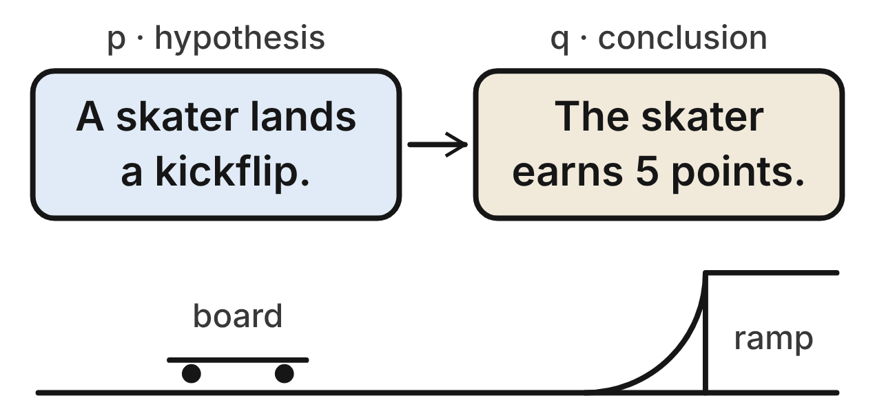
At a skate park contest, this rule is true: “If a skater lands a kickflip, then the skater earns 5 points.” p is its hypothesis and q is its conclusion. Other tricks can also earn 5 points.
1. Which symbols stand for “A skater lands a kickflip and does not earn 5 points”?
A. p ∨ ~q
B. p ∧ ~q ✔
C. ~p ∧ q
D. ~(p ∧ q)
G.RLT.1 · skill G.RLT.1.1 (LOTS): Translate statements into symbols and words: negation (~p), conjunction (p ∧ q), disjunction (p ∨ q), conditional (p → q) and biconditional (p ↔ q)
☐ Answer key correct ☐ Wording clear Notes: ________________________________
2. Which sentence is the converse of the kickflip rule?
A. If a skater earns 5 points, then the skater lands a kickflip. ✔
B. If a skater does not land a kickflip, then the skater does not earn 5 points.
C. If a skater does not earn 5 points, then the skater does not land a kickflip.
D. If a skater lands a kickflip, then the skater does not earn 5 points.
G.RLT.1 · skill G.RLT.1.2 (LOTS): Identify the converse, inverse and contrapositive of a conditional statement and decide whether each is true
☐ Answer key correct ☐ Wording clear Notes: ________________________________
3. Which is the inverse of the kickflip rule p → q, written in symbols?
A. q → p
B. ~q → ~p
C. ~p → ~q ✔
D. p → ~q
G.RLT.1 · skill G.RLT.1.2 (LOTS): Identify the converse, inverse and contrapositive of a conditional statement and decide whether each is true
☐ Answer key correct ☐ Wording clear Notes: ________________________________
4. What is true about the converse and the inverse of the kickflip rule?
A. Both are true, because the rule is true.
B. The converse is true, but the inverse is false.
C. The inverse is true, but the converse is false.
D. Both are false, since other tricks earn 5 points. ✔
G.RLT.1 · skill G.RLT.1.2 (LOTS): Identify the converse, inverse and contrapositive of a conditional statement and decide whether each is true
☐ Answer key correct ☐ Wording clear Notes: ________________________________
5. Using p and q from the kickflip rule, which sentence is ~p ∧ q?
A. A skater does not land a kickflip, and the skater earns 5 points. ✔
B. A skater does not land a kickflip, or the skater earns 5 points.
C. A skater lands a kickflip, and the skater does not earn 5 points.
D. If a skater does not land a kickflip, then the skater earns 5 points.
G.RLT.1 · skill G.RLT.1.1 (LOTS): Translate statements into symbols and words: negation (~p), conjunction (p ∧ q), disjunction (p ∨ q), conditional (p → q) and biconditional (p ↔ q)
☐ Answer key correct ☐ Wording clear Notes: ________________________________
6. Which skater is a counterexample to the converse of the kickflip rule?
A. Ana lands a kickflip and earns 5 points.
B. Bo lands no trick and earns 0 points.
C. Cy lands a kickflip but earns 3 points.
D. Dev lands only a 360 spin and earns 5 points. ✔
G.RLT.1 · skill G.RLT.1.2 (LOTS): Identify the converse, inverse and contrapositive of a conditional statement and decide whether each is true
☐ Answer key correct ☐ Wording clear Notes: ________________________________

The Archery Club Roster
Level 1 · Logic · G.RLT.1 · ID geo-rlt1-raid-archery
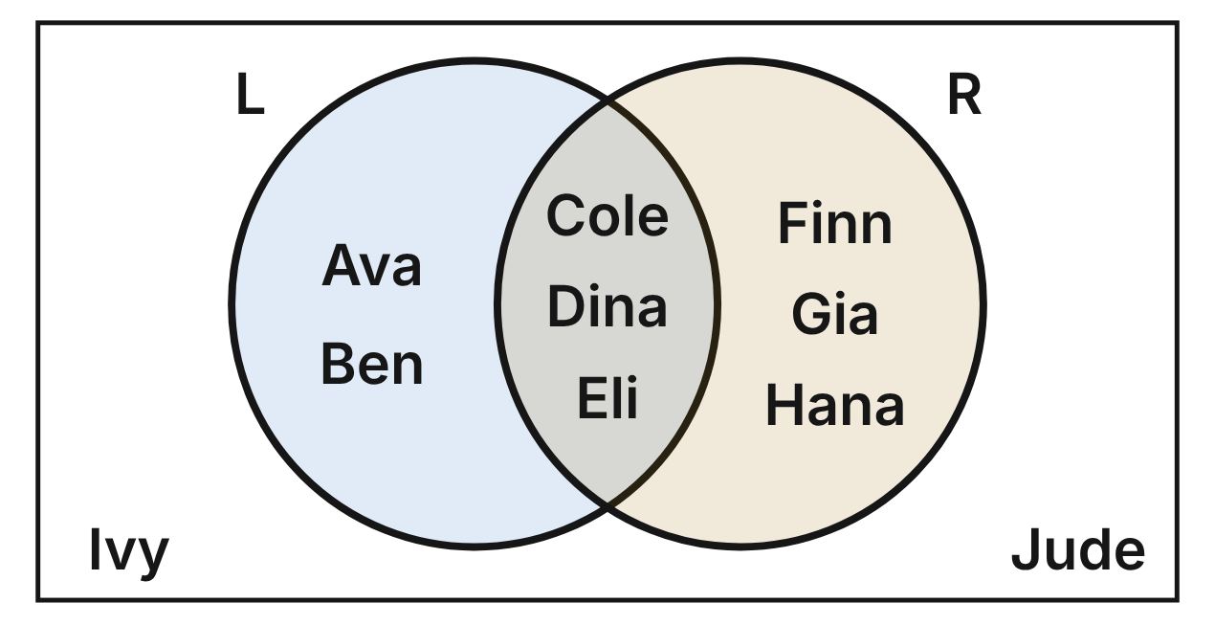
The Venn diagram places all 10 members of an archery club. L is the set of left-handed archers, and R is the set of archers who shoot a recurve bow.
7. Which archers are in L ∩ R?
A. Ava and Ben
B. Ivy and Jude
C. Cole, Dina and Eli ✔
D. Ava, Ben, Cole, Dina and Eli
G.RLT.1 · skill G.RLT.1.4 (LOTS): Use and interpret Venn diagrams: union, intersection, subset and negation, including in context
☐ Answer key correct ☐ Wording clear Notes: ________________________________
8. How many archers in the club are in L ∪ R?
A. 3
B. 8 ✔
C. 11
D. 2
G.RLT.1 · skill G.RLT.1.4 (LOTS): Use and interpret Venn diagrams: union, intersection, subset and negation, including in context
☐ Answer key correct ☐ Wording clear Notes: ________________________________
9. How many archers in the club are in ~R?
A. 2
B. 6
C. 5
D. 4 ✔
G.RLT.1 · skill G.RLT.1.4 (LOTS): Use and interpret Venn diagrams: union, intersection, subset and negation, including in context
☐ Answer key correct ☐ Wording clear Notes: ________________________________
10. Which expression names the region that holds Finn, Gia and Hana?
A. R ∩ ~L ✔
B. L ∩ ~R
C. R
D. ~(L ∪ R)
G.RLT.1 · skill G.RLT.1.4 (LOTS): Use and interpret Venn diagrams: union, intersection, subset and negation, including in context
☐ Answer key correct ☐ Wording clear Notes: ________________________________
11. Consider “If an archer shoots a recurve bow, then the archer is left-handed.” Which archer is a counterexample to this statement?
A. Cole
B. Ava
C. Gia ✔
D. Ivy
G.RLT.1 · skill G.RLT.1.2 (LOTS): Identify the converse, inverse and contrapositive of a conditional statement and decide whether each is true
☐ Answer key correct ☐ Wording clear Notes: ________________________________
12. Let l be “Jude is left-handed” and r be “Jude shoots a recurve bow.” Which statement is true?
A. l ∨ r
B. ~l ∧ ~r ✔
C. ~l ∧ r
D. l ↔ ~r
G.RLT.1 · skill G.RLT.1.1 (LOTS): Translate statements into symbols and words: negation (~p), conjunction (p ∧ q), disjunction (p ∨ q), conditional (p → q) and biconditional (p ↔ q)
☐ Answer key correct ☐ Wording clear Notes: ________________________________

Rain at the Tennis Courts
Level 2 · Logic · G.RLT.1 · ID geo-rlt1-raid-rain-chain
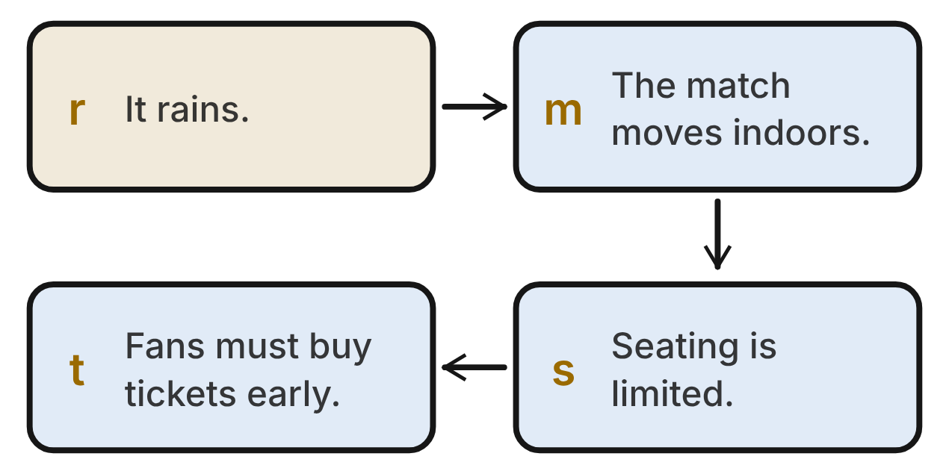
At a tennis tournament, each arrow in the chart is a true conditional: r → m, m → s and s → t. The letters stand for the statements in the boxes.
13. Which conclusion follows from the tennis chart by the Law of Syllogism?
A. If fans must buy tickets early, then it rains.
B. If it does not rain, then seating is not limited.
C. If seating is limited, then it rains.
D. If it rains, then fans must buy tickets early. ✔
G.RLT.1 · skill G.RLT.1.3 (HOTS): Use deductive reasoning (the Law of Detachment and the Law of Syllogism) to decide whether a conclusion is valid
☐ Answer key correct ☐ Wording clear Notes: ________________________________
14. It rains on Saturday. Which statement must also be true on Saturday?
A. The match moves indoors, but seating may not be limited.
B. Fans must buy tickets early. ✔
C. Nothing else can be concluded.
D. Fans do not have to buy tickets early.
G.RLT.1 · skill G.RLT.1.3 (HOTS): Use deductive reasoning (the Law of Detachment and the Law of Syllogism) to decide whether a conclusion is valid
☐ Answer key correct ☐ Wording clear Notes: ________________________________
15. On Sunday, seating is limited. What can be concluded about rain on Sunday?
A. It rains, by the Law of Detachment.
B. It does not rain, by the contrapositive.
C. Nothing; that would use a converse. ✔
D. It rains, by the Law of Syllogism.
G.RLT.1 · skill G.RLT.1.3 (HOTS): Use deductive reasoning (the Law of Detachment and the Law of Syllogism) to decide whether a conclusion is valid
☐ Answer key correct ☐ Wording clear Notes: ________________________________
16. Which statement must be true at the tournament?
A. If seating is not limited, then the match does not move indoors. ✔
B. If the match does not move indoors, then seating is not limited.
C. If seating is limited, then the match moves indoors.
D. If it does not rain, then the match does not move indoors.
G.RLT.1 · skill G.RLT.1.2 (LOTS): Identify the converse, inverse and contrapositive of a conditional statement and decide whether each is true
☐ Answer key correct ☐ Wording clear Notes: ________________________________
17. On Monday, fans do not have to buy tickets early. What can be concluded?
A. It rains on Monday.
B. It does not rain on Monday. ✔
C. Seating is limited on Monday.
D. Nothing can be concluded.
G.RLT.1 · skill G.RLT.1.3 (HOTS): Use deductive reasoning (the Law of Detachment and the Law of Syllogism) to decide whether a conclusion is valid
☐ Answer key correct ☐ Wording clear Notes: ________________________________
18. Using the tennis chart, which sentence is ~r ∨ m?
A. It does not rain, and the match moves indoors.
B. If it does not rain, then the match moves indoors.
C. It rains, or the match does not move indoors.
D. It does not rain, or the match moves indoors. ✔
G.RLT.1 · skill G.RLT.1.1 (LOTS): Translate statements into symbols and words: negation (~p), conjunction (p ∧ q), disjunction (p ∨ q), conditional (p → q) and biconditional (p ↔ q)
☐ Answer key correct ☐ Wording clear Notes: ________________________________

Console or PC?
Level 2 · Logic · G.RLT.1 · ID geo-rlt1-raid-gamers
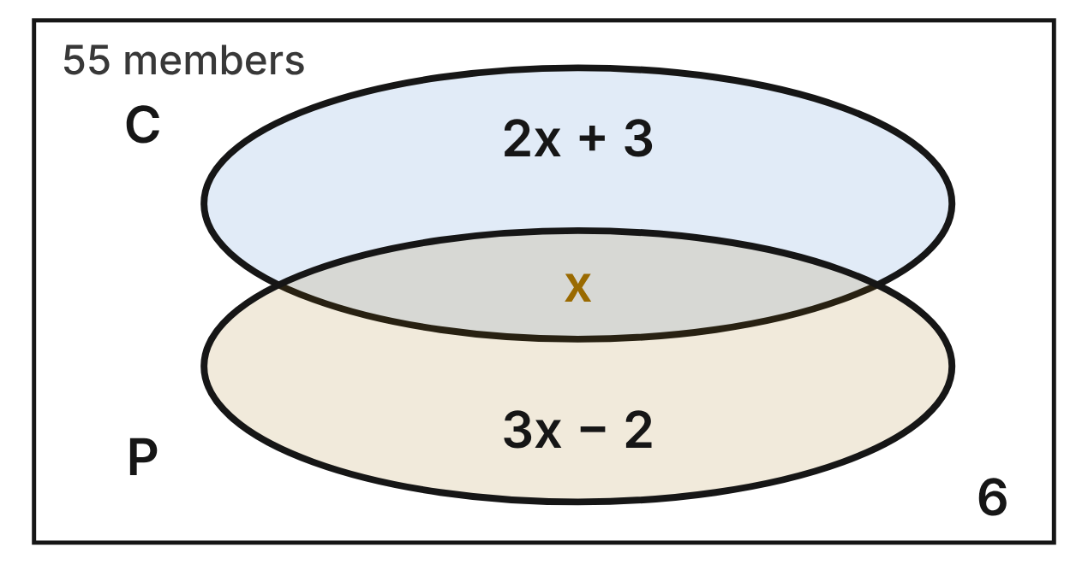
A video game club surveyed all 55 of its members. C is the set of members who play on a console, and P is the set who play on a PC. Each expression is the number of members in that region; 6 members use neither.
19. What is the value of x in the game-club diagram?
A. 9
B. 48
C. 8 ✔
D. 19
G.RLT.1 · skill G.RLT.1.4 (LOTS): Use and interpret Venn diagrams: union, intersection, subset and negation, including in context
☐ Answer key correct ☐ Wording clear Notes: ________________________________
20. How many club members play on a console?
A. 27 ✔
B. 19
C. 30
D. 49
G.RLT.1 · skill G.RLT.1.4 (LOTS): Use and interpret Venn diagrams: union, intersection, subset and negation, including in context
☐ Answer key correct ☐ Wording clear Notes: ________________________________
21. How many club members are in C ∪ P?
A. 57
B. 55
C. 41
D. 49 ✔
G.RLT.1 · skill G.RLT.1.4 (LOTS): Use and interpret Venn diagrams: union, intersection, subset and negation, including in context
☐ Answer key correct ☐ Wording clear Notes: ________________________________
22. How many club members play on exactly one of the two: a console or a PC?
A. 8
B. 41 ✔
C. 49
D. 47
G.RLT.1 · skill G.RLT.1.4 (LOTS): Use and interpret Venn diagrams: union, intersection, subset and negation, including in context
☐ Answer key correct ☐ Wording clear Notes: ________________________________
23. Which statement about the 55 club members is NOT true?
A. P has 22 members. ✔
B. C ∩ P has 8 members.
C. ~C has 28 members.
D. ~(C ∪ P) has 6 members.
G.RLT.1 · skill G.RLT.1.4 (LOTS): Use and interpret Venn diagrams: union, intersection, subset and negation, including in context
☐ Answer key correct ☐ Wording clear Notes: ________________________________
24. Is “If a member plays on a console, then the member plays on a PC” true for this club?
A. Yes; 8 members play on both.
B. No; 22 members are counterexamples.
C. No; 19 members are counterexamples. ✔
D. No; 6 members are counterexamples.
G.RLT.1 · skill G.RLT.1.2 (LOTS): Identify the converse, inverse and contrapositive of a conditional statement and decide whether each is true
☐ Answer key correct ☐ Wording clear Notes: ________________________________

Heat 3 at the Swim Meet
Level 2 · Logic · G.RLT.1 · ID geo-rlt1-raid-swim
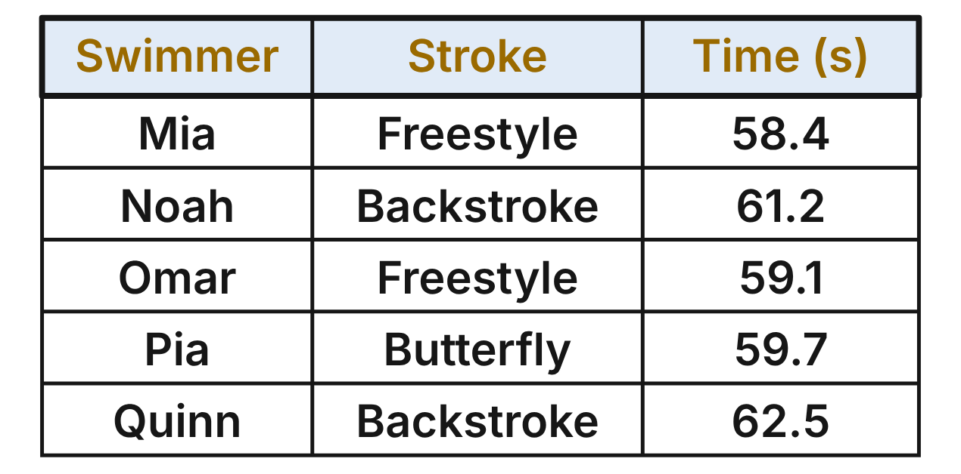
For each swimmer in heat 3, let p be “The swimmer swam freestyle” and q be “The swimmer's time was under 60 seconds.”
25. For how many of the five swimmers in heat 3 is p ↔ q true?
A. 2
B. 1
C. 3
D. 4 ✔
G.RLT.1 · skill G.RLT.1.1 (LOTS): Translate statements into symbols and words: negation (~p), conjunction (p ∧ q), disjunction (p ∨ q), conditional (p → q) and biconditional (p ↔ q)
☐ Answer key correct ☐ Wording clear Notes: ________________________________
26. For which swimmer in heat 3 is ~p ∧ q true?
A. Mia
B. Noah
C. Pia ✔
D. No swimmer
G.RLT.1 · skill G.RLT.1.1 (LOTS): Translate statements into symbols and words: negation (~p), conjunction (p ∧ q), disjunction (p ∨ q), conditional (p → q) and biconditional (p ↔ q)
☐ Answer key correct ☐ Wording clear Notes: ________________________________
27. Which statement is true for every swimmer in heat 3?
A. ~q → ~p ✔
B. q → p
C. ~p → ~q
D. p ↔ q
G.RLT.1 · skill G.RLT.1.2 (LOTS): Identify the converse, inverse and contrapositive of a conditional statement and decide whether each is true
☐ Answer key correct ☐ Wording clear Notes: ________________________________
28. Assume p → q holds for every swimmer at the meet. Rex swam freestyle in heat 4. What can be concluded?
A. Rex's time was 60 seconds or more.
B. Nothing, because Rex is not in heat 3.
C. Rex's time was under 58.4 seconds.
D. Rex's time was under 60 seconds. ✔
G.RLT.1 · skill G.RLT.1.3 (HOTS): Use deductive reasoning (the Law of Detachment and the Law of Syllogism) to decide whether a conclusion is valid
☐ Answer key correct ☐ Wording clear Notes: ________________________________
29. Assume p → q holds at the whole meet. Sal's time was 58.0 seconds, so Lin says Sal swam freestyle. Which describes Lin's reasoning?
A. Valid, by the Law of Detachment
B. Invalid; Pia's swim has q true while p is false ✔
C. Valid, because Mia and Omar were under 60 s
D. Invalid; Omar's swim shows p → q is false
G.RLT.1 · skill G.RLT.1.3 (HOTS): Use deductive reasoning (the Law of Detachment and the Law of Syllogism) to decide whether a conclusion is valid
☐ Answer key correct ☐ Wording clear Notes: ________________________________
30. For how many swimmers in heat 3 is ~(p ∨ q) true?
A. 2 ✔
B. 3
C. 5
D. 1
G.RLT.1 · skill G.RLT.1.1 (LOTS): Translate statements into symbols and words: negation (~p), conjunction (p ∧ q), disjunction (p ∨ q), conditional (p → q) and biconditional (p ↔ q)
☐ Answer key correct ☐ Wording clear Notes: ________________________________

Regulars at the Bowling Center
Level 3 · Logic · G.RLT.1 · ID geo-rlt1-raid-bowling
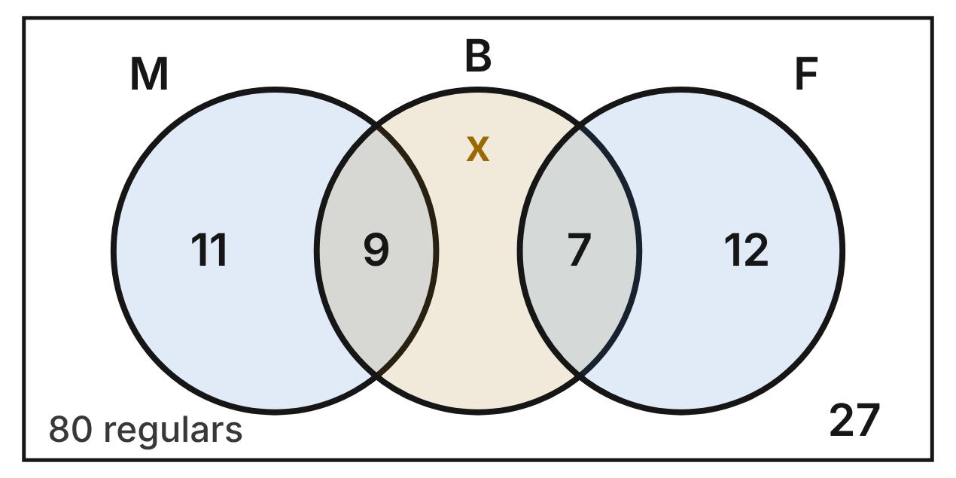
The diagram shows all 80 regulars at a bowling center. M is the Monday league, F is the Friday league, and B is the set of regulars who own a bowling ball. No one may join both leagues. In all, 30 regulars own a ball; x of them are in neither league.
31. How many regulars own a ball but are in neither league (the value of x)?
A. 21
B. 14 ✔
C. 16
D. 46
G.RLT.1 · skill G.RLT.1.4 (LOTS): Use and interpret Venn diagrams: union, intersection, subset and negation, including in context
☐ Answer key correct ☐ Wording clear Notes: ________________________________
32. How many regulars at the bowling center are in M ∪ B?
A. 50
B. 27
C. 53
D. 41 ✔
G.RLT.1 · skill G.RLT.1.4 (LOTS): Use and interpret Venn diagrams: union, intersection, subset and negation, including in context
☐ Answer key correct ☐ Wording clear Notes: ________________________________
33. Which conditional is true for these 80 regulars?
A. If a regular is in M, then the regular is not in F. ✔
B. If a regular is in B, then the regular is in M or F.
C. If a regular is in F, then the regular is in B.
D. If a regular is not in M, then the regular is in F.
G.RLT.1 · skill G.RLT.1.4 (LOTS): Use and interpret Venn diagrams: union, intersection, subset and negation, including in context
☐ Answer key correct ☐ Wording clear Notes: ________________________________
34. Ty is a regular who owns a bowling ball. Which conclusion about Ty is valid?
A. Ty is in at least one league.
B. Ty is in the Monday league.
C. Ty is not in both leagues. ✔
D. Ty is in neither league.
G.RLT.1 · skill G.RLT.1.3 (HOTS): Use deductive reasoning (the Law of Detachment and the Law of Syllogism) to decide whether a conclusion is valid
☐ Answer key correct ☐ Wording clear Notes: ________________________________
35. How many regulars are in exactly one of the sets M, F and B?
A. 23
B. 16
C. 53
D. 37 ✔
G.RLT.1 · skill G.RLT.1.4 (LOTS): Use and interpret Venn diagrams: union, intersection, subset and negation, including in context
☐ Answer key correct ☐ Wording clear Notes: ________________________________
36. A new regular joins the Friday league and does not own a ball. After that, how many regulars are in F ∩ ~B?
A. 8
B. 13 ✔
C. 20
D. 12
G.RLT.1 · skill G.RLT.1.4 (LOTS): Use and interpret Venn diagrams: union, intersection, subset and negation, including in context
☐ Answer key correct ☐ Wording clear Notes: ________________________________

Dragon Run Rule Cards
Level 3 · Logic · G.RLT.1 · ID geo-rlt1-raid-dragon
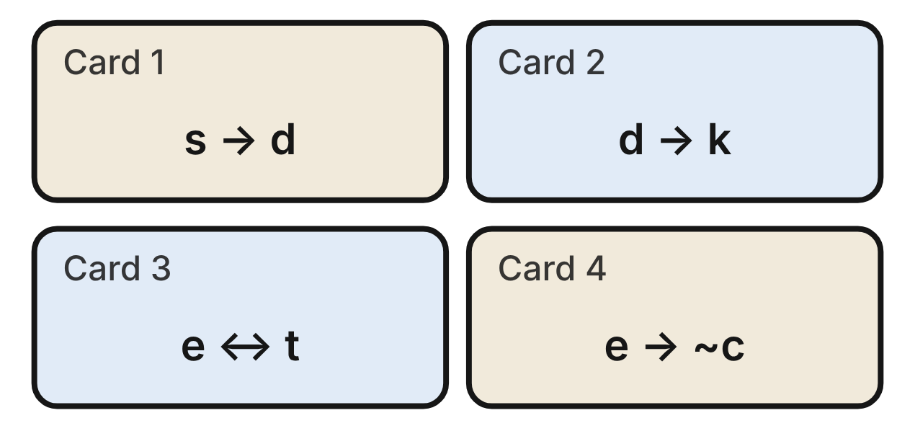
In the board game Dragon Run, all four rule cards are true. The letters stand for statements about one player's turn.
s: the player rolls a 6. d: the player moves the dragon. k: the player loses a coin. t: the player lands on a tower. e: the player earns a shield. c: the player can be captured.
37. Which conclusion follows from cards 1 and 2 by the Law of Syllogism?
A. If a player loses a coin, then the player rolls a 6.
B. If a player does not roll a 6, then the player does not lose a coin.
C. If a player rolls a 6, then the player loses a coin. ✔
D. If a player moves the dragon, then the player rolls a 6.
G.RLT.1 · skill G.RLT.1.3 (HOTS): Use deductive reasoning (the Law of Detachment and the Law of Syllogism) to decide whether a conclusion is valid
☐ Answer key correct ☐ Wording clear Notes: ________________________________
38. Kim did not lose a coin on her turn. What can be concluded from cards 1 and 2?
A. Kim did not roll a 6. ✔
B. Kim rolled a 6.
C. Kim moved the dragon.
D. Nothing about Kim's roll.
G.RLT.1 · skill G.RLT.1.3 (HOTS): Use deductive reasoning (the Law of Detachment and the Law of Syllogism) to decide whether a conclusion is valid
☐ Answer key correct ☐ Wording clear Notes: ________________________________
39. Raj lost a coin on his turn. Eva says, “Then Raj must have rolled a 6.” Which describes Eva's reasoning?
A. Valid, by the Law of Detachment
B. Valid, by the Law of Syllogism
C. Invalid; it uses the inverse of s → k
D. Invalid; it uses the converse of s → k ✔
G.RLT.1 · skill G.RLT.1.3 (HOTS): Use deductive reasoning (the Law of Detachment and the Law of Syllogism) to decide whether a conclusion is valid
☐ Answer key correct ☐ Wording clear Notes: ________________________________
40. Which pair of conditionals means the same as card 3, e ↔ t?
A. e → t or t → e
B. e → t and t → e ✔
C. e → t and ~t → ~e
D. e ∧ t
G.RLT.1 · skill G.RLT.1.1 (LOTS): Translate statements into symbols and words: negation (~p), conjunction (p ∧ q), disjunction (p ∨ q), conditional (p → q) and biconditional (p ↔ q)
☐ Answer key correct ☐ Wording clear Notes: ________________________________
41. Which sentence is the contrapositive of card 4?
A. If a player cannot be captured, then the player earns a shield.
B. If a player does not earn a shield, then the player can be captured.
C. If a player can be captured, then the player does not earn a shield. ✔
D. If a player earns a shield, then the player can be captured.
G.RLT.1 · skill G.RLT.1.2 (LOTS): Identify the converse, inverse and contrapositive of a conditional statement and decide whether each is true
☐ Answer key correct ☐ Wording clear Notes: ________________________________
42. Leo lands on a tower. Using cards 3 and 4, what can be concluded about Leo?
A. He earns a shield and cannot be captured. ✔
B. He earns a shield, but he can be captured.
C. Nothing; card 3 starts with e, not t.
D. He cannot earn a shield on a tower.
G.RLT.1 · skill G.RLT.1.3 (HOTS): Use deductive reasoning (the Law of Detachment and the Law of Syllogism) to decide whether a conclusion is valid
☐ Answer key correct ☐ Wording clear Notes: ________________________________

G.RLT.2 · Analyze, prove, and justify the relationships of parallel lines cut by a transversal.

Lane Lines at the Pool
Level 1 · Lines · G.RLT.2 · ID geo-rlt2-raid-pool-lanes
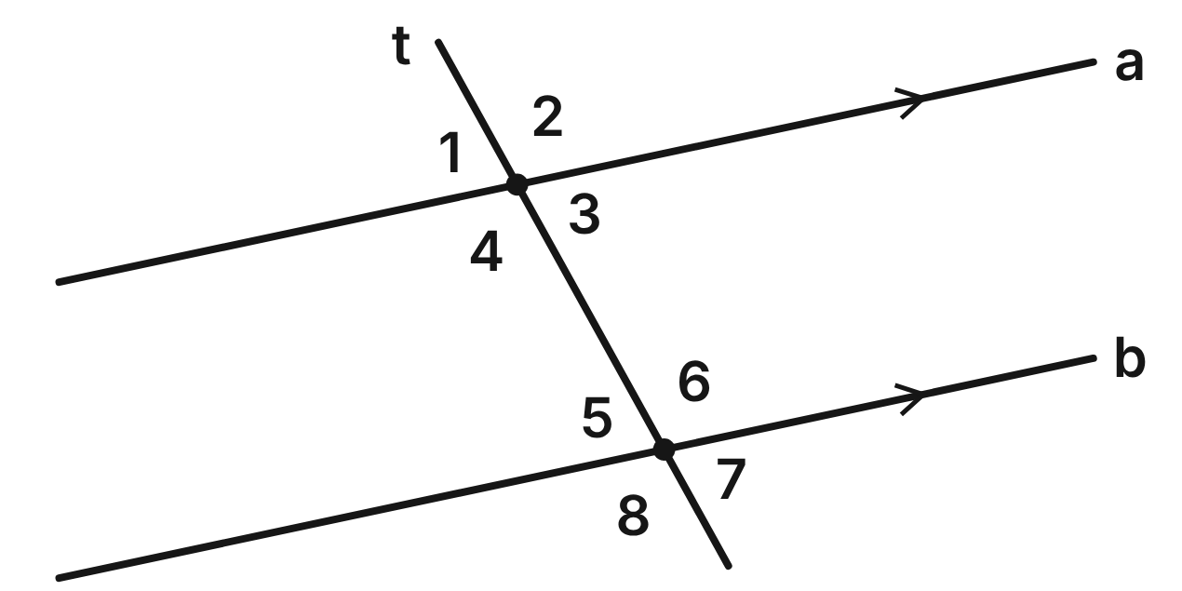
Lane lines a and b on the pool floor are parallel. A swimmer swims along the straight path t across both lines. m∠4 = 107°.
43. Which angle forms a pair of vertical angles with ∠4?
A. ∠2 ✔
B. ∠8
C. ∠6
D. ∠3
G.RLT.2 · skill G.RLT.2.1 (LOTS): Identify angle pairs formed by a transversal: corresponding, alternate interior, alternate exterior, same-side interior, vertical and linear pairs
☐ Answer key correct ☐ Wording clear Notes: ________________________________
44. What is m∠6?
A. 73°
B. 53.5°
C. 107° ✔
D. 253°
G.RLT.2 · skill G.RLT.2.3 (LOTS): Solve problems, including algebraic ones, using the angles formed by parallel lines and a transversal
☐ Answer key correct ☐ Wording clear Notes: ________________________________
45. Name the angle pair formed by ∠1 and ∠7.
A. Corresponding angles
B. Alternate exterior angles ✔
C. Vertical angles
D. Alternate interior angles
G.RLT.2 · skill G.RLT.2.1 (LOTS): Identify angle pairs formed by a transversal: corresponding, alternate interior, alternate exterior, same-side interior, vertical and linear pairs
☐ Answer key correct ☐ Wording clear Notes: ________________________________
46. Find the measure of ∠5.
A. 107°
B. 17°
C. 36.5°
D. 73° ✔
G.RLT.2 · skill G.RLT.2.3 (LOTS): Solve problems, including algebraic ones, using the angles formed by parallel lines and a transversal
☐ Answer key correct ☐ Wording clear Notes: ________________________________
47. Which two angles are NOT congruent?
A. ∠1 and ∠5
B. ∠3 and ∠5
C. ∠2 and ∠8
D. ∠3 and ∠6 ✔
G.RLT.2 · skill G.RLT.2.1 (LOTS): Identify angle pairs formed by a transversal: corresponding, alternate interior, alternate exterior, same-side interior, vertical and linear pairs
☐ Answer key correct ☐ Wording clear Notes: ________________________________
48. A coach checks two other lane lines. A swim path makes angles in the places of ∠4 and ∠6 that measure 107° and 106°. What can she conclude?
A. Parallel; the angles are only 1° apart.
B. Parallel; both angles are obtuse.
C. Not parallel; alternate interior angles must be equal. ✔
D. Cannot tell without a third angle.
G.RLT.2 · skill G.RLT.2.2 (HOTS): Prove or justify that two lines are parallel, or are not, from angle measures
☐ Answer key correct ☐ Wording clear Notes: ________________________________

Boards on the Bowling Lane
Level 1 · Lines · G.RLT.2 · ID geo-rlt2-raid-bowling-boards
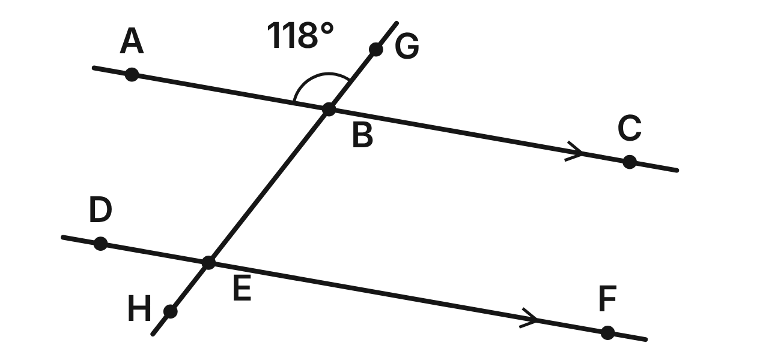
The edges of two boards on a bowling lane, line AC and line DF, are parallel. A ball rolls along the straight line GH, crossing them at B and E. m∠ABG = 118°.
49. Which angle corresponds to ∠ABG?
A. ∠FEH
B. ∠CBE
C. ∠DEB ✔
D. ∠DEH
G.RLT.2 · skill G.RLT.2.1 (LOTS): Identify angle pairs formed by a transversal: corresponding, alternate interior, alternate exterior, same-side interior, vertical and linear pairs
☐ Answer key correct ☐ Wording clear Notes: ________________________________
50. What is m∠BEF?
A. 118°
B. 28°
C. 242°
D. 62° ✔
G.RLT.2 · skill G.RLT.2.3 (LOTS): Solve problems, including algebraic ones, using the angles formed by parallel lines and a transversal
☐ Answer key correct ☐ Wording clear Notes: ________________________________
51. What kind of angle pair are ∠ABE and ∠BEF?
A. Alternate interior angles ✔
B. Same-side interior angles
C. Corresponding angles
D. Vertical angles
G.RLT.2 · skill G.RLT.2.1 (LOTS): Identify angle pairs formed by a transversal: corresponding, alternate interior, alternate exterior, same-side interior, vertical and linear pairs
☐ Answer key correct ☐ Wording clear Notes: ________________________________
52. What is m∠CBE?
A. 62°
B. 118° ✔
C. 59°
D. 236°
G.RLT.2 · skill G.RLT.2.3 (LOTS): Solve problems, including algebraic ones, using the angles formed by parallel lines and a transversal
☐ Answer key correct ☐ Wording clear Notes: ________________________________
53. Which two angles form a linear pair?
A. ∠ABG and ∠GBC ✔
B. ∠ABG and ∠CBE
C. ∠ABG and ∠DEB
D. ∠GBC and ∠DEH
G.RLT.2 · skill G.RLT.2.1 (LOTS): Identify angle pairs formed by a transversal: corresponding, alternate interior, alternate exterior, same-side interior, vertical and linear pairs
☐ Answer key correct ☐ Wording clear Notes: ________________________________
54. A bowler measures m∠GBC = 62° and m∠BEF = 62°. Which reason proves the boards are parallel?
A. Corresponding Angles Postulate
B. Vertical Angles Theorem
C. Converse of the Corresponding Angles Postulate ✔
D. Converse of the Same-Side Interior Angles Theorem
G.RLT.2 · skill G.RLT.2.2 (HOTS): Prove or justify that two lines are parallel, or are not, from angle measures
☐ Answer key correct ☐ Wording clear Notes: ________________________________

Rails at the Skate Park
Level 2 · Lines · G.RLT.2 · ID geo-rlt2-raid-skate-rails
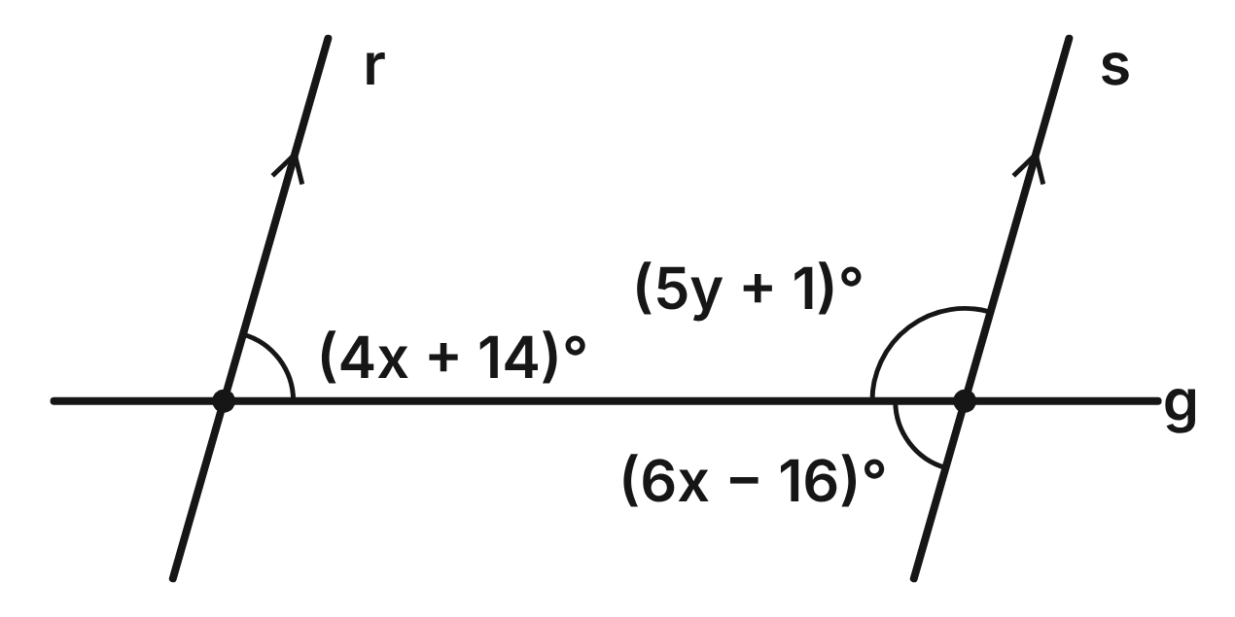
Grind rails r and s at the skate park are parallel. Both cross the straight edge of a ledge, g. The figure gives three angle measures in terms of x and y.
55. Using the two angles labeled with x, what is x?
A. 18.2
B. 15 ✔
C. 1
D. 30
G.RLT.2 · skill G.RLT.2.3 (LOTS): Solve problems, including algebraic ones, using the angles formed by parallel lines and a transversal
☐ Answer key correct ☐ Wording clear Notes: ________________________________
56. What is the measure of the angle labeled (4x + 14)°?
A. 74° ✔
B. 106°
C. 15
D. 18°
G.RLT.2 · skill G.RLT.2.3 (LOTS): Solve problems, including algebraic ones, using the angles formed by parallel lines and a transversal
☐ Answer key correct ☐ Wording clear Notes: ________________________________
57. What is the value of y?
A. 14.6
B. 35.8
C. 21.4
D. 21 ✔
G.RLT.2 · skill G.RLT.2.3 (LOTS): Solve problems, including algebraic ones, using the angles formed by parallel lines and a transversal
☐ Answer key correct ☐ Wording clear Notes: ________________________________
58. The angles labeled (4x + 14)° and (5y + 1)° are what kind of angle pair?
A. Alternate interior angles
B. Corresponding angles
C. Same-side interior angles ✔
D. A linear pair
G.RLT.2 · skill G.RLT.2.1 (LOTS): Identify angle pairs formed by a transversal: corresponding, alternate interior, alternate exterior, same-side interior, vertical and linear pairs
☐ Answer key correct ☐ Wording clear Notes: ________________________________
59. When x = 15, both angles labeled with x measure 74°. Which statement proves r ∥ s?
A. Corresponding angles are congruent, so r ∥ s.
B. Alternate interior angles are congruent, so r ∥ s. ✔
C. The two angles add to 148°, so r ∥ s.
D. Vertical angles are congruent, so r ∥ s.
G.RLT.2 · skill G.RLT.2.2 (HOTS): Prove or justify that two lines are parallel, or are not, from angle measures
☐ Answer key correct ☐ Wording clear Notes: ________________________________
60. What is the measure of the angle below the ledge and to the right of rail s?
A. 74°
B. 16°
C. 21
D. 106° ✔
G.RLT.2 · skill G.RLT.2.3 (LOTS): Solve problems, including algebraic ones, using the angles formed by parallel lines and a transversal
☐ Answer key correct ☐ Wording clear Notes: ________________________________

The Bank Shot
Level 2 · Lines · G.RLT.2 · ID geo-rlt2-raid-bank-shot
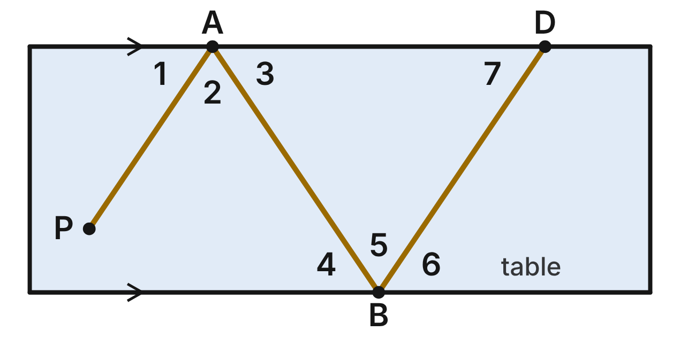
The top and bottom rails of a pool table are parallel. A ball rolls from P to A, then B, then D. At each bounce it leaves the rail at the same angle it arrives: ∠1 ≅ ∠3 and ∠4 ≅ ∠6. m∠1 = 56°.
61. With segment AB as the transversal of the two rails, what kind of angle pair are ∠3 and ∠4?
A. Corresponding angles
B. Same-side interior angles
C. Vertical angles
D. Alternate interior angles ✔
G.RLT.2 · skill G.RLT.2.1 (LOTS): Identify angle pairs formed by a transversal: corresponding, alternate interior, alternate exterior, same-side interior, vertical and linear pairs
☐ Answer key correct ☐ Wording clear Notes: ________________________________
62. What is m∠4?
A. 124°
B. 68°
C. 56° ✔
D. 34°
G.RLT.2 · skill G.RLT.2.3 (LOTS): Solve problems, including algebraic ones, using the angles formed by parallel lines and a transversal
☐ Answer key correct ☐ Wording clear Notes: ________________________________
63. What is m∠2, the angle between the ball's two paths at A?
A. 124°
B. 68° ✔
C. 112°
D. 34°
G.RLT.2 · skill G.RLT.2.3 (LOTS): Solve problems, including algebraic ones, using the angles formed by parallel lines and a transversal
☐ Answer key correct ☐ Wording clear Notes: ________________________________
64. m∠7 = 56°. Which statement about segments PA and BD is true?
A. PA ∥ BD; corresponding angles ∠1 and ∠7 are congruent. ✔
B. PA ∥ BD; ∠1 and ∠7 are alternate interior angles.
C. PA and BD are not parallel; they do not touch.
D. PA and BD are not parallel; ∠1 + ∠7 ≠ 180°.
G.RLT.2 · skill G.RLT.2.2 (HOTS): Prove or justify that two lines are parallel, or are not, from angle measures
☐ Answer key correct ☐ Wording clear Notes: ________________________________
65. On a new shot, the ball bounces off the top rail with ∠1 ≅ ∠3 and m∠2 = 80°. What is m∠1?
A. 100°
B. 40°
C. 50° ✔
D. 10°
G.RLT.2 · skill G.RLT.2.3 (LOTS): Solve problems, including algebraic ones, using the angles formed by parallel lines and a transversal
☐ Answer key correct ☐ Wording clear Notes: ________________________________
66. Lee says ∠1 ≅ ∠4 because they are alternate interior angles. What is wrong with his reason?
A. ∠1 and ∠4 are formed by different transversals. ✔
B. Nothing; ∠1 and ∠4 are alternate interior angles.
C. They are corresponding angles, not alternate.
D. They are supplementary, not congruent.
G.RLT.2 · skill G.RLT.2.1 (LOTS): Identify angle pairs formed by a transversal: corresponding, alternate interior, alternate exterior, same-side interior, vertical and linear pairs
☐ Answer key correct ☐ Wording clear Notes: ________________________________

Lines on the Tennis Court
Level 2 · Lines · G.RLT.2 · ID geo-rlt2-raid-tennis-lines
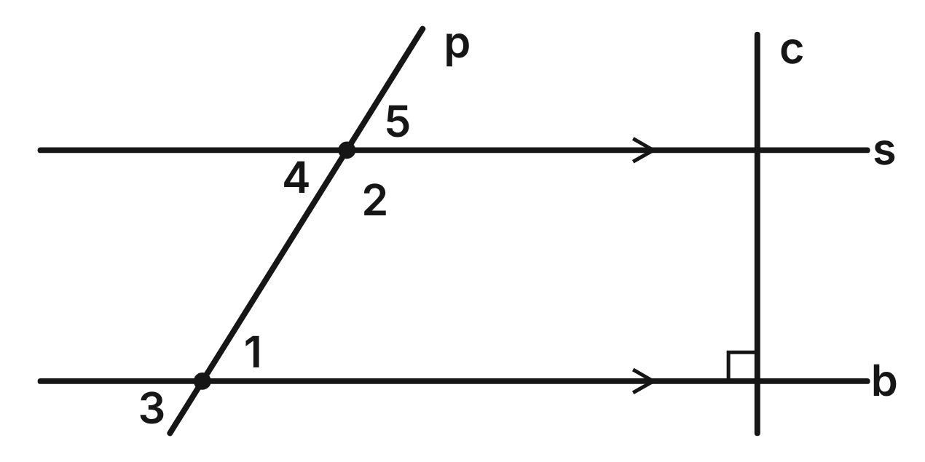
On a tennis court, the baseline b and service line s are parallel. The center line c is perpendicular to b. A ball travels along path p. m∠1 = (3x + 4)° and m∠2 = (7x − 4)°.
67. Find x, using m∠1 = (3x + 4)° and m∠2 = (7x − 4)°.
A. 18 ✔
B. 2
C. 9
D. 17.2
G.RLT.2 · skill G.RLT.2.3 (LOTS): Solve problems, including algebraic ones, using the angles formed by parallel lines and a transversal
☐ Answer key correct ☐ Wording clear Notes: ________________________________
68. What is m∠2?
A. 58°
B. 122° ✔
C. 18
D. 32°
G.RLT.2 · skill G.RLT.2.3 (LOTS): Solve problems, including algebraic ones, using the angles formed by parallel lines and a transversal
☐ Answer key correct ☐ Wording clear Notes: ________________________________
69. Which angle is an alternate interior angle to ∠1?
A. ∠2
B. ∠5
C. ∠4 ✔
D. ∠3
G.RLT.2 · skill G.RLT.2.1 (LOTS): Identify angle pairs formed by a transversal: corresponding, alternate interior, alternate exterior, same-side interior, vertical and linear pairs
☐ Answer key correct ☐ Wording clear Notes: ________________________________
70. Why must center line c also be perpendicular to s?
A. Lines c and s are parallel lines.
B. Vertical angles are congruent, so c ⊥ s.
C. Same-side interior angles add to 90°.
D. b ∥ s, so the corresponding angles are both 90°. ✔
G.RLT.2 · skill G.RLT.2.3 (LOTS): Solve problems, including algebraic ones, using the angles formed by parallel lines and a transversal
☐ Answer key correct ☐ Wording clear Notes: ________________________________
71. Suppose the service line is repainted so that m∠2 = 120°, while m∠1 = 58°. Which is true?
A. s ∥ b, since ∠1 and ∠2 are on the same side of p.
B. s is not parallel to b, since 58° + 120° = 178°. ✔
C. s ∥ b, since ∠2 is still obtuse.
D. Cannot tell without measuring ∠3.
G.RLT.2 · skill G.RLT.2.2 (HOTS): Prove or justify that two lines are parallel, or are not, from angle measures
☐ Answer key correct ☐ Wording clear Notes: ________________________________
72. ∠1 and ∠2 are which kind of angle pair?
A. Alternate interior angles
B. Corresponding angles
C. Alternate exterior angles
D. Same-side interior angles ✔
G.RLT.2 · skill G.RLT.2.1 (LOTS): Identify angle pairs formed by a transversal: corresponding, alternate interior, alternate exterior, same-side interior, vertical and linear pairs
☐ Answer key correct ☐ Wording clear Notes: ________________________________

The Laser Puzzle
Level 3 · Lines · G.RLT.2 · ID geo-rlt2-raid-laser-puzzle
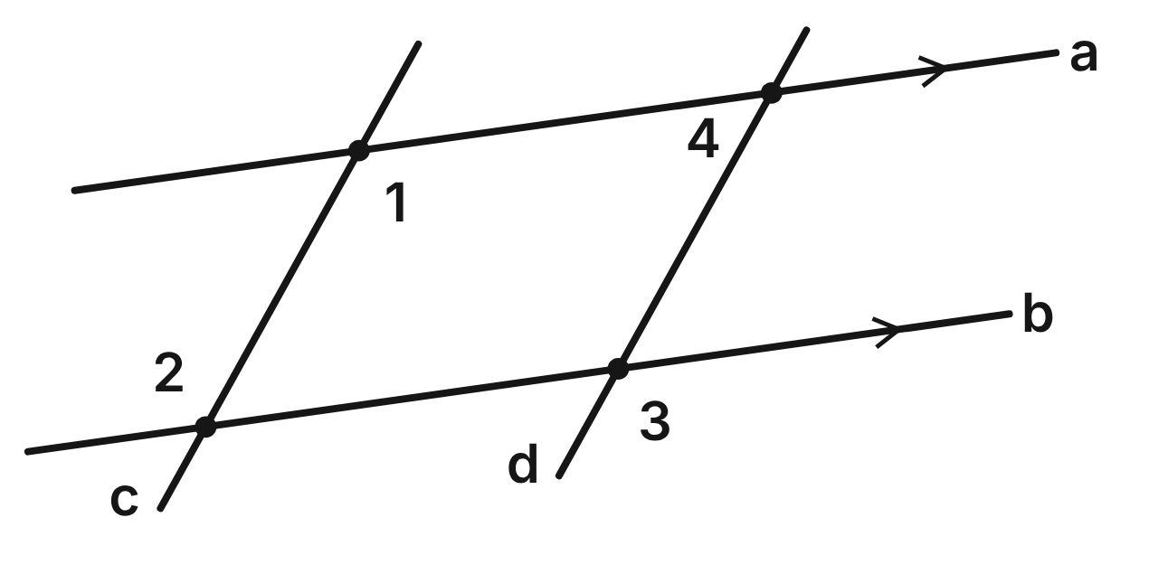
In a puzzle video game, four straight laser beams a, b, c and d cross. Given: a ∥ b and ∠1 ≅ ∠3. Prove: c ∥ d.
Statement | Reason
1. a ∥ b | Given
2. ∠2 ≅ ∠1 | ____ (a)
3. ∠1 ≅ ∠3 | Given
4. ∠2 ≅ ∠3 | ____ (b)
5. c ∥ d | ____ (c)

73. In the laser proof, what is the reason for step 2 (blank a)?
A. Converse of the Alternate Interior Angles Theorem
B. Corresponding Angles Postulate
C. Alternate Interior Angles Theorem ✔
D. Vertical Angles Theorem
G.RLT.2 · skill G.RLT.2.2 (HOTS): Prove or justify that two lines are parallel, or are not, from angle measures
☐ Answer key correct ☐ Wording clear Notes: ________________________________
74. In the laser proof, what is the reason for step 4 (blank b)?
A. Transitive Property of Congruence ✔
B. Reflexive Property of Congruence
C. Symmetric Property of Congruence
D. Vertical Angles Theorem
G.RLT.2 · skill G.RLT.2.2 (HOTS): Prove or justify that two lines are parallel, or are not, from angle measures
☐ Answer key correct ☐ Wording clear Notes: ________________________________
75. In the laser proof, what is the reason for step 5 (blank c)?
A. Alternate Exterior Angles Theorem
B. Converse of the Alternate Exterior Angles Theorem ✔
C. Converse of the Alternate Interior Angles Theorem
D. Converse of the Corresponding Angles Postulate
G.RLT.2 · skill G.RLT.2.2 (HOTS): Prove or justify that two lines are parallel, or are not, from angle measures
☐ Answer key correct ☐ Wording clear Notes: ________________________________
76. Suppose a ∥ b, m∠1 = (6x − 17)° and m∠3 = (4x + 31)°. For what value of x is c ∥ d?
A. 16.6
B. 7
C. 48
D. 24 ✔
G.RLT.2 · skill G.RLT.2.3 (LOTS): Solve problems, including algebraic ones, using the angles formed by parallel lines and a transversal
☐ Answer key correct ☐ Wording clear Notes: ________________________________
77. Instead of ∠1 ≅ ∠3, which given would also prove c ∥ d, along with a ∥ b?
A. ∠1 ≅ ∠4
B. ∠2 and ∠3 are supplementary.
C. ∠1 ≅ ∠2
D. ∠1 and ∠4 are supplementary. ✔
G.RLT.2 · skill G.RLT.2.2 (HOTS): Prove or justify that two lines are parallel, or are not, from angle measures
☐ Answer key correct ☐ Wording clear Notes: ________________________________
78. If a ∥ b, c ∥ d and m∠4 = 53°, what is m∠2?
A. 53°
B. 127° ✔
C. 37°
D. 106°
G.RLT.2 · skill G.RLT.2.3 (LOTS): Solve problems, including algebraic ones, using the angles formed by parallel lines and a transversal
☐ Answer key correct ☐ Wording clear Notes: ________________________________

The Mini-Golf Bumper
Level 3 · Lines · G.RLT.2 · ID geo-rlt2-raid-mini-golf
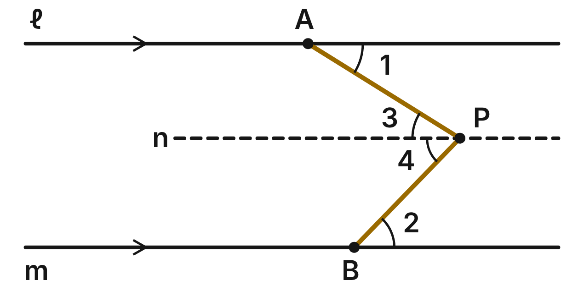
On a mini-golf hole, walls ℓ and m are parallel. A bent bumper runs from A to P to B. Dashed line n is drawn through P parallel to ℓ. m∠1 = 32° and m∠2 = 46°.
79. What is m∠APB?
A. 102°
B. 14°
C. 282°
D. 78° ✔
G.RLT.2 · skill G.RLT.2.3 (LOTS): Solve problems, including algebraic ones, using the angles formed by parallel lines and a transversal
☐ Answer key correct ☐ Wording clear Notes: ________________________________
80. Why is ∠3 ≅ ∠1?
A. They are corresponding angles, and n ∥ ℓ.
B. They are vertical angles.
C. They are alternate interior angles, and n ∥ ℓ. ✔
D. They are same-side interior angles.
G.RLT.2 · skill G.RLT.2.1 (LOTS): Identify angle pairs formed by a transversal: corresponding, alternate interior, alternate exterior, same-side interior, vertical and linear pairs
☐ Answer key correct ☐ Wording clear Notes: ________________________________
81. Suppose m∠1 = (x + 12)°, m∠2 = (2x + 6)° and m∠APB = 78°. What is x?
A. 20 ✔
B. 28
C. 32
D. 60
G.RLT.2 · skill G.RLT.2.3 (LOTS): Solve problems, including algebraic ones, using the angles formed by parallel lines and a transversal
☐ Answer key correct ☐ Wording clear Notes: ________________________________
82. Why is the dashed line n parallel to wall m?
A. n and m are both horizontal in the drawing.
B. Lines parallel to the same line are parallel. ✔
C. n crosses the bumper, as m does.
D. ∠2 and ∠4 are vertical angles.
G.RLT.2 · skill G.RLT.2.2 (HOTS): Prove or justify that two lines are parallel, or are not, from angle measures
☐ Answer key correct ☐ Wording clear Notes: ________________________________
83. On another hole, m∠1 = 32°, m∠2 = 46° and m∠APB = 80°. What can you conclude about its walls?
A. They are not parallel, since 32° + 46° ≠ 80°. ✔
B. They are parallel, since all three angles are acute.
C. They are parallel, since 80° is close to 78°.
D. Cannot tell unless ∠1 ≅ ∠2.
G.RLT.2 · skill G.RLT.2.2 (HOTS): Prove or justify that two lines are parallel, or are not, from angle measures
☐ Answer key correct ☐ Wording clear Notes: ________________________________
84. Rosa writes m∠APB = 180° − 32° − 46° = 102°. What was her mistake?
A. She should subtract from 360°, not 180°.
B. She should subtract the smaller from the larger.
C. ∠APB is the sum m∠1 + m∠2, not 180° minus it. ✔
D. Nothing; her answer is correct.
G.RLT.2 · skill G.RLT.2.3 (LOTS): Solve problems, including algebraic ones, using the angles formed by parallel lines and a transversal
☐ Answer key correct ☐ Wording clear Notes: ________________________________

G.RLT.3 · Solve problems, including contextual problems, involving symmetry and transformation.

A Tile on the Game Board
Level 1 · Transformations · G.RLT.3 · ID geo-rlt3-raid-game-tile
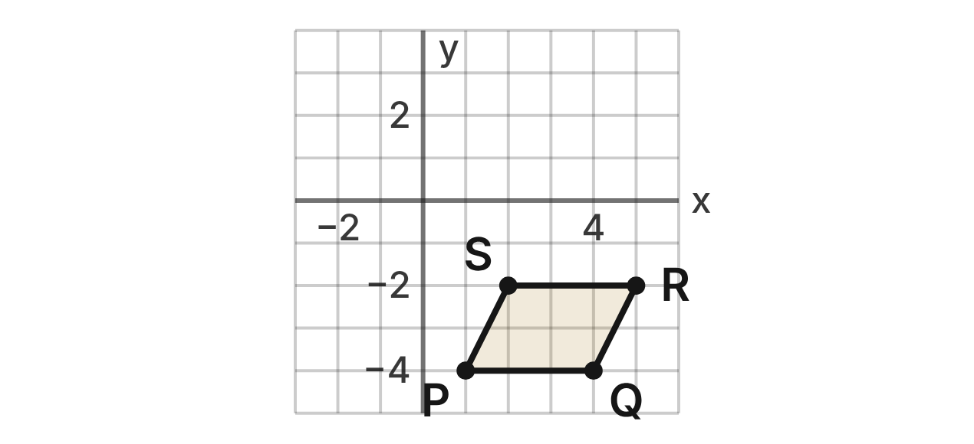
A board game is played on a coordinate grid. A game tile is parallelogram PQRS with P(1, −4), Q(4, −4), R(5, −2) and S(2, −2).
85. A player moves the tile by (x, y) → (x − 6, y + 5). What is the image of S?
A. (8, −7)
B. (−4, 3) ✔
C. (−4, −2)
D. (7, −8)
G.RLT.3 · skill G.RLT.3.2 (LOTS): Find the image of a figure on the coordinate plane under a translation, reflection, rotation or dilation
☐ Answer key correct ☐ Wording clear Notes: ________________________________
86. What is the image of P after a reflection over the y-axis?
A. (−1, −4) ✔
B. (1, 4)
C. (−1, 4)
D. (−4, 1)
G.RLT.3 · skill G.RLT.3.2 (LOTS): Find the image of a figure on the coordinate plane under a translation, reflection, rotation or dilation
☐ Answer key correct ☐ Wording clear Notes: ________________________________
87. What is the image of R after a rotation of 180° about the origin?
A. (5, 2)
B. (−5, −2)
C. (2, 5)
D. (−5, 2) ✔
G.RLT.3 · skill G.RLT.3.2 (LOTS): Find the image of a figure on the coordinate plane under a translation, reflection, rotation or dilation
☐ Answer key correct ☐ Wording clear Notes: ________________________________
88. On another turn, the tile slides so that Q lands on (1, 2). Which rule describes the slide?
A. (x, y) → (x + 3, y − 6)
B. (x, y) → (x + 1, y + 2)
C. (x, y) → (x − 3, y + 6) ✔
D. (x, y) → (x − 3, y − 6)
G.RLT.3 · skill G.RLT.3.3 (HOTS): Determine the transformation or composition that maps a preimage to an image, and whether it preserves size and shape
☐ Answer key correct ☐ Wording clear Notes: ________________________________
89. Which describes the symmetry of parallelogram PQRS?
A. No lines of symmetry; rotational symmetry of order 2 ✔
B. 2 lines of symmetry; rotational symmetry of order 2
C. 1 line of symmetry; no rotational symmetry
D. No lines of symmetry; no rotational symmetry
G.RLT.3 · skill G.RLT.3.1 (LOTS): Identify line symmetry and rotational symmetry of a figure
☐ Answer key correct ☐ Wording clear Notes: ________________________________
90. A Shrink card moves the tile by (x, y) → (0.5x, 0.5y). Which is true of the new tile?
A. It is congruent to PQRS.
B. Its sides are half as long; its angles are the same. ✔
C. Its sides and its angles are half as large.
D. Its area is half the area of PQRS.
G.RLT.3 · skill G.RLT.3.3 (HOTS): Determine the transformation or composition that maps a preimage to an image, and whether it preserves size and shape
☐ Answer key correct ☐ Wording clear Notes: ________________________________

Symmetry in Sports Shapes
Level 1 · Transformations · G.RLT.3 · ID geo-rlt3-raid-sport-shapes
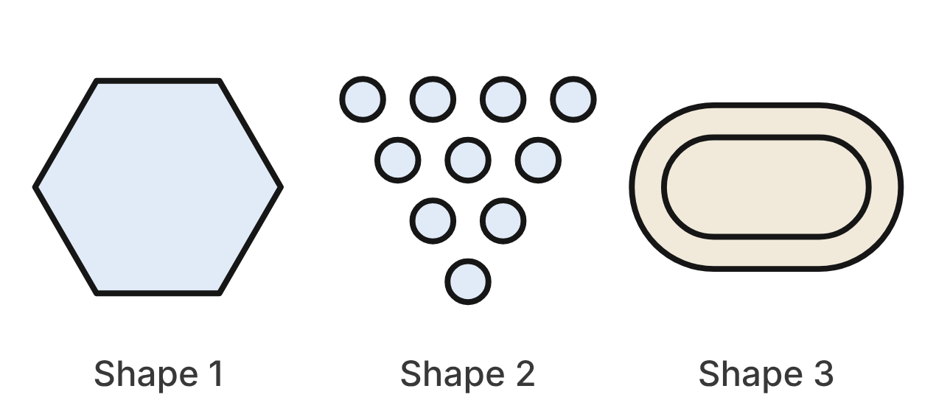
Shape 1 is a regular hexagon from a soccer ball. Shape 2 is the triangle of 10 bowling pins, seen from above. Shape 3 is a running track: two equal, parallel straight sides joined by two half circles.
91. How many lines of symmetry does Shape 1 have?
A. 3
B. 12
C. 6 ✔
D. 2
G.RLT.3 · skill G.RLT.3.1 (LOTS): Identify line symmetry and rotational symmetry of a figure
☐ Answer key correct ☐ Wording clear Notes: ________________________________
92. What is the smallest angle of rotation, about its center, that maps Shape 1 onto itself?
A. 120°
B. 30°
C. 180°
D. 60° ✔
G.RLT.3 · skill G.RLT.3.1 (LOTS): Identify line symmetry and rotational symmetry of a figure
☐ Answer key correct ☐ Wording clear Notes: ________________________________
93. What is the order of rotational symmetry of Shape 2?
A. 10
B. 3 ✔
C. 1
D. 6
G.RLT.3 · skill G.RLT.3.1 (LOTS): Identify line symmetry and rotational symmetry of a figure
☐ Answer key correct ☐ Wording clear Notes: ________________________________
94. Which describes the symmetry of Shape 3?
A. Both line and rotational symmetry ✔
B. Line symmetry only
C. Rotational symmetry only
D. Neither kind of symmetry
G.RLT.3 · skill G.RLT.3.1 (LOTS): Identify line symmetry and rotational symmetry of a figure
☐ Answer key correct ☐ Wording clear Notes: ________________________________
95. Which rotation about its center does NOT map Shape 1 onto itself?
A. 120°
B. 180°
C. 240°
D. 90° ✔
G.RLT.3 · skill G.RLT.3.1 (LOTS): Identify line symmetry and rotational symmetry of a figure
☐ Answer key correct ☐ Wording clear Notes: ________________________________
96. A photo of Shape 2 is enlarged by a dilation with scale factor 2. How many lines of symmetry does the enlarged shape have?
A. 6
B. 1
C. 3 ✔
D. 0
G.RLT.3 · skill G.RLT.3.3 (HOTS): Determine the transformation or composition that maps a preimage to an image, and whether it preserves size and shape
☐ Answer key correct ☐ Wording clear Notes: ________________________________

The Skate Park Ramp
Level 2 · Transformations · G.RLT.3 · ID geo-rlt3-raid-skate-ramp
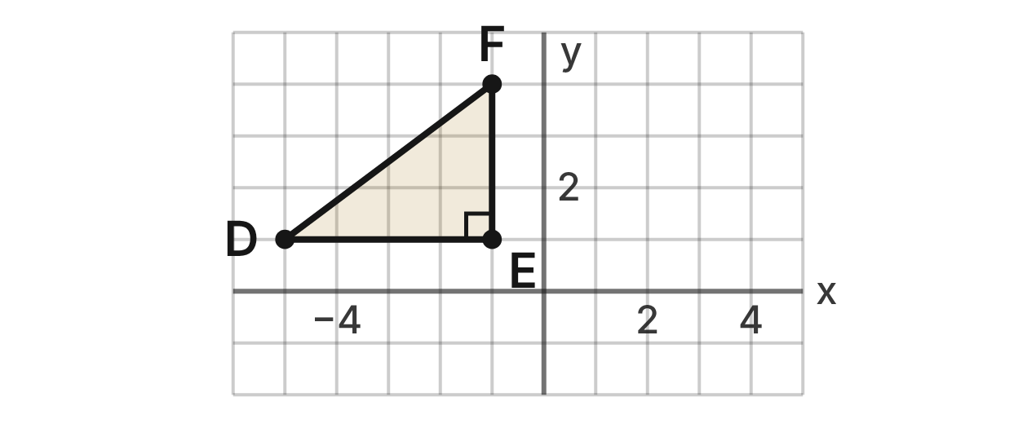
On a skate park plan, a ramp's footprint is right triangle DEF with D(−5, 1), E(−1, 1) and F(−1, 4). The right angle is at E.
97. What is the image of F after a reflection over the line y = x?
A. (−4, 1)
B. (1, 4)
C. (−1, −4)
D. (4, −1) ✔
G.RLT.3 · skill G.RLT.3.2 (LOTS): Find the image of a figure on the coordinate plane under a translation, reflection, rotation or dilation
☐ Answer key correct ☐ Wording clear Notes: ________________________________
98. What is the image of D after a reflection over the line y = −x?
A. (1, −5)
B. (5, −1)
C. (−1, 5) ✔
D. (−1, −5)
G.RLT.3 · skill G.RLT.3.2 (LOTS): Find the image of a figure on the coordinate plane under a translation, reflection, rotation or dilation
☐ Answer key correct ☐ Wording clear Notes: ________________________________
99. What is the image of F after a rotation of 90° counterclockwise about the origin?
A. (−4, −1) ✔
B. (4, 1)
C. (1, −4)
D. (−4, 1)
G.RLT.3 · skill G.RLT.3.2 (LOTS): Find the image of a figure on the coordinate plane under a translation, reflection, rotation or dilation
☐ Answer key correct ☐ Wording clear Notes: ________________________________
100. A builder tries the rule (x, y) → (x + 4, 2y) on the ramp. Is the new footprint congruent to △DEF?
A. Yes; adding 4 to x is a translation.
B. No; it gets taller but not wider. ✔
C. Yes; it is still a right triangle.
D. No; it is a dilation by scale factor 2.
G.RLT.3 · skill G.RLT.3.3 (HOTS): Determine the transformation or composition that maps a preimage to an image, and whether it preserves size and shape
☐ Answer key correct ☐ Wording clear Notes: ________________________________
101. A second ramp has D′(1, 5), E′(1, 1) and F′(4, 1). Which single transformation maps △DEF to △D′E′F′?
A. Rotation of 90° counterclockwise about the origin
B. Reflection over the line y = x
C. Rotation of 90° clockwise about the origin ✔
D. Reflection over the x-axis
G.RLT.3 · skill G.RLT.3.3 (HOTS): Determine the transformation or composition that maps a preimage to an image, and whether it preserves size and shape
☐ Answer key correct ☐ Wording clear Notes: ________________________________
102. The ramp is moved by a translation so that E lands at (3, −2). Where does D land?
A. (−1, −2) ✔
B. (−9, 4)
C. (−1, 4)
D. (−2, −1)
G.RLT.3 · skill G.RLT.3.2 (LOTS): Find the image of a figure on the coordinate plane under a translation, reflection, rotation or dilation
☐ Answer key correct ☐ Wording clear Notes: ________________________________

Home Plate on the Scoreboard
Level 2 · Transformations · G.RLT.3 · ID geo-rlt3-raid-home-plate
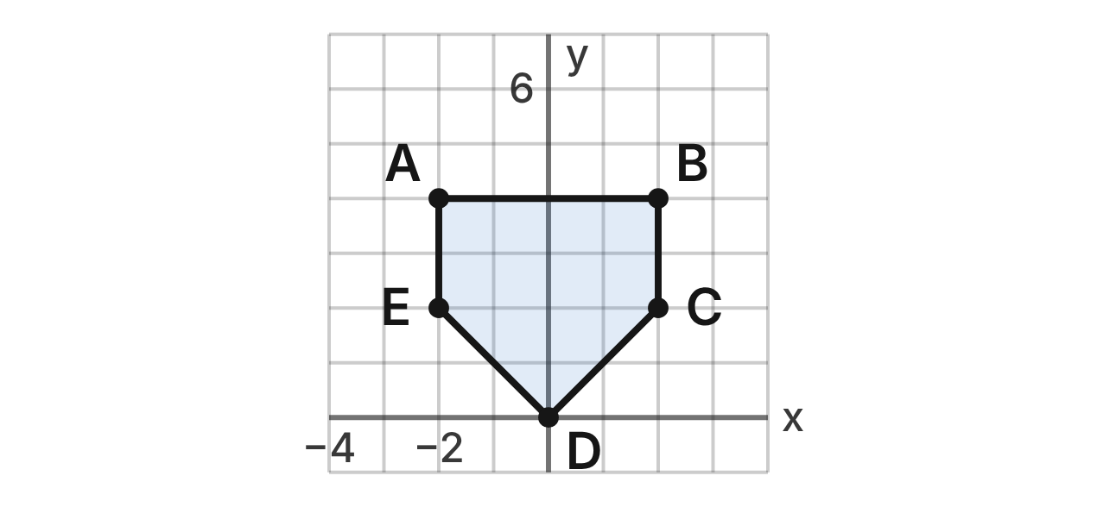
A scoreboard draws home plate as pentagon ABCDE: A(−2, 4), B(2, 4), C(2, 2), D(0, 0) and E(−2, 2). Its perimeter is 8 + 4√2 units and its area is 12 square units. The animation dilates it about the origin.
103. Under a dilation with scale factor 3/2 centered at the origin, what is the image of C?
A. (3, 3) ✔
B. (3.5, 3.5)
C. (3, 2)
D. (6, 6)
G.RLT.3 · skill G.RLT.3.2 (LOTS): Find the image of a figure on the coordinate plane under a translation, reflection, rotation or dilation
☐ Answer key correct ☐ Wording clear Notes: ________________________________
104. Under a dilation with scale factor 3/2 centered at the origin, which vertices are their own images?
A. None of them
B. D only ✔
C. C and E
D. A and B
G.RLT.3 · skill G.RLT.3.3 (HOTS): Determine the transformation or composition that maps a preimage to an image, and whether it preserves size and shape
☐ Answer key correct ☐ Wording clear Notes: ________________________________
105. What is the perimeter of the image of ABCDE under a dilation with scale factor 3/2 centered at the origin?
A. 8 + 4√2 units
B. 18 + 9√2 units
C. 12 + 4√2 units
D. 12 + 6√2 units ✔
G.RLT.3 · skill G.RLT.3.2 (LOTS): Find the image of a figure on the coordinate plane under a translation, reflection, rotation or dilation
☐ Answer key correct ☐ Wording clear Notes: ________________________________
106. What is the area of the image of ABCDE under a dilation with scale factor 1/2 centered at the origin?
A. 6 square units
B. 12 square units
C. 3 square units ✔
D. 48 square units
G.RLT.3 · skill G.RLT.3.2 (LOTS): Find the image of a figure on the coordinate plane under a translation, reflection, rotation or dilation
☐ Answer key correct ☐ Wording clear Notes: ________________________________
107. Which line is a line of symmetry of ABCDE?
A. The x-axis
B. The line y = 2
C. The line y = x
D. The y-axis ✔
G.RLT.3 · skill G.RLT.3.1 (LOTS): Identify line symmetry and rotational symmetry of a figure
☐ Answer key correct ☐ Wording clear Notes: ________________________________
108. A dilation centered at the origin makes a small plate whose image of side AB is 1 unit long. What is the scale factor?
A. 4
B. 1/4 ✔
C. 3
D. 1/16
G.RLT.3 · skill G.RLT.3.3 (HOTS): Determine the transformation or composition that maps a preimage to an image, and whether it preserves size and shape
☐ Answer key correct ☐ Wording clear Notes: ________________________________

The Falling-Block Game
Level 2 · Transformations · G.RLT.3 · ID geo-rlt3-raid-block-game
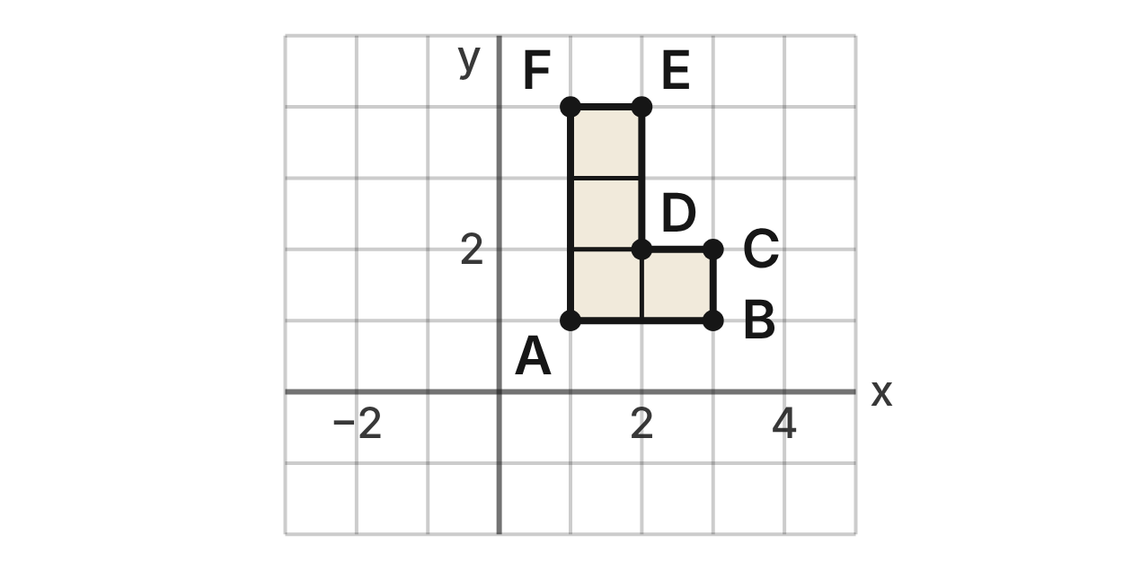
In a falling-block video game, an L piece is hexagon ABCDEF with A(1, 1), B(3, 1), C(3, 2), D(2, 2), E(2, 4) and F(1, 4). The game turns pieces about the origin.
109. What is the image of F after a rotation of 90° clockwise about the origin?
A. (−4, 1)
B. (−1, −4)
C. (4, −1) ✔
D. (4, 1)
G.RLT.3 · skill G.RLT.3.2 (LOTS): Find the image of a figure on the coordinate plane under a translation, reflection, rotation or dilation
☐ Answer key correct ☐ Wording clear Notes: ________________________________
110. What is the image of B after a rotation of 180° about the origin?
A. (−3, −1) ✔
B. (−3, 1)
C. (3, −1)
D. (−1, −3)
G.RLT.3 · skill G.RLT.3.2 (LOTS): Find the image of a figure on the coordinate plane under a translation, reflection, rotation or dilation
☐ Answer key correct ☐ Wording clear Notes: ________________________________
111. The game shows the piece at A′(−1, 1), B′(−1, 3), C′(−2, 3), D′(−2, 2), E′(−4, 2) and F′(−4, 1). Which rotation about the origin maps ABCDEF to A′B′C′D′E′F′?
A. 90° clockwise
B. 270° clockwise ✔
C. 180°
D. 270° counterclockwise
G.RLT.3 · skill G.RLT.3.3 (HOTS): Determine the transformation or composition that maps a preimage to an image, and whether it preserves size and shape
☐ Answer key correct ☐ Wording clear Notes: ________________________________
112. A player wants the mirror image of the L piece (a J piece). Can a rotation about the origin make it?
A. Yes; a 180° rotation flips it over.
B. Yes; a 90° rotation flips it over.
C. No; a rotation changes its size.
D. No; a rotation never flips a piece over. ✔
G.RLT.3 · skill G.RLT.3.3 (HOTS): Determine the transformation or composition that maps a preimage to an image, and whether it preserves size and shape
☐ Answer key correct ☐ Wording clear Notes: ________________________________
113. The piece is rotated 180° about the origin and then translated by (x, y) → (x + 4, y). Where does D end up?
A. (2, −2) ✔
B. (−6, −2)
C. (−2, −2)
D. (−2, 2)
G.RLT.3 · skill G.RLT.3.2 (LOTS): Find the image of a figure on the coordinate plane under a translation, reflection, rotation or dilation
☐ Answer key correct ☐ Wording clear Notes: ________________________________
114. Which describes the symmetry of the L piece?
A. One line of symmetry, the line y = x
B. Rotational symmetry of order 4
C. No line symmetry and no rotational symmetry ✔
D. One line of symmetry, the line x = 2
G.RLT.3 · skill G.RLT.3.1 (LOTS): Identify line symmetry and rotational symmetry of a figure
☐ Answer key correct ☐ Wording clear Notes: ________________________________

The Kickboard and the Lane Rope
Level 2 · Transformations · G.RLT.3 · ID geo-rlt3-raid-kickboard
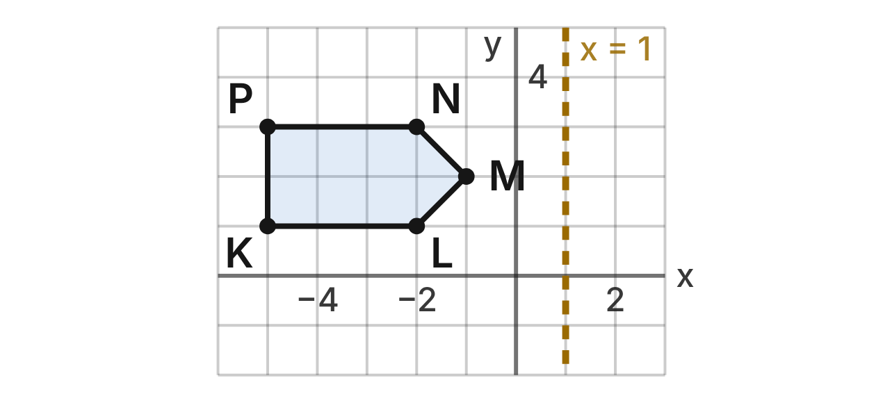
A pool map uses a grid in meters. A kickboard is pentagon KLMNP with K(−5, 1), L(−2, 1), M(−1, 2), N(−2, 3) and P(−5, 3). A lane rope lies along the line x = 1.
115. What is the image of K after a reflection over the lane rope, x = 1?
A. (5, 1)
B. (7, 1) ✔
C. (−3, 1)
D. (6, 1)
G.RLT.3 · skill G.RLT.3.2 (LOTS): Find the image of a figure on the coordinate plane under a translation, reflection, rotation or dilation
☐ Answer key correct ☐ Wording clear Notes: ________________________________
116. What is the image of N after a reflection over the line y = −1?
A. (−2, −3)
B. (−2, 1)
C. (4, 3)
D. (−2, −5) ✔
G.RLT.3 · skill G.RLT.3.2 (LOTS): Find the image of a figure on the coordinate plane under a translation, reflection, rotation or dilation
☐ Answer key correct ☐ Wording clear Notes: ________________________________
117. The kickboard is reflected over the line x = 1 and then over the line x = 4. Which single transformation has the same result?
A. A translation 3 units right
B. A translation 6 units left
C. A translation 6 units right ✔
D. A reflection over the line x = 5
G.RLT.3 · skill G.RLT.3.3 (HOTS): Determine the transformation or composition that maps a preimage to an image, and whether it preserves size and shape
☐ Answer key correct ☐ Wording clear Notes: ________________________________
118. Over which line would you reflect the kickboard so that K lands on (3, 1)?
A. x = −1 ✔
B. x = 4
C. the y-axis
D. x = −2
G.RLT.3 · skill G.RLT.3.3 (HOTS): Determine the transformation or composition that maps a preimage to an image, and whether it preserves size and shape
☐ Answer key correct ☐ Wording clear Notes: ________________________________
119. Which line is a line of symmetry of kickboard KLMNP?
A. x = −3
B. x = 1
C. y = 2 ✔
D. y = 1
G.RLT.3 · skill G.RLT.3.1 (LOTS): Identify line symmetry and rotational symmetry of a figure
☐ Answer key correct ☐ Wording clear Notes: ________________________________
120. Which property does a reflection keep but a dilation with scale factor 2 does NOT keep?
A. Angle measures
B. Parallel sides stay parallel
C. Clockwise order of the vertices
D. Side lengths ✔
G.RLT.3 · skill G.RLT.3.3 (HOTS): Determine the transformation or composition that maps a preimage to an image, and whether it preserves size and shape
☐ Answer key correct ☐ Wording clear Notes: ________________________________

Moving the Archery Targets
Level 3 · Transformations · G.RLT.3 · ID geo-rlt3-raid-archery
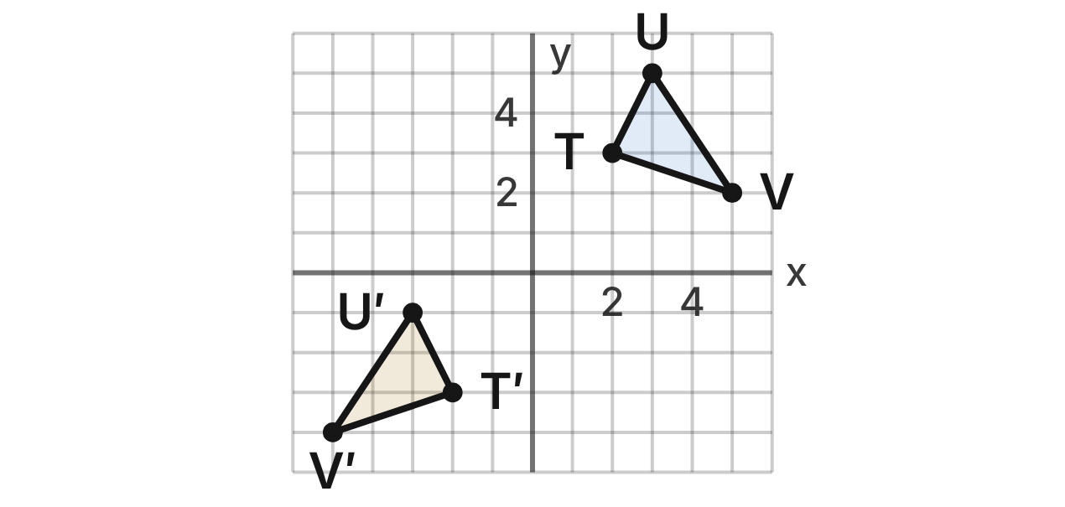
On the archery range map, a target stand is △TUV with T(2, 3), U(3, 5) and V(5, 2). After the range is rearranged, the stand is △T′U′V′ with T′(−2, −3), U′(−3, −1) and V′(−5, −4).
121. Which composition maps △TUV to △T′U′V′?
A. Reflect over the y-axis, then translate 6 units down ✔
B. Reflect over the x-axis, then translate 6 units left
C. Translate 6 units down, then reflect over the x-axis
D. Reflect over the y-axis, then translate 6 units up
G.RLT.3 · skill G.RLT.3.3 (HOTS): Determine the transformation or composition that maps a preimage to an image, and whether it preserves size and shape
☐ Answer key correct ☐ Wording clear Notes: ________________________________
122. Which statement about △T′U′V′ is true?
A. It is congruent to △TUV, with the same orientation.
B. It is similar to △TUV, but smaller.
C. It is congruent to △TUV, with opposite orientation. ✔
D. It is a 180° rotation of △TUV about the origin.
G.RLT.3 · skill G.RLT.3.3 (HOTS): Determine the transformation or composition that maps a preimage to an image, and whether it preserves size and shape
☐ Answer key correct ☐ Wording clear Notes: ________________________________
123. What is the image of U after a rotation of 270° clockwise about the origin?
A. (5, −3)
B. (−3, −5)
C. (3, −5)
D. (−5, 3) ✔
G.RLT.3 · skill G.RLT.3.2 (LOTS): Find the image of a figure on the coordinate plane under a translation, reflection, rotation or dilation
☐ Answer key correct ☐ Wording clear Notes: ________________________________
124. △TUV is dilated by scale factor 1/2 centered at the origin, then translated by (x, y) → (x + 3, y − 1). Where does V end up?
A. (4, 0.5)
B. (5.5, 0) ✔
C. (13, 3)
D. (2.5, 1)
G.RLT.3 · skill G.RLT.3.2 (LOTS): Find the image of a figure on the coordinate plane under a translation, reflection, rotation or dilation
☐ Answer key correct ☐ Wording clear Notes: ________________________________
125. Reflecting △TUV over the x-axis and then over the y-axis gives the same image as which single transformation?
A. Reflection over the line y = x
B. Rotation of 180° about the origin ✔
C. Rotation of 90° counterclockwise about the origin
D. Reflection over the line y = −x
G.RLT.3 · skill G.RLT.3.3 (HOTS): Determine the transformation or composition that maps a preimage to an image, and whether it preserves size and shape
☐ Answer key correct ☐ Wording clear Notes: ________________________________
126. Kai writes the rule for a 90° clockwise rotation about the origin as (x, y) → (−y, x). What is wrong?
A. It turns counterclockwise; T should go to (3, −2). ✔
B. Nothing; T goes to (−3, 2).
C. Both signs change; T should go to (−3, −2).
D. Only swap; T should go to (3, 2).
G.RLT.3 · skill G.RLT.3.2 (LOTS): Find the image of a figure on the coordinate plane under a translation, reflection, rotation or dilation
☐ Answer key correct ☐ Wording clear Notes: ________________________________

The Esports Team Logo
Level 3 · Transformations · G.RLT.3 · ID geo-rlt3-raid-esports-logo
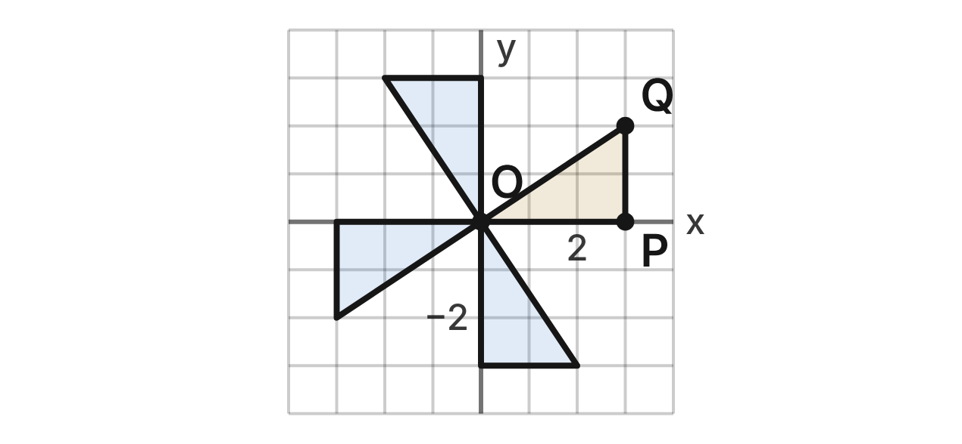
An esports team's logo is four congruent right triangles that meet at the origin O. One blade is △OPQ with O(0, 0), P(3, 0) and Q(3, 2). The other blades are its images under rotations of 90°, 180° and 270° about O.
127. What is the order of rotational symmetry of the logo?
A. 1
B. 2
C. 8
D. 4 ✔
G.RLT.3 · skill G.RLT.3.1 (LOTS): Identify line symmetry and rotational symmetry of a figure
☐ Answer key correct ☐ Wording clear Notes: ________________________________
128. How many lines of symmetry does the logo have?
A. 4
B. 0 ✔
C. 2
D. 1
G.RLT.3 · skill G.RLT.3.1 (LOTS): Identify line symmetry and rotational symmetry of a figure
☐ Answer key correct ☐ Wording clear Notes: ________________________________
129. Which transformation does NOT map the logo onto itself?
A. Reflection over the line y = x ✔
B. Rotation of 90° clockwise about O
C. Rotation of 180° about O
D. Rotation of 270° clockwise about O
G.RLT.3 · skill G.RLT.3.3 (HOTS): Determine the transformation or composition that maps a preimage to an image, and whether it preserves size and shape
☐ Answer key correct ☐ Wording clear Notes: ________________________________
130. For a jersey, the logo is dilated by scale factor 1.5 centered at O. What is the image of Q?
A. (4.5, 3.5)
B. (4.5, 2)
C. (4.5, 3) ✔
D. (6, 4)
G.RLT.3 · skill G.RLT.3.2 (LOTS): Find the image of a figure on the coordinate plane under a translation, reflection, rotation or dilation
☐ Answer key correct ☐ Wording clear Notes: ________________________________
131. For a banner, the logo is reflected over the y-axis. Which is true of the mirrored logo?
A. It is exactly the same as the logo.
B. It is the logo turned 90° about O.
C. It now has 4 lines of symmetry.
D. It has order 4, but its blades turn the other way. ✔
G.RLT.3 · skill G.RLT.3.3 (HOTS): Determine the transformation or composition that maps a preimage to an image, and whether it preserves size and shape
☐ Answer key correct ☐ Wording clear Notes: ________________________________
132. Q(3, 2) is rotated 90° counterclockwise about O and then reflected over the x-axis. Where does Q end up?
A. (2, 3)
B. (−2, −3) ✔
C. (−2, 3)
D. (−3, 2)
G.RLT.3 · skill G.RLT.3.2 (LOTS): Find the image of a figure on the coordinate plane under a translation, reflection, rotation or dilation
☐ Answer key correct ☐ Wording clear Notes: ________________________________

Triangles (G.TR)

G.TR.1 · Determine the relationships between the measures of angles and lengths of sides in triangles, including problems in context.

Three Players, One Ball
Level 1 · Triangles · G.TR.1 · ID geo-tr1-raid-corner-kick
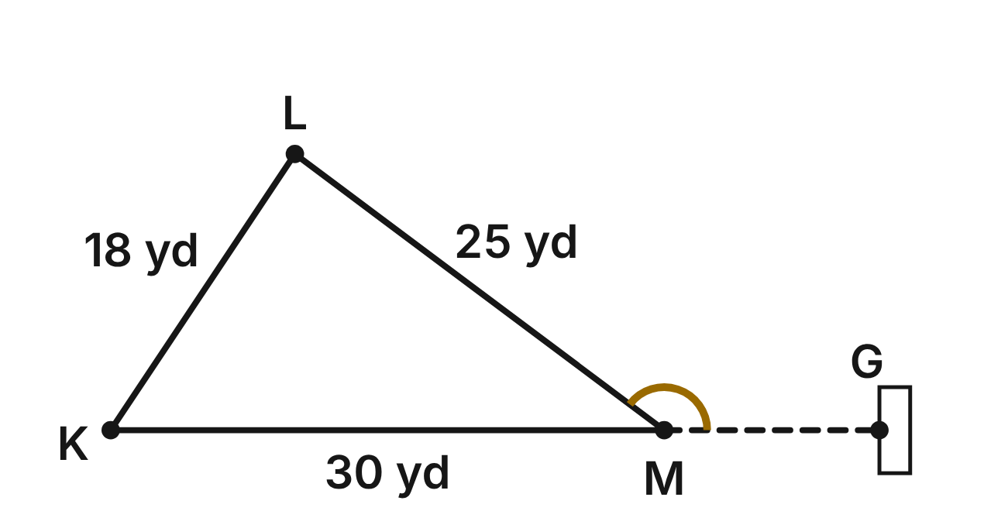
Soccer players stand at K (Kim), L (Luis) and M (Maya): KL = 18 yd, LM = 25 yd and KM = 30 yd. The line from Kim through Maya continues straight to the goal post G.
133. Using the three distances, which angle of △KLM is the largest?
A. ∠K
B. ∠L ✔
C. ∠M
D. You need a protractor to tell.
G.TR.1 · skill G.TR.1.1 (LOTS): Order the sides of a triangle by length given its angles, or its angles by size given its sides
☐ Answer key correct ☐ Wording clear Notes: ________________________________
134. Which list orders the angles of △KLM from smallest to largest?
A. ∠L, ∠K, ∠M
B. ∠K, ∠L, ∠M
C. ∠K, ∠M, ∠L
D. ∠M, ∠K, ∠L ✔
G.TR.1 · skill G.TR.1.1 (LOTS): Order the sides of a triangle by length given its angles, or its angles by size given its sides
☐ Answer key correct ☐ Wording clear Notes: ________________________________
135. The coach measures m∠K ≈ 56° and m∠M ≈ 37°. What is m∠L, to the nearest degree?
A. 87° ✔
B. 93°
C. 124°
D. 267°
G.TR.1 · skill G.TR.1.3 (LOTS): Solve problems using the triangle angle sum and the exterior angle theorem
☐ Answer key correct ☐ Wording clear Notes: ________________________________
136. m∠KML ≈ 37°. What is m∠LMG, to the nearest degree?
A. 37°
B. 53°
C. 143° ✔
D. 323°
G.TR.1 · skill G.TR.1.3 (LOTS): Solve problems using the triangle angle sum and the exterior angle theorem
☐ Answer key correct ☐ Wording clear Notes: ________________________________
137. Luis moves, but stays 18 yd from Kim. Kim and Maya stay 30 yd apart, and the three players still form a triangle. Which could be the new distance LM?
A. 11 yd
B. 12 yd
C. 48 yd
D. 40 yd ✔
G.TR.1 · skill G.TR.1.2 (LOTS): Decide whether three lengths can form a triangle and find the range of possible lengths of the third side
☐ Answer key correct ☐ Wording clear Notes: ________________________________
138. Nia says she is 9 yd from Kim and 20 yd from Maya. Kim and Maya are 30 yd apart. Why must one of Nia's distances be wrong?
A. 9 + 30 is greater than 20.
B. 9 + 20 is less than 30. ✔
C. 20 − 9 is less than 30.
D. No two of the distances are equal.
G.TR.1 · skill G.TR.1.2 (LOTS): Decide whether three lengths can form a triangle and find the range of possible lengths of the third side
☐ Answer key correct ☐ Wording clear Notes: ________________________________

The Pin Rack
Level 1 · Triangles · G.TR.1 · ID geo-tr1-raid-pin-rack
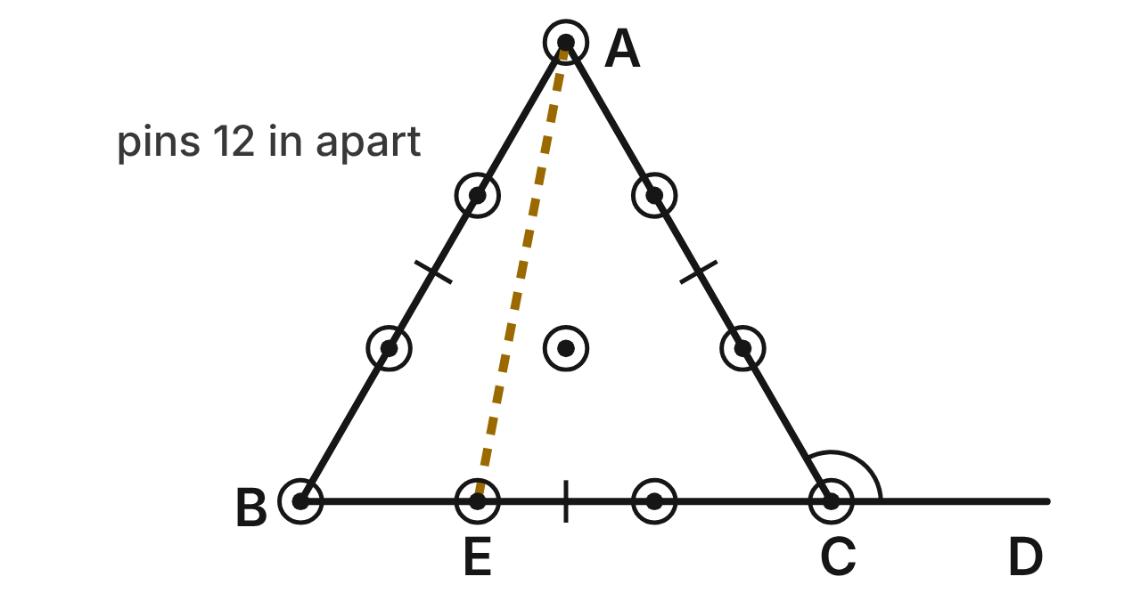
Ten pins stand 12 in apart, so the rack is an equilateral triangle ABC with sides of 36 in. Pin E is next to B on the back row, so BE = 12 in and AE ≈ 31.7 in. The back row BC is extended past C to D.
139. What is the measure of each angle of the rack, △ABC?
A. 180°
B. 90°
C. 60° ✔
D. 120°
G.TR.1 · skill G.TR.1.3 (LOTS): Solve problems using the triangle angle sum and the exterior angle theorem
☐ Answer key correct ☐ Wording clear Notes: ________________________________
140. What is m∠ACD?
A. 120° ✔
B. 60°
C. 180°
D. 300°
G.TR.1 · skill G.TR.1.3 (LOTS): Solve problems using the triangle angle sum and the exterior angle theorem
☐ Answer key correct ☐ Wording clear Notes: ________________________________
141. In △ABE, which angle is the largest?
A. ∠ABE
B. ∠AEB ✔
C. ∠BAE
D. All three are 60°.
G.TR.1 · skill G.TR.1.1 (LOTS): Order the sides of a triangle by length given its angles, or its angles by size given its sides
☐ Answer key correct ☐ Wording clear Notes: ________________________________
142. In △ABE, m∠BAE ≈ 19°. What is m∠AEB, to the nearest degree?
A. 79°
B. 161°
C. 41°
D. 101° ✔
G.TR.1 · skill G.TR.1.3 (LOTS): Solve problems using the triangle angle sum and the exterior angle theorem
☐ Answer key correct ☐ Wording clear Notes: ________________________________
143. The bowling alley's logo is an isosceles triangle with a 40° vertex angle. What is the measure of each base angle?
A. 140°
B. 70° ✔
C. 40°
D. 50°
G.TR.1 · skill G.TR.1.3 (LOTS): Solve problems using the triangle angle sum and the exterior angle theorem
☐ Answer key correct ☐ Wording clear Notes: ________________________________
144. Which three lengths, in inches, could NOT be the sides of a triangle?
A. 12, 12, 20
B. 12, 30, 36
C. 12, 24, 36 ✔
D. 20, 20, 36
G.TR.1 · skill G.TR.1.2 (LOTS): Decide whether three lengths can form a triangle and find the range of possible lengths of the third side
☐ Answer key correct ☐ Wording clear Notes: ________________________________

The Pump Track Loop
Level 2 · Triangles · G.TR.1 · ID geo-tr1-raid-pump-track
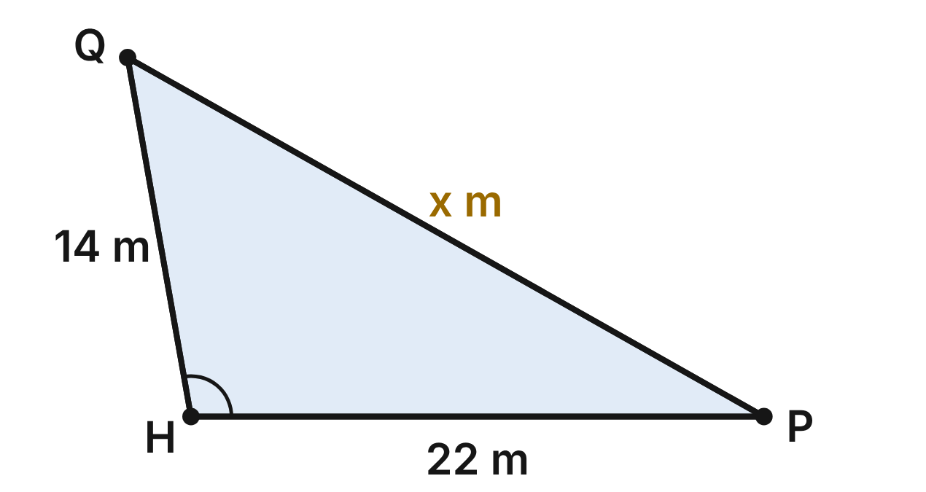
A skate park's pump track is a triangular loop HPQ. Side HP is 22 m and side HQ is 14 m. The designer has not yet chosen the length x of side PQ.
145. Which inequality gives all possible values of x, in meters?
A. 0 < x < 36
B. 8 < x < 36 ✔
C. 8 < x < 22
D. 14 < x < 22
G.TR.1 · skill G.TR.1.2 (LOTS): Decide whether three lengths can form a triangle and find the range of possible lengths of the third side
☐ Answer key correct ☐ Wording clear Notes: ________________________________
146. How many whole-number lengths, in meters, could x be?
A. 27 ✔
B. 28
C. 29
D. 35
G.TR.1 · skill G.TR.1.2 (LOTS): Decide whether three lengths can form a triangle and find the range of possible lengths of the third side
☐ Answer key correct ☐ Wording clear Notes: ________________________________
147. Suppose the designer makes x = 30 m. Which angle of the loop is then the largest?
A. ∠P
B. ∠Q
C. ∠H ✔
D. It cannot be found without a protractor.
G.TR.1 · skill G.TR.1.1 (LOTS): Order the sides of a triangle by length given its angles, or its angles by size given its sides
☐ Answer key correct ☐ Wording clear Notes: ________________________________
148. Suppose the designer makes x = 18 m. Which statement is then true?
A. m∠H is greater than m∠Q.
B. m∠P is greater than m∠H.
C. m∠P is greater than m∠Q.
D. m∠Q is greater than m∠H. ✔
G.TR.1 · skill G.TR.1.1 (LOTS): Order the sides of a triangle by length given its angles, or its angles by size given its sides
☐ Answer key correct ☐ Wording clear Notes: ________________________________
149. Another loop will have sides of 12 m, 20 m and (2y − 4) m. What is the least whole number y could be?
A. 7 ✔
B. 6
C. 8
D. 3
G.TR.1 · skill G.TR.1.2 (LOTS): Decide whether three lengths can form a triangle and find the range of possible lengths of the third side
☐ Answer key correct ☐ Wording clear Notes: ________________________________
150. Suppose the designer makes m∠H = 100°. Then m∠P ≈ 29°. What is m∠Q, to the nearest degree?
A. 129°
B. 80°
C. 51° ✔
D. 151°
G.TR.1 · skill G.TR.1.3 (LOTS): Solve problems using the triangle angle sum and the exterior angle theorem
☐ Answer key correct ☐ Wording clear Notes: ________________________________

The Video Game Map
Level 2 · Triangles · G.TR.1 · ID geo-tr1-raid-game-map
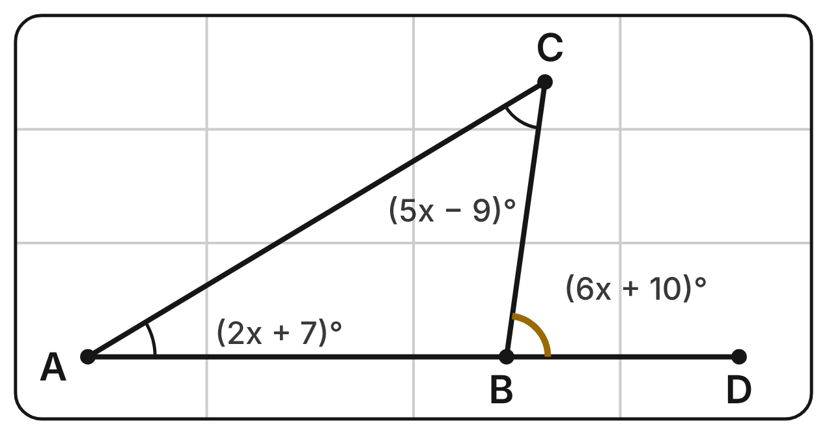
On a video game map, routes join the checkpoints A, B and C. The route from A through B goes straight on to D. m∠A = (2x + 7)⁠°, m∠BCA = (5x − 9)⁠° and m∠CBD = (6x + 10)⁠°.
151. Which equation can be used to find x?
A. (2x + 7) + (5x − 9) + (6x + 10) = 180
B. 6x + 10 = (2x + 7) + (5x − 9) ✔
C. (6x + 10) + (5x − 9) = 180
D. (2x + 7) + (5x − 9) = 180
G.TR.1 · skill G.TR.1.3 (LOTS): Solve problems using the triangle angle sum and the exterior angle theorem
☐ Answer key correct ☐ Wording clear Notes: ________________________________
152. What is m∠ABC?
A. 98° ✔
B. 82°
C. 51°
D. 149°
G.TR.1 · skill G.TR.1.3 (LOTS): Solve problems using the triangle angle sum and the exterior angle theorem
☐ Answer key correct ☐ Wording clear Notes: ________________________________
153. Which list orders the routes from shortest to longest?
A. AC, AB, BC
B. AB, AC, BC
C. BC, AB, AC ✔
D. BC, AC, AB
G.TR.1 · skill G.TR.1.1 (LOTS): Order the sides of a triangle by length given its angles, or its angles by size given its sides
☐ Answer key correct ☐ Wording clear Notes: ________________________________
154. Which theorem says that m∠CBD = m∠A + m∠BCA?
A. Vertical Angles Theorem
B. Isosceles Triangle Theorem
C. Triangle Inequality Theorem
D. Exterior Angle Theorem ✔
G.TR.1 · skill G.TR.1.3 (LOTS): Solve problems using the triangle angle sum and the exterior angle theorem
☐ Answer key correct ☐ Wording clear Notes: ________________________________
155. In a new level, two routes from one checkpoint are 35 and 50 units long, and a third route closes the triangle. Which could NOT be the length of the third route?
A. 16 units
B. 50 units
C. 84 units
D. 85 units ✔
G.TR.1 · skill G.TR.1.2 (LOTS): Decide whether three lengths can form a triangle and find the range of possible lengths of the third side
☐ Answer key correct ☐ Wording clear Notes: ________________________________
156. Kai says: ∠A is the smallest angle, so AB, a side at A, is the shortest route. What is Kai's error?
A. ∠C is the smallest angle, not ∠A.
B. The shortest side is opposite ∠A, so it is BC. ✔
C. The shortest side is AC, the other side at A.
D. Kai made no error.
G.TR.1 · skill G.TR.1.1 (LOTS): Order the sides of a triangle by length given its angles, or its angles by size given its sides
☐ Answer key correct ☐ Wording clear Notes: ________________________________

The Open-Water Swim
Level 2 · Triangles · G.TR.1 · ID geo-tr1-raid-swim-course
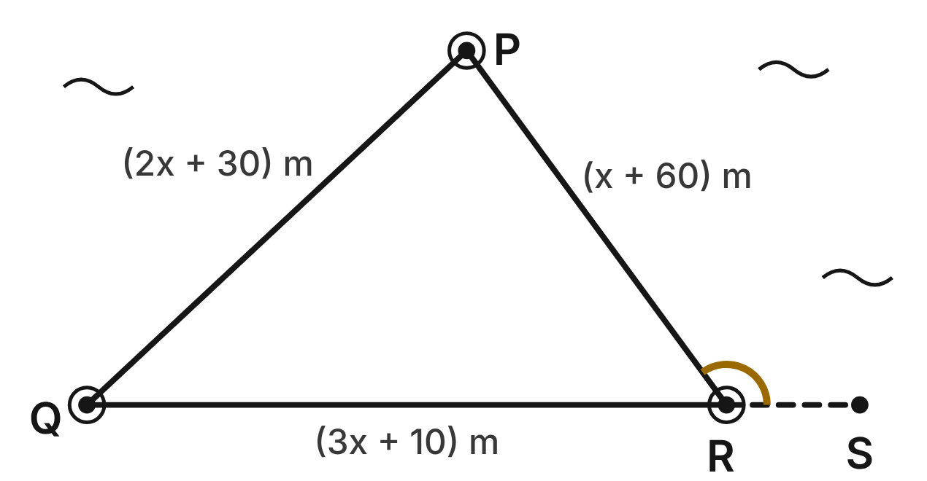
A swim course is the triangle PQR, with a buoy at each corner. PQ = (2x + 30) m, QR = (3x + 10) m and PR = (x + 60) m. The whole loop is 400 m. The line of leg QR continues straight past R to the dock S.
157. Which angle of the course is the largest?
A. ∠P, opposite QR ✔
B. ∠Q, between the two longest legs
C. ∠R, opposite PQ
D. You cannot tell until you know x.
G.TR.1 · skill G.TR.1.1 (LOTS): Order the sides of a triangle by length given its angles, or its angles by size given its sides
☐ Answer key correct ☐ Wording clear Notes: ________________________________
158. Before the loop length was set, the planner tried x = 5. Could the three legs form a triangle then?
A. Yes, because 25 + 65 is greater than 40.
B. Yes, because every leg is a positive length.
C. No, because 40 + 25 is not greater than 65. ✔
D. No, because the three legs are not equal.
G.TR.1 · skill G.TR.1.2 (LOTS): Decide whether three lengths can form a triangle and find the range of possible lengths of the third side
☐ Answer key correct ☐ Wording clear Notes: ________________________________
159. Ignore the 400 m loop length. For which values of x do the three expressions form a triangle?
A. x > 0
B. x > −20
C. x ≥ 5
D. x > 5 ✔
G.TR.1 · skill G.TR.1.2 (LOTS): Decide whether three lengths can form a triangle and find the range of possible lengths of the third side
☐ Answer key correct ☐ Wording clear Notes: ________________________________
160. The angles of the course are m∠P ≈ 83° and m∠Q ≈ 43°. What is m∠R, to the nearest degree?
A. 126°
B. 54° ✔
C. 97°
D. 137°
G.TR.1 · skill G.TR.1.3 (LOTS): Solve problems using the triangle angle sum and the exterior angle theorem
☐ Answer key correct ☐ Wording clear Notes: ________________________________
161. The angles of the course are m∠P ≈ 83° and m∠Q ≈ 43°. What is m∠PRS, to the nearest degree?
A. 54°
B. 40°
C. 126° ✔
D. 234°
G.TR.1 · skill G.TR.1.3 (LOTS): Solve problems using the triangle angle sum and the exterior angle theorem
☐ Answer key correct ☐ Wording clear Notes: ________________________________
162. How long is the leg opposite the largest angle of the course?
A. 160 m ✔
B. 110 m
C. 130 m
D. 210 m
G.TR.1 · skill G.TR.1.1 (LOTS): Order the sides of a triangle by length given its angles, or its angles by size given its sides
☐ Answer key correct ☐ Wording clear Notes: ________________________________

The Pitcher's Mound
Level 3 · Triangles · G.TR.1 · ID geo-tr1-raid-pitchers-mound
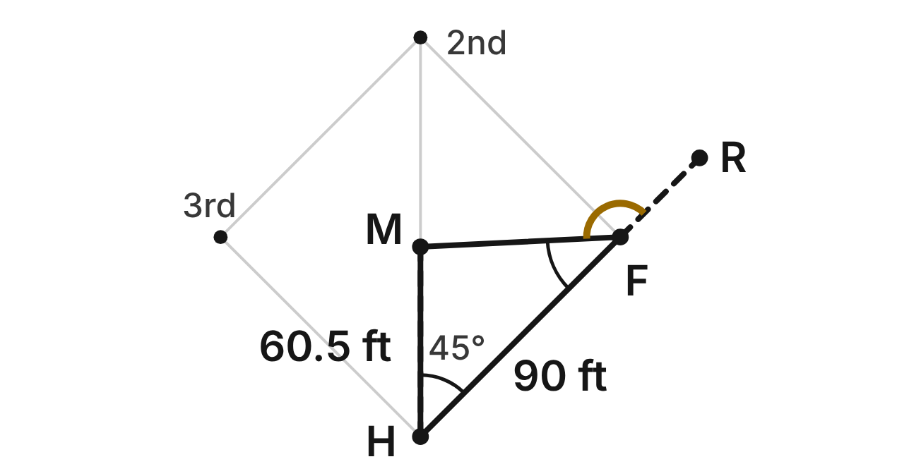
On a baseball field, the pitcher's mound M is on the line from home plate H to second base, so m∠MHF = 45°. HM = 60.5 ft and HF = 90 ft, and m∠HFM ≈ 42°. The baseline HF continues straight past first base F to R.
163. What is m∠HMF, to the nearest degree?
A. 87°
B. 135°
C. 138°
D. 93° ✔
G.TR.1 · skill G.TR.1.3 (LOTS): Solve problems using the triangle angle sum and the exterior angle theorem
☐ Answer key correct ☐ Wording clear Notes: ________________________________
164. Which list orders the sides of △HMF from shortest to longest?
A. HF, MF, HM
B. HM, MF, HF ✔
C. MF, HM, HF
D. HM, HF, MF
G.TR.1 · skill G.TR.1.1 (LOTS): Order the sides of a triangle by length given its angles, or its angles by size given its sides
☐ Answer key correct ☐ Wording clear Notes: ________________________________
165. Using only the triangle inequality, which gives all possible lengths of MF, in feet?
A. 0 < MF < 150.5
B. 29.5 < MF < 90
C. 29.5 < MF < 150.5 ✔
D. 60.5 < MF < 150.5
G.TR.1 · skill G.TR.1.2 (LOTS): Decide whether three lengths can form a triangle and find the range of possible lengths of the third side
☐ Answer key correct ☐ Wording clear Notes: ________________________________
166. Use the angles and the side lengths. About how far is the mound from first base?
A. about 64 ft ✔
B. about 55 ft
C. about 95 ft
D. about 152 ft
G.TR.1 · skill G.TR.1.1 (LOTS): Order the sides of a triangle by length given its angles, or its angles by size given its sides
☐ Answer key correct ☐ Wording clear Notes: ________________________________
167. What is m∠MFR, to the nearest degree?
A. 42°
B. 87°
C. 135°
D. 138° ✔
G.TR.1 · skill G.TR.1.3 (LOTS): Solve problems using the triangle angle sum and the exterior angle theorem
☐ Answer key correct ☐ Wording clear Notes: ________________________________
168. Mira says MF could be 30 ft, because 30 ft passes all three triangle inequality tests. Why is she wrong?
A. 30 + 60.5 is less than 90.
B. MF is opposite the largest angle, so it must be longer than HF.
C. ∠H is larger than ∠F, so MF must be longer than HM. ✔
D. MF must equal HM, since M is on the diagonal.
G.TR.1 · skill G.TR.1.1 (LOTS): Order the sides of a triangle by length given its angles, or its angles by size given its sides
☐ Answer key correct ☐ Wording clear Notes: ________________________________

The Passing Drill
Level 3 · Triangles · G.TR.1 · ID geo-tr1-raid-pass-drill
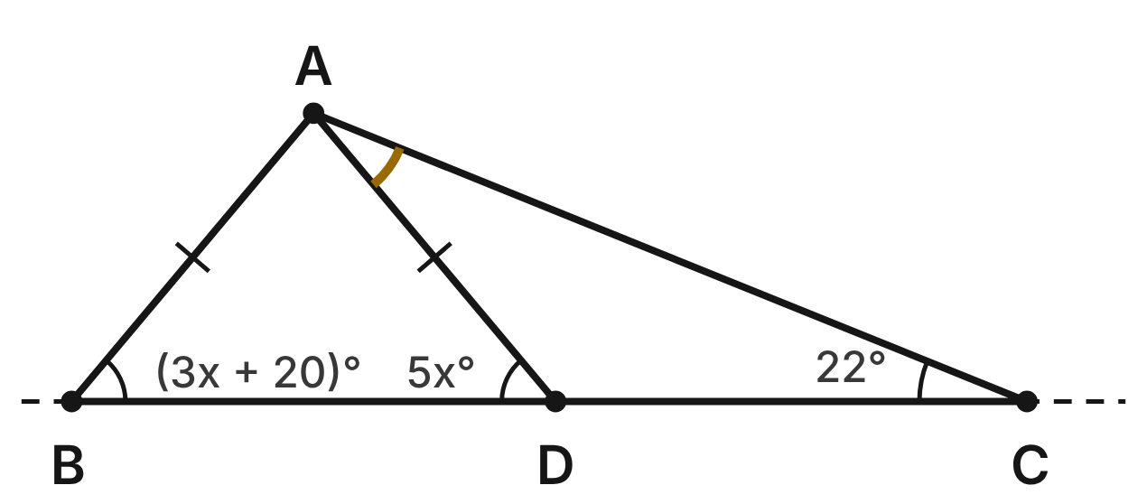
In a passing drill, players stand at A, B, C and D, with D on the baseline BC. The passes AB and AD are equal: AB ≅ AD. m∠ABD = (3x + 20)⁠°, m∠ADB = 5x° and m∠ACD = 22°.
169. What is m∠BAD?
A. 80° ✔
B. 50°
C. 130°
D. 65°
G.TR.1 · skill G.TR.1.3 (LOTS): Solve problems using the triangle angle sum and the exterior angle theorem
☐ Answer key correct ☐ Wording clear Notes: ________________________________
170. What is m∠ADC?
A. 50°
B. 100°
C. 158°
D. 130° ✔
G.TR.1 · skill G.TR.1.3 (LOTS): Solve problems using the triangle angle sum and the exterior angle theorem
☐ Answer key correct ☐ Wording clear Notes: ________________________________
171. What is m∠DAC?
A. 108°
B. 28° ✔
C. 158°
D. 72°
G.TR.1 · skill G.TR.1.3 (LOTS): Solve problems using the triangle angle sum and the exterior angle theorem
☐ Answer key correct ☐ Wording clear Notes: ________________________________
172. Which pass is the longest: AB, AD or AC?
A. AB
B. AD
C. AC ✔
D. AB and AD tie for longest
G.TR.1 · skill G.TR.1.1 (LOTS): Order the sides of a triangle by length given its angles, or its angles by size given its sides
☐ Answer key correct ☐ Wording clear Notes: ________________________________
173. Which statement about the distances is NOT true?
A. AC is longer than AD.
B. BD is longer than AB.
C. AB is shorter than AC.
D. AD is longer than DC. ✔
G.TR.1 · skill G.TR.1.1 (LOTS): Order the sides of a triangle by length given its angles, or its angles by size given its sides
☐ Answer key correct ☐ Wording clear Notes: ________________________________
174. Another drill uses a triangle of passes 10 ft, (n + 3) ft and (2n − 2) ft long. Which inequality gives all possible values of n?
A. n < 15
B. 3 < n < 15 ✔
C. n > 3
D. −5 < n < 15
G.TR.1 · skill G.TR.1.2 (LOTS): Decide whether three lengths can form a triangle and find the range of possible lengths of the third side
☐ Answer key correct ☐ Wording clear Notes: ________________________________

G.TR.2 · Prove two triangles are congruent, using direct and indirect proofs, and solve problems involving measured attributes of congruent triangles.

The Climbing Wall Hold
Level 1 · Triangles · G.TR.2 · ID geo-tr2-raid-climbing-hold
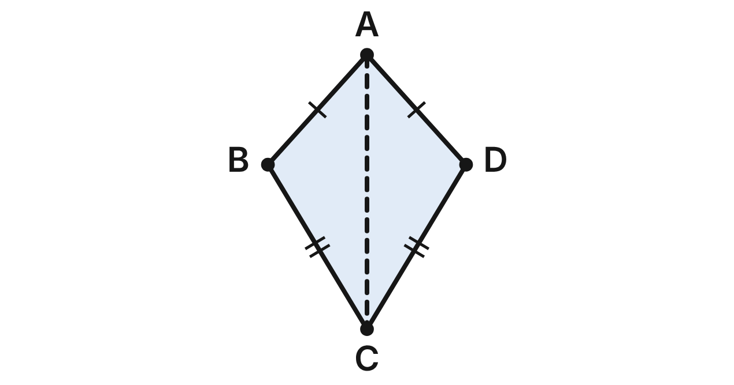
A hold on the climbing wall is shaped like ABCD, with AB ≅ AD and CB ≅ CD. A seam runs along AC.
175. Which criterion proves △ABC ≅ △ADC?
A. SSS ✔
B. SAS
C. ASA
D. HL
G.TR.2 · skill G.TR.2.1 (LOTS): Identify the congruence criterion (SSS, SAS, ASA, AAS, HL) that the given information supports, and recognize when none does
☐ Answer key correct ☐ Wording clear Notes: ________________________________
176. A proof that △ABC ≅ △ADC uses the statement AC ≅ AC. Which reason supports it?
A. Symmetric property
B. Given
C. Reflexive property ✔
D. CPCTC
G.TR.2 · skill G.TR.2.2 (HOTS): Complete or justify a direct or indirect proof that two triangles are congruent
☐ Answer key correct ☐ Wording clear Notes: ________________________________
177. m∠BAC = 42°. What is m∠BAD?
A. 42°
B. 84° ✔
C. 21°
D. 138°
G.TR.2 · skill G.TR.2.3 (LOTS): Solve problems, including algebraic ones, using corresponding parts of congruent triangles
☐ Answer key correct ☐ Wording clear Notes: ________________________________
178. AB = (3x − 4) cm and AD = (x + 10) cm. How long is AB?
A. 7 cm
B. 5 cm
C. 34 cm
D. 17 cm ✔
G.TR.2 · skill G.TR.2.3 (LOTS): Solve problems, including algebraic ones, using corresponding parts of congruent triangles
☐ Answer key correct ☐ Wording clear Notes: ________________________________
179. Which angle is congruent to ∠BCA?
A. ∠BAC
B. ∠DCA ✔
C. ∠DAC
D. ∠ABC
G.TR.2 · skill G.TR.2.3 (LOTS): Solve problems, including algebraic ones, using corresponding parts of congruent triangles
☐ Answer key correct ☐ Wording clear Notes: ________________________________
180. A second hold, PQRS with seam PR, has PQ ≅ PS and ∠PRQ ≅ ∠PRS. What can you conclude about △PQR and △PSR?
A. They are congruent by SAS
B. They are congruent by ASA
C. No conclusion: this is SSA ✔
D. They are congruent by HL
G.TR.2 · skill G.TR.2.1 (LOTS): Identify the congruence criterion (SSS, SAS, ASA, AAS, HL) that the given information supports, and recognize when none does
☐ Answer key correct ☐ Wording clear Notes: ________________________________

Twin Skate Ramps
Level 1 · Triangles · G.TR.2 · ID geo-tr2-raid-skate-ramps
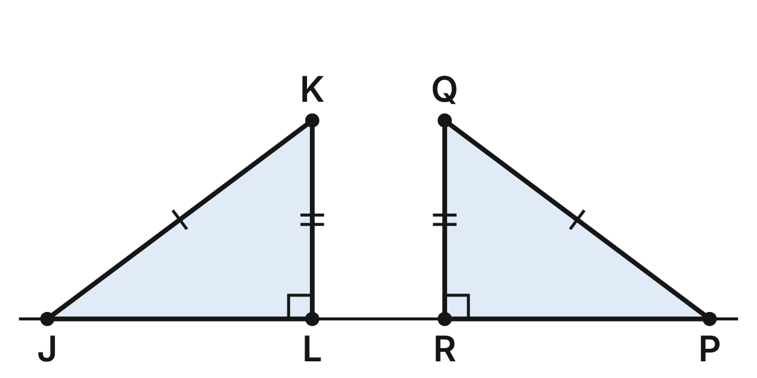
Two ramps at the skate park face each other. Their sides are the right triangles △JKL and △PQR, with right angles at L and R. The marks show JK ≅ PQ and KL ≅ QR.
181. Which criterion proves △JKL ≅ △PQR?
A. SSA
B. SAS
C. HL ✔
D. ASA
G.TR.2 · skill G.TR.2.1 (LOTS): Identify the congruence criterion (SSS, SAS, ASA, AAS, HL) that the given information supports, and recognize when none does
☐ Answer key correct ☐ Wording clear Notes: ________________________________
182. Suppose the marks showed JL ≅ PR and KL ≅ QR instead, with the same right angles. Which criterion would prove the ramps congruent?
A. SAS ✔
B. HL
C. SSA
D. AAS
G.TR.2 · skill G.TR.2.1 (LOTS): Identify the congruence criterion (SSS, SAS, ASA, AAS, HL) that the given information supports, and recognize when none does
☐ Answer key correct ☐ Wording clear Notes: ________________________________
183. JK = 10 ft and KL = 6 ft. How long is the base PR of the other ramp?
A. 6 ft
B. 4 ft
C. 2√34 ft
D. 8 ft ✔
G.TR.2 · skill G.TR.2.3 (LOTS): Solve problems, including algebraic ones, using corresponding parts of congruent triangles
☐ Answer key correct ☐ Wording clear Notes: ________________________________
184. Theo says any ramp with the same three angles as △JKL must be congruent to △JKL. Is he right?
A. Yes; AAA proves congruence
B. No; AAA proves only similarity ✔
C. Yes; ASA proves congruence
D. Yes; HL proves congruence
G.TR.2 · skill G.TR.2.1 (LOTS): Identify the congruence criterion (SSS, SAS, ASA, AAS, HL) that the given information supports, and recognize when none does
☐ Answer key correct ☐ Wording clear Notes: ________________________________
185. KL = (4x − 2) ft and QR = (2x + 2) ft. What is x?
A. 0
B. 2/3
C. 4
D. 2 ✔
G.TR.2 · skill G.TR.2.3 (LOTS): Solve problems, including algebraic ones, using corresponding parts of congruent triangles
☐ Answer key correct ☐ Wording clear Notes: ________________________________
186. Dev says, “The marks show two sides and a non-included angle, so no criterion proves these ramps congruent.” What is wrong with his claim?
A. HL proves these right triangles congruent ✔
B. Nothing; SSA never proves congruence
C. The right angles are included, so SAS works
D. Two angles match, so AAS works
G.TR.2 · skill G.TR.2.2 (HOTS): Complete or justify a direct or indirect proof that two triangles are congruent
☐ Answer key correct ☐ Wording clear Notes: ________________________________

The Archery Target Easel
Level 2 · Triangles · G.TR.2 · ID geo-tr2-raid-archery-easel
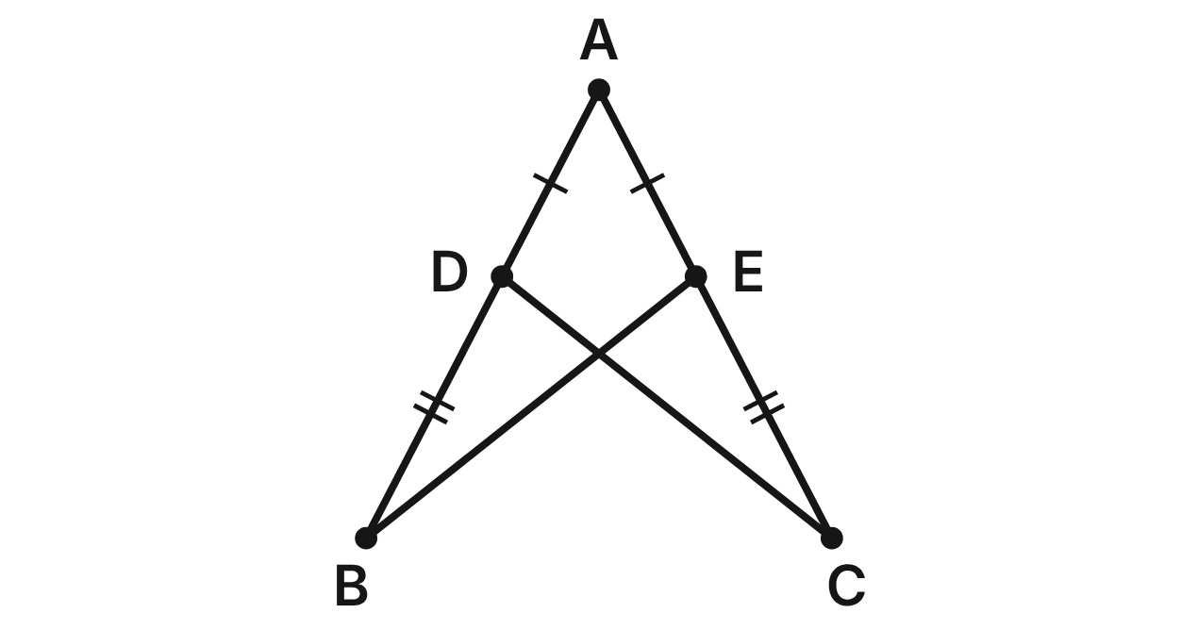
The legs AB and AC of an archery target easel meet at A. Crossbars BE and CD join the legs, with D on AB and E on AC. AD ≅ AE and DB ≅ EC. Prove that BE ≅ CD.
Statement | Reason
1. AD ≅ AE; DB ≅ EC | Given
2. AB ≅ AC | Segment addition
3. ∠A ≅ ∠A | (a) ____
4. △ABE ≅ △ACD | (b) ____
5. BE ≅ CD | CPCTC

187. Which reason justifies step 3, ∠A ≅ ∠A (blank a)?
A. Vertical angles are congruent
B. Reflexive property ✔
C. Given
D. CPCTC
G.TR.2 · skill G.TR.2.2 (HOTS): Complete or justify a direct or indirect proof that two triangles are congruent
☐ Answer key correct ☐ Wording clear Notes: ________________________________
188. Which reason justifies step 4, △ABE ≅ △ACD (blank b)?
A. SSA
B. ASA
C. HL
D. SAS ✔
G.TR.2 · skill G.TR.2.2 (HOTS): Complete or justify a direct or indirect proof that two triangles are congruent
☐ Answer key correct ☐ Wording clear Notes: ________________________________
189. BE = (5x − 10) in. and CD = (3x + 14) in. How long is crossbar CD?
A. 12 in.
B. 20 in.
C. 50 in. ✔
D. 100 in.
G.TR.2 · skill G.TR.2.3 (LOTS): Solve problems, including algebraic ones, using corresponding parts of congruent triangles
☐ Answer key correct ☐ Wording clear Notes: ________________________________
190. Leg AB is 60 in. long and AE = 25 in. How long is EC?
A. 35 in. ✔
B. 25 in.
C. 85 in.
D. 60 in.
G.TR.2 · skill G.TR.2.3 (LOTS): Solve problems, including algebraic ones, using corresponding parts of congruent triangles
☐ Answer key correct ☐ Wording clear Notes: ________________________________
191. Ana starts again with only AB ≅ AC and ∠ABE ≅ ∠ACD. Which criterion lets her prove △ABE ≅ △ACD directly from those parts and the shared angle A?
A. AAS
B. SAS
C. ASA ✔
D. SSA
G.TR.2 · skill G.TR.2.1 (LOTS): Identify the congruence criterion (SSS, SAS, ASA, AAS, HL) that the given information supports, and recognize when none does
☐ Answer key correct ☐ Wording clear Notes: ________________________________
192. Suppose you knew only AD ≅ AE and BE ≅ CD. Which other fact would prove △ABE ≅ △ACD by SSS?
A. ∠A ≅ ∠A
B. AB ≅ AC ✔
C. ∠AEB ≅ ∠ADC
D. AD ≅ DB
G.TR.2 · skill G.TR.2.1 (LOTS): Identify the congruence criterion (SSS, SAS, ASA, AAS, HL) that the given information supports, and recognize when none does
☐ Answer key correct ☐ Wording clear Notes: ________________________________

Shields on a Game Map
Level 2 · Triangles · G.TR.2 · ID geo-tr2-raid-game-map
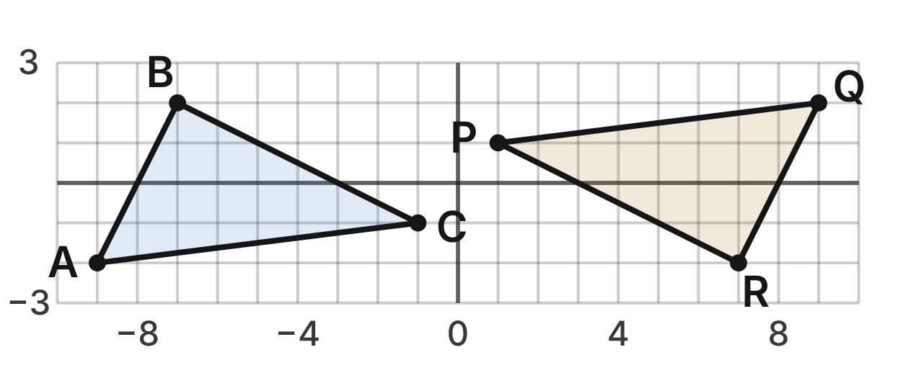
In a video game, a shield △ABC is copied to △QRP on the map grid: A(−9, −2), B(−7, 2), C(−1, −1), Q(9, 2), R(7, −2) and P(1, 1).
193. What is the length of QR, in grid units?
A. 6
B. 20
C. 2√3
D. 2√5 ✔
G.TR.2 · skill G.TR.2.3 (LOTS): Solve problems, including algebraic ones, using corresponding parts of congruent triangles
☐ Answer key correct ☐ Wording clear Notes: ________________________________
194. Max shows that ∠B and ∠R are right angles, AC = QP = √65 and AB = QR = 2√5. Which criterion proves △ABC ≅ △QRP?
A. SSA
B. HL ✔
C. SAS
D. ASA
G.TR.2 · skill G.TR.2.1 (LOTS): Identify the congruence criterion (SSS, SAS, ASA, AAS, HL) that the given information supports, and recognize when none does
☐ Answer key correct ☐ Wording clear Notes: ________________________________
195. Which segment is congruent to BC?
A. RP ✔
B. PQ
C. QR
D. AC
G.TR.2 · skill G.TR.2.3 (LOTS): Solve problems, including algebraic ones, using corresponding parts of congruent triangles
☐ Answer key correct ☐ Wording clear Notes: ________________________________
196. What is the area of △QRP, in square units?
A. 30
B. 27
C. 15 ✔
D. 5√13
G.TR.2 · skill G.TR.2.3 (LOTS): Solve problems, including algebraic ones, using corresponding parts of congruent triangles
☐ Answer key correct ☐ Wording clear Notes: ________________________________
197. AB = QR and BC = RP. Which added fact would NOT prove △ABC ≅ △QRP?
A. ∠C ≅ ∠P ✔
B. AC = QP
C. ∠B ≅ ∠R
D. △QRP is a rotation of △ABC
G.TR.2 · skill G.TR.2.1 (LOTS): Identify the congruence criterion (SSS, SAS, ASA, AAS, HL) that the given information supports, and recognize when none does
☐ Answer key correct ☐ Wording clear Notes: ________________________________
198. On another level, △XYZ has XY = 2√5, YZ = 3√5 and XZ = 8. To prove indirectly that △XYZ is not congruent to △ABC, what should you assume first?
A. △XYZ ≇ △ABC
B. XZ ≠ AC
C. XZ = 8
D. △XYZ ≅ △ABC ✔
G.TR.2 · skill G.TR.2.2 (HOTS): Complete or justify a direct or indirect proof that two triangles are congruent
☐ Answer key correct ☐ Wording clear Notes: ________________________________

The Tennis Court Diagonals
Level 2 · Triangles · G.TR.2 · ID geo-tr2-raid-tennis-court
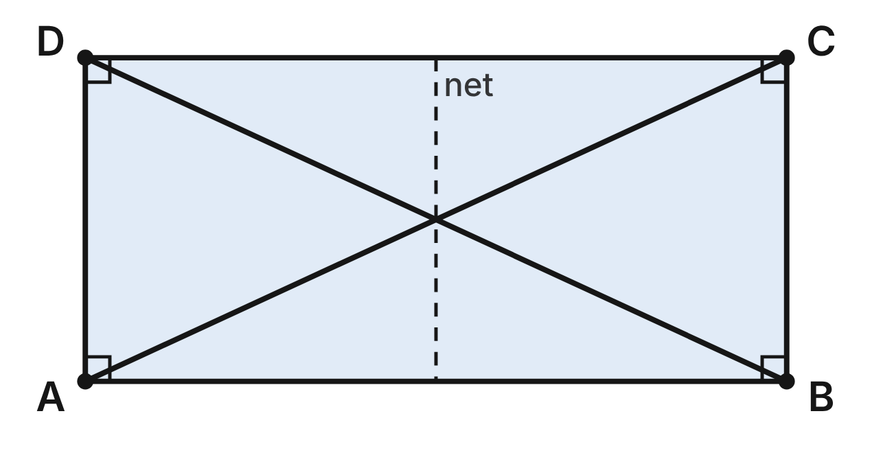
A tennis court is the rectangle ABCD. Prove that its diagonals are congruent: BD ≅ AC.
Statement | Reason
1. ABCD is a rectangle | Given
2. AD ≅ BC | (a) ____
3. ∠DAB and ∠CBA are right angles | Definition of rectangle
4. ∠DAB ≅ ∠CBA | All right angles are congruent
5. AB ≅ BA | Reflexive property
6. △DAB ≅ △CBA | (b) ____
7. BD ≅ AC | (c) ____

199. Which reason justifies step 2, AD ≅ BC (blank a)?
A. Opposite sides of a rectangle are congruent ✔
B. Diagonals of a rectangle are congruent
C. Adjacent sides of a rectangle are congruent
D. Opposite angles of a rectangle are congruent
G.TR.2 · skill G.TR.2.2 (HOTS): Complete or justify a direct or indirect proof that two triangles are congruent
☐ Answer key correct ☐ Wording clear Notes: ________________________________
200. Which reason justifies step 6, △DAB ≅ △CBA (blank b)?
A. HL
B. SSA
C. SAS ✔
D. AAS
G.TR.2 · skill G.TR.2.2 (HOTS): Complete or justify a direct or indirect proof that two triangles are congruent
☐ Answer key correct ☐ Wording clear Notes: ________________________________
201. Which reason justifies step 7, BD ≅ AC (blank c)?
A. SAS
B. Reflexive property
C. Transitive property
D. CPCTC ✔
G.TR.2 · skill G.TR.2.2 (HOTS): Complete or justify a direct or indirect proof that two triangles are congruent
☐ Answer key correct ☐ Wording clear Notes: ________________________________
202. A doubles court is 78 ft long (AB) and 36 ft wide (AD). To the nearest tenth of a foot, how long is diagonal BD?
A. 114.0 ft
B. 85.9 ft ✔
C. 69.2 ft
D. 43.0 ft
G.TR.2 · skill G.TR.2.3 (LOTS): Solve problems, including algebraic ones, using corresponding parts of congruent triangles
☐ Answer key correct ☐ Wording clear Notes: ________________________________
203. Suppose you knew only AD ≅ BC and AC ≅ BD, without using the right angles. Which criterion proves △DAB ≅ △CBA?
A. SAS
B. HL
C. SSA
D. SSS ✔
G.TR.2 · skill G.TR.2.1 (LOTS): Identify the congruence criterion (SSS, SAS, ASA, AAS, HL) that the given information supports, and recognize when none does
☐ Answer key correct ☐ Wording clear Notes: ________________________________
204. m∠ADB ≈ 65°. To the nearest degree, what is m∠CAB?
A. 65°
B. 115°
C. 25° ✔
D. 155°
G.TR.2 · skill G.TR.2.3 (LOTS): Solve problems, including algebraic ones, using corresponding parts of congruent triangles
☐ Answer key correct ☐ Wording clear Notes: ________________________________

The Lifeguard's Lane Line
Level 3 · Triangles · G.TR.2 · ID geo-tr2-raid-lifeguard
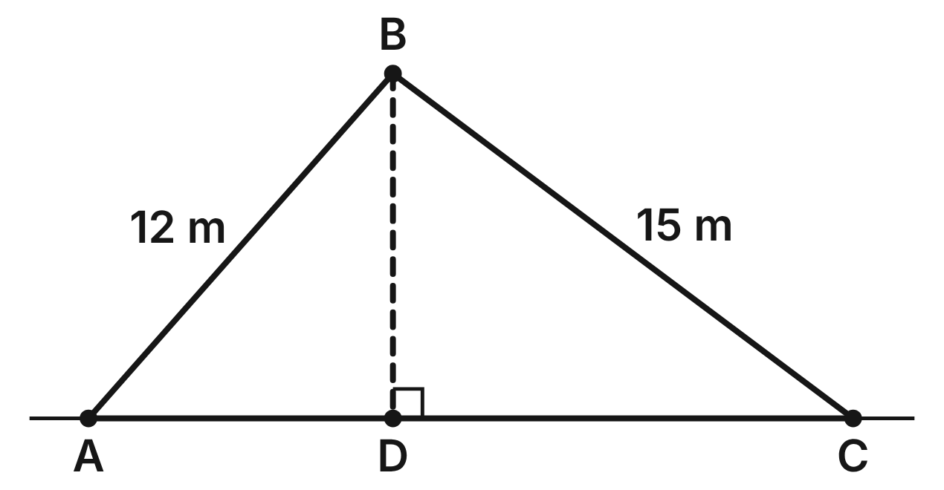
From the lifeguard chair B, ropes run to buoys A and C on a straight lane line. BD ⊥ AC, BA = 12 m and BC = 15 m. The indirect proof below shows that D is not the midpoint of AC.
Statement | Reason
1. AD ≅ CD | Assumption
2. ∠BDA ≅ ∠BDC | BD ⊥ AC, so both are right angles
3. BD ≅ BD | Reflexive property
4. △BDA ≅ △BDC | (a) ____
5. BA ≅ BC | CPCTC
6. BA = 12 m and BC = 15 m | Given
7. AD ≇ CD | (b) ____

205. Why does the proof start by assuming AD ≅ CD?
A. It is one of the given facts
B. It follows from BD ⊥ AC
C. It is the opposite of what is to be proved ✔
D. It is the statement the proof sets out to show
G.TR.2 · skill G.TR.2.2 (HOTS): Complete or justify a direct or indirect proof that two triangles are congruent
☐ Answer key correct ☐ Wording clear Notes: ________________________________
206. Which reason justifies step 4, △BDA ≅ △BDC (blank a)?
A. SAS ✔
B. HL
C. SSS
D. ASA
G.TR.2 · skill G.TR.2.2 (HOTS): Complete or justify a direct or indirect proof that two triangles are congruent
☐ Answer key correct ☐ Wording clear Notes: ________________________________
207. Which reason justifies step 7, AD ≇ CD (blank b)?
A. Definition of midpoint
B. Steps 5 and 6 contradict each other ✔
C. Steps 1 and 3 contradict each other
D. Steps 4 and 5 contradict each other
G.TR.2 · skill G.TR.2.2 (HOTS): Complete or justify a direct or indirect proof that two triangles are congruent
☐ Answer key correct ☐ Wording clear Notes: ________________________________
208. BD = 9 m. To the nearest tenth of a meter, how far apart are buoys A and C?
A. 24.0 m
B. 4.1 m
C. 27.0 m
D. 19.9 m ✔
G.TR.2 · skill G.TR.2.3 (LOTS): Solve problems, including algebraic ones, using corresponding parts of congruent triangles
☐ Answer key correct ☐ Wording clear Notes: ________________________________
209. At another pool, BD ⊥ AC and the two ropes are equal, BA = BC. Which criterion proves △BDA ≅ △BDC most directly?
A. SAS
B. HL ✔
C. SSA
D. AAA
G.TR.2 · skill G.TR.2.1 (LOTS): Identify the congruence criterion (SSS, SAS, ASA, AAS, HL) that the given information supports, and recognize when none does
☐ Answer key correct ☐ Wording clear Notes: ________________________________
210. At another pool, BD ⊥ AC and BA = BC. AD = (2k + 3) m and CD = (5k − 9) m. How long is AC?
A. 22 m ✔
B. 11 m
C. 14 m
D. 4 m
G.TR.2 · skill G.TR.2.3 (LOTS): Solve problems, including algebraic ones, using corresponding parts of congruent triangles
☐ Answer key correct ☐ Wording clear Notes: ________________________________

The Board Game Corners
Level 3 · Triangles · G.TR.2 · ID geo-tr2-raid-game-board
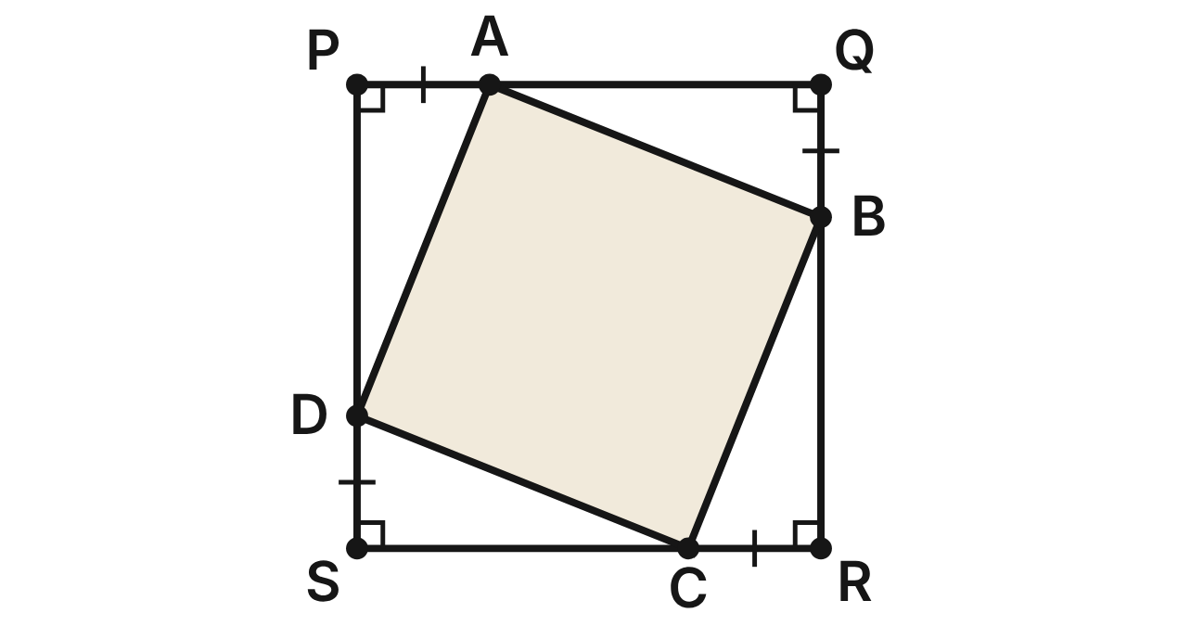
A game board is the square PQRS. Points A, B, C and D on its sides cut off four corner triangles, with PA = QB = RC = SD. Prove that △DPA ≅ △AQB.
Statement | Reason
1. PQRS is a square; PA = QB = RC = SD | Given
2. PS = PQ; ∠P and ∠Q are right angles | Definition of a square
3. PS − SD = PQ − PA | (a) ____
4. DP = AQ | Segment Addition Postulate
5. ∠P ≅ ∠Q | All right angles are congruent
6. △DPA ≅ △AQB | (b) ____
7. DA ≅ AB | CPCTC

211. Which reason justifies step 3, PS − SD = PQ − PA (blank a)?
A. Addition property of equality
B. Subtraction property of equality ✔
C. Reflexive property
D. Segment Addition Postulate
G.TR.2 · skill G.TR.2.2 (HOTS): Complete or justify a direct or indirect proof that two triangles are congruent
☐ Answer key correct ☐ Wording clear Notes: ________________________________
212. Which reason justifies step 6, △DPA ≅ △AQB (blank b)?
A. HL
B. ASA
C. SSA
D. SAS ✔
G.TR.2 · skill G.TR.2.2 (HOTS): Complete or justify a direct or indirect proof that two triangles are congruent
☐ Answer key correct ☐ Wording clear Notes: ________________________________
213. DA = (3m + 4) cm and AB = (5m − 6) cm. What is the perimeter of ABCD?
A. 19 cm
B. 5 cm
C. 76 cm ✔
D. 38 cm
G.TR.2 · skill G.TR.2.3 (LOTS): Solve problems, including algebraic ones, using corresponding parts of congruent triangles
☐ Answer key correct ☐ Wording clear Notes: ________________________________
214. The board is 28 cm on each side and PA = 8 cm. What is the area of ABCD?
A. 464 cm² ✔
B. 144 cm²
C. 336 cm²
D. 704 cm²
G.TR.2 · skill G.TR.2.3 (LOTS): Solve problems, including algebraic ones, using corresponding parts of congruent triangles
☐ Answer key correct ☐ Wording clear Notes: ________________________________
215. m∠PAD = 68°. What is m∠DAB?
A. 90° ✔
B. 44°
C. 22°
D. 112°
G.TR.2 · skill G.TR.2.3 (LOTS): Solve problems, including algebraic ones, using corresponding parts of congruent triangles
☐ Answer key correct ☐ Wording clear Notes: ________________________________
216. Raj starts over knowing only ∠P ≅ ∠Q, ∠PAD ≅ ∠QBA and DA ≅ AB. Which criterion proves △DPA ≅ △AQB directly from those parts?
A. ASA
B. SAS
C. AAS ✔
D. HL
G.TR.2 · skill G.TR.2.1 (LOTS): Identify the congruence criterion (SSS, SAS, ASA, AAS, HL) that the given information supports, and recognize when none does
☐ Answer key correct ☐ Wording clear Notes: ________________________________

G.TR.3 · Prove two triangles are similar, using direct and indirect proofs, and solve problems involving measured attributes of similar triangles.

The Swim Team Pennants
Level 1 · Triangles · G.TR.3 · ID geo-tr3-raid-pennants
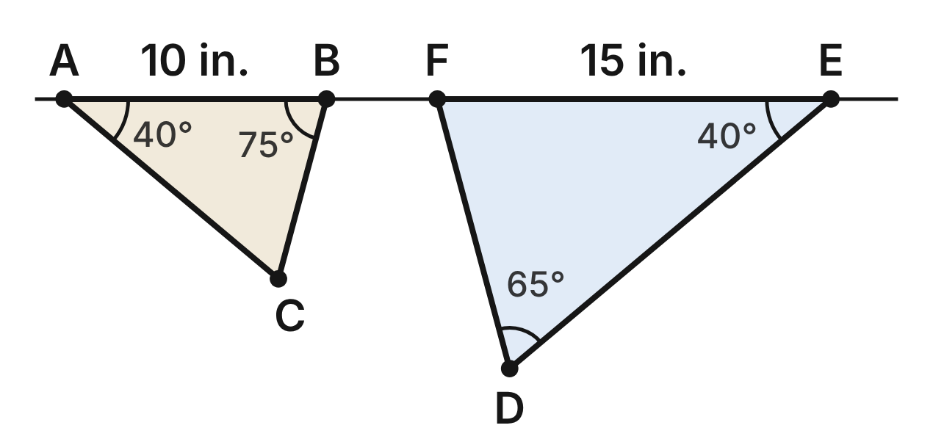
Two swim-team pennants hang from a rope. In △ABC, m∠A = 40°, m∠B = 75° and AB = 10 in. In △DEF, m∠D = 65°, m∠E = 40° and EF = 15 in.
217. Which criterion shows that the two pennants are similar?
A. AA ✔
B. SAS∼
C. SSS∼
D. ASA
G.TR.3 · skill G.TR.3.1 (LOTS): Identify the similarity criterion (AA, SSS, SAS) that the given information supports
☐ Answer key correct ☐ Wording clear Notes: ________________________________
218. Are the two pennants similar? Choose the answer with the correct reason.
A. No; m∠C ≠ m∠D
B. Yes; AB = EF
C. No; m∠C = 75°
D. Yes; m∠C = 65° = m∠D ✔
G.TR.3 · skill G.TR.3.2 (HOTS): Justify that two triangles are similar, or are not, using angle measures or side ratios
☐ Answer key correct ☐ Wording clear Notes: ________________________________
219. Which similarity statement for the two pennants is correct?
A. △ABC ∼ △DEF
B. △ABC ∼ △EDF
C. △ABC ∼ △EFD ✔
D. △ABC ∼ △FED
G.TR.3 · skill G.TR.3.1 (LOTS): Identify the similarity criterion (AA, SSS, SAS) that the given information supports
☐ Answer key correct ☐ Wording clear Notes: ________________________________
220. What is the scale factor from △ABC to the larger pennant?
A. 2/3
B. 3/2 ✔
C. 5
D. 9/4
G.TR.3 · skill G.TR.3.3 (LOTS): Solve problems, including contextual ones, using proportional sides of similar triangles
☐ Answer key correct ☐ Wording clear Notes: ________________________________
221. The coach says the large pennant's perimeter is 1.5 times the small one's. Is the coach right? Choose the answer with the correct reason.
A. No; it is 1.5² = 2.25 times as long
B. No; it is 3 × 5 = 15 in. longer
C. Yes; each angle is 1.5 times as large
D. Yes; perimeters grow by the scale factor ✔
G.TR.3 · skill G.TR.3.3 (LOTS): Solve problems, including contextual ones, using proportional sides of similar triangles
☐ Answer key correct ☐ Wording clear Notes: ________________________________
222. Which equation is true for these two pennants?
A. DF/BC = 15/10 ✔
B. DF/AC = 15/10
C. DF/BC = 10/15
D. DF − BC = 15 − 10
G.TR.3 · skill G.TR.3.3 (LOTS): Solve problems, including contextual ones, using proportional sides of similar triangles
☐ Answer key correct ☐ Wording clear Notes: ________________________________

Zones on the Game Map
Level 1 · Triangles · G.TR.3 · ID geo-tr3-raid-game-zones
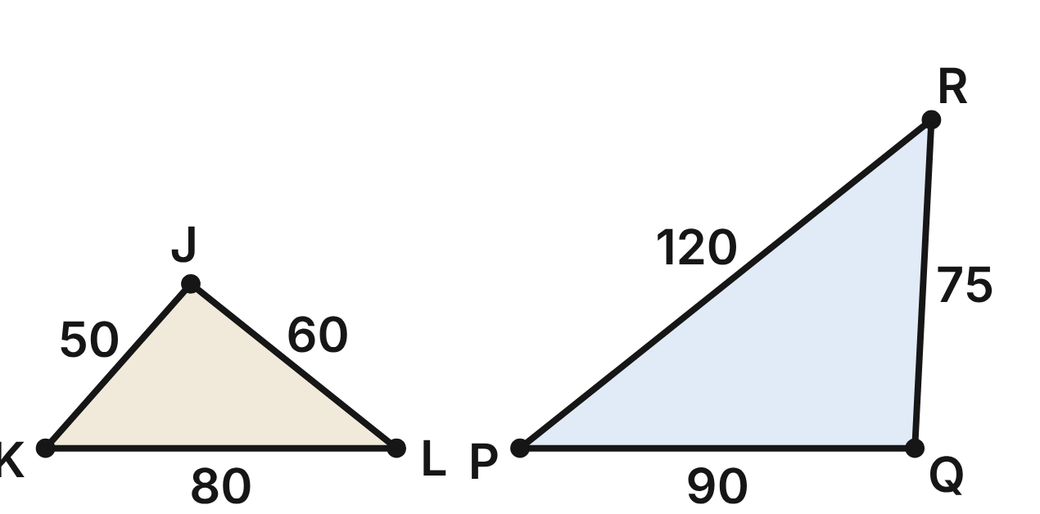
A video game map has two triangular zones. In △JKL, JK = 50 m, KL = 80 m and JL = 60 m. In △PQR, PQ = 90 m, QR = 75 m and PR = 120 m.
223. Which criterion shows that the two zones are similar?
A. SAS∼
B. AA
C. SSS∼ ✔
D. SSS
G.TR.3 · skill G.TR.3.1 (LOTS): Identify the similarity criterion (AA, SSS, SAS) that the given information supports
☐ Answer key correct ☐ Wording clear Notes: ________________________________
224. Which similarity statement for the two zones is correct?
A. △JKL ∼ △PQR
B. △JKL ∼ △QRP ✔
C. △JKL ∼ △QPR
D. △JKL ∼ △RQP
G.TR.3 · skill G.TR.3.1 (LOTS): Identify the similarity criterion (AA, SSS, SAS) that the given information supports
☐ Answer key correct ☐ Wording clear Notes: ________________________________
225. Ari says the scale factor from △JKL to △PQR is 25, because 75 − 50 = 25. What is his mistake?
A. He used the wrong sides; it is 120 − 80 = 40
B. He reversed it; it is 50/75 = 2/3
C. He subtracted; it is 120/50 = 2.4
D. He subtracted; it is 75/50 = 1.5 ✔
G.TR.3 · skill G.TR.3.3 (LOTS): Solve problems, including contextual ones, using proportional sides of similar triangles
☐ Answer key correct ☐ Wording clear Notes: ________________________________
226. Which angle of △PQR is congruent to ∠K?
A. ∠R ✔
B. ∠Q
C. ∠P
D. None; the zones differ in size
G.TR.3 · skill G.TR.3.3 (LOTS): Solve problems, including contextual ones, using proportional sides of similar triangles
☐ Answer key correct ☐ Wording clear Notes: ________________________________
227. A new zone has sides of 70 m, 80 m and 100 m. Is it similar to △JKL? Choose the answer with the correct reason.
A. Yes; 70/50 = 100/80
B. No; 70/50 ≠ 100/80 ✔
C. Yes; 70/50 = 80/60
D. No; similar zones need equal sides
G.TR.3 · skill G.TR.3.2 (HOTS): Justify that two triangles are similar, or are not, using angle measures or side ratios
☐ Answer key correct ☐ Wording clear Notes: ________________________________
228. A player builds a zone similar to △JKL. Its shortest side is 20 m. How long is its longest side?
A. 50 m
B. 12.5 m
C. 32 m ✔
D. 24 m
G.TR.3 · skill G.TR.3.3 (LOTS): Solve problems, including contextual ones, using proportional sides of similar triangles
☐ Answer key correct ☐ Wording clear Notes: ________________________________

Shadows on the Tennis Court
Level 2 · Triangles · G.TR.3 · ID geo-tr3-raid-court-shadow
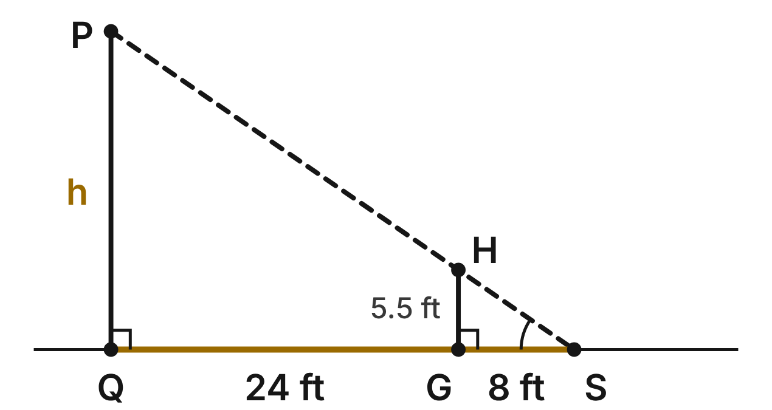
A tennis player GH stands 24 ft from the base Q of a light pole PQ. The tip of her shadow and the tip of the pole's shadow meet at S. She is 5.5 ft tall, and her shadow GS is 8 ft long. The pole and the player are vertical, on level ground.
229. Why is the player's triangle similar to the pole's triangle?
A. SAS∼: SG/SQ = 8/24 and the right angles
B. AA: shared ∠S and two right angles ✔
C. SSS∼: three sides of each are known
D. HL: both are right triangles
G.TR.3 · skill G.TR.3.1 (LOTS): Identify the similarity criterion (AA, SSS, SAS) that the given information supports
☐ Answer key correct ☐ Wording clear Notes: ________________________________
230. How tall is the light pole PQ (h)?
A. 22 ft ✔
B. 16.5 ft
C. about 46.5 ft
D. about 1.4 ft
G.TR.3 · skill G.TR.3.3 (LOTS): Solve problems, including contextual ones, using proportional sides of similar triangles
☐ Answer key correct ☐ Wording clear Notes: ________________________________
231. Which similarity statement for the player's and the pole's triangles is correct?
A. △SGH ∼ △QSP
B. △GSH ∼ △SQP
C. △SGH ∼ △SQP ✔
D. △SGH ∼ △SPQ
G.TR.3 · skill G.TR.3.1 (LOTS): Identify the similarity criterion (AA, SSS, SAS) that the given information supports
☐ Answer key correct ☐ Wording clear Notes: ________________________________
232. Which equation can be solved for the pole's height h?
A. 5.5/8 = h/24
B. 8/5.5 = h/32
C. 5.5/24 = h/32
D. 5.5/8 = h/32 ✔
G.TR.3 · skill G.TR.3.3 (LOTS): Solve problems, including contextual ones, using proportional sides of similar triangles
☐ Answer key correct ☐ Wording clear Notes: ________________________________
233. At the same moment, a parent says a 3-ft child nearby casts a 5.5-ft shadow. Can that be right? Choose the answer with the correct reason.
A. No; 3/5.5 ≠ 5.5/8 ✔
B. Yes; 3/5.5 = 5.5/8
C. Yes; shadows do not depend on height
D. No; the child must stand where the tips meet
G.TR.3 · skill G.TR.3.2 (HOTS): Justify that two triangles are similar, or are not, using angle measures or side ratios
☐ Answer key correct ☐ Wording clear Notes: ________________________________
234. What is the scale factor from the player's triangle to the pole's triangle?
A. 3
B. 4 ✔
C. 1/4
D. 24
G.TR.3 · skill G.TR.3.3 (LOTS): Solve problems, including contextual ones, using proportional sides of similar triangles
☐ Answer key correct ☐ Wording clear Notes: ________________________________

Sighting the Climbing Wall
Level 2 · Triangles · G.TR.3 · ID geo-tr3-raid-climbing-wall
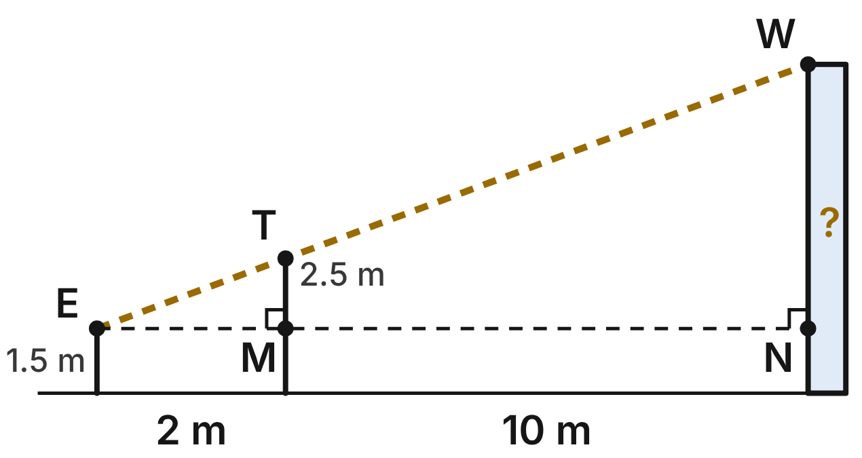
Not drawn to scale
Coach Ruiz's eye E is 1.5 m above the ground. She sights the top W of the climbing wall over the top T of a 2.5-m pole. The pole is 2 m from her, and the wall is 10 m beyond the pole. The pole and the wall are vertical. The dashed level line from E meets the pole at M and the wall at N.
235. Why are the two sight triangles with vertex E similar?
A. SAS∼: EM/EN = 2/10 and the right angles
B. SSS∼: EM, MT and ET are known
C. AA: ∠T ≅ ∠E and ∠M ≅ ∠N
D. AA: shared ∠E, right angles at M, N ✔
G.TR.3 · skill G.TR.3.1 (LOTS): Identify the similarity criterion (AA, SSS, SAS) that the given information supports
☐ Answer key correct ☐ Wording clear Notes: ________________________________
236. How tall is the climbing wall, to the nearest tenth of a meter?
A. 6 m
B. 15 m
C. 7.5 m ✔
D. 6.5 m
G.TR.3 · skill G.TR.3.3 (LOTS): Solve problems, including contextual ones, using proportional sides of similar triangles
☐ Answer key correct ☐ Wording clear Notes: ________________________________
237. Let x be the height of the wall above the dashed line (NW). Which proportion finds x?
A. 1/2 = x/10
B. 1/2 = x/12 ✔
C. 2.5/2 = x/12
D. 2/1 = x/12
G.TR.3 · skill G.TR.3.3 (LOTS): Solve problems, including contextual ones, using proportional sides of similar triangles
☐ Answer key correct ☐ Wording clear Notes: ________________________________
238. Which similarity statement for the two sight triangles is correct?
A. △EMT ∼ △ENW ✔
B. △EMT ∼ △EWN
C. △MET ∼ △ENW
D. △TME ∼ △NWE
G.TR.3 · skill G.TR.3.1 (LOTS): Identify the similarity criterion (AA, SSS, SAS) that the given information supports
☐ Answer key correct ☐ Wording clear Notes: ________________________________
239. Why must the pole and the wall both be vertical for this method to work?
A. So the pole and the wall are the same height
B. So EM and MN are the same length
C. So ∠M and ∠N are right angles, for AA ✔
D. So the two triangles are congruent
G.TR.3 · skill G.TR.3.2 (HOTS): Justify that two triangles are similar, or are not, using angle measures or side ratios
☐ Answer key correct ☐ Wording clear Notes: ________________________________
240. What is the scale factor from the pole's sight triangle to the wall's sight triangle?
A. 5
B. 1/6
C. 3
D. 6 ✔
G.TR.3 · skill G.TR.3.3 (LOTS): Solve problems, including contextual ones, using proportional sides of similar triangles
☐ Answer key correct ☐ Wording clear Notes: ________________________________

Three Skate Park Ramps
Level 2 · Triangles · G.TR.3 · ID geo-tr3-raid-skate-ramps
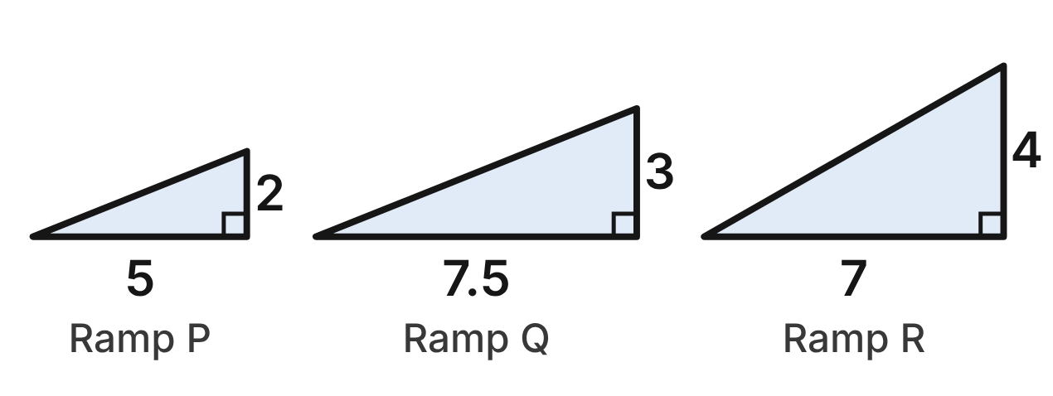
The side view of each skate-park ramp is a right triangle. Ramp P: rise 2 ft, run 5 ft. Ramp Q: rise 3 ft, run 7.5 ft. Ramp R: rise 4 ft, run 7 ft.
241. Which two ramps are similar triangles?
A. P and R
B. Q and R
C. P and Q ✔
D. No two of them
G.TR.3 · skill G.TR.3.2 (HOTS): Justify that two triangles are similar, or are not, using angle measures or side ratios
☐ Answer key correct ☐ Wording clear Notes: ________________________________
242. Using the rise, the run and the right angle of each ramp, which criterion shows ramp P ∼ ramp Q?
A. SAS∼ ✔
B. AA
C. SSS∼
D. SAS
G.TR.3 · skill G.TR.3.1 (LOTS): Identify the similarity criterion (AA, SSS, SAS) that the given information supports
☐ Answer key correct ☐ Wording clear Notes: ________________________________
243. Is ramp R similar to ramp P? Choose the answer with the correct reason.
A. Yes; 4/2 = 7/5
B. No; 4/2 ≠ 7/5 ✔
C. Yes; all right triangles are similar
D. No; ramp R has no right angle
G.TR.3 · skill G.TR.3.2 (HOTS): Justify that two triangles are similar, or are not, using angle measures or side ratios
☐ Answer key correct ☐ Wording clear Notes: ________________________________
244. Ramp P's sloped surface is √29 ft long. To the nearest tenth of a foot, how long is ramp Q's sloped surface?
A. 7.9 ft
B. 12.1 ft
C. 8.1 ft ✔
D. 3.6 ft
G.TR.3 · skill G.TR.3.3 (LOTS): Solve problems, including contextual ones, using proportional sides of similar triangles
☐ Answer key correct ☐ Wording clear Notes: ________________________________
245. A new ramp is to be similar to ramp P, with a rise of 4 ft. How long should its run be?
A. 7 ft
B. 1.6 ft
C. 8 ft
D. 10 ft ✔
G.TR.3 · skill G.TR.3.3 (LOTS): Solve problems, including contextual ones, using proportional sides of similar triangles
☐ Answer key correct ☐ Wording clear Notes: ________________________________
246. Ramp P meets the ground at an angle of about 21.8°. To the nearest tenth, what angle does ramp Q make with the ground?
A. 21.8° ✔
B. 32.7°
C. 14.5°
D. 68.2°
G.TR.3 · skill G.TR.3.3 (LOTS): Solve problems, including contextual ones, using proportional sides of similar triangles
☐ Answer key correct ☐ Wording clear Notes: ________________________________

The Archery Target Stand
Level 2 · Triangles · G.TR.3 · ID geo-tr3-raid-target-stand
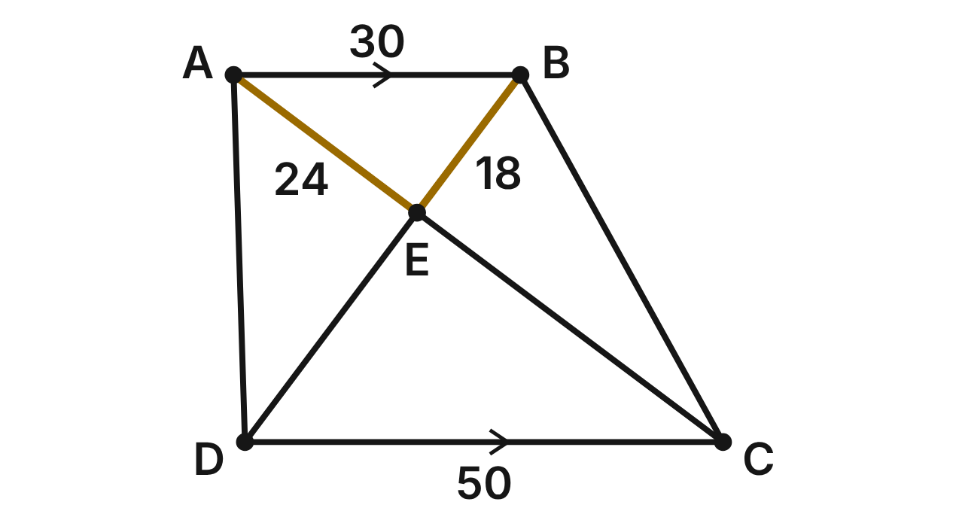
The side frame of an archery target stand is ABCD. The top bar AB is parallel to the floor bar DC. Braces AC and BD cross at E. AB = 30 in., DC = 50 in., AE = 24 in. and BE = 18 in.
247. Why are the triangles above and below E similar?
A. SAS∼: AB/DC = AE/DE, with vertical angles
B. AA: alternate interior angles and vertical angles ✔
C. SSS∼: AB/DC = 30/50 is enough
D. AA: ∠ABE ≅ ∠BAE, since AB is level
G.TR.3 · skill G.TR.3.1 (LOTS): Identify the similarity criterion (AA, SSS, SAS) that the given information supports
☐ Answer key correct ☐ Wording clear Notes: ________________________________
248. Which similarity statement for the triangles above and below E is correct?
A. △ABE ∼ △DCE
B. △BAE ∼ △CDE
C. △ABE ∼ △ECD
D. △ABE ∼ △CDE ✔
G.TR.3 · skill G.TR.3.1 (LOTS): Identify the similarity criterion (AA, SSS, SAS) that the given information supports
☐ Answer key correct ☐ Wording clear Notes: ________________________________
249. How long is the lower part EC of brace AC?
A. 40 in. ✔
B. 14.4 in.
C. 44 in.
D. 30 in.
G.TR.3 · skill G.TR.3.3 (LOTS): Solve problems, including contextual ones, using proportional sides of similar triangles
☐ Answer key correct ☐ Wording clear Notes: ________________________________
250. How long is the whole brace BD?
A. 30 in.
B. 28.8 in.
C. 38 in.
D. 48 in. ✔
G.TR.3 · skill G.TR.3.3 (LOTS): Solve problems, including contextual ones, using proportional sides of similar triangles
☐ Answer key correct ☐ Wording clear Notes: ________________________________
251. On a second stand, AE = 20 in., EC = 32 in., BE = 15 in. and ED = 27 in. Is AB ∥ DC there? Choose the answer with the correct reason.
A. Yes; the vertical angles at E give AA
B. Yes; 20/32 = 15/27
C. No; 20/32 ≠ 15/27 ✔
D. No; AE must equal BE
G.TR.3 · skill G.TR.3.2 (HOTS): Justify that two triangles are similar, or are not, using angle measures or side ratios
☐ Answer key correct ☐ Wording clear Notes: ________________________________
252. What is the perimeter of △CDE?
A. 43.2 in.
B. 120 in. ✔
C. 200 in.
D. 132 in.
G.TR.3 · skill G.TR.3.3 (LOTS): Solve problems, including contextual ones, using proportional sides of similar triangles
☐ Answer key correct ☐ Wording clear Notes: ________________________________

The Soccer Cone Drill
Level 3 · Triangles · G.TR.3 · ID geo-tr3-raid-cone-drill
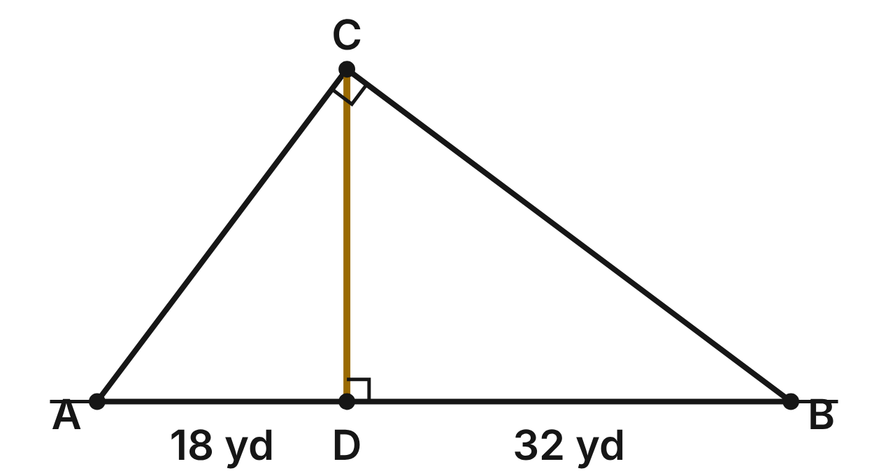
A soccer coach sets cones at A, B and C so that ∠ACB is a right angle. A player runs from C straight to D on AB, with CD ⊥ AB. AD = 18 yd and DB = 32 yd.
253. Using only the given facts, which criterion shows that △ADC is similar to △ACB?
A. SAS∼
B. SSS∼
C. HL
D. AA ✔
G.TR.3 · skill G.TR.3.1 (LOTS): Identify the similarity criterion (AA, SSS, SAS) that the given information supports
☐ Answer key correct ☐ Wording clear Notes: ________________________________
254. Which similarity statement about the two smaller triangles is correct?
A. △ADC ∼ △CDB ✔
B. △ADC ∼ △BDC
C. △ADC ∼ △DCB
D. △ACD ∼ △CDB
G.TR.3 · skill G.TR.3.1 (LOTS): Identify the similarity criterion (AA, SSS, SAS) that the given information supports
☐ Answer key correct ☐ Wording clear Notes: ________________________________
255. How long is the player's run CD?
A. 25 yd
B. 14 yd
C. 24 yd ✔
D. about 36.7 yd
G.TR.3 · skill G.TR.3.3 (LOTS): Solve problems, including contextual ones, using proportional sides of similar triangles
☐ Answer key correct ☐ Wording clear Notes: ________________________________
256. How far apart are cones A and C?
A. 24 yd
B. 30 yd ✔
C. 40 yd
D. 25 yd
G.TR.3 · skill G.TR.3.3 (LOTS): Solve problems, including contextual ones, using proportional sides of similar triangles
☐ Answer key correct ☐ Wording clear Notes: ________________________________
257. Which statement is NOT true for this drill?
A. AD/CD = DB/CD ✔
B. ∠ACD ≅ ∠B
C. ∠DCB ≅ ∠A
D. AD/AC = AC/AB
G.TR.3 · skill G.TR.3.2 (HOTS): Justify that two triangles are similar, or are not, using angle measures or side ratios
☐ Answer key correct ☐ Wording clear Notes: ________________________________
258. On a smaller field, the coach sets up the same shape with AB = 30 yd. How long is the run CD there?
A. 4 yd
B. about 8.6 yd
C. 40 yd
D. 14.4 yd ✔
G.TR.3 · skill G.TR.3.3 (LOTS): Solve problems, including contextual ones, using proportional sides of similar triangles
☐ Answer key correct ☐ Wording clear Notes: ________________________________

The Orienteering Course
Level 3 · Triangles · G.TR.3 · ID geo-tr3-raid-orienteering
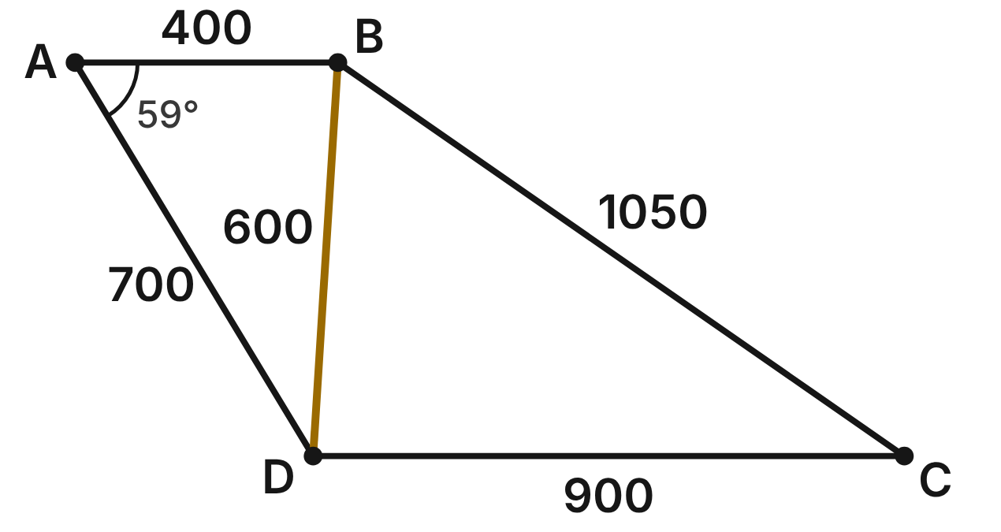
Checkpoints A, B, C and D of an orienteering course are joined by straight trails: AB = 400 m, AD = 700 m, BD = 600 m, BC = 1050 m and CD = 900 m. m∠BAD ≈ 59°.
259. Which criterion shows that the two triangles on either side of trail BD are similar?
A. SSS∼ ✔
B. SAS∼
C. AA
D. SSS
G.TR.3 · skill G.TR.3.1 (LOTS): Identify the similarity criterion (AA, SSS, SAS) that the given information supports
☐ Answer key correct ☐ Wording clear Notes: ________________________________
260. Which similarity statement for the triangles that share trail BD is correct?
A. △ABD ∼ △DBC
B. △ABD ∼ △BCD
C. △ABD ∼ △BDC ✔
D. △ADB ∼ △BDC
G.TR.3 · skill G.TR.3.1 (LOTS): Identify the similarity criterion (AA, SSS, SAS) that the given information supports
☐ Answer key correct ☐ Wording clear Notes: ________________________________
261. Which equal ratios prove that the two triangles are similar?
A. AB/BC = AD/DC = BD/BD
B. AB/BD = AD/BC = BD/DC ✔
C. AB/DC = AD/BC = BD/BD
D. AB/BD = AD/DC = BD/BC
G.TR.3 · skill G.TR.3.2 (HOTS): Justify that two triangles are similar, or are not, using angle measures or side ratios
☐ Answer key correct ☐ Wording clear Notes: ________________________________
262. Because the triangles are similar, what else must be true about the course?
A. AD ∥ BC, since ∠ADB ≅ ∠DBC
B. AB = DC, since the triangles are similar
C. AD = BC, since BD is a shared side
D. AB ∥ DC, since ∠ABD ≅ ∠BDC ✔
G.TR.3 · skill G.TR.3.2 (HOTS): Justify that two triangles are similar, or are not, using angle measures or side ratios
☐ Answer key correct ☐ Wording clear Notes: ________________________________
263. A smaller course is to be similar to △BDC, with its longest trail 700 m. How long is its shortest trail?
A. 250 m
B. 400 m ✔
C. 1225 m
D. 600 m
G.TR.3 · skill G.TR.3.3 (LOTS): Solve problems, including contextual ones, using proportional sides of similar triangles
☐ Answer key correct ☐ Wording clear Notes: ________________________________
264. Which angle of △BDC also measures about 59°?
A. ∠BDC
B. ∠BCD
C. ∠DBC ✔
D. ∠ABD
G.TR.3 · skill G.TR.3.3 (LOTS): Solve problems, including contextual ones, using proportional sides of similar triangles
☐ Answer key correct ☐ Wording clear Notes: ________________________________

G.TR.4 · Model and solve problems, including those in context, involving trigonometry in right triangles and applications of the Pythagorean Theorem.

The Softball Diamond
Level 1 · Triangles · G.TR.4 · ID geo-tr4-raid-softball
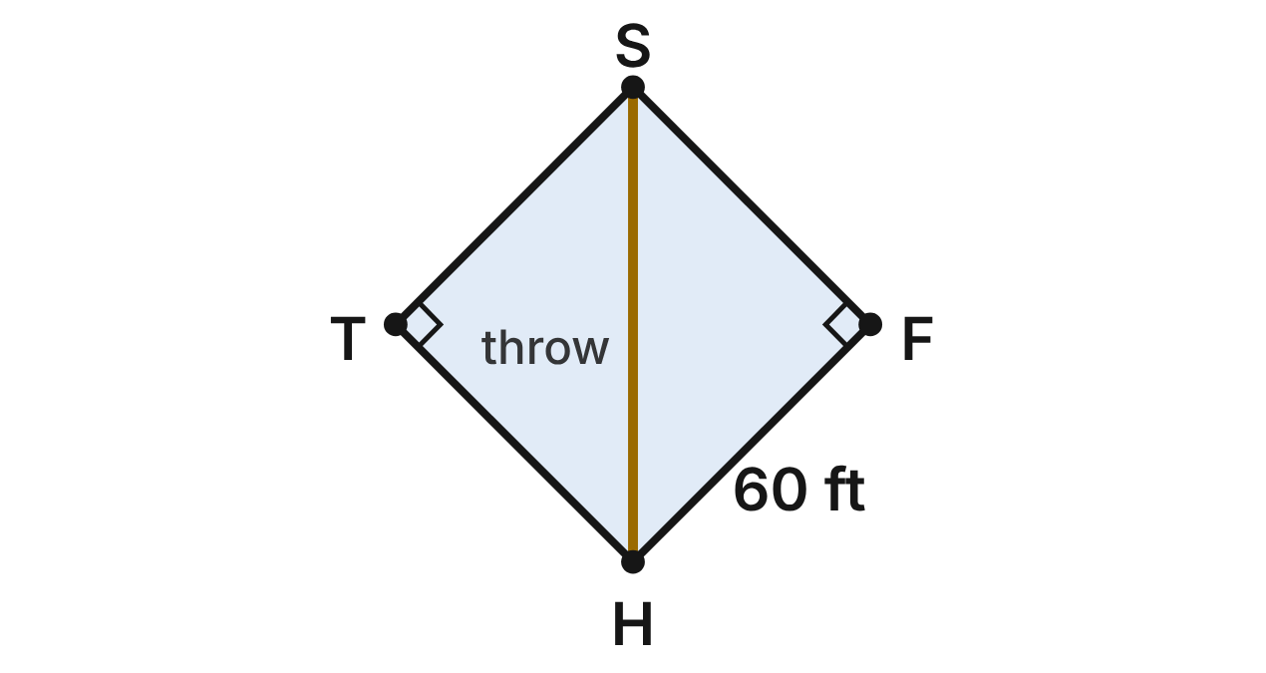
A softball diamond is a square HFST with 60-ft sides: home plate H, first base F, second base S and third base T. The catcher throws from H straight to S.
265. How far is the throw from home plate H to second base S? Give an exact answer.
A. 120 ft
B. 60√3 ft
C. 30√2 ft
D. 60√2 ft ✔
G.TR.4 · skill G.TR.4.2 (LOTS): Use the relationships in 45°-45°-90° and 30°-60°-90° triangles
☐ Answer key correct ☐ Wording clear Notes: ________________________________
266. To the nearest foot, how much shorter is the throw HS than running from H to F to S?
A. 35 ft ✔
B. 85 ft
C. 16 ft
D. 78 ft
G.TR.4 · skill G.TR.4.2 (LOTS): Use the relationships in 45°-45°-90° and 30°-60°-90° triangles
☐ Answer key correct ☐ Wording clear Notes: ________________________________
267. What is m∠FHS, the angle between the first-base line HF and the throw HS?
A. 90°
B. 60°
C. 45° ✔
D. 30°
G.TR.4 · skill G.TR.4.2 (LOTS): Use the relationships in 45°-45°-90° and 30°-60°-90° triangles
☐ Answer key correct ☐ Wording clear Notes: ________________________________
268. In right triangle HFS, what is sin ∠FSH?
A. √3/2
B. √2/2 ✔
C. √2
D. 1/2
G.TR.4 · skill G.TR.4.3 (LOTS): Use sine, cosine and tangent ratios to find a side length or an angle measure
☐ Answer key correct ☐ Wording clear Notes: ________________________________
269. On a practice field, the sides from H to F and F to S are 60 ft, and H to S measures 86 ft. What is true about the angle at F?
A. It is obtuse, because 86² is more than 60² + 60². ✔
B. It is acute, because 86² is more than 60² + 60².
C. It is a right angle, because 86 is close to 60√2.
D. It is a right angle, because 60 + 60 is more than 86.
G.TR.4 · skill G.TR.4.1 (LOTS): Use the Pythagorean Theorem and its converse, including to classify a triangle as right, acute or obtuse
☐ Answer key correct ☐ Wording clear Notes: ________________________________
270. A fan sits 20 ft above the field, 50 ft back from home plate (horizontally). To the nearest degree, what is the angle of depression from the fan to home plate?
A. 68°
B. 24°
C. 66°
D. 22° ✔
G.TR.4 · skill G.TR.4.4 (HOTS): Model a contextual problem (angles of elevation and depression, ramps, ladders, distances) with a right triangle and solve it
☐ Answer key correct ☐ Wording clear Notes: ________________________________

The Video Game Map
Level 1 · Triangles · G.TR.4 · ID geo-tr4-raid-game-map
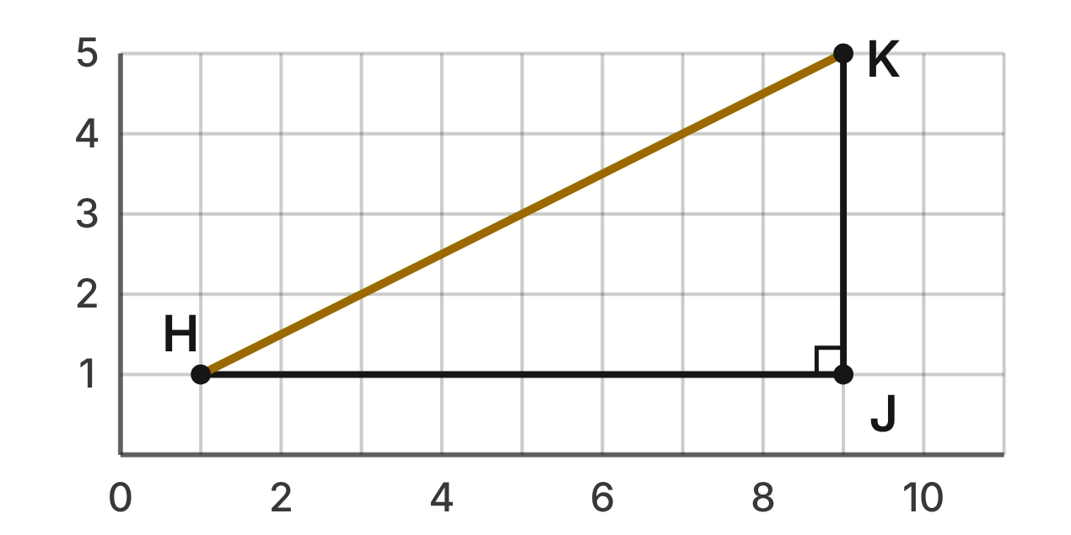
On a video game map, each grid square is 1 block. The hero walks from H(1, 1) east to J(9, 1), then north to K(9, 5). A dash power-up moves the hero straight from H to K.
271. To the nearest tenth of a block, how long is the straight dash from H to K?
A. 12.0 blocks
B. 6.9 blocks
C. 8.9 blocks ✔
D. 80.0 blocks
G.TR.4 · skill G.TR.4.1 (LOTS): Use the Pythagorean Theorem and its converse, including to classify a triangle as right, acute or obtuse
☐ Answer key correct ☐ Wording clear Notes: ________________________________
272. What is tan ∠KHJ?
A. 2
B. 1/2 ✔
C. √5/5
D. 2√5/5
G.TR.4 · skill G.TR.4.3 (LOTS): Use sine, cosine and tangent ratios to find a side length or an angle measure
☐ Answer key correct ☐ Wording clear Notes: ________________________________
273. To the nearest degree, what angle does the dash make with the east direction (m∠KHJ)?
A. 63°
B. 30°
C. 60°
D. 27° ✔
G.TR.4 · skill G.TR.4.3 (LOTS): Use sine, cosine and tangent ratios to find a side length or an angle measure
☐ Answer key correct ☐ Wording clear Notes: ________________________________
274. Points H(1, 1), M(4, 5) and J(9, 1) form a triangle on the map. Which describes triangle HMJ?
A. Acute, because 8² is less than 5² + (√41)² ✔
B. Right, because 3² + 4² = 5²
C. Obtuse, because 8² is more than 5² + 4²
D. Obtuse, because 41 is more than 25
G.TR.4 · skill G.TR.4.1 (LOTS): Use the Pythagorean Theorem and its converse, including to classify a triangle as right, acute or obtuse
☐ Answer key correct ☐ Wording clear Notes: ________________________________
275. A glide move crosses squares corner to corner, at 45° to the grid lines. What is the exact length of a glide across 5 squares?
A. 10 blocks
B. 5√3 blocks
C. 5√2 blocks ✔
D. 5 blocks
G.TR.4 · skill G.TR.4.2 (LOTS): Use the relationships in 45°-45°-90° and 30°-60°-90° triangles
☐ Answer key correct ☐ Wording clear Notes: ________________________________
276. On the next level, the gate is 20 blocks east and 21 blocks north of the hero. How far is it in a straight line?
A. 41 blocks
B. 29 blocks ✔
C. about 6.4 blocks
D. 841 blocks
G.TR.4 · skill G.TR.4.1 (LOTS): Use the Pythagorean Theorem and its converse, including to classify a triangle as right, acute or obtuse
☐ Answer key correct ☐ Wording clear Notes: ________________________________

The Pool's Sloped Floor
Level 2 · Triangles · G.TR.4 · ID geo-tr4-raid-pool
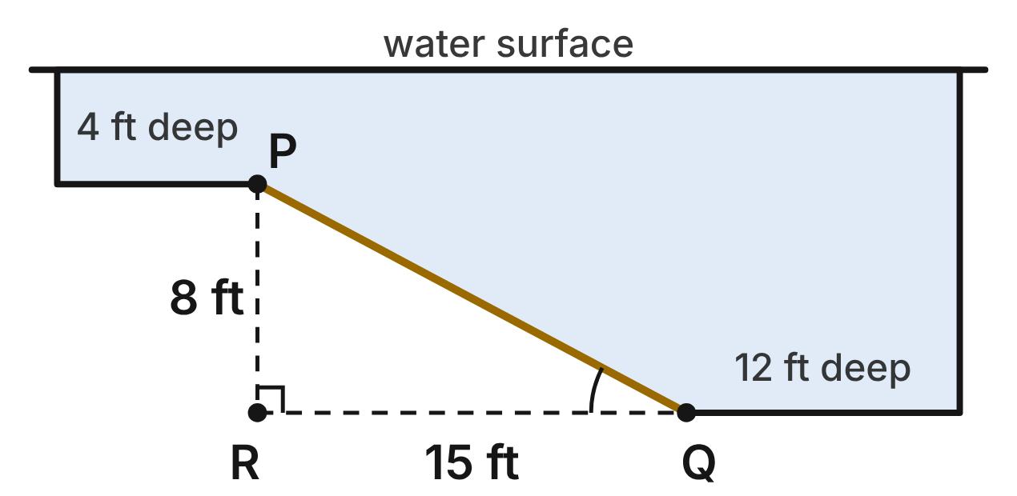
A side view of a pool. The water is 4 ft deep over the shallow floor and 12 ft deep over the deep floor. The sloped floor PQ drops from P to Q over a horizontal run RQ of 15 ft; PR is vertical.
277. How long is the sloped floor PQ?
A. 17 ft ✔
B. 23 ft
C. about 12.7 ft
D. about 15.5 ft
G.TR.4 · skill G.TR.4.1 (LOTS): Use the Pythagorean Theorem and its converse, including to classify a triangle as right, acute or obtuse
☐ Answer key correct ☐ Wording clear Notes: ________________________________
278. To the nearest degree, what angle does the sloped floor make with the horizontal (m∠PQR)?
A. 62°
B. 28° ✔
C. 32°
D. 58°
G.TR.4 · skill G.TR.4.3 (LOTS): Use sine, cosine and tangent ratios to find a side length or an angle measure
☐ Answer key correct ☐ Wording clear Notes: ________________________________
279. A lifeguard measures 9 ft along one edge of the deck, 12 ft along the other, and 14.7 ft between the two marks. What is true about the corner?
A. It is more than 90°, because 14.7² is less than 9² + 12².
B. It is exactly 90°, because 14.7 rounds to 15.
C. It is more than 90°, because 9 + 12 is more than 14.7.
D. It is less than 90°, because 14.7² is less than 9² + 12². ✔
G.TR.4 · skill G.TR.4.1 (LOTS): Use the Pythagorean Theorem and its converse, including to classify a triangle as right, acute or obtuse
☐ Answer key correct ☐ Wording clear Notes: ________________________________
280. A lifeguard's eyes are 9 ft above the water. The angle of depression to a swimmer is 16°. To the nearest foot, how far is the swimmer from the point on the water directly below her eyes?
A. 3 ft
B. 31 ft ✔
C. 33 ft
D. 9 ft
G.TR.4 · skill G.TR.4.4 (HOTS): Model a contextual problem (angles of elevation and depression, ramps, ladders, distances) with a right triangle and solve it
☐ Answer key correct ☐ Wording clear Notes: ________________________________
281. A diver touches the sloped floor at a point 6 ft past P, measured horizontally. To the nearest tenth of a foot, how deep is the water there?
A. 3.2 ft
B. 6.8 ft
C. 7.2 ft ✔
D. 8.8 ft
G.TR.4 · skill G.TR.4.4 (HOTS): Model a contextual problem (angles of elevation and depression, ramps, ladders, distances) with a right triangle and solve it
☐ Answer key correct ☐ Wording clear Notes: ________________________________
282. The pool slide's chute is 11 ft long and makes a 30° angle with the deck. How high is the top of the chute above the deck?
A. 5.5 ft ✔
B. (11√3)/2 ft
C. 11√3 ft
D. 22 ft
G.TR.4 · skill G.TR.4.2 (LOTS): Use the relationships in 45°-45°-90° and 30°-60°-90° triangles
☐ Answer key correct ☐ Wording clear Notes: ________________________________

The Tennis Serve
Level 2 · Triangles · G.TR.4 · ID geo-tr4-raid-tennis
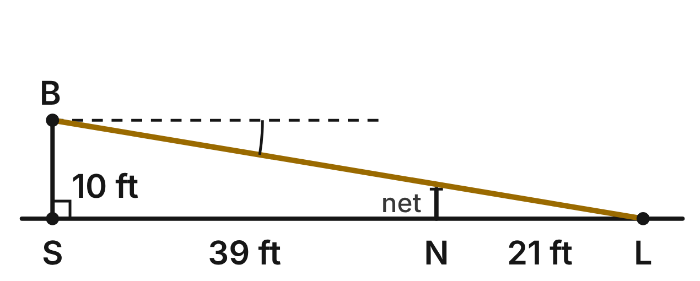
A player hits a serve at B, 10 ft above point S on the baseline. Model its path as a straight line to L, 60 ft from S on the court. The net, 3 ft high, stands at N, 39 ft from S.
283. To the nearest degree, what is the angle of depression from B to L?
A. 81°
B. 14°
C. 3°
D. 9° ✔
G.TR.4 · skill G.TR.4.4 (HOTS): Model a contextual problem (angles of elevation and depression, ramps, ladders, distances) with a right triangle and solve it
☐ Answer key correct ☐ Wording clear Notes: ________________________________
284. To the nearest tenth of a foot, how far does the ball travel from B to L?
A. 70.0 ft
B. 59.2 ft
C. 60.8 ft ✔
D. 50.0 ft
G.TR.4 · skill G.TR.4.1 (LOTS): Use the Pythagorean Theorem and its converse, including to classify a triangle as right, acute or obtuse
☐ Answer key correct ☐ Wording clear Notes: ________________________________
285. To the nearest tenth of a foot, how far above the top of the net does the ball's path pass?
A. 0.5 ft ✔
B. 3.5 ft
C. 0.8 ft
D. 7.0 ft
G.TR.4 · skill G.TR.4.4 (HOTS): Model a contextual problem (angles of elevation and depression, ramps, ladders, distances) with a right triangle and solve it
☐ Answer key correct ☐ Wording clear Notes: ________________________________
286. Let θ be the angle of depression from B to L. Which equation is true?
A. sin θ = 10/60
B. tan θ = 60/10
C. cos θ = 10/60
D. tan θ = 10/60 ✔
G.TR.4 · skill G.TR.4.3 (LOTS): Use sine, cosine and tangent ratios to find a side length or an angle measure
☐ Answer key correct ☐ Wording clear Notes: ________________________________
287. Suppose the ball left B at a 30° angle of depression. How far from S would it land? Give an exact answer.
A. (10√3)/3 ft
B. 10√3 ft ✔
C. 20 ft
D. 5√3 ft
G.TR.4 · skill G.TR.4.2 (LOTS): Use the relationships in 45°-45°-90° and 30°-60°-90° triangles
☐ Answer key correct ☐ Wording clear Notes: ________________________________
288. An umpire's eyes are 7 ft above the court. The angle of depression to a ball on the court is 23°. To the nearest tenth of a foot, how long is the line of sight from the umpire's eyes to the ball?
A. 16.5 ft
B. 7.6 ft
C. 17.9 ft ✔
D. 2.7 ft
G.TR.4 · skill G.TR.4.3 (LOTS): Use sine, cosine and tangent ratios to find a side length or an angle measure
☐ Answer key correct ☐ Wording clear Notes: ________________________________

The Archery Target Stand
Level 2 · Triangles · G.TR.4 · ID geo-tr4-raid-archery
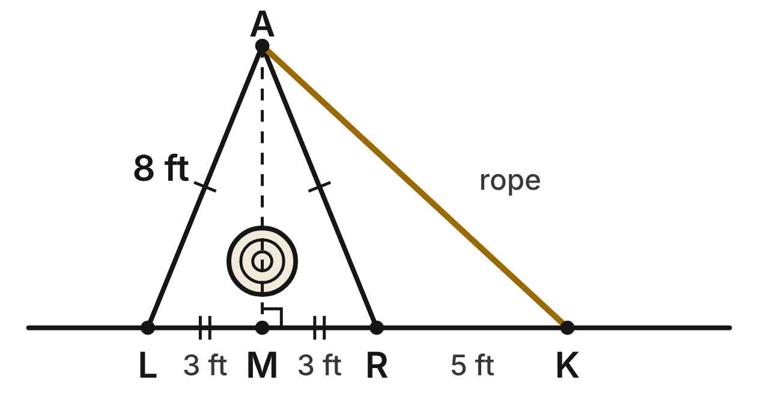
A target stand is an A-frame. Legs AL and AR are each 8 ft long, the feet L and R are 6 ft apart, and M is the midpoint of LR, with AM perpendicular to the ground. A rope runs from A to a stake K on the ground, 5 ft past R.
289. To the nearest tenth of a foot, how tall is the stand (AM)?
A. 8.5 ft
B. 5.3 ft
C. 7.4 ft ✔
D. 5.0 ft
G.TR.4 · skill G.TR.4.1 (LOTS): Use the Pythagorean Theorem and its converse, including to classify a triangle as right, acute or obtuse
☐ Answer key correct ☐ Wording clear Notes: ________________________________
290. To the nearest degree, what angle does each leg make with the ground (m∠ALM)?
A. 68° ✔
B. 22°
C. 21°
D. 41°
G.TR.4 · skill G.TR.4.3 (LOTS): Use sine, cosine and tangent ratios to find a side length or an angle measure
☐ Answer key correct ☐ Wording clear Notes: ________________________________
291. A smaller stand has 5-ft legs that make a 60° angle with the ground. What is its exact height?
A. 5/2 ft
B. 5√3 ft
C. (5√2)/2 ft
D. (5√3)/2 ft ✔
G.TR.4 · skill G.TR.4.2 (LOTS): Use the relationships in 45°-45°-90° and 30°-60°-90° triangles
☐ Answer key correct ☐ Wording clear Notes: ________________________________
292. On a hill course, a target is 40 m away horizontally, up an angle of elevation of 20°. To the nearest tenth of a meter, how much higher is the target than the archer's bow?
A. 13.7 m
B. 37.6 m
C. 14.6 m ✔
D. 109.9 m
G.TR.4 · skill G.TR.4.4 (HOTS): Model a contextual problem (angles of elevation and depression, ramps, ladders, distances) with a right triangle and solve it
☐ Answer key correct ☐ Wording clear Notes: ________________________________
293. To the nearest tenth of a foot, how long is the rope AK?
A. 8.9 ft
B. 10.9 ft ✔
C. 15.4 ft
D. 13.0 ft
G.TR.4 · skill G.TR.4.4 (HOTS): Model a contextual problem (angles of elevation and depression, ramps, ladders, distances) with a right triangle and solve it
☐ Answer key correct ☐ Wording clear Notes: ________________________________
294. Which ratio is equal to sin ∠LAM?
A. 3/8 ✔
B. √55/8
C. 3/√55
D. 8/3
G.TR.4 · skill G.TR.4.3 (LOTS): Use sine, cosine and tangent ratios to find a side length or an angle measure
☐ Answer key correct ☐ Wording clear Notes: ________________________________

The Basketball Hoop
Level 2 · Triangles · G.TR.4 · ID geo-tr4-raid-hoop
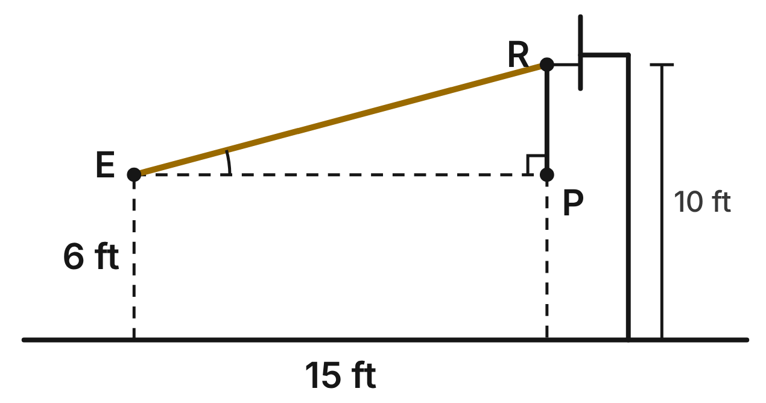
A player's eyes E are 6 ft above the floor, 15 ft (horizontally) from the point below the rim R. The rim is 10 ft above the floor. P is level with E, directly below R.
295. To the nearest degree, what is the angle of elevation from E to R?
A. 34°
B. 15° ✔
C. 75°
D. 22°
G.TR.4 · skill G.TR.4.4 (HOTS): Model a contextual problem (angles of elevation and depression, ramps, ladders, distances) with a right triangle and solve it
☐ Answer key correct ☐ Wording clear Notes: ________________________________
296. To the nearest tenth of a foot, how far is it from E straight to R?
A. 18.0 ft
B. 19.0 ft
C. 14.5 ft
D. 15.5 ft ✔
G.TR.4 · skill G.TR.4.1 (LOTS): Use the Pythagorean Theorem and its converse, including to classify a triangle as right, acute or obtuse
☐ Answer key correct ☐ Wording clear Notes: ________________________________
297. A portable hoop's base has a triangle with sides 12 in., 35 in. and 37 in. Is the angle between the 12-in. and 35-in. sides a right angle?
A. No, because 12 + 35 is not equal to 37.
B. No, it is acute, because 37² is less than 12² + 35².
C. Yes, because 12² + 35² = 37². ✔
D. Yes, because 37 is the longest side.
G.TR.4 · skill G.TR.4.1 (LOTS): Use the Pythagorean Theorem and its converse, including to classify a triangle as right, acute or obtuse
☐ Answer key correct ☐ Wording clear Notes: ________________________________
298. Which statement about right triangle EPR is NOT true?
A. sin ∠E = 4/15 ✔
B. tan ∠E = 4/15
C. tan ∠R = 15/4
D. ∠E and ∠R are complementary
G.TR.4 · skill G.TR.4.3 (LOTS): Use sine, cosine and tangent ratios to find a side length or an angle measure
☐ Answer key correct ☐ Wording clear Notes: ________________________________
299. A support arm makes a 60° angle with the hoop's pole and reaches 4 ft out from the pole. How long is the arm? Give an exact answer.
A. 8 ft
B. 4√3 ft
C. (4√3)/3 ft
D. (8√3)/3 ft ✔
G.TR.4 · skill G.TR.4.2 (LOTS): Use the relationships in 45°-45°-90° and 30°-60°-90° triangles
☐ Answer key correct ☐ Wording clear Notes: ________________________________
300. A player whose eyes are 5.5 ft above the floor sees the top of the 13-ft backboard at a 28° angle of elevation. To the nearest tenth of a foot, how far is she from the backboard, horizontally?
A. 24.4 ft
B. 14.1 ft ✔
C. 4.0 ft
D. 16.0 ft
G.TR.4 · skill G.TR.4.4 (HOTS): Model a contextual problem (angles of elevation and depression, ramps, ladders, distances) with a right triangle and solve it
☐ Answer key correct ☐ Wording clear Notes: ________________________________

The Soccer Shot Angle
Level 3 · Triangles · G.TR.4 · ID geo-tr4-raid-soccer
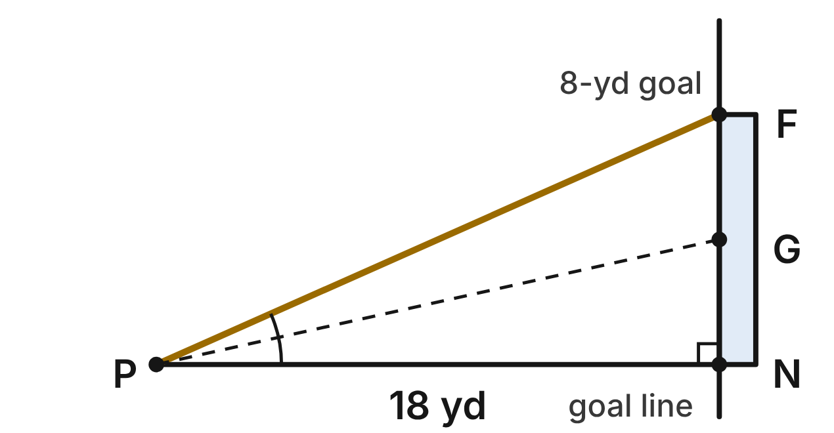
Top view of a goal. The posts N and F are 8 yd apart on the goal line, and G is the midpoint of NF. Player P is 18 yd from the goal line, in line with the near post: PN is perpendicular to the goal line.
301. To the nearest degree, what is m∠NPF, the angle she has to shoot into?
A. 24° ✔
B. 66°
C. 26°
D. 64°
G.TR.4 · skill G.TR.4.3 (LOTS): Use sine, cosine and tangent ratios to find a side length or an angle measure
☐ Answer key correct ☐ Wording clear Notes: ________________________________
302. To the nearest tenth of a yard, how far is the player from the far post (PF)?
A. 26.0 yd
B. 16.1 yd
C. 10.0 yd
D. 19.7 yd ✔
G.TR.4 · skill G.TR.4.1 (LOTS): Use the Pythagorean Theorem and its converse, including to classify a triangle as right, acute or obtuse
☐ Answer key correct ☐ Wording clear Notes: ________________________________
303. She dribbles straight toward N until she is 12 yd from the goal line. To the nearest degree, by how much does her shooting angle ∠NPF grow?
A. 34°
B. 10° ✔
C. 15°
D. 53°
G.TR.4 · skill G.TR.4.4 (HOTS): Model a contextual problem (angles of elevation and depression, ramps, ladders, distances) with a right triangle and solve it
☐ Answer key correct ☐ Wording clear Notes: ________________________________
304. The goalkeeper stands at G. To the nearest degree, what is m∠GPF, the part of her shooting angle on the far side of the goalkeeper?
A. 36°
B. 13°
C. 11° ✔
D. 24°
G.TR.4 · skill G.TR.4.4 (HOTS): Model a contextual problem (angles of elevation and depression, ramps, ladders, distances) with a right triangle and solve it
☐ Answer key correct ☐ Wording clear Notes: ________________________________
305. On a small practice field, the posts are 4 yd apart. A player in line with the near post sees the goal at a 30° angle. How far is she from the goal line? Give an exact answer.
A. (4√3)/3 yd
B. 8 yd
C. 2√3 yd
D. 4√3 yd ✔
G.TR.4 · skill G.TR.4.2 (LOTS): Use the relationships in 45°-45°-90° and 30°-60°-90° triangles
☐ Answer key correct ☐ Wording clear Notes: ________________________________
306. Let d be her distance from the goal line when ∠NPF measures 40°, with the same 8-yd goal. Which equation finds d?
A. tan 40° = 8/d ✔
B. tan 40° = d/8
C. sin 40° = 8/d
D. cos 40° = 8/d
G.TR.4 · skill G.TR.4.4 (HOTS): Model a contextual problem (angles of elevation and depression, ramps, ladders, distances) with a right triangle and solve it
☐ Answer key correct ☐ Wording clear Notes: ________________________________

The Climbing Wall Camera
Level 3 · Triangles · G.TR.4 · ID geo-tr4-raid-climbing
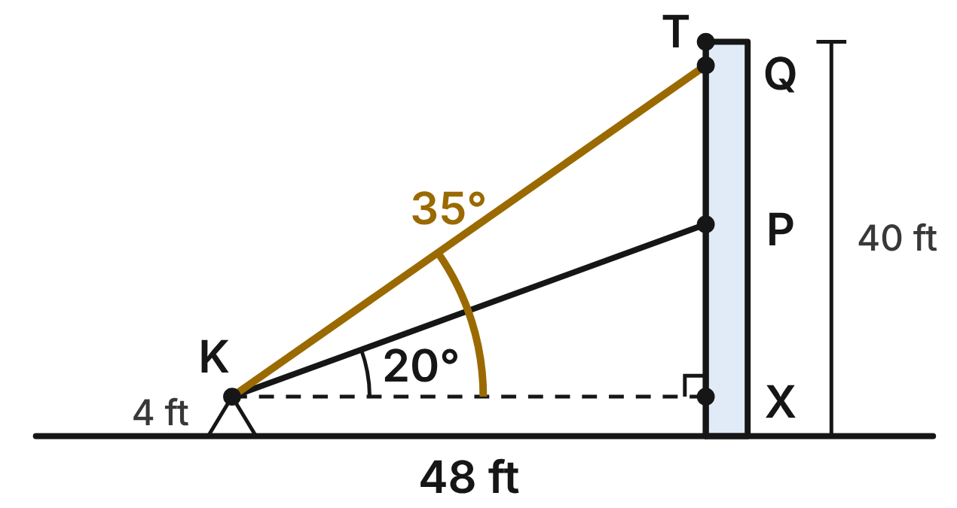
A camera K on a tripod is 4 ft above the floor and 48 ft from a 40-ft climbing wall. X is on the wall, level with K, and T is the top of the wall. The angle of elevation from K to a climber is 20° when she is at P and 35° when she is at Q.
307. To the nearest tenth of a foot, how high above the floor is the climber at P?
A. 17.5 ft
B. 20.4 ft
C. 21.5 ft ✔
D. 135.9 ft
G.TR.4 · skill G.TR.4.4 (HOTS): Model a contextual problem (angles of elevation and depression, ramps, ladders, distances) with a right triangle and solve it
☐ Answer key correct ☐ Wording clear Notes: ________________________________
308. To the nearest tenth of a foot, how far up the wall does she climb from P to Q?
A. 33.6 ft
B. 16.1 ft ✔
C. 37.6 ft
D. 12.9 ft
G.TR.4 · skill G.TR.4.4 (HOTS): Model a contextual problem (angles of elevation and depression, ramps, ladders, distances) with a right triangle and solve it
☐ Answer key correct ☐ Wording clear Notes: ________________________________
309. To the nearest foot, how long is the camera's line of sight KQ?
A. 59 ft ✔
B. 84 ft
C. 39 ft
D. 34 ft
G.TR.4 · skill G.TR.4.3 (LOTS): Use sine, cosine and tangent ratios to find a side length or an angle measure
☐ Answer key correct ☐ Wording clear Notes: ________________________________
310. How far is the camera K from T, the top of the wall?
A. about 62.5 ft
B. 84 ft
C. about 31.7 ft
D. 60 ft ✔
G.TR.4 · skill G.TR.4.1 (LOTS): Use the Pythagorean Theorem and its converse, including to classify a triangle as right, acute or obtuse
☐ Answer key correct ☐ Wording clear Notes: ________________________________
311. Part of another wall leans back at 45°. A climber moves 12 ft along it. How much higher does she get? Give an exact answer.
A. 12√2 ft
B. 6√2 ft ✔
C. 6 ft
D. 6√3 ft
G.TR.4 · skill G.TR.4.2 (LOTS): Use the relationships in 45°-45°-90° and 30°-60°-90° triangles
☐ Answer key correct ☐ Wording clear Notes: ________________________________
312. Which statement about the angles in the figure is NOT true?
A. The angle of depression from Q to K is 35°.
B. m∠KPX = 70°
C. The angle of depression from P to K is 70°. ✔
D. m∠PKQ = 15°
G.TR.4 · skill G.TR.4.4 (HOTS): Model a contextual problem (angles of elevation and depression, ramps, ladders, distances) with a right triangle and solve it
☐ Answer key correct ☐ Wording clear Notes: ________________________________

Polygons and circles (G.PC)

G.PC.1 · Prove and justify theorems and properties of quadrilaterals, and verify and use properties of quadrilaterals to solve problems, including the relationships between the sides, angles, and diagonals.

Around the Bases
Level 1 · Quadrilaterals · G.PC.1 · ID geo-pc1-raid-diamond
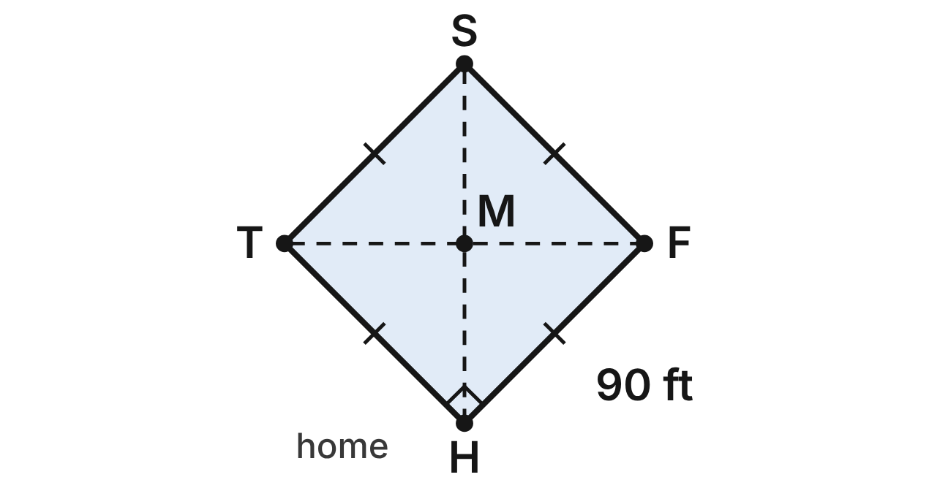
A baseball diamond is square HFST with 90-foot sides: H is home plate, F first base, S second base and T third base. The diagonals HS and FT meet at M.
313. Which statement about diagonals HS and FT is true?
A. They are congruent and perpendicular. ✔
B. They are congruent but not perpendicular.
C. They are perpendicular but not congruent.
D. They do not bisect each other.
G.PC.1 · skill G.PC.1.1 (LOTS): Identify the properties of parallelograms, rectangles, rhombi, squares, trapezoids and kites (sides, angles, diagonals)
☐ Answer key correct ☐ Wording clear Notes: ________________________________
314. To the nearest tenth of a foot, how far is it from home plate to second base?
A. 180 ft
B. 90 ft
C. 127.3 ft ✔
D. 63.6 ft
G.PC.1 · skill G.PC.1.3 (LOTS): Solve problems, including algebraic ones, using the properties of quadrilaterals
☐ Answer key correct ☐ Wording clear Notes: ________________________________
315. What is m∠SHF, the angle between diagonal HS and the first-base line HF?
A. 90°
B. 45° ✔
C. 135°
D. 22.5°
G.PC.1 · skill G.PC.1.1 (LOTS): Identify the properties of parallelograms, rectangles, rhombi, squares, trapezoids and kites (sides, angles, diagonals)
☐ Answer key correct ☐ Wording clear Notes: ________________________________
316. Which segment must be congruent to HM?
A. HF
B. HS
C. FT
D. FM ✔
G.PC.1 · skill G.PC.1.1 (LOTS): Identify the properties of parallelograms, rectangles, rhombi, squares, trapezoids and kites (sides, angles, diagonals)
☐ Answer key correct ☐ Wording clear Notes: ________________________________
317. A coach chalks a smaller practice square. One side is (4x − 6) ft and the next side is (2x + 24) ft. How long is each side?
A. 15 ft
B. 216 ft
C. 30 ft
D. 54 ft ✔
G.PC.1 · skill G.PC.1.3 (LOTS): Solve problems, including algebraic ones, using the properties of quadrilaterals
☐ Answer key correct ☐ Wording clear Notes: ________________________________
318. Which statement is true of every square, including HFST?
A. It is both a rhombus and a rectangle. ✔
B. It is a rhombus but not a rectangle.
C. It is a rectangle but not a rhombus.
D. It is neither a rhombus nor a rectangle.
G.PC.1 · skill G.PC.1.1 (LOTS): Identify the properties of parallelograms, rectangles, rhombi, squares, trapezoids and kites (sides, angles, diagonals)
☐ Answer key correct ☐ Wording clear Notes: ________________________________

The Skate Park Funbox
Level 1 · Quadrilaterals · G.PC.1 · ID geo-pc1-raid-funbox
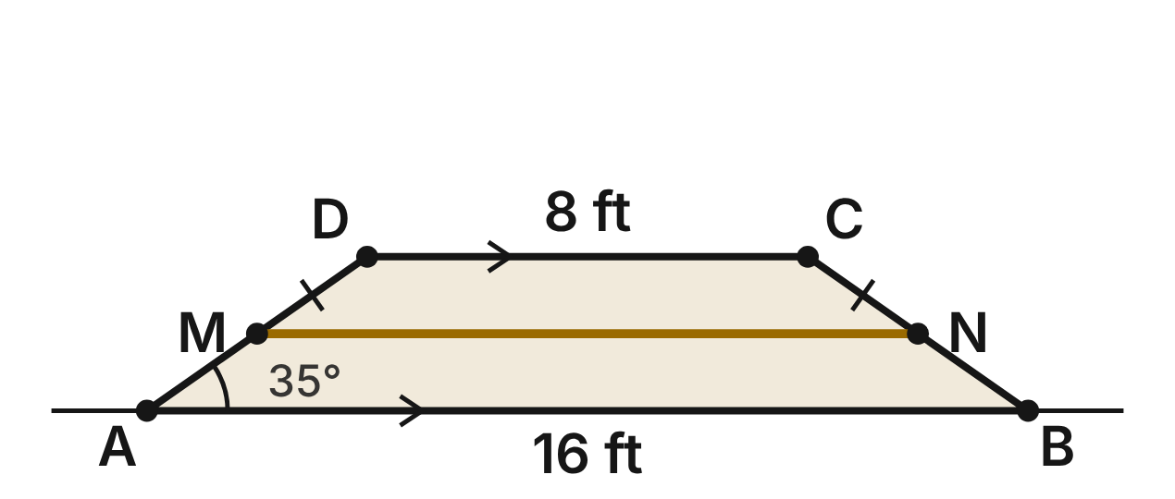
From the side, a skate park funbox ABCD is an isosceles trapezoid. The ground base AB = 16 ft, the flat deck DC = 8 ft and m∠DAB = 35°. A support beam MN (gold) joins the midpoints of the ramps AD and BC.
319. How long is the support beam MN?
A. 24 ft
B. 12 ft ✔
C. 8 ft
D. 4 ft
G.PC.1 · skill G.PC.1.3 (LOTS): Solve problems, including algebraic ones, using the properties of quadrilaterals
☐ Answer key correct ☐ Wording clear Notes: ________________________________
320. Which pair of angles must be congruent?
A. ∠DAB and ∠BCD
B. ∠DAB and ∠ADC
C. ∠ABC and ∠ADC
D. ∠DAB and ∠ABC ✔
G.PC.1 · skill G.PC.1.1 (LOTS): Identify the properties of parallelograms, rectangles, rhombi, squares, trapezoids and kites (sides, angles, diagonals)
☐ Answer key correct ☐ Wording clear Notes: ________________________________
321. Which statement is NOT true for funbox ABCD?
A. AB ∥ DC
B. AD ≅ BC
C. AD ∥ BC ✔
D. ∠ADC ≅ ∠BCD
G.PC.1 · skill G.PC.1.1 (LOTS): Identify the properties of parallelograms, rectangles, rhombi, squares, trapezoids and kites (sides, angles, diagonals)
☐ Answer key correct ☐ Wording clear Notes: ________________________________
322. What is m∠BCD?
A. 145° ✔
B. 35°
C. 55°
D. 290°
G.PC.1 · skill G.PC.1.3 (LOTS): Solve problems, including algebraic ones, using the properties of quadrilaterals
☐ Answer key correct ☐ Wording clear Notes: ________________________________
323. On another funbox, the deck is (x + 2) ft, the ground base is (3x − 2) ft and the beam joining the midpoints of the ramps is 14 ft. What is x?
A. 7 ✔
B. 3.5
C. 9
D. 19
G.PC.1 · skill G.PC.1.3 (LOTS): Solve problems, including algebraic ones, using the properties of quadrilaterals
☐ Answer key correct ☐ Wording clear Notes: ________________________________
324. Why is ABCD a trapezoid and not a parallelogram?
A. Its legs AD and BC are congruent.
B. It has no right angles.
C. Only one pair of its sides is parallel. ✔
D. Its diagonals are congruent.
G.PC.1 · skill G.PC.1.1 (LOTS): Identify the properties of parallelograms, rectangles, rhombi, squares, trapezoids and kites (sides, angles, diagonals)
☐ Answer key correct ☐ Wording clear Notes: ________________________________

The Board Game Tile
Level 2 · Quadrilaterals · G.PC.1 · ID geo-pc1-raid-game-tile
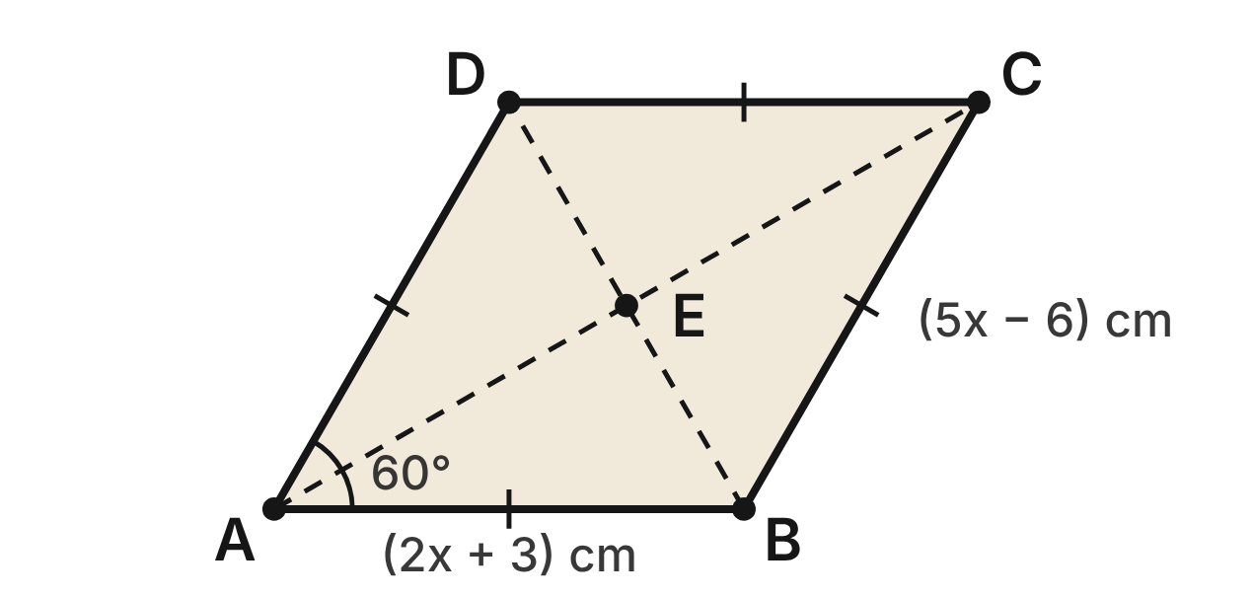
A board game uses rhombus-shaped tiles. On tile ABCD, AB = (2x + 3) cm, BC = (5x − 6) cm and m∠DAB = 60°. The diagonals (dashed) meet at E.
325. Use the two side lengths to find the value of x.
A. −1
B. 9
C. 9/7
D. 3 ✔
G.PC.1 · skill G.PC.1.3 (LOTS): Solve problems, including algebraic ones, using the properties of quadrilaterals
☐ Answer key correct ☐ Wording clear Notes: ________________________________
326. How long is diagonal BD?
A. 9 cm ✔
B. 18 cm
C. 4.5 cm
D. 9√3 cm
G.PC.1 · skill G.PC.1.3 (LOTS): Solve problems, including algebraic ones, using the properties of quadrilaterals
☐ Answer key correct ☐ Wording clear Notes: ________________________________
327. What is m∠ABC?
A. 60°
B. 120° ✔
C. 30°
D. 300°
G.PC.1 · skill G.PC.1.1 (LOTS): Identify the properties of parallelograms, rectangles, rhombi, squares, trapezoids and kites (sides, angles, diagonals)
☐ Answer key correct ☐ Wording clear Notes: ________________________________
328. What is m∠BAC?
A. 60°
B. 90°
C. 30° ✔
D. 45°
G.PC.1 · skill G.PC.1.1 (LOTS): Identify the properties of parallelograms, rectangles, rhombi, squares, trapezoids and kites (sides, angles, diagonals)
☐ Answer key correct ☐ Wording clear Notes: ________________________________
329. A different tile PQRS is known to be a parallelogram. Which single fact is enough to prove it is a rhombus?
A. Diagonals PR and QS are congruent.
B. Diagonal PR bisects ∠SPQ. ✔
C. ∠SPQ is a right angle.
D. Sides PQ and SR are parallel.
G.PC.1 · skill G.PC.1.1 (LOTS): Identify the properties of parallelograms, rectangles, rhombi, squares, trapezoids and kites (sides, angles, diagonals)
☐ Answer key correct ☐ Wording clear Notes: ________________________________
330. Lena says that since ABCD has four congruent sides, its diagonals must be congruent too. Which statement explains her error?
A. She is right: all rhombus diagonals are congruent.
B. Rhombus diagonals are never perpendicular.
C. Rhombus diagonals never bisect each other.
D. Rhombus diagonals are congruent only in a square. ✔
G.PC.1 · skill G.PC.1.1 (LOTS): Identify the properties of parallelograms, rectangles, rhombi, squares, trapezoids and kites (sides, angles, diagonals)
☐ Answer key correct ☐ Wording clear Notes: ________________________________

The Shield Icon
Level 2 · Quadrilaterals · G.PC.1 · ID geo-pc1-raid-shield
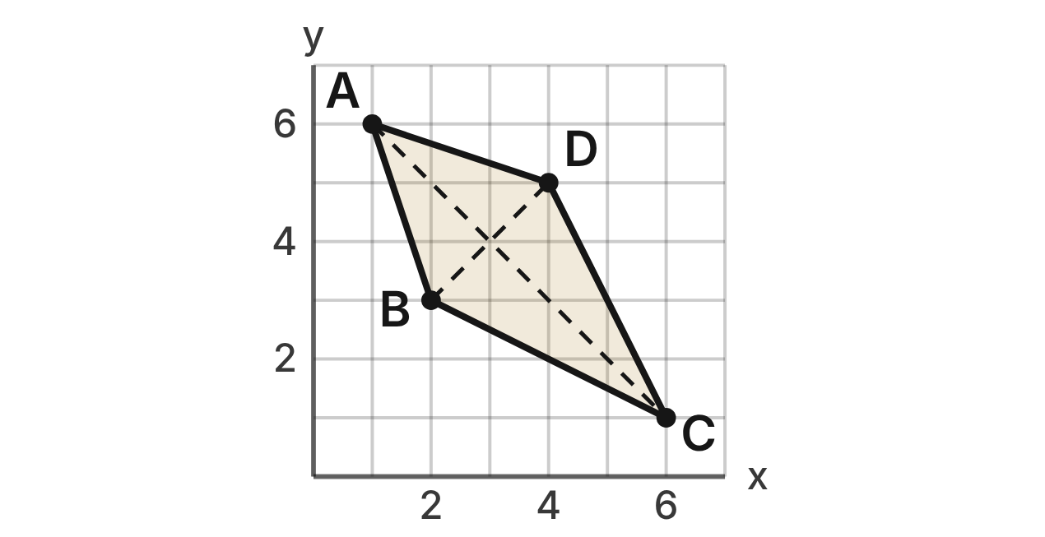
In a video game, a shield icon is quadrilateral ABCD drawn on a pixel grid with A(1, 6), B(2, 3), C(6, 1) and D(4, 5). The artist says it is a kite. The dashed segments are its diagonals.
331. How many grid units long is side AB of the shield?
A. 4
B. 10
C. √10 ✔
D. 2√2
G.PC.1 · skill G.PC.1.2 (HOTS): Use coordinate methods (slope, distance, midpoint) to classify a quadrilateral or justify a property
☐ Answer key correct ☐ Wording clear Notes: ________________________________
332. Which facts show that ABCD is a kite?
A. AB = CD = √10 and AD = CB = 2√5
B. AB = AD = √10 and CB = CD = 2√5 ✔
C. AB = BC = CD = DA = √10
D. AC = BD = 2√5, so the diagonals are ≅
G.PC.1 · skill G.PC.1.2 (HOTS): Use coordinate methods (slope, distance, midpoint) to classify a quadrilateral or justify a property
☐ Answer key correct ☐ Wording clear Notes: ________________________________
333. What do the slopes of the diagonals show?
A. AC: −1 and BD: 1, so AC ⊥ BD ✔
B. AC: −1 and BD: 1, so AC ∥ BD
C. AC: 1 and BD: 1, so AC ∥ BD
D. AC: −1 and BD: 1, so AC ≅ BD
G.PC.1 · skill G.PC.1.2 (HOTS): Use coordinate methods (slope, distance, midpoint) to classify a quadrilateral or justify a property
☐ Answer key correct ☐ Wording clear Notes: ________________________________
334. What is the midpoint of diagonal BD?
A. (3.5, 3.5)
B. (1, 1)
C. (6, 8)
D. (3, 4) ✔
G.PC.1 · skill G.PC.1.2 (HOTS): Use coordinate methods (slope, distance, midpoint) to classify a quadrilateral or justify a property
☐ Answer key correct ☐ Wording clear Notes: ________________________________
335. Which statement about how the diagonals of kite ABCD cut each other is true?
A. BD bisects AC, but AC does not bisect BD.
B. AC and BD bisect each other.
C. AC bisects BD, but BD does not bisect AC. ✔
D. Neither diagonal bisects the other.
G.PC.1 · skill G.PC.1.1 (LOTS): Identify the properties of parallelograms, rectangles, rhombi, squares, trapezoids and kites (sides, angles, diagonals)
☐ Answer key correct ☐ Wording clear Notes: ________________________________
336. The artist moves only C so that ABCD becomes a rhombus. A, B and D stay put. Where should C go?
A. (5, 2) ✔
B. (6, 1)
C. (3, 4)
D. (6, 8)
G.PC.1 · skill G.PC.1.2 (HOTS): Use coordinate methods (slope, distance, midpoint) to classify a quadrilateral or justify a property
☐ Answer key correct ☐ Wording clear Notes: ________________________________

The Lap Pool
Level 2 · Quadrilaterals · G.PC.1 · ID geo-pc1-raid-lap-pool
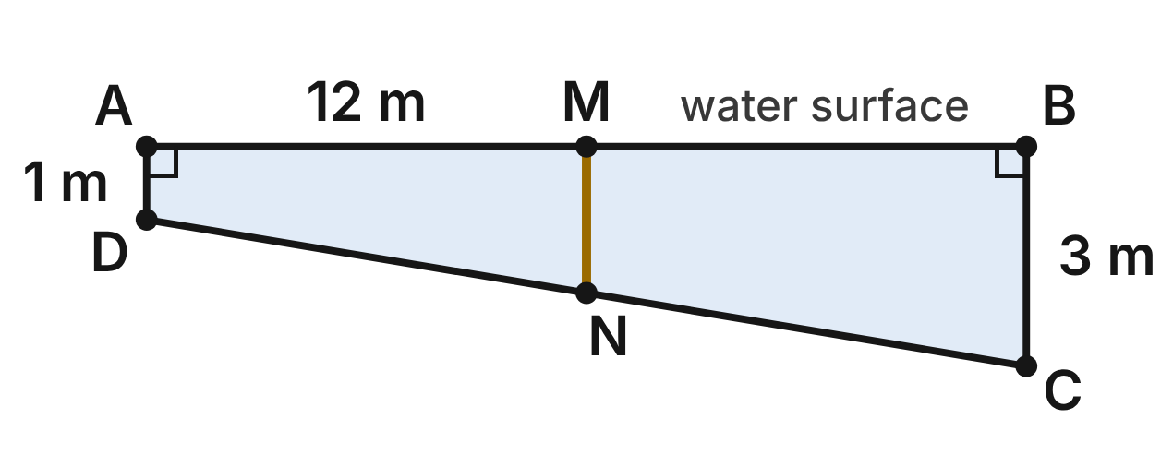
The side view of a lap pool is trapezoid ABCD. The end walls AD and BC are vertical, and the water surface AB is level and 12 m long. The shallow end is AD = 1 m deep and the deep end is BC = 3 m deep. MN (gold) joins the midpoints of AB and DC.
337. How deep is the water halfway along the pool (the length of MN)?
A. 2 m ✔
B. 4 m
C. 1 m
D. 1.5 m
G.PC.1 · skill G.PC.1.3 (LOTS): Solve problems, including algebraic ones, using the properties of quadrilaterals
☐ Answer key correct ☐ Wording clear Notes: ________________________________
338. Which two sides of ABCD are parallel?
A. AB and DC
B. AB and BC
C. AD and DC
D. AD and BC ✔
G.PC.1 · skill G.PC.1.1 (LOTS): Identify the properties of parallelograms, rectangles, rhombi, squares, trapezoids and kites (sides, angles, diagonals)
☐ Answer key correct ☐ Wording clear Notes: ________________________________
339. Which pair of angles is supplementary?
A. ∠ADC and ∠DAB
B. ∠ADC and ∠BCD ✔
C. ∠BCD and ∠ABC
D. ∠DAB and ∠BCD
G.PC.1 · skill G.PC.1.1 (LOTS): Identify the properties of parallelograms, rectangles, rhombi, squares, trapezoids and kites (sides, angles, diagonals)
☐ Answer key correct ☐ Wording clear Notes: ________________________________
340. Another pool has the same shape. Its shallow end is 1.2 m deep, its deep end is 3.4 m deep, and the depth halfway along is (x + 1) m. What is x?
A. 3.6
B. 0.1
C. 1.3 ✔
D. 2.3
G.PC.1 · skill G.PC.1.3 (LOTS): Solve problems, including algebraic ones, using the properties of quadrilaterals
☐ Answer key correct ☐ Wording clear Notes: ________________________________
341. To the nearest tenth of a meter, how long is the sloped floor DC?
A. 14 m
B. 11.8 m
C. 12.4 m
D. 12.2 m ✔
G.PC.1 · skill G.PC.1.3 (LOTS): Solve problems, including algebraic ones, using the properties of quadrilaterals
☐ Answer key correct ☐ Wording clear Notes: ________________________________
342. What is the most specific name for ABCD?
A. an isosceles trapezoid
B. a right trapezoid ✔
C. a rectangle
D. a parallelogram
G.PC.1 · skill G.PC.1.1 (LOTS): Identify the properties of parallelograms, rectangles, rhombi, squares, trapezoids and kites (sides, angles, diagonals)
☐ Answer key correct ☐ Wording clear Notes: ________________________________

The Archery Field Plan
Level 3 · Quadrilaterals · G.PC.1 · ID geo-pc1-raid-archery
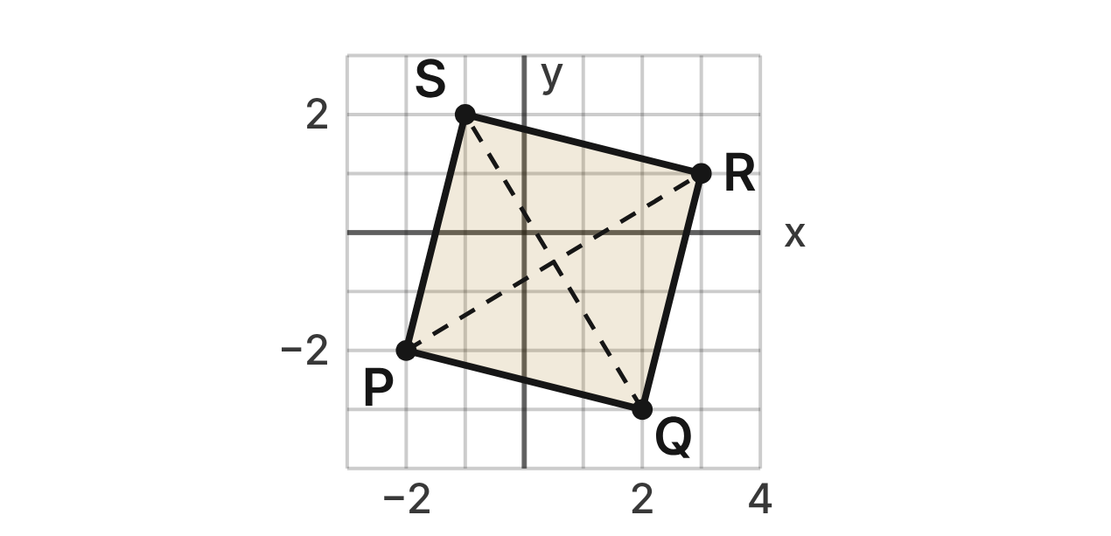
On a field plan, four archery target stands sit at P(−2, −2), Q(2, −3), R(3, 1) and S(−1, 2). Each grid unit is 5 m.
343. The slope of PQ is −1/4. What is the slope of QR, and what does it show?
A. 1/4, so PQ ⊥ QR
B. 4, so PQ ⊥ QR ✔
C. −4, so PQ ⊥ QR
D. 4, so PQ ∥ QR
G.PC.1 · skill G.PC.1.2 (HOTS): Use coordinate methods (slope, distance, midpoint) to classify a quadrilateral or justify a property
☐ Answer key correct ☐ Wording clear Notes: ________________________________
344. How long is diagonal PR on the plan?
A. 8 units
B. 34 units
C. √34 units ✔
D. 4 units
G.PC.1 · skill G.PC.1.2 (HOTS): Use coordinate methods (slope, distance, midpoint) to classify a quadrilateral or justify a property
☐ Answer key correct ☐ Wording clear Notes: ________________________________
345. What is the midpoint of QS?
A. (−1.5, 2.5)
B. (1, −1)
C. (1.5, 2.5)
D. (0.5, −0.5) ✔
G.PC.1 · skill G.PC.1.2 (HOTS): Use coordinate methods (slope, distance, midpoint) to classify a quadrilateral or justify a property
☐ Answer key correct ☐ Wording clear Notes: ________________________________
346. All four of these facts are true. Which one, by itself, proves that PQRS is a square?
A. PR and QS bisect each other, are ≅ and are ⊥ ✔
B. All four sides measure √17 units each
C. PR and QS bisect each other and are ≅
D. PR ⊥ QS and PR bisects QS
G.PC.1 · skill G.PC.1.2 (HOTS): Use coordinate methods (slope, distance, midpoint) to classify a quadrilateral or justify a property
☐ Answer key correct ☐ Wording clear Notes: ________________________________
347. To the nearest meter, how far does an archer walk going once around all four stands, from P to Q to R to S and back to P?
A. 82 m ✔
B. 16 m
C. 100 m
D. 41 m
G.PC.1 · skill G.PC.1.3 (LOTS): Solve problems, including algebraic ones, using the properties of quadrilaterals
☐ Answer key correct ☐ Wording clear Notes: ________________________________
348. Dev says PQRS is only a rhombus, because its diagonals are perpendicular. Which reply is correct?
A. Perpendicular diagonals make it a rectangle.
B. Its diagonals are also congruent, so it is a square. ✔
C. Its diagonals are not perpendicular, so it is a kite.
D. A square cannot also be a rhombus.
G.PC.1 · skill G.PC.1.1 (LOTS): Identify the properties of parallelograms, rectangles, rhombi, squares, trapezoids and kites (sides, angles, diagonals)
☐ Answer key correct ☐ Wording clear Notes: ________________________________

The Tangram Parallelogram
Level 3 · Quadrilaterals · G.PC.1 · ID geo-pc1-raid-tangram
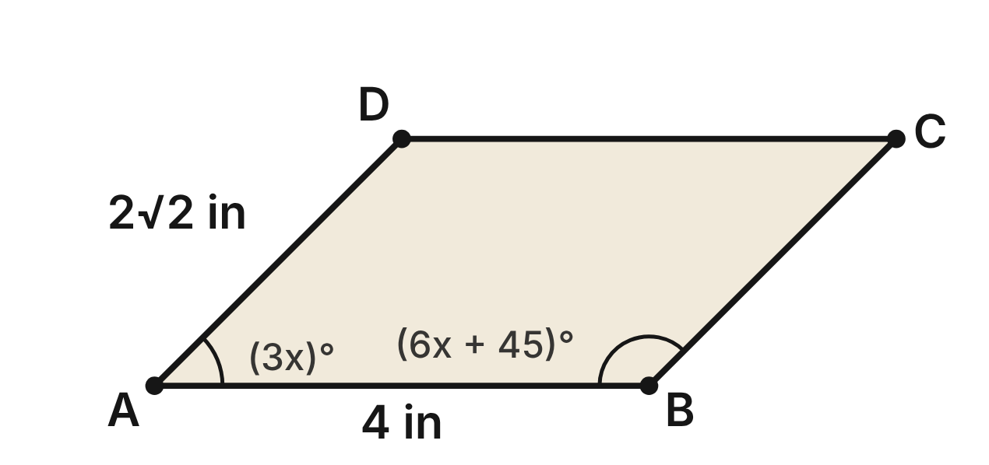
The parallelogram piece ABCD of a tangram puzzle has AB = 4 in and AD = 2√2 in. m∠DAB = (3x)° and m∠ABC = (6x + 45)°.
349. Which equation can be used to find x?
A. 3x = 6x + 45
B. 3x + 6x + 45 = 360
C. 3x + 6x + 45 = 90
D. 3x + 6x + 45 = 180 ✔
G.PC.1 · skill G.PC.1.3 (LOTS): Solve problems, including algebraic ones, using the properties of quadrilaterals
☐ Answer key correct ☐ Wording clear Notes: ________________________________
350. What is the measure of ∠BCD on the tangram piece?
A. 45° ✔
B. 135°
C. 90°
D. 15°
G.PC.1 · skill G.PC.1.3 (LOTS): Solve problems, including algebraic ones, using the properties of quadrilaterals
☐ Answer key correct ☐ Wording clear Notes: ________________________________
351. Diagonal BD is 2√2 in long, the same as AD. What is m∠ADB?
A. 45°
B. 135°
C. 90° ✔
D. 67.5°
G.PC.1 · skill G.PC.1.3 (LOTS): Solve problems, including algebraic ones, using the properties of quadrilaterals
☐ Answer key correct ☐ Wording clear Notes: ________________________________
352. The piece is 2 in tall (the distance between AB and DC). How long is diagonal AC?
A. 2√5 in
B. 2√10 in ✔
C. 2√6 in
D. (4 + 2√2) in
G.PC.1 · skill G.PC.1.3 (LOTS): Solve problems, including algebraic ones, using the properties of quadrilaterals
☐ Answer key correct ☐ Wording clear Notes: ________________________________
353. Suppose a parallelogram is known to be a rectangle. Which single extra fact proves it is a square?
A. Its diagonals are congruent.
B. Its opposite sides are parallel.
C. Its diagonals are perpendicular. ✔
D. Its diagonals bisect each other.
G.PC.1 · skill G.PC.1.1 (LOTS): Identify the properties of parallelograms, rectangles, rhombi, squares, trapezoids and kites (sides, angles, diagonals)
☐ Answer key correct ☐ Wording clear Notes: ________________________________
354. Which statement is NOT true for piece ABCD?
A. Its diagonals bisect each other.
B. Its opposite sides are congruent.
C. ∠DAB and ∠ADC are supplementary.
D. Its diagonals bisect its angles. ✔
G.PC.1 · skill G.PC.1.1 (LOTS): Identify the properties of parallelograms, rectangles, rhombi, squares, trapezoids and kites (sides, angles, diagonals)
☐ Answer key correct ☐ Wording clear Notes: ________________________________

G.PC.2 · Verify relationships and solve problems involving the number of sides and measures of angles of convex polygons.

Home Plate
Level 1 · Polygons · G.PC.2 · ID geo-pc2-raid-home-plate
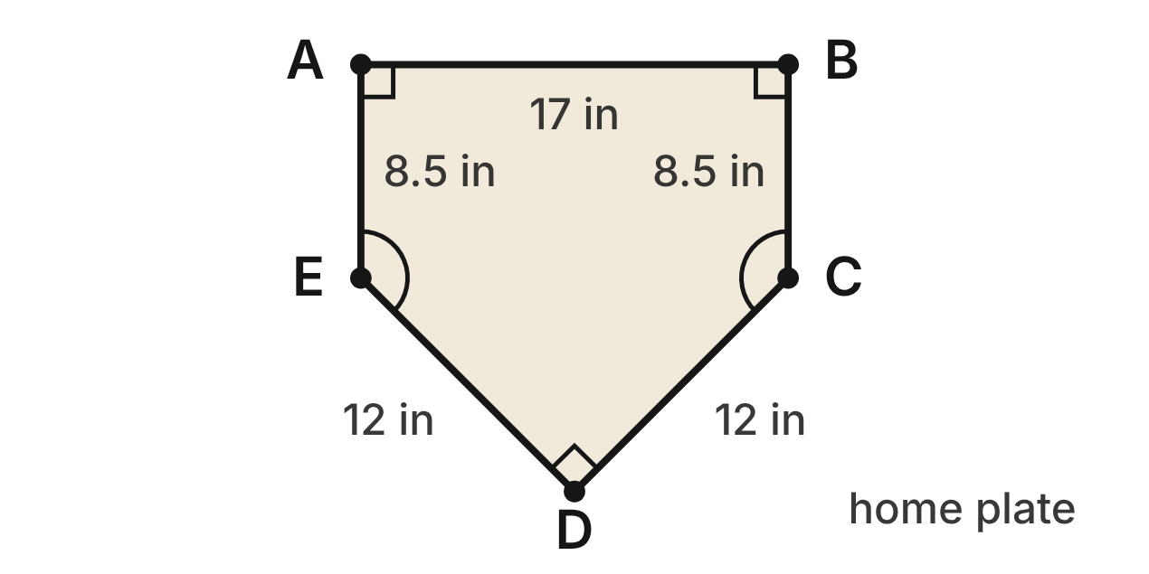
A baseball home plate is pentagon ABCDE. ∠A, ∠B and ∠D are right angles, and ∠C ≅ ∠E.
355. What is the sum of the interior angles of home plate?
A. 540° ✔
B. 900°
C. 720°
D. 360°
G.PC.2 · skill G.PC.2.1 (LOTS): Find the sum of the interior angles, and the measure of each interior and exterior angle, of a convex or regular polygon
☐ Answer key correct ☐ Wording clear Notes: ________________________________
356. What is m∠C?
A. 270°
B. 45°
C. 135° ✔
D. 108°
G.PC.2 · skill G.PC.2.1 (LOTS): Find the sum of the interior angles, and the measure of each interior and exterior angle, of a convex or regular polygon
☐ Answer key correct ☐ Wording clear Notes: ________________________________
357. What is the measure of an exterior angle of home plate at corner C?
A. 135°
B. 225°
C. 72°
D. 45° ✔
G.PC.2 · skill G.PC.2.1 (LOTS): Find the sum of the interior angles, and the measure of each interior and exterior angle, of a convex or regular polygon
☐ Answer key correct ☐ Wording clear Notes: ________________________________
358. Which statement about the exterior angles of home plate, one at each corner, is true?
A. They add to 540°.
B. They add to 360°. ✔
C. Each one measures 72°.
D. They add to 900°.
G.PC.2 · skill G.PC.2.1 (LOTS): Find the sum of the interior angles, and the measure of each interior and exterior angle, of a convex or regular polygon
☐ Answer key correct ☐ Wording clear Notes: ________________________________
359. Is home plate a regular pentagon?
A. Yes: it has five sides.
B. Yes: its angles add to 540°.
C. No: its angles are not all congruent. ✔
D. No: a pentagon's angles add to 360°.
G.PC.2 · skill G.PC.2.1 (LOTS): Find the sum of the interior angles, and the measure of each interior and exterior angle, of a convex or regular polygon
☐ Answer key correct ☐ Wording clear Notes: ________________________________
360. A team logo is a regular polygon. Each interior angle measures 162°. How many sides does the logo have?
A. 20 ✔
B. 10
C. about 2.2
D. 18
G.PC.2 · skill G.PC.2.2 (LOTS): Find the number of sides of a regular polygon given the measure of an interior or exterior angle
☐ Answer key correct ☐ Wording clear Notes: ________________________________

The Board Game Spinner
Level 1 · Polygons · G.PC.2 · ID geo-pc2-raid-spinner
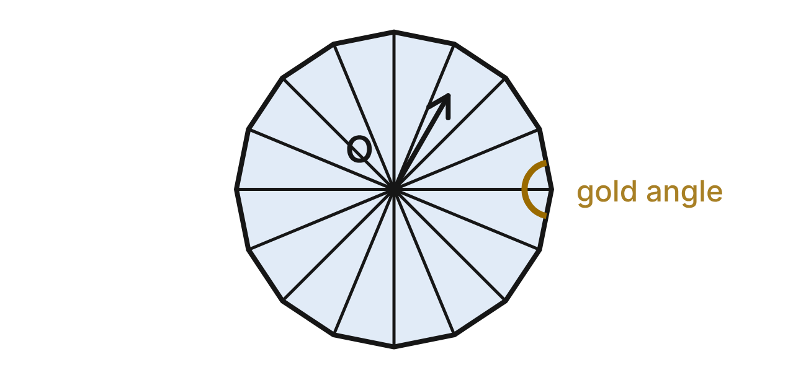
The edge of a board game spinner is a regular 16-gon. Segments from the center O to the 16 corners split it into 16 congruent triangles. The gold arc marks one interior angle.
361. What is the sum of the interior angles of the 16-gon?
A. 2880°
B. 2700°
C. 360°
D. 2520° ✔
G.PC.2 · skill G.PC.2.1 (LOTS): Find the sum of the interior angles, and the measure of each interior and exterior angle, of a convex or regular polygon
☐ Answer key correct ☐ Wording clear Notes: ________________________________
362. What is the measure of the gold interior angle?
A. 22.5°
B. 157.5° ✔
C. 168.75°
D. 180°
G.PC.2 · skill G.PC.2.1 (LOTS): Find the sum of the interior angles, and the measure of each interior and exterior angle, of a convex or regular polygon
☐ Answer key correct ☐ Wording clear Notes: ________________________________
363. What is the measure of each exterior angle of the 16-gon?
A. 22.5° ✔
B. 157.5°
C. 11.25°
D. 24°
G.PC.2 · skill G.PC.2.1 (LOTS): Find the sum of the interior angles, and the measure of each interior and exterior angle, of a convex or regular polygon
☐ Answer key correct ☐ Wording clear Notes: ________________________________
364. The 16 triangles have angles that add to 16 · 180° = 2880°, but the 16-gon's angles add to less. Why?
A. Two of the 16 triangles overlap each other.
B. Each triangle's angles add to less than 180°.
C. The 360° around O is not part of the 16-gon's angles. ✔
D. The segments add two extra 180° angles.
G.PC.2 · skill G.PC.2.1 (LOTS): Find the sum of the interior angles, and the measure of each interior and exterior angle, of a convex or regular polygon
☐ Answer key correct ☐ Wording clear Notes: ________________________________
365. What is the sum of the 16 exterior angles, one at each corner?
A. 2520°
B. 5760°
C. 22.5°
D. 360° ✔
G.PC.2 · skill G.PC.2.1 (LOTS): Find the sum of the interior angles, and the measure of each interior and exterior angle, of a convex or regular polygon
☐ Answer key correct ☐ Wording clear Notes: ________________________________
366. A bigger spinner's edge is a regular polygon with exterior angles of 7.5°. How many sides does its edge have?
A. 24
B. 48 ✔
C. 172.5
D. 50
G.PC.2 · skill G.PC.2.2 (LOTS): Find the number of sides of a regular polygon given the measure of an interior or exterior angle
☐ Answer key correct ☐ Wording clear Notes: ________________________________

Panels on a Soccer Ball
Level 2 · Polygons · G.PC.2 · ID geo-pc2-raid-soccer-ball
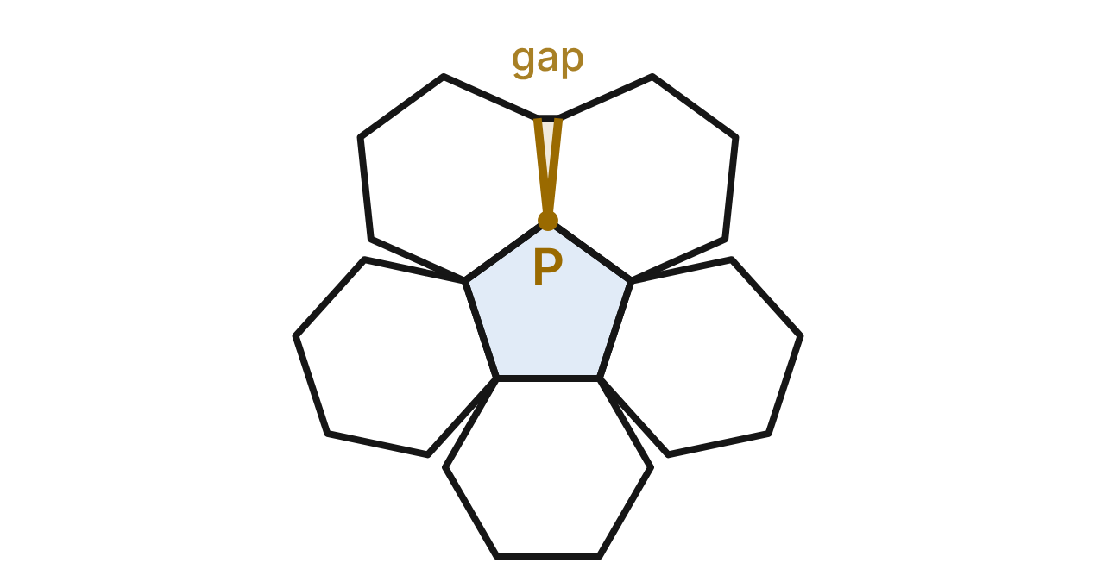
A soccer ball is stitched from regular pentagon and regular hexagon panels with equal sides. Laid flat, the panels around one pentagon do not quite fit: at a corner such as P, one pentagon and two hexagons meet and leave a gap (gold).
367. What is the measure of each interior angle of a pentagon panel?
A. 72°
B. 108° ✔
C. 540°
D. 120°
G.PC.2 · skill G.PC.2.1 (LOTS): Find the sum of the interior angles, and the measure of each interior and exterior angle, of a convex or regular polygon
☐ Answer key correct ☐ Wording clear Notes: ________________________________
368. What is the measure of the gold gap at P?
A. 132°
B. 348°
C. 36°
D. 12° ✔
G.PC.2 · skill G.PC.2.1 (LOTS): Find the sum of the interior angles, and the measure of each interior and exterior angle, of a convex or regular polygon
☐ Answer key correct ☐ Wording clear Notes: ________________________________
369. Regular hexagons alone can cover a flat field with no gaps. Which reason explains why?
A. A hexagon has an even number of sides.
B. Its 60° exterior angles add to 360°.
C. Three 120° angles fill the 360° at a point. ✔
D. Its angle sum, 720°, is a multiple of 360°.
G.PC.2 · skill G.PC.2.1 (LOTS): Find the sum of the interior angles, and the measure of each interior and exterior angle, of a convex or regular polygon
☐ Answer key correct ☐ Wording clear Notes: ________________________________
370. A designer wants a regular polygon panel whose interior angles are each twice its exterior angles. How many sides will it have?
A. 6 ✔
B. 3
C. 4
D. 12
G.PC.2 · skill G.PC.2.2 (LOTS): Find the number of sides of a regular polygon given the measure of an interior or exterior angle
☐ Answer key correct ☐ Wording clear Notes: ________________________________
371. Kai says, "At P, 108° + 120° + 120° = 360°, so the flat panels fit with no gap." What is his error?
A. The three angles add to 348°, not 360°. ✔
B. A pentagon's angle is 72°, not 108°.
C. A hexagon's angle is 135°, not 120°.
D. Angles around a point add to 180°.
G.PC.2 · skill G.PC.2.1 (LOTS): Find the sum of the interior angles, and the measure of each interior and exterior angle, of a convex or regular polygon
☐ Answer key correct ☐ Wording clear Notes: ________________________________
372. Which set of regular polygons can meet at one point with no gap or overlap?
A. a pentagon and two hexagons
B. three regular pentagons
C. a square, a hexagon and a 12-gon ✔
D. two octagons and a triangle
G.PC.2 · skill G.PC.2.1 (LOTS): Find the sum of the interior angles, and the measure of each interior and exterior angle, of a convex or regular polygon
☐ Answer key correct ☐ Wording clear Notes: ________________________________

The Cone Course at the Skate Park
Level 2 · Polygons · G.PC.2 · ID geo-pc2-raid-cone-course
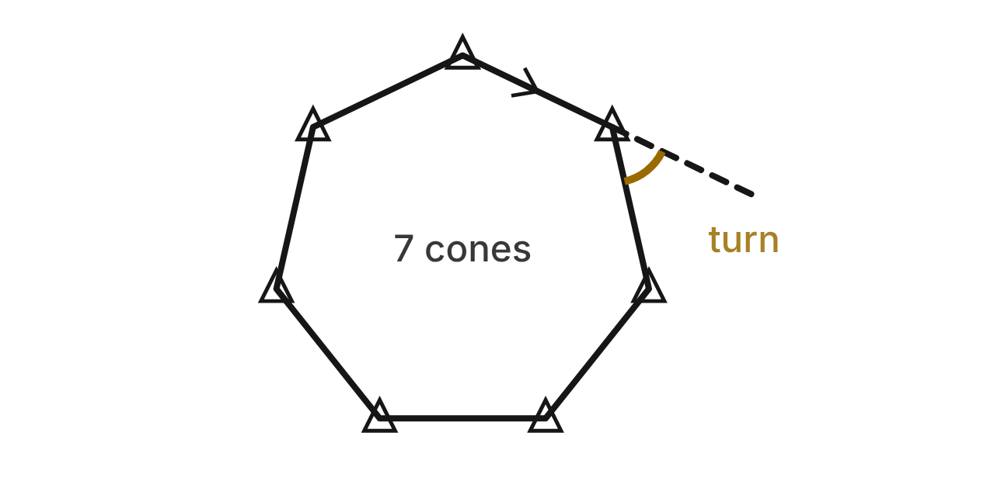
A skater rides a closed course of straight legs around 7 cones. The cones are the corners of a regular heptagon. At each cone she turns through the same angle (gold) to start the next leg.
373. Through how many degrees does the skater turn in all during one full lap?
A. 900°
B. 2520°
C. 360° ✔
D. 180°
G.PC.2 · skill G.PC.2.1 (LOTS): Find the sum of the interior angles, and the measure of each interior and exterior angle, of a convex or regular polygon
☐ Answer key correct ☐ Wording clear Notes: ________________________________
374. To the nearest tenth of a degree, what is the measure of each gold turn?
A. 51.4° ✔
B. 128.6°
C. 25.7°
D. 60.0°
G.PC.2 · skill G.PC.2.1 (LOTS): Find the sum of the interior angles, and the measure of each interior and exterior angle, of a convex or regular polygon
☐ Answer key correct ☐ Wording clear Notes: ________________________________
375. To the nearest tenth of a degree, what is the angle between two legs at a cone, inside the course?
A. 51.4°
B. 154.3°
C. 180.0°
D. 128.6° ✔
G.PC.2 · skill G.PC.2.1 (LOTS): Find the sum of the interior angles, and the measure of each interior and exterior angle, of a convex or regular polygon
☐ Answer key correct ☐ Wording clear Notes: ________________________________
376. For a contest, the coach sets up a regular course with a 15° turn at each cone. How many cones does the course have?
A. 12
B. 24 ✔
C. 165
D. 26
G.PC.2 · skill G.PC.2.2 (LOTS): Find the number of sides of a regular polygon given the measure of an interior or exterior angle
☐ Answer key correct ☐ Wording clear Notes: ________________________________
377. Which equal turn at every cone can NOT make a closed regular course?
A. 40°
B. 70° ✔
C. 45°
D. 72°
G.PC.2 · skill G.PC.2.2 (LOTS): Find the number of sides of a regular polygon given the measure of an interior or exterior angle
☐ Answer key correct ☐ Wording clear Notes: ________________________________
378. What is the sum of the seven angles inside the course, one at each cone?
A. 1260°
B. 1080°
C. 360°
D. 900° ✔
G.PC.2 · skill G.PC.2.1 (LOTS): Find the sum of the interior angles, and the measure of each interior and exterior angle, of a convex or regular polygon
☐ Answer key correct ☐ Wording clear Notes: ________________________________

The Ballfield Fence
Level 2 · Polygons · G.PC.2 · ID geo-pc2-raid-ballfield
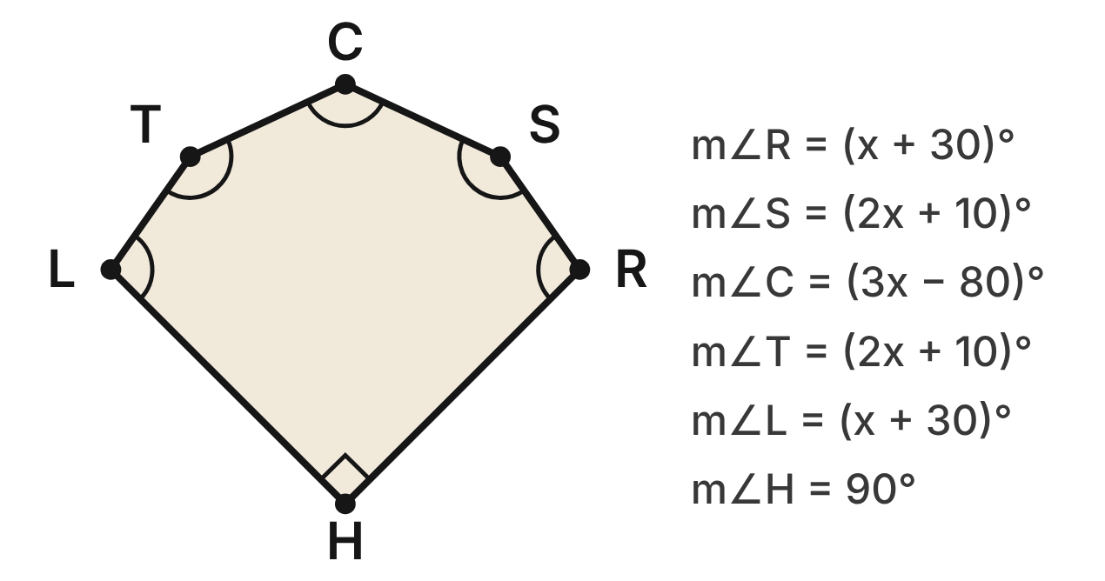
A youth ballfield is the convex hexagon HRSCTL. The foul lines meet at a right angle at home plate H. The outfield fence runs in straight sections from foul pole R through S, C and T to foul pole L. The other angles are given in terms of x, in degrees.
379. Which equation can be used to find x?
A. 9x + 90 = 720 ✔
B. 9x = 720
C. 9x + 90 = 540
D. 9x + 90 = 360
G.PC.2 · skill G.PC.2.1 (LOTS): Find the sum of the interior angles, and the measure of each interior and exterior angle, of a convex or regular polygon
☐ Answer key correct ☐ Wording clear Notes: ________________________________
380. Solve for x using the angles of the field.
A. 80
B. 50
C. 70 ✔
D. 110
G.PC.2 · skill G.PC.2.1 (LOTS): Find the sum of the interior angles, and the measure of each interior and exterior angle, of a convex or regular polygon
☐ Answer key correct ☐ Wording clear Notes: ________________________________
381. What is the measure of the angle at center field, m∠C?
A. 160°
B. 130° ✔
C. 70°
D. 50°
G.PC.2 · skill G.PC.2.1 (LOTS): Find the sum of the interior angles, and the measure of each interior and exterior angle, of a convex or regular polygon
☐ Answer key correct ☐ Wording clear Notes: ________________________________
382. What is the measure of an exterior angle of the field at foul pole R?
A. 100°
B. 60°
C. 260°
D. 80° ✔
G.PC.2 · skill G.PC.2.1 (LOTS): Find the sum of the interior angles, and the measure of each interior and exterior angle, of a convex or regular polygon
☐ Answer key correct ☐ Wording clear Notes: ________________________________
383. Which corners of the field have the largest angles?
A. C only
B. R and L
C. S and T ✔
D. H only
G.PC.2 · skill G.PC.2.1 (LOTS): Find the sum of the interior angles, and the measure of each interior and exterior angle, of a convex or regular polygon
☐ Answer key correct ☐ Wording clear Notes: ________________________________
384. A groundskeeper walks the whole boundary once. How many degrees does she turn in all at R, S, C, T and L together, leaving out H?
A. 270° ✔
B. 360°
C. 630°
D. 90°
G.PC.2 · skill G.PC.2.1 (LOTS): Find the sum of the interior angles, and the measure of each interior and exterior angle, of a convex or regular polygon
☐ Answer key correct ☐ Wording clear Notes: ________________________________

The Video Game Arena
Level 3 · Polygons · G.PC.2 · ID geo-pc2-raid-arena
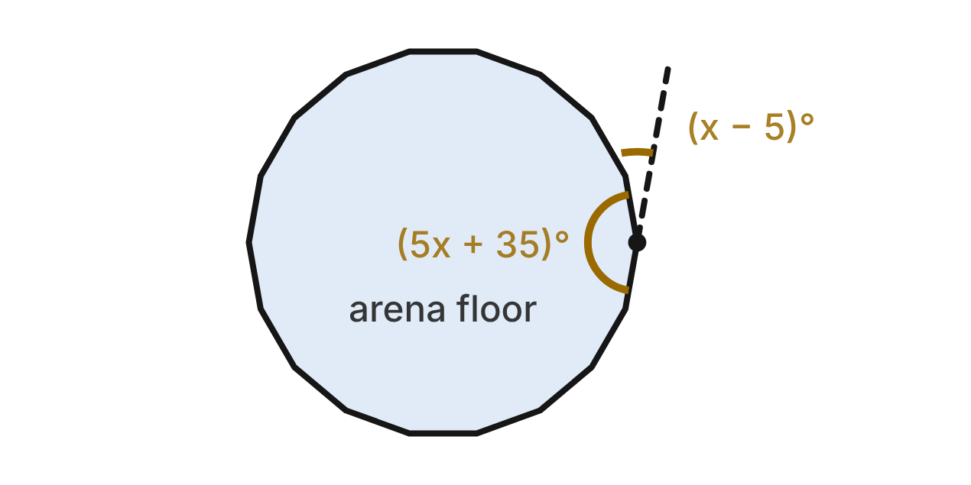
In a video game, the arena floor is a regular polygon. At one corner, the interior angle measures (5x + 35)° and the exterior angle measures (x − 5)°.
385. Which equation relates the two marked angles?
A. (5x + 35) + (x − 5) = 360
B. 5x + 35 = x − 5
C. (5x + 35) + (x − 5) = 90
D. (5x + 35) + (x − 5) = 180 ✔
G.PC.2 · skill G.PC.2.1 (LOTS): Find the sum of the interior angles, and the measure of each interior and exterior angle, of a convex or regular polygon
☐ Answer key correct ☐ Wording clear Notes: ________________________________
386. What is the measure of each exterior angle of the arena floor?
A. 20° ✔
B. 160°
C. 25°
D. 50°
G.PC.2 · skill G.PC.2.1 (LOTS): Find the sum of the interior angles, and the measure of each interior and exterior angle, of a convex or regular polygon
☐ Answer key correct ☐ Wording clear Notes: ________________________________
387. How many sides does the arena floor have?
A. 9
B. 18 ✔
C. 20
D. 2.25
G.PC.2 · skill G.PC.2.2 (LOTS): Find the number of sides of a regular polygon given the measure of an interior or exterior angle
☐ Answer key correct ☐ Wording clear Notes: ________________________________
388. What is the sum of the interior angles of the arena floor?
A. 3240°
B. 3060°
C. 2880° ✔
D. 360°
G.PC.2 · skill G.PC.2.1 (LOTS): Find the sum of the interior angles, and the measure of each interior and exterior angle, of a convex or regular polygon
☐ Answer key correct ☐ Wording clear Notes: ________________________________
389. The next level's arena is a regular polygon with 6 more sides than this one. What is each of its interior angles?
A. 15°
B. 165° ✔
C. 160°
D. 120°
G.PC.2 · skill G.PC.2.1 (LOTS): Find the sum of the interior angles, and the measure of each interior and exterior angle, of a convex or regular polygon
☐ Answer key correct ☐ Wording clear Notes: ________________________________
390. What value of x fits the two marked angles?
A. 55
B. 10
C. 30
D. 25 ✔
G.PC.2 · skill G.PC.2.1 (LOTS): Find the sum of the interior angles, and the measure of each interior and exterior angle, of a convex or regular polygon
☐ Answer key correct ☐ Wording clear Notes: ________________________________

The Bike Race Loop
Level 3 · Polygons · G.PC.2 · ID geo-pc2-raid-bike-loop
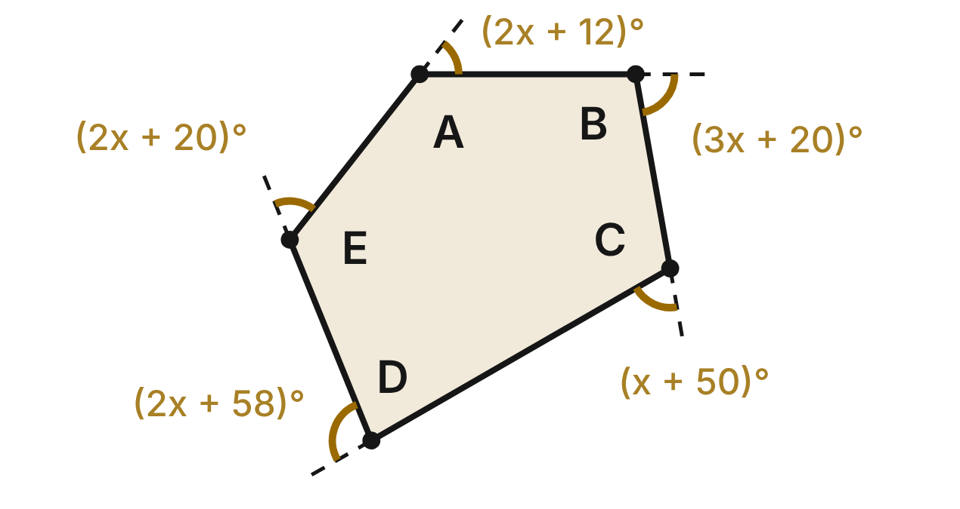
A bike race loop ABCDE has five straight legs. At each corner a rider turns through the gold angle (an exterior angle of the loop), given in terms of x, in degrees.
391. Which equation can a rider use to find x from the turns?
A. 10x + 160 = 540
B. 10x + 160 = 360 ✔
C. 10x = 360
D. 10x + 160 = 180
G.PC.2 · skill G.PC.2.1 (LOTS): Find the sum of the interior angles, and the measure of each interior and exterior angle, of a convex or regular polygon
☐ Answer key correct ☐ Wording clear Notes: ________________________________
392. Use the five turns to find x.
A. 38
B. 36
C. 56
D. 20 ✔
G.PC.2 · skill G.PC.2.1 (LOTS): Find the sum of the interior angles, and the measure of each interior and exterior angle, of a convex or regular polygon
☐ Answer key correct ☐ Wording clear Notes: ________________________________
393. At which corner does the rider make the largest turn?
A. at D ✔
B. at B
C. at C
D. at E
G.PC.2 · skill G.PC.2.1 (LOTS): Find the sum of the interior angles, and the measure of each interior and exterior angle, of a convex or regular polygon
☐ Answer key correct ☐ Wording clear Notes: ________________________________
394. What is the measure of the angle inside the loop at corner D?
A. 98°
B. 262°
C. 82° ✔
D. 108°
G.PC.2 · skill G.PC.2.1 (LOTS): Find the sum of the interior angles, and the measure of each interior and exterior angle, of a convex or regular polygon
☐ Answer key correct ☐ Wording clear Notes: ________________________________
395. Next year the loop will have six straight legs and six turns. What will the six turns add to?
A. 360° ✔
B. 720°
C. 540°
D. 432°
G.PC.2 · skill G.PC.2.1 (LOTS): Find the sum of the interior angles, and the measure of each interior and exterior angle, of a convex or regular polygon
☐ Answer key correct ☐ Wording clear Notes: ________________________________
396. A practice loop is a regular polygon in which each angle inside the loop is 4 times each turn. How many sides does it have?
A. 5
B. 8
C. 10 ✔
D. about 2.5
G.PC.2 · skill G.PC.2.2 (LOTS): Find the number of sides of a regular polygon given the measure of an interior or exterior angle
☐ Answer key correct ☐ Wording clear Notes: ________________________________

G.PC.3 · Solve problems, including contextual problems, by applying properties of circles.

The Game Spinner
Level 1 · Circles · G.PC.3 · ID geo-pc3-raid-game-spinner
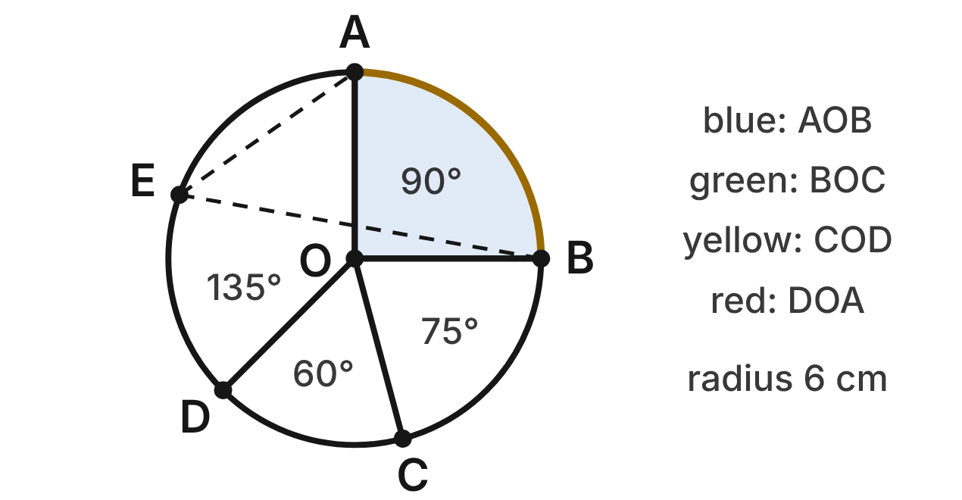
A game spinner has center O and radius 6 cm. Its sectors are blue (AOB, 90°), green (BOC, 75°), yellow (COD, 60°) and red (DOA, 135°). Point E is on the edge of the red sector.
397. What is the length of arc AB, the edge of the blue sector? Give the answer in terms of π.
A. 3π cm ✔
B. 1.5π cm
C. 6π cm
D. 9π cm
G.PC.3 · skill G.PC.3.3 (LOTS): Find arc length and the area of a sector, or use them to find a radius or a central angle
☐ Answer key correct ☐ Wording clear Notes: ________________________________
398. What is the area of the green sector, to the nearest tenth of a square centimeter?
A. 7.9 cm²
B. 94.2 cm²
C. 113.1 cm²
D. 23.6 cm² ✔
G.PC.3 · skill G.PC.3.3 (LOTS): Find arc length and the area of a sector, or use them to find a radius or a central angle
☐ Answer key correct ☐ Wording clear Notes: ________________________________
399. What is m∠AEB, the angle at E between points A and B?
A. 90°
B. 45° ✔
C. 22.5°
D. 135°
G.PC.3 · skill G.PC.3.1 (LOTS): Use the angles formed by chords, secants and tangents (central, inscribed, and angles inside and outside a circle) and their arcs
☐ Answer key correct ☐ Wording clear Notes: ________________________________
400. A designer wants a new sector with an area of 6π cm² on this spinner. What central angle should it have?
A. 60° ✔
B. 180°
C. 15°
D. 30°
G.PC.3 · skill G.PC.3.3 (LOTS): Find arc length and the area of a sector, or use them to find a radius or a central angle
☐ Answer key correct ☐ Wording clear Notes: ________________________________
401. A bigger spinner has a 120° arc that is 8π cm long. What is the radius of that spinner?
A. 24 cm
B. 4 cm
C. 12 cm ✔
D. about 4.9 cm
G.PC.3 · skill G.PC.3.3 (LOTS): Find arc length and the area of a sector, or use them to find a radius or a central angle
☐ Answer key correct ☐ Wording clear Notes: ________________________________
402. The red sector is painted. One milliliter of paint covers 10 cm². To the nearest tenth of a milliliter, how much paint is needed?
A. 1.4 mL
B. 11.3 mL
C. 424.1 mL
D. 4.2 mL ✔
G.PC.3 · skill G.PC.3.4 (HOTS): Model and solve a contextual problem with the properties of circles
☐ Answer key correct ☐ Wording clear Notes: ________________________________

The Track Turn
Level 1 · Circles · G.PC.3 · ID geo-pc3-raid-track-turn
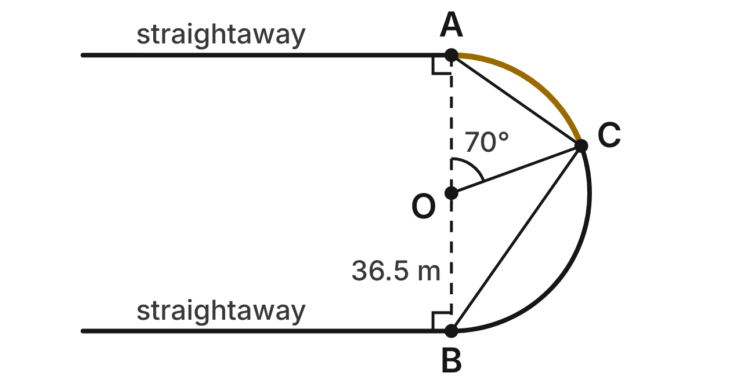
The inside edge of a track's turn is a semicircle from A to B with center O and radius 36.5 m. The straightaways leave the turn at A and B and are tangent to it there. A runner is at C on the turn, and m∠AOC = 70°.
403. What is m∠ACB, the angle at the runner between the lines to A and B?
A. 180°
B. 70°
C. 90° ✔
D. 35°
G.PC.3 · skill G.PC.3.1 (LOTS): Use the angles formed by chords, secants and tangents (central, inscribed, and angles inside and outside a circle) and their arcs
☐ Answer key correct ☐ Wording clear Notes: ________________________________
404. The straightaway at A meets radius OA at a right angle. Which reason explains this?
A. AB is a diameter, so every angle at A is 90°.
B. A tangent is ⊥ to the radius at the point of tangency. ✔
C. Tangent segments from one point are congruent.
D. An angle inscribed in a semicircle is a right angle.
G.PC.3 · skill G.PC.3.1 (LOTS): Use the angles formed by chords, secants and tangents (central, inscribed, and angles inside and outside a circle) and their arcs
☐ Answer key correct ☐ Wording clear Notes: ________________________________
405. How long is the inside edge of the turn, from A to B along the curve? Round to the nearest tenth of a meter.
A. 229.3 m
B. 57.3 m
C. 2,092.7 m
D. 114.7 m ✔
G.PC.3 · skill G.PC.3.3 (LOTS): Find arc length and the area of a sector, or use them to find a radius or a central angle
☐ Answer key correct ☐ Wording clear Notes: ________________________________
406. What is m∠ABC, the angle at B between segment BA and chord BC?
A. 35° ✔
B. 70°
C. 55°
D. 140°
G.PC.3 · skill G.PC.3.1 (LOTS): Use the angles formed by chords, secants and tangents (central, inscribed, and angles inside and outside a circle) and their arcs
☐ Answer key correct ☐ Wording clear Notes: ________________________________
407. How far does the runner go along the curve from A to C? Round to the nearest tenth of a meter.
A. 22.3 m
B. 89.2 m
C. 44.6 m ✔
D. 813.8 m
G.PC.3 · skill G.PC.3.3 (LOTS): Find arc length and the area of a sector, or use them to find a radius or a central angle
☐ Answer key correct ☐ Wording clear Notes: ________________________________
408. The inside edge of lane 2 is also a semicircle with center O, but its radius is 1.22 m longer. How much longer is it than the semicircle from A to B? Round to the nearest hundredth of a meter.
A. 1.22 m
B. 3.83 m ✔
C. 7.67 m
D. 1.92 m
G.PC.3 · skill G.PC.3.4 (HOTS): Model and solve a contextual problem with the properties of circles
☐ Answer key correct ☐ Wording clear Notes: ________________________________

The Softball Fence
Level 2 · Circles · G.PC.3 · ID geo-pc3-raid-softball-fence
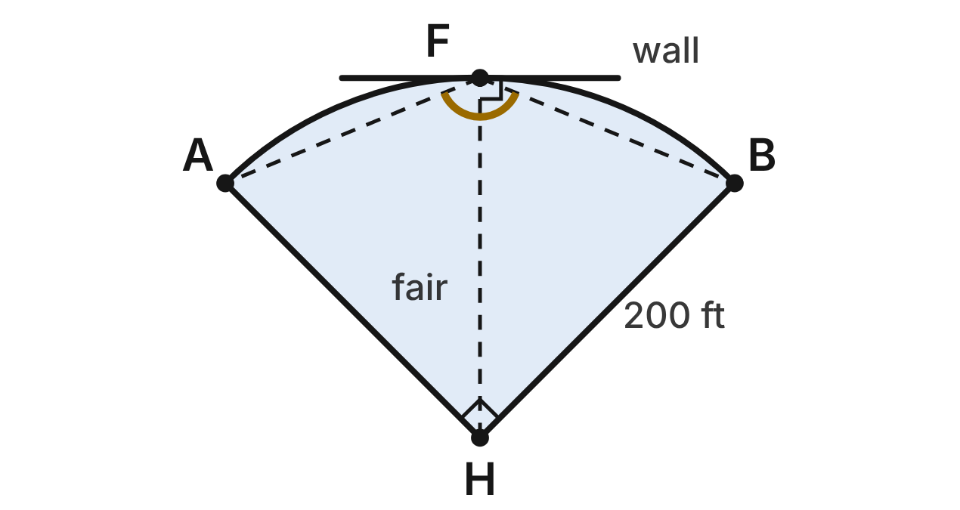
A softball outfield fence is an arc of a circle with center at home plate H and radius 200 ft. The foul lines HA and HB meet at a right angle, and foul poles stand at A and B. F is the middle of the fence. A straight wall touches the fence's arc only at F.
409. How long is the fence, arc AFB, to the nearest foot?
A. 157 ft
B. 314 ft ✔
C. 628 ft
D. 31,416 ft
G.PC.3 · skill G.PC.3.3 (LOTS): Find arc length and the area of a sector, or use them to find a radius or a central angle
☐ Answer key correct ☐ Wording clear Notes: ________________________________
410. Fair territory is sector AHB. To the nearest square foot, what is its area?
A. 314 ft²
B. 125,664 ft²
C. 62,832 ft²
D. 31,416 ft² ✔
G.PC.3 · skill G.PC.3.3 (LOTS): Find arc length and the area of a sector, or use them to find a radius or a central angle
☐ Answer key correct ☐ Wording clear Notes: ________________________________
411. The center fielder stands at F. What is m∠AFB, the angle between her lines of sight to the foul poles?
A. 135° ✔
B. 45°
C. 90°
D. 270°
G.PC.3 · skill G.PC.3.1 (LOTS): Use the angles formed by chords, secants and tangents (central, inscribed, and angles inside and outside a circle) and their arcs
☐ Answer key correct ☐ Wording clear Notes: ________________________________
412. Point W is on the wall, 20 ft from F. To the nearest tenth of a foot, how far is W from home plate H?
A. 220.0 ft
B. 201.0 ft ✔
C. 199.0 ft
D. 180.0 ft
G.PC.3 · skill G.PC.3.2 (LOTS): Use the lengths of segments formed by intersecting chords, secants and tangents
☐ Answer key correct ☐ Wording clear Notes: ________________________________
413. Another field's fence is an arc with radius 250 ft and length 150π ft. What central angle does that fence span?
A. 216°
B. 54°
C. 108° ✔
D. 0.3°
G.PC.3 · skill G.PC.3.3 (LOTS): Find arc length and the area of a sector, or use them to find a radius or a central angle
☐ Answer key correct ☐ Wording clear Notes: ________________________________
414. A 4-ft-wide warning track runs just inside the fence from foul line to foul line. It is the part of sector AHB between 196 ft and 200 ft from H. To the nearest square foot, what is its area?
A. 1,244 ft² ✔
B. 4,976 ft²
C. 30,172 ft²
D. 13 ft²
G.PC.3 · skill G.PC.3.4 (HOTS): Model and solve a contextual problem with the properties of circles
☐ Answer key correct ☐ Wording clear Notes: ________________________________

The Laser Shield
Level 2 · Circles · G.PC.3 · ID geo-pc3-raid-laser-shield
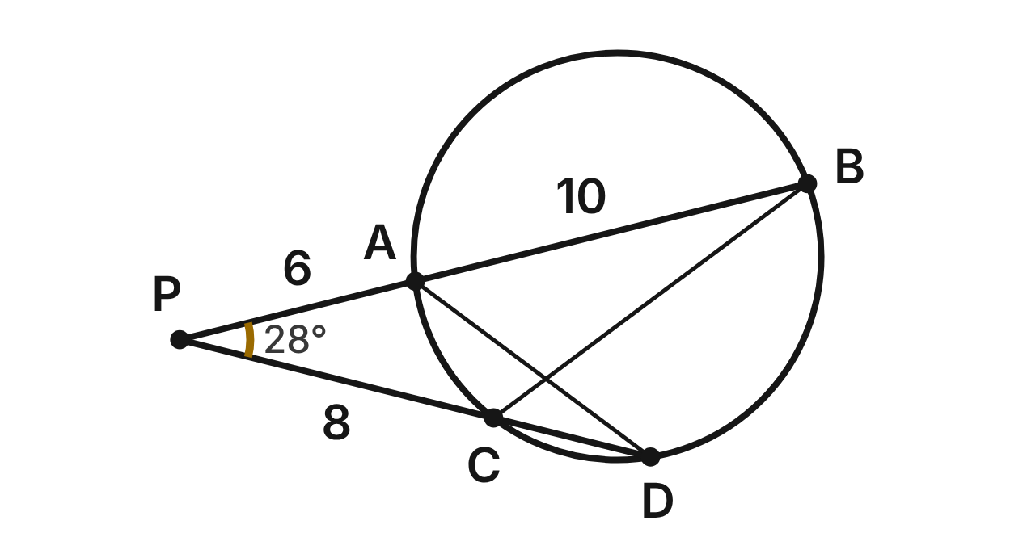
In a video game, a hero at P fires two laser beams at a round force field. Beam 1 enters the field at A and leaves at B. Beam 2 enters at C and leaves at D. PA = 6 units, AB = 10 units, PC = 8 units, and m∠APC = 28°.
415. How long is CD, the part of beam 2 inside the field?
A. 12 units
B. 7.5 units
C. 4 units ✔
D. 8 units
G.PC.3 · skill G.PC.3.2 (LOTS): Use the lengths of segments formed by intersecting chords, secants and tangents
☐ Answer key correct ☐ Wording clear Notes: ________________________________
416. Which statement about the two laser beams is NOT true?
A. m∠APC = ½(arc BD + arc AC) ✔
B. PA · PB = PC · PD
C. PB = 16 units
D. m∠APC = ½(arc BD − arc AC)
G.PC.3 · skill G.PC.3.1 (LOTS): Use the angles formed by chords, secants and tangents (central, inscribed, and angles inside and outside a circle) and their arcs
☐ Answer key correct ☐ Wording clear Notes: ________________________________
417. What is the measure of arc BD minus the measure of arc AC?
A. 14°
B. 28°
C. 152°
D. 56° ✔
G.PC.3 · skill G.PC.3.1 (LOTS): Use the angles formed by chords, secants and tangents (central, inscribed, and angles inside and outside a circle) and their arcs
☐ Answer key correct ☐ Wording clear Notes: ________________________________
418. On another level, two beams from a point outside a round shield cut off a far arc of 130° and a near arc of 50°. What is the angle between the beams?
A. 90°
B. 80°
C. 40° ✔
D. 65°
G.PC.3 · skill G.PC.3.1 (LOTS): Use the angles formed by chords, secants and tangents (central, inscribed, and angles inside and outside a circle) and their arcs
☐ Answer key correct ☐ Wording clear Notes: ________________________________
419. From a new spot Q, one beam just touches the field at T. Another beam from Q enters the field 4 units from Q and leaves 12 units later. How long is QT?
A. about 6.9 units
B. 8 units ✔
C. 16 units
D. 64 units
G.PC.3 · skill G.PC.3.4 (HOTS): Model and solve a contextual problem with the properties of circles
☐ Answer key correct ☐ Wording clear Notes: ________________________________
420. Triangles PAD and PCB are similar. Which proportion follows from this?
A. PA/PC = PB/PD
B. PA/PC = AB/CD
C. PA/PB = PC/PD
D. PA/PC = PD/PB ✔
G.PC.3 · skill G.PC.3.2 (LOTS): Use the lengths of segments formed by intersecting chords, secants and tangents
☐ Answer key correct ☐ Wording clear Notes: ________________________________

Lane Ropes in a Round Pool
Level 2 · Circles · G.PC.3 · ID geo-pc3-raid-pool-ropes
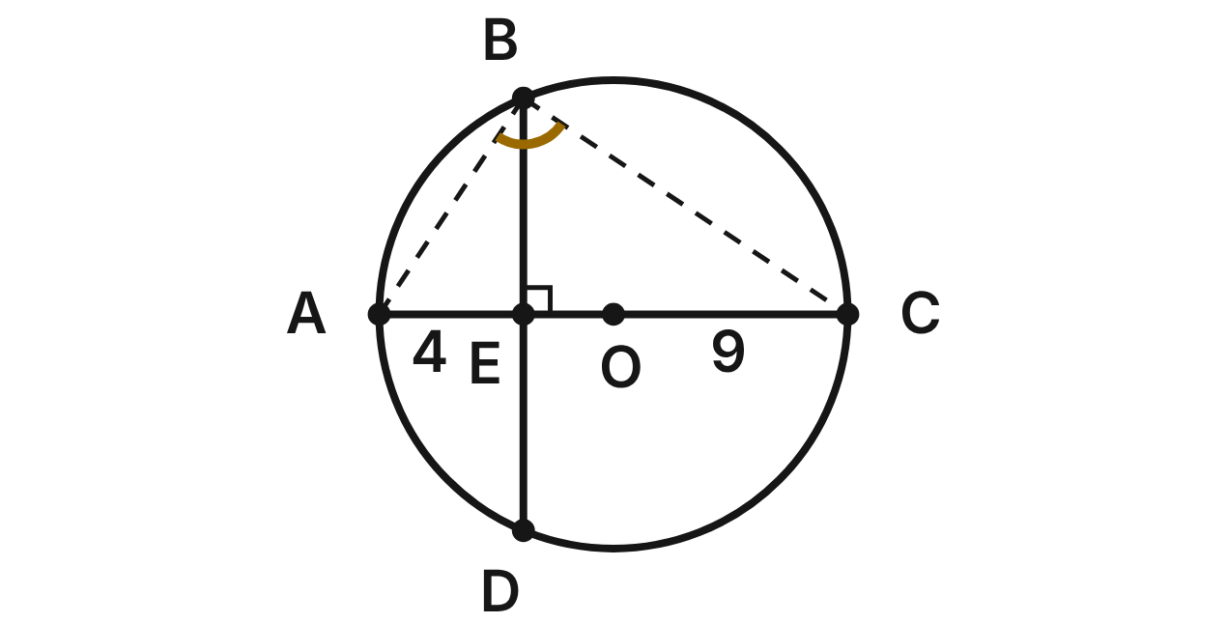
A round pool has two lane ropes. Rope AC passes through the center O. Rope BD crosses it at E, and BD ⊥ AC. AE = 4 m and EC = 9 m. Swimmers rest at A, B and C on the pool's edge.
421. How long is BE, the part of rope BD from B to E?
A. 6 m ✔
B. 6.5 m
C. 18 m
D. 36 m
G.PC.3 · skill G.PC.3.2 (LOTS): Use the lengths of segments formed by intersecting chords, secants and tangents
☐ Answer key correct ☐ Wording clear Notes: ________________________________
422. What is m∠ABC, and why?
A. 180°, because it cuts off a semicircle
B. 45°, because BD bisects ∠ABC
C. 90°, because AC is a diameter ✔
D. 60°, because △ABC is equilateral
G.PC.3 · skill G.PC.3.1 (LOTS): Use the angles formed by chords, secants and tangents (central, inscribed, and angles inside and outside a circle) and their arcs
☐ Answer key correct ☐ Wording clear Notes: ________________________________
423. What is the radius of this round pool?
A. 13 m
B. 6 m
C. 4.5 m
D. 6.5 m ✔
G.PC.3 · skill G.PC.3.4 (HOTS): Model and solve a contextual problem with the properties of circles
☐ Answer key correct ☐ Wording clear Notes: ________________________________
424. What is the sum of the measures of arc AB and arc CD?
A. 90°
B. 45°
C. 180° ✔
D. 360°
G.PC.3 · skill G.PC.3.1 (LOTS): Use the angles formed by chords, secants and tangents (central, inscribed, and angles inside and outside a circle) and their arcs
☐ Answer key correct ☐ Wording clear Notes: ________________________________
425. Use m∠BOC ≈ 112.6°. How far is it along the pool's edge from B to C (minor arc BC)? Round to the nearest tenth of a meter.
A. 6.4 m
B. 12.8 m ✔
C. 25.5 m
D. 41.5 m
G.PC.3 · skill G.PC.3.3 (LOTS): Find arc length and the area of a sector, or use them to find a radius or a central angle
☐ Answer key correct ☐ Wording clear Notes: ________________________________
426. A cover is cut for the part of the pool between rope BD and the edge near A. Use m∠BOD ≈ 134.8° and OE = 2.5 m. To the nearest tenth of a square meter, what is the cover's area?
A. 34.7 m² ✔
B. 49.7 m²
C. 64.7 m²
D. 24.0 m²
G.PC.3 · skill G.PC.3.4 (HOTS): Model and solve a contextual problem with the properties of circles
☐ Answer key correct ☐ Wording clear Notes: ________________________________

The Passing Drill
Level 2 · Circles · G.PC.3 · ID geo-pc3-raid-passing-drill
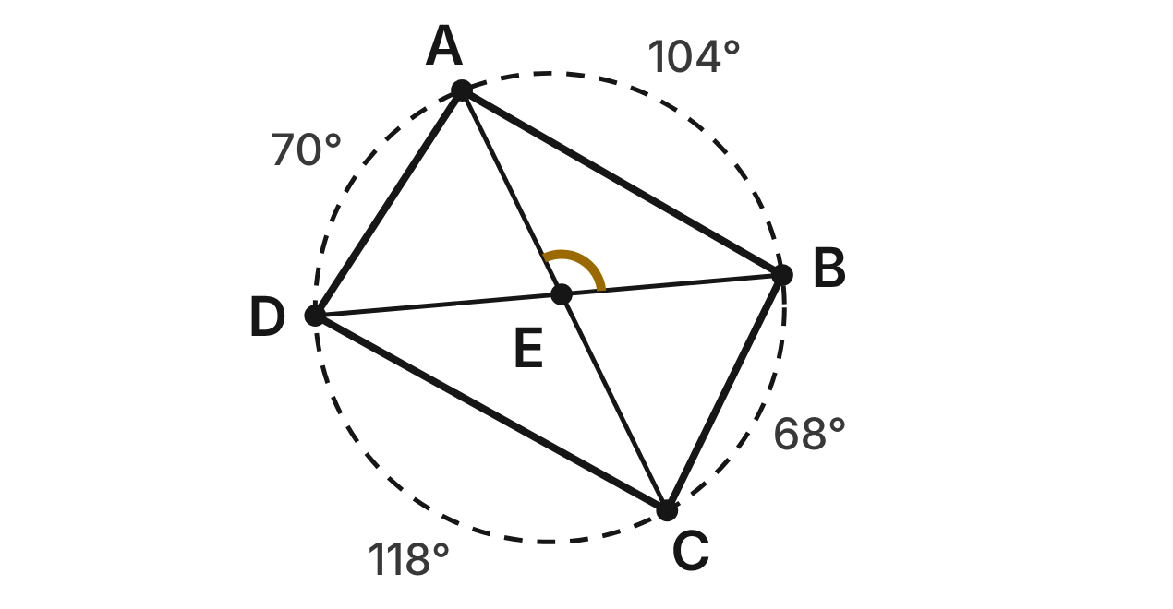
Four volleyball players, A, B, C and D, stand on a circle with radius 5 m. The arcs between them are arc AB = 104°, arc BC = 68°, arc CD = 118° and arc DA = 70°. Passes from A to C and from B to D cross at E.
427. What is m∠DAB, the angle at player A between B and D?
A. 186°
B. 87°
C. 52°
D. 93° ✔
G.PC.3 · skill G.PC.3.1 (LOTS): Use the angles formed by chords, secants and tangents (central, inscribed, and angles inside and outside a circle) and their arcs
☐ Answer key correct ☐ Wording clear Notes: ________________________________
428. What is m∠AEB, where the two passes cross?
A. 222°
B. 111° ✔
C. 7°
D. 69°
G.PC.3 · skill G.PC.3.1 (LOTS): Use the angles formed by chords, secants and tangents (central, inscribed, and angles inside and outside a circle) and their arcs
☐ Answer key correct ☐ Wording clear Notes: ________________________________
429. How far is it from A to B along the circle? Round to the nearest tenth of a meter.
A. 4.5 m
B. 18.2 m
C. 9.1 m ✔
D. 22.7 m
G.PC.3 · skill G.PC.3.3 (LOTS): Find arc length and the area of a sector, or use them to find a radius or a central angle
☐ Answer key correct ☐ Wording clear Notes: ________________________________
430. Which pair of angles must be supplementary?
A. ∠ABC and ∠ADC ✔
B. ∠DAB and ∠ABC
C. ∠AEB and ∠CED
D. ∠BAC and ∠BDC
G.PC.3 · skill G.PC.3.1 (LOTS): Use the angles formed by chords, secants and tangents (central, inscribed, and angles inside and outside a circle) and their arcs
☐ Answer key correct ☐ Wording clear Notes: ________________________________
431. The coach wants arc AB to be exactly 10 m long, still measuring 104°. To the nearest tenth of a meter, what radius should the circle have?
A. 11.0 m
B. 3.3 m
C. 1.6 m
D. 5.5 m ✔
G.PC.3 · skill G.PC.3.3 (LOTS): Find arc length and the area of a sector, or use them to find a radius or a central angle
☐ Answer key correct ☐ Wording clear Notes: ________________________________
432. To the nearest hundredth of a meter, how long is the straight pass from A to C?
A. 15.01 m
B. 9.98 m ✔
C. 4.99 m
D. 10.00 m
G.PC.3 · skill G.PC.3.4 (HOTS): Model and solve a contextual problem with the properties of circles
☐ Answer key correct ☐ Wording clear Notes: ________________________________

The Archery Target
Level 3 · Circles · G.PC.3 · ID geo-pc3-raid-archery-target
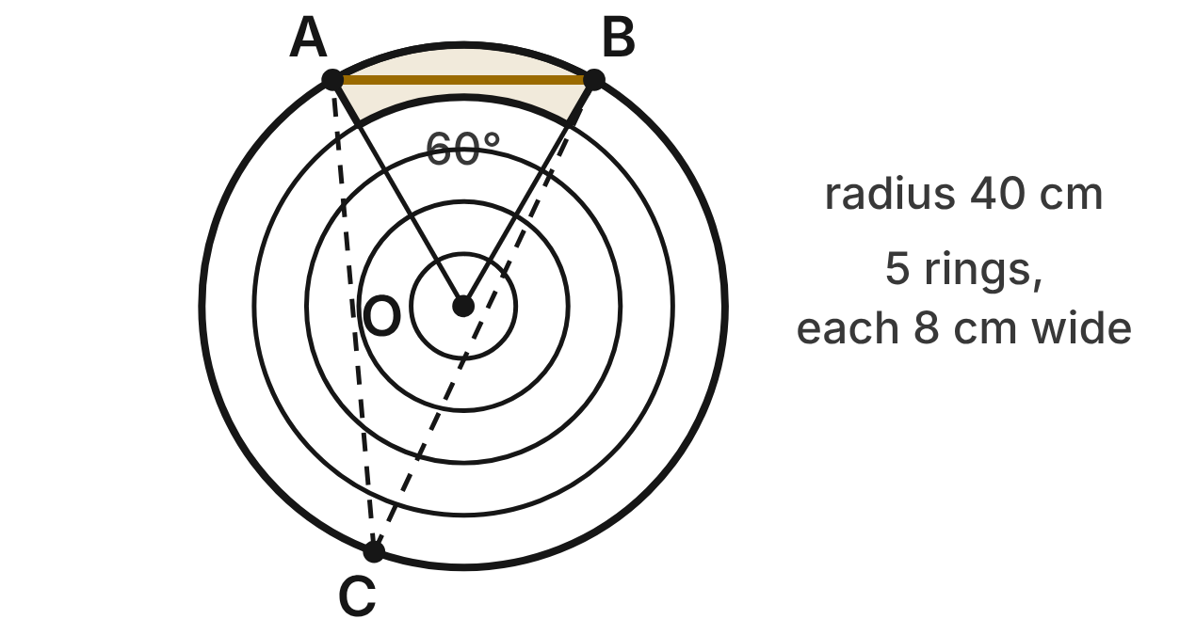
An archery target has center O and radius 40 cm. It has 5 rings, each 8 cm wide. The shaded part is the outer ring inside the 60° wedge AOB. Arrows hit the outer edge at A, B and C.
433. To the nearest square centimeter, what is the area of the shaded part?
A. 838 cm²
B. 34 cm²
C. 1,810 cm²
D. 302 cm² ✔
G.PC.3 · skill G.PC.3.3 (LOTS): Find arc length and the area of a sector, or use them to find a radius or a central angle
☐ Answer key correct ☐ Wording clear Notes: ________________________________
434. The shaded part has two curved edges. How much longer is the outer curved edge than the inner one? Round to the nearest tenth of a centimeter.
A. 8.4 cm ✔
B. 8.0 cm
C. 50.3 cm
D. 4.2 cm
G.PC.3 · skill G.PC.3.3 (LOTS): Find arc length and the area of a sector, or use them to find a radius or a central angle
☐ Answer key correct ☐ Wording clear Notes: ________________________________
435. How far apart are the arrows at A and B, in a straight line?
A. about 41.9 cm
B. 20 cm
C. 40 cm ✔
D. 80 cm
G.PC.3 · skill G.PC.3.4 (HOTS): Model and solve a contextual problem with the properties of circles
☐ Answer key correct ☐ Wording clear Notes: ________________________________
436. What is m∠ACB, the angle at arrow C between arrows A and B?
A. 60°
B. 30° ✔
C. 120°
D. 150°
G.PC.3 · skill G.PC.3.1 (LOTS): Use the angles formed by chords, secants and tangents (central, inscribed, and angles inside and outside a circle) and their arcs
☐ Answer key correct ☐ Wording clear Notes: ________________________________
437. A scoring wedge on another target has radius 30 cm, and its outer arc is 15 cm long. To the nearest degree, what is its central angle?
A. 29° ✔
B. 57°
C. 14°
D. 2°
G.PC.3 · skill G.PC.3.3 (LOTS): Find arc length and the area of a sector, or use them to find a radius or a central angle
☐ Answer key correct ☐ Wording clear Notes: ________________________________
438. What percent of the whole target face is shaded?
A. 36%
B. about 16.7%
C. about 3.3%
D. 6% ✔
G.PC.3 · skill G.PC.3.4 (HOTS): Model and solve a contextual problem with the properties of circles
☐ Answer key correct ☐ Wording clear Notes: ________________________________

The Skate Bowl
Level 3 · Circles · G.PC.3 · ID geo-pc3-raid-skate-bowl
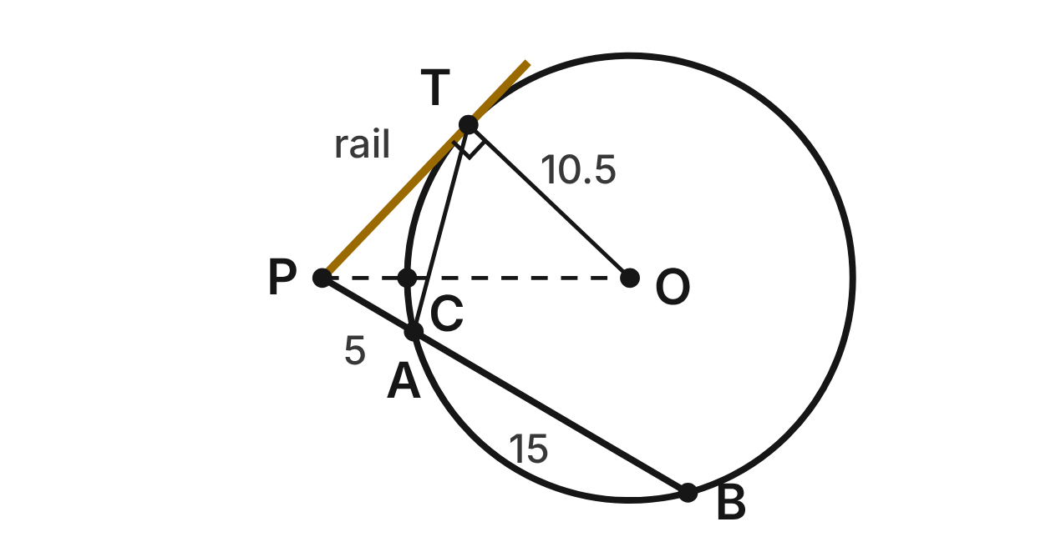
A round skate bowl has center O and radius 10.5 ft. A straight rail from P touches the bowl's edge only at T. A skater rolls straight from P, crossing the edge at A and again at B: PA = 5 ft and AB = 15 ft. Segment OP crosses the edge at C.
439. How long is PT, from P to where the rail touches the bowl?
A. about 8.7 ft
B. 10 ft ✔
C. 20 ft
D. 100 ft
G.PC.3 · skill G.PC.3.2 (LOTS): Use the lengths of segments formed by intersecting chords, secants and tangents
☐ Answer key correct ☐ Wording clear Notes: ________________________________
440. How far is P from the center O?
A. 20.5 ft
B. about 11.6 ft
C. 14.5 ft ✔
D. about 3.2 ft
G.PC.3 · skill G.PC.3.4 (HOTS): Model and solve a contextual problem with the properties of circles
☐ Answer key correct ☐ Wording clear Notes: ________________________________
441. Which expression equals m∠PTA, the angle between the rail and chord TA?
A. ½ · m(minor arc TA) ✔
B. m(minor arc TA)
C. ½ · m(arc TB)
D. ½(m arc TB − m arc TA)
G.PC.3 · skill G.PC.3.1 (LOTS): Use the angles formed by chords, secants and tangents (central, inscribed, and angles inside and outside a circle) and their arcs
☐ Answer key correct ☐ Wording clear Notes: ________________________________
442. To the nearest degree, what is m∠TOP?
A. 46°
B. 25°
C. 136°
D. 44° ✔
G.PC.3 · skill G.PC.3.4 (HOTS): Model and solve a contextual problem with the properties of circles
☐ Answer key correct ☐ Wording clear Notes: ________________________________
443. Use m∠TOP ≈ 43.6°. To the nearest tenth of a foot, how long is arc TC along the bowl's edge?
A. 4.0 ft
B. 41.9 ft
C. 8.0 ft ✔
D. 16.0 ft
G.PC.3 · skill G.PC.3.3 (LOTS): Find arc length and the area of a sector, or use them to find a radius or a central angle
☐ Answer key correct ☐ Wording clear Notes: ________________________________
444. Which statement about the rail and the skater's path is NOT true?
A. PT² = PA · PB
B. PT = PA + AB ✔
C. OT ⊥ PT
D. OP² = PT² + OT²
G.PC.3 · skill G.PC.3.2 (LOTS): Use the lengths of segments formed by intersecting chords, secants and tangents
☐ Answer key correct ☐ Wording clear Notes: ________________________________

G.PC.4 · Solve problems involving equations of circles.

The Archery Target
Level 1 · Equations of circles · G.PC.4 · ID geo-pc4-raid-archery
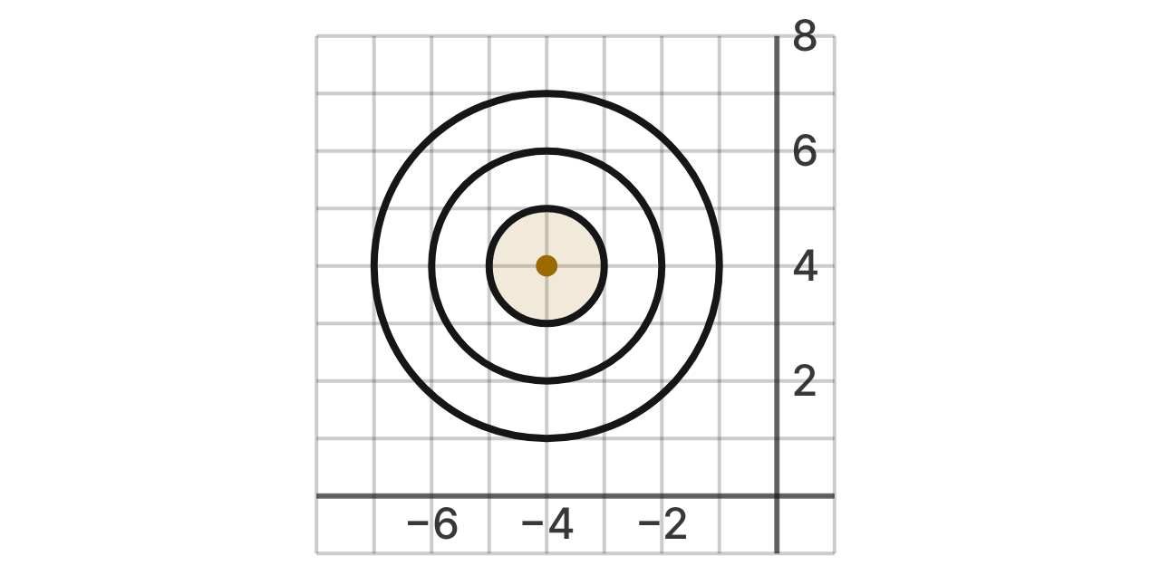
An archery target is drawn on a coordinate grid. Its three rings are circles with the same center, the gold point. Their radii are 1, 2 and 3 units.
445. What are the coordinates of the center of the target?
A. (4, 4)
B. (4, −4)
C. (−4, 4) ✔
D. (−4, 7)
G.PC.4 · skill G.PC.4.1 (LOTS): Identify the center and radius of a circle from its graph or from its equation in standard form
☐ Answer key correct ☐ Wording clear Notes: ________________________________
446. Which equation describes the outer ring?
A. (x + 4)² + (y − 4)² = 9 ✔
B. (x − 4)² + (y + 4)² = 9
C. (x + 4)² + (y − 4)² = 3
D. (x + 4)² + (y − 4)² = 6
G.PC.4 · skill G.PC.4.2 (LOTS): Write the equation of a circle from its center and radius, its center and a point, or the endpoints of a diameter
☐ Answer key correct ☐ Wording clear Notes: ________________________________
447. An arrow hits (−2, 5). Where on the target is it?
A. Outside the outer ring
B. Exactly on the outer ring
C. Exactly on the middle ring
D. Between the middle and outer rings ✔
G.PC.4 · skill G.PC.4.1 (LOTS): Identify the center and radius of a circle from its graph or from its equation in standard form
☐ Answer key correct ☐ Wording clear Notes: ________________________________
448. An arrow lands at (−6, 5). Which expression gives its distance from the center of the target?
A. √((−6 − 4)² + (5 + 4)²)
B. √((−6 + 4)² + (5 − 4)²) ✔
C. (−6 + 4)² + (5 − 4)²
D. √((−6 + 4)² − (5 − 4)²)
G.PC.4 · skill G.PC.4.3 (HOTS): Derive the equation of a circle with the Pythagorean Theorem or the distance formula
☐ Answer key correct ☐ Wording clear Notes: ________________________________
449. A larger practice target has the same center. Its outer ring passes through (−4, 8). Which equation describes that ring?
A. (x + 4)² + (y − 4)² = 4
B. (x + 4)² + (y − 8)² = 16
C. (x + 4)² + (y − 4)² = 64
D. (x + 4)² + (y − 4)² = 16 ✔
G.PC.4 · skill G.PC.4.2 (LOTS): Write the equation of a circle from its center and radius, its center and a point, or the endpoints of a diameter
☐ Answer key correct ☐ Wording clear Notes: ________________________________
450. Which statement about the rings is NOT true?
A. (−3, 5) is inside the inner ring. ✔
B. (−4, 2) is on the middle ring.
C. (−7, 4) is on the outer ring.
D. (−4, 5) is on the inner ring.
G.PC.4 · skill G.PC.4.1 (LOTS): Identify the center and radius of a circle from its graph or from its equation in standard form
☐ Answer key correct ☐ Wording clear Notes: ________________________________

The Shield Bubble
Level 1 · Equations of circles · G.PC.4 · ID geo-pc4-raid-shield
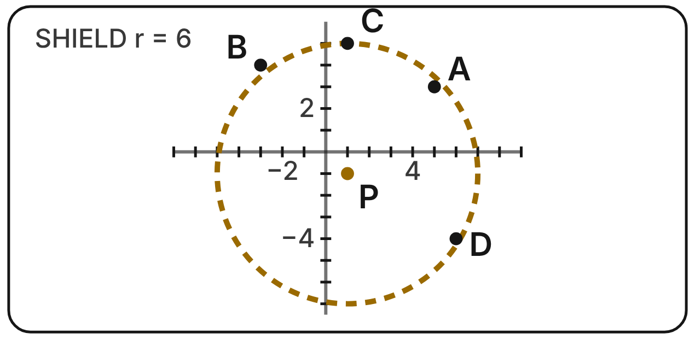
In a video game, the hero stands at P(1, −1) inside a round shield with a radius of 6 units. Enemies stand at A(5, 3), B(−3, 4), C(1, 5) and D(6, −4).
451. Which equation describes the edge of the shield?
A. (x − 1)² + (y + 1)² = 36 ✔
B. (x + 1)² + (y − 1)² = 36
C. (x − 1)² + (y + 1)² = 6
D. (x − 1)² + (y + 1)² = 12
G.PC.4 · skill G.PC.4.2 (LOTS): Write the equation of a circle from its center and radius, its center and a point, or the endpoints of a diameter
☐ Answer key correct ☐ Wording clear Notes: ________________________________
452. Which enemy is outside the shield?
A. A at (5, 3)
B. B at (−3, 4) ✔
C. C at (1, 5)
D. D at (6, −4)
G.PC.4 · skill G.PC.4.1 (LOTS): Identify the center and radius of a circle from its graph or from its equation in standard form
☐ Answer key correct ☐ Wording clear Notes: ________________________________
453. Player 2's shield has the edge (x + 5)² + (y − 4)² = 50. What are its center and radius?
A. (5, −4); r = 5√2
B. (−5, 4); r = 25
C. (−5, 4); r = 50
D. (−5, 4); r = 5√2 ✔
G.PC.4 · skill G.PC.4.1 (LOTS): Identify the center and radius of a circle from its graph or from its equation in standard form
☐ Answer key correct ☐ Wording clear Notes: ________________________________
454. The game finds the distance PA with the Pythagorean theorem. Which equation does it use?
A. 4 + 4 = PA
B. 5² + 3² = PA²
C. 4² + 4² = PA² ✔
D. 6² + 2² = PA²
G.PC.4 · skill G.PC.4.3 (HOTS): Derive the equation of a circle with the Pythagorean Theorem or the distance formula
☐ Answer key correct ☐ Wording clear Notes: ________________________________
455. A power-up doubles the shield's radius. The center stays at P. Which equation describes the new edge?
A. (x − 1)² + (y + 1)² = 144 ✔
B. (x − 1)² + (y + 1)² = 72
C. (x − 1)² + (y + 1)² = 12
D. (x − 2)² + (y + 2)² = 144
G.PC.4 · skill G.PC.4.2 (LOTS): Write the equation of a circle from its center and radius, its center and a point, or the endpoints of a diameter
☐ Answer key correct ☐ Wording clear Notes: ________________________________
456. Which point is on the edge of the shield?
A. (7, 5)
B. (5, 1)
C. (−5, −1) ✔
D. (1, 11)
G.PC.4 · skill G.PC.4.1 (LOTS): Identify the center and radius of a circle from its graph or from its equation in standard form
☐ Answer key correct ☐ Wording clear Notes: ________________________________

The Diving Pool
Level 2 · Equations of circles · G.PC.4 · ID geo-pc4-raid-diving-pool
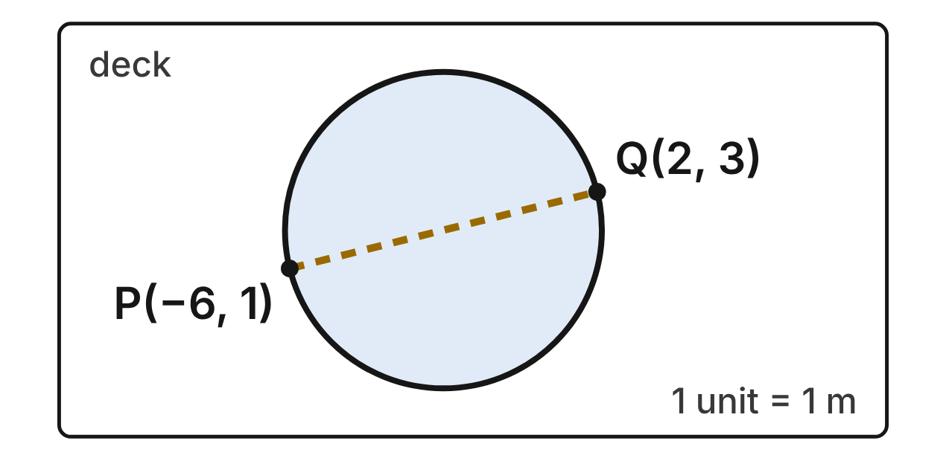
A round diving pool is drawn on a coordinate plan in meters. A lane rope runs straight across the pool through its center, from P(−6, 1) to Q(2, 3).
457. What are the coordinates of the center of the pool?
A. (−2, 2) ✔
B. (−4, 4)
C. (4, 1)
D. (8, 2)
G.PC.4 · skill G.PC.4.2 (LOTS): Write the equation of a circle from its center and radius, its center and a point, or the endpoints of a diameter
☐ Answer key correct ☐ Wording clear Notes: ________________________________
458. Which equation describes the edge of the pool?
A. (x − 2)² + (y + 2)² = 17
B. (x + 2)² + (y − 2)² = 68
C. (x + 2)² + (y − 2)² = 17 ✔
D. (x + 2)² + (y − 2)² = √17
G.PC.4 · skill G.PC.4.2 (LOTS): Write the equation of a circle from its center and radius, its center and a point, or the endpoints of a diameter
☐ Answer key correct ☐ Wording clear Notes: ________________________________
459. To the nearest tenth of a meter, what is the radius of the pool?
A. 8.2 m
B. 4.1 m ✔
C. 8.5 m
D. 5.0 m
G.PC.4 · skill G.PC.4.1 (LOTS): Identify the center and radius of a circle from its graph or from its equation in standard form
☐ Answer key correct ☐ Wording clear Notes: ________________________________
460. Which expression gives the length of the lane rope PQ?
A. √((2 − 6)² + (3 − 1)²)
B. (2 + 6)² + (3 − 1)²
C. √((2 + 6)² + (3 + 1)²)
D. √((2 + 6)² + (3 − 1)²) ✔
G.PC.4 · skill G.PC.4.3 (HOTS): Derive the equation of a circle with the Pythagorean Theorem or the distance formula
☐ Answer key correct ☐ Wording clear Notes: ________________________________
461. A swimmer's ball floats at (1, −1). Is it in the pool?
A. Yes: 6 is less than 17
B. No: 18 is more than 17 ✔
C. Yes: 2 is less than 17
D. Yes: √18 is less than 17
G.PC.4 · skill G.PC.4.1 (LOTS): Identify the center and radius of a circle from its graph or from its equation in standard form
☐ Answer key correct ☐ Wording clear Notes: ________________________________
462. A round float line in the pool has the same center as the pool. It passes through (0, 3). Which equation describes it?
A. (x + 2)² + (y − 2)² = √5
B. x² + (y − 3)² = 5
C. (x + 2)² + (y − 2)² = 3
D. (x + 2)² + (y − 2)² = 5 ✔
G.PC.4 · skill G.PC.4.2 (LOTS): Write the equation of a circle from its center and radius, its center and a point, or the endpoints of a diameter
☐ Answer key correct ☐ Wording clear Notes: ________________________________

The Shot Put Throw
Level 2 · Equations of circles · G.PC.4 · ID geo-pc4-raid-shot-put
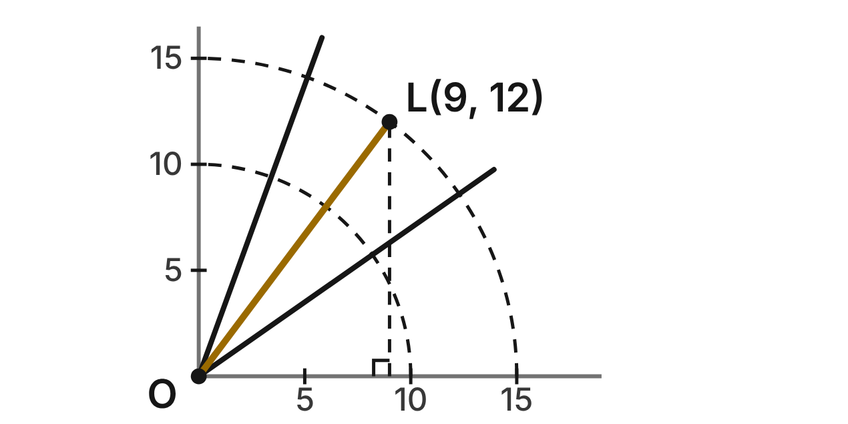
In a shot put event, the throw starts at the center O(0, 0) of the ring. Distances are in meters. A throw lands at L(9, 12). The dashed arcs are 10 m and 15 m from O.
463. Which equation uses the Pythagorean theorem to find the length of the throw, OL?
A. 9 + 12 = OL
B. 9² + 12² = OL² ✔
C. 12² − 9² = OL²
D. 9² + 12² = OL
G.PC.4 · skill G.PC.4.3 (HOTS): Derive the equation of a circle with the Pythagorean Theorem or the distance formula
☐ Answer key correct ☐ Wording clear Notes: ________________________________
464. How far from O did the throw land?
A. 21 m
B. 3√7 m
C. 225 m
D. 15 m ✔
G.PC.4 · skill G.PC.4.1 (LOTS): Identify the center and radius of a circle from its graph or from its equation in standard form
☐ Answer key correct ☐ Wording clear Notes: ________________________________
465. Which equation describes the circle with center O that passes through L?
A. x² + y² = 225 ✔
B. x² + y² = 15
C. (x − 9)² + (y − 12)² = 225
D. x² + y² = 441
G.PC.4 · skill G.PC.4.2 (LOTS): Write the equation of a circle from its center and radius, its center and a point, or the endpoints of a diameter
☐ Answer key correct ☐ Wording clear Notes: ________________________________
466. Another throw lands at (10, 13). To the nearest tenth of a meter, how far from O is it?
A. 23.0 m
B. 8.3 m
C. 16.4 m ✔
D. 269.0 m
G.PC.4 · skill G.PC.4.1 (LOTS): Identify the center and radius of a circle from its graph or from its equation in standard form
☐ Answer key correct ☐ Wording clear Notes: ________________________________
467. The 14-meter line is the arc x² + y² = 196. Which landing point is short of that line (inside the arc)?
A. (9, 11)
B. (0, 14)
C. (6, 12) ✔
D. (13, 6)
G.PC.4 · skill G.PC.4.1 (LOTS): Identify the center and radius of a circle from its graph or from its equation in standard form
☐ Answer key correct ☐ Wording clear Notes: ________________________________
468. Why does a circle with center (0, 0) and radius r have the equation x² + y² = r²?
A. The distance from (0, 0) to (x, y) is √(x² + y²), and it is r. ✔
B. The legs x and y of a right triangle add up to r.
C. The slope from (0, 0) to (x, y) is always r.
D. Every point (x, y) is r units right and r units up.
G.PC.4 · skill G.PC.4.3 (HOTS): Derive the equation of a circle with the Pythagorean Theorem or the distance formula
☐ Answer key correct ☐ Wording clear Notes: ________________________________

Two Skate Bowls
Level 2 · Equations of circles · G.PC.4 · ID geo-pc4-raid-skate-bowls
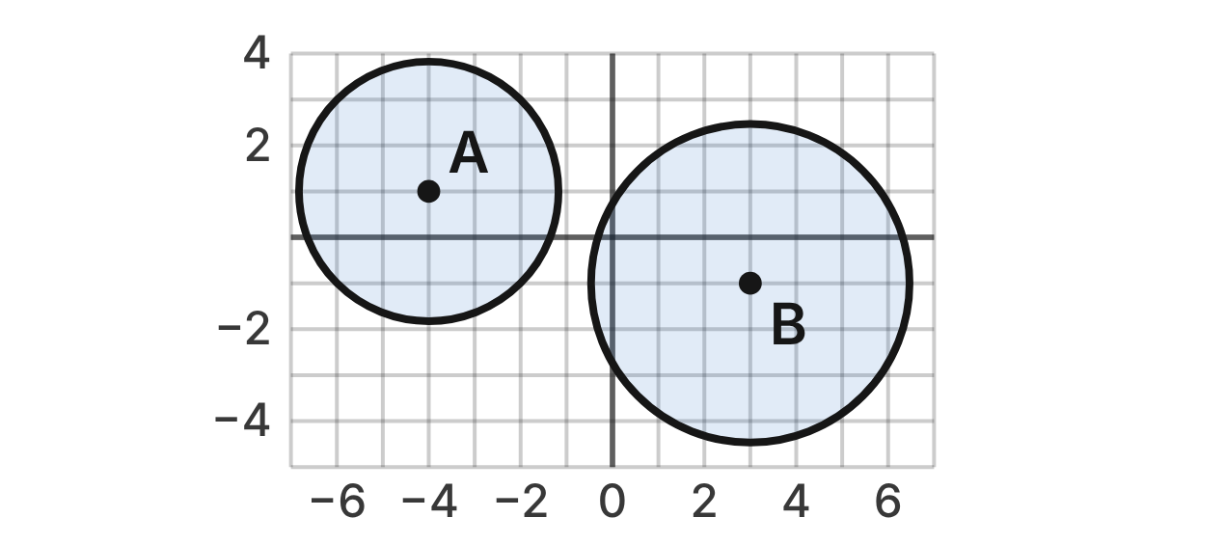
Two round skate bowls are drawn on a grid in meters. Bowl A has center A and edge (x + 4)² + (y − 1)² = 8. Bowl B has center B and edge (x − 3)² + (y + 1)² = 12.
469. What are the center and radius of bowl A?
A. (4, −1); r = 2√2
B. (−4, 1); r = 4
C. (−4, 1); r = 2√2 ✔
D. (−4, 1); r = 8
G.PC.4 · skill G.PC.4.1 (LOTS): Identify the center and radius of a circle from its graph or from its equation in standard form
☐ Answer key correct ☐ Wording clear Notes: ________________________________
470. What is the radius of bowl B?
A. 2√3 m ✔
B. 6 m
C. 12 m
D. 4√3 m
G.PC.4 · skill G.PC.4.1 (LOTS): Identify the center and radius of a circle from its graph or from its equation in standard form
☐ Answer key correct ☐ Wording clear Notes: ________________________________
471. Which expression gives the distance between the centers of the two bowls?
A. √((3 − 4)² + (−1 + 1)²)
B. (3 + 4)² + (−1 − 1)²
C. √((3 + 4)² − (−1 − 1)²)
D. √((3 + 4)² + (−1 − 1)²) ✔
G.PC.4 · skill G.PC.4.3 (HOTS): Derive the equation of a circle with the Pythagorean Theorem or the distance formula
☐ Answer key correct ☐ Wording clear Notes: ________________________________
472. Do the two bowls overlap? Lengths are rounded to the nearest tenth of a meter.
A. Yes: centers 7.3 m apart, radii add to 20.0 m
B. No: centers 7.3 m apart, radii add to 6.3 m ✔
C. Yes: centers 7.3 m apart, radii add to 10.0 m
D. No: centers 9.0 m apart, radii add to 6.3 m
G.PC.4 · skill G.PC.4.1 (LOTS): Identify the center and radius of a circle from its graph or from its equation in standard form
☐ Answer key correct ☐ Wording clear Notes: ________________________________
473. A third bowl will have center (1, 9). Its edge will pass through (6, 7). Which equation describes its edge?
A. (x + 1)² + (y + 9)² = 29
B. (x − 6)² + (y − 7)² = 29
C. (x − 1)² + (y − 9)² = 29 ✔
D. (x − 1)² + (y − 9)² = 49
G.PC.4 · skill G.PC.4.2 (LOTS): Write the equation of a circle from its center and radius, its center and a point, or the endpoints of a diameter
☐ Answer key correct ☐ Wording clear Notes: ________________________________
474. Which point is inside bowl B?
A. (5, 1) ✔
B. (6, −3)
C. (−3, 1)
D. (3, 3)
G.PC.4 · skill G.PC.4.1 (LOTS): Identify the center and radius of a circle from its graph or from its equation in standard form
☐ Answer key correct ☐ Wording clear Notes: ________________________________

The Mini-Golf Pond
Level 3 · Equations of circles · G.PC.4 · ID geo-pc4-raid-mini-golf
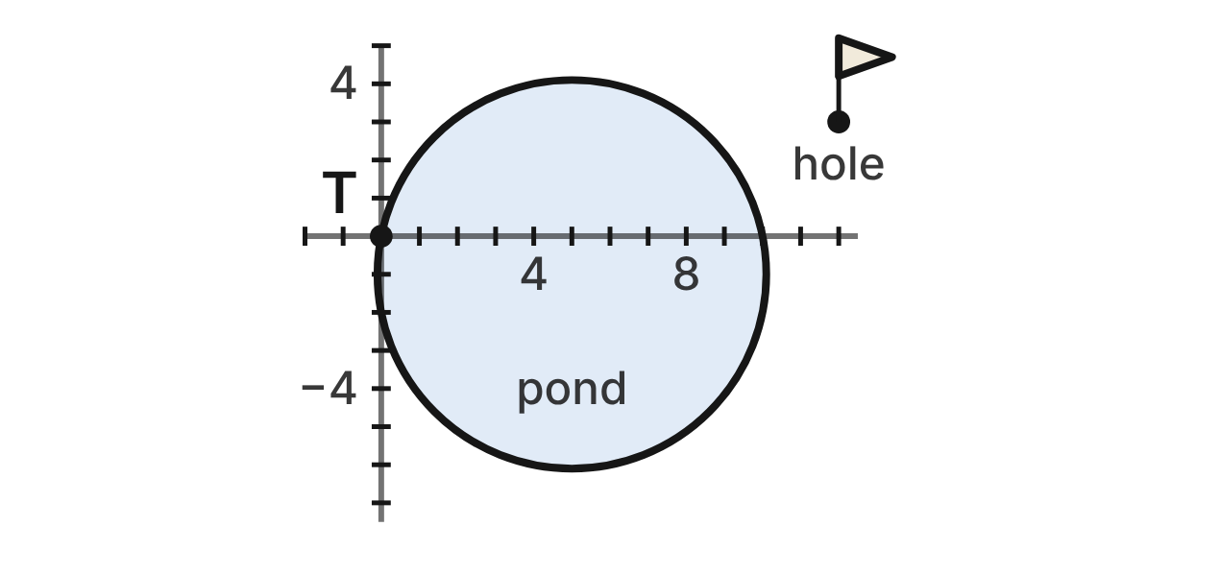
On a mini-golf plan (units in feet), the edge of a round pond has the equation x² + y² − 10x + 2y = 0. The tee T is at the origin.
475. To complete the square, which numbers are added to both sides of x² − 10x + y² + 2y = 0?
A. 5 and 1
B. 25 and 1 ✔
C. 100 and 4
D. −25 and 1
G.PC.4 · skill G.PC.4.1 (LOTS): Identify the center and radius of a circle from its graph or from its equation in standard form
☐ Answer key correct ☐ Wording clear Notes: ________________________________
476. What are the center and radius of the pond?
A. (−5, 1); r = √26
B. (5, −1); r = 26
C. (5, −1); r = 2√6
D. (5, −1); r = √26 ✔
G.PC.4 · skill G.PC.4.1 (LOTS): Identify the center and radius of a circle from its graph or from its equation in standard form
☐ Answer key correct ☐ Wording clear Notes: ________________________________
477. Which reason shows that the tee T(0, 0) is on the edge of the pond?
A. It is √(5² + 1²) = √26 ft from the center (5, −1). ✔
B. It is √(5² + 1²) = √26 ft from the center (−5, 1).
C. Every circle's equation is true at the point (0, 0).
D. It is 5 + 1 = 6 ft from the center (5, −1).
G.PC.4 · skill G.PC.4.3 (HOTS): Derive the equation of a circle with the Pythagorean Theorem or the distance formula
☐ Answer key correct ☐ Wording clear Notes: ________________________________
478. A golf ball stops at (8, 3). Is it in the pond?
A. No: 8² + 3² = 73, more than 26
B. No: (8 + 5)² + (3 − 1)² = 173, more than 26
C. Yes: (8 − 5)² + (3 + 1)² = 25, less than 26 ✔
D. No: 3 + 4 = 7, more than √26
G.PC.4 · skill G.PC.4.1 (LOTS): Identify the center and radius of a circle from its graph or from its equation in standard form
☐ Answer key correct ☐ Wording clear Notes: ________________________________
479. A round walking path has the same center as the pond. It passes through a bench at (−1, 5). Which equation describes the path?
A. (x − 5)² + (y + 1)² = 6√2
B. (x − 5)² + (y + 1)² = 72 ✔
C. (x + 5)² + (y − 1)² = 72
D. (x + 1)² + (y − 5)² = 72
G.PC.4 · skill G.PC.4.2 (LOTS): Write the equation of a circle from its center and radius, its center and a point, or the endpoints of a diameter
☐ Answer key correct ☐ Wording clear Notes: ________________________________
480. The edge of the pond crosses the x-axis at T and at one other point. Which point?
A. (5, 0)
B. (−10, 0)
C. (0, −2)
D. (10, 0) ✔
G.PC.4 · skill G.PC.4.1 (LOTS): Identify the center and radius of a circle from its graph or from its equation in standard form
☐ Answer key correct ☐ Wording clear Notes: ________________________________

The Blast Zone
Level 3 · Equations of circles · G.PC.4 · ID geo-pc4-raid-blast-zone
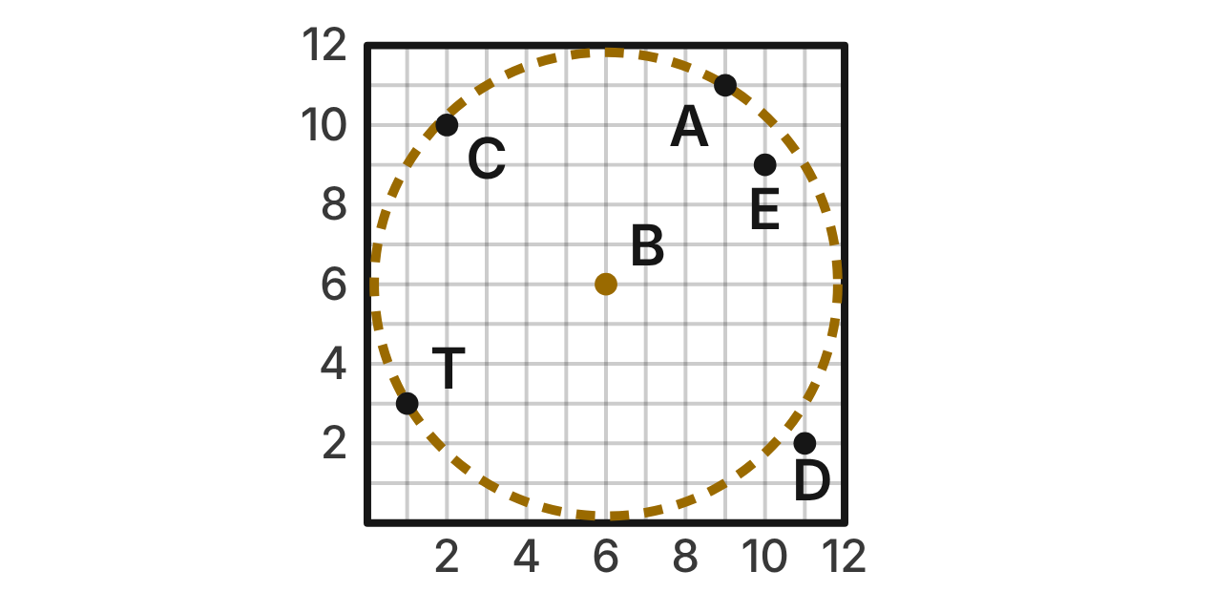
On a game board, the bomb token B is at (6, 6). Its blast reaches exactly as far as the tower T(1, 3) in every direction; the dashed circle is the edge of the blast. A, C, D and E are game pieces.
481. Which equation describes the edge of the blast?
A. (x + 6)² + (y + 6)² = 34
B. (x − 6)² + (y − 6)² = √34
C. (x − 6)² + (y − 6)² = 34 ✔
D. (x − 1)² + (y − 3)² = 34
G.PC.4 · skill G.PC.4.2 (LOTS): Write the equation of a circle from its center and radius, its center and a point, or the endpoints of a diameter
☐ Answer key correct ☐ Wording clear Notes: ________________________________
482. Which expression gives the distance BT?
A. √((6 − 1)² + (6 − 3)²) ✔
B. √((6 + 1)² + (6 + 3)²)
C. (6 − 1)² + (6 − 3)²
D. √((6 − 6)² + (1 − 3)²)
G.PC.4 · skill G.PC.4.3 (HOTS): Derive the equation of a circle with the Pythagorean Theorem or the distance formula
☐ Answer key correct ☐ Wording clear Notes: ________________________________
483. A piece is hit if it is as close to B as T is, or closer. Which piece is NOT hit?
A. A at (9, 11)
B. C at (2, 10)
C. E at (10, 9)
D. D at (11, 2) ✔
G.PC.4 · skill G.PC.4.1 (LOTS): Identify the center and radius of a circle from its graph or from its equation in standard form
☐ Answer key correct ☐ Wording clear Notes: ________________________________
484. The token slides 3 squares left and 2 squares down. The blast size stays the same. Which equation describes the new edge?
A. (x − 9)² + (y − 8)² = 34
B. (x − 3)² + (y − 4)² = 34 ✔
C. (x + 3)² + (y + 4)² = 34
D. (x − 3)² + (y − 4)² = 29
G.PC.4 · skill G.PC.4.2 (LOTS): Write the equation of a circle from its center and radius, its center and a point, or the endpoints of a diameter
☐ Answer key correct ☐ Wording clear Notes: ________________________________
485. Sam writes √((x − 6)² + (y − 6)²) = √34 for a point (x, y) on the edge of the blast. Which equation should come next?
A. (x − 6) + (y − 6) = √34
B. (x − 6)² + (y − 6)² = 34 ✔
C. (x − 6)² + (y − 6)² = √34
D. (x − 6)² + (y − 6)² = 1156
G.PC.4 · skill G.PC.4.3 (HOTS): Derive the equation of a circle with the Pythagorean Theorem or the distance formula
☐ Answer key correct ☐ Wording clear Notes: ________________________________
486. Each square on the board is 2 cm wide. To the nearest tenth of a centimeter, how far does the blast reach from B?
A. 5.8 cm
B. 68.0 cm
C. 11.7 cm ✔
D. 16.0 cm
G.PC.4 · skill G.PC.4.1 (LOTS): Identify the center and radius of a circle from its graph or from its equation in standard form
☐ Answer key correct ☐ Wording clear Notes: ________________________________

3-D figures (G.DF)

G.DF.1 · Create models and solve problems, including those in context, involving surface area and volume of rectangular and triangular prisms, cylinders, cones, pyramids, and spheres.

The Hockey Puck
Level 1 · 3-D figures · G.DF.1 · ID geo-df1-raid-hockey-puck
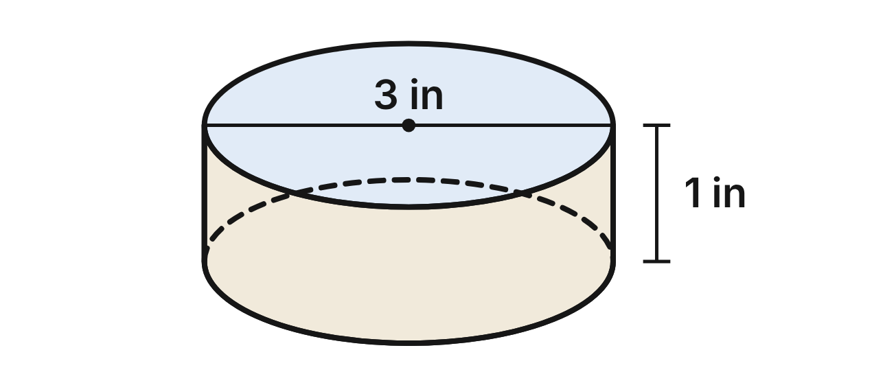
A hockey puck is a solid rubber cylinder. Its flat faces are circles 3 in across, and it is 1 in thick.
487. What is the volume of the puck, in terms of π?
A. 9π in³
B. 3π in³
C. 0.75π in³
D. 2.25π in³ ✔
G.DF.1 · skill G.DF.1.2 (LOTS): Find the surface area and volume of prisms, cylinders, cones, pyramids and spheres
☐ Answer key correct ☐ Wording clear Notes: ________________________________
488. What is the total surface area of the puck, to the nearest tenth of a square inch?
A. 9.4 in²
B. 23.6 in² ✔
C. 16.5 in²
D. 75.4 in²
G.DF.1 · skill G.DF.1.2 (LOTS): Find the surface area and volume of prisms, cylinders, cones, pyramids and spheres
☐ Answer key correct ☐ Wording clear Notes: ________________________________
489. Which shapes make up a net of the puck?
A. a rectangle and one circle
B. a sector and one circle
C. a rectangle and two circles ✔
D. a square and two circles
G.DF.1 · skill G.DF.1.1 (LOTS): Identify the two-dimensional cross sections and nets of three-dimensional figures
☐ Answer key correct ☐ Wording clear Notes: ________________________________
490. A plane cuts the puck straight down through the centers of both flat faces. What is the cross section?
A. a rectangle 3 in by 1 in ✔
B. a circle 3 in across
C. a rectangle 1.5 in by 1 in
D. a triangle with base 3 in
G.DF.1 · skill G.DF.1.1 (LOTS): Identify the two-dimensional cross sections and nets of three-dimensional figures
☐ Answer key correct ☐ Wording clear Notes: ________________________________
491. A plane parallel to the flat faces cuts the puck halfway through its thickness. What is the cross section?
A. a circle 1.5 in across
B. a circle 3 in across ✔
C. a rectangle 3 in by 0.5 in
D. a ring 3 in across
G.DF.1 · skill G.DF.1.1 (LOTS): Identify the two-dimensional cross sections and nets of three-dimensional figures
☐ Answer key correct ☐ Wording clear Notes: ________________________________
492. Which statement about the puck is NOT true?
A. Its two flat faces are congruent circles.
B. Its curved side unrolls into a rectangle 1 in wide.
C. Its volume is the area of a flat face times 1 in.
D. Its radius is 3 in. ✔
G.DF.1 · skill G.DF.1.2 (LOTS): Find the surface area and volume of prisms, cylinders, cones, pyramids and spheres
☐ Answer key correct ☐ Wording clear Notes: ________________________________

The Shot Put
Level 1 · 3-D figures · G.DF.1 · ID geo-df1-raid-shot-put
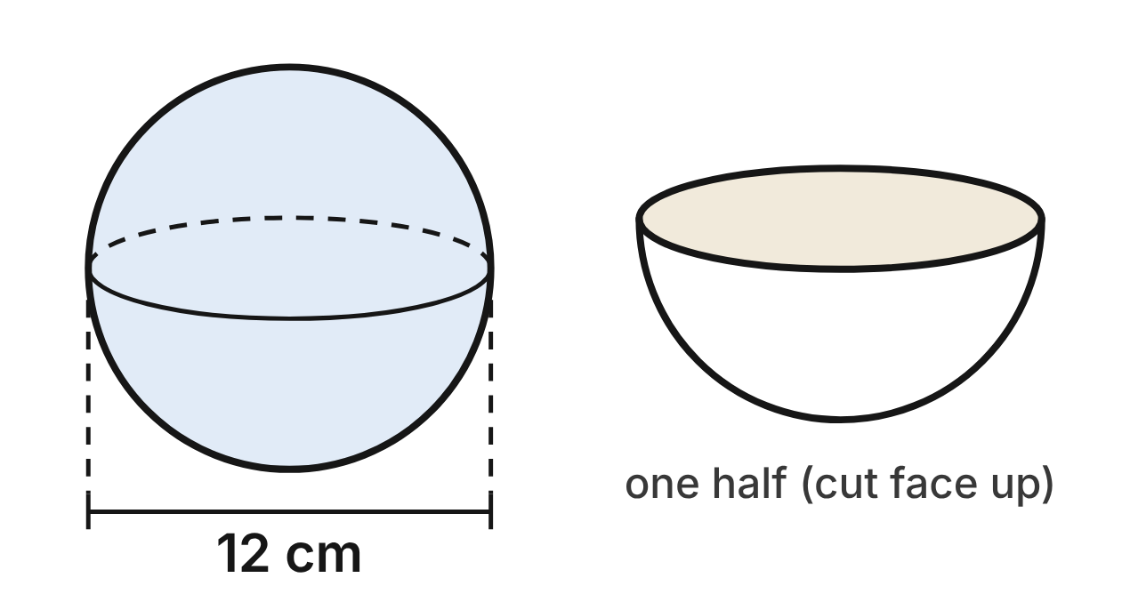
A shot put is a solid iron sphere with a diameter of 12 cm. A practice shot of the same size is cut in half to show its inside; each half is a hemisphere.
493. What is the volume of the shot, in terms of π?
A. 288π cm³ ✔
B. 2,304π cm³
C. 144π cm³
D. 48π cm³
G.DF.1 · skill G.DF.1.2 (LOTS): Find the surface area and volume of prisms, cylinders, cones, pyramids and spheres
☐ Answer key correct ☐ Wording clear Notes: ________________________________
494. What is the surface area of the shot, to the nearest tenth of a square centimeter?
A. 1,809.6 cm²
B. 113.1 cm²
C. 226.2 cm²
D. 452.4 cm² ✔
G.DF.1 · skill G.DF.1.2 (LOTS): Find the surface area and volume of prisms, cylinders, cones, pyramids and spheres
☐ Answer key correct ☐ Wording clear Notes: ________________________________
495. A plane passes through the center of the shot. What is the area of the cross section, in terms of π?
A. 144π cm²
B. 36π cm² ✔
C. 12π cm²
D. 72π cm²
G.DF.1 · skill G.DF.1.1 (LOTS): Identify the two-dimensional cross sections and nets of three-dimensional figures
☐ Answer key correct ☐ Wording clear Notes: ________________________________
496. A plane cuts the shot 3 cm from its center. What is the cross section?
A. a circle with radius 6 cm
B. an ellipse with a long axis of 12 cm
C. a circle with radius less than 6 cm ✔
D. a semicircle with radius 6 cm
G.DF.1 · skill G.DF.1.1 (LOTS): Identify the two-dimensional cross sections and nets of three-dimensional figures
☐ Answer key correct ☐ Wording clear Notes: ________________________________
497. What is the total surface area of one half, curved part and flat face together, in terms of π?
A. 108π cm² ✔
B. 72π cm²
C. 144π cm²
D. 180π cm²
G.DF.1 · skill G.DF.1.2 (LOTS): Find the surface area and volume of prisms, cylinders, cones, pyramids and spheres
☐ Answer key correct ☐ Wording clear Notes: ________________________________
498. Iron has a mass of about 7.87 g per cubic centimeter. What is the mass of the whole shot, to the nearest tenth of a kilogram? Use 1 kg = 1,000 g.
A. 57.0 kg
B. 3.6 kg
C. 7.1 kg ✔
D. 7,120.6 kg
G.DF.1 · skill G.DF.1.3 (HOTS): Solve multistep contextual problems with surface area and volume, including composite figures
☐ Answer key correct ☐ Wording clear Notes: ________________________________

The Gem Token
Level 2 · 3-D figures · G.DF.1 · ID geo-df1-raid-game-gem
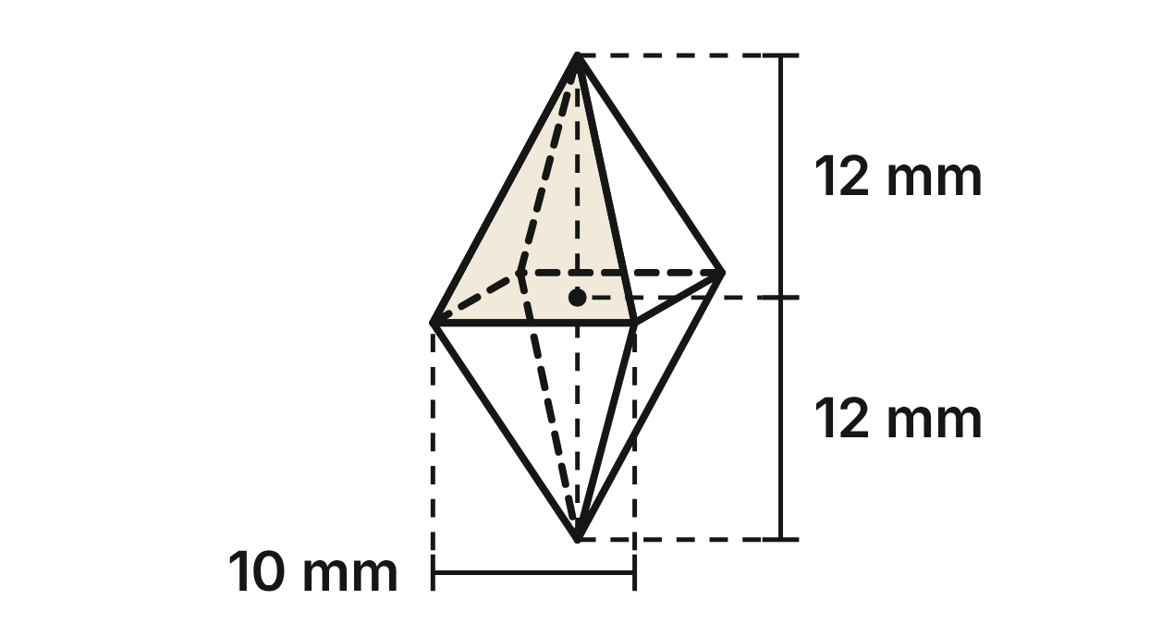
A board-game token is a gem made of two square pyramids joined at their bases. The shared square has sides of 10 mm, and each pyramid is 12 mm tall.
499. What is the slant height of each triangular face?
A. about 15.6 mm
B. 17 mm
C. 13 mm ✔
D. about 10.9 mm
G.DF.1 · skill G.DF.1.2 (LOTS): Find the surface area and volume of prisms, cylinders, cones, pyramids and spheres
☐ Answer key correct ☐ Wording clear Notes: ________________________________
500. What is the volume of the gem?
A. 800 mm³ ✔
B. 2,400 mm³
C. 400 mm³
D. 1,600 mm³
G.DF.1 · skill G.DF.1.2 (LOTS): Find the surface area and volume of prisms, cylinders, cones, pyramids and spheres
☐ Answer key correct ☐ Wording clear Notes: ________________________________
501. What is the surface area of the gem?
A. 480 mm²
B. 620 mm²
C. 1,040 mm²
D. 520 mm² ✔
G.DF.1 · skill G.DF.1.2 (LOTS): Find the surface area and volume of prisms, cylinders, cones, pyramids and spheres
☐ Answer key correct ☐ Wording clear Notes: ________________________________
502. A plane parallel to the shared square cuts the top pyramid halfway between the square and the top tip. What is the cross section?
A. a square with sides 10 mm
B. a square with sides 5 mm ✔
C. a square with sides 2.5 mm
D. a triangle with base 5 mm
G.DF.1 · skill G.DF.1.1 (LOTS): Identify the two-dimensional cross sections and nets of three-dimensional figures
☐ Answer key correct ☐ Wording clear Notes: ________________________________
503. A vertical plane passes through both tips and the midpoints of two opposite sides of the shared square. What is the cross section?
A. a square with sides 10 mm
B. a triangle with base 10 mm and height 24 mm
C. a rhombus with diagonals 10 mm and 12 mm
D. a rhombus with diagonals 10 mm and 24 mm ✔
G.DF.1 · skill G.DF.1.1 (LOTS): Identify the two-dimensional cross sections and nets of three-dimensional figures
☐ Answer key correct ☐ Wording clear Notes: ________________________________
504. A game maker prints 250 gems. Resin costs $0.12 per cubic centimeter, and 1 cm³ = 1,000 mm³. What does the resin cost?
A. $72.00
B. $24.00 ✔
C. $12.00
D. $240.00
G.DF.1 · skill G.DF.1.3 (HOTS): Solve multistep contextual problems with surface area and volume, including composite figures
☐ Answer key correct ☐ Wording clear Notes: ________________________________

The Team Water Cooler
Level 2 · 3-D figures · G.DF.1 · ID geo-df1-raid-water-cooler
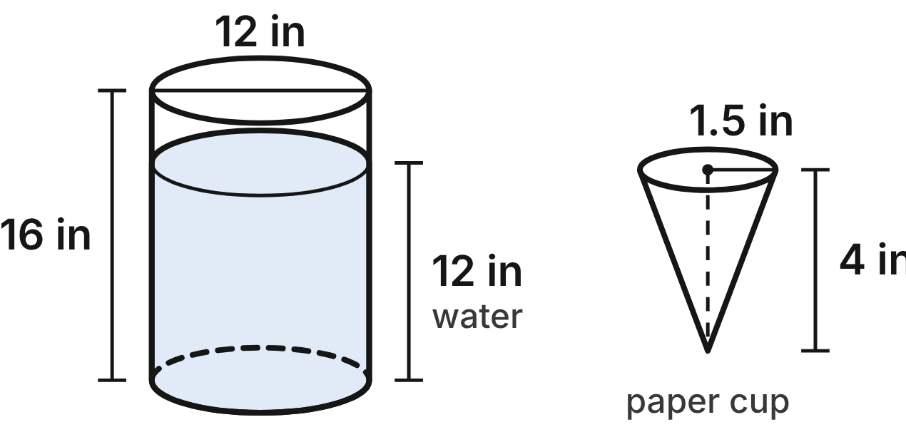
Not drawn to scale
The team's water cooler is a cylinder with an inside diameter of 12 in and an inside height of 16 in. Water fills it to a depth of 12 in. Each paper cup is a cone, open at the top, with radius 1.5 in and height 4 in.
505. How much can the cooler hold when it is full, to the nearest cubic inch?
A. 7,238 in³
B. 1,810 in³ ✔
C. 603 in³
D. 829 in³
G.DF.1 · skill G.DF.1.2 (LOTS): Find the surface area and volume of prisms, cylinders, cones, pyramids and spheres
☐ Answer key correct ☐ Wording clear Notes: ________________________________
506. How many gallons of water are in the cooler, to the nearest tenth? Use 1 gallon = 231 in³.
A. 7.8 gal
B. 23.5 gal
C. 5.9 gal ✔
D. 2.0 gal
G.DF.1 · skill G.DF.1.3 (HOTS): Solve multistep contextual problems with surface area and volume, including composite figures
☐ Answer key correct ☐ Wording clear Notes: ________________________________
507. What is the volume of one cup, in terms of π?
A. 3π in³ ✔
B. 9π in³
C. 12π in³
D. 2π in³
G.DF.1 · skill G.DF.1.2 (LOTS): Find the surface area and volume of prisms, cylinders, cones, pyramids and spheres
☐ Answer key correct ☐ Wording clear Notes: ________________________________
508. How many cups can be filled completely with the water in the cooler?
A. 192
B. 48
C. 36
D. 144 ✔
G.DF.1 · skill G.DF.1.3 (HOTS): Solve multistep contextual problems with surface area and volume, including composite figures
☐ Answer key correct ☐ Wording clear Notes: ________________________________
509. A cup is cut open and laid flat. Which shape is its net?
A. a sector of a circle ✔
B. a sector and a circle
C. a rectangle and a circle
D. a triangle
G.DF.1 · skill G.DF.1.1 (LOTS): Identify the two-dimensional cross sections and nets of three-dimensional figures
☐ Answer key correct ☐ Wording clear Notes: ________________________________
510. How much paper makes one cup, to the nearest tenth of a square inch?
A. 18.8 in²
B. 27.2 in²
C. 20.1 in² ✔
D. 47.1 in²
G.DF.1 · skill G.DF.1.2 (LOTS): Find the surface area and volume of prisms, cylinders, cones, pyramids and spheres
☐ Answer key correct ☐ Wording clear Notes: ________________________________

The Skate Park Quarter-Pipe
Level 2 · 3-D figures · G.DF.1 · ID geo-df1-raid-quarter-pipe
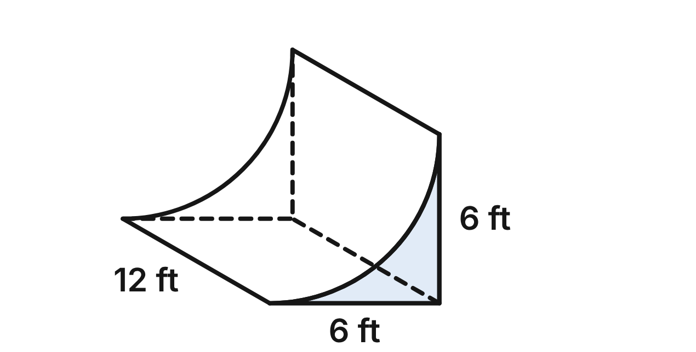
A skate park quarter-pipe is solid concrete. Each end is a 6 ft by 6 ft square with a quarter circle of radius 6 ft cut out of it, and the ramp is 12 ft wide.
511. A plane parallel to the two ends cuts through the ramp. What is the shape of the cross section?
A. a right triangle with legs of 6 ft
B. a quarter circle with radius 6 ft
C. a rectangle 6 ft by 12 ft
D. a square with a quarter circle cut out ✔
G.DF.1 · skill G.DF.1.1 (LOTS): Identify the two-dimensional cross sections and nets of three-dimensional figures
☐ Answer key correct ☐ Wording clear Notes: ________________________________
512. What is the area of one end of the ramp, to the nearest tenth of a square foot?
A. 7.7 ft² ✔
B. 28.3 ft²
C. 26.6 ft²
D. 18.0 ft²
G.DF.1 · skill G.DF.1.2 (LOTS): Find the surface area and volume of prisms, cylinders, cones, pyramids and spheres
☐ Answer key correct ☐ Wording clear Notes: ________________________________
513. How many cubic yards of concrete are in the ramp, to the nearest tenth? Use 1 yd³ = 27 ft³.
A. 92.7 yd³
B. 16.0 yd³
C. 3.4 yd³ ✔
D. 12.6 yd³
G.DF.1 · skill G.DF.1.3 (HOTS): Solve multistep contextual problems with surface area and volume, including composite figures
☐ Answer key correct ☐ Wording clear Notes: ________________________________
514. Concrete is sold only in whole cubic yards, at $140 per cubic yard. What does the concrete for the ramp cost? Use 1 yd³ = 27 ft³.
A. $476
B. $560 ✔
C. $2,240
D. $420
G.DF.1 · skill G.DF.1.3 (HOTS): Solve multistep contextual problems with surface area and volume, including composite figures
☐ Answer key correct ☐ Wording clear Notes: ________________________________
515. What is the area of the curved riding surface, to the nearest square foot?
A. 226 ft²
B. 452 ft²
C. 113 ft² ✔
D. 339 ft²
G.DF.1 · skill G.DF.1.2 (LOTS): Find the surface area and volume of prisms, cylinders, cones, pyramids and spheres
☐ Answer key correct ☐ Wording clear Notes: ________________________________
516. Jae writes the volume of the ramp as 6 · 6 · 12 − π · 6² · 12. What is wrong?
A. Jae should add the cylinder, not take it away.
B. Jae should use 12 ft as the radius.
C. Jae should multiply the cylinder part by 1/3.
D. Jae took away a whole cylinder, not a quarter of one. ✔
G.DF.1 · skill G.DF.1.2 (LOTS): Find the surface area and volume of prisms, cylinders, cones, pyramids and spheres
☐ Answer key correct ☐ Wording clear Notes: ________________________________

The Archery Target Block
Level 2 · 3-D figures · G.DF.1 · ID geo-df1-raid-archery-block
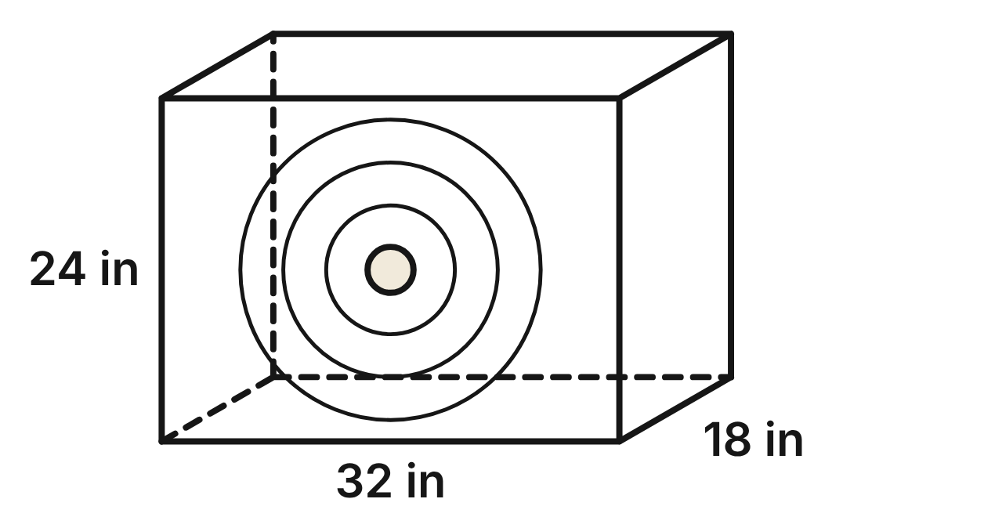
An archery target is a foam block shaped like a rectangular prism. It is 32 in wide, 24 in tall and 18 in thick from front to back.
517. What is the volume of the block in cubic feet? Use 1 ft³ = 1,728 in³.
A. 8 ft³ ✔
B. 96 ft³
C. 1,152 ft³
D. 13,824 ft³
G.DF.1 · skill G.DF.1.3 (HOTS): Solve multistep contextual problems with surface area and volume, including composite figures
☐ Answer key correct ☐ Wording clear Notes: ________________________________
518. What is the total surface area of the block?
A. 1,776 in²
B. 3,552 in² ✔
C. 2,016 in²
D. 2,784 in²
G.DF.1 · skill G.DF.1.2 (LOTS): Find the surface area and volume of prisms, cylinders, cones, pyramids and spheres
☐ Answer key correct ☐ Wording clear Notes: ________________________________
519. A plane cuts the block through its top front edge and its bottom back edge. What is the area of the cross section?
A. 768 in²
B. 1,280 in²
C. 576 in²
D. 960 in² ✔
G.DF.1 · skill G.DF.1.1 (LOTS): Identify the two-dimensional cross sections and nets of three-dimensional figures
☐ Answer key correct ☐ Wording clear Notes: ________________________________
520. A plane slices one corner off the block, through the three corners next to it. Which describes the cross section?
A. a right triangle with legs 24 in and 18 in
B. a right triangle with sides 30, 40 and 50 in
C. a triangle with sides 30, 40 and about 36.7 in ✔
D. a rectangle 32 in by 30 in
G.DF.1 · skill G.DF.1.1 (LOTS): Identify the two-dimensional cross sections and nets of three-dimensional figures
☐ Answer key correct ☐ Wording clear Notes: ________________________________
521. Which set of rectangles can be folded into the block?
A. three 32 by 24 and three 24 by 18
B. two 32 by 24, two 32 by 18, two 24 by 18 ✔
C. two 32 by 24 and four 24 by 18
D. six 32 by 24
G.DF.1 · skill G.DF.1.1 (LOTS): Identify the two-dimensional cross sections and nets of three-dimensional figures
☐ Answer key correct ☐ Wording clear Notes: ________________________________
522. The front and back faces are covered with target fabric that costs $3.50 per square foot. What does the fabric cost, to the nearest cent? Use 1 ft² = 144 in².
A. $37.33 ✔
B. $18.67
C. $448.00
D. $86.33
G.DF.1 · skill G.DF.1.3 (HOTS): Solve multistep contextual problems with surface area and volume, including composite figures
☐ Answer key correct ☐ Wording clear Notes: ________________________________

The Swim Meet Pool
Level 3 · 3-D figures · G.DF.1 · ID geo-df1-raid-swim-pool
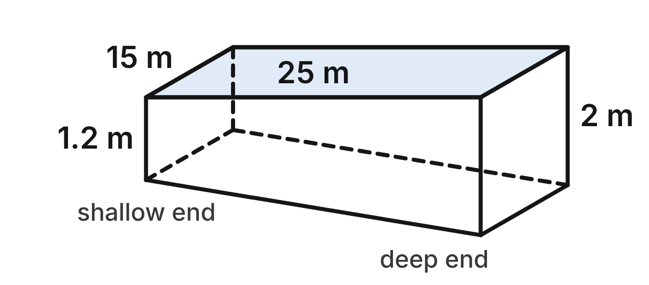
Not drawn to scale
A swim meet pool is 25 m long and 15 m wide. The water is 1.2 m deep at the shallow end and 2 m deep at the deep end, and the floor slopes evenly between them, so each long wall is a trapezoid.
523. What is the area of one long wall, up to the water line?
A. 80 m²
B. 50 m²
C. 40 m² ✔
D. 30 m²
G.DF.1 · skill G.DF.1.2 (LOTS): Find the surface area and volume of prisms, cylinders, cones, pyramids and spheres
☐ Answer key correct ☐ Wording clear Notes: ________________________________
524. What is the volume of water in the full pool?
A. 1,200 m³
B. 750 m³
C. 450 m³
D. 600 m³ ✔
G.DF.1 · skill G.DF.1.2 (LOTS): Find the surface area and volume of prisms, cylinders, cones, pyramids and spheres
☐ Answer key correct ☐ Wording clear Notes: ________________________________
525. A pump adds 2,500 L of water per minute, and 1 m³ = 1,000 L. How many hours does it take to fill the empty pool?
A. 8 h
B. 4 h ✔
C. 5 h
D. 240 h
G.DF.1 · skill G.DF.1.3 (HOTS): Solve multistep contextual problems with surface area and volume, including composite figures
☐ Answer key correct ☐ Wording clear Notes: ________________________________
526. The two long walls and the two end walls are tiled up to the water line. How many square meters of wall are tiled?
A. 128 m² ✔
B. 88 m²
C. 208 m²
D. 160 m²
G.DF.1 · skill G.DF.1.3 (HOTS): Solve multistep contextual problems with surface area and volume, including composite figures
☐ Answer key correct ☐ Wording clear Notes: ________________________________
527. A vertical plane parallel to the end walls cuts the water halfway along the pool. What is the cross section?
A. a rectangle 15 m by 2 m
B. a rectangle 15 m by 1.2 m
C. a trapezoid with parallel sides 1.2 m and 2 m
D. a rectangle 15 m by 1.6 m ✔
G.DF.1 · skill G.DF.1.1 (LOTS): Identify the two-dimensional cross sections and nets of three-dimensional figures
☐ Answer key correct ☐ Wording clear Notes: ________________________________
528. Which statement about cross sections of the water is NOT true?
A. A plane parallel to an end wall gives a rectangle.
B. A level plane 1.5 m below the surface gives a 25 m by 15 m rectangle. ✔
C. A plane parallel to a long wall gives a trapezoid.
D. A level plane 0.5 m below the surface gives a 25 m by 15 m rectangle.
G.DF.1 · skill G.DF.1.1 (LOTS): Identify the two-dimensional cross sections and nets of three-dimensional figures
☐ Answer key correct ☐ Wording clear Notes: ________________________________

Sand for the Volleyball Court
Level 3 · 3-D figures · G.DF.1 · ID geo-df1-raid-sand-court
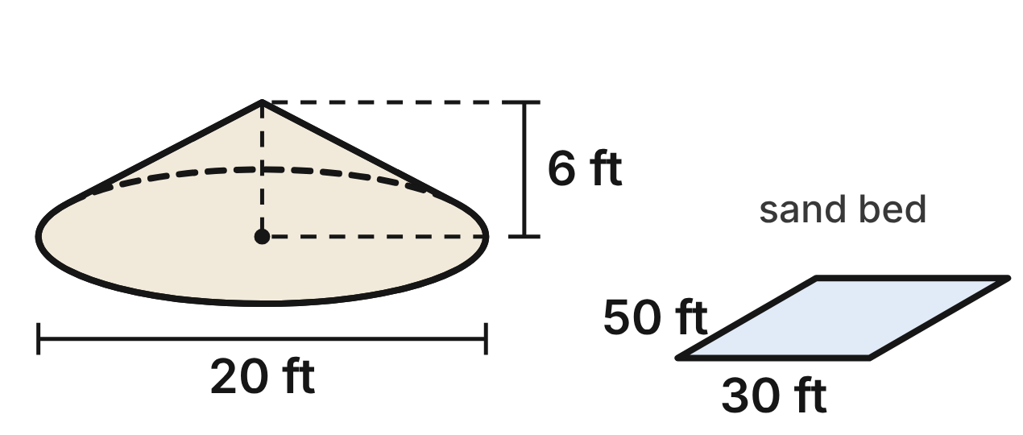
Not drawn to scale
A truck dumps sand for a beach volleyball court in a pile shaped like a cone, 20 ft across and 6 ft high. The court's sand bed is a rectangle 50 ft long and 30 ft wide.
529. What is the volume of the pile, to the nearest cubic foot?
A. 1,885 ft³
B. 628 ft³ ✔
C. 2,513 ft³
D. 1,221 ft³
G.DF.1 · skill G.DF.1.2 (LOTS): Find the surface area and volume of prisms, cylinders, cones, pyramids and spheres
☐ Answer key correct ☐ Wording clear Notes: ________________________________
530. The sand must be 18 in deep over the whole bed. How many piles like this one must be delivered?
A. 4 ✔
B. 3
C. 2
D. 43
G.DF.1 · skill G.DF.1.3 (HOTS): Solve multistep contextual problems with surface area and volume, including composite figures
☐ Answer key correct ☐ Wording clear Notes: ________________________________
531. One pile is spread evenly over the whole bed. How deep is the sand, to the nearest tenth of an inch?
A. 0.4 in
B. 15.1 in
C. 5.0 in ✔
D. 20.1 in
G.DF.1 · skill G.DF.1.3 (HOTS): Solve multistep contextual problems with surface area and volume, including composite figures
☐ Answer key correct ☐ Wording clear Notes: ________________________________
532. What is the slant height of the pile, to the nearest tenth of a foot?
A. 8.0 ft
B. 16.0 ft
C. 20.9 ft
D. 11.7 ft ✔
G.DF.1 · skill G.DF.1.2 (LOTS): Find the surface area and volume of prisms, cylinders, cones, pyramids and spheres
☐ Answer key correct ☐ Wording clear Notes: ________________________________
533. A tarp covers the curved surface of the pile. What is its area, to the nearest square foot?
A. 366 ft² ✔
B. 188 ft²
C. 681 ft²
D. 1,312 ft²
G.DF.1 · skill G.DF.1.2 (LOTS): Find the surface area and volume of prisms, cylinders, cones, pyramids and spheres
☐ Answer key correct ☐ Wording clear Notes: ________________________________
534. A plane parallel to the ground cuts the pile 2 ft above the ground. What is the cross section?
A. a circle with radius about 3.3 ft
B. a circle with radius 10 ft
C. a circle with radius about 6.7 ft ✔
D. a circle with radius 8 ft
G.DF.1 · skill G.DF.1.1 (LOTS): Identify the two-dimensional cross sections and nets of three-dimensional figures
☐ Answer key correct ☐ Wording clear Notes: ________________________________

G.DF.2 · Determine how changes in one or more dimensions affect perimeter, area, surface area, and volume, and solve problems with similar two- and three-dimensional figures.

The Archery Target
Level 1 · Changing dimensions · G.DF.2 · ID geo-df2-raid-archery
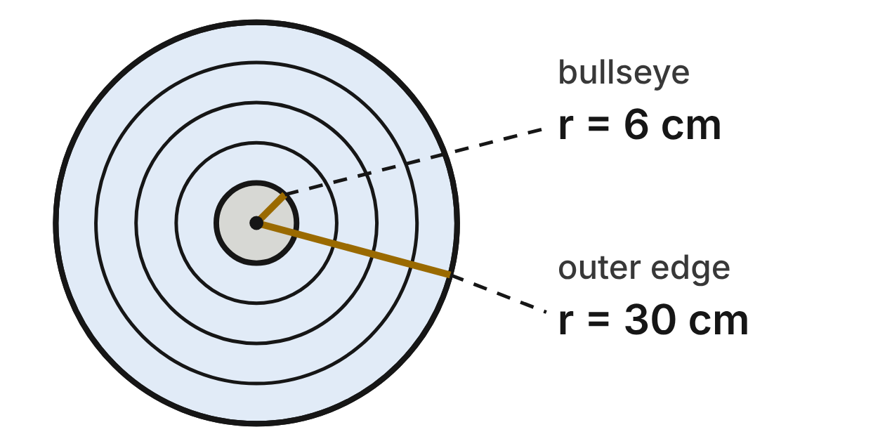
An archery target is five circles with the same center. The gold bullseye has a radius of 6 cm, and each ring adds 6 cm, so the outer edge has a radius of 30 cm.
535. What is the ratio of the circumference of the outer edge to the circumference of the bullseye?
A. 25 : 1
B. 125 : 1
C. 5 : 1 ✔
D. 1 : 5
G.DF.2 · skill G.DF.2.2 (LOTS): Use the ratios k, k² and k³ of similar figures to find lengths, areas and volumes
☐ Answer key correct ☐ Wording clear Notes: ________________________________
536. The bullseye has an area of 36π cm². What is the area of the whole target face?
A. 4,500π cm²
B. 900π cm² ✔
C. 60π cm²
D. 180π cm²
G.DF.2 · skill G.DF.2.2 (LOTS): Use the ratios k, k² and k³ of similar figures to find lengths, areas and volumes
☐ Answer key correct ☐ Wording clear Notes: ________________________________
537. A youth target doubles the radius of every ring. What is the area of its bullseye?
A. 576π cm²
B. 72π cm²
C. 288π cm²
D. 144π cm² ✔
G.DF.2 · skill G.DF.2.1 (LOTS): Describe how changing one or more dimensions of a figure changes its perimeter, area, surface area or volume
☐ Answer key correct ☐ Wording clear Notes: ________________________________
538. Which statement about the bullseye circle and the outer-edge circle is true?
A. They are similar, since all circles are similar. ✔
B. They are not similar, since their radii differ.
C. They are congruent, since they share a center.
D. They are similar only because they share a center.
G.DF.2 · skill G.DF.2.3 (HOTS): Decide whether two figures are similar and justify the decision with ratios of corresponding measures
☐ Answer key correct ☐ Wording clear Notes: ________________________________
539. A toy target is similar to this one, with an outer radius of 7.5 cm. What is the radius of its bullseye?
A. 0.375 cm
B. 1.5 cm ✔
C. 1.25 cm
D. 24 cm
G.DF.2 · skill G.DF.2.2 (LOTS): Use the ratios k, k² and k³ of similar figures to find lengths, areas and volumes
☐ Answer key correct ☐ Wording clear Notes: ________________________________
540. If the radius of the outer edge is tripled to 90 cm, what is the new outer circumference?
A. 180π cm ✔
B. 8,100π cm
C. 540π cm
D. 1,620π cm
G.DF.2 · skill G.DF.2.1 (LOTS): Describe how changing one or more dimensions of a figure changes its perimeter, area, surface area or volume
☐ Answer key correct ☐ Wording clear Notes: ________________________________

Giant Foam Dice
Level 1 · Changing dimensions · G.DF.2 · ID geo-df2-raid-dice
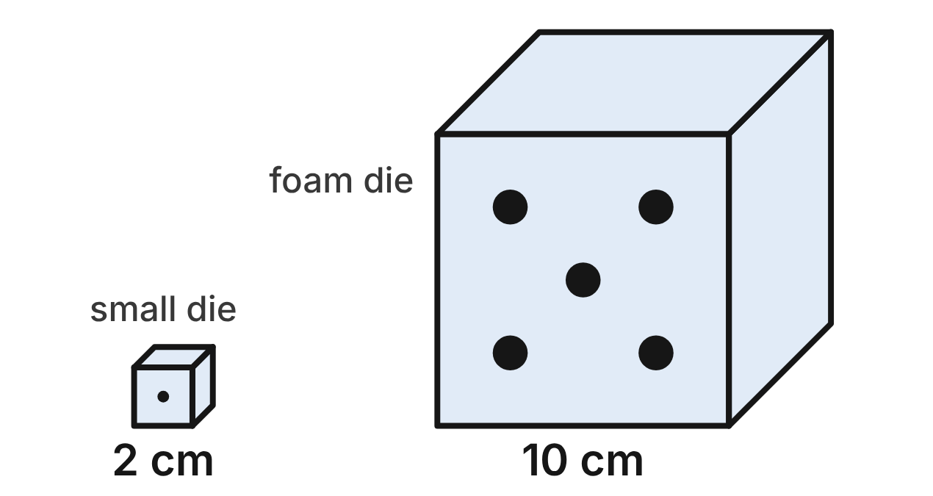
A board game's small die is a cube with 2 cm edges. A foam die for a giant floor game is a cube with 10 cm edges. All cubes are similar.
541. Which statement comparing the foam die to the small die is NOT true?
A. Each edge is 5 times as long.
B. Each face has 25 times the area.
C. Its surface area is 25 times as much.
D. Its volume is 25 times as much. ✔
G.DF.2 · skill G.DF.2.2 (LOTS): Use the ratios k, k² and k³ of similar figures to find lengths, areas and volumes
☐ Answer key correct ☐ Wording clear Notes: ________________________________
542. The small die has a surface area of 24 cm². What is the surface area of the foam die?
A. 600 cm² ✔
B. 3,000 cm²
C. 100 cm²
D. 120 cm²
G.DF.2 · skill G.DF.2.2 (LOTS): Use the ratios k, k² and k³ of similar figures to find lengths, areas and volumes
☐ Answer key correct ☐ Wording clear Notes: ________________________________
543. The small die has a volume of 8 cm³. What is the volume of the foam die?
A. 600 cm³
B. 40 cm³
C. 1,000 cm³ ✔
D. 200 cm³
G.DF.2 · skill G.DF.2.2 (LOTS): Use the ratios k, k² and k³ of similar figures to find lengths, areas and volumes
☐ Answer key correct ☐ Wording clear Notes: ________________________________
544. A game piece is made by stretching the small die to 6 cm tall while keeping its 2 cm by 2 cm base. What is the volume of the piece?
A. 216 cm³
B. 24 cm³ ✔
C. 72 cm³
D. 12 cm³
G.DF.2 · skill G.DF.2.1 (LOTS): Describe how changing one or more dimensions of a figure changes its perimeter, area, surface area or volume
☐ Answer key correct ☐ Wording clear Notes: ________________________________
545. A game piece measures 2 cm by 2 cm by 6 cm. Is it similar to the small die?
A. Yes: its volume is 3 times as much.
B. Yes: two of its edges match the die.
C. No: 6/2 = 3 but 2/2 = 1. ✔
D. Yes: both are rectangular prisms.
G.DF.2 · skill G.DF.2.3 (HOTS): Decide whether two figures are similar and justify the decision with ratios of corresponding measures
☐ Answer key correct ☐ Wording clear Notes: ________________________________
546. A jumbo die is similar to the small die and has a surface area of 54 cm². How long is each edge?
A. 9 cm
B. 4.5 cm
C. about 7.3 cm
D. 3 cm ✔
G.DF.2 · skill G.DF.2.2 (LOTS): Use the ratios k, k² and k³ of similar figures to find lengths, areas and volumes
☐ Answer key correct ☐ Wording clear Notes: ________________________________

The Swim-Team Pool
Level 2 · Changing dimensions · G.DF.2 · ID geo-df2-raid-pool
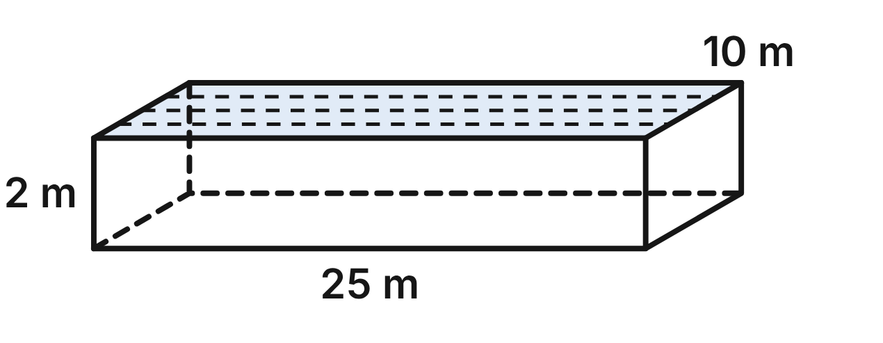
Not drawn to scale
The swim team's pool is a rectangular prism 25 m long, 10 m wide and 2 m deep. It holds 500 m³ of water when full. Tile covers its floor and four walls: 390 m².
547. The pool is made deeper, from 2 m to 3 m. The length and width stay the same. How much water does it hold when full?
A. 1,125 m³
B. 750 m³ ✔
C. 1,687.5 m³
D. 858 m³
G.DF.2 · skill G.DF.2.1 (LOTS): Describe how changing one or more dimensions of a figure changes its perimeter, area, surface area or volume
☐ Answer key correct ☐ Wording clear Notes: ________________________________
548. A new pool doubles the length and the width but stays 2 m deep. How much tile does its floor and four walls need?
A. 1,560 m²
B. 3,120 m²
C. 780 m²
D. 1,280 m² ✔
G.DF.2 · skill G.DF.2.1 (LOTS): Describe how changing one or more dimensions of a figure changes its perimeter, area, surface area or volume
☐ Answer key correct ☐ Wording clear Notes: ________________________________
549. A kiddie pool is similar to the swim-team pool and is 5 m long. How deep is it?
A. 0.4 m ✔
B. 2 m
C. 0.08 m
D. 1 m
G.DF.2 · skill G.DF.2.2 (LOTS): Use the ratios k, k² and k³ of similar figures to find lengths, areas and volumes
☐ Answer key correct ☐ Wording clear Notes: ________________________________
550. A kiddie pool is similar to the swim-team pool and is 5 m long. How much water does it hold when full?
A. 100 m³
B. 20 m³
C. 4 m³ ✔
D. 125 m³
G.DF.2 · skill G.DF.2.2 (LOTS): Use the ratios k, k² and k³ of similar figures to find lengths, areas and volumes
☐ Answer key correct ☐ Wording clear Notes: ________________________________
551. A diving pool is 20 m long, 8 m wide and 5 m deep. Is it similar to the swim-team pool? Choose the answer with the correct reason.
A. No: 20/25 = 8/10, but 5/2 is not 0.8. ✔
B. Yes: both pools are rectangular prisms.
C. No: a similar pool would have to hold 500 m³.
D. Yes: its length and width ratios are both 0.8.
G.DF.2 · skill G.DF.2.3 (HOTS): Decide whether two figures are similar and justify the decision with ratios of corresponding measures
☐ Answer key correct ☐ Wording clear Notes: ________________________________
552. A practice pool is similar to the swim-team pool. Its floor has an area of 160 m². How long is it?
A. 8 m
B. 20 m ✔
C. 16 m
D. about 12.6 m
G.DF.2 · skill G.DF.2.2 (LOTS): Use the ratios k, k² and k³ of similar figures to find lengths, areas and volumes
☐ Answer key correct ☐ Wording clear Notes: ________________________________

The Skate-Park Wedge
Level 2 · Changing dimensions · G.DF.2 · ID geo-df2-raid-skate-ramp
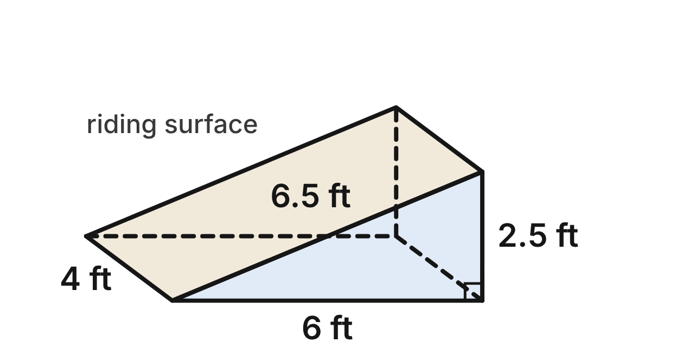
A skate-park ramp is a wedge (a triangular prism). Its front face is a right triangle with a run of 6 ft, a rise of 2.5 ft and a sloped side of 6.5 ft. The ramp is 4 ft wide. Its volume is 30 ft³, and its sloped riding surface (gold) has an area of 26 ft².
553. The ramp is widened from 4 ft to 8 ft, with the same front triangle. What is its new volume?
A. 60 ft³ ✔
B. 120 ft³
C. 240 ft³
D. 34 ft³
G.DF.2 · skill G.DF.2.1 (LOTS): Describe how changing one or more dimensions of a figure changes its perimeter, area, surface area or volume
☐ Answer key correct ☐ Wording clear Notes: ________________________________
554. Only the rise is changed, from 2.5 ft to 5 ft; the run stays 6 ft and the width 4 ft. To the nearest tenth, what is the area of the new riding surface?
A. 26.0 ft²
B. 44.0 ft²
C. 31.2 ft² ✔
D. 52.0 ft²
G.DF.2 · skill G.DF.2.1 (LOTS): Describe how changing one or more dimensions of a figure changes its perimeter, area, surface area or volume
☐ Answer key correct ☐ Wording clear Notes: ________________________________
555. A mini ramp is similar to this ramp and has a rise of 1 ft. What is its volume?
A. 75 ft³
B. 12 ft³
C. 4.8 ft³
D. 1.92 ft³ ✔
G.DF.2 · skill G.DF.2.2 (LOTS): Use the ratios k, k² and k³ of similar figures to find lengths, areas and volumes
☐ Answer key correct ☐ Wording clear Notes: ________________________________
556. A bigger ramp is similar to this ramp, and its riding surface has an area of 58.5 ft². What is its rise?
A. 5.625 ft
B. 3.75 ft ✔
C. 9.75 ft
D. about 7.6 ft
G.DF.2 · skill G.DF.2.2 (LOTS): Use the ratios k, k² and k³ of similar figures to find lengths, areas and volumes
☐ Answer key correct ☐ Wording clear Notes: ________________________________
557. A second wedge ramp has a right-triangle front face with a rise of 3 ft and a run of 7.2 ft, and it is 4.8 ft wide. Is it similar to this ramp?
A. No: its sloped side is not given.
B. No: the widths would have to match.
C. No: 3 − 2.5 ≠ 7.2 − 6.
D. Yes: each ratio is 1.2. ✔
G.DF.2 · skill G.DF.2.3 (HOTS): Decide whether two figures are similar and justify the decision with ratios of corresponding measures
☐ Answer key correct ☐ Wording clear Notes: ________________________________
558. Sam says a ramp similar to this one with a 5 ft rise has a 52 ft² riding surface, because the scale factor is 2. What is true?
A. The scale factor is 2.5, so it is 65 ft².
B. Area grows by 2³ = 8, so it is 208 ft².
C. Area grows by 2² = 4, so it is 104 ft². ✔
D. Sam is right: it is 52 ft².
G.DF.2 · skill G.DF.2.2 (LOTS): Use the ratios k, k² and k³ of similar figures to find lengths, areas and volumes
☐ Answer key correct ☐ Wording clear Notes: ________________________________

Handball and Cage Ball
Level 2 · Changing dimensions · G.DF.2 · ID geo-df2-raid-ball-sizes
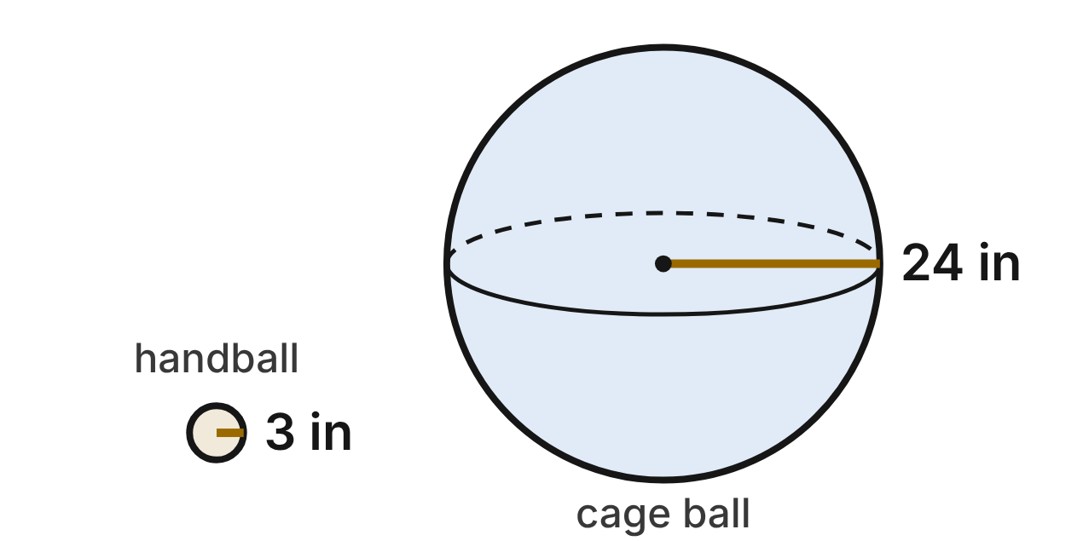
A gym-class handball is a sphere with a radius of 3 in. Its surface area is 36π in², and its volume is 36π in³. A giant cage ball is a sphere with a radius of 24 in.
559. What is the surface area of the cage ball?
A. 288π in²
B. 18,432π in²
C. 9,216π in²
D. 2,304π in² ✔
G.DF.2 · skill G.DF.2.2 (LOTS): Use the ratios k, k² and k³ of similar figures to find lengths, areas and volumes
☐ Answer key correct ☐ Wording clear Notes: ________________________________
560. What is the volume of the cage ball?
A. 288π in³
B. 18,432π in³ ✔
C. 13,824π in³
D. 2,304π in³
G.DF.2 · skill G.DF.2.2 (LOTS): Use the ratios k, k² and k³ of similar figures to find lengths, areas and volumes
☐ Answer key correct ☐ Wording clear Notes: ________________________________
561. A ball maker doubles the radius of the handball. What is the volume of the new ball?
A. 288π in³ ✔
B. 216π in³
C. 72π in³
D. 144π in³
G.DF.2 · skill G.DF.2.1 (LOTS): Describe how changing one or more dimensions of a figure changes its perimeter, area, surface area or volume
☐ Answer key correct ☐ Wording clear Notes: ________________________________
562. A ball has a surface area of 81π in². What is its radius?
A. 6.75 in
B. 9 in
C. 4.5 in ✔
D. 20.25 in
G.DF.2 · skill G.DF.2.2 (LOTS): Use the ratios k, k² and k³ of similar figures to find lengths, areas and volumes
☐ Answer key correct ☐ Wording clear Notes: ________________________________
563. Which statement about balls (spheres) is true?
A. Two spheres are similar only if their radii have a whole-number ratio.
B. Any two spheres are similar. ✔
C. A sphere and a cylinder with the same radius are similar.
D. Two spheres are similar only if their volumes are equal.
G.DF.2 · skill G.DF.2.3 (HOTS): Decide whether two figures are similar and justify the decision with ratios of corresponding measures
☐ Answer key correct ☐ Wording clear Notes: ________________________________
564. A medicine ball is similar to the cage ball and holds 1/27 of its volume. What is the radius of the medicine ball?
A. 8 in ✔
B. about 4.6 in
C. about 0.9 in
D. about 2.7 in
G.DF.2 · skill G.DF.2.2 (LOTS): Use the ratios k, k² and k³ of similar figures to find lengths, areas and volumes
☐ Answer key correct ☐ Wording clear Notes: ________________________________

The Puzzle-Game Block
Level 3 · Changing dimensions · G.DF.2 · ID geo-df2-raid-pixel-block
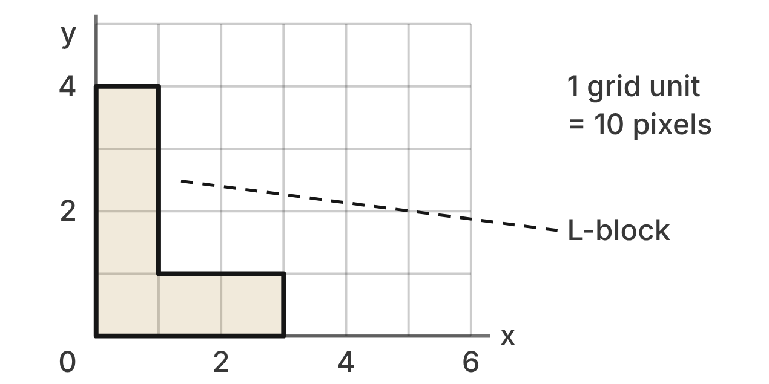
In a puzzle video game, the L-block has vertices (0, 0), (3, 0), (3, 1), (1, 1), (1, 4) and (0, 4). Its area is 6 square grid units and its perimeter is 14 grid units. On a phone, 1 grid unit is 10 pixels.
565. The game zooms in on the L-block with a scale factor of 3. What is the area of the zoomed block, in square grid units?
A. 18
B. 162
C. 54 ✔
D. 42
G.DF.2 · skill G.DF.2.2 (LOTS): Use the ratios k, k² and k³ of similar figures to find lengths, areas and volumes
☐ Answer key correct ☐ Wording clear Notes: ________________________________
566. A power-up doubles every x-coordinate of the block and keeps every y-coordinate. What is the new area, in square grid units?
A. 12 ✔
B. 6
C. 9
D. 24
G.DF.2 · skill G.DF.2.1 (LOTS): Describe how changing one or more dimensions of a figure changes its perimeter, area, surface area or volume
☐ Answer key correct ☐ Wording clear Notes: ________________________________
567. A power-up doubles every x-coordinate of the block and keeps every y-coordinate. Is the new block similar to the original?
A. Yes: its vertices are still on grid points.
B. No: widths double but heights stay the same. ✔
C. Yes: its area is exactly twice as much.
D. Yes: all its angles are still right angles.
G.DF.2 · skill G.DF.2.3 (HOTS): Decide whether two figures are similar and justify the decision with ratios of corresponding measures
☐ Answer key correct ☐ Wording clear Notes: ________________________________
568. A giant block is similar to the L-block and has an area of 150 square grid units. How tall is it, in grid units?
A. 100
B. 25
C. about 12.2
D. 20 ✔
G.DF.2 · skill G.DF.2.2 (LOTS): Use the ratios k, k² and k³ of similar figures to find lengths, areas and volumes
☐ Answer key correct ☐ Wording clear Notes: ________________________________
569. A block similar to the L-block has a perimeter of 49 grid units. Which expression gives its area, in square grid units?
A. 6 · (14/49)²
B. 6 · (49/14)³
C. 6 · (49/14)
D. 6 · (49/14)² ✔
G.DF.2 · skill G.DF.2.2 (LOTS): Use the ratios k, k² and k³ of similar figures to find lengths, areas and volumes
☐ Answer key correct ☐ Wording clear Notes: ________________________________
570. On a phone the block covers 600 square pixels, with 10 pixels per grid unit. On a tablet, 1 grid unit is 25 pixels. How many square pixels does the block cover on the tablet?
A. 150
B. 1,500
C. 3,750 ✔
D. 9,375
G.DF.2 · skill G.DF.2.2 (LOTS): Use the ratios k, k² and k³ of similar figures to find lengths, areas and volumes
☐ Answer key correct ☐ Wording clear Notes: ________________________________

The Hockey Puck
Level 3 · Changing dimensions · G.DF.2 · ID geo-df2-raid-hockey-puck
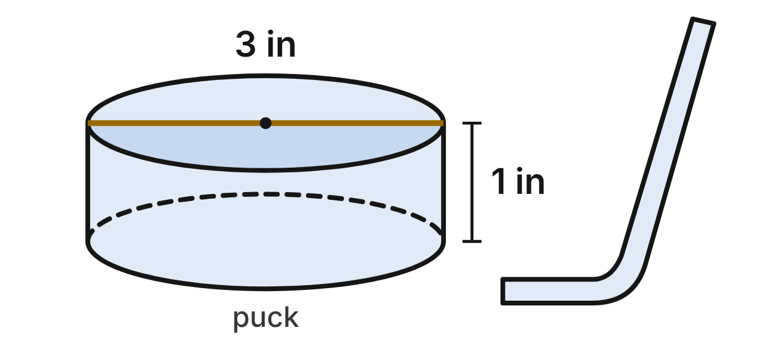
A hockey puck is a cylinder 3 in across (radius 1.5 in) and 1 in thick. Its volume is 2.25π in³, and its total surface area (top, bottom and side) is 7.5π in².
571. A giant fan puck is similar to this puck and is 36 in across. What is its volume?
A. 324π in³
B. 3,888π in³ ✔
C. 27π in³
D. 15,552π in³
G.DF.2 · skill G.DF.2.2 (LOTS): Use the ratios k, k² and k³ of similar figures to find lengths, areas and volumes
☐ Answer key correct ☐ Wording clear Notes: ________________________________
572. A giant fan puck similar to this puck is 36 in across. Its whole surface is painted, and one can of paint covers 1,000 in². How many cans are needed?
A. 1 can
B. 41 cans
C. 4 cans ✔
D. 3 cans
G.DF.2 · skill G.DF.2.2 (LOTS): Use the ratios k, k² and k³ of similar figures to find lengths, areas and volumes
☐ Answer key correct ☐ Wording clear Notes: ________________________________
573. A wide puck is 6 in across and still 1 in thick. What is its volume?
A. 9π in³ ✔
B. 36π in³
C. 18π in³
D. 4.5π in³
G.DF.2 · skill G.DF.2.1 (LOTS): Describe how changing one or more dimensions of a figure changes its perimeter, area, surface area or volume
☐ Answer key correct ☐ Wording clear Notes: ________________________________
574. A thick puck keeps the 3 in width but is 2 in thick. What is its total surface area?
A. 15π in²
B. 30π in²
C. 12π in²
D. 10.5π in² ✔
G.DF.2 · skill G.DF.2.1 (LOTS): Describe how changing one or more dimensions of a figure changes its perimeter, area, surface area or volume
☐ Answer key correct ☐ Wording clear Notes: ________________________________
575. A puck-shaped coaster is 4 in across and 1.5 in thick. Is it similar to the puck? Choose the answer with the correct reason.
A. Yes: both measures are larger.
B. No: it would have to be 1 in thick.
C. No: 4/3 ≠ 1.5/1. ✔
D. Yes: both are cylinders.
G.DF.2 · skill G.DF.2.3 (HOTS): Decide whether two figures are similar and justify the decision with ratios of corresponding measures
☐ Answer key correct ☐ Wording clear Notes: ________________________________
576. A youth puck is similar to this puck and holds 51.2% as much rubber. How far across is it?
A. 2.4 in ✔
B. about 2.15 in
C. 1.536 in
D. 1.92 in
G.DF.2 · skill G.DF.2.2 (LOTS): Use the ratios k, k² and k³ of similar figures to find lengths, areas and volumes
☐ Answer key correct ☐ Wording clear Notes: ________________________________

Answer key
Pack | Question | Standard | Skill | Level | Answer
rlt1-raid-kickflip | 1 | G.RLT.1 | G.RLT.1.1 LOTS | 1 | B
rlt1-raid-kickflip | 2 | G.RLT.1 | G.RLT.1.2 LOTS | 1 | A
rlt1-raid-kickflip | 3 | G.RLT.1 | G.RLT.1.2 LOTS | 1 | C
rlt1-raid-kickflip | 4 | G.RLT.1 | G.RLT.1.2 LOTS | 1 | D
rlt1-raid-kickflip | 5 | G.RLT.1 | G.RLT.1.1 LOTS | 1 | A
rlt1-raid-kickflip | 6 | G.RLT.1 | G.RLT.1.2 LOTS | 1 | D
rlt1-raid-archery | 7 | G.RLT.1 | G.RLT.1.4 LOTS | 1 | C
rlt1-raid-archery | 8 | G.RLT.1 | G.RLT.1.4 LOTS | 1 | B
rlt1-raid-archery | 9 | G.RLT.1 | G.RLT.1.4 LOTS | 1 | D
rlt1-raid-archery | 10 | G.RLT.1 | G.RLT.1.4 LOTS | 1 | A
rlt1-raid-archery | 11 | G.RLT.1 | G.RLT.1.2 LOTS | 1 | C
rlt1-raid-archery | 12 | G.RLT.1 | G.RLT.1.1 LOTS | 1 | B
rlt1-raid-rain-chain | 13 | G.RLT.1 | G.RLT.1.3 HOTS | 2 | D
rlt1-raid-rain-chain | 14 | G.RLT.1 | G.RLT.1.3 HOTS | 2 | B
rlt1-raid-rain-chain | 15 | G.RLT.1 | G.RLT.1.3 HOTS | 2 | C
rlt1-raid-rain-chain | 16 | G.RLT.1 | G.RLT.1.2 LOTS | 2 | A
rlt1-raid-rain-chain | 17 | G.RLT.1 | G.RLT.1.3 HOTS | 2 | B
rlt1-raid-rain-chain | 18 | G.RLT.1 | G.RLT.1.1 LOTS | 2 | D
rlt1-raid-gamers | 19 | G.RLT.1 | G.RLT.1.4 LOTS | 2 | C
rlt1-raid-gamers | 20 | G.RLT.1 | G.RLT.1.4 LOTS | 2 | A
rlt1-raid-gamers | 21 | G.RLT.1 | G.RLT.1.4 LOTS | 2 | D
rlt1-raid-gamers | 22 | G.RLT.1 | G.RLT.1.4 LOTS | 2 | B
rlt1-raid-gamers | 23 | G.RLT.1 | G.RLT.1.4 LOTS | 2 | A
rlt1-raid-gamers | 24 | G.RLT.1 | G.RLT.1.2 LOTS | 2 | C
rlt1-raid-swim | 25 | G.RLT.1 | G.RLT.1.1 LOTS | 2 | D
rlt1-raid-swim | 26 | G.RLT.1 | G.RLT.1.1 LOTS | 2 | C
rlt1-raid-swim | 27 | G.RLT.1 | G.RLT.1.2 LOTS | 2 | A
rlt1-raid-swim | 28 | G.RLT.1 | G.RLT.1.3 HOTS | 2 | D
rlt1-raid-swim | 29 | G.RLT.1 | G.RLT.1.3 HOTS | 2 | B
rlt1-raid-swim | 30 | G.RLT.1 | G.RLT.1.1 LOTS | 2 | A
rlt1-raid-bowling | 31 | G.RLT.1 | G.RLT.1.4 LOTS | 3 | B
rlt1-raid-bowling | 32 | G.RLT.1 | G.RLT.1.4 LOTS | 3 | D
rlt1-raid-bowling | 33 | G.RLT.1 | G.RLT.1.4 LOTS | 3 | A
rlt1-raid-bowling | 34 | G.RLT.1 | G.RLT.1.3 HOTS | 3 | C
rlt1-raid-bowling | 35 | G.RLT.1 | G.RLT.1.4 LOTS | 3 | D
rlt1-raid-bowling | 36 | G.RLT.1 | G.RLT.1.4 LOTS | 3 | B
rlt1-raid-dragon | 37 | G.RLT.1 | G.RLT.1.3 HOTS | 3 | C
rlt1-raid-dragon | 38 | G.RLT.1 | G.RLT.1.3 HOTS | 3 | A
rlt1-raid-dragon | 39 | G.RLT.1 | G.RLT.1.3 HOTS | 3 | D
rlt1-raid-dragon | 40 | G.RLT.1 | G.RLT.1.1 LOTS | 3 | B
rlt1-raid-dragon | 41 | G.RLT.1 | G.RLT.1.2 LOTS | 3 | C
rlt1-raid-dragon | 42 | G.RLT.1 | G.RLT.1.3 HOTS | 3 | A
rlt2-raid-pool-lanes | 43 | G.RLT.2 | G.RLT.2.1 LOTS | 1 | A
rlt2-raid-pool-lanes | 44 | G.RLT.2 | G.RLT.2.3 LOTS | 1 | C
rlt2-raid-pool-lanes | 45 | G.RLT.2 | G.RLT.2.1 LOTS | 1 | B
rlt2-raid-pool-lanes | 46 | G.RLT.2 | G.RLT.2.3 LOTS | 1 | D
rlt2-raid-pool-lanes | 47 | G.RLT.2 | G.RLT.2.1 LOTS | 1 | D
rlt2-raid-pool-lanes | 48 | G.RLT.2 | G.RLT.2.2 HOTS | 1 | C
rlt2-raid-bowling-boards | 49 | G.RLT.2 | G.RLT.2.1 LOTS | 1 | C
rlt2-raid-bowling-boards | 50 | G.RLT.2 | G.RLT.2.3 LOTS | 1 | D
rlt2-raid-bowling-boards | 51 | G.RLT.2 | G.RLT.2.1 LOTS | 1 | A
rlt2-raid-bowling-boards | 52 | G.RLT.2 | G.RLT.2.3 LOTS | 1 | B
rlt2-raid-bowling-boards | 53 | G.RLT.2 | G.RLT.2.1 LOTS | 1 | A
rlt2-raid-bowling-boards | 54 | G.RLT.2 | G.RLT.2.2 HOTS | 1 | C
rlt2-raid-skate-rails | 55 | G.RLT.2 | G.RLT.2.3 LOTS | 2 | B
rlt2-raid-skate-rails | 56 | G.RLT.2 | G.RLT.2.3 LOTS | 2 | A
rlt2-raid-skate-rails | 57 | G.RLT.2 | G.RLT.2.3 LOTS | 2 | D
rlt2-raid-skate-rails | 58 | G.RLT.2 | G.RLT.2.1 LOTS | 2 | C
rlt2-raid-skate-rails | 59 | G.RLT.2 | G.RLT.2.2 HOTS | 2 | B
rlt2-raid-skate-rails | 60 | G.RLT.2 | G.RLT.2.3 LOTS | 2 | D
rlt2-raid-bank-shot | 61 | G.RLT.2 | G.RLT.2.1 LOTS | 2 | D
rlt2-raid-bank-shot | 62 | G.RLT.2 | G.RLT.2.3 LOTS | 2 | C
rlt2-raid-bank-shot | 63 | G.RLT.2 | G.RLT.2.3 LOTS | 2 | B
rlt2-raid-bank-shot | 64 | G.RLT.2 | G.RLT.2.2 HOTS | 2 | A
rlt2-raid-bank-shot | 65 | G.RLT.2 | G.RLT.2.3 LOTS | 2 | C
rlt2-raid-bank-shot | 66 | G.RLT.2 | G.RLT.2.1 LOTS | 2 | A
rlt2-raid-tennis-lines | 67 | G.RLT.2 | G.RLT.2.3 LOTS | 2 | A
rlt2-raid-tennis-lines | 68 | G.RLT.2 | G.RLT.2.3 LOTS | 2 | B
rlt2-raid-tennis-lines | 69 | G.RLT.2 | G.RLT.2.1 LOTS | 2 | C
rlt2-raid-tennis-lines | 70 | G.RLT.2 | G.RLT.2.3 LOTS | 2 | D
rlt2-raid-tennis-lines | 71 | G.RLT.2 | G.RLT.2.2 HOTS | 2 | B
rlt2-raid-tennis-lines | 72 | G.RLT.2 | G.RLT.2.1 LOTS | 2 | D
rlt2-raid-laser-puzzle | 73 | G.RLT.2 | G.RLT.2.2 HOTS | 3 | C
rlt2-raid-laser-puzzle | 74 | G.RLT.2 | G.RLT.2.2 HOTS | 3 | A
rlt2-raid-laser-puzzle | 75 | G.RLT.2 | G.RLT.2.2 HOTS | 3 | B
rlt2-raid-laser-puzzle | 76 | G.RLT.2 | G.RLT.2.3 LOTS | 3 | D
rlt2-raid-laser-puzzle | 77 | G.RLT.2 | G.RLT.2.2 HOTS | 3 | D
rlt2-raid-laser-puzzle | 78 | G.RLT.2 | G.RLT.2.3 LOTS | 3 | B
rlt2-raid-mini-golf | 79 | G.RLT.2 | G.RLT.2.3 LOTS | 3 | D
rlt2-raid-mini-golf | 80 | G.RLT.2 | G.RLT.2.1 LOTS | 3 | C
rlt2-raid-mini-golf | 81 | G.RLT.2 | G.RLT.2.3 LOTS | 3 | A
rlt2-raid-mini-golf | 82 | G.RLT.2 | G.RLT.2.2 HOTS | 3 | B
rlt2-raid-mini-golf | 83 | G.RLT.2 | G.RLT.2.2 HOTS | 3 | A
rlt2-raid-mini-golf | 84 | G.RLT.2 | G.RLT.2.3 LOTS | 3 | C
rlt3-raid-game-tile | 85 | G.RLT.3 | G.RLT.3.2 LOTS | 1 | B
rlt3-raid-game-tile | 86 | G.RLT.3 | G.RLT.3.2 LOTS | 1 | A
rlt3-raid-game-tile | 87 | G.RLT.3 | G.RLT.3.2 LOTS | 1 | D
rlt3-raid-game-tile | 88 | G.RLT.3 | G.RLT.3.3 HOTS | 1 | C
rlt3-raid-game-tile | 89 | G.RLT.3 | G.RLT.3.1 LOTS | 1 | A
rlt3-raid-game-tile | 90 | G.RLT.3 | G.RLT.3.3 HOTS | 1 | B
rlt3-raid-sport-shapes | 91 | G.RLT.3 | G.RLT.3.1 LOTS | 1 | C
rlt3-raid-sport-shapes | 92 | G.RLT.3 | G.RLT.3.1 LOTS | 1 | D
rlt3-raid-sport-shapes | 93 | G.RLT.3 | G.RLT.3.1 LOTS | 1 | B
rlt3-raid-sport-shapes | 94 | G.RLT.3 | G.RLT.3.1 LOTS | 1 | A
rlt3-raid-sport-shapes | 95 | G.RLT.3 | G.RLT.3.1 LOTS | 1 | D
rlt3-raid-sport-shapes | 96 | G.RLT.3 | G.RLT.3.3 HOTS | 1 | C
rlt3-raid-skate-ramp | 97 | G.RLT.3 | G.RLT.3.2 LOTS | 2 | D
rlt3-raid-skate-ramp | 98 | G.RLT.3 | G.RLT.3.2 LOTS | 2 | C
rlt3-raid-skate-ramp | 99 | G.RLT.3 | G.RLT.3.2 LOTS | 2 | A
rlt3-raid-skate-ramp | 100 | G.RLT.3 | G.RLT.3.3 HOTS | 2 | B
rlt3-raid-skate-ramp | 101 | G.RLT.3 | G.RLT.3.3 HOTS | 2 | C
rlt3-raid-skate-ramp | 102 | G.RLT.3 | G.RLT.3.2 LOTS | 2 | A
rlt3-raid-home-plate | 103 | G.RLT.3 | G.RLT.3.2 LOTS | 2 | A
rlt3-raid-home-plate | 104 | G.RLT.3 | G.RLT.3.3 HOTS | 2 | B
rlt3-raid-home-plate | 105 | G.RLT.3 | G.RLT.3.2 LOTS | 2 | D
rlt3-raid-home-plate | 106 | G.RLT.3 | G.RLT.3.2 LOTS | 2 | C
rlt3-raid-home-plate | 107 | G.RLT.3 | G.RLT.3.1 LOTS | 2 | D
rlt3-raid-home-plate | 108 | G.RLT.3 | G.RLT.3.3 HOTS | 2 | B
rlt3-raid-block-game | 109 | G.RLT.3 | G.RLT.3.2 LOTS | 2 | C
rlt3-raid-block-game | 110 | G.RLT.3 | G.RLT.3.2 LOTS | 2 | A
rlt3-raid-block-game | 111 | G.RLT.3 | G.RLT.3.3 HOTS | 2 | B
rlt3-raid-block-game | 112 | G.RLT.3 | G.RLT.3.3 HOTS | 2 | D
rlt3-raid-block-game | 113 | G.RLT.3 | G.RLT.3.2 LOTS | 2 | A
rlt3-raid-block-game | 114 | G.RLT.3 | G.RLT.3.1 LOTS | 2 | C
rlt3-raid-kickboard | 115 | G.RLT.3 | G.RLT.3.2 LOTS | 2 | B
rlt3-raid-kickboard | 116 | G.RLT.3 | G.RLT.3.2 LOTS | 2 | D
rlt3-raid-kickboard | 117 | G.RLT.3 | G.RLT.3.3 HOTS | 2 | C
rlt3-raid-kickboard | 118 | G.RLT.3 | G.RLT.3.3 HOTS | 2 | A
rlt3-raid-kickboard | 119 | G.RLT.3 | G.RLT.3.1 LOTS | 2 | C
rlt3-raid-kickboard | 120 | G.RLT.3 | G.RLT.3.3 HOTS | 2 | D
rlt3-raid-archery | 121 | G.RLT.3 | G.RLT.3.3 HOTS | 3 | A
rlt3-raid-archery | 122 | G.RLT.3 | G.RLT.3.3 HOTS | 3 | C
rlt3-raid-archery | 123 | G.RLT.3 | G.RLT.3.2 LOTS | 3 | D
rlt3-raid-archery | 124 | G.RLT.3 | G.RLT.3.2 LOTS | 3 | B
rlt3-raid-archery | 125 | G.RLT.3 | G.RLT.3.3 HOTS | 3 | B
rlt3-raid-archery | 126 | G.RLT.3 | G.RLT.3.2 LOTS | 3 | A
rlt3-raid-esports-logo | 127 | G.RLT.3 | G.RLT.3.1 LOTS | 3 | D
rlt3-raid-esports-logo | 128 | G.RLT.3 | G.RLT.3.1 LOTS | 3 | B
rlt3-raid-esports-logo | 129 | G.RLT.3 | G.RLT.3.3 HOTS | 3 | A
rlt3-raid-esports-logo | 130 | G.RLT.3 | G.RLT.3.2 LOTS | 3 | C
rlt3-raid-esports-logo | 131 | G.RLT.3 | G.RLT.3.3 HOTS | 3 | D
rlt3-raid-esports-logo | 132 | G.RLT.3 | G.RLT.3.2 LOTS | 3 | B
tr1-raid-corner-kick | 133 | G.TR.1 | G.TR.1.1 LOTS | 1 | B
tr1-raid-corner-kick | 134 | G.TR.1 | G.TR.1.1 LOTS | 1 | D
tr1-raid-corner-kick | 135 | G.TR.1 | G.TR.1.3 LOTS | 1 | A
tr1-raid-corner-kick | 136 | G.TR.1 | G.TR.1.3 LOTS | 1 | C
tr1-raid-corner-kick | 137 | G.TR.1 | G.TR.1.2 LOTS | 1 | D
tr1-raid-corner-kick | 138 | G.TR.1 | G.TR.1.2 LOTS | 1 | B
tr1-raid-pin-rack | 139 | G.TR.1 | G.TR.1.3 LOTS | 1 | C
tr1-raid-pin-rack | 140 | G.TR.1 | G.TR.1.3 LOTS | 1 | A
tr1-raid-pin-rack | 141 | G.TR.1 | G.TR.1.1 LOTS | 1 | B
tr1-raid-pin-rack | 142 | G.TR.1 | G.TR.1.3 LOTS | 1 | D
tr1-raid-pin-rack | 143 | G.TR.1 | G.TR.1.3 LOTS | 1 | B
tr1-raid-pin-rack | 144 | G.TR.1 | G.TR.1.2 LOTS | 1 | C
tr1-raid-pump-track | 145 | G.TR.1 | G.TR.1.2 LOTS | 2 | B
tr1-raid-pump-track | 146 | G.TR.1 | G.TR.1.2 LOTS | 2 | A
tr1-raid-pump-track | 147 | G.TR.1 | G.TR.1.1 LOTS | 2 | C
tr1-raid-pump-track | 148 | G.TR.1 | G.TR.1.1 LOTS | 2 | D
tr1-raid-pump-track | 149 | G.TR.1 | G.TR.1.2 LOTS | 2 | A
tr1-raid-pump-track | 150 | G.TR.1 | G.TR.1.3 LOTS | 2 | C
tr1-raid-game-map | 151 | G.TR.1 | G.TR.1.3 LOTS | 2 | B
tr1-raid-game-map | 152 | G.TR.1 | G.TR.1.3 LOTS | 2 | A
tr1-raid-game-map | 153 | G.TR.1 | G.TR.1.1 LOTS | 2 | C
tr1-raid-game-map | 154 | G.TR.1 | G.TR.1.3 LOTS | 2 | D
tr1-raid-game-map | 155 | G.TR.1 | G.TR.1.2 LOTS | 2 | D
tr1-raid-game-map | 156 | G.TR.1 | G.TR.1.1 LOTS | 2 | B
tr1-raid-swim-course | 157 | G.TR.1 | G.TR.1.1 LOTS | 2 | A
tr1-raid-swim-course | 158 | G.TR.1 | G.TR.1.2 LOTS | 2 | C
tr1-raid-swim-course | 159 | G.TR.1 | G.TR.1.2 LOTS | 2 | D
tr1-raid-swim-course | 160 | G.TR.1 | G.TR.1.3 LOTS | 2 | B
tr1-raid-swim-course | 161 | G.TR.1 | G.TR.1.3 LOTS | 2 | C
tr1-raid-swim-course | 162 | G.TR.1 | G.TR.1.1 LOTS | 2 | A
tr1-raid-pitchers-mound | 163 | G.TR.1 | G.TR.1.3 LOTS | 3 | D
tr1-raid-pitchers-mound | 164 | G.TR.1 | G.TR.1.1 LOTS | 3 | B
tr1-raid-pitchers-mound | 165 | G.TR.1 | G.TR.1.2 LOTS | 3 | C
tr1-raid-pitchers-mound | 166 | G.TR.1 | G.TR.1.1 LOTS | 3 | A
tr1-raid-pitchers-mound | 167 | G.TR.1 | G.TR.1.3 LOTS | 3 | D
tr1-raid-pitchers-mound | 168 | G.TR.1 | G.TR.1.1 LOTS | 3 | C
tr1-raid-pass-drill | 169 | G.TR.1 | G.TR.1.3 LOTS | 3 | A
tr1-raid-pass-drill | 170 | G.TR.1 | G.TR.1.3 LOTS | 3 | D
tr1-raid-pass-drill | 171 | G.TR.1 | G.TR.1.3 LOTS | 3 | B
tr1-raid-pass-drill | 172 | G.TR.1 | G.TR.1.1 LOTS | 3 | C
tr1-raid-pass-drill | 173 | G.TR.1 | G.TR.1.1 LOTS | 3 | D
tr1-raid-pass-drill | 174 | G.TR.1 | G.TR.1.2 LOTS | 3 | B
tr2-raid-climbing-hold | 175 | G.TR.2 | G.TR.2.1 LOTS | 1 | A
tr2-raid-climbing-hold | 176 | G.TR.2 | G.TR.2.2 HOTS | 1 | C
tr2-raid-climbing-hold | 177 | G.TR.2 | G.TR.2.3 LOTS | 1 | B
tr2-raid-climbing-hold | 178 | G.TR.2 | G.TR.2.3 LOTS | 1 | D
tr2-raid-climbing-hold | 179 | G.TR.2 | G.TR.2.3 LOTS | 1 | B
tr2-raid-climbing-hold | 180 | G.TR.2 | G.TR.2.1 LOTS | 1 | C
tr2-raid-skate-ramps | 181 | G.TR.2 | G.TR.2.1 LOTS | 1 | C
tr2-raid-skate-ramps | 182 | G.TR.2 | G.TR.2.1 LOTS | 1 | A
tr2-raid-skate-ramps | 183 | G.TR.2 | G.TR.2.3 LOTS | 1 | D
tr2-raid-skate-ramps | 184 | G.TR.2 | G.TR.2.1 LOTS | 1 | B
tr2-raid-skate-ramps | 185 | G.TR.2 | G.TR.2.3 LOTS | 1 | D
tr2-raid-skate-ramps | 186 | G.TR.2 | G.TR.2.2 HOTS | 1 | A
tr2-raid-archery-easel | 187 | G.TR.2 | G.TR.2.2 HOTS | 2 | B
tr2-raid-archery-easel | 188 | G.TR.2 | G.TR.2.2 HOTS | 2 | D
tr2-raid-archery-easel | 189 | G.TR.2 | G.TR.2.3 LOTS | 2 | C
tr2-raid-archery-easel | 190 | G.TR.2 | G.TR.2.3 LOTS | 2 | A
tr2-raid-archery-easel | 191 | G.TR.2 | G.TR.2.1 LOTS | 2 | C
tr2-raid-archery-easel | 192 | G.TR.2 | G.TR.2.1 LOTS | 2 | B
tr2-raid-game-map | 193 | G.TR.2 | G.TR.2.3 LOTS | 2 | D
tr2-raid-game-map | 194 | G.TR.2 | G.TR.2.1 LOTS | 2 | B
tr2-raid-game-map | 195 | G.TR.2 | G.TR.2.3 LOTS | 2 | A
tr2-raid-game-map | 196 | G.TR.2 | G.TR.2.3 LOTS | 2 | C
tr2-raid-game-map | 197 | G.TR.2 | G.TR.2.1 LOTS | 2 | A
tr2-raid-game-map | 198 | G.TR.2 | G.TR.2.2 HOTS | 2 | D
tr2-raid-tennis-court | 199 | G.TR.2 | G.TR.2.2 HOTS | 2 | A
tr2-raid-tennis-court | 200 | G.TR.2 | G.TR.2.2 HOTS | 2 | C
tr2-raid-tennis-court | 201 | G.TR.2 | G.TR.2.2 HOTS | 2 | D
tr2-raid-tennis-court | 202 | G.TR.2 | G.TR.2.3 LOTS | 2 | B
tr2-raid-tennis-court | 203 | G.TR.2 | G.TR.2.1 LOTS | 2 | D
tr2-raid-tennis-court | 204 | G.TR.2 | G.TR.2.3 LOTS | 2 | C
tr2-raid-lifeguard | 205 | G.TR.2 | G.TR.2.2 HOTS | 3 | C
tr2-raid-lifeguard | 206 | G.TR.2 | G.TR.2.2 HOTS | 3 | A
tr2-raid-lifeguard | 207 | G.TR.2 | G.TR.2.2 HOTS | 3 | B
tr2-raid-lifeguard | 208 | G.TR.2 | G.TR.2.3 LOTS | 3 | D
tr2-raid-lifeguard | 209 | G.TR.2 | G.TR.2.1 LOTS | 3 | B
tr2-raid-lifeguard | 210 | G.TR.2 | G.TR.2.3 LOTS | 3 | A
tr2-raid-game-board | 211 | G.TR.2 | G.TR.2.2 HOTS | 3 | B
tr2-raid-game-board | 212 | G.TR.2 | G.TR.2.2 HOTS | 3 | D
tr2-raid-game-board | 213 | G.TR.2 | G.TR.2.3 LOTS | 3 | C
tr2-raid-game-board | 214 | G.TR.2 | G.TR.2.3 LOTS | 3 | A
tr2-raid-game-board | 215 | G.TR.2 | G.TR.2.3 LOTS | 3 | A
tr2-raid-game-board | 216 | G.TR.2 | G.TR.2.1 LOTS | 3 | C
tr3-raid-pennants | 217 | G.TR.3 | G.TR.3.1 LOTS | 1 | A
tr3-raid-pennants | 218 | G.TR.3 | G.TR.3.2 HOTS | 1 | D
tr3-raid-pennants | 219 | G.TR.3 | G.TR.3.1 LOTS | 1 | C
tr3-raid-pennants | 220 | G.TR.3 | G.TR.3.3 LOTS | 1 | B
tr3-raid-pennants | 221 | G.TR.3 | G.TR.3.3 LOTS | 1 | D
tr3-raid-pennants | 222 | G.TR.3 | G.TR.3.3 LOTS | 1 | A
tr3-raid-game-zones | 223 | G.TR.3 | G.TR.3.1 LOTS | 1 | C
tr3-raid-game-zones | 224 | G.TR.3 | G.TR.3.1 LOTS | 1 | B
tr3-raid-game-zones | 225 | G.TR.3 | G.TR.3.3 LOTS | 1 | D
tr3-raid-game-zones | 226 | G.TR.3 | G.TR.3.3 LOTS | 1 | A
tr3-raid-game-zones | 227 | G.TR.3 | G.TR.3.2 HOTS | 1 | B
tr3-raid-game-zones | 228 | G.TR.3 | G.TR.3.3 LOTS | 1 | C
tr3-raid-court-shadow | 229 | G.TR.3 | G.TR.3.1 LOTS | 2 | B
tr3-raid-court-shadow | 230 | G.TR.3 | G.TR.3.3 LOTS | 2 | A
tr3-raid-court-shadow | 231 | G.TR.3 | G.TR.3.1 LOTS | 2 | C
tr3-raid-court-shadow | 232 | G.TR.3 | G.TR.3.3 LOTS | 2 | D
tr3-raid-court-shadow | 233 | G.TR.3 | G.TR.3.2 HOTS | 2 | A
tr3-raid-court-shadow | 234 | G.TR.3 | G.TR.3.3 LOTS | 2 | B
tr3-raid-climbing-wall | 235 | G.TR.3 | G.TR.3.1 LOTS | 2 | D
tr3-raid-climbing-wall | 236 | G.TR.3 | G.TR.3.3 LOTS | 2 | C
tr3-raid-climbing-wall | 237 | G.TR.3 | G.TR.3.3 LOTS | 2 | B
tr3-raid-climbing-wall | 238 | G.TR.3 | G.TR.3.1 LOTS | 2 | A
tr3-raid-climbing-wall | 239 | G.TR.3 | G.TR.3.2 HOTS | 2 | C
tr3-raid-climbing-wall | 240 | G.TR.3 | G.TR.3.3 LOTS | 2 | D
tr3-raid-skate-ramps | 241 | G.TR.3 | G.TR.3.2 HOTS | 2 | C
tr3-raid-skate-ramps | 242 | G.TR.3 | G.TR.3.1 LOTS | 2 | A
tr3-raid-skate-ramps | 243 | G.TR.3 | G.TR.3.2 HOTS | 2 | B
tr3-raid-skate-ramps | 244 | G.TR.3 | G.TR.3.3 LOTS | 2 | C
tr3-raid-skate-ramps | 245 | G.TR.3 | G.TR.3.3 LOTS | 2 | D
tr3-raid-skate-ramps | 246 | G.TR.3 | G.TR.3.3 LOTS | 2 | A
tr3-raid-target-stand | 247 | G.TR.3 | G.TR.3.1 LOTS | 2 | B
tr3-raid-target-stand | 248 | G.TR.3 | G.TR.3.1 LOTS | 2 | D
tr3-raid-target-stand | 249 | G.TR.3 | G.TR.3.3 LOTS | 2 | A
tr3-raid-target-stand | 250 | G.TR.3 | G.TR.3.3 LOTS | 2 | D
tr3-raid-target-stand | 251 | G.TR.3 | G.TR.3.2 HOTS | 2 | C
tr3-raid-target-stand | 252 | G.TR.3 | G.TR.3.3 LOTS | 2 | B
tr3-raid-cone-drill | 253 | G.TR.3 | G.TR.3.1 LOTS | 3 | D
tr3-raid-cone-drill | 254 | G.TR.3 | G.TR.3.1 LOTS | 3 | A
tr3-raid-cone-drill | 255 | G.TR.3 | G.TR.3.3 LOTS | 3 | C
tr3-raid-cone-drill | 256 | G.TR.3 | G.TR.3.3 LOTS | 3 | B
tr3-raid-cone-drill | 257 | G.TR.3 | G.TR.3.2 HOTS | 3 | A
tr3-raid-cone-drill | 258 | G.TR.3 | G.TR.3.3 LOTS | 3 | D
tr3-raid-orienteering | 259 | G.TR.3 | G.TR.3.1 LOTS | 3 | A
tr3-raid-orienteering | 260 | G.TR.3 | G.TR.3.1 LOTS | 3 | C
tr3-raid-orienteering | 261 | G.TR.3 | G.TR.3.2 HOTS | 3 | B
tr3-raid-orienteering | 262 | G.TR.3 | G.TR.3.2 HOTS | 3 | D
tr3-raid-orienteering | 263 | G.TR.3 | G.TR.3.3 LOTS | 3 | B
tr3-raid-orienteering | 264 | G.TR.3 | G.TR.3.3 LOTS | 3 | C
tr4-raid-softball | 265 | G.TR.4 | G.TR.4.2 LOTS | 1 | D
tr4-raid-softball | 266 | G.TR.4 | G.TR.4.2 LOTS | 1 | A
tr4-raid-softball | 267 | G.TR.4 | G.TR.4.2 LOTS | 1 | C
tr4-raid-softball | 268 | G.TR.4 | G.TR.4.3 LOTS | 1 | B
tr4-raid-softball | 269 | G.TR.4 | G.TR.4.1 LOTS | 1 | A
tr4-raid-softball | 270 | G.TR.4 | G.TR.4.4 HOTS | 1 | D
tr4-raid-game-map | 271 | G.TR.4 | G.TR.4.1 LOTS | 1 | C
tr4-raid-game-map | 272 | G.TR.4 | G.TR.4.3 LOTS | 1 | B
tr4-raid-game-map | 273 | G.TR.4 | G.TR.4.3 LOTS | 1 | D
tr4-raid-game-map | 274 | G.TR.4 | G.TR.4.1 LOTS | 1 | A
tr4-raid-game-map | 275 | G.TR.4 | G.TR.4.2 LOTS | 1 | C
tr4-raid-game-map | 276 | G.TR.4 | G.TR.4.1 LOTS | 1 | B
tr4-raid-pool | 277 | G.TR.4 | G.TR.4.1 LOTS | 2 | A
tr4-raid-pool | 278 | G.TR.4 | G.TR.4.3 LOTS | 2 | B
tr4-raid-pool | 279 | G.TR.4 | G.TR.4.1 LOTS | 2 | D
tr4-raid-pool | 280 | G.TR.4 | G.TR.4.4 HOTS | 2 | B
tr4-raid-pool | 281 | G.TR.4 | G.TR.4.4 HOTS | 2 | C
tr4-raid-pool | 282 | G.TR.4 | G.TR.4.2 LOTS | 2 | A
tr4-raid-tennis | 283 | G.TR.4 | G.TR.4.4 HOTS | 2 | D
tr4-raid-tennis | 284 | G.TR.4 | G.TR.4.1 LOTS | 2 | C
tr4-raid-tennis | 285 | G.TR.4 | G.TR.4.4 HOTS | 2 | A
tr4-raid-tennis | 286 | G.TR.4 | G.TR.4.3 LOTS | 2 | D
tr4-raid-tennis | 287 | G.TR.4 | G.TR.4.2 LOTS | 2 | B
tr4-raid-tennis | 288 | G.TR.4 | G.TR.4.3 LOTS | 2 | C
tr4-raid-archery | 289 | G.TR.4 | G.TR.4.1 LOTS | 2 | C
tr4-raid-archery | 290 | G.TR.4 | G.TR.4.3 LOTS | 2 | A
tr4-raid-archery | 291 | G.TR.4 | G.TR.4.2 LOTS | 2 | D
tr4-raid-archery | 292 | G.TR.4 | G.TR.4.4 HOTS | 2 | C
tr4-raid-archery | 293 | G.TR.4 | G.TR.4.4 HOTS | 2 | B
tr4-raid-archery | 294 | G.TR.4 | G.TR.4.3 LOTS | 2 | A
tr4-raid-hoop | 295 | G.TR.4 | G.TR.4.4 HOTS | 2 | B
tr4-raid-hoop | 296 | G.TR.4 | G.TR.4.1 LOTS | 2 | D
tr4-raid-hoop | 297 | G.TR.4 | G.TR.4.1 LOTS | 2 | C
tr4-raid-hoop | 298 | G.TR.4 | G.TR.4.3 LOTS | 2 | A
tr4-raid-hoop | 299 | G.TR.4 | G.TR.4.2 LOTS | 2 | D
tr4-raid-hoop | 300 | G.TR.4 | G.TR.4.4 HOTS | 2 | B
tr4-raid-soccer | 301 | G.TR.4 | G.TR.4.3 LOTS | 3 | A
tr4-raid-soccer | 302 | G.TR.4 | G.TR.4.1 LOTS | 3 | D
tr4-raid-soccer | 303 | G.TR.4 | G.TR.4.4 HOTS | 3 | B
tr4-raid-soccer | 304 | G.TR.4 | G.TR.4.4 HOTS | 3 | C
tr4-raid-soccer | 305 | G.TR.4 | G.TR.4.2 LOTS | 3 | D
tr4-raid-soccer | 306 | G.TR.4 | G.TR.4.4 HOTS | 3 | A
tr4-raid-climbing | 307 | G.TR.4 | G.TR.4.4 HOTS | 3 | C
tr4-raid-climbing | 308 | G.TR.4 | G.TR.4.4 HOTS | 3 | B
tr4-raid-climbing | 309 | G.TR.4 | G.TR.4.3 LOTS | 3 | A
tr4-raid-climbing | 310 | G.TR.4 | G.TR.4.1 LOTS | 3 | D
tr4-raid-climbing | 311 | G.TR.4 | G.TR.4.2 LOTS | 3 | B
tr4-raid-climbing | 312 | G.TR.4 | G.TR.4.4 HOTS | 3 | C
pc1-raid-diamond | 313 | G.PC.1 | G.PC.1.1 LOTS | 1 | A
pc1-raid-diamond | 314 | G.PC.1 | G.PC.1.3 LOTS | 1 | C
pc1-raid-diamond | 315 | G.PC.1 | G.PC.1.1 LOTS | 1 | B
pc1-raid-diamond | 316 | G.PC.1 | G.PC.1.1 LOTS | 1 | D
pc1-raid-diamond | 317 | G.PC.1 | G.PC.1.3 LOTS | 1 | D
pc1-raid-diamond | 318 | G.PC.1 | G.PC.1.1 LOTS | 1 | A
pc1-raid-funbox | 319 | G.PC.1 | G.PC.1.3 LOTS | 1 | B
pc1-raid-funbox | 320 | G.PC.1 | G.PC.1.1 LOTS | 1 | D
pc1-raid-funbox | 321 | G.PC.1 | G.PC.1.1 LOTS | 1 | C
pc1-raid-funbox | 322 | G.PC.1 | G.PC.1.3 LOTS | 1 | A
pc1-raid-funbox | 323 | G.PC.1 | G.PC.1.3 LOTS | 1 | A
pc1-raid-funbox | 324 | G.PC.1 | G.PC.1.1 LOTS | 1 | C
pc1-raid-game-tile | 325 | G.PC.1 | G.PC.1.3 LOTS | 2 | D
pc1-raid-game-tile | 326 | G.PC.1 | G.PC.1.3 LOTS | 2 | A
pc1-raid-game-tile | 327 | G.PC.1 | G.PC.1.1 LOTS | 2 | B
pc1-raid-game-tile | 328 | G.PC.1 | G.PC.1.1 LOTS | 2 | C
pc1-raid-game-tile | 329 | G.PC.1 | G.PC.1.1 LOTS | 2 | B
pc1-raid-game-tile | 330 | G.PC.1 | G.PC.1.1 LOTS | 2 | D
pc1-raid-shield | 331 | G.PC.1 | G.PC.1.2 HOTS | 2 | C
pc1-raid-shield | 332 | G.PC.1 | G.PC.1.2 HOTS | 2 | B
pc1-raid-shield | 333 | G.PC.1 | G.PC.1.2 HOTS | 2 | A
pc1-raid-shield | 334 | G.PC.1 | G.PC.1.2 HOTS | 2 | D
pc1-raid-shield | 335 | G.PC.1 | G.PC.1.1 LOTS | 2 | C
pc1-raid-shield | 336 | G.PC.1 | G.PC.1.2 HOTS | 2 | A
pc1-raid-lap-pool | 337 | G.PC.1 | G.PC.1.3 LOTS | 2 | A
pc1-raid-lap-pool | 338 | G.PC.1 | G.PC.1.1 LOTS | 2 | D
pc1-raid-lap-pool | 339 | G.PC.1 | G.PC.1.1 LOTS | 2 | B
pc1-raid-lap-pool | 340 | G.PC.1 | G.PC.1.3 LOTS | 2 | C
pc1-raid-lap-pool | 341 | G.PC.1 | G.PC.1.3 LOTS | 2 | D
pc1-raid-lap-pool | 342 | G.PC.1 | G.PC.1.1 LOTS | 2 | B
pc1-raid-archery | 343 | G.PC.1 | G.PC.1.2 HOTS | 3 | B
pc1-raid-archery | 344 | G.PC.1 | G.PC.1.2 HOTS | 3 | C
pc1-raid-archery | 345 | G.PC.1 | G.PC.1.2 HOTS | 3 | D
pc1-raid-archery | 346 | G.PC.1 | G.PC.1.2 HOTS | 3 | A
pc1-raid-archery | 347 | G.PC.1 | G.PC.1.3 LOTS | 3 | A
pc1-raid-archery | 348 | G.PC.1 | G.PC.1.1 LOTS | 3 | B
pc1-raid-tangram | 349 | G.PC.1 | G.PC.1.3 LOTS | 3 | D
pc1-raid-tangram | 350 | G.PC.1 | G.PC.1.3 LOTS | 3 | A
pc1-raid-tangram | 351 | G.PC.1 | G.PC.1.3 LOTS | 3 | C
pc1-raid-tangram | 352 | G.PC.1 | G.PC.1.3 LOTS | 3 | B
pc1-raid-tangram | 353 | G.PC.1 | G.PC.1.1 LOTS | 3 | C
pc1-raid-tangram | 354 | G.PC.1 | G.PC.1.1 LOTS | 3 | D
pc2-raid-home-plate | 355 | G.PC.2 | G.PC.2.1 LOTS | 1 | A
pc2-raid-home-plate | 356 | G.PC.2 | G.PC.2.1 LOTS | 1 | C
pc2-raid-home-plate | 357 | G.PC.2 | G.PC.2.1 LOTS | 1 | D
pc2-raid-home-plate | 358 | G.PC.2 | G.PC.2.1 LOTS | 1 | B
pc2-raid-home-plate | 359 | G.PC.2 | G.PC.2.1 LOTS | 1 | C
pc2-raid-home-plate | 360 | G.PC.2 | G.PC.2.2 LOTS | 1 | A
pc2-raid-spinner | 361 | G.PC.2 | G.PC.2.1 LOTS | 1 | D
pc2-raid-spinner | 362 | G.PC.2 | G.PC.2.1 LOTS | 1 | B
pc2-raid-spinner | 363 | G.PC.2 | G.PC.2.1 LOTS | 1 | A
pc2-raid-spinner | 364 | G.PC.2 | G.PC.2.1 LOTS | 1 | C
pc2-raid-spinner | 365 | G.PC.2 | G.PC.2.1 LOTS | 1 | D
pc2-raid-spinner | 366 | G.PC.2 | G.PC.2.2 LOTS | 1 | B
pc2-raid-soccer-ball | 367 | G.PC.2 | G.PC.2.1 LOTS | 2 | B
pc2-raid-soccer-ball | 368 | G.PC.2 | G.PC.2.1 LOTS | 2 | D
pc2-raid-soccer-ball | 369 | G.PC.2 | G.PC.2.1 LOTS | 2 | C
pc2-raid-soccer-ball | 370 | G.PC.2 | G.PC.2.2 LOTS | 2 | A
pc2-raid-soccer-ball | 371 | G.PC.2 | G.PC.2.1 LOTS | 2 | A
pc2-raid-soccer-ball | 372 | G.PC.2 | G.PC.2.1 LOTS | 2 | C
pc2-raid-cone-course | 373 | G.PC.2 | G.PC.2.1 LOTS | 2 | C
pc2-raid-cone-course | 374 | G.PC.2 | G.PC.2.1 LOTS | 2 | A
pc2-raid-cone-course | 375 | G.PC.2 | G.PC.2.1 LOTS | 2 | D
pc2-raid-cone-course | 376 | G.PC.2 | G.PC.2.2 LOTS | 2 | B
pc2-raid-cone-course | 377 | G.PC.2 | G.PC.2.2 LOTS | 2 | B
pc2-raid-cone-course | 378 | G.PC.2 | G.PC.2.1 LOTS | 2 | D
pc2-raid-ballfield | 379 | G.PC.2 | G.PC.2.1 LOTS | 2 | A
pc2-raid-ballfield | 380 | G.PC.2 | G.PC.2.1 LOTS | 2 | C
pc2-raid-ballfield | 381 | G.PC.2 | G.PC.2.1 LOTS | 2 | B
pc2-raid-ballfield | 382 | G.PC.2 | G.PC.2.1 LOTS | 2 | D
pc2-raid-ballfield | 383 | G.PC.2 | G.PC.2.1 LOTS | 2 | C
pc2-raid-ballfield | 384 | G.PC.2 | G.PC.2.1 LOTS | 2 | A
pc2-raid-arena | 385 | G.PC.2 | G.PC.2.1 LOTS | 3 | D
pc2-raid-arena | 386 | G.PC.2 | G.PC.2.1 LOTS | 3 | A
pc2-raid-arena | 387 | G.PC.2 | G.PC.2.2 LOTS | 3 | B
pc2-raid-arena | 388 | G.PC.2 | G.PC.2.1 LOTS | 3 | C
pc2-raid-arena | 389 | G.PC.2 | G.PC.2.1 LOTS | 3 | B
pc2-raid-arena | 390 | G.PC.2 | G.PC.2.1 LOTS | 3 | D
pc2-raid-bike-loop | 391 | G.PC.2 | G.PC.2.1 LOTS | 3 | B
pc2-raid-bike-loop | 392 | G.PC.2 | G.PC.2.1 LOTS | 3 | D
pc2-raid-bike-loop | 393 | G.PC.2 | G.PC.2.1 LOTS | 3 | A
pc2-raid-bike-loop | 394 | G.PC.2 | G.PC.2.1 LOTS | 3 | C
pc2-raid-bike-loop | 395 | G.PC.2 | G.PC.2.1 LOTS | 3 | A
pc2-raid-bike-loop | 396 | G.PC.2 | G.PC.2.2 LOTS | 3 | C
pc3-raid-game-spinner | 397 | G.PC.3 | G.PC.3.3 LOTS | 1 | A
pc3-raid-game-spinner | 398 | G.PC.3 | G.PC.3.3 LOTS | 1 | D
pc3-raid-game-spinner | 399 | G.PC.3 | G.PC.3.1 LOTS | 1 | B
pc3-raid-game-spinner | 400 | G.PC.3 | G.PC.3.3 LOTS | 1 | A
pc3-raid-game-spinner | 401 | G.PC.3 | G.PC.3.3 LOTS | 1 | C
pc3-raid-game-spinner | 402 | G.PC.3 | G.PC.3.4 HOTS | 1 | D
pc3-raid-track-turn | 403 | G.PC.3 | G.PC.3.1 LOTS | 1 | C
pc3-raid-track-turn | 404 | G.PC.3 | G.PC.3.1 LOTS | 1 | B
pc3-raid-track-turn | 405 | G.PC.3 | G.PC.3.3 LOTS | 1 | D
pc3-raid-track-turn | 406 | G.PC.3 | G.PC.3.1 LOTS | 1 | A
pc3-raid-track-turn | 407 | G.PC.3 | G.PC.3.3 LOTS | 1 | C
pc3-raid-track-turn | 408 | G.PC.3 | G.PC.3.4 HOTS | 1 | B
pc3-raid-softball-fence | 409 | G.PC.3 | G.PC.3.3 LOTS | 2 | B
pc3-raid-softball-fence | 410 | G.PC.3 | G.PC.3.3 LOTS | 2 | D
pc3-raid-softball-fence | 411 | G.PC.3 | G.PC.3.1 LOTS | 2 | A
pc3-raid-softball-fence | 412 | G.PC.3 | G.PC.3.2 LOTS | 2 | B
pc3-raid-softball-fence | 413 | G.PC.3 | G.PC.3.3 LOTS | 2 | C
pc3-raid-softball-fence | 414 | G.PC.3 | G.PC.3.4 HOTS | 2 | A
pc3-raid-laser-shield | 415 | G.PC.3 | G.PC.3.2 LOTS | 2 | C
pc3-raid-laser-shield | 416 | G.PC.3 | G.PC.3.1 LOTS | 2 | A
pc3-raid-laser-shield | 417 | G.PC.3 | G.PC.3.1 LOTS | 2 | D
pc3-raid-laser-shield | 418 | G.PC.3 | G.PC.3.1 LOTS | 2 | C
pc3-raid-laser-shield | 419 | G.PC.3 | G.PC.3.4 HOTS | 2 | B
pc3-raid-laser-shield | 420 | G.PC.3 | G.PC.3.2 LOTS | 2 | D
pc3-raid-pool-ropes | 421 | G.PC.3 | G.PC.3.2 LOTS | 2 | A
pc3-raid-pool-ropes | 422 | G.PC.3 | G.PC.3.1 LOTS | 2 | C
pc3-raid-pool-ropes | 423 | G.PC.3 | G.PC.3.4 HOTS | 2 | D
pc3-raid-pool-ropes | 424 | G.PC.3 | G.PC.3.1 LOTS | 2 | C
pc3-raid-pool-ropes | 425 | G.PC.3 | G.PC.3.3 LOTS | 2 | B
pc3-raid-pool-ropes | 426 | G.PC.3 | G.PC.3.4 HOTS | 2 | A
pc3-raid-passing-drill | 427 | G.PC.3 | G.PC.3.1 LOTS | 2 | D
pc3-raid-passing-drill | 428 | G.PC.3 | G.PC.3.1 LOTS | 2 | B
pc3-raid-passing-drill | 429 | G.PC.3 | G.PC.3.3 LOTS | 2 | C
pc3-raid-passing-drill | 430 | G.PC.3 | G.PC.3.1 LOTS | 2 | A
pc3-raid-passing-drill | 431 | G.PC.3 | G.PC.3.3 LOTS | 2 | D
pc3-raid-passing-drill | 432 | G.PC.3 | G.PC.3.4 HOTS | 2 | B
pc3-raid-archery-target | 433 | G.PC.3 | G.PC.3.3 LOTS | 3 | D
pc3-raid-archery-target | 434 | G.PC.3 | G.PC.3.3 LOTS | 3 | A
pc3-raid-archery-target | 435 | G.PC.3 | G.PC.3.4 HOTS | 3 | C
pc3-raid-archery-target | 436 | G.PC.3 | G.PC.3.1 LOTS | 3 | B
pc3-raid-archery-target | 437 | G.PC.3 | G.PC.3.3 LOTS | 3 | A
pc3-raid-archery-target | 438 | G.PC.3 | G.PC.3.4 HOTS | 3 | D
pc3-raid-skate-bowl | 439 | G.PC.3 | G.PC.3.2 LOTS | 3 | B
pc3-raid-skate-bowl | 440 | G.PC.3 | G.PC.3.4 HOTS | 3 | C
pc3-raid-skate-bowl | 441 | G.PC.3 | G.PC.3.1 LOTS | 3 | A
pc3-raid-skate-bowl | 442 | G.PC.3 | G.PC.3.4 HOTS | 3 | D
pc3-raid-skate-bowl | 443 | G.PC.3 | G.PC.3.3 LOTS | 3 | C
pc3-raid-skate-bowl | 444 | G.PC.3 | G.PC.3.2 LOTS | 3 | B
pc4-raid-archery | 445 | G.PC.4 | G.PC.4.1 LOTS | 1 | C
pc4-raid-archery | 446 | G.PC.4 | G.PC.4.2 LOTS | 1 | A
pc4-raid-archery | 447 | G.PC.4 | G.PC.4.1 LOTS | 1 | D
pc4-raid-archery | 448 | G.PC.4 | G.PC.4.3 HOTS | 1 | B
pc4-raid-archery | 449 | G.PC.4 | G.PC.4.2 LOTS | 1 | D
pc4-raid-archery | 450 | G.PC.4 | G.PC.4.1 LOTS | 1 | A
pc4-raid-shield | 451 | G.PC.4 | G.PC.4.2 LOTS | 1 | A
pc4-raid-shield | 452 | G.PC.4 | G.PC.4.1 LOTS | 1 | B
pc4-raid-shield | 453 | G.PC.4 | G.PC.4.1 LOTS | 1 | D
pc4-raid-shield | 454 | G.PC.4 | G.PC.4.3 HOTS | 1 | C
pc4-raid-shield | 455 | G.PC.4 | G.PC.4.2 LOTS | 1 | A
pc4-raid-shield | 456 | G.PC.4 | G.PC.4.1 LOTS | 1 | C
pc4-raid-diving-pool | 457 | G.PC.4 | G.PC.4.2 LOTS | 2 | A
pc4-raid-diving-pool | 458 | G.PC.4 | G.PC.4.2 LOTS | 2 | C
pc4-raid-diving-pool | 459 | G.PC.4 | G.PC.4.1 LOTS | 2 | B
pc4-raid-diving-pool | 460 | G.PC.4 | G.PC.4.3 HOTS | 2 | D
pc4-raid-diving-pool | 461 | G.PC.4 | G.PC.4.1 LOTS | 2 | B
pc4-raid-diving-pool | 462 | G.PC.4 | G.PC.4.2 LOTS | 2 | D
pc4-raid-shot-put | 463 | G.PC.4 | G.PC.4.3 HOTS | 2 | B
pc4-raid-shot-put | 464 | G.PC.4 | G.PC.4.1 LOTS | 2 | D
pc4-raid-shot-put | 465 | G.PC.4 | G.PC.4.2 LOTS | 2 | A
pc4-raid-shot-put | 466 | G.PC.4 | G.PC.4.1 LOTS | 2 | C
pc4-raid-shot-put | 467 | G.PC.4 | G.PC.4.1 LOTS | 2 | C
pc4-raid-shot-put | 468 | G.PC.4 | G.PC.4.3 HOTS | 2 | A
pc4-raid-skate-bowls | 469 | G.PC.4 | G.PC.4.1 LOTS | 2 | C
pc4-raid-skate-bowls | 470 | G.PC.4 | G.PC.4.1 LOTS | 2 | A
pc4-raid-skate-bowls | 471 | G.PC.4 | G.PC.4.3 HOTS | 2 | D
pc4-raid-skate-bowls | 472 | G.PC.4 | G.PC.4.1 LOTS | 2 | B
pc4-raid-skate-bowls | 473 | G.PC.4 | G.PC.4.2 LOTS | 2 | C
pc4-raid-skate-bowls | 474 | G.PC.4 | G.PC.4.1 LOTS | 2 | A
pc4-raid-mini-golf | 475 | G.PC.4 | G.PC.4.1 LOTS | 3 | B
pc4-raid-mini-golf | 476 | G.PC.4 | G.PC.4.1 LOTS | 3 | D
pc4-raid-mini-golf | 477 | G.PC.4 | G.PC.4.3 HOTS | 3 | A
pc4-raid-mini-golf | 478 | G.PC.4 | G.PC.4.1 LOTS | 3 | C
pc4-raid-mini-golf | 479 | G.PC.4 | G.PC.4.2 LOTS | 3 | B
pc4-raid-mini-golf | 480 | G.PC.4 | G.PC.4.1 LOTS | 3 | D
pc4-raid-blast-zone | 481 | G.PC.4 | G.PC.4.2 LOTS | 3 | C
pc4-raid-blast-zone | 482 | G.PC.4 | G.PC.4.3 HOTS | 3 | A
pc4-raid-blast-zone | 483 | G.PC.4 | G.PC.4.1 LOTS | 3 | D
pc4-raid-blast-zone | 484 | G.PC.4 | G.PC.4.2 LOTS | 3 | B
pc4-raid-blast-zone | 485 | G.PC.4 | G.PC.4.3 HOTS | 3 | B
pc4-raid-blast-zone | 486 | G.PC.4 | G.PC.4.1 LOTS | 3 | C
df1-raid-hockey-puck | 487 | G.DF.1 | G.DF.1.2 LOTS | 1 | D
df1-raid-hockey-puck | 488 | G.DF.1 | G.DF.1.2 LOTS | 1 | B
df1-raid-hockey-puck | 489 | G.DF.1 | G.DF.1.1 LOTS | 1 | C
df1-raid-hockey-puck | 490 | G.DF.1 | G.DF.1.1 LOTS | 1 | A
df1-raid-hockey-puck | 491 | G.DF.1 | G.DF.1.1 LOTS | 1 | B
df1-raid-hockey-puck | 492 | G.DF.1 | G.DF.1.2 LOTS | 1 | D
df1-raid-shot-put | 493 | G.DF.1 | G.DF.1.2 LOTS | 1 | A
df1-raid-shot-put | 494 | G.DF.1 | G.DF.1.2 LOTS | 1 | D
df1-raid-shot-put | 495 | G.DF.1 | G.DF.1.1 LOTS | 1 | B
df1-raid-shot-put | 496 | G.DF.1 | G.DF.1.1 LOTS | 1 | C
df1-raid-shot-put | 497 | G.DF.1 | G.DF.1.2 LOTS | 1 | A
df1-raid-shot-put | 498 | G.DF.1 | G.DF.1.3 HOTS | 1 | C
df1-raid-game-gem | 499 | G.DF.1 | G.DF.1.2 LOTS | 2 | C
df1-raid-game-gem | 500 | G.DF.1 | G.DF.1.2 LOTS | 2 | A
df1-raid-game-gem | 501 | G.DF.1 | G.DF.1.2 LOTS | 2 | D
df1-raid-game-gem | 502 | G.DF.1 | G.DF.1.1 LOTS | 2 | B
df1-raid-game-gem | 503 | G.DF.1 | G.DF.1.1 LOTS | 2 | D
df1-raid-game-gem | 504 | G.DF.1 | G.DF.1.3 HOTS | 2 | B
df1-raid-water-cooler | 505 | G.DF.1 | G.DF.1.2 LOTS | 2 | B
df1-raid-water-cooler | 506 | G.DF.1 | G.DF.1.3 HOTS | 2 | C
df1-raid-water-cooler | 507 | G.DF.1 | G.DF.1.2 LOTS | 2 | A
df1-raid-water-cooler | 508 | G.DF.1 | G.DF.1.3 HOTS | 2 | D
df1-raid-water-cooler | 509 | G.DF.1 | G.DF.1.1 LOTS | 2 | A
df1-raid-water-cooler | 510 | G.DF.1 | G.DF.1.2 LOTS | 2 | C
df1-raid-quarter-pipe | 511 | G.DF.1 | G.DF.1.1 LOTS | 2 | D
df1-raid-quarter-pipe | 512 | G.DF.1 | G.DF.1.2 LOTS | 2 | A
df1-raid-quarter-pipe | 513 | G.DF.1 | G.DF.1.3 HOTS | 2 | C
df1-raid-quarter-pipe | 514 | G.DF.1 | G.DF.1.3 HOTS | 2 | B
df1-raid-quarter-pipe | 515 | G.DF.1 | G.DF.1.2 LOTS | 2 | C
df1-raid-quarter-pipe | 516 | G.DF.1 | G.DF.1.2 LOTS | 2 | D
df1-raid-archery-block | 517 | G.DF.1 | G.DF.1.3 HOTS | 2 | A
df1-raid-archery-block | 518 | G.DF.1 | G.DF.1.2 LOTS | 2 | B
df1-raid-archery-block | 519 | G.DF.1 | G.DF.1.1 LOTS | 2 | D
df1-raid-archery-block | 520 | G.DF.1 | G.DF.1.1 LOTS | 2 | C
df1-raid-archery-block | 521 | G.DF.1 | G.DF.1.1 LOTS | 2 | B
df1-raid-archery-block | 522 | G.DF.1 | G.DF.1.3 HOTS | 2 | A
df1-raid-swim-pool | 523 | G.DF.1 | G.DF.1.2 LOTS | 3 | C
df1-raid-swim-pool | 524 | G.DF.1 | G.DF.1.2 LOTS | 3 | D
df1-raid-swim-pool | 525 | G.DF.1 | G.DF.1.3 HOTS | 3 | B
df1-raid-swim-pool | 526 | G.DF.1 | G.DF.1.3 HOTS | 3 | A
df1-raid-swim-pool | 527 | G.DF.1 | G.DF.1.1 LOTS | 3 | D
df1-raid-swim-pool | 528 | G.DF.1 | G.DF.1.1 LOTS | 3 | B
df1-raid-sand-court | 529 | G.DF.1 | G.DF.1.2 LOTS | 3 | B
df1-raid-sand-court | 530 | G.DF.1 | G.DF.1.3 HOTS | 3 | A
df1-raid-sand-court | 531 | G.DF.1 | G.DF.1.3 HOTS | 3 | C
df1-raid-sand-court | 532 | G.DF.1 | G.DF.1.2 LOTS | 3 | D
df1-raid-sand-court | 533 | G.DF.1 | G.DF.1.2 LOTS | 3 | A
df1-raid-sand-court | 534 | G.DF.1 | G.DF.1.1 LOTS | 3 | C
df2-raid-archery | 535 | G.DF.2 | G.DF.2.2 LOTS | 1 | C
df2-raid-archery | 536 | G.DF.2 | G.DF.2.2 LOTS | 1 | B
df2-raid-archery | 537 | G.DF.2 | G.DF.2.1 LOTS | 1 | D
df2-raid-archery | 538 | G.DF.2 | G.DF.2.3 HOTS | 1 | A
df2-raid-archery | 539 | G.DF.2 | G.DF.2.2 LOTS | 1 | B
df2-raid-archery | 540 | G.DF.2 | G.DF.2.1 LOTS | 1 | A
df2-raid-dice | 541 | G.DF.2 | G.DF.2.2 LOTS | 1 | D
df2-raid-dice | 542 | G.DF.2 | G.DF.2.2 LOTS | 1 | A
df2-raid-dice | 543 | G.DF.2 | G.DF.2.2 LOTS | 1 | C
df2-raid-dice | 544 | G.DF.2 | G.DF.2.1 LOTS | 1 | B
df2-raid-dice | 545 | G.DF.2 | G.DF.2.3 HOTS | 1 | C
df2-raid-dice | 546 | G.DF.2 | G.DF.2.2 LOTS | 1 | D
df2-raid-pool | 547 | G.DF.2 | G.DF.2.1 LOTS | 2 | B
df2-raid-pool | 548 | G.DF.2 | G.DF.2.1 LOTS | 2 | D
df2-raid-pool | 549 | G.DF.2 | G.DF.2.2 LOTS | 2 | A
df2-raid-pool | 550 | G.DF.2 | G.DF.2.2 LOTS | 2 | C
df2-raid-pool | 551 | G.DF.2 | G.DF.2.3 HOTS | 2 | A
df2-raid-pool | 552 | G.DF.2 | G.DF.2.2 LOTS | 2 | B
df2-raid-skate-ramp | 553 | G.DF.2 | G.DF.2.1 LOTS | 2 | A
df2-raid-skate-ramp | 554 | G.DF.2 | G.DF.2.1 LOTS | 2 | C
df2-raid-skate-ramp | 555 | G.DF.2 | G.DF.2.2 LOTS | 2 | D
df2-raid-skate-ramp | 556 | G.DF.2 | G.DF.2.2 LOTS | 2 | B
df2-raid-skate-ramp | 557 | G.DF.2 | G.DF.2.3 HOTS | 2 | D
df2-raid-skate-ramp | 558 | G.DF.2 | G.DF.2.2 LOTS | 2 | C
df2-raid-ball-sizes | 559 | G.DF.2 | G.DF.2.2 LOTS | 2 | D
df2-raid-ball-sizes | 560 | G.DF.2 | G.DF.2.2 LOTS | 2 | B
df2-raid-ball-sizes | 561 | G.DF.2 | G.DF.2.1 LOTS | 2 | A
df2-raid-ball-sizes | 562 | G.DF.2 | G.DF.2.2 LOTS | 2 | C
df2-raid-ball-sizes | 563 | G.DF.2 | G.DF.2.3 HOTS | 2 | B
df2-raid-ball-sizes | 564 | G.DF.2 | G.DF.2.2 LOTS | 2 | A
df2-raid-pixel-block | 565 | G.DF.2 | G.DF.2.2 LOTS | 3 | C
df2-raid-pixel-block | 566 | G.DF.2 | G.DF.2.1 LOTS | 3 | A
df2-raid-pixel-block | 567 | G.DF.2 | G.DF.2.3 HOTS | 3 | B
df2-raid-pixel-block | 568 | G.DF.2 | G.DF.2.2 LOTS | 3 | D
df2-raid-pixel-block | 569 | G.DF.2 | G.DF.2.2 LOTS | 3 | D
df2-raid-pixel-block | 570 | G.DF.2 | G.DF.2.2 LOTS | 3 | C
df2-raid-hockey-puck | 571 | G.DF.2 | G.DF.2.2 LOTS | 3 | B
df2-raid-hockey-puck | 572 | G.DF.2 | G.DF.2.2 LOTS | 3 | C
df2-raid-hockey-puck | 573 | G.DF.2 | G.DF.2.1 LOTS | 3 | A
df2-raid-hockey-puck | 574 | G.DF.2 | G.DF.2.1 LOTS | 3 | D
df2-raid-hockey-puck | 575 | G.DF.2 | G.DF.2.3 HOTS | 3 | C
df2-raid-hockey-puck | 576 | G.DF.2 | G.DF.2.2 LOTS | 3 | A

The standards and skills
The game's own list (js/standards-geo.js): each 2023 Geometry standard, summarized, and the skills its questions are tagged with. LOTS = lower-order thinking (identify, find, use); HOTS = higher-order (justify, prove, model, decide whether an argument is valid). Counts are questions in this pool.
Skill | LOTS / HOTS | What the question asks | Questions
G.RLT.1 |  | Translate logic statements, identify conditional statements, and use and interpret Venn diagrams.
G.RLT.1.1 | LOTS | Translate statements into symbols and words: negation (~p), conjunction (p ∧ q), disjunction (p ∨ q), conditional (p → q) and biconditional (p ↔ q) | 8
G.RLT.1.2 | LOTS | Identify the converse, inverse and contrapositive of a conditional statement and decide whether each is true | 9
G.RLT.1.3 | HOTS | Use deductive reasoning (the Law of Detachment and the Law of Syllogism) to decide whether a conclusion is valid | 11
G.RLT.1.4 | LOTS | Use and interpret Venn diagrams: union, intersection, subset and negation, including in context | 14
G.RLT.2 |  | Analyze, prove, and justify the relationships of parallel lines cut by a transversal.
G.RLT.2.1 | LOTS | Identify angle pairs formed by a transversal: corresponding, alternate interior, alternate exterior, same-side interior, vertical and linear pairs | 12
G.RLT.2.2 | HOTS | Prove or justify that two lines are parallel, or are not, from angle measures | 11
G.RLT.2.3 | LOTS | Solve problems, including algebraic ones, using the angles formed by parallel lines and a transversal | 19
G.RLT.3 |  | Solve problems, including contextual problems, involving symmetry and transformation.
G.RLT.3.1 | LOTS | Identify line symmetry and rotational symmetry of a figure | 11
G.RLT.3.2 | LOTS | Find the image of a figure on the coordinate plane under a translation, reflection, rotation or dilation | 20
G.RLT.3.3 | HOTS | Determine the transformation or composition that maps a preimage to an image, and whether it preserves size and shape | 17
G.TR.1 |  | Determine the relationships between the measures of angles and lengths of sides in triangles, including problems in context.
G.TR.1.1 | LOTS | Order the sides of a triangle by length given its angles, or its angles by size given its sides | 14
G.TR.1.2 | LOTS | Decide whether three lengths can form a triangle and find the range of possible lengths of the third side | 11
G.TR.1.3 | LOTS | Solve problems using the triangle angle sum and the exterior angle theorem | 17
G.TR.2 |  | Prove two triangles are congruent, using direct and indirect proofs, and solve problems involving measured attributes of congruent triangles.
G.TR.2.1 | LOTS | Identify the congruence criterion (SSS, SAS, ASA, AAS, HL) that the given information supports, and recognize when none does | 12
G.TR.2.2 | HOTS | Complete or justify a direct or indirect proof that two triangles are congruent | 13
G.TR.2.3 | LOTS | Solve problems, including algebraic ones, using corresponding parts of congruent triangles | 17
G.TR.3 |  | Prove two triangles are similar, using direct and indirect proofs, and solve problems involving measured attributes of similar triangles.
G.TR.3.1 | LOTS | Identify the similarity criterion (AA, SSS, SAS) that the given information supports | 15
G.TR.3.2 | HOTS | Justify that two triangles are similar, or are not, using angle measures or side ratios | 10
G.TR.3.3 | LOTS | Solve problems, including contextual ones, using proportional sides of similar triangles | 23
G.TR.4 |  | Model and solve problems, including those in context, involving trigonometry in right triangles and applications of the Pythagorean Theorem.
G.TR.4.1 | LOTS | Use the Pythagorean Theorem and its converse, including to classify a triangle as right, acute or obtuse | 12
G.TR.4.2 | LOTS | Use the relationships in 45°-45°-90° and 30°-60°-90° triangles | 10
G.TR.4.3 | LOTS | Use sine, cosine and tangent ratios to find a side length or an angle measure | 11
G.TR.4.4 | HOTS | Model a contextual problem (angles of elevation and depression, ramps, ladders, distances) with a right triangle and solve it | 15
G.PC.1 |  | Prove and justify theorems and properties of quadrilaterals, and verify and use properties of quadrilaterals to solve problems, including the relationships between the sides, angles, and diagonals.
G.PC.1.1 | LOTS | Identify the properties of parallelograms, rectangles, rhombi, squares, trapezoids and kites (sides, angles, diagonals) | 18
G.PC.1.2 | HOTS | Use coordinate methods (slope, distance, midpoint) to classify a quadrilateral or justify a property | 9
G.PC.1.3 | LOTS | Solve problems, including algebraic ones, using the properties of quadrilaterals | 15
G.PC.2 |  | Verify relationships and solve problems involving the number of sides and measures of angles of convex polygons.
G.PC.2.1 | LOTS | Find the sum of the interior angles, and the measure of each interior and exterior angle, of a convex or regular polygon | 35
G.PC.2.2 | LOTS | Find the number of sides of a regular polygon given the measure of an interior or exterior angle | 7
G.PC.3 |  | Solve problems, including contextual problems, by applying properties of circles.
G.PC.3.1 | LOTS | Use the angles formed by chords, secants and tangents (central, inscribed, and angles inside and outside a circle) and their arcs | 15
G.PC.3.2 | LOTS | Use the lengths of segments formed by intersecting chords, secants and tangents | 6
G.PC.3.3 | LOTS | Find arc length and the area of a sector, or use them to find a radius or a central angle | 16
G.PC.3.4 | HOTS | Model and solve a contextual problem with the properties of circles | 11
G.PC.4 |  | Solve problems involving equations of circles.
G.PC.4.1 | LOTS | Identify the center and radius of a circle from its graph or from its equation in standard form | 21
G.PC.4.2 | LOTS | Write the equation of a circle from its center and radius, its center and a point, or the endpoints of a diameter | 12
G.PC.4.3 | HOTS | Derive the equation of a circle with the Pythagorean Theorem or the distance formula | 9
G.DF.1 |  | Create models and solve problems, including those in context, involving surface area and volume of rectangular and triangular prisms, cylinders, cones, pyramids, and spheres.
G.DF.1.1 | LOTS | Identify the two-dimensional cross sections and nets of three-dimensional figures | 15
G.DF.1.2 | LOTS | Find the surface area and volume of prisms, cylinders, cones, pyramids and spheres | 21
G.DF.1.3 | HOTS | Solve multistep contextual problems with surface area and volume, including composite figures | 12
G.DF.2 |  | Determine how changes in one or more dimensions affect perimeter, area, surface area, and volume, and solve problems with similar two- and three-dimensional figures.
G.DF.2.1 | LOTS | Describe how changing one or more dimensions of a figure changes its perimeter, area, surface area or volume | 11
G.DF.2.2 | LOTS | Use the ratios k, k² and k³ of similar figures to find lengths, areas and volumes | 24
G.DF.2.3 | HOTS | Decide whether two figures are similar and justify the decision with ratios of corresponding measures | 7

