Sol's Labyrinth: Geometry — Rune Rocks questions
Virginia 2023 Geometry Standards of Learning · game version 5.20.0 · 96 question sets · 576 questions

How to read this list
These are the questions of one game mode, Rune Rocks: a level in this mode asks only these, and no other mode asks them (each mode has its own document). They are grouped by strand and standard. A question set is one figure and its given facts, then six questions about it. In the game, students see the figure before each question and keep it in the side panel while they play.
The correct answer is in bold with a check mark (✔). Under each question: its standard, its skill (from the game's standards list, at the end of this document) and whether that skill is lower-order (LOTS) or higher-order (HOTS) thinking.
Level 1 sets are one-step problems, level 2 two-step, level 3 multistep, proof or modeling problems. The game picks questions by level to match how each student is doing, and never asks a question again until the student has seen the rest.
The review line under each question is for checking: tick the boxes and write notes, then send the changes back to be made in the game. The standard statements are short summaries of the 2023 Geometry SOL; please check them and the skills against the VDOE document too.

What is in the pool
Strand | Standard | Question sets | Questions
Logic, lines and transformations | G.RLT.1 · Translate logic statements, identify conditional statements, and use and interpret Venn diagrams. | 7 | 42
 | G.RLT.2 · Analyze, prove, and justify the relationships of parallel lines cut by a transversal. | 7 | 42
 | G.RLT.3 · Solve problems, including contextual problems, involving symmetry and transformation. | 8 | 48
Triangles | G.TR.1 · Determine the relationships between the measures of angles and lengths of sides in triangles, including problems in context. | 7 | 42
 | G.TR.2 · Prove two triangles are congruent, using direct and indirect proofs, and solve problems involving measured attributes of congruent triangles. | 7 | 42
 | G.TR.3 · Prove two triangles are similar, using direct and indirect proofs, and solve problems involving measured attributes of similar triangles. | 8 | 48
 | G.TR.4 · Model and solve problems, including those in context, involving trigonometry in right triangles and applications of the Pythagorean Theorem. | 8 | 48
Polygons and circles | G.PC.1 · Prove and justify theorems and properties of quadrilaterals, and verify and use properties of quadrilaterals to solve problems, including the relationships between the sides, angles, and diagonals. | 7 | 42
 | G.PC.2 · Verify relationships and solve problems involving the number of sides and measures of angles of convex polygons. | 7 | 42
 | G.PC.3 · Solve problems, including contextual problems, by applying properties of circles. | 8 | 48
 | G.PC.4 · Solve problems involving equations of circles. | 7 | 42
3-D figures | G.DF.1 · Create models and solve problems, including those in context, involving surface area and volume of rectangular and triangular prisms, cylinders, cones, pyramids, and spheres. | 8 | 48
 | G.DF.2 · Determine how changes in one or more dimensions affect perimeter, area, surface area, and volume, and solve problems with similar two- and three-dimensional figures. | 7 | 42

Logic, lines and transformations (G.RLT)

G.RLT.1 · Translate logic statements, identify conditional statements, and use and interpret Venn diagrams.

The Rooftop Weather Station
Level 1 · Logic · G.RLT.1 · ID geo-rlt1-rocks-weather-station
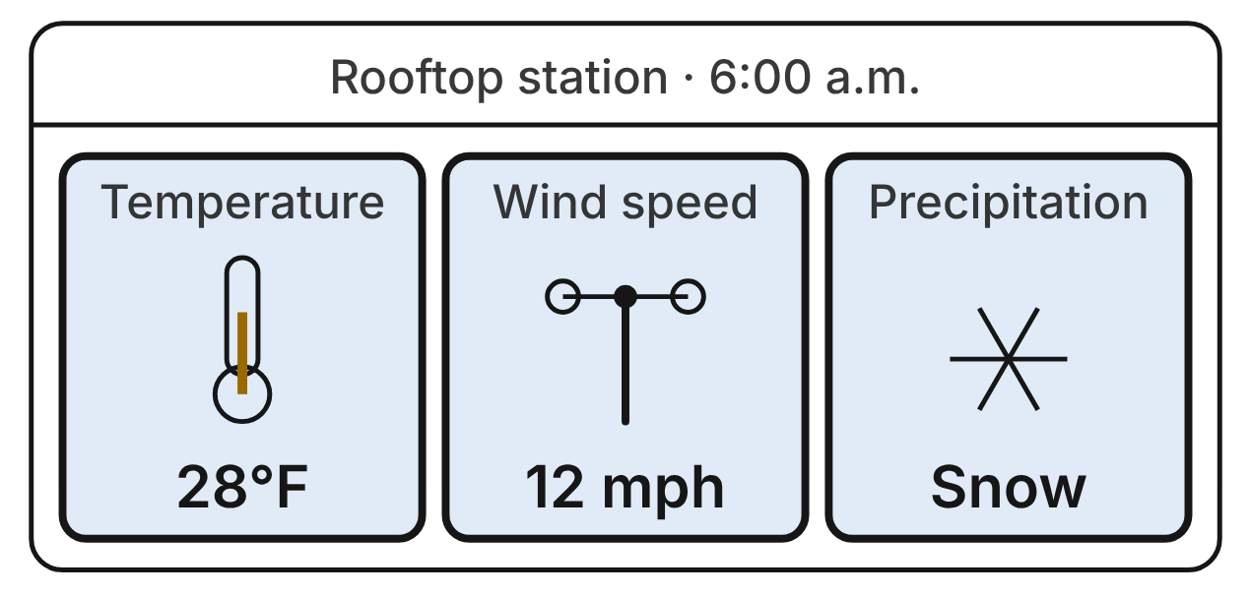
A school weather station shows these readings. Let p be “The temperature is below 32°F,” q be “The wind speed is over 20 mph,” and r be “It is snowing.” Use the readings to decide whether each is true.
1. Which sentence is r ∧ ~q?
A. It is snowing, or the wind speed is not over 20 mph.
B. It is snowing, and the wind speed is not over 20 mph. ✔
C. It is not snowing, and the wind speed is over 20 mph.
D. If it is snowing, then the wind speed is not over 20 mph.
G.RLT.1 · skill G.RLT.1.1 (LOTS): Translate statements into symbols and words: negation (~p), conjunction (p ∧ q), disjunction (p ∨ q), conditional (p → q) and biconditional (p ↔ q)
☐ Answer key correct ☐ Wording clear Notes: ________________________________
2. At these readings, what is the truth value of q ∨ r?
A. False, because q is false.
B. True, because q is true.
C. False, because q and r differ.
D. True, because r is true. ✔
G.RLT.1 · skill G.RLT.1.1 (LOTS): Translate statements into symbols and words: negation (~p), conjunction (p ∧ q), disjunction (p ∨ q), conditional (p → q) and biconditional (p ↔ q)
☐ Answer key correct ☐ Wording clear Notes: ________________________________
3. Which statement is false at these readings?
A. p → q ✔
B. r → p
C. q → r
D. p ∧ ~q
G.RLT.1 · skill G.RLT.1.1 (LOTS): Translate statements into symbols and words: negation (~p), conjunction (p ∧ q), disjunction (p ∨ q), conditional (p → q) and biconditional (p ↔ q)
☐ Answer key correct ☐ Wording clear Notes: ________________________________
4. A rule card at the station says, “If it is snowing, then the temperature is below 32°F.” Which is the contrapositive of the rule?
A. If the temperature is below 32°F, then it is snowing.
B. If it is not snowing, then the temperature is not below 32°F.
C. If the temperature is not below 32°F, then it is not snowing. ✔
D. If it is snowing, then the temperature is not below 32°F.
G.RLT.1 · skill G.RLT.1.2 (LOTS): Identify the converse, inverse and contrapositive of a conditional statement and decide whether each is true
☐ Answer key correct ☐ Wording clear Notes: ________________________________
5. Which is the inverse of r → p, written in symbols?
A. ~r → ~p ✔
B. p → r
C. ~p → ~r
D. r → ~p
G.RLT.1 · skill G.RLT.1.2 (LOTS): Identify the converse, inverse and contrapositive of a conditional statement and decide whether each is true
☐ Answer key correct ☐ Wording clear Notes: ________________________________
6. The station's wind alarm follows the rule a ↔ q, where a is “The wind alarm sounds.” Using the readings, what is true right now?
A. The wind alarm is sounding.
B. Nothing can be decided about the alarm.
C. The rule a ↔ q cannot hold right now.
D. The wind alarm is not sounding. ✔
G.RLT.1 · skill G.RLT.1.1 (LOTS): Translate statements into symbols and words: negation (~p), conjunction (p ∧ q), disjunction (p ∨ q), conditional (p → q) and biconditional (p ↔ q)
☐ Answer key correct ☐ Wording clear Notes: ________________________________

Sorting the Solar System
Level 1 · Logic · G.RLT.1 · ID geo-rlt1-rocks-solar-sets
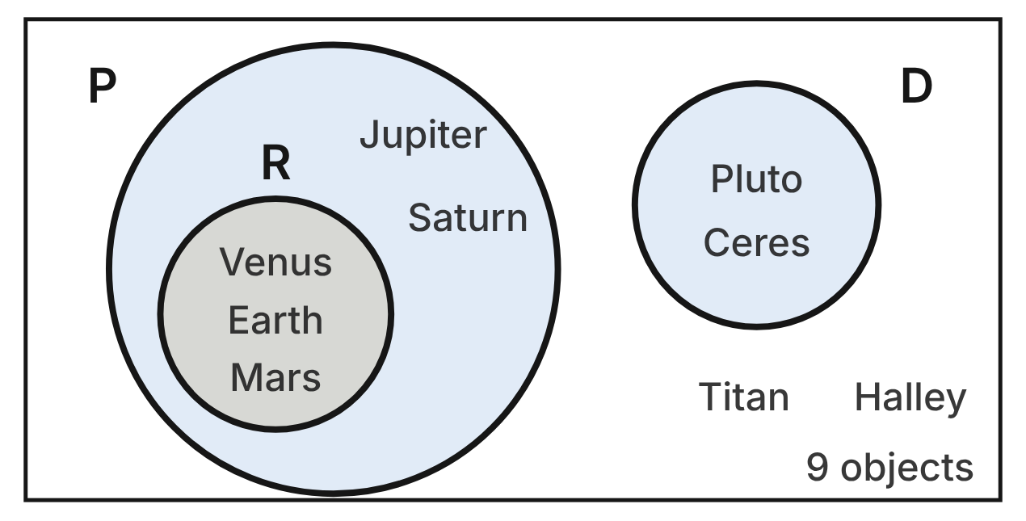
The diagram sorts 9 objects in the solar system. P is the set of planets, R is the set of rocky planets, and D is the set of dwarf planets. Titan is a moon of Saturn, and Halley is a comet.
7. Which conditional does the diagram show is true for these 9 objects?
A. If an object is a planet, then it is a rocky planet.
B. If an object is not a planet, then it is a dwarf planet.
C. If an object is a rocky planet, then it is a planet. ✔
D. If an object is a dwarf planet, then it is a planet.
G.RLT.1 · skill G.RLT.1.4 (LOTS): Use and interpret Venn diagrams: union, intersection, subset and negation, including in context
☐ Answer key correct ☐ Wording clear Notes: ________________________________
8. Which objects in the diagram are in P ∩ ~R?
A. Jupiter and Saturn ✔
B. Venus, Earth and Mars
C. Pluto and Ceres
D. Titan and Halley
G.RLT.1 · skill G.RLT.1.4 (LOTS): Use and interpret Venn diagrams: union, intersection, subset and negation, including in context
☐ Answer key correct ☐ Wording clear Notes: ________________________________
9. How many of the 9 objects are in ~P?
A. 2
B. 5
C. 6
D. 4 ✔
G.RLT.1 · skill G.RLT.1.4 (LOTS): Use and interpret Venn diagrams: union, intersection, subset and negation, including in context
☐ Answer key correct ☐ Wording clear Notes: ________________________________
10. Which set is R ∩ D?
A. Pluto and Ceres
B. The empty set ✔
C. Venus, Earth and Mars
D. Venus, Earth, Mars, Pluto and Ceres
G.RLT.1 · skill G.RLT.1.4 (LOTS): Use and interpret Venn diagrams: union, intersection, subset and negation, including in context
☐ Answer key correct ☐ Wording clear Notes: ________________________________
11. Consider “If an object is a planet, then it is a rocky planet.” Which object is a counterexample to it?
A. Earth
B. Jupiter ✔
C. Pluto
D. Titan
G.RLT.1 · skill G.RLT.1.2 (LOTS): Identify the converse, inverse and contrapositive of a conditional statement and decide whether each is true
☐ Answer key correct ☐ Wording clear Notes: ________________________________
12. This statement is true: “If an object is a dwarf planet, then it is not a planet.” Ceres is a dwarf planet. What can be concluded by the Law of Detachment?
A. Ceres is a rocky planet.
B. Ceres is a planet.
C. Ceres is not a planet. ✔
D. Nothing can be concluded.
G.RLT.1 · skill G.RLT.1.3 (HOTS): Use deductive reasoning (the Law of Detachment and the Law of Syllogism) to decide whether a conclusion is valid
☐ Answer key correct ☐ Wording clear Notes: ________________________________

Five Launch Windows
Level 2 · Logic · G.RLT.1 · ID geo-rlt1-rocks-launch-log
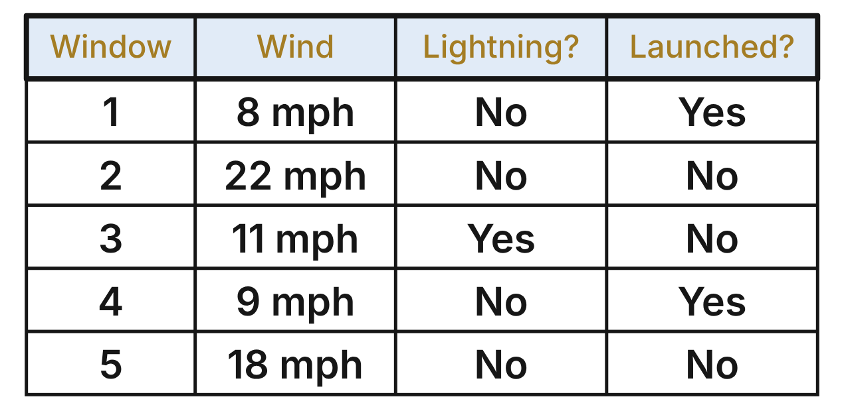
A model rocket club logged five launch windows. For each window, let p be “The wind is under 15 mph,” l be “There is lightning nearby,” and q be “The rocket launched.”
13. For how many of the five windows is p ∧ ~l true?
A. 5
B. 1
C. 3
D. 2 ✔
G.RLT.1 · skill G.RLT.1.1 (LOTS): Translate statements into symbols and words: negation (~p), conjunction (p ∧ q), disjunction (p ∨ q), conditional (p → q) and biconditional (p ↔ q)
☐ Answer key correct ☐ Wording clear Notes: ________________________________
14. Which statement is true for window 3?
A. ~p ∨ q
B. p ∧ l ✔
C. l → q
D. p ↔ q
G.RLT.1 · skill G.RLT.1.1 (LOTS): Translate statements into symbols and words: negation (~p), conjunction (p ∧ q), disjunction (p ∨ q), conditional (p → q) and biconditional (p ↔ q)
☐ Answer key correct ☐ Wording clear Notes: ________________________________
15. Which window is a counterexample to “If the wind is under 15 mph, then the rocket launched”?
A. Window 1
B. Window 2
C. Window 3 ✔
D. Window 5
G.RLT.1 · skill G.RLT.1.2 (LOTS): Identify the converse, inverse and contrapositive of a conditional statement and decide whether each is true
☐ Answer key correct ☐ Wording clear Notes: ________________________________
16. Which conditional is true for all five windows?
A. If the rocket launched, then there was no lightning nearby. ✔
B. If there was no lightning nearby, then the rocket launched.
C. If the rocket did not launch, then there was lightning nearby.
D. If the wind was 15 mph or more, then there was lightning nearby.
G.RLT.1 · skill G.RLT.1.2 (LOTS): Identify the converse, inverse and contrapositive of a conditional statement and decide whether each is true
☐ Answer key correct ☐ Wording clear Notes: ________________________________
17. The club's rule is true: “If the rocket launches, then the wind is under 15 mph.” In a sixth window the wind is 10 mph, so Rae concludes that the rocket launched. Which describes her reasoning?
A. Valid, by the Law of Detachment.
B. Valid, by the Law of Syllogism.
C. Invalid; it uses the inverse of the rule.
D. Invalid; it uses the converse of the rule. ✔
G.RLT.1 · skill G.RLT.1.3 (HOTS): Use deductive reasoning (the Law of Detachment and the Law of Syllogism) to decide whether a conclusion is valid
☐ Answer key correct ☐ Wording clear Notes: ________________________________
18. Two rules hold in every window: “If there is lightning nearby, then the pad is closed.” “If the pad is closed, then the crew waits in the bunker.” What can be concluded about window 3?
A. The crew waited in the bunker. ✔
B. The pad closed, but the crew may not have waited.
C. Nothing, since the rocket did not launch.
D. The crew waited, but the pad stayed open.
G.RLT.1 · skill G.RLT.1.3 (HOTS): Use deductive reasoning (the Law of Detachment and the Law of Syllogism) to decide whether a conclusion is valid
☐ Answer key correct ☐ Wording clear Notes: ________________________________

Building a Volcano Diagram
Level 2 · Logic · G.RLT.1 · ID geo-rlt1-rocks-volcano-card
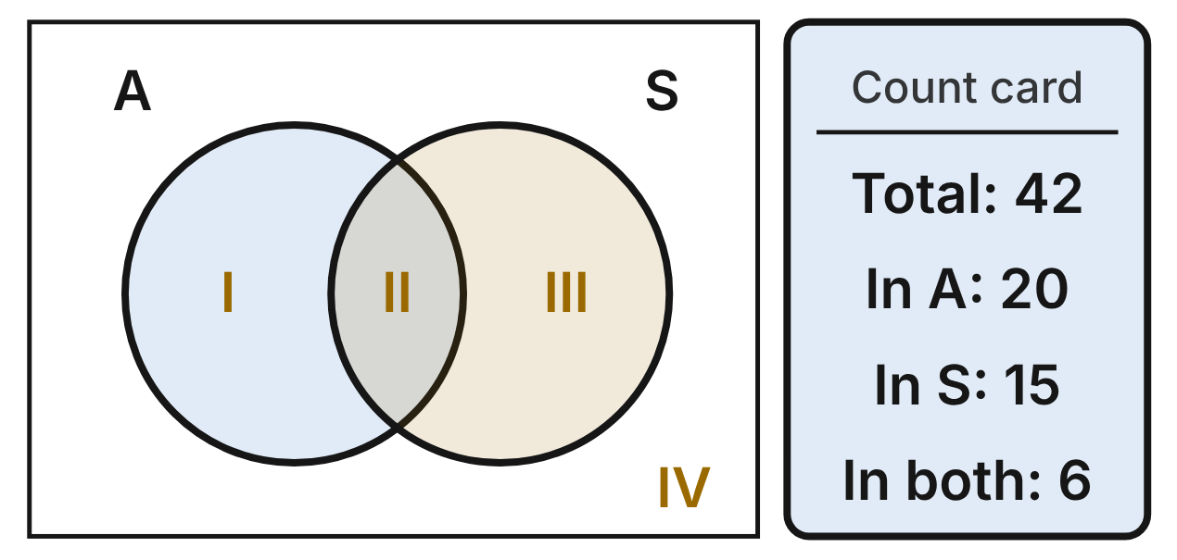
A science class studied 42 volcanoes. A is the set that erupted in the last 100 years, and S is the set with a crater lake at the summit. The card gives how many are in A in all, in S in all, and in both. The regions of the empty diagram are numbered I to IV.
19. Which number belongs in region I?
A. 14 ✔
B. 20
C. 9
D. 26
G.RLT.1 · skill G.RLT.1.4 (LOTS): Use and interpret Venn diagrams: union, intersection, subset and negation, including in context
☐ Answer key correct ☐ Wording clear Notes: ________________________________
20. Which number belongs in region IV, outside both circles?
A. 7
B. 22
C. 13 ✔
D. 27
G.RLT.1 · skill G.RLT.1.4 (LOTS): Use and interpret Venn diagrams: union, intersection, subset and negation, including in context
☐ Answer key correct ☐ Wording clear Notes: ________________________________
21. Which expression names region III?
A. A ∩ ~S
B. ~A ∩ S ✔
C. ~(A ∪ S)
D. A ∩ S
G.RLT.1 · skill G.RLT.1.4 (LOTS): Use and interpret Venn diagrams: union, intersection, subset and negation, including in context
☐ Answer key correct ☐ Wording clear Notes: ________________________________
22. How many of the volcanoes are in A ∪ S?
A. 35
B. 6
C. 23
D. 29 ✔
G.RLT.1 · skill G.RLT.1.4 (LOTS): Use and interpret Venn diagrams: union, intersection, subset and negation, including in context
☐ Answer key correct ☐ Wording clear Notes: ________________________________
23. Consider “If a volcano has a crater lake, then it erupted in the last 100 years.” For how many of the 42 volcanoes is this statement false?
A. 14
B. 9 ✔
C. 13
D. 15
G.RLT.1 · skill G.RLT.1.2 (LOTS): Identify the converse, inverse and contrapositive of a conditional statement and decide whether each is true
☐ Answer key correct ☐ Wording clear Notes: ________________________________
24. Volcano V is in region III. Let a be “V erupted in the last 100 years” and s be “V has a crater lake.” Which statement is true?
A. a ∨ ~s
B. s → a
C. s ∧ ~a ✔
D. a ↔ s
G.RLT.1 · skill G.RLT.1.1 (LOTS): Translate statements into symbols and words: negation (~p), conjunction (p ∧ q), disjunction (p ∨ q), conditional (p → q) and biconditional (p ↔ q)
☐ Answer key correct ☐ Wording clear Notes: ________________________________

Signs Before an Eruption
Level 2 · Logic · G.RLT.1 · ID geo-rlt1-rocks-eruption-steps
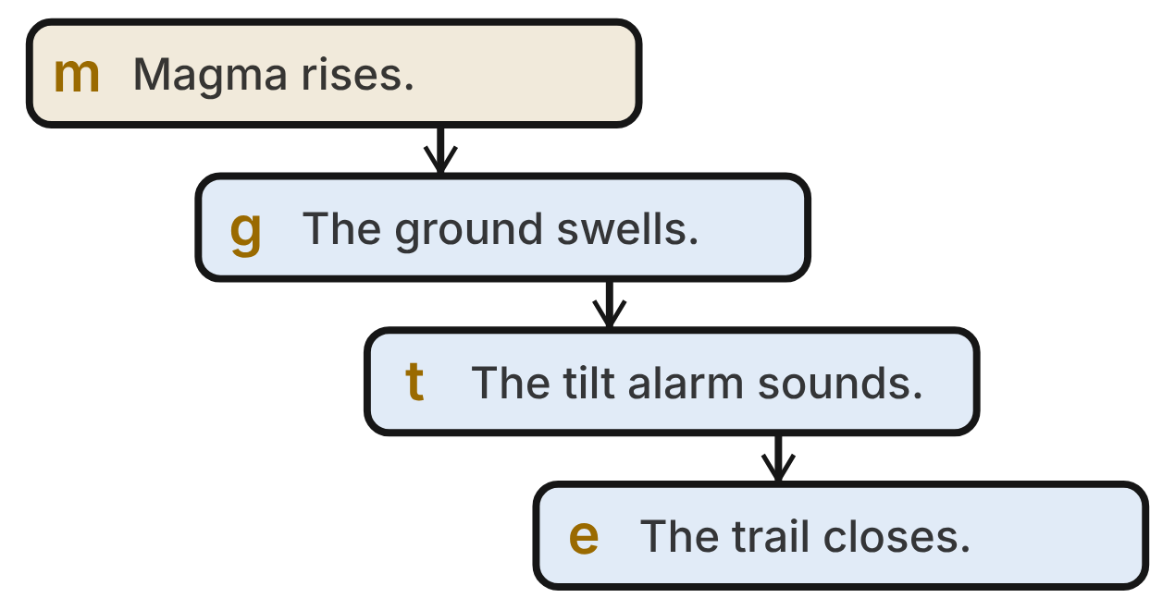
At a volcano park, each arrow is a true conditional: m → g, g → t and t → e. Here m is “Magma rises under the volcano,” g is “The ground swells,” t is “The tilt alarm sounds,” and e is “The park closes the summit trail.”
25. Which conditional follows from all three arrows by the Law of Syllogism?
A. e → m
B. m → e ✔
C. ~m → ~e
D. e → t
G.RLT.1 · skill G.RLT.1.3 (HOTS): Use deductive reasoning (the Law of Detachment and the Law of Syllogism) to decide whether a conclusion is valid
☐ Answer key correct ☐ Wording clear Notes: ________________________________
26. Today the tilt alarm sounds. What can be concluded?
A. The park closes the summit trail. ✔
B. Magma is rising under the volcano.
C. The ground is swelling.
D. Nothing can be concluded.
G.RLT.1 · skill G.RLT.1.3 (HOTS): Use deductive reasoning (the Law of Detachment and the Law of Syllogism) to decide whether a conclusion is valid
☐ Answer key correct ☐ Wording clear Notes: ________________________________
27. Today the summit trail is open. What can be concluded?
A. Nothing can be concluded.
B. The alarm sounds, but the ground is not swelling.
C. The alarm is silent, but magma may be rising.
D. Magma is not rising under the volcano. ✔
G.RLT.1 · skill G.RLT.1.3 (HOTS): Use deductive reasoning (the Law of Detachment and the Law of Syllogism) to decide whether a conclusion is valid
☐ Answer key correct ☐ Wording clear Notes: ________________________________
28. Which sentence is the contrapositive of g → t?
A. If the tilt alarm sounds, then the ground swells.
B. If the ground does not swell, then the tilt alarm does not sound.
C. If the tilt alarm does not sound, then the ground does not swell. ✔
D. If the ground swells, then the tilt alarm does not sound.
G.RLT.1 · skill G.RLT.1.2 (LOTS): Identify the converse, inverse and contrapositive of a conditional statement and decide whether each is true
☐ Answer key correct ☐ Wording clear Notes: ________________________________
29. Heavy rain can make the ground swell when no magma rises. Which statement does this fact show is false?
A. g → m ✔
B. m → g
C. ~g → ~m
D. g → t
G.RLT.1 · skill G.RLT.1.2 (LOTS): Identify the converse, inverse and contrapositive of a conditional statement and decide whether each is true
☐ Answer key correct ☐ Wording clear Notes: ________________________________
30. Which sentence is ~e ∨ t?
A. The park does not close the summit trail, and the tilt alarm sounds.
B. If the park does not close the summit trail, then the tilt alarm sounds.
C. The park closes the summit trail, or the tilt alarm does not sound.
D. The park does not close the summit trail, or the tilt alarm sounds. ✔
G.RLT.1 · skill G.RLT.1.1 (LOTS): Translate statements into symbols and words: negation (~p), conjunction (p ∧ q), disjunction (p ∨ q), conditional (p → q) and biconditional (p ↔ q)
☐ Answer key correct ☐ Wording clear Notes: ________________________________

Thirty Days of June Weather
Level 3 · Logic · G.RLT.1 · ID geo-rlt1-rocks-june-storms
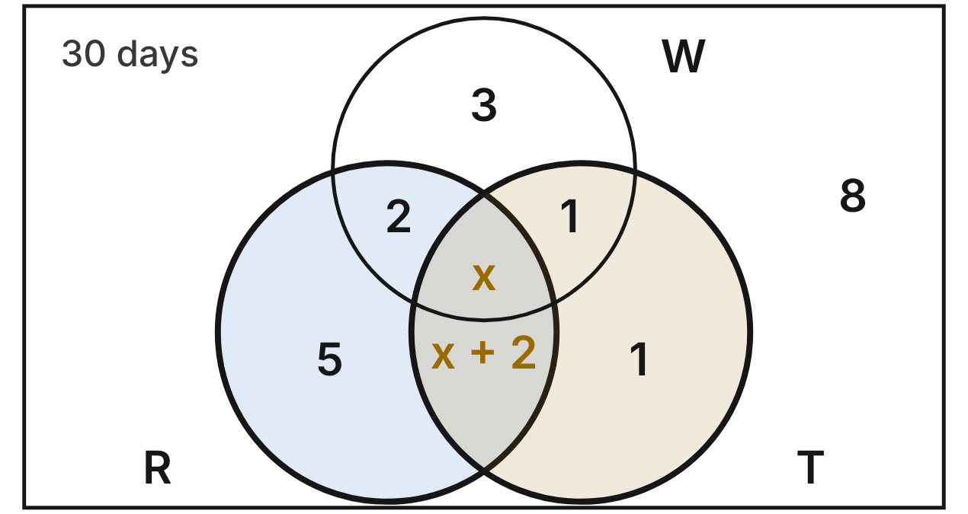
A weather station logged all 30 days of June. R is the set of days with rain, T is the set of days with thunder, and W is the set of days with wind gusts over 30 mph. Each number or expression is the number of days in that region.
31. What is the value of x?
A. 8
B. 5
C. 4 ✔
D. 6
G.RLT.1 · skill G.RLT.1.4 (LOTS): Use and interpret Venn diagrams: union, intersection, subset and negation, including in context
☐ Answer key correct ☐ Wording clear Notes: ________________________________
32. How many days in June are in R ∩ T?
A. 6
B. 4
C. 19
D. 10 ✔
G.RLT.1 · skill G.RLT.1.4 (LOTS): Use and interpret Venn diagrams: union, intersection, subset and negation, including in context
☐ Answer key correct ☐ Wording clear Notes: ________________________________
33. How many days in June are in ~W?
A. 20 ✔
B. 10
C. 8
D. 12
G.RLT.1 · skill G.RLT.1.4 (LOTS): Use and interpret Venn diagrams: union, intersection, subset and negation, including in context
☐ Answer key correct ☐ Wording clear Notes: ________________________________
34. How many days in June are counterexamples to “If there is thunder, then there is rain”?
A. 1
B. 2 ✔
C. 7
D. 12
G.RLT.1 · skill G.RLT.1.2 (LOTS): Identify the converse, inverse and contrapositive of a conditional statement and decide whether each is true
☐ Answer key correct ☐ Wording clear Notes: ________________________________
35. On one June day there was thunder. Leo concludes that it must have rained that day. Which describes his reasoning?
A. Valid; most thunder days had rain.
B. Valid, by the Law of Detachment.
C. Invalid; 2 thunder days had no rain. ✔
D. Invalid; it uses the inverse.
G.RLT.1 · skill G.RLT.1.3 (HOTS): Use deductive reasoning (the Law of Detachment and the Law of Syllogism) to decide whether a conclusion is valid
☐ Answer key correct ☐ Wording clear Notes: ________________________________
36. How many days in June are in (R ∪ W) ∩ ~T?
A. 8
B. 10 ✔
C. 18
D. 21
G.RLT.1 · skill G.RLT.1.4 (LOTS): Use and interpret Venn diagrams: union, intersection, subset and negation, including in context
☐ Answer key correct ☐ Wording clear Notes: ________________________________

The Observatory Rule Book
Level 3 · Logic · G.RLT.1 · ID geo-rlt1-rocks-observatory
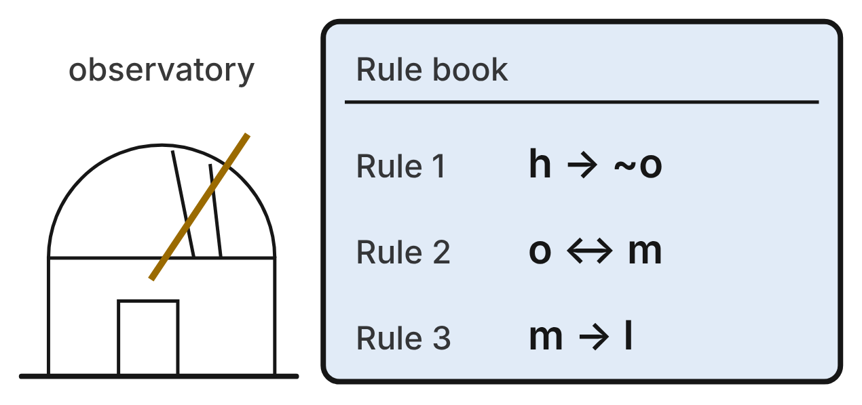
At a school observatory, the rule book lists three rules, and the staff always follow them.
h: The humidity is above 90%. o: The dome opens. m: The mirror is uncovered. l: The night log is signed.
37. Tonight the humidity is 95%. What can be concluded?
A. The dome stays shut, but the mirror may be uncovered.
B. The dome stays shut, and the log is not signed.
C. The dome opens, but the mirror stays covered.
D. The dome stays shut, and the mirror stays covered. ✔
G.RLT.1 · skill G.RLT.1.3 (HOTS): Use deductive reasoning (the Law of Detachment and the Law of Syllogism) to decide whether a conclusion is valid
☐ Answer key correct ☐ Wording clear Notes: ________________________________
38. Tonight the night log is signed. Pat concludes that the mirror was uncovered. Which describes Pat's reasoning?
A. Valid, by the Law of Detachment.
B. Valid, because rule 2 works both ways.
C. Invalid; it uses the converse of rule 3. ✔
D. Invalid; it uses the inverse of rule 3.
G.RLT.1 · skill G.RLT.1.3 (HOTS): Use deductive reasoning (the Law of Detachment and the Law of Syllogism) to decide whether a conclusion is valid
☐ Answer key correct ☐ Wording clear Notes: ________________________________
39. Which conditional follows from rules 2 and 3 by the Law of Syllogism?
A. l → o
B. o → l ✔
C. ~o → ~l
D. l → m
G.RLT.1 · skill G.RLT.1.3 (HOTS): Use deductive reasoning (the Law of Detachment and the Law of Syllogism) to decide whether a conclusion is valid
☐ Answer key correct ☐ Wording clear Notes: ________________________________
40. Which is the contrapositive of rule 1?
A. o → ~h ✔
B. ~o → h
C. ~h → o
D. o → h
G.RLT.1 · skill G.RLT.1.2 (LOTS): Identify the converse, inverse and contrapositive of a conditional statement and decide whether each is true
☐ Answer key correct ☐ Wording clear Notes: ________________________________
41. One night a visitor ran the telescope. The humidity was 60%, the dome opened and the mirror was uncovered, but the log was not signed. Which rule did the visitor break?
A. Rule 1
B. Rule 2
C. No rule
D. Rule 3 ✔
G.RLT.1 · skill G.RLT.1.1 (LOTS): Translate statements into symbols and words: negation (~p), conjunction (p ∧ q), disjunction (p ∨ q), conditional (p → q) and biconditional (p ↔ q)
☐ Answer key correct ☐ Wording clear Notes: ________________________________
42. Which sentence is rule 1 written in words?
A. If the humidity is above 90%, then the dome does not open. ✔
B. If the dome does not open, then the humidity is above 90%.
C. The humidity is above 90%, and the dome does not open.
D. If the humidity is not above 90%, then the dome opens.
G.RLT.1 · skill G.RLT.1.1 (LOTS): Translate statements into symbols and words: negation (~p), conjunction (p ∧ q), disjunction (p ∨ q), conditional (p → q) and biconditional (p ↔ q)
☐ Answer key correct ☐ Wording clear Notes: ________________________________

G.RLT.2 · Analyze, prove, and justify the relationships of parallel lines cut by a transversal.

Struts on the Solar Array
Level 1 · Lines · G.RLT.2 · ID geo-rlt2-rocks-solar-array
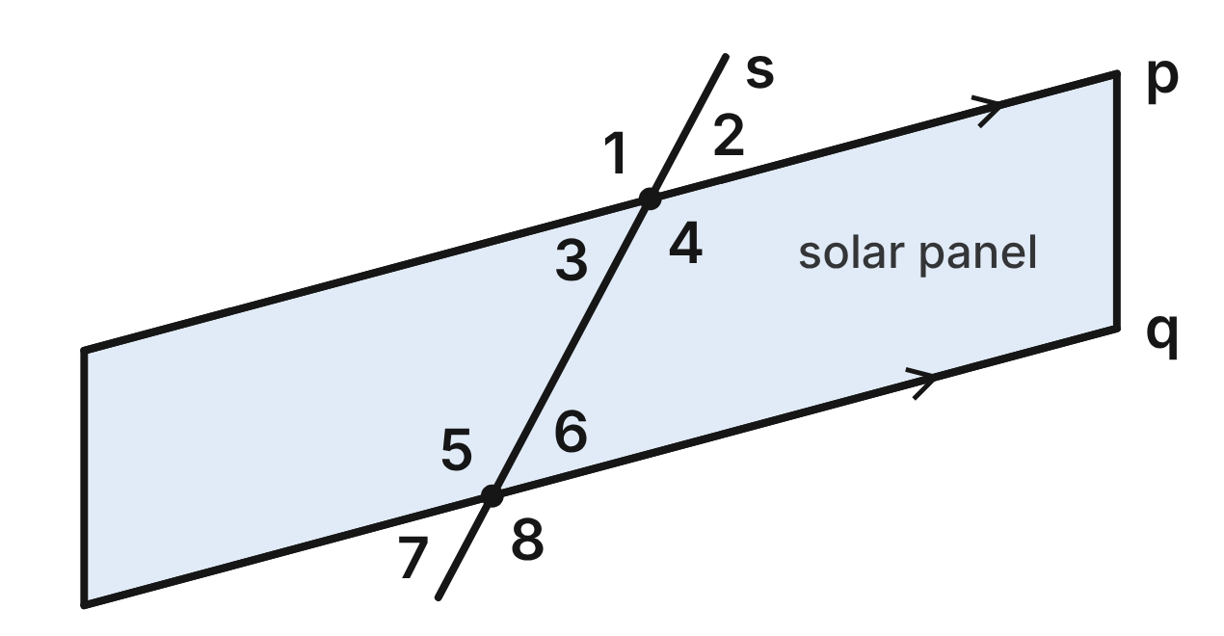
On a satellite's solar array, panel edges p and q are parallel. A straight support strut, s, crosses both edges. m∠2 = 47°.
43. Which angle is vertical to ∠3?
A. ∠1
B. ∠2 ✔
C. ∠7
D. ∠6
G.RLT.2 · skill G.RLT.2.1 (LOTS): Identify angle pairs formed by a transversal: corresponding, alternate interior, alternate exterior, same-side interior, vertical and linear pairs
☐ Answer key correct ☐ Wording clear Notes: ________________________________
44. What is m∠8, at edge q?
A. 47°
B. 43°
C. 313°
D. 133° ✔
G.RLT.2 · skill G.RLT.2.3 (LOTS): Solve problems, including algebraic ones, using the angles formed by parallel lines and a transversal
☐ Answer key correct ☐ Wording clear Notes: ________________________________
45. ∠4 and ∠5 are what kind of angle pair?
A. Alternate interior angles ✔
B. Same-side interior angles
C. Corresponding angles
D. Alternate exterior angles
G.RLT.2 · skill G.RLT.2.1 (LOTS): Identify angle pairs formed by a transversal: corresponding, alternate interior, alternate exterior, same-side interior, vertical and linear pairs
☐ Answer key correct ☐ Wording clear Notes: ________________________________
46. Which angle is an alternate exterior angle to ∠2?
A. ∠6
B. ∠3
C. ∠7 ✔
D. ∠8
G.RLT.2 · skill G.RLT.2.1 (LOTS): Identify angle pairs formed by a transversal: corresponding, alternate interior, alternate exterior, same-side interior, vertical and linear pairs
☐ Answer key correct ☐ Wording clear Notes: ________________________________
47. What is the measure of ∠5, where the strut meets edge q?
A. 47°
B. 133° ✔
C. 43°
D. 227°
G.RLT.2 · skill G.RLT.2.3 (LOTS): Solve problems, including algebraic ones, using the angles formed by parallel lines and a transversal
☐ Answer key correct ☐ Wording clear Notes: ________________________________
48. Which of these angles does NOT measure 133°?
A. ∠1
B. ∠4
C. ∠8
D. ∠6 ✔
G.RLT.2 · skill G.RLT.2.3 (LOTS): Solve problems, including algebraic ones, using the angles formed by parallel lines and a transversal
☐ Answer key correct ☐ Wording clear Notes: ________________________________

Storm Track on the Weather Map
Level 1 · Lines · G.RLT.2 · ID geo-rlt2-rocks-storm-track
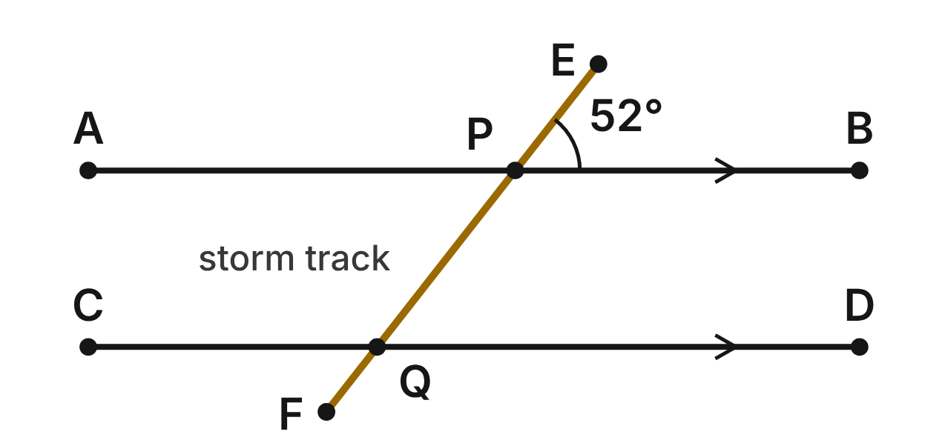
On a weather map, grid lines AB and CD are parallel. A storm moves along a straight track, EF, that crosses AB at P and CD at Q. m∠EPB = 52°.
49. What kind of angle pair are ∠APQ and ∠PQD?
A. Corresponding angles
B. Same-side interior angles
C. Alternate interior angles ✔
D. Vertical angles
G.RLT.2 · skill G.RLT.2.1 (LOTS): Identify angle pairs formed by a transversal: corresponding, alternate interior, alternate exterior, same-side interior, vertical and linear pairs
☐ Answer key correct ☐ Wording clear Notes: ________________________________
50. What is m∠PQD?
A. 52° ✔
B. 128°
C. 38°
D. 104°
G.RLT.2 · skill G.RLT.2.3 (LOTS): Solve problems, including algebraic ones, using the angles formed by parallel lines and a transversal
☐ Answer key correct ☐ Wording clear Notes: ________________________________
51. What is m∠BPQ?
A. 52°
B. 38°
C. 308°
D. 128° ✔
G.RLT.2 · skill G.RLT.2.3 (LOTS): Solve problems, including algebraic ones, using the angles formed by parallel lines and a transversal
☐ Answer key correct ☐ Wording clear Notes: ________________________________
52. Which angle corresponds to ∠APE?
A. ∠DQF
B. ∠CQP ✔
C. ∠CQF
D. ∠PQD
G.RLT.2 · skill G.RLT.2.1 (LOTS): Identify angle pairs formed by a transversal: corresponding, alternate interior, alternate exterior, same-side interior, vertical and linear pairs
☐ Answer key correct ☐ Wording clear Notes: ________________________________
53. Which two angles are same-side interior angles along the storm track?
A. ∠BPQ and ∠PQD ✔
B. ∠APQ and ∠PQD
C. ∠EPB and ∠PQD
D. ∠APE and ∠CQF
G.RLT.2 · skill G.RLT.2.1 (LOTS): Identify angle pairs formed by a transversal: corresponding, alternate interior, alternate exterior, same-side interior, vertical and linear pairs
☐ Answer key correct ☐ Wording clear Notes: ________________________________
54. Suppose no one knew the grid lines were parallel. Which measurement would prove that AB ∥ CD?
A. m∠APQ = 52°
B. m∠DQF = 52°
C. m∠CQF = 52° ✔
D. m∠BPQ = 128°
G.RLT.2 · skill G.RLT.2.2 (HOTS): Prove or justify that two lines are parallel, or are not, from angle measures
☐ Answer key correct ☐ Wording clear Notes: ________________________________

The Laser and the Glass Block
Level 2 · Lines · G.RLT.2 · ID geo-rlt2-rocks-laser-block
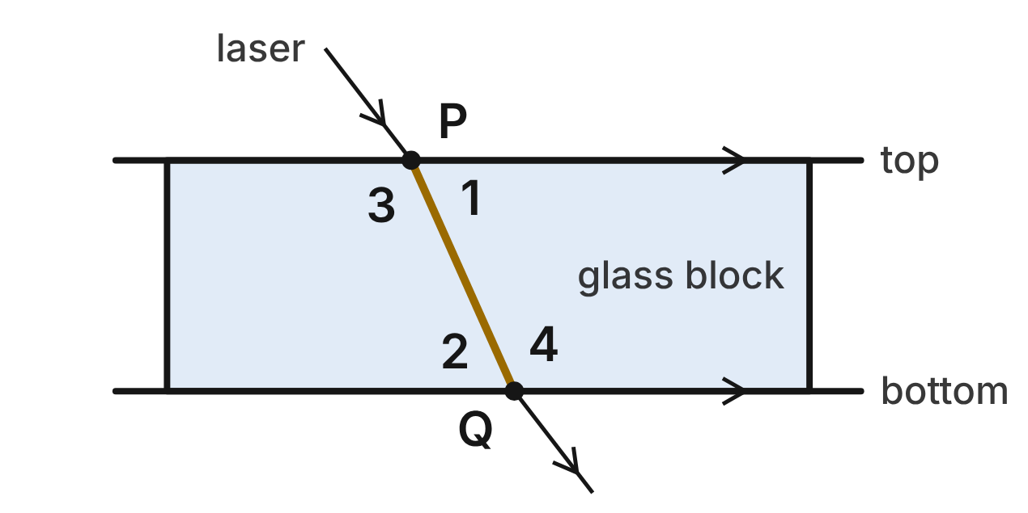
In a science lab, a laser beam passes through a glass block. The top and bottom faces of the block are parallel. Inside the block the beam runs straight from P to Q. m∠1 = (5x − 19)⁠° and m∠2 = (3x + 15)⁠°.
55. What is the value of x for this beam?
A. 23
B. 17 ✔
C. −2
D. 34
G.RLT.2 · skill G.RLT.2.3 (LOTS): Solve problems, including algebraic ones, using the angles formed by parallel lines and a transversal
☐ Answer key correct ☐ Wording clear Notes: ________________________________
56. What is m∠1, the angle between the beam and the top face?
A. 114°
B. 17°
C. 96°
D. 66° ✔
G.RLT.2 · skill G.RLT.2.3 (LOTS): Solve problems, including algebraic ones, using the angles formed by parallel lines and a transversal
☐ Answer key correct ☐ Wording clear Notes: ________________________________
57. What is m∠4, inside the block at Q?
A. 114° ✔
B. 66°
C. 24°
D. 294°
G.RLT.2 · skill G.RLT.2.3 (LOTS): Solve problems, including algebraic ones, using the angles formed by parallel lines and a transversal
☐ Answer key correct ☐ Wording clear Notes: ________________________________
58. ∠1 and ∠4 are what kind of angle pair?
A. Alternate interior angles
B. Corresponding angles
C. Same-side interior angles ✔
D. Vertical angles
G.RLT.2 · skill G.RLT.2.1 (LOTS): Identify angle pairs formed by a transversal: corresponding, alternate interior, alternate exterior, same-side interior, vertical and linear pairs
☐ Answer key correct ☐ Wording clear Notes: ________________________________
59. Suppose a student did not know the faces were parallel. She finds that ∠1 and ∠2 are congruent. Which reason lets her conclude that the faces are parallel?
A. Alternate Interior Angles Theorem
B. Converse of the Same-Side Interior Angles Theorem
C. Converse of the Corresponding Angles Postulate
D. Converse of the Alternate Interior Angles Theorem ✔
G.RLT.2 · skill G.RLT.2.2 (HOTS): Prove or justify that two lines are parallel, or are not, from angle measures
☐ Answer key correct ☐ Wording clear Notes: ________________________________
60. A second block is cut badly. Its beam makes 66° in the place of ∠1 and 61° in the place of ∠2. What can you conclude?
A. Its faces are parallel; both angles are acute.
B. Its faces are parallel; 66° and 61° are close.
C. Its faces are not parallel; the alternate interior angles differ. ✔
D. You cannot tell without measuring ∠3 too.
G.RLT.2 · skill G.RLT.2.2 (HOTS): Prove or justify that two lines are parallel, or are not, from angle measures
☐ Answer key correct ☐ Wording clear Notes: ________________________________

Layers in the Canyon Wall
Level 2 · Lines · G.RLT.2 · ID geo-rlt2-rocks-canyon-layers
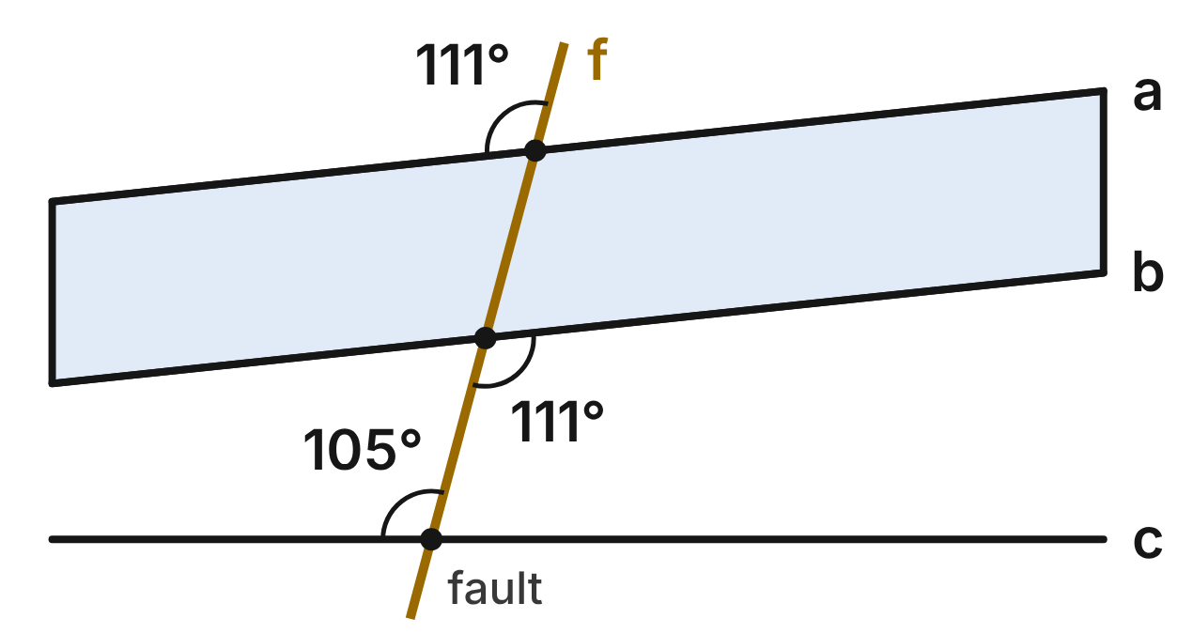
A geologist sketches a canyon wall. The boundaries of three rock layers, a, b and c, are straight lines. A straight fault line, f, crosses all three. The figure shows the angle she measured at each boundary.
61. The 111° angle at boundary a and the 111° angle at boundary b are what kind of angle pair?
A. Alternate exterior angles ✔
B. Alternate interior angles
C. Corresponding angles
D. Vertical angles
G.RLT.2 · skill G.RLT.2.1 (LOTS): Identify angle pairs formed by a transversal: corresponding, alternate interior, alternate exterior, same-side interior, vertical and linear pairs
☐ Answer key correct ☐ Wording clear Notes: ________________________________
62. Are boundaries a and b parallel?
A. No; the two angles should add to 180°.
B. Yes; vertical angles are congruent.
C. Yes; alternate exterior angles are congruent. ✔
D. Cannot tell, because f is not perpendicular to them.
G.RLT.2 · skill G.RLT.2.2 (HOTS): Prove or justify that two lines are parallel, or are not, from angle measures
☐ Answer key correct ☐ Wording clear Notes: ________________________________
63. Is boundary c parallel to boundary b?
A. Yes; 105° and 111° are both obtuse.
B. No; corresponding angles measure 105° and 111°. ✔
C. Yes; both boundaries are cut by f.
D. No; corresponding angles must add to 180°.
G.RLT.2 · skill G.RLT.2.2 (HOTS): Prove or justify that two lines are parallel, or are not, from angle measures
☐ Answer key correct ☐ Wording clear Notes: ________________________________
64. What is the measure of the angle above boundary b, to the left of f?
A. 69°
B. 105°
C. 249°
D. 111° ✔
G.RLT.2 · skill G.RLT.2.3 (LOTS): Solve problems, including algebraic ones, using the angles formed by parallel lines and a transversal
☐ Answer key correct ☐ Wording clear Notes: ________________________________
65. Suppose c were redrawn parallel to b, with the angles at b unchanged. If the angle above c and left of f were (3x + 21)⁠°, what would x be?
A. 16
B. 28
C. 44
D. 30 ✔
G.RLT.2 · skill G.RLT.2.3 (LOTS): Solve problems, including algebraic ones, using the angles formed by parallel lines and a transversal
☐ Answer key correct ☐ Wording clear Notes: ________________________________
66. Jon says the angle above boundary b, right of f, is 111° because it is vertical to the marked 111° angle at b. What is his error?
A. They are vertical, but it measures 69°.
B. They form a linear pair, so it is 69°. ✔
C. Nothing; vertical angles are congruent.
D. They are corresponding, so it is 105°.
G.RLT.2 · skill G.RLT.2.1 (LOTS): Identify angle pairs formed by a transversal: corresponding, alternate interior, alternate exterior, same-side interior, vertical and linear pairs
☐ Answer key correct ☐ Wording clear Notes: ________________________________

The Calcite Crystal Face
Level 2 · Lines · G.RLT.2 · ID geo-rlt2-rocks-calcite-face
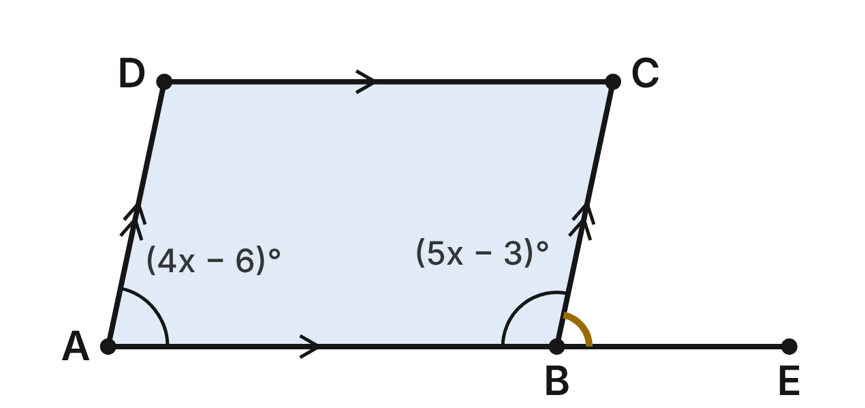
In a model of a calcite crystal, face ABCD is a parallelogram: AB ∥ DC and AD ∥ BC. Edge AB is extended past B to E. m∠DAB = (4x − 6)⁠° and m∠ABC = (5x − 3)⁠°.
67. With line AE as the transversal of AD and BC, what kind of angle pair are ∠DAB and ∠ABC?
A. Same-side interior angles ✔
B. Alternate interior angles
C. Corresponding angles
D. A linear pair
G.RLT.2 · skill G.RLT.2.1 (LOTS): Identify angle pairs formed by a transversal: corresponding, alternate interior, alternate exterior, same-side interior, vertical and linear pairs
☐ Answer key correct ☐ Wording clear Notes: ________________________________
68. What is the value of x for this crystal face?
A. −3
B. 11
C. 21 ✔
D. 41
G.RLT.2 · skill G.RLT.2.3 (LOTS): Solve problems, including algebraic ones, using the angles formed by parallel lines and a transversal
☐ Answer key correct ☐ Wording clear Notes: ________________________________
69. What is m∠ABC, inside the face at B?
A. 78°
B. 102° ✔
C. 21°
D. 108°
G.RLT.2 · skill G.RLT.2.3 (LOTS): Solve problems, including algebraic ones, using the angles formed by parallel lines and a transversal
☐ Answer key correct ☐ Wording clear Notes: ________________________________
70. What is m∠CBE, outside the face at B?
A. 102°
B. 12°
C. 282°
D. 78° ✔
G.RLT.2 · skill G.RLT.2.3 (LOTS): Solve problems, including algebraic ones, using the angles formed by parallel lines and a transversal
☐ Answer key correct ☐ Wording clear Notes: ________________________________
71. With line AE as the transversal of AD and BC, ∠DAB and ∠CBE are what kind of angle pair?
A. Alternate exterior angles
B. Same-side interior angles
C. Corresponding angles ✔
D. Vertical angles
G.RLT.2 · skill G.RLT.2.1 (LOTS): Identify angle pairs formed by a transversal: corresponding, alternate interior, alternate exterior, same-side interior, vertical and linear pairs
☐ Answer key correct ☐ Wording clear Notes: ________________________________
72. Another crystal face has m∠DAB = 78° and m∠ABC = 101°. Can AD be parallel to BC?
A. No; the same-side interior angles add to 179°. ✔
B. Yes; every crystal face is a parallelogram.
C. Yes; ∠DAB and ∠ABC are on the same side of AB.
D. No; ∠DAB and ∠ABC would have to be congruent.
G.RLT.2 · skill G.RLT.2.2 (HOTS): Prove or justify that two lines are parallel, or are not, from angle measures
☐ Answer key correct ☐ Wording clear Notes: ________________________________

Measuring Earth with Sunlight
Level 3 · Lines · G.RLT.2 · ID geo-rlt2-rocks-earth-sunlight
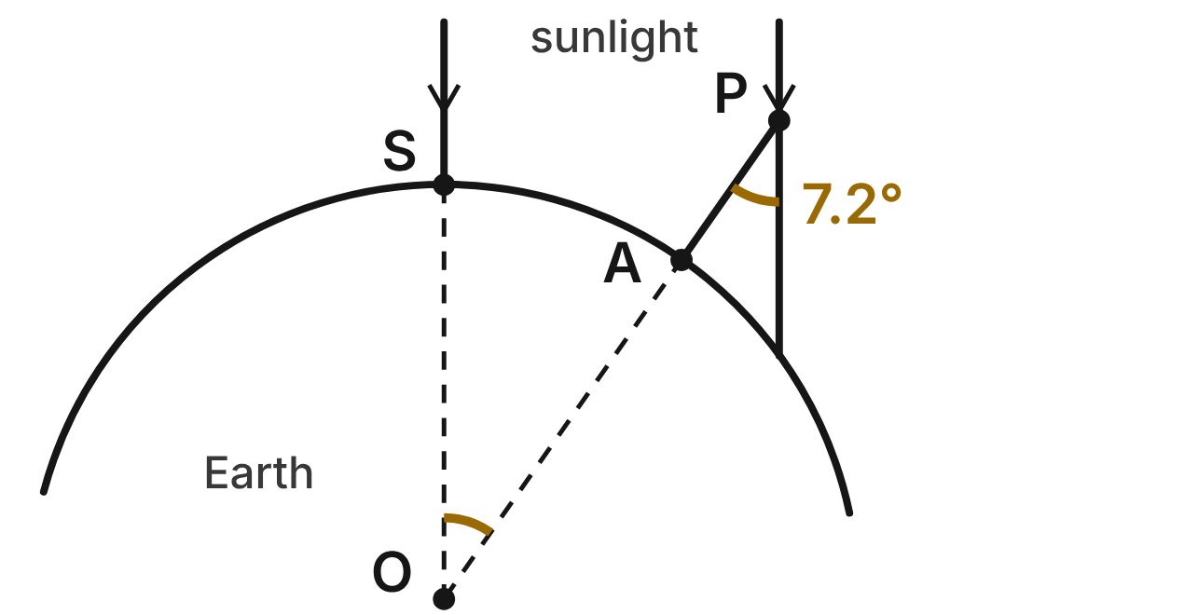
Not drawn to scale
Sunlight reaches Earth in parallel rays. At noon in Syene, S, a ray shines straight down a well toward Earth's center, O. At the same moment in Alexandria, A, a pole AP points straight away from O, and a parallel ray makes a 7.2° angle with the pole at P.
73. With line OP as the transversal of the two rays, the 7.2° angle at P and ∠SOA are what kind of angle pair?
A. Corresponding angles
B. Same-side interior angles
C. Vertical angles
D. Alternate interior angles ✔
G.RLT.2 · skill G.RLT.2.1 (LOTS): Identify angle pairs formed by a transversal: corresponding, alternate interior, alternate exterior, same-side interior, vertical and linear pairs
☐ Answer key correct ☐ Wording clear Notes: ________________________________
74. What is m∠SOA?
A. 172.8°
B. 7.2° ✔
C. 82.8°
D. 14.4°
G.RLT.2 · skill G.RLT.2.3 (LOTS): Solve problems, including algebraic ones, using the angles formed by parallel lines and a transversal
☐ Answer key correct ☐ Wording clear Notes: ________________________________
75. Why is ∠SOA congruent to the 7.2° angle at P?
A. Parallel rays make alternate interior angles congruent. ✔
B. They are vertical angles, so they are congruent.
C. They form a linear pair along the pole.
D. The pole is perpendicular to the ground at A.
G.RLT.2 · skill G.RLT.2.2 (HOTS): Prove or justify that two lines are parallel, or are not, from angle measures
☐ Answer key correct ☐ Wording clear Notes: ________________________________
76. S and A are about 800 km apart along Earth's surface, and that arc matches the 7.2° angle at O. About how far is it all the way around Earth?
A. 20,000 km
B. 10,000 km
C. 40,000 km ✔
D. 5,760 km
G.RLT.2 · skill G.RLT.2.3 (LOTS): Solve problems, including algebraic ones, using the angles formed by parallel lines and a transversal
☐ Answer key correct ☐ Wording clear Notes: ________________________________
77. In a class model, the ray makes a (2x + 3)⁠° angle with the pole, and m∠SOA = (5x − 9)⁠°. What is m∠SOA in the model?
A. 11° ✔
B. 4°
C. 1°
D. 169°
G.RLT.2 · skill G.RLT.2.3 (LOTS): Solve problems, including algebraic ones, using the angles formed by parallel lines and a transversal
☐ Answer key correct ☐ Wording clear Notes: ________________________________
78. Rosa says the 7.2° angle would equal ∠SOA even if the sun's rays were not parallel. Why is she wrong?
A. Alternate interior angles are always supplementary.
B. Vertical angles need parallel lines to be congruent.
C. She is right; alternate interior angles are always congruent.
D. Alternate interior angles are congruent only for parallel lines. ✔
G.RLT.2 · skill G.RLT.2.2 (HOTS): Prove or justify that two lines are parallel, or are not, from angle measures
☐ Answer key correct ☐ Wording clear Notes: ________________________________

The Telescope Truss
Level 3 · Lines · G.RLT.2 · ID geo-rlt2-rocks-telescope-truss
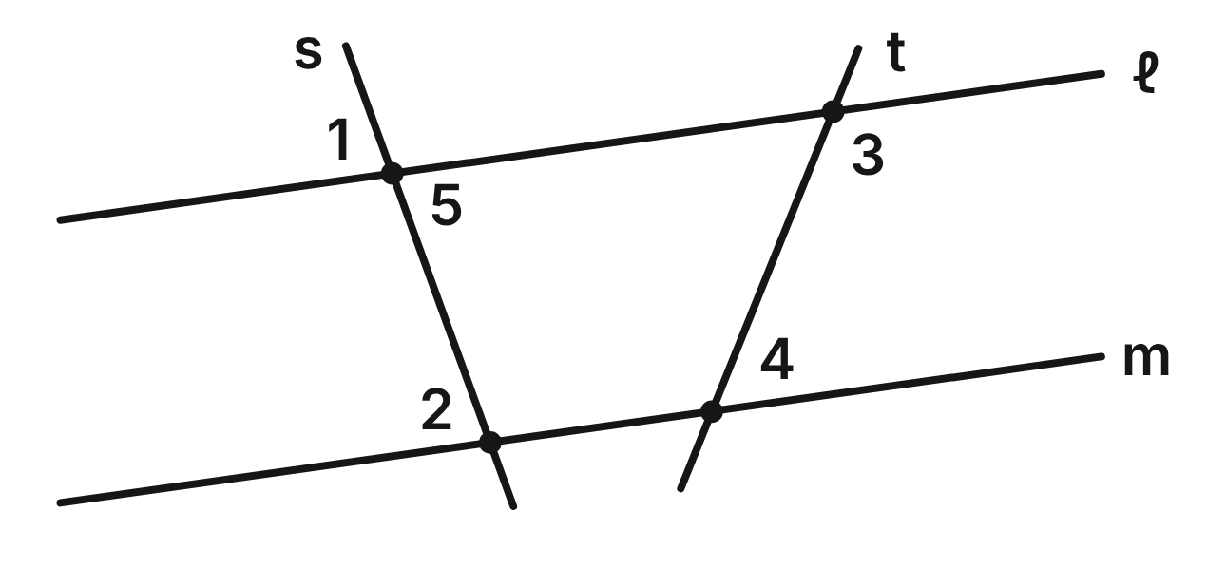
In a side view of a telescope's truss, lines ℓ and m are the edges of two rings, and struts s and t cross both. Given: ∠1 ≅ ∠2. Prove: ∠3 and ∠4 are supplementary.
Statement | Reason
1. ∠1 ≅ ∠2 | Given
2. ∠1 ≅ ∠5 | ____ (a)
3. ∠5 ≅ ∠2 | Transitive Property of Congruence
4. ℓ ∥ m | ____ (b)
5. ∠3 and ∠4 are supplementary. | ____ (c)

79. In the truss proof, which reason fills blank (a)?
A. Linear Pair Postulate
B. Corresponding Angles Postulate
C. Vertical Angles Theorem ✔
D. Converse of the Corresponding Angles Postulate
G.RLT.2 · skill G.RLT.2.2 (HOTS): Prove or justify that two lines are parallel, or are not, from angle measures
☐ Answer key correct ☐ Wording clear Notes: ________________________________
80. In the truss proof, which reason fills blank (b)?
A. Converse of the Alternate Interior Angles Theorem ✔
B. Alternate Interior Angles Theorem
C. Converse of the Same-Side Interior Angles Theorem
D. Transitive Property of Congruence
G.RLT.2 · skill G.RLT.2.2 (HOTS): Prove or justify that two lines are parallel, or are not, from angle measures
☐ Answer key correct ☐ Wording clear Notes: ________________________________
81. In the truss proof, which reason fills blank (c)?
A. Converse of the Same-Side Interior Angles Theorem
B. Same-Side Interior Angles Theorem ✔
C. Linear Pair Postulate
D. Alternate Interior Angles Theorem
G.RLT.2 · skill G.RLT.2.2 (HOTS): Prove or justify that two lines are parallel, or are not, from angle measures
☐ Answer key correct ☐ Wording clear Notes: ________________________________
82. Which single step could replace steps 2 to 4 of the truss proof?
A. ℓ ∥ m, by the Corresponding Angles Postulate
B. ℓ ∥ m, by the Converse of the Alternate Exterior Angles Theorem
C. ℓ ∥ m, by the Vertical Angles Theorem
D. ℓ ∥ m, by the Converse of the Corresponding Angles Postulate ✔
G.RLT.2 · skill G.RLT.2.2 (HOTS): Prove or justify that two lines are parallel, or are not, from angle measures
☐ Answer key correct ☐ Wording clear Notes: ________________________________
83. Suppose m∠3 = (7x − 13)⁠° and m∠4 = (3x + 3)⁠°, and ℓ ∥ m. What is m∠3?
A. 120° ✔
B. 15°
C. 60°
D. 19°
G.RLT.2 · skill G.RLT.2.3 (LOTS): Solve problems, including algebraic ones, using the angles formed by parallel lines and a transversal
☐ Answer key correct ☐ Wording clear Notes: ________________________________
84. Which pair of angles in the truss figure are alternate interior angles?
A. ∠1 and ∠2
B. ∠5 and ∠2 ✔
C. ∠3 and ∠4
D. ∠1 and ∠5
G.RLT.2 · skill G.RLT.2.1 (LOTS): Identify angle pairs formed by a transversal: corresponding, alternate interior, alternate exterior, same-side interior, vertical and linear pairs
☐ Answer key correct ☐ Wording clear Notes: ________________________________

G.RLT.3 · Solve problems, including contextual problems, involving symmetry and transformation.

Snowflakes and Crystals
Level 1 · Transformations · G.RLT.3 · ID geo-rlt3-rocks-ice-crystals
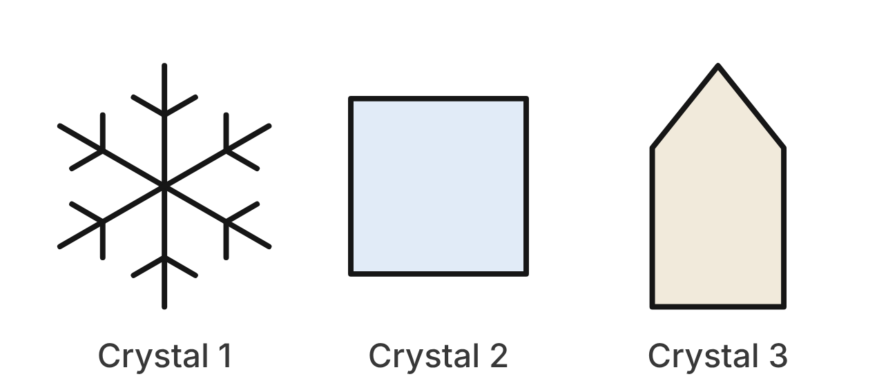
A science class photographs three crystals. Crystal 1 is a snowflake with six identical arms equally spaced around its center. Crystal 2 is the square face of a salt crystal. Crystal 3 is a quartz crystal seen from the side: a rectangle topped by a point that is centered above it.
85. How many lines of symmetry does Crystal 1 have?
A. 3
B. 6 ✔
C. 12
D. 2
G.RLT.3 · skill G.RLT.3.1 (LOTS): Identify line symmetry and rotational symmetry of a figure
☐ Answer key correct ☐ Wording clear Notes: ________________________________
86. What is the smallest angle of rotation, about its center, that maps Crystal 1 onto itself?
A. 120°
B. 30°
C. 360°
D. 60° ✔
G.RLT.3 · skill G.RLT.3.1 (LOTS): Identify line symmetry and rotational symmetry of a figure
☐ Answer key correct ☐ Wording clear Notes: ________________________________
87. What is the order of rotational symmetry of Crystal 2?
A. 4 ✔
B. 90
C. 8
D. 2
G.RLT.3 · skill G.RLT.3.1 (LOTS): Identify line symmetry and rotational symmetry of a figure
☐ Answer key correct ☐ Wording clear Notes: ________________________________
88. Which describes the symmetry of Crystal 3?
A. 2 lines of symmetry; rotational symmetry of order 2
B. No lines of symmetry; rotational symmetry of order 2
C. 1 line of symmetry; no rotational symmetry ✔
D. 1 line of symmetry; rotational symmetry of order 5
G.RLT.3 · skill G.RLT.3.1 (LOTS): Identify line symmetry and rotational symmetry of a figure
☐ Answer key correct ☐ Wording clear Notes: ________________________________
89. Which rotation about its center does NOT map Crystal 1 onto itself?
A. 120°
B. 180°
C. 90° ✔
D. 240°
G.RLT.3 · skill G.RLT.3.1 (LOTS): Identify line symmetry and rotational symmetry of a figure
☐ Answer key correct ☐ Wording clear Notes: ________________________________
90. A microscope camera enlarges Crystal 1 by a dilation with scale factor 40. Which is true of the image?
A. Its arms are 40 times as long; neighboring arms meet at 60°. ✔
B. It is congruent to Crystal 1.
C. Its arms are 40 times as long; neighboring arms meet at 1.5°.
D. Its arms are 1,600 times as long; neighboring arms meet at 60°.
G.RLT.3 · skill G.RLT.3.3 (HOTS): Determine the transformation or composition that maps a preimage to an image, and whether it preserves size and shape
☐ Answer key correct ☐ Wording clear Notes: ________________________________

Stars on the Star Map
Level 1 · Transformations · G.RLT.3 · ID geo-rlt3-rocks-star-map
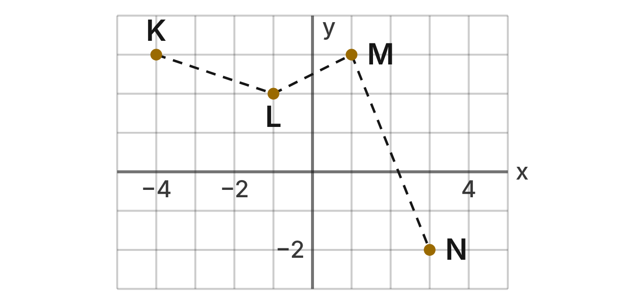
A star map puts a grid on the night sky. Four stars of a small constellation are at K(−4, 3), L(−1, 2), M(1, 3) and N(3, −2).
91. The map is shifted by the rule (x, y) → (x + 3, y − 4). What is the image of K?
A. (−1, −1) ✔
B. (−7, 7)
C. (−8, 6)
D. (−1, 3)
G.RLT.3 · skill G.RLT.3.2 (LOTS): Find the image of a figure on the coordinate plane under a translation, reflection, rotation or dilation
☐ Answer key correct ☐ Wording clear Notes: ________________________________
92. What is the image of star N after a reflection over the x-axis?
A. (−3, −2)
B. (−3, 2)
C. (−2, 3)
D. (3, 2) ✔
G.RLT.3 · skill G.RLT.3.2 (LOTS): Find the image of a figure on the coordinate plane under a translation, reflection, rotation or dilation
☐ Answer key correct ☐ Wording clear Notes: ________________________________
93. What is the image of star M after a rotation of 90° counterclockwise about the origin?
A. (3, −1)
B. (−3, 1) ✔
C. (3, 1)
D. (−1, −3)
G.RLT.3 · skill G.RLT.3.2 (LOTS): Find the image of a figure on the coordinate plane under a translation, reflection, rotation or dilation
☐ Answer key correct ☐ Wording clear Notes: ________________________________
94. What is the image of star L after a reflection over the line y = x?
A. (−2, 1)
B. (1, 2)
C. (2, −1) ✔
D. (1, −2)
G.RLT.3 · skill G.RLT.3.2 (LOTS): Find the image of a figure on the coordinate plane under a translation, reflection, rotation or dilation
☐ Answer key correct ☐ Wording clear Notes: ________________________________
95. A second chart shows the same stars at K′(4, 3), L′(1, 2), M′(−1, 3) and N′(−3, −2). Which single transformation maps K, L, M, N to K′, L′, M′, N′?
A. Reflection over the x-axis
B. Reflection over the y-axis ✔
C. Rotation of 180° about the origin
D. Translation 8 units right
G.RLT.3 · skill G.RLT.3.3 (HOTS): Determine the transformation or composition that maps a preimage to an image, and whether it preserves size and shape
☐ Answer key correct ☐ Wording clear Notes: ________________________________
96. The whole map is rotated 180° about the origin. Which is true of the distance between any two of the stars?
A. It doubles.
B. It is cut in half.
C. It changes unless a star is on an axis.
D. It stays the same. ✔
G.RLT.3 · skill G.RLT.3.3 (HOTS): Determine the transformation or composition that maps a preimage to an image, and whether it preserves size and shape
☐ Answer key correct ☐ Wording clear Notes: ________________________________

A Storm Cell on the Radar
Level 2 · Transformations · G.RLT.3 · ID geo-rlt3-rocks-radar-storm
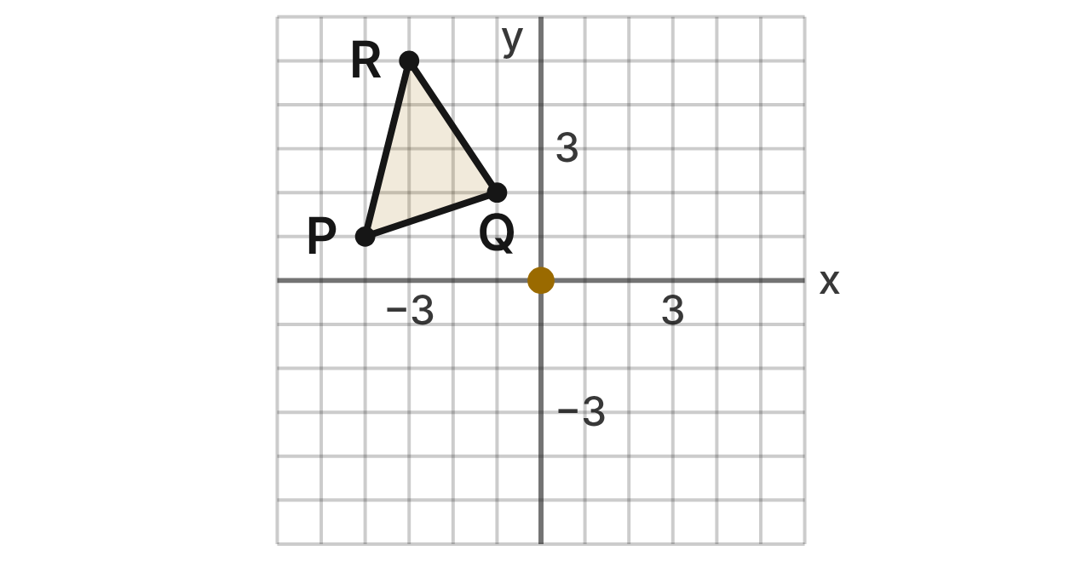
A weather radar sits at the origin of a grid measured in miles. A storm cell is △PQR with P(−4, 1), Q(−1, 2) and R(−3, 5). Forecasters study how the cell would look turned about the radar.
97. What is the image of Q after a rotation of 90° clockwise about the origin?
A. (−2, −1)
B. (1, −2)
C. (2, 1) ✔
D. (2, −1)
G.RLT.3 · skill G.RLT.3.2 (LOTS): Find the image of a figure on the coordinate plane under a translation, reflection, rotation or dilation
☐ Answer key correct ☐ Wording clear Notes: ________________________________
98. What is the image of R after a rotation of 180° about the origin?
A. (3, −5) ✔
B. (−3, −5)
C. (3, 5)
D. (5, −3)
G.RLT.3 · skill G.RLT.3.2 (LOTS): Find the image of a figure on the coordinate plane under a translation, reflection, rotation or dilation
☐ Answer key correct ☐ Wording clear Notes: ________________________________
99. What is the image of P after a rotation of 270° counterclockwise about the origin?
A. (−1, −4)
B. (4, −1)
C. (1, −4)
D. (1, 4) ✔
G.RLT.3 · skill G.RLT.3.2 (LOTS): Find the image of a figure on the coordinate plane under a translation, reflection, rotation or dilation
☐ Answer key correct ☐ Wording clear Notes: ________________________________
100. Which rule describes a rotation of 90° counterclockwise about the origin?
A. (x, y) → (y, −x)
B. (x, y) → (−y, x) ✔
C. (x, y) → (−x, −y)
D. (x, y) → (y, x)
G.RLT.3 · skill G.RLT.3.3 (HOTS): Determine the transformation or composition that maps a preimage to an image, and whether it preserves size and shape
☐ Answer key correct ☐ Wording clear Notes: ________________________________
101. Later the cell appears as △P′Q′R′ with P′(−1, −4), Q′(−2, −1) and R′(−5, −3). Which single transformation maps △PQR to △P′Q′R′?
A. Rotation of 90° counterclockwise about the origin ✔
B. Rotation of 90° clockwise about the origin
C. Reflection over the line y = x
D. Rotation of 180° about the origin
G.RLT.3 · skill G.RLT.3.3 (HOTS): Determine the transformation or composition that maps a preimage to an image, and whether it preserves size and shape
☐ Answer key correct ☐ Wording clear Notes: ________________________________
102. The cell is rotated 90° clockwise about the origin and then translated 3 miles up. Where does R end up?
A. (8, 3)
B. (−5, 0)
C. (5, 6) ✔
D. (5, 3)
G.RLT.3 · skill G.RLT.3.2 (LOTS): Find the image of a figure on the coordinate plane under a translation, reflection, rotation or dilation
☐ Answer key correct ☐ Wording clear Notes: ________________________________

The Storm on the Weather Map
Level 2 · Transformations · G.RLT.3 · ID geo-rlt3-rocks-storm-track
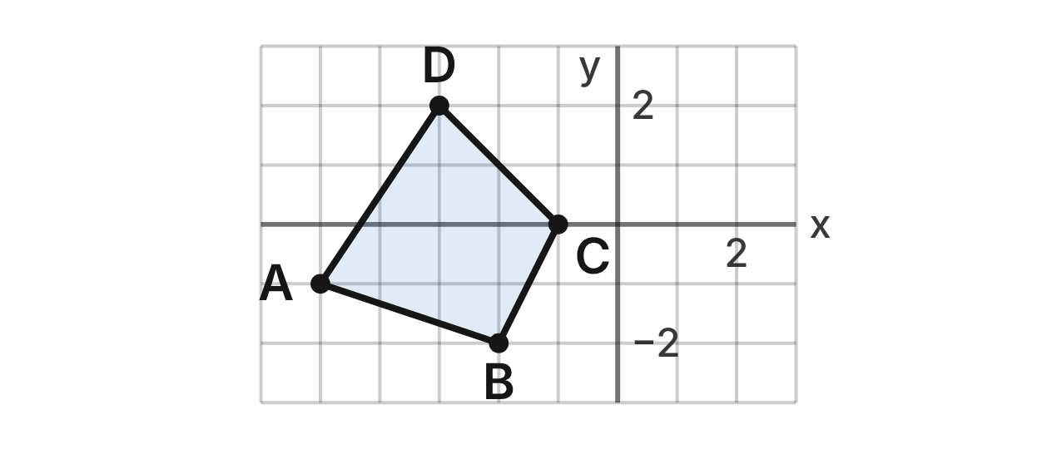
On a weather map, a storm is region ABCD with A(−5, −1), B(−2, −2), C(−1, 0) and D(−3, 2). Its area is 8.5 square units. Each day the storm moves by the rule (x, y) → (x + 2, y + 1).
103. Where is point C of the storm after one day?
A. (−3, −1)
B. (1, 1) ✔
C. (0, 2)
D. (1, 0)
G.RLT.3 · skill G.RLT.3.2 (LOTS): Find the image of a figure on the coordinate plane under a translation, reflection, rotation or dilation
☐ Answer key correct ☐ Wording clear Notes: ________________________________
104. Where is point A of the storm after three days?
A. (−3, 0)
B. (−2, 2)
C. (1, 0)
D. (1, 2) ✔
G.RLT.3 · skill G.RLT.3.2 (LOTS): Find the image of a figure on the coordinate plane under a translation, reflection, rotation or dilation
☐ Answer key correct ☐ Wording clear Notes: ________________________________
105. Which single rule moves the storm as far as three days of moves?
A. (x, y) → (x + 6, y + 3) ✔
B. (x, y) → (x + 5, y + 4)
C. (x, y) → (x + 6, y + 1)
D. (x, y) → (3x + 2, 3y + 1)
G.RLT.3 · skill G.RLT.3.3 (HOTS): Determine the transformation or composition that maps a preimage to an image, and whether it preserves size and shape
☐ Answer key correct ☐ Wording clear Notes: ________________________________
106. A second storm moves from (−4, 3) to (1, 1) in one day. Which rule describes its move?
A. (x, y) → (x − 5, y + 2)
B. (x, y) → (x + 1, y + 1)
C. (x, y) → (x + 5, y − 2) ✔
D. (x, y) → (x − 3, y + 4)
G.RLT.3 · skill G.RLT.3.3 (HOTS): Determine the transformation or composition that maps a preimage to an image, and whether it preserves size and shape
☐ Answer key correct ☐ Wording clear Notes: ________________________________
107. What is the area of the storm region after it moves for 2 days?
A. 17 square units
B. 34 square units
C. 10.5 square units
D. 8.5 square units ✔
G.RLT.3 · skill G.RLT.3.3 (HOTS): Determine the transformation or composition that maps a preimage to an image, and whether it preserves size and shape
☐ Answer key correct ☐ Wording clear Notes: ________________________________
108. The map is printed at half size by a dilation with scale factor 1/2 centered at the origin. What is the image of D?
A. (−6, 4)
B. (−1.5, 1) ✔
C. (−3.5, 1.5)
D. (−1.5, 2)
G.RLT.3 · skill G.RLT.3.2 (LOTS): Find the image of a figure on the coordinate plane under a translation, reflection, rotation or dilation
☐ Answer key correct ☐ Wording clear Notes: ________________________________

A Molecule Under the Microscope
Level 2 · Transformations · G.RLT.3 · ID geo-rlt3-rocks-molecule-zoom
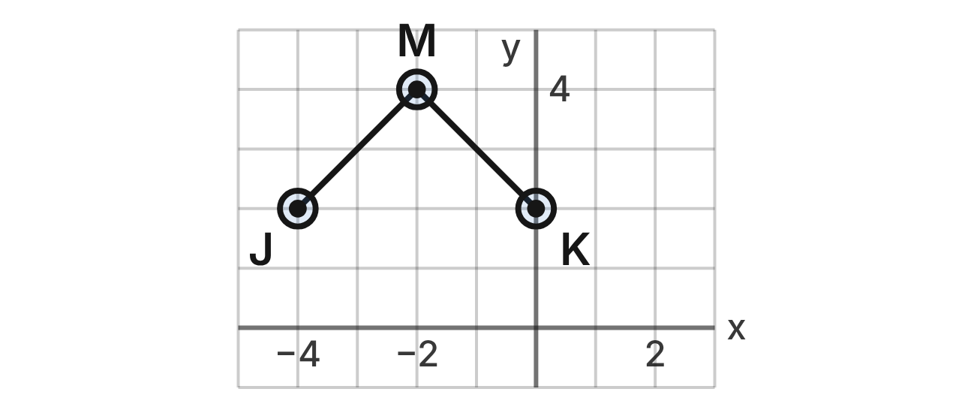
A microscope image of a molecule model is placed on a grid. Atoms J(−4, 2) and K(0, 2) are each bonded to the central atom M(−2, 4). Each bond is 2√2 units long. Zooming in or out is a dilation centered at the origin.
109. The image is zoomed in by a dilation with scale factor 3. What is the image of M?
A. (1, 7)
B. (−6, 4)
C. (−6, 12) ✔
D. (−2/3, 4/3)
G.RLT.3 · skill G.RLT.3.2 (LOTS): Find the image of a figure on the coordinate plane under a translation, reflection, rotation or dilation
☐ Answer key correct ☐ Wording clear Notes: ________________________________
110. The image is zoomed out by a dilation with scale factor 1/2. What is the image of J?
A. (−2, 1) ✔
B. (−8, 4)
C. (−4.5, 1.5)
D. (−2, 2)
G.RLT.3 · skill G.RLT.3.2 (LOTS): Find the image of a figure on the coordinate plane under a translation, reflection, rotation or dilation
☐ Answer key correct ☐ Wording clear Notes: ________________________________
111. How long is each bond in the image after a dilation with scale factor 3?
A. 2√2 units
B. 18√2 units
C. 2√2 + 3 units
D. 6√2 units ✔
G.RLT.3 · skill G.RLT.3.3 (HOTS): Determine the transformation or composition that maps a preimage to an image, and whether it preserves size and shape
☐ Answer key correct ☐ Wording clear Notes: ________________________________
112. A dilation centered at the origin maps J(−4, 2) to (−10, 5). What is its scale factor?
A. 2/5
B. 5/2 ✔
C. 6
D. 3
G.RLT.3 · skill G.RLT.3.3 (HOTS): Determine the transformation or composition that maps a preimage to an image, and whether it preserves size and shape
☐ Answer key correct ☐ Wording clear Notes: ________________________________
113. Which line is a line of symmetry of the molecule model JMK?
A. x = 0
B. y = 3
C. x = −2 ✔
D. y = −x
G.RLT.3 · skill G.RLT.3.1 (LOTS): Identify line symmetry and rotational symmetry of a figure
☐ Answer key correct ☐ Wording clear Notes: ________________________________
114. Which is NOT true of the image of the model after a dilation with scale factor 3 centered at the origin?
A. The angle at M is 3 times as large. ✔
B. Each bond is 3 times as long.
C. The image is similar to the model.
D. Its line of symmetry is x = −6.
G.RLT.3 · skill G.RLT.3.3 (HOTS): Determine the transformation or composition that maps a preimage to an image, and whether it preserves size and shape
☐ Answer key correct ☐ Wording clear Notes: ________________________________

The Satellite and Its Panels
Level 2 · Transformations · G.RLT.3 · ID geo-rlt3-rocks-satellite
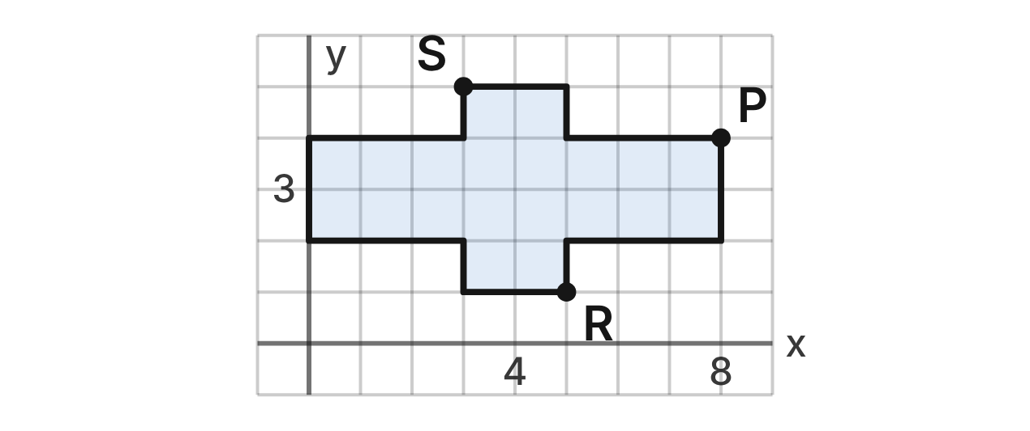
A satellite's outline is drawn on a grid: a body from x = 3 to x = 5 and y = 1 to y = 5, with a solar panel on each side from x = 0 to x = 8 and y = 2 to y = 4. Its center is (4, 3). Corners P(8, 4), R(5, 1) and S(3, 5) are labeled.
115. Which lines are lines of symmetry of the satellite outline?
A. x = 3 and y = 4
B. x = 4 only
C. x = 8 and y = 4
D. x = 4 and y = 3 ✔
G.RLT.3 · skill G.RLT.3.1 (LOTS): Identify line symmetry and rotational symmetry of a figure
☐ Answer key correct ☐ Wording clear Notes: ________________________________
116. Which transformation maps the satellite outline onto itself?
A. Rotation of 90° about (4, 3)
B. Rotation of 180° about (4, 3) ✔
C. Reflection over the line y = x
D. Translation 4 units right
G.RLT.3 · skill G.RLT.3.1 (LOTS): Identify line symmetry and rotational symmetry of a figure
☐ Answer key correct ☐ Wording clear Notes: ________________________________
117. A twin satellite is the mirror image of this one over the line x = 10. What is the image of P?
A. (12, 4) ✔
B. (−8, 4)
C. (8, 16)
D. (18, 4)
G.RLT.3 · skill G.RLT.3.2 (LOTS): Find the image of a figure on the coordinate plane under a translation, reflection, rotation or dilation
☐ Answer key correct ☐ Wording clear Notes: ________________________________
118. What is the image of R after a reflection over the line y = x?
A. (−1, −5)
B. (−5, 1)
C. (1, 5) ✔
D. (5, −1)
G.RLT.3 · skill G.RLT.3.2 (LOTS): Find the image of a figure on the coordinate plane under a translation, reflection, rotation or dilation
☐ Answer key correct ☐ Wording clear Notes: ________________________________
119. What is the image of S after a reflection over the line y = −x?
A. (5, 3)
B. (−3, −5)
C. (−3, 5)
D. (−5, −3) ✔
G.RLT.3 · skill G.RLT.3.2 (LOTS): Find the image of a figure on the coordinate plane under a translation, reflection, rotation or dilation
☐ Answer key correct ☐ Wording clear Notes: ________________________________
120. The outline is reflected over the line y = x. Which is true of the image?
A. It is larger, because it moves farther from the origin.
B. It is congruent to the outline, with its panels running up and down. ✔
C. It lands exactly on the outline, because y = x is a line of symmetry.
D. It is congruent, with its panels still running left and right.
G.RLT.3 · skill G.RLT.3.3 (HOTS): Determine the transformation or composition that maps a preimage to an image, and whether it preserves size and shape
☐ Answer key correct ☐ Wording clear Notes: ________________________________

Docking the Space Capsule
Level 3 · Transformations · G.RLT.3 · ID geo-rlt3-rocks-capsule-dock
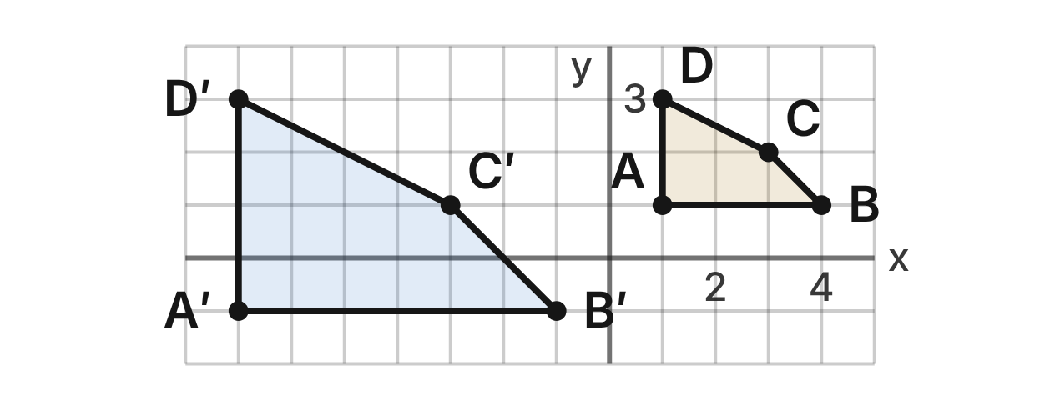
A docking simulation shows a capsule as ABCD: A(1, 1), B(4, 1), C(3, 2) and D(1, 3); its area is 3.5 square units. At the dock it appears as A′B′C′D′: A′(−7, −1), B′(−1, −1), C′(−3, 1) and D′(−7, 3).
121. Which sequence maps ABCD to A′B′C′D′?
A. Translate by (x, y) → (x − 9, y − 3), then dilate by 2 about the origin
B. Dilate by 1/2 about the origin, then translate by (x, y) → (x − 9, y − 3)
C. Dilate by 2 about the origin, then translate by (x, y) → (x − 9, y − 3) ✔
D. Translate by (x, y) → (x − 8, y − 2), with no dilation
G.RLT.3 · skill G.RLT.3.3 (HOTS): Determine the transformation or composition that maps a preimage to an image, and whether it preserves size and shape
☐ Answer key correct ☐ Wording clear Notes: ________________________________
122. Which is true of ABCD and A′B′C′D′?
A. They are similar but not congruent. ✔
B. They are congruent, because a translation is an isometry.
C. They are neither similar nor congruent.
D. They are congruent, because their angles are equal.
G.RLT.3 · skill G.RLT.3.3 (HOTS): Determine the transformation or composition that maps a preimage to an image, and whether it preserves size and shape
☐ Answer key correct ☐ Wording clear Notes: ________________________________
123. What is the area of A′B′C′D′?
A. 7 square units
B. 14 square units ✔
C. 3.5 square units
D. 28 square units
G.RLT.3 · skill G.RLT.3.3 (HOTS): Determine the transformation or composition that maps a preimage to an image, and whether it preserves size and shape
☐ Answer key correct ☐ Wording clear Notes: ________________________________
124. If the translation (x, y) → (x − 9, y − 3) is done first and the dilation by 2 about the origin second, where does C(3, 2) land?
A. (−3, 1)
B. (−3, −0.5)
C. (6, 4)
D. (−12, −2) ✔
G.RLT.3 · skill G.RLT.3.2 (LOTS): Find the image of a figure on the coordinate plane under a translation, reflection, rotation or dilation
☐ Answer key correct ☐ Wording clear Notes: ________________________________
125. Which sequence maps A′B′C′D′ back onto ABCD?
A. Dilate by 1/2 about the origin, then translate by (x, y) → (x + 9, y + 3)
B. Translate by (x, y) → (x + 9, y + 3), then dilate by 1/2 about the origin ✔
C. Translate by (x, y) → (x + 9, y + 3), then dilate by 2 about the origin
D. Translate by (x, y) → (x − 9, y − 3), then dilate by 1/2 about the origin
G.RLT.3 · skill G.RLT.3.3 (HOTS): Determine the transformation or composition that maps a preimage to an image, and whether it preserves size and shape
☐ Answer key correct ☐ Wording clear Notes: ________________________________
126. Before docking, ABCD is rotated 90° clockwise about the origin. What is the image of D?
A. (−3, 1)
B. (3, 1)
C. (3, −1) ✔
D. (−1, −3)
G.RLT.3 · skill G.RLT.3.2 (LOTS): Find the image of a figure on the coordinate plane under a translation, reflection, rotation or dilation
☐ Answer key correct ☐ Wording clear Notes: ________________________________

The Hurricane Symbol
Level 3 · Transformations · G.RLT.3 · ID geo-rlt3-rocks-hurricane
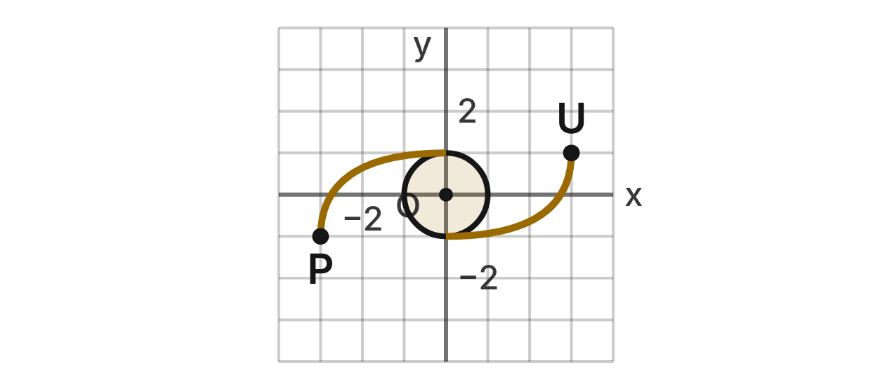
A weather map marks a hurricane with the symbol shown, centered at the origin O. Each arm is the other arm turned 180° about O. The arm tips are P(−3, −1) and U(3, 1). Maps of the Southern Hemisphere use the mirror image of this symbol.
127. What is the order of rotational symmetry of the hurricane symbol about O?
A. 2 ✔
B. 1
C. 4
D. 180
G.RLT.3 · skill G.RLT.3.1 (LOTS): Identify line symmetry and rotational symmetry of a figure
☐ Answer key correct ☐ Wording clear Notes: ________________________________
128. Which describes the line symmetry of the hurricane symbol?
A. The x- and y-axes are lines of symmetry.
B. The line y = x is its only line of symmetry.
C. It has 2 lines of symmetry, one for each arm.
D. It has no lines of symmetry. ✔
G.RLT.3 · skill G.RLT.3.1 (LOTS): Identify line symmetry and rotational symmetry of a figure
☐ Answer key correct ☐ Wording clear Notes: ________________________________
129. The symbol is rotated 90° clockwise about O. What is the image of tip P?
A. (1, −3)
B. (3, 1)
C. (−1, 3) ✔
D. (−1, −3)
G.RLT.3 · skill G.RLT.3.2 (LOTS): Find the image of a figure on the coordinate plane under a translation, reflection, rotation or dilation
☐ Answer key correct ☐ Wording clear Notes: ________________________________
130. The Southern Hemisphere symbol is made by reflecting this symbol over the y-axis. Which is true of it?
A. It is the original turned 180° about O.
B. It is congruent, but no turn of the original matches it. ✔
C. It is the original turned 90° about O.
D. It is smaller than the original.
G.RLT.3 · skill G.RLT.3.3 (HOTS): Determine the transformation or composition that maps a preimage to an image, and whether it preserves size and shape
☐ Answer key correct ☐ Wording clear Notes: ________________________________
131. For a TV map, the symbol is dilated by scale factor 1.5 centered at O. What is the image of tip U?
A. (4.5, 1.5) ✔
B. (4.5, 2.5)
C. (4.5, 1)
D. (6, 2)
G.RLT.3 · skill G.RLT.3.2 (LOTS): Find the image of a figure on the coordinate plane under a translation, reflection, rotation or dilation
☐ Answer key correct ☐ Wording clear Notes: ________________________________
132. The symbol is reflected over the x-axis and then over the y-axis. Which is true?
A. This is a reflection over y = x, so the symbol is mirrored.
B. This is a 90° turn about O, so the arms point a new way.
C. This is a translation, so the symbol moves off O.
D. This is a 180° turn about O, so the symbol lands on itself. ✔
G.RLT.3 · skill G.RLT.3.3 (HOTS): Determine the transformation or composition that maps a preimage to an image, and whether it preserves size and shape
☐ Answer key correct ☐ Wording clear Notes: ________________________________

Triangles (G.TR)

G.TR.1 · Determine the relationships between the measures of angles and lengths of sides in triangles, including problems in context.

The Summer Triangle
Level 1 · Triangles · G.TR.1 · ID geo-tr1-rocks-summer-triangle
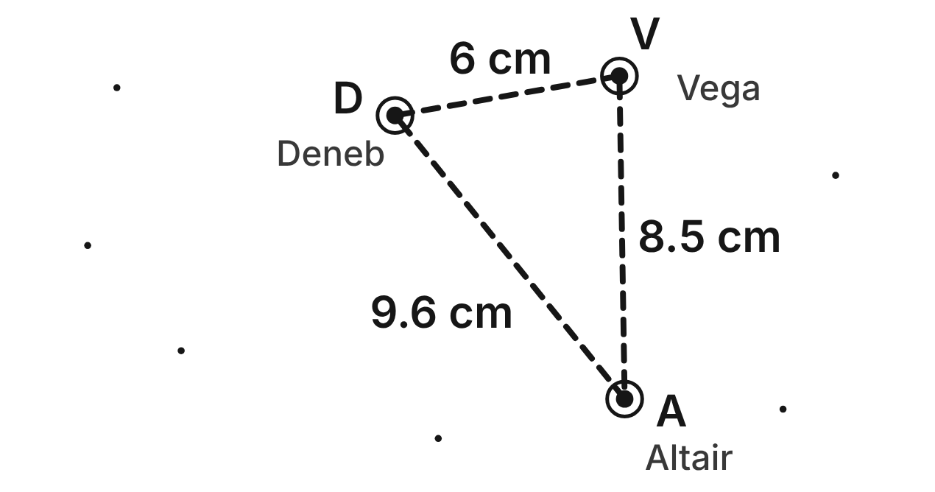
On a star chart, the bright stars V (Vega), D (Deneb) and A (Altair) form the Summer Triangle. The chart distances are VD = 6 cm, VA = 8.5 cm and DA = 9.6 cm.
133. Using only the chart distances, which angle of △VDA has the greatest measure?
A. ∠D
B. ∠A
C. You cannot tell without a protractor.
D. ∠V ✔
G.TR.1 · skill G.TR.1.1 (LOTS): Order the sides of a triangle by length given its angles, or its angles by size given its sides
☐ Answer key correct ☐ Wording clear Notes: ________________________________
134. Using only the chart distances, which statement about the angles must be true?
A. m∠A is greater than m∠D.
B. m∠D is greater than m∠A. ✔
C. m∠A is greater than m∠V.
D. m∠D is greater than m∠V.
G.TR.1 · skill G.TR.1.1 (LOTS): Order the sides of a triangle by length given its angles, or its angles by size given its sides
☐ Answer key correct ☐ Wording clear Notes: ________________________________
135. A student measures m∠V ≈ 81° and m∠D ≈ 61° on the chart. Using these readings, what is m∠A?
A. 142°
B. 119°
C. 38° ✔
D. 99°
G.TR.1 · skill G.TR.1.3 (LOTS): Solve problems using the triangle angle sum and the exterior angle theorem
☐ Answer key correct ☐ Wording clear Notes: ________________________________
136. A fourth star, Albireo, is 5 cm from Vega on the chart. Albireo is not on line VA. Which could be its chart distance from Altair?
A. 10 cm ✔
B. 3.5 cm
C. 13.5 cm
D. 14.6 cm
G.TR.1 · skill G.TR.1.2 (LOTS): Decide whether three lengths can form a triangle and find the range of possible lengths of the third side
☐ Answer key correct ☐ Wording clear Notes: ________________________________
137. Which three chart lengths could NOT be the sides of a triangle?
A. 6 cm, 8.5 cm, 9.6 cm
B. 4 cm, 4 cm, 7 cm
C. 3 cm, 5.5 cm, 8.5 cm ✔
D. 2 cm, 9 cm, 10 cm
G.TR.1 · skill G.TR.1.2 (LOTS): Decide whether three lengths can form a triangle and find the range of possible lengths of the third side
☐ Answer key correct ☐ Wording clear Notes: ________________________________
138. Three other stars form an isosceles triangle on the chart. Its two base angles are each 46°. What is its vertex angle?
A. 134°
B. 46°
C. 92°
D. 88° ✔
G.TR.1 · skill G.TR.1.3 (LOTS): Solve problems using the triangle angle sum and the exterior angle theorem
☐ Answer key correct ☐ Wording clear Notes: ________________________________

The Rocket Fin
Level 1 · Triangles · G.TR.1 · ID geo-tr1-rocks-rocket-fin
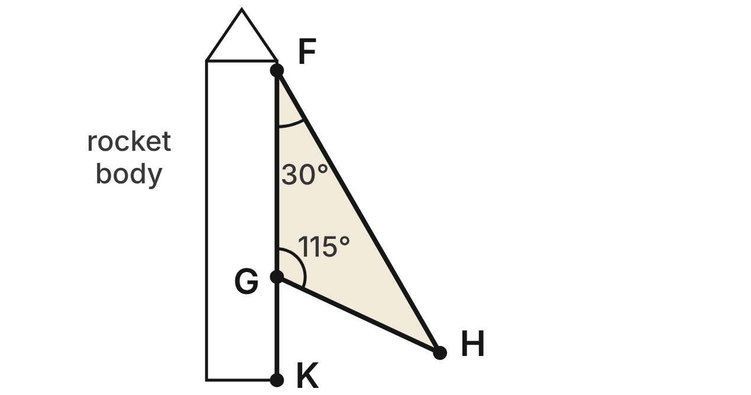
A model rocket fin is the triangle FGH. Its edge FG lies along the rocket's body, and the body line continues straight past G to K. m∠GFH = 30° and m∠FGH = 115°.
139. What is m∠FHG, the angle at the tip of the fin?
A. 35° ✔
B. 65°
C. 145°
D. 150°
G.TR.1 · skill G.TR.1.3 (LOTS): Solve problems using the triangle angle sum and the exterior angle theorem
☐ Answer key correct ☐ Wording clear Notes: ________________________________
140. What is m∠HGK, the angle between the fin edge GH and the body below G?
A. 115°
B. 65° ✔
C. 35°
D. 145°
G.TR.1 · skill G.TR.1.3 (LOTS): Solve problems using the triangle angle sum and the exterior angle theorem
☐ Answer key correct ☐ Wording clear Notes: ________________________________
141. Which equation is true for this fin?
A. m∠HGK = m∠GFH + m∠FGH
B. m∠HGK + m∠FHG = 180°
C. m∠HGK = m∠FGH − m∠GFH
D. m∠HGK = m∠GFH + m∠FHG ✔
G.TR.1 · skill G.TR.1.3 (LOTS): Solve problems using the triangle angle sum and the exterior angle theorem
☐ Answer key correct ☐ Wording clear Notes: ________________________________
142. Which edge of the fin is the longest?
A. FH ✔
B. FG
C. GH
D. FG and GH are the same length
G.TR.1 · skill G.TR.1.1 (LOTS): Order the sides of a triangle by length given its angles, or its angles by size given its sides
☐ Answer key correct ☐ Wording clear Notes: ________________________________
143. Which list orders the edges of the fin from shortest to longest?
A. FH, FG, GH
B. GH, FG, FH ✔
C. FG, GH, FH
D. GH, FH, FG
G.TR.1 · skill G.TR.1.1 (LOTS): Order the sides of a triangle by length given its angles, or its angles by size given its sides
☐ Answer key correct ☐ Wording clear Notes: ________________________________
144. A rocket club cuts fins from balsa strips. Which three strip lengths can form a triangle?
A. 3 cm, 5 cm, 9 cm
B. 4 cm, 6 cm, 10 cm
C. 4 cm, 7 cm, 10 cm ✔
D. 2 cm, 2 cm, 5 cm
G.TR.1 · skill G.TR.1.2 (LOTS): Decide whether three lengths can form a triangle and find the range of possible lengths of the third side
☐ Answer key correct ☐ Wording clear Notes: ________________________________

Tracking a Satellite
Level 2 · Triangles · G.TR.1 · ID geo-tr1-rocks-satellite
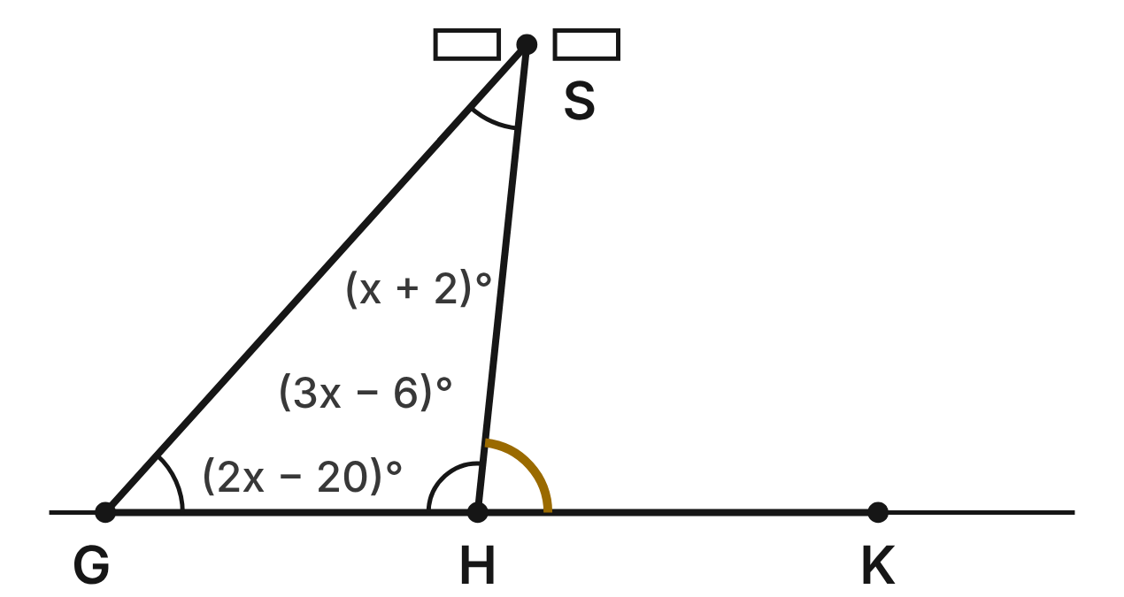
Ground stations G and H track a satellite S. The ground line GH continues straight past H to K. m∠SGH = (2x − 20)°, m∠GHS = (3x − 6)° and m∠GSH = (x + 2)°.
145. Which equation can be used to find x?
A. (x + 2) + (2x − 20) = 3x − 6
B. (x + 2) + (2x − 20) + (3x − 6) = 360
C. (2x − 20) + (3x − 6) = 180
D. (x + 2) + (2x − 20) + (3x − 6) = 180 ✔
G.TR.1 · skill G.TR.1.3 (LOTS): Solve problems using the triangle angle sum and the exterior angle theorem
☐ Answer key correct ☐ Wording clear Notes: ________________________________
146. What is m∠GHS, the angle inside the triangle at station H?
A. 34°
B. 96° ✔
C. 84°
D. 36°
G.TR.1 · skill G.TR.1.3 (LOTS): Solve problems using the triangle angle sum and the exterior angle theorem
☐ Answer key correct ☐ Wording clear Notes: ________________________________
147. Station H measures m∠SHK, the angle from the ground ray HK up to the satellite. What is m∠SHK?
A. 96°
B. 48°
C. 84° ✔
D. 132°
G.TR.1 · skill G.TR.1.3 (LOTS): Solve problems using the triangle angle sum and the exterior angle theorem
☐ Answer key correct ☐ Wording clear Notes: ________________________________
148. Which of the three distances GH, HS and GS is the longest?
A. GS ✔
B. HS
C. GH
D. HS and GS are equal
G.TR.1 · skill G.TR.1.1 (LOTS): Order the sides of a triangle by length given its angles, or its angles by size given its sides
☐ Answer key correct ☐ Wording clear Notes: ________________________________
149. Which list orders GH, HS and GS from shortest to longest?
A. GS, HS, GH
B. HS, GH, GS
C. GH, HS, GS ✔
D. GH, GS, HS
G.TR.1 · skill G.TR.1.1 (LOTS): Order the sides of a triangle by length given its angles, or its angles by size given its sides
☐ Answer key correct ☐ Wording clear Notes: ________________________________
150. Which statement about △GHS is NOT true?
A. ∠GSH is the smallest angle of △GHS.
B. GS is shorter than HS. ✔
C. HS is longer than GH.
D. m∠SHK = m∠SGH + m∠GSH
G.TR.1 · skill G.TR.1.1 (LOTS): Order the sides of a triangle by length given its angles, or its angles by size given its sides
☐ Answer key correct ☐ Wording clear Notes: ________________________________

The Lab Truss
Level 2 · Triangles · G.TR.1 · ID geo-tr1-rocks-lab-truss
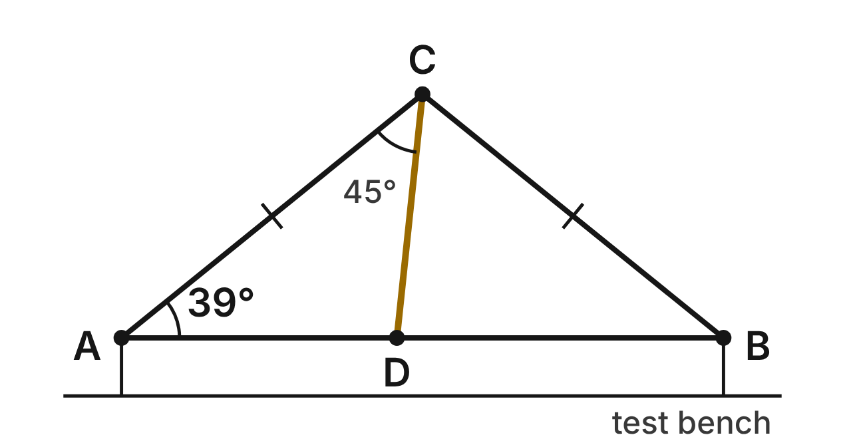
A truss for a bridge-strength lab is the triangle ABC, with CA ≅ CB. A strut runs from C to D on the base AB. m∠CAB = 39° and m∠ACD = 45°.
151. What is m∠ACB, the angle at the top of the truss?
A. 141°
B. 78°
C. 45°
D. 102° ✔
G.TR.1 · skill G.TR.1.3 (LOTS): Solve problems using the triangle angle sum and the exterior angle theorem
☐ Answer key correct ☐ Wording clear Notes: ________________________________
152. What is m∠CDB, the angle between the strut and DB?
A. 84° ✔
B. 96°
C. 57°
D. 78°
G.TR.1 · skill G.TR.1.3 (LOTS): Solve problems using the triangle angle sum and the exterior angle theorem
☐ Answer key correct ☐ Wording clear Notes: ________________________________
153. In △BCD, which list orders the sides from shortest to longest?
A. BC, BD, CD
B. BD, CD, BC
C. CD, BD, BC ✔
D. CD, BC, BD
G.TR.1 · skill G.TR.1.1 (LOTS): Order the sides of a triangle by length given its angles, or its angles by size given its sides
☐ Answer key correct ☐ Wording clear Notes: ________________________________
154. Which statement about the truss is true?
A. AD is the longest side of △ACD.
B. CD is the shortest side of △ACD. ✔
C. CD is longer than BC.
D. AC is shorter than AD.
G.TR.1 · skill G.TR.1.1 (LOTS): Order the sides of a triangle by length given its angles, or its angles by size given its sides
☐ Answer key correct ☐ Wording clear Notes: ________________________________
155. A student builds another truss triangle with members of 14 cm and 23 cm. What is the shortest whole-number length the third member can have?
A. 9 cm
B. 37 cm
C. 36 cm
D. 10 cm ✔
G.TR.1 · skill G.TR.1.2 (LOTS): Decide whether three lengths can form a triangle and find the range of possible lengths of the third side
☐ Answer key correct ☐ Wording clear Notes: ________________________________
156. Suppose the strut is moved so that m∠ACD = 51°, and the base angles stay 39°. What is m∠CDB then?
A. 90° ✔
B. 84°
C. 12°
D. 129°
G.TR.1 · skill G.TR.1.3 (LOTS): Solve problems using the triangle angle sum and the exterior angle theorem
☐ Answer key correct ☐ Wording clear Notes: ________________________________

Weather Stations and a Storm
Level 2 · Triangles · G.TR.1 · ID geo-tr1-rocks-weather-stations
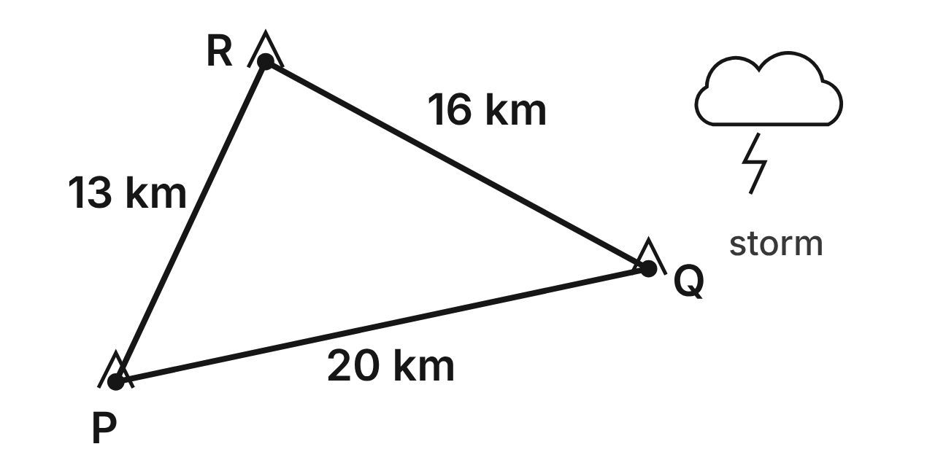
Weather stations P, Q and R track storms. The straight-line distances are PQ = 20 km, QR = 16 km and PR = 13 km.
157. Which angle of △PQR is the largest?
A. ∠P
B. ∠R ✔
C. ∠Q
D. You cannot tell without a protractor.
G.TR.1 · skill G.TR.1.1 (LOTS): Order the sides of a triangle by length given its angles, or its angles by size given its sides
☐ Answer key correct ☐ Wording clear Notes: ________________________________
158. A lightning strike is not on line PQ. Which pair of distances, from P and from Q, could the two stations report?
A. 12 km from P and 9 km from Q ✔
B. 6 km from P and 13 km from Q
C. 5 km from P and 26 km from Q
D. 10 km from P and 10 km from Q
G.TR.1 · skill G.TR.1.2 (LOTS): Decide whether three lengths can form a triangle and find the range of possible lengths of the third side
☐ Answer key correct ☐ Wording clear Notes: ________________________________
159. A new station T will be 7 km from P. T, P and Q will not lie on one line. Which inequality gives all possible distances d from T to Q, in km?
A. 0 < d < 27
B. 7 < d < 20
C. 13 < d < 27 ✔
D. 13 < d < 20
G.TR.1 · skill G.TR.1.2 (LOTS): Decide whether three lengths can form a triangle and find the range of possible lengths of the third side
☐ Answer key correct ☐ Wording clear Notes: ________________________________
160. Another station U is planned with PU = (x + 5) km and QU = (2x − 3) km, so that P, Q and U form a triangle. Which inequality gives all possible values of x?
A. x > 6
B. x < 28
C. −12 < x < 28
D. 6 < x < 28 ✔
G.TR.1 · skill G.TR.1.2 (LOTS): Decide whether three lengths can form a triangle and find the range of possible lengths of the third side
☐ Answer key correct ☐ Wording clear Notes: ________________________________
161. A forecaster measures m∠P ≈ 53° and m∠Q ≈ 40°. Using these, what is m∠R?
A. 93°
B. 127°
C. 87° ✔
D. 140°
G.TR.1 · skill G.TR.1.3 (LOTS): Solve problems using the triangle angle sum and the exterior angle theorem
☐ Answer key correct ☐ Wording clear Notes: ________________________________
162. Which list orders the angles of △PQR from smallest to largest?
A. ∠R, ∠P, ∠Q
B. ∠P, ∠Q, ∠R
C. ∠Q, ∠R, ∠P
D. ∠Q, ∠P, ∠R ✔
G.TR.1 · skill G.TR.1.1 (LOTS): Order the sides of a triangle by length given its angles, or its angles by size given its sides
☐ Answer key correct ☐ Wording clear Notes: ________________________________

The Volcano Cross Section
Level 3 · Triangles · G.TR.1 · ID geo-tr1-rocks-volcano
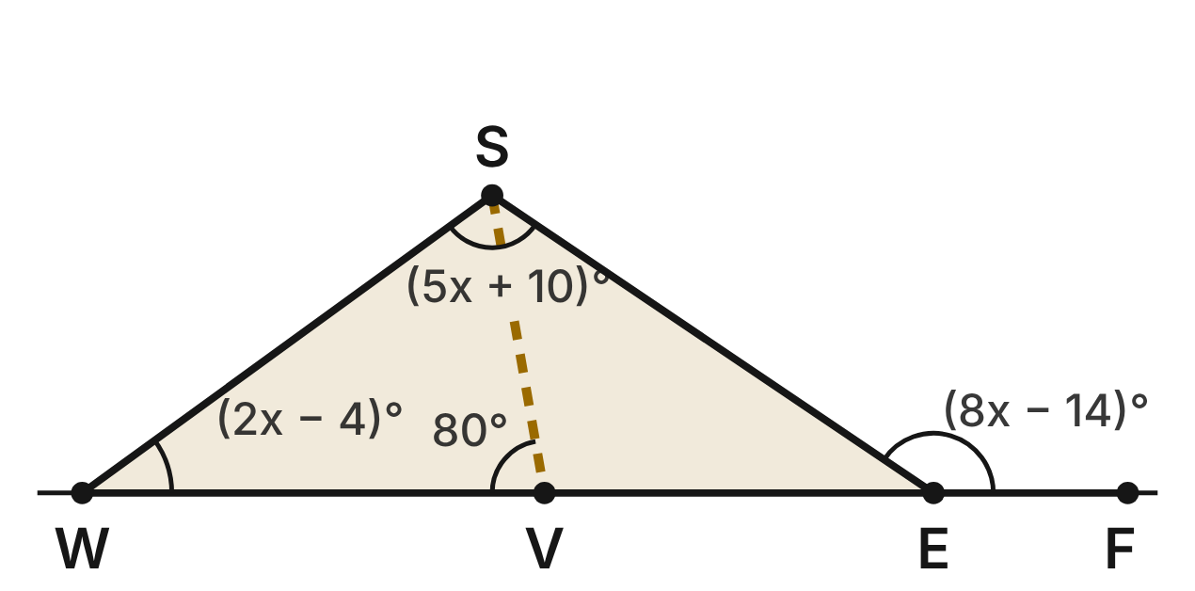
A cross section of a volcano is the triangle WSE, with summit S. The ground line WE continues straight past E to F. m∠SWE = (2x − 4)°, m∠WSE = (5x + 10)° and m∠SEF = (8x − 14)°. A lava tube runs straight from S to V on WE, with m∠SVW = 80°.
163. What is m∠SEF?
A. 20°
B. 146° ✔
C. 34°
D. 110°
G.TR.1 · skill G.TR.1.3 (LOTS): Solve problems using the triangle angle sum and the exterior angle theorem
☐ Answer key correct ☐ Wording clear Notes: ________________________________
164. What is m∠WSE, the angle at the summit?
A. 110° ✔
B. 20°
C. 70°
D. 90°
G.TR.1 · skill G.TR.1.3 (LOTS): Solve problems using the triangle angle sum and the exterior angle theorem
☐ Answer key correct ☐ Wording clear Notes: ________________________________
165. Which list orders SW, SE and WE from shortest to longest?
A. SE, SW, WE
B. WE, SE, SW
C. SW, WE, SE
D. SW, SE, WE ✔
G.TR.1 · skill G.TR.1.1 (LOTS): Order the sides of a triangle by length given its angles, or its angles by size given its sides
☐ Answer key correct ☐ Wording clear Notes: ________________________________
166. What is m∠VSE, the angle between the lava tube and the slope SE?
A. 100°
B. 46° ✔
C. 64°
D. 114°
G.TR.1 · skill G.TR.1.3 (LOTS): Solve problems using the triangle angle sum and the exterior angle theorem
☐ Answer key correct ☐ Wording clear Notes: ________________________________
167. Which of the segments SV, SW and SE is the shortest?
A. SV ✔
B. SW
C. SE
D. SV and SW are the same length
G.TR.1 · skill G.TR.1.1 (LOTS): Order the sides of a triangle by length given its angles, or its angles by size given its sides
☐ Answer key correct ☐ Wording clear Notes: ________________________________
168. Another volcano's cross section is a triangle with slopes of 4 km and 6 km and a base of (3n − 2) km. Which inequality gives all possible values of n?
A. 2 < n < 10
B. n < 4
C. 4/3 < n < 4 ✔
D. 0 < n < 8/3
G.TR.1 · skill G.TR.1.2 (LOTS): Decide whether three lengths can form a triangle and find the range of possible lengths of the third side
☐ Answer key correct ☐ Wording clear Notes: ________________________________

The Laser and the Mirror
Level 3 · Triangles · G.TR.1 · ID geo-tr1-rocks-laser-mirror
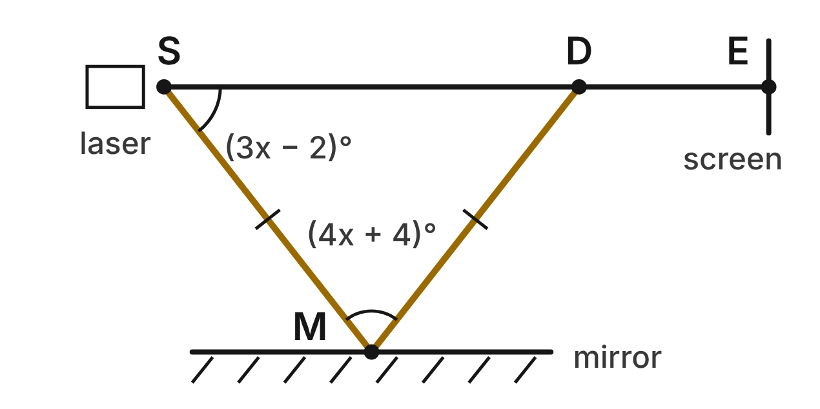
In a lab, a laser beam goes from the source S to a flat mirror at M and reflects to the detector D, so SM ≅ MD. The straight line SD continues past D to a screen at E. m∠SMD = (4x + 4)° and m∠MSD = (3x − 2)°.
169. Which equation models the angles of △SMD?
A. (4x + 4) + 2(3x − 2) = 180 ✔
B. (4x + 4) + (3x − 2) = 180
C. 4x + 4 = 3x − 2
D. (4x + 4) + 2(3x − 2) = 360
G.TR.1 · skill G.TR.1.3 (LOTS): Solve problems using the triangle angle sum and the exterior angle theorem
☐ Answer key correct ☐ Wording clear Notes: ________________________________
170. What is m∠SMD, the angle between the two beams at the mirror?
A. 18°
B. 76° ✔
C. 52°
D. 104°
G.TR.1 · skill G.TR.1.3 (LOTS): Solve problems using the triangle angle sum and the exterior angle theorem
☐ Answer key correct ☐ Wording clear Notes: ________________________________
171. What is m∠MDE?
A. 52°
B. 76°
C. 128° ✔
D. 104°
G.TR.1 · skill G.TR.1.3 (LOTS): Solve problems using the triangle angle sum and the exterior angle theorem
☐ Answer key correct ☐ Wording clear Notes: ________________________________
172. Which statement about the lengths is true?
A. SM is longer than SD.
B. SD is shorter than MD.
C. All three are the same length.
D. SD is longer than SM. ✔
G.TR.1 · skill G.TR.1.1 (LOTS): Order the sides of a triangle by length given its angles, or its angles by size given its sides
☐ Answer key correct ☐ Wording clear Notes: ________________________________
173. The mirror is turned so that m∠SMD = 60°, and SM and MD stay equal. Which describes △SMD then?
A. Isosceles only: each base angle is 30°
B. Right: its angles are 60°, 90° and 30°
C. Equilateral: each base angle is also 60° ✔
D. Isosceles only: each base angle is 120°
G.TR.1 · skill G.TR.1.3 (LOTS): Solve problems using the triangle angle sum and the exterior angle theorem
☐ Answer key correct ☐ Wording clear Notes: ________________________________
174. In a new setup, SM = MD = (y + 4) cm and SD = 30 cm. Which inequality gives all possible values of y?
A. y > 13
B. y > 11 ✔
C. y > 26
D. y < 11
G.TR.1 · skill G.TR.1.2 (LOTS): Decide whether three lengths can form a triangle and find the range of possible lengths of the third side
☐ Answer key correct ☐ Wording clear Notes: ________________________________

G.TR.2 · Prove two triangles are congruent, using direct and indirect proofs, and solve problems involving measured attributes of congruent triangles.

Brackets on the Solar Farm
Level 1 · Triangles · G.TR.2 · ID geo-tr2-rocks-solar-brackets
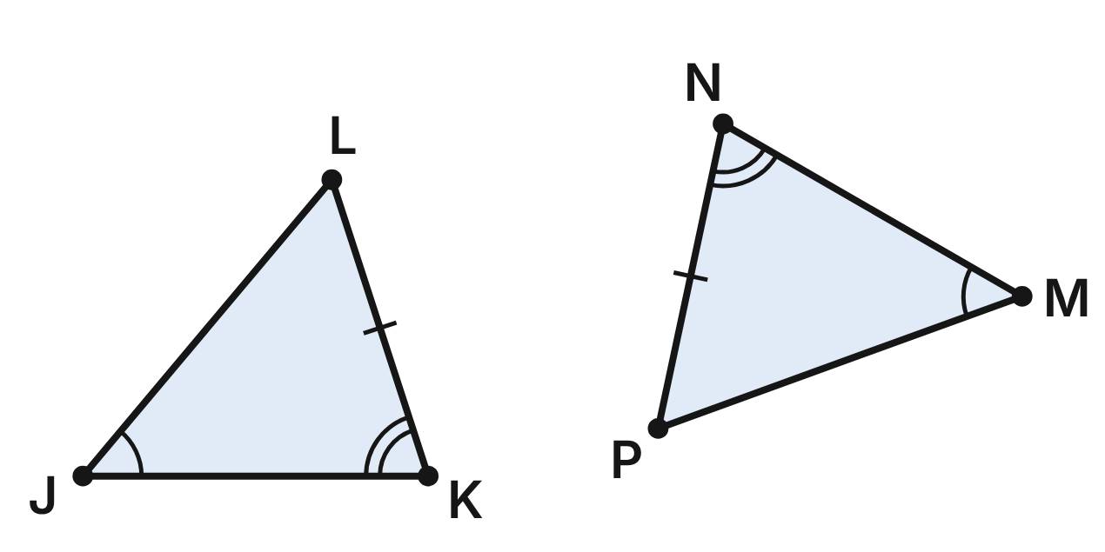
Two triangular brackets, △JKL and △MNP, hold up panels on a solar farm. The second one was bolted on turned around. The marks show ∠J ≅ ∠M, ∠K ≅ ∠N and KL ≅ NP.
175. Which shortcut do the marks support directly for △JKL ≅ △MNP?
A. ASA
B. SSA
C. AAS ✔
D. AAA
G.TR.2 · skill G.TR.2.1 (LOTS): Identify the congruence criterion (SSS, SAS, ASA, AAS, HL) that the given information supports, and recognize when none does
☐ Answer key correct ☐ Wording clear Notes: ________________________________
176. m∠J = 50° and m∠K = 72°. What is m∠P?
A. 58° ✔
B. 72°
C. 50°
D. 122°
G.TR.2 · skill G.TR.2.3 (LOTS): Solve problems, including algebraic ones, using corresponding parts of congruent triangles
☐ Answer key correct ☐ Wording clear Notes: ________________________________
177. Keep ∠J ≅ ∠M and ∠K ≅ ∠N. Which pair of sides would prove the brackets congruent by ASA instead?
A. KL ≅ NP
B. JK ≅ MN ✔
C. JL ≅ MP
D. KL ≅ MP
G.TR.2 · skill G.TR.2.1 (LOTS): Identify the congruence criterion (SSS, SAS, ASA, AAS, HL) that the given information supports, and recognize when none does
☐ Answer key correct ☐ Wording clear Notes: ________________________________
178. KL = 36 cm and NP = (3x − 6) cm. What is x?
A. 10
B. 12
C. 42
D. 14 ✔
G.TR.2 · skill G.TR.2.3 (LOTS): Solve problems, including algebraic ones, using corresponding parts of congruent triangles
☐ Answer key correct ☐ Wording clear Notes: ________________________________
179. Which set of facts would NOT prove another bracket congruent to △JKL?
A. Its three sides match △JKL's sides
B. Two angles and a non-included side match
C. Two sides and the included angle match
D. Its three angles match △JKL's angles ✔
G.TR.2 · skill G.TR.2.1 (LOTS): Identify the congruence criterion (SSS, SAS, ASA, AAS, HL) that the given information supports, and recognize when none does
☐ Answer key correct ☐ Wording clear Notes: ________________________________
180. Rosa writes: ∠J ≅ ∠M and ∠K ≅ ∠N, so ∠L ≅ ∠P (Third Angles Theorem). Then ∠K, KL and ∠L give ASA. Is her proof valid?
A. Yes; KL lies between ∠K and ∠L ✔
B. No; ASA needs side JK
C. No; that theorem is only for right triangles
D. No; she has only SSA
G.TR.2 · skill G.TR.2.2 (HOTS): Complete or justify a direct or indirect proof that two triangles are congruent
☐ Answer key correct ☐ Wording clear Notes: ________________________________

Four Satellites, One Orbit
Level 1 · Triangles · G.TR.2 · ID geo-tr2-rocks-orbit
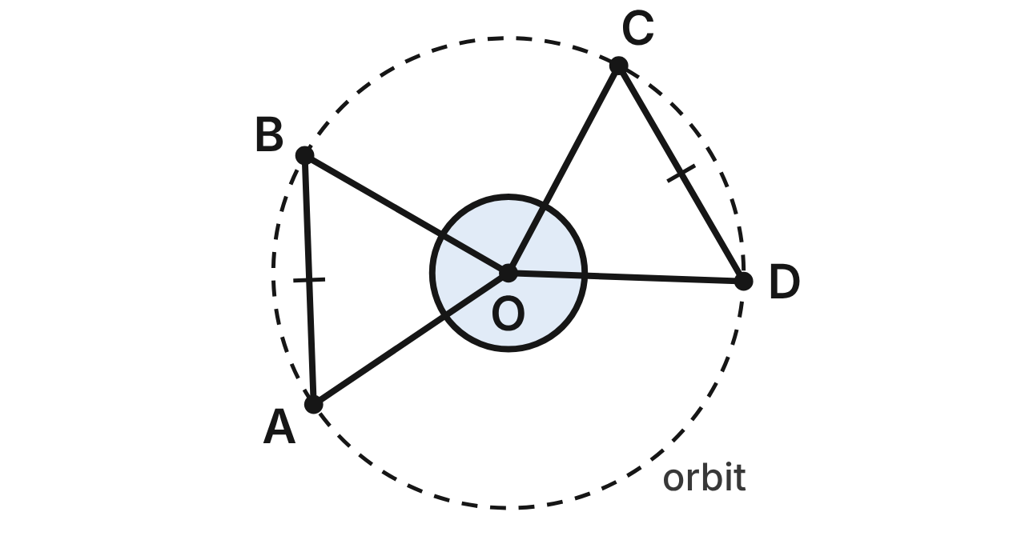
Satellites A, B, C and D travel on a circular orbit with center O. The straight-line distances AB and CD are equal.
181. Which criterion proves △AOB ≅ △COD?
A. SAS
B. SSS ✔
C. HL
D. AAA
G.TR.2 · skill G.TR.2.1 (LOTS): Identify the congruence criterion (SSS, SAS, ASA, AAS, HL) that the given information supports, and recognize when none does
☐ Answer key correct ☐ Wording clear Notes: ________________________________
182. Why is OA ≅ OC?
A. Reflexive property of congruence
B. Vertical angles are congruent
C. All radii of a circle are congruent ✔
D. Definition of congruent chords
G.TR.2 · skill G.TR.2.2 (HOTS): Complete or justify a direct or indirect proof that two triangles are congruent
☐ Answer key correct ☐ Wording clear Notes: ________________________________
183. m∠AOB = 64°. What is m∠OCD?
A. 64°
B. 116°
C. 26°
D. 58° ✔
G.TR.2 · skill G.TR.2.3 (LOTS): Solve problems, including algebraic ones, using corresponding parts of congruent triangles
☐ Answer key correct ☐ Wording clear Notes: ________________________________
184. AB = (3x + 200) km and CD = (5x − 1,800) km. How far apart are satellites A and B?
A. 3,200 km ✔
B. 1,000 km
C. 950 km
D. 6,400 km
G.TR.2 · skill G.TR.2.3 (LOTS): Solve problems, including algebraic ones, using corresponding parts of congruent triangles
☐ Answer key correct ☐ Wording clear Notes: ________________________________
185. Suppose the orbit were not a circle, and you knew only that OA ≅ OC and AB ≅ CD. What could you conclude about △AOB and △COD?
A. Not enough to prove congruence ✔
B. They are congruent by SSS
C. They are congruent by SAS
D. They are congruent by HL
G.TR.2 · skill G.TR.2.1 (LOTS): Identify the congruence criterion (SSS, SAS, ASA, AAS, HL) that the given information supports, and recognize when none does
☐ Answer key correct ☐ Wording clear Notes: ________________________________
186. Which statement is NOT necessarily true?
A. ∠OAB ≅ ∠OCD
B. ∠AOB ≅ ∠COD
C. AB ∥ CD ✔
D. OB ≅ OD
G.TR.2 · skill G.TR.2.3 (LOTS): Solve problems, including algebraic ones, using corresponding parts of congruent triangles
☐ Answer key correct ☐ Wording clear Notes: ________________________________

Braces on the Weather Shelter
Level 2 · Triangles · G.TR.2 · ID geo-tr2-rocks-weather-shelter
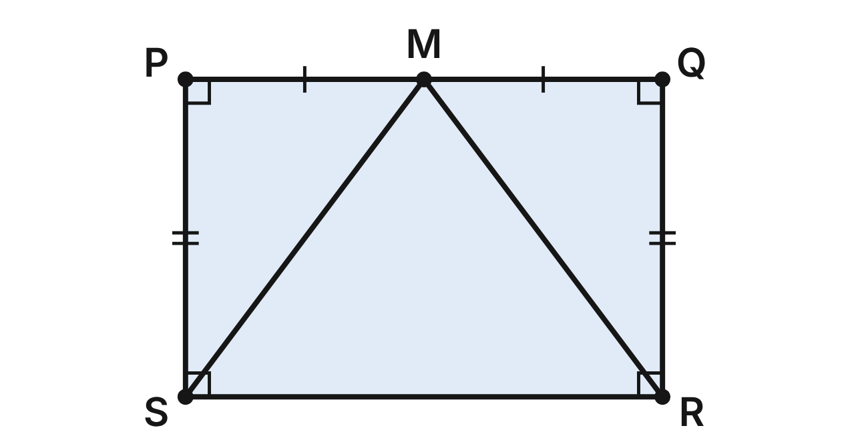
The front of a weather station shelter is the rectangle PQRS. M is the midpoint of the top edge PQ. Braces MS and MR run to the bottom corners. Prove that MS ≅ MR.
Statement | Reason
1. PQRS is a rectangle; M is the midpoint of PQ | Given
2. PM ≅ QM | (a) ____
3. ∠P ≅ ∠Q | All right angles are congruent
4. PS ≅ QR | Opposite sides of a rectangle are congruent
5. △MPS ≅ △MQR | (b) ____
6. MS ≅ MR | CPCTC

187. Which reason justifies step 2, PM ≅ QM (blank a)?
A. Reflexive property
B. Definition of midpoint ✔
C. Segment Addition Postulate
D. Definition of right angle
G.TR.2 · skill G.TR.2.2 (HOTS): Complete or justify a direct or indirect proof that two triangles are congruent
☐ Answer key correct ☐ Wording clear Notes: ________________________________
188. Which reason justifies step 5, △MPS ≅ △MQR (blank b)?
A. SSA
B. ASA
C. HL
D. SAS ✔
G.TR.2 · skill G.TR.2.2 (HOTS): Complete or justify a direct or indirect proof that two triangles are congruent
☐ Answer key correct ☐ Wording clear Notes: ________________________________
189. MS = (5y − 10) in. and MR = (3y + 6) in. How long is brace MS?
A. 8 in.
B. 60 in.
C. 30 in. ✔
D. 40 in.
G.TR.2 · skill G.TR.2.3 (LOTS): Solve problems, including algebraic ones, using corresponding parts of congruent triangles
☐ Answer key correct ☐ Wording clear Notes: ________________________________
190. The shelter is 36 in. wide (PQ) and 24 in. tall (PS). How many inches of brace do MS and MR use together?
A. 60 in. ✔
B. 30 in.
C. 84 in.
D. about 86.5 in.
G.TR.2 · skill G.TR.2.3 (LOTS): Solve problems, including algebraic ones, using corresponding parts of congruent triangles
☐ Answer key correct ☐ Wording clear Notes: ________________________________
191. Suppose PQRS were not a rectangle, but you knew PM ≅ QM, PS ≅ QR and MS ≅ MR. Which criterion would prove △MPS ≅ △MQR?
A. SAS
B. HL
C. ASA
D. SSS ✔
G.TR.2 · skill G.TR.2.1 (LOTS): Identify the congruence criterion (SSS, SAS, ASA, AAS, HL) that the given information supports, and recognize when none does
☐ Answer key correct ☐ Wording clear Notes: ________________________________
192. Lee says step 5 could use HL instead, because ∠P and ∠Q are right angles. What is wrong with his idea?
A. HL works only for isosceles triangles
B. ∠P and ∠Q are not right angles
C. HL needs MS ≅ MR, the thing being proved ✔
D. HL needs two pairs of angles
G.TR.2 · skill G.TR.2.2 (HOTS): Complete or justify a direct or indirect proof that two triangles are congruent
☐ Answer key correct ☐ Wording clear Notes: ________________________________

The Probe's Lines of Sight
Level 2 · Triangles · G.TR.2 · ID geo-tr2-rocks-probe-tangents
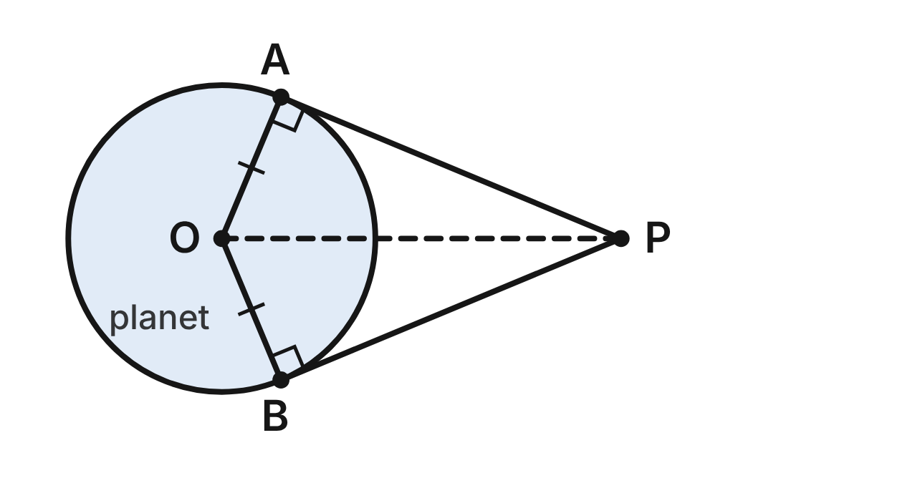
A space probe P sees the edges of a planet at A and B. The lines of sight PA and PB are tangent to the planet's circular outline, which has center O.
193. Why are ∠OAP and ∠OBP right angles?
A. A tangent is ⊥ to the radius at its endpoint ✔
B. All radii of a circle are congruent
C. Vertical angles are congruent
D. The two lines of sight are the same length
G.TR.2 · skill G.TR.2.2 (HOTS): Complete or justify a direct or indirect proof that two triangles are congruent
☐ Answer key correct ☐ Wording clear Notes: ________________________________
194. Which criterion proves △OAP ≅ △OBP most directly?
A. SSA
B. HL ✔
C. ASA
D. AAA
G.TR.2 · skill G.TR.2.1 (LOTS): Identify the congruence criterion (SSS, SAS, ASA, AAS, HL) that the given information supports, and recognize when none does
☐ Answer key correct ☐ Wording clear Notes: ________________________________
195. The planet's radius OA is 2,500 km, and OP = 6,500 km. How far is the probe from B (PB)?
A. 4,000 km
B. about 6,964 km
C. 2,500 km
D. 6,000 km ✔
G.TR.2 · skill G.TR.2.3 (LOTS): Solve problems, including algebraic ones, using corresponding parts of congruent triangles
☐ Answer key correct ☐ Wording clear Notes: ________________________________
196. m∠APO ≈ 22.6°. To the nearest tenth of a degree, what is m∠AOB?
A. 67.4°
B. 45.2°
C. 134.8° ✔
D. 157.4°
G.TR.2 · skill G.TR.2.3 (LOTS): Solve problems, including algebraic ones, using corresponding parts of congruent triangles
☐ Answer key correct ☐ Wording clear Notes: ________________________________
197. Mo says, “Each triangle shows only two sides and a non-included angle, so they cannot be proved congruent.” Why is he wrong?
A. The angle is a right angle, so HL applies ✔
B. Two sides are always enough
C. OP is not a side of either triangle
D. The triangles share ∠AOB
G.TR.2 · skill G.TR.2.2 (HOTS): Complete or justify a direct or indirect proof that two triangles are congruent
☐ Answer key correct ☐ Wording clear Notes: ________________________________
198. Without using the right angles, which fact together with OA ≅ OB and OP ≅ OP would prove △OAP ≅ △OBP by SAS?
A. ∠APO ≅ ∠BPO
B. ∠AOP ≅ ∠BOP ✔
C. PA ≅ PB
D. ∠OAP ≅ ∠OBP
G.TR.2 · skill G.TR.2.1 (LOTS): Identify the congruence criterion (SSS, SAS, ASA, AAS, HL) that the given information supports, and recognize when none does
☐ Answer key correct ☐ Wording clear Notes: ________________________________

Triangles on the Star Chart
Level 2 · Triangles · G.TR.2 · ID geo-tr2-rocks-star-chart
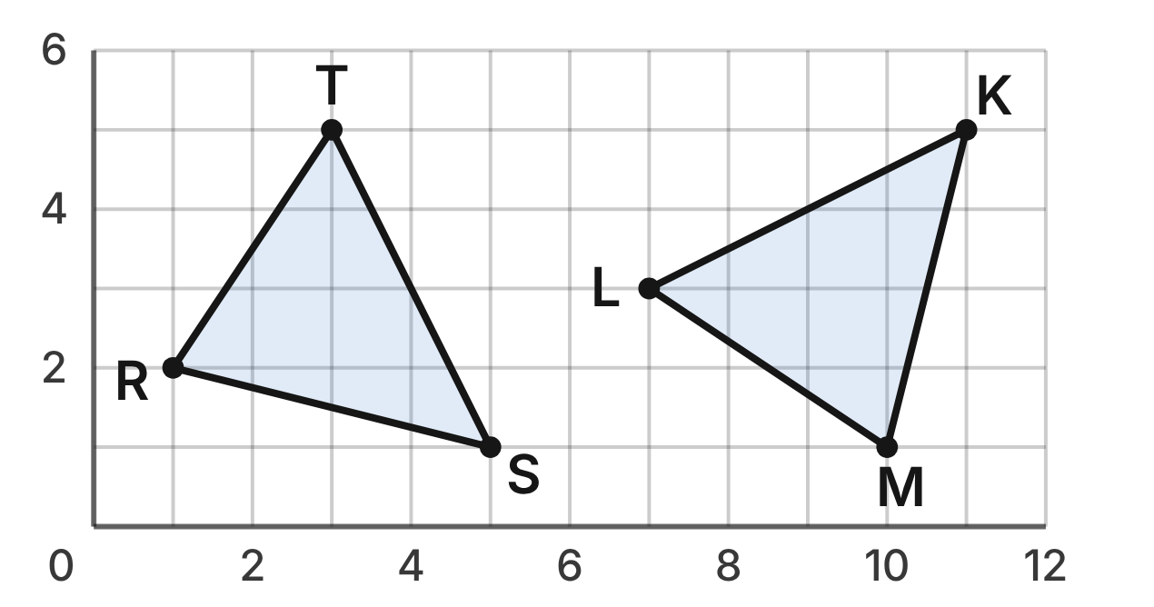
A planetarium star chart shows two triangles of stars on a grid: R(1, 2), S(5, 1), T(3, 5) and M(10, 1), K(11, 5), L(7, 3).
199. What is the length of ST, in grid units?
A. 6
B. 20
C. 2√5 ✔
D. 2√3
G.TR.2 · skill G.TR.2.3 (LOTS): Solve problems, including algebraic ones, using corresponding parts of congruent triangles
☐ Answer key correct ☐ Wording clear Notes: ________________________________
200. Dana finds RS = MK, ST = KL and RT = ML. What can she conclude?
A. △RST ≅ △MKL by SSS ✔
B. △RST ≅ △KLM by SSS
C. Only that the triangles are similar
D. Nothing until she measures an angle
G.TR.2 · skill G.TR.2.1 (LOTS): Identify the congruence criterion (SSS, SAS, ASA, AAS, HL) that the given information supports, and recognize when none does
☐ Answer key correct ☐ Wording clear Notes: ________________________________
201. Which angle is congruent to ∠S?
A. ∠L
B. ∠K ✔
C. ∠M
D. ∠T
G.TR.2 · skill G.TR.2.3 (LOTS): Solve problems, including algebraic ones, using corresponding parts of congruent triangles
☐ Answer key correct ☐ Wording clear Notes: ________________________________
202. Ravi finds KL = √((11 − 7) + (5 − 3)) = √6, so he decides the triangles are not congruent. What is his error?
A. He subtracted the coordinates
B. He should have added the coordinates
C. He chose the wrong pair of points
D. He did not square the differences ✔
G.TR.2 · skill G.TR.2.2 (HOTS): Complete or justify a direct or indirect proof that two triangles are congruent
☐ Answer key correct ☐ Wording clear Notes: ________________________________
203. △MKL is △RST turned 90°. Which statement about their sides is true?
A. RS ∥ MK
B. ST ∥ KL
C. RS ⊥ MK ✔
D. RT ∥ ML
G.TR.2 · skill G.TR.2.3 (LOTS): Solve problems, including algebraic ones, using corresponding parts of congruent triangles
☐ Answer key correct ☐ Wording clear Notes: ________________________________
204. Dana knows only RS = MK = √17 and ST = KL = 2√5. Which one more fact would let her use SAS?
A. ∠S ≅ ∠K ✔
B. ∠R ≅ ∠M
C. ∠T ≅ ∠L
D. RT = ML
G.TR.2 · skill G.TR.2.1 (LOTS): Identify the congruence criterion (SSS, SAS, ASA, AAS, HL) that the given information supports, and recognize when none does
☐ Answer key correct ☐ Wording clear Notes: ________________________________

The Radio Telescope Frame
Level 3 · Triangles · G.TR.2 · ID geo-tr2-rocks-telescope-struts
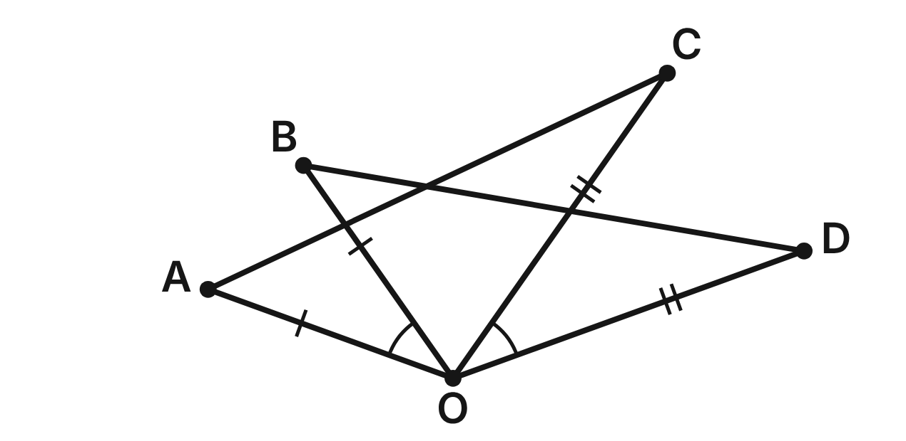
Struts OA, OB, OC and OD meet at the hub O of a radio telescope frame, with OA ≅ OB, OC ≅ OD and ∠AOB ≅ ∠COD. Prove that the cables AC and BD are congruent.
Statement | Reason
1. OA ≅ OB; OC ≅ OD; ∠AOB ≅ ∠COD | Given
2. m∠AOB + m∠BOC = m∠COD + m∠BOC | (a) ____
3. m∠AOC = m∠BOD | Angle Addition Postulate
4. △AOC ≅ △BOD | (b) ____
5. AC ≅ BD | CPCTC

205. Which reason justifies step 2 (blank a)?
A. Angle Addition Postulate
B. Reflexive property
C. Vertical angles are congruent
D. Addition property of equality ✔
G.TR.2 · skill G.TR.2.2 (HOTS): Complete or justify a direct or indirect proof that two triangles are congruent
☐ Answer key correct ☐ Wording clear Notes: ________________________________
206. Which reason justifies step 4, △AOC ≅ △BOD (blank b)?
A. SAS ✔
B. SSA
C. ASA
D. SSS
G.TR.2 · skill G.TR.2.2 (HOTS): Complete or justify a direct or indirect proof that two triangles are congruent
☐ Answer key correct ☐ Wording clear Notes: ________________________________
207. m∠AOB = (2k + 9)°, m∠COD = (4k − 17)° and m∠BOC = 70°. What is m∠BOD?
A. 35°
B. 83°
C. 105° ✔
D. 140°
G.TR.2 · skill G.TR.2.3 (LOTS): Solve problems, including algebraic ones, using corresponding parts of congruent triangles
☐ Answer key correct ☐ Wording clear Notes: ________________________________
208. Suppose you did not know ∠AOB ≅ ∠COD, but you knew AC ≅ BD. Which criterion would prove △AOC ≅ △BOD?
A. SAS
B. HL
C. SSS ✔
D. ASA
G.TR.2 · skill G.TR.2.1 (LOTS): Identify the congruence criterion (SSS, SAS, ASA, AAS, HL) that the given information supports, and recognize when none does
☐ Answer key correct ☐ Wording clear Notes: ________________________________
209. A second frame has the same layout, with OA = OB and OC = OD, but AC = 5.1 m and BD = 4.8 m. To prove indirectly that ∠AOB ≇ ∠COD, what should you assume first?
A. AC ≅ BD
B. ∠AOB ≅ ∠COD ✔
C. ∠AOB ≇ ∠COD
D. OA ≇ OB
G.TR.2 · skill G.TR.2.2 (HOTS): Complete or justify a direct or indirect proof that two triangles are congruent
☐ Answer key correct ☐ Wording clear Notes: ________________________________
210. A second frame has OA = OB and OC = OD, but AC = 5.1 m and BD = 4.8 m. Mia assumes ∠AOB ≅ ∠COD. Which result contradicts the facts?
A. The Angle Addition Postulate gives ∠AOC ≅ ∠BOD
B. OA = OB gives OA = OC
C. SSA gives △AOB ≅ △COD
D. SAS and CPCTC give AC = BD ✔
G.TR.2 · skill G.TR.2.2 (HOTS): Complete or justify a direct or indirect proof that two triangles are congruent
☐ Answer key correct ☐ Wording clear Notes: ________________________________

The Pentagon Crystal Face
Level 3 · Triangles · G.TR.2 · ID geo-tr2-rocks-crystal-face
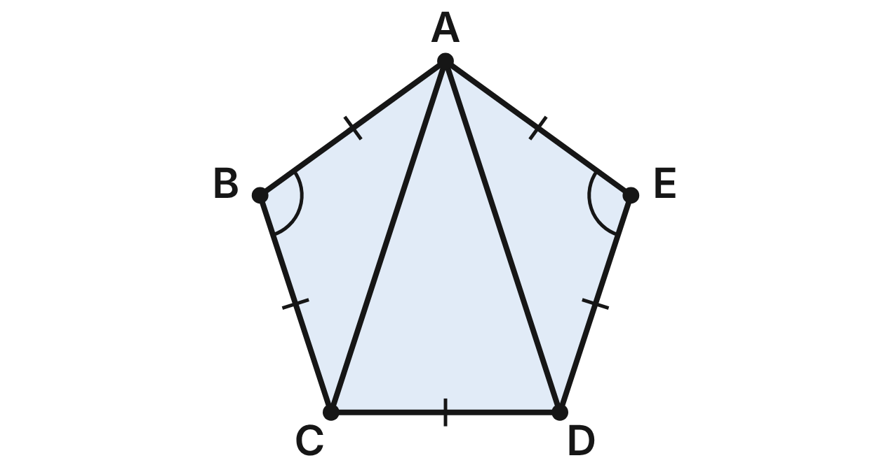
One face of a model crystal is the regular pentagon ABCDE: all five sides are congruent and each angle measures 108°. Diagonals AC and AD are drawn from A.
211. Which criterion shows △ABC ≅ △AED?
A. SSA
B. ASA
C. SAS ✔
D. HL
G.TR.2 · skill G.TR.2.1 (LOTS): Identify the congruence criterion (SSS, SAS, ASA, AAS, HL) that the given information supports, and recognize when none does
☐ Answer key correct ☐ Wording clear Notes: ________________________________
212. Each angle of the pentagon measures 108°. What is m∠BAC?
A. 36° ✔
B. 72°
C. 54°
D. 108°
G.TR.2 · skill G.TR.2.3 (LOTS): Solve problems, including algebraic ones, using corresponding parts of congruent triangles
☐ Answer key correct ☐ Wording clear Notes: ________________________________
213. Each angle of the pentagon measures 108°. Since AC ≅ AD, what is m∠ACD?
A. 36°
B. 108°
C. 54°
D. 72° ✔
G.TR.2 · skill G.TR.2.3 (LOTS): Solve problems, including algebraic ones, using corresponding parts of congruent triangles
☐ Answer key correct ☐ Wording clear Notes: ________________________________
214. AC = (5n − 4) mm and AD = (3n + 10) mm. How long is diagonal AC?
A. 7 mm
B. 31 mm ✔
C. 11 mm
D. 62 mm
G.TR.2 · skill G.TR.2.3 (LOTS): Solve problems, including algebraic ones, using corresponding parts of congruent triangles
☐ Answer key correct ☐ Wording clear Notes: ________________________________
215. After proving △ABC ≅ △AED, which statement is NOT a result of CPCTC?
A. AC ≅ AD
B. AC ≅ CD ✔
C. ∠BCA ≅ ∠EDA
D. ∠BAC ≅ ∠EAD
G.TR.2 · skill G.TR.2.3 (LOTS): Solve problems, including algebraic ones, using corresponding parts of congruent triangles
☐ Answer key correct ☐ Wording clear Notes: ________________________________
216. Another face ABCDE has AB = AE and BC = ED, but m∠B = 110° and m∠E = 104°. Lin assumes AC = AD. Which reasoning gives her contradiction?
A. SAS gives △ABC ≅ △AED, so AC = AD
B. SSA gives △ABC ≅ △AED, so ∠B ≅ ∠E
C. AAA gives △ABC ≅ △AED, so AB = AE
D. SSS gives △ABC ≅ △AED, so ∠B ≅ ∠E ✔
G.TR.2 · skill G.TR.2.2 (HOTS): Complete or justify a direct or indirect proof that two triangles are congruent
☐ Answer key correct ☐ Wording clear Notes: ________________________________

G.TR.3 · Prove two triangles are similar, using direct and indirect proofs, and solve problems involving measured attributes of similar triangles.

The Model Rocket's Fins
Level 1 · Triangles · G.TR.3 · ID geo-tr3-rocks-rocket-fins
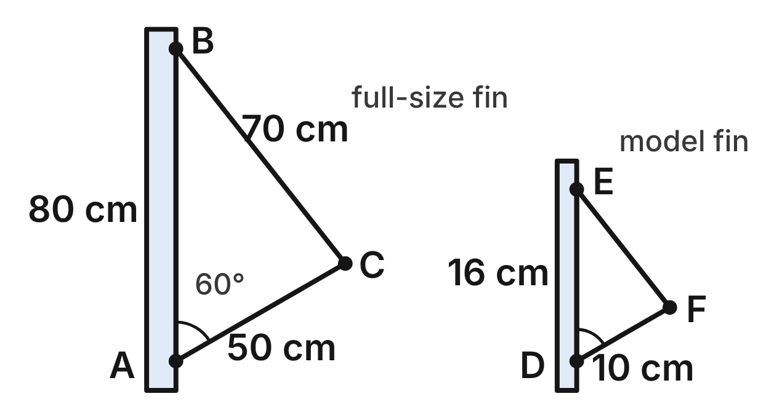
Not drawn to scale
A rocket fin is △ABC, with AB along the rocket's body: AB = 80 cm, AC = 50 cm, BC = 70 cm and m∠A = 60°. A model rocket's fin is △DEF, with DE along its body: DE = 16 cm, DF = 10 cm and m∠D = 60°.
217. Which similarity criterion do the two 60° angles and the sides beside them support?
A. SSS∼
B. SAS∼ ✔
C. AA
D. SAS
G.TR.3 · skill G.TR.3.1 (LOTS): Identify the similarity criterion (AA, SSS, SAS) that the given information supports
☐ Answer key correct ☐ Wording clear Notes: ________________________________
218. Which statement matches the vertices of the two fins correctly?
A. △CAB ∼ △EDF
B. △ABC ∼ △DFE
C. △CAB ∼ △FDE ✔
D. △BAC ∼ △FDE
G.TR.3 · skill G.TR.3.1 (LOTS): Identify the similarity criterion (AA, SSS, SAS) that the given information supports
☐ Answer key correct ☐ Wording clear Notes: ________________________________
219. What is the scale factor from the full-size fin to the model fin?
A. 1/5 ✔
B. 5
C. 8/5
D. 5/8
G.TR.3 · skill G.TR.3.3 (LOTS): Solve problems, including contextual ones, using proportional sides of similar triangles
☐ Answer key correct ☐ Wording clear Notes: ________________________________
220. How long is the model fin's edge EF?
A. 6 cm
B. 350 cm
C. 30 cm
D. 14 cm ✔
G.TR.3 · skill G.TR.3.3 (LOTS): Solve problems, including contextual ones, using proportional sides of similar triangles
☐ Answer key correct ☐ Wording clear Notes: ________________________________
221. What is the perimeter of the model fin △DEF?
A. 8 cm
B. 40 cm ✔
C. 26 cm
D. 1000 cm
G.TR.3 · skill G.TR.3.3 (LOTS): Solve problems, including contextual ones, using proportional sides of similar triangles
☐ Answer key correct ☐ Wording clear Notes: ________________________________
222. A second model fin △GHJ has GH = 24 cm, GJ = 16 cm and m∠G = 60°. Is it similar to △ABC? Choose the answer with the correct reason.
A. No; 24/80 ≠ 16/50 ✔
B. Yes; 24/80 = 16/50
C. Yes; 24/16 = 80/50
D. No; GH must be 16 cm
G.TR.3 · skill G.TR.3.2 (HOTS): Justify that two triangles are similar, or are not, using angle measures or side ratios
☐ Answer key correct ☐ Wording clear Notes: ________________________________

The Pinhole Camera
Level 1 · Triangles · G.TR.3 · ID geo-tr3-rocks-pinhole
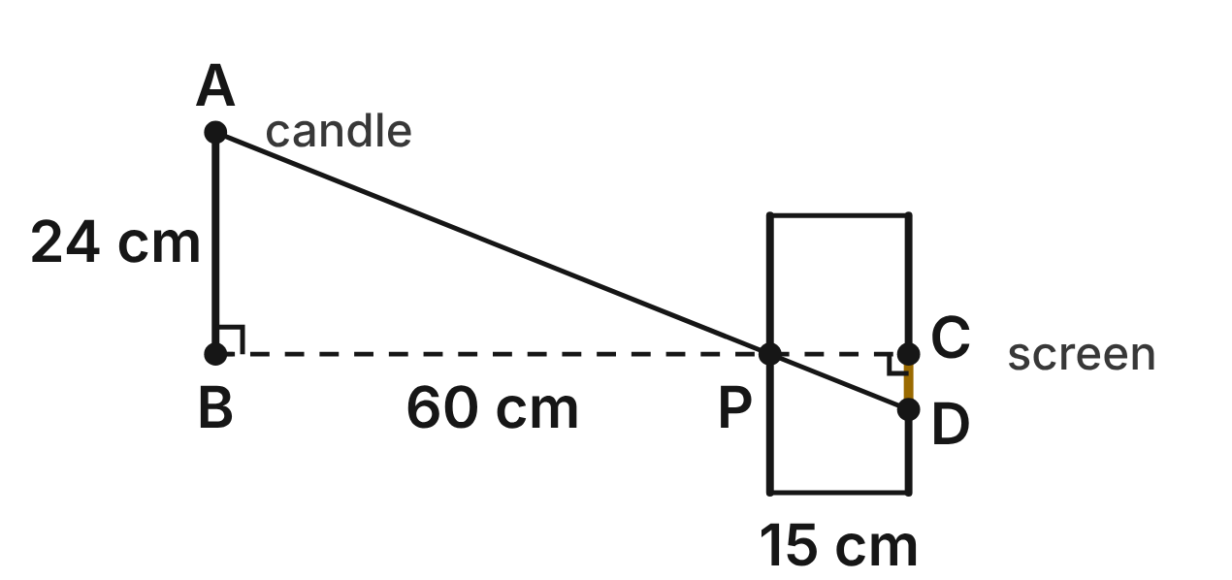
In the science lab, a candle AB, 24 cm tall, stands 60 cm from the pinhole P of a box camera. P is level with the candle's base B. Light from the top A passes through P to D on the back screen, which is 15 cm behind P. The upside-down image is CD. AB and CD are vertical, and BC is level.
223. Why is the candle's triangle at P similar to the image's triangle at P?
A. SAS∼: PB/PC = 60/15 and the right angles
B. SSS∼: all three sides of each are known
C. AA: right angles at B and C, vertical angles at P ✔
D. AA: ∠A ≅ ∠C, since AB ∥ CD
G.TR.3 · skill G.TR.3.1 (LOTS): Identify the similarity criterion (AA, SSS, SAS) that the given information supports
☐ Answer key correct ☐ Wording clear Notes: ________________________________
224. Which similarity statement pairs the candle's triangle with the image's triangle correctly?
A. △ABP ∼ △CDP
B. △APB ∼ △DCP
C. △BAP ∼ △DCP
D. △ABP ∼ △DCP ✔
G.TR.3 · skill G.TR.3.1 (LOTS): Identify the similarity criterion (AA, SSS, SAS) that the given information supports
☐ Answer key correct ☐ Wording clear Notes: ________________________________
225. How tall is the image CD?
A. 6 cm ✔
B. 96 cm
C. 37.5 cm
D. 1.5 cm
G.TR.3 · skill G.TR.3.3 (LOTS): Solve problems, including contextual ones, using proportional sides of similar triangles
☐ Answer key correct ☐ Wording clear Notes: ________________________________
226. What is the scale factor from the candle's triangle to the image's triangle?
A. 4
B. 1/5
C. 1/4 ✔
D. 45
G.TR.3 · skill G.TR.3.3 (LOTS): Solve problems, including contextual ones, using proportional sides of similar triangles
☐ Answer key correct ☐ Wording clear Notes: ________________________________
227. A student moves the candle so that it stands 40 cm from P, still level with P. How tall is the new image?
A. 6 cm
B. 9 cm ✔
C. 64 cm
D. 16 cm
G.TR.3 · skill G.TR.3.3 (LOTS): Solve problems, including contextual ones, using proportional sides of similar triangles
☐ Answer key correct ☐ Wording clear Notes: ________________________________
228. Which statement is NOT true for this camera?
A. AB/CD = PB/PC
B. ∠A ≅ ∠D
C. PA = 4 · PD
D. AB/CD = PC/PB ✔
G.TR.3 · skill G.TR.3.2 (HOTS): Justify that two triangles are similar, or are not, using angle measures or side ratios
☐ Answer key correct ☐ Wording clear Notes: ________________________________

Shadows on the Moon
Level 2 · Triangles · G.TR.3 · ID geo-tr3-rocks-moon-shadows
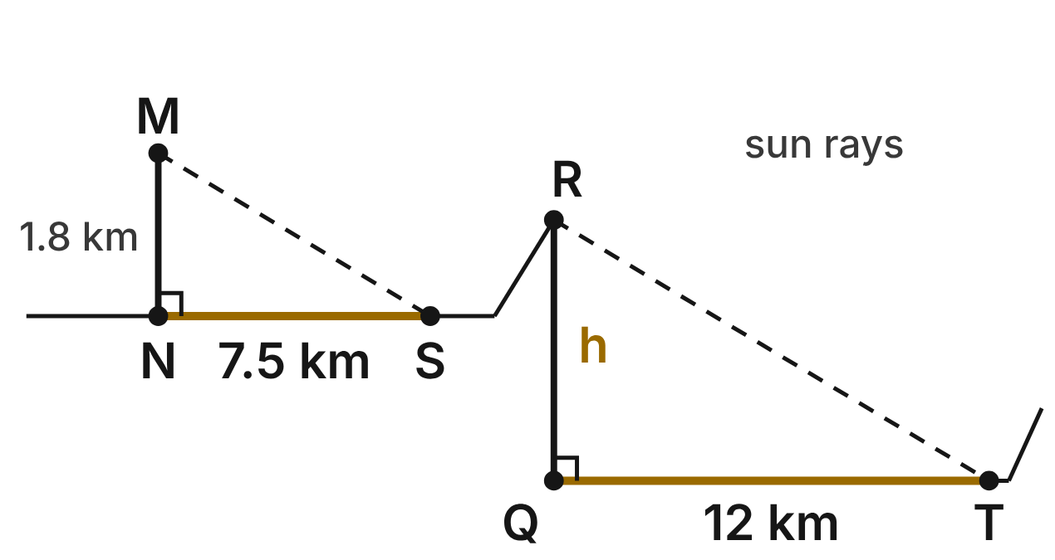
Not drawn to scale
In a photo of the Moon, the Sun is low. A peak M stands 1.8 km above N on the flat plain, and its shadow NS is 7.5 km long. At the same moment, the rim R of a crater stands h km above Q on the flat crater floor, and its shadow QT is 12 km long. MN and RQ are vertical, and the sun rays MS and RT are parallel.
229. Why is the peak's triangle similar to the rim's triangle?
A. AA: right angles at N and Q, and ∠S ≅ ∠T ✔
B. SAS∼: NS/QT = 7.5/12 and the right angles
C. SSS∼: all three sides of each are known
D. HL: both are right triangles
G.TR.3 · skill G.TR.3.1 (LOTS): Identify the similarity criterion (AA, SSS, SAS) that the given information supports
☐ Answer key correct ☐ Wording clear Notes: ________________________________
230. How high is the crater rim above the floor (h)?
A. about 1.1 km
B. 50 km
C. 2.88 km ✔
D. 6.3 km
G.TR.3 · skill G.TR.3.3 (LOTS): Solve problems, including contextual ones, using proportional sides of similar triangles
☐ Answer key correct ☐ Wording clear Notes: ________________________________
231. In the same photo, a hill on the flat plain casts a shadow 5 km long. How tall is the hill?
A. 2.7 km
B. 1.2 km ✔
C. about 20.8 km
D. 0.75 km
G.TR.3 · skill G.TR.3.3 (LOTS): Solve problems, including contextual ones, using proportional sides of similar triangles
☐ Answer key correct ☐ Wording clear Notes: ________________________________
232. Which similarity statement matches the peak's triangle to the rim's triangle?
A. △SNM ∼ △TQR ✔
B. △SNM ∼ △RQT
C. △MSN ∼ △RQT
D. △NMS ∼ △QTR
G.TR.3 · skill G.TR.3.1 (LOTS): Identify the similarity criterion (AA, SSS, SAS) that the given information supports
☐ Answer key correct ☐ Wording clear Notes: ________________________________
233. A student reads another peak in the same photo as 2.4 km tall with a 9-km shadow. Can both numbers be right? Choose the answer with the correct reason.
A. Yes; 2.4/1.8 = 9/7.5
B. Yes; 2.4/9 = 1.8/7.5
C. No; taller peaks cast shorter shadows
D. No; 2.4/9 ≠ 1.8/7.5 ✔
G.TR.3 · skill G.TR.3.2 (HOTS): Justify that two triangles are similar, or are not, using angle measures or side ratios
☐ Answer key correct ☐ Wording clear Notes: ________________________________
234. What is the scale factor from the peak's triangle to the rim's triangle?
A. 0.625
B. 4.5
C. 1.6 ✔
D. 2.56
G.TR.3 · skill G.TR.3.3 (LOTS): Solve problems, including contextual ones, using proportional sides of similar triangles
☐ Answer key correct ☐ Wording clear Notes: ________________________________

The Physics Lab Ramp
Level 2 · Triangles · G.TR.3 · ID geo-tr3-rocks-lab-ramp
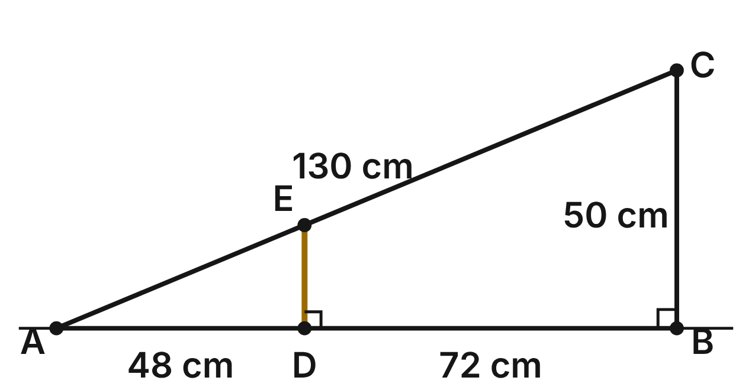
A physics lab ramp is the right triangle ABC: floor AB, support BC and ramp AC, with the right angle at B. A post DE stands straight up from D on the floor to E on the ramp, so DE ⊥ AB. AD = 48 cm, DB = 72 cm, BC = 50 cm and AC = 130 cm.
235. Why is the small triangle cut off by the post similar to the whole ramp triangle?
A. SSS∼: AD/DB = AE/EC = DE/BC
B. AA: ∠A ≅ ∠C, and both have a right angle
C. ASA: ∠A is shared, and DE ∥ BC
D. AA: shared ∠A and right angles at D and B ✔
G.TR.3 · skill G.TR.3.1 (LOTS): Identify the similarity criterion (AA, SSS, SAS) that the given information supports
☐ Answer key correct ☐ Wording clear Notes: ________________________________
236. How tall is the post DE?
A. 30 cm
B. 20 cm ✔
C. 125 cm
D. about 33.3 cm
G.TR.3 · skill G.TR.3.3 (LOTS): Solve problems, including contextual ones, using proportional sides of similar triangles
☐ Answer key correct ☐ Wording clear Notes: ________________________________
237. How far is it along the ramp from E up to C?
A. 78 cm ✔
B. 52 cm
C. 58 cm
D. 195 cm
G.TR.3 · skill G.TR.3.3 (LOTS): Solve problems, including contextual ones, using proportional sides of similar triangles
☐ Answer key correct ☐ Wording clear Notes: ________________________________
238. Jo adds a slanted brace FG, with F on AB, G on AC, AF = 90 cm and AG = 100 cm. Is FG parallel to BC? Choose the answer with the correct reason.
A. Yes; 90/100 = 120/130
B. Yes; 90/120 = 100/130
C. No; a brace must start at the middle of AB
D. No; 90/120 ≠ 100/130 ✔
G.TR.3 · skill G.TR.3.2 (HOTS): Justify that two triangles are similar, or are not, using angle measures or side ratios
☐ Answer key correct ☐ Wording clear Notes: ________________________________
239. What is the perimeter of △ADE?
A. 48 cm
B. 750 cm
C. 120 cm ✔
D. 200 cm
G.TR.3 · skill G.TR.3.3 (LOTS): Solve problems, including contextual ones, using proportional sides of similar triangles
☐ Answer key correct ☐ Wording clear Notes: ________________________________
240. Which similarity statement for the post's triangle and the whole ramp is correct?
A. △EDA ∼ △BCA
B. △EDA ∼ △CBA ✔
C. △DEA ∼ △CBA
D. △EAD ∼ △CBA
G.TR.3 · skill G.TR.3.1 (LOTS): Identify the similarity criterion (AA, SSS, SAS) that the given information supports
☐ Answer key correct ☐ Wording clear Notes: ________________________________

The Telescope's Light Cone
Level 2 · Triangles · G.TR.3 · ID geo-tr3-rocks-telescope
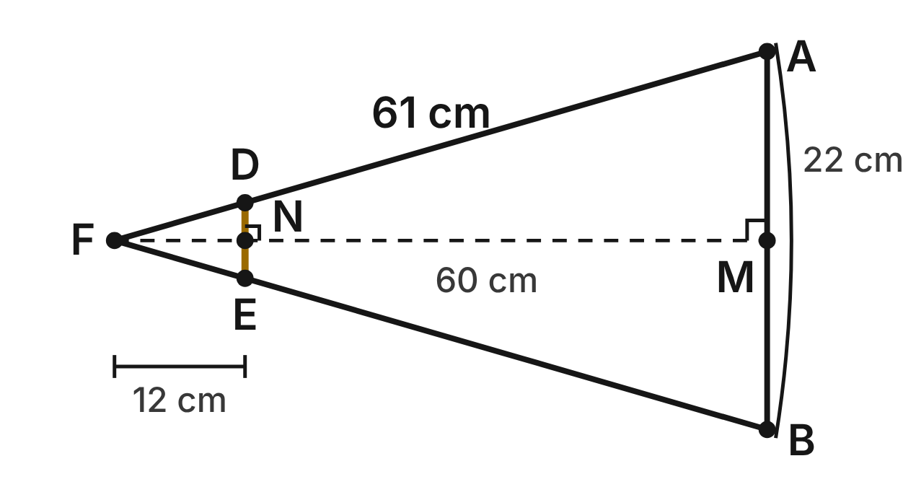
Not drawn to scale
In a telescope, light bounces off the main mirror AB, 22 cm across, and meets at the focus F. The axis FM is perpendicular to AB at its midpoint M. FM = 60 cm and FA = FB = 61 cm. A small flat mirror DE crosses the cone, parallel to AB, with its midpoint N on FM and FN = 12 cm.
241. Which criterion shows that the small mirror's half-cone triangle is similar to the main mirror's?
A. AA ✔
B. SAS∼
C. SSS∼
D. ASA
G.TR.3 · skill G.TR.3.1 (LOTS): Identify the similarity criterion (AA, SSS, SAS) that the given information supports
☐ Answer key correct ☐ Wording clear Notes: ________________________________
242. How wide is the small mirror DE?
A. 2.2 cm
B. 110 cm
C. 5.5 cm
D. 4.4 cm ✔
G.TR.3 · skill G.TR.3.3 (LOTS): Solve problems, including contextual ones, using proportional sides of similar triangles
☐ Answer key correct ☐ Wording clear Notes: ________________________________
243. How long is FD?
A. 13 cm
B. 12.2 cm ✔
C. 305 cm
D. 48.8 cm
G.TR.3 · skill G.TR.3.3 (LOTS): Solve problems, including contextual ones, using proportional sides of similar triangles
☐ Answer key correct ☐ Wording clear Notes: ________________________________
244. A larger telescope has a light cone the same shape, with a main mirror 33 cm across. What is its distance FM?
A. 71 cm
B. 40 cm
C. 90 cm ✔
D. 91.5 cm
G.TR.3 · skill G.TR.3.3 (LOTS): Solve problems, including contextual ones, using proportional sides of similar triangles
☐ Answer key correct ☐ Wording clear Notes: ________________________________
245. Which statement is NOT true for this light cone?
A. FN/FM = DE/AB
B. ∠FDE ≅ ∠FAB
C. FD/DA = FN/NM
D. DE/AB = FD/DA ✔
G.TR.3 · skill G.TR.3.2 (HOTS): Justify that two triangles are similar, or are not, using angle measures or side ratios
☐ Answer key correct ☐ Wording clear Notes: ________________________________
246. Which similarity statement for the two right triangles along the axis is correct?
A. △FND ∼ △FMA ✔
B. △FND ∼ △FAM
C. △FDN ∼ △FMA
D. △NFD ∼ △FMA
G.TR.3 · skill G.TR.3.1 (LOTS): Identify the similarity criterion (AA, SSS, SAS) that the given information supports
☐ Answer key correct ☐ Wording clear Notes: ________________________________

The Summer Triangle
Level 2 · Triangles · G.TR.3 · ID geo-tr3-rocks-summer-triangle
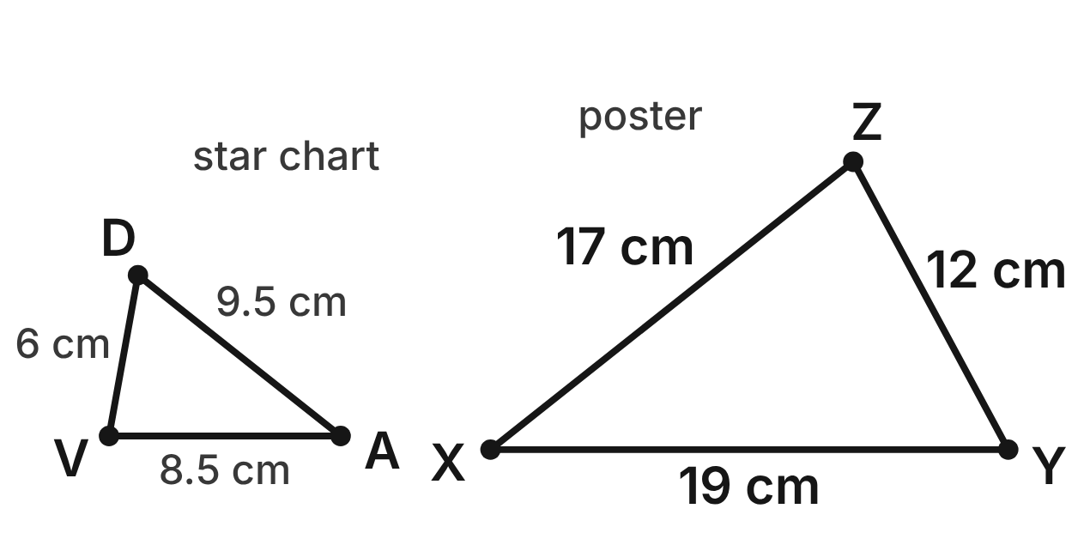
On a star chart, the Summer Triangle joins the stars Vega (V), Deneb (D) and Altair (A): VD = 6 cm, VA = 8.5 cm and DA = 9.5 cm. Sam draws △XYZ on a poster from memory: XY = 19 cm, YZ = 12 cm and XZ = 17 cm.
247. Which criterion shows that the chart triangle is similar to Sam's poster triangle?
A. SAS∼
B. AA
C. SSS∼ ✔
D. SSS
G.TR.3 · skill G.TR.3.1 (LOTS): Identify the similarity criterion (AA, SSS, SAS) that the given information supports
☐ Answer key correct ☐ Wording clear Notes: ________________________________
248. Which similarity statement matches the chart triangle to Sam's triangle?
A. △VDA ∼ △XYZ
B. △VDA ∼ △ZYX ✔
C. △VDA ∼ △YZX
D. △VDA ∼ △ZXY
G.TR.3 · skill G.TR.3.1 (LOTS): Identify the similarity criterion (AA, SSS, SAS) that the given information supports
☐ Answer key correct ☐ Wording clear Notes: ________________________________
249. What is the scale factor from the chart triangle to the poster triangle?
A. 2 ✔
B. 1/2
C. 6
D. 4
G.TR.3 · skill G.TR.3.3 (LOTS): Solve problems, including contextual ones, using proportional sides of similar triangles
☐ Answer key correct ☐ Wording clear Notes: ________________________________
250. Which angle of the poster triangle is congruent to the angle at Vega, ∠DVA?
A. ∠X
B. ∠Y
C. None; the sizes differ
D. ∠Z ✔
G.TR.3 · skill G.TR.3.1 (LOTS): Identify the similarity criterion (AA, SSS, SAS) that the given information supports
☐ Answer key correct ☐ Wording clear Notes: ________________________________
251. Leo draws the Summer Triangle with sides of 15 cm, 21 cm and 24 cm. Is his drawing similar to the chart triangle? Choose the answer with the correct reason.
A. Yes; 21/8.5 = 24/9.5
B. Yes; each side is 9 cm longer
C. No; 15/6 ≠ 24/9.5 ✔
D. No; charts must use 1 cm per degree
G.TR.3 · skill G.TR.3.2 (HOTS): Justify that two triangles are similar, or are not, using angle measures or side ratios
☐ Answer key correct ☐ Wording clear Notes: ________________________________
252. A third chart shows the Summer Triangle the same shape, with its shortest side 4.5 cm. What is its perimeter?
A. 32 cm
B. 18 cm ✔
C. 22.5 cm
D. 13.5 cm
G.TR.3 · skill G.TR.3.3 (LOTS): Solve problems, including contextual ones, using proportional sides of similar triangles
☐ Answer key correct ☐ Wording clear Notes: ________________________________

The Weather Tower's Guy Wires
Level 3 · Triangles · G.TR.3 · ID geo-tr3-rocks-guy-wires
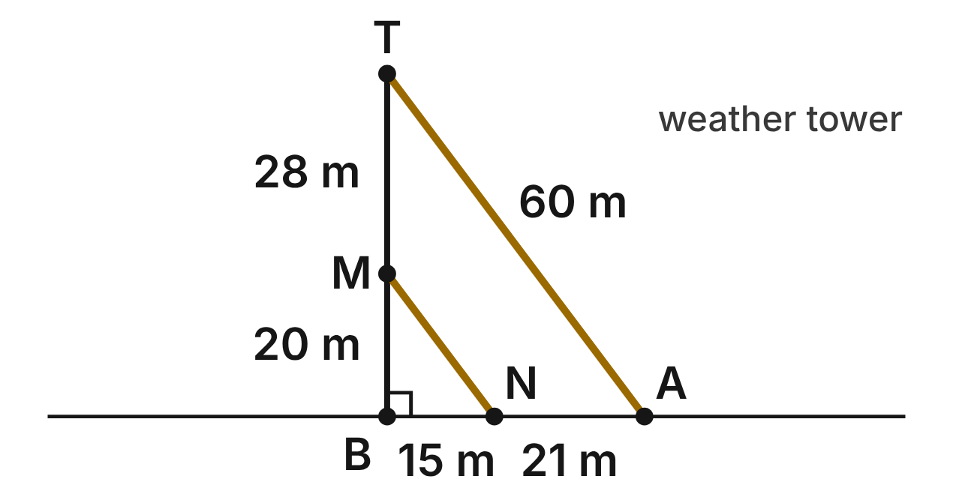
A weather tower TB stands straight up from B on level ground. Guy wire TA runs from the top T to anchor A. Wire MN runs from M on the tower to anchor N. BM = 20 m, MT = 28 m, BN = 15 m, NA = 21 m and TA = 60 m.
253. Using the right angle at B and the lengths along the tower and the ground, which criterion shows that △MBN ∼ △TBA?
A. SAS∼ ✔
B. AA
C. SSS∼
D. SAS
G.TR.3 · skill G.TR.3.1 (LOTS): Identify the similarity criterion (AA, SSS, SAS) that the given information supports
☐ Answer key correct ☐ Wording clear Notes: ________________________________
254. Is wire MN parallel to wire TA? Choose the answer with the correct reason.
A. Yes; 48 − 20 = 36 − 15
B. Yes; △MBN ∼ △TBA, so ∠BNM ≅ ∠BAT ✔
C. No; 20/48 ≠ 15/36
D. No; MN and TA meet at the ground
G.TR.3 · skill G.TR.3.2 (HOTS): Justify that two triangles are similar, or are not, using angle measures or side ratios
☐ Answer key correct ☐ Wording clear Notes: ________________________________
255. How long is wire MN?
A. 32 m
B. 144 m
C. about 42.9 m
D. 25 m ✔
G.TR.3 · skill G.TR.3.3 (LOTS): Solve problems, including contextual ones, using proportional sides of similar triangles
☐ Answer key correct ☐ Wording clear Notes: ________________________________
256. A third wire runs from K, 30 m up the tower, to anchor C on the other side, 24 m from B. Is △KBC similar to △TBA? Choose the answer with the correct reason.
A. Yes; 30/24 = 48/36
B. No; 30/48 ≠ 24/36 ✔
C. Yes; 48 − 30 = 36 − 24
D. No; KC must be parallel to TA
G.TR.3 · skill G.TR.3.2 (HOTS): Justify that two triangles are similar, or are not, using angle measures or side ratios
☐ Answer key correct ☐ Wording clear Notes: ________________________________
257. Engineers want a wire from K, 30 m up the tower, to make a triangle similar to △TBA, with K matching T. How far from B should its anchor be?
A. 18 m
B. 40 m
C. 22.5 m ✔
D. 37.5 m
G.TR.3 · skill G.TR.3.3 (LOTS): Solve problems, including contextual ones, using proportional sides of similar triangles
☐ Answer key correct ☐ Wording clear Notes: ________________________________
258. What is the ratio of the perimeter of △MBN to the perimeter of △TBA?
A. 5/12 ✔
B. 25/144
C. 12/5
D. 5/7
G.TR.3 · skill G.TR.3.3 (LOTS): Solve problems, including contextual ones, using proportional sides of similar triangles
☐ Answer key correct ☐ Wording clear Notes: ________________________________

Covering the Sun
Level 3 · Triangles · G.TR.3 · ID geo-tr3-rocks-eclipse-model
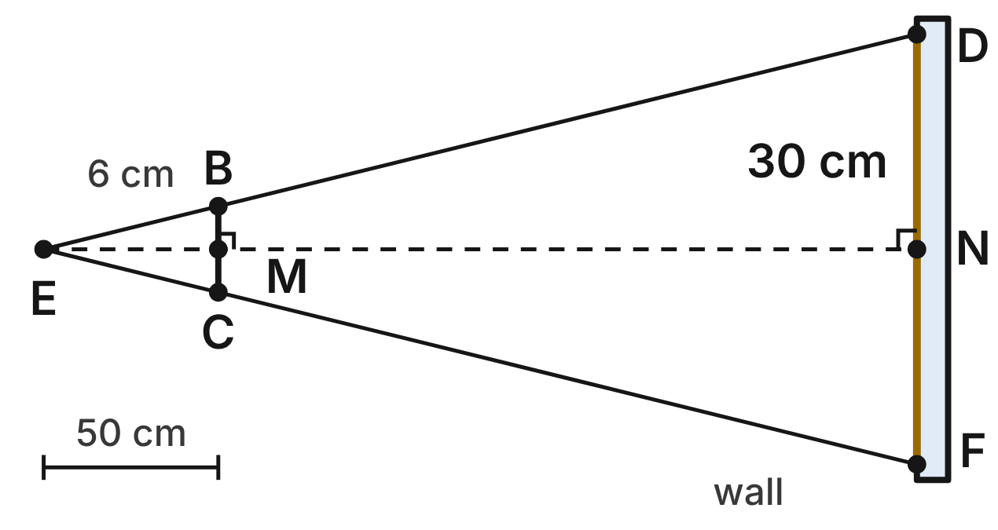
Not drawn to scale
To model an eclipse, Rosa holds a cardboard disk BC (the Moon), 6 cm across, 50 cm from her eye E. It just covers a paper Sun DF, 30 cm across, on the wall. The lines from E through B and C reach D and F. The disk and the paper Sun are parallel, and the line EN meets both at right angles at their midpoints M and N.
259. Why is △EBC similar to △EDF?
A. SAS∼: ∠E is shared, and BC/DF = 6/30
B. HL: EM ⊥ BC and EN ⊥ DF
C. AA: ∠B ≅ ∠F, since both are at an edge
D. AA: ∠E is shared, and ∠EBC ≅ ∠EDF ✔
G.TR.3 · skill G.TR.3.1 (LOTS): Identify the similarity criterion (AA, SSS, SAS) that the given information supports
☐ Answer key correct ☐ Wording clear Notes: ________________________________
260. How far is the paper Sun from Rosa's eye (EN)?
A. 10 cm
B. 74 cm
C. 250 cm ✔
D. 200 cm
G.TR.3 · skill G.TR.3.3 (LOTS): Solve problems, including contextual ones, using proportional sides of similar triangles
☐ Answer key correct ☐ Wording clear Notes: ________________________________
261. The Moon is 3,475 km across and 384,000 km away. In a total eclipse it just covers the Sun, which is 1,392,000 km across. Using similar triangles, about how far away is the Sun?
A. about 154 million km ✔
B. about 959 km
C. about 1.8 million km
D. about 535 billion km
G.TR.3 · skill G.TR.3.3 (LOTS): Solve problems, including contextual ones, using proportional sides of similar triangles
☐ Answer key correct ☐ Wording clear Notes: ________________________________
262. Rosa's friend says a 10-cm disk held 80 cm from the eye would also just cover the paper Sun. Is that right? Choose the answer with the correct reason.
A. Yes; 10/6 = 80/50
B. No; 10/80 ≠ 6/50 ✔
C. Yes; 10/80 = 6/50
D. No; only a 6-cm disk can cover it
G.TR.3 · skill G.TR.3.2 (HOTS): Justify that two triangles are similar, or are not, using angle measures or side ratios
☐ Answer key correct ☐ Wording clear Notes: ________________________________
263. Rosa moves the 6-cm disk to 40 cm from her eye. How wide a paper Sun on the same wall would it just cover now?
A. 30 cm
B. 24 cm
C. 37.5 cm ✔
D. 0.96 cm
G.TR.3 · skill G.TR.3.3 (LOTS): Solve problems, including contextual ones, using proportional sides of similar triangles
☐ Answer key correct ☐ Wording clear Notes: ________________________________
264. Which proportion is true for these similar triangles?
A. BC/DF = EB/BD
B. BC/EB = ED/DF
C. EB/ED = EC/CF
D. BC/DF = EB/ED ✔
G.TR.3 · skill G.TR.3.1 (LOTS): Identify the similarity criterion (AA, SSS, SAS) that the given information supports
☐ Answer key correct ☐ Wording clear Notes: ________________________________

G.TR.4 · Model and solve problems, including those in context, involving trigonometry in right triangles and applications of the Pythagorean Theorem.

The Weather Balloon Tether
Level 1 · Triangles · G.TR.4 · ID geo-tr4-rocks-balloon-tether
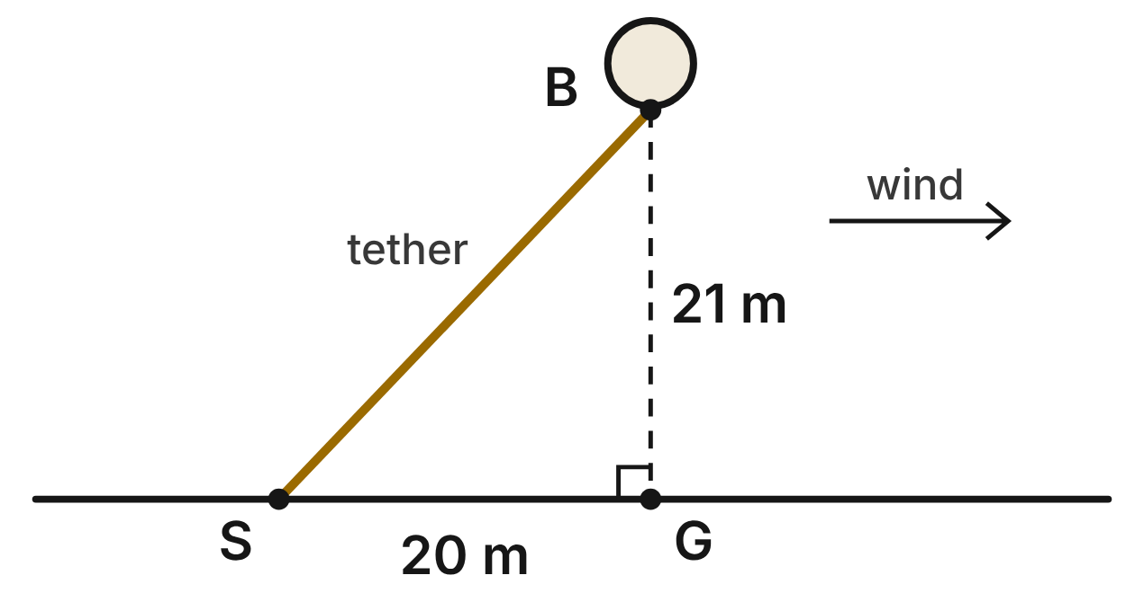
A weather balloon B is tied to a stake S on level ground. The wind pushes it until it is 21 m directly above point G, which is 20 m from S. Treat the tether SB as a straight segment.
265. How long is the tether SB?
A. 41 m
B. 29 m ✔
C. about 6.4 m
D. 841 m
G.TR.4 · skill G.TR.4.1 (LOTS): Use the Pythagorean Theorem and its converse, including to classify a triangle as right, acute or obtuse
☐ Answer key correct ☐ Wording clear Notes: ________________________________
266. Which ratio is equal to tan S?
A. 20/21
B. 21/29
C. 20/29
D. 21/20 ✔
G.TR.4 · skill G.TR.4.3 (LOTS): Use sine, cosine and tangent ratios to find a side length or an angle measure
☐ Answer key correct ☐ Wording clear Notes: ________________________________
267. To the nearest degree, what angle does the tether make with the vertical line BG (m∠SBG)?
A. 44° ✔
B. 46°
C. 72°
D. 18°
G.TR.4 · skill G.TR.4.3 (LOTS): Use sine, cosine and tangent ratios to find a side length or an angle measure
☐ Answer key correct ☐ Wording clear Notes: ________________________________
268. Three weather stations are 12 km, 16 km and 19 km apart. Which describes the triangle they form?
A. Obtuse, because 19² is less than 12² + 16²
B. Right, because 12 + 16 is greater than 19
C. Acute, because 19² is less than 12² + 16² ✔
D. Obtuse, because 19 is the longest side
G.TR.4 · skill G.TR.4.1 (LOTS): Use the Pythagorean Theorem and its converse, including to classify a triangle as right, acute or obtuse
☐ Answer key correct ☐ Wording clear Notes: ________________________________
269. Another balloon is 18 m above the ground, and its straight tether makes a 45° angle with the ground. What is the exact length of the tether?
A. 18√2 m ✔
B. 18√3 m
C. 9√2 m
D. 36 m
G.TR.4 · skill G.TR.4.2 (LOTS): Use the relationships in 45°-45°-90° and 30°-60°-90° triangles
☐ Answer key correct ☐ Wording clear Notes: ________________________________
270. Later the wind eases. A 35-m tether makes a 62° angle with level ground. To the nearest tenth of a meter, how high is the balloon?
A. 16.4 m
B. 30.9 m ✔
C. 65.8 m
D. 39.6 m
G.TR.4 · skill G.TR.4.4 (HOTS): Model a contextual problem (angles of elevation and depression, ramps, ladders, distances) with a right triangle and solve it
☐ Answer key correct ☐ Wording clear Notes: ________________________________

The Tilted Solar Panel
Level 1 · Triangles · G.TR.4 · ID geo-tr4-rocks-solar-panel
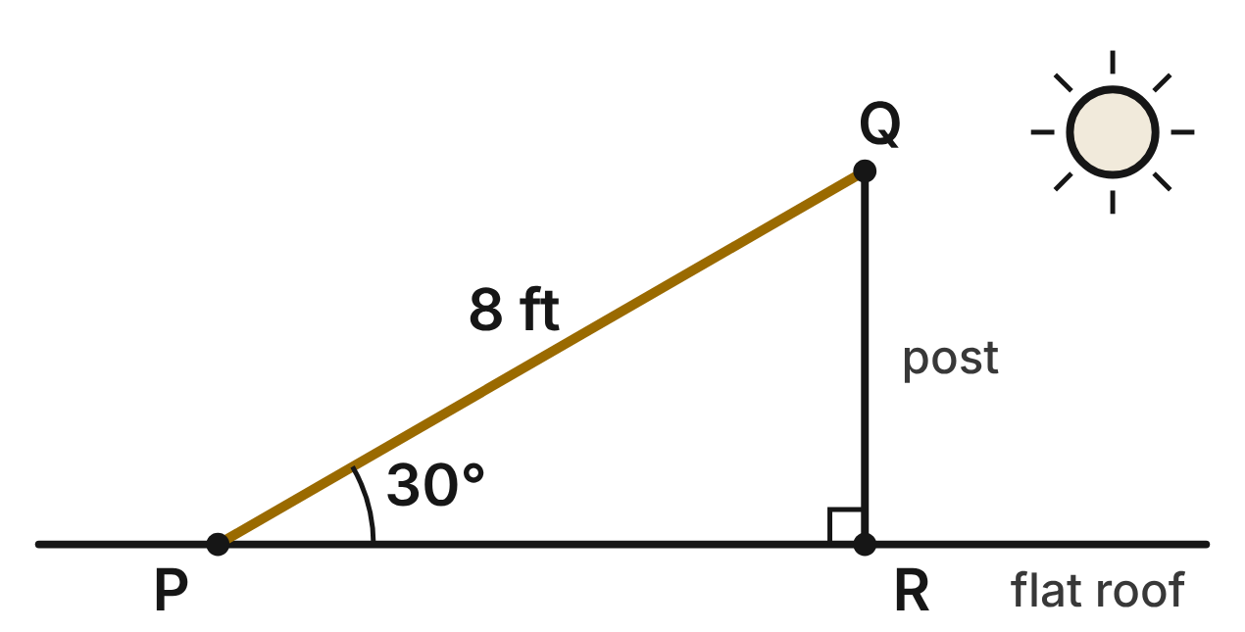
A solar panel PQ, 8 ft long, sits on a flat roof. It is tilted 30° from the roof at P, and its top edge Q rests on a vertical post QR.
271. How tall is the post QR?
A. 4√3 ft
B. 4√2 ft
C. 4 ft ✔
D. 16 ft
G.TR.4 · skill G.TR.4.2 (LOTS): Use the relationships in 45°-45°-90° and 30°-60°-90° triangles
☐ Answer key correct ☐ Wording clear Notes: ________________________________
272. What is the exact distance PR along the roof?
A. 4√3 ft ✔
B. 4 ft
C. 8√3 ft
D. 8√3/3 ft
G.TR.4 · skill G.TR.4.2 (LOTS): Use the relationships in 45°-45°-90° and 30°-60°-90° triangles
☐ Answer key correct ☐ Wording clear Notes: ________________________________
273. Which ratio is equal to cos P?
A. QR/PQ
B. QR/PR
C. PQ/PR
D. PR/PQ ✔
G.TR.4 · skill G.TR.4.3 (LOTS): Use sine, cosine and tangent ratios to find a side length or an angle measure
☐ Answer key correct ☐ Wording clear Notes: ________________________________
274. In summer the 8-ft panel is tilted at 37° instead. To the nearest tenth of a foot, how tall must the post be?
A. 6.4 ft
B. 4.8 ft ✔
C. 6.0 ft
D. 13.3 ft
G.TR.4 · skill G.TR.4.3 (LOTS): Use sine, cosine and tangent ratios to find a side length or an angle measure
☐ Answer key correct ☐ Wording clear Notes: ________________________________
275. A smaller panel is 5 ft long, and its top edge is 2.2 ft above the roof. To the nearest degree, at what angle is it tilted?
A. 24°
B. 64°
C. 66°
D. 26° ✔
G.TR.4 · skill G.TR.4.3 (LOTS): Use sine, cosine and tangent ratios to find a side length or an angle measure
☐ Answer key correct ☐ Wording clear Notes: ________________________________
276. In spring the 8-ft panel is tilted at 45°. What is the exact height of its top edge above the roof?
A. 8√2 ft
B. 4 ft
C. 4√2 ft ✔
D. 4√3 ft
G.TR.4 · skill G.TR.4.2 (LOTS): Use the relationships in 45°-45°-90° and 30°-60°-90° triangles
☐ Answer key correct ☐ Wording clear Notes: ________________________________

Tracking the Rocket's Climb
Level 2 · Triangles · G.TR.4 · ID geo-tr4-rocks-rocket-path
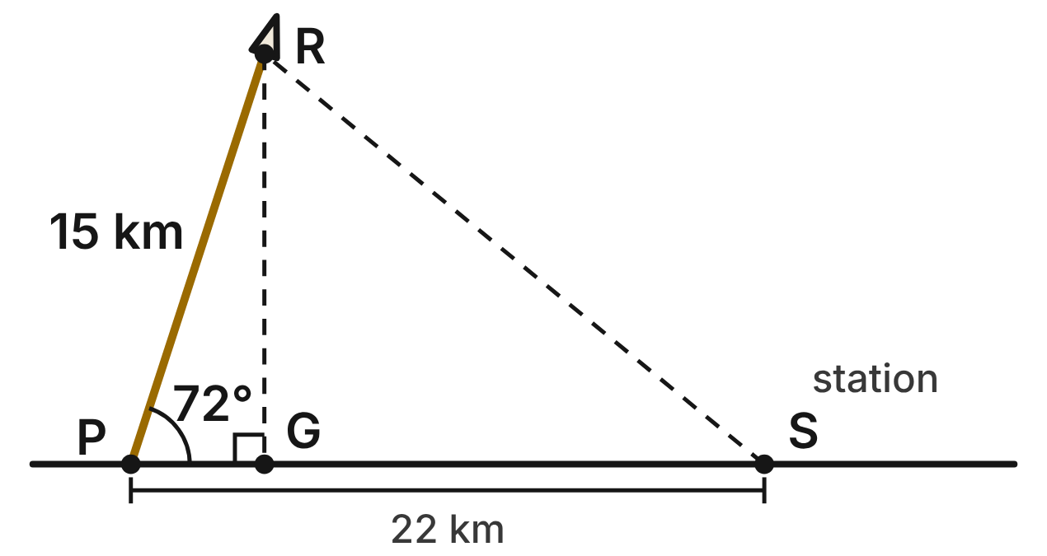
A rocket leaves pad P on a straight path that makes a 72° angle with level ground. R is the rocket after it has flown 15 km along the path, and G is the point on the ground directly below R. A tracking station S is on the ground 22 km from P, past G.
277. To the nearest tenth of a kilometer, what is the rocket's altitude RG?
A. 14.3 km ✔
B. 4.6 km
C. 46.2 km
D. 15.8 km
G.TR.4 · skill G.TR.4.3 (LOTS): Use sine, cosine and tangent ratios to find a side length or an angle measure
☐ Answer key correct ☐ Wording clear Notes: ________________________________
278. Which ratio is equal to cos 72° in this figure?
A. RG/PR
B. RG/PG
C. PG/PR ✔
D. PG/RG
G.TR.4 · skill G.TR.4.3 (LOTS): Use sine, cosine and tangent ratios to find a side length or an angle measure
☐ Answer key correct ☐ Wording clear Notes: ________________________________
279. To the nearest degree, what is the angle of elevation from station S to the rocket at R?
A. 33°
B. 39° ✔
C. 51°
D. 55°
G.TR.4 · skill G.TR.4.4 (HOTS): Model a contextual problem (angles of elevation and depression, ramps, ladders, distances) with a right triangle and solve it
☐ Answer key correct ☐ Wording clear Notes: ________________________________
280. Another rocket flies 15 km along a straight path that makes a 60° angle with the ground. What is its exact altitude?
A. 7.5 km
B. 15√3 km
C. 7.5√2 km
D. 7.5√3 km ✔
G.TR.4 · skill G.TR.4.2 (LOTS): Use the relationships in 45°-45°-90° and 30°-60°-90° triangles
☐ Answer key correct ☐ Wording clear Notes: ________________________________
281. A model rocket rises 120 m straight up while the wind carries it 22 m sideways. How far is it from the launch point, in a straight line?
A. 142 m
B. about 118.0 m
C. 122 m ✔
D. 98 m
G.TR.4 · skill G.TR.4.1 (LOTS): Use the Pythagorean Theorem and its converse, including to classify a triangle as right, acute or obtuse
☐ Answer key correct ☐ Wording clear Notes: ________________________________
282. A second rocket flies 9 km along its straight path and climbs to 8 km above the ground. To the nearest degree, what angle does its path make with the ground?
A. 63° ✔
B. 42°
C. 27°
D. 48°
G.TR.4 · skill G.TR.4.3 (LOTS): Use sine, cosine and tangent ratios to find a side length or an angle measure
☐ Answer key correct ☐ Wording clear Notes: ________________________________

Guy Wires on the Storm Tower
Level 2 · Triangles · G.TR.4 · ID geo-tr4-rocks-storm-tower
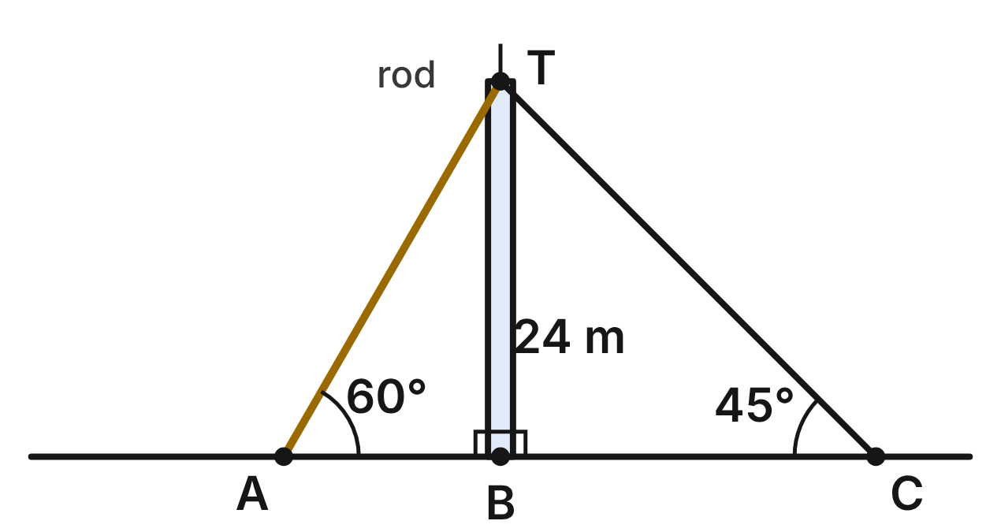
A storm-research tower TB is 24 m tall, with a lightning rod above its top T. It is perpendicular to the level ground. Guy wire TA makes a 60° angle with the ground, and guy wire TC makes a 45° angle with the ground.
283. What is the exact length of guy wire TC?
A. 24√3 m
B. 12√2 m
C. 48 m
D. 24√2 m ✔
G.TR.4 · skill G.TR.4.2 (LOTS): Use the relationships in 45°-45°-90° and 30°-60°-90° triangles
☐ Answer key correct ☐ Wording clear Notes: ________________________________
284. What is the exact distance AB from anchor A to the base of the tower?
A. 24√3 m
B. 8√3 m ✔
C. 12 m
D. 16√3 m
G.TR.4 · skill G.TR.4.2 (LOTS): Use the relationships in 45°-45°-90° and 30°-60°-90° triangles
☐ Answer key correct ☐ Wording clear Notes: ________________________________
285. What is the exact length of guy wire TA?
A. 48 m
B. 8√3 m
C. 16√3 m ✔
D. 24√2 m
G.TR.4 · skill G.TR.4.2 (LOTS): Use the relationships in 45°-45°-90° and 30°-60°-90° triangles
☐ Answer key correct ☐ Wording clear Notes: ________________________________
286. A third wire runs from T to a stake D on the ground, 10 m from B. How long is this wire?
A. 26 m ✔
B. 34 m
C. about 21.8 m
D. 676 m
G.TR.4 · skill G.TR.4.1 (LOTS): Use the Pythagorean Theorem and its converse, including to classify a triangle as right, acute or obtuse
☐ Answer key correct ☐ Wording clear Notes: ________________________________
287. A third wire runs from T to a stake D on the ground, 10 m from B. To the nearest degree, what angle does it make with the ground?
A. 23°
B. 65°
C. 25°
D. 67° ✔
G.TR.4 · skill G.TR.4.3 (LOTS): Use sine, cosine and tangent ratios to find a side length or an angle measure
☐ Answer key correct ☐ Wording clear Notes: ________________________________
288. A worker checks the stand of a rain gauge. She marks 15 cm along the base and 20 cm up the post from the corner, and the marks are 24 cm apart. What can she conclude?
A. The angle is obtuse: 24² is less than 15² + 20².
B. The angle is acute: 24² is less than 15² + 20². ✔
C. The angle is right: 15 + 20 is more than 24.
D. The angle is right: 15² + 20² = 24².
G.TR.4 · skill G.TR.4.1 (LOTS): Use the Pythagorean Theorem and its converse, including to classify a triangle as right, acute or obtuse
☐ Answer key correct ☐ Wording clear Notes: ________________________________

A Shadow in the Crater
Level 2 · Triangles · G.TR.4 · ID geo-tr4-rocks-crater-shadow
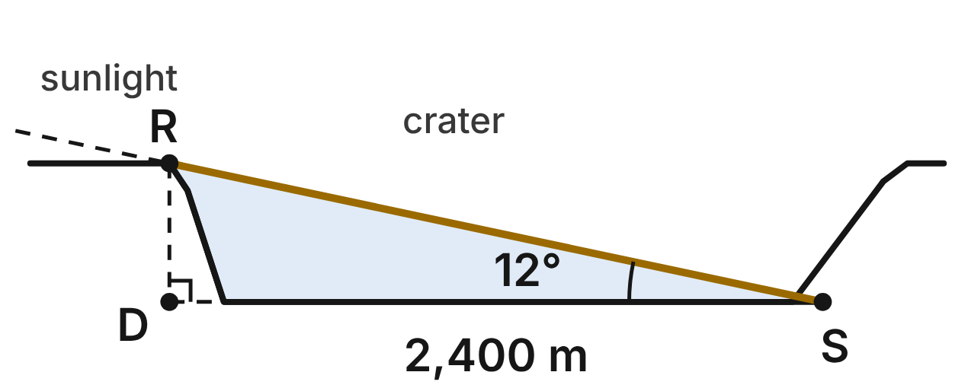
Astronomers estimate a crater's depth from a photo. Sunlight grazes the rim R and reaches the flat floor at S. D is the point on the floor's level directly below R, and the shadow DS is 2,400 m long. The sun's rays make a 12° angle with the floor.
289. To the nearest meter, how deep is the crater (RD)?
A. 510 m ✔
B. 499 m
C. 2,454 m
D. 11,291 m
G.TR.4 · skill G.TR.4.4 (HOTS): Model a contextual problem (angles of elevation and depression, ramps, ladders, distances) with a right triangle and solve it
☐ Answer key correct ☐ Wording clear Notes: ________________________________
290. Let d = RD. Which equation can be used to find the depth d?
A. sin 12° = d/2400
B. tan 12° = 2400/d
C. cos 12° = d/2400
D. tan 12° = d/2400 ✔
G.TR.4 · skill G.TR.4.3 (LOTS): Use sine, cosine and tangent ratios to find a side length or an angle measure
☐ Answer key correct ☐ Wording clear Notes: ________________________________
291. In another photo, a crater 700 m deep casts a shadow 1,300 m long across its floor. To the nearest degree, what angle do the sun's rays make with the floor?
A. 33°
B. 28° ✔
C. 57°
D. 62°
G.TR.4 · skill G.TR.4.3 (LOTS): Use sine, cosine and tangent ratios to find a side length or an angle measure
☐ Answer key correct ☐ Wording clear Notes: ________________________________
292. A rover drives straight down a crater wall that drops 0.65 km over a horizontal distance of 0.72 km. How far does it drive?
A. 1.37 km
B. about 0.31 km
C. 0.97 km ✔
D. about 0.94 km
G.TR.4 · skill G.TR.4.1 (LOTS): Use the Pythagorean Theorem and its converse, including to classify a triangle as right, acute or obtuse
☐ Answer key correct ☐ Wording clear Notes: ________________________________
293. When the sun is 30° above the floor, a rim 400 m above the floor casts a shadow straight across it. What is the exact length of the shadow?
A. 400√3/3 m
B. 800 m
C. 200√3 m
D. 400√3 m ✔
G.TR.4 · skill G.TR.4.2 (LOTS): Use the relationships in 45°-45°-90° and 30°-60°-90° triangles
☐ Answer key correct ☐ Wording clear Notes: ________________________________
294. A lab models crater walls with triangles. Which side lengths, in centimeters, form an obtuse triangle?
A. 5, 9, 11 ✔
B. 5, 12, 13
C. 7, 9, 11
D. 3, 4, 8
G.TR.4 · skill G.TR.4.1 (LOTS): Use the Pythagorean Theorem and its converse, including to classify a triangle as right, acute or obtuse
☐ Answer key correct ☐ Wording clear Notes: ________________________________

The Lab Cart Ramp
Level 2 · Triangles · G.TR.4 · ID geo-tr4-rocks-lab-ramp
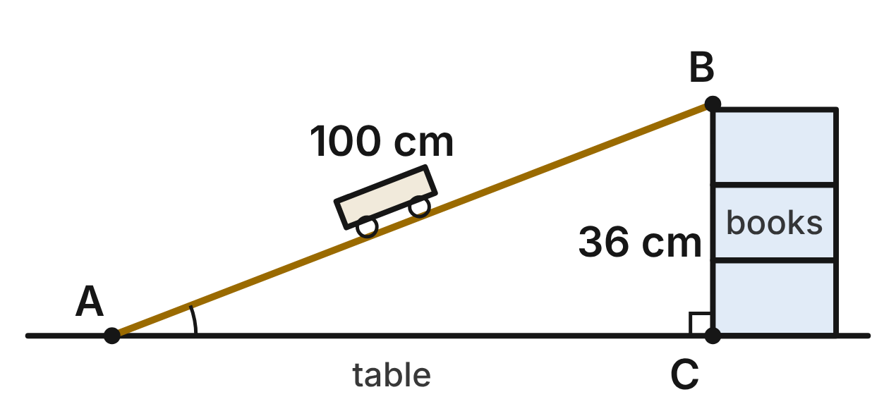
In a physics lab, a 100-cm board AB rests on a table at A and on a stack of books at B. B is 36 cm above the table, and C is the point on the table directly below B.
295. Which expression gives m∠A, the angle between the board and the table?
A. tan⁻¹(36/100)
B. cos⁻¹(36/100)
C. sin⁻¹(36/100) ✔
D. sin⁻¹(100/36)
G.TR.4 · skill G.TR.4.3 (LOTS): Use sine, cosine and tangent ratios to find a side length or an angle measure
☐ Answer key correct ☐ Wording clear Notes: ________________________________
296. To the nearest tenth of a centimeter, how far is A from C?
A. 136.0 cm
B. 93.3 cm ✔
C. 106.3 cm
D. 64.0 cm
G.TR.4 · skill G.TR.4.1 (LOTS): Use the Pythagorean Theorem and its converse, including to classify a triangle as right, acute or obtuse
☐ Answer key correct ☐ Wording clear Notes: ________________________________
297. The teacher raises B so that the board makes a 26° angle with the table. To the nearest tenth of a centimeter, how much higher is B than it is now?
A. 53.9 cm
B. 12.8 cm
C. 43.8 cm
D. 7.8 cm ✔
G.TR.4 · skill G.TR.4.4 (HOTS): Model a contextual problem (angles of elevation and depression, ramps, ladders, distances) with a right triangle and solve it
☐ Answer key correct ☐ Wording clear Notes: ________________________________
298. Another 100-cm board makes a 30° angle with the table. What is the exact horizontal distance between its two ends?
A. 50√3 cm ✔
B. 50 cm
C. 100√3 cm
D. 50√2 cm
G.TR.4 · skill G.TR.4.2 (LOTS): Use the relationships in 45°-45°-90° and 30°-60°-90° triangles
☐ Answer key correct ☐ Wording clear Notes: ________________________________
299. Which ratio is equal to cos B?
A. AC/AB
B. BC/AB ✔
C. AC/BC
D. BC/AC
G.TR.4 · skill G.TR.4.3 (LOTS): Use sine, cosine and tangent ratios to find a side length or an angle measure
☐ Answer key correct ☐ Wording clear Notes: ________________________________
300. Students want a ramp whose height, base and length are whole numbers of centimeters forming a right triangle. Which set works?
A. 12, 35, 36
B. 20, 30, 50
C. 20, 99, 101 ✔
D. 15, 36, 40
G.TR.4 · skill G.TR.4.1 (LOTS): Use the Pythagorean Theorem and its converse, including to classify a triangle as right, acute or obtuse
☐ Answer key correct ☐ Wording clear Notes: ________________________________

Measuring the Cloud Ceiling
Level 3 · Triangles · G.TR.4 · ID geo-tr4-rocks-cloud-ceiling
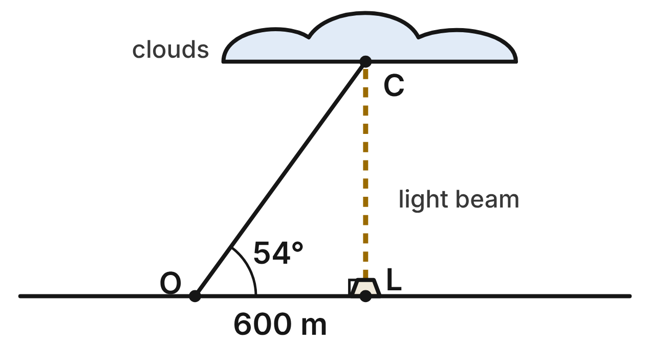
To measure the cloud ceiling at night, a searchlight at L shines straight up and makes a bright spot C on the base of the clouds. An observer at O, 600 m from L on level ground, measures a 54° angle of elevation to C.
301. To the nearest meter, how high is the cloud base (LC)?
A. 485 m
B. 826 m ✔
C. 353 m
D. 436 m
G.TR.4 · skill G.TR.4.4 (HOTS): Model a contextual problem (angles of elevation and depression, ramps, ladders, distances) with a right triangle and solve it
☐ Answer key correct ☐ Wording clear Notes: ________________________________
302. To the nearest meter, how far is the observer from the bright spot (OC)?
A. 353 m
B. 742 m
C. 1,021 m ✔
D. 1,426 m
G.TR.4 · skill G.TR.4.3 (LOTS): Use sine, cosine and tangent ratios to find a side length or an angle measure
☐ Answer key correct ☐ Wording clear Notes: ________________________________
303. An hour later the clouds are lower, and the angle of elevation from O to the new spot is 41°. To the nearest meter, how far did the cloud base drop?
A. 304 m ✔
B. 139 m
C. 522 m
D. 92 m
G.TR.4 · skill G.TR.4.4 (HOTS): Model a contextual problem (angles of elevation and depression, ramps, ladders, distances) with a right triangle and solve it
☐ Answer key correct ☐ Wording clear Notes: ________________________________
304. On another night the cloud base is 1,000 m above L. To the nearest degree, what angle of elevation does the observer at O measure?
A. 31°
B. 53°
C. 37°
D. 59° ✔
G.TR.4 · skill G.TR.4.3 (LOTS): Use sine, cosine and tangent ratios to find a side length or an angle measure
☐ Answer key correct ☐ Wording clear Notes: ________________________________
305. Suppose the observer at O measured a 60° angle of elevation to the spot. What would be the exact height of the cloud base?
A. 200√3 m
B. 600√3 m ✔
C. 1,200 m
D. 300√3 m
G.TR.4 · skill G.TR.4.2 (LOTS): Use the relationships in 45°-45°-90° and 30°-60°-90° triangles
☐ Answer key correct ☐ Wording clear Notes: ________________________________
306. To check that a new weather mast stands straight up, a crew marks 0.9 m along the ground and 1.2 m up the mast from its base. The marks are 1.6 m apart. What can they conclude?
A. The angle is obtuse, so the mast leans. ✔
B. The angle is acute, so the mast leans.
C. The angle is right: 0.9 + 1.2 is over 1.6.
D. The angle is right: 1.6 is close to 1.5.
G.TR.4 · skill G.TR.4.1 (LOTS): Use the Pythagorean Theorem and its converse, including to classify a triangle as right, acute or obtuse
☐ Answer key correct ☐ Wording clear Notes: ________________________________

The Hilltop Observatory
Level 3 · Triangles · G.TR.4 · ID geo-tr4-rocks-observatory
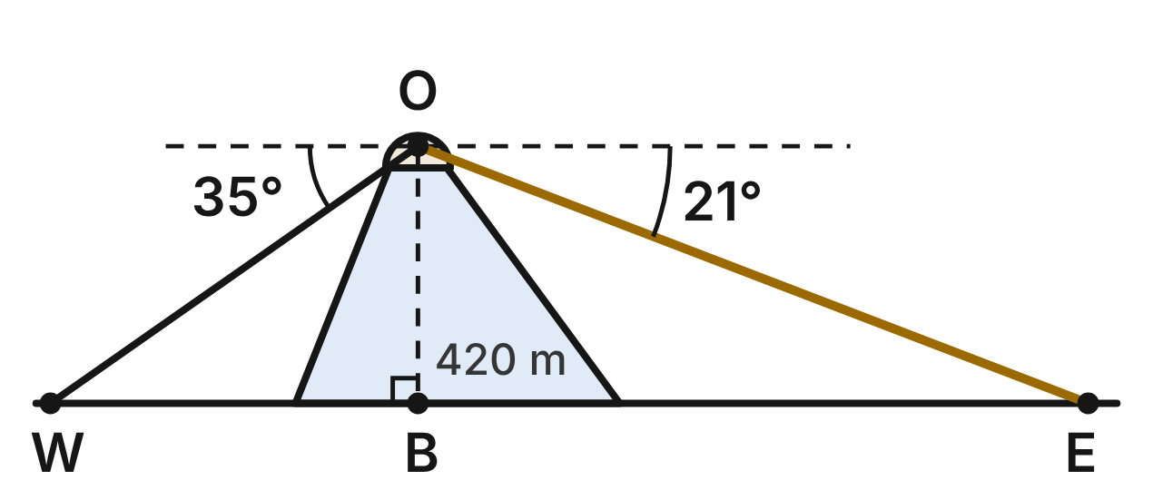
A telescope dome O sits on a hilltop, 420 m above B, the point on the level plain directly below it. Two radio dishes are on the plain on opposite sides of B: from O, the angle of depression to dish W is 35° and to dish E is 21°.
307. Which angle of △OBE has the same measure as the 21° angle of depression from O to E?
A. ∠BOE
B. ∠OBE
C. ∠OWB
D. ∠OEB ✔
G.TR.4 · skill G.TR.4.4 (HOTS): Model a contextual problem (angles of elevation and depression, ramps, ladders, distances) with a right triangle and solve it
☐ Answer key correct ☐ Wording clear Notes: ________________________________
308. To the nearest meter, how far is dish W from B?
A. 294 m
B. 732 m
C. 600 m ✔
D. 344 m
G.TR.4 · skill G.TR.4.4 (HOTS): Model a contextual problem (angles of elevation and depression, ramps, ladders, distances) with a right triangle and solve it
☐ Answer key correct ☐ Wording clear Notes: ________________________________
309. To the nearest meter, how far apart are the two dishes (WE)?
A. 494 m
B. 1,694 m ✔
C. 455 m
D. 1,094 m
G.TR.4 · skill G.TR.4.4 (HOTS): Model a contextual problem (angles of elevation and depression, ramps, ladders, distances) with a right triangle and solve it
☐ Answer key correct ☐ Wording clear Notes: ________________________________
310. To the nearest meter, how long is the line of sight OE?
A. 1,172 m ✔
B. 450 m
C. 1,094 m
D. 1,514 m
G.TR.4 · skill G.TR.4.3 (LOTS): Use sine, cosine and tangent ratios to find a side length or an angle measure
☐ Answer key correct ☐ Wording clear Notes: ________________________________
311. A cable runs straight from O down to a point P on the plain. The angle of depression from O to P is 30°. What is the exact length of the cable?
A. 420√3 m
B. 420√2 m
C. 840 m ✔
D. 280√3 m
G.TR.4 · skill G.TR.4.2 (LOTS): Use the relationships in 45°-45°-90° and 30°-60°-90° triangles
☐ Answer key correct ☐ Wording clear Notes: ________________________________
312. A straight cable runs from O to a point Q on the plain, 560 m from B. How long is the cable?
A. 980 m
B. about 370 m
C. 140 m
D. 700 m ✔
G.TR.4 · skill G.TR.4.1 (LOTS): Use the Pythagorean Theorem and its converse, including to classify a triangle as right, acute or obtuse
☐ Answer key correct ☐ Wording clear Notes: ________________________________

Polygons and circles (G.PC)

G.PC.1 · Prove and justify theorems and properties of quadrilaterals, and verify and use properties of quadrilaterals to solve problems, including the relationships between the sides, angles, and diagonals.

The Weather Station Solar Panel
Level 1 · Quadrilaterals · G.PC.1 · ID geo-pc1-rocks-solar-panel
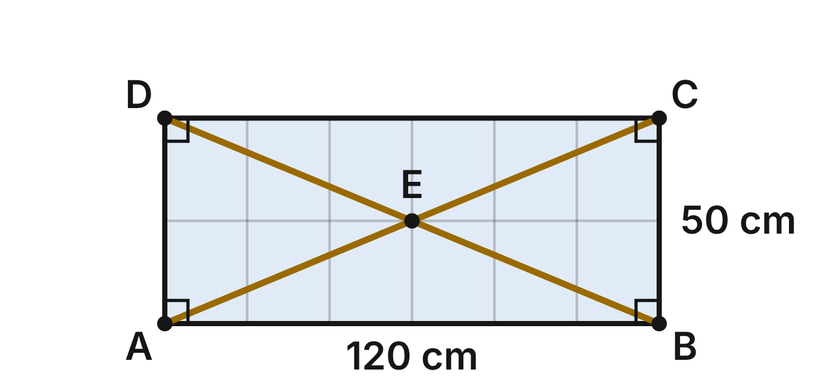
A weather station has a rectangular solar panel ABCD that is 120 cm long and 50 cm tall. Two support wires run along its diagonals AC and BD and cross at E.
313. How long is the wire AC?
A. 170 cm
B. about 109.1 cm
C. 130 cm ✔
D. 65 cm
G.PC.1 · skill G.PC.1.3 (LOTS): Solve problems, including algebraic ones, using the properties of quadrilaterals
☐ Answer key correct ☐ Wording clear Notes: ________________________________
314. Which statement about the wires AC and BD must be true?
A. They are congruent and bisect each other. ✔
B. They are perpendicular to each other.
C. They bisect the angles of the panel.
D. Only AC bisects BD.
G.PC.1 · skill G.PC.1.1 (LOTS): Identify the properties of parallelograms, rectangles, rhombi, squares, trapezoids and kites (sides, angles, diagonals)
☐ Answer key correct ☐ Wording clear Notes: ________________________________
315. How far is the crossing point E from corner B?
A. 130 cm
B. 60 cm
C. 25 cm
D. 65 cm ✔
G.PC.1 · skill G.PC.1.3 (LOTS): Solve problems, including algebraic ones, using the properties of quadrilaterals
☐ Answer key correct ☐ Wording clear Notes: ________________________________
316. Which triangle in the figure must be isosceles?
A. △ABC
B. △BEC ✔
C. △ABD
D. △ACD
G.PC.1 · skill G.PC.1.1 (LOTS): Identify the properties of parallelograms, rectangles, rhombi, squares, trapezoids and kites (sides, angles, diagonals)
☐ Answer key correct ☐ Wording clear Notes: ________________________________
317. Which statement is NOT true for every rectangle?
A. All four sides are congruent. ✔
B. Opposite sides are parallel.
C. All four angles are right angles.
D. Its diagonals are congruent.
G.PC.1 · skill G.PC.1.1 (LOTS): Identify the properties of parallelograms, rectangles, rhombi, squares, trapezoids and kites (sides, angles, diagonals)
☐ Answer key correct ☐ Wording clear Notes: ________________________________
318. A frame for a second panel is a parallelogram. Which single fact is enough to prove the frame is a rectangle?
A. Its opposite sides are congruent.
B. Its diagonals bisect each other.
C. Its diagonals are perpendicular.
D. One of its angles is a right angle. ✔
G.PC.1 · skill G.PC.1.1 (LOTS): Identify the properties of parallelograms, rectangles, rhombi, squares, trapezoids and kites (sides, angles, diagonals)
☐ Answer key correct ☐ Wording clear Notes: ________________________________

The CubeSat Face
Level 1 · Quadrilaterals · G.PC.1 · ID geo-pc1-rocks-cubesat
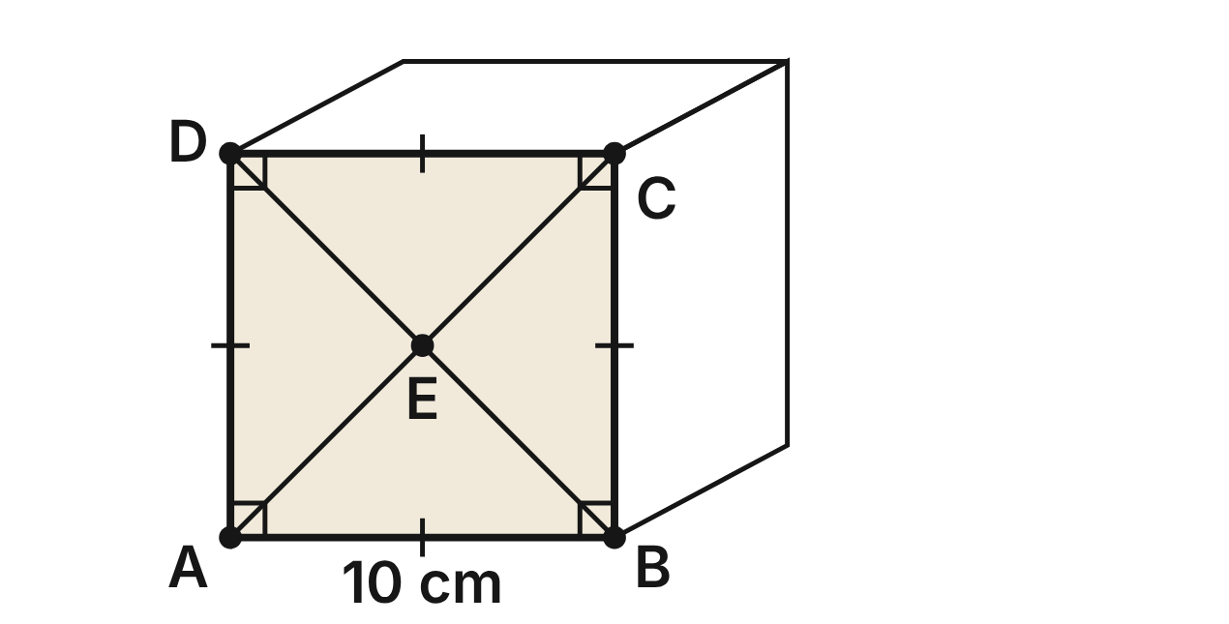
Each face of a small CubeSat satellite is a square. On the front face ABCD, each side is 10 cm, and the diagonals AC and BD meet at E.
319. How long is diagonal AC?
A. 20 cm
B. 10√2 cm ✔
C. 10 cm
D. 5√2 cm
G.PC.1 · skill G.PC.1.3 (LOTS): Solve problems, including algebraic ones, using the properties of quadrilaterals
☐ Answer key correct ☐ Wording clear Notes: ________________________________
320. What is the measure of the angle between diagonal AC and side AB?
A. 90°
B. 60°
C. 135°
D. 45° ✔
G.PC.1 · skill G.PC.1.1 (LOTS): Identify the properties of parallelograms, rectangles, rhombi, squares, trapezoids and kites (sides, angles, diagonals)
☐ Answer key correct ☐ Wording clear Notes: ________________________________
321. Which statement is true of square ABCD but NOT true of every rectangle?
A. Its diagonals are perpendicular. ✔
B. Its diagonals are congruent.
C. Its opposite sides are parallel.
D. All four angles are right angles.
G.PC.1 · skill G.PC.1.1 (LOTS): Identify the properties of parallelograms, rectangles, rhombi, squares, trapezoids and kites (sides, angles, diagonals)
☐ Answer key correct ☐ Wording clear Notes: ________________________________
322. Is every square, like ABCD, also a rhombus?
A. No, because a rhombus has no right angles.
B. Yes, because its diagonals are congruent.
C. Yes, because it has four congruent sides. ✔
D. No, because rhombus diagonals are never congruent.
G.PC.1 · skill G.PC.1.1 (LOTS): Identify the properties of parallelograms, rectangles, rhombi, squares, trapezoids and kites (sides, angles, diagonals)
☐ Answer key correct ☐ Wording clear Notes: ________________________________
323. E is the center of the face. How far is E from side AB?
A. 5√2 cm
B. 10 cm
C. 5 cm ✔
D. 2.5 cm
G.PC.1 · skill G.PC.1.3 (LOTS): Solve problems, including algebraic ones, using the properties of quadrilaterals
☐ Answer key correct ☐ Wording clear Notes: ________________________________
324. A larger CubeSat face is also a square. One side is (3x + 4) cm and the next side is (5x − 8) cm. What is the perimeter of this face?
A. 22 cm
B. 88 cm ✔
C. 6 cm
D. 44 cm
G.PC.1 · skill G.PC.1.3 (LOTS): Solve problems, including algebraic ones, using the properties of quadrilaterals
☐ Answer key correct ☐ Wording clear Notes: ________________________________

The Kite-Shaped Antenna
Level 2 · Quadrilaterals · G.PC.1 · ID geo-pc1-rocks-antenna-kite
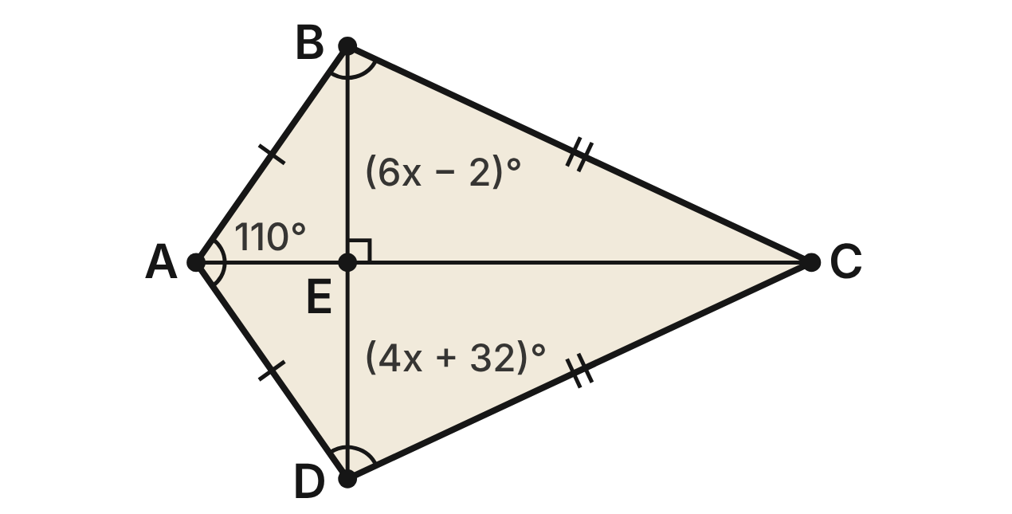
The flat antenna on a weather radio is kite ABCD with AB = AD and CB = CD. Its diagonals meet at E. m∠BAD = 110°, m∠ABC = (6x − 2)° and m∠ADC = (4x + 32)°.
325. What value of x fits the antenna?
A. 15
B. 3.4
C. 100
D. 17 ✔
G.PC.1 · skill G.PC.1.3 (LOTS): Solve problems, including algebraic ones, using the properties of quadrilaterals
☐ Answer key correct ☐ Wording clear Notes: ________________________________
326. Why can (6x − 2) be set equal to (4x + 32)?
A. A kite has one pair of congruent opposite angles, ∠B and ∠D. ✔
B. Opposite angles of a parallelogram are congruent.
C. Consecutive angles of a kite are congruent.
D. The diagonals of a kite are congruent.
G.PC.1 · skill G.PC.1.1 (LOTS): Identify the properties of parallelograms, rectangles, rhombi, squares, trapezoids and kites (sides, angles, diagonals)
☐ Answer key correct ☐ Wording clear Notes: ________________________________
327. What is the measure of ∠BCD, the angle at C?
A. 150°
B. 50° ✔
C. 70°
D. 80°
G.PC.1 · skill G.PC.1.3 (LOTS): Solve problems, including algebraic ones, using the properties of quadrilaterals
☐ Answer key correct ☐ Wording clear Notes: ________________________________
328. Diagonal AC bisects ∠BCD. What is m∠BCA?
A. 50°
B. 55°
C. 25° ✔
D. 65°
G.PC.1 · skill G.PC.1.3 (LOTS): Solve problems, including algebraic ones, using the properties of quadrilaterals
☐ Answer key correct ☐ Wording clear Notes: ________________________________
329. Which statement about diagonals AC and BD is true?
A. AC is the perpendicular bisector of BD. ✔
B. BD is the perpendicular bisector of AC.
C. AC and BD bisect each other.
D. AC and BD are congruent.
G.PC.1 · skill G.PC.1.1 (LOTS): Identify the properties of parallelograms, rectangles, rhombi, squares, trapezoids and kites (sides, angles, diagonals)
☐ Answer key correct ☐ Wording clear Notes: ________________________________
330. Mia says m∠BCD = 110° because opposite angles of a kite are congruent. Which statement explains her error?
A. Opposite angles of a kite are supplementary.
B. ∠BCD is a right angle, since the diagonals are ⊥.
C. Only ∠ABC and ∠ADC must be congruent in a kite. ✔
D. She is right; ∠BCD ≅ ∠BAD.
G.PC.1 · skill G.PC.1.1 (LOTS): Identify the properties of parallelograms, rectangles, rhombi, squares, trapezoids and kites (sides, angles, diagonals)
☐ Answer key correct ☐ Wording clear Notes: ________________________________

Four Stars on a Chart
Level 2 · Quadrilaterals · G.PC.1 · ID geo-pc1-rocks-star-chart
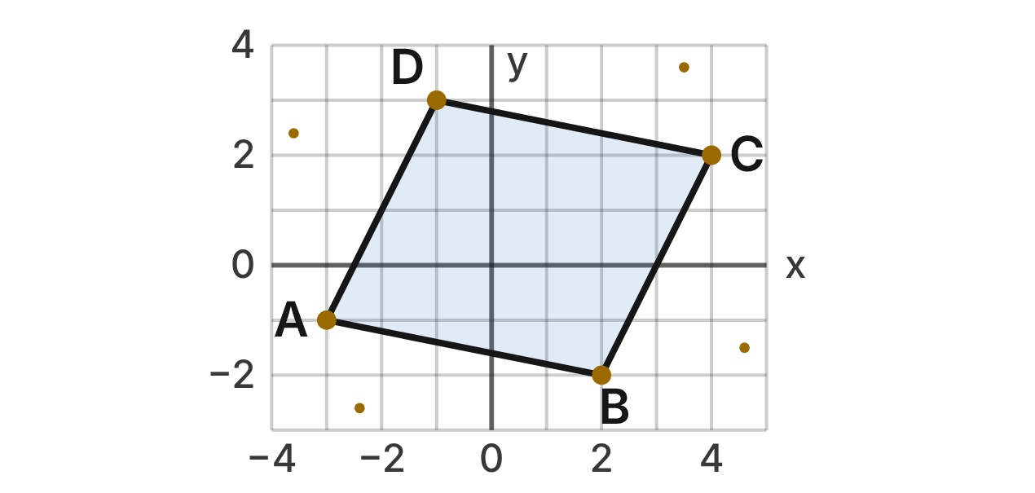
On a star chart, four stars mark the corners of quadrilateral ABCD: A(−3, −1), B(2, −2), C(4, 2) and D(−1, 3).
331. What is the slope of the line through stars A and B?
A. m = −5
B. m = −1/5 ✔
C. m = 1/5
D. m = 5
G.PC.1 · skill G.PC.1.2 (HOTS): Use coordinate methods (slope, distance, midpoint) to classify a quadrilateral or justify a property
☐ Answer key correct ☐ Wording clear Notes: ________________________________
332. Which facts prove that ABCD is a parallelogram?
A. slope AB = −1/5 and slope BC = 2, so AB ⊥ BC
B. AB = DC = √26 and nothing more
C. AB ∥ DC and BC ∥ AD (slopes −1/5 and 2) ✔
D. AC = BD = √58, so the diagonals are congruent
G.PC.1 · skill G.PC.1.2 (HOTS): Use coordinate methods (slope, distance, midpoint) to classify a quadrilateral or justify a property
☐ Answer key correct ☐ Wording clear Notes: ________________________________
333. What is the midpoint of diagonal AC?
A. (3.5, 1.5)
B. (1, 1)
C. (−0.5, −1.5)
D. (0.5, 0.5) ✔
G.PC.1 · skill G.PC.1.2 (HOTS): Use coordinate methods (slope, distance, midpoint) to classify a quadrilateral or justify a property
☐ Answer key correct ☐ Wording clear Notes: ________________________________
334. How far apart are stars A and B, in grid units?
A. √26 units ✔
B. 6 units
C. 26 units
D. 2√6 units
G.PC.1 · skill G.PC.1.2 (HOTS): Use coordinate methods (slope, distance, midpoint) to classify a quadrilateral or justify a property
☐ Answer key correct ☐ Wording clear Notes: ________________________________
335. Is ABCD a rectangle?
A. Yes, since its diagonals bisect each other.
B. No, since slope AB · slope BC = −2/5, not −1. ✔
C. Yes, since both pairs of opposite sides are ∥.
D. No, since AB ≠ BC.
G.PC.1 · skill G.PC.1.2 (HOTS): Use coordinate methods (slope, distance, midpoint) to classify a quadrilateral or justify a property
☐ Answer key correct ☐ Wording clear Notes: ________________________________
336. ABCD is a parallelogram. Which statement must be true?
A. ∠DAB ≅ ∠ABC
B. AC ⊥ BD
C. AC ≅ BD
D. ∠DAB ≅ ∠BCD ✔
G.PC.1 · skill G.PC.1.1 (LOTS): Identify the properties of parallelograms, rectangles, rhombi, squares, trapezoids and kites (sides, angles, diagonals)
☐ Answer key correct ☐ Wording clear Notes: ________________________________

The Observatory Shutter
Level 2 · Quadrilaterals · G.PC.1 · ID geo-pc1-rocks-dome-shutter
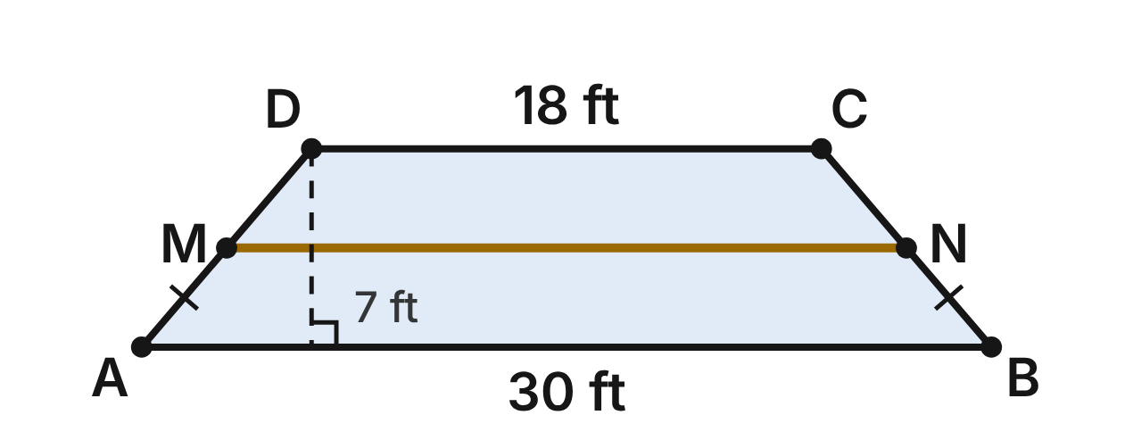
A shutter on a telescope dome is isosceles trapezoid ABCD with AB ∥ DC, AB = 30 ft, DC = 18 ft and legs AD = BC. The shutter is 7 ft tall. A brace MN joins the midpoints of the legs.
337. How long is the brace MN?
A. 24 ft ✔
B. 48 ft
C. 12 ft
D. 6 ft
G.PC.1 · skill G.PC.1.3 (LOTS): Solve problems, including algebraic ones, using the properties of quadrilaterals
☐ Answer key correct ☐ Wording clear Notes: ________________________________
338. How long is diagonal AC of the shutter?
A. about 30.8 ft
B. about 19.3 ft
C. 25 ft ✔
D. 31 ft
G.PC.1 · skill G.PC.1.3 (LOTS): Solve problems, including algebraic ones, using the properties of quadrilaterals
☐ Answer key correct ☐ Wording clear Notes: ________________________________
339. Which statement about the shutter must be true?
A. AC ⊥ BD
B. AC ≅ BD ✔
C. AC and BD bisect each other
D. AD ∥ BC
G.PC.1 · skill G.PC.1.1 (LOTS): Identify the properties of parallelograms, rectangles, rhombi, squares, trapezoids and kites (sides, angles, diagonals)
☐ Answer key correct ☐ Wording clear Notes: ________________________________
340. Another isosceles trapezoid PQRS has bases PQ and SR. m∠SPQ = (5y + 3)° and m∠PSR = (7y − 3)°. What is m∠PQR?
A. 102°
B. 15°
C. 18°
D. 78° ✔
G.PC.1 · skill G.PC.1.3 (LOTS): Solve problems, including algebraic ones, using the properties of quadrilaterals
☐ Answer key correct ☐ Wording clear Notes: ________________________________
341. Which statement is NOT true for shutter ABCD?
A. Its legs AD and BC are congruent.
B. ∠DAB ≅ ∠ABC
C. Its diagonals bisect each other. ✔
D. AB ∥ DC
G.PC.1 · skill G.PC.1.1 (LOTS): Identify the properties of parallelograms, rectangles, rhombi, squares, trapezoids and kites (sides, angles, diagonals)
☐ Answer key correct ☐ Wording clear Notes: ________________________________
342. A smaller shutter is also an isosceles trapezoid. Its bases are (2x + 5) ft and (4x − 3) ft, and the segment joining the midpoints of its legs is 16 ft. What is x?
A. 5 ✔
B. 7/3
C. 5.5
D. 4.75
G.PC.1 · skill G.PC.1.3 (LOTS): Solve problems, including algebraic ones, using the properties of quadrilaterals
☐ Answer key correct ☐ Wording clear Notes: ________________________________

The Rover's Survey Plot
Level 3 · Quadrilaterals · G.PC.1 · ID geo-pc1-rocks-rover-plot
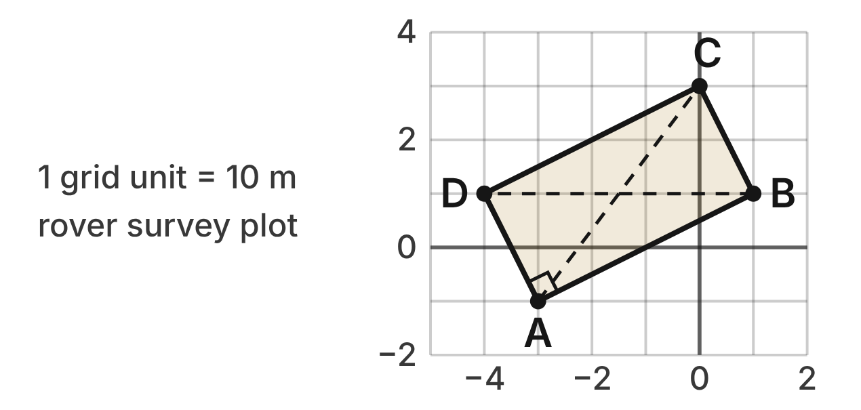
A Mars rover marks a survey plot ABCD on a map with corners A(−3, −1), B(1, 1), C(0, 3) and D(−4, 1). Each grid unit stands for 10 m.
343. Which calculation proves that ∠DAB is a right angle?
A. slope AB · slope AD = (1/2)(2) = 1
B. slope AB = slope DC = 1/2
C. slope AB · slope AD = (1/2)(−2) = −1 ✔
D. AB = AD = 2√5
G.PC.1 · skill G.PC.1.2 (HOTS): Use coordinate methods (slope, distance, midpoint) to classify a quadrilateral or justify a property
☐ Answer key correct ☐ Wording clear Notes: ________________________________
344. How long is diagonal AC, in grid units?
A. 5 units ✔
B. 7 units
C. 25 units
D. √7 units
G.PC.1 · skill G.PC.1.2 (HOTS): Use coordinate methods (slope, distance, midpoint) to classify a quadrilateral or justify a property
☐ Answer key correct ☐ Wording clear Notes: ________________________________
345. AB = 2√5 and BC = √5. Which statement classifies ABCD correctly?
A. a square, since AC = BD
B. a rhombus, since AC ⊥ BD
C. a parallelogram, but not a rectangle
D. a rectangle, but not a square ✔
G.PC.1 · skill G.PC.1.2 (HOTS): Use coordinate methods (slope, distance, midpoint) to classify a quadrilateral or justify a property
☐ Answer key correct ☐ Wording clear Notes: ________________________________
346. What is the area of the survey plot in square meters?
A. 100 m²
B. 1,000 m² ✔
C. 1,250 m²
D. 10 m²
G.PC.1 · skill G.PC.1.3 (LOTS): Solve problems, including algebraic ones, using the properties of quadrilaterals
☐ Answer key correct ☐ Wording clear Notes: ________________________________
347. The rover parks where the diagonals cross. What are the coordinates of that point?
A. (−1, 0)
B. (−3, 2)
C. (1.5, 2)
D. (−1.5, 1) ✔
G.PC.1 · skill G.PC.1.2 (HOTS): Use coordinate methods (slope, distance, midpoint) to classify a quadrilateral or justify a property
☐ Answer key correct ☐ Wording clear Notes: ________________________________
348. Kai says ABCD is a square because its diagonals are congruent. Which reply is correct?
A. Congruent diagonals make a rectangle; AB ≠ BC, so not a square. ✔
B. He is right; congruent diagonals always make a square.
C. It is a rhombus, since its diagonals bisect each other.
D. It cannot be a rectangle, since no side is horizontal.
G.PC.1 · skill G.PC.1.2 (HOTS): Use coordinate methods (slope, distance, midpoint) to classify a quadrilateral or justify a property
☐ Answer key correct ☐ Wording clear Notes: ________________________________

The Lab Jack
Level 3 · Quadrilaterals · G.PC.1 · ID geo-pc1-rocks-lab-jack
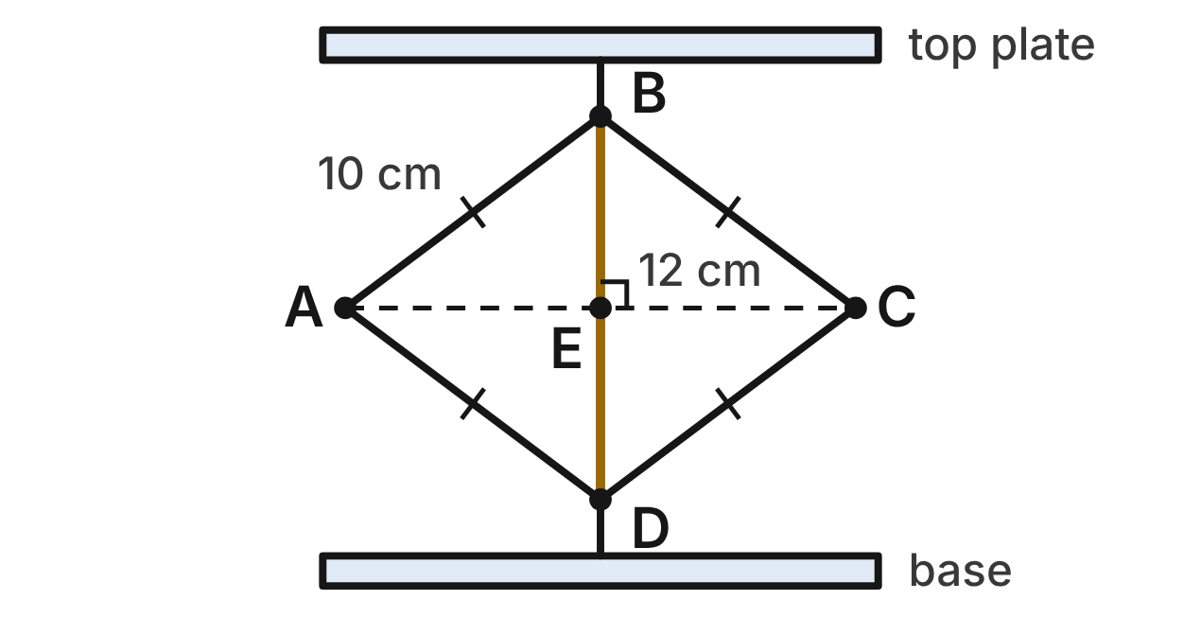
A lab jack raises a beaker. Its four arms form rhombus ABCD with sides of 10 cm, and the diagonals meet at E. The jack can open or close. In the position shown, the height BD is 12 cm.
349. In the position shown, how wide is the jack (the length of AC)?
A. 8 cm
B. 16 cm ✔
C. about 23.3 cm
D. 12 cm
G.PC.1 · skill G.PC.1.3 (LOTS): Solve problems, including algebraic ones, using the properties of quadrilaterals
☐ Answer key correct ☐ Wording clear Notes: ________________________________
350. Which statement is true in every position of the jack?
A. AC and BD are congruent to each other.
B. ∠DAB and ∠ABC are both right angles.
C. AC and BD bisect each other at right angles. ✔
D. AC bisects BD, but BD does not bisect AC.
G.PC.1 · skill G.PC.1.1 (LOTS): Identify the properties of parallelograms, rectangles, rhombi, squares, trapezoids and kites (sides, angles, diagonals)
☐ Answer key correct ☐ Wording clear Notes: ________________________________
351. Which single fact, true in only some positions, would make ABCD a square?
A. m∠DAB = 90° ✔
B. AB = BC
C. AC ⊥ BD
D. AC bisects ∠DAB
G.PC.1 · skill G.PC.1.1 (LOTS): Identify the properties of parallelograms, rectangles, rhombi, squares, trapezoids and kites (sides, angles, diagonals)
☐ Answer key correct ☐ Wording clear Notes: ________________________________
352. The jack is raised until ABCD is a square. How tall is it then (the length of BD)?
A. 20 cm
B. 10 cm
C. 5√2 cm
D. 10√2 cm ✔
G.PC.1 · skill G.PC.1.3 (LOTS): Solve problems, including algebraic ones, using the properties of quadrilaterals
☐ Answer key correct ☐ Wording clear Notes: ________________________________
353. In another position, m∠DAB = (3x + 12)° and m∠ABC = (5x + 8)°. What is m∠DAB?
A. 108°
B. 72° ✔
C. 20°
D. 18°
G.PC.1 · skill G.PC.1.3 (LOTS): Solve problems, including algebraic ones, using the properties of quadrilaterals
☐ Answer key correct ☐ Wording clear Notes: ________________________________
354. The jack is lowered until BD is 6 cm. To the nearest tenth of a centimeter, how wide is it then (the length of AC)?
A. 9.5 cm
B. 20.9 cm
C. 19.1 cm ✔
D. 22.0 cm
G.PC.1 · skill G.PC.1.3 (LOTS): Solve problems, including algebraic ones, using the properties of quadrilaterals
☐ Answer key correct ☐ Wording clear Notes: ________________________________

G.PC.2 · Verify relationships and solve problems involving the number of sides and measures of angles of convex polygons.

The Telescope Mirror Frame
Level 1 · Polygons · G.PC.2 · ID geo-pc2-rocks-telescope-mirror
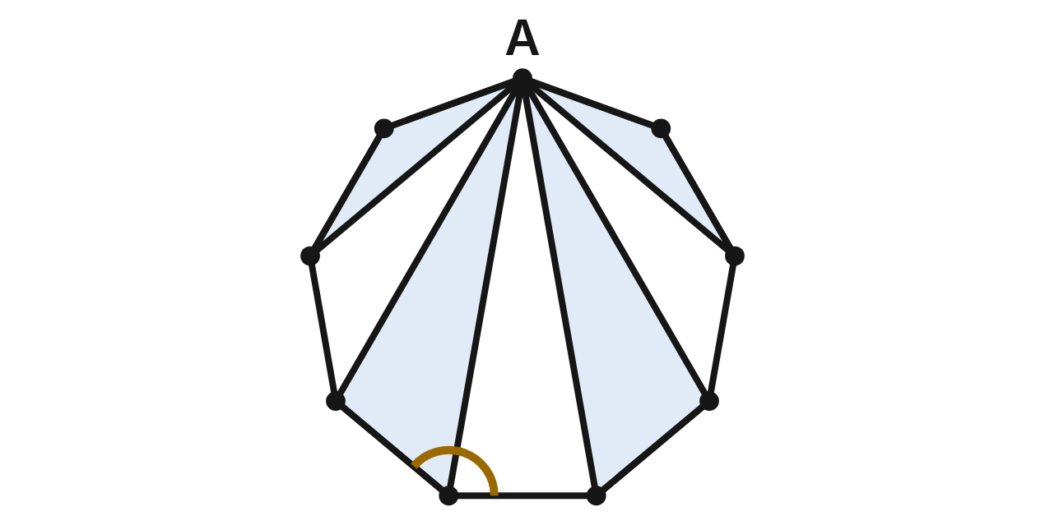
A telescope mirror sits in a frame shaped like a regular nonagon (9 congruent sides and 9 congruent angles). Diagonals from corner A split the frame into triangles. The gold arc marks one interior angle.
355. How many triangles do the diagonals from A make?
A. 9
B. 7 ✔
C. 6
D. 8
G.PC.2 · skill G.PC.2.1 (LOTS): Find the sum of the interior angles, and the measure of each interior and exterior angle, of a convex or regular polygon
☐ Answer key correct ☐ Wording clear Notes: ________________________________
356. What is the sum of the interior angles of the frame?
A. 1620°
B. 1440°
C. 360°
D. 1260° ✔
G.PC.2 · skill G.PC.2.1 (LOTS): Find the sum of the interior angles, and the measure of each interior and exterior angle, of a convex or regular polygon
☐ Answer key correct ☐ Wording clear Notes: ________________________________
357. What is the measure of the gold interior angle?
A. 140° ✔
B. 40°
C. 180°
D. 157.5°
G.PC.2 · skill G.PC.2.1 (LOTS): Find the sum of the interior angles, and the measure of each interior and exterior angle, of a convex or regular polygon
☐ Answer key correct ☐ Wording clear Notes: ________________________________
358. What is the measure of each exterior angle of the frame?
A. 140°
B. 20°
C. 40° ✔
D. 45°
G.PC.2 · skill G.PC.2.1 (LOTS): Find the sum of the interior angles, and the measure of each interior and exterior angle, of a convex or regular polygon
☐ Answer key correct ☐ Wording clear Notes: ________________________________
359. Ava says the frame's angles add to 9 · 180° = 1620°, one triangle for each corner. What is her mistake?
A. She should use 9 · 360°, one full turn per corner.
B. She should use 9 · 90°, since each angle is acute.
C. The angles of any polygon add to 360°.
D. The diagonals from A make only 7 triangles. ✔
G.PC.2 · skill G.PC.2.1 (LOTS): Find the sum of the interior angles, and the measure of each interior and exterior angle, of a convex or regular polygon
☐ Answer key correct ☐ Wording clear Notes: ________________________________
360. A larger telescope's mirror frame is a regular polygon with exterior angles of 9°. How many sides does it have?
A. 20
B. 171
C. 40 ✔
D. 42
G.PC.2 · skill G.PC.2.2 (LOTS): Find the number of sides of a regular polygon given the measure of an interior or exterior angle
☐ Answer key correct ☐ Wording clear Notes: ________________________________

The Radio Dish Rim
Level 1 · Polygons · G.PC.2 · ID geo-pc2-rocks-radio-dish
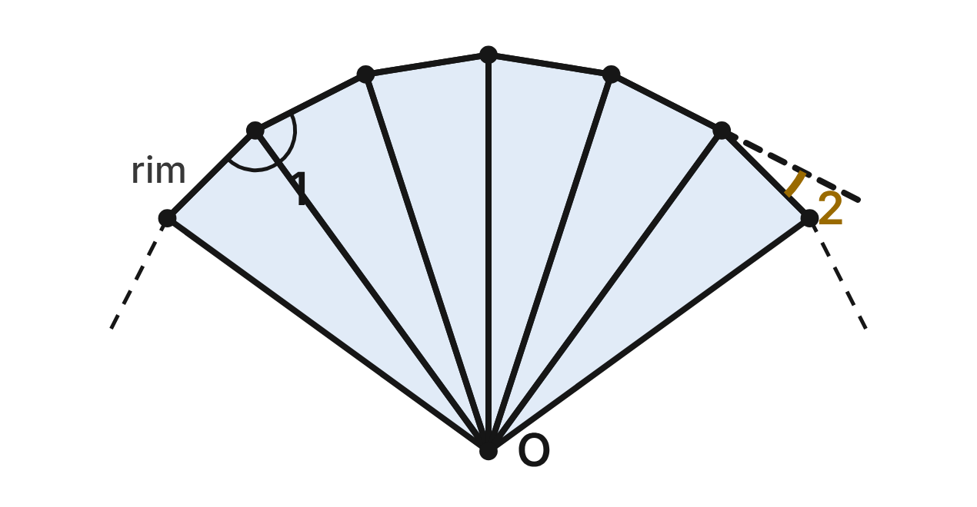
The rim of a radio telescope dish is a regular 20-gon with center O; the figure shows part of it. ∠1 is an interior angle of the rim. One rim section is extended (dashed), and ∠2 is the exterior angle it makes.
361. What is the sum of the interior angles of the 20-gon rim?
A. 3240° ✔
B. 3600°
C. 3420°
D. 360°
G.PC.2 · skill G.PC.2.1 (LOTS): Find the sum of the interior angles, and the measure of each interior and exterior angle, of a convex or regular polygon
☐ Answer key correct ☐ Wording clear Notes: ________________________________
362. What is m∠1, an interior angle of the rim?
A. 18°
B. 171°
C. 162° ✔
D. 180°
G.PC.2 · skill G.PC.2.1 (LOTS): Find the sum of the interior angles, and the measure of each interior and exterior angle, of a convex or regular polygon
☐ Answer key correct ☐ Wording clear Notes: ________________________________
363. What is m∠2, the gold exterior angle?
A. 162°
B. 9°
C. 20°
D. 18° ✔
G.PC.2 · skill G.PC.2.1 (LOTS): Find the sum of the interior angles, and the measure of each interior and exterior angle, of a convex or regular polygon
☐ Answer key correct ☐ Wording clear Notes: ________________________________
364. The full rim has one exterior angle at each of its 20 corners. What do those 20 angles add to?
A. 3240°
B. 360° ✔
C. 7200°
D. 180°
G.PC.2 · skill G.PC.2.1 (LOTS): Find the sum of the interior angles, and the measure of each interior and exterior angle, of a convex or regular polygon
☐ Answer key correct ☐ Wording clear Notes: ________________________________
365. A smaller dish has a rim that is a regular polygon with interior angles of 168°. How many sides does that rim have?
A. 30 ✔
B. 12
C. about 2.1
D. 15
G.PC.2 · skill G.PC.2.2 (LOTS): Find the number of sides of a regular polygon given the measure of an interior or exterior angle
☐ Answer key correct ☐ Wording clear Notes: ________________________________
366. A huge dish has a rim that is a regular polygon with exterior angles of 4°. How many sides does that rim have?
A. 45
B. 90 ✔
C. 176
D. 92
G.PC.2 · skill G.PC.2.2 (LOTS): Find the number of sides of a regular polygon given the measure of an interior or exterior angle
☐ Answer key correct ☐ Wording clear Notes: ________________________________

The Crystal Lattice
Level 2 · Polygons · G.PC.2 · ID geo-pc2-rocks-crystal-lattice
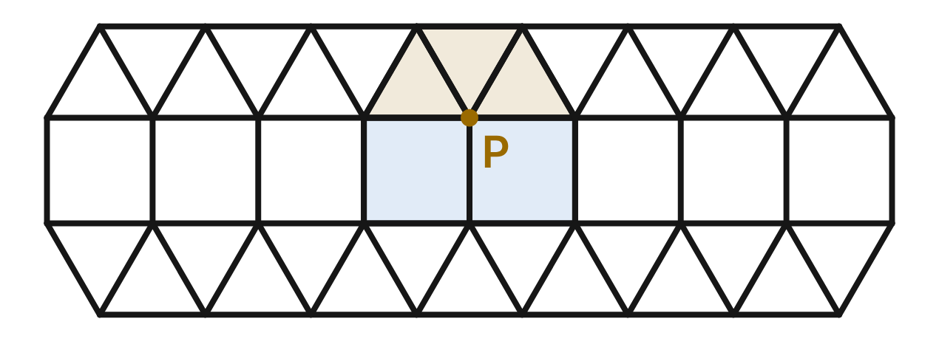
Under a microscope, a crystal surface shows squares and equilateral triangles with no gaps or overlaps. At point P, three triangles (gold) and two squares (blue) meet.
367. Which calculation shows why the shapes leave no gap at P?
A. 2(60°) + 3(90°) = 390°
B. 3(120°) + 2(90°) = 540°
C. 3(60°) + 2(90°) = 360° ✔
D. 5(72°) = 360°
G.PC.2 · skill G.PC.2.1 (LOTS): Find the sum of the interior angles, and the measure of each interior and exterior angle, of a convex or regular polygon
☐ Answer key correct ☐ Wording clear Notes: ________________________________
368. Each angle of a regular octagon is 135°. Which reason explains why regular octagons alone cannot cover a flat surface with no gaps or overlaps?
A. 360 ÷ 135 is not a whole number. ✔
B. Its angle sum, 1080°, is not a multiple of 360°.
C. Its exterior angles add to more than 360°.
D. Only polygons with an odd number of sides tile.
G.PC.2 · skill G.PC.2.1 (LOTS): Find the sum of the interior angles, and the measure of each interior and exterior angle, of a convex or regular polygon
☐ Answer key correct ☐ Wording clear Notes: ________________________________
369. In another crystal, two regular pentagons (108° angles) and one other regular polygon meet at a point with no gap or overlap. How many sides does the other polygon have?
A. 5
B. 2.5
C. 144
D. 10 ✔
G.PC.2 · skill G.PC.2.2 (LOTS): Find the number of sides of a regular polygon given the measure of an interior or exterior angle
☐ Answer key correct ☐ Wording clear Notes: ________________________________
370. Four equilateral triangles and one other regular polygon meet at a point with no gap. How many sides does the other polygon have?
A. 3
B. 6 ✔
C. 120
D. 5
G.PC.2 · skill G.PC.2.2 (LOTS): Find the number of sides of a regular polygon given the measure of an interior or exterior angle
☐ Answer key correct ☐ Wording clear Notes: ________________________________
371. Mia says three regular heptagons (128.6° angles, to the nearest tenth) can fit around a point with no gap or overlap. Which is true?
A. Yes: 3(128.6°) ≈ 360°.
B. No: they leave a gap of about 25.7°.
C. Yes: 7(51.4°) = 360°.
D. No: 3(128.6°) ≈ 385.7°, so they overlap. ✔
G.PC.2 · skill G.PC.2.1 (LOTS): Find the sum of the interior angles, and the measure of each interior and exterior angle, of a convex or regular polygon
☐ Answer key correct ☐ Wording clear Notes: ________________________________
372. Which list names every regular polygon that can cover a flat surface by itself, with no gaps or overlaps?
A. triangle, square, pentagon, hexagon
B. square and hexagon only
C. triangle, square, hexagon ✔
D. square, hexagon, octagon
G.PC.2 · skill G.PC.2.1 (LOTS): Find the sum of the interior angles, and the measure of each interior and exterior angle, of a convex or regular polygon
☐ Answer key correct ☐ Wording clear Notes: ________________________________

The Six-Point Snow Crystal
Level 2 · Polygons · G.PC.2 · ID geo-pc2-rocks-snow-crystal

A snow crystal is modeled by a regular hexagon. Each side is extended both ways until it meets the extended sides next to it, making a six-point star. ∠1 is an exterior angle of the hexagon. The gold arc marks the angle at tip T.
373. What is m∠1, the exterior angle of the hexagon?
A. 120°
B. 60° ✔
C. 30°
D. 72°
G.PC.2 · skill G.PC.2.1 (LOTS): Find the sum of the interior angles, and the measure of each interior and exterior angle, of a convex or regular polygon
☐ Answer key correct ☐ Wording clear Notes: ________________________________
374. What is the measure of the gold angle at tip T?
A. 60° ✔
B. 120°
C. 30°
D. 90°
G.PC.2 · skill G.PC.2.1 (LOTS): Find the sum of the interior angles, and the measure of each interior and exterior angle, of a convex or regular polygon
☐ Answer key correct ☐ Wording clear Notes: ________________________________
375. What is the sum of the angles at all six tips of the star?
A. 720°
B. 1080°
C. 180°
D. 360° ✔
G.PC.2 · skill G.PC.2.1 (LOTS): Find the sum of the interior angles, and the measure of each interior and exterior angle, of a convex or regular polygon
☐ Answer key correct ☐ Wording clear Notes: ________________________________
376. What kind of triangle is each tip of the star?
A. isosceles, with angles 120°, 30°, 30°
B. right, with angles 90°, 45°, 45°
C. equilateral, with three 60° angles ✔
D. isosceles, with angles 30°, 75°, 75°
G.PC.2 · skill G.PC.2.1 (LOTS): Find the sum of the interior angles, and the measure of each interior and exterior angle, of a convex or regular polygon
☐ Answer key correct ☐ Wording clear Notes: ________________________________
377. The sides of a regular octagon are extended the same way to make an 8-point star. What is the angle at each tip?
A. 45°
B. 135°
C. 90° ✔
D. 270°
G.PC.2 · skill G.PC.2.1 (LOTS): Find the sum of the interior angles, and the measure of each interior and exterior angle, of a convex or regular polygon
☐ Answer key correct ☐ Wording clear Notes: ________________________________
378. A star is made the same way from a regular polygon, and each tip angle is 120°. How many sides does the polygon have?
A. 6
B. 3
C. 30
D. 12 ✔
G.PC.2 · skill G.PC.2.2 (LOTS): Find the number of sides of a regular polygon given the measure of an interior or exterior angle
☐ Answer key correct ☐ Wording clear Notes: ________________________________

The Science Fair Graph
Level 2 · Polygons · G.PC.2 · ID geo-pc2-rocks-science-graph
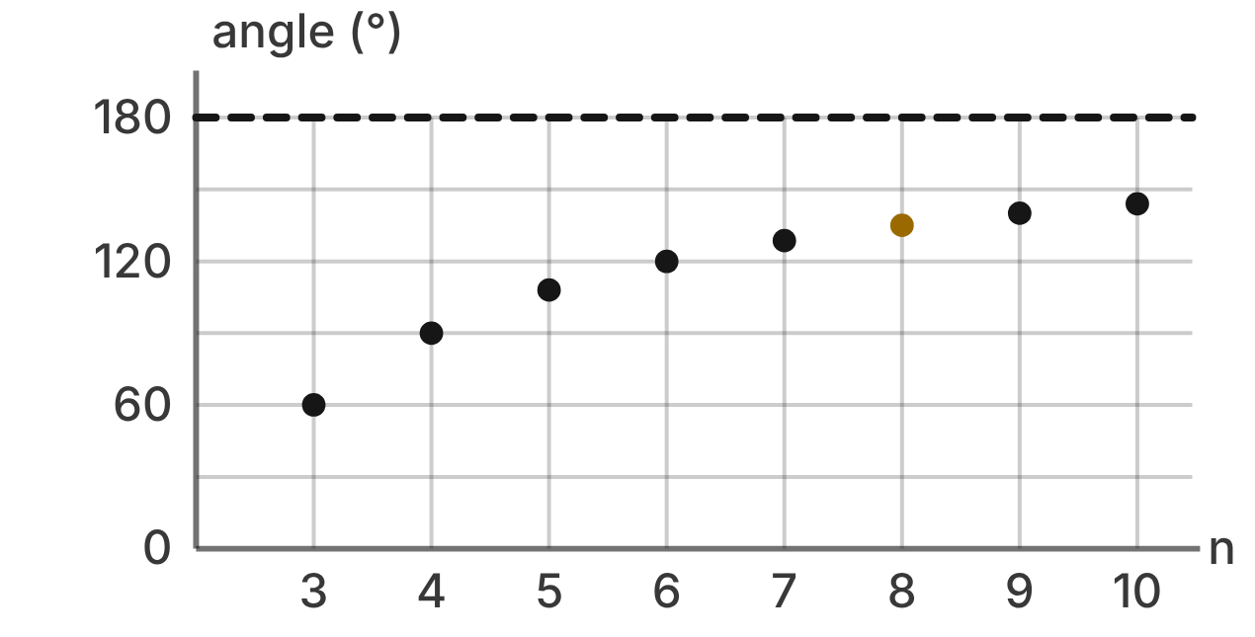
For a science fair, students found one interior angle of each regular polygon with 3 to 10 sides and graphed the angle against the number of sides, n. The dashed line marks 180°.
379. What is the exact angle shown by the gold point, for n = 8?
A. 45°
B. 1080°
C. 135° ✔
D. 157.5°
G.PC.2 · skill G.PC.2.1 (LOTS): Find the sum of the interior angles, and the measure of each interior and exterior angle, of a convex or regular polygon
☐ Answer key correct ☐ Wording clear Notes: ________________________________
380. Which statement about the graph is true?
A. As n grows, the angle gets closer to 180° but never reaches it. ✔
B. The angle grows by the same amount each time n grows by 1.
C. For a large enough n, the angle is more than 180°.
D. The angle is largest when n = 3.
G.PC.2 · skill G.PC.2.1 (LOTS): Find the sum of the interior angles, and the measure of each interior and exterior angle, of a convex or regular polygon
☐ Answer key correct ☐ Wording clear Notes: ________________________________
381. If the graph were extended, what angle would the point for n = 15 show?
A. 24°
B. 156° ✔
C. 2340°
D. 168°
G.PC.2 · skill G.PC.2.1 (LOTS): Find the sum of the interior angles, and the measure of each interior and exterior angle, of a convex or regular polygon
☐ Answer key correct ☐ Wording clear Notes: ________________________________
382. On the extended graph, one point shows an angle of 175°. What is n for that point?
A. 5
B. 36
C. about 2.1
D. 72 ✔
G.PC.2 · skill G.PC.2.2 (LOTS): Find the number of sides of a regular polygon given the measure of an interior or exterior angle
☐ Answer key correct ☐ Wording clear Notes: ________________________________
383. For n = 7, Ben graphed 154.3° (to the nearest tenth). Which error did he make?
A. He used 7 · 180° instead of (7 − 2) · 180°.
B. He divided the sum by 5 instead of 7.
C. He used (7 − 1) · 180° instead of (7 − 2) · 180°. ✔
D. He subtracted the exterior angle from 360°.
G.PC.2 · skill G.PC.2.1 (LOTS): Find the sum of the interior angles, and the measure of each interior and exterior angle, of a convex or regular polygon
☐ Answer key correct ☐ Wording clear Notes: ________________________________
384. A second graph shows the sum of the exterior angles of each polygon, n = 3 to 10. What does that graph look like?
A. points rising by 180° for each added side
B. a flat row of points at 360° ✔
C. points falling closer and closer to 0°
D. a flat row of points at 180°
G.PC.2 · skill G.PC.2.1 (LOTS): Find the sum of the interior angles, and the measure of each interior and exterior angle, of a convex or regular polygon
☐ Answer key correct ☐ Wording clear Notes: ________________________________

The Space Station Module
Level 3 · Polygons · G.PC.2 · ID geo-pc2-rocks-station-module
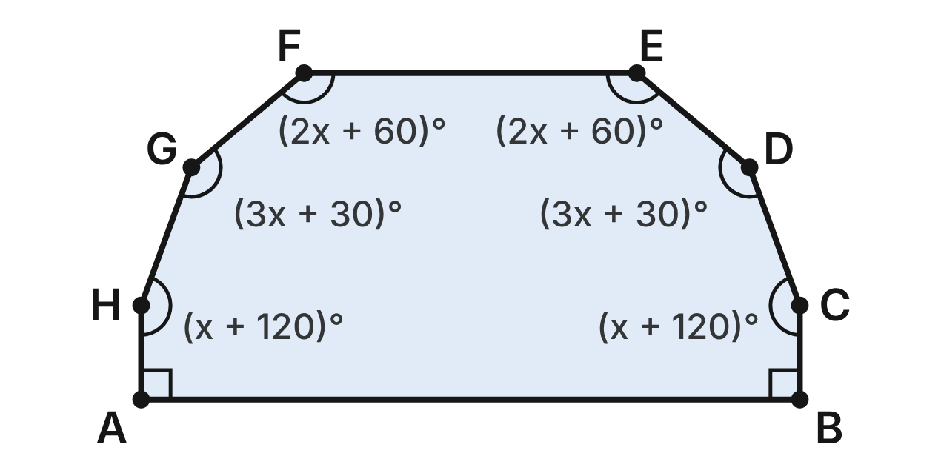
The floor of a space station module is the convex octagon ABCDEFGH. ∠A and ∠B are right angles. The other angle measures, in degrees, are shown in terms of x.
385. Which equation can be used to find x?
A. 12x + 420 = 1080
B. 12x + 600 = 1080 ✔
C. 12x + 600 = 1440
D. 12x + 600 = 360
G.PC.2 · skill G.PC.2.1 (LOTS): Find the sum of the interior angles, and the measure of each interior and exterior angle, of a convex or regular polygon
☐ Answer key correct ☐ Wording clear Notes: ________________________________
386. What is the value of x?
A. 55
B. 70
C. 25
D. 40 ✔
G.PC.2 · skill G.PC.2.1 (LOTS): Find the sum of the interior angles, and the measure of each interior and exterior angle, of a convex or regular polygon
☐ Answer key correct ☐ Wording clear Notes: ________________________________
387. What is m∠E?
A. 140° ✔
B. 170°
C. 40°
D. 110°
G.PC.2 · skill G.PC.2.1 (LOTS): Find the sum of the interior angles, and the measure of each interior and exterior angle, of a convex or regular polygon
☐ Answer key correct ☐ Wording clear Notes: ________________________________
388. What is the measure of an exterior angle of the module at corner C?
A. 160°
B. 200°
C. 20° ✔
D. 45°
G.PC.2 · skill G.PC.2.1 (LOTS): Find the sum of the interior angles, and the measure of each interior and exterior angle, of a convex or regular polygon
☐ Answer key correct ☐ Wording clear Notes: ________________________________
389. What is the sum of the exterior angles at the six corners C, D, E, F, G and H?
A. 180° ✔
B. 360°
C. 900°
D. 270°
G.PC.2 · skill G.PC.2.1 (LOTS): Find the sum of the interior angles, and the measure of each interior and exterior angle, of a convex or regular polygon
☐ Answer key correct ☐ Wording clear Notes: ________________________________
390. A regular polygon has interior angles equal to the mean (average) of this module's eight angles. How many sides does it have?
A. about 2.7
B. 4
C. 10
D. 8 ✔
G.PC.2 · skill G.PC.2.2 (LOTS): Find the number of sides of a regular polygon given the measure of an interior or exterior angle
☐ Answer key correct ☐ Wording clear Notes: ________________________________

The Satellite Ring
Level 3 · Polygons · G.PC.2 · ID geo-pc2-rocks-satellite-ring
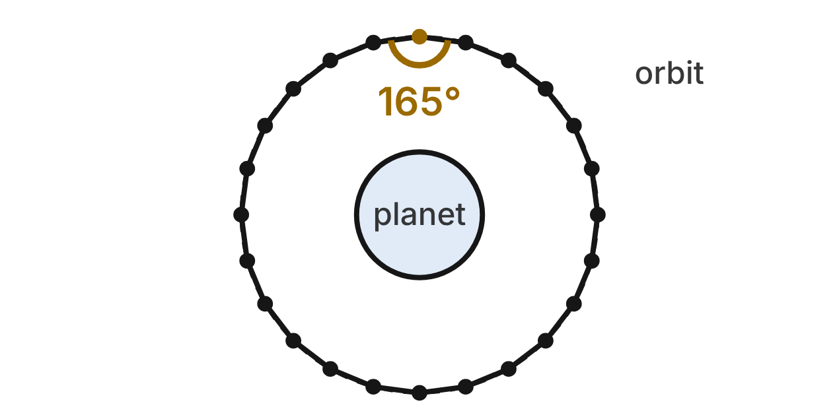
Satellites are evenly spaced on a circular orbit. A laser link joins each satellite to its two neighbors, so the links form a regular polygon. The angle at each satellite between its two links is 165°.
391. Use the 165° angle to find the number of satellites in the ring.
A. 15
B. 12
C. 24 ✔
D. about 2.2
G.PC.2 · skill G.PC.2.2 (LOTS): Find the number of sides of a regular polygon given the measure of an interior or exterior angle
☐ Answer key correct ☐ Wording clear Notes: ________________________________
392. A signal travels along the links around the ring. Through what angle does its direction turn at each satellite?
A. 15° ✔
B. 165°
C. 7.5°
D. 30°
G.PC.2 · skill G.PC.2.1 (LOTS): Find the sum of the interior angles, and the measure of each interior and exterior angle, of a convex or regular polygon
☐ Answer key correct ☐ Wording clear Notes: ________________________________
393. What is the sum of the angles between links at all the satellites in the ring?
A. 4320°
B. 3960° ✔
C. 4140°
D. 360°
G.PC.2 · skill G.PC.2.1 (LOTS): Find the sum of the interior angles, and the measure of each interior and exterior angle, of a convex or regular polygon
☐ Answer key correct ☐ Wording clear Notes: ________________________________
394. Planners ask for a regular ring with a 125° angle at each satellite. Which is true?
A. It works with 6 satellites (360 ÷ 55, rounded down).
B. It works with 7 satellites (360 ÷ 55, rounded up).
C. It works, because 125° is less than 180°.
D. It cannot be done: 360 ÷ 55 is not whole. ✔
G.PC.2 · skill G.PC.2.2 (LOTS): Find the number of sides of a regular polygon given the measure of an interior or exterior angle
☐ Answer key correct ☐ Wording clear Notes: ________________________________
395. An upgrade will place 36 evenly spaced satellites on the orbit instead of 24. By how many degrees will the angle at each satellite increase?
A. 10°
B. 170°
C. 5° ✔
D. 2160°
G.PC.2 · skill G.PC.2.1 (LOTS): Find the sum of the interior angles, and the measure of each interior and exterior angle, of a convex or regular polygon
☐ Answer key correct ☐ Wording clear Notes: ________________________________
396. Which change to the 24-satellite ring would make the angle at each satellite exactly 160°?
A. add 6 satellites
B. remove 6 satellites ✔
C. remove 5 satellites
D. remove 4 satellites
G.PC.2 · skill G.PC.2.2 (LOTS): Find the number of sides of a regular polygon given the measure of an interior or exterior angle
☐ Answer key correct ☐ Wording clear Notes: ________________________________

G.PC.3 · Solve problems, including contextual problems, by applying properties of circles.

The Weather Radar
Level 1 · Circles · G.PC.3 · ID geo-pc3-rocks-weather-radar
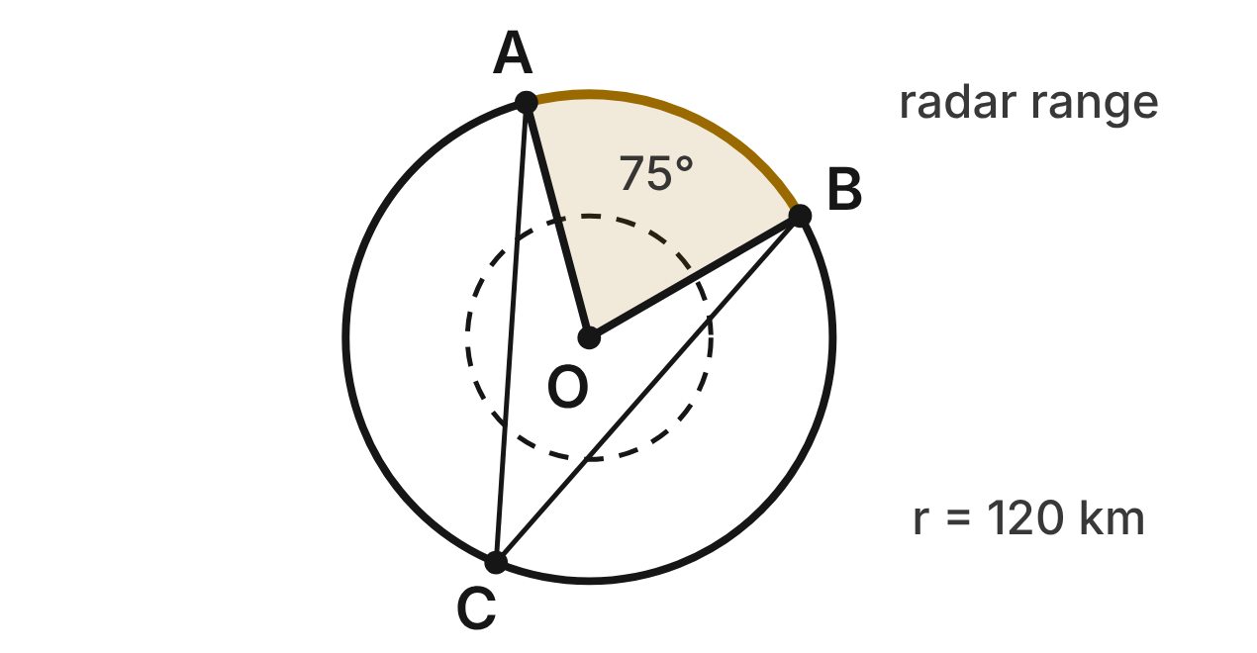
A weather radar at O detects storms up to 120 km away, so its range is a circle with center O and radius 120 km. Storm cells A and B are on the edge of the range, and m∠AOB = 75°. The town C is also on the edge. The radar beam turns all the way around once every 12 seconds.
397. How long is arc AB, the curved edge of the shaded sector? Give the answer in terms of π.
A. 25π km
B. 100π km
C. 50π km ✔
D. 3,000π km
G.PC.3 · skill G.PC.3.3 (LOTS): Find arc length and the area of a sector, or use them to find a radius or a central angle
☐ Answer key correct ☐ Wording clear Notes: ________________________________
398. What is the area of the shaded sector, to the nearest square kilometer?
A. 9,425 km² ✔
B. 4,712 km²
C. 37,699 km²
D. 157 km²
G.PC.3 · skill G.PC.3.3 (LOTS): Find arc length and the area of a sector, or use them to find a radius or a central angle
☐ Answer key correct ☐ Wording clear Notes: ________________________________
399. From the town at C, what is m∠ACB, the angle between the lines to the storm cells A and B?
A. 75°
B. 37.5° ✔
C. 150°
D. 142.5°
G.PC.3 · skill G.PC.3.1 (LOTS): Use the angles formed by chords, secants and tangents (central, inscribed, and angles inside and outside a circle) and their arcs
☐ Answer key correct ☐ Wording clear Notes: ________________________________
400. How many seconds does the beam take to sweep across sector AOB?
A. 6.25 s
B. 5 s
C. 57.6 s
D. 2.5 s ✔
G.PC.3 · skill G.PC.3.4 (HOTS): Model and solve a contextual problem with the properties of circles
☐ Answer key correct ☐ Wording clear Notes: ________________________________
401. A smaller radar at another station covers a 90° sector with an area of 400π km². What is the range (radius) of that radar?
A. 1,600 km
B. 40 km ✔
C. 20 km
D. 800 km
G.PC.3 · skill G.PC.3.3 (LOTS): Find arc length and the area of a sector, or use them to find a radius or a central angle
☐ Answer key correct ☐ Wording clear Notes: ________________________________
402. A storm front lies along an arc of the edge of this radar's range. The arc is 20π km long. What is its central angle?
A. 30° ✔
B. 60°
C. 15°
D. 0.5°
G.PC.3 · skill G.PC.3.3 (LOTS): Find arc length and the area of a sector, or use them to find a radius or a central angle
☐ Answer key correct ☐ Wording clear Notes: ________________________________

The Observatory Dome
Level 1 · Circles · G.PC.3 · ID geo-pc3-rocks-observatory-dome
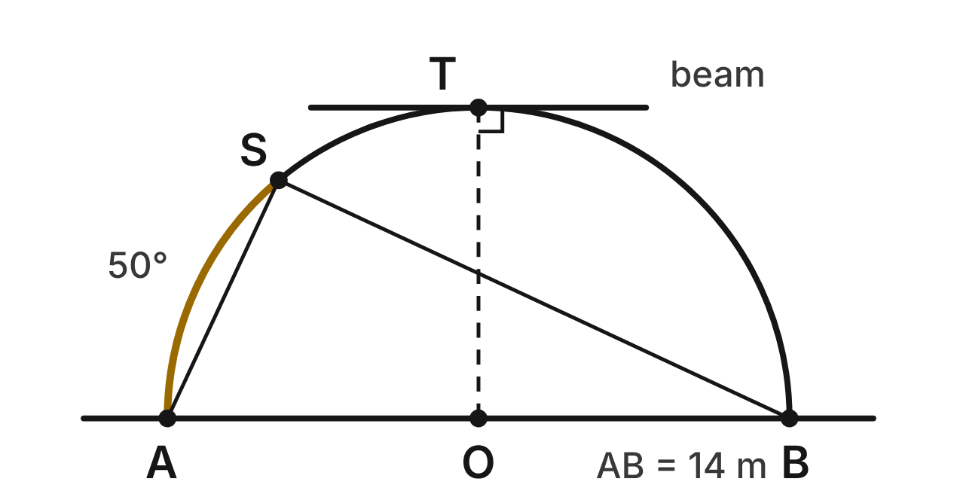
The cross-section of a telescope dome is a semicircle with center O and diameter AB = 14 m along the floor. The slit is at S on the dome, and m(arc AS) = 50°. A crane beam touches the dome only at its highest point, T, directly above O.
403. What is m∠ASB, the angle at the slit between the lines to A and B? Choose the answer with the correct reason.
A. 50°, because ∠ASB equals arc AS
B. 180°, because an inscribed angle equals its arc
C. 65°, because ∠ASB is half of arc SB
D. 90°, because ∠ASB is inscribed in a semicircle ✔
G.PC.3 · skill G.PC.3.1 (LOTS): Use the angles formed by chords, secants and tangents (central, inscribed, and angles inside and outside a circle) and their arcs
☐ Answer key correct ☐ Wording clear Notes: ________________________________
404. What is m∠SBA?
A. 50°
B. 65°
C. 25° ✔
D. 130°
G.PC.3 · skill G.PC.3.1 (LOTS): Use the angles formed by chords, secants and tangents (central, inscribed, and angles inside and outside a circle) and their arcs
☐ Answer key correct ☐ Wording clear Notes: ________________________________
405. Which statement about the crane beam is true?
A. It is parallel to AB, because both are perpendicular to OT. ✔
B. It is perpendicular to AB, because a tangent meets a diameter at 90°.
C. It passes through O, because it touches the dome at T.
D. It makes a 45° angle with OT, because OT splits the dome in half.
G.PC.3 · skill G.PC.3.1 (LOTS): Use the angles formed by chords, secants and tangents (central, inscribed, and angles inside and outside a circle) and their arcs
☐ Answer key correct ☐ Wording clear Notes: ________________________________
406. How far is it along the dome from A up to the slit at S? Round to the nearest tenth of a meter.
A. 3.1 m
B. 6.1 m ✔
C. 12.2 m
D. 15.9 m
G.PC.3 · skill G.PC.3.3 (LOTS): Find arc length and the area of a sector, or use them to find a radius or a central angle
☐ Answer key correct ☐ Wording clear Notes: ________________________________
407. How long is the whole curved dome, from A over the top to B? Give the answer in terms of π.
A. 14π m
B. 24.5π m
C. 7π m ✔
D. 49π m
G.PC.3 · skill G.PC.3.3 (LOTS): Find arc length and the area of a sector, or use them to find a radius or a central angle
☐ Answer key correct ☐ Wording clear Notes: ________________________________
408. The dome sits on a round track with radius 7 m. To aim at a new star, the dome turns until a point on the track has moved 11 m. To the nearest degree, how far did the dome turn?
A. 180°
B. 45°
C. 26°
D. 90° ✔
G.PC.3 · skill G.PC.3.4 (HOTS): Model and solve a contextual problem with the properties of circles
☐ Answer key correct ☐ Wording clear Notes: ________________________________

Flying Through the Eye
Level 2 · Circles · G.PC.3 · ID geo-pc3-rocks-hurricane-eye
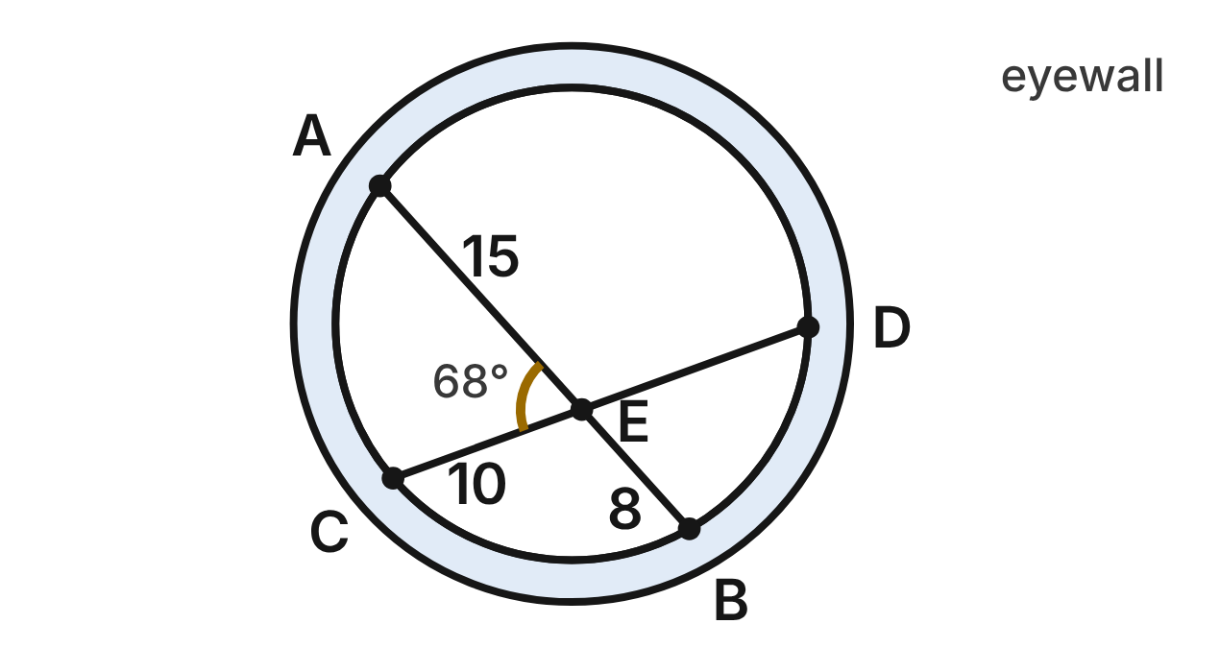
A hurricane's eye is a circle. A hurricane-hunter plane flies two straight legs across it: leg AB and leg CD, which cross at E. AE = 15 km, EB = 8 km, CE = 10 km, and m∠AEC = 68°.
409. How long is ED, the part of leg CD after it crosses leg AB?
A. 12 km ✔
B. about 18.8 km
C. about 5.3 km
D. 13 km
G.PC.3 · skill G.PC.3.2 (LOTS): Use the lengths of segments formed by intersecting chords, secants and tangents
☐ Answer key correct ☐ Wording clear Notes: ________________________________
410. How long is leg CD, from one edge of the eye to the other?
A. 12 km
B. 23 km
C. 22 km ✔
D. 25 km
G.PC.3 · skill G.PC.3.2 (LOTS): Use the lengths of segments formed by intersecting chords, secants and tangents
☐ Answer key correct ☐ Wording clear Notes: ________________________________
411. What is m(arc AD) + m(arc BC)?
A. 136°
B. 112°
C. 56°
D. 224° ✔
G.PC.3 · skill G.PC.3.1 (LOTS): Use the angles formed by chords, secants and tangents (central, inscribed, and angles inside and outside a circle) and their arcs
☐ Answer key correct ☐ Wording clear Notes: ________________________________
412. Dana writes m∠AEC = ½(m arc AC − m arc BD). What is her mistake?
A. She should not halve: m arc AC − m arc BD.
B. She should add the arcs: ½(m arc AC + m arc BD). ✔
C. She should use one arc only: m arc AC.
D. She should use the other arcs: ½(m arc AD − m arc BC).
G.PC.3 · skill G.PC.3.1 (LOTS): Use the angles formed by chords, secants and tangents (central, inscribed, and angles inside and outside a circle) and their arcs
☐ Answer key correct ☐ Wording clear Notes: ________________________________
413. A third straight leg also passes through E, and E is its midpoint. To the nearest tenth of a kilometer, how long is each half of this leg?
A. 11.5 km
B. 60.0 km
C. 11.0 km ✔
D. 12.2 km
G.PC.3 · skill G.PC.3.4 (HOTS): Model and solve a contextual problem with the properties of circles
☐ Answer key correct ☐ Wording clear Notes: ________________________________
414. In another storm, two flight legs cross inside the eye at a 50° angle. This angle and its vertical angle cut off two arcs. One arc measures 64°. What does the other arc measure?
A. 36° ✔
B. 164°
C. 78°
D. 66°
G.PC.3 · skill G.PC.3.1 (LOTS): Use the angles formed by chords, secants and tangents (central, inscribed, and angles inside and outside a circle) and their arcs
☐ Answer key correct ☐ Wording clear Notes: ________________________________

Two Paths Across an Orbit
Level 2 · Circles · G.PC.3 · ID geo-pc3-rocks-orbit-paths
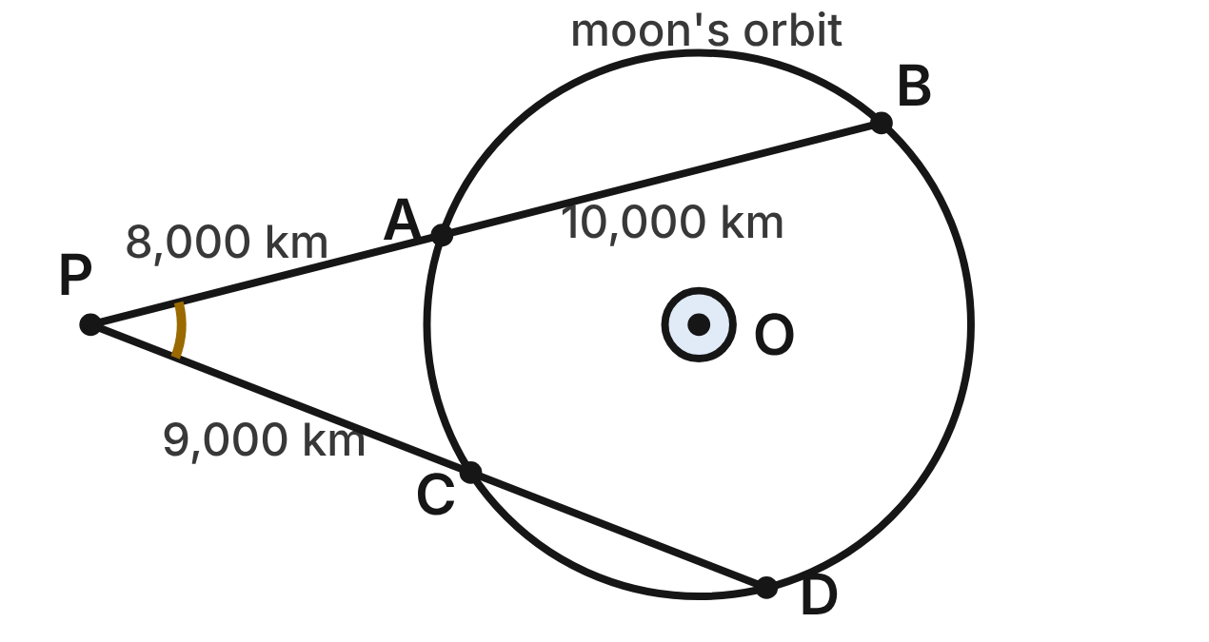
A moon travels on a circular orbit around a planet at O. A space probe at P is outside the orbit. One straight path from P crosses the orbit at A and B; another crosses it at C and D. PA = 8,000 km, AB = 10,000 km and PC = 9,000 km.
415. How long is CD, the part of the second path inside the orbit?
A. about 8,889 km
B. 7,000 km ✔
C. 16,000 km
D. 9,000 km
G.PC.3 · skill G.PC.3.2 (LOTS): Use the lengths of segments formed by intersecting chords, secants and tangents
☐ Answer key correct ☐ Wording clear Notes: ________________________________
416. Which equation is true for the two paths?
A. PA · AB = PC · CD
B. PA · PC = PB · PD
C. PA + AB = PC + CD
D. PA · PB = PC · PD ✔
G.PC.3 · skill G.PC.3.2 (LOTS): Use the lengths of segments formed by intersecting chords, secants and tangents
☐ Answer key correct ☐ Wording clear Notes: ________________________________
417. Which expression equals m∠APC, the angle between the two paths?
A. ½(m arc BD − m arc AC) ✔
B. ½(m arc BD + m arc AC)
C. m arc BD − m arc AC
D. ½ · m arc BD
G.PC.3 · skill G.PC.3.1 (LOTS): Use the angles formed by chords, secants and tangents (central, inscribed, and angles inside and outside a circle) and their arcs
☐ Answer key correct ☐ Wording clear Notes: ________________________________
418. From a point outside another orbit, two straight paths cross the orbit. They form a 35° angle, and the far arc between them measures 150°. What does the near arc measure?
A. 115°
B. 220°
C. 80° ✔
D. 40°
G.PC.3 · skill G.PC.3.1 (LOTS): Use the angles formed by chords, secants and tangents (central, inscribed, and angles inside and outside a circle) and their arcs
☐ Answer key correct ☐ Wording clear Notes: ________________________________
419. The probe could instead fly from P on a path that just touches the orbit at one point, T. How far is it from P to T?
A. about 8,944 km
B. 13,000 km
C. about 12,806 km
D. 12,000 km ✔
G.PC.3 · skill G.PC.3.2 (LOTS): Use the lengths of segments formed by intersecting chords, secants and tangents
☐ Answer key correct ☐ Wording clear Notes: ________________________________
420. The orbit's radius is 6,000 km, and the moon goes all the way around in 30 hours. How far does it travel in 5 hours? Give the answer in terms of π.
A. 1,000π km
B. 2,000π km ✔
C. 4,000π km
D. 12,000π km
G.PC.3 · skill G.PC.3.3 (LOTS): Find arc length and the area of a sector, or use them to find a radius or a central angle
☐ Answer key correct ☐ Wording clear Notes: ________________________________

The Lab Pendulum
Level 2 · Circles · G.PC.3 · ID geo-pc3-rocks-lab-pendulum
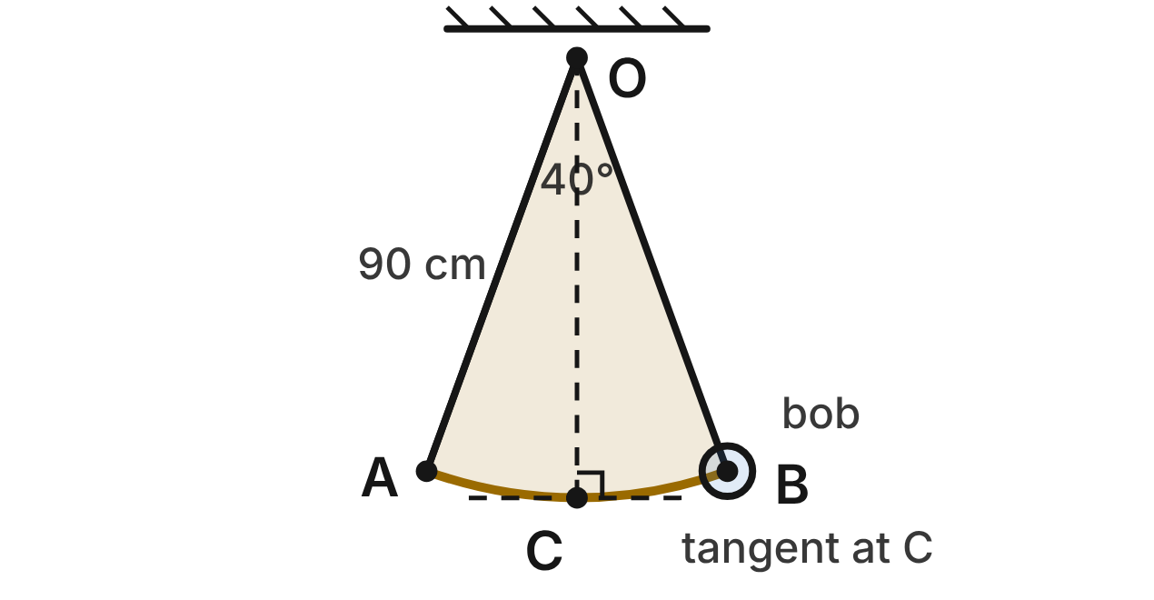
A lab pendulum hangs from a pivot at O. Its string is 90 cm long. The bob swings along arc AB, and m∠AOB = 40°. C is the lowest point of the swing, directly below O.
421. How far does the bob travel along arc AB in one swing from A to B? Round to the nearest tenth of a centimeter.
A. 31.4 cm
B. 125.7 cm
C. 2,827.4 cm
D. 62.8 cm ✔
G.PC.3 · skill G.PC.3.3 (LOTS): Find arc length and the area of a sector, or use them to find a radius or a central angle
☐ Answer key correct ☐ Wording clear Notes: ________________________________
422. What area does the string sweep out in one swing from A to B? Give the answer in terms of π.
A. 900π cm² ✔
B. 20π cm²
C. 3,600π cm²
D. 8,100π cm²
G.PC.3 · skill G.PC.3.3 (LOTS): Find arc length and the area of a sector, or use them to find a radius or a central angle
☐ Answer key correct ☐ Wording clear Notes: ________________________________
423. At C the bob moves along the line tangent to arc AB. What angle does this tangent line make with the string OC?
A. 20°
B. 90° ✔
C. 40°
D. 70°
G.PC.3 · skill G.PC.3.1 (LOTS): Use the angles formed by chords, secants and tangents (central, inscribed, and angles inside and outside a circle) and their arcs
☐ Answer key correct ☐ Wording clear Notes: ________________________________
424. A student pulls the bob farther out, so one swing of this pendulum is 30π cm long. What is the swing's central angle?
A. 120°
B. 30°
C. 60° ✔
D. about 1.3°
G.PC.3 · skill G.PC.3.3 (LOTS): Find arc length and the area of a sector, or use them to find a radius or a central angle
☐ Answer key correct ☐ Wording clear Notes: ________________________________
425. Another pendulum swings through 45°, and its bob travels 15π cm along its arc. How long is its string?
A. 60 cm ✔
B. 120 cm
C. 7.5 cm
D. about 11.0 cm
G.PC.3 · skill G.PC.3.3 (LOTS): Find arc length and the area of a sector, or use them to find a radius or a central angle
☐ Answer key correct ☐ Wording clear Notes: ________________________________
426. How far apart are A and B in a straight line? Round to the nearest tenth of a centimeter.
A. 62.8 cm
B. 30.8 cm
C. 169.1 cm
D. 61.6 cm ✔
G.PC.3 · skill G.PC.3.4 (HOTS): Model and solve a contextual problem with the properties of circles
☐ Answer key correct ☐ Wording clear Notes: ________________________________

The Lab Centrifuge
Level 2 · Circles · G.PC.3 · ID geo-pc3-rocks-centrifuge
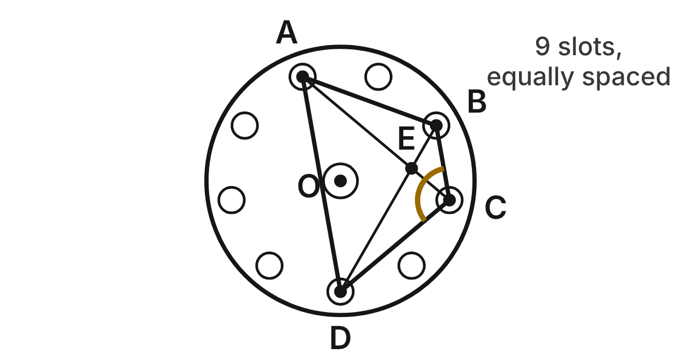
A lab centrifuge rotor has center O and 9 tube slots equally spaced on a circle with radius 7.5 cm. Tubes sit in slots A, B, C and D. Going around, there are 2 gaps from A to B, 1 from B to C, 2 from C to D and 4 from D back to A. The diagonals AC and BD cross at E.
427. What is m∠AOB, the central angle from slot A to slot B?
A. 40°
B. 120°
C. 80° ✔
D. 72°
G.PC.3 · skill G.PC.3.1 (LOTS): Use the angles formed by chords, secants and tangents (central, inscribed, and angles inside and outside a circle) and their arcs
☐ Answer key correct ☐ Wording clear Notes: ________________________________
428. What is m∠BCD, the angle of ABCD at C?
A. 240°
B. 120° ✔
C. 60°
D. 80°
G.PC.3 · skill G.PC.3.1 (LOTS): Use the angles formed by chords, secants and tangents (central, inscribed, and angles inside and outside a circle) and their arcs
☐ Answer key correct ☐ Wording clear Notes: ________________________________
429. What is m∠BEC, where the diagonals cross?
A. 200°
B. 60°
C. 80°
D. 100° ✔
G.PC.3 · skill G.PC.3.1 (LOTS): Use the angles formed by chords, secants and tangents (central, inscribed, and angles inside and outside a circle) and their arcs
☐ Answer key correct ☐ Wording clear Notes: ________________________________
430. How far apart are two slots next to each other, measured along the slot circle? Round to the nearest tenth of a centimeter.
A. 5.2 cm ✔
B. 2.6 cm
C. 10.5 cm
D. 19.6 cm
G.PC.3 · skill G.PC.3.3 (LOTS): Find arc length and the area of a sector, or use them to find a radius or a central angle
☐ Answer key correct ☐ Wording clear Notes: ________________________________
431. The rotor spins at 3,000 revolutions per minute. How far does a tube travel in one second? Round to the nearest tenth of a meter.
A. 11.8 m
B. 23.6 m ✔
C. 47.1 m
D. 1,413.7 m
G.PC.3 · skill G.PC.3.4 (HOTS): Model and solve a contextual problem with the properties of circles
☐ Answer key correct ☐ Wording clear Notes: ________________________________
432. To balance a rotor, a technician loads 3 tubes so they are equally spaced around the circle. What is the measure of each angle of the triangle the 3 tubes form?
A. 120°
B. 40°
C. 60° ✔
D. 180°
G.PC.3 · skill G.PC.3.1 (LOTS): Use the angles formed by chords, secants and tangents (central, inscribed, and angles inside and outside a circle) and their arcs
☐ Answer key correct ☐ Wording clear Notes: ________________________________

The Satellite's View
Level 3 · Circles · G.PC.3 · ID geo-pc3-rocks-satellite-view
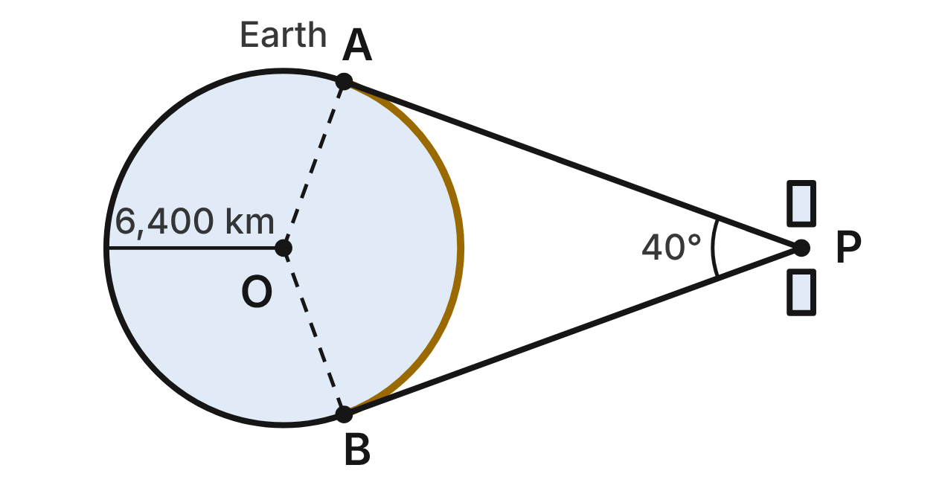
A weather satellite at P looks down at Earth, drawn as a circle with center O and radius 6,400 km. Its lines of sight PA and PB just touch Earth at A and B, so it can see minor arc AB. m∠APB = 40°.
433. What is the measure of minor arc AB, the part of Earth's outline the satellite can see?
A. 140° ✔
B. 80°
C. 40°
D. 220°
G.PC.3 · skill G.PC.3.1 (LOTS): Use the angles formed by chords, secants and tangents (central, inscribed, and angles inside and outside a circle) and their arcs
☐ Answer key correct ☐ Wording clear Notes: ________________________________
434. Which statement must be true?
A. m∠AOB = 40°, because it is vertical to ∠APB.
B. m∠OAP = 90°, because PA is tangent at A. ✔
C. PA = OA, because tangent segments are congruent.
D. m∠OAP = 70°, because △OAP is isosceles.
G.PC.3 · skill G.PC.3.1 (LOTS): Use the angles formed by chords, secants and tangents (central, inscribed, and angles inside and outside a circle) and their arcs
☐ Answer key correct ☐ Wording clear Notes: ________________________________
435. How long is minor arc AB along Earth's outline? Round to the nearest hundred kilometers.
A. 4,500 km
B. 24,600 km
C. 7,800 km
D. 15,600 km ✔
G.PC.3 · skill G.PC.3.3 (LOTS): Find arc length and the area of a sector, or use them to find a radius or a central angle
☐ Answer key correct ☐ Wording clear Notes: ________________________________
436. What percent of Earth's full outline can the satellite see? Round to the nearest tenth of a percent.
A. 11.1%
B. 61.1%
C. 38.9% ✔
D. 22.2%
G.PC.3 · skill G.PC.3.4 (HOTS): Model and solve a contextual problem with the properties of circles
☐ Answer key correct ☐ Wording clear Notes: ________________________________
437. To the nearest hundred kilometers, how far is the satellite from Earth's center O?
A. 6,800 km
B. 18,700 km ✔
C. 17,600 km
D. 10,000 km
G.PC.3 · skill G.PC.3.4 (HOTS): Model and solve a contextual problem with the properties of circles
☐ Answer key correct ☐ Wording clear Notes: ________________________________
438. To the nearest hundred kilometers, how long is PB, the line of sight from the satellite to B?
A. 17,600 km ✔
B. 2,300 km
C. 18,700 km
D. 12,300 km
G.PC.3 · skill G.PC.3.2 (LOTS): Use the lengths of segments formed by intersecting chords, secants and tangents
☐ Answer key correct ☐ Wording clear Notes: ________________________________

Leaving Orbit
Level 3 · Circles · G.PC.3 · ID geo-pc3-rocks-leaving-orbit
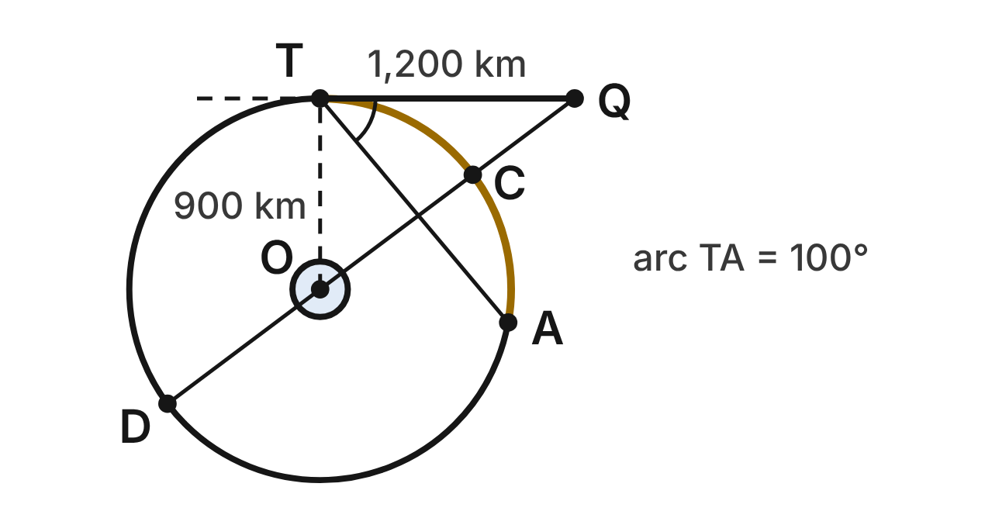
A probe circles a small moon on an orbit with center O and radius 900 km. At T it fires its engine and leaves along line TQ, which is tangent to the orbit at T. TQ = 1,200 km. A beacon at A is on the orbit, and m(arc TA) = 100°. Line QO crosses the orbit at C and D.
439. What is m∠QTA, the angle between the probe's new path and chord TA?
A. 100°
B. 25°
C. 50° ✔
D. 130°
G.PC.3 · skill G.PC.3.1 (LOTS): Use the angles formed by chords, secants and tangents (central, inscribed, and angles inside and outside a circle) and their arcs
☐ Answer key correct ☐ Wording clear Notes: ________________________________
440. Why is △OTQ a right triangle?
A. OT and TQ are congruent sides.
B. OQ is a diameter of the orbit.
C. T is the midpoint of segment OQ.
D. TQ is tangent at T, so TQ ⊥ radius OT. ✔
G.PC.3 · skill G.PC.3.1 (LOTS): Use the angles formed by chords, secants and tangents (central, inscribed, and angles inside and outside a circle) and their arcs
☐ Answer key correct ☐ Wording clear Notes: ________________________________
441. How far is Q from the moon's center O?
A. 2,100 km
B. 1,500 km ✔
C. about 794 km
D. 300 km
G.PC.3 · skill G.PC.3.2 (LOTS): Use the lengths of segments formed by intersecting chords, secants and tangents
☐ Answer key correct ☐ Wording clear Notes: ________________________________
442. How far is Q from C, the nearest point of the orbit?
A. 600 km ✔
B. 1,500 km
C. 800 km
D. 300 km
G.PC.3 · skill G.PC.3.2 (LOTS): Use the lengths of segments formed by intersecting chords, secants and tangents
☐ Answer key correct ☐ Wording clear Notes: ________________________________
443. How far does the probe travel along the orbit from A to T on minor arc AT? Round to the nearest kilometer.
A. 785 km
B. 3,142 km
C. 4,084 km
D. 1,571 km ✔
G.PC.3 · skill G.PC.3.3 (LOTS): Find arc length and the area of a sector, or use them to find a radius or a central angle
☐ Answer key correct ☐ Wording clear Notes: ________________________________
444. One full trip around the orbit takes 3 hours. How many minutes does the probe take to go from A to T along minor arc AT?
A. 25 min
B. 130 min
C. 50 min ✔
D. about 83 min
G.PC.3 · skill G.PC.3.4 (HOTS): Model and solve a contextual problem with the properties of circles
☐ Answer key correct ☐ Wording clear Notes: ________________________________

G.PC.4 · Solve problems involving equations of circles.

The Petri Dish
Level 1 · Equations of circles · G.PC.4 · ID geo-pc4-rocks-petri-dish
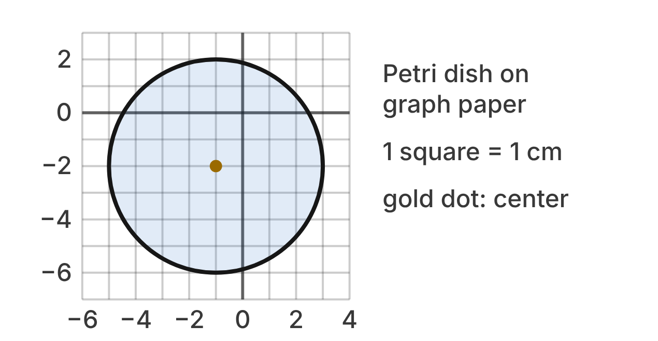
A round petri dish sits on graph paper with x- and y-axes. Each square is 1 cm. The shaded circle is the dish, and the gold dot is its center.
445. What are the coordinates of the center of the petri dish?
A. (1, 2)
B. (−1, −2) ✔
C. (−2, −1)
D. (3, −2)
G.PC.4 · skill G.PC.4.1 (LOTS): Identify the center and radius of a circle from its graph or from its equation in standard form
☐ Answer key correct ☐ Wording clear Notes: ________________________________
446. What is the radius of the petri dish?
A. 4 cm ✔
B. 8 cm
C. 16 cm
D. 2 cm
G.PC.4 · skill G.PC.4.1 (LOTS): Identify the center and radius of a circle from its graph or from its equation in standard form
☐ Answer key correct ☐ Wording clear Notes: ________________________________
447. Which equation describes the edge of the petri dish?
A. (x − 1)² + (y − 2)² = 16
B. (x + 1)² + (y + 2)² = 4
C. (x + 1)² + (y + 2)² = 64
D. (x + 1)² + (y + 2)² = 16 ✔
G.PC.4 · skill G.PC.4.2 (LOTS): Write the equation of a circle from its center and radius, its center and a point, or the endpoints of a diameter
☐ Answer key correct ☐ Wording clear Notes: ________________________________
448. Bacteria colonies grow at the four points below. Which colony is outside the dish?
A. (1, 0)
B. (−5, 1) ✔
C. (3, −2)
D. (−2, −5)
G.PC.4 · skill G.PC.4.1 (LOTS): Identify the center and radius of a circle from its graph or from its equation in standard form
☐ Answer key correct ☐ Wording clear Notes: ________________________________
449. Which expression gives the distance from the center of the dish to a colony at (1, 0)?
A. (1 + 1)² + (0 + 2)²
B. √((1 − 1)² + (0 − 2)²)
C. √((1 + 1)² + (0 + 2)²) ✔
D. √((1 + 1) + (0 + 2))
G.PC.4 · skill G.PC.4.3 (HOTS): Derive the equation of a circle with the Pythagorean Theorem or the distance formula
☐ Answer key correct ☐ Wording clear Notes: ________________________________
450. A larger dish has the edge x² + (y − 3)² = 25. What are its center and radius?
A. (0, 3); r = 5 ✔
B. (0, −3); r = 5
C. (0, 3); r = 25
D. (3, 0); r = 5
G.PC.4 · skill G.PC.4.1 (LOTS): Identify the center and radius of a circle from its graph or from its equation in standard form
☐ Answer key correct ☐ Wording clear Notes: ________________________________

Two Planet Orbits
Level 1 · Equations of circles · G.PC.4 · ID geo-pc4-rocks-planet-orbits
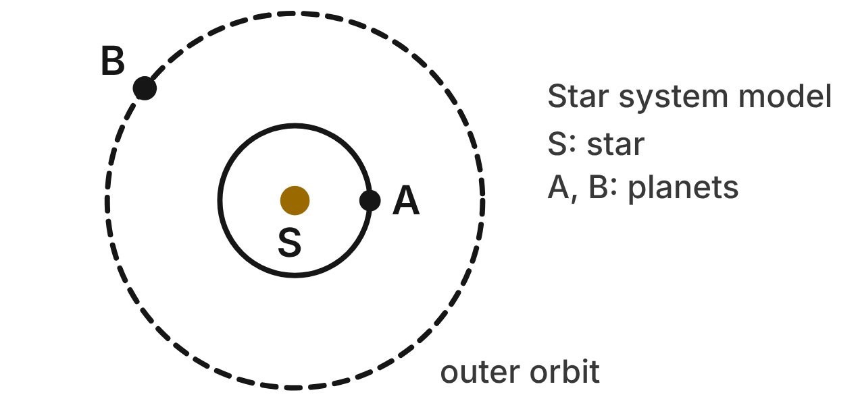
In a model of a star system, the outer orbit is the circle (x + 3)² + (y + 2)² = 25. The inner orbit has the same center, the star S, and a radius of 2 units. Planet A(−1, −2) is on the inner orbit. Planet B(−7, 1) is on the outer orbit.
451. What are the coordinates of the star S?
A. (3, 2)
B. (−2, −3)
C. (−3, −2) ✔
D. (2, 3)
G.PC.4 · skill G.PC.4.1 (LOTS): Identify the center and radius of a circle from its graph or from its equation in standard form
☐ Answer key correct ☐ Wording clear Notes: ________________________________
452. What is the radius of the outer orbit?
A. 25 units
B. 12.5 units
C. 10 units
D. 5 units ✔
G.PC.4 · skill G.PC.4.1 (LOTS): Identify the center and radius of a circle from its graph or from its equation in standard form
☐ Answer key correct ☐ Wording clear Notes: ________________________________
453. Which equation describes the inner orbit?
A. (x + 3)² + (y + 2)² = 4 ✔
B. (x + 3)² + (y + 2)² = 2
C. (x − 3)² + (y − 2)² = 4
D. (x + 3)² + (y + 2)² = 16
G.PC.4 · skill G.PC.4.2 (LOTS): Write the equation of a circle from its center and radius, its center and a point, or the endpoints of a diameter
☐ Answer key correct ☐ Wording clear Notes: ________________________________
454. A comet passes the four points below. Which point is on the outer orbit?
A. (2, 3)
B. (−2, 2)
C. (0, 2) ✔
D. (−3, 23)
G.PC.4 · skill G.PC.4.1 (LOTS): Identify the center and radius of a circle from its graph or from its equation in standard form
☐ Answer key correct ☐ Wording clear Notes: ________________________________
455. Which equation uses the Pythagorean theorem to show that planet B is on the outer orbit?
A. 10² + 1² = 5²
B. 4² + 3² = 5² ✔
C. 4 + 3 = 5
D. 7² + 1² = 5²
G.PC.4 · skill G.PC.4.3 (HOTS): Derive the equation of a circle with the Pythagorean Theorem or the distance formula
☐ Answer key correct ☐ Wording clear Notes: ________________________________
456. A moon circles planet B at a distance of 2 units. Which equation describes the moon's path?
A. (x + 7)² + (y − 1)² = 2
B. (x − 7)² + (y + 1)² = 4
C. (x + 3)² + (y + 2)² = 4
D. (x + 7)² + (y − 1)² = 4 ✔
G.PC.4 · skill G.PC.4.2 (LOTS): Write the equation of a circle from its center and radius, its center and a point, or the endpoints of a diameter
☐ Answer key correct ☐ Wording clear Notes: ________________________________

The Crater Map
Level 2 · Equations of circles · G.PC.4 · ID geo-pc4-rocks-crater-map
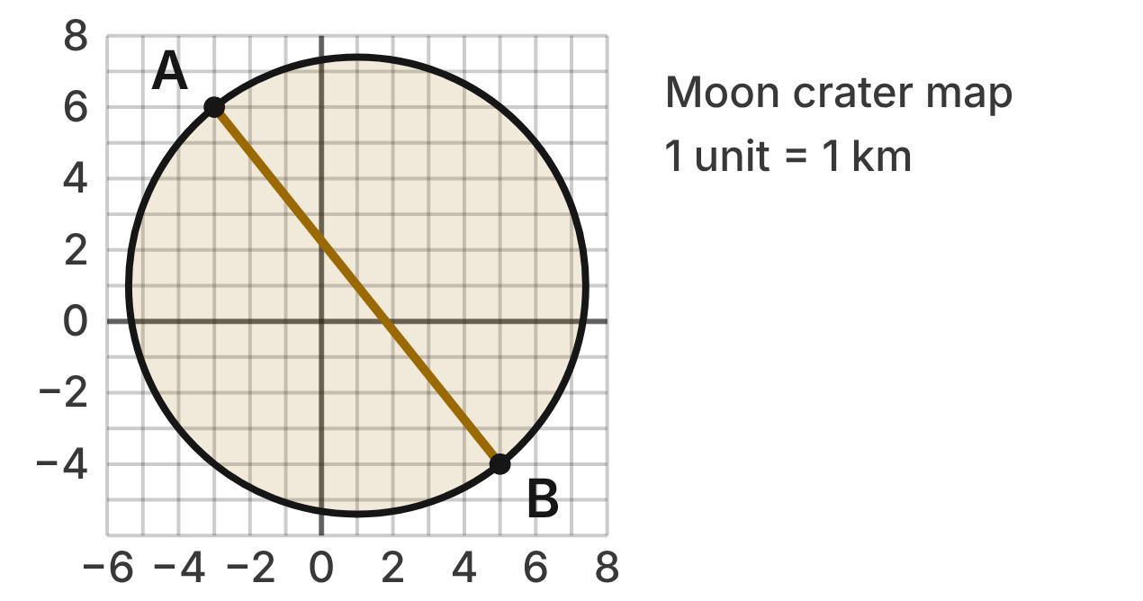
On a map of a moon crater (units in kilometers), segment AB runs straight across the crater through its center, from A(−3, 6) to B(5, −4). Both ends are on the rim.
457. What are the coordinates of the center of the crater?
A. (4, −5)
B. (2, 2)
C. (1, 1) ✔
D. (8, −10)
G.PC.4 · skill G.PC.4.2 (LOTS): Write the equation of a circle from its center and radius, its center and a point, or the endpoints of a diameter
☐ Answer key correct ☐ Wording clear Notes: ________________________________
458. What is the radius of the crater, in simplest radical form?
A. √41 km ✔
B. 2√41 km
C. 41 km
D. 9 km
G.PC.4 · skill G.PC.4.1 (LOTS): Identify the center and radius of a circle from its graph or from its equation in standard form
☐ Answer key correct ☐ Wording clear Notes: ________________________________
459. Which equation describes the rim of the crater?
A. (x + 1)² + (y + 1)² = 41
B. (x − 1)² + (y − 1)² = 41 ✔
C. (x − 1)² + (y − 1)² = 164
D. (x + 3)² + (y − 6)² = 41
G.PC.4 · skill G.PC.4.2 (LOTS): Write the equation of a circle from its center and radius, its center and a point, or the endpoints of a diameter
☐ Answer key correct ☐ Wording clear Notes: ________________________________
460. A rover's map marks four boulders. Which boulder sits exactly on the rim?
A. (6, 3)
B. (−5, 1)
C. (−4, −3) ✔
D. (5, −5)
G.PC.4 · skill G.PC.4.1 (LOTS): Identify the center and radius of a circle from its graph or from its equation in standard form
☐ Answer key correct ☐ Wording clear Notes: ________________________________
461. Lena finds the radius with the distance formula, from the center of the crater to B. Which line of work is correct?
A. √((5 − 1)² + (−4 − 1)²) = 9
B. √((5 + 1)² + (−4 + 1)²) = √45
C. √((5 + 3)² + (−4 − 6)²) = √164
D. √((5 − 1)² + (−4 − 1)²) = √41 ✔
G.PC.4 · skill G.PC.4.3 (HOTS): Derive the equation of a circle with the Pythagorean Theorem or the distance formula
☐ Answer key correct ☐ Wording clear Notes: ________________________________
462. A small crater has its center at A. Its rim passes through (−1, 7). Which equation describes the small crater's rim?
A. (x + 3)² + (y − 6)² = 5 ✔
B. (x − 3)² + (y + 6)² = 5
C. (x + 3)² + (y − 6)² = 9
D. (x + 3)² + (y − 6)² = √5
G.PC.4 · skill G.PC.4.2 (LOTS): Write the equation of a circle from its center and radius, its center and a point, or the endpoints of a diameter
☐ Answer key correct ☐ Wording clear Notes: ________________________________

The Telescope View
Level 2 · Equations of circles · G.PC.4 · ID geo-pc4-rocks-telescope
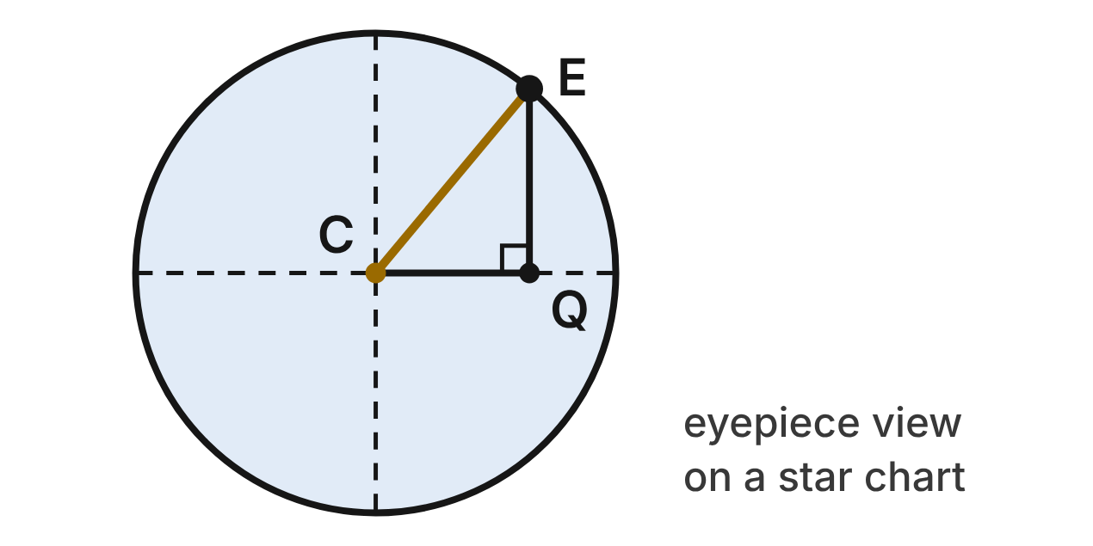
A telescope's round field of view is drawn on a star chart. Its center is C(−2, 1). The star E(3, 7) is on the edge of the field. Point Q(3, 1) makes right triangle CQE.
463. Which expression gives the length of leg CQ?
A. 3 − 2 = 1
B. 7 − 1 = 6
C. −2 − 3 = −5
D. 3 − (−2) = 5 ✔
G.PC.4 · skill G.PC.4.3 (HOTS): Derive the equation of a circle with the Pythagorean Theorem or the distance formula
☐ Answer key correct ☐ Wording clear Notes: ________________________________
464. Which equation does the Pythagorean theorem give for triangle CQE?
A. 5 + 6 = CE
B. 5² + 6² = CE² ✔
C. 5² + CE² = 6²
D. 1² + 6² = CE²
G.PC.4 · skill G.PC.4.3 (HOTS): Derive the equation of a circle with the Pythagorean Theorem or the distance formula
☐ Answer key correct ☐ Wording clear Notes: ________________________________
465. Which equation describes the edge of the field of view?
A. (x + 2)² + (y − 1)² = 61 ✔
B. (x − 2)² + (y + 1)² = 61
C. (x + 2)² + (y − 1)² = 11
D. (x + 2)² + (y − 1)² = √61
G.PC.4 · skill G.PC.4.2 (LOTS): Write the equation of a circle from its center and radius, its center and a point, or the endpoints of a diameter
☐ Answer key correct ☐ Wording clear Notes: ________________________________
466. Why is the right side of the field's equation 61 and not √61?
A. The radius is 5² + 6² = 61 units.
B. 61 is the diameter of the field.
C. √61 is rounded to a whole number.
D. It uses r², and r² = 5² + 6² = 61. ✔
G.PC.4 · skill G.PC.4.3 (HOTS): Derive the equation of a circle with the Pythagorean Theorem or the distance formula
☐ Answer key correct ☐ Wording clear Notes: ________________________________
467. To the nearest tenth, what is the radius of the field of view in grid units?
A. 11.0 units
B. 30.5 units
C. 7.8 units ✔
D. 15.6 units
G.PC.4 · skill G.PC.4.1 (LOTS): Identify the center and radius of a circle from its graph or from its equation in standard form
☐ Answer key correct ☐ Wording clear Notes: ________________________________
468. Which star is inside the field of view?
A. (−8, 6)
B. (4, 4) ✔
C. (5, −3)
D. (1, −7)
G.PC.4 · skill G.PC.4.1 (LOTS): Identify the center and radius of a circle from its graph or from its equation in standard form
☐ Answer key correct ☐ Wording clear Notes: ________________________________

The Storm Track
Level 2 · Equations of circles · G.PC.4 · ID geo-pc4-rocks-storm-track
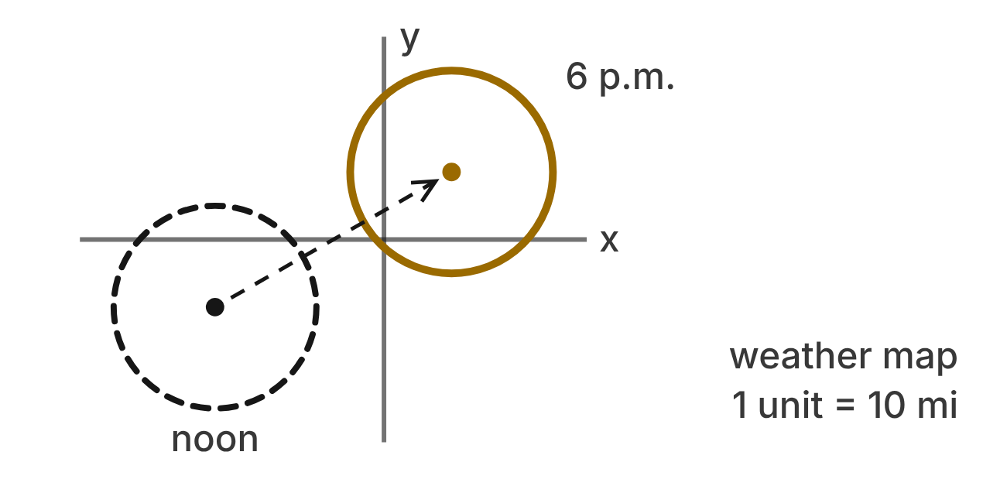
On a weather map (1 unit = 10 miles), the dashed circle shows a storm at noon: (x + 5)² + (y + 2)² = 9. By 6 p.m. the storm has moved 7 units right and 4 units up without changing size (the gold circle).
469. Where was the center of the storm at noon?
A. (5, 2)
B. (−2, −5)
C. (5, −2)
D. (−5, −2) ✔
G.PC.4 · skill G.PC.4.1 (LOTS): Identify the center and radius of a circle from its graph or from its equation in standard form
☐ Answer key correct ☐ Wording clear Notes: ________________________________
470. How far does the storm reach from its center, in miles?
A. 30 mi ✔
B. 90 mi
C. 60 mi
D. 3 mi
G.PC.4 · skill G.PC.4.1 (LOTS): Identify the center and radius of a circle from its graph or from its equation in standard form
☐ Answer key correct ☐ Wording clear Notes: ________________________________
471. Which equation describes the storm at 6 p.m.?
A. (x + 12)² + (y + 6)² = 9
B. (x − 7)² + (y − 4)² = 9
C. (x − 2)² + (y − 2)² = 9 ✔
D. (x + 2)² + (y + 2)² = 9
G.PC.4 · skill G.PC.4.2 (LOTS): Write the equation of a circle from its center and radius, its center and a point, or the endpoints of a diameter
☐ Answer key correct ☐ Wording clear Notes: ________________________________
472. Which expression gives how far the center of the storm moved, in grid units?
A. √(7² + 4²) ✔
B. 7 + 4
C. 7² + 4²
D. √(7² − 4²)
G.PC.4 · skill G.PC.4.3 (HOTS): Derive the equation of a circle with the Pythagorean Theorem or the distance formula
☐ Answer key correct ☐ Wording clear Notes: ________________________________
473. Four weather stations are at the points below. At 6 p.m., which station is inside the storm?
A. (−4, −1)
B. (0, 1) ✔
C. (5, 2)
D. (−2, 0)
G.PC.4 · skill G.PC.4.1 (LOTS): Identify the center and radius of a circle from its graph or from its equation in standard form
☐ Answer key correct ☐ Wording clear Notes: ________________________________
474. At 9 p.m. the storm has the same center as at 6 p.m., but it has grown. Its edge now passes through (6, −1). Which equation describes the storm at 9 p.m.?
A. (x − 2)² + (y − 2)² = 5
B. (x − 6)² + (y + 1)² = 25
C. (x − 2)² + (y − 2)² = 49
D. (x − 2)² + (y − 2)² = 25 ✔
G.PC.4 · skill G.PC.4.2 (LOTS): Write the equation of a circle from its center and radius, its center and a point, or the endpoints of a diameter
☐ Answer key correct ☐ Wording clear Notes: ________________________________

The Weather Balloon
Level 3 · Equations of circles · G.PC.4 · ID geo-pc4-rocks-weather-balloon
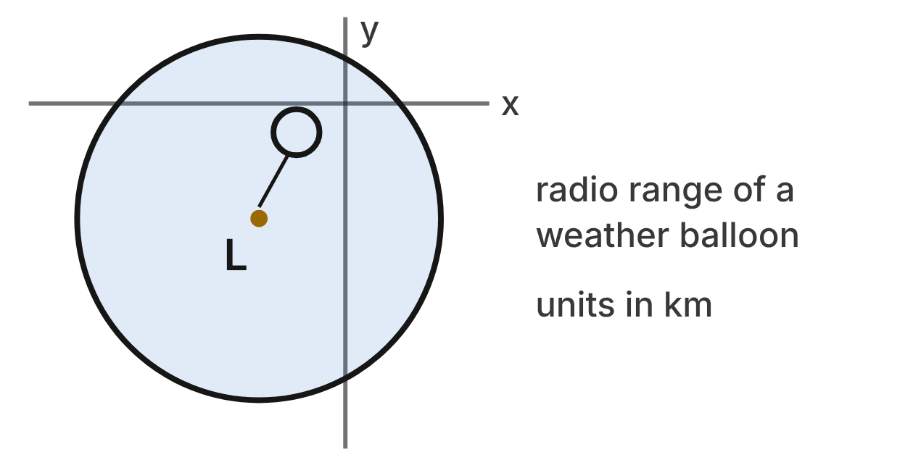
A weather balloon's radio can be heard inside a circle on a map (units in km). The edge of that circle is x² + y² + 6x + 8y − 15 = 0. The balloon was launched from the center of the circle, L.
475. Which line correctly completes the square for the edge of the circle?
A. (x² + 6x + 9) + (y² + 8y + 16) = 15
B. (x² + 6x + 9) + (y² + 8y + 16) = 15 + 9 + 16 ✔
C. (x² + 6x + 3) + (y² + 8y + 4) = 15 + 3 + 4
D. (x² + 6x + 9) + (y² + 8y + 16) = −15 + 9 + 16
G.PC.4 · skill G.PC.4.1 (LOTS): Identify the center and radius of a circle from its graph or from its equation in standard form
☐ Answer key correct ☐ Wording clear Notes: ________________________________
476. What are the center and radius of the circle where the radio can be heard?
A. (3, 4); r = 2√10
B. (−3, −4); r = 40
C. (−3, −4); r = 2√10 ✔
D. (−3, −4); r = √10
G.PC.4 · skill G.PC.4.1 (LOTS): Identify the center and radius of a circle from its graph or from its equation in standard form
☐ Answer key correct ☐ Wording clear Notes: ________________________________
477. Ana says the launch site L is at (3, 4) because the equation has +6x and +8y. Which statement corrects her?
A. L is at (6, 8), the coefficients of x and y.
B. L is at (−6, −8), the opposites of 6 and 8.
C. L is at (9, 16), the numbers added to each side.
D. (x + 3)² = (x − (−3))², so L is at (−3, −4). ✔
G.PC.4 · skill G.PC.4.1 (LOTS): Identify the center and radius of a circle from its graph or from its equation in standard form
☐ Answer key correct ☐ Wording clear Notes: ________________________________
478. Where is a ground station at (3, −2) compared with the circle? Choose the answer with the correct reason.
A. Inside: its distance squared is 36, less than r²
B. On: its distance squared is 40, equal to r² ✔
C. Outside: its distance squared is 40, and r² is 2√10
D. Outside: its distance squared is 40, and r² is 10
G.PC.4 · skill G.PC.4.1 (LOTS): Identify the center and radius of a circle from its graph or from its equation in standard form
☐ Answer key correct ☐ Wording clear Notes: ________________________________
479. Carlos says (x + 3)² + (y + 4)² = 40 cannot be a circle because it is not x² + y² = r². Which reply is correct?
A. Every point on it is √40 km from (−3, −4), so it is a circle. ✔
B. He is right: only x² + y² = r² makes a circle.
C. It is a circle, but its radius is 40 km.
D. It is a circle only if 40 is a perfect square.
G.PC.4 · skill G.PC.4.3 (HOTS): Derive the equation of a circle with the Pythagorean Theorem or the distance formula
☐ Answer key correct ☐ Wording clear Notes: ________________________________
480. A second balloon is launched from L. The edge of its radio range passes through (2, 1). Which equation describes that edge?
A. (x − 3)² + (y − 4)² = 50
B. (x − 2)² + (y − 1)² = 50
C. (x + 3)² + (y + 4)² = 50 ✔
D. (x + 3)² + (y + 4)² = 10
G.PC.4 · skill G.PC.4.2 (LOTS): Write the equation of a circle from its center and radius, its center and a point, or the endpoints of a diameter
☐ Answer key correct ☐ Wording clear Notes: ________________________________

Satellite Coverage
Level 3 · Equations of circles · G.PC.4 · ID geo-pc4-rocks-satellite
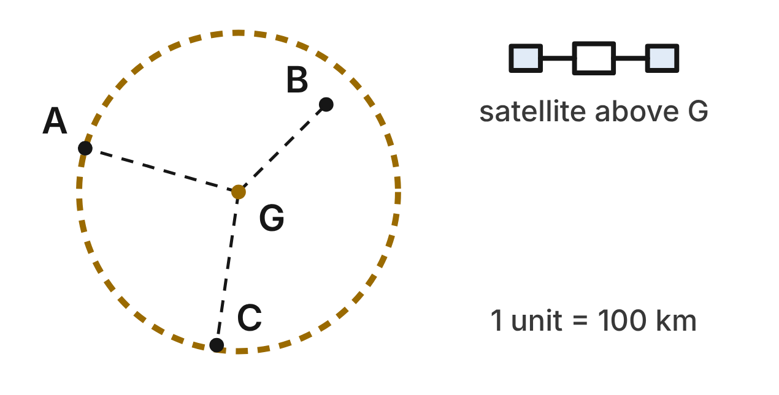
A weather satellite covers a circle centered at G(2, −1), the point on the map right below it (1 unit = 100 km). The towns are A(−5, 1), B(6, 3) and C(1, −8). The dashed circle is the smallest circle centered at G that reaches all three towns.
481. How far from G is the farthest town, in map units?
A. 9 units
B. √53 units ✔
C. 53 units
D. 3√10 units
G.PC.4 · skill G.PC.4.3 (HOTS): Derive the equation of a circle with the Pythagorean Theorem or the distance formula
☐ Answer key correct ☐ Wording clear Notes: ________________________________
482. Which equation describes the dashed circle?
A. (x − 2)² + (y + 1)² = 32
B. (x + 2)² + (y − 1)² = 53
C. (x − 2)² + (y + 1)² = √53
D. (x − 2)² + (y + 1)² = 53 ✔
G.PC.4 · skill G.PC.4.2 (LOTS): Write the equation of a circle from its center and radius, its center and a point, or the endpoints of a diameter
☐ Answer key correct ☐ Wording clear Notes: ________________________________
483. After a drift, the edge of the coverage is x² + y² − 6x + 8y − 11 = 0. What are its center and radius?
A. (3, −4); r = 6 ✔
B. (−3, 4); r = 6
C. (3, −4); r = √11
D. (3, −4); r = 36
G.PC.4 · skill G.PC.4.1 (LOTS): Identify the center and radius of a circle from its graph or from its equation in standard form
☐ Answer key correct ☐ Wording clear Notes: ________________________________
484. After the drift, the coverage is the circle x² + y² − 6x + 8y − 11 = 0 and its inside. Which towns does it reach?
A. A only
B. C only ✔
C. None of them
D. A, B and C
G.PC.4 · skill G.PC.4.1 (LOTS): Identify the center and radius of a circle from its graph or from its equation in standard form
☐ Answer key correct ☐ Wording clear Notes: ________________________________
485. An engineer's rule for a covered point (x, y) is √((x − 2)² + (y + 1)²) ≤ √53. Which rule says the same thing without square roots?
A. (x − 2) + (y + 1) ≤ √53
B. (x − 2)² + (y + 1)² ≤ √53
C. (x − 2)² + (y + 1)² ≤ 53 ✔
D. (x − 2)² + (y + 1)² ≥ 53
G.PC.4 · skill G.PC.4.3 (HOTS): Derive the equation of a circle with the Pythagorean Theorem or the distance formula
☐ Answer key correct ☐ Wording clear Notes: ________________________________
486. A second satellite is right above town B. The edge of its coverage passes through G. Which equation describes that edge?
A. (x − 6)² + (y − 3)² = 32 ✔
B. (x + 6)² + (y + 3)² = 32
C. (x − 2)² + (y + 1)² = 32
D. (x − 6)² + (y − 3)² = 8
G.PC.4 · skill G.PC.4.2 (LOTS): Write the equation of a circle from its center and radius, its center and a point, or the endpoints of a diameter
☐ Answer key correct ☐ Wording clear Notes: ________________________________

3-D figures (G.DF)

G.DF.1 · Create models and solve problems, including those in context, involving surface area and volume of rectangular and triangular prisms, cylinders, cones, pyramids, and spheres.

The Rain Gauge
Level 1 · 3-D figures · G.DF.1 · ID geo-df1-rocks-rain-gauge
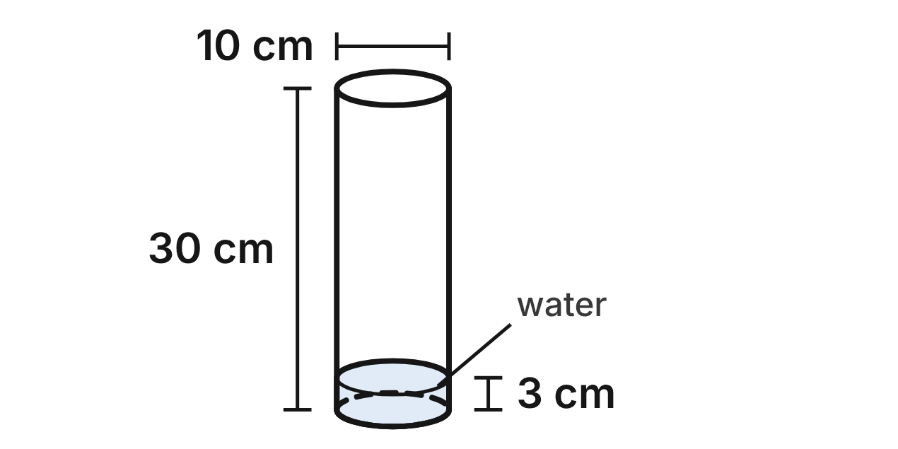
The school weather station's rain gauge is a clear cylinder, open at the top. Its inside diameter is 10 cm and it is 30 cm tall. After a storm, the water in it is 3 cm deep.
487. How much water can the gauge hold when it is full, in terms of π?
A. 3,000π cm³
B. 750π cm³ ✔
C. 150π cm³
D. 300π cm³
G.DF.1 · skill G.DF.1.2 (LOTS): Find the surface area and volume of prisms, cylinders, cones, pyramids and spheres
☐ Answer key correct ☐ Wording clear Notes: ________________________________
488. What is the volume of the water in the gauge after the storm, to the nearest tenth of a cubic centimeter?
A. 235.6 cm³ ✔
B. 942.5 cm³
C. 2,356.2 cm³
D. 47.1 cm³
G.DF.1 · skill G.DF.1.2 (LOTS): Find the surface area and volume of prisms, cylinders, cones, pyramids and spheres
☐ Answer key correct ☐ Wording clear Notes: ________________________________
489. The gauge has a bottom but no top. Which shapes make up a net of the gauge?
A. a rectangle and two circles
B. a sector and one circle
C. a triangle and one circle
D. a rectangle and one circle ✔
G.DF.1 · skill G.DF.1.1 (LOTS): Identify the two-dimensional cross sections and nets of three-dimensional figures
☐ Answer key correct ☐ Wording clear Notes: ________________________________
490. The flat top surface of the water is a cross section of the gauge. What is its area, in terms of π?
A. 100π cm²
B. 25π cm² ✔
C. 10π cm²
D. 30π cm²
G.DF.1 · skill G.DF.1.1 (LOTS): Identify the two-dimensional cross sections and nets of three-dimensional figures
☐ Answer key correct ☐ Wording clear Notes: ________________________________
491. A plane cuts the gauge straight down through the center of its circular bottom. What is the cross section?
A. a rectangle 5 cm by 30 cm
B. a circle with diameter 10 cm
C. a rectangle 10 cm by 30 cm ✔
D. a triangle with base 10 cm and height 30 cm
G.DF.1 · skill G.DF.1.1 (LOTS): Identify the two-dimensional cross sections and nets of three-dimensional figures
☐ Answer key correct ☐ Wording clear Notes: ________________________________
492. How much plastic makes the bottom and the curved side of the gauge, in terms of π?
A. 325π cm² ✔
B. 350π cm²
C. 300π cm²
D. 175π cm²
G.DF.1 · skill G.DF.1.2 (LOTS): Find the surface area and volume of prisms, cylinders, cones, pyramids and spheres
☐ Answer key correct ☐ Wording clear Notes: ________________________________

The Pyramid Crystal
Level 1 · 3-D figures · G.DF.1 · ID geo-df1-rocks-crystal
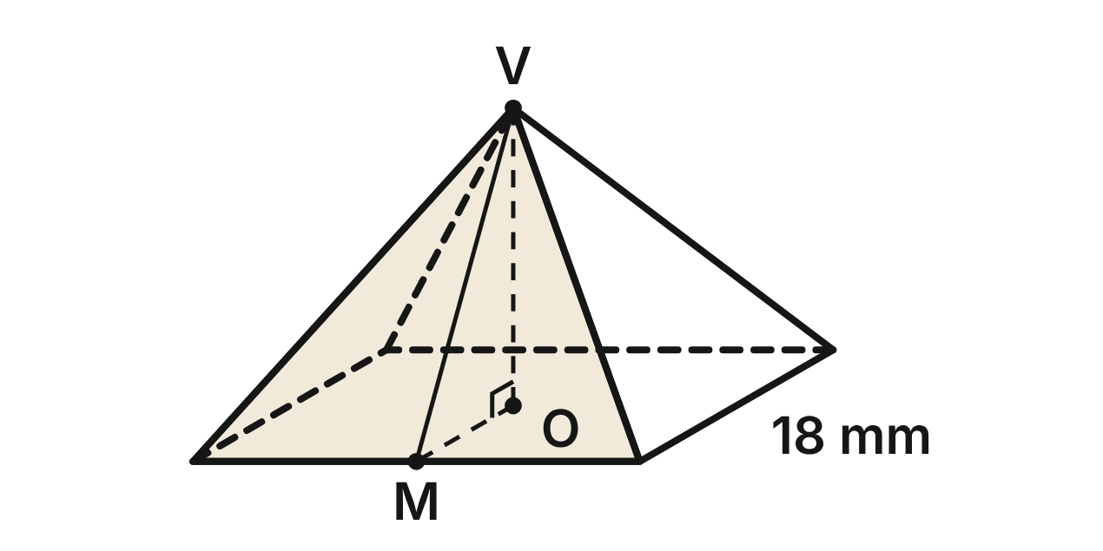
A crystal grown in the science lab is a square pyramid with base edges of 18 mm. V is its tip, O the center of its base and M the midpoint of a base edge. The height VO is 12 mm and the slant height VM is 15 mm.
493. What is the volume of the crystal?
A. 3,888 mm³
B. 1,620 mm³
C. 1,944 mm³
D. 1,296 mm³ ✔
G.DF.1 · skill G.DF.1.2 (LOTS): Find the surface area and volume of prisms, cylinders, cones, pyramids and spheres
☐ Answer key correct ☐ Wording clear Notes: ________________________________
494. What is the total surface area of the crystal, base included?
A. 540 mm²
B. 1,188 mm²
C. 864 mm² ✔
D. 756 mm²
G.DF.1 · skill G.DF.1.2 (LOTS): Find the surface area and volume of prisms, cylinders, cones, pyramids and spheres
☐ Answer key correct ☐ Wording clear Notes: ________________________________
495. A net of the crystal is a square with a triangle on each side. What is the height of each triangle in the net?
A. 15 mm ✔
B. 12 mm
C. 18 mm
D. 9 mm
G.DF.1 · skill G.DF.1.1 (LOTS): Identify the two-dimensional cross sections and nets of three-dimensional figures
☐ Answer key correct ☐ Wording clear Notes: ________________________________
496. A vertical plane passes through V and two opposite corners of the base. What is the cross section?
A. a triangle with base 18 mm and height 12 mm
B. a triangle with base 18√2 mm and height 15 mm
C. a square with sides 18 mm
D. a triangle with base 18√2 mm and height 12 mm ✔
G.DF.1 · skill G.DF.1.1 (LOTS): Identify the two-dimensional cross sections and nets of three-dimensional figures
☐ Answer key correct ☐ Wording clear Notes: ________________________________
497. A plane parallel to the base cuts the crystal 4 mm above the base. What is the cross section?
A. a square with sides 18 mm
B. a square with sides 12 mm ✔
C. a square with sides 6 mm
D. a square with sides 14 mm
G.DF.1 · skill G.DF.1.1 (LOTS): Identify the two-dimensional cross sections and nets of three-dimensional figures
☐ Answer key correct ☐ Wording clear Notes: ________________________________
498. Which statement about the crystal is NOT true?
A. Its four triangular faces are congruent.
B. Its slant height is longer than its height.
C. Its base and each triangular face have equal areas. ✔
D. Its volume is 1/3 of a square prism's with the same base and height.
G.DF.1 · skill G.DF.1.2 (LOTS): Find the surface area and volume of prisms, cylinders, cones, pyramids and spheres
☐ Answer key correct ☐ Wording clear Notes: ________________________________

The Polar Research Tent
Level 2 · 3-D figures · G.DF.1 · ID geo-df1-rocks-polar-tent
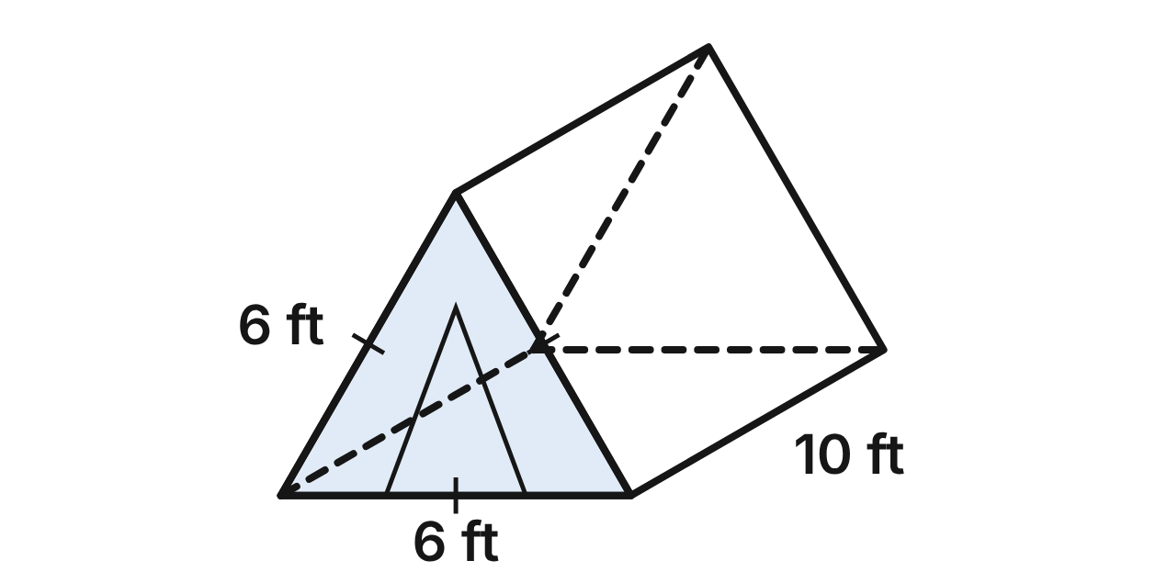
Scientists on a polar ice sheet sleep in a tent shaped like a triangular prism. Each end is an equilateral triangle with sides of 6 ft, and the tent is 10 ft long. The floor, the two ends and the two sloped sides are all made of nylon.
499. How tall is the tent at its peak (the height of one triangular end)?
A. 3√5 ft
B. 3 ft
C. 3√3 ft ✔
D. 6√3 ft
G.DF.1 · skill G.DF.1.2 (LOTS): Find the surface area and volume of prisms, cylinders, cones, pyramids and spheres
☐ Answer key correct ☐ Wording clear Notes: ________________________________
500. How much air space is inside the tent, to the nearest tenth of a cubic foot?
A. 155.9 ft³ ✔
B. 311.8 ft³
C. 180.0 ft³
D. 90.0 ft³
G.DF.1 · skill G.DF.1.2 (LOTS): Find the surface area and volume of prisms, cylinders, cones, pyramids and spheres
☐ Answer key correct ☐ Wording clear Notes: ________________________________
501. How much nylon makes the whole tent, to the nearest tenth of a square foot?
A. 180.0 ft²
B. 211.2 ft² ✔
C. 195.6 ft²
D. 216.0 ft²
G.DF.1 · skill G.DF.1.2 (LOTS): Find the surface area and volume of prisms, cylinders, cones, pyramids and spheres
☐ Answer key correct ☐ Wording clear Notes: ________________________________
502. A plane parallel to the triangular ends cuts the tent 4 ft from the front. What is the cross section?
A. an equilateral triangle with sides of 6 ft ✔
B. an equilateral triangle with sides of 2.4 ft
C. a rectangle 6 ft by 10 ft
D. a rectangle 6 ft by 4 ft
G.DF.1 · skill G.DF.1.1 (LOTS): Identify the two-dimensional cross sections and nets of three-dimensional figures
☐ Answer key correct ☐ Wording clear Notes: ________________________________
503. A plane parallel to the floor cuts the tent halfway up to its peak. What is the cross section?
A. a rectangle 6 ft by 10 ft
B. a rectangle 3 ft by 5 ft
C. a rectangle 3 ft by 10 ft ✔
D. an equilateral triangle with sides of 3 ft
G.DF.1 · skill G.DF.1.1 (LOTS): Identify the two-dimensional cross sections and nets of three-dimensional figures
☐ Answer key correct ☐ Wording clear Notes: ________________________________
504. Each person in the tent needs at least 25 ft³ of air space. How many people can sleep in the tent?
A. 7
B. 12
C. 3
D. 6 ✔
G.DF.1 · skill G.DF.1.3 (HOTS): Solve multistep contextual problems with surface area and volume, including composite figures
☐ Answer key correct ☐ Wording clear Notes: ________________________________

The Model Planet
Level 2 · 3-D figures · G.DF.1 · ID geo-df1-rocks-model-planet
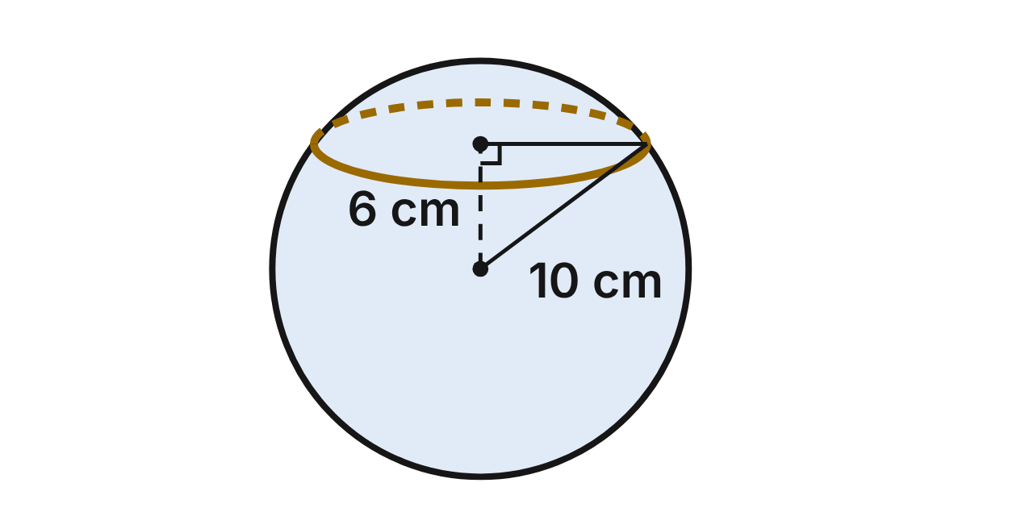
A science club makes a foam model of a planet. The model is a sphere with a radius of 10 cm. To show the layers inside, a plane cuts the model 6 cm from its center.
505. How much foam is in the whole model, to the nearest tenth of a cubic centimeter?
A. 1,256.6 cm³
B. 3,141.6 cm³
C. 33,510.3 cm³
D. 4,188.8 cm³ ✔
G.DF.1 · skill G.DF.1.2 (LOTS): Find the surface area and volume of prisms, cylinders, cones, pyramids and spheres
☐ Answer key correct ☐ Wording clear Notes: ________________________________
506. What is the radius of the circle made by the cut 6 cm from the center?
A. 4 cm
B. 8 cm ✔
C. 10 cm
D. 6 cm
G.DF.1 · skill G.DF.1.1 (LOTS): Identify the two-dimensional cross sections and nets of three-dimensional figures
☐ Answer key correct ☐ Wording clear Notes: ________________________________
507. A second plane cuts the model 8 cm from its center. What is the area of that cross section, in terms of π?
A. 4π cm²
B. 100π cm²
C. 36π cm² ✔
D. 12π cm²
G.DF.1 · skill G.DF.1.1 (LOTS): Identify the two-dimensional cross sections and nets of three-dimensional figures
☐ Answer key correct ☐ Wording clear Notes: ________________________________
508. The outside of the whole model is painted. One jar of paint covers 300 cm². How many jars must be bought?
A. 5 ✔
B. 4
C. 3
D. 17
G.DF.1 · skill G.DF.1.3 (HOTS): Solve multistep contextual problems with surface area and volume, including composite figures
☐ Answer key correct ☐ Wording clear Notes: ________________________________
509. Another model just like this one is cut through its center into two halves. How much flat surface does the cut make on the two halves together, in terms of π?
A. 100π cm²
B. 400π cm²
C. 20π cm²
D. 200π cm² ✔
G.DF.1 · skill G.DF.1.1 (LOTS): Identify the two-dimensional cross sections and nets of three-dimensional figures
☐ Answer key correct ☐ Wording clear Notes: ________________________________
510. Which statement about cross sections of the model is NOT true?
A. Every plane that cuts through the model makes a circle.
B. Planes 3 cm and 6 cm from the center make circles of the same size. ✔
C. A plane through the center makes the largest circle.
D. A plane 10 cm from the center touches the model at just one point.
G.DF.1 · skill G.DF.1.1 (LOTS): Identify the two-dimensional cross sections and nets of three-dimensional figures
☐ Answer key correct ☐ Wording clear Notes: ________________________________

The Lab Funnel
Level 2 · 3-D figures · G.DF.1 · ID geo-df1-rocks-lab-funnel
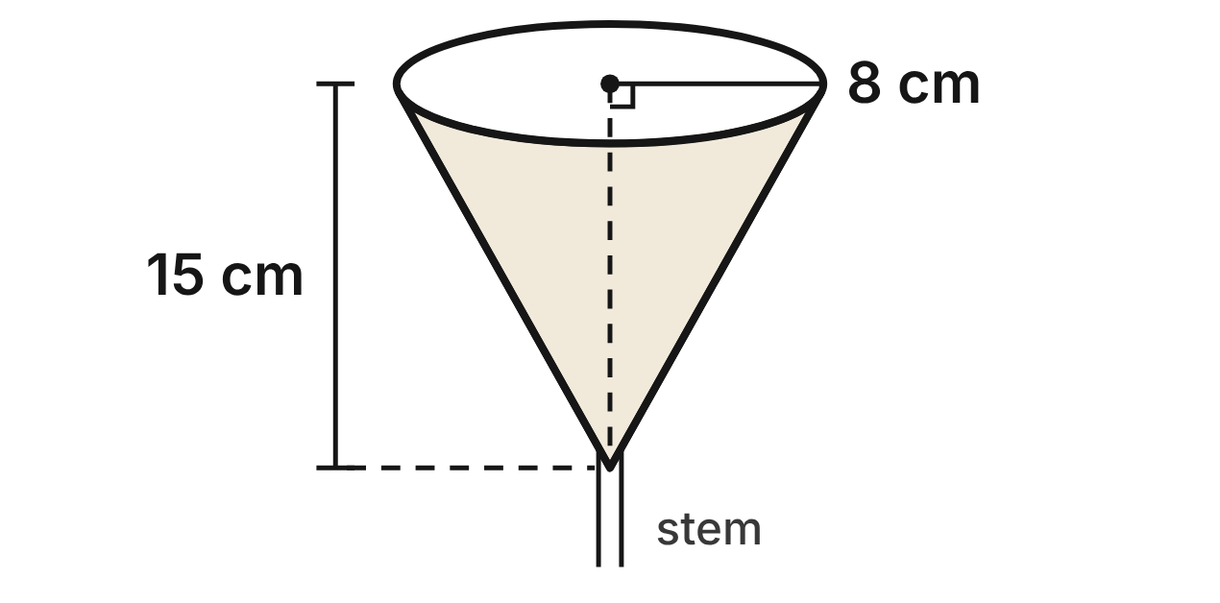
A chemistry lab funnel is shaped like a cone, tip down, with a thin stem below the tip (ignore the stem). Its circular rim has a radius of 8 cm, and the funnel is 15 cm deep from the center of the rim to the tip.
511. What is the slant height of the funnel, from the tip to the rim?
A. 17 cm ✔
B. 23 cm
C. about 12.7 cm
D. about 21.9 cm
G.DF.1 · skill G.DF.1.2 (LOTS): Find the surface area and volume of prisms, cylinders, cones, pyramids and spheres
☐ Answer key correct ☐ Wording clear Notes: ________________________________
512. A vertical plane cuts the funnel through its tip and the center of its rim. What is the area of the cross section?
A. 240 cm²
B. 136 cm²
C. 60 cm²
D. 120 cm² ✔
G.DF.1 · skill G.DF.1.1 (LOTS): Identify the two-dimensional cross sections and nets of three-dimensional figures
☐ Answer key correct ☐ Wording clear Notes: ________________________________
513. A paper filter lines the whole inside of the funnel. What is the area of the filter, in terms of π?
A. 120π cm²
B. 200π cm²
C. 136π cm² ✔
D. 272π cm²
G.DF.1 · skill G.DF.1.2 (LOTS): Find the surface area and volume of prisms, cylinders, cones, pyramids and spheres
☐ Answer key correct ☐ Wording clear Notes: ________________________________
514. The funnel's side is cut along a straight line from the tip and laid flat. It makes a sector of a circle. What fraction of a whole circle is the sector?
A. 8/15
B. 8/17 ✔
C. 15/17
D. 9/17
G.DF.1 · skill G.DF.1.1 (LOTS): Identify the two-dimensional cross sections and nets of three-dimensional figures
☐ Answer key correct ☐ Wording clear Notes: ________________________________
515. A level plane cuts the funnel 6 cm below its rim. What is the radius of the cross section?
A. 3.2 cm
B. 8 cm
C. 2 cm
D. 4.8 cm ✔
G.DF.1 · skill G.DF.1.1 (LOTS): Identify the two-dimensional cross sections and nets of three-dimensional figures
☐ Answer key correct ☐ Wording clear Notes: ________________________________
516. The funnel is full of water, and the water drains out at 15 mL per second. To the nearest second, how long until the funnel is empty? Use 1 cm³ = 1 mL.
A. 67 s ✔
B. 201 s
C. 76 s
D. 268 s
G.DF.1 · skill G.DF.1.3 (HOTS): Solve multistep contextual problems with surface area and volume, including composite figures
☐ Answer key correct ☐ Wording clear Notes: ________________________________

The Planetarium
Level 2 · 3-D figures · G.DF.1 · ID geo-df1-rocks-planetarium
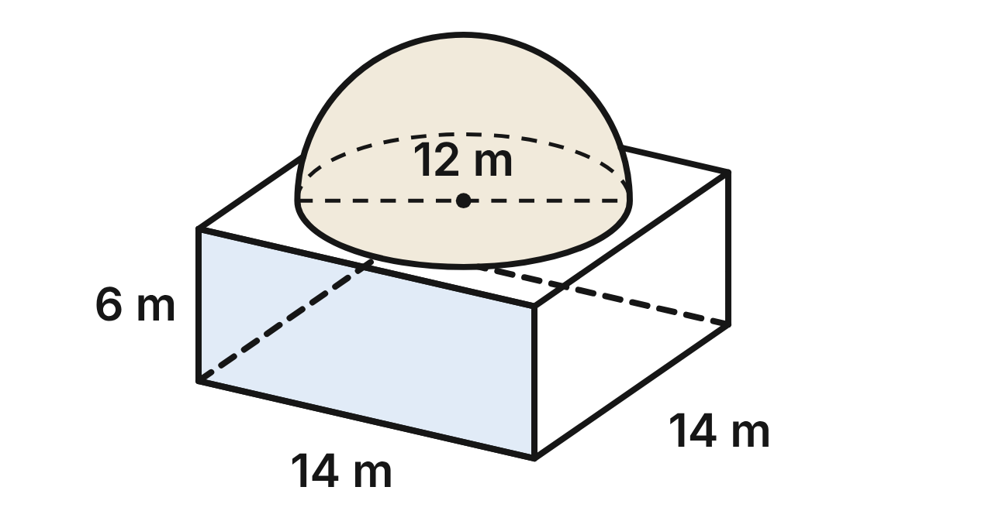
A planetarium is a building shaped like a rectangular prism, 14 m long, 14 m wide and 6 m tall. On its flat roof sits a dome shaped like a hemisphere with a diameter of 12 m. The inside of the dome is open to the room below.
517. What is the volume of the dome, in terms of π?
A. 288π m³
B. 1,152π m³
C. 144π m³ ✔
D. 72π m³
G.DF.1 · skill G.DF.1.2 (LOTS): Find the surface area and volume of prisms, cylinders, cones, pyramids and spheres
☐ Answer key correct ☐ Wording clear Notes: ________________________________
518. How much space is inside the building and the dome together, to the nearest tenth of a cubic meter?
A. 2,080.8 m³
B. 1,628.4 m³ ✔
C. 1,402.2 m³
D. 4,795.1 m³
G.DF.1 · skill G.DF.1.3 (HOTS): Solve multistep contextual problems with surface area and volume, including composite figures
☐ Answer key correct ☐ Wording clear Notes: ________________________________
519. The curved outside of the dome is painted with paint that costs $7 per square meter. To the nearest dollar, what does the paint cost?
A. $1,583 ✔
B. $3,167
C. $792
D. $2,375
G.DF.1 · skill G.DF.1.3 (HOTS): Solve multistep contextual problems with surface area and volume, including composite figures
☐ Answer key correct ☐ Wording clear Notes: ________________________________
520. How much of the flat roof is not covered by the dome, to the nearest tenth of a square meter?
A. 309.1 m²
B. 113.1 m²
C. 160.0 m²
D. 82.9 m² ✔
G.DF.1 · skill G.DF.1.2 (LOTS): Find the surface area and volume of prisms, cylinders, cones, pyramids and spheres
☐ Answer key correct ☐ Wording clear Notes: ________________________________
521. A vertical plane parallel to the front wall cuts through the center of the dome. What is the cross section?
A. a 14 m by 6 m rectangle with a half circle of radius 12 m on top
B. a 14 m by 6 m rectangle with a triangle on top
C. a 14 m by 6 m rectangle with a half circle of radius 6 m on top ✔
D. a 14 m by 12 m rectangle
G.DF.1 · skill G.DF.1.1 (LOTS): Identify the two-dimensional cross sections and nets of three-dimensional figures
☐ Answer key correct ☐ Wording clear Notes: ________________________________
522. A level plane cuts the building 2 m above the floor. What is the cross section?
A. a rectangle 14 m by 2 m
B. a square with sides of 14 m ✔
C. a circle with a radius of 6 m
D. a square with sides of 12 m
G.DF.1 · skill G.DF.1.1 (LOTS): Identify the two-dimensional cross sections and nets of three-dimensional figures
☐ Answer key correct ☐ Wording clear Notes: ________________________________

The Liquid-Oxygen Tank
Level 3 · 3-D figures · G.DF.1 · ID geo-df1-rocks-oxygen-tank
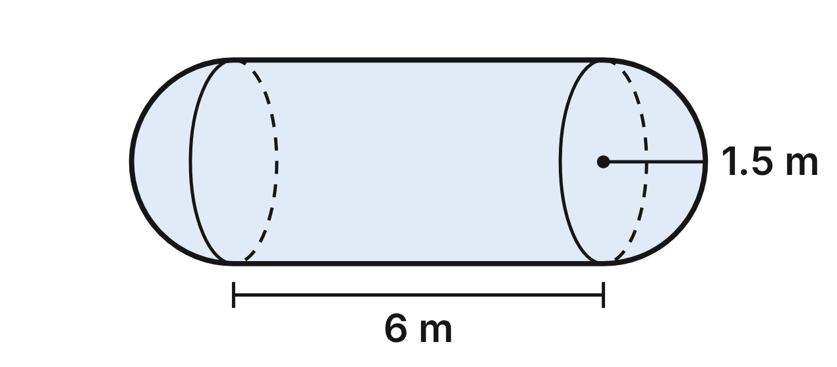
A rocket's liquid-oxygen tank is a cylinder 6 m long with a hemisphere on each end. The cylinder and both hemispheres have a radius of 1.5 m. Use 1 m³ = 1,000 L.
523. What is the volume of the whole tank, in terms of π?
A. 18π m³ ✔
B. 15.75π m³
C. 20.25π m³
D. 22.5π m³
G.DF.1 · skill G.DF.1.2 (LOTS): Find the surface area and volume of prisms, cylinders, cones, pyramids and spheres
☐ Answer key correct ☐ Wording clear Notes: ________________________________
524. A pump fills the empty tank at 500 L per second. To the nearest second, how long does it take to fill the tank?
A. 99 s
B. 113 s ✔
C. 127 s
D. 141 s
G.DF.1 · skill G.DF.1.3 (HOTS): Solve multistep contextual problems with surface area and volume, including composite figures
☐ Answer key correct ☐ Wording clear Notes: ________________________________
525. Kai finds the tank's surface area as 2π(1.5)(6) + 2π(1.5)² = 22.5π m². What did Kai do wrong?
A. He should use the 9 m length in 2πrh; it is 31.5π m².
B. He should use the 3 m diameter in 2πrh; it is 40.5π m².
C. Nothing; the surface area is 22.5π m².
D. He used flat circles for the ends; with hemispheres it is 27π m². ✔
G.DF.1 · skill G.DF.1.2 (LOTS): Find the surface area and volume of prisms, cylinders, cones, pyramids and spheres
☐ Answer key correct ☐ Wording clear Notes: ________________________________
526. A plane cuts the tank along its whole length, through the centers of both hemispheres. What is the cross section?
A. a 6 m by 3 m rectangle with a full circle on each 3 m side
B. a 6 m by 3 m rectangle with a triangle on each 3 m side
C. a 6 m by 3 m rectangle with a half circle on each 3 m side ✔
D. a 6 m by 1.5 m rectangle with a half circle on each end
G.DF.1 · skill G.DF.1.1 (LOTS): Identify the two-dimensional cross sections and nets of three-dimensional figures
☐ Answer key correct ☐ Wording clear Notes: ________________________________
527. A plane perpendicular to the tank's length cuts it 0.5 m from one tip. What is the radius of the cross section, to the nearest tenth of a meter?
A. 1.5 m
B. 1.1 m ✔
C. 0.5 m
D. 1.8 m
G.DF.1 · skill G.DF.1.1 (LOTS): Identify the two-dimensional cross sections and nets of three-dimensional figures
☐ Answer key correct ☐ Wording clear Notes: ________________________________
528. A new tank must hold 60,000 L. It keeps the 1.5 m radius and the two hemispheres, but its cylinder is longer. To the nearest tenth of a meter, how long must the cylinder be?
A. 6.5 m ✔
B. 8.5 m
C. 7.5 m
D. 4.5 m
G.DF.1 · skill G.DF.1.3 (HOTS): Solve multistep contextual problems with surface area and volume, including composite figures
☐ Answer key correct ☐ Wording clear Notes: ________________________________

The Ice Core
Level 3 · 3-D figures · G.DF.1 · ID geo-df1-rocks-ice-core
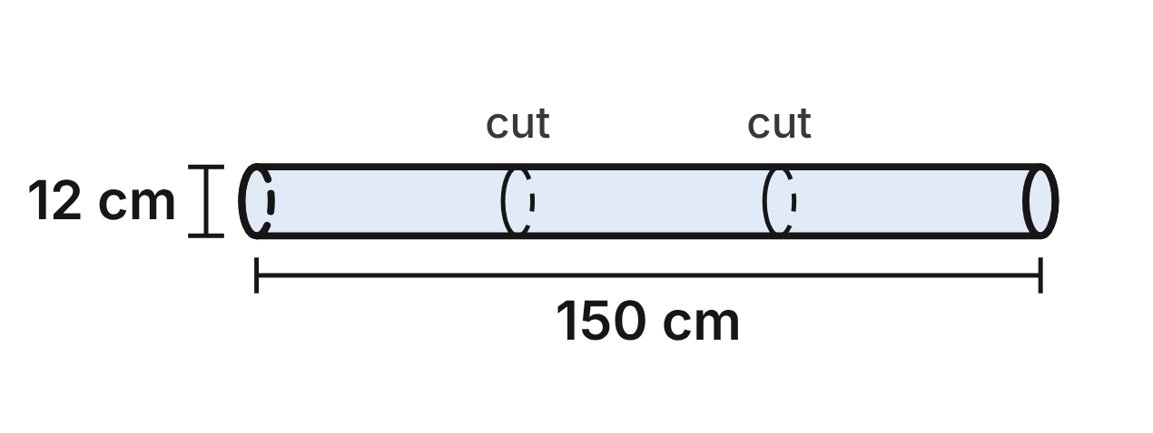
Scientists drill an ice core: a cylinder of ice 12 cm across and 150 cm long. In the lab they cut it into three equal sections, and each section goes in its own storage box, a rectangular prism 52 cm long, 14 cm wide and 14 cm tall on the inside.
529. What is the volume of the whole ice core, in terms of π?
A. 21,600π cm³
B. 1,800π cm³
C. 900π cm³
D. 5,400π cm³ ✔
G.DF.1 · skill G.DF.1.2 (LOTS): Find the surface area and volume of prisms, cylinders, cones, pyramids and spheres
☐ Answer key correct ☐ Wording clear Notes: ________________________________
530. One section lies in its box. How much empty space is left in the box around it, to the nearest cubic centimeter?
A. 4,537 cm³ ✔
B. 5,655 cm³
C. 4,145 cm³
D. 8,307 cm³
G.DF.1 · skill G.DF.1.3 (HOTS): Solve multistep contextual problems with surface area and volume, including composite figures
☐ Answer key correct ☐ Wording clear Notes: ________________________________
531. When ice melts, the water takes up about 0.9 of the ice's volume. To the nearest tenth of a liter, how much water does the whole core make? Use 1 L = 1,000 cm³.
A. 17.0 L
B. 5.1 L
C. 15.3 L ✔
D. 61.1 L
G.DF.1 · skill G.DF.1.3 (HOTS): Solve multistep contextual problems with surface area and volume, including composite figures
☐ Answer key correct ☐ Wording clear Notes: ________________________________
532. A saw cuts through one section at a slant. The cut crosses the curved side all the way around and does not touch the flat ends. What is the shape of the cut face?
A. a circle 12 cm across
B. an ellipse (an oval) ✔
C. a rectangle 12 cm wide
D. a parallelogram
G.DF.1 · skill G.DF.1.1 (LOTS): Identify the two-dimensional cross sections and nets of three-dimensional figures
☐ Answer key correct ☐ Wording clear Notes: ________________________________
533. Cutting the core into three sections makes new flat faces. How much more surface area do the three sections have in all than the whole core had, in terms of π?
A. 72π cm²
B. 216π cm²
C. 144π cm² ✔
D. 576π cm²
G.DF.1 · skill G.DF.1.3 (HOTS): Solve multistep contextual problems with surface area and volume, including composite figures
☐ Answer key correct ☐ Wording clear Notes: ________________________________
534. Each box is closed on all six sides. How much board makes one box, using its inside measurements?
A. 3,108 cm²
B. 2,912 cm²
C. 1,652 cm²
D. 3,304 cm² ✔
G.DF.1 · skill G.DF.1.2 (LOTS): Find the surface area and volume of prisms, cylinders, cones, pyramids and spheres
☐ Answer key correct ☐ Wording clear Notes: ________________________________

G.DF.2 · Determine how changes in one or more dimensions affect perimeter, area, surface area, and volume, and solve problems with similar two- and three-dimensional figures.

The Hexagon Mirror
Level 1 · Changing dimensions · G.DF.2 · ID geo-df2-rocks-hex-mirror
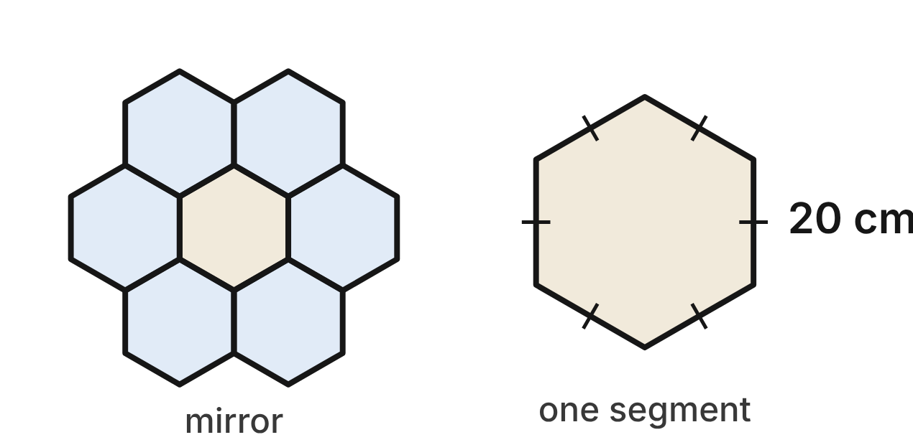
A museum model of a space telescope has a main mirror made of segments. Each segment is a regular hexagon with sides of 20 cm. One segment has a perimeter of 120 cm and an area of 600√3 cm².
535. A new segment has every side doubled, to 40 cm. What is its perimeter?
A. 480 cm
B. 240 cm ✔
C. 960 cm
D. 140 cm
G.DF.2 · skill G.DF.2.1 (LOTS): Describe how changing one or more dimensions of a figure changes its perimeter, area, surface area or volume
☐ Answer key correct ☐ Wording clear Notes: ________________________________
536. Every side of a segment is tripled. What is the area of the new segment?
A. 16,200√3 cm²
B. 3,600√3 cm²
C. 1,800√3 cm²
D. 5,400√3 cm² ✔
G.DF.2 · skill G.DF.2.1 (LOTS): Describe how changing one or more dimensions of a figure changes its perimeter, area, surface area or volume
☐ Answer key correct ☐ Wording clear Notes: ________________________________
537. A desk model uses a similar hexagon with 5 cm sides. What is the ratio of its area to the area of one 20 cm segment?
A. 1 : 16 ✔
B. 16 : 1
C. 1 : 4
D. 1 : 64
G.DF.2 · skill G.DF.2.2 (LOTS): Use the ratios k, k² and k³ of similar figures to find lengths, areas and volumes
☐ Answer key correct ☐ Wording clear Notes: ________________________________
538. Which statement about hexagons is true?
A. Any two hexagons are similar.
B. Two regular hexagons are similar only if their sides are equal.
C. Any two regular hexagons are similar. ✔
D. Any two hexagons with 20 cm sides are similar.
G.DF.2 · skill G.DF.2.3 (HOTS): Decide whether two figures are similar and justify the decision with ratios of corresponding measures
☐ Answer key correct ☐ Wording clear Notes: ________________________________
539. A larger segment is similar to these and has an area of 2,400√3 cm². How long is each of its sides?
A. 40 cm ✔
B. about 31.7 cm
C. 10 cm
D. 80 cm
G.DF.2 · skill G.DF.2.2 (LOTS): Use the ratios k, k² and k³ of similar figures to find lengths, areas and volumes
☐ Answer key correct ☐ Wording clear Notes: ________________________________
540. Juan says a similar segment with 30 cm sides has 1.5 times the area of one 20 cm segment. What is true?
A. Its area is 3 times as much: 1,800√3 cm².
B. Juan is right: the area is 900√3 cm².
C. Its area is 2.25 times as much: 1,350√3 cm². ✔
D. Its area is 3.375 times as much: 2,025√3 cm².
G.DF.2 · skill G.DF.2.2 (LOTS): Use the ratios k, k² and k³ of similar figures to find lengths, areas and volumes
☐ Answer key correct ☐ Wording clear Notes: ________________________________

Hailstones After the Storm
Level 1 · Changing dimensions · G.DF.2 · ID geo-df2-rocks-hailstones
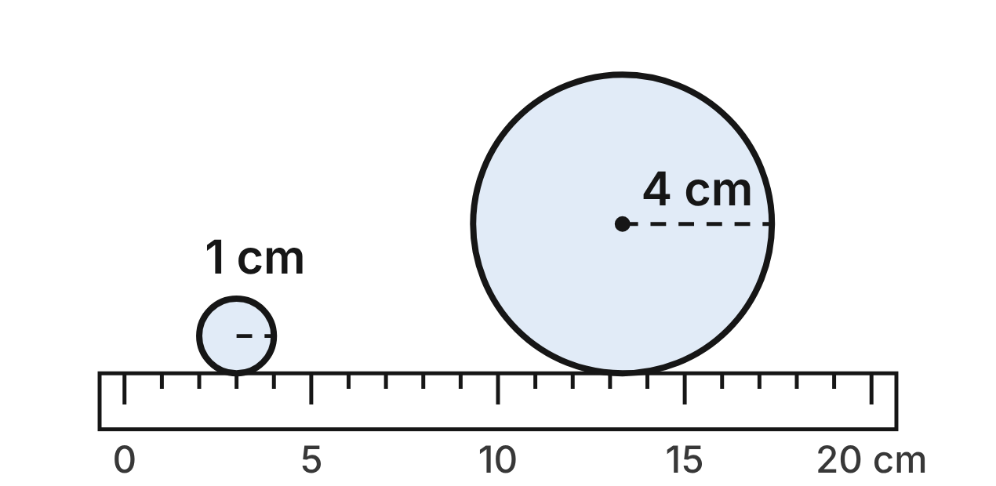
After a storm, a weather spotter measures two hailstones and treats each one as a sphere. The small stone has a radius of 1 cm. The large stone has a radius of 4 cm.
541. What is the ratio of the large stone's surface area to the small stone's surface area?
A. 4 : 1
B. 64 : 1
C. 16 : 1 ✔
D. 8 : 1
G.DF.2 · skill G.DF.2.2 (LOTS): Use the ratios k, k² and k³ of similar figures to find lengths, areas and volumes
☐ Answer key correct ☐ Wording clear Notes: ________________________________
542. Inside a storm cloud, a hailstone's radius grows from 1 cm to 2 cm. Which statement is true?
A. Its surface area becomes 4 times as large and its volume 8 times as large. ✔
B. Its surface area becomes 8 times as large and its volume 4 times as large.
C. Its surface area becomes 4 times as large and its volume 6 times as large.
D. Its surface area and its volume both become 2 times as large.
G.DF.2 · skill G.DF.2.1 (LOTS): Describe how changing one or more dimensions of a figure changes its perimeter, area, surface area or volume
☐ Answer key correct ☐ Wording clear Notes: ________________________________
543. The small stone has a volume of 4π/3 cm³. What is the volume of the large stone?
A. 64π cm³
B. 64π/3 cm³
C. 16π/3 cm³
D. 256π/3 cm³ ✔
G.DF.2 · skill G.DF.2.2 (LOTS): Use the ratios k, k² and k³ of similar figures to find lengths, areas and volumes
☐ Answer key correct ☐ Wording clear Notes: ________________________________
544. A hailstone shaped like an egg is 2 cm wide and 3 cm long. Is it similar to the small stone, a sphere 2 cm across? Choose the answer with the correct reason.
A. Yes: both are round pieces of ice, so they have the same shape.
B. No: the width ratio is 2/2 = 1, but the length ratio is 3/2 = 1.5. ✔
C. No: two hailstones of different sizes can never be similar.
D. Yes: its length is 1.5 times its width, just like a sphere's.
G.DF.2 · skill G.DF.2.3 (HOTS): Decide whether two figures are similar and justify the decision with ratios of corresponding measures
☐ Answer key correct ☐ Wording clear Notes: ________________________________
545. A third hailstone, also a sphere, has 8 times the volume of the small stone. What is its radius?
A. about 2.8 cm
B. 4 cm
C. 8 cm
D. 2 cm ✔
G.DF.2 · skill G.DF.2.2 (LOTS): Use the ratios k, k² and k³ of similar figures to find lengths, areas and volumes
☐ Answer key correct ☐ Wording clear Notes: ________________________________
546. The small stone has a mass of 3.8 g. Both stones are the same kind of ice. What is the mass of the large stone?
A. 6.8 g
B. 243.2 g ✔
C. 60.8 g
D. 15.2 g
G.DF.2 · skill G.DF.2.2 (LOTS): Use the ratios k, k² and k³ of similar figures to find lengths, areas and volumes
☐ Answer key correct ☐ Wording clear Notes: ________________________________

The Lab's Glass Tank
Level 2 · Changing dimensions · G.DF.2 · ID geo-df2-rocks-lab-tank
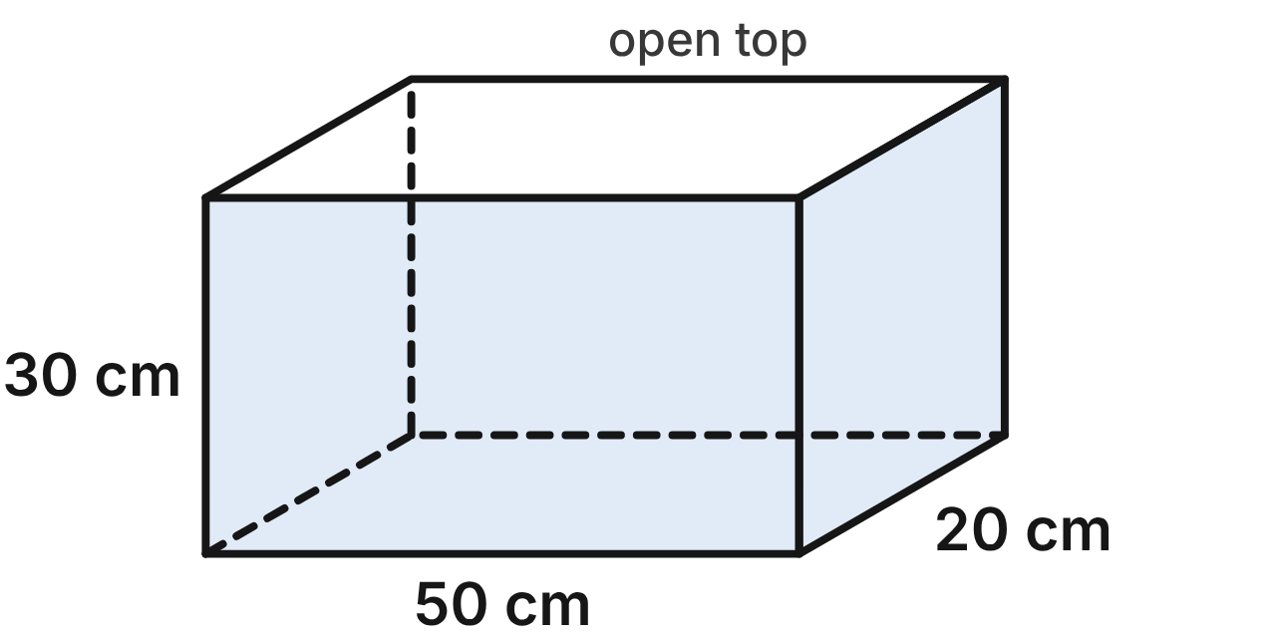
A biology lab keeps tadpoles in a glass tank. The tank is a rectangular prism 50 cm long, 20 cm wide and 30 cm tall, open at the top. Full, it holds 30,000 cm³ of water. Its glass (the bottom and four sides) has an area of 5,200 cm².
547. A new tank has the same 50 cm by 20 cm bottom but is 60 cm tall. How much water does it hold when full?
A. 120,000 cm³
B. 240,000 cm³
C. 15,000 cm³
D. 60,000 cm³ ✔
G.DF.2 · skill G.DF.2.1 (LOTS): Describe how changing one or more dimensions of a figure changes its perimeter, area, surface area or volume
☐ Answer key correct ☐ Wording clear Notes: ________________________________
548. A new open tank has the same 50 cm by 20 cm bottom but is 60 cm tall. How much glass does it need?
A. 20,800 cm²
B. 9,400 cm² ✔
C. 8,400 cm²
D. 10,400 cm²
G.DF.2 · skill G.DF.2.1 (LOTS): Describe how changing one or more dimensions of a figure changes its perimeter, area, surface area or volume
☐ Answer key correct ☐ Wording clear Notes: ________________________________
549. A desk tank has every dimension of this tank cut in half. How much water does it hold when full?
A. 5,000 cm³
B. 15,000 cm³
C. 3,750 cm³ ✔
D. 7,500 cm³
G.DF.2 · skill G.DF.2.1 (LOTS): Describe how changing one or more dimensions of a figure changes its perimeter, area, surface area or volume
☐ Answer key correct ☐ Wording clear Notes: ________________________________
550. A second tank is 75 cm long, 30 cm wide and 40 cm tall. Is it similar to this tank? Choose the answer with the correct reason.
A. No: 75/50 = 30/20 = 1.5, but 40/30 ≈ 1.33. ✔
B. Yes: 75/50 = 30/20, so the tanks are similar.
C. Yes: all rectangular prisms are similar.
D. No: 75/50 is not equal to 30/20.
G.DF.2 · skill G.DF.2.3 (HOTS): Decide whether two figures are similar and justify the decision with ratios of corresponding measures
☐ Answer key correct ☐ Wording clear Notes: ________________________________
551. A display tank is similar to this tank and is 75 cm long. How much glass does it need?
A. 17,550 cm²
B. 9,450 cm²
C. 7,800 cm²
D. 11,700 cm² ✔
G.DF.2 · skill G.DF.2.2 (LOTS): Use the ratios k, k² and k³ of similar figures to find lengths, areas and volumes
☐ Answer key correct ☐ Wording clear Notes: ________________________________
552. A pond tank is similar to this tank and holds 240,000 cm³ when full. How tall is it?
A. 60 cm ✔
B. 100 cm
C. 240 cm
D. about 84.9 cm
G.DF.2 · skill G.DF.2.2 (LOTS): Use the ratios k, k² and k³ of similar figures to find lengths, areas and volumes
☐ Answer key correct ☐ Wording clear Notes: ________________________________

The Light-Splitting Prism
Level 2 · Changing dimensions · G.DF.2 · ID geo-df2-rocks-glass-prism
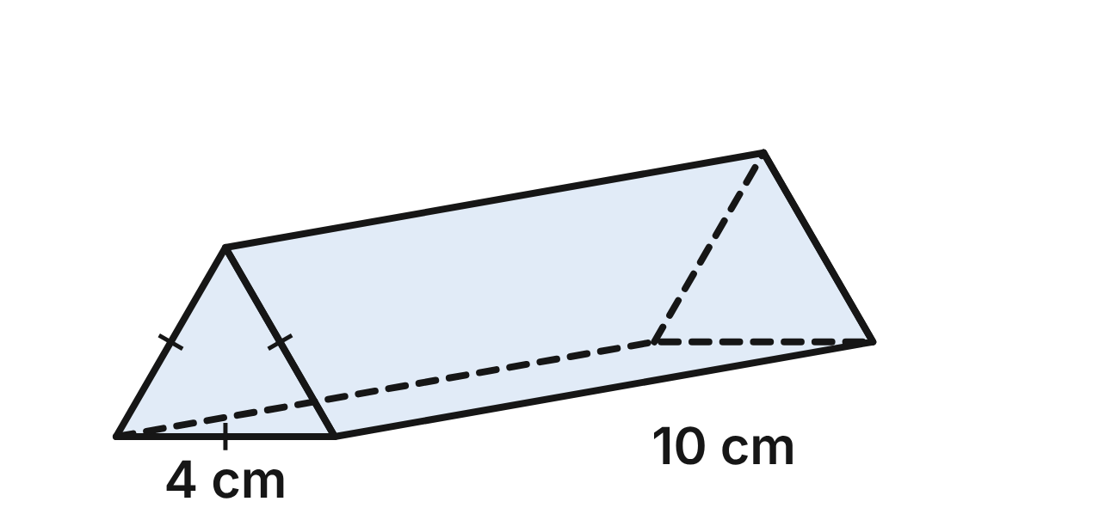
A physics lab uses a glass prism to split white light into colors. The prism's two ends are equilateral triangles with 4 cm sides, and the prism is 10 cm long. Each end has an area of 4√3 cm², the prism's volume is 40√3 cm³, and its total surface area is (8√3 + 120) cm².
553. A longer prism has the same 4 cm triangle ends but is 30 cm long. What is its volume?
A. 120√3 cm³ ✔
B. 360√3 cm³
C. 1,080√3 cm³
D. 40√3 cm³
G.DF.2 · skill G.DF.2.1 (LOTS): Describe how changing one or more dimensions of a figure changes its perimeter, area, surface area or volume
☐ Answer key correct ☐ Wording clear Notes: ________________________________
554. Only the length of the prism is doubled, to 20 cm. What is its new total surface area?
A. (32√3 + 480) cm²
B. (4√3 + 240) cm²
C. (8√3 + 240) cm² ✔
D. (16√3 + 240) cm²
G.DF.2 · skill G.DF.2.1 (LOTS): Describe how changing one or more dimensions of a figure changes its perimeter, area, surface area or volume
☐ Answer key correct ☐ Wording clear Notes: ________________________________
555. A souvenir prism is similar to this one, with 2 cm triangle sides. What is its volume?
A. 8√3 cm³
B. 5√3 cm³ ✔
C. 20√3 cm³
D. 10√3 cm³
G.DF.2 · skill G.DF.2.2 (LOTS): Use the ratios k, k² and k³ of similar figures to find lengths, areas and volumes
☐ Answer key correct ☐ Wording clear Notes: ________________________________
556. Another prism has equilateral triangle ends with 6 cm sides and is 16 cm long. Is it similar to this prism? Choose the answer with the correct reason.
A. Yes: both have equilateral triangle ends.
B. Yes: 6/4 and 16/10 are both equal to 1.5.
C. No: equilateral triangles of different sizes are never similar.
D. No: 6/4 = 1.5, but 16/10 = 1.6. ✔
G.DF.2 · skill G.DF.2.3 (HOTS): Decide whether two figures are similar and justify the decision with ratios of corresponding measures
☐ Answer key correct ☐ Wording clear Notes: ________________________________
557. A display prism is similar to this one and has a volume of 320√3 cm³. How long is it?
A. about 28.3 cm
B. 20 cm ✔
C. 8 cm
D. 80 cm
G.DF.2 · skill G.DF.2.2 (LOTS): Use the ratios k, k² and k³ of similar figures to find lengths, areas and volumes
☐ Answer key correct ☐ Wording clear Notes: ________________________________
558. A larger prism is similar to this one and is 25 cm long. What is the area of one of its triangle ends?
A. 6.25√3 cm²
B. 10√3 cm²
C. 25√3 cm² ✔
D. 62.5√3 cm²
G.DF.2 · skill G.DF.2.2 (LOTS): Use the ratios k, k² and k³ of similar figures to find lengths, areas and volumes
☐ Answer key correct ☐ Wording clear Notes: ________________________________

The Chemistry Beaker
Level 2 · Changing dimensions · G.DF.2 · ID geo-df2-rocks-beaker
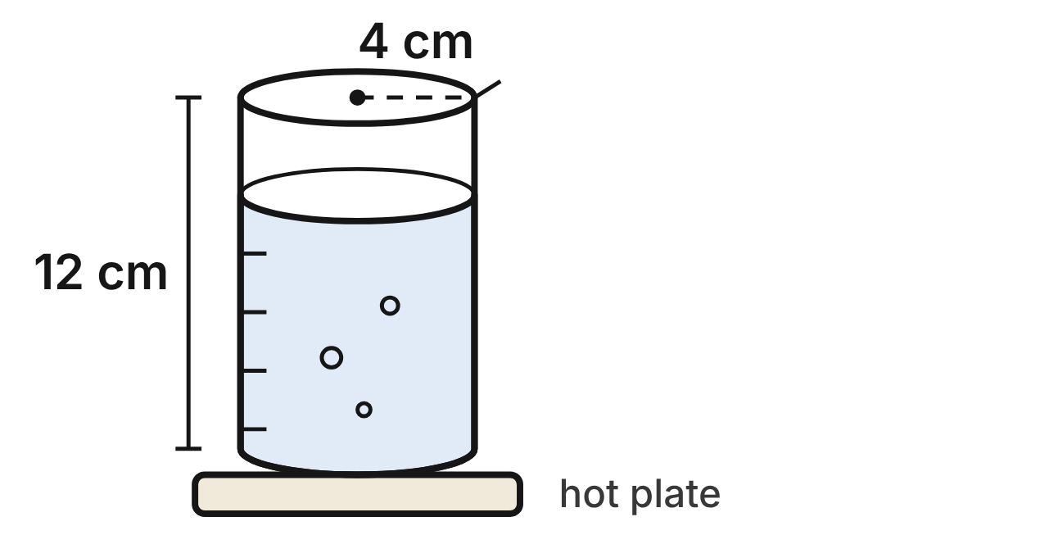
A chemistry beaker is a cylinder with an inside radius of 4 cm and an inside height of 12 cm. Filled to the top, it holds 192π cm³.
559. A wider beaker has a radius of 8 cm and the same 12 cm height. How much does it hold?
A. 384π cm³
B. 768π cm³ ✔
C. 1,536π cm³
D. 3,072π cm³
G.DF.2 · skill G.DF.2.1 (LOTS): Describe how changing one or more dimensions of a figure changes its perimeter, area, surface area or volume
☐ Answer key correct ☐ Wording clear Notes: ________________________________
560. Which change to the beaker makes it hold exactly 3 times as much?
A. Triple the height only. ✔
B. Triple both the radius and the height.
C. Add 3 cm to the radius and 3 cm to the height.
D. Triple the radius only.
G.DF.2 · skill G.DF.2.1 (LOTS): Describe how changing one or more dimensions of a figure changes its perimeter, area, surface area or volume
☐ Answer key correct ☐ Wording clear Notes: ________________________________
561. A small beaker is similar to this one and is 9 cm tall. How much does it hold?
A. 9π cm³
B. 144π cm³
C. 108π cm³
D. 81π cm³ ✔
G.DF.2 · skill G.DF.2.2 (LOTS): Use the ratios k, k² and k³ of similar figures to find lengths, areas and volumes
☐ Answer key correct ☐ Wording clear Notes: ________________________________
562. A graduated cylinder has an inside radius of 2 cm and an inside height of 20 cm. Is it similar to the beaker? Choose the answer with the correct reason.
A. Yes: both are cylinders, and all cylinders are similar.
B. Yes: halving a cylinder's radius always gives a similar cylinder.
C. No: 2/4 = 0.5, but 20/12 ≈ 1.67. ✔
D. No: it holds 80π cm³, which is more than the beaker holds.
G.DF.2 · skill G.DF.2.3 (HOTS): Decide whether two figures are similar and justify the decision with ratios of corresponding measures
☐ Answer key correct ☐ Wording clear Notes: ________________________________
563. A storage jar is similar to the beaker and holds 1,536π cm³. What is its inside radius?
A. 8 cm ✔
B. about 11.3 cm
C. 24 cm
D. 32 cm
G.DF.2 · skill G.DF.2.2 (LOTS): Use the ratios k, k² and k³ of similar figures to find lengths, areas and volumes
☐ Answer key correct ☐ Wording clear Notes: ________________________________
564. A new beaker is similar to this one, with every length doubled. Which statement is NOT true?
A. It holds 8 times as much.
B. Its inside height is 24 cm.
C. Its base has 4 times the area.
D. Its curved side has 8 times the area. ✔
G.DF.2 · skill G.DF.2.2 (LOTS): Use the ratios k, k² and k³ of similar figures to find lengths, areas and volumes
☐ Answer key correct ☐ Wording clear Notes: ________________________________

The Rocket Club's Model
Level 3 · Changing dimensions · G.DF.2 · ID geo-df2-rocks-model-rocket
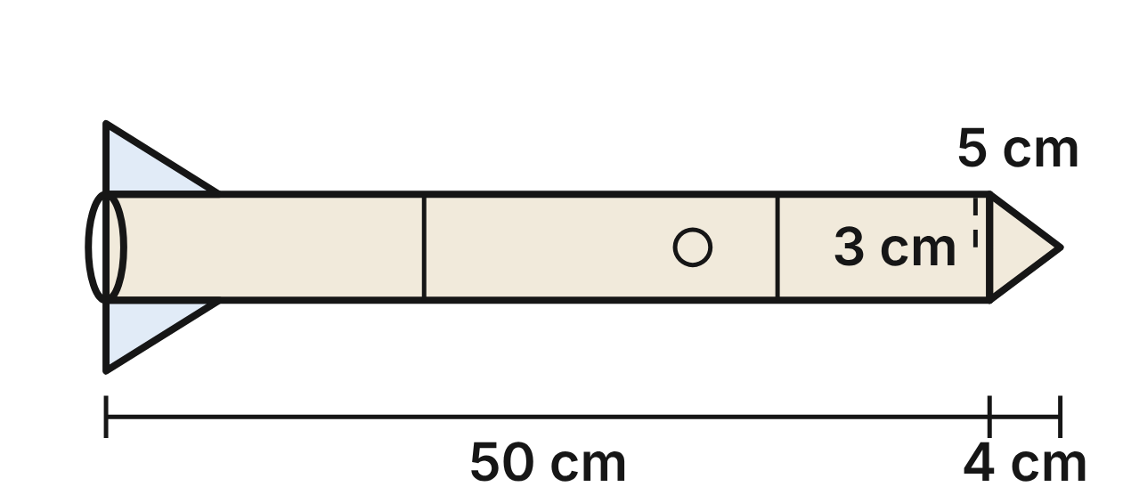
A rocket club builds a model of a real rocket. The model's body is a cylinder 50 cm long with a radius of 3 cm, and its nose is a cone 4 cm long with a slant height of 5 cm. The painted outside (the body's curved side and the cone's side) is 315π cm², and the space inside is 462π cm³.
565. The real rocket is similar to the model at a scale of 1 : 80. To the nearest square meter, what is the area of its matching painted surface? (1 m² = 10,000 cm²)
A. 8 m²
B. 63,335 m²
C. 633 m² ✔
D. 202 m²
G.DF.2 · skill G.DF.2.2 (LOTS): Use the ratios k, k² and k³ of similar figures to find lengths, areas and volumes
☐ Answer key correct ☐ Wording clear Notes: ________________________________
566. The real rocket is similar to the model at a scale of 1 : 80. To the nearest cubic meter, how much space is inside it? (1 m³ = 1,000,000 cm³)
A. 74,312 m³
B. 237 m³
C. 9 m³
D. 743 m³ ✔
G.DF.2 · skill G.DF.2.2 (LOTS): Use the ratios k, k² and k³ of similar figures to find lengths, areas and volumes
☐ Answer key correct ☐ Wording clear Notes: ________________________________
567. A builder makes the body 75 cm long instead of 50 cm, with the same 3 cm radius and the same nose cone. What is the new painted area?
A. 450π cm²
B. 465π cm² ✔
C. 472.5π cm²
D. 708.75π cm²
G.DF.2 · skill G.DF.2.1 (LOTS): Describe how changing one or more dimensions of a figure changes its perimeter, area, surface area or volume
☐ Answer key correct ☐ Wording clear Notes: ________________________________
568. Another club's rocket has a body radius of 4.5 cm, a body 75 cm long and a cone nose 5 cm long. Is it similar to this model? Choose the answer with the correct reason.
A. No: 4.5/3 = 75/50 = 1.5, but 5/4 = 1.25. ✔
B. Yes: the bodies are similar, so the whole rockets are similar.
C. Yes: every length of that rocket is longer than the model's.
D. No: 4.5/3 is not equal to 75/50.
G.DF.2 · skill G.DF.2.3 (HOTS): Decide whether two figures are similar and justify the decision with ratios of corresponding measures
☐ Answer key correct ☐ Wording clear Notes: ________________________________
569. A smaller model is similar to this one, with a cone nose 2 cm long. Which expression gives the space inside it, in cm³?
A. 462π · (1/2)
B. 462π · 2³
C. 462π · (1/2)³ ✔
D. 462π · (1/2)²
G.DF.2 · skill G.DF.2.2 (LOTS): Use the ratios k, k² and k³ of similar figures to find lengths, areas and volumes
☐ Answer key correct ☐ Wording clear Notes: ________________________________
570. Kai builds a similar model with every length 3 times as long. He says it needs 3 times the paint and holds 9 times the space. Which correction is right?
A. It needs 9 times the paint and holds 9 times the space.
B. It needs 9 times the paint and holds 27 times the space. ✔
C. Kai is right about both.
D. It needs 3 times the paint and holds 27 times the space.
G.DF.2 · skill G.DF.2.2 (LOTS): Use the ratios k, k² and k³ of similar figures to find lengths, areas and volumes
☐ Answer key correct ☐ Wording clear Notes: ________________________________

The Science-Fair Volcano
Level 3 · Changing dimensions · G.DF.2 · ID geo-df2-rocks-volcano
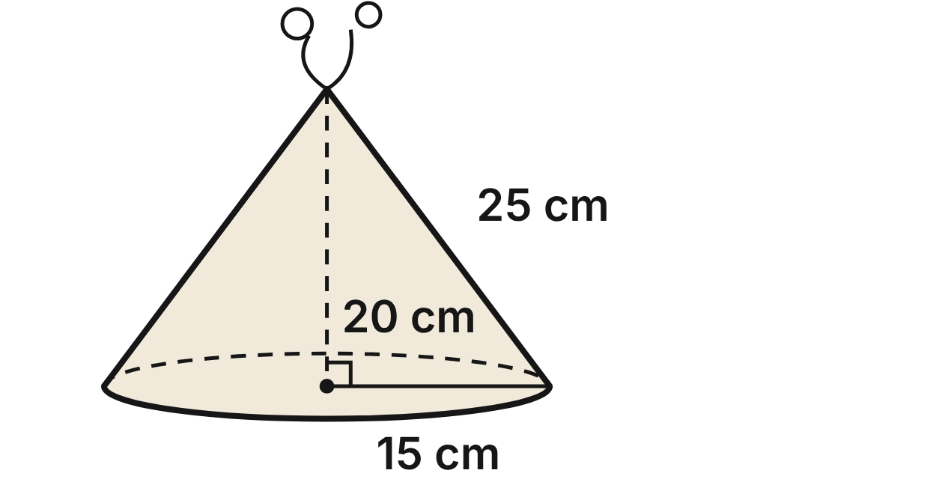
For the science fair, Rosa shapes a clay volcano as a cone with a base radius of 15 cm, a height of 20 cm and a slant height of 25 cm. Its volume is 1,500π cm³, and its sloped side has an area of 375π cm².
571. A real volcano is similar to Rosa's model and is 1,000 m tall. What is its base radius?
A. 1,250 m
B. 7,500 m
C. about 1,333 m
D. 750 m ✔
G.DF.2 · skill G.DF.2.2 (LOTS): Use the ratios k, k² and k³ of similar figures to find lengths, areas and volumes
☐ Answer key correct ☐ Wording clear Notes: ________________________________
572. Rosa doubles the base radius to 30 cm and keeps the 20 cm height. Which statement about the volume is true?
A. It becomes 8 times as large: 12,000π cm³.
B. It stays 1,500π cm³, since the height is the same.
C. It becomes 4 times as large: 6,000π cm³. ✔
D. It doubles: 3,000π cm³.
G.DF.2 · skill G.DF.2.1 (LOTS): Describe how changing one or more dimensions of a figure changes its perimeter, area, surface area or volume
☐ Answer key correct ☐ Wording clear Notes: ________________________________
573. Rosa makes a second volcano twice as tall, 40 cm, with the same 15 cm base radius. To the nearest square centimeter, what is the area of its sloped side?
A. 2,013 cm² ✔
B. 1,885 cm²
C. 2,356 cm²
D. 4,712 cm²
G.DF.2 · skill G.DF.2.1 (LOTS): Describe how changing one or more dimensions of a figure changes its perimeter, area, surface area or volume
☐ Answer key correct ☐ Wording clear Notes: ________________________________
574. A smaller volcano is similar to Rosa's and uses 1/8 as much clay. What is its base radius?
A. 1.875 cm
B. 7.5 cm ✔
C. about 5.3 cm
D. 5 cm
G.DF.2 · skill G.DF.2.2 (LOTS): Use the ratios k, k² and k³ of similar figures to find lengths, areas and volumes
☐ Answer key correct ☐ Wording clear Notes: ________________________________
575. Another clay cone has a base radius of 12 cm and a slant height of 20 cm. Is it similar to Rosa's volcano? Choose the answer with the correct reason.
A. No: its height is not 0.8 × 20 cm.
B. No: a cone's slant ratio can never equal its radius ratio.
C. Yes: all cones are similar.
D. Yes: 12/15 = 20/25 = 0.8. ✔
G.DF.2 · skill G.DF.2.3 (HOTS): Decide whether two figures are similar and justify the decision with ratios of corresponding measures
☐ Answer key correct ☐ Wording clear Notes: ________________________________
576. A real volcano is similar to the model, with every length 5,000 times as long. To the nearest tenth of a square kilometer, what is the area of its sloped side? (1 km² = 10,000,000,000 cm²)
A. 2.9 km² ✔
B. 14,726.2 km²
C. 0.9 km²
D. 29.5 km²
G.DF.2 · skill G.DF.2.2 (LOTS): Use the ratios k, k² and k³ of similar figures to find lengths, areas and volumes
☐ Answer key correct ☐ Wording clear Notes: ________________________________

Answer key
Pack | Question | Standard | Skill | Level | Answer
rlt1-rocks-weather-station | 1 | G.RLT.1 | G.RLT.1.1 LOTS | 1 | B
rlt1-rocks-weather-station | 2 | G.RLT.1 | G.RLT.1.1 LOTS | 1 | D
rlt1-rocks-weather-station | 3 | G.RLT.1 | G.RLT.1.1 LOTS | 1 | A
rlt1-rocks-weather-station | 4 | G.RLT.1 | G.RLT.1.2 LOTS | 1 | C
rlt1-rocks-weather-station | 5 | G.RLT.1 | G.RLT.1.2 LOTS | 1 | A
rlt1-rocks-weather-station | 6 | G.RLT.1 | G.RLT.1.1 LOTS | 1 | D
rlt1-rocks-solar-sets | 7 | G.RLT.1 | G.RLT.1.4 LOTS | 1 | C
rlt1-rocks-solar-sets | 8 | G.RLT.1 | G.RLT.1.4 LOTS | 1 | A
rlt1-rocks-solar-sets | 9 | G.RLT.1 | G.RLT.1.4 LOTS | 1 | D
rlt1-rocks-solar-sets | 10 | G.RLT.1 | G.RLT.1.4 LOTS | 1 | B
rlt1-rocks-solar-sets | 11 | G.RLT.1 | G.RLT.1.2 LOTS | 1 | B
rlt1-rocks-solar-sets | 12 | G.RLT.1 | G.RLT.1.3 HOTS | 1 | C
rlt1-rocks-launch-log | 13 | G.RLT.1 | G.RLT.1.1 LOTS | 2 | D
rlt1-rocks-launch-log | 14 | G.RLT.1 | G.RLT.1.1 LOTS | 2 | B
rlt1-rocks-launch-log | 15 | G.RLT.1 | G.RLT.1.2 LOTS | 2 | C
rlt1-rocks-launch-log | 16 | G.RLT.1 | G.RLT.1.2 LOTS | 2 | A
rlt1-rocks-launch-log | 17 | G.RLT.1 | G.RLT.1.3 HOTS | 2 | D
rlt1-rocks-launch-log | 18 | G.RLT.1 | G.RLT.1.3 HOTS | 2 | A
rlt1-rocks-volcano-card | 19 | G.RLT.1 | G.RLT.1.4 LOTS | 2 | A
rlt1-rocks-volcano-card | 20 | G.RLT.1 | G.RLT.1.4 LOTS | 2 | C
rlt1-rocks-volcano-card | 21 | G.RLT.1 | G.RLT.1.4 LOTS | 2 | B
rlt1-rocks-volcano-card | 22 | G.RLT.1 | G.RLT.1.4 LOTS | 2 | D
rlt1-rocks-volcano-card | 23 | G.RLT.1 | G.RLT.1.2 LOTS | 2 | B
rlt1-rocks-volcano-card | 24 | G.RLT.1 | G.RLT.1.1 LOTS | 2 | C
rlt1-rocks-eruption-steps | 25 | G.RLT.1 | G.RLT.1.3 HOTS | 2 | B
rlt1-rocks-eruption-steps | 26 | G.RLT.1 | G.RLT.1.3 HOTS | 2 | A
rlt1-rocks-eruption-steps | 27 | G.RLT.1 | G.RLT.1.3 HOTS | 2 | D
rlt1-rocks-eruption-steps | 28 | G.RLT.1 | G.RLT.1.2 LOTS | 2 | C
rlt1-rocks-eruption-steps | 29 | G.RLT.1 | G.RLT.1.2 LOTS | 2 | A
rlt1-rocks-eruption-steps | 30 | G.RLT.1 | G.RLT.1.1 LOTS | 2 | D
rlt1-rocks-june-storms | 31 | G.RLT.1 | G.RLT.1.4 LOTS | 3 | C
rlt1-rocks-june-storms | 32 | G.RLT.1 | G.RLT.1.4 LOTS | 3 | D
rlt1-rocks-june-storms | 33 | G.RLT.1 | G.RLT.1.4 LOTS | 3 | A
rlt1-rocks-june-storms | 34 | G.RLT.1 | G.RLT.1.2 LOTS | 3 | B
rlt1-rocks-june-storms | 35 | G.RLT.1 | G.RLT.1.3 HOTS | 3 | C
rlt1-rocks-june-storms | 36 | G.RLT.1 | G.RLT.1.4 LOTS | 3 | B
rlt1-rocks-observatory | 37 | G.RLT.1 | G.RLT.1.3 HOTS | 3 | D
rlt1-rocks-observatory | 38 | G.RLT.1 | G.RLT.1.3 HOTS | 3 | C
rlt1-rocks-observatory | 39 | G.RLT.1 | G.RLT.1.3 HOTS | 3 | B
rlt1-rocks-observatory | 40 | G.RLT.1 | G.RLT.1.2 LOTS | 3 | A
rlt1-rocks-observatory | 41 | G.RLT.1 | G.RLT.1.1 LOTS | 3 | D
rlt1-rocks-observatory | 42 | G.RLT.1 | G.RLT.1.1 LOTS | 3 | A
rlt2-rocks-solar-array | 43 | G.RLT.2 | G.RLT.2.1 LOTS | 1 | B
rlt2-rocks-solar-array | 44 | G.RLT.2 | G.RLT.2.3 LOTS | 1 | D
rlt2-rocks-solar-array | 45 | G.RLT.2 | G.RLT.2.1 LOTS | 1 | A
rlt2-rocks-solar-array | 46 | G.RLT.2 | G.RLT.2.1 LOTS | 1 | C
rlt2-rocks-solar-array | 47 | G.RLT.2 | G.RLT.2.3 LOTS | 1 | B
rlt2-rocks-solar-array | 48 | G.RLT.2 | G.RLT.2.3 LOTS | 1 | D
rlt2-rocks-storm-track | 49 | G.RLT.2 | G.RLT.2.1 LOTS | 1 | C
rlt2-rocks-storm-track | 50 | G.RLT.2 | G.RLT.2.3 LOTS | 1 | A
rlt2-rocks-storm-track | 51 | G.RLT.2 | G.RLT.2.3 LOTS | 1 | D
rlt2-rocks-storm-track | 52 | G.RLT.2 | G.RLT.2.1 LOTS | 1 | B
rlt2-rocks-storm-track | 53 | G.RLT.2 | G.RLT.2.1 LOTS | 1 | A
rlt2-rocks-storm-track | 54 | G.RLT.2 | G.RLT.2.2 HOTS | 1 | C
rlt2-rocks-laser-block | 55 | G.RLT.2 | G.RLT.2.3 LOTS | 2 | B
rlt2-rocks-laser-block | 56 | G.RLT.2 | G.RLT.2.3 LOTS | 2 | D
rlt2-rocks-laser-block | 57 | G.RLT.2 | G.RLT.2.3 LOTS | 2 | A
rlt2-rocks-laser-block | 58 | G.RLT.2 | G.RLT.2.1 LOTS | 2 | C
rlt2-rocks-laser-block | 59 | G.RLT.2 | G.RLT.2.2 HOTS | 2 | D
rlt2-rocks-laser-block | 60 | G.RLT.2 | G.RLT.2.2 HOTS | 2 | C
rlt2-rocks-canyon-layers | 61 | G.RLT.2 | G.RLT.2.1 LOTS | 2 | A
rlt2-rocks-canyon-layers | 62 | G.RLT.2 | G.RLT.2.2 HOTS | 2 | C
rlt2-rocks-canyon-layers | 63 | G.RLT.2 | G.RLT.2.2 HOTS | 2 | B
rlt2-rocks-canyon-layers | 64 | G.RLT.2 | G.RLT.2.3 LOTS | 2 | D
rlt2-rocks-canyon-layers | 65 | G.RLT.2 | G.RLT.2.3 LOTS | 2 | D
rlt2-rocks-canyon-layers | 66 | G.RLT.2 | G.RLT.2.1 LOTS | 2 | B
rlt2-rocks-calcite-face | 67 | G.RLT.2 | G.RLT.2.1 LOTS | 2 | A
rlt2-rocks-calcite-face | 68 | G.RLT.2 | G.RLT.2.3 LOTS | 2 | C
rlt2-rocks-calcite-face | 69 | G.RLT.2 | G.RLT.2.3 LOTS | 2 | B
rlt2-rocks-calcite-face | 70 | G.RLT.2 | G.RLT.2.3 LOTS | 2 | D
rlt2-rocks-calcite-face | 71 | G.RLT.2 | G.RLT.2.1 LOTS | 2 | C
rlt2-rocks-calcite-face | 72 | G.RLT.2 | G.RLT.2.2 HOTS | 2 | A
rlt2-rocks-earth-sunlight | 73 | G.RLT.2 | G.RLT.2.1 LOTS | 3 | D
rlt2-rocks-earth-sunlight | 74 | G.RLT.2 | G.RLT.2.3 LOTS | 3 | B
rlt2-rocks-earth-sunlight | 75 | G.RLT.2 | G.RLT.2.2 HOTS | 3 | A
rlt2-rocks-earth-sunlight | 76 | G.RLT.2 | G.RLT.2.3 LOTS | 3 | C
rlt2-rocks-earth-sunlight | 77 | G.RLT.2 | G.RLT.2.3 LOTS | 3 | A
rlt2-rocks-earth-sunlight | 78 | G.RLT.2 | G.RLT.2.2 HOTS | 3 | D
rlt2-rocks-telescope-truss | 79 | G.RLT.2 | G.RLT.2.2 HOTS | 3 | C
rlt2-rocks-telescope-truss | 80 | G.RLT.2 | G.RLT.2.2 HOTS | 3 | A
rlt2-rocks-telescope-truss | 81 | G.RLT.2 | G.RLT.2.2 HOTS | 3 | B
rlt2-rocks-telescope-truss | 82 | G.RLT.2 | G.RLT.2.2 HOTS | 3 | D
rlt2-rocks-telescope-truss | 83 | G.RLT.2 | G.RLT.2.3 LOTS | 3 | A
rlt2-rocks-telescope-truss | 84 | G.RLT.2 | G.RLT.2.1 LOTS | 3 | B
rlt3-rocks-ice-crystals | 85 | G.RLT.3 | G.RLT.3.1 LOTS | 1 | B
rlt3-rocks-ice-crystals | 86 | G.RLT.3 | G.RLT.3.1 LOTS | 1 | D
rlt3-rocks-ice-crystals | 87 | G.RLT.3 | G.RLT.3.1 LOTS | 1 | A
rlt3-rocks-ice-crystals | 88 | G.RLT.3 | G.RLT.3.1 LOTS | 1 | C
rlt3-rocks-ice-crystals | 89 | G.RLT.3 | G.RLT.3.1 LOTS | 1 | C
rlt3-rocks-ice-crystals | 90 | G.RLT.3 | G.RLT.3.3 HOTS | 1 | A
rlt3-rocks-star-map | 91 | G.RLT.3 | G.RLT.3.2 LOTS | 1 | A
rlt3-rocks-star-map | 92 | G.RLT.3 | G.RLT.3.2 LOTS | 1 | D
rlt3-rocks-star-map | 93 | G.RLT.3 | G.RLT.3.2 LOTS | 1 | B
rlt3-rocks-star-map | 94 | G.RLT.3 | G.RLT.3.2 LOTS | 1 | C
rlt3-rocks-star-map | 95 | G.RLT.3 | G.RLT.3.3 HOTS | 1 | B
rlt3-rocks-star-map | 96 | G.RLT.3 | G.RLT.3.3 HOTS | 1 | D
rlt3-rocks-radar-storm | 97 | G.RLT.3 | G.RLT.3.2 LOTS | 2 | C
rlt3-rocks-radar-storm | 98 | G.RLT.3 | G.RLT.3.2 LOTS | 2 | A
rlt3-rocks-radar-storm | 99 | G.RLT.3 | G.RLT.3.2 LOTS | 2 | D
rlt3-rocks-radar-storm | 100 | G.RLT.3 | G.RLT.3.3 HOTS | 2 | B
rlt3-rocks-radar-storm | 101 | G.RLT.3 | G.RLT.3.3 HOTS | 2 | A
rlt3-rocks-radar-storm | 102 | G.RLT.3 | G.RLT.3.2 LOTS | 2 | C
rlt3-rocks-storm-track | 103 | G.RLT.3 | G.RLT.3.2 LOTS | 2 | B
rlt3-rocks-storm-track | 104 | G.RLT.3 | G.RLT.3.2 LOTS | 2 | D
rlt3-rocks-storm-track | 105 | G.RLT.3 | G.RLT.3.3 HOTS | 2 | A
rlt3-rocks-storm-track | 106 | G.RLT.3 | G.RLT.3.3 HOTS | 2 | C
rlt3-rocks-storm-track | 107 | G.RLT.3 | G.RLT.3.3 HOTS | 2 | D
rlt3-rocks-storm-track | 108 | G.RLT.3 | G.RLT.3.2 LOTS | 2 | B
rlt3-rocks-molecule-zoom | 109 | G.RLT.3 | G.RLT.3.2 LOTS | 2 | C
rlt3-rocks-molecule-zoom | 110 | G.RLT.3 | G.RLT.3.2 LOTS | 2 | A
rlt3-rocks-molecule-zoom | 111 | G.RLT.3 | G.RLT.3.3 HOTS | 2 | D
rlt3-rocks-molecule-zoom | 112 | G.RLT.3 | G.RLT.3.3 HOTS | 2 | B
rlt3-rocks-molecule-zoom | 113 | G.RLT.3 | G.RLT.3.1 LOTS | 2 | C
rlt3-rocks-molecule-zoom | 114 | G.RLT.3 | G.RLT.3.3 HOTS | 2 | A
rlt3-rocks-satellite | 115 | G.RLT.3 | G.RLT.3.1 LOTS | 2 | D
rlt3-rocks-satellite | 116 | G.RLT.3 | G.RLT.3.1 LOTS | 2 | B
rlt3-rocks-satellite | 117 | G.RLT.3 | G.RLT.3.2 LOTS | 2 | A
rlt3-rocks-satellite | 118 | G.RLT.3 | G.RLT.3.2 LOTS | 2 | C
rlt3-rocks-satellite | 119 | G.RLT.3 | G.RLT.3.2 LOTS | 2 | D
rlt3-rocks-satellite | 120 | G.RLT.3 | G.RLT.3.3 HOTS | 2 | B
rlt3-rocks-capsule-dock | 121 | G.RLT.3 | G.RLT.3.3 HOTS | 3 | C
rlt3-rocks-capsule-dock | 122 | G.RLT.3 | G.RLT.3.3 HOTS | 3 | A
rlt3-rocks-capsule-dock | 123 | G.RLT.3 | G.RLT.3.3 HOTS | 3 | B
rlt3-rocks-capsule-dock | 124 | G.RLT.3 | G.RLT.3.2 LOTS | 3 | D
rlt3-rocks-capsule-dock | 125 | G.RLT.3 | G.RLT.3.3 HOTS | 3 | B
rlt3-rocks-capsule-dock | 126 | G.RLT.3 | G.RLT.3.2 LOTS | 3 | C
rlt3-rocks-hurricane | 127 | G.RLT.3 | G.RLT.3.1 LOTS | 3 | A
rlt3-rocks-hurricane | 128 | G.RLT.3 | G.RLT.3.1 LOTS | 3 | D
rlt3-rocks-hurricane | 129 | G.RLT.3 | G.RLT.3.2 LOTS | 3 | C
rlt3-rocks-hurricane | 130 | G.RLT.3 | G.RLT.3.3 HOTS | 3 | B
rlt3-rocks-hurricane | 131 | G.RLT.3 | G.RLT.3.2 LOTS | 3 | A
rlt3-rocks-hurricane | 132 | G.RLT.3 | G.RLT.3.3 HOTS | 3 | D
tr1-rocks-summer-triangle | 133 | G.TR.1 | G.TR.1.1 LOTS | 1 | D
tr1-rocks-summer-triangle | 134 | G.TR.1 | G.TR.1.1 LOTS | 1 | B
tr1-rocks-summer-triangle | 135 | G.TR.1 | G.TR.1.3 LOTS | 1 | C
tr1-rocks-summer-triangle | 136 | G.TR.1 | G.TR.1.2 LOTS | 1 | A
tr1-rocks-summer-triangle | 137 | G.TR.1 | G.TR.1.2 LOTS | 1 | C
tr1-rocks-summer-triangle | 138 | G.TR.1 | G.TR.1.3 LOTS | 1 | D
tr1-rocks-rocket-fin | 139 | G.TR.1 | G.TR.1.3 LOTS | 1 | A
tr1-rocks-rocket-fin | 140 | G.TR.1 | G.TR.1.3 LOTS | 1 | B
tr1-rocks-rocket-fin | 141 | G.TR.1 | G.TR.1.3 LOTS | 1 | D
tr1-rocks-rocket-fin | 142 | G.TR.1 | G.TR.1.1 LOTS | 1 | A
tr1-rocks-rocket-fin | 143 | G.TR.1 | G.TR.1.1 LOTS | 1 | B
tr1-rocks-rocket-fin | 144 | G.TR.1 | G.TR.1.2 LOTS | 1 | C
tr1-rocks-satellite | 145 | G.TR.1 | G.TR.1.3 LOTS | 2 | D
tr1-rocks-satellite | 146 | G.TR.1 | G.TR.1.3 LOTS | 2 | B
tr1-rocks-satellite | 147 | G.TR.1 | G.TR.1.3 LOTS | 2 | C
tr1-rocks-satellite | 148 | G.TR.1 | G.TR.1.1 LOTS | 2 | A
tr1-rocks-satellite | 149 | G.TR.1 | G.TR.1.1 LOTS | 2 | C
tr1-rocks-satellite | 150 | G.TR.1 | G.TR.1.1 LOTS | 2 | B
tr1-rocks-lab-truss | 151 | G.TR.1 | G.TR.1.3 LOTS | 2 | D
tr1-rocks-lab-truss | 152 | G.TR.1 | G.TR.1.3 LOTS | 2 | A
tr1-rocks-lab-truss | 153 | G.TR.1 | G.TR.1.1 LOTS | 2 | C
tr1-rocks-lab-truss | 154 | G.TR.1 | G.TR.1.1 LOTS | 2 | B
tr1-rocks-lab-truss | 155 | G.TR.1 | G.TR.1.2 LOTS | 2 | D
tr1-rocks-lab-truss | 156 | G.TR.1 | G.TR.1.3 LOTS | 2 | A
tr1-rocks-weather-stations | 157 | G.TR.1 | G.TR.1.1 LOTS | 2 | B
tr1-rocks-weather-stations | 158 | G.TR.1 | G.TR.1.2 LOTS | 2 | A
tr1-rocks-weather-stations | 159 | G.TR.1 | G.TR.1.2 LOTS | 2 | C
tr1-rocks-weather-stations | 160 | G.TR.1 | G.TR.1.2 LOTS | 2 | D
tr1-rocks-weather-stations | 161 | G.TR.1 | G.TR.1.3 LOTS | 2 | C
tr1-rocks-weather-stations | 162 | G.TR.1 | G.TR.1.1 LOTS | 2 | D
tr1-rocks-volcano | 163 | G.TR.1 | G.TR.1.3 LOTS | 3 | B
tr1-rocks-volcano | 164 | G.TR.1 | G.TR.1.3 LOTS | 3 | A
tr1-rocks-volcano | 165 | G.TR.1 | G.TR.1.1 LOTS | 3 | D
tr1-rocks-volcano | 166 | G.TR.1 | G.TR.1.3 LOTS | 3 | B
tr1-rocks-volcano | 167 | G.TR.1 | G.TR.1.1 LOTS | 3 | A
tr1-rocks-volcano | 168 | G.TR.1 | G.TR.1.2 LOTS | 3 | C
tr1-rocks-laser-mirror | 169 | G.TR.1 | G.TR.1.3 LOTS | 3 | A
tr1-rocks-laser-mirror | 170 | G.TR.1 | G.TR.1.3 LOTS | 3 | B
tr1-rocks-laser-mirror | 171 | G.TR.1 | G.TR.1.3 LOTS | 3 | C
tr1-rocks-laser-mirror | 172 | G.TR.1 | G.TR.1.1 LOTS | 3 | D
tr1-rocks-laser-mirror | 173 | G.TR.1 | G.TR.1.3 LOTS | 3 | C
tr1-rocks-laser-mirror | 174 | G.TR.1 | G.TR.1.2 LOTS | 3 | B
tr2-rocks-solar-brackets | 175 | G.TR.2 | G.TR.2.1 LOTS | 1 | C
tr2-rocks-solar-brackets | 176 | G.TR.2 | G.TR.2.3 LOTS | 1 | A
tr2-rocks-solar-brackets | 177 | G.TR.2 | G.TR.2.1 LOTS | 1 | B
tr2-rocks-solar-brackets | 178 | G.TR.2 | G.TR.2.3 LOTS | 1 | D
tr2-rocks-solar-brackets | 179 | G.TR.2 | G.TR.2.1 LOTS | 1 | D
tr2-rocks-solar-brackets | 180 | G.TR.2 | G.TR.2.2 HOTS | 1 | A
tr2-rocks-orbit | 181 | G.TR.2 | G.TR.2.1 LOTS | 1 | B
tr2-rocks-orbit | 182 | G.TR.2 | G.TR.2.2 HOTS | 1 | C
tr2-rocks-orbit | 183 | G.TR.2 | G.TR.2.3 LOTS | 1 | D
tr2-rocks-orbit | 184 | G.TR.2 | G.TR.2.3 LOTS | 1 | A
tr2-rocks-orbit | 185 | G.TR.2 | G.TR.2.1 LOTS | 1 | A
tr2-rocks-orbit | 186 | G.TR.2 | G.TR.2.3 LOTS | 1 | C
tr2-rocks-weather-shelter | 187 | G.TR.2 | G.TR.2.2 HOTS | 2 | B
tr2-rocks-weather-shelter | 188 | G.TR.2 | G.TR.2.2 HOTS | 2 | D
tr2-rocks-weather-shelter | 189 | G.TR.2 | G.TR.2.3 LOTS | 2 | C
tr2-rocks-weather-shelter | 190 | G.TR.2 | G.TR.2.3 LOTS | 2 | A
tr2-rocks-weather-shelter | 191 | G.TR.2 | G.TR.2.1 LOTS | 2 | D
tr2-rocks-weather-shelter | 192 | G.TR.2 | G.TR.2.2 HOTS | 2 | C
tr2-rocks-probe-tangents | 193 | G.TR.2 | G.TR.2.2 HOTS | 2 | A
tr2-rocks-probe-tangents | 194 | G.TR.2 | G.TR.2.1 LOTS | 2 | B
tr2-rocks-probe-tangents | 195 | G.TR.2 | G.TR.2.3 LOTS | 2 | D
tr2-rocks-probe-tangents | 196 | G.TR.2 | G.TR.2.3 LOTS | 2 | C
tr2-rocks-probe-tangents | 197 | G.TR.2 | G.TR.2.2 HOTS | 2 | A
tr2-rocks-probe-tangents | 198 | G.TR.2 | G.TR.2.1 LOTS | 2 | B
tr2-rocks-star-chart | 199 | G.TR.2 | G.TR.2.3 LOTS | 2 | C
tr2-rocks-star-chart | 200 | G.TR.2 | G.TR.2.1 LOTS | 2 | A
tr2-rocks-star-chart | 201 | G.TR.2 | G.TR.2.3 LOTS | 2 | B
tr2-rocks-star-chart | 202 | G.TR.2 | G.TR.2.2 HOTS | 2 | D
tr2-rocks-star-chart | 203 | G.TR.2 | G.TR.2.3 LOTS | 2 | C
tr2-rocks-star-chart | 204 | G.TR.2 | G.TR.2.1 LOTS | 2 | A
tr2-rocks-telescope-struts | 205 | G.TR.2 | G.TR.2.2 HOTS | 3 | D
tr2-rocks-telescope-struts | 206 | G.TR.2 | G.TR.2.2 HOTS | 3 | A
tr2-rocks-telescope-struts | 207 | G.TR.2 | G.TR.2.3 LOTS | 3 | C
tr2-rocks-telescope-struts | 208 | G.TR.2 | G.TR.2.1 LOTS | 3 | C
tr2-rocks-telescope-struts | 209 | G.TR.2 | G.TR.2.2 HOTS | 3 | B
tr2-rocks-telescope-struts | 210 | G.TR.2 | G.TR.2.2 HOTS | 3 | D
tr2-rocks-crystal-face | 211 | G.TR.2 | G.TR.2.1 LOTS | 3 | C
tr2-rocks-crystal-face | 212 | G.TR.2 | G.TR.2.3 LOTS | 3 | A
tr2-rocks-crystal-face | 213 | G.TR.2 | G.TR.2.3 LOTS | 3 | D
tr2-rocks-crystal-face | 214 | G.TR.2 | G.TR.2.3 LOTS | 3 | B
tr2-rocks-crystal-face | 215 | G.TR.2 | G.TR.2.3 LOTS | 3 | B
tr2-rocks-crystal-face | 216 | G.TR.2 | G.TR.2.2 HOTS | 3 | D
tr3-rocks-rocket-fins | 217 | G.TR.3 | G.TR.3.1 LOTS | 1 | B
tr3-rocks-rocket-fins | 218 | G.TR.3 | G.TR.3.1 LOTS | 1 | C
tr3-rocks-rocket-fins | 219 | G.TR.3 | G.TR.3.3 LOTS | 1 | A
tr3-rocks-rocket-fins | 220 | G.TR.3 | G.TR.3.3 LOTS | 1 | D
tr3-rocks-rocket-fins | 221 | G.TR.3 | G.TR.3.3 LOTS | 1 | B
tr3-rocks-rocket-fins | 222 | G.TR.3 | G.TR.3.2 HOTS | 1 | A
tr3-rocks-pinhole | 223 | G.TR.3 | G.TR.3.1 LOTS | 1 | C
tr3-rocks-pinhole | 224 | G.TR.3 | G.TR.3.1 LOTS | 1 | D
tr3-rocks-pinhole | 225 | G.TR.3 | G.TR.3.3 LOTS | 1 | A
tr3-rocks-pinhole | 226 | G.TR.3 | G.TR.3.3 LOTS | 1 | C
tr3-rocks-pinhole | 227 | G.TR.3 | G.TR.3.3 LOTS | 1 | B
tr3-rocks-pinhole | 228 | G.TR.3 | G.TR.3.2 HOTS | 1 | D
tr3-rocks-moon-shadows | 229 | G.TR.3 | G.TR.3.1 LOTS | 2 | A
tr3-rocks-moon-shadows | 230 | G.TR.3 | G.TR.3.3 LOTS | 2 | C
tr3-rocks-moon-shadows | 231 | G.TR.3 | G.TR.3.3 LOTS | 2 | B
tr3-rocks-moon-shadows | 232 | G.TR.3 | G.TR.3.1 LOTS | 2 | A
tr3-rocks-moon-shadows | 233 | G.TR.3 | G.TR.3.2 HOTS | 2 | D
tr3-rocks-moon-shadows | 234 | G.TR.3 | G.TR.3.3 LOTS | 2 | C
tr3-rocks-lab-ramp | 235 | G.TR.3 | G.TR.3.1 LOTS | 2 | D
tr3-rocks-lab-ramp | 236 | G.TR.3 | G.TR.3.3 LOTS | 2 | B
tr3-rocks-lab-ramp | 237 | G.TR.3 | G.TR.3.3 LOTS | 2 | A
tr3-rocks-lab-ramp | 238 | G.TR.3 | G.TR.3.2 HOTS | 2 | D
tr3-rocks-lab-ramp | 239 | G.TR.3 | G.TR.3.3 LOTS | 2 | C
tr3-rocks-lab-ramp | 240 | G.TR.3 | G.TR.3.1 LOTS | 2 | B
tr3-rocks-telescope | 241 | G.TR.3 | G.TR.3.1 LOTS | 2 | A
tr3-rocks-telescope | 242 | G.TR.3 | G.TR.3.3 LOTS | 2 | D
tr3-rocks-telescope | 243 | G.TR.3 | G.TR.3.3 LOTS | 2 | B
tr3-rocks-telescope | 244 | G.TR.3 | G.TR.3.3 LOTS | 2 | C
tr3-rocks-telescope | 245 | G.TR.3 | G.TR.3.2 HOTS | 2 | D
tr3-rocks-telescope | 246 | G.TR.3 | G.TR.3.1 LOTS | 2 | A
tr3-rocks-summer-triangle | 247 | G.TR.3 | G.TR.3.1 LOTS | 2 | C
tr3-rocks-summer-triangle | 248 | G.TR.3 | G.TR.3.1 LOTS | 2 | B
tr3-rocks-summer-triangle | 249 | G.TR.3 | G.TR.3.3 LOTS | 2 | A
tr3-rocks-summer-triangle | 250 | G.TR.3 | G.TR.3.1 LOTS | 2 | D
tr3-rocks-summer-triangle | 251 | G.TR.3 | G.TR.3.2 HOTS | 2 | C
tr3-rocks-summer-triangle | 252 | G.TR.3 | G.TR.3.3 LOTS | 2 | B
tr3-rocks-guy-wires | 253 | G.TR.3 | G.TR.3.1 LOTS | 3 | A
tr3-rocks-guy-wires | 254 | G.TR.3 | G.TR.3.2 HOTS | 3 | B
tr3-rocks-guy-wires | 255 | G.TR.3 | G.TR.3.3 LOTS | 3 | D
tr3-rocks-guy-wires | 256 | G.TR.3 | G.TR.3.2 HOTS | 3 | B
tr3-rocks-guy-wires | 257 | G.TR.3 | G.TR.3.3 LOTS | 3 | C
tr3-rocks-guy-wires | 258 | G.TR.3 | G.TR.3.3 LOTS | 3 | A
tr3-rocks-eclipse-model | 259 | G.TR.3 | G.TR.3.1 LOTS | 3 | D
tr3-rocks-eclipse-model | 260 | G.TR.3 | G.TR.3.3 LOTS | 3 | C
tr3-rocks-eclipse-model | 261 | G.TR.3 | G.TR.3.3 LOTS | 3 | A
tr3-rocks-eclipse-model | 262 | G.TR.3 | G.TR.3.2 HOTS | 3 | B
tr3-rocks-eclipse-model | 263 | G.TR.3 | G.TR.3.3 LOTS | 3 | C
tr3-rocks-eclipse-model | 264 | G.TR.3 | G.TR.3.1 LOTS | 3 | D
tr4-rocks-balloon-tether | 265 | G.TR.4 | G.TR.4.1 LOTS | 1 | B
tr4-rocks-balloon-tether | 266 | G.TR.4 | G.TR.4.3 LOTS | 1 | D
tr4-rocks-balloon-tether | 267 | G.TR.4 | G.TR.4.3 LOTS | 1 | A
tr4-rocks-balloon-tether | 268 | G.TR.4 | G.TR.4.1 LOTS | 1 | C
tr4-rocks-balloon-tether | 269 | G.TR.4 | G.TR.4.2 LOTS | 1 | A
tr4-rocks-balloon-tether | 270 | G.TR.4 | G.TR.4.4 HOTS | 1 | B
tr4-rocks-solar-panel | 271 | G.TR.4 | G.TR.4.2 LOTS | 1 | C
tr4-rocks-solar-panel | 272 | G.TR.4 | G.TR.4.2 LOTS | 1 | A
tr4-rocks-solar-panel | 273 | G.TR.4 | G.TR.4.3 LOTS | 1 | D
tr4-rocks-solar-panel | 274 | G.TR.4 | G.TR.4.3 LOTS | 1 | B
tr4-rocks-solar-panel | 275 | G.TR.4 | G.TR.4.3 LOTS | 1 | D
tr4-rocks-solar-panel | 276 | G.TR.4 | G.TR.4.2 LOTS | 1 | C
tr4-rocks-rocket-path | 277 | G.TR.4 | G.TR.4.3 LOTS | 2 | A
tr4-rocks-rocket-path | 278 | G.TR.4 | G.TR.4.3 LOTS | 2 | C
tr4-rocks-rocket-path | 279 | G.TR.4 | G.TR.4.4 HOTS | 2 | B
tr4-rocks-rocket-path | 280 | G.TR.4 | G.TR.4.2 LOTS | 2 | D
tr4-rocks-rocket-path | 281 | G.TR.4 | G.TR.4.1 LOTS | 2 | C
tr4-rocks-rocket-path | 282 | G.TR.4 | G.TR.4.3 LOTS | 2 | A
tr4-rocks-storm-tower | 283 | G.TR.4 | G.TR.4.2 LOTS | 2 | D
tr4-rocks-storm-tower | 284 | G.TR.4 | G.TR.4.2 LOTS | 2 | B
tr4-rocks-storm-tower | 285 | G.TR.4 | G.TR.4.2 LOTS | 2 | C
tr4-rocks-storm-tower | 286 | G.TR.4 | G.TR.4.1 LOTS | 2 | A
tr4-rocks-storm-tower | 287 | G.TR.4 | G.TR.4.3 LOTS | 2 | D
tr4-rocks-storm-tower | 288 | G.TR.4 | G.TR.4.1 LOTS | 2 | B
tr4-rocks-crater-shadow | 289 | G.TR.4 | G.TR.4.4 HOTS | 2 | A
tr4-rocks-crater-shadow | 290 | G.TR.4 | G.TR.4.3 LOTS | 2 | D
tr4-rocks-crater-shadow | 291 | G.TR.4 | G.TR.4.3 LOTS | 2 | B
tr4-rocks-crater-shadow | 292 | G.TR.4 | G.TR.4.1 LOTS | 2 | C
tr4-rocks-crater-shadow | 293 | G.TR.4 | G.TR.4.2 LOTS | 2 | D
tr4-rocks-crater-shadow | 294 | G.TR.4 | G.TR.4.1 LOTS | 2 | A
tr4-rocks-lab-ramp | 295 | G.TR.4 | G.TR.4.3 LOTS | 2 | C
tr4-rocks-lab-ramp | 296 | G.TR.4 | G.TR.4.1 LOTS | 2 | B
tr4-rocks-lab-ramp | 297 | G.TR.4 | G.TR.4.4 HOTS | 2 | D
tr4-rocks-lab-ramp | 298 | G.TR.4 | G.TR.4.2 LOTS | 2 | A
tr4-rocks-lab-ramp | 299 | G.TR.4 | G.TR.4.3 LOTS | 2 | B
tr4-rocks-lab-ramp | 300 | G.TR.4 | G.TR.4.1 LOTS | 2 | C
tr4-rocks-cloud-ceiling | 301 | G.TR.4 | G.TR.4.4 HOTS | 3 | B
tr4-rocks-cloud-ceiling | 302 | G.TR.4 | G.TR.4.3 LOTS | 3 | C
tr4-rocks-cloud-ceiling | 303 | G.TR.4 | G.TR.4.4 HOTS | 3 | A
tr4-rocks-cloud-ceiling | 304 | G.TR.4 | G.TR.4.3 LOTS | 3 | D
tr4-rocks-cloud-ceiling | 305 | G.TR.4 | G.TR.4.2 LOTS | 3 | B
tr4-rocks-cloud-ceiling | 306 | G.TR.4 | G.TR.4.1 LOTS | 3 | A
tr4-rocks-observatory | 307 | G.TR.4 | G.TR.4.4 HOTS | 3 | D
tr4-rocks-observatory | 308 | G.TR.4 | G.TR.4.4 HOTS | 3 | C
tr4-rocks-observatory | 309 | G.TR.4 | G.TR.4.4 HOTS | 3 | B
tr4-rocks-observatory | 310 | G.TR.4 | G.TR.4.3 LOTS | 3 | A
tr4-rocks-observatory | 311 | G.TR.4 | G.TR.4.2 LOTS | 3 | C
tr4-rocks-observatory | 312 | G.TR.4 | G.TR.4.1 LOTS | 3 | D
pc1-rocks-solar-panel | 313 | G.PC.1 | G.PC.1.3 LOTS | 1 | C
pc1-rocks-solar-panel | 314 | G.PC.1 | G.PC.1.1 LOTS | 1 | A
pc1-rocks-solar-panel | 315 | G.PC.1 | G.PC.1.3 LOTS | 1 | D
pc1-rocks-solar-panel | 316 | G.PC.1 | G.PC.1.1 LOTS | 1 | B
pc1-rocks-solar-panel | 317 | G.PC.1 | G.PC.1.1 LOTS | 1 | A
pc1-rocks-solar-panel | 318 | G.PC.1 | G.PC.1.1 LOTS | 1 | D
pc1-rocks-cubesat | 319 | G.PC.1 | G.PC.1.3 LOTS | 1 | B
pc1-rocks-cubesat | 320 | G.PC.1 | G.PC.1.1 LOTS | 1 | D
pc1-rocks-cubesat | 321 | G.PC.1 | G.PC.1.1 LOTS | 1 | A
pc1-rocks-cubesat | 322 | G.PC.1 | G.PC.1.1 LOTS | 1 | C
pc1-rocks-cubesat | 323 | G.PC.1 | G.PC.1.3 LOTS | 1 | C
pc1-rocks-cubesat | 324 | G.PC.1 | G.PC.1.3 LOTS | 1 | B
pc1-rocks-antenna-kite | 325 | G.PC.1 | G.PC.1.3 LOTS | 2 | D
pc1-rocks-antenna-kite | 326 | G.PC.1 | G.PC.1.1 LOTS | 2 | A
pc1-rocks-antenna-kite | 327 | G.PC.1 | G.PC.1.3 LOTS | 2 | B
pc1-rocks-antenna-kite | 328 | G.PC.1 | G.PC.1.3 LOTS | 2 | C
pc1-rocks-antenna-kite | 329 | G.PC.1 | G.PC.1.1 LOTS | 2 | A
pc1-rocks-antenna-kite | 330 | G.PC.1 | G.PC.1.1 LOTS | 2 | C
pc1-rocks-star-chart | 331 | G.PC.1 | G.PC.1.2 HOTS | 2 | B
pc1-rocks-star-chart | 332 | G.PC.1 | G.PC.1.2 HOTS | 2 | C
pc1-rocks-star-chart | 333 | G.PC.1 | G.PC.1.2 HOTS | 2 | D
pc1-rocks-star-chart | 334 | G.PC.1 | G.PC.1.2 HOTS | 2 | A
pc1-rocks-star-chart | 335 | G.PC.1 | G.PC.1.2 HOTS | 2 | B
pc1-rocks-star-chart | 336 | G.PC.1 | G.PC.1.1 LOTS | 2 | D
pc1-rocks-dome-shutter | 337 | G.PC.1 | G.PC.1.3 LOTS | 2 | A
pc1-rocks-dome-shutter | 338 | G.PC.1 | G.PC.1.3 LOTS | 2 | C
pc1-rocks-dome-shutter | 339 | G.PC.1 | G.PC.1.1 LOTS | 2 | B
pc1-rocks-dome-shutter | 340 | G.PC.1 | G.PC.1.3 LOTS | 2 | D
pc1-rocks-dome-shutter | 341 | G.PC.1 | G.PC.1.1 LOTS | 2 | C
pc1-rocks-dome-shutter | 342 | G.PC.1 | G.PC.1.3 LOTS | 2 | A
pc1-rocks-rover-plot | 343 | G.PC.1 | G.PC.1.2 HOTS | 3 | C
pc1-rocks-rover-plot | 344 | G.PC.1 | G.PC.1.2 HOTS | 3 | A
pc1-rocks-rover-plot | 345 | G.PC.1 | G.PC.1.2 HOTS | 3 | D
pc1-rocks-rover-plot | 346 | G.PC.1 | G.PC.1.3 LOTS | 3 | B
pc1-rocks-rover-plot | 347 | G.PC.1 | G.PC.1.2 HOTS | 3 | D
pc1-rocks-rover-plot | 348 | G.PC.1 | G.PC.1.2 HOTS | 3 | A
pc1-rocks-lab-jack | 349 | G.PC.1 | G.PC.1.3 LOTS | 3 | B
pc1-rocks-lab-jack | 350 | G.PC.1 | G.PC.1.1 LOTS | 3 | C
pc1-rocks-lab-jack | 351 | G.PC.1 | G.PC.1.1 LOTS | 3 | A
pc1-rocks-lab-jack | 352 | G.PC.1 | G.PC.1.3 LOTS | 3 | D
pc1-rocks-lab-jack | 353 | G.PC.1 | G.PC.1.3 LOTS | 3 | B
pc1-rocks-lab-jack | 354 | G.PC.1 | G.PC.1.3 LOTS | 3 | C
pc2-rocks-telescope-mirror | 355 | G.PC.2 | G.PC.2.1 LOTS | 1 | B
pc2-rocks-telescope-mirror | 356 | G.PC.2 | G.PC.2.1 LOTS | 1 | D
pc2-rocks-telescope-mirror | 357 | G.PC.2 | G.PC.2.1 LOTS | 1 | A
pc2-rocks-telescope-mirror | 358 | G.PC.2 | G.PC.2.1 LOTS | 1 | C
pc2-rocks-telescope-mirror | 359 | G.PC.2 | G.PC.2.1 LOTS | 1 | D
pc2-rocks-telescope-mirror | 360 | G.PC.2 | G.PC.2.2 LOTS | 1 | C
pc2-rocks-radio-dish | 361 | G.PC.2 | G.PC.2.1 LOTS | 1 | A
pc2-rocks-radio-dish | 362 | G.PC.2 | G.PC.2.1 LOTS | 1 | C
pc2-rocks-radio-dish | 363 | G.PC.2 | G.PC.2.1 LOTS | 1 | D
pc2-rocks-radio-dish | 364 | G.PC.2 | G.PC.2.1 LOTS | 1 | B
pc2-rocks-radio-dish | 365 | G.PC.2 | G.PC.2.2 LOTS | 1 | A
pc2-rocks-radio-dish | 366 | G.PC.2 | G.PC.2.2 LOTS | 1 | B
pc2-rocks-crystal-lattice | 367 | G.PC.2 | G.PC.2.1 LOTS | 2 | C
pc2-rocks-crystal-lattice | 368 | G.PC.2 | G.PC.2.1 LOTS | 2 | A
pc2-rocks-crystal-lattice | 369 | G.PC.2 | G.PC.2.2 LOTS | 2 | D
pc2-rocks-crystal-lattice | 370 | G.PC.2 | G.PC.2.2 LOTS | 2 | B
pc2-rocks-crystal-lattice | 371 | G.PC.2 | G.PC.2.1 LOTS | 2 | D
pc2-rocks-crystal-lattice | 372 | G.PC.2 | G.PC.2.1 LOTS | 2 | C
pc2-rocks-snow-crystal | 373 | G.PC.2 | G.PC.2.1 LOTS | 2 | B
pc2-rocks-snow-crystal | 374 | G.PC.2 | G.PC.2.1 LOTS | 2 | A
pc2-rocks-snow-crystal | 375 | G.PC.2 | G.PC.2.1 LOTS | 2 | D
pc2-rocks-snow-crystal | 376 | G.PC.2 | G.PC.2.1 LOTS | 2 | C
pc2-rocks-snow-crystal | 377 | G.PC.2 | G.PC.2.1 LOTS | 2 | C
pc2-rocks-snow-crystal | 378 | G.PC.2 | G.PC.2.2 LOTS | 2 | D
pc2-rocks-science-graph | 379 | G.PC.2 | G.PC.2.1 LOTS | 2 | C
pc2-rocks-science-graph | 380 | G.PC.2 | G.PC.2.1 LOTS | 2 | A
pc2-rocks-science-graph | 381 | G.PC.2 | G.PC.2.1 LOTS | 2 | B
pc2-rocks-science-graph | 382 | G.PC.2 | G.PC.2.2 LOTS | 2 | D
pc2-rocks-science-graph | 383 | G.PC.2 | G.PC.2.1 LOTS | 2 | C
pc2-rocks-science-graph | 384 | G.PC.2 | G.PC.2.1 LOTS | 2 | B
pc2-rocks-station-module | 385 | G.PC.2 | G.PC.2.1 LOTS | 3 | B
pc2-rocks-station-module | 386 | G.PC.2 | G.PC.2.1 LOTS | 3 | D
pc2-rocks-station-module | 387 | G.PC.2 | G.PC.2.1 LOTS | 3 | A
pc2-rocks-station-module | 388 | G.PC.2 | G.PC.2.1 LOTS | 3 | C
pc2-rocks-station-module | 389 | G.PC.2 | G.PC.2.1 LOTS | 3 | A
pc2-rocks-station-module | 390 | G.PC.2 | G.PC.2.2 LOTS | 3 | D
pc2-rocks-satellite-ring | 391 | G.PC.2 | G.PC.2.2 LOTS | 3 | C
pc2-rocks-satellite-ring | 392 | G.PC.2 | G.PC.2.1 LOTS | 3 | A
pc2-rocks-satellite-ring | 393 | G.PC.2 | G.PC.2.1 LOTS | 3 | B
pc2-rocks-satellite-ring | 394 | G.PC.2 | G.PC.2.2 LOTS | 3 | D
pc2-rocks-satellite-ring | 395 | G.PC.2 | G.PC.2.1 LOTS | 3 | C
pc2-rocks-satellite-ring | 396 | G.PC.2 | G.PC.2.2 LOTS | 3 | B
pc3-rocks-weather-radar | 397 | G.PC.3 | G.PC.3.3 LOTS | 1 | C
pc3-rocks-weather-radar | 398 | G.PC.3 | G.PC.3.3 LOTS | 1 | A
pc3-rocks-weather-radar | 399 | G.PC.3 | G.PC.3.1 LOTS | 1 | B
pc3-rocks-weather-radar | 400 | G.PC.3 | G.PC.3.4 HOTS | 1 | D
pc3-rocks-weather-radar | 401 | G.PC.3 | G.PC.3.3 LOTS | 1 | B
pc3-rocks-weather-radar | 402 | G.PC.3 | G.PC.3.3 LOTS | 1 | A
pc3-rocks-observatory-dome | 403 | G.PC.3 | G.PC.3.1 LOTS | 1 | D
pc3-rocks-observatory-dome | 404 | G.PC.3 | G.PC.3.1 LOTS | 1 | C
pc3-rocks-observatory-dome | 405 | G.PC.3 | G.PC.3.1 LOTS | 1 | A
pc3-rocks-observatory-dome | 406 | G.PC.3 | G.PC.3.3 LOTS | 1 | B
pc3-rocks-observatory-dome | 407 | G.PC.3 | G.PC.3.3 LOTS | 1 | C
pc3-rocks-observatory-dome | 408 | G.PC.3 | G.PC.3.4 HOTS | 1 | D
pc3-rocks-hurricane-eye | 409 | G.PC.3 | G.PC.3.2 LOTS | 2 | A
pc3-rocks-hurricane-eye | 410 | G.PC.3 | G.PC.3.2 LOTS | 2 | C
pc3-rocks-hurricane-eye | 411 | G.PC.3 | G.PC.3.1 LOTS | 2 | D
pc3-rocks-hurricane-eye | 412 | G.PC.3 | G.PC.3.1 LOTS | 2 | B
pc3-rocks-hurricane-eye | 413 | G.PC.3 | G.PC.3.4 HOTS | 2 | C
pc3-rocks-hurricane-eye | 414 | G.PC.3 | G.PC.3.1 LOTS | 2 | A
pc3-rocks-orbit-paths | 415 | G.PC.3 | G.PC.3.2 LOTS | 2 | B
pc3-rocks-orbit-paths | 416 | G.PC.3 | G.PC.3.2 LOTS | 2 | D
pc3-rocks-orbit-paths | 417 | G.PC.3 | G.PC.3.1 LOTS | 2 | A
pc3-rocks-orbit-paths | 418 | G.PC.3 | G.PC.3.1 LOTS | 2 | C
pc3-rocks-orbit-paths | 419 | G.PC.3 | G.PC.3.2 LOTS | 2 | D
pc3-rocks-orbit-paths | 420 | G.PC.3 | G.PC.3.3 LOTS | 2 | B
pc3-rocks-lab-pendulum | 421 | G.PC.3 | G.PC.3.3 LOTS | 2 | D
pc3-rocks-lab-pendulum | 422 | G.PC.3 | G.PC.3.3 LOTS | 2 | A
pc3-rocks-lab-pendulum | 423 | G.PC.3 | G.PC.3.1 LOTS | 2 | B
pc3-rocks-lab-pendulum | 424 | G.PC.3 | G.PC.3.3 LOTS | 2 | C
pc3-rocks-lab-pendulum | 425 | G.PC.3 | G.PC.3.3 LOTS | 2 | A
pc3-rocks-lab-pendulum | 426 | G.PC.3 | G.PC.3.4 HOTS | 2 | D
pc3-rocks-centrifuge | 427 | G.PC.3 | G.PC.3.1 LOTS | 2 | C
pc3-rocks-centrifuge | 428 | G.PC.3 | G.PC.3.1 LOTS | 2 | B
pc3-rocks-centrifuge | 429 | G.PC.3 | G.PC.3.1 LOTS | 2 | D
pc3-rocks-centrifuge | 430 | G.PC.3 | G.PC.3.3 LOTS | 2 | A
pc3-rocks-centrifuge | 431 | G.PC.3 | G.PC.3.4 HOTS | 2 | B
pc3-rocks-centrifuge | 432 | G.PC.3 | G.PC.3.1 LOTS | 2 | C
pc3-rocks-satellite-view | 433 | G.PC.3 | G.PC.3.1 LOTS | 3 | A
pc3-rocks-satellite-view | 434 | G.PC.3 | G.PC.3.1 LOTS | 3 | B
pc3-rocks-satellite-view | 435 | G.PC.3 | G.PC.3.3 LOTS | 3 | D
pc3-rocks-satellite-view | 436 | G.PC.3 | G.PC.3.4 HOTS | 3 | C
pc3-rocks-satellite-view | 437 | G.PC.3 | G.PC.3.4 HOTS | 3 | B
pc3-rocks-satellite-view | 438 | G.PC.3 | G.PC.3.2 LOTS | 3 | A
pc3-rocks-leaving-orbit | 439 | G.PC.3 | G.PC.3.1 LOTS | 3 | C
pc3-rocks-leaving-orbit | 440 | G.PC.3 | G.PC.3.1 LOTS | 3 | D
pc3-rocks-leaving-orbit | 441 | G.PC.3 | G.PC.3.2 LOTS | 3 | B
pc3-rocks-leaving-orbit | 442 | G.PC.3 | G.PC.3.2 LOTS | 3 | A
pc3-rocks-leaving-orbit | 443 | G.PC.3 | G.PC.3.3 LOTS | 3 | D
pc3-rocks-leaving-orbit | 444 | G.PC.3 | G.PC.3.4 HOTS | 3 | C
pc4-rocks-petri-dish | 445 | G.PC.4 | G.PC.4.1 LOTS | 1 | B
pc4-rocks-petri-dish | 446 | G.PC.4 | G.PC.4.1 LOTS | 1 | A
pc4-rocks-petri-dish | 447 | G.PC.4 | G.PC.4.2 LOTS | 1 | D
pc4-rocks-petri-dish | 448 | G.PC.4 | G.PC.4.1 LOTS | 1 | B
pc4-rocks-petri-dish | 449 | G.PC.4 | G.PC.4.3 HOTS | 1 | C
pc4-rocks-petri-dish | 450 | G.PC.4 | G.PC.4.1 LOTS | 1 | A
pc4-rocks-planet-orbits | 451 | G.PC.4 | G.PC.4.1 LOTS | 1 | C
pc4-rocks-planet-orbits | 452 | G.PC.4 | G.PC.4.1 LOTS | 1 | D
pc4-rocks-planet-orbits | 453 | G.PC.4 | G.PC.4.2 LOTS | 1 | A
pc4-rocks-planet-orbits | 454 | G.PC.4 | G.PC.4.1 LOTS | 1 | C
pc4-rocks-planet-orbits | 455 | G.PC.4 | G.PC.4.3 HOTS | 1 | B
pc4-rocks-planet-orbits | 456 | G.PC.4 | G.PC.4.2 LOTS | 1 | D
pc4-rocks-crater-map | 457 | G.PC.4 | G.PC.4.2 LOTS | 2 | C
pc4-rocks-crater-map | 458 | G.PC.4 | G.PC.4.1 LOTS | 2 | A
pc4-rocks-crater-map | 459 | G.PC.4 | G.PC.4.2 LOTS | 2 | B
pc4-rocks-crater-map | 460 | G.PC.4 | G.PC.4.1 LOTS | 2 | C
pc4-rocks-crater-map | 461 | G.PC.4 | G.PC.4.3 HOTS | 2 | D
pc4-rocks-crater-map | 462 | G.PC.4 | G.PC.4.2 LOTS | 2 | A
pc4-rocks-telescope | 463 | G.PC.4 | G.PC.4.3 HOTS | 2 | D
pc4-rocks-telescope | 464 | G.PC.4 | G.PC.4.3 HOTS | 2 | B
pc4-rocks-telescope | 465 | G.PC.4 | G.PC.4.2 LOTS | 2 | A
pc4-rocks-telescope | 466 | G.PC.4 | G.PC.4.3 HOTS | 2 | D
pc4-rocks-telescope | 467 | G.PC.4 | G.PC.4.1 LOTS | 2 | C
pc4-rocks-telescope | 468 | G.PC.4 | G.PC.4.1 LOTS | 2 | B
pc4-rocks-storm-track | 469 | G.PC.4 | G.PC.4.1 LOTS | 2 | D
pc4-rocks-storm-track | 470 | G.PC.4 | G.PC.4.1 LOTS | 2 | A
pc4-rocks-storm-track | 471 | G.PC.4 | G.PC.4.2 LOTS | 2 | C
pc4-rocks-storm-track | 472 | G.PC.4 | G.PC.4.3 HOTS | 2 | A
pc4-rocks-storm-track | 473 | G.PC.4 | G.PC.4.1 LOTS | 2 | B
pc4-rocks-storm-track | 474 | G.PC.4 | G.PC.4.2 LOTS | 2 | D
pc4-rocks-weather-balloon | 475 | G.PC.4 | G.PC.4.1 LOTS | 3 | B
pc4-rocks-weather-balloon | 476 | G.PC.4 | G.PC.4.1 LOTS | 3 | C
pc4-rocks-weather-balloon | 477 | G.PC.4 | G.PC.4.1 LOTS | 3 | D
pc4-rocks-weather-balloon | 478 | G.PC.4 | G.PC.4.1 LOTS | 3 | B
pc4-rocks-weather-balloon | 479 | G.PC.4 | G.PC.4.3 HOTS | 3 | A
pc4-rocks-weather-balloon | 480 | G.PC.4 | G.PC.4.2 LOTS | 3 | C
pc4-rocks-satellite | 481 | G.PC.4 | G.PC.4.3 HOTS | 3 | B
pc4-rocks-satellite | 482 | G.PC.4 | G.PC.4.2 LOTS | 3 | D
pc4-rocks-satellite | 483 | G.PC.4 | G.PC.4.1 LOTS | 3 | A
pc4-rocks-satellite | 484 | G.PC.4 | G.PC.4.1 LOTS | 3 | B
pc4-rocks-satellite | 485 | G.PC.4 | G.PC.4.3 HOTS | 3 | C
pc4-rocks-satellite | 486 | G.PC.4 | G.PC.4.2 LOTS | 3 | A
df1-rocks-rain-gauge | 487 | G.DF.1 | G.DF.1.2 LOTS | 1 | B
df1-rocks-rain-gauge | 488 | G.DF.1 | G.DF.1.2 LOTS | 1 | A
df1-rocks-rain-gauge | 489 | G.DF.1 | G.DF.1.1 LOTS | 1 | D
df1-rocks-rain-gauge | 490 | G.DF.1 | G.DF.1.1 LOTS | 1 | B
df1-rocks-rain-gauge | 491 | G.DF.1 | G.DF.1.1 LOTS | 1 | C
df1-rocks-rain-gauge | 492 | G.DF.1 | G.DF.1.2 LOTS | 1 | A
df1-rocks-crystal | 493 | G.DF.1 | G.DF.1.2 LOTS | 1 | D
df1-rocks-crystal | 494 | G.DF.1 | G.DF.1.2 LOTS | 1 | C
df1-rocks-crystal | 495 | G.DF.1 | G.DF.1.1 LOTS | 1 | A
df1-rocks-crystal | 496 | G.DF.1 | G.DF.1.1 LOTS | 1 | D
df1-rocks-crystal | 497 | G.DF.1 | G.DF.1.1 LOTS | 1 | B
df1-rocks-crystal | 498 | G.DF.1 | G.DF.1.2 LOTS | 1 | C
df1-rocks-polar-tent | 499 | G.DF.1 | G.DF.1.2 LOTS | 2 | C
df1-rocks-polar-tent | 500 | G.DF.1 | G.DF.1.2 LOTS | 2 | A
df1-rocks-polar-tent | 501 | G.DF.1 | G.DF.1.2 LOTS | 2 | B
df1-rocks-polar-tent | 502 | G.DF.1 | G.DF.1.1 LOTS | 2 | A
df1-rocks-polar-tent | 503 | G.DF.1 | G.DF.1.1 LOTS | 2 | C
df1-rocks-polar-tent | 504 | G.DF.1 | G.DF.1.3 HOTS | 2 | D
df1-rocks-model-planet | 505 | G.DF.1 | G.DF.1.2 LOTS | 2 | D
df1-rocks-model-planet | 506 | G.DF.1 | G.DF.1.1 LOTS | 2 | B
df1-rocks-model-planet | 507 | G.DF.1 | G.DF.1.1 LOTS | 2 | C
df1-rocks-model-planet | 508 | G.DF.1 | G.DF.1.3 HOTS | 2 | A
df1-rocks-model-planet | 509 | G.DF.1 | G.DF.1.1 LOTS | 2 | D
df1-rocks-model-planet | 510 | G.DF.1 | G.DF.1.1 LOTS | 2 | B
df1-rocks-lab-funnel | 511 | G.DF.1 | G.DF.1.2 LOTS | 2 | A
df1-rocks-lab-funnel | 512 | G.DF.1 | G.DF.1.1 LOTS | 2 | D
df1-rocks-lab-funnel | 513 | G.DF.1 | G.DF.1.2 LOTS | 2 | C
df1-rocks-lab-funnel | 514 | G.DF.1 | G.DF.1.1 LOTS | 2 | B
df1-rocks-lab-funnel | 515 | G.DF.1 | G.DF.1.1 LOTS | 2 | D
df1-rocks-lab-funnel | 516 | G.DF.1 | G.DF.1.3 HOTS | 2 | A
df1-rocks-planetarium | 517 | G.DF.1 | G.DF.1.2 LOTS | 2 | C
df1-rocks-planetarium | 518 | G.DF.1 | G.DF.1.3 HOTS | 2 | B
df1-rocks-planetarium | 519 | G.DF.1 | G.DF.1.3 HOTS | 2 | A
df1-rocks-planetarium | 520 | G.DF.1 | G.DF.1.2 LOTS | 2 | D
df1-rocks-planetarium | 521 | G.DF.1 | G.DF.1.1 LOTS | 2 | C
df1-rocks-planetarium | 522 | G.DF.1 | G.DF.1.1 LOTS | 2 | B
df1-rocks-oxygen-tank | 523 | G.DF.1 | G.DF.1.2 LOTS | 3 | A
df1-rocks-oxygen-tank | 524 | G.DF.1 | G.DF.1.3 HOTS | 3 | B
df1-rocks-oxygen-tank | 525 | G.DF.1 | G.DF.1.2 LOTS | 3 | D
df1-rocks-oxygen-tank | 526 | G.DF.1 | G.DF.1.1 LOTS | 3 | C
df1-rocks-oxygen-tank | 527 | G.DF.1 | G.DF.1.1 LOTS | 3 | B
df1-rocks-oxygen-tank | 528 | G.DF.1 | G.DF.1.3 HOTS | 3 | A
df1-rocks-ice-core | 529 | G.DF.1 | G.DF.1.2 LOTS | 3 | D
df1-rocks-ice-core | 530 | G.DF.1 | G.DF.1.3 HOTS | 3 | A
df1-rocks-ice-core | 531 | G.DF.1 | G.DF.1.3 HOTS | 3 | C
df1-rocks-ice-core | 532 | G.DF.1 | G.DF.1.1 LOTS | 3 | B
df1-rocks-ice-core | 533 | G.DF.1 | G.DF.1.3 HOTS | 3 | C
df1-rocks-ice-core | 534 | G.DF.1 | G.DF.1.2 LOTS | 3 | D
df2-rocks-hex-mirror | 535 | G.DF.2 | G.DF.2.1 LOTS | 1 | B
df2-rocks-hex-mirror | 536 | G.DF.2 | G.DF.2.1 LOTS | 1 | D
df2-rocks-hex-mirror | 537 | G.DF.2 | G.DF.2.2 LOTS | 1 | A
df2-rocks-hex-mirror | 538 | G.DF.2 | G.DF.2.3 HOTS | 1 | C
df2-rocks-hex-mirror | 539 | G.DF.2 | G.DF.2.2 LOTS | 1 | A
df2-rocks-hex-mirror | 540 | G.DF.2 | G.DF.2.2 LOTS | 1 | C
df2-rocks-hailstones | 541 | G.DF.2 | G.DF.2.2 LOTS | 1 | C
df2-rocks-hailstones | 542 | G.DF.2 | G.DF.2.1 LOTS | 1 | A
df2-rocks-hailstones | 543 | G.DF.2 | G.DF.2.2 LOTS | 1 | D
df2-rocks-hailstones | 544 | G.DF.2 | G.DF.2.3 HOTS | 1 | B
df2-rocks-hailstones | 545 | G.DF.2 | G.DF.2.2 LOTS | 1 | D
df2-rocks-hailstones | 546 | G.DF.2 | G.DF.2.2 LOTS | 1 | B
df2-rocks-lab-tank | 547 | G.DF.2 | G.DF.2.1 LOTS | 2 | D
df2-rocks-lab-tank | 548 | G.DF.2 | G.DF.2.1 LOTS | 2 | B
df2-rocks-lab-tank | 549 | G.DF.2 | G.DF.2.1 LOTS | 2 | C
df2-rocks-lab-tank | 550 | G.DF.2 | G.DF.2.3 HOTS | 2 | A
df2-rocks-lab-tank | 551 | G.DF.2 | G.DF.2.2 LOTS | 2 | D
df2-rocks-lab-tank | 552 | G.DF.2 | G.DF.2.2 LOTS | 2 | A
df2-rocks-glass-prism | 553 | G.DF.2 | G.DF.2.1 LOTS | 2 | A
df2-rocks-glass-prism | 554 | G.DF.2 | G.DF.2.1 LOTS | 2 | C
df2-rocks-glass-prism | 555 | G.DF.2 | G.DF.2.2 LOTS | 2 | B
df2-rocks-glass-prism | 556 | G.DF.2 | G.DF.2.3 HOTS | 2 | D
df2-rocks-glass-prism | 557 | G.DF.2 | G.DF.2.2 LOTS | 2 | B
df2-rocks-glass-prism | 558 | G.DF.2 | G.DF.2.2 LOTS | 2 | C
df2-rocks-beaker | 559 | G.DF.2 | G.DF.2.1 LOTS | 2 | B
df2-rocks-beaker | 560 | G.DF.2 | G.DF.2.1 LOTS | 2 | A
df2-rocks-beaker | 561 | G.DF.2 | G.DF.2.2 LOTS | 2 | D
df2-rocks-beaker | 562 | G.DF.2 | G.DF.2.3 HOTS | 2 | C
df2-rocks-beaker | 563 | G.DF.2 | G.DF.2.2 LOTS | 2 | A
df2-rocks-beaker | 564 | G.DF.2 | G.DF.2.2 LOTS | 2 | D
df2-rocks-model-rocket | 565 | G.DF.2 | G.DF.2.2 LOTS | 3 | C
df2-rocks-model-rocket | 566 | G.DF.2 | G.DF.2.2 LOTS | 3 | D
df2-rocks-model-rocket | 567 | G.DF.2 | G.DF.2.1 LOTS | 3 | B
df2-rocks-model-rocket | 568 | G.DF.2 | G.DF.2.3 HOTS | 3 | A
df2-rocks-model-rocket | 569 | G.DF.2 | G.DF.2.2 LOTS | 3 | C
df2-rocks-model-rocket | 570 | G.DF.2 | G.DF.2.2 LOTS | 3 | B
df2-rocks-volcano | 571 | G.DF.2 | G.DF.2.2 LOTS | 3 | D
df2-rocks-volcano | 572 | G.DF.2 | G.DF.2.1 LOTS | 3 | C
df2-rocks-volcano | 573 | G.DF.2 | G.DF.2.1 LOTS | 3 | A
df2-rocks-volcano | 574 | G.DF.2 | G.DF.2.2 LOTS | 3 | B
df2-rocks-volcano | 575 | G.DF.2 | G.DF.2.3 HOTS | 3 | D
df2-rocks-volcano | 576 | G.DF.2 | G.DF.2.2 LOTS | 3 | A

The standards and skills
The game's own list (js/standards-geo.js): each 2023 Geometry standard, summarized, and the skills its questions are tagged with. LOTS = lower-order thinking (identify, find, use); HOTS = higher-order (justify, prove, model, decide whether an argument is valid). Counts are questions in this pool.
Skill | LOTS / HOTS | What the question asks | Questions
G.RLT.1 |  | Translate logic statements, identify conditional statements, and use and interpret Venn diagrams.
G.RLT.1.1 | LOTS | Translate statements into symbols and words: negation (~p), conjunction (p ∧ q), disjunction (p ∨ q), conditional (p → q) and biconditional (p ↔ q) | 10
G.RLT.1.2 | LOTS | Identify the converse, inverse and contrapositive of a conditional statement and decide whether each is true | 10
G.RLT.1.3 | HOTS | Use deductive reasoning (the Law of Detachment and the Law of Syllogism) to decide whether a conclusion is valid | 10
G.RLT.1.4 | LOTS | Use and interpret Venn diagrams: union, intersection, subset and negation, including in context | 12
G.RLT.2 |  | Analyze, prove, and justify the relationships of parallel lines cut by a transversal.
G.RLT.2.1 | LOTS | Identify angle pairs formed by a transversal: corresponding, alternate interior, alternate exterior, same-side interior, vertical and linear pairs | 13
G.RLT.2.2 | HOTS | Prove or justify that two lines are parallel, or are not, from angle measures | 12
G.RLT.2.3 | LOTS | Solve problems, including algebraic ones, using the angles formed by parallel lines and a transversal | 17
G.RLT.3 |  | Solve problems, including contextual problems, involving symmetry and transformation.
G.RLT.3.1 | LOTS | Identify line symmetry and rotational symmetry of a figure | 10
G.RLT.3.2 | LOTS | Find the image of a figure on the coordinate plane under a translation, reflection, rotation or dilation | 20
G.RLT.3.3 | HOTS | Determine the transformation or composition that maps a preimage to an image, and whether it preserves size and shape | 18
G.TR.1 |  | Determine the relationships between the measures of angles and lengths of sides in triangles, including problems in context.
G.TR.1.1 | LOTS | Order the sides of a triangle by length given its angles, or its angles by size given its sides | 14
G.TR.1.2 | LOTS | Decide whether three lengths can form a triangle and find the range of possible lengths of the third side | 9
G.TR.1.3 | LOTS | Solve problems using the triangle angle sum and the exterior angle theorem | 19
G.TR.2 |  | Prove two triangles are congruent, using direct and indirect proofs, and solve problems involving measured attributes of congruent triangles.
G.TR.2.1 | LOTS | Identify the congruence criterion (SSS, SAS, ASA, AAS, HL) that the given information supports, and recognize when none does | 12
G.TR.2.2 | HOTS | Complete or justify a direct or indirect proof that two triangles are congruent | 13
G.TR.2.3 | LOTS | Solve problems, including algebraic ones, using corresponding parts of congruent triangles | 17
G.TR.3 |  | Prove two triangles are similar, using direct and indirect proofs, and solve problems involving measured attributes of similar triangles.
G.TR.3.1 | LOTS | Identify the similarity criterion (AA, SSS, SAS) that the given information supports | 16
G.TR.3.2 | HOTS | Justify that two triangles are similar, or are not, using angle measures or side ratios | 9
G.TR.3.3 | LOTS | Solve problems, including contextual ones, using proportional sides of similar triangles | 23
G.TR.4 |  | Model and solve problems, including those in context, involving trigonometry in right triangles and applications of the Pythagorean Theorem.
G.TR.4.1 | LOTS | Use the Pythagorean Theorem and its converse, including to classify a triangle as right, acute or obtuse | 11
G.TR.4.2 | LOTS | Use the relationships in 45°-45°-90° and 30°-60°-90° triangles | 12
G.TR.4.3 | LOTS | Use sine, cosine and tangent ratios to find a side length or an angle measure | 16
G.TR.4.4 | HOTS | Model a contextual problem (angles of elevation and depression, ramps, ladders, distances) with a right triangle and solve it | 9
G.PC.1 |  | Prove and justify theorems and properties of quadrilaterals, and verify and use properties of quadrilaterals to solve problems, including the relationships between the sides, angles, and diagonals.
G.PC.1.1 | LOTS | Identify the properties of parallelograms, rectangles, rhombi, squares, trapezoids and kites (sides, angles, diagonals) | 15
G.PC.1.2 | HOTS | Use coordinate methods (slope, distance, midpoint) to classify a quadrilateral or justify a property | 10
G.PC.1.3 | LOTS | Solve problems, including algebraic ones, using the properties of quadrilaterals | 17
G.PC.2 |  | Verify relationships and solve problems involving the number of sides and measures of angles of convex polygons.
G.PC.2.1 | LOTS | Find the sum of the interior angles, and the measure of each interior and exterior angle, of a convex or regular polygon | 31
G.PC.2.2 | LOTS | Find the number of sides of a regular polygon given the measure of an interior or exterior angle | 11
G.PC.3 |  | Solve problems, including contextual problems, by applying properties of circles.
G.PC.3.1 | LOTS | Use the angles formed by chords, secants and tangents (central, inscribed, and angles inside and outside a circle) and their arcs | 18
G.PC.3.2 | LOTS | Use the lengths of segments formed by intersecting chords, secants and tangents | 8
G.PC.3.3 | LOTS | Find arc length and the area of a sector, or use them to find a radius or a central angle | 14
G.PC.3.4 | HOTS | Model and solve a contextual problem with the properties of circles | 8
G.PC.4 |  | Solve problems involving equations of circles.
G.PC.4.1 | LOTS | Identify the center and radius of a circle from its graph or from its equation in standard form | 20
G.PC.4.2 | LOTS | Write the equation of a circle from its center and radius, its center and a point, or the endpoints of a diameter | 12
G.PC.4.3 | HOTS | Derive the equation of a circle with the Pythagorean Theorem or the distance formula | 10
G.DF.1 |  | Create models and solve problems, including those in context, involving surface area and volume of rectangular and triangular prisms, cylinders, cones, pyramids, and spheres.
G.DF.1.1 | LOTS | Identify the two-dimensional cross sections and nets of three-dimensional figures | 20
G.DF.1.2 | LOTS | Find the surface area and volume of prisms, cylinders, cones, pyramids and spheres | 18
G.DF.1.3 | HOTS | Solve multistep contextual problems with surface area and volume, including composite figures | 10
G.DF.2 |  | Determine how changes in one or more dimensions affect perimeter, area, surface area, and volume, and solve problems with similar two- and three-dimensional figures.
G.DF.2.1 | LOTS | Describe how changing one or more dimensions of a figure changes its perimeter, area, surface area or volume | 13
G.DF.2.2 | LOTS | Use the ratios k, k² and k³ of similar figures to find lengths, areas and volumes | 22
G.DF.2.3 | HOTS | Decide whether two figures are similar and justify the decision with ratios of corresponding measures | 7

