Sol's Labyrinth: Geometry — Sun Chariot questions
Virginia 2023 Geometry Standards of Learning · game version 5.20.0 · 96 question sets · 576 questions

How to read this list
These are the questions of one game mode, Sun Chariot: a level in this mode asks only these, and no other mode asks them (each mode has its own document). They are grouped by strand and standard. A question set is one figure and its given facts, then six questions about it. In the game, students see the figure before each question and keep it in the side panel while they play.
The correct answer is in bold with a check mark (✔). Under each question: its standard, its skill (from the game's standards list, at the end of this document) and whether that skill is lower-order (LOTS) or higher-order (HOTS) thinking.
Level 1 sets are one-step problems, level 2 two-step, level 3 multistep, proof or modeling problems. The game picks questions by level to match how each student is doing, and never asks a question again until the student has seen the rest.
The review line under each question is for checking: tick the boxes and write notes, then send the changes back to be made in the game. The standard statements are short summaries of the 2023 Geometry SOL; please check them and the skills against the VDOE document too.

What is in the pool
Strand | Standard | Question sets | Questions
Logic, lines and transformations | G.RLT.1 · Translate logic statements, identify conditional statements, and use and interpret Venn diagrams. | 7 | 42
 | G.RLT.2 · Analyze, prove, and justify the relationships of parallel lines cut by a transversal. | 7 | 42
 | G.RLT.3 · Solve problems, including contextual problems, involving symmetry and transformation. | 8 | 48
Triangles | G.TR.1 · Determine the relationships between the measures of angles and lengths of sides in triangles, including problems in context. | 7 | 42
 | G.TR.2 · Prove two triangles are congruent, using direct and indirect proofs, and solve problems involving measured attributes of congruent triangles. | 7 | 42
 | G.TR.3 · Prove two triangles are similar, using direct and indirect proofs, and solve problems involving measured attributes of similar triangles. | 8 | 48
 | G.TR.4 · Model and solve problems, including those in context, involving trigonometry in right triangles and applications of the Pythagorean Theorem. | 8 | 48
Polygons and circles | G.PC.1 · Prove and justify theorems and properties of quadrilaterals, and verify and use properties of quadrilaterals to solve problems, including the relationships between the sides, angles, and diagonals. | 7 | 42
 | G.PC.2 · Verify relationships and solve problems involving the number of sides and measures of angles of convex polygons. | 7 | 42
 | G.PC.3 · Solve problems, including contextual problems, by applying properties of circles. | 8 | 48
 | G.PC.4 · Solve problems involving equations of circles. | 7 | 42
3-D figures | G.DF.1 · Create models and solve problems, including those in context, involving surface area and volume of rectangular and triangular prisms, cylinders, cones, pyramids, and spheres. | 8 | 48
 | G.DF.2 · Determine how changes in one or more dimensions affect perimeter, area, surface area, and volume, and solve problems with similar two- and three-dimensional figures. | 7 | 42

Logic, lines and transformations (G.RLT)

G.RLT.1 · Translate logic statements, identify conditional statements, and use and interpret Venn diagrams.

The Low Bridge Sign
Level 1 · Logic · G.RLT.1 · ID geo-rlt1-sky-low-bridge
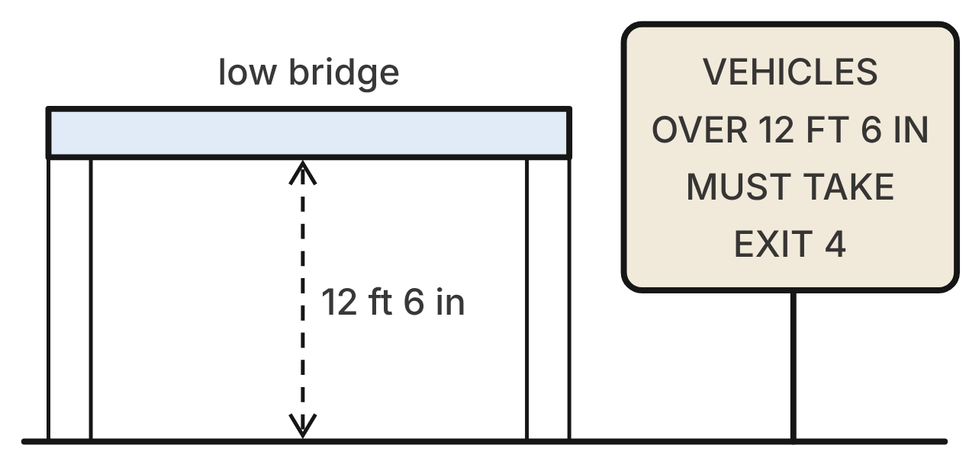
The sign before a low bridge gives a rule, and every driver obeys it. Let p be “A vehicle is over 12 ft 6 in tall” and q be “The vehicle takes Exit 4.” The sign says p → q.
1. Which symbols describe the one kind of trip that would break the sign's rule?
A. ~p ∧ q
B. p ∧ ~q ✔
C. ~p ∧ ~q
D. p ∧ q
G.RLT.1 · skill G.RLT.1.1 (LOTS): Translate statements into symbols and words: negation (~p), conjunction (p ∧ q), disjunction (p ∨ q), conditional (p → q) and biconditional (p ↔ q)
☐ Answer key correct ☐ Wording clear Notes: ________________________________
2. Which sentence is the inverse of the sign's rule?
A. If a vehicle is not over 12 ft 6 in tall, then it does not take Exit 4. ✔
B. If a vehicle takes Exit 4, then it is over 12 ft 6 in tall.
C. If a vehicle does not take Exit 4, then it is not over 12 ft 6 in tall.
D. If a vehicle is over 12 ft 6 in tall, then it does not take Exit 4.
G.RLT.1 · skill G.RLT.1.2 (LOTS): Identify the converse, inverse and contrapositive of a conditional statement and decide whether each is true
☐ Answer key correct ☐ Wording clear Notes: ________________________________
3. Many short cars also take Exit 4 to reach a mall. Which statement is false because of this?
A. p → q
B. ~q → ~p
C. q → p ✔
D. ~p ∨ q
G.RLT.1 · skill G.RLT.1.2 (LOTS): Identify the converse, inverse and contrapositive of a conditional statement and decide whether each is true
☐ Answer key correct ☐ Wording clear Notes: ________________________________
4. A box truck is 13 ft 2 in tall. What can be concluded?
A. It drives under the bridge.
B. It takes Exit 4. ✔
C. Nothing; the sign does not name trucks.
D. It takes Exit 4, and so does every car.
G.RLT.1 · skill G.RLT.1.3 (HOTS): Use deductive reasoning (the Law of Detachment and the Law of Syllogism) to decide whether a conclusion is valid
☐ Answer key correct ☐ Wording clear Notes: ________________________________
5. A van is 12 ft 4 in tall. Ray says, “So the van does not take Exit 4.” Which describes Ray's reasoning?
A. Valid; it uses the contrapositive.
B. Valid, by the Law of Detachment.
C. Invalid; it uses the converse of the rule.
D. Invalid; it uses the inverse of the rule. ✔
G.RLT.1 · skill G.RLT.1.3 (HOTS): Use deductive reasoning (the Law of Detachment and the Law of Syllogism) to decide whether a conclusion is valid
☐ Answer key correct ☐ Wording clear Notes: ________________________________
6. The sign's rule is p → q. Which statement means the same as p → q?
A. q → p
B. ~p → ~q
C. ~q → ~p ✔
D. p ↔ q
G.RLT.1 · skill G.RLT.1.2 (LOTS): Identify the converse, inverse and contrapositive of a conditional statement and decide whether each is true
☐ Answer key correct ☐ Wording clear Notes: ________________________________

Towns Along the Railway
Level 1 · Logic · G.RLT.1 · ID geo-rlt1-sky-rail-map
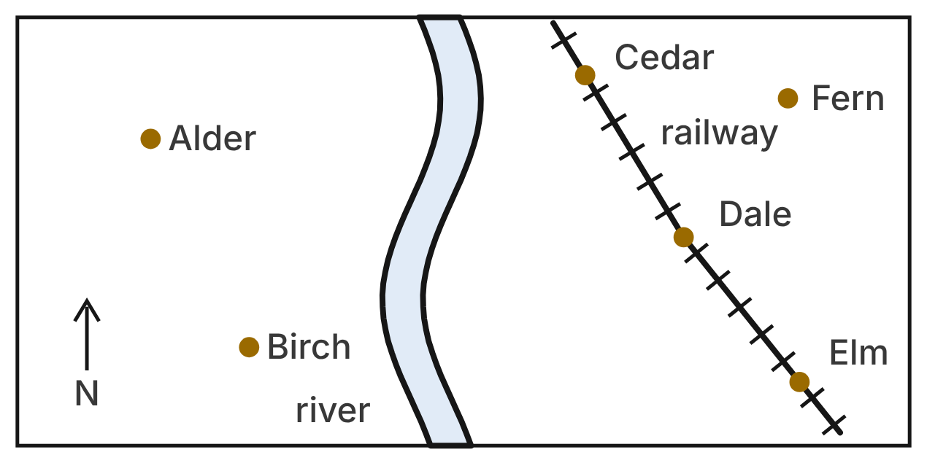
The map shows six towns, a river that runs north to south, and a railway. East is to the right. Let R be the set of towns on the railway and E be the set of towns east of the river.
7. Which statement is true for the six towns on the map?
A. If a town is east of the river, then it is on the railway.
B. If a town is not on the railway, then it is west of the river.
C. If a town is on the railway, then it is west of the river.
D. If a town is west of the river, then it is not on the railway. ✔
G.RLT.1 · skill G.RLT.1.2 (LOTS): Identify the converse, inverse and contrapositive of a conditional statement and decide whether each is true
☐ Answer key correct ☐ Wording clear Notes: ________________________________
8. Which town is a counterexample to “If a town is east of the river, then it is on the railway”?
A. Cedar
B. Alder
C. Fern ✔
D. Birch
G.RLT.1 · skill G.RLT.1.2 (LOTS): Identify the converse, inverse and contrapositive of a conditional statement and decide whether each is true
☐ Answer key correct ☐ Wording clear Notes: ________________________________
9. Which statement about the sets is true?
A. R ⊂ E ✔
B. E ⊂ R
C. R ∩ E is empty.
D. R and E are the same set.
G.RLT.1 · skill G.RLT.1.4 (LOTS): Use and interpret Venn diagrams: union, intersection, subset and negation, including in context
☐ Answer key correct ☐ Wording clear Notes: ________________________________
10. How many towns on the map are in E ∩ ~R?
A. 3
B. 1 ✔
C. 2
D. 4
G.RLT.1 · skill G.RLT.1.4 (LOTS): Use and interpret Venn diagrams: union, intersection, subset and negation, including in context
☐ Answer key correct ☐ Wording clear Notes: ________________________________
11. Let r be “Birch is on the railway” and e be “Birch is east of the river.” Which statement is true?
A. r ∨ e
B. ~r ∧ e
C. ~(r → e)
D. r ↔ e ✔
G.RLT.1 · skill G.RLT.1.1 (LOTS): Translate statements into symbols and words: negation (~p), conjunction (p ∧ q), disjunction (p ∨ q), conditional (p → q) and biconditional (p ↔ q)
☐ Answer key correct ☐ Wording clear Notes: ________________________________
12. Ida knows that every railway town is east of the river. She lives in Fern, east of the river, and concludes that Fern is on the railway. Which describes her reasoning?
A. Invalid; it uses the converse. ✔
B. Valid, by the Law of Detachment.
C. Valid; it uses the contrapositive.
D. Invalid; it uses the inverse.
G.RLT.1 · skill G.RLT.1.3 (HOTS): Use deductive reasoning (the Law of Detachment and the Law of Syllogism) to decide whether a conclusion is valid
☐ Answer key correct ☐ Wording clear Notes: ________________________________

Bike to the Train
Level 2 · Logic · G.RLT.1 · ID geo-rlt1-sky-commuter-table
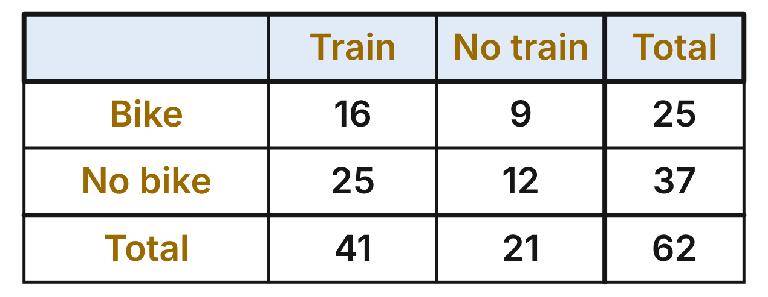
A survey asked all 62 commuters at one station whether they bike to the station and whether they ride the train. Picture the results in a Venn diagram: B is the set of commuters who bike, and T is the set who ride the train.
13. In a Venn diagram of these results, which number belongs in the region B ∩ T?
A. 25
B. 41
C. 16 ✔
D. 9
G.RLT.1 · skill G.RLT.1.4 (LOTS): Use and interpret Venn diagrams: union, intersection, subset and negation, including in context
☐ Answer key correct ☐ Wording clear Notes: ________________________________
14. How many commuters are in B ∪ T?
A. 66
B. 50 ✔
C. 62
D. 34
G.RLT.1 · skill G.RLT.1.4 (LOTS): Use and interpret Venn diagrams: union, intersection, subset and negation, including in context
☐ Answer key correct ☐ Wording clear Notes: ________________________________
15. How many commuters are in ~T?
A. 12
B. 37
C. 41
D. 21 ✔
G.RLT.1 · skill G.RLT.1.4 (LOTS): Use and interpret Venn diagrams: union, intersection, subset and negation, including in context
☐ Answer key correct ☐ Wording clear Notes: ________________________________
16. How many commuters are counterexamples to “If a commuter bikes to the station, then the commuter rides the train”?
A. 25
B. 12
C. 9 ✔
D. 16
G.RLT.1 · skill G.RLT.1.2 (LOTS): Identify the converse, inverse and contrapositive of a conditional statement and decide whether each is true
☐ Answer key correct ☐ Wording clear Notes: ________________________________
17. Kim does not bike to the station, but she rides the train. Let b be “Kim bikes to the station” and t be “Kim rides the train.” Which statement is false?
A. t → b ✔
B. b → t
C. ~b ∨ t
D. b ↔ ~t
G.RLT.1 · skill G.RLT.1.1 (LOTS): Translate statements into symbols and words: negation (~p), conjunction (p ∧ q), disjunction (p ∨ q), conditional (p → q) and biconditional (p ↔ q)
☐ Answer key correct ☐ Wording clear Notes: ________________________________
18. Which expression names the Venn region that holds the 12 commuters who do neither?
A. ~(B ∩ T)
B. ~(B ∪ T) ✔
C. ~B ∩ T
D. B ∩ ~T
G.RLT.1 · skill G.RLT.1.4 (LOTS): Use and interpret Venn diagrams: union, intersection, subset and negation, including in context
☐ Answer key correct ☐ Wording clear Notes: ________________________________

The Drawbridge Light
Level 2 · Logic · G.RLT.1 · ID geo-rlt1-sky-drawbridge
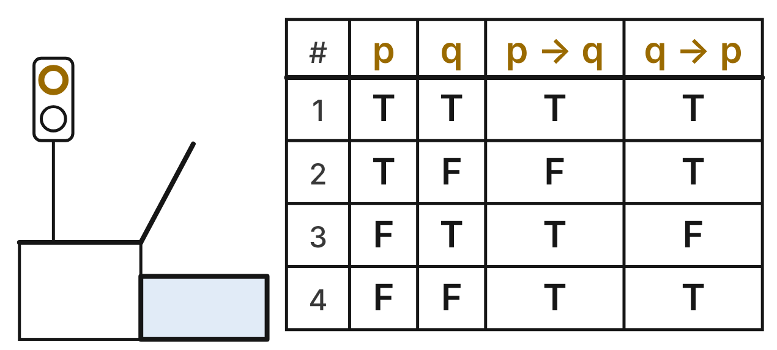
Let p be “The drawbridge is raised.” Let q be “The road light is red.” The table lists all four cases.
19. In which row of the table is p ∧ ~q true?
A. Row 2 ✔
B. Row 3
C. Row 1
D. Row 4
G.RLT.1 · skill G.RLT.1.1 (LOTS): Translate statements into symbols and words: negation (~p), conjunction (p ∧ q), disjunction (p ∨ q), conditional (p → q) and biconditional (p ↔ q)
☐ Answer key correct ☐ Wording clear Notes: ________________________________
20. The contrapositive of p → q is not shown in the table. Which column has the same truth value as the contrapositive in every row?
A. the q → p column
B. the q column
C. neither column
D. the p → q column ✔
G.RLT.1 · skill G.RLT.1.2 (LOTS): Identify the converse, inverse and contrapositive of a conditional statement and decide whether each is true
☐ Answer key correct ☐ Wording clear Notes: ________________________________
21. In which row is p → q true but its converse false?
A. Row 2
B. Row 3 ✔
C. Row 1
D. Row 4
G.RLT.1 · skill G.RLT.1.2 (LOTS): Identify the converse, inverse and contrapositive of a conditional statement and decide whether each is true
☐ Answer key correct ☐ Wording clear Notes: ________________________________
22. The bridge crew follows two rules, p → q and q → p. Which single statement means the same as the pair?
A. p ∧ q
B. p ∨ q
C. p ↔ q ✔
D. ~p → ~q
G.RLT.1 · skill G.RLT.1.1 (LOTS): Translate statements into symbols and words: negation (~p), conjunction (p ∧ q), disjunction (p ∨ q), conditional (p → q) and biconditional (p ↔ q)
☐ Answer key correct ☐ Wording clear Notes: ________________________________
23. Assume p → q is always true. A driver sees that the road light is not red. What can the driver conclude?
A. The drawbridge is not raised. ✔
B. The drawbridge is raised.
C. Nothing about the drawbridge.
D. The rule p → q is broken.
G.RLT.1 · skill G.RLT.1.3 (HOTS): Use deductive reasoning (the Law of Detachment and the Law of Syllogism) to decide whether a conclusion is valid
☐ Answer key correct ☐ Wording clear Notes: ________________________________
24. Which statement is true in row 3 of the table?
A. q → p
B. p ∨ ~q
C. p ↔ q
D. ~p ∧ q ✔
G.RLT.1 · skill G.RLT.1.1 (LOTS): Translate statements into symbols and words: negation (~p), conjunction (p ∧ q), disjunction (p ∨ q), conditional (p → q) and biconditional (p ↔ q)
☐ Answer key correct ☐ Wording clear Notes: ________________________________

Kites and Drones at the Festival
Level 2 · Logic · G.RLT.1 · ID geo-rlt1-sky-kite-festival
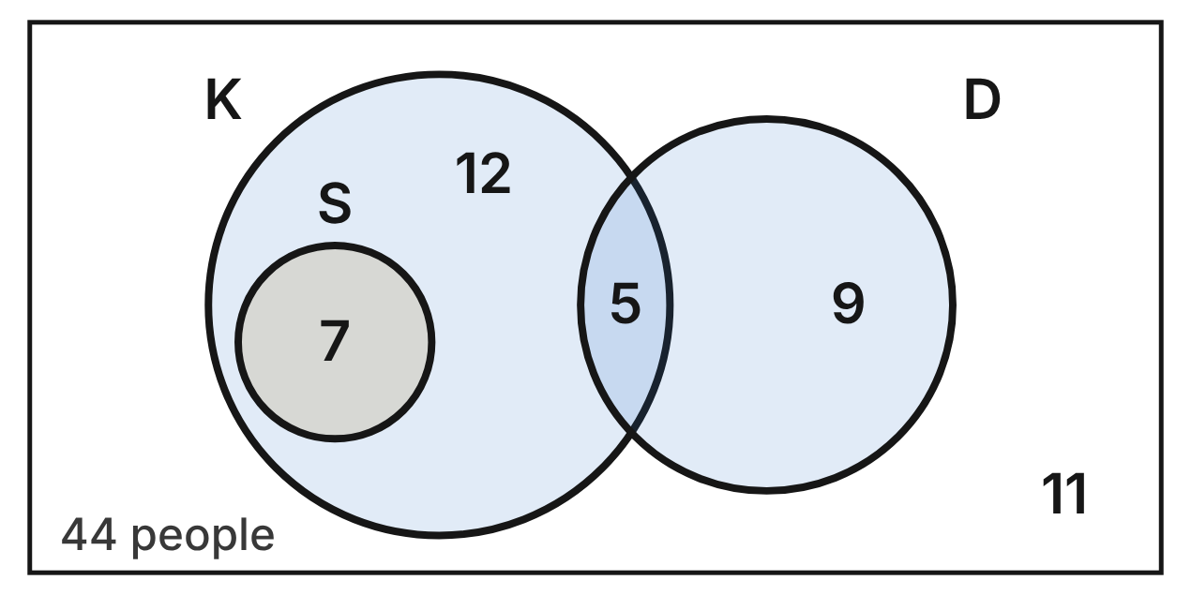
The diagram sorts all 44 people at a kite festival. K is the set who flew a kite, S is the set who flew a stunt kite, and D is the set who flew a drone. Each number is the number of people in that region.
25. How many people at the festival flew a kite?
A. 12
B. 24 ✔
C. 19
D. 29
G.RLT.1 · skill G.RLT.1.4 (LOTS): Use and interpret Venn diagrams: union, intersection, subset and negation, including in context
☐ Answer key correct ☐ Wording clear Notes: ________________________________
26. How many people are in K ∪ D?
A. 38
B. 5
C. 33 ✔
D. 11
G.RLT.1 · skill G.RLT.1.4 (LOTS): Use and interpret Venn diagrams: union, intersection, subset and negation, including in context
☐ Answer key correct ☐ Wording clear Notes: ________________________________
27. Which conditional is true for all 44 people?
A. If a person flew a stunt kite, then the person did not fly a drone. ✔
B. If a person flew a kite, then the person flew a stunt kite.
C. If a person did not fly a stunt kite, then the person did not fly a kite.
D. If a person flew a drone, then the person flew a kite.
G.RLT.1 · skill G.RLT.1.2 (LOTS): Identify the converse, inverse and contrapositive of a conditional statement and decide whether each is true
☐ Answer key correct ☐ Wording clear Notes: ________________________________
28. Which expression names the region with 12 people?
A. K ∩ S ∩ ~D
B. K ∩ ~S ∩ D
C. ~K ∩ ~S ∩ ~D
D. K ∩ ~S ∩ ~D ✔
G.RLT.1 · skill G.RLT.1.4 (LOTS): Use and interpret Venn diagrams: union, intersection, subset and negation, including in context
☐ Answer key correct ☐ Wording clear Notes: ________________________________
29. How many people are in ~(K ∩ D)?
A. 11
B. 5
C. 39 ✔
D. 33
G.RLT.1 · skill G.RLT.1.4 (LOTS): Use and interpret Venn diagrams: union, intersection, subset and negation, including in context
☐ Answer key correct ☐ Wording clear Notes: ________________________________
30. Jo flew a drone at the festival. Ty says that Jo must have flown a kite too. Is Ty right?
A. Yes; 5 drone flyers also flew a kite.
B. No; 9 drone flyers flew no kite. ✔
C. Yes, by the Law of Detachment.
D. No; Jo is not in S, so Jo flew no kite.
G.RLT.1 · skill G.RLT.1.3 (HOTS): Use deductive reasoning (the Law of Detachment and the Law of Syllogism) to decide whether a conclusion is valid
☐ Answer key correct ☐ Wording clear Notes: ________________________________

Ramp Rules at the Station
Level 3 · Logic · G.RLT.1 · ID geo-rlt1-sky-station-ramps
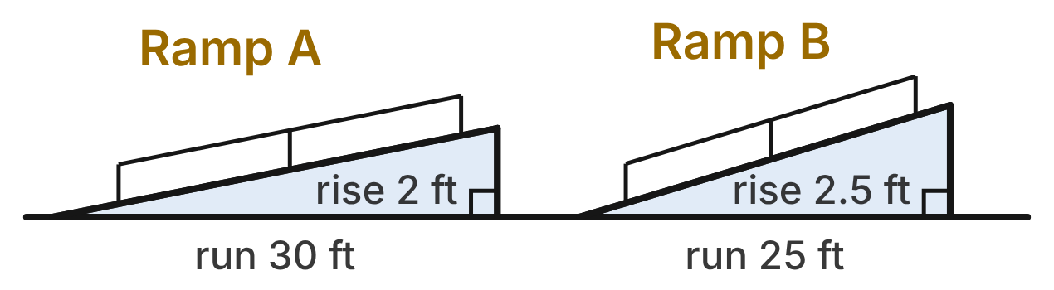
Not drawn to scale
A train station has two ramps, A and B, and both have handrails. Two rules hold for every ramp at the station.
Rule 1: A ramp is approved if and only if its slope is at most 1/12. Rule 2: If a ramp rises more than 6 inches, then it has handrails.
31. Using rule 1, which ramps in the figure are approved?
A. Ramp B only
B. Both ramps
C. Neither ramp
D. Ramp A only ✔
G.RLT.1 · skill G.RLT.1.3 (HOTS): Use deductive reasoning (the Law of Detachment and the Law of Syllogism) to decide whether a conclusion is valid
☐ Answer key correct ☐ Wording clear Notes: ________________________________
32. Which is the contrapositive of rule 2?
A. If a ramp has no handrails, then it rises 6 inches or less. ✔
B. If a ramp has handrails, then it rises more than 6 inches.
C. If a ramp rises 6 inches or less, then it has no handrails.
D. If a ramp has no handrails, then it rises more than 6 inches.
G.RLT.1 · skill G.RLT.1.2 (LOTS): Identify the converse, inverse and contrapositive of a conditional statement and decide whether each is true
☐ Answer key correct ☐ Wording clear Notes: ________________________________
33. A new Ramp C rises 5 inches over a run of 4 feet. What can be concluded from the two rules?
A. It is not approved, and it has no handrails.
B. It is approved; the rules say nothing about handrails.
C. It is not approved; the rules say nothing about handrails. ✔
D. It is approved, and it has no handrails.
G.RLT.1 · skill G.RLT.1.3 (HOTS): Use deductive reasoning (the Law of Detachment and the Law of Syllogism) to decide whether a conclusion is valid
☐ Answer key correct ☐ Wording clear Notes: ________________________________
34. A ramp at the station is approved. Max says, “So its slope is at most 1/12.” Which describes his reasoning?
A. Invalid; it reasons from the converse.
B. Valid; rule 1 works in both directions. ✔
C. Invalid; it reasons from the inverse.
D. Valid, by the Law of Syllogism.
G.RLT.1 · skill G.RLT.1.3 (HOTS): Use deductive reasoning (the Law of Detachment and the Law of Syllogism) to decide whether a conclusion is valid
☐ Answer key correct ☐ Wording clear Notes: ________________________________
35. A third rule is also true: “If a ramp has handrails, then its edge is painted yellow.” Which conclusion follows from rules 2 and 3?
A. If a ramp rises more than 6 inches, then its edge is painted yellow. ✔
B. If a ramp's edge is painted yellow, then it rises more than 6 inches.
C. If a ramp rises 6 inches or less, then its edge is not painted yellow.
D. If a ramp has handrails, then it rises more than 6 inches.
G.RLT.1 · skill G.RLT.1.3 (HOTS): Use deductive reasoning (the Law of Detachment and the Law of Syllogism) to decide whether a conclusion is valid
☐ Answer key correct ☐ Wording clear Notes: ________________________________
36. For Ramp B, let s be “Its slope is at most 1/12” and r be “It rises more than 6 inches.” Which statement is true?
A. s ∨ ~r
B. r → s
C. ~(s ∨ r)
D. s → ~r ✔
G.RLT.1 · skill G.RLT.1.1 (LOTS): Translate statements into symbols and words: negation (~p), conjunction (p ∧ q), disjunction (p ∨ q), conditional (p → q) and biconditional (p ↔ q)
☐ Answer key correct ☐ Wording clear Notes: ________________________________

Snow Day on the Rail Line
Level 3 · Logic · G.RLT.1 · ID geo-rlt1-sky-snow-day-rails
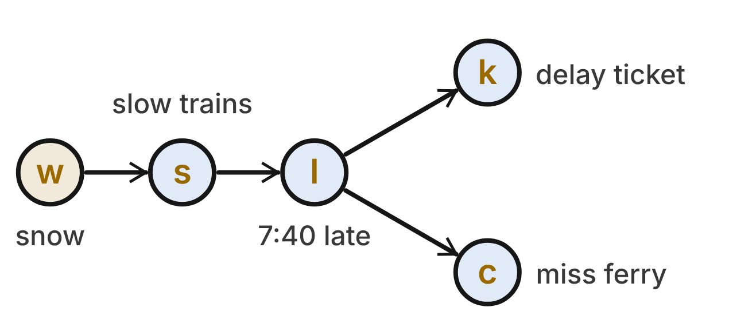
Each arrow in the rail-map diagram is a true conditional: w → s, s → l, l → k and l → c.
w: Snow falls on the tracks. s: Trains run at reduced speed. l: The 7:40 train is late. k: Riders get a delay ticket. c: Commuters miss the 8:15 ferry.
37. Snow falls on the tracks today. What can be concluded?
A. Riders get a delay ticket, but commuters may catch the ferry.
B. The 7:40 is late, but riders may get no delay ticket.
C. Riders get a delay ticket, and commuters miss the ferry. ✔
D. Only that trains run at reduced speed.
G.RLT.1 · skill G.RLT.1.3 (HOTS): Use deductive reasoning (the Law of Detachment and the Law of Syllogism) to decide whether a conclusion is valid
☐ Answer key correct ☐ Wording clear Notes: ________________________________
38. Which conditional follows by the Law of Syllogism?
A. k → c
B. s → c ✔
C. c → s
D. k → l
G.RLT.1 · skill G.RLT.1.3 (HOTS): Use deductive reasoning (the Law of Detachment and the Law of Syllogism) to decide whether a conclusion is valid
☐ Answer key correct ☐ Wording clear Notes: ________________________________
39. Today riders get a delay ticket. Which conclusion is valid?
A. The 7:40 train is late.
B. Commuters miss the 8:15 ferry.
C. Snow falls on the tracks.
D. Nothing else can be concluded. ✔
G.RLT.1 · skill G.RLT.1.3 (HOTS): Use deductive reasoning (the Law of Detachment and the Law of Syllogism) to decide whether a conclusion is valid
☐ Answer key correct ☐ Wording clear Notes: ________________________________
40. Today commuters catch the 8:15 ferry. What can be concluded?
A. No snow falls on the tracks. ✔
B. Riders get no delay ticket.
C. Trains run at reduced speed.
D. Nothing can be concluded.
G.RLT.1 · skill G.RLT.1.3 (HOTS): Use deductive reasoning (the Law of Detachment and the Law of Syllogism) to decide whether a conclusion is valid
☐ Answer key correct ☐ Wording clear Notes: ________________________________
41. Which statement must be true?
A. ~l → ~k
B. ~k → ~l ✔
C. k → l
D. c → k
G.RLT.1 · skill G.RLT.1.2 (LOTS): Identify the converse, inverse and contrapositive of a conditional statement and decide whether each is true
☐ Answer key correct ☐ Wording clear Notes: ________________________________
42. Which sentence is ~k ∨ c?
A. Riders do not get a delay ticket, and commuters miss the 8:15 ferry.
B. If riders do not get a delay ticket, then commuters miss the 8:15 ferry.
C. Riders do not get a delay ticket, or commuters miss the 8:15 ferry. ✔
D. Riders get a delay ticket, or commuters do not miss the 8:15 ferry.
G.RLT.1 · skill G.RLT.1.1 (LOTS): Translate statements into symbols and words: negation (~p), conjunction (p ∧ q), disjunction (p ∨ q), conditional (p → q) and biconditional (p ↔ q)
☐ Answer key correct ☐ Wording clear Notes: ________________________________

G.RLT.2 · Analyze, prove, and justify the relationships of parallel lines cut by a transversal.

Two Runways and a Taxiway
Level 1 · Lines · G.RLT.2 · ID geo-rlt2-sky-runways
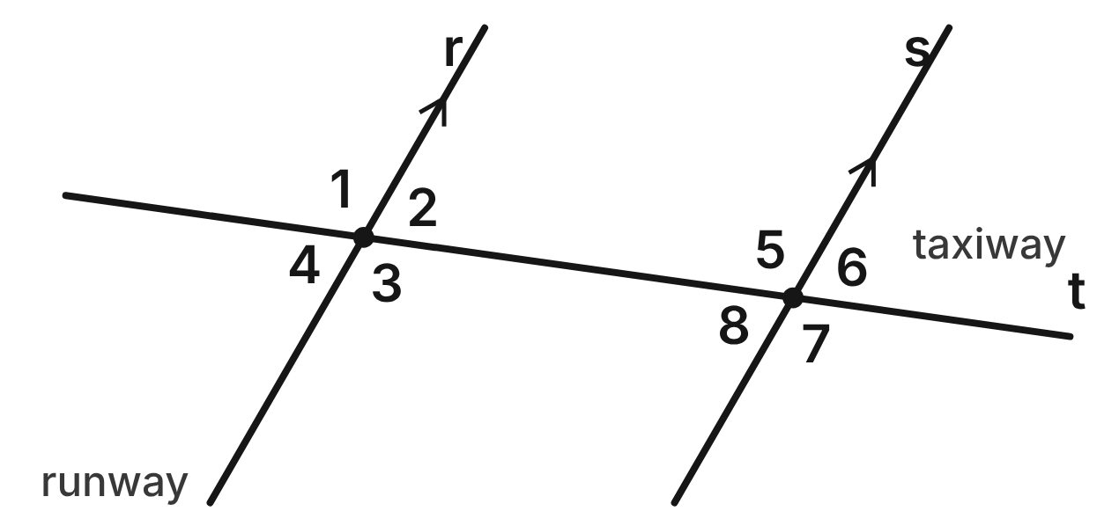
At an airport, runways r and s are parallel. A straight taxiway, t, crosses both runways. m∠5 = 112°.
43. ∠2 and ∠8 are what kind of angle pair?
A. Same-side interior angles
B. Alternate interior angles ✔
C. Corresponding angles
D. Alternate exterior angles
G.RLT.2 · skill G.RLT.2.1 (LOTS): Identify angle pairs formed by a transversal: corresponding, alternate interior, alternate exterior, same-side interior, vertical and linear pairs
☐ Answer key correct ☐ Wording clear Notes: ________________________________
44. What is m∠3, between the runways?
A. 68°
B. 22°
C. 112° ✔
D. 248°
G.RLT.2 · skill G.RLT.2.3 (LOTS): Solve problems, including algebraic ones, using the angles formed by parallel lines and a transversal
☐ Answer key correct ☐ Wording clear Notes: ________________________________
45. Which angle corresponds to ∠6?
A. ∠2 ✔
B. ∠8
C. ∠4
D. ∠7
G.RLT.2 · skill G.RLT.2.1 (LOTS): Identify angle pairs formed by a transversal: corresponding, alternate interior, alternate exterior, same-side interior, vertical and linear pairs
☐ Answer key correct ☐ Wording clear Notes: ________________________________
46. Which of these angles measures 68°?
A. ∠1
B. ∠3
C. ∠7
D. ∠4 ✔
G.RLT.2 · skill G.RLT.2.3 (LOTS): Solve problems, including algebraic ones, using the angles formed by parallel lines and a transversal
☐ Answer key correct ☐ Wording clear Notes: ________________________________
47. Which two angles form a linear pair at one crossing?
A. ∠5 and ∠7
B. ∠1 and ∠5
C. ∠5 and ∠6 ✔
D. ∠3 and ∠8
G.RLT.2 · skill G.RLT.2.1 (LOTS): Identify angle pairs formed by a transversal: corresponding, alternate interior, alternate exterior, same-side interior, vertical and linear pairs
☐ Answer key correct ☐ Wording clear Notes: ________________________________
48. A pilot adds m∠4 and m∠7. What is the sum?
A. 136°
B. 180° ✔
C. 224°
D. 90°
G.RLT.2 · skill G.RLT.2.3 (LOTS): Solve problems, including algebraic ones, using the angles formed by parallel lines and a transversal
☐ Answer key correct ☐ Wording clear Notes: ________________________________

The Ferry Across the Canal
Level 1 · Lines · G.RLT.2 · ID geo-rlt2-sky-ferry-canal
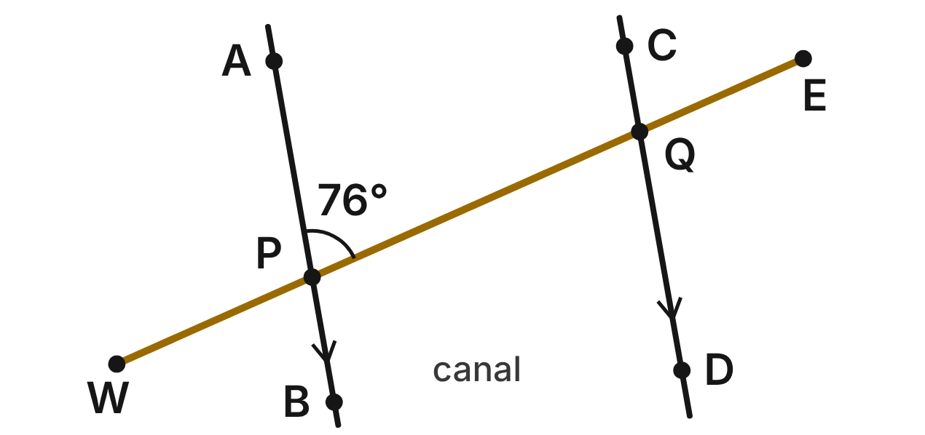
On a map, the banks of a canal are parallel lines, AB and CD. A ferry's straight route from dock W to dock E crosses the banks at P and Q. m∠APQ = 76°.
49. What is m∠PQD, where the route meets the far bank?
A. 76° ✔
B. 104°
C. 14°
D. 152°
G.RLT.2 · skill G.RLT.2.3 (LOTS): Solve problems, including algebraic ones, using the angles formed by parallel lines and a transversal
☐ Answer key correct ☐ Wording clear Notes: ________________________________
50. What kind of angle pair are ∠APQ and ∠CQE?
A. Alternate interior angles
B. Alternate exterior angles
C. Same-side interior angles
D. Corresponding angles ✔
G.RLT.2 · skill G.RLT.2.1 (LOTS): Identify angle pairs formed by a transversal: corresponding, alternate interior, alternate exterior, same-side interior, vertical and linear pairs
☐ Answer key correct ☐ Wording clear Notes: ________________________________
51. What is m∠DQE?
A. 76°
B. 104° ✔
C. 14°
D. 284°
G.RLT.2 · skill G.RLT.2.3 (LOTS): Solve problems, including algebraic ones, using the angles formed by parallel lines and a transversal
☐ Answer key correct ☐ Wording clear Notes: ________________________________
52. Which angle is a same-side interior angle with ∠BPQ?
A. ∠PQC
B. ∠DQE
C. ∠PQD ✔
D. ∠WPA
G.RLT.2 · skill G.RLT.2.1 (LOTS): Identify angle pairs formed by a transversal: corresponding, alternate interior, alternate exterior, same-side interior, vertical and linear pairs
☐ Answer key correct ☐ Wording clear Notes: ________________________________
53. Which two angles are vertical angles?
A. ∠WPA and ∠BPQ ✔
B. ∠APQ and ∠BPQ
C. ∠WPA and ∠PQC
D. ∠APQ and ∠PQD
G.RLT.2 · skill G.RLT.2.1 (LOTS): Identify angle pairs formed by a transversal: corresponding, alternate interior, alternate exterior, same-side interior, vertical and linear pairs
☐ Answer key correct ☐ Wording clear Notes: ________________________________
54. On another canal, a route makes m∠APQ = 76° and m∠PQC = 101°. Are those banks parallel?
A. Yes; one angle is acute and one is obtuse.
B. Yes; same-side interior angles are never equal.
C. No; ∠APQ and ∠PQC should be congruent.
D. No; same-side interior angles add to 177°. ✔
G.RLT.2 · skill G.RLT.2.2 (HOTS): Prove or justify that two lines are parallel, or are not, from angle measures
☐ Answer key correct ☐ Wording clear Notes: ________________________________

The Truss Bridge
Level 2 · Lines · G.RLT.2 · ID geo-rlt2-sky-truss-bridge
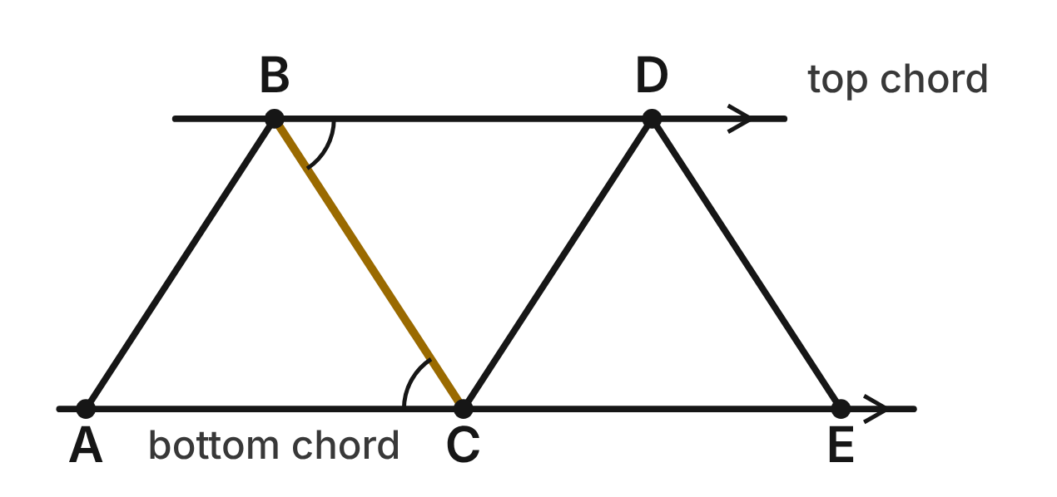
On a truss bridge, the top chord BD and the bottom chord AE are parallel. Straight beams zigzag between them. m∠DBC = (5x − 8)⁠° and m∠BCA = (3x + 18)⁠°.
55. Solve for x using the two marked beam angles.
A. 21.25
B. 5
C. 26
D. 13 ✔
G.RLT.2 · skill G.RLT.2.3 (LOTS): Solve problems, including algebraic ones, using the angles formed by parallel lines and a transversal
☐ Answer key correct ☐ Wording clear Notes: ________________________________
56. With BC as the transversal of the two chords, what kind of angle pair are ∠DBC and ∠BCA?
A. Corresponding angles
B. Alternate interior angles ✔
C. Same-side interior angles
D. Alternate exterior angles
G.RLT.2 · skill G.RLT.2.1 (LOTS): Identify angle pairs formed by a transversal: corresponding, alternate interior, alternate exterior, same-side interior, vertical and linear pairs
☐ Answer key correct ☐ Wording clear Notes: ________________________________
57. What is m∠DBC?
A. 13°
B. 123°
C. 57° ✔
D. 33°
G.RLT.2 · skill G.RLT.2.3 (LOTS): Solve problems, including algebraic ones, using the angles formed by parallel lines and a transversal
☐ Answer key correct ☐ Wording clear Notes: ________________________________
58. An inspector finds m∠BAC = 57° and m∠DCE = 57°. Which statement is proved?
A. AB ∥ CD, by the Converse of the Corresponding Angles Postulate ✔
B. AB ∥ CD, by the Corresponding Angles Postulate
C. AB ∥ CD, by the Converse of the Alternate Interior Angles Theorem
D. AB ∥ CD, by the Converse of the Same-Side Interior Angles Theorem
G.RLT.2 · skill G.RLT.2.2 (HOTS): Prove or justify that two lines are parallel, or are not, from angle measures
☐ Answer key correct ☐ Wording clear Notes: ________________________________
59. Along transversal BC, which two angles are same-side interior angles?
A. ∠DBC and ∠BCA
B. ∠DBC and ∠BCE ✔
C. ∠BCA and ∠BCE
D. ∠DBC and ∠DCE
G.RLT.2 · skill G.RLT.2.1 (LOTS): Identify angle pairs formed by a transversal: corresponding, alternate interior, alternate exterior, same-side interior, vertical and linear pairs
☐ Answer key correct ☐ Wording clear Notes: ________________________________
60. What is m∠BCE?
A. 57°
B. 33°
C. 147°
D. 123° ✔
G.RLT.2 · skill G.RLT.2.3 (LOTS): Solve problems, including algebraic ones, using the angles formed by parallel lines and a transversal
☐ Answer key correct ☐ Wording clear Notes: ________________________________

The Subway Escalator
Level 2 · Lines · G.RLT.2 · ID geo-rlt2-sky-subway-escalator
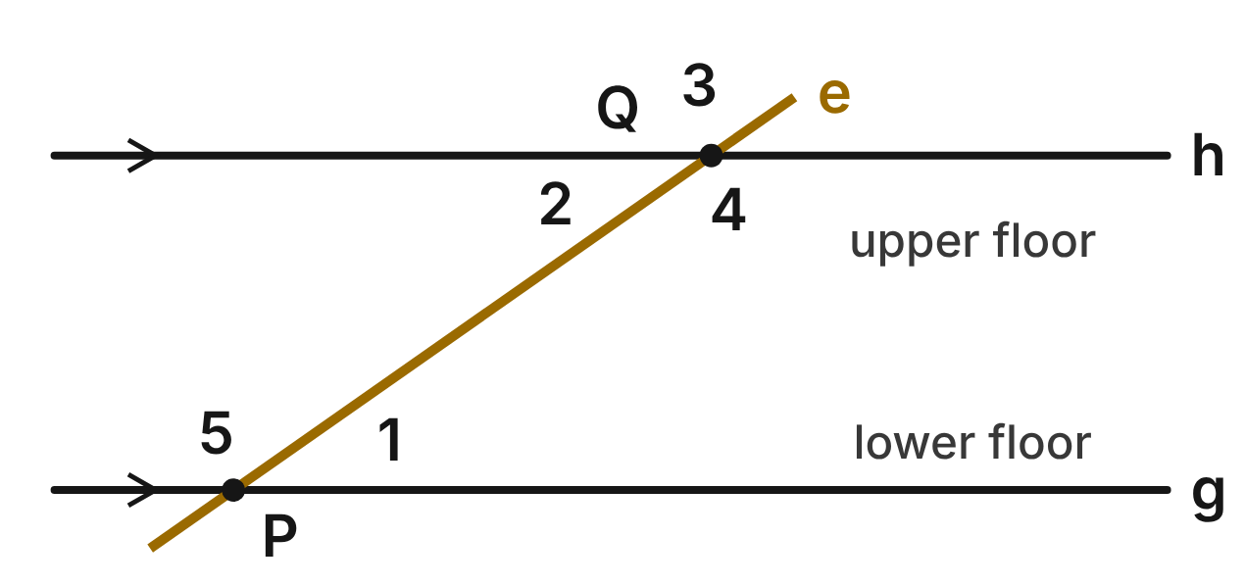
In a subway station, the lower floor g and the upper floor h are parallel. The handrail of an escalator runs along line e from P to Q. m∠1 = (4x − 1)⁠° and m∠2 = (x + 26)⁠°.
61. What is the value of x for the escalator?
A. 31
B. 27
C. 9 ✔
D. 5.4
G.RLT.2 · skill G.RLT.2.3 (LOTS): Solve problems, including algebraic ones, using the angles formed by parallel lines and a transversal
☐ Answer key correct ☐ Wording clear Notes: ________________________________
62. What is m∠1, the angle between the escalator and the lower floor?
A. 35° ✔
B. 55°
C. 145°
D. 9°
G.RLT.2 · skill G.RLT.2.3 (LOTS): Solve problems, including algebraic ones, using the angles formed by parallel lines and a transversal
☐ Answer key correct ☐ Wording clear Notes: ________________________________
63. Which angle is a same-side interior angle with ∠1?
A. ∠2
B. ∠4 ✔
C. ∠5
D. ∠3
G.RLT.2 · skill G.RLT.2.1 (LOTS): Identify angle pairs formed by a transversal: corresponding, alternate interior, alternate exterior, same-side interior, vertical and linear pairs
☐ Answer key correct ☐ Wording clear Notes: ________________________________
64. What is m∠3, above the upper floor?
A. 35°
B. 55°
C. 325°
D. 145° ✔
G.RLT.2 · skill G.RLT.2.3 (LOTS): Solve problems, including algebraic ones, using the angles formed by parallel lines and a transversal
☐ Answer key correct ☐ Wording clear Notes: ________________________________
65. An inspector measures m∠1 = 35° and m∠4 = 145°. Which statement proves that the floors are parallel?
A. Alternate interior angles are congruent, so g ∥ h.
B. ∠1 and ∠4 form a linear pair, so g ∥ h.
C. Same-side interior angles are supplementary, so g ∥ h. ✔
D. ∠1 and ∠4 are not congruent, so g is not parallel to h.
G.RLT.2 · skill G.RLT.2.2 (HOTS): Prove or justify that two lines are parallel, or are not, from angle measures
☐ Answer key correct ☐ Wording clear Notes: ________________________________
66. Which statement about ∠2 and ∠5 is true?
A. They are same-side interior angles, so they are supplementary. ✔
B. They are alternate interior angles, so they are congruent.
C. They are corresponding angles, so they are congruent.
D. They are vertical angles, so they are congruent.
G.RLT.2 · skill G.RLT.2.1 (LOTS): Identify angle pairs formed by a transversal: corresponding, alternate interior, alternate exterior, same-side interior, vertical and linear pairs
☐ Answer key correct ☐ Wording clear Notes: ________________________________

Kites on the Boardwalk
Level 2 · Lines · G.RLT.2 · ID geo-rlt2-sky-kite-strings
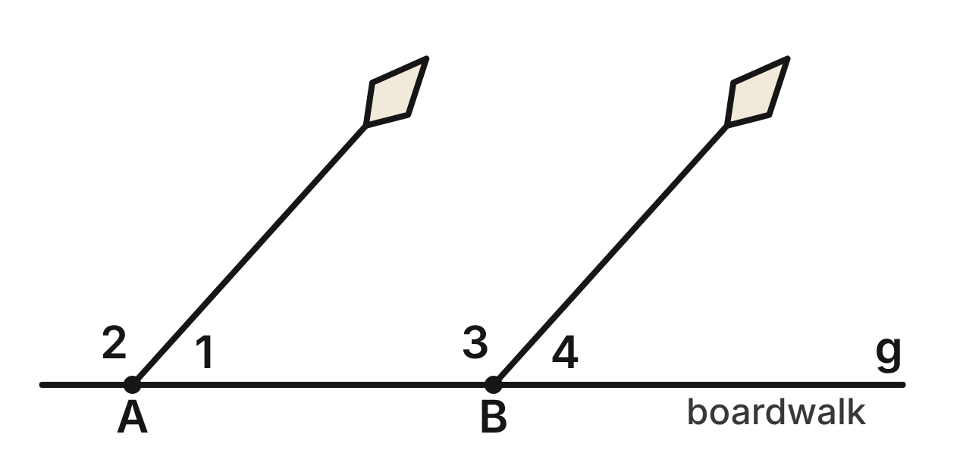
Two kites are tied at A and B on the straight edge of a boardwalk, g. Both strings are pulled straight. m∠1 = 48° and m∠3 = (4x + 8)⁠°.
67. ∠1 and ∠3 are what kind of angle pair?
A. Same-side interior angles ✔
B. Alternate interior angles
C. Corresponding angles
D. A linear pair
G.RLT.2 · skill G.RLT.2.1 (LOTS): Identify angle pairs formed by a transversal: corresponding, alternate interior, alternate exterior, same-side interior, vertical and linear pairs
☐ Answer key correct ☐ Wording clear Notes: ________________________________
68. For the two strings to be parallel, what must x be?
A. 10
B. 76
C. 31 ✔
D. 8.5
G.RLT.2 · skill G.RLT.2.3 (LOTS): Solve problems, including algebraic ones, using the angles formed by parallel lines and a transversal
☐ Answer key correct ☐ Wording clear Notes: ________________________________
69. When x = 31, which reason proves that the strings are parallel?
A. Same-Side Interior Angles Theorem
B. Converse of the Alternate Interior Angles Theorem
C. Converse of the Corresponding Angles Postulate
D. Converse of the Same-Side Interior Angles Theorem ✔
G.RLT.2 · skill G.RLT.2.2 (HOTS): Prove or justify that two lines are parallel, or are not, from angle measures
☐ Answer key correct ☐ Wording clear Notes: ________________________________
70. A gust moves kite B, and now m∠3 = 127°. Which statement is true?
A. The strings are parallel, since ∠3 is still obtuse.
B. The strings are not parallel, since 48° + 127° ≠ 180°. ✔
C. The strings are parallel, since ∠1 did not change.
D. The strings are not parallel, since 127° ≠ 48°.
G.RLT.2 · skill G.RLT.2.2 (HOTS): Prove or justify that two lines are parallel, or are not, from angle measures
☐ Answer key correct ☐ Wording clear Notes: ________________________________
71. When x = 31, what is m∠4?
A. 48° ✔
B. 132°
C. 42°
D. 312°
G.RLT.2 · skill G.RLT.2.3 (LOTS): Solve problems, including algebraic ones, using the angles formed by parallel lines and a transversal
☐ Answer key correct ☐ Wording clear Notes: ________________________________
72. What kind of angle pair are ∠2 and ∠3?
A. Same-side interior angles
B. Alternate exterior angles
C. Corresponding angles ✔
D. Vertical angles
G.RLT.2 · skill G.RLT.2.1 (LOTS): Identify angle pairs formed by a transversal: corresponding, alternate interior, alternate exterior, same-side interior, vertical and linear pairs
☐ Answer key correct ☐ Wording clear Notes: ________________________________

Proof at the Marina
Level 3 · Lines · G.RLT.2 · ID geo-rlt2-sky-marina-docks
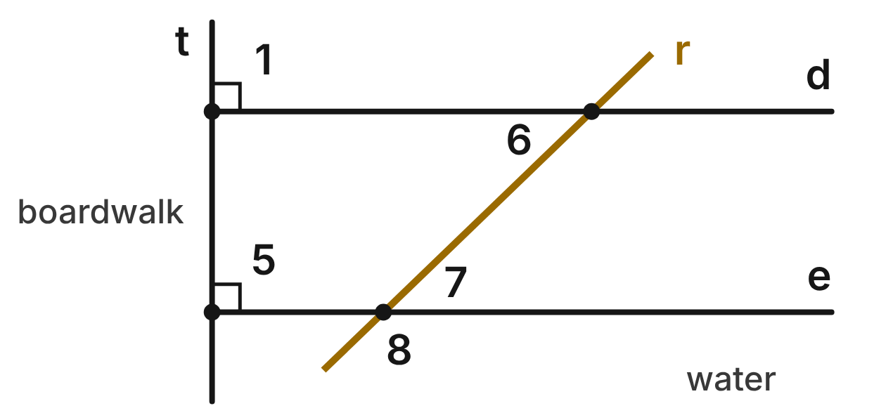
At a marina, docks d and e stick out from a straight boardwalk, t. A rope, r, is stretched across both docks, with m∠6 = (x + 32)⁠° and m∠7 = (3x + 8)⁠°. Given: d ⊥ t and e ⊥ t. Prove: d ∥ e.
Statement | Reason
1. d ⊥ t and e ⊥ t | Given
2. ∠1 and ∠5 are right angles. | ____ (a)
3. ∠1 ≅ ∠5 | ____ (b)
4. d ∥ e | ____ (c)

73. In the marina proof, which reason fills blank (a)?
A. Linear Pair Postulate
B. Definition of perpendicular lines ✔
C. Vertical Angles Theorem
D. Converse of the Corresponding Angles Postulate
G.RLT.2 · skill G.RLT.2.2 (HOTS): Prove or justify that two lines are parallel, or are not, from angle measures
☐ Answer key correct ☐ Wording clear Notes: ________________________________
74. In the marina proof, which reason fills blank (b)?
A. Corresponding Angles Postulate
B. Vertical Angles Theorem
C. Linear Pair Postulate
D. All right angles are congruent. ✔
G.RLT.2 · skill G.RLT.2.2 (HOTS): Prove or justify that two lines are parallel, or are not, from angle measures
☐ Answer key correct ☐ Wording clear Notes: ________________________________
75. In the marina proof, which reason fills blank (c)?
A. Converse of the Corresponding Angles Postulate ✔
B. Corresponding Angles Postulate
C. Converse of the Alternate Interior Angles Theorem
D. All right angles are congruent.
G.RLT.2 · skill G.RLT.2.2 (HOTS): Prove or justify that two lines are parallel, or are not, from angle measures
☐ Answer key correct ☐ Wording clear Notes: ________________________________
76. Along rope r, what kind of angle pair are ∠6 and ∠7?
A. Corresponding angles
B. Same-side interior angles
C. Alternate interior angles ✔
D. Vertical angles
G.RLT.2 · skill G.RLT.2.1 (LOTS): Identify angle pairs formed by a transversal: corresponding, alternate interior, alternate exterior, same-side interior, vertical and linear pairs
☐ Answer key correct ☐ Wording clear Notes: ________________________________
77. Since d ∥ e, what is the value of x for the rope angles?
A. 12 ✔
B. 35
C. 20
D. 24
G.RLT.2 · skill G.RLT.2.3 (LOTS): Solve problems, including algebraic ones, using the angles formed by parallel lines and a transversal
☐ Answer key correct ☐ Wording clear Notes: ________________________________
78. Since d ∥ e, what is m∠8, where the rope crosses dock e?
A. 44°
B. 136° ✔
C. 46°
D. 224°
G.RLT.2 · skill G.RLT.2.3 (LOTS): Solve problems, including algebraic ones, using the angles formed by parallel lines and a transversal
☐ Answer key correct ☐ Wording clear Notes: ________________________________

The Drone Between the Highways
Level 3 · Lines · G.RLT.2 · ID geo-rlt2-sky-drone-highways
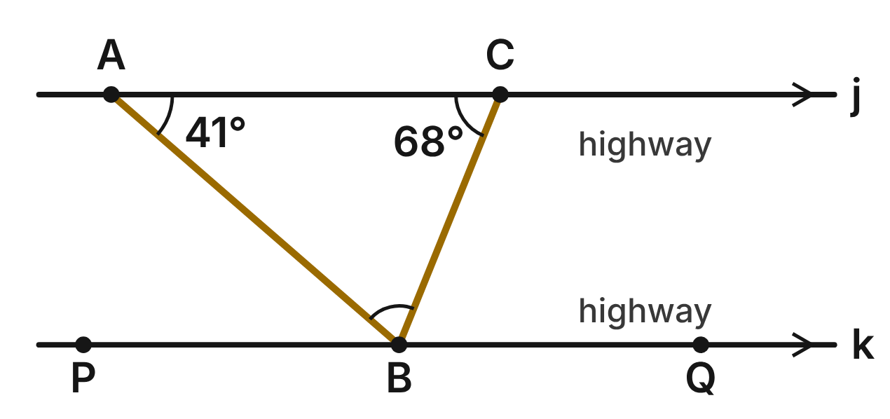
Highways j and k are parallel. A drone flies straight from A to B, then from B to C. A and C are on j; P, B and Q are on k. m∠BAC = 41° and m∠BCA = 68°.
79. With AB as the transversal of j and k, what kind of angle pair are ∠BAC and ∠PBA?
A. Corresponding angles
B. Same-side interior angles
C. Vertical angles
D. Alternate interior angles ✔
G.RLT.2 · skill G.RLT.2.1 (LOTS): Identify angle pairs formed by a transversal: corresponding, alternate interior, alternate exterior, same-side interior, vertical and linear pairs
☐ Answer key correct ☐ Wording clear Notes: ________________________________
80. What is m∠QBC?
A. 112°
B. 68° ✔
C. 41°
D. 22°
G.RLT.2 · skill G.RLT.2.3 (LOTS): Solve problems, including algebraic ones, using the angles formed by parallel lines and a transversal
☐ Answer key correct ☐ Wording clear Notes: ________________________________
81. What is m∠ABC, the angle between the drone's two paths at B?
A. 109°
B. 139°
C. 71° ✔
D. 251°
G.RLT.2 · skill G.RLT.2.3 (LOTS): Solve problems, including algebraic ones, using the angles formed by parallel lines and a transversal
☐ Answer key correct ☐ Wording clear Notes: ________________________________
82. Which reason shows that ∠QBC ≅ ∠BCA?
A. Alternate Interior Angles Theorem ✔
B. Converse of the Alternate Interior Angles Theorem
C. Vertical Angles Theorem
D. Corresponding Angles Postulate
G.RLT.2 · skill G.RLT.2.2 (HOTS): Prove or justify that two lines are parallel, or are not, from angle measures
☐ Answer key correct ☐ Wording clear Notes: ________________________________
83. On a second flight between the same highways, m∠BAC = (4x − 6)⁠°, m∠BCA = (2x + 21)⁠° and m∠ABC = (3x + 39)⁠°. What is x?
A. 34
B. 14 ✔
C. 20
D. 4
G.RLT.2 · skill G.RLT.2.3 (LOTS): Solve problems, including algebraic ones, using the angles formed by parallel lines and a transversal
☐ Answer key correct ☐ Wording clear Notes: ________________________________
84. A pilot says m∠PBA would still be 41° even if j and k were not parallel. Why is she wrong?
A. She is right; alternate interior angles are always congruent.
B. She is right; ∠PBA and ∠BAC are vertical angles.
C. ∠PBA and ∠BAC would have to add to 180° instead.
D. Alternate interior angles are congruent only when the lines are parallel. ✔
G.RLT.2 · skill G.RLT.2.2 (HOTS): Prove or justify that two lines are parallel, or are not, from angle measures
☐ Answer key correct ☐ Wording clear Notes: ________________________________

G.RLT.3 · Solve problems, including contextual problems, involving symmetry and transformation.

Signs at the Train Station
Level 1 · Transformations · G.RLT.3 · ID geo-rlt3-sky-rail-signs
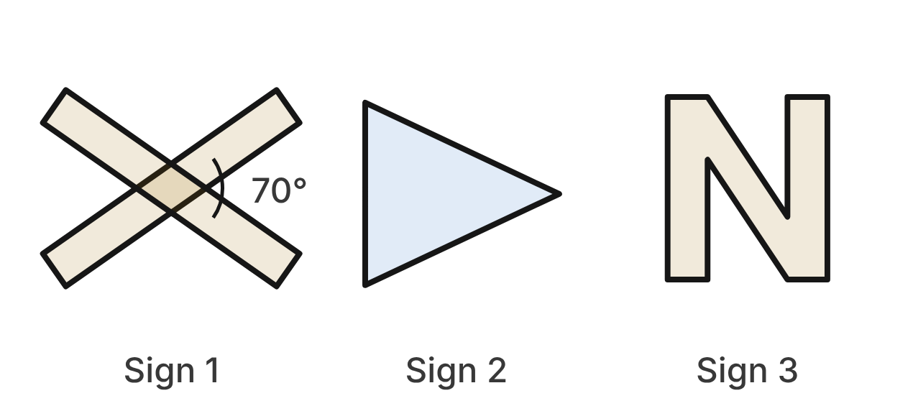
Three signs stand near a train station. Sign 1 is a crossbuck: two identical rectangular boards cross at their centers and meet at a 70° angle. Sign 2 is a pennant shaped like an isosceles triangle. Sign 3 is a block letter N for the north platform.
85. How many lines of symmetry does Sign 1 have?
A. 4
B. 1
C. 2 ✔
D. 0
G.RLT.3 · skill G.RLT.3.1 (LOTS): Identify line symmetry and rotational symmetry of a figure
☐ Answer key correct ☐ Wording clear Notes: ________________________________
86. What is the smallest angle of rotation, about its center, that maps Sign 1 onto itself?
A. 180° ✔
B. 70°
C. 90°
D. 35°
G.RLT.3 · skill G.RLT.3.1 (LOTS): Identify line symmetry and rotational symmetry of a figure
☐ Answer key correct ☐ Wording clear Notes: ________________________________
87. What is the order of rotational symmetry of Sign 3?
A. 1
B. 0
C. 180
D. 2 ✔
G.RLT.3 · skill G.RLT.3.1 (LOTS): Identify line symmetry and rotational symmetry of a figure
☐ Answer key correct ☐ Wording clear Notes: ________________________________
88. Which describes the symmetry of Sign 2?
A. 3 lines of symmetry; rotational symmetry of order 3
B. 1 line of symmetry; no rotational symmetry ✔
C. No lines of symmetry; no rotational symmetry
D. 1 line of symmetry; rotational symmetry of order 2
G.RLT.3 · skill G.RLT.3.1 (LOTS): Identify line symmetry and rotational symmetry of a figure
☐ Answer key correct ☐ Wording clear Notes: ________________________________
89. A highway copy of Sign 2 is made by a dilation with scale factor 2. Which is true of the copy?
A. Its sides and its angles are twice as large.
B. Its sides are twice as long; its area is twice as large.
C. Its sides are twice as long; its angles are the same. ✔
D. It is congruent to Sign 2.
G.RLT.3 · skill G.RLT.3.3 (HOTS): Determine the transformation or composition that maps a preimage to an image, and whether it preserves size and shape
☐ Answer key correct ☐ Wording clear Notes: ________________________________
90. A sign shop flips Sign 3 over a vertical line by mistake. Which is true of the flipped sign?
A. It matches Sign 3, because N has rotational symmetry.
B. It matches Sign 3, because N has a vertical line of symmetry.
C. It is smaller than Sign 3.
D. It is congruent to Sign 3 but reads as a backward N. ✔
G.RLT.3 · skill G.RLT.3.3 (HOTS): Determine the transformation or composition that maps a preimage to an image, and whether it preserves size and shape
☐ Answer key correct ☐ Wording clear Notes: ________________________________

The Plane on the Airport Map
Level 1 · Transformations · G.RLT.3 · ID geo-rlt3-sky-airport-plane
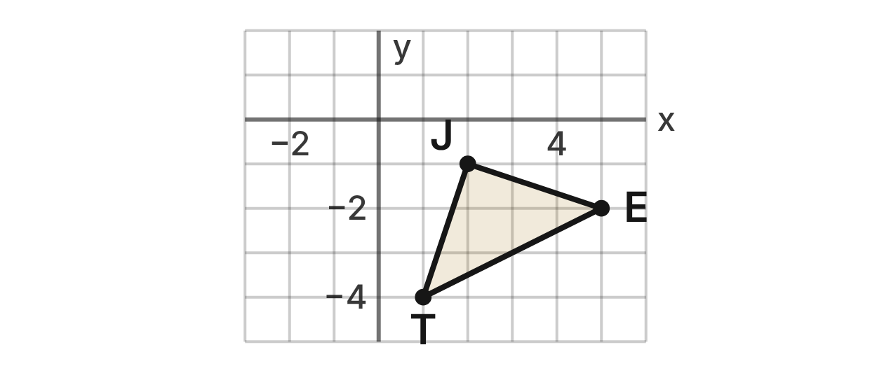
An airport map is drawn on a grid with the control tower at the origin. A plane icon is △JET with J(2, −1), E(5, −2) and T(1, −4). The main runway lies along the y-axis.
91. The plane taxis by the rule (x, y) → (x − 4, y + 3). What is the image of E?
A. (9, −5)
B. (1, 1) ✔
C. (8, −6)
D. (1, −2)
G.RLT.3 · skill G.RLT.3.2 (LOTS): Find the image of a figure on the coordinate plane under a translation, reflection, rotation or dilation
☐ Answer key correct ☐ Wording clear Notes: ________________________________
92. The icon is reflected over the runway (the y-axis). What is the image of J?
A. (−2, −1) ✔
B. (2, 1)
C. (−2, 1)
D. (−1, 2)
G.RLT.3 · skill G.RLT.3.2 (LOTS): Find the image of a figure on the coordinate plane under a translation, reflection, rotation or dilation
☐ Answer key correct ☐ Wording clear Notes: ________________________________
93. What is the image of T after a rotation of 180° about the origin?
A. (1, 4)
B. (−1, −4)
C. (4, 1)
D. (−1, 4) ✔
G.RLT.3 · skill G.RLT.3.2 (LOTS): Find the image of a figure on the coordinate plane under a translation, reflection, rotation or dilation
☐ Answer key correct ☐ Wording clear Notes: ________________________________
94. What is the image of E after a rotation of 90° counterclockwise about the origin?
A. (−2, −5)
B. (−2, 5)
C. (2, 5) ✔
D. (−5, 2)
G.RLT.3 · skill G.RLT.3.2 (LOTS): Find the image of a figure on the coordinate plane under a translation, reflection, rotation or dilation
☐ Answer key correct ☐ Wording clear Notes: ________________________________
95. The tower moves the icon so that J lands on (−3, 2). Which rule describes this translation?
A. (x, y) → (x − 5, y + 3) ✔
B. (x, y) → (x + 5, y − 3)
C. (x, y) → (x − 3, y + 2)
D. (x, y) → (x − 1, y + 1)
G.RLT.3 · skill G.RLT.3.3 (HOTS): Determine the transformation or composition that maps a preimage to an image, and whether it preserves size and shape
☐ Answer key correct ☐ Wording clear Notes: ________________________________
96. A wall map shows the icon at J′(4, −2), E′(10, −4) and T′(2, −8). Which is true?
A. It is a translation, so the icons are congruent.
B. It is a dilation by 2, so the icons are similar, not congruent. ✔
C. It is a dilation by 1/2, so the new icon is smaller.
D. It is a reflection, so the icons are congruent.
G.RLT.3 · skill G.RLT.3.3 (HOTS): Determine the transformation or composition that maps a preimage to an image, and whether it preserves size and shape
☐ Answer key correct ☐ Wording clear Notes: ________________________________

The Kite Festival
Level 2 · Transformations · G.RLT.3 · ID geo-rlt3-sky-kite-festival
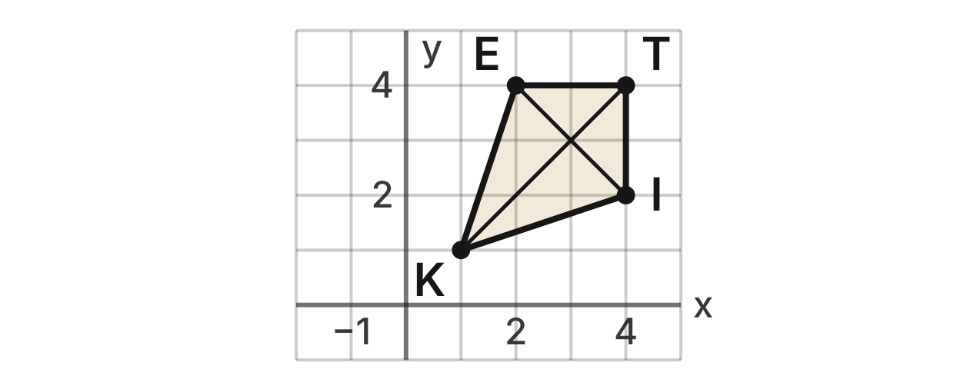
At a kite festival, a field map uses a grid in meters. A kite is KITE with K(1, 1), I(4, 2), T(4, 4) and E(2, 4). KI = KE = √10 m and IT = ET = 2 m. Its two cross sticks are drawn inside it.
97. Which describes the symmetry of kite KITE?
A. 2 lines of symmetry, along both cross sticks
B. 1 line of symmetry, y = x; rotational symmetry of order 2
C. 1 line of symmetry, y = x; no rotational symmetry ✔
D. 1 line of symmetry, x = 2.5; no rotational symmetry
G.RLT.3 · skill G.RLT.3.1 (LOTS): Identify line symmetry and rotational symmetry of a figure
☐ Answer key correct ☐ Wording clear Notes: ________________________________
98. What is the image of I after a reflection over the line y = −x?
A. (−2, −4) ✔
B. (2, 4)
C. (−4, −2)
D. (−4, 2)
G.RLT.3 · skill G.RLT.3.2 (LOTS): Find the image of a figure on the coordinate plane under a translation, reflection, rotation or dilation
☐ Answer key correct ☐ Wording clear Notes: ________________________________
99. A second kite flies as the mirror image of KITE over the line x = −1. What is the image of I?
A. (−4, 2)
B. (−5, 2)
C. (4, −4)
D. (−6, 2) ✔
G.RLT.3 · skill G.RLT.3.2 (LOTS): Find the image of a figure on the coordinate plane under a translation, reflection, rotation or dilation
☐ Answer key correct ☐ Wording clear Notes: ________________________________
100. Which single transformation has the same effect as a rotation of 90° counterclockwise about the origin followed by a reflection over the y-axis?
A. Reflection over the line y = −x
B. Reflection over the line y = x ✔
C. Rotation of 90° clockwise about the origin
D. Rotation of 180° about the origin
G.RLT.3 · skill G.RLT.3.3 (HOTS): Determine the transformation or composition that maps a preimage to an image, and whether it preserves size and shape
☐ Answer key correct ☐ Wording clear Notes: ________________________________
101. What is the image of T after a rotation of 270° clockwise about the origin?
A. (4, −4)
B. (−4, −4)
C. (−4, 4) ✔
D. (4, 4)
G.RLT.3 · skill G.RLT.3.2 (LOTS): Find the image of a figure on the coordinate plane under a translation, reflection, rotation or dilation
☐ Answer key correct ☐ Wording clear Notes: ________________________________
102. A gust moves the kite by (x, y) → (x + 3, y − 5). Then its reflection appears in a pond along the x-axis. Where is the reflection of E?
A. (5, −9)
B. (5, 1) ✔
C. (5, −1)
D. (−5, −1)
G.RLT.3 · skill G.RLT.3.2 (LOTS): Find the image of a figure on the coordinate plane under a translation, reflection, rotation or dilation
☐ Answer key correct ☐ Wording clear Notes: ________________________________

The Engine in the Rail Yard
Level 2 · Transformations · G.RLT.3 · ID geo-rlt3-sky-train-yard
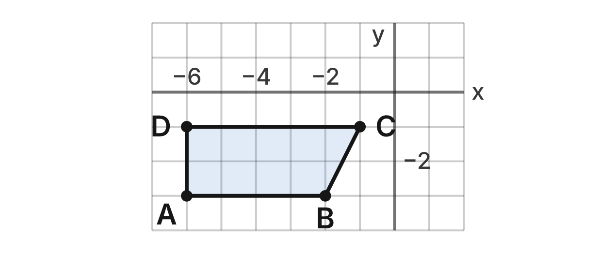
On a rail yard map, a train engine is outlined as ABCD with A(−6, −3), B(−2, −3), C(−1, −1) and D(−6, −1). A turntable for engines is centered at the origin.
103. The engine moves by the rule (x, y) → (x + 6, y + 3). What is the image of C?
A. (−7, −4)
B. (2, 5)
C. (5, −1)
D. (5, 2) ✔
G.RLT.3 · skill G.RLT.3.2 (LOTS): Find the image of a figure on the coordinate plane under a translation, reflection, rotation or dilation
☐ Answer key correct ☐ Wording clear Notes: ________________________________
104. The engine slides so that B lands on (1, 2). Which rule describes the slide?
A. (x, y) → (x + 3, y + 5) ✔
B. (x, y) → (x − 3, y − 5)
C. (x, y) → (x + 1, y + 2)
D. (x, y) → (x + 3, y − 5)
G.RLT.3 · skill G.RLT.3.3 (HOTS): Determine the transformation or composition that maps a preimage to an image, and whether it preserves size and shape
☐ Answer key correct ☐ Wording clear Notes: ________________________________
105. The engine moves by (x, y) → (x + 7, y + 2) and then by (x, y) → (x − 3, y + 5). Which single rule has the same effect?
A. (x, y) → (x + 10, y − 3)
B. (x, y) → (x − 3, y + 5)
C. (x, y) → (x + 4, y + 7) ✔
D. (x, y) → (x − 21, y + 10)
G.RLT.3 · skill G.RLT.3.3 (HOTS): Determine the transformation or composition that maps a preimage to an image, and whether it preserves size and shape
☐ Answer key correct ☐ Wording clear Notes: ________________________________
106. A matching engine on the other side of the platform is the mirror image of ABCD over the line y = 1. What is the image of A?
A. (−6, 3)
B. (−6, 5) ✔
C. (−6, 4)
D. (8, −3)
G.RLT.3 · skill G.RLT.3.2 (LOTS): Find the image of a figure on the coordinate plane under a translation, reflection, rotation or dilation
☐ Answer key correct ☐ Wording clear Notes: ________________________________
107. Which is true of ABCD and its image after any translation?
A. They have the same side lengths but face opposite ways.
B. The image is larger when the slide moves it up.
C. The sides stay the same, but the angles change.
D. They have the same side lengths and face the same way. ✔
G.RLT.3 · skill G.RLT.3.3 (HOTS): Determine the transformation or composition that maps a preimage to an image, and whether it preserves size and shape
☐ Answer key correct ☐ Wording clear Notes: ________________________________
108. The turntable turns the engine 180° about the origin. What is the image of D?
A. (6, 1) ✔
B. (−6, 1)
C. (6, −1)
D. (−1, 6)
G.RLT.3 · skill G.RLT.3.2 (LOTS): Find the image of a figure on the coordinate plane under a translation, reflection, rotation or dilation
☐ Answer key correct ☐ Wording clear Notes: ________________________________

Sails for a Model Boat
Level 2 · Transformations · G.RLT.3 · ID geo-rlt3-sky-model-sail
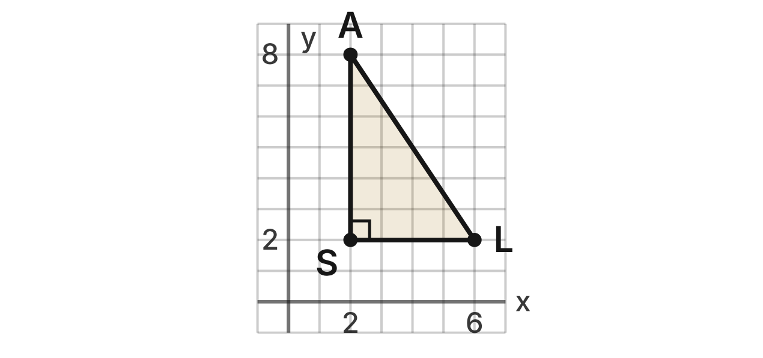
A boat builder draws a sail as right triangle SAL with S(2, 2), A(2, 8) and L(6, 2), in feet. The mast side SA is 6 ft long and the sail's area is 12 square feet. Models of the sail are made by dilations centered at the origin.
109. A model uses a dilation with scale factor 1/2. What is the image of A?
A. (4, 16)
B. (1.5, 7.5)
C. (1, 4) ✔
D. (1, 8)
G.RLT.3 · skill G.RLT.3.2 (LOTS): Find the image of a figure on the coordinate plane under a translation, reflection, rotation or dilation
☐ Answer key correct ☐ Wording clear Notes: ________________________________
110. A larger sail uses a dilation with scale factor 3/2. What is the image of L?
A. (7.5, 3.5)
B. (9, 3) ✔
C. (12, 4)
D. (9, 2)
G.RLT.3 · skill G.RLT.3.2 (LOTS): Find the image of a figure on the coordinate plane under a translation, reflection, rotation or dilation
☐ Answer key correct ☐ Wording clear Notes: ________________________________
111. In another model, the image of the mast side SA is 4.5 ft long. What is the scale factor of the dilation?
A. 4/3
B. 1.5
C. 9/16
D. 3/4 ✔
G.RLT.3 · skill G.RLT.3.3 (HOTS): Determine the transformation or composition that maps a preimage to an image, and whether it preserves size and shape
☐ Answer key correct ☐ Wording clear Notes: ________________________________
112. Dev says a model made with scale factor 1/2 has a sail area of 6 square feet, because each side is half as long. What is his error?
A. Area scales by (1/2)², so it is 3 square feet. ✔
B. There is no error; area scales by 1/2.
C. Dilations keep area, so it is 12 square feet.
D. Area scales by 2², so it is 48 square feet.
G.RLT.3 · skill G.RLT.3.3 (HOTS): Determine the transformation or composition that maps a preimage to an image, and whether it preserves size and shape
☐ Answer key correct ☐ Wording clear Notes: ________________________________
113. A model sail is dilated by scale factor 1/2 about the origin and then translated 3 ft right on a display board. Where does L end up?
A. (4.5, 1)
B. (3, 1)
C. (6, 1) ✔
D. (0, 1)
G.RLT.3 · skill G.RLT.3.2 (LOTS): Find the image of a figure on the coordinate plane under a translation, reflection, rotation or dilation
☐ Answer key correct ☐ Wording clear Notes: ________________________________
114. Which rule makes a larger copy of the sail by a dilation centered at the origin?
A. (x, y) → (0.8x, 0.8y)
B. (x, y) → (1.25x, 1.25y) ✔
C. (x, y) → (x + 1.25, y + 1.25)
D. (x, y) → (−x, −y)
G.RLT.3 · skill G.RLT.3.2 (LOTS): Find the image of a figure on the coordinate plane under a translation, reflection, rotation or dilation
☐ Answer key correct ☐ Wording clear Notes: ________________________________

The Delivery Drone Routes
Level 2 · Transformations · G.RLT.3 · ID geo-rlt3-sky-drone-route
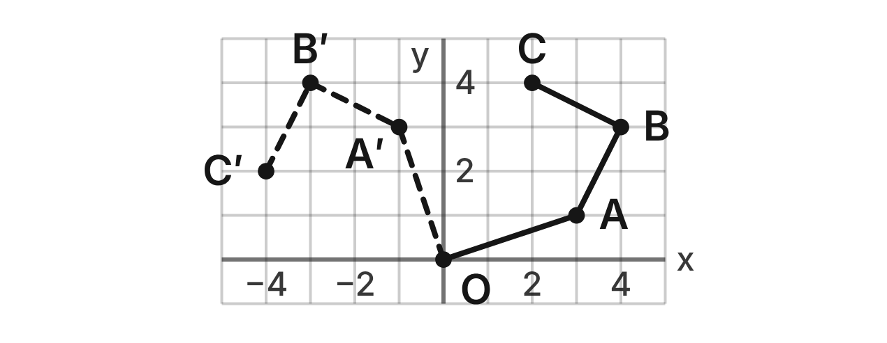
A delivery drone takes off from its launch pad O at the origin. Route 1 (solid) visits A(3, 1), B(4, 3) and C(2, 4). Route 2 (dashed) visits A′(−1, 3), B′(−3, 4) and C′(−4, 2).
115. Which single transformation maps route 1 onto route 2?
A. Rotation of 90° clockwise about O
B. Reflection over the y-axis
C. Reflection over the line y = −x
D. Rotation of 90° counterclockwise about O ✔
G.RLT.3 · skill G.RLT.3.3 (HOTS): Determine the transformation or composition that maps a preimage to an image, and whether it preserves size and shape
☐ Answer key correct ☐ Wording clear Notes: ________________________________
116. A third route is route 1 rotated 180° about O. What is the image of B?
A. (4, −3)
B. (−4, −3) ✔
C. (−4, 3)
D. (3, −4)
G.RLT.3 · skill G.RLT.3.2 (LOTS): Find the image of a figure on the coordinate plane under a translation, reflection, rotation or dilation
☐ Answer key correct ☐ Wording clear Notes: ________________________________
117. What is the image of C after a rotation of 270° counterclockwise about O?
A. (4, −2) ✔
B. (−4, 2)
C. (−2, −4)
D. (4, 2)
G.RLT.3 · skill G.RLT.3.2 (LOTS): Find the image of a figure on the coordinate plane under a translation, reflection, rotation or dilation
☐ Answer key correct ☐ Wording clear Notes: ________________________________
118. Route 2 is route 1 turned about O. How long is leg A′B′ of route 2?
A. 3 units
B. √3 units
C. √5 units ✔
D. 5 units
G.RLT.3 · skill G.RLT.3.3 (HOTS): Determine the transformation or composition that maps a preimage to an image, and whether it preserves size and shape
☐ Answer key correct ☐ Wording clear Notes: ________________________________
119. A short route is route 1 dilated by scale factor 1/2 about O. What is the image of B?
A. (8, 6)
B. (3.5, 2.5)
C. (2, 3)
D. (2, 1.5) ✔
G.RLT.3 · skill G.RLT.3.2 (LOTS): Find the image of a figure on the coordinate plane under a translation, reflection, rotation or dilation
☐ Answer key correct ☐ Wording clear Notes: ________________________________
120. Route 1 is reflected over the x-axis and then rotated 90° counterclockwise about O. Where does A end up?
A. (1, 3) ✔
B. (−1, −3)
C. (3, −1)
D. (−3, 1)
G.RLT.3 · skill G.RLT.3.2 (LOTS): Find the image of a figure on the coordinate plane under a translation, reflection, rotation or dilation
☐ Answer key correct ☐ Wording clear Notes: ________________________________

Two Ferries in the Harbor
Level 3 · Transformations · G.RLT.3 · ID geo-rlt3-sky-ferry-harbor
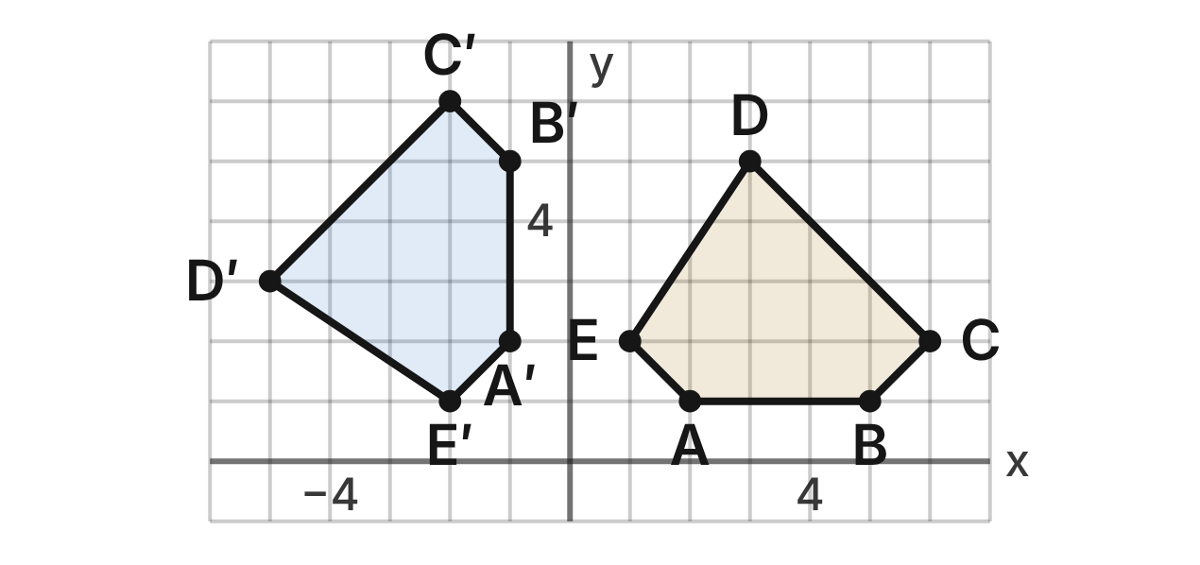
A harbor map shows a ferry as ABCDE: A(2, 1), B(5, 1), C(6, 2), D(3, 5) and E(1, 2). A second ferry of the same design is A′B′C′D′E′: A′(−1, 2), B′(−1, 5), C′(−2, 6), D′(−5, 3) and E′(−2, 1).
121. Which single transformation maps ABCDE to A′B′C′D′E′?
A. Rotation of 90° clockwise about the origin
B. Rotation of 90° counterclockwise about the origin ✔
C. Reflection over the line y = x
D. Reflection over the y-axis
G.RLT.3 · skill G.RLT.3.3 (HOTS): Determine the transformation or composition that maps a preimage to an image, and whether it preserves size and shape
☐ Answer key correct ☐ Wording clear Notes: ________________________________
122. Which pair of reflections, in order, also maps ABCDE to A′B′C′D′E′?
A. Over the line y = x, then over the x-axis
B. Over the y-axis, then over the x-axis
C. Over the x-axis, then over the line y = x ✔
D. Over the x-axis, then over the line y = −x
G.RLT.3 · skill G.RLT.3.3 (HOTS): Determine the transformation or composition that maps a preimage to an image, and whether it preserves size and shape
☐ Answer key correct ☐ Wording clear Notes: ________________________________
123. Vertices A, B, C, D, E run counterclockwise. Which is true of A′B′C′D′E′?
A. It is congruent, and A′, B′, C′, D′, E′ also run counterclockwise. ✔
B. It is congruent, but A′, B′, C′, D′, E′ run clockwise.
C. It is smaller, and A′, B′, C′, D′, E′ run counterclockwise.
D. It is not congruent, because it faces a new way.
G.RLT.3 · skill G.RLT.3.3 (HOTS): Determine the transformation or composition that maps a preimage to an image, and whether it preserves size and shape
☐ Answer key correct ☐ Wording clear Notes: ________________________________
124. The second ferry then sails by the rule (x, y) → (x + 1, y − 4). Where does A′ end up?
A. (−2, 6)
B. (3, −3)
C. (−5, 3)
D. (0, −2) ✔
G.RLT.3 · skill G.RLT.3.2 (LOTS): Find the image of a figure on the coordinate plane under a translation, reflection, rotation or dilation
☐ Answer key correct ☐ Wording clear Notes: ________________________________
125. A third ferry is the mirror image of ABCDE over the line x = −2. What is the image of D?
A. (−3, 5)
B. (−7, 5) ✔
C. (−5, 5)
D. (3, −9)
G.RLT.3 · skill G.RLT.3.2 (LOTS): Find the image of a figure on the coordinate plane under a translation, reflection, rotation or dilation
☐ Answer key correct ☐ Wording clear Notes: ________________________________
126. A fourth ferry is the image of ABCDE under the rule (x, y) → (−y, −x). Which transformation is this?
A. Reflection over the line y = x
B. Rotation of 90° counterclockwise about the origin
C. Rotation of 180° about the origin
D. Reflection over the line y = −x ✔
G.RLT.3 · skill G.RLT.3.3 (HOTS): Determine the transformation or composition that maps a preimage to an image, and whether it preserves size and shape
☐ Answer key correct ☐ Wording clear Notes: ________________________________

The Compass Rose
Level 3 · Transformations · G.RLT.3 · ID geo-rlt3-sky-compass-rose
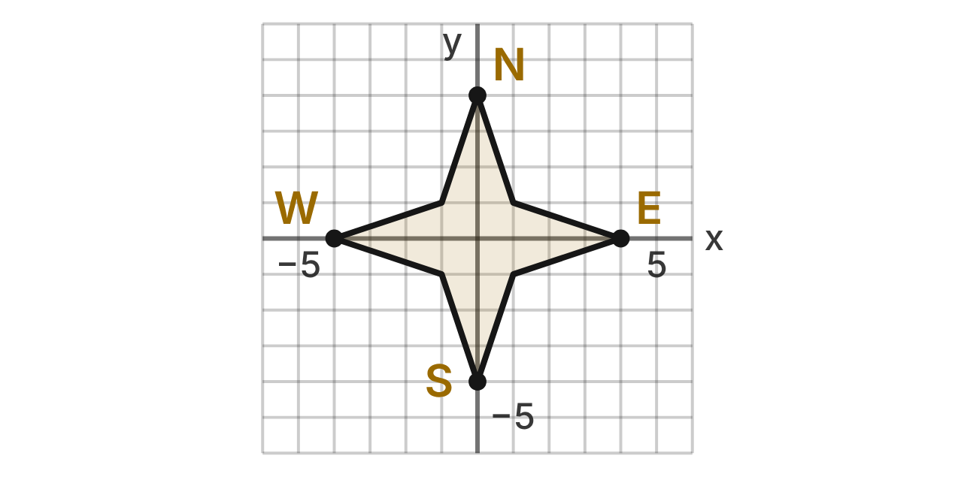
A travel map has a compass rose centered at the origin O. Its long points are at (0, 4), (4, 0), (0, −4) and (−4, 0), marked N, E, S and W. Its short points are at (1, 1), (1, −1), (−1, −1) and (−1, 1).
127. Which describes the symmetry of the compass rose (ignoring the letters)?
A. 4 lines of symmetry; rotational symmetry of order 4 ✔
B. 2 lines of symmetry; rotational symmetry of order 4
C. 4 lines of symmetry; rotational symmetry of order 8
D. 8 lines of symmetry; rotational symmetry of order 8
G.RLT.3 · skill G.RLT.3.1 (LOTS): Identify line symmetry and rotational symmetry of a figure
☐ Answer key correct ☐ Wording clear Notes: ________________________________
128. Which transformation does NOT map the compass rose onto itself (ignoring the letters)?
A. Reflection over the line y = −x
B. Rotation of 270° about O
C. Rotation of 45° about O ✔
D. Reflection over the x-axis
G.RLT.3 · skill G.RLT.3.1 (LOTS): Identify line symmetry and rotational symmetry of a figure
☐ Answer key correct ☐ Wording clear Notes: ________________________________
129. A map maker rotates the rose 90° counterclockwise about O and then reflects it over the line y = x. Which single transformation has the same effect?
A. Reflection over the y-axis
B. Reflection over the x-axis ✔
C. Rotation of 90° clockwise about O
D. Rotation of 180° about O
G.RLT.3 · skill G.RLT.3.3 (HOTS): Determine the transformation or composition that maps a preimage to an image, and whether it preserves size and shape
☐ Answer key correct ☐ Wording clear Notes: ________________________________
130. The rose is rotated 90° clockwise about O, so its outline lands on itself. Where is the letter N now?
A. At the tip (−4, 0)
B. At the tip (0, −4)
C. Still at the tip (0, 4)
D. At the tip (4, 0) ✔
G.RLT.3 · skill G.RLT.3.3 (HOTS): Determine the transformation or composition that maps a preimage to an image, and whether it preserves size and shape
☐ Answer key correct ☐ Wording clear Notes: ________________________________
131. For a poster, the rose is dilated by scale factor 2.5 centered at O. What is the image of the short point (1, −1)?
A. (3.5, 1.5)
B. (2.5, −1)
C. (2.5, −2.5) ✔
D. (0.4, −0.4)
G.RLT.3 · skill G.RLT.3.2 (LOTS): Find the image of a figure on the coordinate plane under a translation, reflection, rotation or dilation
☐ Answer key correct ☐ Wording clear Notes: ________________________________
132. Ana says, “A 90° turn about O maps the rose onto itself, so the rule (x, y) → (−y, x) leaves every point where it was.” What is her error?
A. It lands on itself, but every point except O moves. ✔
B. There is no error; every point stays where it was.
C. A 90° turn does not map the rose onto itself.
D. The rule should be (x, y) → (y, x).
G.RLT.3 · skill G.RLT.3.3 (HOTS): Determine the transformation or composition that maps a preimage to an image, and whether it preserves size and shape
☐ Answer key correct ☐ Wording clear Notes: ________________________________

Triangles (G.TR)

G.TR.1 · Determine the relationships between the measures of angles and lengths of sides in triangles, including problems in context.

Three Airports
Level 1 · Triangles · G.TR.1 · ID geo-tr1-sky-three-airports
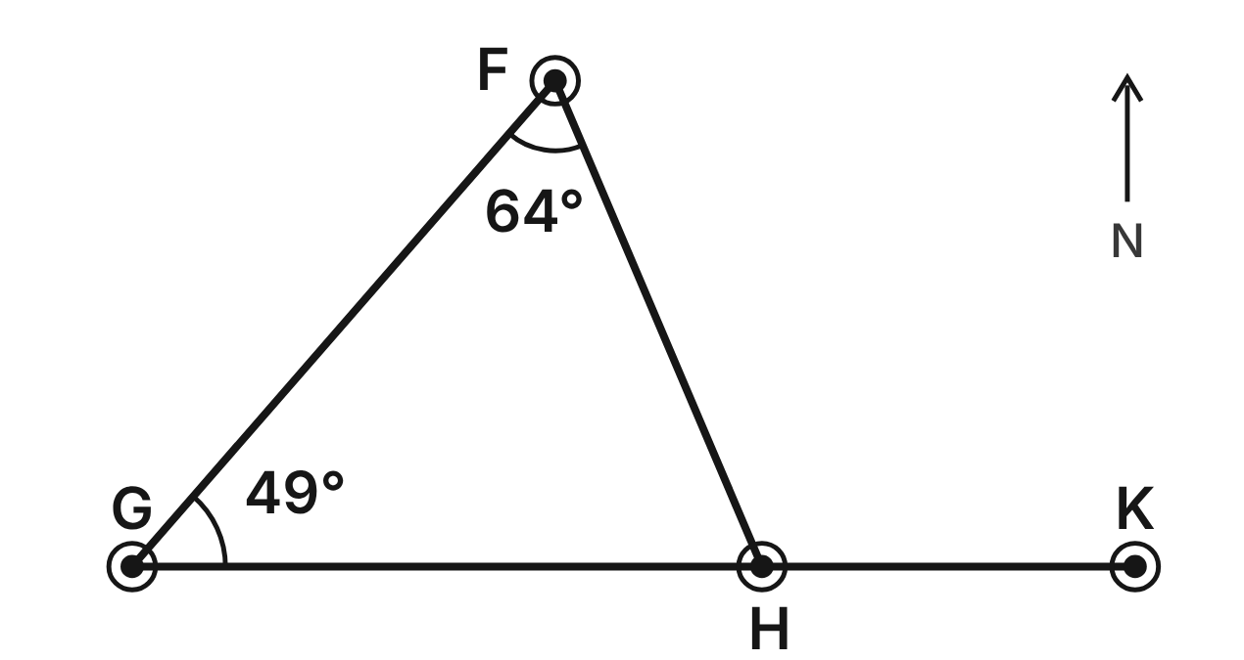
Flights join the airports F, G and H in straight legs. On the route map, m∠GFH = 64° and m∠FGH = 49°. The leg from G to H continues straight on to airport K.
133. What is m∠FHG, the angle at airport H inside the triangle?
A. 67° ✔
B. 113°
C. 116°
D. 131°
G.TR.1 · skill G.TR.1.3 (LOTS): Solve problems using the triangle angle sum and the exterior angle theorem
☐ Answer key correct ☐ Wording clear Notes: ________________________________
134. What is m∠FHK, the angle between leg HF and the route on to K?
A. 67°
B. 131°
C. 116°
D. 113° ✔
G.TR.1 · skill G.TR.1.3 (LOTS): Solve problems using the triangle angle sum and the exterior angle theorem
☐ Answer key correct ☐ Wording clear Notes: ________________________________
135. Which flight leg of the triangle is the longest?
A. GH
B. FH
C. FG ✔
D. FH and GH are the same length
G.TR.1 · skill G.TR.1.1 (LOTS): Order the sides of a triangle by length given its angles, or its angles by size given its sides
☐ Answer key correct ☐ Wording clear Notes: ________________________________
136. Which list orders the three legs from shortest to longest?
A. FG, GH, FH
B. FH, GH, FG ✔
C. GH, FH, FG
D. FH, FG, GH
G.TR.1 · skill G.TR.1.1 (LOTS): Order the sides of a triangle by length given its angles, or its angles by size given its sides
☐ Answer key correct ☐ Wording clear Notes: ________________________________
137. The direct flight from F to G is 380 mi. A traveler instead flies from F to airport X, then from X to G. X is not on the straight route FG. Which could be the total distance of the two legs?
A. 455 mi ✔
B. 380 mi
C. 350 mi
D. 190 mi
G.TR.1 · skill G.TR.1.2 (LOTS): Decide whether three lengths can form a triangle and find the range of possible lengths of the third side
☐ Answer key correct ☐ Wording clear Notes: ________________________________
138. Which three flight legs could form a triangle of routes?
A. 210 mi, 340 mi, 600 mi
B. 420 mi, 180 mi, 250 mi ✔
C. 150 mi, 150 mi, 300 mi
D. 90 mi, 500 mi, 400 mi
G.TR.1 · skill G.TR.1.2 (LOTS): Decide whether three lengths can form a triangle and find the range of possible lengths of the third side
☐ Answer key correct ☐ Wording clear Notes: ________________________________

The Footbridge Truss
Level 1 · Triangles · G.TR.1 · ID geo-tr1-sky-footbridge-truss
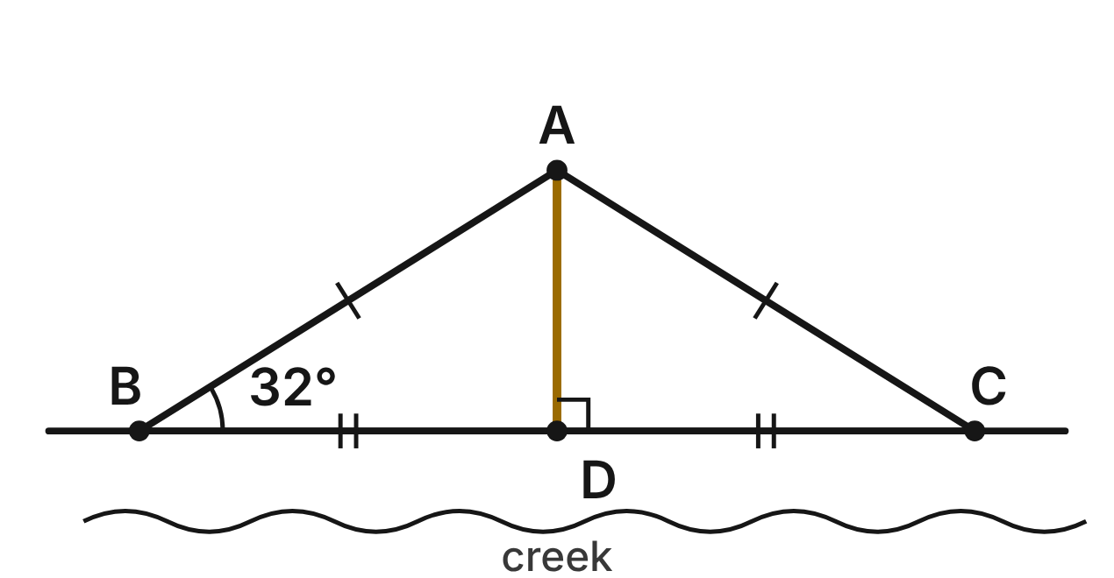
A footbridge truss is the triangle ABC, with AB ≅ AC. The post AD is perpendicular to the deck BC at its midpoint D. m∠ABC = 32°.
139. What is m∠ACB?
A. 58°
B. 116°
C. 148°
D. 32° ✔
G.TR.1 · skill G.TR.1.3 (LOTS): Solve problems using the triangle angle sum and the exterior angle theorem
☐ Answer key correct ☐ Wording clear Notes: ________________________________
140. What is m∠BAC, the angle at the top of the truss?
A. 148°
B. 64°
C. 116° ✔
D. 58°
G.TR.1 · skill G.TR.1.3 (LOTS): Solve problems using the triangle angle sum and the exterior angle theorem
☐ Answer key correct ☐ Wording clear Notes: ________________________________
141. What is m∠BAD, the angle between member AB and the post?
A. 116°
B. 58° ✔
C. 32°
D. 122°
G.TR.1 · skill G.TR.1.3 (LOTS): Solve problems using the triangle angle sum and the exterior angle theorem
☐ Answer key correct ☐ Wording clear Notes: ________________________________
142. In △ABD, which side is the longest?
A. AD
B. BD
C. AD and BD are the same length
D. AB ✔
G.TR.1 · skill G.TR.1.1 (LOTS): Order the sides of a triangle by length given its angles, or its angles by size given its sides
☐ Answer key correct ☐ Wording clear Notes: ________________________________
143. Which list orders the sides of △ABD from shortest to longest?
A. AB, BD, AD
B. BD, AD, AB
C. AD, BD, AB ✔
D. AD, AB, BD
G.TR.1 · skill G.TR.1.1 (LOTS): Order the sides of a triangle by length given its angles, or its angles by size given its sides
☐ Answer key correct ☐ Wording clear Notes: ________________________________
144. A builder has spare members of 9 ft, 9 ft and 20 ft. Can they form a triangular panel? Choose the answer with the correct reason.
A. No, because 9 + 9 is less than 20. ✔
B. Yes, because 9 + 9 is greater than 20.
C. Yes, because any three members make a triangle.
D. No, because a triangle cannot have two equal sides.
G.TR.1 · skill G.TR.1.2 (LOTS): Decide whether three lengths can form a triangle and find the range of possible lengths of the third side
☐ Answer key correct ☐ Wording clear Notes: ________________________________

The Road Junction
Level 2 · Triangles · G.TR.1 · ID geo-tr1-sky-road-junction
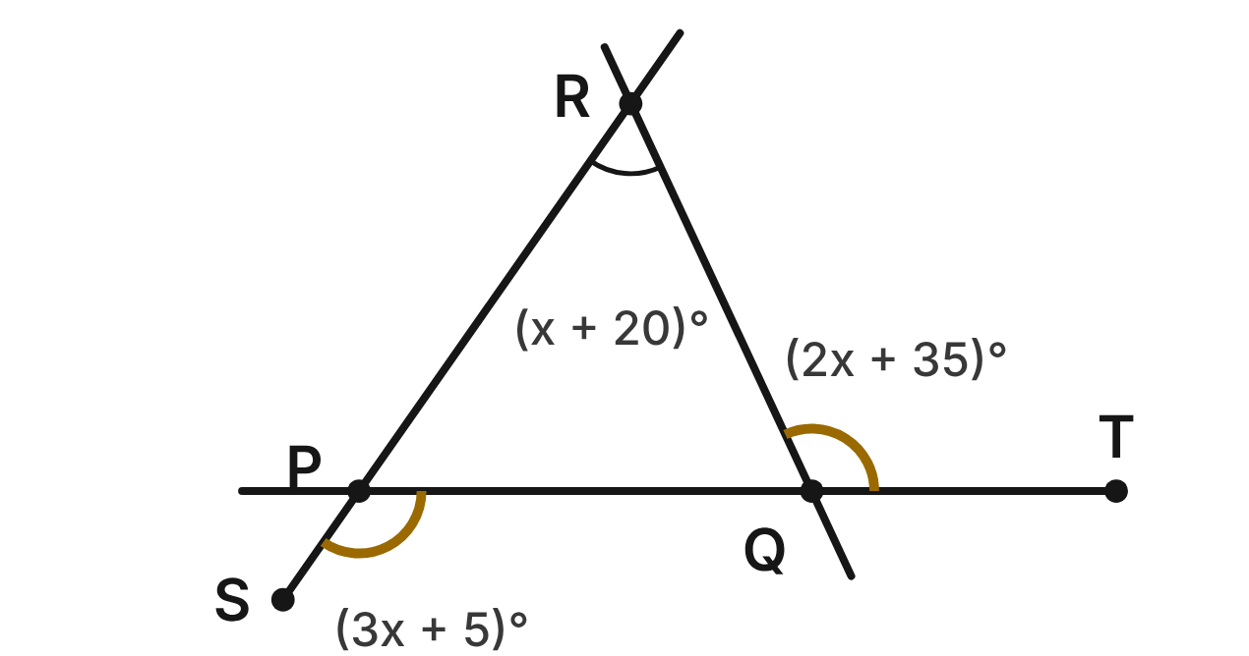
Three straight roads meet at the junctions P, Q and R. Road RP continues past P to S, and road PQ continues past Q to T. m∠QPS = (3x + 5)°, m∠RQT = (2x + 35)° and m∠PRQ = (x + 20)°.
145. What value of x fits the three road angles?
A. 40 ✔
B. 20
C. 28
D. 60
G.TR.1 · skill G.TR.1.3 (LOTS): Solve problems using the triangle angle sum and the exterior angle theorem
☐ Answer key correct ☐ Wording clear Notes: ________________________________
146. What is m∠PQR, the angle inside the triangle at junction Q?
A. 115°
B. 40°
C. 65° ✔
D. 55°
G.TR.1 · skill G.TR.1.3 (LOTS): Solve problems using the triangle angle sum and the exterior angle theorem
☐ Answer key correct ☐ Wording clear Notes: ________________________________
147. Which equation shows the Exterior Angle Theorem at junction P?
A. m∠QPS = m∠QPR + m∠PRQ
B. m∠QPS + m∠RQT = 180°
C. m∠QPS = m∠RQT + m∠PRQ
D. m∠QPS = m∠PQR + m∠PRQ ✔
G.TR.1 · skill G.TR.1.3 (LOTS): Solve problems using the triangle angle sum and the exterior angle theorem
☐ Answer key correct ☐ Wording clear Notes: ________________________________
148. Which side of triangle PQR is the longest road segment?
A. QR
B. PR ✔
C. PQ
D. All three are the same length
G.TR.1 · skill G.TR.1.1 (LOTS): Order the sides of a triangle by length given its angles, or its angles by size given its sides
☐ Answer key correct ☐ Wording clear Notes: ________________________________
149. Which list orders the sides of triangle PQR from shortest to longest?
A. QR, PQ, PR ✔
B. PR, PQ, QR
C. PQ, QR, PR
D. QR, PR, PQ
G.TR.1 · skill G.TR.1.1 (LOTS): Order the sides of a triangle by length given its angles, or its angles by size given its sides
☐ Answer key correct ☐ Wording clear Notes: ________________________________
150. A new triangular junction will have roads of 0.8 mi and 1.3 mi. Which could be the length of the third road?
A. 0.5 mi
B. 2.1 mi
C. 2.6 mi
D. 1.9 mi ✔
G.TR.1 · skill G.TR.1.2 (LOTS): Decide whether three lengths can form a triangle and find the range of possible lengths of the third side
☐ Answer key correct ☐ Wording clear Notes: ________________________________

The Sailing Race
Level 2 · Triangles · G.TR.1 · ID geo-tr1-sky-sailing-race
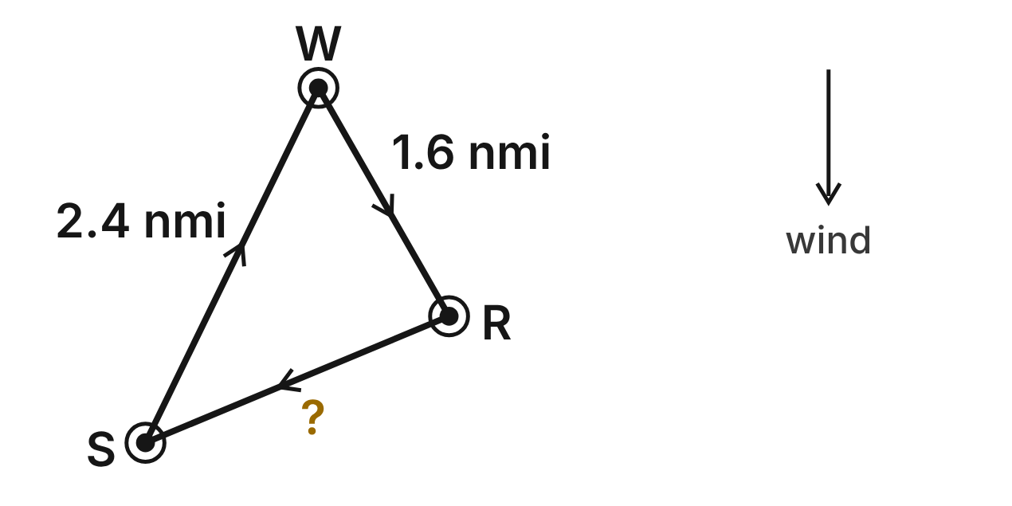
A sailing race goes around three marks: the start S, the windward mark W and the reach mark R. SW = 2.4 nautical miles (nmi) and WR = 1.6 nmi. The committee has not yet chosen RS. At a mark, a boat turns through the exterior angle there.
151. Which inequality gives all possible lengths of RS, in nautical miles?
A. 0 < RS < 4
B. 0.8 < RS < 4 ✔
C. 1.6 < RS < 2.4
D. 0.8 < RS < 2.4
G.TR.1 · skill G.TR.1.2 (LOTS): Decide whether three lengths can form a triangle and find the range of possible lengths of the third side
☐ Answer key correct ☐ Wording clear Notes: ________________________________
152. The race committee wants ∠SWR to be the largest angle of the course. Which gives all possible lengths of RS, in nautical miles?
A. 0.8 < RS < 2.4
B. RS > 2.4
C. 2.4 < RS < 4 ✔
D. 1.6 < RS < 2.4
G.TR.1 · skill G.TR.1.1 (LOTS): Order the sides of a triangle by length given its angles, or its angles by size given its sides
☐ Answer key correct ☐ Wording clear Notes: ________________________________
153. Suppose the committee sets RS = 2.0 nmi. Which angle of the course is then the smallest?
A. ∠S ✔
B. ∠W
C. ∠R
D. ∠S and ∠R are equal
G.TR.1 · skill G.TR.1.1 (LOTS): Order the sides of a triangle by length given its angles, or its angles by size given its sides
☐ Answer key correct ☐ Wording clear Notes: ________________________________
154. On a different course, the angle inside the triangle is 40° at the start and 58° at the reach mark. Through what angle does a boat turn at the windward mark?
A. 82°
B. 122°
C. 98° ✔
D. 140°
G.TR.1 · skill G.TR.1.3 (LOTS): Solve problems using the triangle angle sum and the exterior angle theorem
☐ Answer key correct ☐ Wording clear Notes: ________________________________
155. A training course is an isosceles triangle. Its two 1.5 nmi legs meet at a 50° angle. Through what angle does a boat turn at each of the other two marks?
A. 65°
B. 130°
C. 155°
D. 115° ✔
G.TR.1 · skill G.TR.1.3 (LOTS): Solve problems using the triangle angle sum and the exterior angle theorem
☐ Answer key correct ☐ Wording clear Notes: ________________________________
156. The committee will choose RS as a whole number of tenths of a nautical mile, such as 1.7 nmi or 2.0 nmi. How many lengths are possible?
A. 32
B. 31 ✔
C. 33
D. 3
G.TR.1 · skill G.TR.1.2 (LOTS): Decide whether three lengths can form a triangle and find the range of possible lengths of the third side
☐ Answer key correct ☐ Wording clear Notes: ________________________________

The Beach Kite
Level 2 · Triangles · G.TR.1 · ID geo-tr1-sky-beach-kite
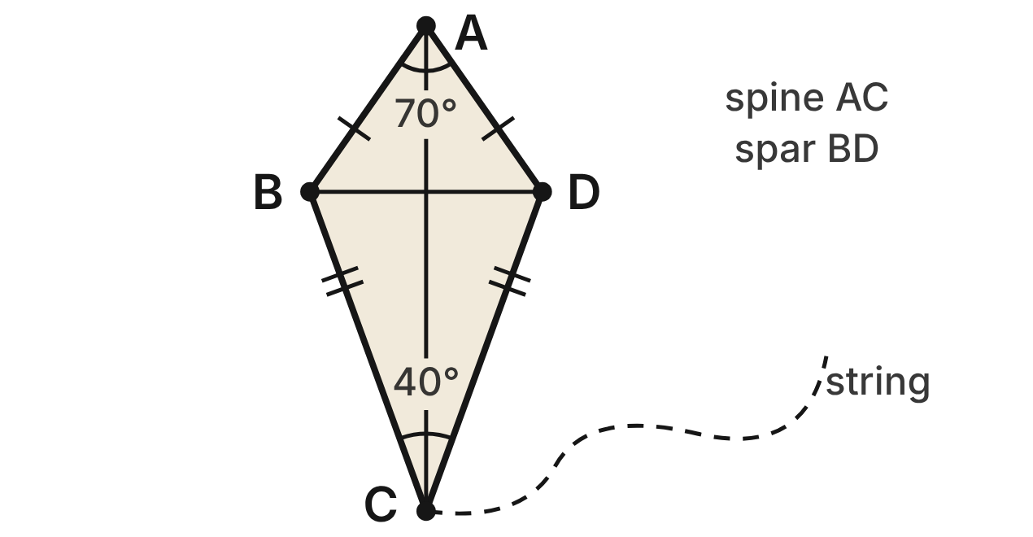
A kite ABCD from a beach-town shop has AB ≅ AD and CB ≅ CD. Its spine AC is a line of symmetry, and its cross spar is BD. m∠BAD = 70° and m∠BCD = 40°.
157. What is m∠ABD?
A. 110°
B. 70°
C. 55° ✔
D. 35°
G.TR.1 · skill G.TR.1.3 (LOTS): Solve problems using the triangle angle sum and the exterior angle theorem
☐ Answer key correct ☐ Wording clear Notes: ________________________________
158. What is m∠ABC, the whole angle of the kite at B?
A. 55°
B. 125° ✔
C. 70°
D. 110°
G.TR.1 · skill G.TR.1.3 (LOTS): Solve problems using the triangle angle sum and the exterior angle theorem
☐ Answer key correct ☐ Wording clear Notes: ________________________________
159. In △BCD, which side is the shortest?
A. BD ✔
B. CB
C. CD
D. All three are the same length
G.TR.1 · skill G.TR.1.1 (LOTS): Order the sides of a triangle by length given its angles, or its angles by size given its sides
☐ Answer key correct ☐ Wording clear Notes: ________________________________
160. In △ABC, which list orders the sides from shortest to longest?
A. AC, BC, AB
B. BC, AB, AC
C. AB, AC, BC
D. AB, BC, AC ✔
G.TR.1 · skill G.TR.1.1 (LOTS): Order the sides of a triangle by length given its angles, or its angles by size given its sides
☐ Answer key correct ☐ Wording clear Notes: ________________________________
161. Which statement about the kite's lengths is NOT true?
A. AD is longer than CD. ✔
B. BD is longer than AB.
C. CB is longer than BD.
D. CB is longer than AB.
G.TR.1 · skill G.TR.1.1 (LOTS): Order the sides of a triangle by length given its angles, or its angles by size given its sides
☐ Answer key correct ☐ Wording clear Notes: ________________________________
162. A different kite has AB = AD = 18 in and CB = CD = 30 in. Using the triangle inequality in △ABD and in △BCD, which gives all possible lengths x of the spar BD, in inches?
A. 12 < x < 48
B. 0 < x < 60
C. 12 < x < 36
D. 0 < x < 36 ✔
G.TR.1 · skill G.TR.1.2 (LOTS): Decide whether three lengths can form a triangle and find the range of possible lengths of the third side
☐ Answer key correct ☐ Wording clear Notes: ________________________________

The Drone Delivery Loop
Level 3 · Triangles · G.TR.1 · ID geo-tr1-sky-drone-loop
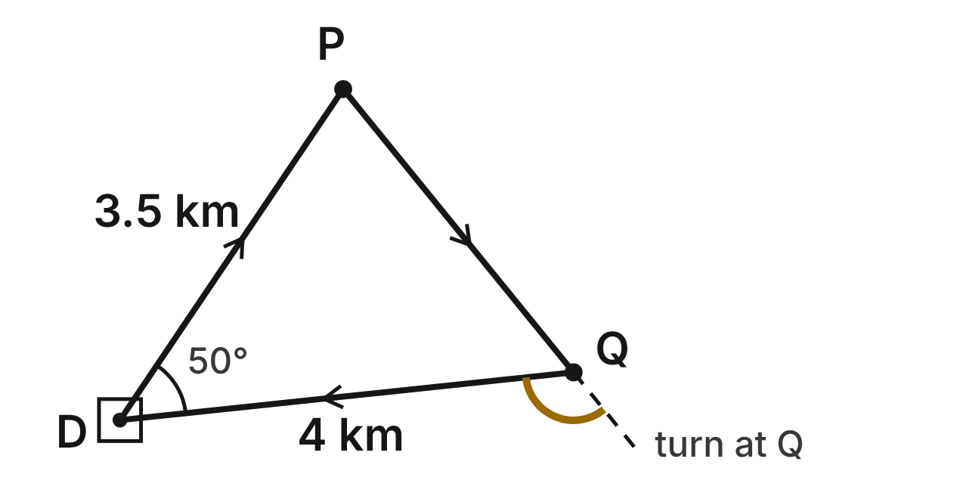
A delivery drone flies from its depot D to stop P, then to stop Q, then back to D, in straight legs. The stops change each day, but DP = 3.5 km and DQ = 4 km every day. The battery allows at most 11 km per loop. At a stop, the drone turns through the exterior angle there. Today, m∠PDQ = 50°.
163. Using only the triangle inequality, which gives all possible lengths of PQ, in km?
A. 0 < PQ < 7.5
B. 0.5 < PQ < 7.5 ✔
C. 3.5 < PQ < 4
D. 0.5 < PQ < 4
G.TR.1 · skill G.TR.1.2 (LOTS): Decide whether three lengths can form a triangle and find the range of possible lengths of the third side
☐ Answer key correct ☐ Wording clear Notes: ________________________________
164. Which gives all lengths of PQ, in km, that the triangle inequality and the battery both allow?
A. 0.5 < PQ < 7.5
B. 0 < PQ ≤ 3.5
C. 0.5 < PQ ≤ 3.5 ✔
D. 0.5 < PQ ≤ 11
G.TR.1 · skill G.TR.1.2 (LOTS): Decide whether three lengths can form a triangle and find the range of possible lengths of the third side
☐ Answer key correct ☐ Wording clear Notes: ________________________________
165. Can the battery allow a loop in which ∠PDQ is the largest angle? Choose the answer with the correct reason.
A. Yes: PQ can be up to 7.5 km, so it can be the longest leg.
B. No: PQ would have to be more than 4 km, but PQ ≤ 3.5 km. ✔
C. Yes: the angle at the depot is always the largest.
D. No: the largest angle is always ∠DQP, at the end of DQ.
G.TR.1 · skill G.TR.1.1 (LOTS): Order the sides of a triangle by length given its angles, or its angles by size given its sides
☐ Answer key correct ☐ Wording clear Notes: ________________________________
166. On another day, PQ = 3 km. Which list orders the angles of △DPQ from smallest to largest?
A. ∠DPQ, ∠DQP, ∠PDQ
B. ∠PDQ, ∠DPQ, ∠DQP
C. ∠DQP, ∠PDQ, ∠DPQ
D. ∠PDQ, ∠DQP, ∠DPQ ✔
G.TR.1 · skill G.TR.1.1 (LOTS): Order the sides of a triangle by length given its angles, or its angles by size given its sides
☐ Answer key correct ☐ Wording clear Notes: ________________________________
167. On another day, the stops are closer together. The drone turns about 98° at P, and m∠DQP = 60°. About what is m∠PDQ?
A. 82°
B. 158°
C. 38° ✔
D. 22°
G.TR.1 · skill G.TR.1.3 (LOTS): Solve problems using the triangle angle sum and the exterior angle theorem
☐ Answer key correct ☐ Wording clear Notes: ________________________________
168. On the loop in the figure, m∠DPQ ≈ 73°. Through about what angle does the drone turn at Q?
A. 123° ✔
B. 57°
C. 107°
D. 130°
G.TR.1 · skill G.TR.1.3 (LOTS): Solve problems using the triangle angle sum and the exterior angle theorem
☐ Answer key correct ☐ Wording clear Notes: ________________________________

The Ferry Ramp
Level 3 · Triangles · G.TR.1 · ID geo-tr1-sky-ferry-ramp
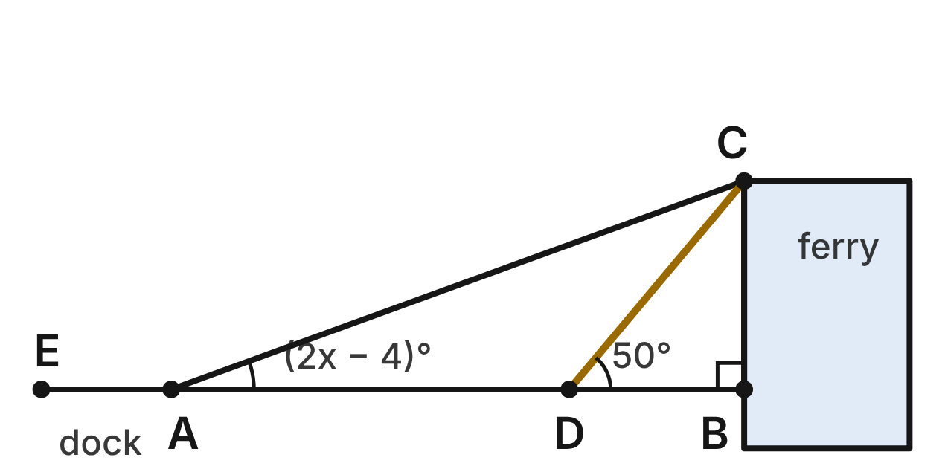
A boarding ramp AC runs from the dock at A up to the ferry deck at C. The post CB is perpendicular to the dock line AB, and a strut runs from C to D on AB. The dock line continues past A to E. m∠CAB = (2x − 4)°, m∠ACB = (5x + 10)° and m∠CDB = 50°.
169. Use △ABC to find x.
A. 12 ✔
B. 20
C. 24.9
D. 13.7
G.TR.1 · skill G.TR.1.3 (LOTS): Solve problems using the triangle angle sum and the exterior angle theorem
☐ Answer key correct ☐ Wording clear Notes: ________________________________
170. What is m∠CAE, the angle between the ramp and the dock beyond A?
A. 20°
B. 70°
C. 160° ✔
D. 110°
G.TR.1 · skill G.TR.1.3 (LOTS): Solve problems using the triangle angle sum and the exterior angle theorem
☐ Answer key correct ☐ Wording clear Notes: ________________________________
171. What is m∠ACD, the angle between the ramp and the strut?
A. 40°
B. 30° ✔
C. 70°
D. 130°
G.TR.1 · skill G.TR.1.3 (LOTS): Solve problems using the triangle angle sum and the exterior angle theorem
☐ Answer key correct ☐ Wording clear Notes: ________________________________
172. Which list orders the sides of △ACD from shortest to longest?
A. AC, AD, CD
B. AD, CD, AC
C. CD, AC, AD
D. CD, AD, AC ✔
G.TR.1 · skill G.TR.1.1 (LOTS): Order the sides of a triangle by length given its angles, or its angles by size given its sides
☐ Answer key correct ☐ Wording clear Notes: ________________________________
173. Which of the four segments CB, CD, AD and AC is the shortest?
A. CD
B. AD
C. CB ✔
D. AC
G.TR.1 · skill G.TR.1.1 (LOTS): Order the sides of a triangle by length given its angles, or its angles by size given its sides
☐ Answer key correct ☐ Wording clear Notes: ________________________________
174. A second ramp's side frame is a triangle with sides of 6 ft, (k + 2) ft and (2k − 1) ft. Which inequality gives all possible values of k?
A. 5/3 < k < 9 ✔
B. k < 9
C. k > 5/3
D. −3 < k < 9
G.TR.1 · skill G.TR.1.2 (LOTS): Decide whether three lengths can form a triangle and find the range of possible lengths of the third side
☐ Answer key correct ☐ Wording clear Notes: ________________________________

G.TR.2 · Prove two triangles are congruent, using direct and indirect proofs, and solve problems involving measured attributes of congruent triangles.

The Rest Stop Between Highways
Level 1 · Triangles · G.TR.2 · ID geo-tr2-sky-rest-stop
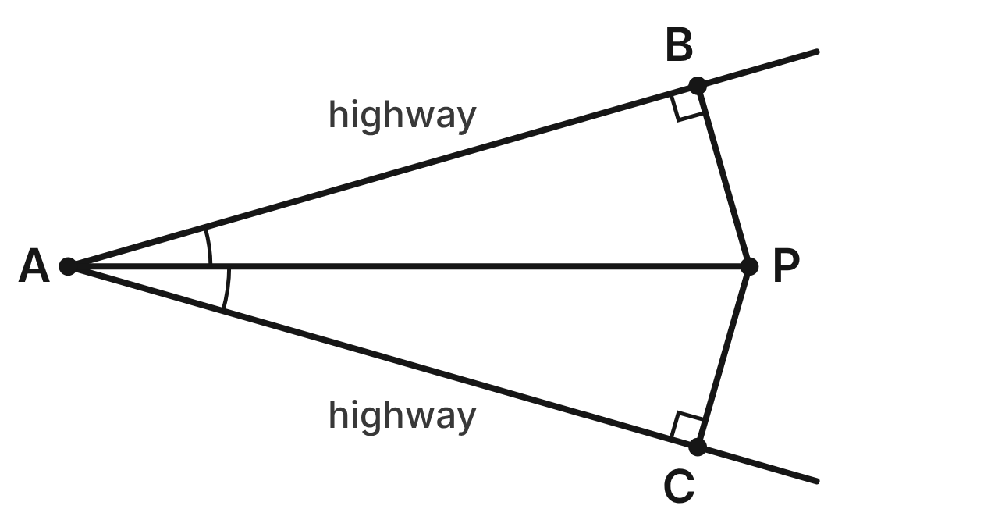
Two highways leave the junction A. Road AP splits the angle between them into two equal angles. From the rest stop P, access roads PB and PC meet the highways at right angles.
175. Using only the given facts and the shared side AP, which shortcut proves △ABP ≅ △ACP directly?
A. ASA
B. AAS ✔
C. SSA
D. HL
G.TR.2 · skill G.TR.2.1 (LOTS): Identify the congruence criterion (SSS, SAS, ASA, AAS, HL) that the given information supports, and recognize when none does
☐ Answer key correct ☐ Wording clear Notes: ________________________________
176. Why is ∠ABP ≅ ∠ACP?
A. All right angles are congruent ✔
B. Vertical angles are congruent
C. Reflexive property
D. Definition of angle bisector
G.TR.2 · skill G.TR.2.2 (HOTS): Complete or justify a direct or indirect proof that two triangles are congruent
☐ Answer key correct ☐ Wording clear Notes: ________________________________
177. AP = 2.5 km and PC = 0.69 km. To the nearest tenth of a kilometer, how far is it from A to C along the highway?
A. 3.2 km
B. 1.8 km
C. 2.6 km
D. 2.4 km ✔
G.TR.2 · skill G.TR.2.3 (LOTS): Solve problems, including algebraic ones, using corresponding parts of congruent triangles
☐ Answer key correct ☐ Wording clear Notes: ________________________________
178. m∠BAP = 16°. What is m∠BPC?
A. 74°
B. 32°
C. 148° ✔
D. 164°
G.TR.2 · skill G.TR.2.3 (LOTS): Solve problems, including algebraic ones, using corresponding parts of congruent triangles
☐ Answer key correct ☐ Wording clear Notes: ________________________________
179. Suppose road AP did not split the angle evenly, but PB = PC. Which criterion would prove △ABP ≅ △ACP?
A. SAS
B. AAS
C. SSA, so none
D. HL ✔
G.TR.2 · skill G.TR.2.1 (LOTS): Identify the congruence criterion (SSS, SAS, ASA, AAS, HL) that the given information supports, and recognize when none does
☐ Answer key correct ☐ Wording clear Notes: ________________________________
180. Which statement is NOT true?
A. PB ≅ PC
B. AB ≅ AC
C. AB ≅ BP ✔
D. ∠APB ≅ ∠APC
G.TR.2 · skill G.TR.2.3 (LOTS): Solve problems, including algebraic ones, using corresponding parts of congruent triangles
☐ Answer key correct ☐ Wording clear Notes: ________________________________

Panels of the Rail Bridge
Level 1 · Triangles · G.TR.2 · ID geo-tr2-sky-rail-bridge
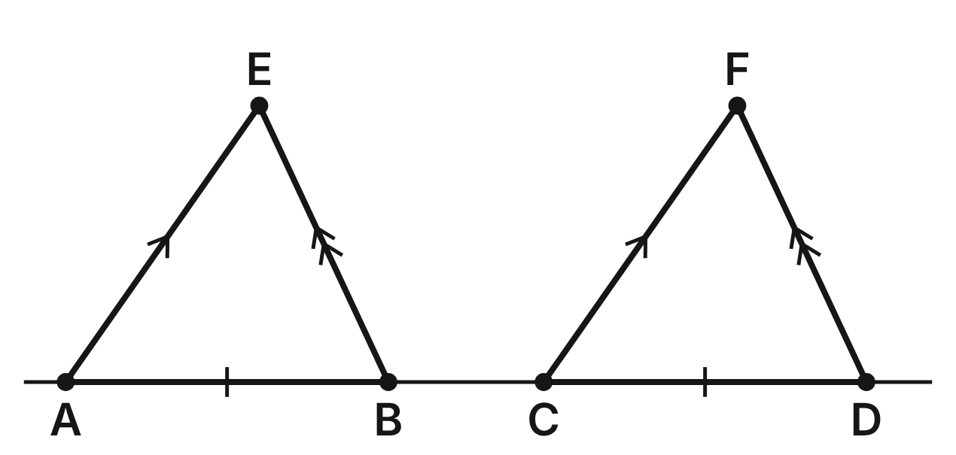
A railroad bridge has triangular panels △ABE and △CDF along its straight deck. AB ≅ CD, AE ∥ CF and BE ∥ DF.
181. Why is ∠EAB ≅ ∠FCD?
A. Alternate interior angles are congruent
B. Vertical angles are congruent
C. Corresponding angles are congruent ✔
D. Reflexive property
G.TR.2 · skill G.TR.2.2 (HOTS): Complete or justify a direct or indirect proof that two triangles are congruent
☐ Answer key correct ☐ Wording clear Notes: ________________________________
182. The parallel sides give ∠EAB ≅ ∠FCD and ∠EBA ≅ ∠FDC. Which criterion then proves △ABE ≅ △CDF?
A. ASA ✔
B. AAS
C. SAS
D. AAA
G.TR.2 · skill G.TR.2.1 (LOTS): Identify the congruence criterion (SSS, SAS, ASA, AAS, HL) that the given information supports, and recognize when none does
☐ Answer key correct ☐ Wording clear Notes: ________________________________
183. m∠EAB = 55° and m∠EBA = 65°. What is m∠CFD?
A. 55°
B. 60° ✔
C. 65°
D. 120°
G.TR.2 · skill G.TR.2.3 (LOTS): Solve problems, including algebraic ones, using corresponding parts of congruent triangles
☐ Answer key correct ☐ Wording clear Notes: ________________________________
184. AB = 12 m and CD = (2x − 4) m. What is x?
A. 4
B. 16
C. 10
D. 8 ✔
G.TR.2 · skill G.TR.2.3 (LOTS): Solve problems, including algebraic ones, using corresponding parts of congruent triangles
☐ Answer key correct ☐ Wording clear Notes: ________________________________
185. Suppose the builders knew only that AE ∥ CF and BE ∥ DF. What could they conclude about the two panels?
A. They are congruent by ASA
B. They are congruent by AAA
C. They are neither similar nor congruent
D. They are similar, but maybe not congruent ✔
G.TR.2 · skill G.TR.2.1 (LOTS): Identify the congruence criterion (SSS, SAS, ASA, AAS, HL) that the given information supports, and recognize when none does
☐ Answer key correct ☐ Wording clear Notes: ________________________________
186. Since △ABE ≅ △CDF, which statement must be true?
A. AE ≅ BE
B. AE ≅ CF ✔
C. BE ≅ CF
D. AB ≅ BC
G.TR.2 · skill G.TR.2.3 (LOTS): Solve problems, including algebraic ones, using corresponding parts of congruent triangles
☐ Answer key correct ☐ Wording clear Notes: ________________________________

The Drone and the Tower
Level 2 · Triangles · G.TR.2 · ID geo-tr2-sky-drone-range
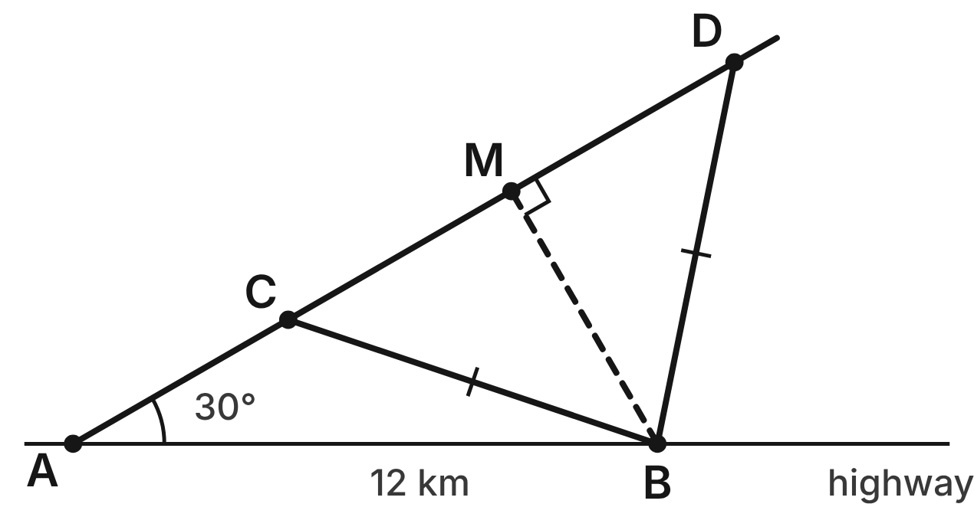
A drone flies from A on a straight path that makes a 30° angle with highway AB. Tower B is 12 km from A. The drone is exactly 8 km from the tower at two points, C and D. M is the point of the path closest to the tower, so BM ⊥ CD.
187. △ABC and △ABD share AB and ∠A, and BC = BD. What does this show?
A. They are congruent by SAS
B. SSA does not prove congruence ✔
C. They are congruent by ASA
D. They are congruent by SSS
G.TR.2 · skill G.TR.2.1 (LOTS): Identify the congruence criterion (SSS, SAS, ASA, AAS, HL) that the given information supports, and recognize when none does
☐ Answer key correct ☐ Wording clear Notes: ________________________________
188. m∠ADB ≈ 49°. To the nearest degree, what is m∠ACB?
A. 131° ✔
B. 49°
C. 101°
D. 82°
G.TR.2 · skill G.TR.2.3 (LOTS): Solve problems, including algebraic ones, using corresponding parts of congruent triangles
☐ Answer key correct ☐ Wording clear Notes: ________________________________
189. Another flight forms △PQR with PQ = 12 km, m∠P = 30° and QR = 8 km. Which extra fact would prove △PQR ≅ △ABC?
A. QR = BC
B. PQ = AB
C. m∠Q + m∠R = 150°
D. PR = AC ✔
G.TR.2 · skill G.TR.2.1 (LOTS): Identify the congruence criterion (SSS, SAS, ASA, AAS, HL) that the given information supports, and recognize when none does
☐ Answer key correct ☐ Wording clear Notes: ________________________________
190. Which criterion proves △BMC ≅ △BMD?
A. SSA
B. SAS
C. HL ✔
D. ASA
G.TR.2 · skill G.TR.2.1 (LOTS): Identify the congruence criterion (SSS, SAS, ASA, AAS, HL) that the given information supports, and recognize when none does
☐ Answer key correct ☐ Wording clear Notes: ________________________________
191. AC ≈ 5.1 km and AM ≈ 10.4 km. To the nearest tenth of a kilometer, how far is A from D?
A. 5.3 km
B. 15.5 km
C. 15.7 km ✔
D. 20.8 km
G.TR.2 · skill G.TR.2.3 (LOTS): Solve problems, including algebraic ones, using corresponding parts of congruent triangles
☐ Answer key correct ☐ Wording clear Notes: ________________________________
192. Sam writes: AB ≅ AB, ∠A ≅ ∠A and BC ≅ BD, so △ABC ≅ △ABD by SAS. What is his mistake?
A. ∠A is not between AB and BC ✔
B. AB ≅ AB needs a reason
C. BC and BD are not congruent
D. SAS needs two pairs of angles
G.TR.2 · skill G.TR.2.2 (HOTS): Complete or justify a direct or indirect proof that two triangles are congruent
☐ Answer key correct ☐ Wording clear Notes: ________________________________

Cables on the Footbridge
Level 2 · Triangles · G.TR.2 · ID geo-tr2-sky-footbridge
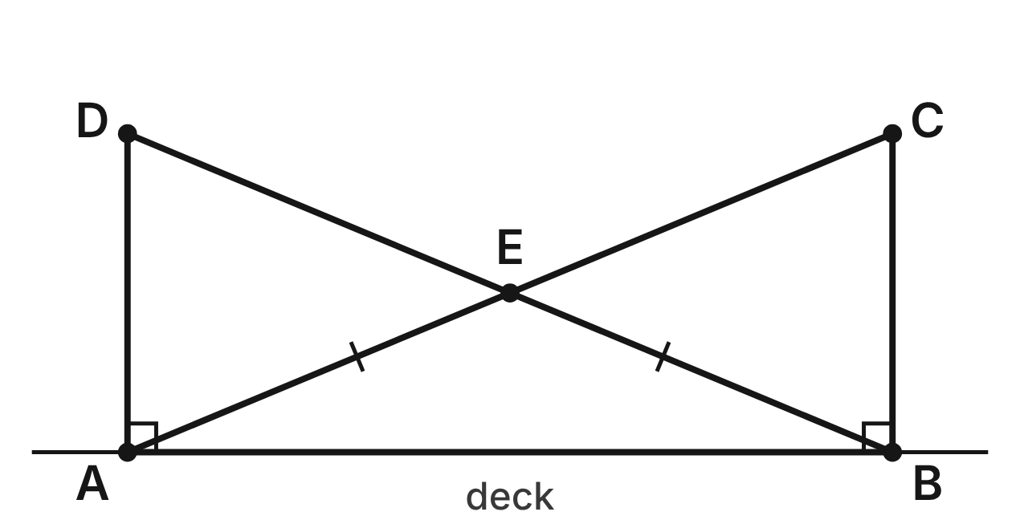
A footbridge has deck AB and towers AD and BC, both perpendicular to the deck. Cables AC and BD are the same length and cross at E. Prove that the towers are the same height.
Statement | Reason
1. AD ⊥ AB; BC ⊥ AB; AC ≅ BD | Given
2. ∠DAB and ∠CBA are right angles | Definition of perpendicular lines
3. AB ≅ BA | Reflexive property
4. △ABC ≅ △BAD | (a) ____
5. BC ≅ AD | CPCTC

193. Which reason justifies step 4, △ABC ≅ △BAD (blank a)?
A. HL ✔
B. SSA
C. SAS
D. AAS
G.TR.2 · skill G.TR.2.2 (HOTS): Complete or justify a direct or indirect proof that two triangles are congruent
☐ Answer key correct ☐ Wording clear Notes: ________________________________
194. The deck AB is 24 m long and each cable is 26 m long. How tall is each tower?
A. 2 m
B. 10 m ✔
C. about 35.4 m
D. 50 m
G.TR.2 · skill G.TR.2.3 (LOTS): Solve problems, including algebraic ones, using corresponding parts of congruent triangles
☐ Answer key correct ☐ Wording clear Notes: ________________________________
195. Which angle is congruent to ∠BAC?
A. ∠BAD
B. ∠ACB
C. ∠ADB
D. ∠ABD ✔
G.TR.2 · skill G.TR.2.3 (LOTS): Solve problems, including algebraic ones, using corresponding parts of congruent triangles
☐ Answer key correct ☐ Wording clear Notes: ________________________________
196. Another footbridge has the same layout, but tower AD is 10 m tall and tower BC is 9 m tall. Kai assumes AC = BD. Which fact does his proof then contradict?
A. AB ≅ BA by the reflexive property
B. ∠DAB and ∠CBA are right angles
C. AD = 10 m and BC = 9 m ✔
D. Cables AC and BD cross at E
G.TR.2 · skill G.TR.2.2 (HOTS): Complete or justify a direct or indirect proof that two triangles are congruent
☐ Answer key correct ☐ Wording clear Notes: ________________________________
197. Suppose the towers were known to be the same height, but the cables were not measured. Which criterion would prove △ABC ≅ △BAD?
A. HL
B. SAS ✔
C. SSS
D. ASA
G.TR.2 · skill G.TR.2.1 (LOTS): Identify the congruence criterion (SSS, SAS, ASA, AAS, HL) that the given information supports, and recognize when none does
☐ Answer key correct ☐ Wording clear Notes: ________________________________
198. Because ∠EAB ≅ ∠EBA, AE = BE. If AE = (2w + 3) m and BE = (5w − 12) m, how long is AE?
A. 5 m
B. 9 m
C. 26 m
D. 13 m ✔
G.TR.2 · skill G.TR.2.3 (LOTS): Solve problems, including algebraic ones, using corresponding parts of congruent triangles
☐ Answer key correct ☐ Wording clear Notes: ________________________________

Two Sailing Race Courses
Level 2 · Triangles · G.TR.2 · ID geo-tr2-sky-race-courses
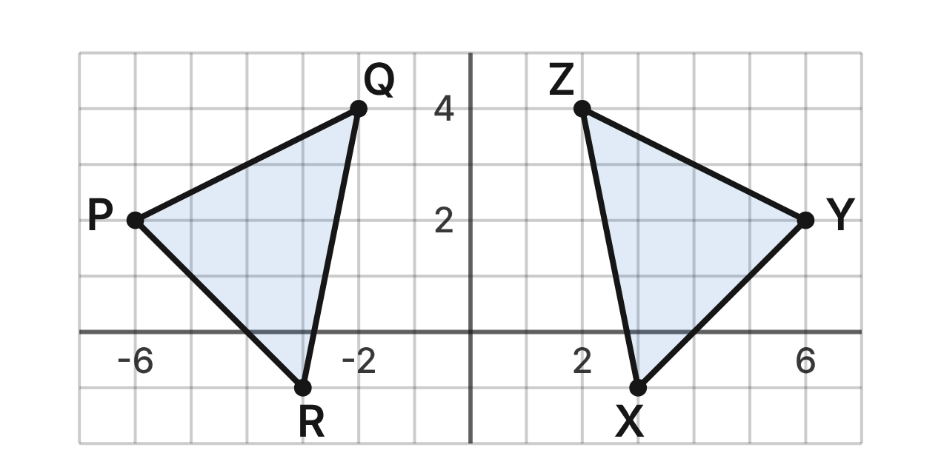
A harbor map shows the buoys of two triangular race courses. Each grid unit is 1 km: P(−6, 2), Q(−2, 4), R(−3, −1) and Y(6, 2), Z(2, 4), X(3, −1).
199. Which expression gives the length of PQ?
A. √((−2 − 4)² + (−6 − 2)²)
B. (−2 − (−6))² + (4 − 2)²
C. √((−2 − (−6))² + (4 − 2)²) ✔
D. √((−2 − 6)² + (4 − 2)²)
G.TR.2 · skill G.TR.2.3 (LOTS): Solve problems, including algebraic ones, using corresponding parts of congruent triangles
☐ Answer key correct ☐ Wording clear Notes: ________________________________
200. Which set of facts is NOT enough to prove △PQR ≅ △YZX?
A. PQ = YZ, QR = ZX and ∠R ≅ ∠X ✔
B. PQ = YZ, QR = ZX and PR = YX
C. PQ = YZ, ∠Q ≅ ∠Z and QR = ZX
D. ∠P ≅ ∠Y, PQ = YZ and ∠Q ≅ ∠Z
G.TR.2 · skill G.TR.2.1 (LOTS): Identify the congruence criterion (SSS, SAS, ASA, AAS, HL) that the given information supports, and recognize when none does
☐ Answer key correct ☐ Wording clear Notes: ________________________________
201. In the congruence △PQR ≅ △YZX, which buoy matches R?
A. Y(6, 2)
B. Z(2, 4)
C. (3, 1)
D. X(3, −1) ✔
G.TR.2 · skill G.TR.2.3 (LOTS): Solve problems, including algebraic ones, using corresponding parts of congruent triangles
☐ Answer key correct ☐ Wording clear Notes: ________________________________
202. To the nearest tenth of a kilometer, how long is leg ZX of the second course?
A. 6 km
B. 5.1 km ✔
C. 26 km
D. 4.9 km
G.TR.2 · skill G.TR.2.3 (LOTS): Solve problems, including algebraic ones, using corresponding parts of congruent triangles
☐ Answer key correct ☐ Wording clear Notes: ________________________________
203. Omar writes △PQR ≅ △ZYX. Which pair of lengths shows that his statement is wrong?
A. PQ = 2√5, but ZY = √26
B. PR = 3√2, but ZX = 2√5
C. QR = √26, but YX = 3√2 ✔
D. PQ = 2√5, but ZY = 3√2
G.TR.2 · skill G.TR.2.2 (HOTS): Complete or justify a direct or indirect proof that two triangles are congruent
☐ Answer key correct ☐ Wording clear Notes: ________________________________
204. Sam shows only PQ = YZ and QR = ZX. What else does he need to prove △PQR ≅ △YZX?
A. Nothing; two pairs of sides are enough
B. PR = YX, or ∠Q ≅ ∠Z ✔
C. ∠R ≅ ∠X
D. Equal areas for the two courses
G.TR.2 · skill G.TR.2.1 (LOTS): Identify the congruence criterion (SSS, SAS, ASA, AAS, HL) that the given information supports, and recognize when none does
☐ Answer key correct ☐ Wording clear Notes: ________________________________

The Station Canopy Truss
Level 3 · Triangles · G.TR.2 · ID geo-tr2-sky-station-truss
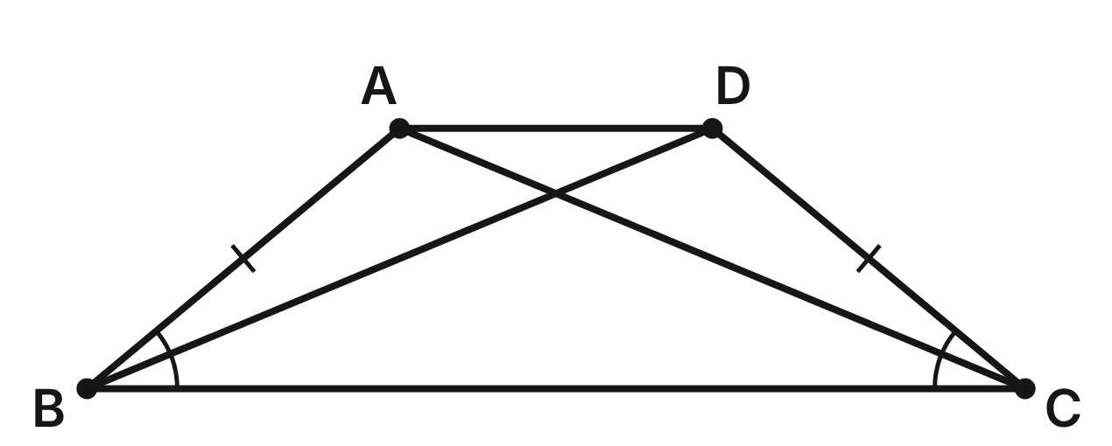
A train station canopy rests on the steel truss ABCD, a trapezoid with AB ≅ DC and ∠ABC ≅ ∠DCB. Braces AC and BD cross the truss. Prove that AC ≅ DB.
Statement | Reason
1. AB ≅ DC; ∠ABC ≅ ∠DCB | Given
2. BC ≅ CB | Reflexive property
3. △ABC ≅ △DCB | (a) ____
4. AC ≅ DB | CPCTC

205. Which reason justifies step 3, △ABC ≅ △DCB (blank a)?
A. ASA
B. SSA
C. SAS ✔
D. HL
G.TR.2 · skill G.TR.2.2 (HOTS): Complete or justify a direct or indirect proof that two triangles are congruent
☐ Answer key correct ☐ Wording clear Notes: ________________________________
206. In the congruence △ABC ≅ △DCB, which angle of the truss matches ∠BAC?
A. ∠CDB ✔
B. ∠DBC
C. ∠ADB
D. ∠ABD
G.TR.2 · skill G.TR.2.3 (LOTS): Solve problems, including algebraic ones, using corresponding parts of congruent triangles
☐ Answer key correct ☐ Wording clear Notes: ________________________________
207. AC = (3p + 1) m and BD = (5p − 7) m. How long is brace BD?
A. 4 m
B. 8 m
C. 20 m
D. 13 m ✔
G.TR.2 · skill G.TR.2.3 (LOTS): Solve problems, including algebraic ones, using corresponding parts of congruent triangles
☐ Answer key correct ☐ Wording clear Notes: ________________________________
208. The bottom BC is 18 m, the top AD is 6 m, and the truss is 5 m tall. How many meters of steel do the two braces use?
A. 13 m
B. 26 m ✔
C. about 37.4 m
D. 34 m
G.TR.2 · skill G.TR.2.3 (LOTS): Solve problems, including algebraic ones, using corresponding parts of congruent triangles
☐ Answer key correct ☐ Wording clear Notes: ________________________________
209. Suppose you knew ∠ABC ≅ ∠DCB and ∠ACB ≅ ∠DBC, but not AB ≅ DC. Which criterion would prove △ABC ≅ △DCB?
A. AAS
B. ASA ✔
C. AAA
D. SAS
G.TR.2 · skill G.TR.2.1 (LOTS): Identify the congruence criterion (SSS, SAS, ASA, AAS, HL) that the given information supports, and recognize when none does
☐ Answer key correct ☐ Wording clear Notes: ________________________________
210. Jay writes: AB ≅ DC, AC ≅ DB and BC ≅ CB, so △ABC ≅ △DCB by SSS. What is wrong with his proof?
A. AC ≅ DB is what he must prove ✔
B. SSS also needs one pair of angles
C. BC ≅ CB must be given, not assumed
D. He should have used SSA
G.TR.2 · skill G.TR.2.2 (HOTS): Complete or justify a direct or indirect proof that two triangles are congruent
☐ Answer key correct ☐ Wording clear Notes: ________________________________

How Far to the Ferry Buoy?
Level 3 · Triangles · G.TR.2 · ID geo-tr2-sky-ferry-buoy
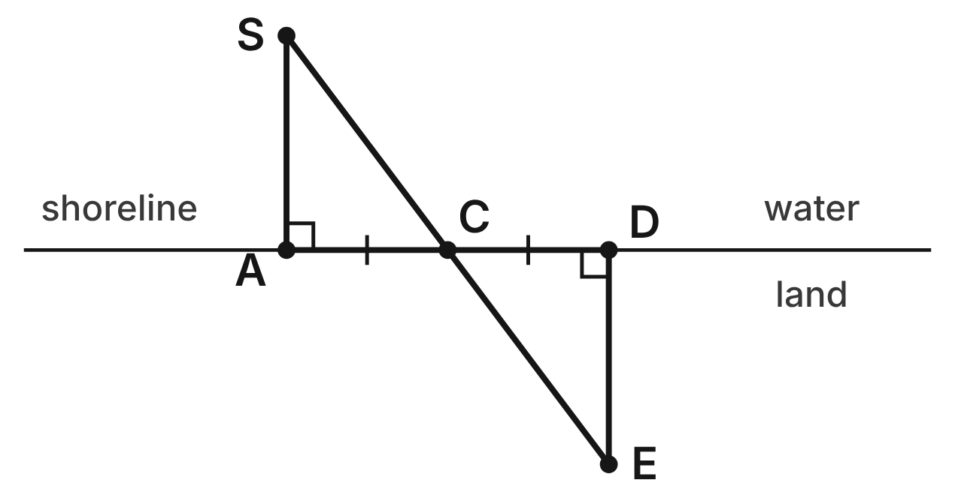
Ana wants the distance from dock A to the ferry buoy S, with SA ⊥ AD. She walks from A to a stake at C, then the same distance on to D. She turns and walks along DE ⊥ AD until E, C and S line up.
211. Why is ∠ACS ≅ ∠DCE?
A. Alternate interior angles are congruent
B. Corresponding angles are congruent
C. Reflexive property
D. Vertical angles are congruent ✔
G.TR.2 · skill G.TR.2.2 (HOTS): Complete or justify a direct or indirect proof that two triangles are congruent
☐ Answer key correct ☐ Wording clear Notes: ________________________________
212. Which criterion proves △ACS ≅ △DCE?
A. SAS
B. HL
C. ASA ✔
D. AAA
G.TR.2 · skill G.TR.2.1 (LOTS): Identify the congruence criterion (SSS, SAS, ASA, AAS, HL) that the given information supports, and recognize when none does
☐ Answer key correct ☐ Wording clear Notes: ________________________________
213. Ana walks 45 m from A to C and measures DE = 60 m. How far is the buoy S from the stake C?
A. 105 m
B. 75 m ✔
C. 60 m
D. 150 m
G.TR.2 · skill G.TR.2.3 (LOTS): Solve problems, including algebraic ones, using corresponding parts of congruent triangles
☐ Answer key correct ☐ Wording clear Notes: ________________________________
214. Ben does the same steps, but he walks 45 m from A to C and only 40 m from C to D. Why can he NOT use DE as the distance AS?
A. AC ≠ CD, so the triangles are not congruent ✔
B. The vertical angles are no longer congruent
C. DE must be measured along the shore
D. He would need HL instead of ASA
G.TR.2 · skill G.TR.2.2 (HOTS): Complete or justify a direct or indirect proof that two triangles are congruent
☐ Answer key correct ☐ Wording clear Notes: ________________________________
215. AC = (2n + 9) m and CD = (4n − 27) m. How far does Ana walk from A to D?
A. 45 m
B. 18 m
C. 54 m
D. 90 m ✔
G.TR.2 · skill G.TR.2.3 (LOTS): Solve problems, including algebraic ones, using corresponding parts of congruent triangles
☐ Answer key correct ☐ Wording clear Notes: ________________________________
216. Suppose Ana could not make a right angle at D, but she walked CD = AC and placed E so that CE = CS. Which criterion would prove △ACS ≅ △DCE?
A. SAS ✔
B. SSS
C. ASA
D. HL
G.TR.2 · skill G.TR.2.1 (LOTS): Identify the congruence criterion (SSS, SAS, ASA, AAS, HL) that the given information supports, and recognize when none does
☐ Answer key correct ☐ Wording clear Notes: ________________________________

G.TR.3 · Prove two triangles are similar, using direct and indirect proofs, and solve problems involving measured attributes of similar triangles.

Three Towns on the Road Map
Level 1 · Triangles · G.TR.3 · ID geo-tr3-sky-road-map
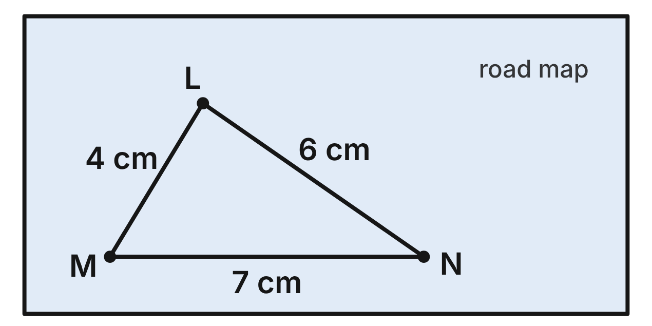
On a road map, straight roads join the towns L, M and N: LM = 4 cm, MN = 7 cm and LN = 6 cm. The real distances are LM = 60 km, MN = 105 km and LN = 90 km.
217. Which criterion shows that the map triangle is similar to the real triangle of towns?
A. SSS∼ ✔
B. SAS∼
C. AA
D. SSS
G.TR.3 · skill G.TR.3.1 (LOTS): Identify the similarity criterion (AA, SSS, SAS) that the given information supports
☐ Answer key correct ☐ Wording clear Notes: ________________________________
218. What is the scale factor from the map triangle to the real triangle, in kilometers per centimeter?
A. 1/15
B. 56
C. 15 ✔
D. 17.5
G.TR.3 · skill G.TR.3.3 (LOTS): Solve problems, including contextual ones, using proportional sides of similar triangles
☐ Answer key correct ☐ Wording clear Notes: ________________________________
219. Town O is 3.2 cm from N on the same map. How far apart are the real towns N and O?
A. 18.2 km
B. about 0.2 km
C. about 4.7 km
D. 48 km ✔
G.TR.3 · skill G.TR.3.3 (LOTS): Solve problems, including contextual ones, using proportional sides of similar triangles
☐ Answer key correct ☐ Wording clear Notes: ________________________________
220. A tourist map shows the same three towns with LM = 6 cm. What is the perimeter of the triangle on the tourist map?
A. 38.25 cm
B. 25.5 cm ✔
C. about 11.3 cm
D. 19 cm
G.TR.3 · skill G.TR.3.3 (LOTS): Solve problems, including contextual ones, using proportional sides of similar triangles
☐ Answer key correct ☐ Wording clear Notes: ________________________________
221. A second map shows LM = 5 cm, MN = 8 cm and LN = 7 cm. Is its triangle similar to the first map's △LMN? Choose the answer with the correct reason.
A. Yes; 5/4 = 7/6
B. Yes; 5/8 = 4/7
C. No; 5/4 ≠ 8/7 ✔
D. No; two maps need the same scale
G.TR.3 · skill G.TR.3.2 (HOTS): Justify that two triangles are similar, or are not, using angle measures or side ratios
☐ Answer key correct ☐ Wording clear Notes: ________________________________
222. For a project, Ana builds △XYZ with XY = 18 cm, YZ = 12 cm and XZ = 21 cm. Which similarity statement is correct?
A. △LMN ∼ △YZX ✔
B. △LMN ∼ △XYZ
C. △LMN ∼ △ZYX
D. △LMN ∼ △YXZ
G.TR.3 · skill G.TR.3.1 (LOTS): Identify the similarity criterion (AA, SSS, SAS) that the given information supports
☐ Answer key correct ☐ Wording clear Notes: ________________________________

Up the Hill Road
Level 1 · Triangles · G.TR.3 · ID geo-tr3-sky-grade-sign
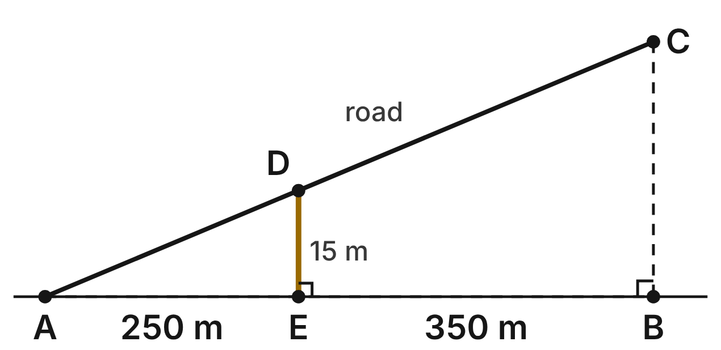
Not drawn to scale
A straight road climbs from A at the foot of a hill to C at the top. Point D on the road is straight above E, and C is straight above B. A, E and B are on one level line. AE = 250 m, EB = 350 m and DE = 15 m.
223. Which criterion shows that the small road triangle is similar to the whole road triangle?
A. SAS∼
B. AA ✔
C. SSS∼
D. HL
G.TR.3 · skill G.TR.3.1 (LOTS): Identify the similarity criterion (AA, SSS, SAS) that the given information supports
☐ Answer key correct ☐ Wording clear Notes: ________________________________
224. How high is C above B?
A. 6.25 m
B. 21 m
C. 365 m
D. 36 m ✔
G.TR.3 · skill G.TR.3.3 (LOTS): Solve problems, including contextual ones, using proportional sides of similar triangles
☐ Answer key correct ☐ Wording clear Notes: ________________________________
225. A road sign says a road has a 6% grade: it rises 6 m for every 100 m of level distance. How much does it rise over 425 m of level distance?
A. 25.5 m ✔
B. about 70.8 m
C. 10.25 m
D. 255 m
G.TR.3 · skill G.TR.3.3 (LOTS): Solve problems, including contextual ones, using proportional sides of similar triangles
☐ Answer key correct ☐ Wording clear Notes: ________________________________
226. Another straight stretch of road rises 20 m over 300 m of level distance. Is its right triangle similar to △AED? Choose the answer with the correct reason.
A. Yes; 20/15 = 300/250
B. Yes; 20/300 = 15/250
C. No; 20/300 ≠ 15/250 ✔
D. No; the stretch must be 600 m long
G.TR.3 · skill G.TR.3.2 (HOTS): Justify that two triangles are similar, or are not, using angle measures or side ratios
☐ Answer key correct ☐ Wording clear Notes: ________________________________
227. Which similarity statement for the two road triangles is correct?
A. △ADE ∼ △ABC
B. △AED ∼ △ACB
C. △EAD ∼ △ABC
D. △AED ∼ △ABC ✔
G.TR.3 · skill G.TR.3.1 (LOTS): Identify the similarity criterion (AA, SSS, SAS) that the given information supports
☐ Answer key correct ☐ Wording clear Notes: ________________________________
228. What is the scale factor from the small road triangle to the whole road triangle?
A. 5/12
B. 2.4 ✔
C. 350
D. 5.76
G.TR.3 · skill G.TR.3.3 (LOTS): Solve problems, including contextual ones, using proportional sides of similar triangles
☐ Answer key correct ☐ Wording clear Notes: ________________________________

Two Sails, One Shape?
Level 2 · Triangles · G.TR.3 · ID geo-tr3-sky-sails
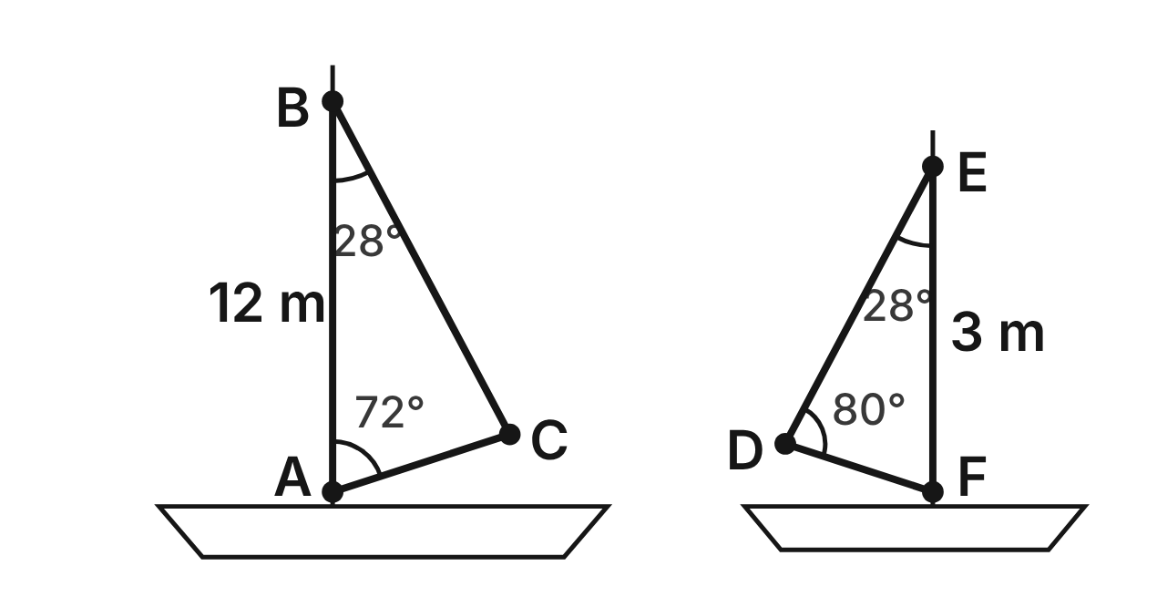
Not drawn to scale
A yacht's sail is △ABC, with AB along the mast: m∠A = 72°, m∠B = 28° and AB = 12 m. A dinghy's sail is △DEF, with FE along its mast: m∠D = 80°, m∠E = 28° and FE = 3 m.
229. Are the two sails similar? Choose the answer with the correct reason.
A. Yes; m∠B = 80° = m∠D
B. No; m∠C = 72° ≠ m∠D
C. No; m∠E = 80° ≠ m∠B
D. Yes; m∠C = 80° = m∠D ✔
G.TR.3 · skill G.TR.3.2 (HOTS): Justify that two triangles are similar, or are not, using angle measures or side ratios
☐ Answer key correct ☐ Wording clear Notes: ________________________________
230. Which similarity statement for the two sails is correct?
A. △ABC ∼ △FED ✔
B. △ABC ∼ △DEF
C. △ABC ∼ △FDE
D. △ABC ∼ △EFD
G.TR.3 · skill G.TR.3.1 (LOTS): Identify the similarity criterion (AA, SSS, SAS) that the given information supports
☐ Answer key correct ☐ Wording clear Notes: ________________________________
231. What is the scale factor from the yacht's sail to the dinghy's sail?
A. 4
B. 9
C. 1/4 ✔
D. 1/16
G.TR.3 · skill G.TR.3.3 (LOTS): Solve problems, including contextual ones, using proportional sides of similar triangles
☐ Answer key correct ☐ Wording clear Notes: ________________________________
232. The yacht sail's edge BC is 11.6 m long. How long is the matching edge of the dinghy's sail?
A. 46.4 m
B. 2.9 m ✔
C. 8.6 m
D. about 0.7 m
G.TR.3 · skill G.TR.3.3 (LOTS): Solve problems, including contextual ones, using proportional sides of similar triangles
☐ Answer key correct ☐ Wording clear Notes: ________________________________
233. The yacht sail's perimeter is 29.3 m. To the nearest tenth of a meter, what is the perimeter of the dinghy's sail?
A. 7.3 m ✔
B. 117.2 m
C. 1.8 m
D. 20.3 m
G.TR.3 · skill G.TR.3.3 (LOTS): Solve problems, including contextual ones, using proportional sides of similar triangles
☐ Answer key correct ☐ Wording clear Notes: ________________________________
234. A third sail △GHJ has m∠G = 72° and m∠H = 30°. Is it similar to the yacht's sail? Choose the answer with the correct reason.
A. Yes; its angles are 72°, 28°, 80°
B. No; m∠G ≠ m∠A
C. No; a sail needs a right angle
D. No; its angles are 72°, 30°, 78° ✔
G.TR.3 · skill G.TR.3.2 (HOTS): Justify that two triangles are similar, or are not, using angle measures or side ratios
☐ Answer key correct ☐ Wording clear Notes: ________________________________

The Bridge Truss
Level 2 · Triangles · G.TR.3 · ID geo-tr3-sky-bridge-truss
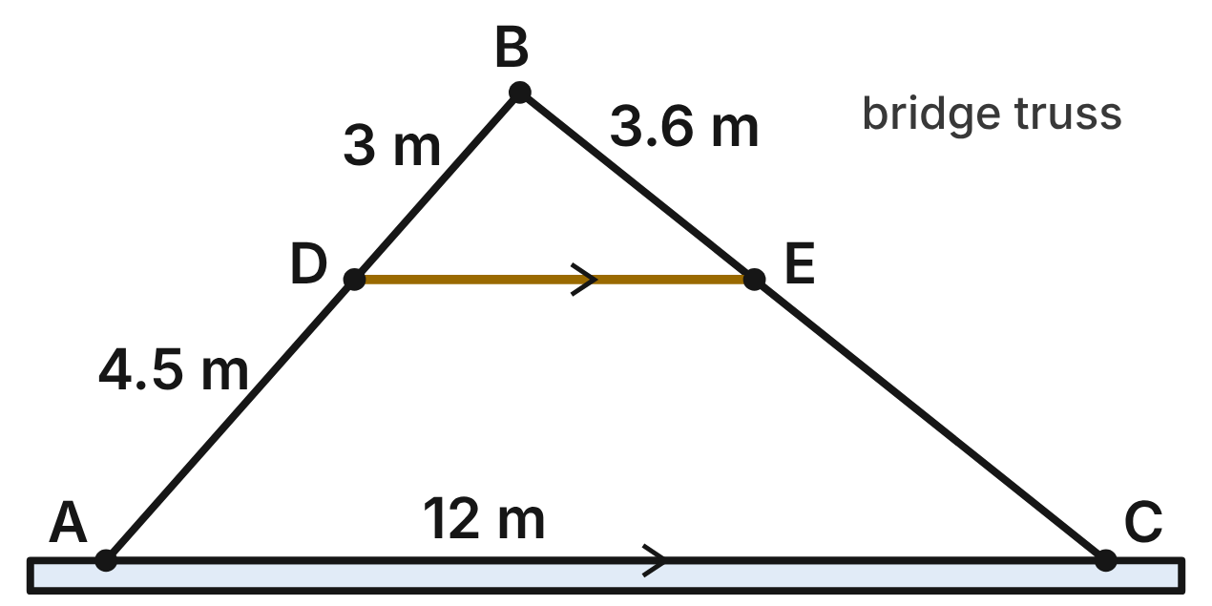
One panel of a bridge truss is △ABC, with AC along the deck. A crossbar DE joins D on AB to E on BC, and DE ∥ AC. BD = 3 m, DA = 4.5 m, BE = 3.6 m and AC = 12 m.
235. Why is △DBE similar to △ABC?
A. SAS∼: BD/DA = BE/EC, with ∠B
B. SSS∼: all three pairs of sides are known
C. AA: ∠B is shared, and ∠BDE ≅ ∠BAC ✔
D. AA: ∠BDE ≅ ∠BED, since DE is level
G.TR.3 · skill G.TR.3.1 (LOTS): Identify the similarity criterion (AA, SSS, SAS) that the given information supports
☐ Answer key correct ☐ Wording clear Notes: ________________________________
236. How long is EC?
A. 2.4 m
B. 5.4 m ✔
C. 5.1 m
D. 9 m
G.TR.3 · skill G.TR.3.3 (LOTS): Solve problems, including contextual ones, using proportional sides of similar triangles
☐ Answer key correct ☐ Wording clear Notes: ________________________________
237. How long is the crossbar DE?
A. 8 m
B. 30 m
C. 7.5 m
D. 4.8 m ✔
G.TR.3 · skill G.TR.3.3 (LOTS): Solve problems, including contextual ones, using proportional sides of similar triangles
☐ Answer key correct ☐ Wording clear Notes: ________________________________
238. On a second panel, BD = 2.5 m, DA = 4 m, BE = 3 m and EC = 5 m. Is its crossbar DE parallel to AC? Choose the answer with the correct reason.
A. No; 2.5/4 ≠ 3/5 ✔
B. Yes; 2.5/3 = 4/5
C. Yes; 4 − 2.5 = 5 − 3
D. No; DE must be half of AC
G.TR.3 · skill G.TR.3.2 (HOTS): Justify that two triangles are similar, or are not, using angle measures or side ratios
☐ Answer key correct ☐ Wording clear Notes: ________________________________
239. The perimeter of △ABC is 28.5 m. What is the perimeter of △DBE?
A. 4.56 m
B. 11.4 m ✔
C. 71.25 m
D. 19 m
G.TR.3 · skill G.TR.3.3 (LOTS): Solve problems, including contextual ones, using proportional sides of similar triangles
☐ Answer key correct ☐ Wording clear Notes: ________________________________
240. Which ratio is equal to BD/BA?
A. BE/EC
B. DA/BA
C. DE/AC ✔
D. AC/DE
G.TR.3 · skill G.TR.3.1 (LOTS): Identify the similarity criterion (AA, SSS, SAS) that the given information supports
☐ Answer key correct ☐ Wording clear Notes: ________________________________

The Ladder Truck
Level 2 · Triangles · G.TR.3 · ID geo-tr3-sky-ladder-truck
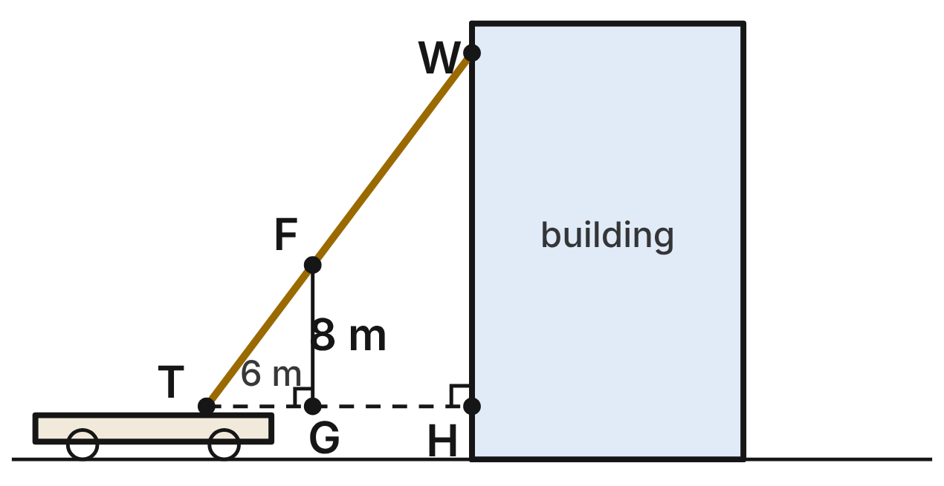
A fire truck's ladder TW rises from the turntable T, 3 m above the ground, to a window W. A dashed level line from T meets the wall at H, and the wall is vertical. A firefighter stands at F on the ladder, straight above G on the dashed line. TG = 6 m, FG = 8 m, TF = 10 m and TH = 15 m.
241. Which similarity statement for the firefighter's triangle and the ladder's triangle is correct?
A. △TGF ∼ △TWH
B. △TGF ∼ △THW ✔
C. △GTF ∼ △THW
D. △TFG ∼ △THW
G.TR.3 · skill G.TR.3.1 (LOTS): Identify the similarity criterion (AA, SSS, SAS) that the given information supports
☐ Answer key correct ☐ Wording clear Notes: ________________________________
242. How far above the dashed line is the window (HW)?
A. 20 m ✔
B. 17 m
C. 11.25 m
D. 3.2 m
G.TR.3 · skill G.TR.3.3 (LOTS): Solve problems, including contextual ones, using proportional sides of similar triangles
☐ Answer key correct ☐ Wording clear Notes: ________________________________
243. How high above the ground is the window W?
A. 20 m
B. 17 m
C. 23 m ✔
D. 14.25 m
G.TR.3 · skill G.TR.3.3 (LOTS): Solve problems, including contextual ones, using proportional sides of similar triangles
☐ Answer key correct ☐ Wording clear Notes: ________________________________
244. How long is the ladder TW?
A. 19 m
B. 4 m
C. 18.75 m
D. 25 m ✔
G.TR.3 · skill G.TR.3.3 (LOTS): Solve problems, including contextual ones, using proportional sides of similar triangles
☐ Answer key correct ☐ Wording clear Notes: ________________________________
245. On another call, the crew reads TG = 9 m, FG = 12 m, TH = 18 m and HW = 26 m. Can these numbers fit one straight ladder? Choose the answer with the correct reason.
A. No; 12/9 ≠ 26/18 ✔
B. Yes; 9/18 = 12/26
C. Yes; 26/12 = 18/9
D. No; HW must equal TH
G.TR.3 · skill G.TR.3.2 (HOTS): Justify that two triangles are similar, or are not, using angle measures or side ratios
☐ Answer key correct ☐ Wording clear Notes: ________________________________
246. Why is the firefighter's triangle similar to the ladder's triangle?
A. SAS∼: TG/TH = 6/15, with the right angles
B. AA: shared ∠T and right angles at G and H ✔
C. SSS∼: TG, FG and TF are known
D. AA: ∠F ≅ ∠T, since FG ⊥ TH
G.TR.3 · skill G.TR.3.1 (LOTS): Identify the similarity criterion (AA, SSS, SAS) that the given information supports
☐ Answer key correct ☐ Wording clear Notes: ________________________________

The Kite's Shadow
Level 2 · Triangles · G.TR.3 · ID geo-tr3-sky-kite-shadow
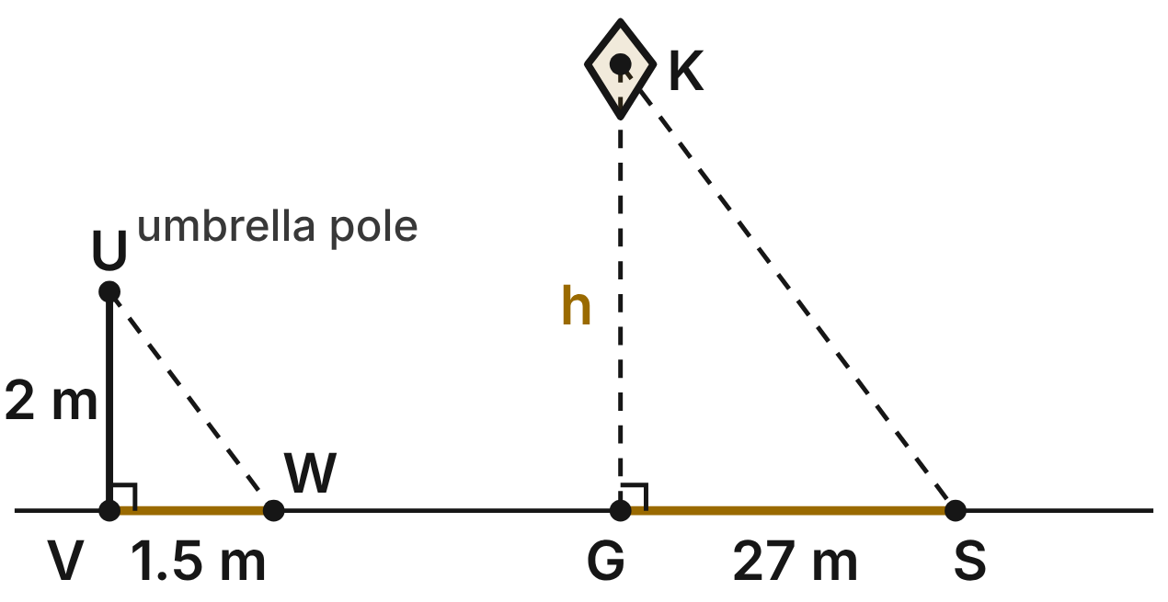
Not drawn to scale
On a beach trip, a kite K flies straight above point G. At the same moment, a 2-m umbrella pole UV casts a shadow VW that is 1.5 m long, and the kite's shadow S is 27 m from G. UV and KG are vertical, the sand is level, and the sun rays UW and KS are parallel.
247. Why is the pole's triangle similar to the kite's triangle?
A. SAS∼: VW/GS = 1.5/27 and the right angles
B. SSS∼: the two shadows are proportional
C. HL: both triangles have a right angle
D. AA: right angles at V and G, and ∠W ≅ ∠S ✔
G.TR.3 · skill G.TR.3.1 (LOTS): Identify the similarity criterion (AA, SSS, SAS) that the given information supports
☐ Answer key correct ☐ Wording clear Notes: ________________________________
248. How high is the kite (h)?
A. 20.25 m
B. 27.5 m
C. 36 m ✔
D. 54 m
G.TR.3 · skill G.TR.3.3 (LOTS): Solve problems, including contextual ones, using proportional sides of similar triangles
☐ Answer key correct ☐ Wording clear Notes: ________________________________
249. Later, the 2-m pole casts a 2.5-m shadow. How far from the point under it is the shadow of a kite flying 30 m high?
A. 24 m
B. 37.5 m ✔
C. 30.5 m
D. 22.5 m
G.TR.3 · skill G.TR.3.3 (LOTS): Solve problems, including contextual ones, using proportional sides of similar triangles
☐ Answer key correct ☐ Wording clear Notes: ________________________________
250. Which similarity statement for the pole's triangle and the kite's triangle is correct?
A. △UVW ∼ △KGS ✔
B. △UVW ∼ △GKS
C. △VUW ∼ △KGS
D. △UWV ∼ △KGS
G.TR.3 · skill G.TR.3.1 (LOTS): Identify the similarity criterion (AA, SSS, SAS) that the given information supports
☐ Answer key correct ☐ Wording clear Notes: ________________________________
251. A boy says his 1.2-m flagpole cast a 1.8-m shadow at that same moment. Can that be right? Choose the answer with the correct reason.
A. Yes; 1.8 − 1.2 = 2 − 1.5
B. Yes; 1.2/2 = 1.8/1.5
C. No; 1.2/1.8 ≠ 2/1.5 ✔
D. Yes; 1.2/1.8 = 1.5/2
G.TR.3 · skill G.TR.3.2 (HOTS): Justify that two triangles are similar, or are not, using angle measures or side ratios
☐ Answer key correct ☐ Wording clear Notes: ________________________________
252. What is the scale factor from the pole's triangle to the kite's triangle?
A. 1/18
B. 25.5
C. 13.5
D. 18 ✔
G.TR.3 · skill G.TR.3.3 (LOTS): Solve problems, including contextual ones, using proportional sides of similar triangles
☐ Answer key correct ☐ Wording clear Notes: ________________________________

How Wide Is the River?
Level 3 · Triangles · G.TR.3 · ID geo-tr3-sky-river-width
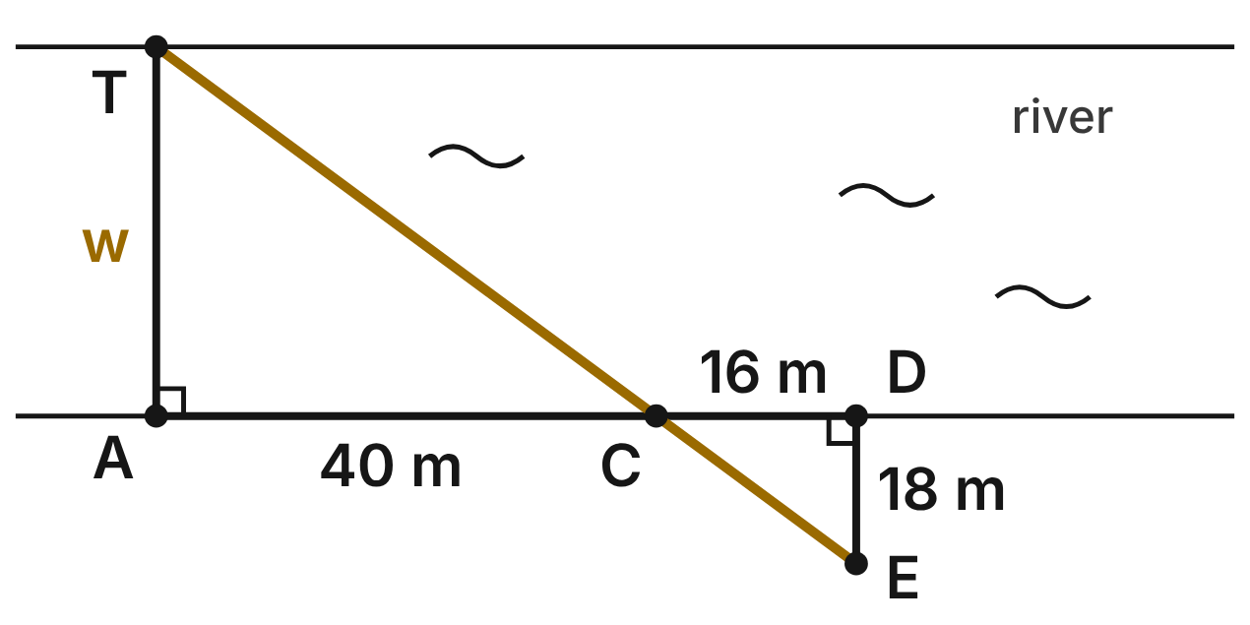
Not drawn to scale
To find the width of a river, Kim picks a tree T on the far bank and a point A on the near bank straight across from it, so TA ⊥ AD. She walks 40 m along the straight bank to C and 16 m more to D. Then she walks straight away from the river, with DE ⊥ AD, until E, C and T line up. DE = 18 m.
253. Why are Kim's two triangles similar?
A. AA: right angles at A and D, vertical angles at C ✔
B. SAS∼: AC/DC = 40/16, with the right angles
C. SSS∼: all three sides of each are known
D. AA: ∠T ≅ ∠D, since both are right angles
G.TR.3 · skill G.TR.3.1 (LOTS): Identify the similarity criterion (AA, SSS, SAS) that the given information supports
☐ Answer key correct ☐ Wording clear Notes: ________________________________
254. How wide is the river (w = TA)?
A. 7.2 m
B. 42 m
C. 45 m ✔
D. 63 m
G.TR.3 · skill G.TR.3.3 (LOTS): Solve problems, including contextual ones, using proportional sides of similar triangles
☐ Answer key correct ☐ Wording clear Notes: ________________________________
255. Which similarity statement for Kim's two triangles is correct?
A. △TAC ∼ △DEC
B. △TAC ∼ △EDC ✔
C. △ATC ∼ △EDC
D. △TCA ∼ △EDC
G.TR.3 · skill G.TR.3.1 (LOTS): Identify the similarity criterion (AA, SSS, SAS) that the given information supports
☐ Answer key correct ☐ Wording clear Notes: ________________________________
256. Which equation can Kim solve for the width w?
A. w/16 = 18/40
B. w/56 = 18/16
C. w/40 = 16/18
D. w/40 = 18/16 ✔
G.TR.3 · skill G.TR.3.3 (LOTS): Solve problems, including contextual ones, using proportional sides of similar triangles
☐ Answer key correct ☐ Wording clear Notes: ________________________________
257. At another spot, Ben's team walks AC = 28 m and CD = 8 m, finds DE = 12 m, and reports a width of 40 m. Is the report right? Choose the answer with the correct reason.
A. No; 40/12 ≠ 28/8 ✔
B. Yes; 40/28 = 12/8
C. Yes; 40 − 12 = 28 + 8
D. No; the river must be 36 m wide
G.TR.3 · skill G.TR.3.2 (HOTS): Justify that two triangles are similar, or are not, using angle measures or side ratios
☐ Answer key correct ☐ Wording clear Notes: ________________________________
258. At another spot the river is 36 m wide and AC = 40 m. Kim can walk only 9 m back from the bank (DE = 9 m). How far from C must D be?
A. 8.1 m
B. 32.4 m
C. 10 m ✔
D. 31 m
G.TR.3 · skill G.TR.3.3 (LOTS): Solve problems, including contextual ones, using proportional sides of similar triangles
☐ Answer key correct ☐ Wording clear Notes: ________________________________

The Airport Approach
Level 3 · Triangles · G.TR.3 · ID geo-tr3-sky-glide-path
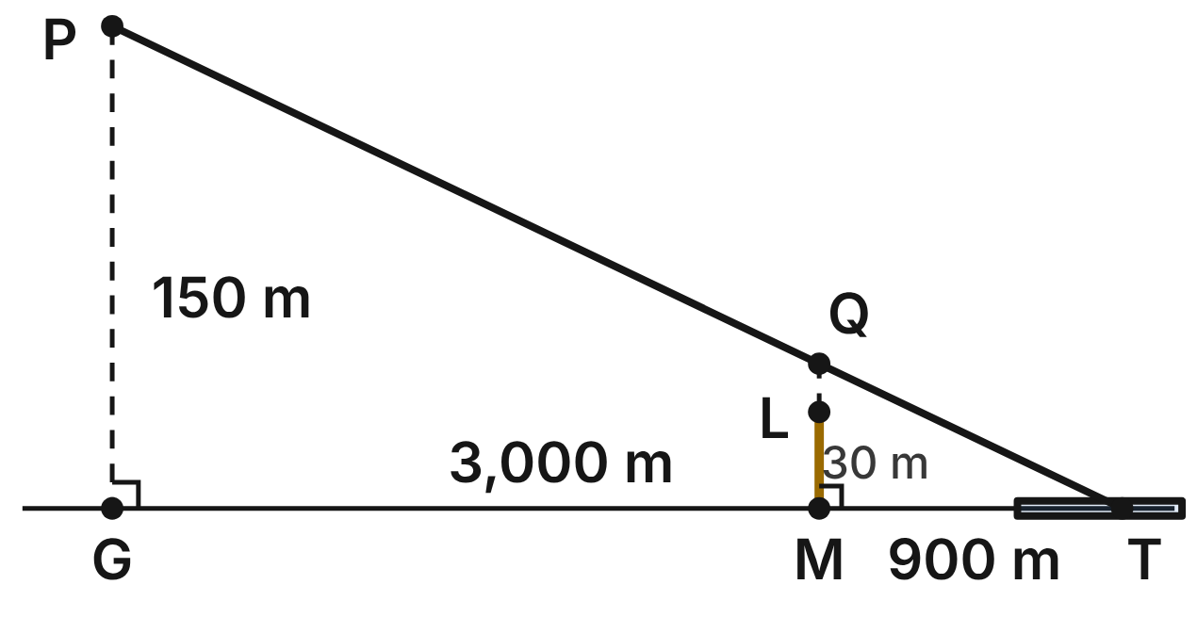
Not drawn to scale
A plane lands along a straight glide path that ends at T on the level runway. At P the plane is 150 m above G, and GT = 3,000 m. A light tower ML, 30 m tall, stands 900 m from T, straight under the point Q on the path. PG and QM are vertical.
259. Which similarity statement for the two right triangles with vertex T is correct?
A. △QMT ∼ △GPT
B. △QMT ∼ △PGT ✔
C. △MQT ∼ △PGT
D. △QTM ∼ △PGT
G.TR.3 · skill G.TR.3.1 (LOTS): Identify the similarity criterion (AA, SSS, SAS) that the given information supports
☐ Answer key correct ☐ Wording clear Notes: ________________________________
260. How far above the top of the light tower does the glide path pass?
A. 45 m
B. 120 m
C. 470 m
D. 15 m ✔
G.TR.3 · skill G.TR.3.3 (LOTS): Solve problems, including contextual ones, using proportional sides of similar triangles
☐ Answer key correct ☐ Wording clear Notes: ________________________________
261. How far from T, measured along the level ground, is the plane when it is 90 m above the ground?
A. 1,800 m ✔
B. 5,000 m
C. 2,940 m
D. 4.5 m
G.TR.3 · skill G.TR.3.3 (LOTS): Solve problems, including contextual ones, using proportional sides of similar triangles
☐ Answer key correct ☐ Wording clear Notes: ________________________________
262. A second plane reports it is 200 m up at 4,200 m from T. Is it on the same glide path? Choose the answer with the correct reason.
A. Yes; 200/150 = 4,200/3,000
B. Yes; 4,200/200 = 3,000/150
C. No; 200/4,200 ≠ 150/3,000 ✔
D. No; a glide path ends 3,000 m out
G.TR.3 · skill G.TR.3.2 (HOTS): Justify that two triangles are similar, or are not, using angle measures or side ratios
☐ Answer key correct ☐ Wording clear Notes: ________________________________
263. What is the scale factor from the tower's triangle at T to the plane's triangle at T?
A. 3/10
B. 10/3 ✔
C. 2,100
D. 100/9
G.TR.3 · skill G.TR.3.3 (LOTS): Solve problems, including contextual ones, using proportional sides of similar triangles
☐ Answer key correct ☐ Wording clear Notes: ________________________________
264. Another plane is 120 m above the ground at 2,400 m from T. Using these lengths, PG, GT and the right angles, which criterion shows that its right triangle with T is similar to △PGT?
A. AA
B. SSS∼
C. SAS
D. SAS∼ ✔
G.TR.3 · skill G.TR.3.1 (LOTS): Identify the similarity criterion (AA, SSS, SAS) that the given information supports
☐ Answer key correct ☐ Wording clear Notes: ________________________________

G.TR.4 · Model and solve problems, including those in context, involving trigonometry in right triangles and applications of the Pythagorean Theorem.

The Moving-Truck Ramp
Level 1 · Triangles · G.TR.4 · ID geo-tr4-sky-truck-ramp
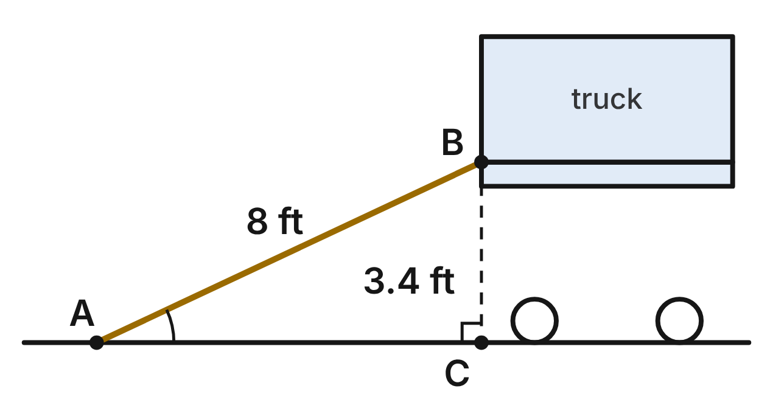
Movers set an 8-ft ramp AB from the ground at A to the back of a truck at B. The truck bed is 3.4 ft above level ground, and C is the point on the ground directly below B.
265. To the nearest tenth of a foot, how far is A from C?
A. 8.7 ft
B. 4.6 ft
C. 7.2 ft ✔
D. 11.4 ft
G.TR.4 · skill G.TR.4.1 (LOTS): Use the Pythagorean Theorem and its converse, including to classify a triangle as right, acute or obtuse
☐ Answer key correct ☐ Wording clear Notes: ________________________________
266. To the nearest degree, what angle does the ramp make with the ground?
A. 25° ✔
B. 23°
C. 65°
D. 67°
G.TR.4 · skill G.TR.4.3 (LOTS): Use sine, cosine and tangent ratios to find a side length or an angle measure
☐ Answer key correct ☐ Wording clear Notes: ________________________________
267. Which ratio is equal to tan A?
A. AC/BC
B. BC/AC ✔
C. BC/AB
D. AC/AB
G.TR.4 · skill G.TR.4.3 (LOTS): Use sine, cosine and tangent ratios to find a side length or an angle measure
☐ Answer key correct ☐ Wording clear Notes: ________________________________
268. Which measures (rise, run, length), in feet, could belong to a ramp that forms a right triangle?
A. 2.8, 4.5, 7.3
B. 2.4, 3.2, 4.2
C. 1.2, 3.5, 3.6
D. 2.8, 4.5, 5.3 ✔
G.TR.4 · skill G.TR.4.1 (LOTS): Use the Pythagorean Theorem and its converse, including to classify a triangle as right, acute or obtuse
☐ Answer key correct ☐ Wording clear Notes: ________________________________
269. A loading dock is 5 ft high. A ramp up to it makes a 30° angle with the ground. What is the exact horizontal run of the ramp?
A. 5√3 ft ✔
B. 10 ft
C. 5√2 ft
D. 5√3/3 ft
G.TR.4 · skill G.TR.4.2 (LOTS): Use the relationships in 45°-45°-90° and 30°-60°-90° triangles
☐ Answer key correct ☐ Wording clear Notes: ________________________________
270. The movers want the ramp to meet the ground at exactly 20° and still reach the 3.4-ft truck bed. To the nearest tenth of a foot, how long must the ramp be?
A. 9.3 ft
B. 1.2 ft
C. 9.9 ft ✔
D. 3.6 ft
G.TR.4 · skill G.TR.4.4 (HOTS): Model a contextual problem (angles of elevation and depression, ramps, ladders, distances) with a right triangle and solve it
☐ Answer key correct ☐ Wording clear Notes: ________________________________

The Kite on a String
Level 1 · Triangles · G.TR.4 · ID geo-tr4-sky-kite-string
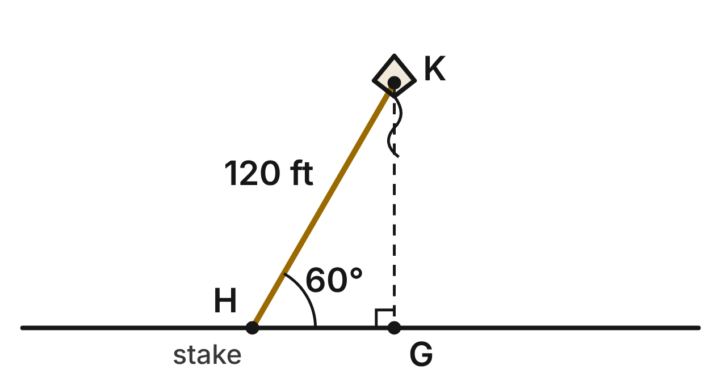
A kite K flies at the end of a 120-ft string tied to a stake H on level ground. The string makes a 60° angle with the ground, and G is the point on the ground directly below K. Treat the string as straight.
271. How high is the kite (KG)? Give an exact answer.
A. 60 ft
B. 120√3 ft
C. 60√2 ft
D. 60√3 ft ✔
G.TR.4 · skill G.TR.4.2 (LOTS): Use the relationships in 45°-45°-90° and 30°-60°-90° triangles
☐ Answer key correct ☐ Wording clear Notes: ________________________________
272. How far is the stake H from point G?
A. 60√3 ft
B. 60 ft ✔
C. 40√3 ft
D. 240 ft
G.TR.4 · skill G.TR.4.2 (LOTS): Use the relationships in 45°-45°-90° and 30°-60°-90° triangles
☐ Answer key correct ☐ Wording clear Notes: ________________________________
273. The wind drops, and the 120-ft string now makes a 48° angle with the ground. To the nearest tenth of a foot, how high is the kite?
A. 89.2 ft ✔
B. 80.3 ft
C. 133.3 ft
D. 161.5 ft
G.TR.4 · skill G.TR.4.3 (LOTS): Use sine, cosine and tangent ratios to find a side length or an angle measure
☐ Answer key correct ☐ Wording clear Notes: ________________________________
274. Which ratio is equal to sin H?
A. HG/KH
B. KG/HG
C. KG/KH ✔
D. KH/KG
G.TR.4 · skill G.TR.4.3 (LOTS): Use sine, cosine and tangent ratios to find a side length or an angle measure
☐ Answer key correct ☐ Wording clear Notes: ________________________________
275. A diamond kite's two spars cross at right angles. From the crossing point, two spar ends are 9 in. and 12 in. away. How long is the kite's edge between those two ends?
A. 21 in.
B. 15 in. ✔
C. about 7.9 in.
D. 225 in.
G.TR.4 · skill G.TR.4.1 (LOTS): Use the Pythagorean Theorem and its converse, including to classify a triangle as right, acute or obtuse
☐ Answer key correct ☐ Wording clear Notes: ________________________________
276. Another kite flies on 100 ft of straight string, 64 ft above the stake it is tied to. To the nearest degree, what angle does the string make with the ground?
A. 33°
B. 50°
C. 57°
D. 40° ✔
G.TR.4 · skill G.TR.4.3 (LOTS): Use sine, cosine and tangent ratios to find a side length or an angle measure
☐ Answer key correct ☐ Wording clear Notes: ________________________________

The 3° Glide Path
Level 2 · Triangles · G.TR.4 · ID geo-tr4-sky-glide-path
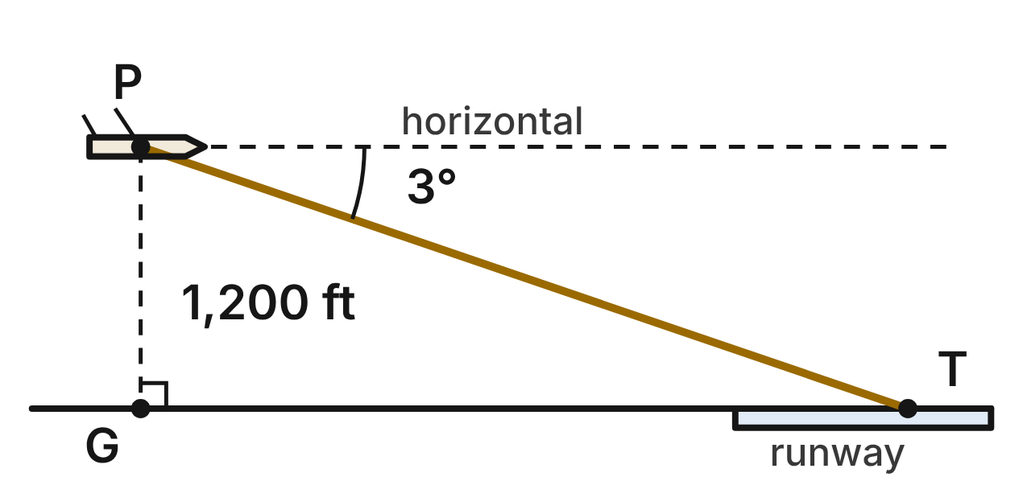
Not drawn to scale
A plane at P is 1,200 ft above the ground on its approach to touchdown point T on the runway. The angle of depression from the plane to T is 3°. G is the point on the ground directly below the plane.
277. What is m∠GPT, the angle at the plane between the vertical segment PG and the glide path PT?
A. 3°
B. 93°
C. 177°
D. 87° ✔
G.TR.4 · skill G.TR.4.4 (HOTS): Model a contextual problem (angles of elevation and depression, ramps, ladders, distances) with a right triangle and solve it
☐ Answer key correct ☐ Wording clear Notes: ________________________________
278. To the nearest foot, how far is G from the touchdown point T?
A. 22,897 ft ✔
B. 63 ft
C. 22,929 ft
D. 1,202 ft
G.TR.4 · skill G.TR.4.4 (HOTS): Model a contextual problem (angles of elevation and depression, ramps, ladders, distances) with a right triangle and solve it
☐ Answer key correct ☐ Wording clear Notes: ________________________________
279. Which equation can be used to find PT, the distance the plane flies to touchdown?
A. cos 3° = 1200/PT
B. tan 3° = 1200/PT
C. sin 3° = 1200/PT ✔
D. sin 3° = PT/1200
G.TR.4 · skill G.TR.4.3 (LOTS): Use sine, cosine and tangent ratios to find a side length or an angle measure
☐ Answer key correct ☐ Wording clear Notes: ________________________________
280. Staying on a 3° glide path, a plane descends from 1,200 ft to 500 ft. To the nearest foot, how far does it travel horizontally?
A. 13,375 ft
B. 13,357 ft ✔
C. 9,541 ft
D. 32,438 ft
G.TR.4 · skill G.TR.4.4 (HOTS): Model a contextual problem (angles of elevation and depression, ramps, ladders, distances) with a right triangle and solve it
☐ Answer key correct ☐ Wording clear Notes: ________________________________
281. A helicopter 300 ft above a helipad's level descends to the pad along a straight path at a 45° angle of depression. What is the exact length of its path?
A. 300√2 ft ✔
B. 300 ft
C. 600 ft
D. 300√3 ft
G.TR.4 · skill G.TR.4.2 (LOTS): Use the relationships in 45°-45°-90° and 30°-60°-90° triangles
☐ Answer key correct ☐ Wording clear Notes: ________________________________
282. On the airport map, the end of a runway is 840 ft east and 130 ft north of the control tower. How far is it from the tower in a straight line?
A. 970 ft
B. about 830 ft
C. 710 ft
D. 850 ft ✔
G.TR.4 · skill G.TR.4.1 (LOTS): Use the Pythagorean Theorem and its converse, including to classify a triangle as right, acute or obtuse
☐ Answer key correct ☐ Wording clear Notes: ________________________________

Cables on the River Bridge
Level 2 · Triangles · G.TR.4 · ID geo-tr4-sky-bridge-cables
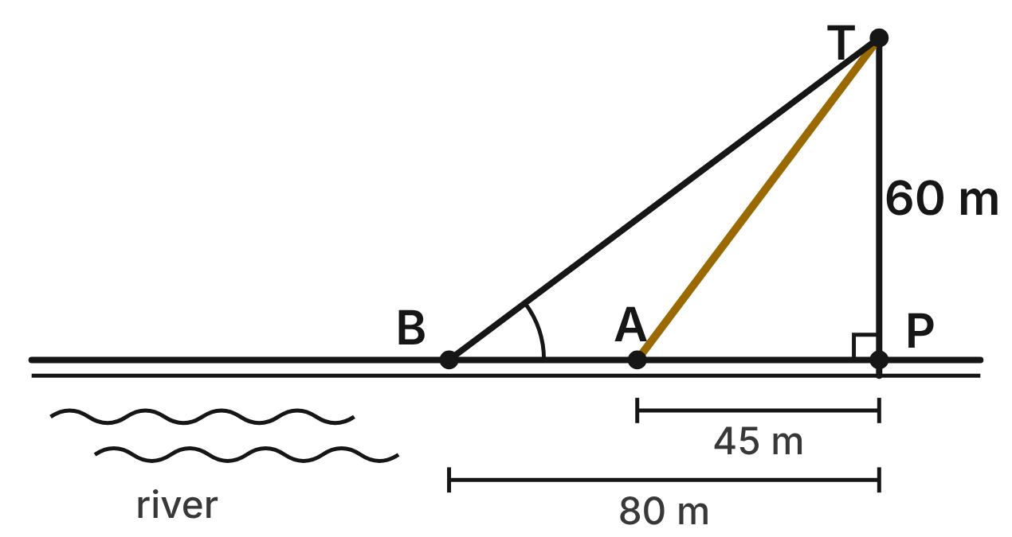
On a cable-stayed bridge, the tower TP rises 60 m above the deck at P and is perpendicular to the deck. Straight cables run from T to anchors A and B on the deck, 45 m and 80 m from P.
283. How long is cable TA?
A. 105 m
B. 75 m ✔
C. about 39.7 m
D. 5,625 m
G.TR.4 · skill G.TR.4.1 (LOTS): Use the Pythagorean Theorem and its converse, including to classify a triangle as right, acute or obtuse
☐ Answer key correct ☐ Wording clear Notes: ________________________________
284. To the nearest degree, what angle does cable TB make with the deck?
A. 53°
B. 49°
C. 37° ✔
D. 41°
G.TR.4 · skill G.TR.4.3 (LOTS): Use sine, cosine and tangent ratios to find a side length or an angle measure
☐ Answer key correct ☐ Wording clear Notes: ________________________________
285. How much longer is cable TB than cable TA?
A. 35 m
B. 100 m
C. 175 m
D. 25 m ✔
G.TR.4 · skill G.TR.4.4 (HOTS): Model a contextual problem (angles of elevation and depression, ramps, ladders, distances) with a right triangle and solve it
☐ Answer key correct ☐ Wording clear Notes: ________________________________
286. A new cable from T will make a 30° angle with the deck. What is the exact distance from P to its anchor?
A. 60√3 m ✔
B. 20√3 m
C. 120 m
D. 30√3 m
G.TR.4 · skill G.TR.4.2 (LOTS): Use the relationships in 45°-45°-90° and 30°-60°-90° triangles
☐ Answer key correct ☐ Wording clear Notes: ________________________________
287. What is cos∠TAP?
A. 4/5
B. 3/4
C. 3/5 ✔
D. 4/3
G.TR.4 · skill G.TR.4.3 (LOTS): Use sine, cosine and tangent ratios to find a side length or an angle measure
☐ Answer key correct ☐ Wording clear Notes: ________________________________
288. On another bridge, an inspector measures 33 m up a tower, 56 m along the deck, and 65 m between those two points. Is that tower perpendicular to the deck?
A. No, because 33 + 56 is not 65.
B. Yes, because 33² + 56² = 65². ✔
C. Yes, because 33 + 56 is more than 65.
D. No, because 65² is more than 33² + 56².
G.TR.4 · skill G.TR.4.1 (LOTS): Use the Pythagorean Theorem and its converse, including to classify a triangle as right, acute or obtuse
☐ Answer key correct ☐ Wording clear Notes: ________________________________

The Delivery Drone
Level 2 · Triangles · G.TR.4 · ID geo-tr4-sky-delivery-drone
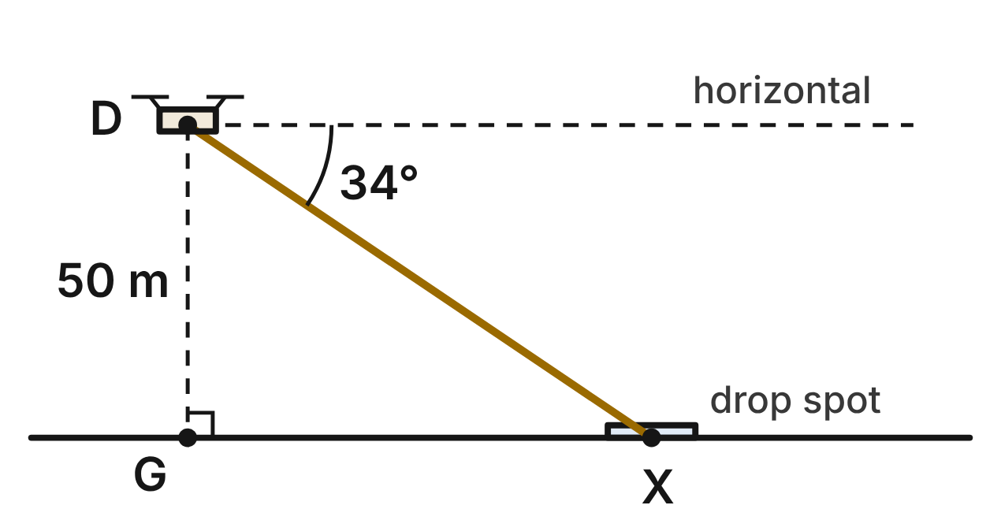
A delivery drone D hovers 50 m above point G on level ground. The angle of depression from the drone to the drop spot X is 34°.
289. To the nearest tenth of a meter, how far is G from the drop spot X?
A. 74.1 m ✔
B. 33.7 m
C. 89.4 m
D. 60.3 m
G.TR.4 · skill G.TR.4.4 (HOTS): Model a contextual problem (angles of elevation and depression, ramps, ladders, distances) with a right triangle and solve it
☐ Answer key correct ☐ Wording clear Notes: ________________________________
290. The drone flies straight from D to X at 5 m per second. To the nearest second, how long does the trip take?
A. 15 s
B. 18 s ✔
C. 10 s
D. 7 s
G.TR.4 · skill G.TR.4.4 (HOTS): Model a contextual problem (angles of elevation and depression, ramps, ladders, distances) with a right triangle and solve it
☐ Answer key correct ☐ Wording clear Notes: ________________________________
291. From D, the angle of depression to another spot Y on the ground, 130 m from G, is θ. To the nearest degree, what is θ?
A. 69°
B. 23°
C. 67°
D. 21° ✔
G.TR.4 · skill G.TR.4.3 (LOTS): Use sine, cosine and tangent ratios to find a side length or an angle measure
☐ Answer key correct ☐ Wording clear Notes: ________________________________
292. Another drone, 50 m up, flies in a straight line down to the ground along a path that makes a 45° angle with the ground. What is the exact length of its path?
A. 50 m
B. 100 m
C. 50√2 m ✔
D. 25√2 m
G.TR.4 · skill G.TR.4.2 (LOTS): Use the relationships in 45°-45°-90° and 30°-60°-90° triangles
☐ Answer key correct ☐ Wording clear Notes: ________________________________
293. On a delivery route, a drone flies 48 m east and then 55 m north at a constant height. How far is it from its start, in a straight line?
A. 103 m
B. 73 m ✔
C. about 27 m
D. 5,329 m
G.TR.4 · skill G.TR.4.1 (LOTS): Use the Pythagorean Theorem and its converse, including to classify a triangle as right, acute or obtuse
☐ Answer key correct ☐ Wording clear Notes: ________________________________
294. Which expression gives DX, the distance from the drone to the drop spot?
A. 50 / sin 34° ✔
B. 50 · sin 34°
C. 50 / cos 34°
D. 50 · tan 34°
G.TR.4 · skill G.TR.4.3 (LOTS): Use sine, cosine and tangent ratios to find a side length or an angle measure
☐ Answer key correct ☐ Wording clear Notes: ________________________________

The Zip Line Ride
Level 2 · Triangles · G.TR.4 · ID geo-tr4-sky-zip-line
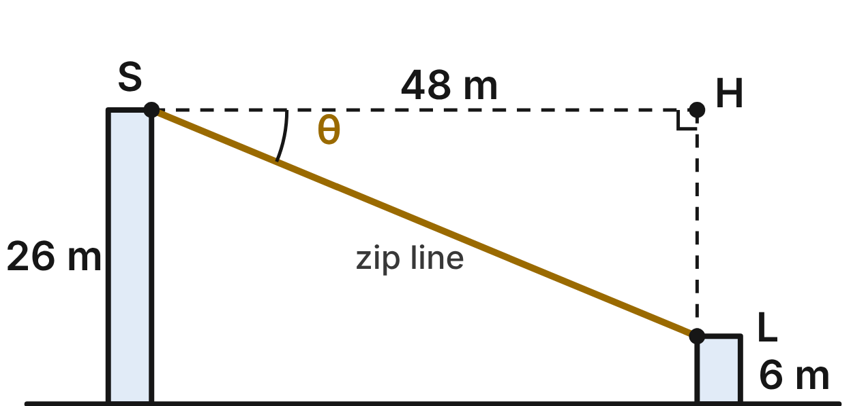
A zip line runs straight from the start platform S, 26 m above level ground, to the landing platform L, 6 m above the ground. L is 48 m from S horizontally. H is level with S, directly above L, and θ is the angle of depression from S to L.
295. How long is the zip line SL?
A. about 54.6 m
B. 68 m
C. about 43.6 m
D. 52 m ✔
G.TR.4 · skill G.TR.4.1 (LOTS): Use the Pythagorean Theorem and its converse, including to classify a triangle as right, acute or obtuse
☐ Answer key correct ☐ Wording clear Notes: ________________________________
296. To the nearest degree, what is θ?
A. 25°
B. 67°
C. 23° ✔
D. 28°
G.TR.4 · skill G.TR.4.4 (HOTS): Model a contextual problem (angles of elevation and depression, ramps, ladders, distances) with a right triangle and solve it
☐ Answer key correct ☐ Wording clear Notes: ________________________________
297. What is tan θ?
A. 5/12 ✔
B. 12/5
C. 5/13
D. 12/13
G.TR.4 · skill G.TR.4.3 (LOTS): Use sine, cosine and tangent ratios to find a side length or an angle measure
☐ Answer key correct ☐ Wording clear Notes: ________________________________
298. A practice zip line is 14 m long and drops at a 30° angle of depression. What is the exact horizontal distance between its ends?
A. 7 m
B. 7√3 m ✔
C. 14√3 m
D. 7√2 m
G.TR.4 · skill G.TR.4.2 (LOTS): Use the relationships in 45°-45°-90° and 30°-60°-90° triangles
☐ Answer key correct ☐ Wording clear Notes: ________________________________
299. The park wants θ to be 15°, with the same platform heights. To the nearest tenth of a meter, how far apart horizontally must the platforms be?
A. 5.4 m
B. 77.3 m
C. 97.0 m
D. 74.6 m ✔
G.TR.4 · skill G.TR.4.4 (HOTS): Model a contextual problem (angles of elevation and depression, ramps, ladders, distances) with a right triangle and solve it
☐ Answer key correct ☐ Wording clear Notes: ________________________________
300. A brace under a platform forms a triangle with sides 1.2 m, 1.6 m and 2.1 m. What kind of angle is opposite the 2.1-m side?
A. acute
B. right
C. obtuse ✔
D. cannot tell without measuring an angle
G.TR.4 · skill G.TR.4.1 (LOTS): Use the Pythagorean Theorem and its converse, including to classify a triangle as right, acute or obtuse
☐ Answer key correct ☐ Wording clear Notes: ________________________________

A Tunnel Under the Hill
Level 3 · Triangles · G.TR.4 · ID geo-tr4-sky-hill-tunnel
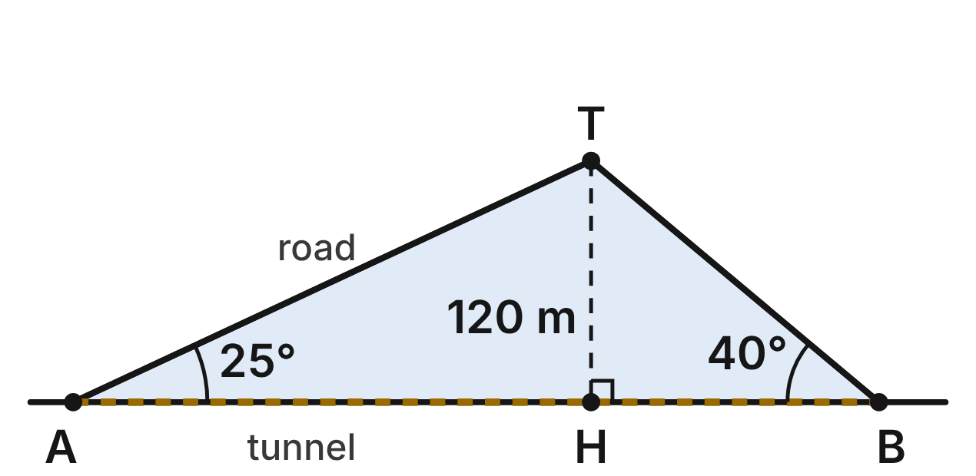
A road climbs straight from A to the hilltop T at a 25° angle with level ground, then descends straight to B at a 40° angle. T is 120 m above H, the point on line AB directly below T. A tunnel will run straight from A to B.
301. To the nearest meter, how far is A from H?
A. 56 m
B. 284 m
C. 257 m ✔
D. 109 m
G.TR.4 · skill G.TR.4.4 (HOTS): Model a contextual problem (angles of elevation and depression, ramps, ladders, distances) with a right triangle and solve it
☐ Answer key correct ☐ Wording clear Notes: ________________________________
302. To the nearest meter, how long will the tunnel AB be?
A. 157 m
B. 471 m
C. 257 m
D. 400 m ✔
G.TR.4 · skill G.TR.4.4 (HOTS): Model a contextual problem (angles of elevation and depression, ramps, ladders, distances) with a right triangle and solve it
☐ Answer key correct ☐ Wording clear Notes: ________________________________
303. To the nearest meter, how much shorter is the tunnel than the road from A over T to B?
A. 70 m ✔
B. 27 m
C. 44 m
D. 471 m
G.TR.4 · skill G.TR.4.4 (HOTS): Model a contextual problem (angles of elevation and depression, ramps, ladders, distances) with a right triangle and solve it
☐ Answer key correct ☐ Wording clear Notes: ________________________________
304. Which equation can be used to find BT, the length of the road down the hill?
A. cos 40° = 120/BT
B. sin 40° = 120/BT ✔
C. tan 40° = 120/BT
D. sin 40° = BT/120
G.TR.4 · skill G.TR.4.3 (LOTS): Use sine, cosine and tangent ratios to find a side length or an angle measure
☐ Answer key correct ☐ Wording clear Notes: ________________________________
305. On a smaller hill, a path rises at 45° to a top 30 m high, then falls at 60° to the ground. What is the exact horizontal distance across the base of the hill?
A. (30 + 30√3) m
B. 60 m
C. (30 + 10√3) m ✔
D. (30√2 + 20√3) m
G.TR.4 · skill G.TR.4.2 (LOTS): Use the relationships in 45°-45°-90° and 30°-60°-90° triangles
☐ Answer key correct ☐ Wording clear Notes: ________________________________
306. Survey stakes near the hill form a triangle with sides 300 m, 400 m and 480 m. Which statement is true?
A. It is acute: 480² is less than 300² + 400². ✔
B. It is right: 300-400-500 is a triple.
C. It is obtuse: 480 is the longest side.
D. It is obtuse: 480² is less than 300² + 400².
G.TR.4 · skill G.TR.4.1 (LOTS): Use the Pythagorean Theorem and its converse, including to classify a triangle as right, acute or obtuse
☐ Answer key correct ☐ Wording clear Notes: ________________________________

The Ferry and the Lighthouse
Level 3 · Triangles · G.TR.4 · ID geo-tr4-sky-ferry-lighthouse
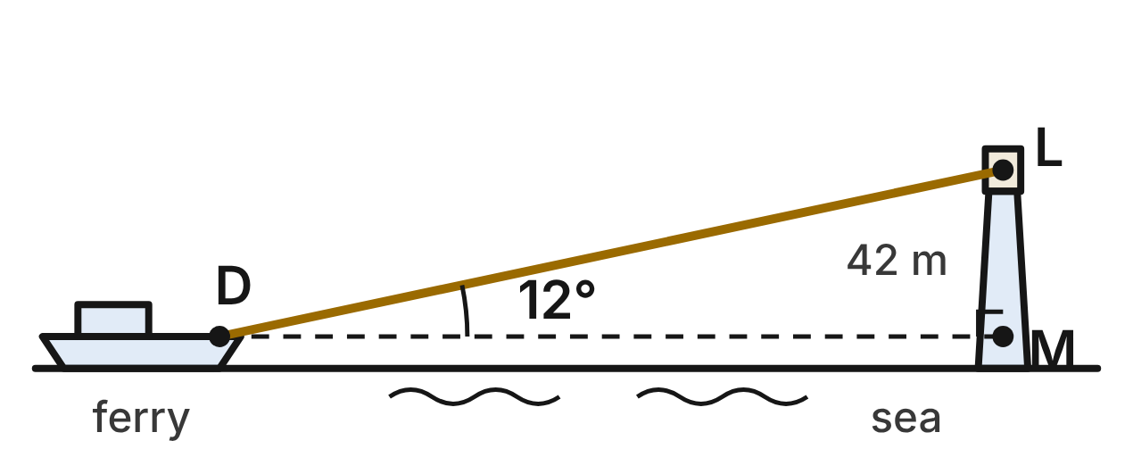
A ferry's deck D is 8 m above the sea. The light L at the top of a lighthouse is 50 m above the sea. M is the point on the lighthouse level with D, so LM = 42 m. From D, the angle of elevation to L is 12°.
307. To the nearest meter, how far is the ferry from the lighthouse horizontally (DM)?
A. 235 m
B. 198 m ✔
C. 9 m
D. 202 m
G.TR.4 · skill G.TR.4.4 (HOTS): Model a contextual problem (angles of elevation and depression, ramps, ladders, distances) with a right triangle and solve it
☐ Answer key correct ☐ Wording clear Notes: ________________________________
308. The ferry sails straight toward the lighthouse until the angle of elevation from D to L is 20°. To the nearest meter, how far did it sail?
A. 82 m ✔
B. 299 m
C. 115 m
D. 98 m
G.TR.4 · skill G.TR.4.4 (HOTS): Model a contextual problem (angles of elevation and depression, ramps, ladders, distances) with a right triangle and solve it
☐ Answer key correct ☐ Wording clear Notes: ________________________________
309. To the nearest meter, how long is the line of sight DL?
A. 198 m
B. 43 m
C. 240 m
D. 202 m ✔
G.TR.4 · skill G.TR.4.3 (LOTS): Use sine, cosine and tangent ratios to find a side length or an angle measure
☐ Answer key correct ☐ Wording clear Notes: ________________________________
310. At one moment, the angle of elevation from D to L is 30°. What is the exact horizontal distance from D to the lighthouse then?
A. 14√3 m
B. 84 m
C. 42√3 m ✔
D. 50√3 m
G.TR.4 · skill G.TR.4.2 (LOTS): Use the relationships in 45°-45°-90° and 30°-60°-90° triangles
☐ Answer key correct ☐ Wording clear Notes: ________________________________
311. The ferry's radar shows a buoy 0.5 km north and 1.2 km east of the ferry. How far is the buoy from the ferry, in a straight line?
A. 1.7 km
B. about 1.1 km
C. 0.7 km
D. 1.3 km ✔
G.TR.4 · skill G.TR.4.1 (LOTS): Use the Pythagorean Theorem and its converse, including to classify a triangle as right, acute or obtuse
☐ Answer key correct ☐ Wording clear Notes: ________________________________
312. When the ferry is 160 m from the lighthouse horizontally, what is the angle of elevation from D to L, to the nearest degree?
A. 17°
B. 15° ✔
C. 75°
D. 3°
G.TR.4 · skill G.TR.4.3 (LOTS): Use sine, cosine and tangent ratios to find a side length or an angle measure
☐ Answer key correct ☐ Wording clear Notes: ________________________________

Polygons and circles (G.PC)

G.PC.1 · Prove and justify theorems and properties of quadrilaterals, and verify and use properties of quadrilaterals to solve problems, including the relationships between the sides, angles, and diagonals.

The Kite at the Beach
Level 1 · Quadrilaterals · G.PC.1 · ID geo-pc1-sky-beach-kite
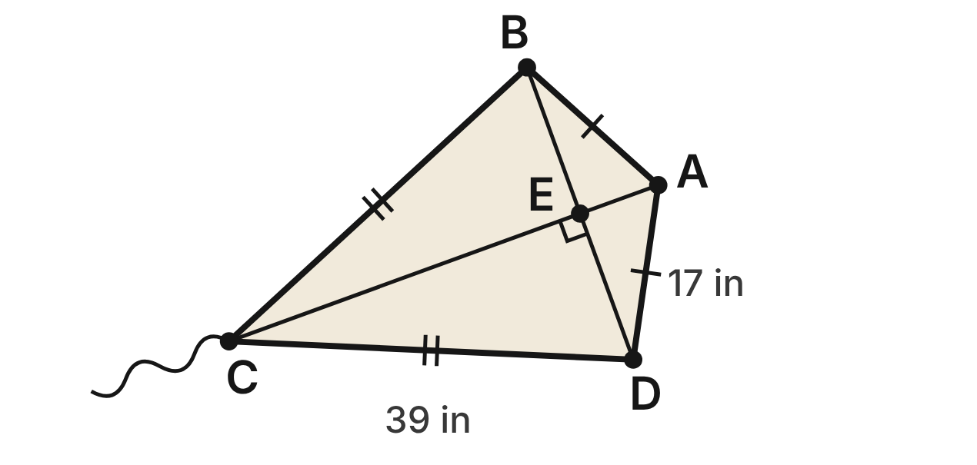
A kite ABCD flies above the beach. AB = AD = 17 in and CB = CD = 39 in. Its spars AC and BD cross at right angles at E, and BD = 30 in.
313. How long is segment BE of the spar?
A. 15 in ✔
B. 30 in
C. 7.5 in
D. 8.5 in
G.PC.1 · skill G.PC.1.3 (LOTS): Solve problems, including algebraic ones, using the properties of quadrilaterals
☐ Answer key correct ☐ Wording clear Notes: ________________________________
314. How long is segment AE of spar AC?
A. 32 in
B. about 22.7 in
C. 2 in
D. 8 in ✔
G.PC.1 · skill G.PC.1.3 (LOTS): Solve problems, including algebraic ones, using the properties of quadrilaterals
☐ Answer key correct ☐ Wording clear Notes: ________________________________
315. EC is 36 in. How long is spar AC?
A. 36 in
B. 28 in
C. 44 in ✔
D. 56 in
G.PC.1 · skill G.PC.1.3 (LOTS): Solve problems, including algebraic ones, using the properties of quadrilaterals
☐ Answer key correct ☐ Wording clear Notes: ________________________________
316. Which angle must be congruent to ∠CBE?
A. ∠ABE
B. ∠CDE ✔
C. ∠BCE
D. ∠BAE
G.PC.1 · skill G.PC.1.1 (LOTS): Identify the properties of parallelograms, rectangles, rhombi, squares, trapezoids and kites (sides, angles, diagonals)
☐ Answer key correct ☐ Wording clear Notes: ________________________________
317. Which statement is NOT true for kite ABCD?
A. Its spars are perpendicular.
B. AC bisects ∠BAD.
C. BE = DE
D. Its spars bisect each other. ✔
G.PC.1 · skill G.PC.1.1 (LOTS): Identify the properties of parallelograms, rectangles, rhombi, squares, trapezoids and kites (sides, angles, diagonals)
☐ Answer key correct ☐ Wording clear Notes: ________________________________
318. Which change to the kite would make it a rhombus?
A. Make CB and CD 17 in, like AB and AD. ✔
B. Make spar BD as long as spar AC.
C. Make the spars meet at right angles.
D. Make ∠ABC ≅ ∠ADC.
G.PC.1 · skill G.PC.1.1 (LOTS): Identify the properties of parallelograms, rectangles, rhombi, squares, trapezoids and kites (sides, angles, diagonals)
☐ Answer key correct ☐ Wording clear Notes: ________________________________

The Canal Barge
Level 1 · Quadrilaterals · G.PC.1 · ID geo-pc1-sky-barge-hull
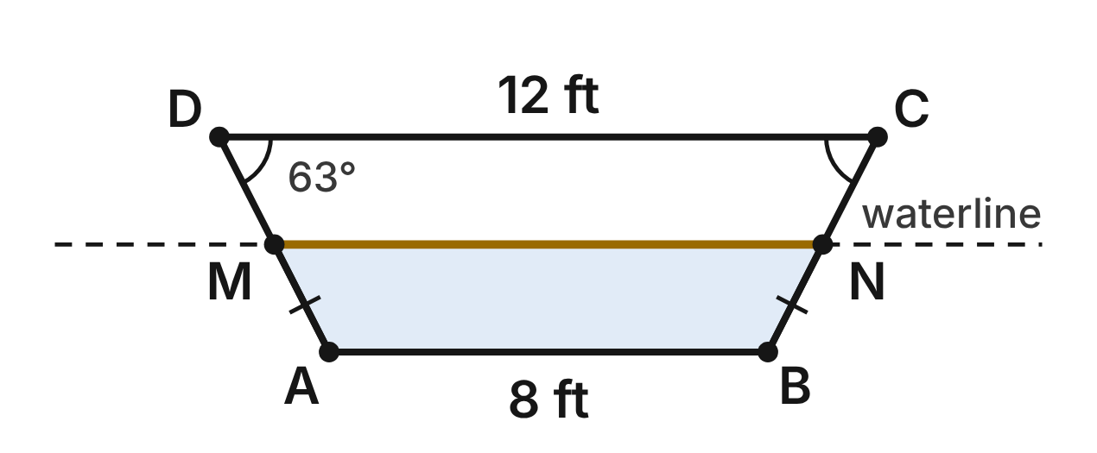
The cross-section of a flat-bottomed canal barge is isosceles trapezoid ABCD. The deck DC is 12 ft, the bottom AB is 8 ft, DC ∥ AB and m∠ADC = 63°. The waterline MN joins the midpoints of the sides AD and BC.
319. How long is the waterline MN?
A. 20 ft
B. 4 ft
C. 10 ft ✔
D. 2 ft
G.PC.1 · skill G.PC.1.3 (LOTS): Solve problems, including algebraic ones, using the properties of quadrilaterals
☐ Answer key correct ☐ Wording clear Notes: ________________________________
320. What is m∠ABC, at the bottom corner B?
A. 63°
B. 117° ✔
C. 27°
D. 126°
G.PC.1 · skill G.PC.1.1 (LOTS): Identify the properties of parallelograms, rectangles, rhombi, squares, trapezoids and kites (sides, angles, diagonals)
☐ Answer key correct ☐ Wording clear Notes: ________________________________
321. Which two sides of the hull must be congruent?
A. AB and DC
B. AD and DC
C. AB and BC
D. AD and BC ✔
G.PC.1 · skill G.PC.1.1 (LOTS): Identify the properties of parallelograms, rectangles, rhombi, squares, trapezoids and kites (sides, angles, diagonals)
☐ Answer key correct ☐ Wording clear Notes: ________________________________
322. Which statement about the diagonals AC and BD of the hull is true?
A. They are congruent but do not bisect each other. ✔
B. They bisect each other but are not congruent.
C. They are perpendicular to each other.
D. They are congruent and bisect each other.
G.PC.1 · skill G.PC.1.1 (LOTS): Identify the properties of parallelograms, rectangles, rhombi, squares, trapezoids and kites (sides, angles, diagonals)
☐ Answer key correct ☐ Wording clear Notes: ________________________________
323. A bigger barge has the same shape. Its deck is (x + 9) ft, its bottom is (x + 1) ft and its waterline (the midsegment) is 13 ft. How wide is its deck?
A. 8 ft
B. 17 ft ✔
C. 9 ft
D. 10.5 ft
G.PC.1 · skill G.PC.1.3 (LOTS): Solve problems, including algebraic ones, using the properties of quadrilaterals
☐ Answer key correct ☐ Wording clear Notes: ________________________________
324. A deckhand says ∠DAB ≅ ∠ADC because the hull is an isosceles trapezoid. Which statement corrects him?
A. He is right; all four angles are congruent.
B. Opposite angles match: ∠DAB ≅ ∠BCD.
C. The base angles match: ∠DAB ≅ ∠ABC and ∠ADC ≅ ∠BCD. ✔
D. ∠DAB and ∠ADC are complementary.
G.PC.1 · skill G.PC.1.1 (LOTS): Identify the properties of parallelograms, rectangles, rhombi, squares, trapezoids and kites (sides, angles, diagonals)
☐ Answer key correct ☐ Wording clear Notes: ________________________________

The Ferry Landing Map
Level 2 · Quadrilaterals · G.PC.1 · ID geo-pc1-sky-ferry-landing
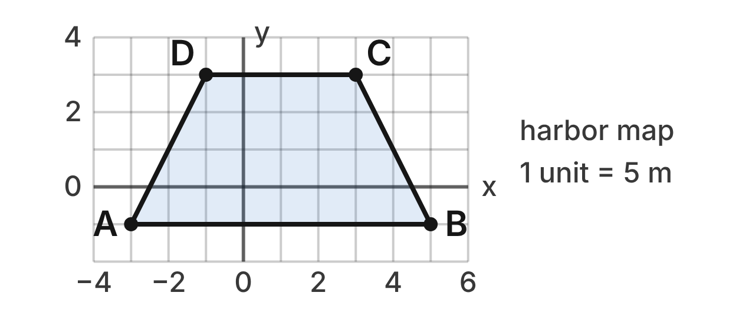
On a harbor map, the ferry landing dock is quadrilateral ABCD with corners A(−3, −1), B(5, −1), C(3, 3) and D(−1, 3). Each grid unit is 5 m. A walkway MN will join the midpoints of AD and BC.
325. Which slopes show that ABCD has exactly one pair of parallel sides?
A. AB and DC: 0; AD: 1/2; BC: −1/2
B. AB and DC: 0; AD and BC: 2
C. AB: 0; DC: undefined
D. AB and DC: 0; AD: 2; BC: −2 ✔
G.PC.1 · skill G.PC.1.2 (HOTS): Use coordinate methods (slope, distance, midpoint) to classify a quadrilateral or justify a property
☐ Answer key correct ☐ Wording clear Notes: ________________________________
326. How long is side AD?
A. 2√5 units ✔
B. 6 units
C. 20 units
D. 2√3 units
G.PC.1 · skill G.PC.1.2 (HOTS): Use coordinate methods (slope, distance, midpoint) to classify a quadrilateral or justify a property
☐ Answer key correct ☐ Wording clear Notes: ________________________________
327. Which fact shows that trapezoid ABCD is isosceles?
A. AB ∥ DC
B. AD = BC = 2√5 ✔
C. AD ⊥ BC
D. AB = 2 · DC
G.PC.1 · skill G.PC.1.2 (HOTS): Use coordinate methods (slope, distance, midpoint) to classify a quadrilateral or justify a property
☐ Answer key correct ☐ Wording clear Notes: ________________________________
328. N is the midpoint of BC. What are the coordinates of N?
A. (−1, 2)
B. (8, 2)
C. (4, 1) ✔
D. (−2, 1)
G.PC.1 · skill G.PC.1.2 (HOTS): Use coordinate methods (slope, distance, midpoint) to classify a quadrilateral or justify a property
☐ Answer key correct ☐ Wording clear Notes: ________________________________
329. How long will walkway MN be, in meters?
A. 30 m ✔
B. 6 m
C. 60 m
D. 20 m
G.PC.1 · skill G.PC.1.3 (LOTS): Solve problems, including algebraic ones, using the properties of quadrilaterals
☐ Answer key correct ☐ Wording clear Notes: ________________________________
330. Which statement is NOT true for dock ABCD?
A. Diagonals AC and BD are congruent.
B. Base angles ∠DAB and ∠ABC are congruent.
C. Bases AB and DC are parallel.
D. Its diagonals bisect each other. ✔
G.PC.1 · skill G.PC.1.1 (LOTS): Identify the properties of parallelograms, rectangles, rhombi, squares, trapezoids and kites (sides, angles, diagonals)
☐ Answer key correct ☐ Wording clear Notes: ________________________________

The Footbridge Panel
Level 2 · Quadrilaterals · G.PC.1 · ID geo-pc1-sky-footbridge
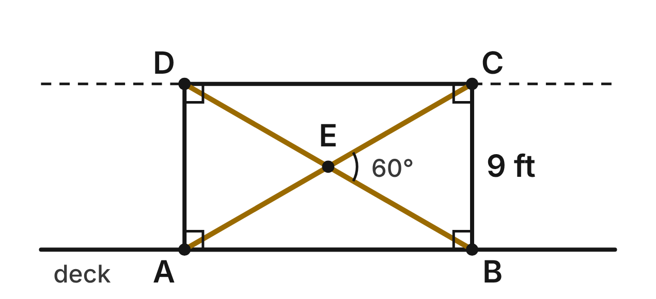
A side panel of a footbridge is rectangle ABCD. Its cross-braces AC and BD meet at E. BC = 9 ft and m∠BEC = 60°.
331. What is m∠EBC?
A. 30°
B. 60° ✔
C. 120°
D. 90°
G.PC.1 · skill G.PC.1.1 (LOTS): Identify the properties of parallelograms, rectangles, rhombi, squares, trapezoids and kites (sides, angles, diagonals)
☐ Answer key correct ☐ Wording clear Notes: ________________________________
332. How long is brace BD?
A. 9 ft
B. 9√2 ft
C. 9√3 ft
D. 18 ft ✔
G.PC.1 · skill G.PC.1.3 (LOTS): Solve problems, including algebraic ones, using the properties of quadrilaterals
☐ Answer key correct ☐ Wording clear Notes: ________________________________
333. What is m∠EAB?
A. 30° ✔
B. 60°
C. 120°
D. 45°
G.PC.1 · skill G.PC.1.3 (LOTS): Solve problems, including algebraic ones, using the properties of quadrilaterals
☐ Answer key correct ☐ Wording clear Notes: ________________________________
334. How long is the bottom side AB of the panel?
A. 18 ft
B. 9√5 ft
C. 9√3 ft ✔
D. 9 ft
G.PC.1 · skill G.PC.1.3 (LOTS): Solve problems, including algebraic ones, using the properties of quadrilaterals
☐ Answer key correct ☐ Wording clear Notes: ________________________________
335. Another rectangular panel PQRS has diagonals PR = (4y + 2) ft and QS = (6y − 10) ft. How long is PR?
A. 6 ft
B. 26 ft ✔
C. 13 ft
D. 52 ft
G.PC.1 · skill G.PC.1.3 (LOTS): Solve problems, including algebraic ones, using the properties of quadrilaterals
☐ Answer key correct ☐ Wording clear Notes: ________________________________
336. Which statement is NOT true for panel ABCD?
A. AC ⊥ BD ✔
B. AE = BE
C. AC ≅ BD
D. ∠ABC is a right angle
G.PC.1 · skill G.PC.1.1 (LOTS): Identify the properties of parallelograms, rectangles, rhombi, squares, trapezoids and kites (sides, angles, diagonals)
☐ Answer key correct ☐ Wording clear Notes: ________________________________

The Angled Parking Space
Level 2 · Quadrilaterals · G.PC.1 · ID geo-pc1-sky-angled-parking
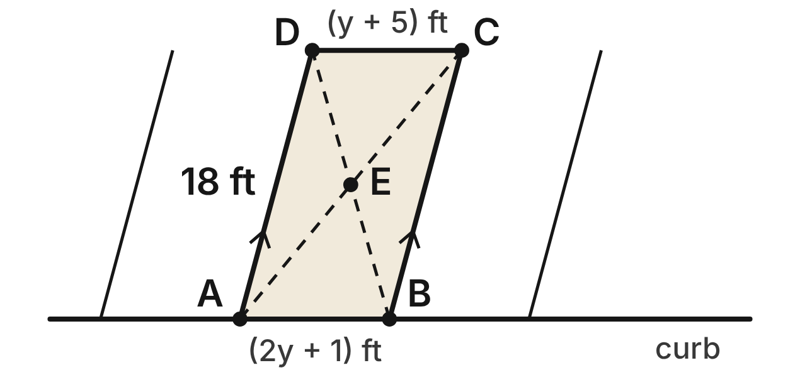
An angled parking space is parallelogram ABCD, with AB along the curb. AB = (2y + 1) ft, DC = (y + 5) ft and the stripe AD = 18 ft. m∠DAB = (3x + 15)° and m∠ABC = (5x + 5)°. The diagonals meet at E.
337. What is m∠BCD in the parking space?
A. 105°
B. 20°
C. 75° ✔
D. 30°
G.PC.1 · skill G.PC.1.3 (LOTS): Solve problems, including algebraic ones, using the properties of quadrilaterals
☐ Answer key correct ☐ Wording clear Notes: ________________________________
338. How long is the curb side AB?
A. 9 ft ✔
B. 4 ft
C. 13 ft
D. 18 ft
G.PC.1 · skill G.PC.1.3 (LOTS): Solve problems, including algebraic ones, using the properties of quadrilaterals
☐ Answer key correct ☐ Wording clear Notes: ________________________________
339. Which segment must be congruent to BE?
A. AE
B. BD
C. AB
D. DE ✔
G.PC.1 · skill G.PC.1.1 (LOTS): Identify the properties of parallelograms, rectangles, rhombi, squares, trapezoids and kites (sides, angles, diagonals)
☐ Answer key correct ☐ Wording clear Notes: ________________________________
340. Why are the stripes AD and BC the same length?
A. The diagonals of a parallelogram are congruent.
B. Opposite sides of a parallelogram are congruent. ✔
C. Consecutive sides of a parallelogram are congruent.
D. AD and BC are perpendicular to the curb.
G.PC.1 · skill G.PC.1.1 (LOTS): Identify the properties of parallelograms, rectangles, rhombi, squares, trapezoids and kites (sides, angles, diagonals)
☐ Answer key correct ☐ Wording clear Notes: ________________________________
341. Space WXYZ is also a parallelogram. Which single fact is enough to prove WXYZ is a rhombus?
A. WY = XZ
B. ∠W is a right angle
C. WX = XY ✔
D. WX = YZ
G.PC.1 · skill G.PC.1.1 (LOTS): Identify the properties of parallelograms, rectangles, rhombi, squares, trapezoids and kites (sides, angles, diagonals)
☐ Answer key correct ☐ Wording clear Notes: ________________________________
342. How long is the painted border of the space, all the way around?
A. 27 ft
B. 44 ft
C. 36 ft
D. 54 ft ✔
G.PC.1 · skill G.PC.1.3 (LOTS): Solve problems, including algebraic ones, using the properties of quadrilaterals
☐ Answer key correct ☐ Wording clear Notes: ________________________________

The Drone Delivery Route
Level 3 · Quadrilaterals · G.PC.1 · ID geo-pc1-sky-drone-route
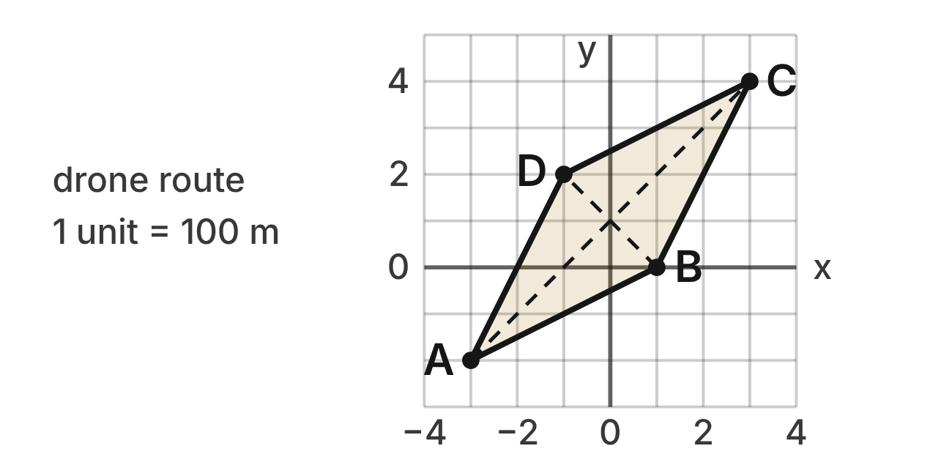
A delivery drone flies a route A → B → C → D → A between drop points A(−3, −2), B(1, 0), C(3, 4) and D(−1, 2) on a city map. Each grid unit is 100 m.
343. Which facts, taken together, prove that ABCD is a rhombus?
A. AC and BD bisect each other and are ⊥. ✔
B. Both pairs of opposite sides are parallel.
C. Both pairs of opposite sides are congruent.
D. AC and BD bisect each other.
G.PC.1 · skill G.PC.1.2 (HOTS): Use coordinate methods (slope, distance, midpoint) to classify a quadrilateral or justify a property
☐ Answer key correct ☐ Wording clear Notes: ________________________________
344. To the nearest meter, how long is diagonal BD on the ground?
A. 400 m
B. 283 m ✔
C. 800 m
D. 200 m
G.PC.1 · skill G.PC.1.2 (HOTS): Use coordinate methods (slope, distance, midpoint) to classify a quadrilateral or justify a property
☐ Answer key correct ☐ Wording clear Notes: ________________________________
345. At what point do the diagonals cross?
A. (3, 3)
B. (0, 2)
C. (−2, 0)
D. (0, 1) ✔
G.PC.1 · skill G.PC.1.2 (HOTS): Use coordinate methods (slope, distance, midpoint) to classify a quadrilateral or justify a property
☐ Answer key correct ☐ Wording clear Notes: ________________________________
346. Which result shows that ∠ABC is NOT a right angle?
A. AB = BC = 2√5, so the sides are equal
B. slope AB = slope DC = 1/2
C. slope AB · slope BC = 1, not −1 ✔
D. slope AC · slope BD = −1
G.PC.1 · skill G.PC.1.2 (HOTS): Use coordinate methods (slope, distance, midpoint) to classify a quadrilateral or justify a property
☐ Answer key correct ☐ Wording clear Notes: ________________________________
347. To the nearest meter, how far does the drone fly on the whole route A → B → C → D → A?
A. 1,789 m ✔
B. 447 m
C. 2,400 m
D. 894 m
G.PC.1 · skill G.PC.1.3 (LOTS): Solve problems, including algebraic ones, using the properties of quadrilaterals
☐ Answer key correct ☐ Wording clear Notes: ________________________________
348. Which statement about the angles of ABCD is true?
A. All four angles are right angles.
B. Diagonal AC bisects ∠DAB and ∠BCD. ✔
C. ∠DAB ≅ ∠ABC.
D. ∠DAB and ∠BCD are supplementary.
G.PC.1 · skill G.PC.1.1 (LOTS): Identify the properties of parallelograms, rectangles, rhombi, squares, trapezoids and kites (sides, angles, diagonals)
☐ Answer key correct ☐ Wording clear Notes: ________________________________

The Four-Town Rail Loop
Level 3 · Quadrilaterals · G.PC.1 · ID geo-pc1-sky-rail-loop
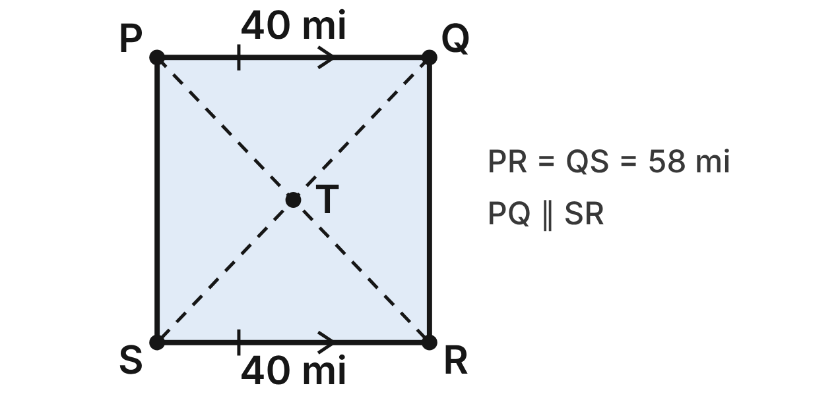
A rail loop joins four towns P, Q, R and S. Straight roads PR and QS cross at T. Surveyors know only that PQ ∥ SR, PQ = SR = 40 mi and PR = QS = 58 mi.
349. Using only the facts PQ ∥ SR and PQ = SR, what can you conclude?
A. PQRS is a trapezoid.
B. PQRS is a rectangle.
C. PQRS is a rhombus.
D. PQRS is a parallelogram. ✔
G.PC.1 · skill G.PC.1.1 (LOTS): Identify the properties of parallelograms, rectangles, rhombi, squares, trapezoids and kites (sides, angles, diagonals)
☐ Answer key correct ☐ Wording clear Notes: ________________________________
350. Which reason proves that PQRS is a rectangle?
A. Its diagonals bisect each other.
B. It has a pair of congruent opposite sides.
C. It is a parallelogram with congruent diagonals. ✔
D. Its diagonals are perpendicular.
G.PC.1 · skill G.PC.1.1 (LOTS): Identify the properties of parallelograms, rectangles, rhombi, squares, trapezoids and kites (sides, angles, diagonals)
☐ Answer key correct ☐ Wording clear Notes: ________________________________
351. PQRS is a rectangle. How long is the rail line QR?
A. 18 mi
B. 42 mi ✔
C. about 70.5 mi
D. 98 mi
G.PC.1 · skill G.PC.1.3 (LOTS): Solve problems, including algebraic ones, using the properties of quadrilaterals
☐ Answer key correct ☐ Wording clear Notes: ________________________________
352. How long is the whole rail loop P → Q → R → S → P?
A. 164 mi ✔
B. 82 mi
C. 160 mi
D. 196 mi
G.PC.1 · skill G.PC.1.3 (LOTS): Solve problems, including algebraic ones, using the properties of quadrilaterals
☐ Answer key correct ☐ Wording clear Notes: ________________________________
353. How far is it along road PR from town P to the crossing T?
A. 58 mi
B. 20 mi
C. 21 mi
D. 29 mi ✔
G.PC.1 · skill G.PC.1.3 (LOTS): Solve problems, including algebraic ones, using the properties of quadrilaterals
☐ Answer key correct ☐ Wording clear Notes: ________________________________
354. Which statement is NOT justified by the surveyors' facts?
A. PT = QT
B. PR ⊥ QS ✔
C. ∠PQR is a right angle
D. PS ∥ QR
G.PC.1 · skill G.PC.1.1 (LOTS): Identify the properties of parallelograms, rectangles, rhombi, squares, trapezoids and kites (sides, angles, diagonals)
☐ Answer key correct ☐ Wording clear Notes: ________________________________

G.PC.2 · Verify relationships and solve problems involving the number of sides and measures of angles of convex polygons.

The Roundabout Island
Level 1 · Polygons · G.PC.2 · ID geo-pc2-sky-roundabout
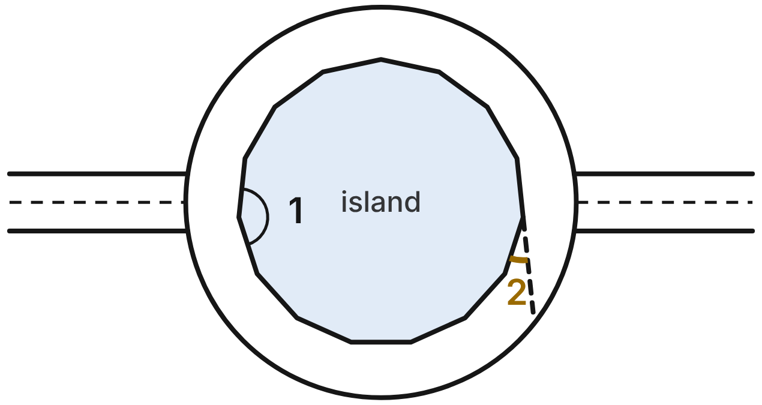
The center island of a roundabout is a regular 15-gon (15 congruent sides and 15 congruent angles). ∠1 is an interior angle of the island. One side is extended (dashed), and ∠2 is the exterior angle it makes.
355. What is the sum of the interior angles of the island?
A. 2700°
B. 2520°
C. 2340° ✔
D. 360°
G.PC.2 · skill G.PC.2.1 (LOTS): Find the sum of the interior angles, and the measure of each interior and exterior angle, of a convex or regular polygon
☐ Answer key correct ☐ Wording clear Notes: ________________________________
356. What is m∠1, an interior angle of the island?
A. 156° ✔
B. 24°
C. 168°
D. 180°
G.PC.2 · skill G.PC.2.1 (LOTS): Find the sum of the interior angles, and the measure of each interior and exterior angle, of a convex or regular polygon
☐ Answer key correct ☐ Wording clear Notes: ________________________________
357. What is the measure of the gold exterior angle, ∠2?
A. 156°
B. 12°
C. about 25.7°
D. 24° ✔
G.PC.2 · skill G.PC.2.1 (LOTS): Find the sum of the interior angles, and the measure of each interior and exterior angle, of a convex or regular polygon
☐ Answer key correct ☐ Wording clear Notes: ________________________________
358. Dev says a regular island with more sides would have a larger sum of exterior angles. Which is true?
A. Yes: each added side adds 180° to the sum.
B. No: the exterior angles always add to 360°. ✔
C. Yes: each added side adds 24° to the sum.
D. No: the sum gets smaller as sides are added.
G.PC.2 · skill G.PC.2.1 (LOTS): Find the sum of the interior angles, and the measure of each interior and exterior angle, of a convex or regular polygon
☐ Answer key correct ☐ Wording clear Notes: ________________________________
359. Another roundabout island is a regular polygon with interior angles of 172°. How many sides does it have?
A. 8
B. about 2.1
C. 22.5
D. 45 ✔
G.PC.2 · skill G.PC.2.2 (LOTS): Find the number of sides of a regular polygon given the measure of an interior or exterior angle
☐ Answer key correct ☐ Wording clear Notes: ________________________________
360. The sign at each entrance is a regular polygon whose exterior angles each measure 120°. How many sides does the sign have?
A. 3 ✔
B. 60
C. 1.5
D. 5
G.PC.2 · skill G.PC.2.2 (LOTS): Find the number of sides of a regular polygon given the measure of an interior or exterior angle
☐ Answer key correct ☐ Wording clear Notes: ________________________________

Symbols on the City Map
Level 1 · Polygons · G.PC.2 · ID geo-pc2-sky-map-symbols
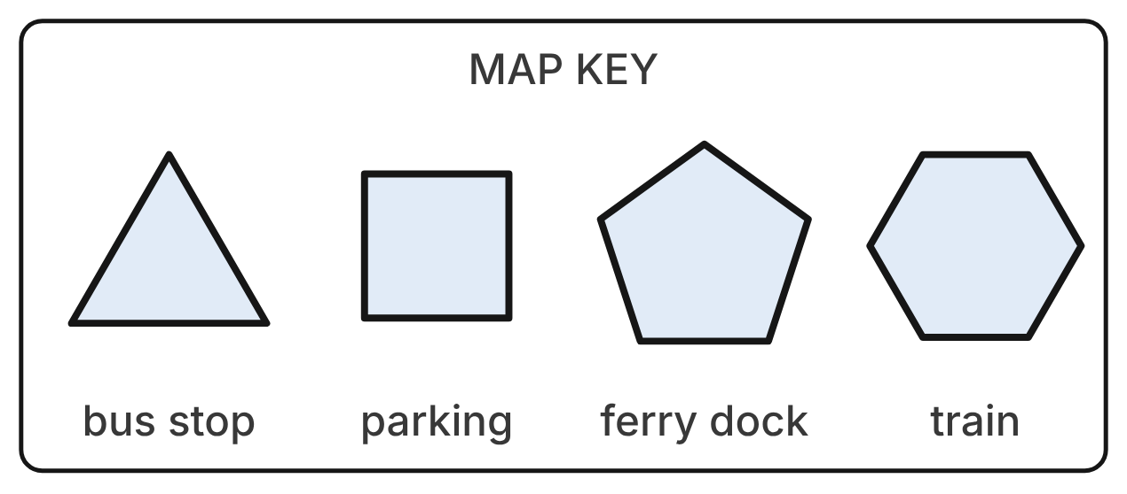
A city map uses four regular polygon symbols: an equilateral triangle (bus stop), a square (parking), a regular pentagon (ferry dock) and a regular hexagon (train station).
361. Which symbol's interior angles add to 540°?
A. the train hexagon
B. the ferry dock pentagon ✔
C. the bus stop triangle
D. the parking square
G.PC.2 · skill G.PC.2.1 (LOTS): Find the sum of the interior angles, and the measure of each interior and exterior angle, of a convex or regular polygon
☐ Answer key correct ☐ Wording clear Notes: ________________________________
362. What is the measure of each interior angle of the train symbol?
A. 60°
B. 180°
C. 720°
D. 120° ✔
G.PC.2 · skill G.PC.2.1 (LOTS): Find the sum of the interior angles, and the measure of each interior and exterior angle, of a convex or regular polygon
☐ Answer key correct ☐ Wording clear Notes: ________________________________
363. Which symbol has the largest exterior angle?
A. the bus stop triangle ✔
B. the train hexagon
C. All four are equal.
D. the parking square
G.PC.2 · skill G.PC.2.1 (LOTS): Find the sum of the interior angles, and the measure of each interior and exterior angle, of a convex or regular polygon
☐ Answer key correct ☐ Wording clear Notes: ________________________________
364. Which statement about the exterior angles of the symbols is true?
A. The hexagon's exterior angles add to 720°.
B. The triangle's exterior angles add to 180°.
C. Each symbol's exterior angles add to 360°. ✔
D. The square's exterior angles add to 90°.
G.PC.2 · skill G.PC.2.1 (LOTS): Find the sum of the interior angles, and the measure of each interior and exterior angle, of a convex or regular polygon
☐ Answer key correct ☐ Wording clear Notes: ________________________________
365. How many degrees larger is each angle of the ferry dock pentagon than each angle of the parking square?
A. 180°
B. 72°
C. 18° ✔
D. 108°
G.PC.2 · skill G.PC.2.1 (LOTS): Find the sum of the interior angles, and the measure of each interior and exterior angle, of a convex or regular polygon
☐ Answer key correct ☐ Wording clear Notes: ________________________________
366. The map maker adds a fifth symbol: a regular polygon whose exterior angles each measure 36°. How many sides does it have?
A. 5
B. 10 ✔
C. 144
D. 12
G.PC.2 · skill G.PC.2.2 (LOTS): Find the number of sides of a regular polygon given the measure of an interior or exterior angle
☐ Answer key correct ☐ Wording clear Notes: ________________________________

The Station Plaza Pavers
Level 2 · Polygons · G.PC.2 · ID geo-pc2-sky-station-pavers
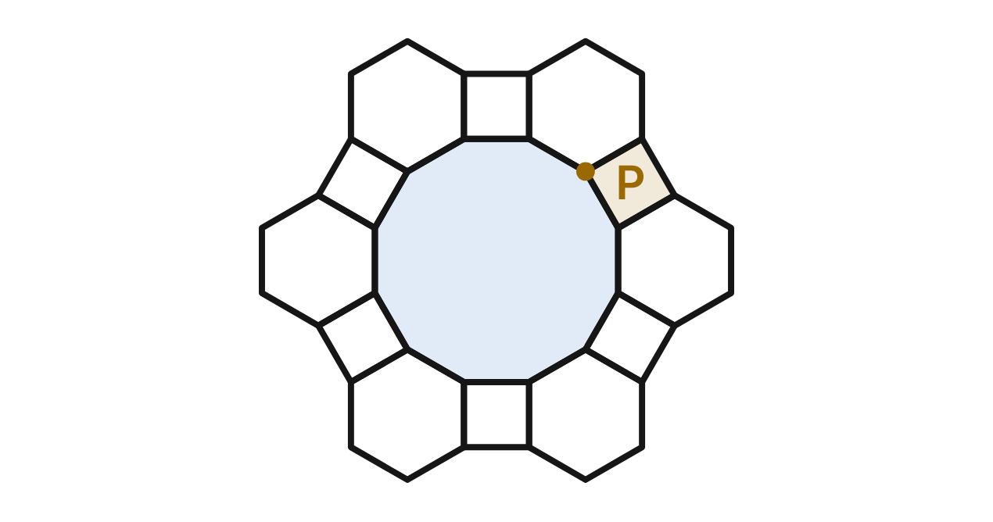
A train station plaza is paved with regular 12-gons, regular hexagons and squares, all with equal sides, with no gaps or overlaps. At point P, one of each shape meets.
367. What is the measure of each angle of a 12-sided paver?
A. 30°
B. 150° ✔
C. 165°
D. 1800°
G.PC.2 · skill G.PC.2.1 (LOTS): Find the sum of the interior angles, and the measure of each interior and exterior angle, of a convex or regular polygon
☐ Answer key correct ☐ Wording clear Notes: ________________________________
368. Which calculation shows why the three pavers leave no gap at P?
A. 90° + 60° + 30° = 180°
B. 360° + 720° + 1800° = 2880°
C. 90° + 108° + 162° = 360°
D. 90° + 120° + 150° = 360° ✔
G.PC.2 · skill G.PC.2.1 (LOTS): Find the sum of the interior angles, and the measure of each interior and exterior angle, of a convex or regular polygon
☐ Answer key correct ☐ Wording clear Notes: ________________________________
369. Could the 12-sided pavers alone cover the plaza with no gaps or overlaps?
A. No: 360 ÷ 150 = 2.4 is not whole. ✔
B. Yes: the angle sum, 1800°, is a multiple of 360°.
C. Yes: its exterior angles add to 360°.
D. Yes: 12 is a multiple of 6, like a hexagon.
G.PC.2 · skill G.PC.2.1 (LOTS): Find the sum of the interior angles, and the measure of each interior and exterior angle, of a convex or regular polygon
☐ Answer key correct ☐ Wording clear Notes: ________________________________
370. A paver catalog lists a regular polygon with interior angles of 105°. Which is true?
A. It has 5 sides, rounding 4.8 up.
B. It has about 3.4 sides: 360 ÷ 105.
C. It cannot exist: 360 ÷ 75 = 4.8. ✔
D. It exists, since 105° is less than 180°.
G.PC.2 · skill G.PC.2.2 (LOTS): Find the number of sides of a regular polygon given the measure of an interior or exterior angle
☐ Answer key correct ☐ Wording clear Notes: ________________________________
371. At another corner, a regular hexagon and two squares meet. How large is the gap that is left?
A. 120°
B. 60° ✔
C. 150°
D. 240°
G.PC.2 · skill G.PC.2.1 (LOTS): Find the sum of the interior angles, and the measure of each interior and exterior angle, of a convex or regular polygon
☐ Answer key correct ☐ Wording clear Notes: ________________________________
372. Around another point, one square and two congruent regular pavers meet with no gap. How many sides does each of those two pavers have?
A. 135
B. about 2.7
C. 8 ✔
D. 4
G.PC.2 · skill G.PC.2.2 (LOTS): Find the number of sides of a regular polygon given the measure of an interior or exterior angle
☐ Answer key correct ☐ Wording clear Notes: ________________________________

The Train Roundhouse
Level 2 · Polygons · G.PC.2 · ID geo-pc2-sky-roundhouse
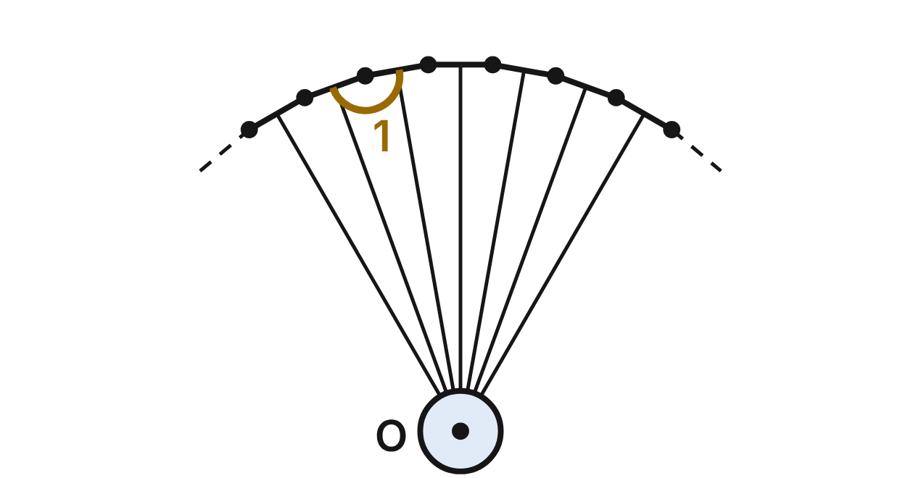
In a train roundhouse, tracks fan out from a turntable at O, 10° apart, to a wall made of straight sections. The wall corners are all the same distance from O, and each section spans 10° at O. If the stalls went all the way around, the wall would be a regular polygon.
373. If the wall went all the way around O, how many sides would it have?
A. 36 ✔
B. 18
C. 10
D. 34
G.PC.2 · skill G.PC.2.2 (LOTS): Find the number of sides of a regular polygon given the measure of an interior or exterior angle
☐ Answer key correct ☐ Wording clear Notes: ________________________________
374. What is m∠1, the angle between two wall sections?
A. 10°
B. 160°
C. 175°
D. 170° ✔
G.PC.2 · skill G.PC.2.1 (LOTS): Find the sum of the interior angles, and the measure of each interior and exterior angle, of a convex or regular polygon
☐ Answer key correct ☐ Wording clear Notes: ________________________________
375. One wall section is extended straight past a corner. What angle does the extension make with the next wall section?
A. 170°
B. 10° ✔
C. 5°
D. 20°
G.PC.2 · skill G.PC.2.1 (LOTS): Find the sum of the interior angles, and the measure of each interior and exterior angle, of a convex or regular polygon
☐ Answer key correct ☐ Wording clear Notes: ________________________________
376. What would be the sum of the interior angles of the full wall polygon?
A. 6480°
B. 6300°
C. 6120° ✔
D. 360°
G.PC.2 · skill G.PC.2.1 (LOTS): Find the sum of the interior angles, and the measure of each interior and exterior angle, of a convex or regular polygon
☐ Answer key correct ☐ Wording clear Notes: ________________________________
377. A larger roundhouse's wall would form a regular polygon with interior angles of 174°. How many sides would it have?
A. 6
B. 30
C. about 2.1
D. 60 ✔
G.PC.2 · skill G.PC.2.2 (LOTS): Find the number of sides of a regular polygon given the measure of an interior or exterior angle
☐ Answer key correct ☐ Wording clear Notes: ________________________________
378. Rosa says the angle between two wall sections is 360° ÷ 36 = 10°. Which is true?
A. She found the exterior angle; it is 170°. ✔
B. She is right: the angle is 10°.
C. She should use 180° ÷ 36 = 5°.
D. She should use (36 − 2) · 180° = 6120°.
G.PC.2 · skill G.PC.2.1 (LOTS): Find the sum of the interior angles, and the measure of each interior and exterior angle, of a convex or regular polygon
☐ Answer key correct ☐ Wording clear Notes: ________________________________

The Sailing Race Course
Level 2 · Polygons · G.PC.2 · ID geo-pc2-sky-sailing-course
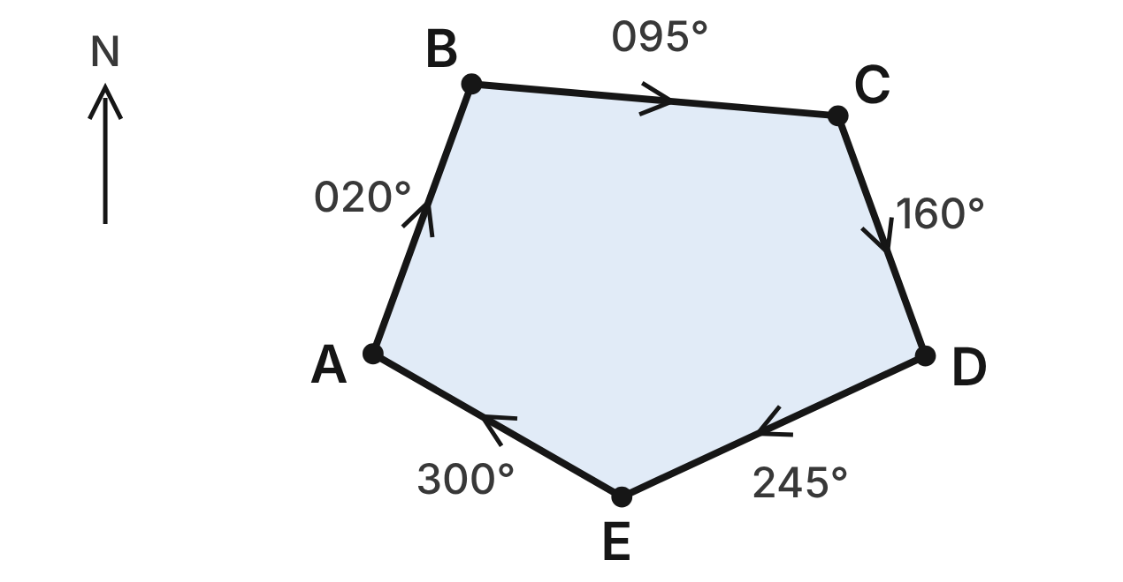
A sailboat races once around the closed course ABCDE, clockwise. Each leg's compass heading is shown, in degrees clockwise from north. At each buoy the boat turns right by the change in heading.
379. Through what angle does the boat turn at buoy C?
A. 115°
B. 160°
C. 65° ✔
D. 255°
G.PC.2 · skill G.PC.2.1 (LOTS): Find the sum of the interior angles, and the measure of each interior and exterior angle, of a convex or regular polygon
☐ Answer key correct ☐ Wording clear Notes: ________________________________
380. What is the angle inside the course at buoy D?
A. 95° ✔
B. 85°
C. 265°
D. 245°
G.PC.2 · skill G.PC.2.1 (LOTS): Find the sum of the interior angles, and the measure of each interior and exterior angle, of a convex or regular polygon
☐ Answer key correct ☐ Wording clear Notes: ________________________________
381. Through how many degrees does the boat turn in all during one lap?
A. 540°
B. 360° ✔
C. 180°
D. 900°
G.PC.2 · skill G.PC.2.1 (LOTS): Find the sum of the interior angles, and the measure of each interior and exterior angle, of a convex or regular polygon
☐ Answer key correct ☐ Wording clear Notes: ________________________________
382. What is the sum of the five angles inside the course?
A. 360°
B. 900°
C. 720°
D. 540° ✔
G.PC.2 · skill G.PC.2.1 (LOTS): Find the sum of the interior angles, and the measure of each interior and exterior angle, of a convex or regular polygon
☐ Answer key correct ☐ Wording clear Notes: ________________________________
383. At which buoy is the angle inside the course the smallest?
A. at E
B. at D ✔
C. at C
D. at A
G.PC.2 · skill G.PC.2.1 (LOTS): Find the sum of the interior angles, and the measure of each interior and exterior angle, of a convex or regular polygon
☐ Answer key correct ☐ Wording clear Notes: ________________________________
384. For practice, the crew sails a regular course, turning 20° at each buoy. How many buoys does the practice course have?
A. 9
B. 160
C. 18 ✔
D. 16
G.PC.2 · skill G.PC.2.2 (LOTS): Find the number of sides of a regular polygon given the measure of an interior or exterior angle
☐ Answer key correct ☐ Wording clear Notes: ________________________________

The Airport Terminal
Level 3 · Polygons · G.PC.2 · ID geo-pc2-sky-airport-terminal
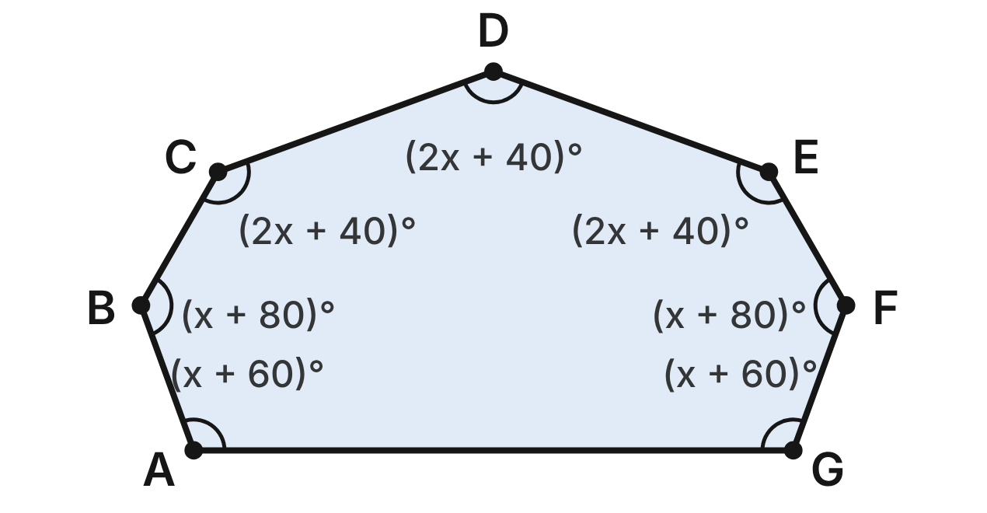
The floor plan of a new airport terminal is the convex heptagon ABCDEFG. Its angle measures, in degrees, are shown in terms of x.
385. Which equation uses the terminal's angle sum to find x?
A. 10x + 400 = 1260
B. 10x + 400 = 1080
C. 10x + 400 = 360
D. 10x + 400 = 900 ✔
G.PC.2 · skill G.PC.2.1 (LOTS): Find the sum of the interior angles, and the measure of each interior and exterior angle, of a convex or regular polygon
☐ Answer key correct ☐ Wording clear Notes: ________________________________
386. Find the value of x.
A. 86
B. 50 ✔
C. 68
D. 90
G.PC.2 · skill G.PC.2.1 (LOTS): Find the sum of the interior angles, and the measure of each interior and exterior angle, of a convex or regular polygon
☐ Answer key correct ☐ Wording clear Notes: ________________________________
387. What is m∠B?
A. 130° ✔
B. 148°
C. 50°
D. 166°
G.PC.2 · skill G.PC.2.1 (LOTS): Find the sum of the interior angles, and the measure of each interior and exterior angle, of a convex or regular polygon
☐ Answer key correct ☐ Wording clear Notes: ________________________________
388. What is the measure of an exterior angle of the terminal at corner A?
A. 110°
B. 250°
C. 70° ✔
D. about 51.4°
G.PC.2 · skill G.PC.2.1 (LOTS): Find the sum of the interior angles, and the measure of each interior and exterior angle, of a convex or regular polygon
☐ Answer key correct ☐ Wording clear Notes: ________________________________
389. Which statement about the terminal is NOT true?
A. Each exterior angle is about 51.4°. ✔
B. ∠C and ∠E have the same measure.
C. The exterior angles add to 360°.
D. The angles at A and B add to 240°.
G.PC.2 · skill G.PC.2.1 (LOTS): Find the sum of the interior angles, and the measure of each interior and exterior angle, of a convex or regular polygon
☐ Answer key correct ☐ Wording clear Notes: ________________________________
390. A planned terminal will be a regular polygon whose interior angles each equal m∠B. Which is true?
A. It will have 7 sides, rounding 7.2 down.
B. It will have 8 sides, rounding 7.2 up.
C. It cannot be built: 360 ÷ 50 = 7.2. ✔
D. It is possible, since m∠B is less than 180°.
G.PC.2 · skill G.PC.2.2 (LOTS): Find the number of sides of a regular polygon given the measure of an interior or exterior angle
☐ Answer key correct ☐ Wording clear Notes: ________________________________

The Drone's Turning Path
Level 3 · Polygons · G.PC.2 · ID geo-pc2-sky-drone-path
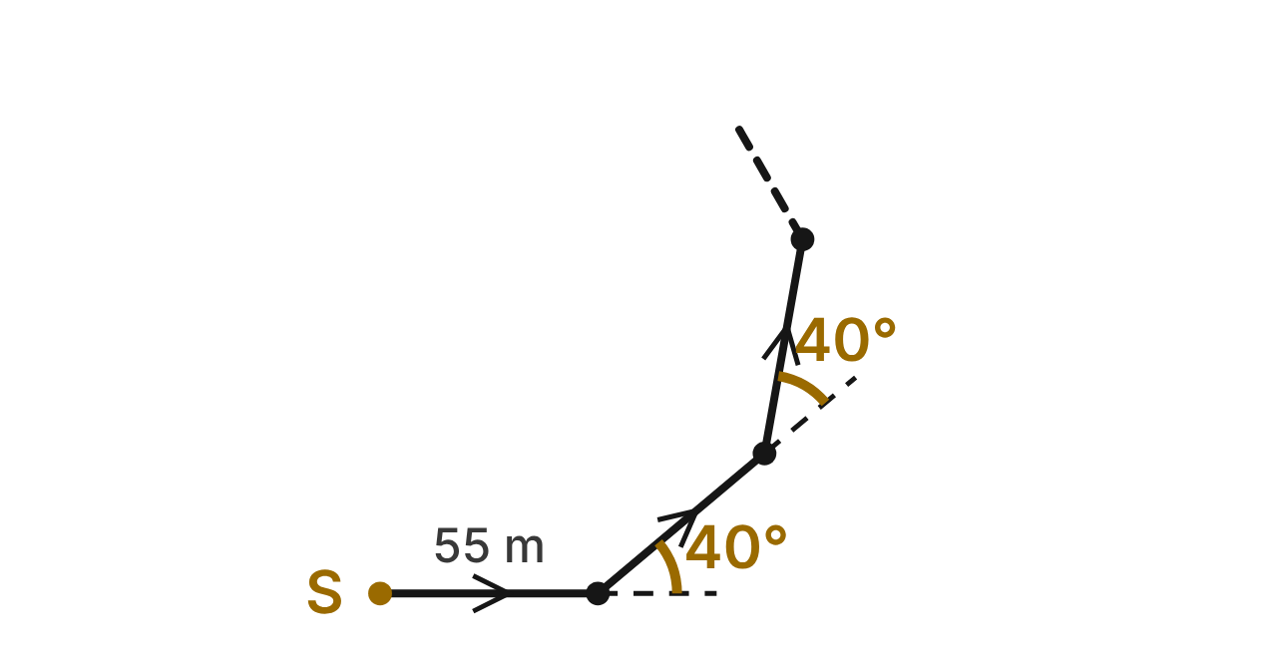
A drone starts at S and flies straight 55-m legs. After each leg it turns left 40°, as shown. It keeps flying legs and turning until it is back at S, heading the way it started.
391. The drone's whole path is a regular polygon. How many legs does it have?
A. 4.5
B. 9 ✔
C. about 2.6
D. 7
G.PC.2 · skill G.PC.2.2 (LOTS): Find the number of sides of a regular polygon given the measure of an interior or exterior angle
☐ Answer key correct ☐ Wording clear Notes: ________________________________
392. What is the angle between two legs at a turn, measured inside the path?
A. 40°
B. 220°
C. 320°
D. 140° ✔
G.PC.2 · skill G.PC.2.1 (LOTS): Find the sum of the interior angles, and the measure of each interior and exterior angle, of a convex or regular polygon
☐ Answer key correct ☐ Wording clear Notes: ________________________________
393. Through how many degrees does the drone turn in all, from S until it is back at S heading the way it started?
A. 180°
B. 400°
C. 360° ✔
D. 1260°
G.PC.2 · skill G.PC.2.1 (LOTS): Find the sum of the interior angles, and the measure of each interior and exterior angle, of a convex or regular polygon
☐ Answer key correct ☐ Wording clear Notes: ________________________________
394. Does the drone ever fly in exactly the opposite direction from its first leg?
A. No: 180 ÷ 40 = 4.5 is not whole. ✔
B. Yes: 4 turns of 40° make about 180°.
C. Yes: 5 turns of 40° make about 180°.
D. Yes: after 9 turns it has turned 360°.
G.PC.2 · skill G.PC.2.1 (LOTS): Find the sum of the interior angles, and the measure of each interior and exterior angle, of a convex or regular polygon
☐ Answer key correct ☐ Wording clear Notes: ________________________________
395. The pilot changes the turn so that the drone first flies exactly opposite its first leg after 6 equal turns. How many legs will the closed path have?
A. 6
B. 30
C. 24
D. 12 ✔
G.PC.2 · skill G.PC.2.2 (LOTS): Find the number of sides of a regular polygon given the measure of an interior or exterior angle
☐ Answer key correct ☐ Wording clear Notes: ________________________________
396. Which statement about the drone's path is NOT true?
A. The closed path has 9 legs.
B. Each angle inside the path measures 40°. ✔
C. The 9 turns add to 360°.
D. At each turn, the turn and the inside angle add to 180°.
G.PC.2 · skill G.PC.2.1 (LOTS): Find the sum of the interior angles, and the measure of each interior and exterior angle, of a convex or regular polygon
☐ Answer key correct ☐ Wording clear Notes: ________________________________

G.PC.3 · Solve problems, including contextual problems, by applying properties of circles.

The Locomotive Wheel
Level 1 · Circles · G.PC.3 · ID geo-pc3-sky-locomotive-wheel
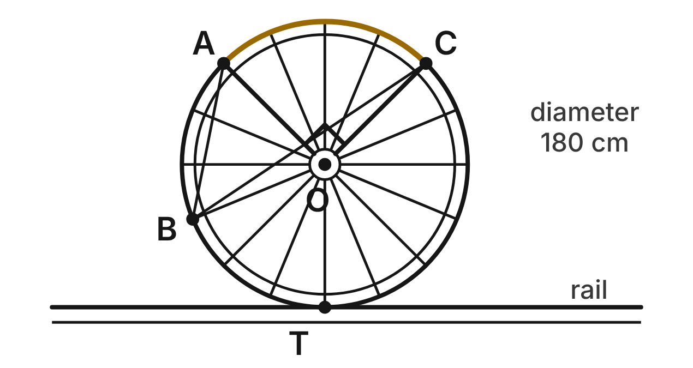
A locomotive wheel has center O, a diameter of 180 cm and 16 equally spaced spokes. Spokes OA and OC are perpendicular, and B is the end of another spoke. The wheel rolls along a straight rail and touches it at T.
397. What is the central angle between two spokes next to each other?
A. 22.5° ✔
B. 11.25°
C. 45°
D. 157.5°
G.PC.3 · skill G.PC.3.1 (LOTS): Use the angles formed by chords, secants and tangents (central, inscribed, and angles inside and outside a circle) and their arcs
☐ Answer key correct ☐ Wording clear Notes: ________________________________
398. The wheel makes one full turn without slipping. How far does the train move? Round to the nearest centimeter.
A. 283 cm
B. 1,131 cm
C. 565 cm ✔
D. 25,447 cm
G.PC.3 · skill G.PC.3.4 (HOTS): Model and solve a contextual problem with the properties of circles
☐ Answer key correct ☐ Wording clear Notes: ________________________________
399. How long is arc AC along the rim? Give the answer in terms of π.
A. 22.5π cm
B. 45π cm ✔
C. 90π cm
D. 2,025π cm
G.PC.3 · skill G.PC.3.3 (LOTS): Find arc length and the area of a sector, or use them to find a radius or a central angle
☐ Answer key correct ☐ Wording clear Notes: ________________________________
400. Which statement about radius OT and the rail must be true?
A. OT is parallel to the rail.
B. OT meets the rail at a 22.5° angle.
C. OT meets the rail at a 45° angle.
D. OT is perpendicular to the rail. ✔
G.PC.3 · skill G.PC.3.1 (LOTS): Use the angles formed by chords, secants and tangents (central, inscribed, and angles inside and outside a circle) and their arcs
☐ Answer key correct ☐ Wording clear Notes: ________________________________
401. What is m∠ABC, the angle at B between the chords to A and C?
A. 45° ✔
B. 90°
C. 135°
D. 22.5°
G.PC.3 · skill G.PC.3.1 (LOTS): Use the angles formed by chords, secants and tangents (central, inscribed, and angles inside and outside a circle) and their arcs
☐ Answer key correct ☐ Wording clear Notes: ________________________________
402. A smaller wheel has a 60° arc between two spokes that is 15π cm long. What is that wheel's radius?
A. 90 cm
B. 7.5 cm
C. 45 cm ✔
D. about 9.5 cm
G.PC.3 · skill G.PC.3.3 (LOTS): Find arc length and the area of a sector, or use them to find a radius or a central angle
☐ Answer key correct ☐ Wording clear Notes: ________________________________

The Compass Rose
Level 1 · Circles · G.PC.3 · ID geo-pc3-sky-compass-rose
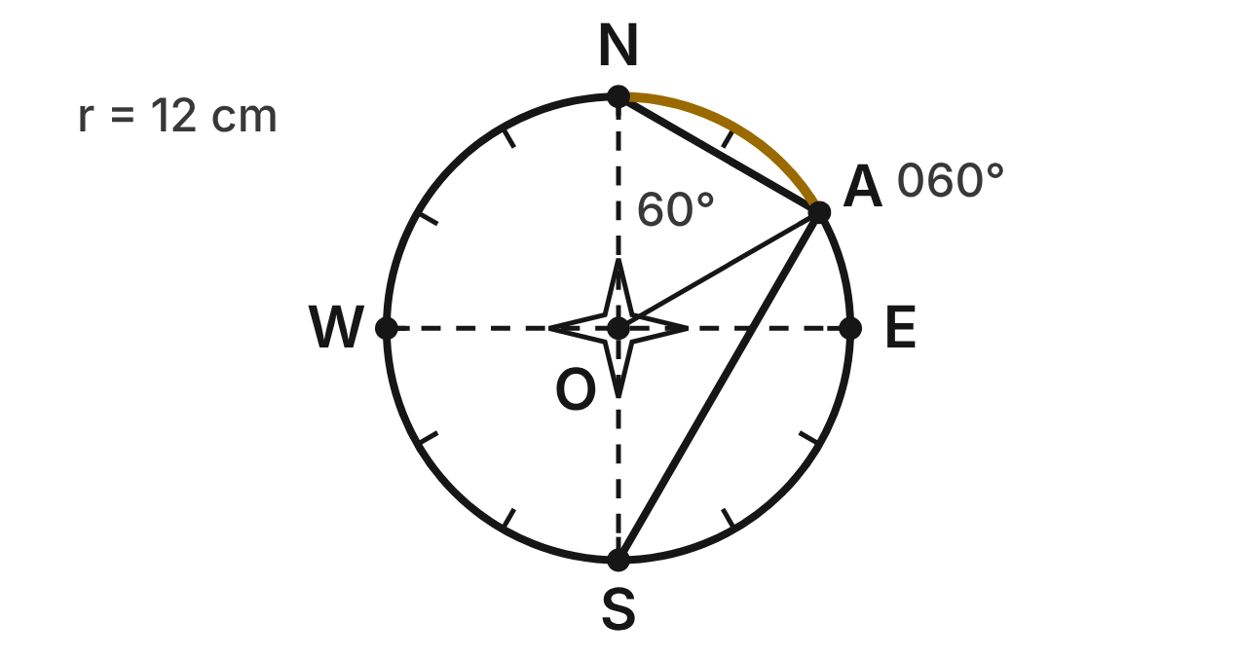
A compass rose on a travel map is a circle with center O and radius 12 cm. Points N, E, S and W on the circle mark north, east, south and west, so NS and WE are diameters. Point A on the circle marks the bearing 060°, which is 60° clockwise from north.
403. What is m∠AOS?
A. 60°
B. 240°
C. 30°
D. 120° ✔
G.PC.3 · skill G.PC.3.1 (LOTS): Use the angles formed by chords, secants and tangents (central, inscribed, and angles inside and outside a circle) and their arcs
☐ Answer key correct ☐ Wording clear Notes: ________________________________
404. What is m∠NAS, the angle at A between the chords to N and S?
A. 60°
B. 90° ✔
C. 120°
D. 180°
G.PC.3 · skill G.PC.3.1 (LOTS): Use the angles formed by chords, secants and tangents (central, inscribed, and angles inside and outside a circle) and their arcs
☐ Answer key correct ☐ Wording clear Notes: ________________________________
405. What is m∠NSA, the angle at S between the diameter SN and the chord SA?
A. 60°
B. 120°
C. 30° ✔
D. 90°
G.PC.3 · skill G.PC.3.1 (LOTS): Use the angles formed by chords, secants and tangents (central, inscribed, and angles inside and outside a circle) and their arcs
☐ Answer key correct ☐ Wording clear Notes: ________________________________
406. How long is arc NA? Give the answer in terms of π.
A. 4π cm ✔
B. 2π cm
C. 8π cm
D. 24π cm
G.PC.3 · skill G.PC.3.3 (LOTS): Find arc length and the area of a sector, or use them to find a radius or a central angle
☐ Answer key correct ☐ Wording clear Notes: ________________________________
407. What is the area of sector AOE, between bearing 060° and due east? Round to the nearest tenth of a square centimeter.
A. 75.4 cm²
B. 6.3 cm²
C. 150.8 cm²
D. 37.7 cm² ✔
G.PC.3 · skill G.PC.3.3 (LOTS): Find arc length and the area of a sector, or use them to find a radius or a central angle
☐ Answer key correct ☐ Wording clear Notes: ________________________________
408. A tour boat circles a lighthouse, staying 3 km from it. It sails clockwise from due north of the lighthouse to bearing 060°. How far does it sail? Round to the nearest tenth of a kilometer.
A. 1.6 km
B. 3.1 km ✔
C. 6.3 km
D. 4.7 km
G.PC.3 · skill G.PC.3.4 (HOTS): Model and solve a contextual problem with the properties of circles
☐ Answer key correct ☐ Wording clear Notes: ________________________________

The Roundabout
Level 2 · Circles · G.PC.3 · ID geo-pc3-sky-roundabout
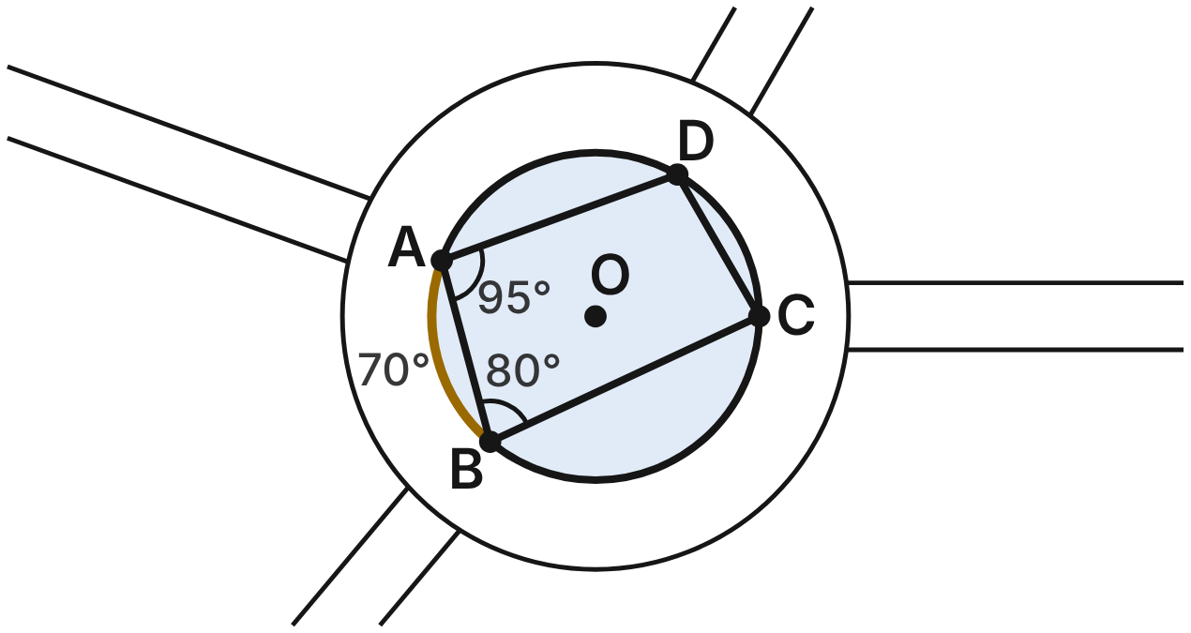
A roundabout's central island is a circle with center O and radius 15 m. Four roads meet it at A, B, C and D. Straight paths across the island join these points to form quadrilateral ABCD. m∠DAB = 95°, m∠ABC = 80° and m(arc AB) = 70°.
409. What is m∠BCD?
A. 95°
B. 85° ✔
C. 100°
D. 170°
G.PC.3 · skill G.PC.3.1 (LOTS): Use the angles formed by chords, secants and tangents (central, inscribed, and angles inside and outside a circle) and their arcs
☐ Answer key correct ☐ Wording clear Notes: ________________________________
410. What is m∠ACB, the angle at C between the lines to A and B?
A. 35° ✔
B. 70°
C. 140°
D. 145°
G.PC.3 · skill G.PC.3.1 (LOTS): Use the angles formed by chords, secants and tangents (central, inscribed, and angles inside and outside a circle) and their arcs
☐ Answer key correct ☐ Wording clear Notes: ________________________________
411. What is m(arc CD)?
A. 190°
B. 160°
C. 100°
D. 60° ✔
G.PC.3 · skill G.PC.3.1 (LOTS): Use the angles formed by chords, secants and tangents (central, inscribed, and angles inside and outside a circle) and their arcs
☐ Answer key correct ☐ Wording clear Notes: ________________________________
412. How long is the curb of the island from A to B along arc AB? Round to the nearest tenth of a meter.
A. 9.2 m
B. 36.7 m
C. 18.3 m ✔
D. 94.2 m
G.PC.3 · skill G.PC.3.3 (LOTS): Find arc length and the area of a sector, or use them to find a radius or a central angle
☐ Answer key correct ☐ Wording clear Notes: ________________________________
413. Flowers are planted in sector AOB. To the nearest tenth of a square meter, what is its area?
A. 18.3 m²
B. 549.8 m²
C. 68.7 m²
D. 137.4 m² ✔
G.PC.3 · skill G.PC.3.3 (LOTS): Find arc length and the area of a sector, or use them to find a radius or a central angle
☐ Answer key correct ☐ Wording clear Notes: ________________________________
414. Cars drive around the island on a circle with radius 20 m. Planners want a car to drive at most 50 m on that circle between two entrances. To the nearest degree, what is the largest central angle between the entrances?
A. 143° ✔
B. 286°
C. 72°
D. 14°
G.PC.3 · skill G.PC.3.4 (HOTS): Model and solve a contextual problem with the properties of circles
☐ Answer key correct ☐ Wording clear Notes: ________________________________

The Airport Radar
Level 2 · Circles · G.PC.3 · ID geo-pc3-sky-airport-radar
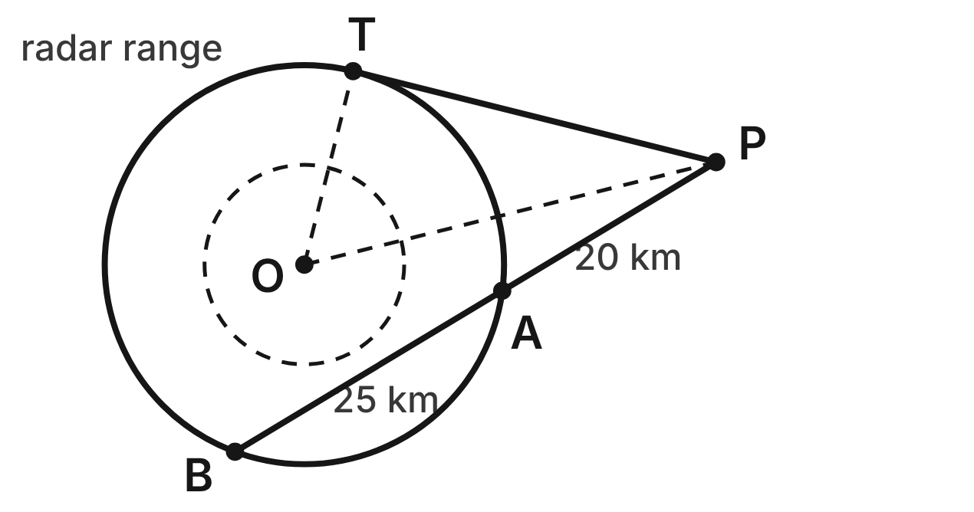
An airport radar at O tracks planes inside a circle with radius 16 km. A plane flies a straight path from P that crosses the circle at A and B: PA = 20 km and AB = 25 km. A helicopter flies straight from P on a path that touches the circle only at T.
415. How far does the helicopter fly from P to T?
A. about 22.4 km
B. 32.5 km
C. 30 km ✔
D. 45 km
G.PC.3 · skill G.PC.3.2 (LOTS): Use the lengths of segments formed by intersecting chords, secants and tangents
☐ Answer key correct ☐ Wording clear Notes: ________________________________
416. Which equation is true for the two paths from P?
A. PT² = PA · AB
B. PT² = PA · PB ✔
C. PT² = PA² + AB²
D. PT · PB = PA · AB
G.PC.3 · skill G.PC.3.2 (LOTS): Use the lengths of segments formed by intersecting chords, secants and tangents
☐ Answer key correct ☐ Wording clear Notes: ________________________________
417. How far is P from the radar at O?
A. 34 km ✔
B. 46 km
C. about 25.4 km
D. 14 km
G.PC.3 · skill G.PC.3.4 (HOTS): Model and solve a contextual problem with the properties of circles
☐ Answer key correct ☐ Wording clear Notes: ________________________________
418. From a point Q outside another radar circle, one path touches the circle and another crosses it. The far arc between the paths measures 170°, and the near arc measures 50°. What is the angle at Q?
A. 110°
B. 120°
C. 85°
D. 60° ✔
G.PC.3 · skill G.PC.3.1 (LOTS): Use the angles formed by chords, secants and tangents (central, inscribed, and angles inside and outside a circle) and their arcs
☐ Answer key correct ☐ Wording clear Notes: ________________________________
419. Lena finds PT by writing PT² = 20 · 25. What is her mistake?
A. She must add the parts: PT = 20 + 25.
B. She must use the whole path: PT² = 20 · 45. ✔
C. She must square both: PT² = 20² + 25².
D. She made no mistake, so PT ≈ 22.4 km.
G.PC.3 · skill G.PC.3.2 (LOTS): Use the lengths of segments formed by intersecting chords, secants and tangents
☐ Answer key correct ☐ Wording clear Notes: ________________________________
420. To the nearest degree, what is m∠TPO, the angle at P between the helicopter's path and the line to the radar?
A. 62°
B. 32°
C. 28° ✔
D. 25°
G.PC.3 · skill G.PC.3.4 (HOTS): Model and solve a contextual problem with the properties of circles
☐ Answer key correct ☐ Wording clear Notes: ________________________________

The Ship's Wheel
Level 2 · Circles · G.PC.3 · ID geo-pc3-sky-ships-wheel
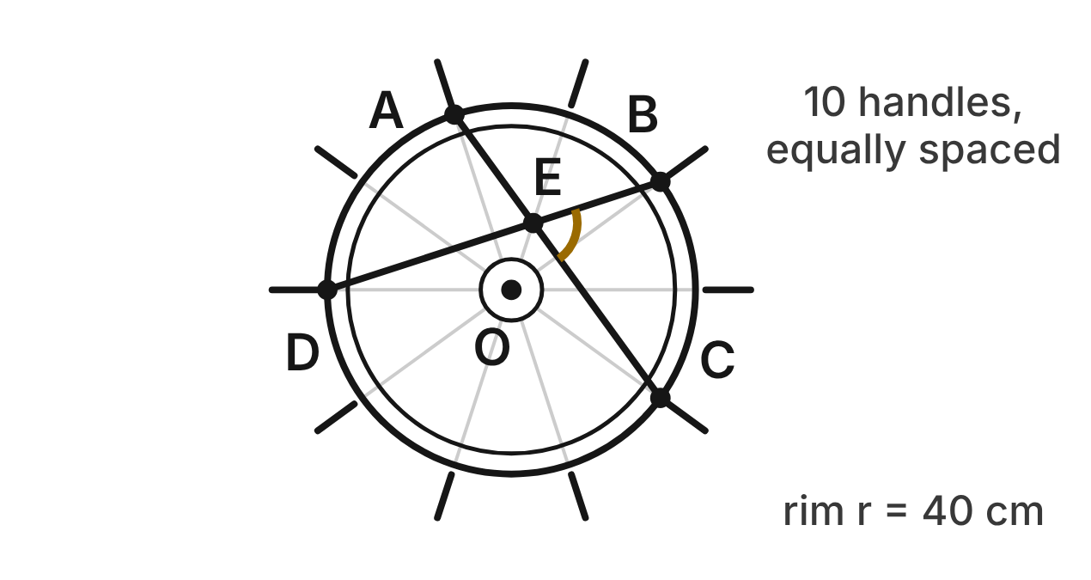
A ship's wheel has center O and 10 handles equally spaced around a rim with radius 40 cm. Ropes are tied to the rim beside handles A, B, C and D. Going around, there are 2 gaps from A to B, 2 from B to C, 4 from C to D and 2 from D back to A. Rope AC and rope BD cross at E.
421. What is m∠AOC, the central angle from A to C?
A. 72°
B. 144° ✔
C. 36°
D. 160°
G.PC.3 · skill G.PC.3.1 (LOTS): Use the angles formed by chords, secants and tangents (central, inscribed, and angles inside and outside a circle) and their arcs
☐ Answer key correct ☐ Wording clear Notes: ________________________________
422. What is m∠ABC, the angle at B between the lines to A and C?
A. 216°
B. 72°
C. 108° ✔
D. 144°
G.PC.3 · skill G.PC.3.1 (LOTS): Use the angles formed by chords, secants and tangents (central, inscribed, and angles inside and outside a circle) and their arcs
☐ Answer key correct ☐ Wording clear Notes: ________________________________
423. What is m∠BEC, where the ropes cross?
A. 72° ✔
B. 144°
C. 108°
D. 36°
G.PC.3 · skill G.PC.3.1 (LOTS): Use the angles formed by chords, secants and tangents (central, inscribed, and angles inside and outside a circle) and their arcs
☐ Answer key correct ☐ Wording clear Notes: ________________________________
424. The helmsman turns the wheel the short way until the rim point at A reaches the spot where B was. How far does that point travel? Round to the nearest tenth of a centimeter.
A. 25.1 cm
B. 100.5 cm
C. 1,005.3 cm
D. 50.3 cm ✔
G.PC.3 · skill G.PC.3.3 (LOTS): Find arc length and the area of a sector, or use them to find a radius or a central angle
☐ Answer key correct ☐ Wording clear Notes: ________________________________
425. The tip of each handle is 52 cm from O. The wheel turns 1¼ full turns. How far does a handle tip travel? Round to the nearest centimeter.
A. 408 cm ✔
B. 314 cm
C. 327 cm
D. 204 cm
G.PC.3 · skill G.PC.3.4 (HOTS): Model and solve a contextual problem with the properties of circles
☐ Answer key correct ☐ Wording clear Notes: ________________________________
426. On another ship's wheel, two straight ropes are each tied to the rim at both ends, and they cross. The crossing point divides one rope into pieces of 18 cm and 32 cm. One piece of the other rope is 16 cm. How long is its other piece?
A. 9 cm
B. 36 cm ✔
C. 34 cm
D. about 28.4 cm
G.PC.3 · skill G.PC.3.2 (LOTS): Use the lengths of segments formed by intersecting chords, secants and tangents
☐ Answer key correct ☐ Wording clear Notes: ________________________________

The Road Tunnel
Level 2 · Circles · G.PC.3 · ID geo-pc3-sky-road-tunnel
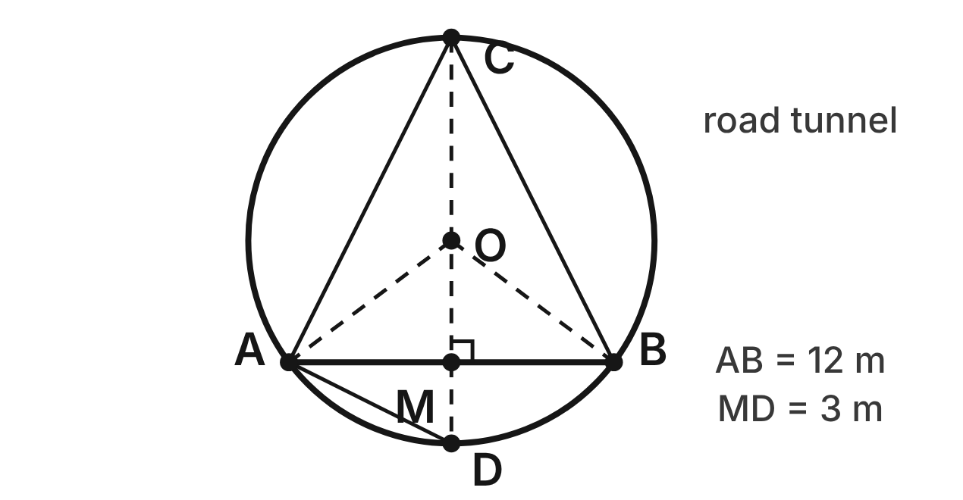
A road tunnel's cross-section is a circle with center O. The flat road is chord AB, 12 m wide, with midpoint M. A vertical line through O and M meets the tunnel at the top C and the bottom D, and it is perpendicular to the road. MD = 3 m.
427. How high is the top of the tunnel above the road (the length CM)?
A. 24 m
B. 9 m
C. 6 m
D. 12 m ✔
G.PC.3 · skill G.PC.3.2 (LOTS): Use the lengths of segments formed by intersecting chords, secants and tangents
☐ Answer key correct ☐ Wording clear Notes: ________________________________
428. What is the radius of the tunnel?
A. 15 m
B. 12 m
C. 7.5 m ✔
D. 6 m
G.PC.3 · skill G.PC.3.2 (LOTS): Use the lengths of segments formed by intersecting chords, secants and tangents
☐ Answer key correct ☐ Wording clear Notes: ________________________________
429. Which statement about ∠ACB and ∠AOB is true?
A. m∠ACB = 2 · m∠AOB
B. m∠AOB = 2 · m∠ACB ✔
C. m∠ACB = m∠AOB
D. m∠ACB + m∠AOB = 180°
G.PC.3 · skill G.PC.3.1 (LOTS): Use the angles formed by chords, secants and tangents (central, inscribed, and angles inside and outside a circle) and their arcs
☐ Answer key correct ☐ Wording clear Notes: ________________________________
430. What is m∠CAD? Choose the answer with the correct reason.
A. 90°, because CD is a diameter ✔
B. 45°, because AC bisects ∠MAD
C. 180°, because it equals its arc
D. 60°, because △ACD is equilateral
G.PC.3 · skill G.PC.3.1 (LOTS): Use the angles formed by chords, secants and tangents (central, inscribed, and angles inside and outside a circle) and their arcs
☐ Answer key correct ☐ Wording clear Notes: ________________________________
431. The tunnel's lining above the road is arc ACB. Use m∠AOB ≈ 106.3°. How long is arc ACB? Round to the nearest tenth of a meter.
A. 13.9 m
B. 16.6 m
C. 33.2 m ✔
D. 66.4 m
G.PC.3 · skill G.PC.3.3 (LOTS): Find arc length and the area of a sector, or use them to find a radius or a central angle
☐ Answer key correct ☐ Wording clear Notes: ________________________________
432. A sign hangs from the ceiling 3 m to the side of line CD. To the nearest tenth of a meter, how high is the ceiling above the road there?
A. 12.0 m
B. 6.9 m
C. 2.4 m
D. 11.4 m ✔
G.PC.3 · skill G.PC.3.4 (HOTS): Model and solve a contextual problem with the properties of circles
☐ Answer key correct ☐ Wording clear Notes: ________________________________

The Rail Curve
Level 3 · Circles · G.PC.3 · ID geo-pc3-sky-rail-curve
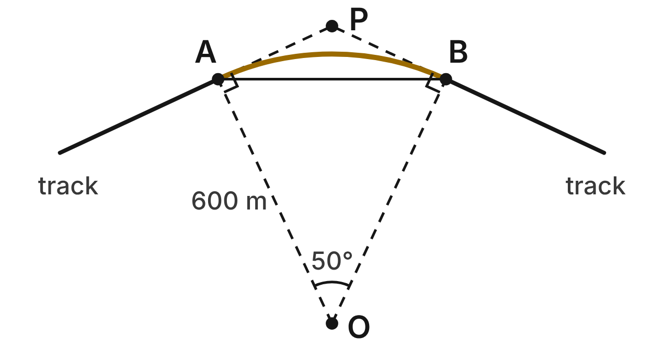
A railroad curve is arc AB of a circle with center O and radius 600 m, and m∠AOB = 50°. The straight tracks on each side are tangent to the curve at A and B. Extended, they meet at P.
433. What is m∠APB, the angle where the extended tracks meet?
A. 130° ✔
B. 50°
C. 25°
D. 155°
G.PC.3 · skill G.PC.3.1 (LOTS): Use the angles formed by chords, secants and tangents (central, inscribed, and angles inside and outside a circle) and their arcs
☐ Answer key correct ☐ Wording clear Notes: ________________________________
434. How long is the curved track, arc AB? Round to the nearest meter.
A. 262 m
B. 1,047 m
C. 157,080 m
D. 524 m ✔
G.PC.3 · skill G.PC.3.3 (LOTS): Find arc length and the area of a sector, or use them to find a radius or a central angle
☐ Answer key correct ☐ Wording clear Notes: ________________________________
435. How far is it from A to P along the extended track? Round to the nearest meter.
A. 254 m
B. 544 m
C. 280 m ✔
D. 1,287 m
G.PC.3 · skill G.PC.3.2 (LOTS): Use the lengths of segments formed by intersecting chords, secants and tangents
☐ Answer key correct ☐ Wording clear Notes: ________________________________
436. A survey line runs straight from A to B. What is m∠PAB, the angle between the survey line and the tangent track?
A. 50°
B. 25° ✔
C. 65°
D. 100°
G.PC.3 · skill G.PC.3.1 (LOTS): Use the angles formed by chords, secants and tangents (central, inscribed, and angles inside and outside a circle) and their arcs
☐ Answer key correct ☐ Wording clear Notes: ________________________________
437. How long is the straight survey line AB? Round to the nearest meter.
A. 524 m
B. 254 m
C. 507 m ✔
D. 1,088 m
G.PC.3 · skill G.PC.3.4 (HOTS): Model and solve a contextual problem with the properties of circles
☐ Answer key correct ☐ Wording clear Notes: ________________________________
438. On another line, a curve turns through 25° and is 500 m long. To the nearest meter, what is its radius?
A. 1,146 m ✔
B. 2,292 m
C. 80 m
D. 48 m
G.PC.3 · skill G.PC.3.3 (LOTS): Find arc length and the area of a sector, or use them to find a radius or a central angle
☐ Answer key correct ☐ Wording clear Notes: ________________________________

The Bike Chain
Level 3 · Circles · G.PC.3 · ID geo-pc3-sky-bike-chain
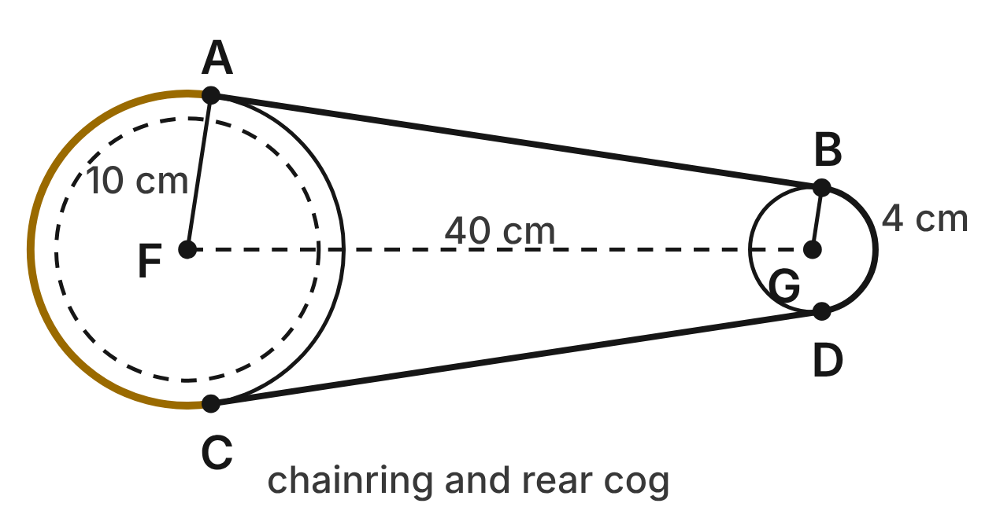
A bike chain wraps around the chainring (center F, radius 10 cm) and the rear cog (center G, radius 4 cm). FG = 40 cm. The top run of chain AB is tangent to the chainring at A and to the cog at B. The bottom run CD is tangent to them at C and D.
439. Which statement about radii FA and GB is true? Choose the answer with the correct reason.
A. FA ⊥ GB, because AB is tangent to both.
B. FA = GB, because both touch the chain.
C. FA ∥ GB, because FA and GB are congruent.
D. FA ∥ GB, because both are ⊥ to AB. ✔
G.PC.3 · skill G.PC.3.1 (LOTS): Use the angles formed by chords, secants and tangents (central, inscribed, and angles inside and outside a circle) and their arcs
☐ Answer key correct ☐ Wording clear Notes: ________________________________
440. How long is the top run of chain, AB? Round to the nearest tenth of a centimeter.
A. 40.0 cm
B. 39.5 cm ✔
C. 37.5 cm
D. 40.4 cm
G.PC.3 · skill G.PC.3.4 (HOTS): Model and solve a contextual problem with the properties of circles
☐ Answer key correct ☐ Wording clear Notes: ________________________________
441. The chainring has 48 teeth and the cog has 16, so the rear wheel turns 3 times for each turn of the pedals. The rear wheel's diameter is 66 cm. How far does the bike go for one turn of the pedals, to the nearest tenth of a meter?
A. 6.2 m ✔
B. 2.1 m
C. 3.1 m
D. 12.4 m
G.PC.3 · skill G.PC.3.4 (HOTS): Model and solve a contextual problem with the properties of circles
☐ Answer key correct ☐ Wording clear Notes: ________________________________
442. The chain touches the chainring along an arc of about 197°. How long is that arc, to the nearest tenth of a centimeter?
A. 17.2 cm
B. 28.4 cm
C. 34.4 cm ✔
D. 68.8 cm
G.PC.3 · skill G.PC.3.3 (LOTS): Find arc length and the area of a sector, or use them to find a radius or a central angle
☐ Answer key correct ☐ Wording clear Notes: ________________________________
443. The chain moves 30 cm as the chainring turns. To the nearest degree, through what angle does the chainring turn?
A. 344°
B. 172° ✔
C. 86°
D. 34°
G.PC.3 · skill G.PC.3.3 (LOTS): Find arc length and the area of a sector, or use them to find a radius or a central angle
☐ Answer key correct ☐ Wording clear Notes: ________________________________
444. Lines AB and CD, extended, meet at a point Q beyond the cog (not shown). Which reason shows that AB = CD?
A. AB and CD are both diameters of the chainring.
B. AB ∥ CD, so the two runs have the same length.
C. FA = GB, so the two runs have the same length.
D. QA = QC and QB = QD, so QA − QB = QC − QD. ✔
G.PC.3 · skill G.PC.3.2 (LOTS): Use the lengths of segments formed by intersecting chords, secants and tangents
☐ Answer key correct ☐ Wording clear Notes: ________________________________

G.PC.4 · Solve problems involving equations of circles.

The Radio Tower
Level 1 · Equations of circles · G.PC.4 · ID geo-pc4-sky-radio-tower
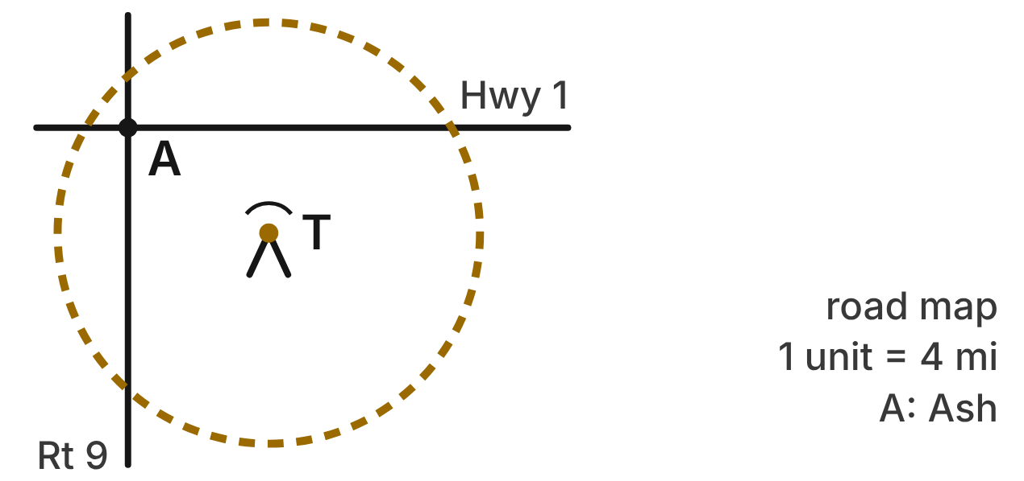
On a road map, each unit is 4 miles, and the town of Ash, A, is at the origin. The radio tower T reaches every point inside the circle (x − 4)² + (y + 3)² = 36, the edge of its range.
445. Where is the radio tower T?
A. (−4, 3)
B. (−3, 4)
C. (4, 3)
D. (4, −3) ✔
G.PC.4 · skill G.PC.4.1 (LOTS): Identify the center and radius of a circle from its graph or from its equation in standard form
☐ Answer key correct ☐ Wording clear Notes: ________________________________
446. How far does the signal reach from the tower, in miles?
A. 144 mi
B. 48 mi
C. 24 mi ✔
D. 6 mi
G.PC.4 · skill G.PC.4.1 (LOTS): Identify the center and radius of a circle from its graph or from its equation in standard form
☐ Answer key correct ☐ Wording clear Notes: ________________________________
447. Four rest stops are at the points below. Which one is outside the tower's range?
A. (9, −3)
B. (−2, −1) ✔
C. (4, 3)
D. (2, 1)
G.PC.4 · skill G.PC.4.1 (LOTS): Identify the center and radius of a circle from its graph or from its equation in standard form
☐ Answer key correct ☐ Wording clear Notes: ________________________________
448. Which expression gives the distance, in map units, from the tower to Ash?
A. (0 − 4)² + (0 + 3)²
B. √((0 − 4) + (0 + 3))
C. √((0 − 4)² − (0 + 3)²)
D. √((0 − 4)² + (0 + 3)²) ✔
G.PC.4 · skill G.PC.4.3 (HOTS): Derive the equation of a circle with the Pythagorean Theorem or the distance formula
☐ Answer key correct ☐ Wording clear Notes: ________________________________
449. An upgrade lets the tower reach 28 miles. Which equation, in map units, describes the new edge of its range?
A. (x − 4)² + (y + 3)² = 49 ✔
B. (x − 4)² + (y + 3)² = 784
C. (x − 4)² + (y + 3)² = 7
D. (x + 4)² + (y − 3)² = 49
G.PC.4 · skill G.PC.4.2 (LOTS): Write the equation of a circle from its center and radius, its center and a point, or the endpoints of a diameter
☐ Answer key correct ☐ Wording clear Notes: ________________________________
450. A second tower's range has the edge (x + 7)² + (y − 1)² = 27. What are its center and radius?
A. (7, −1); r = 3√3
B. (−7, 1); r = 27
C. (−7, 1); r = 3√3 ✔
D. (−7, 1); r = 9√3
G.PC.4 · skill G.PC.4.1 (LOTS): Identify the center and radius of a circle from its graph or from its equation in standard form
☐ Answer key correct ☐ Wording clear Notes: ________________________________

The Roundabout
Level 1 · Equations of circles · G.PC.4 · ID geo-pc4-sky-roundabout
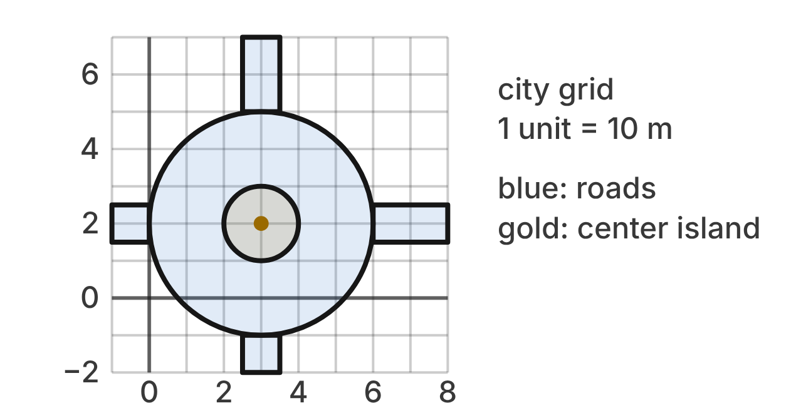
A roundabout is drawn on a city grid (1 unit = 10 m). Cars drive on the blue ring between the gold center island and the outer edge. Both edges are circles with the same center, the gold dot.
451. What are the coordinates of the center of the roundabout?
A. (2, 3)
B. (−3, −2)
C. (3, 2) ✔
D. (3, 5)
G.PC.4 · skill G.PC.4.1 (LOTS): Identify the center and radius of a circle from its graph or from its equation in standard form
☐ Answer key correct ☐ Wording clear Notes: ________________________________
452. What is the radius of the outer edge of the roundabout, in grid units?
A. 3 units ✔
B. 6 units
C. 9 units
D. 2 units
G.PC.4 · skill G.PC.4.1 (LOTS): Identify the center and radius of a circle from its graph or from its equation in standard form
☐ Answer key correct ☐ Wording clear Notes: ________________________________
453. Which equation describes the outer edge of the roundabout?
A. (x + 3)² + (y + 2)² = 9
B. (x − 3)² + (y − 2)² = 9 ✔
C. (x − 3)² + (y − 2)² = 3
D. (x − 2)² + (y − 3)² = 9
G.PC.4 · skill G.PC.4.2 (LOTS): Write the equation of a circle from its center and radius, its center and a point, or the endpoints of a diameter
☐ Answer key correct ☐ Wording clear Notes: ________________________________
454. Which equation describes the edge of the center island?
A. (x − 3)² + (y − 2)² = 1 ✔
B. (x − 3)² + (y − 2)² = 4
C. x² + y² = 1
D. (x + 3)² + (y + 2)² = 1
G.PC.4 · skill G.PC.4.2 (LOTS): Write the equation of a circle from its center and radius, its center and a point, or the endpoints of a diameter
☐ Answer key correct ☐ Wording clear Notes: ________________________________
455. A car is at (5, 4). Where is it? Choose the answer with the correct reason.
A. Outside: its distance is 8, more than 3
B. Outside: its distance is 2 + 2 = 4, more than 3
C. On the ring: its distance squared is 8, between 1 and 9 ✔
D. Outside: its distance squared is 100, more than 9
G.PC.4 · skill G.PC.4.1 (LOTS): Identify the center and radius of a circle from its graph or from its equation in standard form
☐ Answer key correct ☐ Wording clear Notes: ________________________________
456. A driver finds the car's distance d from the center of the roundabout with a right triangle whose legs follow the grid. The car is at (5, 4). Which equation does she use?
A. 5² + 4² = d²
B. 2 + 2 = d
C. 3² + 2² = d²
D. 2² + 2² = d² ✔
G.PC.4 · skill G.PC.4.3 (HOTS): Derive the equation of a circle with the Pythagorean Theorem or the distance formula
☐ Answer key correct ☐ Wording clear Notes: ________________________________

The No-Fly Zone
Level 2 · Equations of circles · G.PC.4 · ID geo-pc4-sky-no-fly-zone
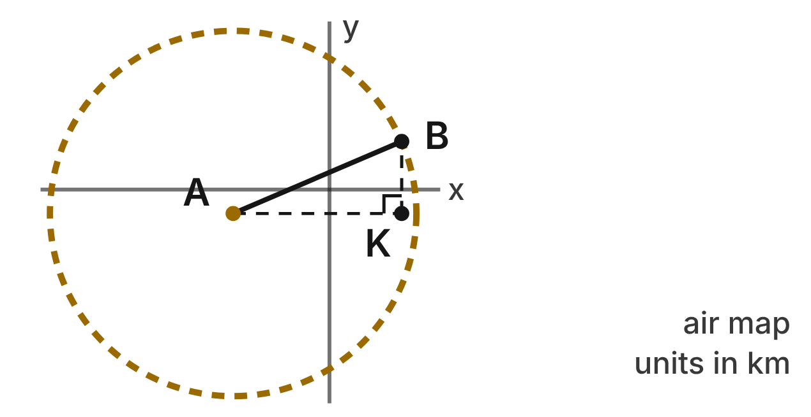
On an air map (units in km), the airport is at A(−4, −1). Planes may not fly inside the dashed circle. Its edge passes through the beacon B(3, 2). Point K(3, −1) makes right triangle AKB.
457. Which equation describes the edge of the no-fly zone?
A. (x − 4)² + (y − 1)² = 58
B. (x + 4)² + (y + 1)² = 58 ✔
C. (x + 4)² + (y + 1)² = 100
D. (x − 3)² + (y − 2)² = 58
G.PC.4 · skill G.PC.4.2 (LOTS): Write the equation of a circle from its center and radius, its center and a point, or the endpoints of a diameter
☐ Answer key correct ☐ Wording clear Notes: ________________________________
458. Which equation applies the Pythagorean theorem to triangle AKB to find the radius r of the zone?
A. 1² + 3² = r²
B. 7 + 3 = r
C. 7² − 3² = r²
D. 7² + 3² = r² ✔
G.PC.4 · skill G.PC.4.3 (HOTS): Derive the equation of a circle with the Pythagorean Theorem or the distance formula
☐ Answer key correct ☐ Wording clear Notes: ________________________________
459. To the nearest tenth of a kilometer, how wide is the no-fly zone (its diameter)?
A. 7.6 km
B. 116.0 km
C. 15.2 km ✔
D. 20.0 km
G.PC.4 · skill G.PC.4.1 (LOTS): Identify the center and radius of a circle from its graph or from its equation in standard form
☐ Answer key correct ☐ Wording clear Notes: ________________________________
460. A pilot reports four possible positions. Which one is inside the no-fly zone?
A. (−10, 2) ✔
B. (2, 4)
C. (−4, 7)
D. (1, −7)
G.PC.4 · skill G.PC.4.1 (LOTS): Identify the center and radius of a circle from its graph or from its equation in standard form
☐ Answer key correct ☐ Wording clear Notes: ________________________________
461. Which statement about the no-fly zone is NOT true?
A. B(3, 2) is on the edge.
B. (4, −4) is inside the zone. ✔
C. (−11, −1) is inside the zone.
D. The radius of the zone is √58 km.
G.PC.4 · skill G.PC.4.1 (LOTS): Identify the center and radius of a circle from its graph or from its equation in standard form
☐ Answer key correct ☐ Wording clear Notes: ________________________________
462. Drones get a smaller zone with the same center and a radius of 3 km. Which equation describes its edge?
A. (x + 4)² + (y + 1)² = 3
B. (x − 4)² + (y − 1)² = 9
C. (x + 4)² + (y + 1)² = 6
D. (x + 4)² + (y + 1)² = 9 ✔
G.PC.4 · skill G.PC.4.2 (LOTS): Write the equation of a circle from its center and radius, its center and a point, or the endpoints of a diameter
☐ Answer key correct ☐ Wording clear Notes: ________________________________

The Harbor Slow Zone
Level 2 · Equations of circles · G.PC.4 · ID geo-pc4-sky-harbor
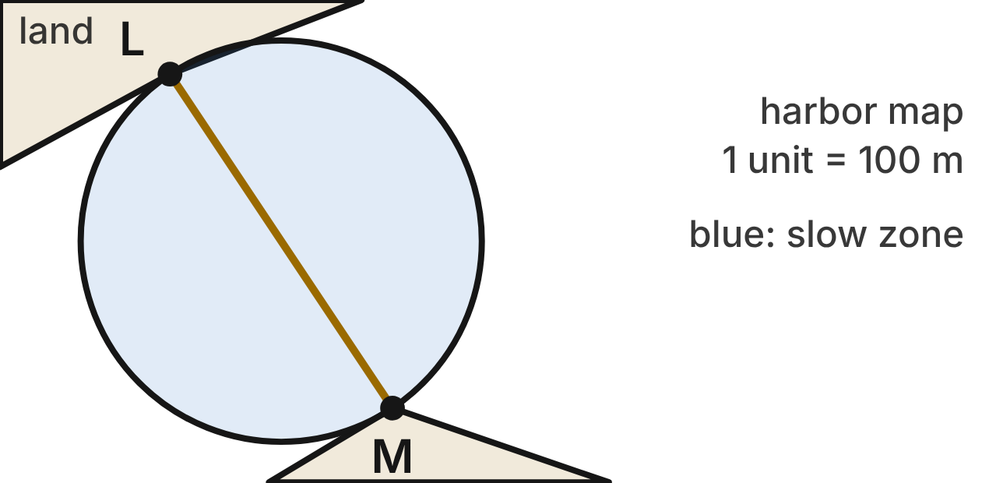
On a harbor map (1 unit = 100 m), boats must slow down inside a circle. Segment LM is a diameter of that circle, from lighthouse L(−5, 6) to lighthouse M(3, −6).
463. What are the coordinates of the center of the slow zone?
A. (−1, 0) ✔
B. (4, −6)
C. (−2, 0)
D. (8, −12)
G.PC.4 · skill G.PC.4.2 (LOTS): Write the equation of a circle from its center and radius, its center and a point, or the endpoints of a diameter
☐ Answer key correct ☐ Wording clear Notes: ________________________________
464. Which equation describes the edge of the slow zone?
A. (x − 1)² + y² = 52
B. (x + 1)² + y² = 208
C. (x + 1)² + y² = 100
D. (x + 1)² + y² = 52 ✔
G.PC.4 · skill G.PC.4.2 (LOTS): Write the equation of a circle from its center and radius, its center and a point, or the endpoints of a diameter
☐ Answer key correct ☐ Wording clear Notes: ________________________________
465. A dock is at (5, 4). Which equation uses the Pythagorean theorem to check that the dock is on the edge of the slow zone?
A. 4² + 4² = 52
B. 6² + 4² = 52 ✔
C. 5² + 4² = 52
D. 6² + 4² = 52²
G.PC.4 · skill G.PC.4.3 (HOTS): Derive the equation of a circle with the Pythagorean Theorem or the distance formula
☐ Answer key correct ☐ Wording clear Notes: ________________________________
466. A ferry waits at (−5, −5). Is it inside the slow zone? Choose the answer with the correct reason.
A. Yes: it lies on segment LM
B. No: its distance squared is 61, more than 52
C. No: its distance is 4 + 5 = 9, more than √52
D. Yes: its distance squared is 41, less than 52 ✔
G.PC.4 · skill G.PC.4.1 (LOTS): Identify the center and radius of a circle from its graph or from its equation in standard form
☐ Answer key correct ☐ Wording clear Notes: ________________________________
467. Which point is exactly on the edge of the slow zone?
A. (−5, −4)
B. (−6, −4)
C. (−7, −4) ✔
D. (9, 0)
G.PC.4 · skill G.PC.4.1 (LOTS): Identify the center and radius of a circle from its graph or from its equation in standard form
☐ Answer key correct ☐ Wording clear Notes: ________________________________
468. The harbor adds a no-wake circle around lighthouse M with a radius of 300 m. Which equation, in map units, describes it?
A. (x − 3)² + (y + 6)² = 9 ✔
B. (x − 3)² + (y + 6)² = 90000
C. (x − 3)² + (y + 6)² = 3
D. (x + 3)² + (y − 6)² = 9
G.PC.4 · skill G.PC.4.2 (LOTS): Write the equation of a circle from its center and radius, its center and a point, or the endpoints of a diameter
☐ Answer key correct ☐ Wording clear Notes: ________________________________

Drone Delivery
Level 2 · Equations of circles · G.PC.4 · ID geo-pc4-sky-drone-delivery
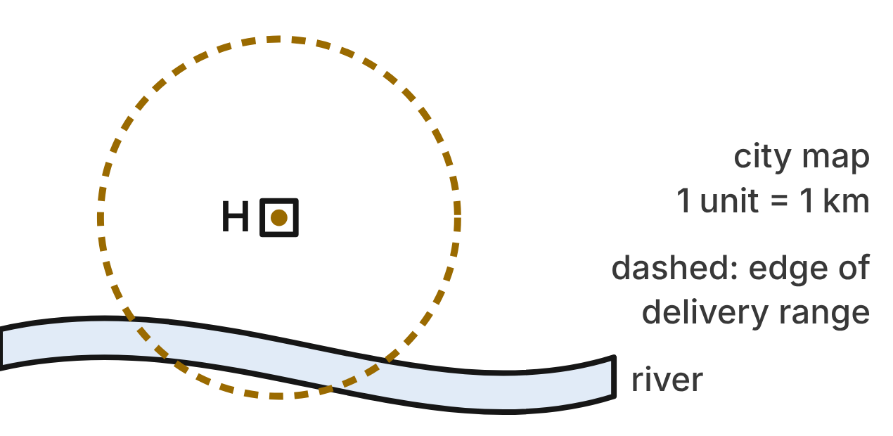
A drone delivery hub H is at (−2, 4) on a city map (units in km). A drone can fly up to 8 km from the hub. The dashed circle is the edge of the delivery range.
469. The app checks a delivery address (x, y). Which rule says the address is within 8 km of the hub?
A. √((x − 2)² + (y + 4)²) ≤ 8
B. (x + 2) + (y − 4) ≤ 8
C. √((x + 2)² + (y − 4)²) ≤ 8 ✔
D. √((x + 2)² + (y − 4)²) ≥ 8
G.PC.4 · skill G.PC.4.3 (HOTS): Derive the equation of a circle with the Pythagorean Theorem or the distance formula
☐ Answer key correct ☐ Wording clear Notes: ________________________________
470. Which equation describes the edge of the delivery range?
A. (x + 2)² + (y − 4)² = 8
B. (x + 2)² + (y − 4)² = 64 ✔
C. (x + 2)² + (y − 4)² = 16
D. (x − 2)² + (y + 4)² = 64
G.PC.4 · skill G.PC.4.2 (LOTS): Write the equation of a circle from its center and radius, its center and a point, or the endpoints of a diameter
☐ Answer key correct ☐ Wording clear Notes: ________________________________
471. Can a drone deliver to a house at (6, 1)? Choose the answer with the correct reason.
A. No: its distance from H is √73 km, more than 8 km ✔
B. No: its distance from H is 11 km, more than 8 km
C. Yes: its distance from H is √41 km
D. Yes: it is exactly 8 km from H, on the edge
G.PC.4 · skill G.PC.4.1 (LOTS): Identify the center and radius of a circle from its graph or from its equation in standard form
☐ Answer key correct ☐ Wording clear Notes: ________________________________
472. A customer is at (6, 6). To the nearest tenth of a kilometer, how far is the customer from the hub?
A. 10.0 km
B. 68.0 km
C. 8.2 km ✔
D. 10.8 km
G.PC.4 · skill G.PC.4.3 (HOTS): Derive the equation of a circle with the Pythagorean Theorem or the distance formula
☐ Answer key correct ☐ Wording clear Notes: ________________________________
473. The company adds a second hub at (3, −5) with a range of 6 km. Which equation describes the edge of its range?
A. (x + 3)² + (y − 5)² = 36
B. (x − 3)² + (y + 5)² = 6
C. (x − 3)² + (y + 5)² = 12
D. (x − 3)² + (y + 5)² = 36 ✔
G.PC.4 · skill G.PC.4.2 (LOTS): Write the equation of a circle from its center and radius, its center and a point, or the endpoints of a diameter
☐ Answer key correct ☐ Wording clear Notes: ________________________________
474. Which point is exactly on the edge of the delivery range?
A. (6, 12)
B. (6, 4) ✔
C. (2, 4)
D. (2, 8)
G.PC.4 · skill G.PC.4.1 (LOTS): Identify the center and radius of a circle from its graph or from its equation in standard form
☐ Answer key correct ☐ Wording clear Notes: ________________________________

The Bike Loop
Level 3 · Equations of circles · G.PC.4 · ID geo-pc4-sky-bike-loop
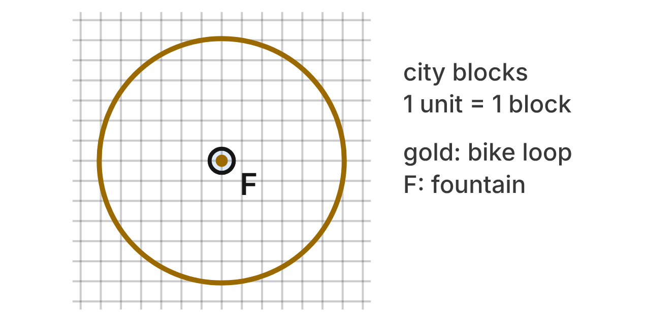
On a city map, 1 unit is 1 block. A circular bike loop has the equation x² + y² − 8x + 4y − 17 = 0. The loop goes around a fountain F at its center.
475. Which equation is the result of completing the square for the bike loop?
A. (x − 4)² + (y + 2)² = 17
B. (x − 4)² + (y + 2)² = 37 ✔
C. (x + 4)² + (y − 2)² = 37
D. (x − 8)² + (y + 4)² = 37
G.PC.4 · skill G.PC.4.1 (LOTS): Identify the center and radius of a circle from its graph or from its equation in standard form
☐ Answer key correct ☐ Wording clear Notes: ________________________________
476. What are the center and radius of the bike loop?
A. (4, −2); r = √37 ✔
B. (−4, 2); r = √37
C. (4, −2); r = 37
D. (4, −2); r = √17
G.PC.4 · skill G.PC.4.1 (LOTS): Identify the center and radius of a circle from its graph or from its equation in standard form
☐ Answer key correct ☐ Wording clear Notes: ________________________________
477. Jo completes the square and writes (x − 4)² + (y + 2)² = 17 + 16 − 4. What is her mistake?
A. She should add 64 and 16, not 16 and 4.
B. She should use −17 on the right side, not 17.
C. She subtracted 4; she must add 4 to the right side. ✔
D. She should add 8 and 4, the coefficients.
G.PC.4 · skill G.PC.4.1 (LOTS): Identify the center and radius of a circle from its graph or from its equation in standard form
☐ Answer key correct ☐ Wording clear Notes: ________________________________
478. Why does completing the square show that the bike loop is a circle?
A. It gives x² + y² = 37, centered at the origin.
B. Its x² and y² terms show a radius of 17 blocks.
C. Each point (x, y) on it is 37 blocks from (4, −2).
D. Each point (x, y) on it is √37 blocks from (4, −2). ✔
G.PC.4 · skill G.PC.4.3 (HOTS): Derive the equation of a circle with the Pythagorean Theorem or the distance formula
☐ Answer key correct ☐ Wording clear Notes: ________________________________
479. Which landmark is outside the bike loop?
A. School at (10, 1) ✔
B. Library at (5, 4)
C. Park at (0, 0)
D. City hall at (−1, 0)
G.PC.4 · skill G.PC.4.1 (LOTS): Identify the center and radius of a circle from its graph or from its equation in standard form
☐ Answer key correct ☐ Wording clear Notes: ________________________________
480. A longer loop will have the same center and pass the stadium at (−2, 6). Which equation describes the longer loop?
A. (x + 4)² + (y − 2)² = 100
B. (x − 4)² + (y + 2)² = 100 ✔
C. (x + 2)² + (y − 6)² = 100
D. (x − 4)² + (y + 2)² = 14
G.PC.4 · skill G.PC.4.2 (LOTS): Write the equation of a circle from its center and radius, its center and a point, or the endpoints of a diameter
☐ Answer key correct ☐ Wording clear Notes: ________________________________

The Pickup Zone
Level 3 · Equations of circles · G.PC.4 · ID geo-pc4-sky-pickup-zone
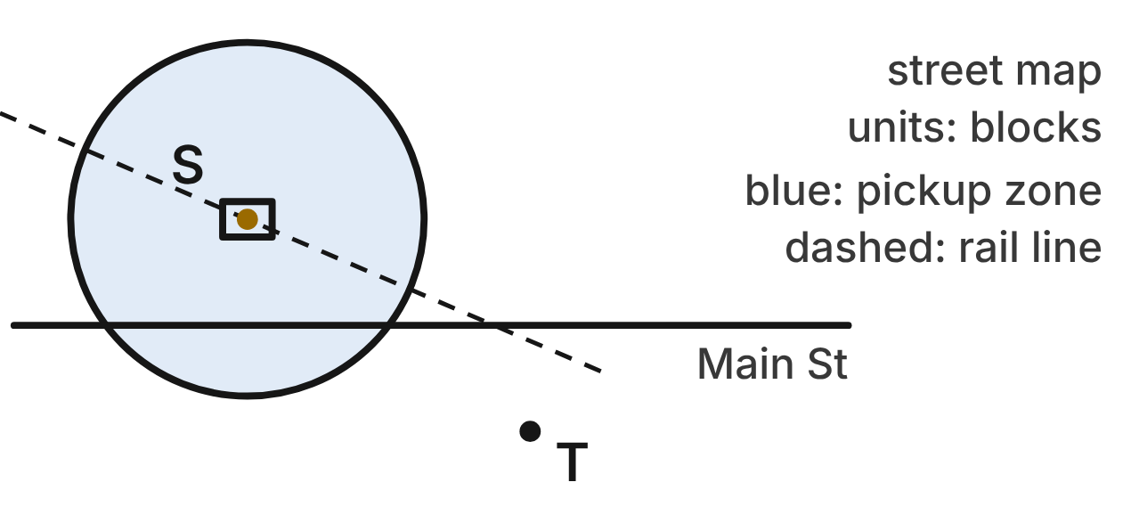
A train station S has a rideshare pickup zone: the circle (x + 3)² + (y − 2)² = 25 and its inside. Units are city blocks. Main Street is the line y = −1. The taxi stand is at T(5, −4).
481. What are the coordinates of the station S and the radius of the pickup zone?
A. (3, −2); r = 5
B. (−3, 2); r = 25
C. (2, −3); r = 5
D. (−3, 2); r = 5 ✔
G.PC.4 · skill G.PC.4.1 (LOTS): Identify the center and radius of a circle from its graph or from its equation in standard form
☐ Answer key correct ☐ Wording clear Notes: ________________________________
482. Where does Main Street cross the edge of the pickup zone?
A. (7, −1) and (−1, −1)
B. (2, −1) and (−8, −1)
C. (1, −1) and (−7, −1) ✔
D. (1, −1) only
G.PC.4 · skill G.PC.4.1 (LOTS): Identify the center and radius of a circle from its graph or from its equation in standard form
☐ Answer key correct ☐ Wording clear Notes: ________________________________
483. The city keeps the center and enlarges the zone so that its edge reaches the bus stop at (2, −5). Which equation describes the new edge?
A. (x + 3)² + (y − 2)² = 74 ✔
B. (x − 3)² + (y + 2)² = 74
C. (x − 2)² + (y + 5)² = 74
D. (x + 3)² + (y − 2)² = 144
G.PC.4 · skill G.PC.4.2 (LOTS): Write the equation of a circle from its center and radius, its center and a point, or the endpoints of a diameter
☐ Answer key correct ☐ Wording clear Notes: ________________________________
484. A rider stands at (0, 6). Using the distance formula, where is she compared with the pickup zone?
A. Outside: her distance is 3 + 4 = 7
B. Outside: her distance is √73
C. Inside: her distance is √7
D. On the edge: her distance is √(3² + 4²) = 5 ✔
G.PC.4 · skill G.PC.4.3 (HOTS): Derive the equation of a circle with the Pythagorean Theorem or the distance formula
☐ Answer key correct ☐ Wording clear Notes: ________________________________
485. The ferry terminal's pickup zone has the edge x² + y² − 2x + 10y + 10 = 0. What are its center and radius?
A. (−1, 5); r = 4
B. (1, −5); r = 4 ✔
C. (1, −5); r = 16
D. (1, −5); r = √2
G.PC.4 · skill G.PC.4.1 (LOTS): Identify the center and radius of a circle from its graph or from its equation in standard form
☐ Answer key correct ☐ Wording clear Notes: ________________________________
486. A new zone will have a diameter from the station S to the taxi stand T. Which equation describes its edge?
A. (x + 3)² + (y − 2)² = 100
B. (x + 1)² + (y − 1)² = 25
C. (x − 1)² + (y + 1)² = 25 ✔
D. (x − 1)² + (y + 1)² = 100
G.PC.4 · skill G.PC.4.2 (LOTS): Write the equation of a circle from its center and radius, its center and a point, or the endpoints of a diameter
☐ Answer key correct ☐ Wording clear Notes: ________________________________

3-D figures (G.DF)

G.DF.1 · Create models and solve problems, including those in context, involving surface area and volume of rectangular and triangular prisms, cylinders, cones, pyramids, and spheres.

The Carry-On Suitcase
Level 1 · 3-D figures · G.DF.1 · ID geo-df1-sky-suitcase
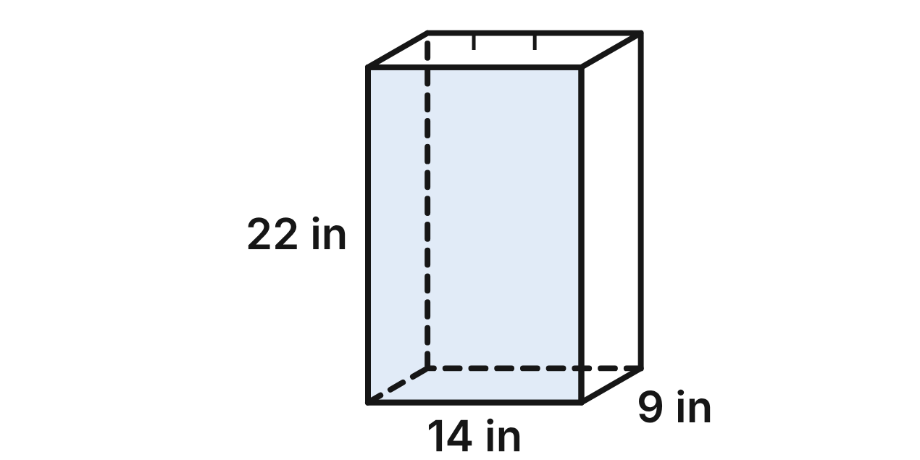
A carry-on suitcase is a rectangular prism. Standing up, it is 14 in wide, 22 in tall and 9 in deep.
487. How much space is inside the suitcase, using its outside measurements?
A. 308 in³
B. 924 in³
C. 2,772 in³ ✔
D. 1,264 in³
G.DF.1 · skill G.DF.1.2 (LOTS): Find the surface area and volume of prisms, cylinders, cones, pyramids and spheres
☐ Answer key correct ☐ Wording clear Notes: ________________________________
488. What is the total surface area of the suitcase?
A. 632 in²
B. 1,138 in²
C. 2,772 in²
D. 1,264 in² ✔
G.DF.1 · skill G.DF.1.2 (LOTS): Find the surface area and volume of prisms, cylinders, cones, pyramids and spheres
☐ Answer key correct ☐ Wording clear Notes: ________________________________
489. A net of the suitcase is made of six rectangles. How many of them are 22 in by 9 in?
A. 2 ✔
B. 4
C. 1
D. 6
G.DF.1 · skill G.DF.1.1 (LOTS): Identify the two-dimensional cross sections and nets of three-dimensional figures
☐ Answer key correct ☐ Wording clear Notes: ________________________________
490. A plane parallel to the front face cuts the suitcase halfway between the front and the back. What is the cross section?
A. a rectangle 22 in by 9 in
B. a rectangle 14 in by 22 in ✔
C. a rectangle 14 in by 9 in
D. a rectangle 7 in by 11 in
G.DF.1 · skill G.DF.1.1 (LOTS): Identify the two-dimensional cross sections and nets of three-dimensional figures
☐ Answer key correct ☐ Wording clear Notes: ________________________________
491. A travel cover wraps the whole outside of the suitcase. To the nearest tenth of a square foot, how much cover is that? Use 1 ft² = 144 in².
A. 105.3 ft²
B. 4.4 ft²
C. 8.8 ft² ✔
D. 7.9 ft²
G.DF.1 · skill G.DF.1.3 (HOTS): Solve multistep contextual problems with surface area and volume, including composite figures
☐ Answer key correct ☐ Wording clear Notes: ________________________________
492. Which statement about the suitcase is NOT true?
A. Its surface area is 14 · 22 · 9 square inches. ✔
B. Its front and back faces are congruent rectangles.
C. Its volume is the area of its bottom times 22 in.
D. Every cross section parallel to the bottom is 14 in by 9 in.
G.DF.1 · skill G.DF.1.2 (LOTS): Find the surface area and volume of prisms, cylinders, cones, pyramids and spheres
☐ Answer key correct ☐ Wording clear Notes: ________________________________

The Wheel Chock
Level 1 · 3-D figures · G.DF.1 · ID geo-df1-sky-wheel-chock
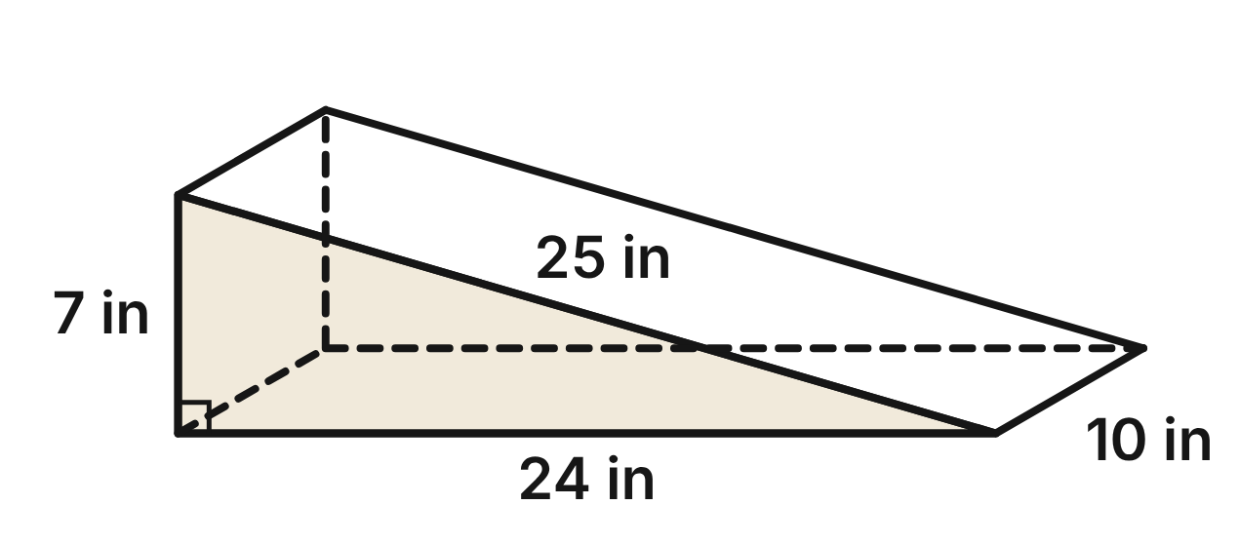
At the airport, a rubber wheel chock keeps a parked plane from rolling. The chock is a triangular prism. Each end is a right triangle with legs of 7 in and 24 in and a sloped side of 25 in, and the chock is 10 in wide.
493. How much rubber is in the chock?
A. 1,680 in³
B. 840 in³ ✔
C. 875 in³
D. 280 in³
G.DF.1 · skill G.DF.1.2 (LOTS): Find the surface area and volume of prisms, cylinders, cones, pyramids and spheres
☐ Answer key correct ☐ Wording clear Notes: ________________________________
494. What is the total surface area of the chock?
A. 560 in²
B. 896 in²
C. 644 in²
D. 728 in² ✔
G.DF.1 · skill G.DF.1.2 (LOTS): Find the surface area and volume of prisms, cylinders, cones, pyramids and spheres
☐ Answer key correct ☐ Wording clear Notes: ________________________________
495. Which shape is NOT one of the faces of the chock?
A. a rectangle 24 in by 7 in ✔
B. a rectangle 25 in by 10 in
C. a rectangle 7 in by 10 in
D. a right triangle with legs 7 in and 24 in
G.DF.1 · skill G.DF.1.1 (LOTS): Identify the two-dimensional cross sections and nets of three-dimensional figures
☐ Answer key correct ☐ Wording clear Notes: ________________________________
496. A vertical plane parallel to the 7 in tall back face cuts the chock 12 in in front of it. What is the cross section?
A. a rectangle 7 in by 10 in
B. a rectangle 3.5 in by 12 in
C. a rectangle 3.5 in by 10 in ✔
D. a right triangle with legs 3.5 in and 12 in
G.DF.1 · skill G.DF.1.1 (LOTS): Identify the two-dimensional cross sections and nets of three-dimensional figures
☐ Answer key correct ☐ Wording clear Notes: ________________________________
497. The rubber weighs 0.05 lb per cubic inch. How much does the chock weigh?
A. 84 lb
B. 14 lb
C. 16,800 lb
D. 42 lb ✔
G.DF.1 · skill G.DF.1.3 (HOTS): Solve multistep contextual problems with surface area and volume, including composite figures
☐ Answer key correct ☐ Wording clear Notes: ________________________________
498. A grip pad covers the whole sloped face that touches the tire. What is the area of the pad?
A. 240 in²
B. 250 in² ✔
C. 125 in²
D. 70 in²
G.DF.1 · skill G.DF.1.2 (LOTS): Find the surface area and volume of prisms, cylinders, cones, pyramids and spheres
☐ Answer key correct ☐ Wording clear Notes: ________________________________

The Fuel Truck
Level 2 · 3-D figures · G.DF.1 · ID geo-df1-sky-fuel-truck
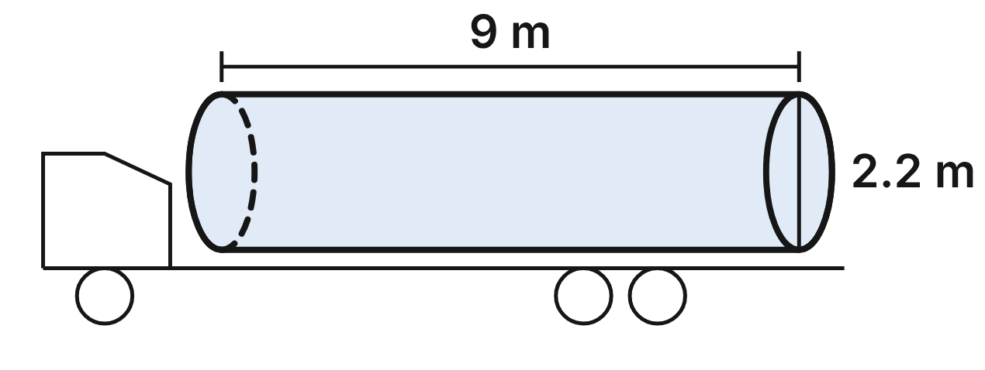
The tank on a fuel truck is a cylinder lying on its side, closed at both ends. It is 2.2 m across and 9 m long. Use 1 m³ = 1,000 L.
499. How many liters does the full tank hold, to the nearest liter?
A. 136,848 L
B. 31,102 L
C. 10,890 L
D. 34,212 L ✔
G.DF.1 · skill G.DF.1.3 (HOTS): Solve multistep contextual problems with surface area and volume, including composite figures
☐ Answer key correct ☐ Wording clear Notes: ________________________________
500. A vertical plane cuts straight across the tank, parallel to its flat ends. What is the cross section?
A. a circle 2.2 m across ✔
B. a circle 4.4 m across
C. a rectangle 2.2 m by 9 m
D. a circle 1.1 m across
G.DF.1 · skill G.DF.1.1 (LOTS): Identify the two-dimensional cross sections and nets of three-dimensional figures
☐ Answer key correct ☐ Wording clear Notes: ________________________________
501. When the tank is exactly half full, the top of the fuel is a level cross section through the middle of the tank. What is its area?
A. 9.9 m²
B. 19.8 m² ✔
C. 3.8 m²
D. 62.2 m²
G.DF.1 · skill G.DF.1.1 (LOTS): Identify the two-dimensional cross sections and nets of three-dimensional figures
☐ Answer key correct ☐ Wording clear Notes: ________________________________
502. The whole outside of the tank is painted. What area is painted, to the nearest tenth of a square meter?
A. 62.2 m²
B. 66.0 m²
C. 69.8 m² ✔
D. 154.8 m²
G.DF.1 · skill G.DF.1.2 (LOTS): Find the surface area and volume of prisms, cylinders, cones, pyramids and spheres
☐ Answer key correct ☐ Wording clear Notes: ________________________________
503. A depot must deliver 100,000 L of fuel. The truck carries at most one full tank per trip. How many trips does it take?
A. 3 ✔
B. 2
C. 1
D. 4
G.DF.1 · skill G.DF.1.3 (HOTS): Solve multistep contextual problems with surface area and volume, including composite figures
☐ Answer key correct ☐ Wording clear Notes: ________________________________
504. A reflective band 0.4 m wide goes once around the curved side of the tank. What is the area of the band, to the nearest tenth of a square meter?
A. 1.4 m²
B. 5.5 m²
C. 0.9 m²
D. 2.8 m² ✔
G.DF.1 · skill G.DF.1.2 (LOTS): Find the surface area and volume of prisms, cylinders, cones, pyramids and spheres
☐ Answer key correct ☐ Wording clear Notes: ________________________________

The Airport Hangar
Level 2 · 3-D figures · G.DF.1 · ID geo-df1-sky-hangar
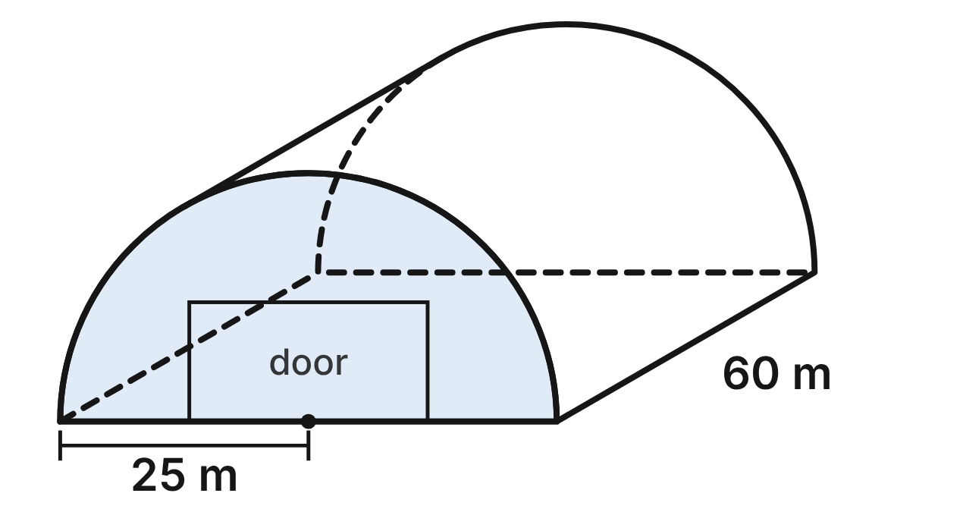
An airport hangar is half of a cylinder lying on its flat side. The curved roof has a radius of 25 m, and the hangar is 60 m long. The front wall is a half circle with a door opening 24 m wide and 12 m tall.
505. What is the volume of the hangar, in terms of π?
A. 37,500π m³
B. 18,750π m³ ✔
C. 75,000π m³
D. 750π m³
G.DF.1 · skill G.DF.1.2 (LOTS): Find the surface area and volume of prisms, cylinders, cones, pyramids and spheres
☐ Answer key correct ☐ Wording clear Notes: ________________________________
506. Which expression gives the area of the curved roof, in square meters?
A. 2 · π · 25 · 60
B. π · 25 · 60 + π · 25²
C. π · 25 · 60 ✔
D. ½ · π · 25² · 60
G.DF.1 · skill G.DF.1.2 (LOTS): Find the surface area and volume of prisms, cylinders, cones, pyramids and spheres
☐ Answer key correct ☐ Wording clear Notes: ________________________________
507. A vertical plane cuts the hangar from front to back through the top of the arch. What is the cross section?
A. a rectangle 50 m tall and 60 m long
B. a rectangle 12.5 m tall and 60 m long
C. a half circle with radius 25 m
D. a rectangle 25 m tall and 60 m long ✔
G.DF.1 · skill G.DF.1.1 (LOTS): Identify the two-dimensional cross sections and nets of three-dimensional figures
☐ Answer key correct ☐ Wording clear Notes: ________________________________
508. A level plane cuts the hangar 7 m above the floor. What is the cross section?
A. a rectangle 48 m by 60 m ✔
B. a rectangle 24 m by 60 m
C. a rectangle 50 m by 60 m
D. a rectangle 36 m by 60 m
G.DF.1 · skill G.DF.1.1 (LOTS): Identify the two-dimensional cross sections and nets of three-dimensional figures
☐ Answer key correct ☐ Wording clear Notes: ________________________________
509. Metal for the curved roof costs $26 per square meter. To the nearest dollar, what does the roof metal cost?
A. $245,044
B. $173,573
C. $122,522 ✔
D. $78,000
G.DF.1 · skill G.DF.1.3 (HOTS): Solve multistep contextual problems with surface area and volume, including composite figures
☐ Answer key correct ☐ Wording clear Notes: ________________________________
510. To the nearest square meter, what is the area of the front wall, not counting the door opening?
A. 982 m²
B. 694 m² ✔
C. 1,270 m²
D. 3,639 m²
G.DF.1 · skill G.DF.1.3 (HOTS): Solve multistep contextual problems with surface area and volume, including composite figures
☐ Answer key correct ☐ Wording clear Notes: ________________________________

The Station Clock Tower
Level 2 · 3-D figures · G.DF.1 · ID geo-df1-sky-clock-tower
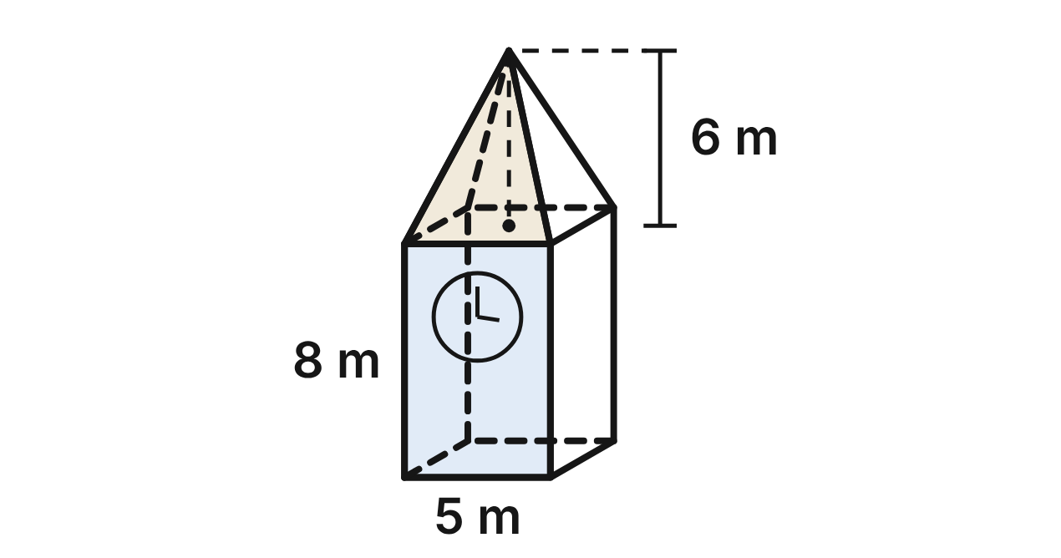
A train station's clock tower is a square prism 5 m wide and 8 m tall. Its roof is a square pyramid with the same 5 m by 5 m base and a height of 6 m. A round clock face 3 m across is on each of the four walls.
511. What is the slant height of the roof's triangular faces?
A. 8.5 m
B. 6.5 m ✔
C. 6 m
D. about 7.8 m
G.DF.1 · skill G.DF.1.2 (LOTS): Find the surface area and volume of prisms, cylinders, cones, pyramids and spheres
☐ Answer key correct ☐ Wording clear Notes: ________________________________
512. The four sloped faces of the roof are covered with copper. What area is covered?
A. 60 m²
B. 130 m²
C. 65 m² ✔
D. 16.25 m²
G.DF.1 · skill G.DF.1.2 (LOTS): Find the surface area and volume of prisms, cylinders, cones, pyramids and spheres
☐ Answer key correct ☐ Wording clear Notes: ________________________________
513. What is the volume of the whole tower, roof included?
A. 250 m³ ✔
B. 350 m³
C. 200 m³
D. 275 m³
G.DF.1 · skill G.DF.1.3 (HOTS): Solve multistep contextual problems with surface area and volume, including composite figures
☐ Answer key correct ☐ Wording clear Notes: ________________________________
514. A vertical plane parallel to the front wall passes through the tip of the roof. What is the area of the cross section?
A. 40 m²
B. 70 m²
C. 56.25 m²
D. 55 m² ✔
G.DF.1 · skill G.DF.1.1 (LOTS): Identify the two-dimensional cross sections and nets of three-dimensional figures
☐ Answer key correct ☐ Wording clear Notes: ________________________________
515. A level plane cuts the roof 4.8 m above the bottom of the roof. What is the cross section?
A. a square with 1 m sides ✔
B. a square with 4 m sides
C. a square with 5 m sides
D. a square with 0.2 m sides
G.DF.1 · skill G.DF.1.1 (LOTS): Identify the two-dimensional cross sections and nets of three-dimensional figures
☐ Answer key correct ☐ Wording clear Notes: ________________________________
516. The four walls are painted, but not the clock faces. Each can of paint covers 25 m². How many cans must be bought?
A. 7
B. 6 ✔
C. 5
D. 2
G.DF.1 · skill G.DF.1.3 (HOTS): Solve multistep contextual problems with surface area and volume, including composite figures
☐ Answer key correct ☐ Wording clear Notes: ________________________________

The Road Salt Shed
Level 2 · 3-D figures · G.DF.1 · ID geo-df1-sky-salt-shed
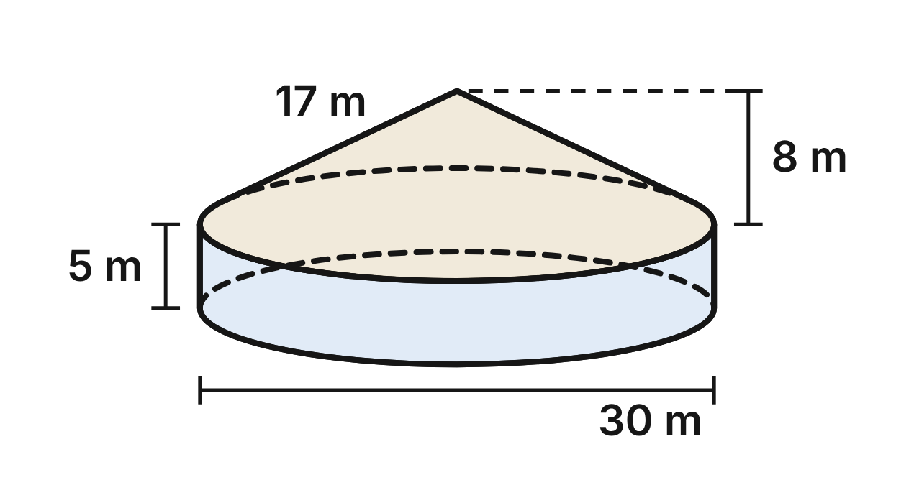
The highway department stores road salt for icy roads in a round shed. Its wall is a cylinder 30 m across and 5 m tall. The roof is a cone with the same 30 m diameter, a height of 8 m and a slant height of 17 m.
517. How much space is inside the shed, wall part and roof part together, to the nearest cubic meter?
A. 3,534 m³
B. 9,189 m³
C. 5,419 m³ ✔
D. 7,540 m³
G.DF.1 · skill G.DF.1.3 (HOTS): Solve multistep contextual problems with surface area and volume, including composite figures
☐ Answer key correct ☐ Wording clear Notes: ________________________________
518. The roof is covered with metal. What is the area of the roof, in terms of π?
A. 120π m²
B. 480π m²
C. 510π m²
D. 255π m² ✔
G.DF.1 · skill G.DF.1.2 (LOTS): Find the surface area and volume of prisms, cylinders, cones, pyramids and spheres
☐ Answer key correct ☐ Wording clear Notes: ________________________________
519. A vertical plane cuts the shed through the tip of the roof and the center of the floor. What is the area of the cross section?
A. 150 m²
B. 270 m² ✔
C. 390 m²
D. 405 m²
G.DF.1 · skill G.DF.1.1 (LOTS): Identify the two-dimensional cross sections and nets of three-dimensional figures
☐ Answer key correct ☐ Wording clear Notes: ________________________________
520. The curved outside of the wall is painted. One can of paint covers 40 m². How many cans must be bought?
A. 12 ✔
B. 11
C. 24
D. 6
G.DF.1 · skill G.DF.1.3 (HOTS): Solve multistep contextual problems with surface area and volume, including composite figures
☐ Answer key correct ☐ Wording clear Notes: ________________________________
521. The floor, the wall and the roof are unfolded flat. Which shapes make up the net of the shed?
A. two circles, a rectangle and a sector
B. a circle, a rectangle and a triangle
C. a circle and two rectangles
D. a circle, a rectangle and a sector ✔
G.DF.1 · skill G.DF.1.1 (LOTS): Identify the two-dimensional cross sections and nets of three-dimensional figures
☐ Answer key correct ☐ Wording clear Notes: ________________________________
522. Mia writes the volume of the roof as (1/3) · π · 15² · 17. What did she do wrong?
A. She should use the 30 m diameter in place of 15 m.
B. She should leave out the 1/3 because the roof sits on a cylinder.
C. She used the slant height; the 8 m height belongs there. ✔
D. Nothing; that expression gives the roof's volume.
G.DF.1 · skill G.DF.1.2 (LOTS): Find the surface area and volume of prisms, cylinders, cones, pyramids and spheres
☐ Answer key correct ☐ Wording clear Notes: ________________________________

The Bridge Pier
Level 3 · 3-D figures · G.DF.1 · ID geo-df1-sky-bridge-pier
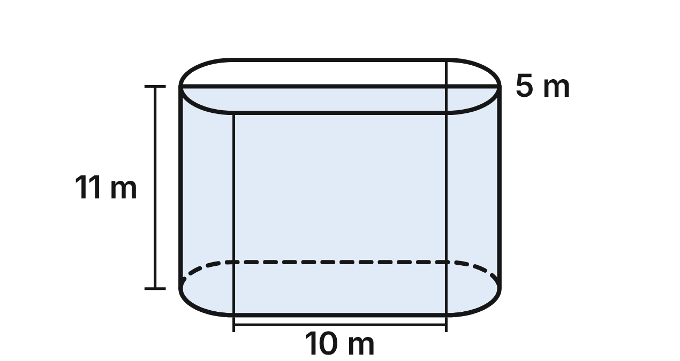
A concrete bridge pier stands on a riverbed. Every level cross section of the pier is a 10 m by 5 m rectangle with a half circle on each 5 m end, and the pier is 11 m tall.
523. How much concrete is in the pier, to the nearest cubic meter?
A. 766 m³ ✔
B. 982 m³
C. 825 m³
D. 1,414 m³
G.DF.1 · skill G.DF.1.3 (HOTS): Solve multistep contextual problems with surface area and volume, including composite figures
☐ Answer key correct ☐ Wording clear Notes: ________________________________
524. A vertical plane cuts the pier along its whole length, through the centers of both rounded ends. What is the cross section?
A. a rectangle 10 m by 11 m
B. a rectangle 5 m by 11 m
C. a rectangle 15 m by 11 m ✔
D. a rectangle 12.5 m by 11 m
G.DF.1 · skill G.DF.1.1 (LOTS): Identify the two-dimensional cross sections and nets of three-dimensional figures
☐ Answer key correct ☐ Wording clear Notes: ________________________________
525. A vertical plane perpendicular to the pier's length cuts through a rounded end, 1.8 m from the tip. What is the cross section?
A. a rectangle 5 m by 11 m
B. a rectangle 2.4 m by 11 m
C. a rectangle 3.6 m by 11 m
D. a rectangle 4.8 m by 11 m ✔
G.DF.1 · skill G.DF.1.1 (LOTS): Identify the two-dimensional cross sections and nets of three-dimensional figures
☐ Answer key correct ☐ Wording clear Notes: ________________________________
526. Before the pour, wooden forms covered the flat and curved sides of the pier, but not the top or bottom. To the nearest square meter, what area did the forms cover?
A. 220 m²
B. 393 m² ✔
C. 532 m²
D. 283 m²
G.DF.1 · skill G.DF.1.2 (LOTS): Find the surface area and volume of prisms, cylinders, cones, pyramids and spheres
☐ Answer key correct ☐ Wording clear Notes: ________________________________
527. Each concrete truck carries 8 m³. How many truckloads were needed to pour the pier?
A. 95
B. 123
C. 96 ✔
D. 104
G.DF.1 · skill G.DF.1.3 (HOTS): Solve multistep contextual problems with surface area and volume, including composite figures
☐ Answer key correct ☐ Wording clear Notes: ________________________________
528. The river is 5 m deep at the pier. To the nearest cubic meter, what volume of the pier is under water?
A. 348 m³ ✔
B. 418 m³
C. 446 m³
D. 375 m³
G.DF.1 · skill G.DF.1.3 (HOTS): Solve multistep contextual problems with surface area and volume, including composite figures
☐ Answer key correct ☐ Wording clear Notes: ________________________________

The Airplane Cargo Container
Level 3 · 3-D figures · G.DF.1 · ID geo-df1-sky-cargo-container
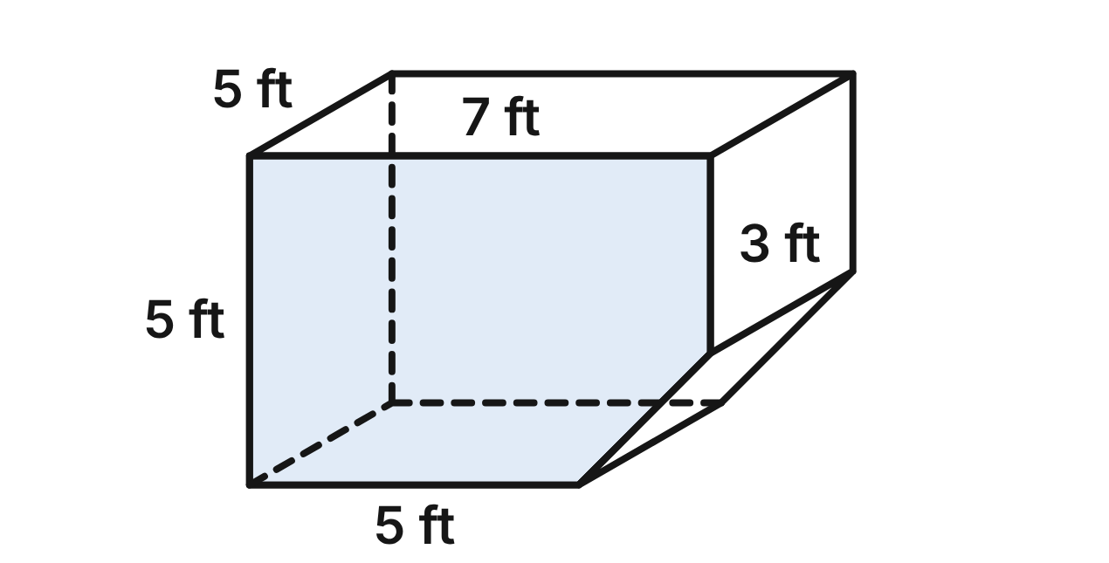
Bags ride in the plane's hold in a metal container shaped like a prism, 5 ft deep. Each end is a 7 ft by 5 ft rectangle with one lower corner cut off: the cut removes a right triangle with legs of 2 ft and 2 ft, so the floor is 5 ft wide.
529. What is the area of one five-sided end of the container?
A. 35 ft²
B. 31 ft²
C. 25 ft²
D. 33 ft² ✔
G.DF.1 · skill G.DF.1.2 (LOTS): Find the surface area and volume of prisms, cylinders, cones, pyramids and spheres
☐ Answer key correct ☐ Wording clear Notes: ________________________________
530. A level plane cuts the container 1 ft above the floor. What is the cross section?
A. a rectangle 5 ft by 5 ft
B. a rectangle 6 ft by 5 ft ✔
C. a rectangle 7 ft by 5 ft
D. a five-sided shape like the ends
G.DF.1 · skill G.DF.1.1 (LOTS): Identify the two-dimensional cross sections and nets of three-dimensional figures
☐ Answer key correct ☐ Wording clear Notes: ________________________________
531. How many faces does the container have, and what are they?
A. 7 faces: 2 pentagons and 5 rectangles ✔
B. 6 faces: 2 pentagons and 4 rectangles
C. 7 faces: 2 pentagons, 4 rectangles and 1 triangle
D. 8 faces: 2 pentagons and 6 rectangles
G.DF.1 · skill G.DF.1.1 (LOTS): Identify the two-dimensional cross sections and nets of three-dimensional figures
☐ Answer key correct ☐ Wording clear Notes: ________________________________
532. The container's whole outside is aluminum. To the nearest square foot, how much aluminum is that?
A. 114 ft²
B. 176 ft²
C. 180 ft² ✔
D. 190 ft²
G.DF.1 · skill G.DF.1.3 (HOTS): Solve multistep contextual problems with surface area and volume, including composite figures
☐ Answer key correct ☐ Wording clear Notes: ________________________________
533. Each bag is a box 2.5 ft by 1.5 ft by 1 ft. Only 80% of the container's space can be filled with bags. How many bags can it hold?
A. 44
B. 35 ✔
C. 36
D. 37
G.DF.1 · skill G.DF.1.3 (HOTS): Solve multistep contextual problems with surface area and volume, including composite figures
☐ Answer key correct ☐ Wording clear Notes: ________________________________
534. Airlines list space in cubic meters. To the nearest tenth, how many cubic meters does the container hold? Use 1 m³ ≈ 35.3 ft³.
A. 5,824.5 m³
B. 4.4 m³
C. 0.9 m³
D. 4.7 m³ ✔
G.DF.1 · skill G.DF.1.3 (HOTS): Solve multistep contextual problems with surface area and volume, including composite figures
☐ Answer key correct ☐ Wording clear Notes: ________________________________

G.DF.2 · Determine how changes in one or more dimensions affect perimeter, area, surface area, and volume, and solve problems with similar two- and three-dimensional figures.

The Beach Kite
Level 1 · Changing dimensions · G.DF.2 · ID geo-df2-sky-kite
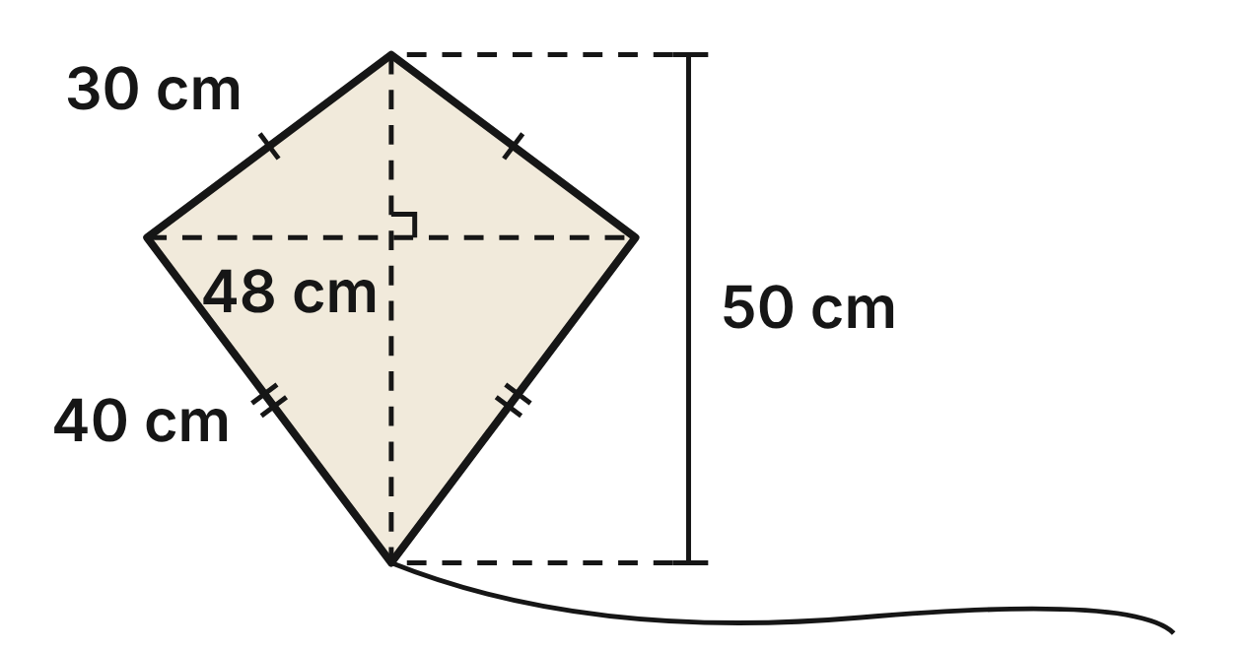
A beach shop's kite has a spine 50 cm long and a cross spar 48 cm long. They meet at right angles, and the spar crosses the spine 18 cm below the top. The kite's sides are 30 cm, 30 cm, 40 cm and 40 cm, so its perimeter is 140 cm. Its area is 1,200 cm².
535. A new kite doubles the spine to 100 cm and keeps the 48 cm spar. What is its area?
A. 2,400 cm² ✔
B. 4,800 cm²
C. 9,600 cm²
D. 1,250 cm²
G.DF.2 · skill G.DF.2.1 (LOTS): Describe how changing one or more dimensions of a figure changes its perimeter, area, surface area or volume
☐ Answer key correct ☐ Wording clear Notes: ________________________________
536. Every length of the kite is multiplied by 1.5. What is the new perimeter?
A. 472.5 cm
B. 210 cm ✔
C. 141.5 cm
D. 315 cm
G.DF.2 · skill G.DF.2.1 (LOTS): Describe how changing one or more dimensions of a figure changes its perimeter, area, surface area or volume
☐ Answer key correct ☐ Wording clear Notes: ________________________________
537. A mini kite is similar to this one and has a spine 25 cm long. What is its area?
A. 312.5 cm²
B. 600 cm²
C. 150 cm²
D. 300 cm² ✔
G.DF.2 · skill G.DF.2.2 (LOTS): Use the ratios k, k² and k³ of similar figures to find lengths, areas and volumes
☐ Answer key correct ☐ Wording clear Notes: ________________________________
538. A second kite has a 48 cm spar and a 60 cm spine that meet at right angles, with the spar 18 cm below the top. Is it similar to this kite? Choose the answer with the correct reason.
A. Yes: all kites are similar.
B. Yes: stretching one diagonal of a kite keeps it similar.
C. No: 48/48 = 1, but 60/50 = 1.2. ✔
D. No: its spine is shorter than this kite's spine.
G.DF.2 · skill G.DF.2.3 (HOTS): Decide whether two figures are similar and justify the decision with ratios of corresponding measures
☐ Answer key correct ☐ Wording clear Notes: ________________________________
539. A giant kite is similar to this one and has an area of 4,800 cm². How long is its spine?
A. about 79.4 cm
B. 100 cm ✔
C. 96 cm
D. 200 cm
G.DF.2 · skill G.DF.2.2 (LOTS): Use the ratios k, k² and k³ of similar figures to find lengths, areas and volumes
☐ Answer key correct ☐ Wording clear Notes: ________________________________
540. A festival kite is similar to this one, with every length 3 times as long. Which statement is NOT true?
A. Its area is 10,800 cm².
B. Its spine is 150 cm.
C. Its area is 3,600 cm². ✔
D. Its perimeter is 420 cm.
G.DF.2 · skill G.DF.2.2 (LOTS): Use the ratios k, k² and k³ of similar figures to find lengths, areas and volumes
☐ Answer key correct ☐ Wording clear Notes: ________________________________

The Downtown Bus Map
Level 1 · Changing dimensions · G.DF.2 · ID geo-df2-sky-bus-map
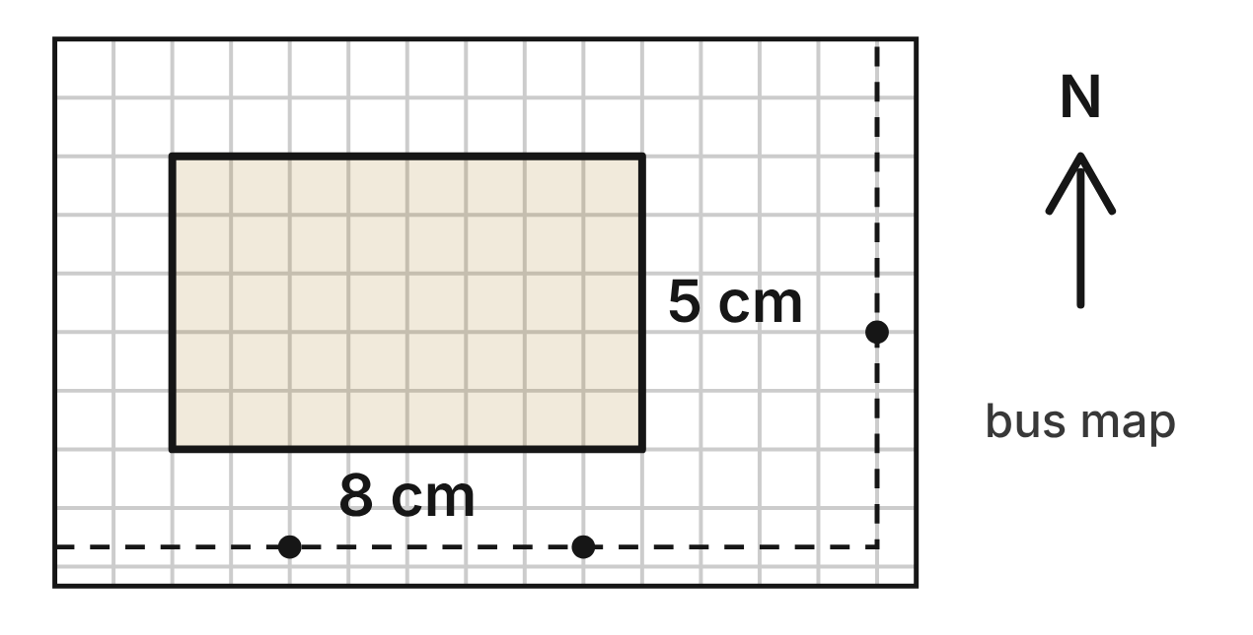
On a city bus map, the downtown zone is a rectangle 8 cm long and 5 cm wide. Its area on the map is 40 cm² and its perimeter is 26 cm. The map scale is 1 cm = 0.5 km.
541. The map is copied at 200%, so every length on it doubles. What is the area of the zone on the copy?
A. 80 cm²
B. 320 cm²
C. 160 cm² ✔
D. 52 cm²
G.DF.2 · skill G.DF.2.1 (LOTS): Describe how changing one or more dimensions of a figure changes its perimeter, area, surface area or volume
☐ Answer key correct ☐ Wording clear Notes: ________________________________
542. The map is copied at 200%, so every length on it doubles. What is the scale of the copy?
A. 1 cm = 0.125 km
B. 1 cm = 0.25 km ✔
C. 1 cm = 0.5 km
D. 1 cm = 1 km
G.DF.2 · skill G.DF.2.2 (LOTS): Use the ratios k, k² and k³ of similar figures to find lengths, areas and volumes
☐ Answer key correct ☐ Wording clear Notes: ________________________________
543. What is the real area of the downtown zone?
A. 10 km² ✔
B. 40 km²
C. 20 km²
D. 5 km²
G.DF.2 · skill G.DF.2.2 (LOTS): Use the ratios k, k² and k³ of similar figures to find lengths, areas and volumes
☐ Answer key correct ☐ Wording clear Notes: ________________________________
544. A pocket map shows the zone as a rectangle 4 cm by 3 cm. Is it similar to the zone on this map? Choose the answer with the correct reason.
A. Yes: both are rectangles, and all rectangles are similar.
B. Yes: 4/8 = 3/5.
C. No: a smaller map can never be similar to a larger one.
D. No: 4/8 = 0.5, but 3/5 = 0.6. ✔
G.DF.2 · skill G.DF.2.3 (HOTS): Decide whether two figures are similar and justify the decision with ratios of corresponding measures
☐ Answer key correct ☐ Wording clear Notes: ________________________________
545. On a wall map that is a similar enlargement, the zone covers 360 cm². How long is the zone on the wall map?
A. 24 cm ✔
B. about 16.6 cm
C. 15 cm
D. 72 cm
G.DF.2 · skill G.DF.2.2 (LOTS): Use the ratios k, k² and k³ of similar figures to find lengths, areas and volumes
☐ Answer key correct ☐ Wording clear Notes: ________________________________
546. A designer stretches the map sideways only: the zone's 8 cm length becomes 12 cm and its 5 cm width stays. Which statement is true?
A. The area becomes 60 cm², and the zone is still similar.
B. The area becomes 90 cm², since lengths grew by 1.5.
C. The area stays 40 cm², since only one side changed.
D. The area becomes 60 cm², and the zone is no longer similar. ✔
G.DF.2 · skill G.DF.2.1 (LOTS): Describe how changing one or more dimensions of a figure changes its perimeter, area, surface area or volume
☐ Answer key correct ☐ Wording clear Notes: ________________________________

The Truss Footbridge
Level 2 · Changing dimensions · G.DF.2 · ID geo-df2-sky-truss-bridge
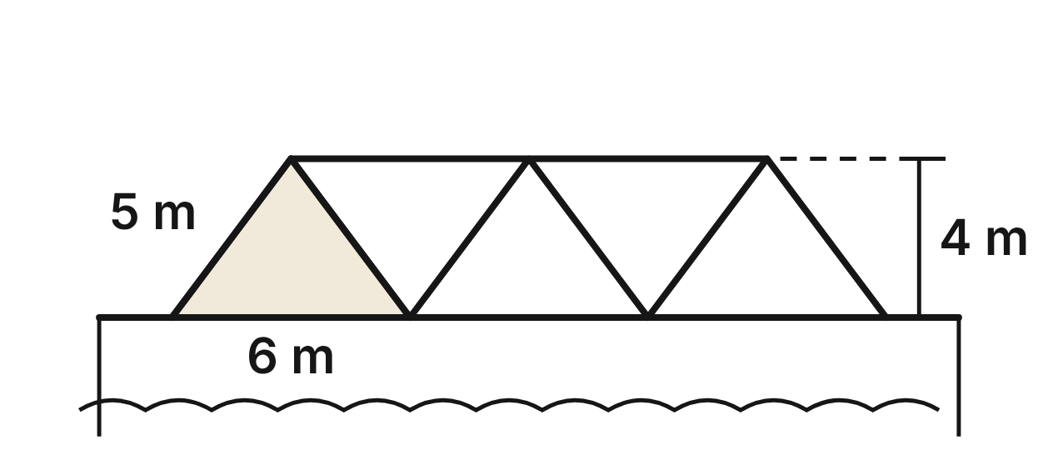
The side of a river footbridge is a truss of congruent isosceles triangles. Each triangle has a base of 6 m, legs of 5 m and a height of 4 m, so its perimeter is 16 m and its area is 12 m². Each triangle is welded from three steel bars.
547. A model of the bridge is built at a scale of 1 : 50. What is the area of one triangle on the model? (1 m² = 10,000 cm²)
A. 2,400 cm²
B. 0.96 cm²
C. 4.8 cm²
D. 48 cm² ✔
G.DF.2 · skill G.DF.2.2 (LOTS): Use the ratios k, k² and k³ of similar figures to find lengths, areas and volumes
☐ Answer key correct ☐ Wording clear Notes: ________________________________
548. Engineers make each triangle 8 m tall instead of 4 m, with the same 6 m base. What is the area of one new triangle?
A. 24 m² ✔
B. 12 m²
C. 16 m²
D. 48 m²
G.DF.2 · skill G.DF.2.1 (LOTS): Describe how changing one or more dimensions of a figure changes its perimeter, area, surface area or volume
☐ Answer key correct ☐ Wording clear Notes: ________________________________
549. Engineers make each triangle 8 m tall instead of 4 m, with the same 6 m base. To the nearest tenth of a meter, what is the perimeter of one new triangle?
A. 22.0 m
B. 32.0 m
C. 23.1 m ✔
D. 26.0 m
G.DF.2 · skill G.DF.2.1 (LOTS): Describe how changing one or more dimensions of a figure changes its perimeter, area, surface area or volume
☐ Answer key correct ☐ Wording clear Notes: ________________________________
550. Another bridge's truss triangles have a base of 9 m and legs of 7.5 m. Are they similar to these triangles? Choose the answer with the correct reason.
A. Yes: all isosceles triangles are similar.
B. Yes: 9/6 = 7.5/5 = 1.5 for all three sides. ✔
C. No: 9/6 is not equal to 7.5/5.
D. No: the heights must be given before we can decide.
G.DF.2 · skill G.DF.2.3 (HOTS): Decide whether two figures are similar and justify the decision with ratios of corresponding measures
☐ Answer key correct ☐ Wording clear Notes: ________________________________
551. A larger bridge uses similar triangles, each with an area of 48 m². How long is each base?
A. about 9.5 m
B. 10 m
C. 12 m ✔
D. 24 m
G.DF.2 · skill G.DF.2.2 (LOTS): Use the ratios k, k² and k³ of similar figures to find lengths, areas and volumes
☐ Answer key correct ☐ Wording clear Notes: ________________________________
552. A larger bridge uses similar triangles with 15 m bases. How many meters of steel bar are in one of its triangles?
A. 25 m
B. 40 m ✔
C. 100 m
D. 250 m
G.DF.2 · skill G.DF.2.2 (LOTS): Use the ratios k, k² and k³ of similar figures to find lengths, areas and volumes
☐ Answer key correct ☐ Wording clear Notes: ________________________________

Twenty-Foot and Forty-Foot Boxes
Level 2 · Changing dimensions · G.DF.2 · ID geo-df2-sky-containers
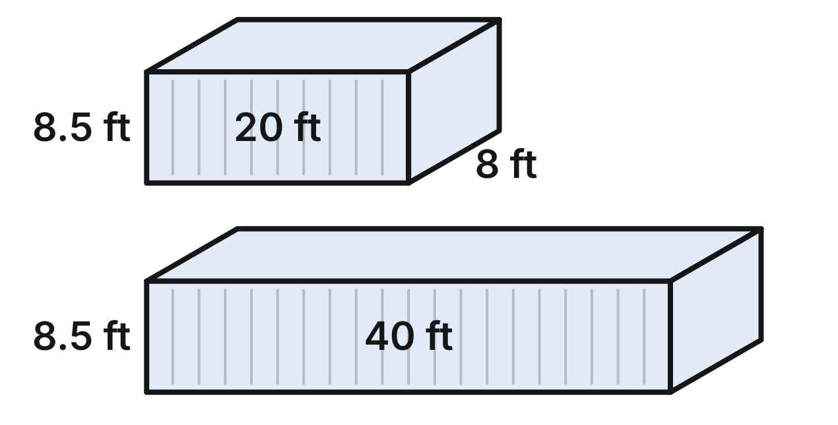
At a port, a short shipping container is a rectangular prism 20 ft long, 8 ft wide and 8.5 ft tall. It holds 1,360 ft³, and its outside surface area is 796 ft². A long container is 40 ft long, 8 ft wide and 8.5 ft tall.
553. What is the volume of the long container?
A. 5,440 ft³
B. 2,720 ft³ ✔
C. 10,880 ft³
D. 1,380 ft³
G.DF.2 · skill G.DF.2.1 (LOTS): Describe how changing one or more dimensions of a figure changes its perimeter, area, surface area or volume
☐ Answer key correct ☐ Wording clear Notes: ________________________________
554. Both containers are painted on the outside. How much more surface does the long container have than the short one?
A. 2,388 ft²
B. 340 ft²
C. 660 ft² ✔
D. 796 ft²
G.DF.2 · skill G.DF.2.1 (LOTS): Describe how changing one or more dimensions of a figure changes its perimeter, area, surface area or volume
☐ Answer key correct ☐ Wording clear Notes: ________________________________
555. Is the long container similar to the short one? Choose the answer with the correct reason.
A. No: its volume is 4 times as much.
B. Yes: all rectangular prisms are similar.
C. Yes: every length of the long container is doubled.
D. No: 40/20 = 2, but 8/8 = 1. ✔
G.DF.2 · skill G.DF.2.3 (HOTS): Decide whether two figures are similar and justify the decision with ratios of corresponding measures
☐ Answer key correct ☐ Wording clear Notes: ________________________________
556. A toy-shop model of the short container is similar to it at a scale of 1 : 40. What is the model's volume? (1 ft³ = 1,728 in³)
A. 36.72 in³ ✔
B. 1,468.8 in³
C. 58,752 in³
D. about 0.02 in³
G.DF.2 · skill G.DF.2.2 (LOTS): Use the ratios k, k² and k³ of similar figures to find lengths, areas and volumes
☐ Answer key correct ☐ Wording clear Notes: ________________________________
557. A new container is similar to the short one and has an outside surface area of 1,791 ft². How long is it?
A. about 26.2 ft
B. 30 ft ✔
C. 12 ft
D. 45 ft
G.DF.2 · skill G.DF.2.2 (LOTS): Use the ratios k, k² and k³ of similar figures to find lengths, areas and volumes
☐ Answer key correct ☐ Wording clear Notes: ________________________________
558. A designer wants a container similar to the short one that holds twice as much. Which equation gives its length L, in feet?
A. (L/20)³ = 2 ✔
B. (20/L)³ = 2
C. L/20 = 2
D. (L/20)² = 2
G.DF.2 · skill G.DF.2.2 (LOTS): Use the ratios k, k² and k³ of similar figures to find lengths, areas and volumes
☐ Answer key correct ☐ Wording clear Notes: ________________________________

The Drone's Photo
Level 2 · Changing dimensions · G.DF.2 · ID geo-df2-sky-drone-photo
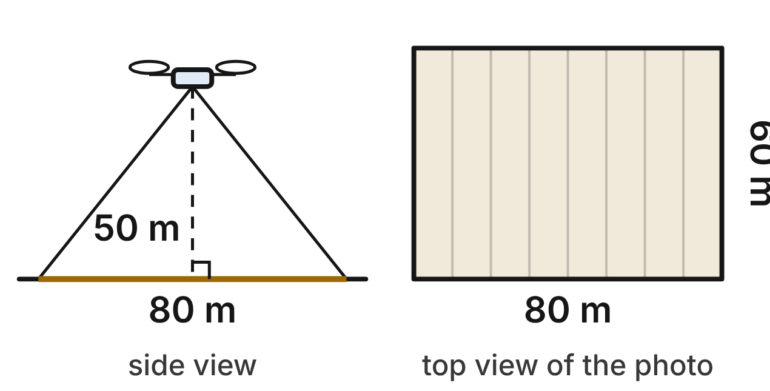
A survey drone hovers 50 m above flat ground and takes a photo straight down. The photo covers a rectangle of ground 80 m long and 60 m wide: an area of 4,800 m² and a perimeter of 280 m. When the drone flies higher, the covered rectangle stays similar, and its lengths grow in proportion to the height.
559. The drone climbs to 100 m. How much ground does one photo cover?
A. 19,200 m² ✔
B. 9,600 m²
C. 38,400 m²
D. 14,300 m²
G.DF.2 · skill G.DF.2.2 (LOTS): Use the ratios k, k² and k³ of similar figures to find lengths, areas and volumes
☐ Answer key correct ☐ Wording clear Notes: ________________________________
560. At what height does one photo cover 10,800 m²?
A. about 65.5 m
B. about 103.9 m
C. 112.5 m
D. 75 m ✔
G.DF.2 · skill G.DF.2.2 (LOTS): Use the ratios k, k² and k³ of similar figures to find lengths, areas and volumes
☐ Answer key correct ☐ Wording clear Notes: ________________________________
561. With a new lens, a photo from 50 m covers a rectangle 120 m long and still 60 m wide. What area does it cover?
A. 360 m²
B. 7,200 m² ✔
C. 10,800 m²
D. 4,840 m²
G.DF.2 · skill G.DF.2.1 (LOTS): Describe how changing one or more dimensions of a figure changes its perimeter, area, surface area or volume
☐ Answer key correct ☐ Wording clear Notes: ________________________________
562. A wide-angle camera covers a rectangle 100 m long and 75 m wide. Is it similar to the 80 m by 60 m rectangle? Choose the answer with the correct reason.
A. Yes: all rectangles are similar.
B. No: 100/80 is not equal to 75/60.
C. Yes: 100/80 = 75/60 = 1.25. ✔
D. No: similar rectangles must grow by equal amounts, and 20 ≠ 15.
G.DF.2 · skill G.DF.2.3 (HOTS): Decide whether two figures are similar and justify the decision with ratios of corresponding measures
☐ Answer key correct ☐ Wording clear Notes: ________________________________
563. What is the perimeter of the ground covered by one photo taken from 125 m?
A. 4,375 m
B. 355 m
C. 1,750 m
D. 700 m ✔
G.DF.2 · skill G.DF.2.2 (LOTS): Use the ratios k, k² and k³ of similar figures to find lengths, areas and volumes
☐ Answer key correct ☐ Wording clear Notes: ________________________________
564. The drone flies lower, at 25 m, to get sharper photos. Which statement is true?
A. Each photo covers the same area, just in more detail.
B. Each photo covers 1/2 the area, so about 2 times as many photos are needed.
C. Each photo covers 1/4 the area, so about 4 times as many photos are needed. ✔
D. Each photo covers 1/8 the area, so about 8 times as many photos are needed.
G.DF.2 · skill G.DF.2.1 (LOTS): Describe how changing one or more dimensions of a figure changes its perimeter, area, surface area or volume
☐ Answer key correct ☐ Wording clear Notes: ________________________________

The Museum's Model Plane
Level 3 · Changing dimensions · G.DF.2 · ID geo-df2-sky-model-plane
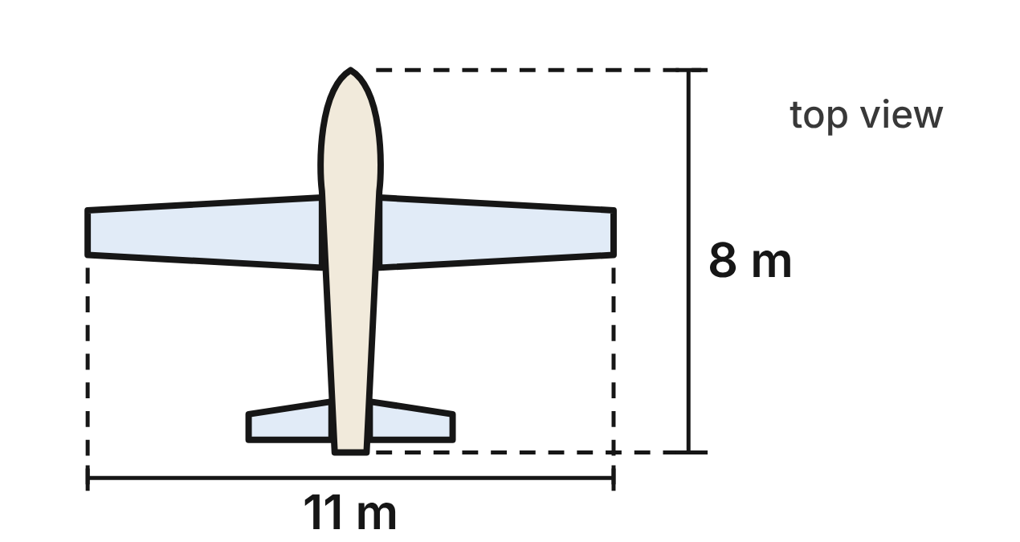
A travel museum hangs a model plane that is similar to a real plane at a scale of 1 : 20. The real plane has an 11 m wingspan and is 8 m long. Its wings have an area of 16 m², and its fuel tank holds 200 L.
565. What is the model's wingspan, in centimeters?
A. 5.5 cm
B. 2.75 cm
C. 55 cm ✔
D. 22,000 cm
G.DF.2 · skill G.DF.2.2 (LOTS): Use the ratios k, k² and k³ of similar figures to find lengths, areas and volumes
☐ Answer key correct ☐ Wording clear Notes: ________________________________
566. What is the area of the model's wings, in square centimeters? (1 m² = 10,000 cm²)
A. 400 cm² ✔
B. 20 cm²
C. 0.04 cm²
D. 8,000 cm²
G.DF.2 · skill G.DF.2.2 (LOTS): Use the ratios k, k² and k³ of similar figures to find lengths, areas and volumes
☐ Answer key correct ☐ Wording clear Notes: ________________________________
567. If the model had a tank similar to the real one, how much would it hold, in cubic centimeters? (1 L = 1,000 cm³)
A. about 3,333 cm³
B. 25 cm³ ✔
C. 10,000 cm³
D. 500 cm³
G.DF.2 · skill G.DF.2.2 (LOTS): Use the ratios k, k² and k³ of similar figures to find lengths, areas and volumes
☐ Answer key correct ☐ Wording clear Notes: ________________________________
568. Another model has wings with an area of 300 cm² and a 50 cm span. A builder stretches the wings only from tip to tip, to a 60 cm span, keeping their front-to-back width. What is the new wing area?
A. 432 cm²
B. 518.4 cm²
C. 310 cm²
D. 360 cm² ✔
G.DF.2 · skill G.DF.2.1 (LOTS): Describe how changing one or more dimensions of a figure changes its perimeter, area, surface area or volume
☐ Answer key correct ☐ Wording clear Notes: ________________________________
569. A toy plane has a 22 cm wingspan and is 20 cm long. Is it similar to the real plane? Choose the answer with the correct reason.
A. No: 22/1,100 = 0.02, but 20/800 = 0.025. ✔
B. Yes: 22/1,100 = 20/800.
C. No: a similar toy would have to use the museum's 1 : 20 scale.
D. Yes: any two planes whose wingspan is longer than the body are similar.
G.DF.2 · skill G.DF.2.3 (HOTS): Decide whether two figures are similar and justify the decision with ratios of corresponding measures
☐ Answer key correct ☐ Wording clear Notes: ________________________________
570. The real plane's outside takes 30 L of paint. How much paint, in milliliters, would the model's outside take, with paint spread just as thick? (1 L = 1,000 mL)
A. 750 mL
B. 75 mL ✔
C. 1,500 mL
D. 3.75 mL
G.DF.2 · skill G.DF.2.2 (LOTS): Use the ratios k, k² and k³ of similar figures to find lengths, areas and volumes
☐ Answer key correct ☐ Wording clear Notes: ________________________________

The Railway Tunnel
Level 3 · Changing dimensions · G.DF.2 · ID geo-df2-sky-rail-tunnel
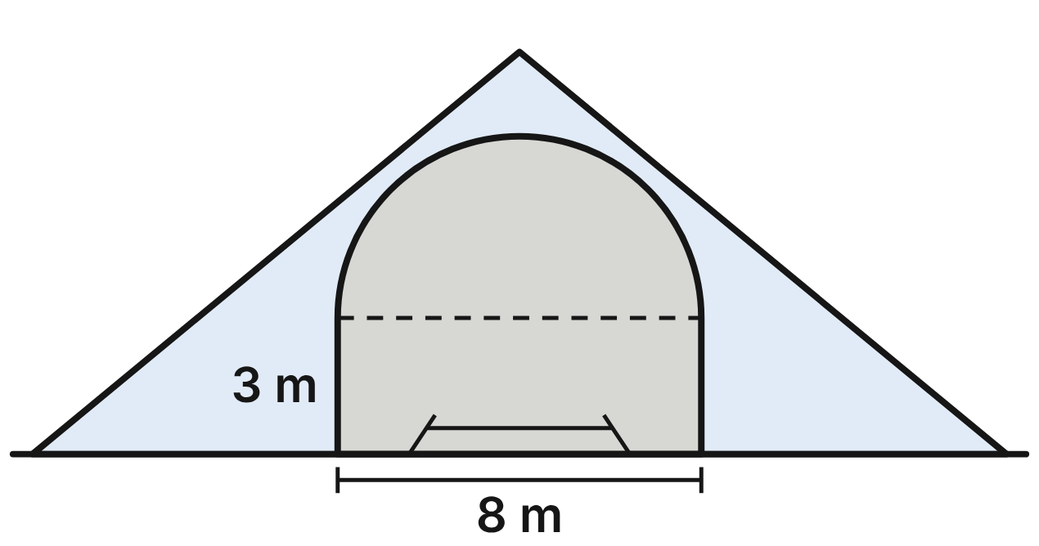
A railway tunnel's opening is a rectangle 8 m wide with walls 3 m tall, topped by a half-circle with an 8 m diameter. The opening's area is (24 + 8π) m². The tunnel is 200 m long, so (4,800 + 1,600π) m³ of rock was removed.
571. A new tunnel has the same opening but is 300 m long. How much rock is removed? Give the answer in terms of π.
A. (10,800 + 3,600π) m³
B. (16,200 + 5,400π) m³
C. (7,200 + 1,600π) m³
D. (7,200 + 2,400π) m³ ✔
G.DF.2 · skill G.DF.2.1 (LOTS): Describe how changing one or more dimensions of a figure changes its perimeter, area, surface area or volume
☐ Answer key correct ☐ Wording clear Notes: ________________________________
572. A model railroad has a tunnel similar to this one at a scale of 1 : 80. To the nearest square centimeter, what is the area of the model's opening? (1 m² = 10,000 cm²)
A. 1 cm²
B. 38 cm²
C. 77 cm² ✔
D. 6,142 cm²
G.DF.2 · skill G.DF.2.2 (LOTS): Use the ratios k, k² and k³ of similar figures to find lengths, areas and volumes
☐ Answer key correct ☐ Wording clear Notes: ________________________________
573. A highway tunnel is similar to this one, and its opening has 4 times the area. How wide is it?
A. 16 m ✔
B. 6 m
C. 32 m
D. about 12.7 m
G.DF.2 · skill G.DF.2.2 (LOTS): Use the ratios k, k² and k³ of similar figures to find lengths, areas and volumes
☐ Answer key correct ☐ Wording clear Notes: ________________________________
574. Another tunnel's opening is a rectangle 12 m wide with walls 4.5 m tall, topped by a half-circle with a 12 m diameter. Is it similar to this opening? Choose the answer with the correct reason.
A. Yes: only the half-circles must match, and all half-circles are similar.
B. No: 12/8 is not equal to 4.5/3.
C. No: a similar opening would have exactly 1.5 times the area.
D. Yes: 12/8 = 4.5/3 = 6/4 = 1.5. ✔
G.DF.2 · skill G.DF.2.3 (HOTS): Decide whether two figures are similar and justify the decision with ratios of corresponding measures
☐ Answer key correct ☐ Wording clear Notes: ________________________________
575. Engineers raise the walls from 3 m to 4 m and keep the 8 m width and the half-circle. By how much does the opening's area increase?
A. 32 m²
B. 8 m² ✔
C. about 38.2 m²
D. about 16.4 m²
G.DF.2 · skill G.DF.2.1 (LOTS): Describe how changing one or more dimensions of a figure changes its perimeter, area, surface area or volume
☐ Answer key correct ☐ Wording clear Notes: ________________________________
576. A model railroad has a tunnel similar to this one at a scale of 1 : 80. To the nearest liter, how much foam is carved out to make it? (1 m³ = 1,000 L)
A. 13 L
B. 1,535 L
C. 19 L ✔
D. 122,832 L
G.DF.2 · skill G.DF.2.2 (LOTS): Use the ratios k, k² and k³ of similar figures to find lengths, areas and volumes
☐ Answer key correct ☐ Wording clear Notes: ________________________________

Answer key
Pack | Question | Standard | Skill | Level | Answer
rlt1-sky-low-bridge | 1 | G.RLT.1 | G.RLT.1.1 LOTS | 1 | B
rlt1-sky-low-bridge | 2 | G.RLT.1 | G.RLT.1.2 LOTS | 1 | A
rlt1-sky-low-bridge | 3 | G.RLT.1 | G.RLT.1.2 LOTS | 1 | C
rlt1-sky-low-bridge | 4 | G.RLT.1 | G.RLT.1.3 HOTS | 1 | B
rlt1-sky-low-bridge | 5 | G.RLT.1 | G.RLT.1.3 HOTS | 1 | D
rlt1-sky-low-bridge | 6 | G.RLT.1 | G.RLT.1.2 LOTS | 1 | C
rlt1-sky-rail-map | 7 | G.RLT.1 | G.RLT.1.2 LOTS | 1 | D
rlt1-sky-rail-map | 8 | G.RLT.1 | G.RLT.1.2 LOTS | 1 | C
rlt1-sky-rail-map | 9 | G.RLT.1 | G.RLT.1.4 LOTS | 1 | A
rlt1-sky-rail-map | 10 | G.RLT.1 | G.RLT.1.4 LOTS | 1 | B
rlt1-sky-rail-map | 11 | G.RLT.1 | G.RLT.1.1 LOTS | 1 | D
rlt1-sky-rail-map | 12 | G.RLT.1 | G.RLT.1.3 HOTS | 1 | A
rlt1-sky-commuter-table | 13 | G.RLT.1 | G.RLT.1.4 LOTS | 2 | C
rlt1-sky-commuter-table | 14 | G.RLT.1 | G.RLT.1.4 LOTS | 2 | B
rlt1-sky-commuter-table | 15 | G.RLT.1 | G.RLT.1.4 LOTS | 2 | D
rlt1-sky-commuter-table | 16 | G.RLT.1 | G.RLT.1.2 LOTS | 2 | C
rlt1-sky-commuter-table | 17 | G.RLT.1 | G.RLT.1.1 LOTS | 2 | A
rlt1-sky-commuter-table | 18 | G.RLT.1 | G.RLT.1.4 LOTS | 2 | B
rlt1-sky-drawbridge | 19 | G.RLT.1 | G.RLT.1.1 LOTS | 2 | A
rlt1-sky-drawbridge | 20 | G.RLT.1 | G.RLT.1.2 LOTS | 2 | D
rlt1-sky-drawbridge | 21 | G.RLT.1 | G.RLT.1.2 LOTS | 2 | B
rlt1-sky-drawbridge | 22 | G.RLT.1 | G.RLT.1.1 LOTS | 2 | C
rlt1-sky-drawbridge | 23 | G.RLT.1 | G.RLT.1.3 HOTS | 2 | A
rlt1-sky-drawbridge | 24 | G.RLT.1 | G.RLT.1.1 LOTS | 2 | D
rlt1-sky-kite-festival | 25 | G.RLT.1 | G.RLT.1.4 LOTS | 2 | B
rlt1-sky-kite-festival | 26 | G.RLT.1 | G.RLT.1.4 LOTS | 2 | C
rlt1-sky-kite-festival | 27 | G.RLT.1 | G.RLT.1.2 LOTS | 2 | A
rlt1-sky-kite-festival | 28 | G.RLT.1 | G.RLT.1.4 LOTS | 2 | D
rlt1-sky-kite-festival | 29 | G.RLT.1 | G.RLT.1.4 LOTS | 2 | C
rlt1-sky-kite-festival | 30 | G.RLT.1 | G.RLT.1.3 HOTS | 2 | B
rlt1-sky-station-ramps | 31 | G.RLT.1 | G.RLT.1.3 HOTS | 3 | D
rlt1-sky-station-ramps | 32 | G.RLT.1 | G.RLT.1.2 LOTS | 3 | A
rlt1-sky-station-ramps | 33 | G.RLT.1 | G.RLT.1.3 HOTS | 3 | C
rlt1-sky-station-ramps | 34 | G.RLT.1 | G.RLT.1.3 HOTS | 3 | B
rlt1-sky-station-ramps | 35 | G.RLT.1 | G.RLT.1.3 HOTS | 3 | A
rlt1-sky-station-ramps | 36 | G.RLT.1 | G.RLT.1.1 LOTS | 3 | D
rlt1-sky-snow-day-rails | 37 | G.RLT.1 | G.RLT.1.3 HOTS | 3 | C
rlt1-sky-snow-day-rails | 38 | G.RLT.1 | G.RLT.1.3 HOTS | 3 | B
rlt1-sky-snow-day-rails | 39 | G.RLT.1 | G.RLT.1.3 HOTS | 3 | D
rlt1-sky-snow-day-rails | 40 | G.RLT.1 | G.RLT.1.3 HOTS | 3 | A
rlt1-sky-snow-day-rails | 41 | G.RLT.1 | G.RLT.1.2 LOTS | 3 | B
rlt1-sky-snow-day-rails | 42 | G.RLT.1 | G.RLT.1.1 LOTS | 3 | C
rlt2-sky-runways | 43 | G.RLT.2 | G.RLT.2.1 LOTS | 1 | B
rlt2-sky-runways | 44 | G.RLT.2 | G.RLT.2.3 LOTS | 1 | C
rlt2-sky-runways | 45 | G.RLT.2 | G.RLT.2.1 LOTS | 1 | A
rlt2-sky-runways | 46 | G.RLT.2 | G.RLT.2.3 LOTS | 1 | D
rlt2-sky-runways | 47 | G.RLT.2 | G.RLT.2.1 LOTS | 1 | C
rlt2-sky-runways | 48 | G.RLT.2 | G.RLT.2.3 LOTS | 1 | B
rlt2-sky-ferry-canal | 49 | G.RLT.2 | G.RLT.2.3 LOTS | 1 | A
rlt2-sky-ferry-canal | 50 | G.RLT.2 | G.RLT.2.1 LOTS | 1 | D
rlt2-sky-ferry-canal | 51 | G.RLT.2 | G.RLT.2.3 LOTS | 1 | B
rlt2-sky-ferry-canal | 52 | G.RLT.2 | G.RLT.2.1 LOTS | 1 | C
rlt2-sky-ferry-canal | 53 | G.RLT.2 | G.RLT.2.1 LOTS | 1 | A
rlt2-sky-ferry-canal | 54 | G.RLT.2 | G.RLT.2.2 HOTS | 1 | D
rlt2-sky-truss-bridge | 55 | G.RLT.2 | G.RLT.2.3 LOTS | 2 | D
rlt2-sky-truss-bridge | 56 | G.RLT.2 | G.RLT.2.1 LOTS | 2 | B
rlt2-sky-truss-bridge | 57 | G.RLT.2 | G.RLT.2.3 LOTS | 2 | C
rlt2-sky-truss-bridge | 58 | G.RLT.2 | G.RLT.2.2 HOTS | 2 | A
rlt2-sky-truss-bridge | 59 | G.RLT.2 | G.RLT.2.1 LOTS | 2 | B
rlt2-sky-truss-bridge | 60 | G.RLT.2 | G.RLT.2.3 LOTS | 2 | D
rlt2-sky-subway-escalator | 61 | G.RLT.2 | G.RLT.2.3 LOTS | 2 | C
rlt2-sky-subway-escalator | 62 | G.RLT.2 | G.RLT.2.3 LOTS | 2 | A
rlt2-sky-subway-escalator | 63 | G.RLT.2 | G.RLT.2.1 LOTS | 2 | B
rlt2-sky-subway-escalator | 64 | G.RLT.2 | G.RLT.2.3 LOTS | 2 | D
rlt2-sky-subway-escalator | 65 | G.RLT.2 | G.RLT.2.2 HOTS | 2 | C
rlt2-sky-subway-escalator | 66 | G.RLT.2 | G.RLT.2.1 LOTS | 2 | A
rlt2-sky-kite-strings | 67 | G.RLT.2 | G.RLT.2.1 LOTS | 2 | A
rlt2-sky-kite-strings | 68 | G.RLT.2 | G.RLT.2.3 LOTS | 2 | C
rlt2-sky-kite-strings | 69 | G.RLT.2 | G.RLT.2.2 HOTS | 2 | D
rlt2-sky-kite-strings | 70 | G.RLT.2 | G.RLT.2.2 HOTS | 2 | B
rlt2-sky-kite-strings | 71 | G.RLT.2 | G.RLT.2.3 LOTS | 2 | A
rlt2-sky-kite-strings | 72 | G.RLT.2 | G.RLT.2.1 LOTS | 2 | C
rlt2-sky-marina-docks | 73 | G.RLT.2 | G.RLT.2.2 HOTS | 3 | B
rlt2-sky-marina-docks | 74 | G.RLT.2 | G.RLT.2.2 HOTS | 3 | D
rlt2-sky-marina-docks | 75 | G.RLT.2 | G.RLT.2.2 HOTS | 3 | A
rlt2-sky-marina-docks | 76 | G.RLT.2 | G.RLT.2.1 LOTS | 3 | C
rlt2-sky-marina-docks | 77 | G.RLT.2 | G.RLT.2.3 LOTS | 3 | A
rlt2-sky-marina-docks | 78 | G.RLT.2 | G.RLT.2.3 LOTS | 3 | B
rlt2-sky-drone-highways | 79 | G.RLT.2 | G.RLT.2.1 LOTS | 3 | D
rlt2-sky-drone-highways | 80 | G.RLT.2 | G.RLT.2.3 LOTS | 3 | B
rlt2-sky-drone-highways | 81 | G.RLT.2 | G.RLT.2.3 LOTS | 3 | C
rlt2-sky-drone-highways | 82 | G.RLT.2 | G.RLT.2.2 HOTS | 3 | A
rlt2-sky-drone-highways | 83 | G.RLT.2 | G.RLT.2.3 LOTS | 3 | B
rlt2-sky-drone-highways | 84 | G.RLT.2 | G.RLT.2.2 HOTS | 3 | D
rlt3-sky-rail-signs | 85 | G.RLT.3 | G.RLT.3.1 LOTS | 1 | C
rlt3-sky-rail-signs | 86 | G.RLT.3 | G.RLT.3.1 LOTS | 1 | A
rlt3-sky-rail-signs | 87 | G.RLT.3 | G.RLT.3.1 LOTS | 1 | D
rlt3-sky-rail-signs | 88 | G.RLT.3 | G.RLT.3.1 LOTS | 1 | B
rlt3-sky-rail-signs | 89 | G.RLT.3 | G.RLT.3.3 HOTS | 1 | C
rlt3-sky-rail-signs | 90 | G.RLT.3 | G.RLT.3.3 HOTS | 1 | D
rlt3-sky-airport-plane | 91 | G.RLT.3 | G.RLT.3.2 LOTS | 1 | B
rlt3-sky-airport-plane | 92 | G.RLT.3 | G.RLT.3.2 LOTS | 1 | A
rlt3-sky-airport-plane | 93 | G.RLT.3 | G.RLT.3.2 LOTS | 1 | D
rlt3-sky-airport-plane | 94 | G.RLT.3 | G.RLT.3.2 LOTS | 1 | C
rlt3-sky-airport-plane | 95 | G.RLT.3 | G.RLT.3.3 HOTS | 1 | A
rlt3-sky-airport-plane | 96 | G.RLT.3 | G.RLT.3.3 HOTS | 1 | B
rlt3-sky-kite-festival | 97 | G.RLT.3 | G.RLT.3.1 LOTS | 2 | C
rlt3-sky-kite-festival | 98 | G.RLT.3 | G.RLT.3.2 LOTS | 2 | A
rlt3-sky-kite-festival | 99 | G.RLT.3 | G.RLT.3.2 LOTS | 2 | D
rlt3-sky-kite-festival | 100 | G.RLT.3 | G.RLT.3.3 HOTS | 2 | B
rlt3-sky-kite-festival | 101 | G.RLT.3 | G.RLT.3.2 LOTS | 2 | C
rlt3-sky-kite-festival | 102 | G.RLT.3 | G.RLT.3.2 LOTS | 2 | B
rlt3-sky-train-yard | 103 | G.RLT.3 | G.RLT.3.2 LOTS | 2 | D
rlt3-sky-train-yard | 104 | G.RLT.3 | G.RLT.3.3 HOTS | 2 | A
rlt3-sky-train-yard | 105 | G.RLT.3 | G.RLT.3.3 HOTS | 2 | C
rlt3-sky-train-yard | 106 | G.RLT.3 | G.RLT.3.2 LOTS | 2 | B
rlt3-sky-train-yard | 107 | G.RLT.3 | G.RLT.3.3 HOTS | 2 | D
rlt3-sky-train-yard | 108 | G.RLT.3 | G.RLT.3.2 LOTS | 2 | A
rlt3-sky-model-sail | 109 | G.RLT.3 | G.RLT.3.2 LOTS | 2 | C
rlt3-sky-model-sail | 110 | G.RLT.3 | G.RLT.3.2 LOTS | 2 | B
rlt3-sky-model-sail | 111 | G.RLT.3 | G.RLT.3.3 HOTS | 2 | D
rlt3-sky-model-sail | 112 | G.RLT.3 | G.RLT.3.3 HOTS | 2 | A
rlt3-sky-model-sail | 113 | G.RLT.3 | G.RLT.3.2 LOTS | 2 | C
rlt3-sky-model-sail | 114 | G.RLT.3 | G.RLT.3.2 LOTS | 2 | B
rlt3-sky-drone-route | 115 | G.RLT.3 | G.RLT.3.3 HOTS | 2 | D
rlt3-sky-drone-route | 116 | G.RLT.3 | G.RLT.3.2 LOTS | 2 | B
rlt3-sky-drone-route | 117 | G.RLT.3 | G.RLT.3.2 LOTS | 2 | A
rlt3-sky-drone-route | 118 | G.RLT.3 | G.RLT.3.3 HOTS | 2 | C
rlt3-sky-drone-route | 119 | G.RLT.3 | G.RLT.3.2 LOTS | 2 | D
rlt3-sky-drone-route | 120 | G.RLT.3 | G.RLT.3.2 LOTS | 2 | A
rlt3-sky-ferry-harbor | 121 | G.RLT.3 | G.RLT.3.3 HOTS | 3 | B
rlt3-sky-ferry-harbor | 122 | G.RLT.3 | G.RLT.3.3 HOTS | 3 | C
rlt3-sky-ferry-harbor | 123 | G.RLT.3 | G.RLT.3.3 HOTS | 3 | A
rlt3-sky-ferry-harbor | 124 | G.RLT.3 | G.RLT.3.2 LOTS | 3 | D
rlt3-sky-ferry-harbor | 125 | G.RLT.3 | G.RLT.3.2 LOTS | 3 | B
rlt3-sky-ferry-harbor | 126 | G.RLT.3 | G.RLT.3.3 HOTS | 3 | D
rlt3-sky-compass-rose | 127 | G.RLT.3 | G.RLT.3.1 LOTS | 3 | A
rlt3-sky-compass-rose | 128 | G.RLT.3 | G.RLT.3.1 LOTS | 3 | C
rlt3-sky-compass-rose | 129 | G.RLT.3 | G.RLT.3.3 HOTS | 3 | B
rlt3-sky-compass-rose | 130 | G.RLT.3 | G.RLT.3.3 HOTS | 3 | D
rlt3-sky-compass-rose | 131 | G.RLT.3 | G.RLT.3.2 LOTS | 3 | C
rlt3-sky-compass-rose | 132 | G.RLT.3 | G.RLT.3.3 HOTS | 3 | A
tr1-sky-three-airports | 133 | G.TR.1 | G.TR.1.3 LOTS | 1 | A
tr1-sky-three-airports | 134 | G.TR.1 | G.TR.1.3 LOTS | 1 | D
tr1-sky-three-airports | 135 | G.TR.1 | G.TR.1.1 LOTS | 1 | C
tr1-sky-three-airports | 136 | G.TR.1 | G.TR.1.1 LOTS | 1 | B
tr1-sky-three-airports | 137 | G.TR.1 | G.TR.1.2 LOTS | 1 | A
tr1-sky-three-airports | 138 | G.TR.1 | G.TR.1.2 LOTS | 1 | B
tr1-sky-footbridge-truss | 139 | G.TR.1 | G.TR.1.3 LOTS | 1 | D
tr1-sky-footbridge-truss | 140 | G.TR.1 | G.TR.1.3 LOTS | 1 | C
tr1-sky-footbridge-truss | 141 | G.TR.1 | G.TR.1.3 LOTS | 1 | B
tr1-sky-footbridge-truss | 142 | G.TR.1 | G.TR.1.1 LOTS | 1 | D
tr1-sky-footbridge-truss | 143 | G.TR.1 | G.TR.1.1 LOTS | 1 | C
tr1-sky-footbridge-truss | 144 | G.TR.1 | G.TR.1.2 LOTS | 1 | A
tr1-sky-road-junction | 145 | G.TR.1 | G.TR.1.3 LOTS | 2 | A
tr1-sky-road-junction | 146 | G.TR.1 | G.TR.1.3 LOTS | 2 | C
tr1-sky-road-junction | 147 | G.TR.1 | G.TR.1.3 LOTS | 2 | D
tr1-sky-road-junction | 148 | G.TR.1 | G.TR.1.1 LOTS | 2 | B
tr1-sky-road-junction | 149 | G.TR.1 | G.TR.1.1 LOTS | 2 | A
tr1-sky-road-junction | 150 | G.TR.1 | G.TR.1.2 LOTS | 2 | D
tr1-sky-sailing-race | 151 | G.TR.1 | G.TR.1.2 LOTS | 2 | B
tr1-sky-sailing-race | 152 | G.TR.1 | G.TR.1.1 LOTS | 2 | C
tr1-sky-sailing-race | 153 | G.TR.1 | G.TR.1.1 LOTS | 2 | A
tr1-sky-sailing-race | 154 | G.TR.1 | G.TR.1.3 LOTS | 2 | C
tr1-sky-sailing-race | 155 | G.TR.1 | G.TR.1.3 LOTS | 2 | D
tr1-sky-sailing-race | 156 | G.TR.1 | G.TR.1.2 LOTS | 2 | B
tr1-sky-beach-kite | 157 | G.TR.1 | G.TR.1.3 LOTS | 2 | C
tr1-sky-beach-kite | 158 | G.TR.1 | G.TR.1.3 LOTS | 2 | B
tr1-sky-beach-kite | 159 | G.TR.1 | G.TR.1.1 LOTS | 2 | A
tr1-sky-beach-kite | 160 | G.TR.1 | G.TR.1.1 LOTS | 2 | D
tr1-sky-beach-kite | 161 | G.TR.1 | G.TR.1.1 LOTS | 2 | A
tr1-sky-beach-kite | 162 | G.TR.1 | G.TR.1.2 LOTS | 2 | D
tr1-sky-drone-loop | 163 | G.TR.1 | G.TR.1.2 LOTS | 3 | B
tr1-sky-drone-loop | 164 | G.TR.1 | G.TR.1.2 LOTS | 3 | C
tr1-sky-drone-loop | 165 | G.TR.1 | G.TR.1.1 LOTS | 3 | B
tr1-sky-drone-loop | 166 | G.TR.1 | G.TR.1.1 LOTS | 3 | D
tr1-sky-drone-loop | 167 | G.TR.1 | G.TR.1.3 LOTS | 3 | C
tr1-sky-drone-loop | 168 | G.TR.1 | G.TR.1.3 LOTS | 3 | A
tr1-sky-ferry-ramp | 169 | G.TR.1 | G.TR.1.3 LOTS | 3 | A
tr1-sky-ferry-ramp | 170 | G.TR.1 | G.TR.1.3 LOTS | 3 | C
tr1-sky-ferry-ramp | 171 | G.TR.1 | G.TR.1.3 LOTS | 3 | B
tr1-sky-ferry-ramp | 172 | G.TR.1 | G.TR.1.1 LOTS | 3 | D
tr1-sky-ferry-ramp | 173 | G.TR.1 | G.TR.1.1 LOTS | 3 | C
tr1-sky-ferry-ramp | 174 | G.TR.1 | G.TR.1.2 LOTS | 3 | A
tr2-sky-rest-stop | 175 | G.TR.2 | G.TR.2.1 LOTS | 1 | B
tr2-sky-rest-stop | 176 | G.TR.2 | G.TR.2.2 HOTS | 1 | A
tr2-sky-rest-stop | 177 | G.TR.2 | G.TR.2.3 LOTS | 1 | D
tr2-sky-rest-stop | 178 | G.TR.2 | G.TR.2.3 LOTS | 1 | C
tr2-sky-rest-stop | 179 | G.TR.2 | G.TR.2.1 LOTS | 1 | D
tr2-sky-rest-stop | 180 | G.TR.2 | G.TR.2.3 LOTS | 1 | C
tr2-sky-rail-bridge | 181 | G.TR.2 | G.TR.2.2 HOTS | 1 | C
tr2-sky-rail-bridge | 182 | G.TR.2 | G.TR.2.1 LOTS | 1 | A
tr2-sky-rail-bridge | 183 | G.TR.2 | G.TR.2.3 LOTS | 1 | B
tr2-sky-rail-bridge | 184 | G.TR.2 | G.TR.2.3 LOTS | 1 | D
tr2-sky-rail-bridge | 185 | G.TR.2 | G.TR.2.1 LOTS | 1 | D
tr2-sky-rail-bridge | 186 | G.TR.2 | G.TR.2.3 LOTS | 1 | B
tr2-sky-drone-range | 187 | G.TR.2 | G.TR.2.1 LOTS | 2 | B
tr2-sky-drone-range | 188 | G.TR.2 | G.TR.2.3 LOTS | 2 | A
tr2-sky-drone-range | 189 | G.TR.2 | G.TR.2.1 LOTS | 2 | D
tr2-sky-drone-range | 190 | G.TR.2 | G.TR.2.1 LOTS | 2 | C
tr2-sky-drone-range | 191 | G.TR.2 | G.TR.2.3 LOTS | 2 | C
tr2-sky-drone-range | 192 | G.TR.2 | G.TR.2.2 HOTS | 2 | A
tr2-sky-footbridge | 193 | G.TR.2 | G.TR.2.2 HOTS | 2 | A
tr2-sky-footbridge | 194 | G.TR.2 | G.TR.2.3 LOTS | 2 | B
tr2-sky-footbridge | 195 | G.TR.2 | G.TR.2.3 LOTS | 2 | D
tr2-sky-footbridge | 196 | G.TR.2 | G.TR.2.2 HOTS | 2 | C
tr2-sky-footbridge | 197 | G.TR.2 | G.TR.2.1 LOTS | 2 | B
tr2-sky-footbridge | 198 | G.TR.2 | G.TR.2.3 LOTS | 2 | D
tr2-sky-race-courses | 199 | G.TR.2 | G.TR.2.3 LOTS | 2 | C
tr2-sky-race-courses | 200 | G.TR.2 | G.TR.2.1 LOTS | 2 | A
tr2-sky-race-courses | 201 | G.TR.2 | G.TR.2.3 LOTS | 2 | D
tr2-sky-race-courses | 202 | G.TR.2 | G.TR.2.3 LOTS | 2 | B
tr2-sky-race-courses | 203 | G.TR.2 | G.TR.2.2 HOTS | 2 | C
tr2-sky-race-courses | 204 | G.TR.2 | G.TR.2.1 LOTS | 2 | B
tr2-sky-station-truss | 205 | G.TR.2 | G.TR.2.2 HOTS | 3 | C
tr2-sky-station-truss | 206 | G.TR.2 | G.TR.2.3 LOTS | 3 | A
tr2-sky-station-truss | 207 | G.TR.2 | G.TR.2.3 LOTS | 3 | D
tr2-sky-station-truss | 208 | G.TR.2 | G.TR.2.3 LOTS | 3 | B
tr2-sky-station-truss | 209 | G.TR.2 | G.TR.2.1 LOTS | 3 | B
tr2-sky-station-truss | 210 | G.TR.2 | G.TR.2.2 HOTS | 3 | A
tr2-sky-ferry-buoy | 211 | G.TR.2 | G.TR.2.2 HOTS | 3 | D
tr2-sky-ferry-buoy | 212 | G.TR.2 | G.TR.2.1 LOTS | 3 | C
tr2-sky-ferry-buoy | 213 | G.TR.2 | G.TR.2.3 LOTS | 3 | B
tr2-sky-ferry-buoy | 214 | G.TR.2 | G.TR.2.2 HOTS | 3 | A
tr2-sky-ferry-buoy | 215 | G.TR.2 | G.TR.2.3 LOTS | 3 | D
tr2-sky-ferry-buoy | 216 | G.TR.2 | G.TR.2.1 LOTS | 3 | A
tr3-sky-road-map | 217 | G.TR.3 | G.TR.3.1 LOTS | 1 | A
tr3-sky-road-map | 218 | G.TR.3 | G.TR.3.3 LOTS | 1 | C
tr3-sky-road-map | 219 | G.TR.3 | G.TR.3.3 LOTS | 1 | D
tr3-sky-road-map | 220 | G.TR.3 | G.TR.3.3 LOTS | 1 | B
tr3-sky-road-map | 221 | G.TR.3 | G.TR.3.2 HOTS | 1 | C
tr3-sky-road-map | 222 | G.TR.3 | G.TR.3.1 LOTS | 1 | A
tr3-sky-grade-sign | 223 | G.TR.3 | G.TR.3.1 LOTS | 1 | B
tr3-sky-grade-sign | 224 | G.TR.3 | G.TR.3.3 LOTS | 1 | D
tr3-sky-grade-sign | 225 | G.TR.3 | G.TR.3.3 LOTS | 1 | A
tr3-sky-grade-sign | 226 | G.TR.3 | G.TR.3.2 HOTS | 1 | C
tr3-sky-grade-sign | 227 | G.TR.3 | G.TR.3.1 LOTS | 1 | D
tr3-sky-grade-sign | 228 | G.TR.3 | G.TR.3.3 LOTS | 1 | B
tr3-sky-sails | 229 | G.TR.3 | G.TR.3.2 HOTS | 2 | D
tr3-sky-sails | 230 | G.TR.3 | G.TR.3.1 LOTS | 2 | A
tr3-sky-sails | 231 | G.TR.3 | G.TR.3.3 LOTS | 2 | C
tr3-sky-sails | 232 | G.TR.3 | G.TR.3.3 LOTS | 2 | B
tr3-sky-sails | 233 | G.TR.3 | G.TR.3.3 LOTS | 2 | A
tr3-sky-sails | 234 | G.TR.3 | G.TR.3.2 HOTS | 2 | D
tr3-sky-bridge-truss | 235 | G.TR.3 | G.TR.3.1 LOTS | 2 | C
tr3-sky-bridge-truss | 236 | G.TR.3 | G.TR.3.3 LOTS | 2 | B
tr3-sky-bridge-truss | 237 | G.TR.3 | G.TR.3.3 LOTS | 2 | D
tr3-sky-bridge-truss | 238 | G.TR.3 | G.TR.3.2 HOTS | 2 | A
tr3-sky-bridge-truss | 239 | G.TR.3 | G.TR.3.3 LOTS | 2 | B
tr3-sky-bridge-truss | 240 | G.TR.3 | G.TR.3.1 LOTS | 2 | C
tr3-sky-ladder-truck | 241 | G.TR.3 | G.TR.3.1 LOTS | 2 | B
tr3-sky-ladder-truck | 242 | G.TR.3 | G.TR.3.3 LOTS | 2 | A
tr3-sky-ladder-truck | 243 | G.TR.3 | G.TR.3.3 LOTS | 2 | C
tr3-sky-ladder-truck | 244 | G.TR.3 | G.TR.3.3 LOTS | 2 | D
tr3-sky-ladder-truck | 245 | G.TR.3 | G.TR.3.2 HOTS | 2 | A
tr3-sky-ladder-truck | 246 | G.TR.3 | G.TR.3.1 LOTS | 2 | B
tr3-sky-kite-shadow | 247 | G.TR.3 | G.TR.3.1 LOTS | 2 | D
tr3-sky-kite-shadow | 248 | G.TR.3 | G.TR.3.3 LOTS | 2 | C
tr3-sky-kite-shadow | 249 | G.TR.3 | G.TR.3.3 LOTS | 2 | B
tr3-sky-kite-shadow | 250 | G.TR.3 | G.TR.3.1 LOTS | 2 | A
tr3-sky-kite-shadow | 251 | G.TR.3 | G.TR.3.2 HOTS | 2 | C
tr3-sky-kite-shadow | 252 | G.TR.3 | G.TR.3.3 LOTS | 2 | D
tr3-sky-river-width | 253 | G.TR.3 | G.TR.3.1 LOTS | 3 | A
tr3-sky-river-width | 254 | G.TR.3 | G.TR.3.3 LOTS | 3 | C
tr3-sky-river-width | 255 | G.TR.3 | G.TR.3.1 LOTS | 3 | B
tr3-sky-river-width | 256 | G.TR.3 | G.TR.3.3 LOTS | 3 | D
tr3-sky-river-width | 257 | G.TR.3 | G.TR.3.2 HOTS | 3 | A
tr3-sky-river-width | 258 | G.TR.3 | G.TR.3.3 LOTS | 3 | C
tr3-sky-glide-path | 259 | G.TR.3 | G.TR.3.1 LOTS | 3 | B
tr3-sky-glide-path | 260 | G.TR.3 | G.TR.3.3 LOTS | 3 | D
tr3-sky-glide-path | 261 | G.TR.3 | G.TR.3.3 LOTS | 3 | A
tr3-sky-glide-path | 262 | G.TR.3 | G.TR.3.2 HOTS | 3 | C
tr3-sky-glide-path | 263 | G.TR.3 | G.TR.3.3 LOTS | 3 | B
tr3-sky-glide-path | 264 | G.TR.3 | G.TR.3.1 LOTS | 3 | D
tr4-sky-truck-ramp | 265 | G.TR.4 | G.TR.4.1 LOTS | 1 | C
tr4-sky-truck-ramp | 266 | G.TR.4 | G.TR.4.3 LOTS | 1 | A
tr4-sky-truck-ramp | 267 | G.TR.4 | G.TR.4.3 LOTS | 1 | B
tr4-sky-truck-ramp | 268 | G.TR.4 | G.TR.4.1 LOTS | 1 | D
tr4-sky-truck-ramp | 269 | G.TR.4 | G.TR.4.2 LOTS | 1 | A
tr4-sky-truck-ramp | 270 | G.TR.4 | G.TR.4.4 HOTS | 1 | C
tr4-sky-kite-string | 271 | G.TR.4 | G.TR.4.2 LOTS | 1 | D
tr4-sky-kite-string | 272 | G.TR.4 | G.TR.4.2 LOTS | 1 | B
tr4-sky-kite-string | 273 | G.TR.4 | G.TR.4.3 LOTS | 1 | A
tr4-sky-kite-string | 274 | G.TR.4 | G.TR.4.3 LOTS | 1 | C
tr4-sky-kite-string | 275 | G.TR.4 | G.TR.4.1 LOTS | 1 | B
tr4-sky-kite-string | 276 | G.TR.4 | G.TR.4.3 LOTS | 1 | D
tr4-sky-glide-path | 277 | G.TR.4 | G.TR.4.4 HOTS | 2 | D
tr4-sky-glide-path | 278 | G.TR.4 | G.TR.4.4 HOTS | 2 | A
tr4-sky-glide-path | 279 | G.TR.4 | G.TR.4.3 LOTS | 2 | C
tr4-sky-glide-path | 280 | G.TR.4 | G.TR.4.4 HOTS | 2 | B
tr4-sky-glide-path | 281 | G.TR.4 | G.TR.4.2 LOTS | 2 | A
tr4-sky-glide-path | 282 | G.TR.4 | G.TR.4.1 LOTS | 2 | D
tr4-sky-bridge-cables | 283 | G.TR.4 | G.TR.4.1 LOTS | 2 | B
tr4-sky-bridge-cables | 284 | G.TR.4 | G.TR.4.3 LOTS | 2 | C
tr4-sky-bridge-cables | 285 | G.TR.4 | G.TR.4.4 HOTS | 2 | D
tr4-sky-bridge-cables | 286 | G.TR.4 | G.TR.4.2 LOTS | 2 | A
tr4-sky-bridge-cables | 287 | G.TR.4 | G.TR.4.3 LOTS | 2 | C
tr4-sky-bridge-cables | 288 | G.TR.4 | G.TR.4.1 LOTS | 2 | B
tr4-sky-delivery-drone | 289 | G.TR.4 | G.TR.4.4 HOTS | 2 | A
tr4-sky-delivery-drone | 290 | G.TR.4 | G.TR.4.4 HOTS | 2 | B
tr4-sky-delivery-drone | 291 | G.TR.4 | G.TR.4.3 LOTS | 2 | D
tr4-sky-delivery-drone | 292 | G.TR.4 | G.TR.4.2 LOTS | 2 | C
tr4-sky-delivery-drone | 293 | G.TR.4 | G.TR.4.1 LOTS | 2 | B
tr4-sky-delivery-drone | 294 | G.TR.4 | G.TR.4.3 LOTS | 2 | A
tr4-sky-zip-line | 295 | G.TR.4 | G.TR.4.1 LOTS | 2 | D
tr4-sky-zip-line | 296 | G.TR.4 | G.TR.4.4 HOTS | 2 | C
tr4-sky-zip-line | 297 | G.TR.4 | G.TR.4.3 LOTS | 2 | A
tr4-sky-zip-line | 298 | G.TR.4 | G.TR.4.2 LOTS | 2 | B
tr4-sky-zip-line | 299 | G.TR.4 | G.TR.4.4 HOTS | 2 | D
tr4-sky-zip-line | 300 | G.TR.4 | G.TR.4.1 LOTS | 2 | C
tr4-sky-hill-tunnel | 301 | G.TR.4 | G.TR.4.4 HOTS | 3 | C
tr4-sky-hill-tunnel | 302 | G.TR.4 | G.TR.4.4 HOTS | 3 | D
tr4-sky-hill-tunnel | 303 | G.TR.4 | G.TR.4.4 HOTS | 3 | A
tr4-sky-hill-tunnel | 304 | G.TR.4 | G.TR.4.3 LOTS | 3 | B
tr4-sky-hill-tunnel | 305 | G.TR.4 | G.TR.4.2 LOTS | 3 | C
tr4-sky-hill-tunnel | 306 | G.TR.4 | G.TR.4.1 LOTS | 3 | A
tr4-sky-ferry-lighthouse | 307 | G.TR.4 | G.TR.4.4 HOTS | 3 | B
tr4-sky-ferry-lighthouse | 308 | G.TR.4 | G.TR.4.4 HOTS | 3 | A
tr4-sky-ferry-lighthouse | 309 | G.TR.4 | G.TR.4.3 LOTS | 3 | D
tr4-sky-ferry-lighthouse | 310 | G.TR.4 | G.TR.4.2 LOTS | 3 | C
tr4-sky-ferry-lighthouse | 311 | G.TR.4 | G.TR.4.1 LOTS | 3 | D
tr4-sky-ferry-lighthouse | 312 | G.TR.4 | G.TR.4.3 LOTS | 3 | B
pc1-sky-beach-kite | 313 | G.PC.1 | G.PC.1.3 LOTS | 1 | A
pc1-sky-beach-kite | 314 | G.PC.1 | G.PC.1.3 LOTS | 1 | D
pc1-sky-beach-kite | 315 | G.PC.1 | G.PC.1.3 LOTS | 1 | C
pc1-sky-beach-kite | 316 | G.PC.1 | G.PC.1.1 LOTS | 1 | B
pc1-sky-beach-kite | 317 | G.PC.1 | G.PC.1.1 LOTS | 1 | D
pc1-sky-beach-kite | 318 | G.PC.1 | G.PC.1.1 LOTS | 1 | A
pc1-sky-barge-hull | 319 | G.PC.1 | G.PC.1.3 LOTS | 1 | C
pc1-sky-barge-hull | 320 | G.PC.1 | G.PC.1.1 LOTS | 1 | B
pc1-sky-barge-hull | 321 | G.PC.1 | G.PC.1.1 LOTS | 1 | D
pc1-sky-barge-hull | 322 | G.PC.1 | G.PC.1.1 LOTS | 1 | A
pc1-sky-barge-hull | 323 | G.PC.1 | G.PC.1.3 LOTS | 1 | B
pc1-sky-barge-hull | 324 | G.PC.1 | G.PC.1.1 LOTS | 1 | C
pc1-sky-ferry-landing | 325 | G.PC.1 | G.PC.1.2 HOTS | 2 | D
pc1-sky-ferry-landing | 326 | G.PC.1 | G.PC.1.2 HOTS | 2 | A
pc1-sky-ferry-landing | 327 | G.PC.1 | G.PC.1.2 HOTS | 2 | B
pc1-sky-ferry-landing | 328 | G.PC.1 | G.PC.1.2 HOTS | 2 | C
pc1-sky-ferry-landing | 329 | G.PC.1 | G.PC.1.3 LOTS | 2 | A
pc1-sky-ferry-landing | 330 | G.PC.1 | G.PC.1.1 LOTS | 2 | D
pc1-sky-footbridge | 331 | G.PC.1 | G.PC.1.1 LOTS | 2 | B
pc1-sky-footbridge | 332 | G.PC.1 | G.PC.1.3 LOTS | 2 | D
pc1-sky-footbridge | 333 | G.PC.1 | G.PC.1.3 LOTS | 2 | A
pc1-sky-footbridge | 334 | G.PC.1 | G.PC.1.3 LOTS | 2 | C
pc1-sky-footbridge | 335 | G.PC.1 | G.PC.1.3 LOTS | 2 | B
pc1-sky-footbridge | 336 | G.PC.1 | G.PC.1.1 LOTS | 2 | A
pc1-sky-angled-parking | 337 | G.PC.1 | G.PC.1.3 LOTS | 2 | C
pc1-sky-angled-parking | 338 | G.PC.1 | G.PC.1.3 LOTS | 2 | A
pc1-sky-angled-parking | 339 | G.PC.1 | G.PC.1.1 LOTS | 2 | D
pc1-sky-angled-parking | 340 | G.PC.1 | G.PC.1.1 LOTS | 2 | B
pc1-sky-angled-parking | 341 | G.PC.1 | G.PC.1.1 LOTS | 2 | C
pc1-sky-angled-parking | 342 | G.PC.1 | G.PC.1.3 LOTS | 2 | D
pc1-sky-drone-route | 343 | G.PC.1 | G.PC.1.2 HOTS | 3 | A
pc1-sky-drone-route | 344 | G.PC.1 | G.PC.1.2 HOTS | 3 | B
pc1-sky-drone-route | 345 | G.PC.1 | G.PC.1.2 HOTS | 3 | D
pc1-sky-drone-route | 346 | G.PC.1 | G.PC.1.2 HOTS | 3 | C
pc1-sky-drone-route | 347 | G.PC.1 | G.PC.1.3 LOTS | 3 | A
pc1-sky-drone-route | 348 | G.PC.1 | G.PC.1.1 LOTS | 3 | B
pc1-sky-rail-loop | 349 | G.PC.1 | G.PC.1.1 LOTS | 3 | D
pc1-sky-rail-loop | 350 | G.PC.1 | G.PC.1.1 LOTS | 3 | C
pc1-sky-rail-loop | 351 | G.PC.1 | G.PC.1.3 LOTS | 3 | B
pc1-sky-rail-loop | 352 | G.PC.1 | G.PC.1.3 LOTS | 3 | A
pc1-sky-rail-loop | 353 | G.PC.1 | G.PC.1.3 LOTS | 3 | D
pc1-sky-rail-loop | 354 | G.PC.1 | G.PC.1.1 LOTS | 3 | B
pc2-sky-roundabout | 355 | G.PC.2 | G.PC.2.1 LOTS | 1 | C
pc2-sky-roundabout | 356 | G.PC.2 | G.PC.2.1 LOTS | 1 | A
pc2-sky-roundabout | 357 | G.PC.2 | G.PC.2.1 LOTS | 1 | D
pc2-sky-roundabout | 358 | G.PC.2 | G.PC.2.1 LOTS | 1 | B
pc2-sky-roundabout | 359 | G.PC.2 | G.PC.2.2 LOTS | 1 | D
pc2-sky-roundabout | 360 | G.PC.2 | G.PC.2.2 LOTS | 1 | A
pc2-sky-map-symbols | 361 | G.PC.2 | G.PC.2.1 LOTS | 1 | B
pc2-sky-map-symbols | 362 | G.PC.2 | G.PC.2.1 LOTS | 1 | D
pc2-sky-map-symbols | 363 | G.PC.2 | G.PC.2.1 LOTS | 1 | A
pc2-sky-map-symbols | 364 | G.PC.2 | G.PC.2.1 LOTS | 1 | C
pc2-sky-map-symbols | 365 | G.PC.2 | G.PC.2.1 LOTS | 1 | C
pc2-sky-map-symbols | 366 | G.PC.2 | G.PC.2.2 LOTS | 1 | B
pc2-sky-station-pavers | 367 | G.PC.2 | G.PC.2.1 LOTS | 2 | B
pc2-sky-station-pavers | 368 | G.PC.2 | G.PC.2.1 LOTS | 2 | D
pc2-sky-station-pavers | 369 | G.PC.2 | G.PC.2.1 LOTS | 2 | A
pc2-sky-station-pavers | 370 | G.PC.2 | G.PC.2.2 LOTS | 2 | C
pc2-sky-station-pavers | 371 | G.PC.2 | G.PC.2.1 LOTS | 2 | B
pc2-sky-station-pavers | 372 | G.PC.2 | G.PC.2.2 LOTS | 2 | C
pc2-sky-roundhouse | 373 | G.PC.2 | G.PC.2.2 LOTS | 2 | A
pc2-sky-roundhouse | 374 | G.PC.2 | G.PC.2.1 LOTS | 2 | D
pc2-sky-roundhouse | 375 | G.PC.2 | G.PC.2.1 LOTS | 2 | B
pc2-sky-roundhouse | 376 | G.PC.2 | G.PC.2.1 LOTS | 2 | C
pc2-sky-roundhouse | 377 | G.PC.2 | G.PC.2.2 LOTS | 2 | D
pc2-sky-roundhouse | 378 | G.PC.2 | G.PC.2.1 LOTS | 2 | A
pc2-sky-sailing-course | 379 | G.PC.2 | G.PC.2.1 LOTS | 2 | C
pc2-sky-sailing-course | 380 | G.PC.2 | G.PC.2.1 LOTS | 2 | A
pc2-sky-sailing-course | 381 | G.PC.2 | G.PC.2.1 LOTS | 2 | B
pc2-sky-sailing-course | 382 | G.PC.2 | G.PC.2.1 LOTS | 2 | D
pc2-sky-sailing-course | 383 | G.PC.2 | G.PC.2.1 LOTS | 2 | B
pc2-sky-sailing-course | 384 | G.PC.2 | G.PC.2.2 LOTS | 2 | C
pc2-sky-airport-terminal | 385 | G.PC.2 | G.PC.2.1 LOTS | 3 | D
pc2-sky-airport-terminal | 386 | G.PC.2 | G.PC.2.1 LOTS | 3 | B
pc2-sky-airport-terminal | 387 | G.PC.2 | G.PC.2.1 LOTS | 3 | A
pc2-sky-airport-terminal | 388 | G.PC.2 | G.PC.2.1 LOTS | 3 | C
pc2-sky-airport-terminal | 389 | G.PC.2 | G.PC.2.1 LOTS | 3 | A
pc2-sky-airport-terminal | 390 | G.PC.2 | G.PC.2.2 LOTS | 3 | C
pc2-sky-drone-path | 391 | G.PC.2 | G.PC.2.2 LOTS | 3 | B
pc2-sky-drone-path | 392 | G.PC.2 | G.PC.2.1 LOTS | 3 | D
pc2-sky-drone-path | 393 | G.PC.2 | G.PC.2.1 LOTS | 3 | C
pc2-sky-drone-path | 394 | G.PC.2 | G.PC.2.1 LOTS | 3 | A
pc2-sky-drone-path | 395 | G.PC.2 | G.PC.2.2 LOTS | 3 | D
pc2-sky-drone-path | 396 | G.PC.2 | G.PC.2.1 LOTS | 3 | B
pc3-sky-locomotive-wheel | 397 | G.PC.3 | G.PC.3.1 LOTS | 1 | A
pc3-sky-locomotive-wheel | 398 | G.PC.3 | G.PC.3.4 HOTS | 1 | C
pc3-sky-locomotive-wheel | 399 | G.PC.3 | G.PC.3.3 LOTS | 1 | B
pc3-sky-locomotive-wheel | 400 | G.PC.3 | G.PC.3.1 LOTS | 1 | D
pc3-sky-locomotive-wheel | 401 | G.PC.3 | G.PC.3.1 LOTS | 1 | A
pc3-sky-locomotive-wheel | 402 | G.PC.3 | G.PC.3.3 LOTS | 1 | C
pc3-sky-compass-rose | 403 | G.PC.3 | G.PC.3.1 LOTS | 1 | D
pc3-sky-compass-rose | 404 | G.PC.3 | G.PC.3.1 LOTS | 1 | B
pc3-sky-compass-rose | 405 | G.PC.3 | G.PC.3.1 LOTS | 1 | C
pc3-sky-compass-rose | 406 | G.PC.3 | G.PC.3.3 LOTS | 1 | A
pc3-sky-compass-rose | 407 | G.PC.3 | G.PC.3.3 LOTS | 1 | D
pc3-sky-compass-rose | 408 | G.PC.3 | G.PC.3.4 HOTS | 1 | B
pc3-sky-roundabout | 409 | G.PC.3 | G.PC.3.1 LOTS | 2 | B
pc3-sky-roundabout | 410 | G.PC.3 | G.PC.3.1 LOTS | 2 | A
pc3-sky-roundabout | 411 | G.PC.3 | G.PC.3.1 LOTS | 2 | D
pc3-sky-roundabout | 412 | G.PC.3 | G.PC.3.3 LOTS | 2 | C
pc3-sky-roundabout | 413 | G.PC.3 | G.PC.3.3 LOTS | 2 | D
pc3-sky-roundabout | 414 | G.PC.3 | G.PC.3.4 HOTS | 2 | A
pc3-sky-airport-radar | 415 | G.PC.3 | G.PC.3.2 LOTS | 2 | C
pc3-sky-airport-radar | 416 | G.PC.3 | G.PC.3.2 LOTS | 2 | B
pc3-sky-airport-radar | 417 | G.PC.3 | G.PC.3.4 HOTS | 2 | A
pc3-sky-airport-radar | 418 | G.PC.3 | G.PC.3.1 LOTS | 2 | D
pc3-sky-airport-radar | 419 | G.PC.3 | G.PC.3.2 LOTS | 2 | B
pc3-sky-airport-radar | 420 | G.PC.3 | G.PC.3.4 HOTS | 2 | C
pc3-sky-ships-wheel | 421 | G.PC.3 | G.PC.3.1 LOTS | 2 | B
pc3-sky-ships-wheel | 422 | G.PC.3 | G.PC.3.1 LOTS | 2 | C
pc3-sky-ships-wheel | 423 | G.PC.3 | G.PC.3.1 LOTS | 2 | A
pc3-sky-ships-wheel | 424 | G.PC.3 | G.PC.3.3 LOTS | 2 | D
pc3-sky-ships-wheel | 425 | G.PC.3 | G.PC.3.4 HOTS | 2 | A
pc3-sky-ships-wheel | 426 | G.PC.3 | G.PC.3.2 LOTS | 2 | B
pc3-sky-road-tunnel | 427 | G.PC.3 | G.PC.3.2 LOTS | 2 | D
pc3-sky-road-tunnel | 428 | G.PC.3 | G.PC.3.2 LOTS | 2 | C
pc3-sky-road-tunnel | 429 | G.PC.3 | G.PC.3.1 LOTS | 2 | B
pc3-sky-road-tunnel | 430 | G.PC.3 | G.PC.3.1 LOTS | 2 | A
pc3-sky-road-tunnel | 431 | G.PC.3 | G.PC.3.3 LOTS | 2 | C
pc3-sky-road-tunnel | 432 | G.PC.3 | G.PC.3.4 HOTS | 2 | D
pc3-sky-rail-curve | 433 | G.PC.3 | G.PC.3.1 LOTS | 3 | A
pc3-sky-rail-curve | 434 | G.PC.3 | G.PC.3.3 LOTS | 3 | D
pc3-sky-rail-curve | 435 | G.PC.3 | G.PC.3.2 LOTS | 3 | C
pc3-sky-rail-curve | 436 | G.PC.3 | G.PC.3.1 LOTS | 3 | B
pc3-sky-rail-curve | 437 | G.PC.3 | G.PC.3.4 HOTS | 3 | C
pc3-sky-rail-curve | 438 | G.PC.3 | G.PC.3.3 LOTS | 3 | A
pc3-sky-bike-chain | 439 | G.PC.3 | G.PC.3.1 LOTS | 3 | D
pc3-sky-bike-chain | 440 | G.PC.3 | G.PC.3.4 HOTS | 3 | B
pc3-sky-bike-chain | 441 | G.PC.3 | G.PC.3.4 HOTS | 3 | A
pc3-sky-bike-chain | 442 | G.PC.3 | G.PC.3.3 LOTS | 3 | C
pc3-sky-bike-chain | 443 | G.PC.3 | G.PC.3.3 LOTS | 3 | B
pc3-sky-bike-chain | 444 | G.PC.3 | G.PC.3.2 LOTS | 3 | D
pc4-sky-radio-tower | 445 | G.PC.4 | G.PC.4.1 LOTS | 1 | D
pc4-sky-radio-tower | 446 | G.PC.4 | G.PC.4.1 LOTS | 1 | C
pc4-sky-radio-tower | 447 | G.PC.4 | G.PC.4.1 LOTS | 1 | B
pc4-sky-radio-tower | 448 | G.PC.4 | G.PC.4.3 HOTS | 1 | D
pc4-sky-radio-tower | 449 | G.PC.4 | G.PC.4.2 LOTS | 1 | A
pc4-sky-radio-tower | 450 | G.PC.4 | G.PC.4.1 LOTS | 1 | C
pc4-sky-roundabout | 451 | G.PC.4 | G.PC.4.1 LOTS | 1 | C
pc4-sky-roundabout | 452 | G.PC.4 | G.PC.4.1 LOTS | 1 | A
pc4-sky-roundabout | 453 | G.PC.4 | G.PC.4.2 LOTS | 1 | B
pc4-sky-roundabout | 454 | G.PC.4 | G.PC.4.2 LOTS | 1 | A
pc4-sky-roundabout | 455 | G.PC.4 | G.PC.4.1 LOTS | 1 | C
pc4-sky-roundabout | 456 | G.PC.4 | G.PC.4.3 HOTS | 1 | D
pc4-sky-no-fly-zone | 457 | G.PC.4 | G.PC.4.2 LOTS | 2 | B
pc4-sky-no-fly-zone | 458 | G.PC.4 | G.PC.4.3 HOTS | 2 | D
pc4-sky-no-fly-zone | 459 | G.PC.4 | G.PC.4.1 LOTS | 2 | C
pc4-sky-no-fly-zone | 460 | G.PC.4 | G.PC.4.1 LOTS | 2 | A
pc4-sky-no-fly-zone | 461 | G.PC.4 | G.PC.4.1 LOTS | 2 | B
pc4-sky-no-fly-zone | 462 | G.PC.4 | G.PC.4.2 LOTS | 2 | D
pc4-sky-harbor | 463 | G.PC.4 | G.PC.4.2 LOTS | 2 | A
pc4-sky-harbor | 464 | G.PC.4 | G.PC.4.2 LOTS | 2 | D
pc4-sky-harbor | 465 | G.PC.4 | G.PC.4.3 HOTS | 2 | B
pc4-sky-harbor | 466 | G.PC.4 | G.PC.4.1 LOTS | 2 | D
pc4-sky-harbor | 467 | G.PC.4 | G.PC.4.1 LOTS | 2 | C
pc4-sky-harbor | 468 | G.PC.4 | G.PC.4.2 LOTS | 2 | A
pc4-sky-drone-delivery | 469 | G.PC.4 | G.PC.4.3 HOTS | 2 | C
pc4-sky-drone-delivery | 470 | G.PC.4 | G.PC.4.2 LOTS | 2 | B
pc4-sky-drone-delivery | 471 | G.PC.4 | G.PC.4.1 LOTS | 2 | A
pc4-sky-drone-delivery | 472 | G.PC.4 | G.PC.4.3 HOTS | 2 | C
pc4-sky-drone-delivery | 473 | G.PC.4 | G.PC.4.2 LOTS | 2 | D
pc4-sky-drone-delivery | 474 | G.PC.4 | G.PC.4.1 LOTS | 2 | B
pc4-sky-bike-loop | 475 | G.PC.4 | G.PC.4.1 LOTS | 3 | B
pc4-sky-bike-loop | 476 | G.PC.4 | G.PC.4.1 LOTS | 3 | A
pc4-sky-bike-loop | 477 | G.PC.4 | G.PC.4.1 LOTS | 3 | C
pc4-sky-bike-loop | 478 | G.PC.4 | G.PC.4.3 HOTS | 3 | D
pc4-sky-bike-loop | 479 | G.PC.4 | G.PC.4.1 LOTS | 3 | A
pc4-sky-bike-loop | 480 | G.PC.4 | G.PC.4.2 LOTS | 3 | B
pc4-sky-pickup-zone | 481 | G.PC.4 | G.PC.4.1 LOTS | 3 | D
pc4-sky-pickup-zone | 482 | G.PC.4 | G.PC.4.1 LOTS | 3 | C
pc4-sky-pickup-zone | 483 | G.PC.4 | G.PC.4.2 LOTS | 3 | A
pc4-sky-pickup-zone | 484 | G.PC.4 | G.PC.4.3 HOTS | 3 | D
pc4-sky-pickup-zone | 485 | G.PC.4 | G.PC.4.1 LOTS | 3 | B
pc4-sky-pickup-zone | 486 | G.PC.4 | G.PC.4.2 LOTS | 3 | C
df1-sky-suitcase | 487 | G.DF.1 | G.DF.1.2 LOTS | 1 | C
df1-sky-suitcase | 488 | G.DF.1 | G.DF.1.2 LOTS | 1 | D
df1-sky-suitcase | 489 | G.DF.1 | G.DF.1.1 LOTS | 1 | A
df1-sky-suitcase | 490 | G.DF.1 | G.DF.1.1 LOTS | 1 | B
df1-sky-suitcase | 491 | G.DF.1 | G.DF.1.3 HOTS | 1 | C
df1-sky-suitcase | 492 | G.DF.1 | G.DF.1.2 LOTS | 1 | A
df1-sky-wheel-chock | 493 | G.DF.1 | G.DF.1.2 LOTS | 1 | B
df1-sky-wheel-chock | 494 | G.DF.1 | G.DF.1.2 LOTS | 1 | D
df1-sky-wheel-chock | 495 | G.DF.1 | G.DF.1.1 LOTS | 1 | A
df1-sky-wheel-chock | 496 | G.DF.1 | G.DF.1.1 LOTS | 1 | C
df1-sky-wheel-chock | 497 | G.DF.1 | G.DF.1.3 HOTS | 1 | D
df1-sky-wheel-chock | 498 | G.DF.1 | G.DF.1.2 LOTS | 1 | B
df1-sky-fuel-truck | 499 | G.DF.1 | G.DF.1.3 HOTS | 2 | D
df1-sky-fuel-truck | 500 | G.DF.1 | G.DF.1.1 LOTS | 2 | A
df1-sky-fuel-truck | 501 | G.DF.1 | G.DF.1.1 LOTS | 2 | B
df1-sky-fuel-truck | 502 | G.DF.1 | G.DF.1.2 LOTS | 2 | C
df1-sky-fuel-truck | 503 | G.DF.1 | G.DF.1.3 HOTS | 2 | A
df1-sky-fuel-truck | 504 | G.DF.1 | G.DF.1.2 LOTS | 2 | D
df1-sky-hangar | 505 | G.DF.1 | G.DF.1.2 LOTS | 2 | B
df1-sky-hangar | 506 | G.DF.1 | G.DF.1.2 LOTS | 2 | C
df1-sky-hangar | 507 | G.DF.1 | G.DF.1.1 LOTS | 2 | D
df1-sky-hangar | 508 | G.DF.1 | G.DF.1.1 LOTS | 2 | A
df1-sky-hangar | 509 | G.DF.1 | G.DF.1.3 HOTS | 2 | C
df1-sky-hangar | 510 | G.DF.1 | G.DF.1.3 HOTS | 2 | B
df1-sky-clock-tower | 511 | G.DF.1 | G.DF.1.2 LOTS | 2 | B
df1-sky-clock-tower | 512 | G.DF.1 | G.DF.1.2 LOTS | 2 | C
df1-sky-clock-tower | 513 | G.DF.1 | G.DF.1.3 HOTS | 2 | A
df1-sky-clock-tower | 514 | G.DF.1 | G.DF.1.1 LOTS | 2 | D
df1-sky-clock-tower | 515 | G.DF.1 | G.DF.1.1 LOTS | 2 | A
df1-sky-clock-tower | 516 | G.DF.1 | G.DF.1.3 HOTS | 2 | B
df1-sky-salt-shed | 517 | G.DF.1 | G.DF.1.3 HOTS | 2 | C
df1-sky-salt-shed | 518 | G.DF.1 | G.DF.1.2 LOTS | 2 | D
df1-sky-salt-shed | 519 | G.DF.1 | G.DF.1.1 LOTS | 2 | B
df1-sky-salt-shed | 520 | G.DF.1 | G.DF.1.3 HOTS | 2 | A
df1-sky-salt-shed | 521 | G.DF.1 | G.DF.1.1 LOTS | 2 | D
df1-sky-salt-shed | 522 | G.DF.1 | G.DF.1.2 LOTS | 2 | C
df1-sky-bridge-pier | 523 | G.DF.1 | G.DF.1.3 HOTS | 3 | A
df1-sky-bridge-pier | 524 | G.DF.1 | G.DF.1.1 LOTS | 3 | C
df1-sky-bridge-pier | 525 | G.DF.1 | G.DF.1.1 LOTS | 3 | D
df1-sky-bridge-pier | 526 | G.DF.1 | G.DF.1.2 LOTS | 3 | B
df1-sky-bridge-pier | 527 | G.DF.1 | G.DF.1.3 HOTS | 3 | C
df1-sky-bridge-pier | 528 | G.DF.1 | G.DF.1.3 HOTS | 3 | A
df1-sky-cargo-container | 529 | G.DF.1 | G.DF.1.2 LOTS | 3 | D
df1-sky-cargo-container | 530 | G.DF.1 | G.DF.1.1 LOTS | 3 | B
df1-sky-cargo-container | 531 | G.DF.1 | G.DF.1.1 LOTS | 3 | A
df1-sky-cargo-container | 532 | G.DF.1 | G.DF.1.3 HOTS | 3 | C
df1-sky-cargo-container | 533 | G.DF.1 | G.DF.1.3 HOTS | 3 | B
df1-sky-cargo-container | 534 | G.DF.1 | G.DF.1.3 HOTS | 3 | D
df2-sky-kite | 535 | G.DF.2 | G.DF.2.1 LOTS | 1 | A
df2-sky-kite | 536 | G.DF.2 | G.DF.2.1 LOTS | 1 | B
df2-sky-kite | 537 | G.DF.2 | G.DF.2.2 LOTS | 1 | D
df2-sky-kite | 538 | G.DF.2 | G.DF.2.3 HOTS | 1 | C
df2-sky-kite | 539 | G.DF.2 | G.DF.2.2 LOTS | 1 | B
df2-sky-kite | 540 | G.DF.2 | G.DF.2.2 LOTS | 1 | C
df2-sky-bus-map | 541 | G.DF.2 | G.DF.2.1 LOTS | 1 | C
df2-sky-bus-map | 542 | G.DF.2 | G.DF.2.2 LOTS | 1 | B
df2-sky-bus-map | 543 | G.DF.2 | G.DF.2.2 LOTS | 1 | A
df2-sky-bus-map | 544 | G.DF.2 | G.DF.2.3 HOTS | 1 | D
df2-sky-bus-map | 545 | G.DF.2 | G.DF.2.2 LOTS | 1 | A
df2-sky-bus-map | 546 | G.DF.2 | G.DF.2.1 LOTS | 1 | D
df2-sky-truss-bridge | 547 | G.DF.2 | G.DF.2.2 LOTS | 2 | D
df2-sky-truss-bridge | 548 | G.DF.2 | G.DF.2.1 LOTS | 2 | A
df2-sky-truss-bridge | 549 | G.DF.2 | G.DF.2.1 LOTS | 2 | C
df2-sky-truss-bridge | 550 | G.DF.2 | G.DF.2.3 HOTS | 2 | B
df2-sky-truss-bridge | 551 | G.DF.2 | G.DF.2.2 LOTS | 2 | C
df2-sky-truss-bridge | 552 | G.DF.2 | G.DF.2.2 LOTS | 2 | B
df2-sky-containers | 553 | G.DF.2 | G.DF.2.1 LOTS | 2 | B
df2-sky-containers | 554 | G.DF.2 | G.DF.2.1 LOTS | 2 | C
df2-sky-containers | 555 | G.DF.2 | G.DF.2.3 HOTS | 2 | D
df2-sky-containers | 556 | G.DF.2 | G.DF.2.2 LOTS | 2 | A
df2-sky-containers | 557 | G.DF.2 | G.DF.2.2 LOTS | 2 | B
df2-sky-containers | 558 | G.DF.2 | G.DF.2.2 LOTS | 2 | A
df2-sky-drone-photo | 559 | G.DF.2 | G.DF.2.2 LOTS | 2 | A
df2-sky-drone-photo | 560 | G.DF.2 | G.DF.2.2 LOTS | 2 | D
df2-sky-drone-photo | 561 | G.DF.2 | G.DF.2.1 LOTS | 2 | B
df2-sky-drone-photo | 562 | G.DF.2 | G.DF.2.3 HOTS | 2 | C
df2-sky-drone-photo | 563 | G.DF.2 | G.DF.2.2 LOTS | 2 | D
df2-sky-drone-photo | 564 | G.DF.2 | G.DF.2.1 LOTS | 2 | C
df2-sky-model-plane | 565 | G.DF.2 | G.DF.2.2 LOTS | 3 | C
df2-sky-model-plane | 566 | G.DF.2 | G.DF.2.2 LOTS | 3 | A
df2-sky-model-plane | 567 | G.DF.2 | G.DF.2.2 LOTS | 3 | B
df2-sky-model-plane | 568 | G.DF.2 | G.DF.2.1 LOTS | 3 | D
df2-sky-model-plane | 569 | G.DF.2 | G.DF.2.3 HOTS | 3 | A
df2-sky-model-plane | 570 | G.DF.2 | G.DF.2.2 LOTS | 3 | B
df2-sky-rail-tunnel | 571 | G.DF.2 | G.DF.2.1 LOTS | 3 | D
df2-sky-rail-tunnel | 572 | G.DF.2 | G.DF.2.2 LOTS | 3 | C
df2-sky-rail-tunnel | 573 | G.DF.2 | G.DF.2.2 LOTS | 3 | A
df2-sky-rail-tunnel | 574 | G.DF.2 | G.DF.2.3 HOTS | 3 | D
df2-sky-rail-tunnel | 575 | G.DF.2 | G.DF.2.1 LOTS | 3 | B
df2-sky-rail-tunnel | 576 | G.DF.2 | G.DF.2.2 LOTS | 3 | C

The standards and skills
The game's own list (js/standards-geo.js): each 2023 Geometry standard, summarized, and the skills its questions are tagged with. LOTS = lower-order thinking (identify, find, use); HOTS = higher-order (justify, prove, model, decide whether an argument is valid). Counts are questions in this pool.
Skill | LOTS / HOTS | What the question asks | Questions
G.RLT.1 |  | Translate logic statements, identify conditional statements, and use and interpret Venn diagrams.
G.RLT.1.1 | LOTS | Translate statements into symbols and words: negation (~p), conjunction (p ∧ q), disjunction (p ∨ q), conditional (p → q) and biconditional (p ↔ q) | 8
G.RLT.1.2 | LOTS | Identify the converse, inverse and contrapositive of a conditional statement and decide whether each is true | 11
G.RLT.1.3 | HOTS | Use deductive reasoning (the Law of Detachment and the Law of Syllogism) to decide whether a conclusion is valid | 13
G.RLT.1.4 | LOTS | Use and interpret Venn diagrams: union, intersection, subset and negation, including in context | 10
G.RLT.2 |  | Analyze, prove, and justify the relationships of parallel lines cut by a transversal.
G.RLT.2.1 | LOTS | Identify angle pairs formed by a transversal: corresponding, alternate interior, alternate exterior, same-side interior, vertical and linear pairs | 14
G.RLT.2.2 | HOTS | Prove or justify that two lines are parallel, or are not, from angle measures | 10
G.RLT.2.3 | LOTS | Solve problems, including algebraic ones, using the angles formed by parallel lines and a transversal | 18
G.RLT.3 |  | Solve problems, including contextual problems, involving symmetry and transformation.
G.RLT.3.1 | LOTS | Identify line symmetry and rotational symmetry of a figure | 7
G.RLT.3.2 | LOTS | Find the image of a figure on the coordinate plane under a translation, reflection, rotation or dilation | 22
G.RLT.3.3 | HOTS | Determine the transformation or composition that maps a preimage to an image, and whether it preserves size and shape | 19
G.TR.1 |  | Determine the relationships between the measures of angles and lengths of sides in triangles, including problems in context.
G.TR.1.1 | LOTS | Order the sides of a triangle by length given its angles, or its angles by size given its sides | 15
G.TR.1.2 | LOTS | Decide whether three lengths can form a triangle and find the range of possible lengths of the third side | 10
G.TR.1.3 | LOTS | Solve problems using the triangle angle sum and the exterior angle theorem | 17
G.TR.2 |  | Prove two triangles are congruent, using direct and indirect proofs, and solve problems involving measured attributes of congruent triangles.
G.TR.2.1 | LOTS | Identify the congruence criterion (SSS, SAS, ASA, AAS, HL) that the given information supports, and recognize when none does | 13
G.TR.2.2 | HOTS | Complete or justify a direct or indirect proof that two triangles are congruent | 10
G.TR.2.3 | LOTS | Solve problems, including algebraic ones, using corresponding parts of congruent triangles | 19
G.TR.3 |  | Prove two triangles are similar, using direct and indirect proofs, and solve problems involving measured attributes of similar triangles.
G.TR.3.1 | LOTS | Identify the similarity criterion (AA, SSS, SAS) that the given information supports | 15
G.TR.3.2 | HOTS | Justify that two triangles are similar, or are not, using angle measures or side ratios | 9
G.TR.3.3 | LOTS | Solve problems, including contextual ones, using proportional sides of similar triangles | 24
G.TR.4 |  | Model and solve problems, including those in context, involving trigonometry in right triangles and applications of the Pythagorean Theorem.
G.TR.4.1 | LOTS | Use the Pythagorean Theorem and its converse, including to classify a triangle as right, acute or obtuse | 11
G.TR.4.2 | LOTS | Use the relationships in 45°-45°-90° and 30°-60°-90° triangles | 9
G.TR.4.3 | LOTS | Use sine, cosine and tangent ratios to find a side length or an angle measure | 14
G.TR.4.4 | HOTS | Model a contextual problem (angles of elevation and depression, ramps, ladders, distances) with a right triangle and solve it | 14
G.PC.1 |  | Prove and justify theorems and properties of quadrilaterals, and verify and use properties of quadrilaterals to solve problems, including the relationships between the sides, angles, and diagonals.
G.PC.1.1 | LOTS | Identify the properties of parallelograms, rectangles, rhombi, squares, trapezoids and kites (sides, angles, diagonals) | 17
G.PC.1.2 | HOTS | Use coordinate methods (slope, distance, midpoint) to classify a quadrilateral or justify a property | 8
G.PC.1.3 | LOTS | Solve problems, including algebraic ones, using the properties of quadrilaterals | 17
G.PC.2 |  | Verify relationships and solve problems involving the number of sides and measures of angles of convex polygons.
G.PC.2.1 | LOTS | Find the sum of the interior angles, and the measure of each interior and exterior angle, of a convex or regular polygon | 31
G.PC.2.2 | LOTS | Find the number of sides of a regular polygon given the measure of an interior or exterior angle | 11
G.PC.3 |  | Solve problems, including contextual problems, by applying properties of circles.
G.PC.3.1 | LOTS | Use the angles formed by chords, secants and tangents (central, inscribed, and angles inside and outside a circle) and their arcs | 18
G.PC.3.2 | LOTS | Use the lengths of segments formed by intersecting chords, secants and tangents | 8
G.PC.3.3 | LOTS | Find arc length and the area of a sector, or use them to find a radius or a central angle | 12
G.PC.3.4 | HOTS | Model and solve a contextual problem with the properties of circles | 10
G.PC.4 |  | Solve problems involving equations of circles.
G.PC.4.1 | LOTS | Identify the center and radius of a circle from its graph or from its equation in standard form | 21
G.PC.4.2 | LOTS | Write the equation of a circle from its center and radius, its center and a point, or the endpoints of a diameter | 13
G.PC.4.3 | HOTS | Derive the equation of a circle with the Pythagorean Theorem or the distance formula | 8
G.DF.1 |  | Create models and solve problems, including those in context, involving surface area and volume of rectangular and triangular prisms, cylinders, cones, pyramids, and spheres.
G.DF.1.1 | LOTS | Identify the two-dimensional cross sections and nets of three-dimensional figures | 16
G.DF.1.2 | LOTS | Find the surface area and volume of prisms, cylinders, cones, pyramids and spheres | 16
G.DF.1.3 | HOTS | Solve multistep contextual problems with surface area and volume, including composite figures | 16
G.DF.2 |  | Determine how changes in one or more dimensions affect perimeter, area, surface area, and volume, and solve problems with similar two- and three-dimensional figures.
G.DF.2.1 | LOTS | Describe how changing one or more dimensions of a figure changes its perimeter, area, surface area or volume | 13
G.DF.2.2 | LOTS | Use the ratios k, k² and k³ of similar figures to find lengths, areas and volumes | 22
G.DF.2.3 | HOTS | Decide whether two figures are similar and justify the decision with ratios of corresponding measures | 7

