Sol's Labyrinth: Geometry — Wolf Ring questions
Virginia 2023 Geometry Standards of Learning · game version 5.20.0 · 96 question sets · 576 questions

How to read this list
These are the questions of one game mode, Wolf Ring: a level in this mode asks only these, and no other mode asks them (each mode has its own document). They are grouped by strand and standard. A question set is one figure and its given facts, then six questions about it. In the game, students see the figure before each question and keep it in the side panel while they play.
The correct answer is in bold with a check mark (✔). Under each question: its standard, its skill (from the game's standards list, at the end of this document) and whether that skill is lower-order (LOTS) or higher-order (HOTS) thinking.
Level 1 sets are one-step problems, level 2 two-step, level 3 multistep, proof or modeling problems. The game picks questions by level to match how each student is doing, and never asks a question again until the student has seen the rest.
The review line under each question is for checking: tick the boxes and write notes, then send the changes back to be made in the game. The standard statements are short summaries of the 2023 Geometry SOL; please check them and the skills against the VDOE document too.

What is in the pool
Strand | Standard | Question sets | Questions
Logic, lines and transformations | G.RLT.1 · Translate logic statements, identify conditional statements, and use and interpret Venn diagrams. | 7 | 42
 | G.RLT.2 · Analyze, prove, and justify the relationships of parallel lines cut by a transversal. | 7 | 42
 | G.RLT.3 · Solve problems, including contextual problems, involving symmetry and transformation. | 8 | 48
Triangles | G.TR.1 · Determine the relationships between the measures of angles and lengths of sides in triangles, including problems in context. | 7 | 42
 | G.TR.2 · Prove two triangles are congruent, using direct and indirect proofs, and solve problems involving measured attributes of congruent triangles. | 7 | 42
 | G.TR.3 · Prove two triangles are similar, using direct and indirect proofs, and solve problems involving measured attributes of similar triangles. | 8 | 48
 | G.TR.4 · Model and solve problems, including those in context, involving trigonometry in right triangles and applications of the Pythagorean Theorem. | 8 | 48
Polygons and circles | G.PC.1 · Prove and justify theorems and properties of quadrilaterals, and verify and use properties of quadrilaterals to solve problems, including the relationships between the sides, angles, and diagonals. | 7 | 42
 | G.PC.2 · Verify relationships and solve problems involving the number of sides and measures of angles of convex polygons. | 7 | 42
 | G.PC.3 · Solve problems, including contextual problems, by applying properties of circles. | 8 | 48
 | G.PC.4 · Solve problems involving equations of circles. | 7 | 42
3-D figures | G.DF.1 · Create models and solve problems, including those in context, involving surface area and volume of rectangular and triangular prisms, cylinders, cones, pyramids, and spheres. | 8 | 48
 | G.DF.2 · Determine how changes in one or more dimensions affect perimeter, area, surface area, and volume, and solve problems with similar two- and three-dimensional figures. | 7 | 42

Logic, lines and transformations (G.RLT)

G.RLT.1 · Translate logic statements, identify conditional statements, and use and interpret Venn diagrams.

The Quilt Block Rule
Level 1 · Logic · G.RLT.1 · ID geo-rlt1-ring-quilt-blocks
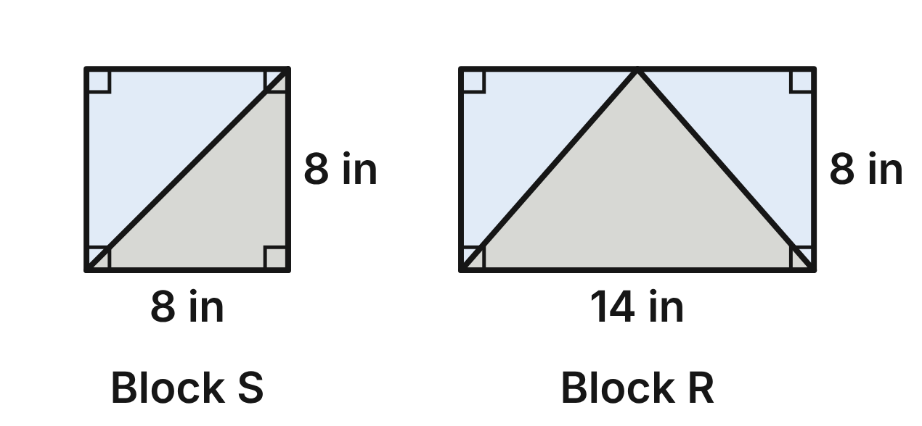
A quilter's rule: “If a quilt block is a square, then it has four right angles.” Let p be “A quilt block is a square” and q be “The block has four right angles.” The rule is p → q, and it is true.
1. Which symbols stand for “A block has four right angles, but it is not a square”?
A. p ∧ ~q
B. q ∧ ~p ✔
C. q ∨ ~p
D. ~(q ∧ p)
G.RLT.1 · skill G.RLT.1.1 (LOTS): Translate statements into symbols and words: negation (~p), conjunction (p ∧ q), disjunction (p ∨ q), conditional (p → q) and biconditional (p ↔ q)
☐ Answer key correct ☐ Wording clear Notes: ________________________________
2. Which sentence is the converse of the quilter's rule?
A. If a block is not a square, then it does not have four right angles.
B. If a block does not have four right angles, then it is not a square.
C. A block is a square if and only if it has four right angles.
D. If a block has four right angles, then it is a square. ✔
G.RLT.1 · skill G.RLT.1.2 (LOTS): Identify the converse, inverse and contrapositive of a conditional statement and decide whether each is true
☐ Answer key correct ☐ Wording clear Notes: ________________________________
3. Which is the contrapositive of p → q, written in symbols?
A. ~q → ~p ✔
B. ~p → ~q
C. q → p
D. ~q → p
G.RLT.1 · skill G.RLT.1.2 (LOTS): Identify the converse, inverse and contrapositive of a conditional statement and decide whether each is true
☐ Answer key correct ☐ Wording clear Notes: ________________________________
4. Block R has four right angles but is not a square. Block R is a counterexample to which statements?
A. p → q and its contrapositive
B. The converse only
C. The converse and the inverse ✔
D. The inverse only
G.RLT.1 · skill G.RLT.1.2 (LOTS): Identify the converse, inverse and contrapositive of a conditional statement and decide whether each is true
☐ Answer key correct ☐ Wording clear Notes: ________________________________
5. Mo finds that block T has four right angles. He says, “So block T is a square.” Which describes Mo's reasoning?
A. Valid, by the Law of Detachment
B. Invalid: it assumes the converse of the rule ✔
C. Invalid: it assumes the inverse of the rule
D. Valid, by the Law of Syllogism
G.RLT.1 · skill G.RLT.1.3 (HOTS): Use deductive reasoning (the Law of Detachment and the Law of Syllogism) to decide whether a conclusion is valid
☐ Answer key correct ☐ Wording clear Notes: ________________________________
6. Block U is a square. By the Law of Detachment, what can be concluded?
A. Block U is 8 in by 8 in.
B. Nothing can be concluded about block U.
C. Every block with four right angles is a square.
D. Block U has four right angles. ✔
G.RLT.1 · skill G.RLT.1.3 (HOTS): Use deductive reasoning (the Law of Detachment and the Law of Syllogism) to decide whether a conclusion is valid
☐ Answer key correct ☐ Wording clear Notes: ________________________________

Photo Contest Entries
Level 1 · Logic · G.RLT.1 · ID geo-rlt1-ring-photo-contest
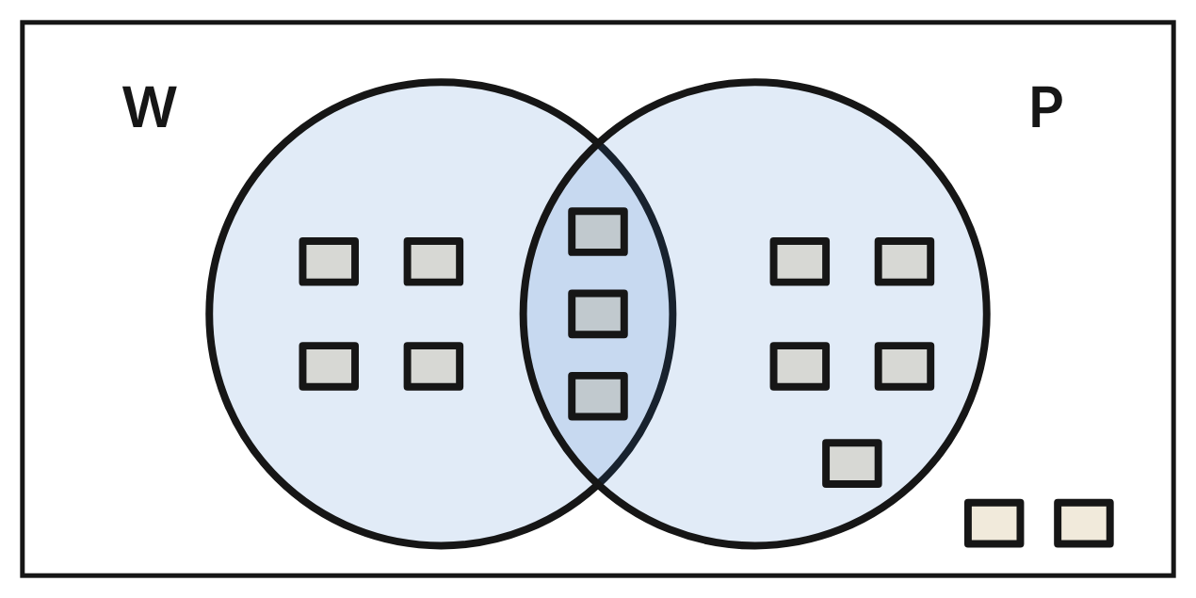
The diagram shows every photo entered in an art club's contest. W is the set of black-and-white photos and P is the set of portraits. Each small square is one photo.
7. How many photos are in W ∩ P?
A. 7
B. 12
C. 3 ✔
D. 8
G.RLT.1 · skill G.RLT.1.4 (LOTS): Use and interpret Venn diagrams: union, intersection, subset and negation, including in context
☐ Answer key correct ☐ Wording clear Notes: ________________________________
8. How many photos are in W ∪ P?
A. 12 ✔
B. 15
C. 9
D. 14
G.RLT.1 · skill G.RLT.1.4 (LOTS): Use and interpret Venn diagrams: union, intersection, subset and negation, including in context
☐ Answer key correct ☐ Wording clear Notes: ________________________________
9. How many photos are in ~P?
A. 8
B. 4
C. 11
D. 6 ✔
G.RLT.1 · skill G.RLT.1.4 (LOTS): Use and interpret Venn diagrams: union, intersection, subset and negation, including in context
☐ Answer key correct ☐ Wording clear Notes: ________________________________
10. Which phrase describes the photos in W ∩ ~P?
A. portraits that are not black and white
B. black-and-white photos that are not portraits ✔
C. photos that are neither black and white nor portraits
D. photos that are black and white or are not portraits
G.RLT.1 · skill G.RLT.1.1 (LOTS): Translate statements into symbols and words: negation (~p), conjunction (p ∧ q), disjunction (p ∨ q), conditional (p → q) and biconditional (p ↔ q)
☐ Answer key correct ☐ Wording clear Notes: ________________________________
11. The 2 photos outside both circles are color landscapes. Which expression names their region?
A. ~(W ∪ P) ✔
B. ~(W ∩ P)
C. ~W ∩ P
D. W ∪ P
G.RLT.1 · skill G.RLT.1.4 (LOTS): Use and interpret Venn diagrams: union, intersection, subset and negation, including in context
☐ Answer key correct ☐ Wording clear Notes: ________________________________
12. This statement is true: “If a photo is in W ∩ P, then it is a portrait.” Which is its converse, and is the converse true for these photos?
A. If a photo is not in W ∩ P, then it is not a portrait; false
B. If a photo is not a portrait, then it is not in W ∩ P; true
C. If a photo is a portrait, then it is in W ∩ P; true
D. If a photo is a portrait, then it is in W ∩ P; false ✔
G.RLT.1 · skill G.RLT.1.2 (LOTS): Identify the converse, inverse and contrapositive of a conditional statement and decide whether each is true
☐ Answer key correct ☐ Wording clear Notes: ________________________________

The Backstage Stair Light
Level 2 · Logic · G.RLT.1 · ID geo-rlt1-ring-stair-light
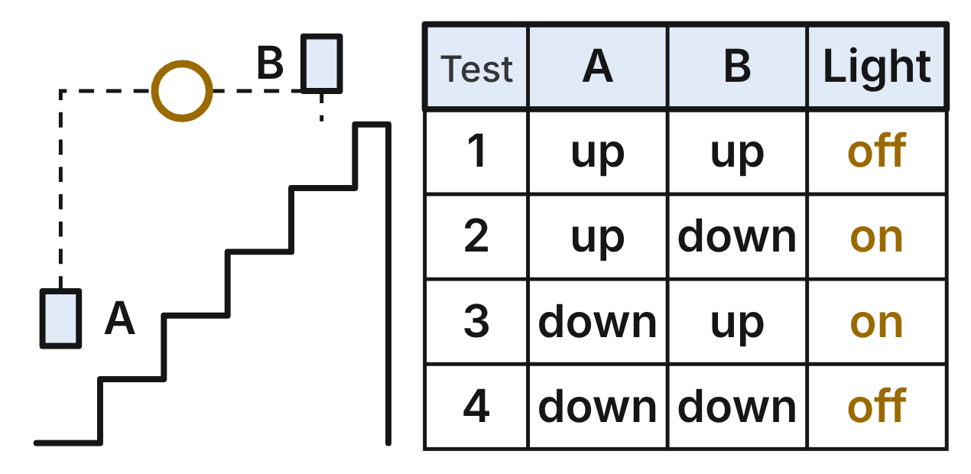
The stage crew tested the light over the backstage stairs. Switch A is at the bottom and switch B is at the top. Let a be “Switch A is up,” b be “Switch B is up” and l be “The light is on.” The table shows all four tests.
13. Which sentence is a ∧ ~l?
A. Switch A is up or the light is off.
B. Switch A is up and the light is off. ✔
C. Switch A is down and the light is on.
D. If switch A is up, then the light is off.
G.RLT.1 · skill G.RLT.1.1 (LOTS): Translate statements into symbols and words: negation (~p), conjunction (p ∧ q), disjunction (p ∨ q), conditional (p → q) and biconditional (p ↔ q)
☐ Answer key correct ☐ Wording clear Notes: ________________________________
14. In which test is a → l false?
A. Test 3
B. Test 2
C. Test 4
D. Test 1 ✔
G.RLT.1 · skill G.RLT.1.1 (LOTS): Translate statements into symbols and words: negation (~p), conjunction (p ∧ q), disjunction (p ∨ q), conditional (p → q) and biconditional (p ↔ q)
☐ Answer key correct ☐ Wording clear Notes: ________________________________
15. Which statement is true in all four tests?
A. l ↔ (a ↔ b)
B. l ↔ (a ∧ b)
C. l ↔ ~(a ↔ b) ✔
D. l ↔ (a ∨ b)
G.RLT.1 · skill G.RLT.1.1 (LOTS): Translate statements into symbols and words: negation (~p), conjunction (p ∧ q), disjunction (p ∨ q), conditional (p → q) and biconditional (p ↔ q)
☐ Answer key correct ☐ Wording clear Notes: ________________________________
16. Is the converse of “If both switches are up, then the light is off” true in all four tests? Choose the answer with the correct reason.
A. Yes; the light is off only in test 1.
B. No; in test 4 the light is off but both switches are down. ✔
C. No; in test 2 the light is off but switch B is down.
D. Yes; it is the contrapositive of a true statement.
G.RLT.1 · skill G.RLT.1.2 (LOTS): Identify the converse, inverse and contrapositive of a conditional statement and decide whether each is true
☐ Answer key correct ☐ Wording clear Notes: ________________________________
17. The crew's rule is true: “If exactly one switch is up, then the light is on.” Tonight switch A is down and switch B is up. What can be concluded?
A. The light is on. ✔
B. The light is off.
C. Nothing can be concluded about the light.
D. The light is on only when switch B is up.
G.RLT.1 · skill G.RLT.1.3 (HOTS): Use deductive reasoning (the Law of Detachment and the Law of Syllogism) to decide whether a conclusion is valid
☐ Answer key correct ☐ Wording clear Notes: ________________________________
18. Tonight the light is off. Jo says, “So both switches must be down.” Which describes Jo's reasoning?
A. Valid, by the Law of Detachment
B. Valid, by the Law of Syllogism
C. Invalid: the light is also off when both switches are up ✔
D. Invalid: the light is never off when both switches are down
G.RLT.1 · skill G.RLT.1.3 (HOTS): Use deductive reasoning (the Law of Detachment and the Law of Syllogism) to decide whether a conclusion is valid
☐ Answer key correct ☐ Wording clear Notes: ________________________________

Tags on the Woodshop Pegboard
Level 2 · Logic · G.RLT.1 · ID geo-rlt1-ring-shop-tags
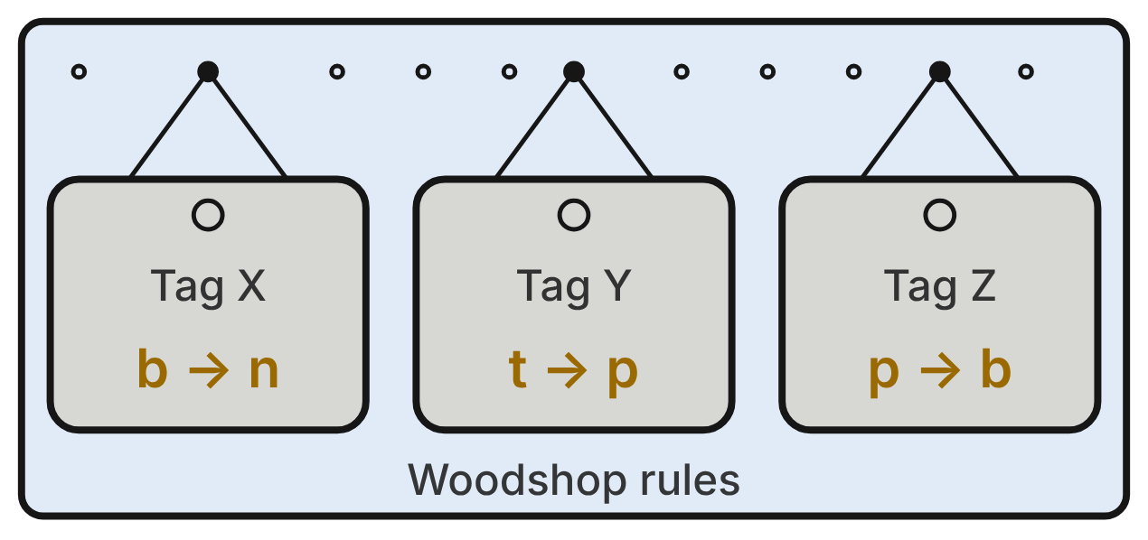
Each tag is a true rule for students in the woodshop. t is “The student uses the table saw,” p is “The student passed the saw test,” b is “The student has a green badge” and n is “The student's name is on the shop board.”
19. In which order do the tags link t to n by the Law of Syllogism?
A. X, Y, Z
B. Z, Y, X
C. Y, Z, X ✔
D. Y, X, Z
G.RLT.1 · skill G.RLT.1.3 (HOTS): Use deductive reasoning (the Law of Detachment and the Law of Syllogism) to decide whether a conclusion is valid
☐ Answer key correct ☐ Wording clear Notes: ________________________________
20. Which conclusion follows from all three tags, written in symbols?
A. t → n ✔
B. n → t
C. t ↔ n
D. ~t → ~n
G.RLT.1 · skill G.RLT.1.3 (HOTS): Use deductive reasoning (the Law of Detachment and the Law of Syllogism) to decide whether a conclusion is valid
☐ Answer key correct ☐ Wording clear Notes: ________________________________
21. Ava has no green badge. Using the tags, what can be concluded?
A. Ava's name is not on the shop board.
B. Ava uses the table saw but did not pass the saw test.
C. Nothing can be concluded about Ava.
D. Ava does not use the table saw. ✔
G.RLT.1 · skill G.RLT.1.3 (HOTS): Use deductive reasoning (the Law of Detachment and the Law of Syllogism) to decide whether a conclusion is valid
☐ Answer key correct ☐ Wording clear Notes: ________________________________
22. Cy's name is on the shop board. Dee says, “So Cy has a green badge.” Which describes Dee's reasoning?
A. Valid, by the Law of Detachment with tag X
B. Invalid: it assumes the converse of tag X ✔
C. Invalid: it assumes the inverse of tag X
D. Valid, by the Law of Syllogism
G.RLT.1 · skill G.RLT.1.3 (HOTS): Use deductive reasoning (the Law of Detachment and the Law of Syllogism) to decide whether a conclusion is valid
☐ Answer key correct ☐ Wording clear Notes: ________________________________
23. Which sentence is the contrapositive of tag Y?
A. If a student did not pass the saw test, then the student does not use the table saw. ✔
B. If a student does not use the table saw, then the student did not pass the saw test.
C. If a student passed the saw test, then the student uses the table saw.
D. If a student did not pass the saw test, then the student uses the table saw.
G.RLT.1 · skill G.RLT.1.2 (LOTS): Identify the converse, inverse and contrapositive of a conditional statement and decide whether each is true
☐ Answer key correct ☐ Wording clear Notes: ________________________________
24. Which sentence is p ∧ ~b?
A. The student did not pass the saw test and has a green badge.
B. The student passed the saw test or does not have a green badge.
C. If the student passed the saw test, then the student does not have a green badge.
D. The student passed the saw test and does not have a green badge. ✔
G.RLT.1 · skill G.RLT.1.1 (LOTS): Translate statements into symbols and words: negation (~p), conjunction (p ∧ q), disjunction (p ∨ q), conditional (p → q) and biconditional (p ↔ q)
☐ Answer key correct ☐ Wording clear Notes: ________________________________

Band, Orchestra and Jazz
Level 2 · Logic · G.RLT.1 · ID geo-rlt1-ring-music-rosters
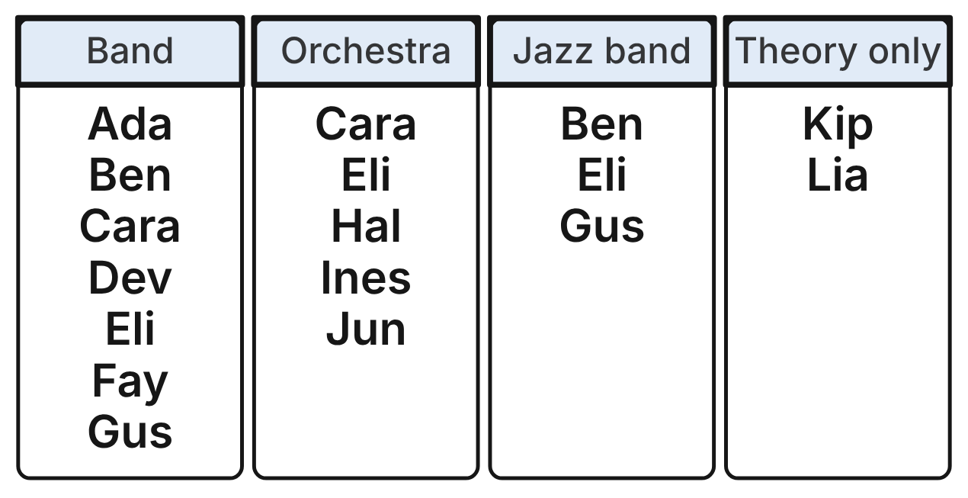
The cards list all 12 students in a school's music department. B is the set of students in band, O the set in orchestra and J the set in jazz band. A name on two cards is in both groups. Kip and Lia take only music theory.
25. How many students are in B ∩ O?
A. 5
B. 2 ✔
C. 1
D. 10
G.RLT.1 · skill G.RLT.1.4 (LOTS): Use and interpret Venn diagrams: union, intersection, subset and negation, including in context
☐ Answer key correct ☐ Wording clear Notes: ________________________________
26. How many of the 12 students are in ~(B ∪ O)?
A. 5
B. 10
C. 2 ✔
D. 0
G.RLT.1 · skill G.RLT.1.4 (LOTS): Use and interpret Venn diagrams: union, intersection, subset and negation, including in context
☐ Answer key correct ☐ Wording clear Notes: ________________________________
27. Which student is in O ∩ ~B?
A. Hal ✔
B. Cara
C. Gus
D. Lia
G.RLT.1 · skill G.RLT.1.4 (LOTS): Use and interpret Venn diagrams: union, intersection, subset and negation, including in context
☐ Answer key correct ☐ Wording clear Notes: ________________________________
28. Which conditional is true for all 12 students?
A. If a student is in band, then the student is in jazz band.
B. If a student is in orchestra, then the student is not in jazz band.
C. If a student is not in jazz band, then the student is not in band.
D. If a student is in jazz band, then the student is in band. ✔
G.RLT.1 · skill G.RLT.1.2 (LOTS): Identify the converse, inverse and contrapositive of a conditional statement and decide whether each is true
☐ Answer key correct ☐ Wording clear Notes: ________________________________
29. A rule says, “If a student is in jazz band, then the student is in band.” Ines is not in band. What can be concluded from the rule?
A. Ines is not in jazz band. ✔
B. Ines is in jazz band.
C. Ines is not in orchestra.
D. Nothing can be concluded about Ines.
G.RLT.1 · skill G.RLT.1.3 (HOTS): Use deductive reasoning (the Law of Detachment and the Law of Syllogism) to decide whether a conclusion is valid
☐ Answer key correct ☐ Wording clear Notes: ________________________________
30. A new student, Max, joins band. Pia says, “The rule ‘If a student is in jazz band, then the student is in band’ shows that Max is in jazz band.” Which describes Pia's reasoning?
A. Valid, by the Law of Detachment
B. Invalid: it uses the inverse of the rule
C. Invalid: it uses the converse of the rule ✔
D. Valid, because Ben and Gus are in both groups
G.RLT.1 · skill G.RLT.1.3 (HOTS): Use deductive reasoning (the Law of Detachment and the Law of Syllogism) to decide whether a conclusion is valid
☐ Answer key correct ☐ Wording clear Notes: ________________________________

Bracing the Stage Set
Level 3 · Logic · G.RLT.1 · ID geo-rlt1-ring-set-pieces
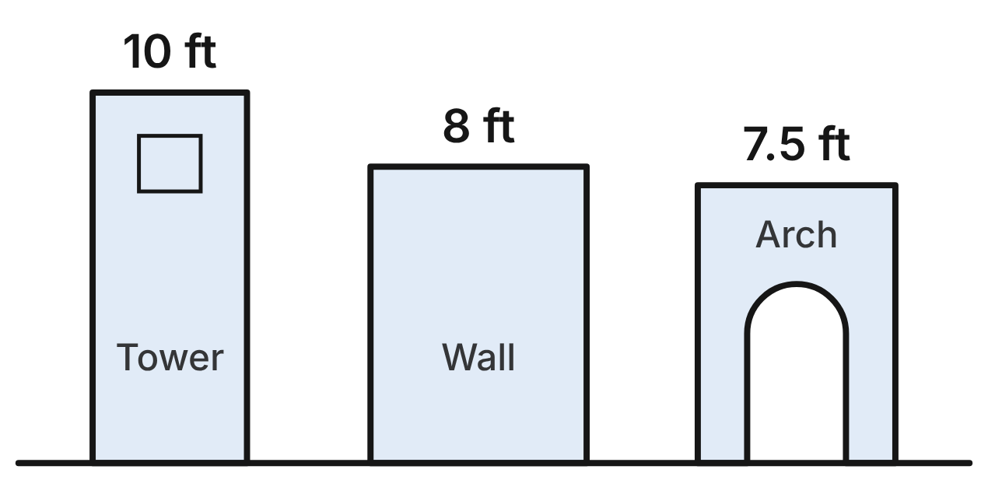
The theater crew follows two true rules. Rule 1: If a set piece is taller than 8 ft, then it needs a brace. Rule 2: If a set piece needs a brace, then the stage manager signs it off. In the table, “the manager” is the stage manager.
Statement | Reason
1. If a piece is taller than 8 ft, then it needs a brace. | Rule 1
2. If a piece needs a brace, then the manager signs it off. | Rule 2
3. The tower is taller than 8 ft. | Figure (10 ft)
4. The tower needs a brace. | Detachment (1, 3)
5. The manager signs off the tower. | ____
6. If a piece is taller than 8 ft, then the manager signs it off. | ____

31. What is the reason for step 5?
A. Law of Syllogism, using steps 1 and 2
B. Law of Detachment, using steps 2 and 4 ✔
C. Law of Detachment, using steps 1 and 3
D. The converse of step 2
G.RLT.1 · skill G.RLT.1.3 (HOTS): Use deductive reasoning (the Law of Detachment and the Law of Syllogism) to decide whether a conclusion is valid
☐ Answer key correct ☐ Wording clear Notes: ________________________________
32. What is the reason for step 6?
A. Law of Detachment, using steps 3 and 5
B. Law of Syllogism, using steps 4 and 5
C. The contrapositive of step 1
D. Law of Syllogism, using steps 1 and 2 ✔
G.RLT.1 · skill G.RLT.1.3 (HOTS): Use deductive reasoning (the Law of Detachment and the Law of Syllogism) to decide whether a conclusion is valid
☐ Answer key correct ☐ Wording clear Notes: ________________________________
33. Rafa says, “The wall is not taller than 8 ft, so it does not need a brace.” Which describes Rafa's reasoning?
A. Invalid: it assumes the inverse of rule 1 ✔
B. Valid, by the contrapositive of rule 1
C. Invalid: it assumes the converse of rule 1
D. Valid, by the Law of Detachment
G.RLT.1 · skill G.RLT.1.3 (HOTS): Use deductive reasoning (the Law of Detachment and the Law of Syllogism) to decide whether a conclusion is valid
☐ Answer key correct ☐ Wording clear Notes: ________________________________
34. Which sentence is the contrapositive of rule 2 for the set pieces?
A. If the stage manager signs off a piece, then it needs a brace.
B. If a piece does not need a brace, then the stage manager does not sign it off.
C. If the stage manager does not sign off a piece, then it does not need a brace. ✔
D. If a piece does not need a brace, then the stage manager signs it off.
G.RLT.1 · skill G.RLT.1.2 (LOTS): Identify the converse, inverse and contrapositive of a conditional statement and decide whether each is true
☐ Answer key correct ☐ Wording clear Notes: ________________________________
35. The stage manager did not sign off a new piece, the stairs. Using the rules, which conclusion about the stairs is valid?
A. The stairs need a brace.
B. The stairs are taller than 8 ft.
C. The stairs are exactly 8 ft tall.
D. The stairs are not taller than 8 ft. ✔
G.RLT.1 · skill G.RLT.1.3 (HOTS): Use deductive reasoning (the Law of Detachment and the Law of Syllogism) to decide whether a conclusion is valid
☐ Answer key correct ☐ Wording clear Notes: ________________________________
36. Let t be “The tower is taller than 8 ft,” b be “The tower needs a brace” and m be “The stage manager signs off the tower.” Which statement is true?
A. t ∧ ~m
B. ~b ∨ ~m
C. b ∧ m ✔
D. t → ~b
G.RLT.1 · skill G.RLT.1.1 (LOTS): Translate statements into symbols and words: negation (~p), conjunction (p ∧ q), disjunction (p ∨ q), conditional (p → q) and biconditional (p ↔ q)
☐ Answer key correct ☐ Wording clear Notes: ________________________________

Booths at the Craft Fair
Level 3 · Logic · G.RLT.1 · ID geo-rlt1-ring-craft-fair
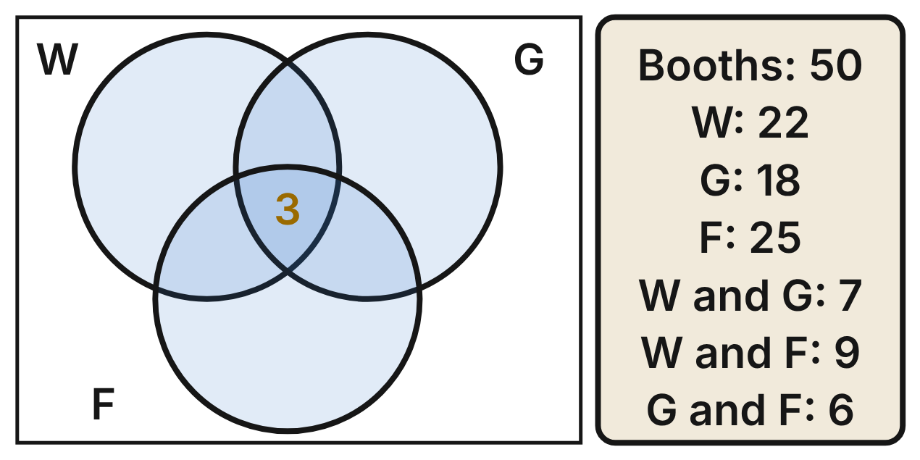
A craft fair has 50 booths. W is the set of booths that sell wood items, G glass items and F fabric items. The card gives how many booths are in each set and in each pair of sets. Each pair count includes the 3 booths that sell all three kinds.
37. How many booths sell wood and glass items but not fabric items?
A. 7
B. 4 ✔
C. 1
D. 10
G.RLT.1 · skill G.RLT.1.4 (LOTS): Use and interpret Venn diagrams: union, intersection, subset and negation, including in context
☐ Answer key correct ☐ Wording clear Notes: ________________________________
38. How many booths sell wood items only?
A. 6
B. 15
C. 22
D. 9 ✔
G.RLT.1 · skill G.RLT.1.4 (LOTS): Use and interpret Venn diagrams: union, intersection, subset and negation, including in context
☐ Answer key correct ☐ Wording clear Notes: ________________________________
39. How many of the 50 booths are in none of the three sets?
A. 7
B. 10
C. 4 ✔
D. 20
G.RLT.1 · skill G.RLT.1.4 (LOTS): Use and interpret Venn diagrams: union, intersection, subset and negation, including in context
☐ Answer key correct ☐ Wording clear Notes: ________________________________
40. How many booths are in exactly two of the three sets?
A. 13 ✔
B. 22
C. 16
D. 30
G.RLT.1 · skill G.RLT.1.4 (LOTS): Use and interpret Venn diagrams: union, intersection, subset and negation, including in context
☐ Answer key correct ☐ Wording clear Notes: ________________________________
41. A fair rule says, “If a booth sells glass items, then it has a padded table.” Using the rule and the card, how many booths must have a padded table?
A. 8
B. 32
C. 18 ✔
D. 3
G.RLT.1 · skill G.RLT.1.3 (HOTS): Use deductive reasoning (the Law of Detachment and the Law of Syllogism) to decide whether a conclusion is valid
☐ Answer key correct ☐ Wording clear Notes: ________________________________
42. A fair rule says, “If a booth sells glass items, then it has a padded table.” Booth 31 has no padded table. What can be concluded?
A. Booth 31 sells none of the three kinds of items.
B. Booth 31 does not sell glass items. ✔
C. Booth 31 sells wood items.
D. Nothing can be concluded about booth 31.
G.RLT.1 · skill G.RLT.1.3 (HOTS): Use deductive reasoning (the Law of Detachment and the Law of Syllogism) to decide whether a conclusion is valid
☐ Answer key correct ☐ Wording clear Notes: ________________________________

G.RLT.2 · Analyze, prove, and justify the relationships of parallel lines cut by a transversal.

The Slanted Fret
Level 1 · Lines · G.RLT.2 · ID geo-rlt2-ring-fanned-fret
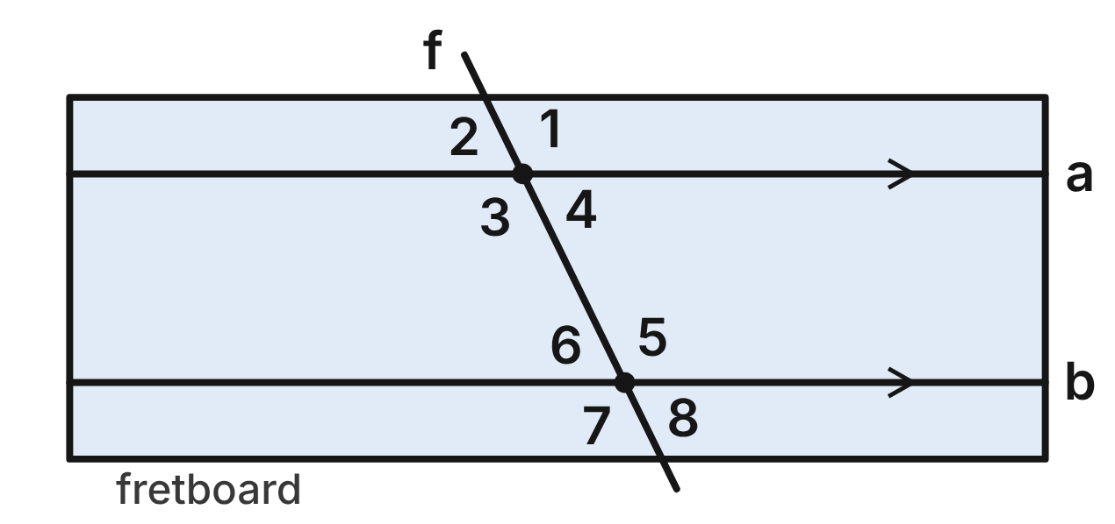
On a fanned-fret guitar, the frets are slanted. Strings a and b are parallel. Fret f crosses both strings. m∠7 = 116°.
43. ∠4 and ∠6 are what kind of angle pair?
A. Same-side interior angles
B. Alternate interior angles ✔
C. Corresponding angles
D. Alternate exterior angles
G.RLT.2 · skill G.RLT.2.1 (LOTS): Identify angle pairs formed by a transversal: corresponding, alternate interior, alternate exterior, same-side interior, vertical and linear pairs
☐ Answer key correct ☐ Wording clear Notes: ________________________________
44. What is m∠2, at string a?
A. 116°
B. 244°
C. 64° ✔
D. 26°
G.RLT.2 · skill G.RLT.2.3 (LOTS): Solve problems, including algebraic ones, using the angles formed by parallel lines and a transversal
☐ Answer key correct ☐ Wording clear Notes: ________________________________
45. Which angle corresponds to ∠3?
A. ∠7 ✔
B. ∠5
C. ∠1
D. ∠6
G.RLT.2 · skill G.RLT.2.1 (LOTS): Identify angle pairs formed by a transversal: corresponding, alternate interior, alternate exterior, same-side interior, vertical and linear pairs
☐ Answer key correct ☐ Wording clear Notes: ________________________________
46. Which angle measures 64°?
A. ∠5
B. ∠3
C. ∠1
D. ∠8 ✔
G.RLT.2 · skill G.RLT.2.3 (LOTS): Solve problems, including algebraic ones, using the angles formed by parallel lines and a transversal
☐ Answer key correct ☐ Wording clear Notes: ________________________________
47. Which two angles form a linear pair?
A. ∠5 and ∠7
B. ∠5 and ∠6 ✔
C. ∠2 and ∠6
D. ∠4 and ∠5
G.RLT.2 · skill G.RLT.2.1 (LOTS): Identify angle pairs formed by a transversal: corresponding, alternate interior, alternate exterior, same-side interior, vertical and linear pairs
☐ Answer key correct ☐ Wording clear Notes: ________________________________
48. A luthier checks a second guitar. Its fret makes 116° in the place of ∠7 and 113° in the place of ∠3. Are those two strings parallel? Choose the answer with the correct reason.
A. Yes; the two angles differ by only 3°.
B. Yes; ∠3 and ∠7 are alternate exterior angles.
C. No; ∠3 and ∠7 should add to 180°.
D. No; corresponding angles ∠3 and ∠7 are not congruent. ✔
G.RLT.2 · skill G.RLT.2.2 (HOTS): Prove or justify that two lines are parallel, or are not, from angle measures
☐ Answer key correct ☐ Wording clear Notes: ________________________________

The Beam Across the Staff
Level 1 · Lines · G.RLT.2 · ID geo-rlt2-ring-music-staff
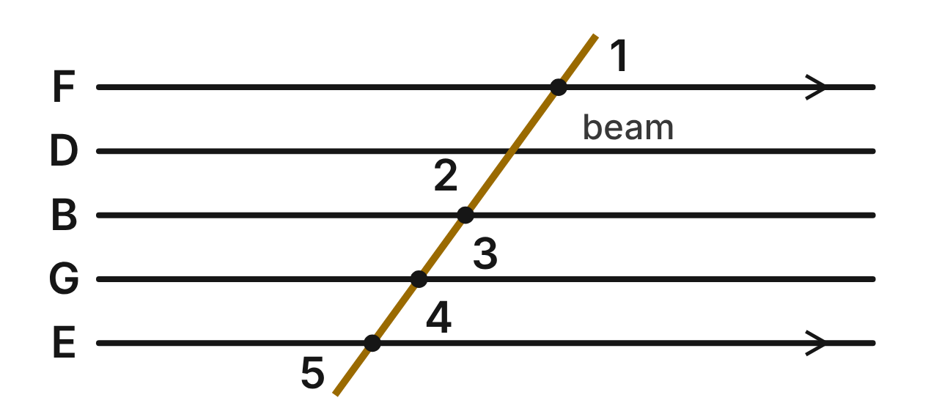
The five lines of a music staff are parallel. From bottom to top they are named E, G, B, D and F. A composer draws a straight slanted beam across all five lines. m∠1 = 54°.
49. What is m∠5, at line E?
A. 54° ✔
B. 126°
C. 36°
D. 306°
G.RLT.2 · skill G.RLT.2.3 (LOTS): Solve problems, including algebraic ones, using the angles formed by parallel lines and a transversal
☐ Answer key correct ☐ Wording clear Notes: ________________________________
50. Using lines F and E, what kind of angle pair are ∠1 and ∠5?
A. Corresponding angles
B. Alternate interior angles
C. Alternate exterior angles ✔
D. Same-side interior angles
G.RLT.2 · skill G.RLT.2.1 (LOTS): Identify angle pairs formed by a transversal: corresponding, alternate interior, alternate exterior, same-side interior, vertical and linear pairs
☐ Answer key correct ☐ Wording clear Notes: ________________________________
51. What is m∠2, at line B?
A. 54°
B. 36°
C. 144°
D. 126° ✔
G.RLT.2 · skill G.RLT.2.3 (LOTS): Solve problems, including algebraic ones, using the angles formed by parallel lines and a transversal
☐ Answer key correct ☐ Wording clear Notes: ________________________________
52. Using lines B and G, what kind of angle pair are ∠3 and ∠4?
A. Alternate interior angles
B. Corresponding angles ✔
C. Alternate exterior angles
D. Same-side interior angles
G.RLT.2 · skill G.RLT.2.1 (LOTS): Identify angle pairs formed by a transversal: corresponding, alternate interior, alternate exterior, same-side interior, vertical and linear pairs
☐ Answer key correct ☐ Wording clear Notes: ________________________________
53. Which statement about ∠2 and ∠3 is true?
A. They are vertical angles, so they are congruent. ✔
B. They form a linear pair, so they are supplementary.
C. They are corresponding angles, so they are congruent.
D. They are alternate interior angles, so they are congruent.
G.RLT.2 · skill G.RLT.2.1 (LOTS): Identify angle pairs formed by a transversal: corresponding, alternate interior, alternate exterior, same-side interior, vertical and linear pairs
☐ Answer key correct ☐ Wording clear Notes: ________________________________
54. A second straight beam crosses line F to the right of the first one. It makes a 54° angle above line F and right of the new beam. Which reason proves that the two beams are parallel?
A. Converse of the Alternate Interior Angles Theorem
B. Corresponding Angles Postulate
C. Converse of the Corresponding Angles Postulate ✔
D. Converse of the Same-Side Interior Angles Theorem
G.RLT.2 · skill G.RLT.2.2 (HOTS): Prove or justify that two lines are parallel, or are not, from angle measures
☐ Answer key correct ☐ Wording clear Notes: ________________________________

The Twill Line on the Loom
Level 2 · Lines · G.RLT.2 · ID geo-rlt2-ring-loom-twill
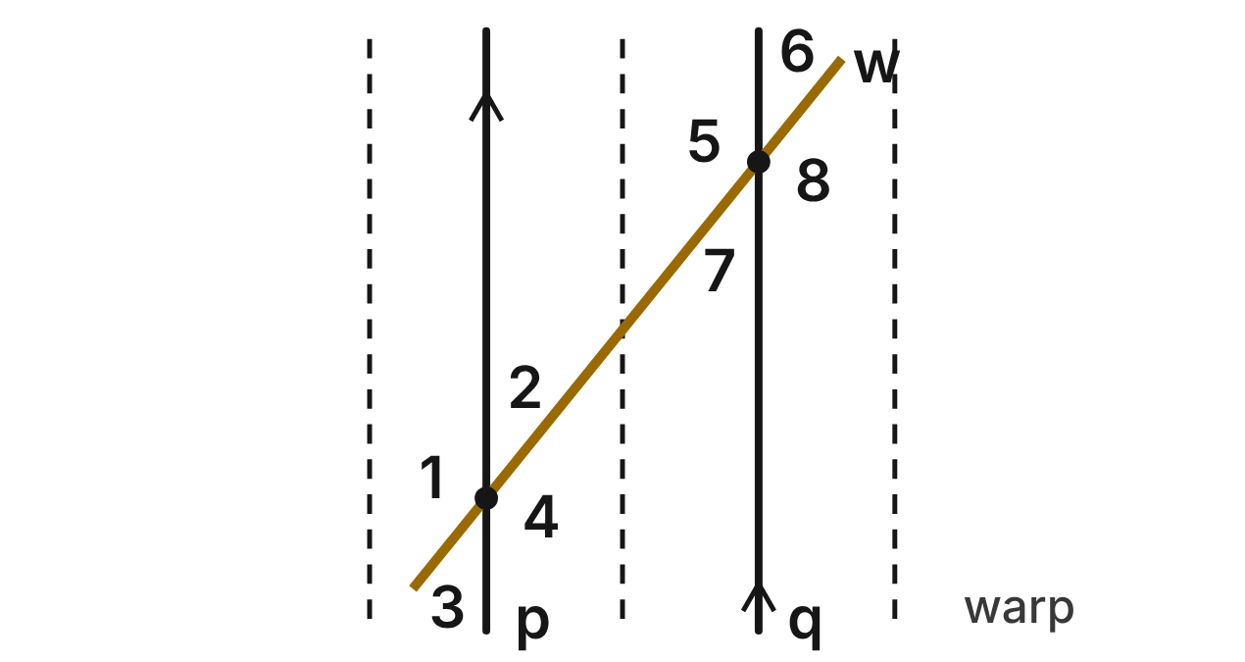
On a loom, warp threads p and q are parallel. A slanted thread of a twill pattern, w, crosses both. m∠1 = (7x − 20)⁠° and m∠8 = (5x + 26)⁠°.
55. ∠1 and ∠8 are what kind of angle pair?
A. Alternate interior angles
B. Corresponding angles
C. Same-side interior angles
D. Alternate exterior angles ✔
G.RLT.2 · skill G.RLT.2.1 (LOTS): Identify angle pairs formed by a transversal: corresponding, alternate interior, alternate exterior, same-side interior, vertical and linear pairs
☐ Answer key correct ☐ Wording clear Notes: ________________________________
56. What is the value of x for the twill thread?
A. 23 ✔
B. 14.5
C. 3
D. 46
G.RLT.2 · skill G.RLT.2.3 (LOTS): Solve problems, including algebraic ones, using the angles formed by parallel lines and a transversal
☐ Answer key correct ☐ Wording clear Notes: ________________________________
57. What is m∠8, at thread q?
A. 39°
B. 115°
C. 141° ✔
D. 23°
G.RLT.2 · skill G.RLT.2.3 (LOTS): Solve problems, including algebraic ones, using the angles formed by parallel lines and a transversal
☐ Answer key correct ☐ Wording clear Notes: ________________________________
58. Find m∠6.
A. 141°
B. 39° ✔
C. 51°
D. 219°
G.RLT.2 · skill G.RLT.2.3 (LOTS): Solve problems, including algebraic ones, using the angles formed by parallel lines and a transversal
☐ Answer key correct ☐ Wording clear Notes: ________________________________
59. On another loom, a slanted thread crosses two warp threads. It makes 139° in the place of ∠1 and 41° in the place of ∠8. Are those warp threads parallel? Choose the answer with the correct reason.
A. Yes; alternate exterior angles are supplementary.
B. Yes; ∠1 and ∠8 are corresponding angles.
C. No; alternate exterior angles 139° and 41° are not congruent. ✔
D. No; alternate exterior angles must add to 180°.
G.RLT.2 · skill G.RLT.2.2 (HOTS): Prove or justify that two lines are parallel, or are not, from angle measures
☐ Answer key correct ☐ Wording clear Notes: ________________________________
60. Which pair of angles must be supplementary?
A. ∠1 and ∠8
B. ∠2 and ∠6
C. ∠3 and ∠6
D. ∠4 and ∠7 ✔
G.RLT.2 · skill G.RLT.2.1 (LOTS): Identify angle pairs formed by a transversal: corresponding, alternate interior, alternate exterior, same-side interior, vertical and linear pairs
☐ Answer key correct ☐ Wording clear Notes: ________________________________

The Striped Mural
Level 2 · Lines · G.RLT.2 · ID geo-rlt2-ring-mural-stripes
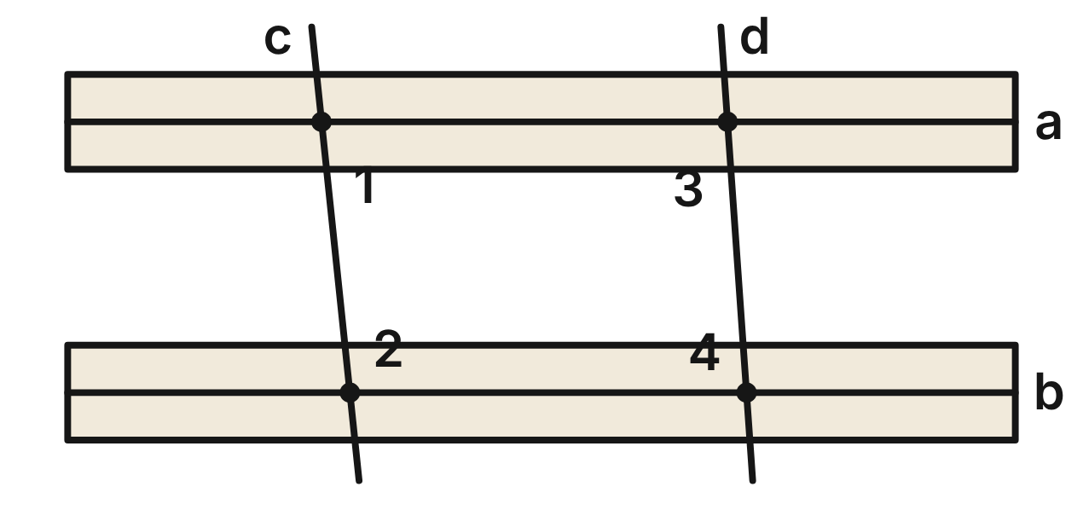
A mural has two long stripes, a and b, and two slanted bands, c and d. The artist measures m∠1 = 84°, m∠2 = 96° and m∠3 = 94°. No lines are marked parallel.
61. What is the measure of the angle below stripe b and left of band c?
A. 84°
B. 96° ✔
C. 94°
D. 86°
G.RLT.2 · skill G.RLT.2.3 (LOTS): Solve problems, including algebraic ones, using the angles formed by parallel lines and a transversal
☐ Answer key correct ☐ Wording clear Notes: ________________________________
62. Are stripes a and b parallel? Choose the answer with the correct reason.
A. Yes; same-side interior angles ∠1 and ∠2 are supplementary. ✔
B. Yes; ∠1 and ∠3 are alternate interior angles.
C. No; same-side interior angles must be congruent.
D. No; ∠1 and ∠2 form a linear pair.
G.RLT.2 · skill G.RLT.2.2 (HOTS): Prove or justify that two lines are parallel, or are not, from angle measures
☐ Answer key correct ☐ Wording clear Notes: ________________________________
63. Are bands c and d parallel? Choose the answer with the correct reason.
A. Yes; ∠1 and ∠3 are corresponding angles.
B. Yes; ∠2 and ∠3 are alternate interior angles.
C. No; ∠1 and ∠3 should be congruent.
D. No; same-side interior angles ∠1 and ∠3 add to 178°. ✔
G.RLT.2 · skill G.RLT.2.2 (HOTS): Prove or justify that two lines are parallel, or are not, from angle measures
☐ Answer key correct ☐ Wording clear Notes: ________________________________
64. Use the measures given for this mural. What is m∠4?
A. 94°
B. 96°
C. 86° ✔
D. 84°
G.RLT.2 · skill G.RLT.2.3 (LOTS): Solve problems, including algebraic ones, using the angles formed by parallel lines and a transversal
☐ Answer key correct ☐ Wording clear Notes: ________________________________
65. The artist repaints band d so that it is parallel to band c. ∠1 still measures 84°, and the angle in the place of ∠3 is now (2x + 12)⁠°. What is x?
A. 36
B. 42 ✔
C. 41
D. 84
G.RLT.2 · skill G.RLT.2.3 (LOTS): Solve problems, including algebraic ones, using the angles formed by parallel lines and a transversal
☐ Answer key correct ☐ Wording clear Notes: ________________________________
66. Which statement about ∠2 and ∠4 is true?
A. They are same-side interior angles along stripe b. ✔
B. They are corresponding angles along stripe b.
C. They are alternate interior angles along stripe b.
D. They form a linear pair.
G.RLT.2 · skill G.RLT.2.1 (LOTS): Identify angle pairs formed by a transversal: corresponding, alternate interior, alternate exterior, same-side interior, vertical and linear pairs
☐ Answer key correct ☐ Wording clear Notes: ________________________________

The Diamond-Pane Window
Level 2 · Lines · G.RLT.2 · ID geo-rlt2-ring-diamond-window
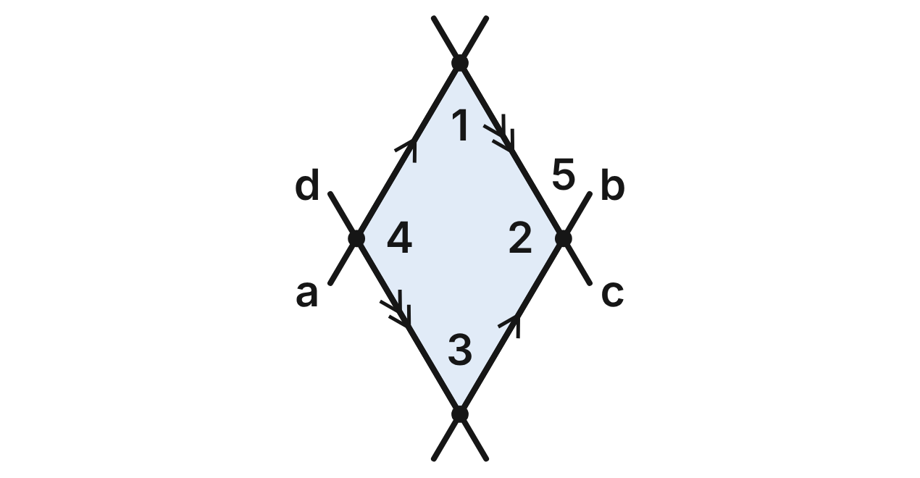
In a diamond-pane window, lead strips a and b are parallel, and strips c and d are parallel. m∠1 = (3x − 17)⁠° and m∠2 = (5x − 11)⁠°.
67. What is the value of x for the window?
A. −3
B. 19
C. 26 ✔
D. 22.5
G.RLT.2 · skill G.RLT.2.3 (LOTS): Solve problems, including algebraic ones, using the angles formed by parallel lines and a transversal
☐ Answer key correct ☐ Wording clear Notes: ________________________________
68. Which fact gives the equation (3x − 17) + (5x − 11) = 180?
A. ∠1 and ∠2 form a linear pair.
B. ∠1 and ∠2 are same-side interior angles, and a ∥ b. ✔
C. ∠1 and ∠2 are alternate interior angles, and a ∥ b.
D. ∠1 and ∠2 are same-side interior angles, and c ∥ d.
G.RLT.2 · skill G.RLT.2.1 (LOTS): Identify angle pairs formed by a transversal: corresponding, alternate interior, alternate exterior, same-side interior, vertical and linear pairs
☐ Answer key correct ☐ Wording clear Notes: ________________________________
69. What is m∠2, at the right corner of the pane?
A. 61°
B. 130°
C. 29°
D. 119° ✔
G.RLT.2 · skill G.RLT.2.3 (LOTS): Solve problems, including algebraic ones, using the angles formed by parallel lines and a transversal
☐ Answer key correct ☐ Wording clear Notes: ________________________________
70. What is m∠3, at the bottom corner of the pane?
A. 61° ✔
B. 119°
C. 26°
D. 29°
G.RLT.2 · skill G.RLT.2.3 (LOTS): Solve problems, including algebraic ones, using the angles formed by parallel lines and a transversal
☐ Answer key correct ☐ Wording clear Notes: ________________________________
71. Suppose you did not know that any of the strips were parallel. Which fact alone would prove that c ∥ d?
A. ∠1 and ∠2 are supplementary.
B. ∠2 and ∠3 are supplementary. ✔
C. ∠1 and ∠3 are congruent.
D. ∠2 and ∠4 are congruent.
G.RLT.2 · skill G.RLT.2.2 (HOTS): Prove or justify that two lines are parallel, or are not, from angle measures
☐ Answer key correct ☐ Wording clear Notes: ________________________________
72. With strip c as the transversal of a and b, what kind of angle pair are ∠1 and ∠5?
A. Corresponding angles
B. Same-side interior angles
C. Alternate interior angles ✔
D. Alternate exterior angles
G.RLT.2 · skill G.RLT.2.1 (LOTS): Identify angle pairs formed by a transversal: corresponding, alternate interior, alternate exterior, same-side interior, vertical and linear pairs
☐ Answer key correct ☐ Wording clear Notes: ________________________________

The Painter's Easel
Level 3 · Lines · G.RLT.2 · ID geo-rlt2-ring-painters-easel
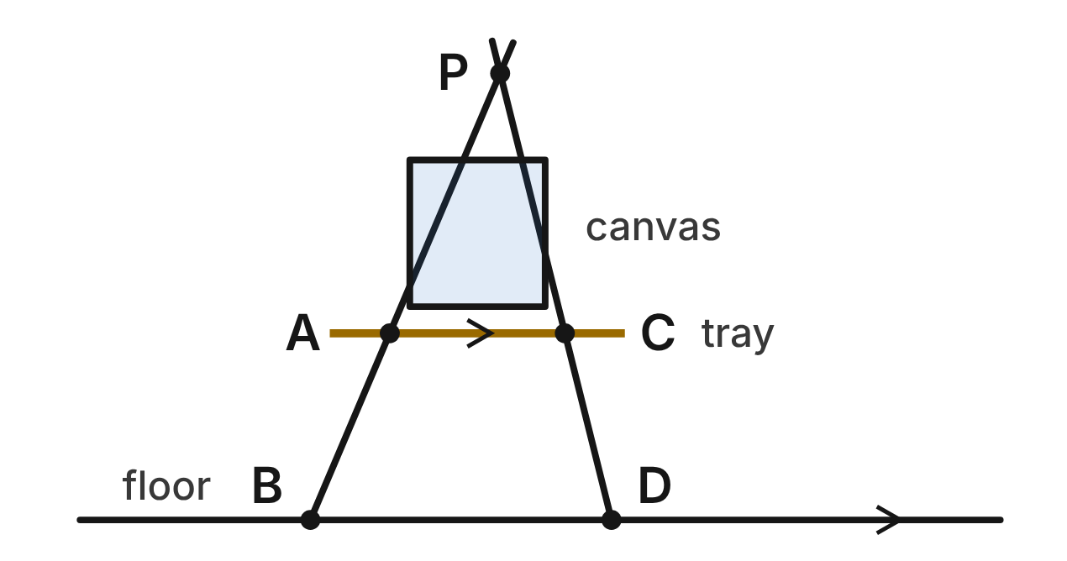
The legs of an easel meet at P. The tray AC is parallel to the floor BD. m∠PBD = (3x + 10)⁠°, m∠PAC = (5x − 28)⁠° and m∠PDB = 76°.
73. With the left leg as the transversal, what kind of angle pair are ∠PAC and ∠PBD?
A. Alternate interior angles
B. Same-side interior angles
C. Alternate exterior angles
D. Corresponding angles ✔
G.RLT.2 · skill G.RLT.2.1 (LOTS): Identify angle pairs formed by a transversal: corresponding, alternate interior, alternate exterior, same-side interior, vertical and linear pairs
☐ Answer key correct ☐ Wording clear Notes: ________________________________
74. Solve for x using ∠PAC and ∠PBD.
A. 9
B. 19 ✔
C. 38
D. 24.75
G.RLT.2 · skill G.RLT.2.3 (LOTS): Solve problems, including algebraic ones, using the angles formed by parallel lines and a transversal
☐ Answer key correct ☐ Wording clear Notes: ________________________________
75. What is m∠ACD, the angle below the tray at C, inside the easel?
A. 104° ✔
B. 76°
C. 67°
D. 113°
G.RLT.2 · skill G.RLT.2.3 (LOTS): Solve problems, including algebraic ones, using the angles formed by parallel lines and a transversal
☐ Answer key correct ☐ Wording clear Notes: ________________________________
76. What is m∠APC, the angle between the legs at the top?
A. 143°
B. 9°
C. 37° ✔
D. 217°
G.RLT.2 · skill G.RLT.2.3 (LOTS): Solve problems, including algebraic ones, using the angles formed by parallel lines and a transversal
☐ Answer key correct ☐ Wording clear Notes: ________________________________
77. The tray slips, but the legs do not move. Now m∠PAC = 66° and m∠PCA = 77°. Is the tray still parallel to the floor? Choose the answer with the correct reason.
A. Yes; ∠PAC and ∠PCA are alternate interior angles.
B. Yes; any segment joining the two legs is parallel to the floor.
C. No; ∠PAC and ∠PCA should be congruent.
D. No; ∠PCA and ∠PDB are corresponding angles that are not congruent. ✔
G.RLT.2 · skill G.RLT.2.2 (HOTS): Prove or justify that two lines are parallel, or are not, from angle measures
☐ Answer key correct ☐ Wording clear Notes: ________________________________
78. Along the right leg, which two angles are same-side interior angles?
A. ∠PCA and ∠CDB
B. ∠PCA and ∠ACD
C. ∠ACD and ∠CDB ✔
D. ∠PAC and ∠PCA
G.RLT.2 · skill G.RLT.2.1 (LOTS): Identify angle pairs formed by a transversal: corresponding, alternate interior, alternate exterior, same-side interior, vertical and linear pairs
☐ Answer key correct ☐ Wording clear Notes: ________________________________

The Architect's Glass Wall
Level 3 · Lines · G.RLT.2 · ID geo-rlt2-ring-glass-wall-proof
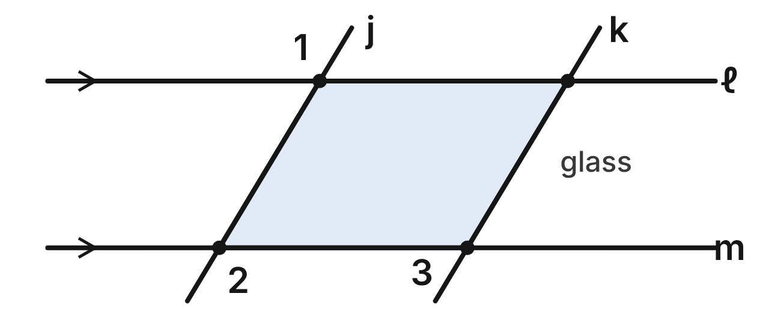
An architect sketches a slanted glass wall. Floor lines ℓ and m are parallel, and the edges of the glass are j and k. Given: ℓ ∥ m, and ∠1 and ∠3 are supplementary. Prove: j ∥ k.
Statement | Reason
1. ℓ ∥ m | Given
2. ∠1 ≅ ∠2 | ____ (a)
3. ∠1 and ∠3 are supplementary. | Given
4. m∠1 + m∠3 = 180° | Definition of supplementary angles
5. m∠2 + m∠3 = 180° | ____ (b)
6. j ∥ k | ____ (c)

79. In the glass-wall proof, which reason fills blank (a)?
A. Alternate Exterior Angles Theorem ✔
B. Corresponding Angles Postulate
C. Vertical Angles Theorem
D. Converse of the Alternate Exterior Angles Theorem
G.RLT.2 · skill G.RLT.2.2 (HOTS): Prove or justify that two lines are parallel, or are not, from angle measures
☐ Answer key correct ☐ Wording clear Notes: ________________________________
80. In the glass-wall proof, which reason fills blank (b)?
A. Reflexive Property
B. Angle Addition Postulate
C. Substitution Property ✔
D. Linear Pair Postulate
G.RLT.2 · skill G.RLT.2.2 (HOTS): Prove or justify that two lines are parallel, or are not, from angle measures
☐ Answer key correct ☐ Wording clear Notes: ________________________________
81. In the glass-wall proof, which reason fills blank (c)?
A. Same-Side Interior Angles Theorem
B. Converse of the Alternate Interior Angles Theorem
C. Converse of the Corresponding Angles Postulate
D. Converse of the Same-Side Interior Angles Theorem ✔
G.RLT.2 · skill G.RLT.2.2 (HOTS): Prove or justify that two lines are parallel, or are not, from angle measures
☐ Answer key correct ☐ Wording clear Notes: ________________________________
82. In step 5, what kind of angle pair are ∠2 and ∠3, and along which transversal?
A. Same-side interior angles, along j
B. Same-side interior angles, along m ✔
C. Alternate interior angles, along m
D. Corresponding angles, along k
G.RLT.2 · skill G.RLT.2.1 (LOTS): Identify angle pairs formed by a transversal: corresponding, alternate interior, alternate exterior, same-side interior, vertical and linear pairs
☐ Answer key correct ☐ Wording clear Notes: ________________________________
83. Suppose ℓ ∥ m, m∠1 = (12x + 25)⁠° and m∠3 = (8x − 5)⁠°. For what value of x is j ∥ k?
A. 10
B. −7.5
C. 3.5
D. 8 ✔
G.RLT.2 · skill G.RLT.2.3 (LOTS): Solve problems, including algebraic ones, using the angles formed by parallel lines and a transversal
☐ Answer key correct ☐ Wording clear Notes: ________________________________
84. In another sketch, ℓ ∥ m, m∠1 = 121° and m∠3 = 55°. Which conclusion is correct? Choose the answer with the correct reason.
A. j ∥ k, since ∠1 and ∠3 are alternate exterior angles.
B. j and k are not parallel, since m∠2 + m∠3 = 176°. ✔
C. j ∥ k, since ∠2 ≅ ∠3.
D. j and k are not parallel, since ∠1 and ∠3 are not congruent.
G.RLT.2 · skill G.RLT.2.2 (HOTS): Prove or justify that two lines are parallel, or are not, from angle measures
☐ Answer key correct ☐ Wording clear Notes: ________________________________

G.RLT.3 · Solve problems, including contextual problems, involving symmetry and transformation.

Stamps for Printing Fabric
Level 1 · Transformations · G.RLT.3 · ID geo-rlt3-ring-fabric-stamps
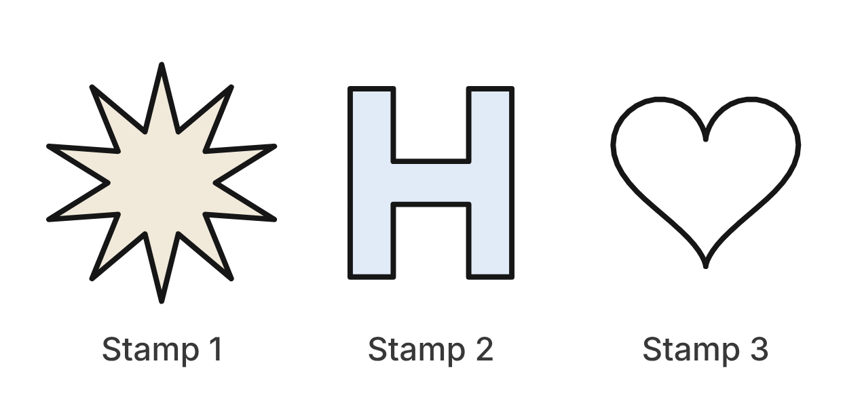
A print shop carves three rubber stamps for fabric. Stamp 1 is a star with ten identical points, equally spaced. Stamp 2 is a block letter H: its two posts are the same size, and its crossbar is at the middle. Stamp 3 is a heart.
85. How many lines of symmetry does Stamp 1 have?
A. 5
B. 10 ✔
C. 20
D. 2
G.RLT.3 · skill G.RLT.3.1 (LOTS): Identify line symmetry and rotational symmetry of a figure
☐ Answer key correct ☐ Wording clear Notes: ________________________________
86. What is the smallest angle of rotation, about its center, that maps Stamp 1 onto itself?
A. 72°
B. 36° ✔
C. 18°
D. 180°
G.RLT.3 · skill G.RLT.3.1 (LOTS): Identify line symmetry and rotational symmetry of a figure
☐ Answer key correct ☐ Wording clear Notes: ________________________________
87. Which describes the symmetry of Stamp 2?
A. 1 line of symmetry; rotational symmetry of order 2
B. 2 lines of symmetry; no rotational symmetry
C. 4 lines of symmetry; rotational symmetry of order 4
D. 2 lines of symmetry; rotational symmetry of order 2 ✔
G.RLT.3 · skill G.RLT.3.1 (LOTS): Identify line symmetry and rotational symmetry of a figure
☐ Answer key correct ☐ Wording clear Notes: ________________________________
88. Which describes the symmetry of Stamp 3?
A. 1 line of symmetry; no rotational symmetry ✔
B. 2 lines of symmetry; no rotational symmetry
C. No lines of symmetry; rotational symmetry of order 2
D. No lines of symmetry; no rotational symmetry
G.RLT.3 · skill G.RLT.3.1 (LOTS): Identify line symmetry and rotational symmetry of a figure
☐ Answer key correct ☐ Wording clear Notes: ________________________________
89. Which rotation about its center does NOT map Stamp 1 onto itself?
A. 108°
B. 144°
C. 60° ✔
D. 252°
G.RLT.3 · skill G.RLT.3.1 (LOTS): Identify line symmetry and rotational symmetry of a figure
☐ Answer key correct ☐ Wording clear Notes: ________________________________
90. Pressing a stamp onto fabric prints its mirror image at the same size. Which describes the print compared with the stamp?
A. A reflection; it is congruent to the stamp. ✔
B. A rotation; it is congruent to the stamp.
C. A reflection; it is similar but not congruent.
D. A translation; it is congruent to the stamp.
G.RLT.3 · skill G.RLT.3.3 (HOTS): Determine the transformation or composition that maps a preimage to an image, and whether it preserves size and shape
☐ Answer key correct ☐ Wording clear Notes: ________________________________

The Cross-Stitch Crown
Level 1 · Transformations · G.RLT.3 · ID geo-rlt3-ring-cross-stitch
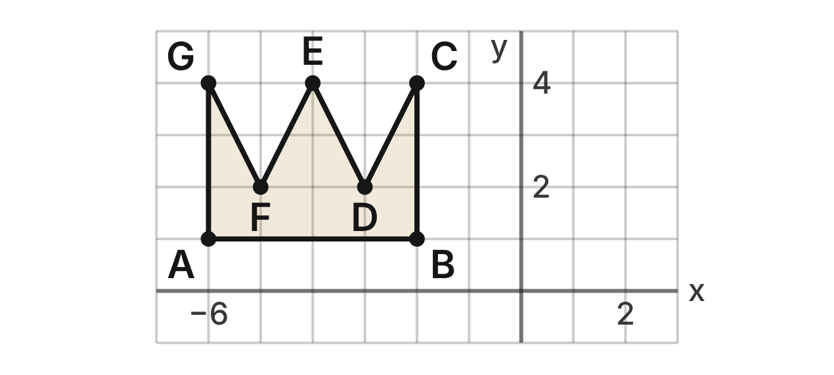
A cross-stitch pattern is sewn on a grid. A crown is polygon ABCDEFG with A(−6, 1), B(−2, 1), C(−2, 4), D(−3, 2), E(−4, 4), F(−5, 2) and G(−6, 4).
91. The crown is stitched again using the rule (x, y) → (x + 6, y − 3). What is the image of C?
A. (−8, 7)
B. (−5, 10)
C. (4, 4)
D. (4, 1) ✔
G.RLT.3 · skill G.RLT.3.2 (LOTS): Find the image of a figure on the coordinate plane under a translation, reflection, rotation or dilation
☐ Answer key correct ☐ Wording clear Notes: ________________________________
92. What is the image of G after a reflection over the x-axis?
A. (−6, −4) ✔
B. (6, 4)
C. (6, −4)
D. (4, −6)
G.RLT.3 · skill G.RLT.3.2 (LOTS): Find the image of a figure on the coordinate plane under a translation, reflection, rotation or dilation
☐ Answer key correct ☐ Wording clear Notes: ________________________________
93. What is the image of A after a rotation of 180° about the origin?
A. (−6, −1)
B. (6, 1)
C. (−1, −6)
D. (6, −1) ✔
G.RLT.3 · skill G.RLT.3.2 (LOTS): Find the image of a figure on the coordinate plane under a translation, reflection, rotation or dilation
☐ Answer key correct ☐ Wording clear Notes: ________________________________
94. What is the image of F after a reflection over the y-axis?
A. (−5, −2)
B. (5, −2)
C. (5, 2) ✔
D. (2, −5)
G.RLT.3 · skill G.RLT.3.2 (LOTS): Find the image of a figure on the coordinate plane under a translation, reflection, rotation or dilation
☐ Answer key correct ☐ Wording clear Notes: ________________________________
95. Which line is a line of symmetry of the crown?
A. y = 2.5
B. x = −4 ✔
C. x = 0
D. x = −2
G.RLT.3 · skill G.RLT.3.1 (LOTS): Identify line symmetry and rotational symmetry of a figure
☐ Answer key correct ☐ Wording clear Notes: ________________________________
96. The crown is reflected over the x-axis for a bottom border. Which is true of the image?
A. It is congruent to the crown, and its points still face up.
B. It is congruent to the crown, and its points face left.
C. It is congruent to the crown, and its points face down. ✔
D. It is not congruent, because a flip changes the angles.
G.RLT.3 · skill G.RLT.3.3 (HOTS): Determine the transformation or composition that maps a preimage to an image, and whether it preserves size and shape
☐ Answer key correct ☐ Wording clear Notes: ________________________________

Turns on the Dance Stage
Level 2 · Transformations · G.RLT.3 · ID geo-rlt3-ring-stage-turns
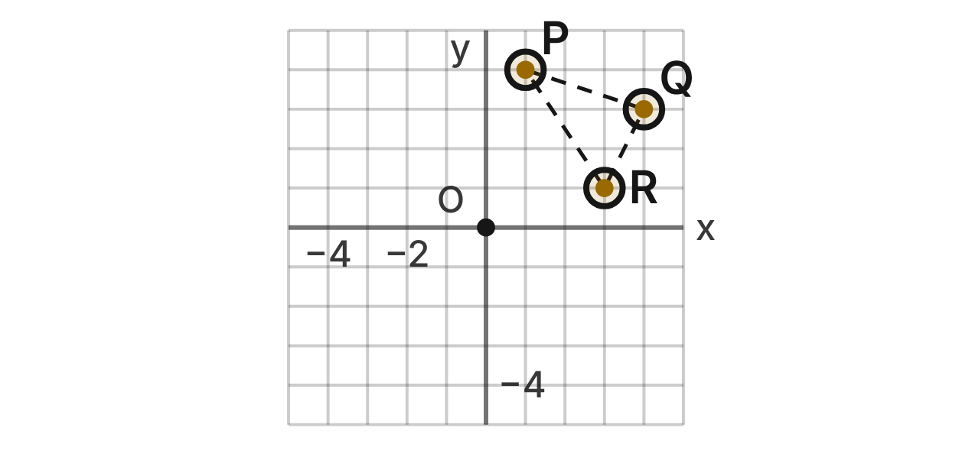
A dance is planned on a stage grid with center stage at the origin O. Three dancers start at P(1, 4), Q(4, 3) and R(3, 1). During the dance their formation turns about O.
97. What is the image of Q after a rotation of 90° clockwise about O?
A. (−3, 4)
B. (−4, −3)
C. (3, −4) ✔
D. (3, 4)
G.RLT.3 · skill G.RLT.3.2 (LOTS): Find the image of a figure on the coordinate plane under a translation, reflection, rotation or dilation
☐ Answer key correct ☐ Wording clear Notes: ________________________________
98. What is the image of P after a rotation of 270° clockwise about O?
A. (4, −1)
B. (−1, −4)
C. (−1, 4)
D. (−4, 1) ✔
G.RLT.3 · skill G.RLT.3.2 (LOTS): Find the image of a figure on the coordinate plane under a translation, reflection, rotation or dilation
☐ Answer key correct ☐ Wording clear Notes: ________________________________
99. On a later count the dancers stand at P′(−1, −4), Q′(−4, −3) and R′(−3, −1). Which single transformation maps P, Q, R to P′, Q′, R′?
A. Rotation of 180° about O ✔
B. Rotation of 90° clockwise about O
C. Reflection over the line y = −x
D. Reflection over the x-axis
G.RLT.3 · skill G.RLT.3.3 (HOTS): Determine the transformation or composition that maps a preimage to an image, and whether it preserves size and shape
☐ Answer key correct ☐ Wording clear Notes: ________________________________
100. In a mirror move, the formation is reflected over the y-axis and then turned 90° counterclockwise about O. Which single transformation has the same effect?
A. Rotation of 180° about O
B. Reflection over the line y = −x ✔
C. Reflection over the line y = x
D. Rotation of 90° counterclockwise about O
G.RLT.3 · skill G.RLT.3.3 (HOTS): Determine the transformation or composition that maps a preimage to an image, and whether it preserves size and shape
☐ Answer key correct ☐ Wording clear Notes: ________________________________
101. In the finale, 9 dancers stand evenly spaced on a circle centered at O. Which rotation about O does NOT map their formation onto itself?
A. 60° ✔
B. 80°
C. 120°
D. 200°
G.RLT.3 · skill G.RLT.3.1 (LOTS): Identify line symmetry and rotational symmetry of a figure
☐ Answer key correct ☐ Wording clear Notes: ________________________________
102. The formation turns 180° about O and then moves up the stage by (x, y) → (x, y + 2). Where does R end up?
A. (−3, −3)
B. (−3, −1)
C. (−3, 1) ✔
D. (3, 1)
G.RLT.3 · skill G.RLT.3.2 (LOTS): Find the image of a figure on the coordinate plane under a translation, reflection, rotation or dilation
☐ Answer key correct ☐ Wording clear Notes: ________________________________

The Chevron Floor Tile
Level 2 · Transformations · G.RLT.3 · ID geo-rlt3-ring-chevron-tile
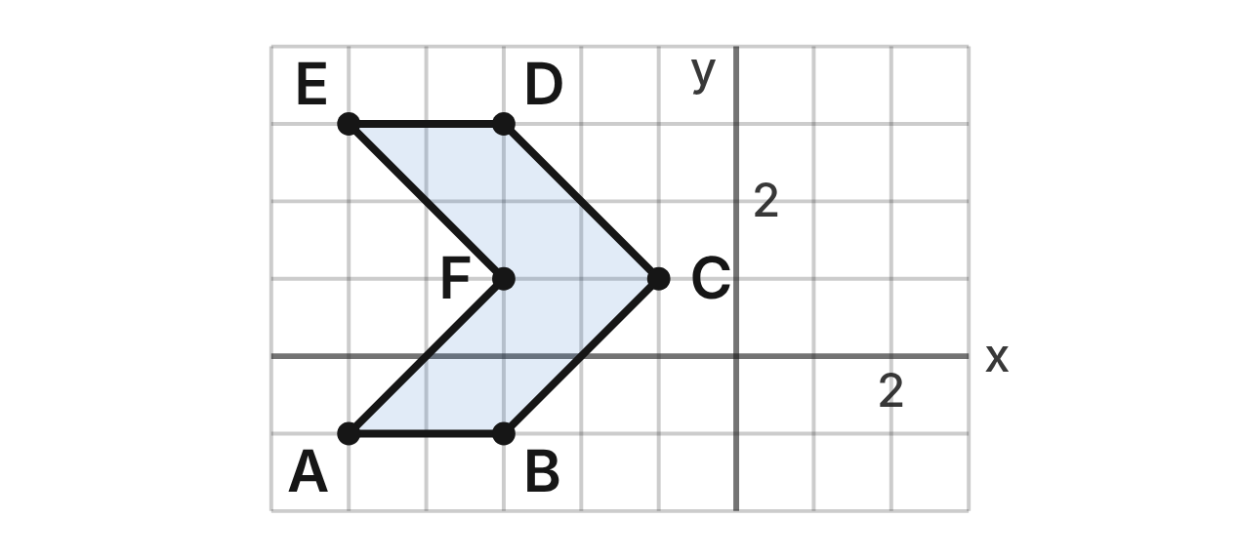
A tile maker designs a chevron tile, ABCDEF, with A(−5, −1), B(−3, −1), C(−1, 1), D(−3, 3), E(−5, 3) and F(−3, 1). Copies of the tile cover a floor with no gaps or overlaps.
103. The next tile in the row is the image of ABCDEF under (x, y) → (x + 2, y). Which vertex of the next tile lands exactly on C(−1, 1)?
A. E′
B. F′ ✔
C. A′
D. C′
G.RLT.3 · skill G.RLT.3.2 (LOTS): Find the image of a figure on the coordinate plane under a translation, reflection, rotation or dilation
☐ Answer key correct ☐ Wording clear Notes: ________________________________
104. The tile directly above ABCDEF has its vertex A″ at (−5, 3). Which rule maps ABCDEF to that tile?
A. (x, y) → (x, y + 3)
B. (x, y) → (x, y − 4)
C. (x, y) → (x, y + 4) ✔
D. (x, y) → (x − 5, y + 3)
G.RLT.3 · skill G.RLT.3.3 (HOTS): Determine the transformation or composition that maps a preimage to an image, and whether it preserves size and shape
☐ Answer key correct ☐ Wording clear Notes: ________________________________
105. A layout moves the tile by (x, y) → (x + 2, y) three times, then by (x, y) → (x, y + 4) twice. Which single rule has the same effect?
A. (x, y) → (x + 2, y + 4)
B. (x, y) → (x + 6, y + 8) ✔
C. (x, y) → (x + 6, y + 12)
D. (x, y) → (x + 4, y + 12)
G.RLT.3 · skill G.RLT.3.3 (HOTS): Determine the transformation or composition that maps a preimage to an image, and whether it preserves size and shape
☐ Answer key correct ☐ Wording clear Notes: ________________________________
106. Which line is a line of symmetry of tile ABCDEF?
A. x = −3
B. y = −1
C. x = −1
D. y = 1 ✔
G.RLT.3 · skill G.RLT.3.1 (LOTS): Identify line symmetry and rotational symmetry of a figure
☐ Answer key correct ☐ Wording clear Notes: ________________________________
107. Which is NOT true of every image of tile ABCDEF under a translation?
A. Its sides have the same lengths.
B. Its angles have the same measures.
C. Its area is the same.
D. It points in a different direction. ✔
G.RLT.3 · skill G.RLT.3.3 (HOTS): Determine the transformation or composition that maps a preimage to an image, and whether it preserves size and shape
☐ Answer key correct ☐ Wording clear Notes: ________________________________
108. For a border, the tile is reflected over the line x = −1. What is the image of E?
A. (3, 3) ✔
B. (5, 3)
C. (−1, 3)
D. (−5, −5)
G.RLT.3 · skill G.RLT.3.2 (LOTS): Find the image of a figure on the coordinate plane under a translation, reflection, rotation or dilation
☐ Answer key correct ☐ Wording clear Notes: ________________________________

Folding the Printed Fabric
Level 2 · Transformations · G.RLT.3 · ID geo-rlt3-ring-fabric-fold
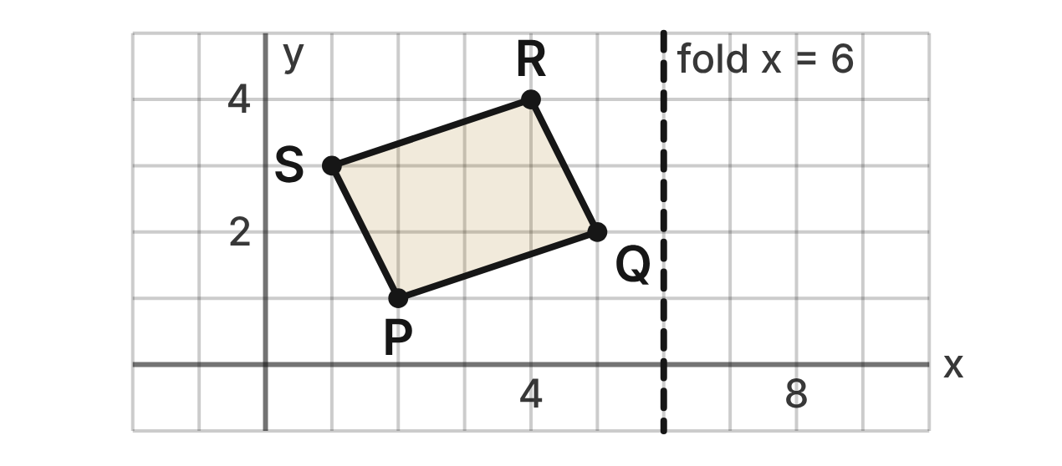
A fabric designer prints motif PQRS with P(2, 1), Q(5, 2), R(4, 4) and S(1, 3). She makes mirror copies by reflecting the motif over lines, like folding the fabric. One fold line is x = 6.
109. One fold runs along the line y = x. What is the image of S in that fold?
A. (−3, −1)
B. (−1, 3)
C. (3, 1) ✔
D. (3, −1)
G.RLT.3 · skill G.RLT.3.2 (LOTS): Find the image of a figure on the coordinate plane under a translation, reflection, rotation or dilation
☐ Answer key correct ☐ Wording clear Notes: ________________________________
110. Another fold runs along the line y = −x. What is the image of Q in that fold?
A. (2, 5)
B. (−2, −5) ✔
C. (−5, −2)
D. (−2, 5)
G.RLT.3 · skill G.RLT.3.2 (LOTS): Find the image of a figure on the coordinate plane under a translation, reflection, rotation or dilation
☐ Answer key correct ☐ Wording clear Notes: ________________________________
111. What is the image of P after a reflection over the fold line x = 6?
A. (6, 1)
B. (4, 1)
C. (8, 1)
D. (10, 1) ✔
G.RLT.3 · skill G.RLT.3.2 (LOTS): Find the image of a figure on the coordinate plane under a translation, reflection, rotation or dilation
☐ Answer key correct ☐ Wording clear Notes: ________________________________
112. On another copy, R(4, 4) lands on (4, −2). Over which line was the motif reflected?
A. y = 1 ✔
B. y = −2
C. y = 3
D. y = 0
G.RLT.3 · skill G.RLT.3.3 (HOTS): Determine the transformation or composition that maps a preimage to an image, and whether it preserves size and shape
☐ Answer key correct ☐ Wording clear Notes: ________________________________
113. The motif is reflected over the line y = x and then over the x-axis. Which single transformation has the same effect?
A. Rotation of 90° counterclockwise about the origin
B. Rotation of 180° about the origin
C. Reflection over the line y = −x
D. Rotation of 90° clockwise about the origin ✔
G.RLT.3 · skill G.RLT.3.3 (HOTS): Determine the transformation or composition that maps a preimage to an image, and whether it preserves size and shape
☐ Answer key correct ☐ Wording clear Notes: ________________________________
114. A border shows motif PQRS together with its mirror image over the line y = x. Which line is a line of symmetry of the two motifs together?
A. y = x ✔
B. x = 3
C. x = 0
D. y = −x
G.RLT.3 · skill G.RLT.3.1 (LOTS): Identify line symmetry and rotational symmetry of a figure
☐ Answer key correct ☐ Wording clear Notes: ________________________________

The Letter T Stencil
Level 2 · Transformations · G.RLT.3 · ID geo-rlt3-ring-t-stencil
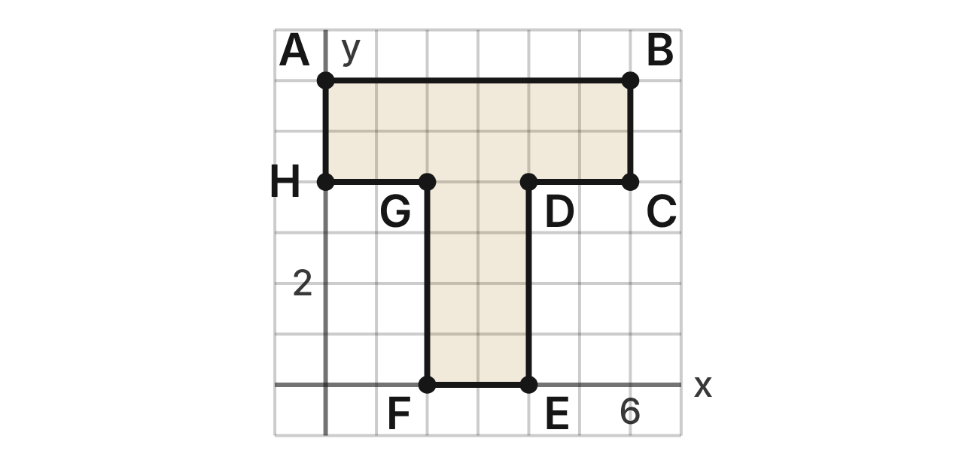
A sign maker cuts a stencil of the letter T, polygon ABCDEFGH: A(0, 6), B(6, 6), C(6, 4), D(4, 4), E(4, 0), F(2, 0), G(2, 4) and H(0, 4). Its perimeter is 24 units and its area is 20 square units. Copies are made by dilations centered at the origin.
115. What is the image of D under a dilation with scale factor 1/2 centered at the origin?
A. (8, 8)
B. (3.5, 3.5)
C. (2, 2) ✔
D. (2, 4)
G.RLT.3 · skill G.RLT.3.2 (LOTS): Find the image of a figure on the coordinate plane under a translation, reflection, rotation or dilation
☐ Answer key correct ☐ Wording clear Notes: ________________________________
116. What is the perimeter of the image of the stencil under a dilation with scale factor 1/2 centered at the origin?
A. 12 units ✔
B. 6 units
C. 24 units
D. 20 units
G.RLT.3 · skill G.RLT.3.2 (LOTS): Find the image of a figure on the coordinate plane under a translation, reflection, rotation or dilation
☐ Answer key correct ☐ Wording clear Notes: ________________________________
117. What is the area of the image of the stencil under a dilation with scale factor 3/2 centered at the origin?
A. 30 square units
B. 45 square units ✔
C. 67.5 square units
D. 21.5 square units
G.RLT.3 · skill G.RLT.3.2 (LOTS): Find the image of a figure on the coordinate plane under a translation, reflection, rotation or dilation
☐ Answer key correct ☐ Wording clear Notes: ________________________________
118. For a small sticker, a dilation centered at the origin maps C(6, 4) to (1.5, 1). What is its scale factor?
A. k = 4
B. k = 4.5
C. k = 1/4 ✔
D. k = 3
G.RLT.3 · skill G.RLT.3.3 (HOTS): Determine the transformation or composition that maps a preimage to an image, and whether it preserves size and shape
☐ Answer key correct ☐ Wording clear Notes: ________________________________
119. Which line is a line of symmetry of the image of the stencil under a dilation with scale factor 1/2 centered at the origin?
A. x = 3
B. x = 1.5 ✔
C. x = 6
D. y = 1.5
G.RLT.3 · skill G.RLT.3.1 (LOTS): Identify line symmetry and rotational symmetry of a figure
☐ Answer key correct ☐ Wording clear Notes: ________________________________
120. Jo says that after a dilation with scale factor 1/2, each 90° corner of the T becomes a 45° corner. What is her error?
A. There is no error; each angle is multiplied by 1/2.
B. Only the 270° corners change; they become 135°.
C. Dilations keep side lengths; only the angles change.
D. Dilations keep angle measures; the corners stay 90°. ✔
G.RLT.3 · skill G.RLT.3.3 (HOTS): Determine the transformation or composition that maps a preimage to an image, and whether it preserves size and shape
☐ Answer key correct ☐ Wording clear Notes: ________________________________

Moving the Monogram
Level 3 · Transformations · G.RLT.3 · ID geo-rlt3-ring-monogram
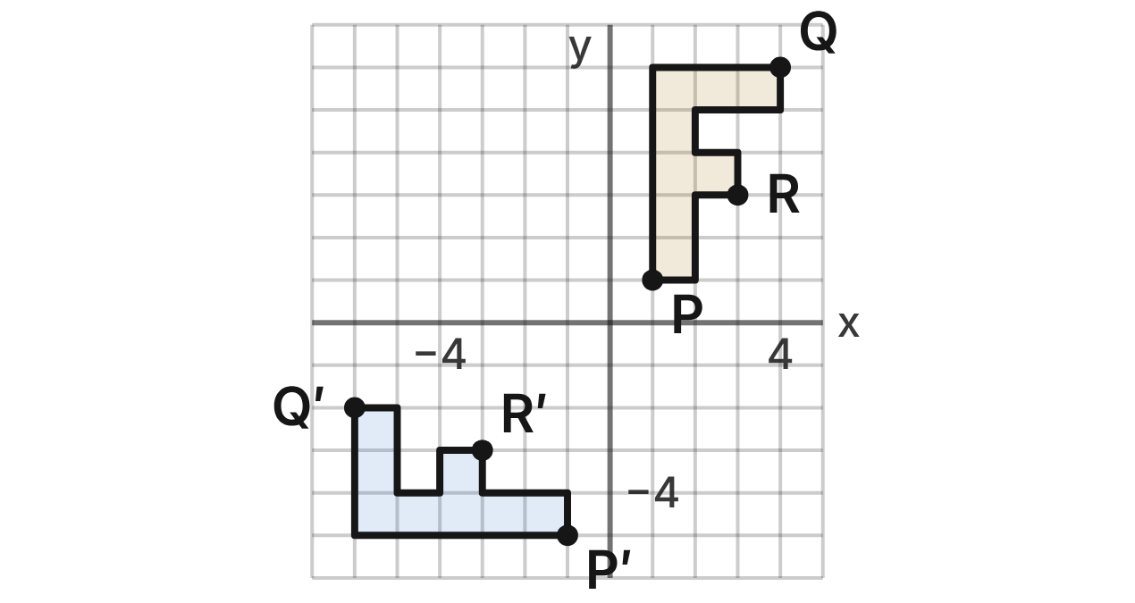
A designer's monogram is the letter F (gold), with corners P(1, 1), Q(4, 6) and R(3, 3). After two moves it appears as F′ (blue), with P′(−1, −5), Q′(−6, −2) and R′(−3, −3).
121. Which sequence of moves maps F to F′?
A. Rotate 90° clockwise about the origin, then translate 6 units down
B. Translate 6 units down, then rotate 90° counterclockwise about the origin
C. Rotate 90° counterclockwise about the origin, then translate 6 units down ✔
D. Reflect over the line y = x, then translate 6 units down
G.RLT.3 · skill G.RLT.3.3 (HOTS): Determine the transformation or composition that maps a preimage to an image, and whether it preserves size and shape
☐ Answer key correct ☐ Wording clear Notes: ________________________________
122. Which is true of F′ compared with F?
A. It is congruent to F but is a mirror image.
B. It is congruent to F and is not a mirror image. ✔
C. It is similar to F but smaller.
D. It is not congruent, because it was turned.
G.RLT.3 · skill G.RLT.3.3 (HOTS): Determine the transformation or composition that maps a preimage to an image, and whether it preserves size and shape
☐ Answer key correct ☐ Wording clear Notes: ________________________________
123. Suppose the moves are done in the other order: translate F 6 units down, then rotate it 90° counterclockwise about the origin. Where does Q(4, 6) end up?
A. (−6, −2)
B. (0, 4) ✔
C. (0, −4)
D. (−6, 4)
G.RLT.3 · skill G.RLT.3.2 (LOTS): Find the image of a figure on the coordinate plane under a translation, reflection, rotation or dilation
☐ Answer key correct ☐ Wording clear Notes: ________________________________
124. For a wax seal, F is dilated by scale factor 2 about the origin and then reflected over the x-axis. Where does Q(4, 6) end up?
A. (8, −12) ✔
B. (8, 12)
C. (−8, 12)
D. (6, −8)
G.RLT.3 · skill G.RLT.3.2 (LOTS): Find the image of a figure on the coordinate plane under a translation, reflection, rotation or dilation
☐ Answer key correct ☐ Wording clear Notes: ________________________________
125. Which sequence maps F′ back onto F?
A. Rotate 90° clockwise about the origin, then translate 6 units up
B. Translate 6 units up, then rotate 90° counterclockwise about the origin
C. Translate 6 units down, then rotate 90° clockwise about the origin
D. Translate 6 units up, then rotate 90° clockwise about the origin ✔
G.RLT.3 · skill G.RLT.3.3 (HOTS): Determine the transformation or composition that maps a preimage to an image, and whether it preserves size and shape
☐ Answer key correct ☐ Wording clear Notes: ________________________________
126. In a plain block font, which letter maps onto itself under a reflection over a horizontal line but NOT under a rotation of 180°?
A. E ✔
B. X
C. S
D. A
G.RLT.3 · skill G.RLT.3.1 (LOTS): Identify line symmetry and rotational symmetry of a figure
☐ Answer key correct ☐ Wording clear Notes: ________________________________

Inside the Kaleidoscope
Level 3 · Transformations · G.RLT.3 · ID geo-rlt3-ring-kaleidoscope
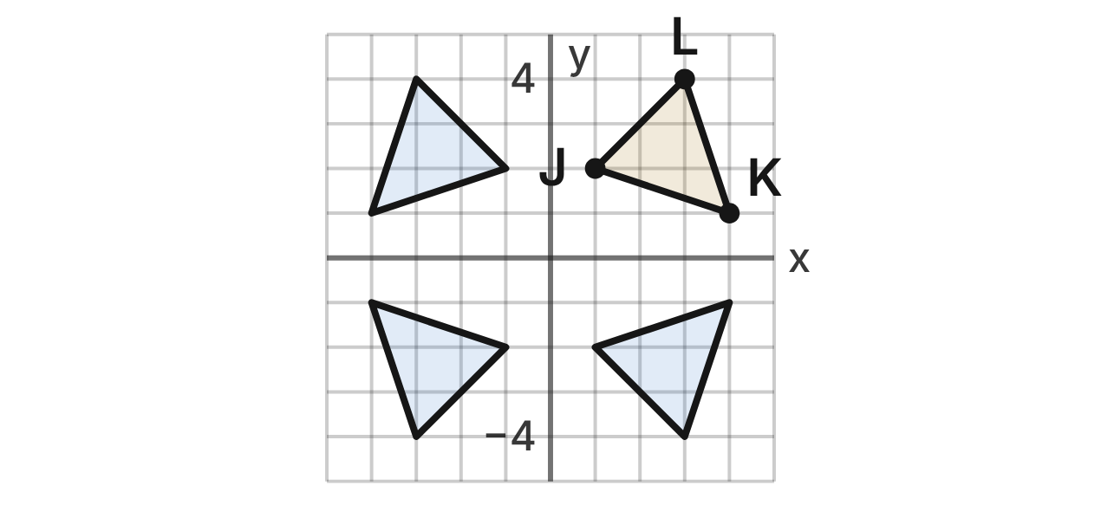
A kaleidoscope has two mirrors at right angles, along the x-axis and the y-axis. A bead shaped like △JKL, with J(1, 2), K(4, 1) and L(3, 4), sits in Quadrant I. The mirrors show its images in the other three quadrants, which makes the pattern.
127. How many lines of symmetry does the whole pattern of four triangles have?
A. 4
B. 0
C. 1
D. 2 ✔
G.RLT.3 · skill G.RLT.3.1 (LOTS): Identify line symmetry and rotational symmetry of a figure
☐ Answer key correct ☐ Wording clear Notes: ________________________________
128. Lena says the pattern has rotational symmetry of order 4 because it has four copies of the bead. What is her error?
A. There is no error; four copies give order 4.
B. A 90° turn does not map the pattern onto itself; the order is 2. ✔
C. No turn maps the pattern onto itself; the order is 1.
D. Each copy has two mirror images; the order is 8.
G.RLT.3 · skill G.RLT.3.1 (LOTS): Identify line symmetry and rotational symmetry of a figure
☐ Answer key correct ☐ Wording clear Notes: ________________________________
129. The triangle in Quadrant IV is the image of △JKL under which single transformation?
A. Reflection over the x-axis ✔
B. Reflection over the y-axis
C. Rotation of 180° about the origin
D. Rotation of 90° clockwise about the origin
G.RLT.3 · skill G.RLT.3.3 (HOTS): Determine the transformation or composition that maps a preimage to an image, and whether it preserves size and shape
☐ Answer key correct ☐ Wording clear Notes: ________________________________
130. A third mirror is added along the line y = x. L is reflected over the y-axis and then over the line y = x. Where does L end up?
A. (−4, 3)
B. (−3, 4)
C. (−3, −4)
D. (4, −3) ✔
G.RLT.3 · skill G.RLT.3.2 (LOTS): Find the image of a figure on the coordinate plane under a translation, reflection, rotation or dilation
☐ Answer key correct ☐ Wording clear Notes: ________________________________
131. The tube is turned so the whole pattern rotates 90° counterclockwise about the origin. What is the image of K?
A. (1, −4)
B. (1, 4)
C. (−1, 4) ✔
D. (−4, −1)
G.RLT.3 · skill G.RLT.3.2 (LOTS): Find the image of a figure on the coordinate plane under a translation, reflection, rotation or dilation
☐ Answer key correct ☐ Wording clear Notes: ________________________________
132. Which single transformation maps the triangle in Quadrant II onto the triangle in Quadrant IV?
A. Reflection over the x-axis
B. Reflection over the line y = x
C. Rotation of 180° about the origin ✔
D. Rotation of 90° counterclockwise about the origin
G.RLT.3 · skill G.RLT.3.3 (HOTS): Determine the transformation or composition that maps a preimage to an image, and whether it preserves size and shape
☐ Answer key correct ☐ Wording clear Notes: ________________________________

Triangles (G.TR)

G.TR.1 · Determine the relationships between the measures of angles and lengths of sides in triangles, including problems in context.

The Hanging Mobile
Level 1 · Triangles · G.TR.1 · ID geo-tr1-ring-hanging-mobile
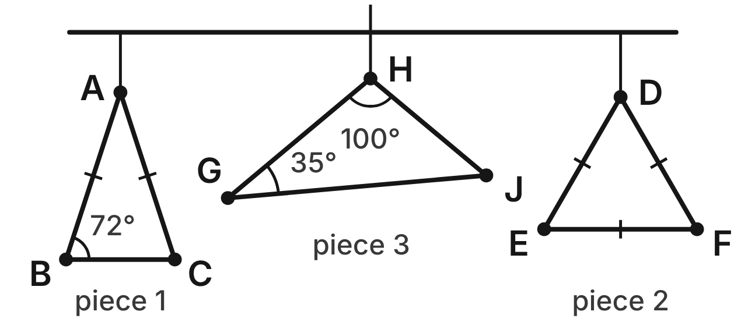
A mobile holds three flat pieces. Piece 1 is △ABC, with AB ≅ AC and m∠ABC = 72°. Piece 2 is the equilateral triangle DEF. Piece 3 is △GHJ, with m∠G = 35° and m∠H = 100°.
133. What is m∠BAC, the top angle of piece 1?
A. 108°
B. 36° ✔
C. 72°
D. 144°
G.TR.1 · skill G.TR.1.3 (LOTS): Solve problems using the triangle angle sum and the exterior angle theorem
☐ Answer key correct ☐ Wording clear Notes: ________________________________
134. Which side of piece 1 is the shortest?
A. BC ✔
B. AB
C. AB and AC tie for shortest
D. All three sides are equal
G.TR.1 · skill G.TR.1.1 (LOTS): Order the sides of a triangle by length given its angles, or its angles by size given its sides
☐ Answer key correct ☐ Wording clear Notes: ________________________________
135. What is m∠DEF in piece 2?
A. 180°
B. 90°
C. 120°
D. 60° ✔
G.TR.1 · skill G.TR.1.3 (LOTS): Solve problems using the triangle angle sum and the exterior angle theorem
☐ Answer key correct ☐ Wording clear Notes: ________________________________
136. What is m∠J in piece 3?
A. 135°
B. 145°
C. 45° ✔
D. 80°
G.TR.1 · skill G.TR.1.3 (LOTS): Solve problems using the triangle angle sum and the exterior angle theorem
☐ Answer key correct ☐ Wording clear Notes: ________________________________
137. Which list orders the sides of piece 3 from shortest to longest?
A. GJ, GH, HJ
B. HJ, GH, GJ ✔
C. GH, HJ, GJ
D. HJ, GJ, GH
G.TR.1 · skill G.TR.1.1 (LOTS): Order the sides of a triangle by length given its angles, or its angles by size given its sides
☐ Answer key correct ☐ Wording clear Notes: ________________________________
138. The artist will bend wire into a fourth piece. Which three lengths can form a triangle?
A. 7 cm, 10 cm, 15 cm ✔
B. 4 cm, 7 cm, 12 cm
C. 5 cm, 8 cm, 13 cm
D. 3 cm, 3 cm, 7 cm
G.TR.1 · skill G.TR.1.2 (LOTS): Decide whether three lengths can form a triangle and find the range of possible lengths of the third side
☐ Answer key correct ☐ Wording clear Notes: ________________________________

The Folding Easel
Level 1 · Triangles · G.TR.1 · ID geo-tr1-ring-folding-easel
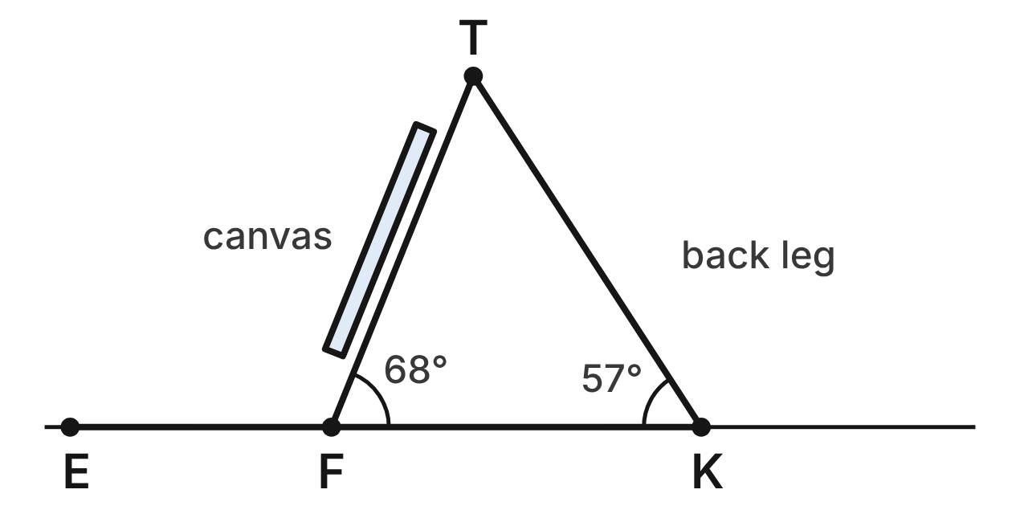
From the side, a folding easel is the triangle TFK: the front leg TF, the back leg TK and the floor FK. m∠TFK = 68° and m∠TKF = 57°. The floor line continues past F to E.
139. What is m∠FTK, the angle at the top of the easel?
A. 125°
B. 112°
C. 123°
D. 55° ✔
G.TR.1 · skill G.TR.1.3 (LOTS): Solve problems using the triangle angle sum and the exterior angle theorem
☐ Answer key correct ☐ Wording clear Notes: ________________________________
140. What is m∠TFE, the angle between the front leg and the floor beyond F?
A. 68°
B. 123°
C. 112° ✔
D. 125°
G.TR.1 · skill G.TR.1.3 (LOTS): Solve problems using the triangle angle sum and the exterior angle theorem
☐ Answer key correct ☐ Wording clear Notes: ________________________________
141. Which part of the easel triangle is the longest?
A. the front leg TF
B. the floor distance FK
C. TF and TK are the same length
D. the back leg TK ✔
G.TR.1 · skill G.TR.1.1 (LOTS): Order the sides of a triangle by length given its angles, or its angles by size given its sides
☐ Answer key correct ☐ Wording clear Notes: ________________________________
142. Which list orders FK, TF and TK from shortest to longest?
A. FK, TF, TK ✔
B. TK, TF, FK
C. TF, FK, TK
D. FK, TK, TF
G.TR.1 · skill G.TR.1.1 (LOTS): Order the sides of a triangle by length given its angles, or its angles by size given its sides
☐ Answer key correct ☐ Wording clear Notes: ________________________________
143. Kai says: ∠TKF is smaller than ∠TFK, so the back leg TK is shorter than the front leg TF. What is Kai's error?
A. ∠TKF is larger than ∠TFK, not smaller.
B. The legs are equal, since easels are symmetric.
C. TK is opposite the larger angle, so TK is longer. ✔
D. Kai made no error; his reasoning is correct.
G.TR.1 · skill G.TR.1.1 (LOTS): Order the sides of a triangle by length given its angles, or its angles by size given its sides
☐ Answer key correct ☐ Wording clear Notes: ________________________________
144. An artist builds a taller easel with legs of 1.6 m and 1.4 m. The legs and the floor form a triangle. Which could be the distance between the feet?
A. 0.2 m
B. 1.1 m ✔
C. 3.0 m
D. 3.2 m
G.TR.1 · skill G.TR.1.2 (LOTS): Decide whether three lengths can form a triangle and find the range of possible lengths of the third side
☐ Answer key correct ☐ Wording clear Notes: ________________________________

The Quilt Piece
Level 2 · Triangles · G.TR.1 · ID geo-tr1-ring-quilt-piece
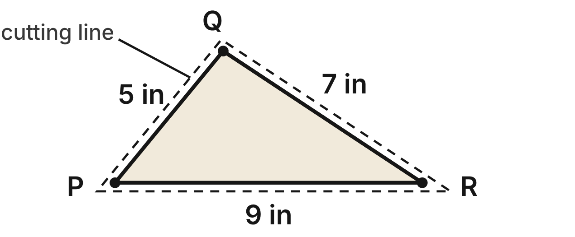
A quilter cuts the triangle PQR from fabric. Along its sewing lines, PQ = 5 in, QR = 7 in and PR = 9 in. The dashed cutting line is 1/4 in outside the sewing lines.
145. Which statement about the angles of △PQR is true?
A. m∠Q is greater than m∠P. ✔
B. m∠R is greater than m∠P.
C. m∠P is greater than m∠Q.
D. m∠R is the largest angle.
G.TR.1 · skill G.TR.1.1 (LOTS): Order the sides of a triangle by length given its angles, or its angles by size given its sides
☐ Answer key correct ☐ Wording clear Notes: ________________________________
146. Which list orders the angles of △PQR from largest to smallest?
A. ∠R, ∠P, ∠Q
B. ∠Q, ∠P, ∠R ✔
C. ∠Q, ∠R, ∠P
D. ∠P, ∠Q, ∠R
G.TR.1 · skill G.TR.1.1 (LOTS): Order the sides of a triangle by length given its angles, or its angles by size given its sides
☐ Answer key correct ☐ Wording clear Notes: ________________________________
147. The quilter keeps PQ = 5 in and QR = 7 in but changes PR. Which inequality gives all possible lengths of PR, in inches?
A. 5 < PR < 7
B. 0 < PR < 12
C. 2 < PR < 12 ✔
D. 7 < PR < 12
G.TR.1 · skill G.TR.1.2 (LOTS): Decide whether three lengths can form a triangle and find the range of possible lengths of the third side
☐ Answer key correct ☐ Wording clear Notes: ________________________________
148. A pattern lists a piece with sides of 3 in, 4.5 in and 8 in. Can it be a triangle? Choose the answer with the correct reason.
A. Yes, because 3 + 8 is greater than 4.5.
B. No, because 8 − 3 is less than 4.5.
C. Yes, because 4.5 + 8 is greater than 3.
D. No, because 3 + 4.5 is less than 8. ✔
G.TR.1 · skill G.TR.1.2 (LOTS): Decide whether three lengths can form a triangle and find the range of possible lengths of the third side
☐ Answer key correct ☐ Wording clear Notes: ________________________________
149. A protractor gives m∠P ≈ 50.7° and m∠R ≈ 33.6°. What is m∠Q, to the nearest tenth of a degree?
A. 84.3°
B. 129.3°
C. 95.7° ✔
D. 146.4°
G.TR.1 · skill G.TR.1.3 (LOTS): Solve problems using the triangle angle sum and the exterior angle theorem
☐ Answer key correct ☐ Wording clear Notes: ________________________________
150. Another piece is a half-square triangle: an isosceles right triangle. What is the measure of each of its acute angles?
A. 90°
B. 45° ✔
C. 60°
D. 135°
G.TR.1 · skill G.TR.1.3 (LOTS): Solve problems using the triangle angle sum and the exterior angle theorem
☐ Answer key correct ☐ Wording clear Notes: ________________________________

The A-Frame Sign
Level 2 · Triangles · G.TR.1 · ID geo-tr1-ring-a-frame-sign
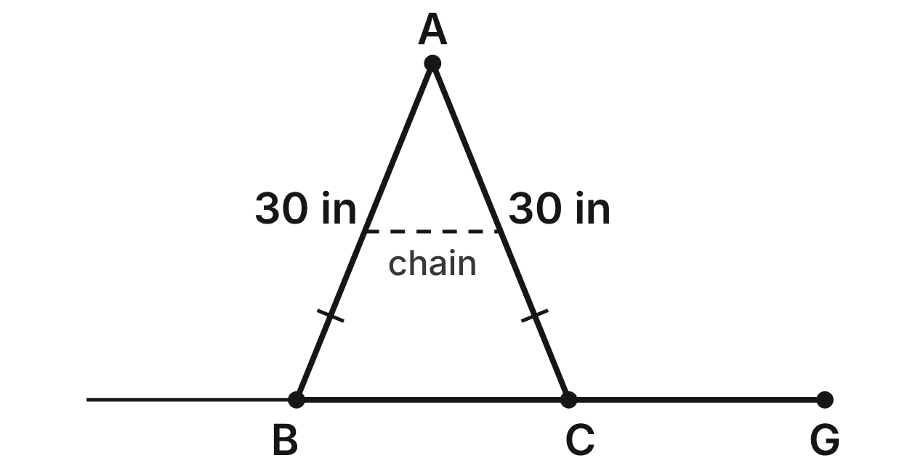
From the side, an A-frame sign is the triangle ABC. Its legs are equal: AB = AC = 30 in. A chain sets the spread BC, so BC can change; the figure shows one setting. The ground line continues past C to G.
151. Which spread BC is NOT possible for this sign?
A. 6 in
B. 30 in
C. 59 in
D. 60 in ✔
G.TR.1 · skill G.TR.1.2 (LOTS): Decide whether three lengths can form a triangle and find the range of possible lengths of the third side
☐ Answer key correct ☐ Wording clear Notes: ________________________________
152. Suppose the chain is set so that m∠BAC = 48°. What is m∠ABC?
A. 66° ✔
B. 132°
C. 48°
D. 42°
G.TR.1 · skill G.TR.1.3 (LOTS): Solve problems using the triangle angle sum and the exterior angle theorem
☐ Answer key correct ☐ Wording clear Notes: ________________________________
153. Suppose the spread is BC = 38 in. Which list orders the angles of △ABC from smallest to largest?
A. ∠A, then ∠B and ∠C (equal)
B. All three angles are equal
C. ∠B and ∠C (equal), then ∠A ✔
D. ∠B, then ∠A, then ∠C
G.TR.1 · skill G.TR.1.1 (LOTS): Order the sides of a triangle by length given its angles, or its angles by size given its sides
☐ Answer key correct ☐ Wording clear Notes: ________________________________
154. For which spread BC is each angle of △ABC equal to 60°?
A. 60 in
B. 15 in
C. No spread gives three 60° angles
D. 30 in ✔
G.TR.1 · skill G.TR.1.1 (LOTS): Order the sides of a triangle by length given its angles, or its angles by size given its sides
☐ Answer key correct ☐ Wording clear Notes: ________________________________
155. Another A-frame sign is △JKL, with JK ≅ JL. m∠KJL = (2y + 10)⁠° and m∠JKL = (3y + 5)⁠°. What is m∠JKL?
A. 104°
B. 65° ✔
C. 50°
D. 20°
G.TR.1 · skill G.TR.1.3 (LOTS): Solve problems using the triangle angle sum and the exterior angle theorem
☐ Answer key correct ☐ Wording clear Notes: ________________________________
156. Suppose m∠BAC = 40°. What is m∠ACG?
A. 110° ✔
B. 140°
C. 70°
D. 40°
G.TR.1 · skill G.TR.1.3 (LOTS): Solve problems using the triangle angle sum and the exterior angle theorem
☐ Answer key correct ☐ Wording clear Notes: ________________________________

The Tent-Shaped Display
Level 2 · Triangles · G.TR.1 · ID geo-tr1-ring-tent-display
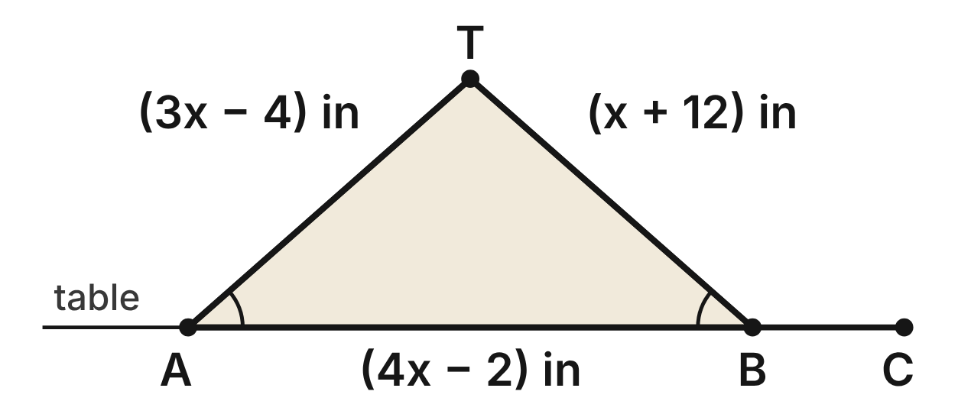
A tent-shaped display stand at an art fair is the triangle TAB, with ∠TAB ≅ ∠TBA. TA = (3x − 4) in, TB = (x + 12) in and AB = (4x − 2) in. The base AB lies along the table edge, which continues past B to C.
157. The base angles are equal, so the sides opposite them are equal. What is the value of x?
A. 4
B. 14/3
C. 8 ✔
D. 20
G.TR.1 · skill G.TR.1.1 (LOTS): Order the sides of a triangle by length given its angles, or its angles by size given its sides
☐ Answer key correct ☐ Wording clear Notes: ________________________________
158. Which angle of △TAB is the largest?
A. ∠TAB
B. ∠TAB and ∠TBA tie for largest
C. You cannot tell without a protractor.
D. ∠T ✔
G.TR.1 · skill G.TR.1.1 (LOTS): Order the sides of a triangle by length given its angles, or its angles by size given its sides
☐ Answer key correct ☐ Wording clear Notes: ________________________________
159. Which statement about △TAB must be true?
A. m∠T is greater than 60°. ✔
B. m∠TAB is greater than 60°.
C. m∠T is less than m∠TAB.
D. m∠TAB + m∠TBA is greater than 120°.
G.TR.1 · skill G.TR.1.1 (LOTS): Order the sides of a triangle by length given its angles, or its angles by size given its sides
☐ Answer key correct ☐ Wording clear Notes: ________________________________
160. Another stand has sides of (3x − 4) in, (x + 12) in and (4x − 2) in, with no two angles equal. Which value of x would NOT give three side lengths that form a triangle?
A. x = 4
B. x = 2 ✔
C. x = 6
D. x = 12
G.TR.1 · skill G.TR.1.2 (LOTS): Decide whether three lengths can form a triangle and find the range of possible lengths of the third side
☐ Answer key correct ☐ Wording clear Notes: ________________________________
161. Another stand, △KLM, has KL ≅ KM. Its base LM is extended past M to N, and m∠KMN = 132°. What is m∠LKM?
A. 48°
B. 66°
C. 132°
D. 84° ✔
G.TR.1 · skill G.TR.1.3 (LOTS): Solve problems using the triangle angle sum and the exterior angle theorem
☐ Answer key correct ☐ Wording clear Notes: ________________________________
162. Which statement about △TAB and ∠TBC is NOT true?
A. m∠TBC = m∠TAB + m∠TBA ✔
B. m∠TBC = m∠ATB + m∠TAB
C. m∠TBC + m∠TBA = 180°
D. m∠TBC is greater than m∠ATB
G.TR.1 · skill G.TR.1.3 (LOTS): Solve problems using the triangle angle sum and the exterior angle theorem
☐ Answer key correct ☐ Wording clear Notes: ________________________________

The Shelf Bracket
Level 3 · Triangles · G.TR.1 · ID geo-tr1-ring-shelf-bracket
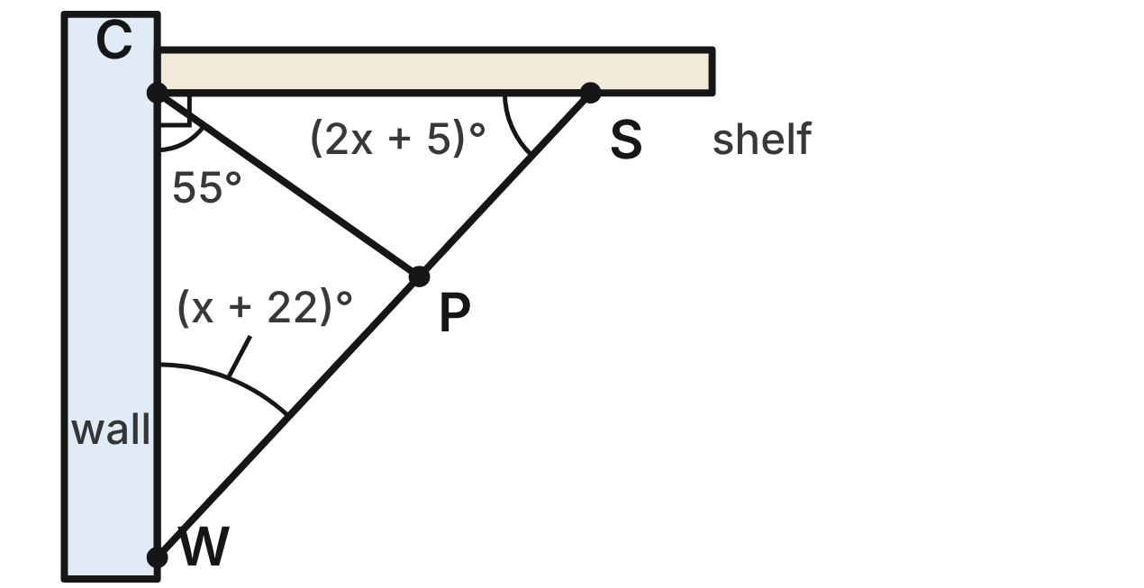
A shelf bracket is the triangle WCS. The wall CW is perpendicular to the shelf CS, and the brace WS joins them. A strut joins C to the point P on the brace. m∠CWS = (x + 22)⁠°, m∠CSW = (2x + 5)⁠° and m∠WCP = 55°.
163. Use the right angle at C to find the value of x.
A. 17
B. 51
C. 21 ✔
D. 43
G.TR.1 · skill G.TR.1.3 (LOTS): Solve problems using the triangle angle sum and the exterior angle theorem
☐ Answer key correct ☐ Wording clear Notes: ________________________________
164. What is m∠CPS, the angle between the strut and the brace PS?
A. 82°
B. 98° ✔
C. 102°
D. 125°
G.TR.1 · skill G.TR.1.3 (LOTS): Solve problems using the triangle angle sum and the exterior angle theorem
☐ Answer key correct ☐ Wording clear Notes: ________________________________
165. What is m∠PCS, the angle between the strut and the shelf?
A. 55°
B. 125°
C. 145°
D. 35° ✔
G.TR.1 · skill G.TR.1.3 (LOTS): Solve problems using the triangle angle sum and the exterior angle theorem
☐ Answer key correct ☐ Wording clear Notes: ________________________________
166. In △CPS, which list orders the sides from shortest to longest?
A. CS, CP, PS
B. PS, CP, CS ✔
C. CP, PS, CS
D. PS, CS, CP
G.TR.1 · skill G.TR.1.1 (LOTS): Order the sides of a triangle by length given its angles, or its angles by size given its sides
☐ Answer key correct ☐ Wording clear Notes: ________________________________
167. Which statement about the bracket is NOT true?
A. CP is shorter than CS.
B. CP is shorter than CW.
C. CW is shorter than CS. ✔
D. WS is the longest side of △WCS.
G.TR.1 · skill G.TR.1.1 (LOTS): Order the sides of a triangle by length given its angles, or its angles by size given its sides
☐ Answer key correct ☐ Wording clear Notes: ________________________________
168. Another brace triangle will have sides of 20 in, (3b − 2) in and (b + 6) in. Which inequality gives all possible values of b?
A. 4 < b < 14 ✔
B. b > 4
C. b < 14
D. −6 < b < 14
G.TR.1 · skill G.TR.1.2 (LOTS): Decide whether three lengths can form a triangle and find the range of possible lengths of the third side
☐ Answer key correct ☐ Wording clear Notes: ________________________________

The Stage Spotlights
Level 3 · Triangles · G.TR.1 · ID geo-tr1-ring-stage-spotlights
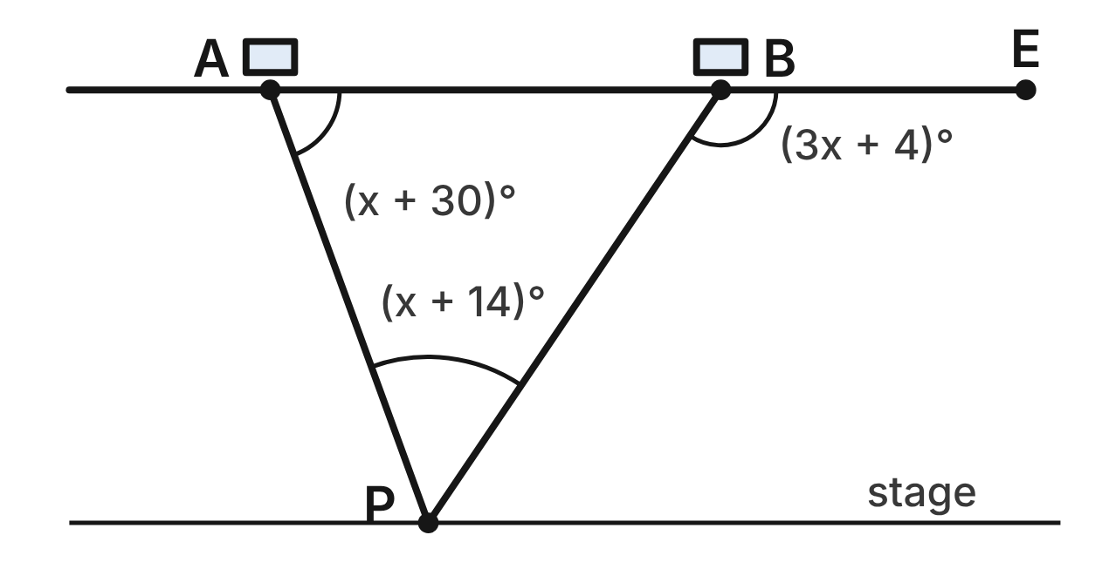
Spotlights A and B hang on a straight lighting bar, which continues past B to E. Their beams meet at the performer P. m∠PAB = (x + 30)⁠°, m∠APB = (x + 14)⁠° and m∠PBE = (3x + 4)⁠°.
169. Which equation can be used to find x?
A. (x + 30) + (x + 14) + (3x + 4) = 180
B. 3x + 4 = (x + 30) + (x + 14) ✔
C. (3x + 4) + (x + 30) = 180
D. 3x + 4 = (x + 30) − (x + 14)
G.TR.1 · skill G.TR.1.3 (LOTS): Solve problems using the triangle angle sum and the exterior angle theorem
☐ Answer key correct ☐ Wording clear Notes: ________________________________
170. What is m∠ABP, the angle between the bar and beam BP?
A. 124°
B. 40°
C. 54°
D. 56° ✔
G.TR.1 · skill G.TR.1.3 (LOTS): Solve problems using the triangle angle sum and the exterior angle theorem
☐ Answer key correct ☐ Wording clear Notes: ________________________________
171. Which beam is longer, AP or BP? Choose the answer with the correct reason.
A. BP, because it is opposite the larger angle, ∠PAB. ✔
B. AP, because it is opposite the larger angle, ∠ABP.
C. BP, because ∠ABP is the largest angle of △ABP.
D. AP, because ∠PBE is greater than ∠PAB.
G.TR.1 · skill G.TR.1.1 (LOTS): Order the sides of a triangle by length given its angles, or its angles by size given its sides
☐ Answer key correct ☐ Wording clear Notes: ________________________________
172. Which list orders the sides of △ABP from shortest to longest?
A. BP, AP, AB
B. AP, AB, BP
C. AB, AP, BP ✔
D. AB, BP, AP
G.TR.1 · skill G.TR.1.1 (LOTS): Order the sides of a triangle by length given its angles, or its angles by size given its sides
☐ Answer key correct ☐ Wording clear Notes: ________________________________
173. For a different show, the beams are AP = 5 m and BP = 6.5 m. Which could NOT be the distance AB between the lights?
A. 1.6 m
B. 1.2 m ✔
C. 6.5 m
D. 11.4 m
G.TR.1 · skill G.TR.1.2 (LOTS): Decide whether three lengths can form a triangle and find the range of possible lengths of the third side
☐ Answer key correct ☐ Wording clear Notes: ________________________________
174. For the next song, the light at A is tilted so that m∠PAB = 62°, and the performer moves so that m∠APB = 50°. What is m∠PBE then?
A. 112° ✔
B. 68°
C. 130°
D. 118°
G.TR.1 · skill G.TR.1.3 (LOTS): Solve problems using the triangle angle sum and the exterior angle theorem
☐ Answer key correct ☐ Wording clear Notes: ________________________________

G.TR.2 · Prove two triangles are congruent, using direct and indirect proofs, and solve problems involving measured attributes of congruent triangles.

The Stained Glass Triangle
Level 1 · Triangles · G.TR.2 · ID geo-tr2-ring-stained-glass
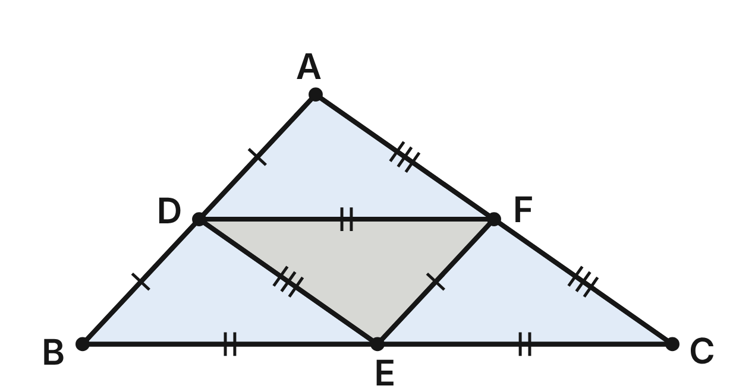
A stained glass panel is the triangle ABC. Lead strips join D, E and F, the midpoints of its sides, to make four small pieces. Matching tick marks show congruent segments.
175. Which criterion do the tick marks support for △ADF ≅ △DBE?
A. SAS
B. ASA
C. SSS ✔
D. HL
G.TR.2 · skill G.TR.2.1 (LOTS): Identify the congruence criterion (SSS, SAS, ASA, AAS, HL) that the given information supports, and recognize when none does
☐ Answer key correct ☐ Wording clear Notes: ________________________________
176. In the congruence △ADF ≅ △DBE, which angle matches ∠DFA?
A. ∠BED ✔
B. ∠DBE
C. ∠BDE
D. ∠FDA
G.TR.2 · skill G.TR.2.3 (LOTS): Solve problems, including algebraic ones, using corresponding parts of congruent triangles
☐ Answer key correct ☐ Wording clear Notes: ________________________________
177. FA = (3x − 4) cm and ED = (x + 12) cm. How long is the lead strip ED?
A. 8 cm
B. 40 cm
C. 16 cm
D. 20 cm ✔
G.TR.2 · skill G.TR.2.3 (LOTS): Solve problems, including algebraic ones, using corresponding parts of congruent triangles
☐ Answer key correct ☐ Wording clear Notes: ________________________________
178. m∠BAC = 98°. What is m∠DEF in the middle piece?
A. 82°
B. 98° ✔
C. 49°
D. 41°
G.TR.2 · skill G.TR.2.3 (LOTS): Solve problems, including algebraic ones, using corresponding parts of congruent triangles
☐ Answer key correct ☐ Wording clear Notes: ________________________________
179. Suppose the marks showed only AD ≅ DB and DF ≅ BE. Which one more fact would prove △ADF ≅ △DBE by SAS?
A. ∠ADF ≅ ∠DBE ✔
B. ∠DAF ≅ ∠BDE
C. ∠AFD ≅ ∠DEB
D. FA ≅ ED
G.TR.2 · skill G.TR.2.1 (LOTS): Identify the congruence criterion (SSS, SAS, ASA, AAS, HL) that the given information supports, and recognize when none does
☐ Answer key correct ☐ Wording clear Notes: ________________________________
180. Theo says SSS gives △ADF ≅ △DBE, so ∠DAF ≅ ∠DBE. Is he right? Choose the answer with the correct reason.
A. Yes; CPCTC matches ∠DAF with ∠DBE
B. No; ∠DAF matches ∠BDE ✔
C. No; SSS does not prove congruence
D. Yes; all angles in the panel match
G.TR.2 · skill G.TR.2.2 (HOTS): Complete or justify a direct or indirect proof that two triangles are congruent
☐ Answer key correct ☐ Wording clear Notes: ________________________________

Two Earrings, One Recipe
Level 1 · Triangles · G.TR.2 · ID geo-tr2-ring-earrings
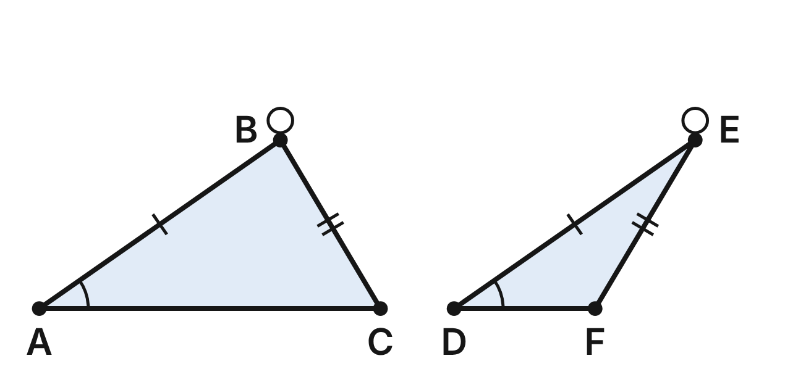
A jeweler cuts two triangular earrings, △ABC and △DEF, from one recipe: AB = DE = 30 mm, BC = EF = 20 mm and m∠A = m∠D = 35°. The earrings come out different shapes.
181. Do the marks prove △ABC ≅ △DEF? Choose the answer with the correct reason.
A. Yes; SAS, since ∠A is between AB and BC
B. Yes; HL, since both are right triangles
C. No; SSA can fit two different triangles ✔
D. No; no pair of angles is marked congruent
G.TR.2 · skill G.TR.2.1 (LOTS): Identify the congruence criterion (SSS, SAS, ASA, AAS, HL) that the given information supports, and recognize when none does
☐ Answer key correct ☐ Wording clear Notes: ________________________________
182. For a new pair, the jeweler matches AB ≅ DE and ∠A ≅ ∠D. Which added fact would still NOT prove the new pair congruent?
A. AC ≅ DF
B. ∠B ≅ ∠E
C. ∠C ≅ ∠F
D. BC ≅ EF ✔
G.TR.2 · skill G.TR.2.1 (LOTS): Identify the congruence criterion (SSS, SAS, ASA, AAS, HL) that the given information supports, and recognize when none does
☐ Answer key correct ☐ Wording clear Notes: ________________________________
183. m∠C ≈ 59° and m∠F ≈ 121°. Jo assumes △ABC ≅ △DEF, to show that it is false. Which fact gives her contradiction?
A. CPCTC gives ∠C ≅ ∠F, but 59° ≠ 121° ✔
B. CPCTC gives ∠A ≅ ∠F, but 35° ≠ 121°
C. CPCTC gives AB ≅ EF, but 30 mm ≠ 20 mm
D. ∠C and ∠F add to 180°, so they are congruent
G.TR.2 · skill G.TR.2.2 (HOTS): Complete or justify a direct or indirect proof that two triangles are congruent
☐ Answer key correct ☐ Wording clear Notes: ________________________________
184. Another earring is cut so that △GHJ ≅ △ABC. GH = (4n − 6) mm. What is n?
A. 6
B. 9 ✔
C. 7.5
D. 36
G.TR.2 · skill G.TR.2.3 (LOTS): Solve problems, including algebraic ones, using corresponding parts of congruent triangles
☐ Answer key correct ☐ Wording clear Notes: ________________________________
185. Another earring is cut so that △GHJ ≅ △ABC. Which side of △GHJ must be 20 mm long?
A. GH
B. HJ ✔
C. GJ
D. None; SSA leaves it unknown
G.TR.2 · skill G.TR.2.3 (LOTS): Solve problems, including algebraic ones, using corresponding parts of congruent triangles
☐ Answer key correct ☐ Wording clear Notes: ________________________________
186. Which set of facts about two earrings is enough to prove them congruent?
A. Two sides and an angle not between them
B. All three pairs of angles
C. One side and the angle next to it
D. Two angles and the side between them ✔
G.TR.2 · skill G.TR.2.1 (LOTS): Identify the congruence criterion (SSS, SAS, ASA, AAS, HL) that the given information supports, and recognize when none does
☐ Answer key correct ☐ Wording clear Notes: ________________________________

Guitar Picks on the Design Grid
Level 2 · Triangles · G.TR.2 · ID geo-tr2-ring-guitar-picks
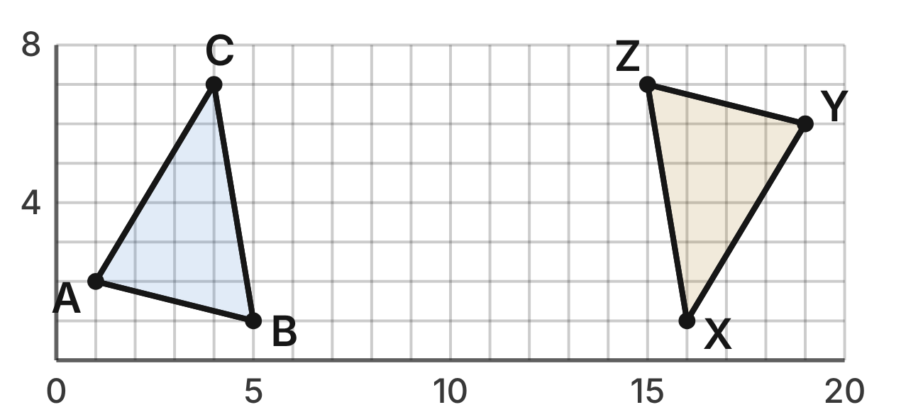
A designer draws a guitar pick △ABC on a grid and turns a copy, △YZX, halfway around. The corners are A(1, 2), B(5, 1), C(4, 7), X(16, 1), Y(19, 6) and Z(15, 7).
187. What is the length of AC, in grid units?
A. 34
B. 2√2
C. 4
D. √34 ✔
G.TR.2 · skill G.TR.2.3 (LOTS): Solve problems, including algebraic ones, using corresponding parts of congruent triangles
☐ Answer key correct ☐ Wording clear Notes: ________________________________
188. Rosa finds AB = √17 and XY = √34, so she says the picks are not congruent. What is her error?
A. √17 and √34 are equal
B. XY is really √17
C. AB matches YZ, not XY ✔
D. She must compare angles, not sides
G.TR.2 · skill G.TR.2.2 (HOTS): Complete or justify a direct or indirect proof that two triangles are congruent
☐ Answer key correct ☐ Wording clear Notes: ________________________________
189. Kai knows only AB = YZ and BC = ZX. Which added fact would prove the picks congruent by SSS?
A. ∠B ≅ ∠Z
B. AC = XY ✔
C. AC = YZ
D. AB = XY
G.TR.2 · skill G.TR.2.1 (LOTS): Identify the congruence criterion (SSS, SAS, ASA, AAS, HL) that the given information supports, and recognize when none does
☐ Answer key correct ☐ Wording clear Notes: ________________________________
190. To the nearest tenth, what is the perimeter of △XYZ, in grid units?
A. 16.0 ✔
B. 88.0
C. 20.0
D. 9.4
G.TR.2 · skill G.TR.2.3 (LOTS): Solve problems, including algebraic ones, using corresponding parts of congruent triangles
☐ Answer key correct ☐ Wording clear Notes: ________________________________
191. m∠ABC ≈ 66.5°. To the nearest tenth of a degree, what is m∠YZX?
A. 23.5°
B. 113.5°
C. 33.3°
D. 66.5° ✔
G.TR.2 · skill G.TR.2.3 (LOTS): Solve problems, including algebraic ones, using corresponding parts of congruent triangles
☐ Answer key correct ☐ Wording clear Notes: ________________________________
192. Which reason shows △YZX ≅ △ABC without measuring any angles?
A. SSS: all three pairs of sides match ✔
B. SAS: two sides and the angle between
C. AAA: all three angles match
D. HL: both are right triangles
G.TR.2 · skill G.TR.2.1 (LOTS): Identify the congruence criterion (SSS, SAS, ASA, AAS, HL) that the given information supports, and recognize when none does
☐ Answer key correct ☐ Wording clear Notes: ________________________________

Slats on the Stage Flat
Level 2 · Triangles · G.TR.2 · ID geo-tr2-ring-stage-flat
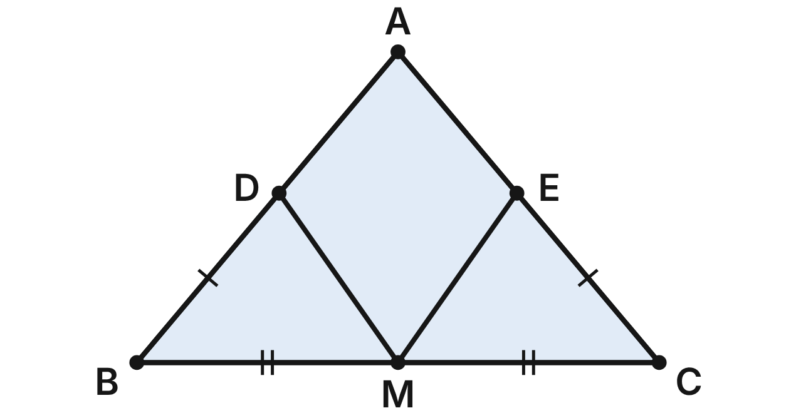
A stage flat for the school play is the triangle ABC, with AB ≅ AC. M is the midpoint of BC. Slats MD and ME reach the sides at D and E, with BD ≅ CE. Prove that MD ≅ ME.
Statement | Reason
1. AB ≅ AC; M is the midpoint of BC; BD ≅ CE | Given
2. ∠B ≅ ∠C | (a) ____
3. BM ≅ CM | Definition of midpoint
4. △DBM ≅ △ECM | (b) ____
5. MD ≅ ME | CPCTC

193. Which reason justifies step 2, ∠B ≅ ∠C (blank a)?
A. Base Angles Theorem ✔
B. Converse of the Base Angles Theorem
C. Vertical Angles Theorem
D. Third Angles Theorem
G.TR.2 · skill G.TR.2.2 (HOTS): Complete or justify a direct or indirect proof that two triangles are congruent
☐ Answer key correct ☐ Wording clear Notes: ________________________________
194. Which reason justifies step 4, △DBM ≅ △ECM (blank b)?
A. SSA
B. ASA
C. HL
D. SAS ✔
G.TR.2 · skill G.TR.2.2 (HOTS): Complete or justify a direct or indirect proof that two triangles are congruent
☐ Answer key correct ☐ Wording clear Notes: ________________________________
195. MD = (5y − 7) ft and ME = (2y + 8) ft. How long is slat MD?
A. 5 ft
B. 18 ft ✔
C. 36 ft
D. 32 ft
G.TR.2 · skill G.TR.2.3 (LOTS): Solve problems, including algebraic ones, using corresponding parts of congruent triangles
☐ Answer key correct ☐ Wording clear Notes: ________________________________
196. m∠BMD = 55°. What is m∠DME, the angle between the slats?
A. 55°
B. 125°
C. 70° ✔
D. 110°
G.TR.2 · skill G.TR.2.3 (LOTS): Solve problems, including algebraic ones, using corresponding parts of congruent triangles
☐ Answer key correct ☐ Wording clear Notes: ________________________________
197. Which pair of facts, with BM ≅ CM, would prove △DBM ≅ △ECM by ASA?
A. ∠B ≅ ∠C and BD ≅ CE
B. ∠BDM ≅ ∠CEM and ∠B ≅ ∠C
C. ∠B ≅ ∠C and ∠BMD ≅ ∠CME ✔
D. BD ≅ CE and MD ≅ ME
G.TR.2 · skill G.TR.2.1 (LOTS): Identify the congruence criterion (SSS, SAS, ASA, AAS, HL) that the given information supports, and recognize when none does
☐ Answer key correct ☐ Wording clear Notes: ________________________________
198. Which statement follows from step 4 by CPCTC?
A. ∠BDM ≅ ∠CEM ✔
B. ∠BDM ≅ ∠CME
C. ∠DMB ≅ ∠MEC
D. MD ≅ MC
G.TR.2 · skill G.TR.2.3 (LOTS): Solve problems, including algebraic ones, using corresponding parts of congruent triangles
☐ Answer key correct ☐ Wording clear Notes: ________________________________

The Origami Corner Fold
Level 2 · Triangles · G.TR.2 · ID geo-tr2-ring-origami-fold
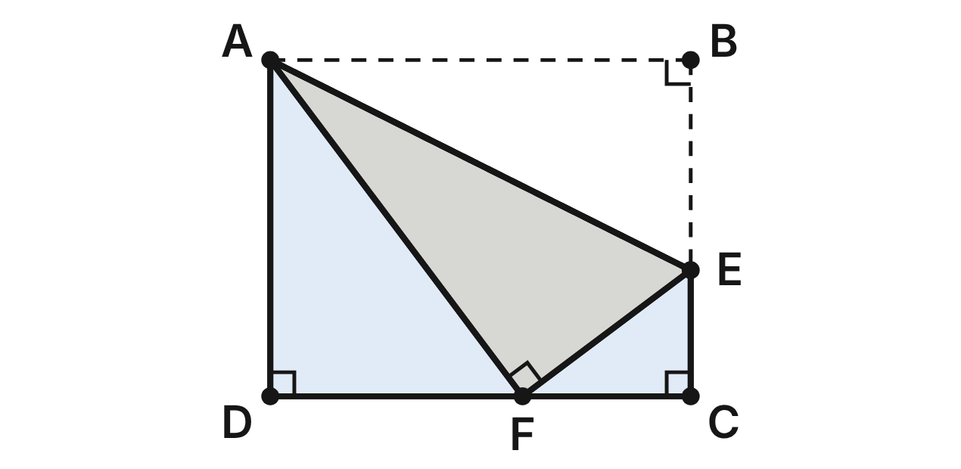
A sheet of origami paper is the rectangle ABCD, with AB = 10 cm and AD = 8 cm. Corner B is folded along the crease AE, with E on BC, so that B lands at F on DC. Folding does not stretch the paper.
199. Folding does not stretch the paper, so AF = AB and EF = EB. With the shared crease AE, which criterion proves △ABE ≅ △AFE?
A. SAS
B. SSS ✔
C. SSA
D. AAS
G.TR.2 · skill G.TR.2.1 (LOTS): Identify the congruence criterion (SSS, SAS, ASA, AAS, HL) that the given information supports, and recognize when none does
☐ Answer key correct ☐ Wording clear Notes: ________________________________
200. Folding does not change angles, so ∠AFE is a right angle like ∠ABE. Lin uses only these right angles, the shared crease AE and AB = AF. Which criterion is she using?
A. SAS
B. SSA
C. ASA
D. HL ✔
G.TR.2 · skill G.TR.2.1 (LOTS): Identify the congruence criterion (SSS, SAS, ASA, AAS, HL) that the given information supports, and recognize when none does
☐ Answer key correct ☐ Wording clear Notes: ________________________________
201. How far is F from corner D (the length DF)?
A. 2 cm
B. 4 cm
C. 6 cm ✔
D. 12.8 cm
G.TR.2 · skill G.TR.2.3 (LOTS): Solve problems, including algebraic ones, using corresponding parts of congruent triangles
☐ Answer key correct ☐ Wording clear Notes: ________________________________
202. How long is BE? Use EF = EB and the right angle at C in △ECF.
A. 5 cm ✔
B. 3 cm
C. 4 cm
D. 6 cm
G.TR.2 · skill G.TR.2.3 (LOTS): Solve problems, including algebraic ones, using corresponding parts of congruent triangles
☐ Answer key correct ☐ Wording clear Notes: ________________________________
203. m∠DAF ≈ 36.9°. To the nearest tenth of a degree, what is m∠BAE?
A. 53.1°
B. 36.9°
C. 26.6° ✔
D. 71.6°
G.TR.2 · skill G.TR.2.3 (LOTS): Solve problems, including algebraic ones, using corresponding parts of congruent triangles
☐ Answer key correct ☐ Wording clear Notes: ________________________________
204. Why is ∠AFE a right angle?
A. F is a corner of the rectangle
B. It matches ∠ABE by CPCTC ✔
C. AF is perpendicular to DC
D. Vertical angles are congruent
G.TR.2 · skill G.TR.2.2 (HOTS): Complete or justify a direct or indirect proof that two triangles are congruent
☐ Answer key correct ☐ Wording clear Notes: ________________________________

The Two-Triangle Logo
Level 3 · Triangles · G.TR.2 · ID geo-tr2-ring-logo
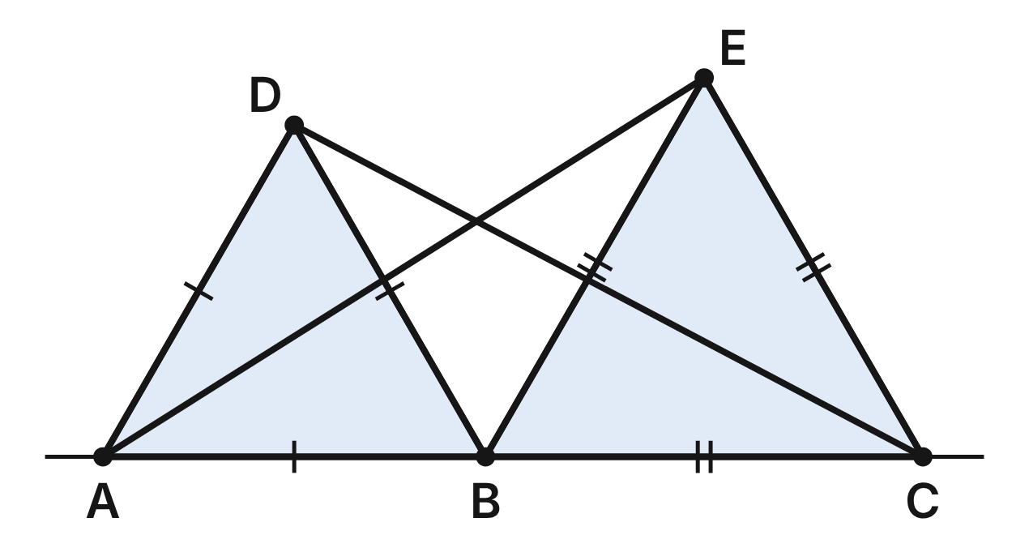
A music label's logo has two equilateral triangles, △ABD and △BCE, on the same side of segment AC, with B on AC. Long strokes AE and DC are drawn. Prove that AE ≅ DC.
Statement | Reason
1. △ABD and △BCE are equilateral; B is on AC | Given
2. AB ≅ DB; BE ≅ BC | Definition of equilateral triangle
3. m∠ABD = m∠EBC = 60° | Each angle of an equilateral triangle is 60°
4. m∠ABE = m∠DBC = 120° | (a) ____
5. △ABE ≅ △DBC | (b) ____
6. AE ≅ DC | CPCTC

205. Which reason justifies step 4, m∠ABE = m∠DBC = 120° (blank a)?
A. Vertical angles are congruent
B. Base angles of an isosceles triangle match
C. Angles in a linear pair add to 180° ✔
D. Angles of a triangle add to 180°
G.TR.2 · skill G.TR.2.2 (HOTS): Complete or justify a direct or indirect proof that two triangles are congruent
☐ Answer key correct ☐ Wording clear Notes: ________________________________
206. Which reason justifies step 5, △ABE ≅ △DBC (blank b)?
A. ASA
B. SAS ✔
C. SSS
D. AAS
G.TR.2 · skill G.TR.2.2 (HOTS): Complete or justify a direct or indirect proof that two triangles are congruent
☐ Answer key correct ☐ Wording clear Notes: ________________________________
207. AE = (2k + 10) cm and DC = (5k − 14) cm. How long is stroke AE?
A. 8 cm
B. 52 cm
C. 24 cm
D. 26 cm ✔
G.TR.2 · skill G.TR.2.3 (LOTS): Solve problems, including algebraic ones, using corresponding parts of congruent triangles
☐ Answer key correct ☐ Wording clear Notes: ________________________________
208. m∠BAE ≈ 32.2°. To the nearest tenth of a degree, what is m∠BDC?
A. 32.2° ✔
B. 27.8°
C. 57.8°
D. 147.8°
G.TR.2 · skill G.TR.2.3 (LOTS): Solve problems, including algebraic ones, using corresponding parts of congruent triangles
☐ Answer key correct ☐ Wording clear Notes: ________________________________
209. A second logo has equilateral △ABD, B on AC and BE ≅ BC, but AE = 26 cm and DC = 25 cm. To prove indirectly that m∠EBC ≠ 60°, what should you assume first?
A. m∠EBC ≠ 60°
B. AE = DC
C. △ABD is not equilateral
D. m∠EBC = 60° ✔
G.TR.2 · skill G.TR.2.2 (HOTS): Complete or justify a direct or indirect proof that two triangles are congruent
☐ Answer key correct ☐ Wording clear Notes: ________________________________
210. A second logo has equilateral △ABD, B on AC and BE ≅ BC, but AE = 26 cm and DC = 25 cm. Jo assumes m∠EBC = 60°. Which result gives her contradiction?
A. Linear pairs give m∠ABE = 60°, not 120°
B. SSS gives △ABE ≅ △DBC, but 26 ≠ 25
C. SAS and CPCTC give AE = DC, but 26 ≠ 25 ✔
D. △BCE is equilateral, so BE ≠ BC
G.TR.2 · skill G.TR.2.2 (HOTS): Complete or justify a direct or indirect proof that two triangles are congruent
☐ Answer key correct ☐ Wording clear Notes: ________________________________

The Framing Square Jig
Level 3 · Triangles · G.TR.2 · ID geo-tr2-ring-framing-square
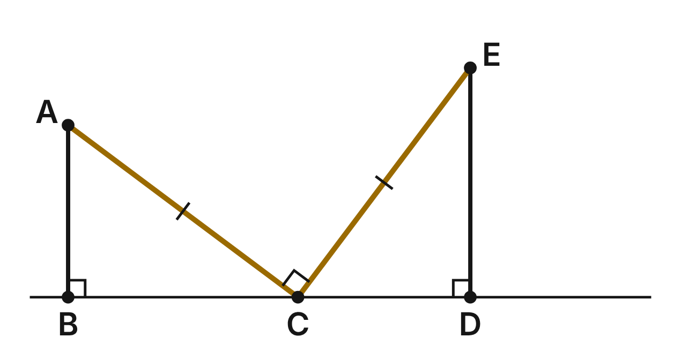
In a woodshop jig, the corner C of a framing square sits on a straight board edge BD. Its arms CA and CE are congruent and meet at a right angle. AB and ED are perpendicular to the edge. Prove that △ABC ≅ △CDE.
Statement | Reason
1. ∠ACE is a right angle; AB ⊥ BD; ED ⊥ BD; CA ≅ CE | Given
2. ∠B and ∠D are right angles | Definition of perpendicular lines
3. m∠ACB + m∠ECD = 90° | B, C, D are on a line and m∠ACE = 90°
4. m∠BAC + m∠ACB = 90° | Acute angles of a right triangle are complementary
5. ∠BAC ≅ ∠DCE | (a) ____
6. △ABC ≅ △CDE | (b) ____
7. AB ≅ CD; BC ≅ DE | CPCTC

211. Which reason justifies step 5, ∠BAC ≅ ∠DCE (blank a)?
A. Vertical Angles Theorem
B. Congruent Complements Theorem ✔
C. Congruent Supplements Theorem
D. Alternate Interior Angles Theorem
G.TR.2 · skill G.TR.2.2 (HOTS): Complete or justify a direct or indirect proof that two triangles are congruent
☐ Answer key correct ☐ Wording clear Notes: ________________________________
212. Which reason justifies step 6, △ABC ≅ △CDE (blank b), using the parts in steps 1, 2 and 5?
A. AAS ✔
B. ASA
C. HL
D. SAS
G.TR.2 · skill G.TR.2.2 (HOTS): Complete or justify a direct or indirect proof that two triangles are congruent
☐ Answer key correct ☐ Wording clear Notes: ________________________________
213. AB = 9 in. and BC = 12 in. How far apart are B and D?
A. 24 in.
B. 30 in.
C. 21 in. ✔
D. 15 in.
G.TR.2 · skill G.TR.2.3 (LOTS): Solve problems, including algebraic ones, using corresponding parts of congruent triangles
☐ Answer key correct ☐ Wording clear Notes: ________________________________
214. AB = (3t − 6) in. and CD = (t + 4) in. What is t?
A. −1
B. 2.5
C. 10
D. 5 ✔
G.TR.2 · skill G.TR.2.3 (LOTS): Solve problems, including algebraic ones, using corresponding parts of congruent triangles
☐ Answer key correct ☐ Wording clear Notes: ________________________________
215. Which criterion uses only AB ≅ CD, BC ≅ DE and the right angles at B and D to prove △ABC ≅ △CDE?
A. SAS ✔
B. HL
C. SSS
D. ASA
G.TR.2 · skill G.TR.2.1 (LOTS): Identify the congruence criterion (SSS, SAS, ASA, AAS, HL) that the given information supports, and recognize when none does
☐ Answer key correct ☐ Wording clear Notes: ________________________________
216. Another jig has m∠ACE = 90°, AB ⊥ BD and ED ⊥ BD, but AB = 9 in. and CD = 8 in. Sam assumes CA = CE. Which result contradicts the facts?
A. CPCTC gives AB = DE, but 9 ≠ 8
B. AB ⊥ BD and ED ⊥ BD give AB = ED
C. ∠BAC ≅ ∠ACB, so CA ≠ CE
D. AAS and CPCTC give AB = CD, but 9 ≠ 8 ✔
G.TR.2 · skill G.TR.2.2 (HOTS): Complete or justify a direct or indirect proof that two triangles are congruent
☐ Answer key correct ☐ Wording clear Notes: ________________________________

G.TR.3 · Prove two triangles are similar, using direct and indirect proofs, and solve problems involving measured attributes of similar triangles.

The Pantograph
Level 1 · Triangles · G.TR.3 · ID geo-tr3-ring-pantograph
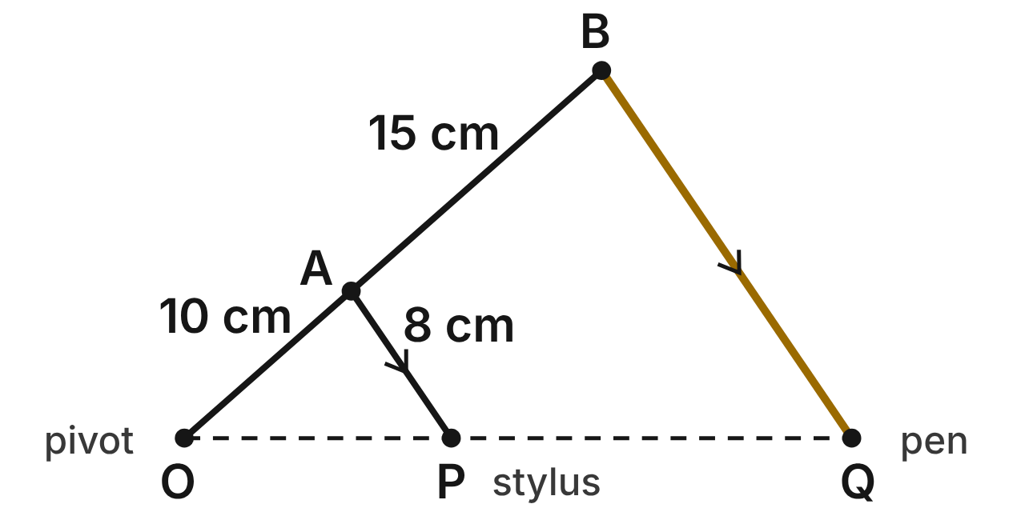
A pantograph copies a drawing. The pivot O is fixed, the stylus P traces the drawing and the pen Q draws the copy. O, A and B lie on one rod, O, P and Q stay in one line, and rod AP stays parallel to rod BQ. OA = 10 cm, AB = 15 cm and AP = 8 cm.
217. Which criterion shows that △OAP ∼ △OBQ?
A. SSS∼
B. SAS∼
C. AA ✔
D. ASA
G.TR.3 · skill G.TR.3.1 (LOTS): Identify the similarity criterion (AA, SSS, SAS) that the given information supports
☐ Answer key correct ☐ Wording clear Notes: ________________________________
218. Which pair of angles is congruent because AP ∥ BQ?
A. ∠OAP ≅ ∠OBQ ✔
B. ∠OAP ≅ ∠OQB
C. ∠APO ≅ ∠OBQ
D. ∠AOP ≅ ∠OQB
G.TR.3 · skill G.TR.3.1 (LOTS): Identify the similarity criterion (AA, SSS, SAS) that the given information supports
☐ Answer key correct ☐ Wording clear Notes: ________________________________
219. How long is rod BQ?
A. 12 cm
B. 23 cm
C. 3.2 cm
D. 20 cm ✔
G.TR.3 · skill G.TR.3.3 (LOTS): Solve problems, including contextual ones, using proportional sides of similar triangles
☐ Answer key correct ☐ Wording clear Notes: ________________________________
220. What is the scale factor from the drawing traced by P to the copy drawn by Q?
A. 2/5
B. 5/2 ✔
C. 3/2
D. 5/3
G.TR.3 · skill G.TR.3.3 (LOTS): Solve problems, including contextual ones, using proportional sides of similar triangles
☐ Answer key correct ☐ Wording clear Notes: ________________________________
221. The stylus traces a line segment 6 cm long. How long is the segment the pen draws?
A. 2.4 cm
B. 21 cm
C. 15 cm ✔
D. 37.5 cm
G.TR.3 · skill G.TR.3.3 (LOTS): Solve problems, including contextual ones, using proportional sides of similar triangles
☐ Answer key correct ☐ Wording clear Notes: ________________________________
222. Kai builds his own pantograph with OA = 9 cm, OB = 27 cm, OP = 11 cm and OQ = 33 cm, with ∠O shared. Is △OAP ∼ △OBQ? Choose the answer with the correct reason.
A. Yes; 27 − 9 = 33 − 11 and ∠O is shared
B. No; 9/11 ≠ 27/33, so the sides differ
C. No; 27/9 ≠ 33/11, so the sides differ
D. Yes; 27/9 = 33/11 and ∠O is shared ✔
G.TR.3 · skill G.TR.3.2 (HOTS): Justify that two triangles are similar, or are not, using angle measures or side ratios
☐ Answer key correct ☐ Wording clear Notes: ________________________________

The Sculpture and Its Model
Level 1 · Triangles · G.TR.3 · ID geo-tr3-ring-sculpture-model
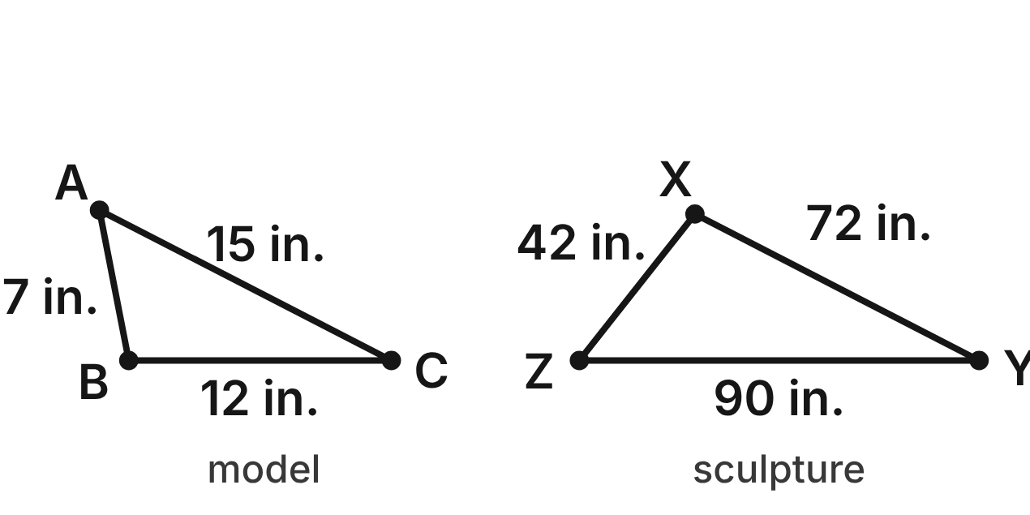
Not drawn to scale
An artist builds a model △ABC of a steel sculpture △XYZ. Model: AB = 7 in., BC = 12 in. and AC = 15 in. Sculpture: XZ = 42 in., XY = 72 in. and YZ = 90 in.
223. Which criterion shows that the model is similar to the sculpture?
A. AA
B. SSS∼ ✔
C. SAS∼
D. SSS
G.TR.3 · skill G.TR.3.1 (LOTS): Identify the similarity criterion (AA, SSS, SAS) that the given information supports
☐ Answer key correct ☐ Wording clear Notes: ________________________________
224. Which similarity statement matches the model to the sculpture?
A. △ABC ∼ △XYZ
B. △ABC ∼ △ZYX
C. △ABC ∼ △XZY
D. △ABC ∼ △ZXY ✔
G.TR.3 · skill G.TR.3.1 (LOTS): Identify the similarity criterion (AA, SSS, SAS) that the given information supports
☐ Answer key correct ☐ Wording clear Notes: ________________________________
225. What is the scale factor from the model to the sculpture?
A. 6 ✔
B. 1/6
C. 35
D. 4.8
G.TR.3 · skill G.TR.3.3 (LOTS): Solve problems, including contextual ones, using proportional sides of similar triangles
☐ Answer key correct ☐ Wording clear Notes: ________________________________
226. What is the perimeter of the sculpture?
A. 34 in.
B. 1224 in.
C. 204 in. ✔
D. about 5.7 in.
G.TR.3 · skill G.TR.3.3 (LOTS): Solve problems, including contextual ones, using proportional sides of similar triangles
☐ Answer key correct ☐ Wording clear Notes: ________________________________
227. A second model has sides 14 in., 24 in. and 32 in. Is it similar to the sculpture? Choose the answer with the correct reason.
A. No; 90/32 ≠ 42/14 ✔
B. Yes; 42/14 = 72/24 = 90/32
C. No; 72/24 ≠ 42/14
D. Yes; 42 − 14 = 72 − 24
G.TR.3 · skill G.TR.3.2 (HOTS): Justify that two triangles are similar, or are not, using angle measures or side ratios
☐ Answer key correct ☐ Wording clear Notes: ________________________________
228. A mini model of the same sculpture has a longest side of 7.5 in. How long is its shortest side?
A. about 16.1 in.
B. 3.5 in. ✔
C. 6 in.
D. about 0.6 in.
G.TR.3 · skill G.TR.3.3 (LOTS): Solve problems, including contextual ones, using proportional sides of similar triangles
☐ Answer key correct ☐ Wording clear Notes: ________________________________

The Quilt Patch
Level 2 · Triangles · G.TR.3 · ID geo-tr3-ring-quilt-patch
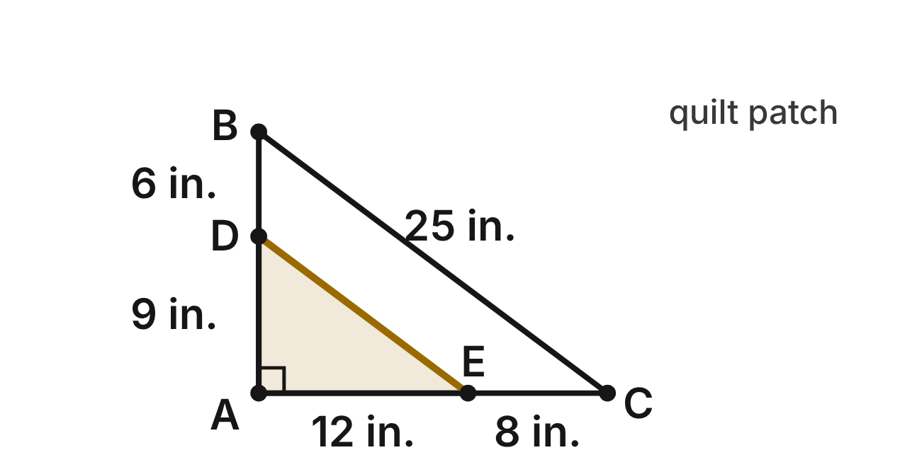
A quilt patch is the right triangle ABC, with the right angle at A. A straight seam DE joins D on AB to E on AC. AD = 9 in., DB = 6 in., AE = 12 in., EC = 8 in. and BC = 25 in.
229. Is the seam DE parallel to BC? Choose the answer with the correct reason.
A. Yes; 9/6 = 12/8 ✔
B. No; 9/12 ≠ 6/8
C. Yes; 9 + 6 = 12 + 8
D. No; 9/6 ≠ 12/8
G.TR.3 · skill G.TR.3.2 (HOTS): Justify that two triangles are similar, or are not, using angle measures or side ratios
☐ Answer key correct ☐ Wording clear Notes: ________________________________
230. Using AD, AB, AE, AC and the angle at A, which criterion shows △ADE ∼ △ABC?
A. AA
B. SSS∼
C. SAS∼ ✔
D. SAS
G.TR.3 · skill G.TR.3.1 (LOTS): Identify the similarity criterion (AA, SSS, SAS) that the given information supports
☐ Answer key correct ☐ Wording clear Notes: ________________________________
231. How long is the seam DE?
A. 37.5 in.
B. 15 in. ✔
C. 19 in.
D. 10 in.
G.TR.3 · skill G.TR.3.3 (LOTS): Solve problems, including contextual ones, using proportional sides of similar triangles
☐ Answer key correct ☐ Wording clear Notes: ________________________________
232. A second seam FG will run parallel to BC, with F on AB and G on AC. If AF = 12 in., how long is AG?
A. 9 in.
B. 17 in.
C. 20 in.
D. 16 in. ✔
G.TR.3 · skill G.TR.3.3 (LOTS): Solve problems, including contextual ones, using proportional sides of similar triangles
☐ Answer key correct ☐ Wording clear Notes: ________________________________
233. What is the perimeter of the small triangle ADE?
A. 36 in. ✔
B. 21.6 in.
C. 46 in.
D. 24 in.
G.TR.3 · skill G.TR.3.3 (LOTS): Solve problems, including contextual ones, using proportional sides of similar triangles
☐ Answer key correct ☐ Wording clear Notes: ________________________________
234. Which statement about the patch is NOT true?
A. AD/AB = DE/BC
B. ∠ADE ≅ ∠ABC
C. △AED ∼ △ACB
D. AD/DB = DE/BC ✔
G.TR.3 · skill G.TR.3.3 (LOTS): Solve problems, including contextual ones, using proportional sides of similar triangles
☐ Answer key correct ☐ Wording clear Notes: ________________________________

The Camera and the Statue
Level 2 · Triangles · G.TR.3 · ID geo-tr3-ring-camera-lens
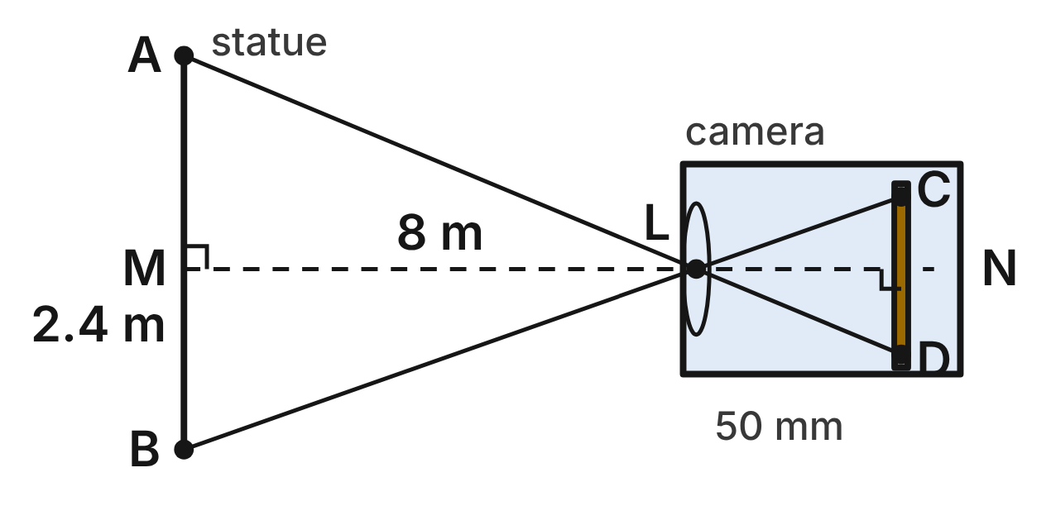
Not drawn to scale
A statue AB is 2.4 m tall and 8 m from the camera's lens L (LM = 8 m). Light from A and B crosses at L and reaches the sensor at D and C. The sensor is 50 mm behind the lens (LN = 50 mm). AB ∥ CD, and the axis MN is perpendicular to both.
235. Why is the statue's triangle LAB similar to the image's triangle?
A. SAS∼: LM/LN and the vertical angles at L
B. AA: vertical angles at L, and ∠A ≅ ∠D ✔
C. SSS∼: all three sides of each are known
D. AA: right angles at M and N, and vertical angles at L
G.TR.3 · skill G.TR.3.1 (LOTS): Identify the similarity criterion (AA, SSS, SAS) that the given information supports
☐ Answer key correct ☐ Wording clear Notes: ________________________________
236. Which proportion is true for the statue's triangle and the image's triangle?
A. AB/DC = LA/LC
B. AB/DC = LB/LD
C. LA/LD = LC/LB
D. AB/DC = LA/LD ✔
G.TR.3 · skill G.TR.3.3 (LOTS): Solve problems, including contextual ones, using proportional sides of similar triangles
☐ Answer key correct ☐ Wording clear Notes: ________________________________
237. How tall is the statue's image CD on the sensor?
A. about 166.7 mm
B. 120 mm
C. 15 mm ✔
D. 1.5 mm
G.TR.3 · skill G.TR.3.3 (LOTS): Solve problems, including contextual ones, using proportional sides of similar triangles
☐ Answer key correct ☐ Wording clear Notes: ________________________________
238. The sensor is 24 mm tall. How far from the statue should the lens be so that the image exactly fills the sensor's height?
A. 5 m ✔
B. 12.8 m
C. 0.5 m
D. about 1.2 m
G.TR.3 · skill G.TR.3.3 (LOTS): Solve problems, including contextual ones, using proportional sides of similar triangles
☐ Answer key correct ☐ Wording clear Notes: ________________________________
239. Which reason proves that ∠BAL ≅ ∠CDL?
A. They are alternate interior angles, and AB ∥ CD. ✔
B. They are vertical angles.
C. They are both right angles.
D. They are angles of congruent triangles.
G.TR.3 · skill G.TR.3.2 (HOTS): Justify that two triangles are similar, or are not, using angle measures or side ratios
☐ Answer key correct ☐ Wording clear Notes: ________________________________
240. The photographer steps back so the lens is 10 m from the statue. The sensor stays 50 mm behind the lens. How tall is the image now?
A. 18.75 mm
B. 12 mm ✔
C. 13 mm
D. 9.6 mm
G.TR.3 · skill G.TR.3.3 (LOTS): Solve problems, including contextual ones, using proportional sides of similar triangles
☐ Answer key correct ☐ Wording clear Notes: ________________________________

The Stage Set in Perspective
Level 2 · Triangles · G.TR.3 · ID geo-tr3-ring-stage-perspective
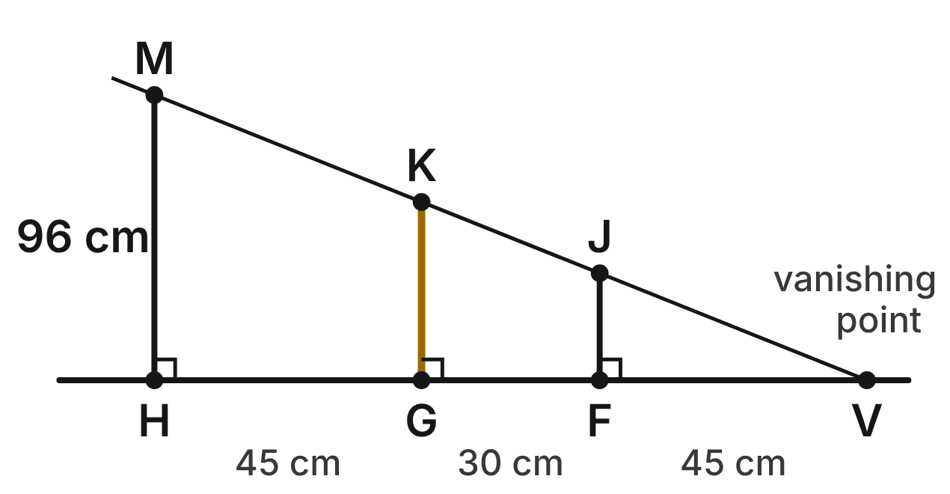
Not drawn to scale
A backdrop for a play shows lamp posts in perspective. Their bases H, G and F lie on the level floor line through the vanishing point V, and their tops M, K and J lie on line VM. The posts are vertical. HG = 45 cm, GF = 30 cm, FV = 45 cm and post HM is 96 cm tall.
241. Which criterion shows that △VFJ ∼ △VHM?
A. SAS∼
B. SSS∼
C. HL
D. AA ✔
G.TR.3 · skill G.TR.3.1 (LOTS): Identify the similarity criterion (AA, SSS, SAS) that the given information supports
☐ Answer key correct ☐ Wording clear Notes: ________________________________
242. How tall is the middle post GK?
A. 51 cm
B. 60 cm ✔
C. 153.6 cm
D. 36 cm
G.TR.3 · skill G.TR.3.3 (LOTS): Solve problems, including contextual ones, using proportional sides of similar triangles
☐ Answer key correct ☐ Wording clear Notes: ________________________________
243. The painter adds one more post, 30 cm tall, between the two lines. How far from V is its base?
A. 37.5 cm ✔
B. 24 cm
C. 54 cm
D. 60 cm
G.TR.3 · skill G.TR.3.3 (LOTS): Solve problems, including contextual ones, using proportional sides of similar triangles
☐ Answer key correct ☐ Wording clear Notes: ________________________________
244. What is the scale factor from △VFJ to △VHM?
A. 3/8
B. 75
C. 8/3 ✔
D. 5/3
G.TR.3 · skill G.TR.3.3 (LOTS): Solve problems, including contextual ones, using proportional sides of similar triangles
☐ Answer key correct ☐ Wording clear Notes: ________________________________
245. A helper paints a post whose base is 100 cm from V and makes it 82 cm tall. Does its top lie on line VM? Choose the answer with the correct reason.
A. Yes; 82/100 = 96/120
B. Yes; 120 − 100 = 96 − 82
C. No; it should be 76 cm tall
D. No; 82/100 ≠ 96/120 ✔
G.TR.3 · skill G.TR.3.2 (HOTS): Justify that two triangles are similar, or are not, using angle measures or side ratios
☐ Answer key correct ☐ Wording clear Notes: ________________________________
246. Which equation can be used to find the height of post GK?
A. GK/96 = 120/75
B. GK/96 = 45/120
C. GK/96 = 75/120 ✔
D. GK/75 = 120/96
G.TR.3 · skill G.TR.3.3 (LOTS): Solve problems, including contextual ones, using proportional sides of similar triangles
☐ Answer key correct ☐ Wording clear Notes: ________________________________

The Logo on Grid Paper
Level 2 · Triangles · G.TR.3 · ID geo-tr3-ring-grid-logo
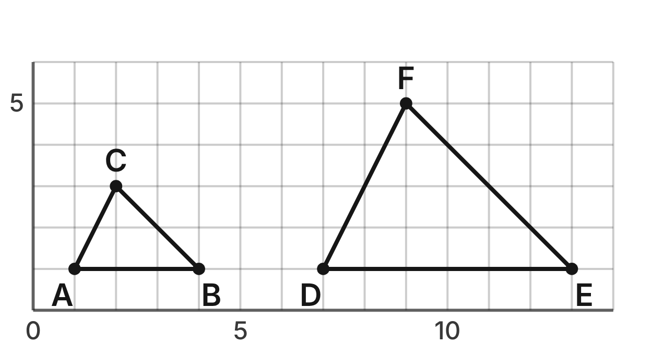
A designer draws a small logo △ABC and a large logo △DEF on grid paper: A(1, 1), B(4, 1), C(2, 3), D(7, 1), E(13, 1) and F(9, 5). Each grid square is 1 unit on a side.
247. The side lengths are AB = 3, AC = √5, BC = 2√2, DE = 6, DF = 2√5 and EF = 4√2 units. Which similarity criterion do these lengths support?
A. SSS∼ ✔
B. SAS∼
C. AA
D. SSS
G.TR.3 · skill G.TR.3.1 (LOTS): Identify the similarity criterion (AA, SSS, SAS) that the given information supports
☐ Answer key correct ☐ Wording clear Notes: ________________________________
248. What is the scale factor from the small logo to the large logo?
A. 1/2
B. 3
C. 2 ✔
D. 4
G.TR.3 · skill G.TR.3.3 (LOTS): Solve problems, including contextual ones, using proportional sides of similar triangles
☐ Answer key correct ☐ Wording clear Notes: ________________________________
249. What is the perimeter of the large logo, to the nearest tenth of a unit?
A. 32.3 units
B. 16.1 units ✔
C. 8.1 units
D. 20.0 units
G.TR.3 · skill G.TR.3.3 (LOTS): Solve problems, including contextual ones, using proportional sides of similar triangles
☐ Answer key correct ☐ Wording clear Notes: ________________________________
250. △GHJ has vertices G(0, 0), H(6, 0) and J(3, 3). Is it similar to △ABC? Choose the answer with the correct reason.
A. Yes; GH/AB = GJ/AC = HJ/BC = 2
B. No; GH/AB = 3, so the ratios differ
C. Yes; GH = 2 · AB and GJ = 2 · AC
D. No; GJ = HJ, but △ABC has no equal sides ✔
G.TR.3 · skill G.TR.3.2 (HOTS): Justify that two triangles are similar, or are not, using angle measures or side ratios
☐ Answer key correct ☐ Wording clear Notes: ________________________________
251. Which statement about the angles of the two logos is true?
A. m∠D = 2 · m∠A
B. m∠E = 45° ✔
C. ∠F ≅ ∠B
D. m∠D = 90°
G.TR.3 · skill G.TR.3.3 (LOTS): Solve problems, including contextual ones, using proportional sides of similar triangles
☐ Answer key correct ☐ Wording clear Notes: ________________________________
252. The small logo is printed so that AB is 6 cm long. How long is AC on the print, to the nearest tenth of a centimeter?
A. 4.5 cm ✔
B. 2.2 cm
C. 4.0 cm
D. 5.7 cm
G.TR.3 · skill G.TR.3.3 (LOTS): Solve problems, including contextual ones, using proportional sides of similar triangles
☐ Answer key correct ☐ Wording clear Notes: ________________________________

The Easel's Brace
Level 3 · Triangles · G.TR.3 · ID geo-tr3-ring-easel-brace
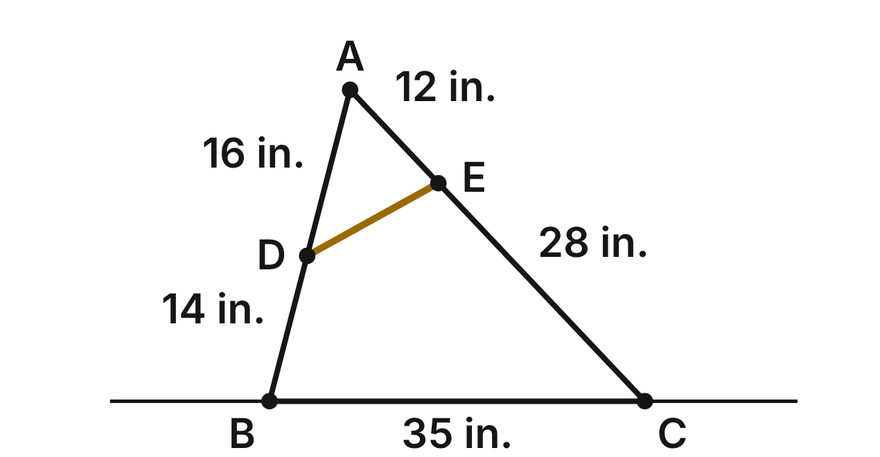
The side of a folding easel is △ABC: legs AB and AC meet at the top A, and a floor bar joins their feet B and C. A brace DE joins D on AB to E on AC. AD = 16 in., DB = 14 in., AE = 12 in., EC = 28 in. and BC = 35 in.
253. Which criterion shows that the small triangle at the top of the easel is similar to the whole easel triangle?
A. AA
B. SAS∼ ✔
C. SSS∼
D. SAS
G.TR.3 · skill G.TR.3.1 (LOTS): Identify the similarity criterion (AA, SSS, SAS) that the given information supports
☐ Answer key correct ☐ Wording clear Notes: ________________________________
254. Which similarity statement matches the vertices of the two easel triangles?
A. △ADE ∼ △ABC
B. △AED ∼ △ACB
C. △ADE ∼ △ACB ✔
D. △DAE ∼ △ACB
G.TR.3 · skill G.TR.3.1 (LOTS): Identify the similarity criterion (AA, SSS, SAS) that the given information supports
☐ Answer key correct ☐ Wording clear Notes: ________________________________
255. How long is the brace DE?
A. 14 in. ✔
B. about 18.7 in.
C. 10.5 in.
D. 87.5 in.
G.TR.3 · skill G.TR.3.3 (LOTS): Solve problems, including contextual ones, using proportional sides of similar triangles
☐ Answer key correct ☐ Wording clear Notes: ________________________________
256. Is the brace DE parallel to BC? Choose the answer with the correct reason.
A. Yes; 16/30 = 12/40
B. Yes; 16/28 = 12/14
C. Yes; 16 + 14 = 12 + 28
D. No; 16/30 ≠ 12/40 ✔
G.TR.3 · skill G.TR.3.2 (HOTS): Justify that two triangles are similar, or are not, using angle measures or side ratios
☐ Answer key correct ☐ Wording clear Notes: ________________________________
257. The painter keeps D where it is and slides E along AC so that the brace becomes parallel to BC. How far from A is E then, to the nearest tenth of an inch?
A. 21.3 in. ✔
B. 16.0 in.
C. 12.0 in.
D. 24.0 in.
G.TR.3 · skill G.TR.3.3 (LOTS): Solve problems, including contextual ones, using proportional sides of similar triangles
☐ Answer key correct ☐ Wording clear Notes: ________________________________
258. What is the perimeter of the triangle ADE at the top of the easel?
A. 105 in.
B. 16.8 in.
C. 262.5 in.
D. 42 in. ✔
G.TR.3 · skill G.TR.3.3 (LOTS): Solve problems, including contextual ones, using proportional sides of similar triangles
☐ Answer key correct ☐ Wording clear Notes: ________________________________

The Mosaic Tile Cut
Level 3 · Triangles · G.TR.3 · ID geo-tr3-ring-mosaic-cut
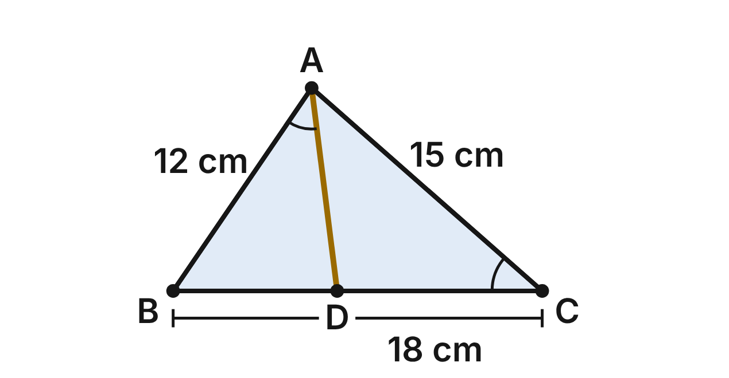
A mosaic artist cuts a triangular tile ABC along AD, from A to D on BC, so that ∠BAD ≅ ∠C. AB = 12 cm, AC = 15 cm and BC = 18 cm.
259. Which criterion shows that the piece ABD is similar to the whole tile?
A. SAS∼
B. SSS∼
C. AA ✔
D. ASA
G.TR.3 · skill G.TR.3.1 (LOTS): Identify the similarity criterion (AA, SSS, SAS) that the given information supports
☐ Answer key correct ☐ Wording clear Notes: ________________________________
260. Which similarity statement pairs the piece ABD with the whole tile?
A. △BAD ∼ △BCA ✔
B. △BAD ∼ △BAC
C. △BDA ∼ △BCA
D. △ABD ∼ △ACB
G.TR.3 · skill G.TR.3.1 (LOTS): Identify the similarity criterion (AA, SSS, SAS) that the given information supports
☐ Answer key correct ☐ Wording clear Notes: ________________________________
261. How long is BD?
A. 9.6 cm
B. 6 cm
C. 27 cm
D. 8 cm ✔
G.TR.3 · skill G.TR.3.3 (LOTS): Solve problems, including contextual ones, using proportional sides of similar triangles
☐ Answer key correct ☐ Wording clear Notes: ________________________________
262. How long is the cut AD?
A. 22.5 cm
B. 10 cm ✔
C. about 6.7 cm
D. 12 cm
G.TR.3 · skill G.TR.3.3 (LOTS): Solve problems, including contextual ones, using proportional sides of similar triangles
☐ Answer key correct ☐ Wording clear Notes: ________________________________
263. Is the other piece, ADC, similar to the whole tile? Choose the answer with the correct reason.
A. Yes; DC/BC = AC/AB, so the sides match
B. No; ∠ADC is a right angle, but ∠B is not
C. No; AD = DC, but the tile has no equal sides ✔
D. Yes; AD/AB = DC/AC, and ∠C is shared
G.TR.3 · skill G.TR.3.2 (HOTS): Justify that two triangles are similar, or are not, using angle measures or side ratios
☐ Answer key correct ☐ Wording clear Notes: ________________________________
264. The artist makes a larger tile similar to △ABC, with a longest side of 27 cm. What is its perimeter?
A. 54 cm
B. 67.5 cm ✔
C. 101.25 cm
D. 30 cm
G.TR.3 · skill G.TR.3.3 (LOTS): Solve problems, including contextual ones, using proportional sides of similar triangles
☐ Answer key correct ☐ Wording clear Notes: ________________________________

G.TR.4 · Model and solve problems, including those in context, involving trigonometry in right triangles and applications of the Pythagorean Theorem.

The Mitered Picture Frame
Level 1 · Triangles · G.TR.4 · ID geo-tr4-ring-miter-frame
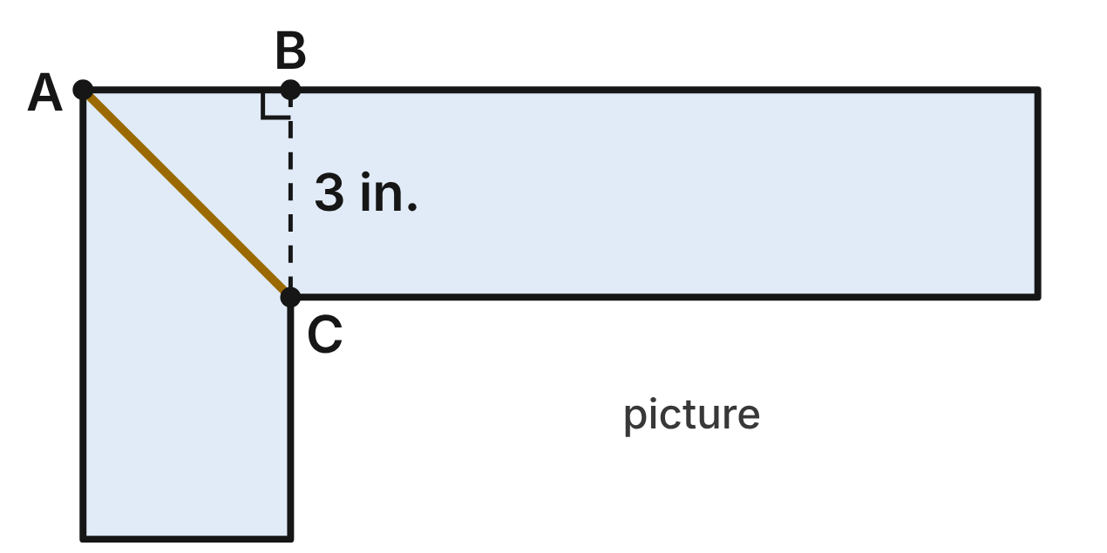
A picture frame is made of moulding 3 in. wide. At the corner, two pieces meet along the miter seam AC, cut at 45°. B is on the outer edge, with BC perpendicular to that edge and BC = 3 in.
265. How long is the miter seam AC?
A. 3 in.
B. 3√2 in. ✔
C. 6 in.
D. 3√3 in.
G.TR.4 · skill G.TR.4.2 (LOTS): Use the relationships in 45°-45°-90° and 30°-60°-90° triangles
☐ Answer key correct ☐ Wording clear Notes: ________________________________
266. Another frame has a 45° miter seam that is 8 in. long. How wide is its moulding?
A. 4√2 in. ✔
B. 8√2 in.
C. 4 in.
D. 4√3 in.
G.TR.4 · skill G.TR.4.2 (LOTS): Use the relationships in 45°-45°-90° and 30°-60°-90° triangles
☐ Answer key correct ☐ Wording clear Notes: ________________________________
267. In △ABC, what is cos ∠BAC?
A. 1
B. √2
C. √3/2
D. √2/2 ✔
G.TR.4 · skill G.TR.4.3 (LOTS): Use sine, cosine and tangent ratios to find a side length or an angle measure
☐ Answer key correct ☐ Wording clear Notes: ________________________________
268. To check a frame corner, a framer marks 10 in. along one outer edge and 24 in. along the other. The marks are 25 in. apart. What can the framer conclude about the corner?
A. It is more than 90°, because 25² is less than 10² + 24².
B. It is less than 90°, because 25² is less than 10² + 24². ✔
C. It is exactly 90°, because 10² + 24² = 25².
D. It is exactly 90°, because 10, 24 and 25 form a Pythagorean triple.
G.TR.4 · skill G.TR.4.1 (LOTS): Use the Pythagorean Theorem and its converse, including to classify a triangle as right, acute or obtuse
☐ Answer key correct ☐ Wording clear Notes: ________________________________
269. Which statement about △ABC is NOT true?
A. m∠BCA = 45°
B. AB = BC
C. AC = 2·BC ✔
D. AC = BC·√2
G.TR.4 · skill G.TR.4.2 (LOTS): Use the relationships in 45°-45°-90° and 30°-60°-90° triangles
☐ Answer key correct ☐ Wording clear Notes: ________________________________
270. A frame maker cuts a corner block shaped like a 30°-60°-90° triangle. Its shortest side is 4 in. How long is its longest side?
A. 8 in. ✔
B. 4√3 in.
C. 4√2 in.
D. 2 in.
G.TR.4 · skill G.TR.4.2 (LOTS): Use the relationships in 45°-45°-90° and 30°-60°-90° triangles
☐ Answer key correct ☐ Wording clear Notes: ________________________________

Hanging the Gallery Painting
Level 1 · Triangles · G.TR.4 · ID geo-tr4-ring-picture-wire
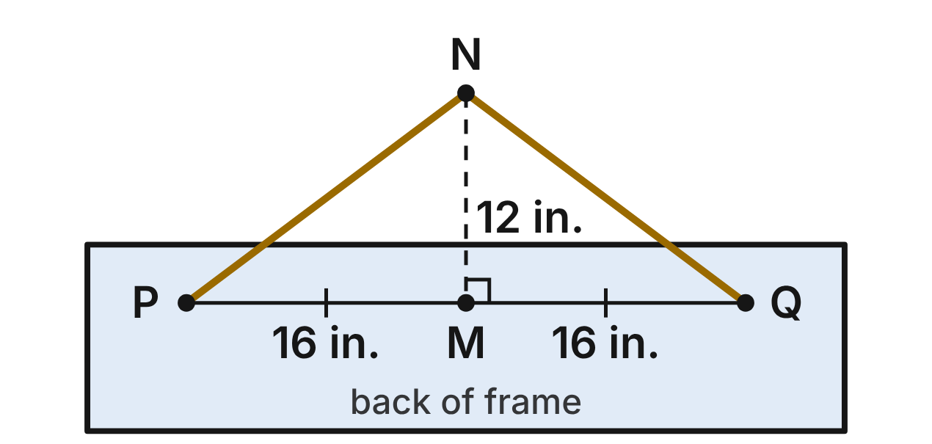
A painting hangs from a wire. The wire runs from hook P up over the nail N and down to hook Q. The hooks are 32 in. apart. N is directly above M, the midpoint of PQ, and NM = 12 in.
271. How long is the wire from P to N?
A. 28 in.
B. about 34.2 in.
C. 20 in. ✔
D. about 10.6 in.
G.TR.4 · skill G.TR.4.1 (LOTS): Use the Pythagorean Theorem and its converse, including to classify a triangle as right, acute or obtuse
☐ Answer key correct ☐ Wording clear Notes: ________________________________
272. Which equation can be used to find m∠NPM?
A. sin ∠NPM = 12/16
B. tan ∠NPM = 16/12
C. cos ∠NPM = 12/16
D. tan ∠NPM = 12/16 ✔
G.TR.4 · skill G.TR.4.3 (LOTS): Use sine, cosine and tangent ratios to find a side length or an angle measure
☐ Answer key correct ☐ Wording clear Notes: ________________________________
273. To the nearest degree, what angle does the wire PN make with PQ (m∠NPM)?
A. 37° ✔
B. 53°
C. 49°
D. 41°
G.TR.4 · skill G.TR.4.3 (LOTS): Use sine, cosine and tangent ratios to find a side length or an angle measure
☐ Answer key correct ☐ Wording clear Notes: ________________________________
274. Suppose the nail is moved to 15 in. above M, with the hooks still 32 in. apart. How long must the whole wire be, to the nearest tenth of an inch?
A. 21.9 in.
B. 62.0 in.
C. 43.9 in. ✔
D. 70.7 in.
G.TR.4 · skill G.TR.4.1 (LOTS): Use the Pythagorean Theorem and its converse, including to classify a triangle as right, acute or obtuse
☐ Answer key correct ☐ Wording clear Notes: ________________________________
275. A larger painting has hooks 30 in. apart and a 50-in. wire over one nail, with the nail directly above the hooks' midpoint. How far above that midpoint is the nail?
A. 10 in.
B. 20 in. ✔
C. about 29.2 in.
D. 40 in.
G.TR.4 · skill G.TR.4.4 (HOTS): Model a contextual problem (angles of elevation and depression, ramps, ladders, distances) with a right triangle and solve it
☐ Answer key correct ☐ Wording clear Notes: ________________________________
276. Which set of numbers is a Pythagorean triple?
A. 15, 20, 35
B. 4, 5, 6
C. 8, 15, 16
D. 9, 40, 41 ✔
G.TR.4 · skill G.TR.4.1 (LOTS): Use the Pythagorean Theorem and its converse, including to classify a triangle as right, acute or obtuse
☐ Answer key correct ☐ Wording clear Notes: ________________________________

The Grand Piano Lid
Level 2 · Triangles · G.TR.4 · ID geo-tr4-ring-piano-lid
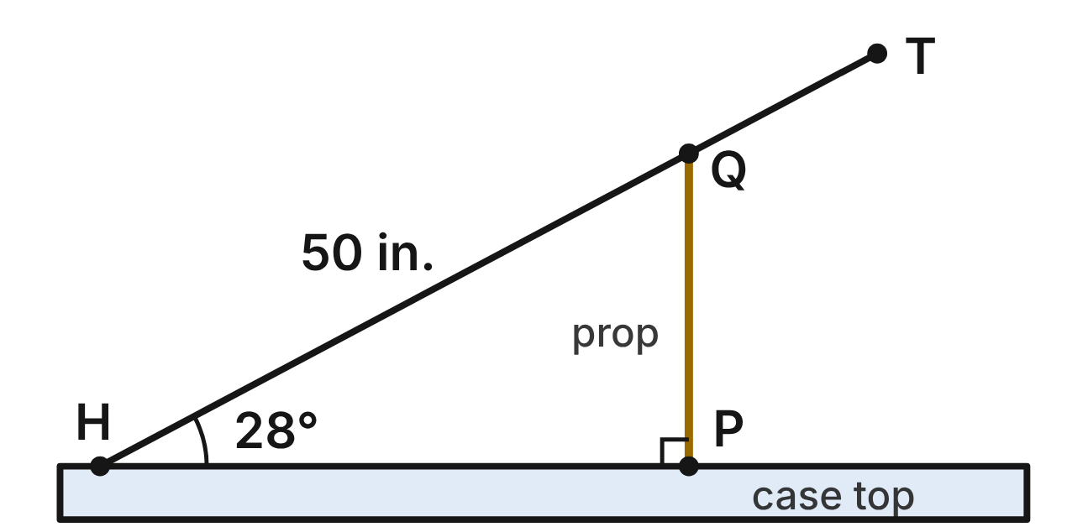
The lid of a grand piano is hinged at H. A prop stick PQ holds it open: P is on the flat case top, Q is on the lid, and PQ is perpendicular to the case top. HQ = 50 in., the lid makes a 28° angle with the case top, and the lid's tip T is 66 in. from H.
277. How long is the prop stick PQ, to the nearest tenth of an inch?
A. 23.5 in. ✔
B. 44.1 in.
C. 26.6 in.
D. 106.5 in.
G.TR.4 · skill G.TR.4.3 (LOTS): Use sine, cosine and tangent ratios to find a side length or an angle measure
☐ Answer key correct ☐ Wording clear Notes: ________________________________
278. Which equation gives HP, the distance along the case top from the hinge to the prop?
A. HP = 50·sin 28°
B. HP = 50/cos 28°
C. HP = 50·cos 28° ✔
D. HP = 50·tan 28°
G.TR.4 · skill G.TR.4.3 (LOTS): Use sine, cosine and tangent ratios to find a side length or an angle measure
☐ Answer key correct ☐ Wording clear Notes: ________________________________
279. How high above the case top is the lid's tip T, to the nearest tenth of an inch?
A. 58.3 in.
B. 31.0 in. ✔
C. 35.1 in.
D. 23.5 in.
G.TR.4 · skill G.TR.4.4 (HOTS): Model a contextual problem (angles of elevation and depression, ramps, ladders, distances) with a right triangle and solve it
☐ Answer key correct ☐ Wording clear Notes: ________________________________
280. On a higher setting, a 32-in. prop stands perpendicular to the case top and touches the lid 50 in. from H. To the nearest degree, what angle does the lid make with the case top?
A. 33°
B. 50°
C. 57°
D. 40° ✔
G.TR.4 · skill G.TR.4.3 (LOTS): Use sine, cosine and tangent ratios to find a side length or an angle measure
☐ Answer key correct ☐ Wording clear Notes: ________________________________
281. The music desk leans back at 72° from the case top, and its slanted edge is 15 in. long. How high does its top edge rise above the case top, to the nearest tenth of an inch?
A. 4.6 in.
B. 46.2 in.
C. 14.3 in. ✔
D. 15.8 in.
G.TR.4 · skill G.TR.4.3 (LOTS): Use sine, cosine and tangent ratios to find a side length or an angle measure
☐ Answer key correct ☐ Wording clear Notes: ________________________________
282. On another piano, a tuner measures HP = 40 in., PQ = 21 in. and HQ = 45 in. Is ∠HPQ a right angle? Choose the answer with the correct reason.
A. No, it is acute, because 45² is less than 40² + 21². ✔
B. Yes, because 45² = 40² + 21².
C. No, it is obtuse, because 45² is greater than 40² + 21².
D. Yes, because 40, 21 and 45 form a Pythagorean triple.
G.TR.4 · skill G.TR.4.1 (LOTS): Use the Pythagorean Theorem and its converse, including to classify a triangle as right, acute or obtuse
☐ Answer key correct ☐ Wording clear Notes: ________________________________

The Spotlight on the Truss
Level 2 · Triangles · G.TR.4 · ID geo-tr4-ring-stage-spotlight
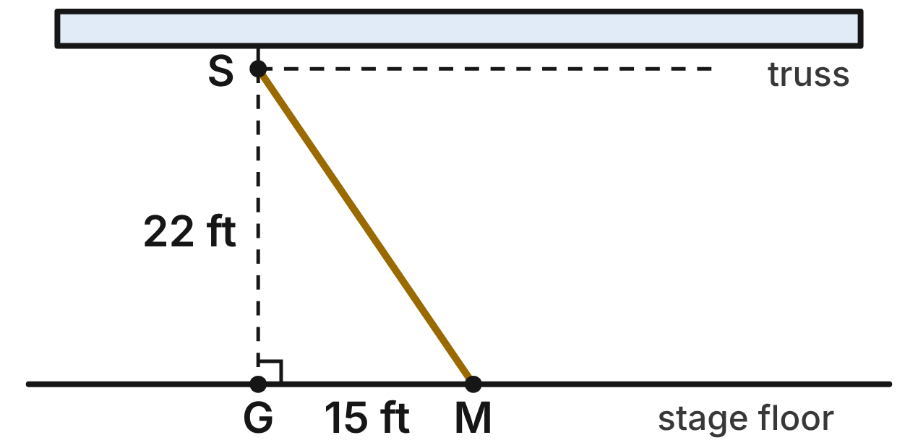
A spotlight S hangs from a lighting truss, 22 ft directly above point G on the level stage floor. It is aimed at a singer's mark M on the floor, 15 ft from G. The truss is parallel to the floor.
283. How long is the light beam SM, to the nearest tenth of a foot?
A. 37.0 ft
B. 16.1 ft
C. 709 ft
D. 26.6 ft ✔
G.TR.4 · skill G.TR.4.1 (LOTS): Use the Pythagorean Theorem and its converse, including to classify a triangle as right, acute or obtuse
☐ Answer key correct ☐ Wording clear Notes: ________________________________
284. To the nearest degree, what is the angle of depression from S to M?
A. 34°
B. 56° ✔
C. 43°
D. 47°
G.TR.4 · skill G.TR.4.4 (HOTS): Model a contextual problem (angles of elevation and depression, ramps, ladders, distances) with a right triangle and solve it
☐ Answer key correct ☐ Wording clear Notes: ________________________________
285. Which statement about the angle of depression from S to M is true?
A. It equals m∠SMG, because the truss is parallel to the floor. ✔
B. It equals m∠GSM, because they are vertical angles.
C. It is the complement of m∠SMG, because they form a linear pair.
D. It is 90°, because the beam is perpendicular to the floor.
G.TR.4 · skill G.TR.4.4 (HOTS): Model a contextual problem (angles of elevation and depression, ramps, ladders, distances) with a right triangle and solve it
☐ Answer key correct ☐ Wording clear Notes: ________________________________
286. The director moves the mark so that the angle of depression from S is 40°. The light stays where it is. How far from G is the new mark, to the nearest tenth of a foot?
A. 18.5 ft
B. 34.2 ft
C. 26.2 ft ✔
D. 16.9 ft
G.TR.4 · skill G.TR.4.4 (HOTS): Model a contextual problem (angles of elevation and depression, ramps, ladders, distances) with a right triangle and solve it
☐ Answer key correct ☐ Wording clear Notes: ________________________________
287. Which ratio is equal to tan ∠GSM?
A. 22/15
B. 15/22 ✔
C. 15/37
D. 22/37
G.TR.4 · skill G.TR.4.3 (LOTS): Use sine, cosine and tangent ratios to find a side length or an angle measure
☐ Answer key correct ☐ Wording clear Notes: ________________________________
288. The designer wants the beam to meet the floor at a 60° angle at M, with M still 15 ft from G. How high above G should the light hang? Give the exact answer.
A. 5√3 ft
B. 30 ft
C. 15√2 ft
D. 15√3 ft ✔
G.TR.4 · skill G.TR.4.2 (LOTS): Use the relationships in 45°-45°-90° and 30°-60°-90° triangles
☐ Answer key correct ☐ Wording clear Notes: ________________________________

The Model House Roof
Level 2 · Triangles · G.TR.4 · ID geo-tr4-ring-model-roof
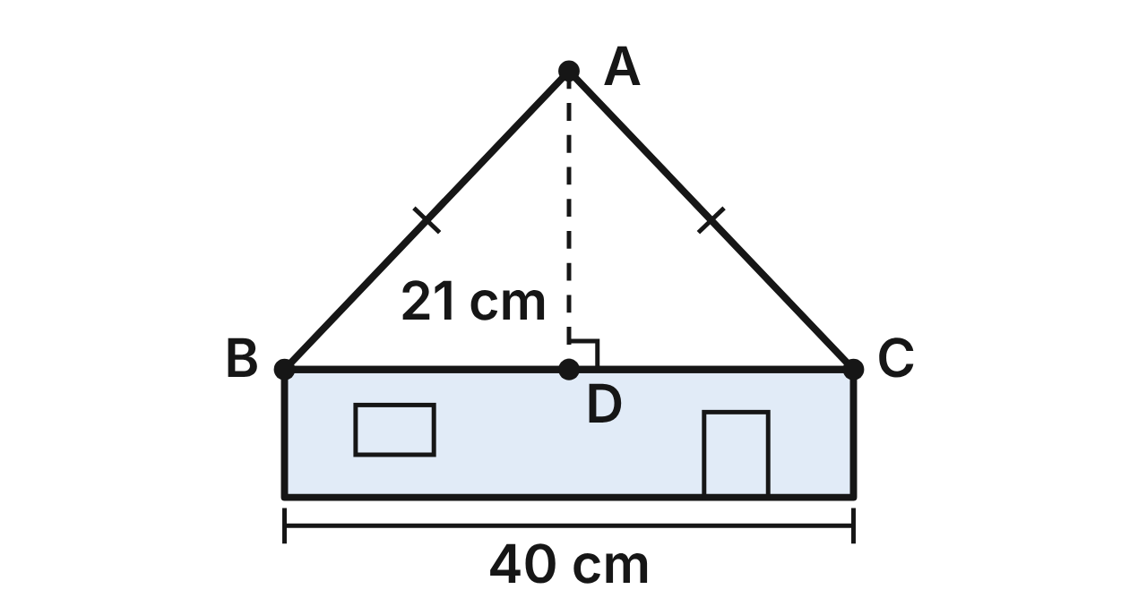
The front of a model house has a gable roof, triangle ABC, with AB = AC. D is the midpoint of BC, and AD ⊥ BC. BC = 40 cm and AD = 21 cm.
289. How long is the rafter AB?
A. 41 cm
B. about 45.2 cm
C. about 6.4 cm
D. 29 cm ✔
G.TR.4 · skill G.TR.4.1 (LOTS): Use the Pythagorean Theorem and its converse, including to classify a triangle as right, acute or obtuse
☐ Answer key correct ☐ Wording clear Notes: ________________________________
290. To the nearest degree, what is the roof's pitch angle, m∠ABD?
A. 46° ✔
B. 44°
C. 87°
D. 134°
G.TR.4 · skill G.TR.4.3 (LOTS): Use sine, cosine and tangent ratios to find a side length or an angle measure
☐ Answer key correct ☐ Wording clear Notes: ________________________________
291. Which ratio is equal to cos ∠ABD?
A. 21/29
B. 21/20
C. 20/29 ✔
D. 29/20
G.TR.4 · skill G.TR.4.3 (LOTS): Use sine, cosine and tangent ratios to find a side length or an angle measure
☐ Answer key correct ☐ Wording clear Notes: ________________________________
292. Builders write a roof's pitch as its rise for every 12 units of run, where the run of each side is half the roof's width. A model roof 40 cm wide, like BC, has a pitch of 9 in 12. How tall is its gable, from the peak down to BC?
A. 15 cm ✔
B. 30 cm
C. 9 cm
D. about 26.7 cm
G.TR.4 · skill G.TR.4.4 (HOTS): Model a contextual problem (angles of elevation and depression, ramps, ladders, distances) with a right triangle and solve it
☐ Answer key correct ☐ Wording clear Notes: ________________________________
293. A model chapel has rafters that make 60° angles with its flat ceiling, and its roof is 12 cm tall. How long is each rafter? Give the exact answer.
A. 24 cm
B. 8√3 cm ✔
C. 4√3 cm
D. 6√3 cm
G.TR.4 · skill G.TR.4.2 (LOTS): Use the relationships in 45°-45°-90° and 30°-60°-90° triangles
☐ Answer key correct ☐ Wording clear Notes: ________________________________
294. A dormer front is cut with sides 9 cm, 12 cm and 14 cm. Which describes this triangle? Choose the answer with the correct reason.
A. Obtuse, because 14² is greater than 9² + 12².
B. Right, because 14² = 9² + 12².
C. Right, because 9, 12 and 14 form a Pythagorean triple.
D. Acute, because 14² is less than 9² + 12². ✔
G.TR.4 · skill G.TR.4.1 (LOTS): Use the Pythagorean Theorem and its converse, including to classify a triangle as right, acute or obtuse
☐ Answer key correct ☐ Wording clear Notes: ________________________________

The Stained-Glass Panel
Level 2 · Triangles · G.TR.4 · ID geo-tr4-ring-stained-glass
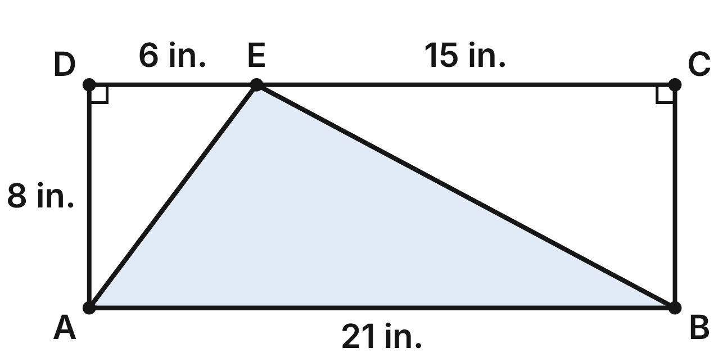
A stained-glass panel is rectangle ABCD, 21 in. long and 8 in. tall. Lead lines run from A and B to point E on side DC, with DE = 6 in. and EC = 15 in.
295. How long is the lead line AE?
A. 14 in.
B. about 5.3 in.
C. 10 in. ✔
D. 100 in.
G.TR.4 · skill G.TR.4.1 (LOTS): Use the Pythagorean Theorem and its converse, including to classify a triangle as right, acute or obtuse
☐ Answer key correct ☐ Wording clear Notes: ________________________________
296. Which equation can be used to find BE?
A. BE² = 15² − 8²
B. BE² = 8² + 15² ✔
C. BE = 8 + 15
D. BE² = 8² + 21²
G.TR.4 · skill G.TR.4.1 (LOTS): Use the Pythagorean Theorem and its converse, including to classify a triangle as right, acute or obtuse
☐ Answer key correct ☐ Wording clear Notes: ________________________________
297. Is ∠AEB a right angle? Choose the answer with the correct reason.
A. Yes, because AE² + BE² = AB².
B. No, it is acute, because AB² is less than AE² + BE².
C. Yes, because △ADE and △BCE are congruent.
D. No, it is obtuse, because AB² is greater than AE² + BE². ✔
G.TR.4 · skill G.TR.4.1 (LOTS): Use the Pythagorean Theorem and its converse, including to classify a triangle as right, acute or obtuse
☐ Answer key correct ☐ Wording clear Notes: ________________________________
298. To the nearest degree, what is m∠CBE?
A. 62° ✔
B. 28°
C. 32°
D. 58°
G.TR.4 · skill G.TR.4.3 (LOTS): Use sine, cosine and tangent ratios to find a side length or an angle measure
☐ Answer key correct ☐ Wording clear Notes: ________________________________
299. The artist cuts a piece shaped like a 45°-45°-90° triangle with a 10-in. hypotenuse. How long is each leg?
A. 10√2 in.
B. 5√2 in. ✔
C. 5 in.
D. 5√3 in.
G.TR.4 · skill G.TR.4.2 (LOTS): Use the relationships in 45°-45°-90° and 30°-60°-90° triangles
☐ Answer key correct ☐ Wording clear Notes: ________________________________
300. Another piece is a 30°-60°-90° triangle whose longer leg is 9 in. How long is its shorter leg?
A. 9√3 in.
B. 4.5 in.
C. 3√3 in. ✔
D. 18 in.
G.TR.4 · skill G.TR.4.2 (LOTS): Use the relationships in 45°-45°-90° and 30°-60°-90° triangles
☐ Answer key correct ☐ Wording clear Notes: ________________________________

Sight Lines from the Balcony
Level 3 · Triangles · G.TR.4 · ID geo-tr4-ring-theater-balcony
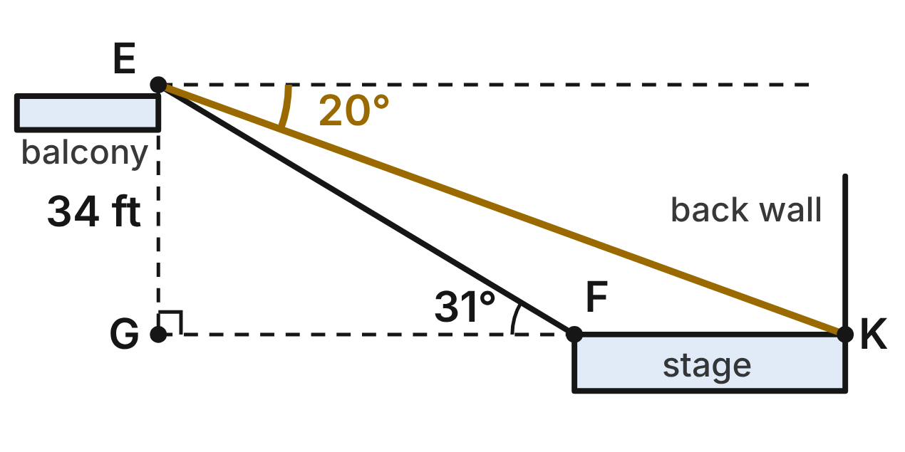
A viewer's eyes E in a theater balcony are 34 ft above the level of the stage floor. G is the point on that level directly below E. F, the front edge of the stage, and K, the foot of the back wall, are in line with G. From E, the angle of depression to K is 20°. From F, the angle of elevation to E is 31°.
301. How far is F from G, to the nearest tenth of a foot?
A. 56.6 ft ✔
B. 20.4 ft
C. 66.0 ft
D. 29.1 ft
G.TR.4 · skill G.TR.4.4 (HOTS): Model a contextual problem (angles of elevation and depression, ramps, ladders, distances) with a right triangle and solve it
☐ Answer key correct ☐ Wording clear Notes: ________________________________
302. How deep is the stage, from F to K, to the nearest tenth of a foot?
A. 93.4 ft
B. 36.8 ft ✔
C. 174.9 ft
D. 8.1 ft
G.TR.4 · skill G.TR.4.4 (HOTS): Model a contextual problem (angles of elevation and depression, ramps, ladders, distances) with a right triangle and solve it
☐ Answer key correct ☐ Wording clear Notes: ________________________________
303. Which equation gives GK?
A. GK = 34·tan 20°
B. GK = 34/sin 20°
C. GK = 34/tan 20° ✔
D. GK = 34·cos 20°
G.TR.4 · skill G.TR.4.3 (LOTS): Use sine, cosine and tangent ratios to find a side length or an angle measure
☐ Answer key correct ☐ Wording clear Notes: ________________________________
304. How long is the sight line EK, to the nearest tenth of a foot?
A. 36.2 ft
B. 99.4 ft ✔
C. 11.6 ft
D. 93.4 ft
G.TR.4 · skill G.TR.4.3 (LOTS): Use sine, cosine and tangent ratios to find a side length or an angle measure
☐ Answer key correct ☐ Wording clear Notes: ________________________________
305. A seat directly below E has eyes 24 ft above the stage floor level. To the nearest degree, what is the angle of depression from this seat to F?
A. 67°
B. 25°
C. 10°
D. 23° ✔
G.TR.4 · skill G.TR.4.4 (HOTS): Model a contextual problem (angles of elevation and depression, ramps, ladders, distances) with a right triangle and solve it
☐ Answer key correct ☐ Wording clear Notes: ________________________________
306. A brace under the balcony rail forms a triangle with sides 18 in., 24 in. and 31 in. Which describes the triangle? Choose the answer with the correct reason.
A. Obtuse, because 31² is greater than 18² + 24². ✔
B. Acute, because 31² is less than 18² + 24².
C. Right, because 31² = 18² + 24².
D. Right, because 18, 24 and 31 form a Pythagorean triple.
G.TR.4 · skill G.TR.4.1 (LOTS): Use the Pythagorean Theorem and its converse, including to classify a triangle as right, acute or obtuse
☐ Answer key correct ☐ Wording clear Notes: ________________________________

The Camera Crane at the Concert
Level 3 · Triangles · G.TR.4 · ID geo-tr4-ring-camera-crane
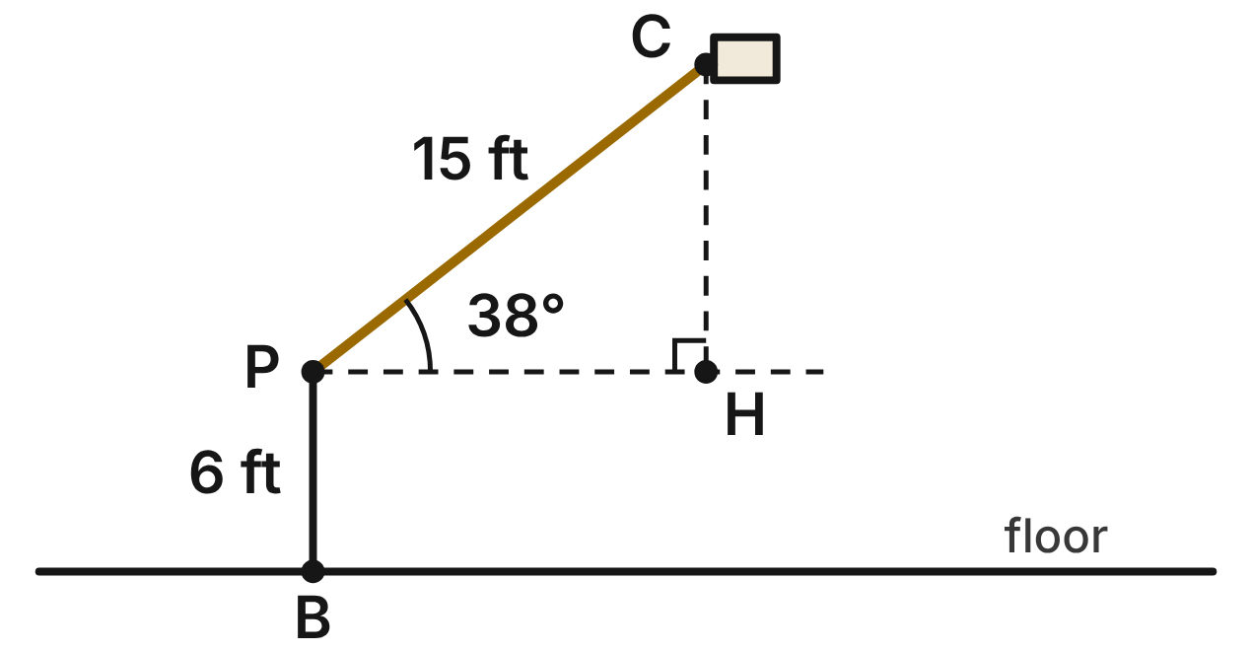
A camera crane films a concert. Its arm PC is 15 ft long and pivots at P, on top of a post 6 ft above the floor at B. PB is perpendicular to the level floor. In the figure, the arm is raised 38° above the horizontal line through P, and H on that line is directly below the camera C.
307. How high above the floor is the camera C, to the nearest tenth of a foot?
A. 9.2 ft
B. 17.8 ft
C. 21.0 ft
D. 15.2 ft ✔
G.TR.4 · skill G.TR.4.4 (HOTS): Model a contextual problem (angles of elevation and depression, ramps, ladders, distances) with a right triangle and solve it
☐ Answer key correct ☐ Wording clear Notes: ________________________________
308. Jay finds PH this way: PH = 15·sin 38°. Which statement about his work is correct?
A. PH is opposite the 38° angle, so his answer is correct.
B. He should divide: PH = 15/sin 38°.
C. PH is adjacent to the 38° angle, so PH = 15·cos 38°. ✔
D. He should use tangent: PH = 15·tan 38°.
G.TR.4 · skill G.TR.4.3 (LOTS): Use sine, cosine and tangent ratios to find a side length or an angle measure
☐ Answer key correct ☐ Wording clear Notes: ________________________________
309. To film the drummer, the camera must be 14 ft above the floor. To the nearest degree, how far above the horizontal must the arm be raised?
A. 28°
B. 32° ✔
C. 58°
D. 69°
G.TR.4 · skill G.TR.4.4 (HOTS): Model a contextual problem (angles of elevation and depression, ramps, ladders, distances) with a right triangle and solve it
☐ Answer key correct ☐ Wording clear Notes: ________________________________
310. For a low shot, the arm is lowered to 20° below the horizontal. How high above the floor is the camera then, to the nearest tenth of a foot?
A. 11.1 ft
B. 5.1 ft
C. 0.5 ft
D. 0.9 ft ✔
G.TR.4 · skill G.TR.4.4 (HOTS): Model a contextual problem (angles of elevation and depression, ramps, ladders, distances) with a right triangle and solve it
☐ Answer key correct ☐ Wording clear Notes: ________________________________
311. When the arm is raised 45° above the horizontal, how high above the pivot P is the camera? Give the exact answer.
A. 15√2/2 ft ✔
B. 15√2 ft
C. 7.5 ft
D. 15√3/2 ft
G.TR.4 · skill G.TR.4.2 (LOTS): Use the relationships in 45°-45°-90° and 30°-60°-90° triangles
☐ Answer key correct ☐ Wording clear Notes: ________________________________
312. A counterweight rope runs straight from P to a hook on the floor, 4.5 ft from B. How long is the rope?
A. 10.5 ft
B. about 4.0 ft
C. 7.5 ft ✔
D. 56.25 ft
G.TR.4 · skill G.TR.4.1 (LOTS): Use the Pythagorean Theorem and its converse, including to classify a triangle as right, acute or obtuse
☐ Answer key correct ☐ Wording clear Notes: ________________________________

Polygons and circles (G.PC)

G.PC.1 · Prove and justify theorems and properties of quadrilaterals, and verify and use properties of quadrilaterals to solve problems, including the relationships between the sides, angles, and diagonals.

The Quilt Patch
Level 1 · Quadrilaterals · G.PC.1 · ID geo-pc1-ring-quilt-patch
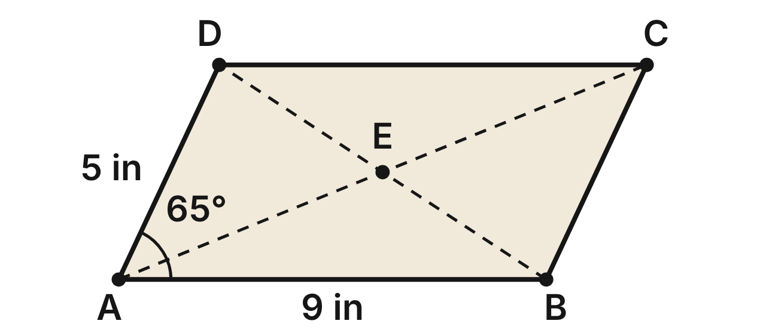
A quilter cuts a patch shaped like parallelogram ABCD. AB = 9 in, AD = 5 in and m∠DAB = 65°. Seams run along the diagonals AC and BD, which meet at E.
313. What is m∠BCD on the patch?
A. 65° ✔
B. 115°
C. 25°
D. 295°
G.PC.1 · skill G.PC.1.1 (LOTS): Identify the properties of parallelograms, rectangles, rhombi, squares, trapezoids and kites (sides, angles, diagonals)
☐ Answer key correct ☐ Wording clear Notes: ________________________________
314. What is m∠ABC on the patch?
A. 65°
B. 25°
C. 230°
D. 115° ✔
G.PC.1 · skill G.PC.1.1 (LOTS): Identify the properties of parallelograms, rectangles, rhombi, squares, trapezoids and kites (sides, angles, diagonals)
☐ Answer key correct ☐ Wording clear Notes: ________________________________
315. The quilter sews binding all the way around the edge of the patch. How long is the binding?
A. 14 in
B. 28 in ✔
C. 45 in
D. 19 in
G.PC.1 · skill G.PC.1.3 (LOTS): Solve problems, including algebraic ones, using the properties of quadrilaterals
☐ Answer key correct ☐ Wording clear Notes: ________________________________
316. Which statement about the seams AC and BD must be true?
A. They bisect each other. ✔
B. They are congruent.
C. They are perpendicular.
D. They bisect the angles of the patch.
G.PC.1 · skill G.PC.1.1 (LOTS): Identify the properties of parallelograms, rectangles, rhombi, squares, trapezoids and kites (sides, angles, diagonals)
☐ Answer key correct ☐ Wording clear Notes: ________________________________
317. On the patch, AE = (2x − 2) in and EC = (x + 2) in. How long is seam AC?
A. 4 in
B. 12 in ✔
C. 6 in
D. 8 in
G.PC.1 · skill G.PC.1.3 (LOTS): Solve problems, including algebraic ones, using the properties of quadrilaterals
☐ Answer key correct ☐ Wording clear Notes: ________________________________
318. Which statement is NOT true for patch ABCD?
A. AB ∥ DC
B. AD = BC
C. ∠DAB ≅ ∠ABC ✔
D. ∠DAB and ∠ADC are supplementary.
G.PC.1 · skill G.PC.1.1 (LOTS): Identify the properties of parallelograms, rectangles, rhombi, squares, trapezoids and kites (sides, angles, diagonals)
☐ Answer key correct ☐ Wording clear Notes: ________________________________

The Stained-Glass Kite
Level 1 · Quadrilaterals · G.PC.1 · ID geo-pc1-ring-stained-glass
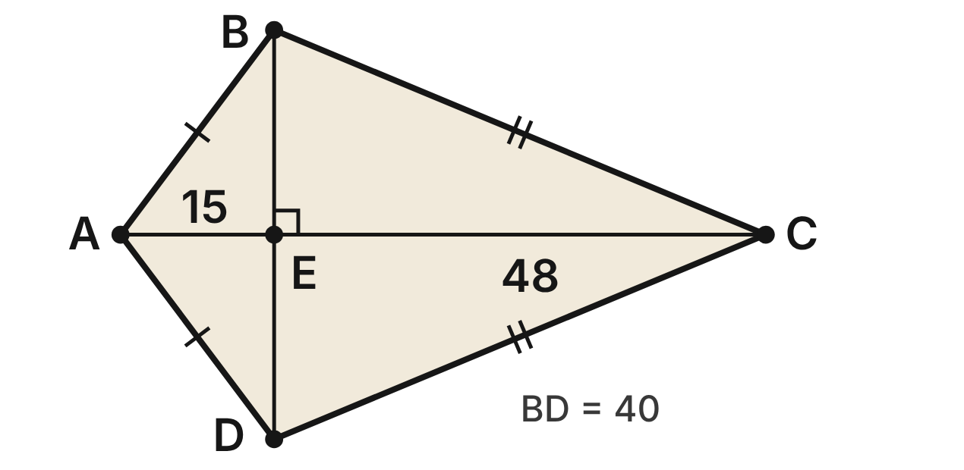
A stained-glass pane is kite ABCD with AB = AD and CB = CD. Lead strips run along its diagonals, which meet at E. AE = 15 cm, EC = 48 cm and BD = 40 cm.
319. Which segment must be congruent to BE?
A. AE
B. EC
C. AB
D. ED ✔
G.PC.1 · skill G.PC.1.1 (LOTS): Identify the properties of parallelograms, rectangles, rhombi, squares, trapezoids and kites (sides, angles, diagonals)
☐ Answer key correct ☐ Wording clear Notes: ________________________________
320. How long is the short edge AB of the pane?
A. 35 cm
B. 25 cm ✔
C. 5√7 cm
D. 5√73 cm
G.PC.1 · skill G.PC.1.3 (LOTS): Solve problems, including algebraic ones, using the properties of quadrilaterals
☐ Answer key correct ☐ Wording clear Notes: ________________________________
321. How long is the long edge CB of the pane?
A. 52 cm ✔
B. 68 cm
C. about 43.6 cm
D. about 62.5 cm
G.PC.1 · skill G.PC.1.3 (LOTS): Solve problems, including algebraic ones, using the properties of quadrilaterals
☐ Answer key correct ☐ Wording clear Notes: ________________________________
322. Which angle must be congruent to ∠BAE?
A. ∠BCE
B. ∠ABE
C. ∠ABC
D. ∠DAE ✔
G.PC.1 · skill G.PC.1.1 (LOTS): Identify the properties of parallelograms, rectangles, rhombi, squares, trapezoids and kites (sides, angles, diagonals)
☐ Answer key correct ☐ Wording clear Notes: ________________________________
323. Lucia says the pane is a rhombus because its diagonals are perpendicular. Which statement explains her error?
A. A rhombus never has perpendicular diagonals.
B. A rhombus must have BD longer than AC.
C. Perpendicular diagonals are not enough; AE ≠ EC. ✔
D. There is no error; the pane is a rhombus.
G.PC.1 · skill G.PC.1.1 (LOTS): Identify the properties of parallelograms, rectangles, rhombi, squares, trapezoids and kites (sides, angles, diagonals)
☐ Answer key correct ☐ Wording clear Notes: ________________________________
324. A lead strip also runs around the whole edge of the pane. How long is that strip?
A. 77 cm
B. 103 cm
C. 154 cm ✔
D. 100 cm
G.PC.1 · skill G.PC.1.3 (LOTS): Solve problems, including algebraic ones, using the properties of quadrilaterals
☐ Answer key correct ☐ Wording clear Notes: ________________________________

The Stage Flat
Level 2 · Quadrilaterals · G.PC.1 · ID geo-pc1-ring-stage-flat
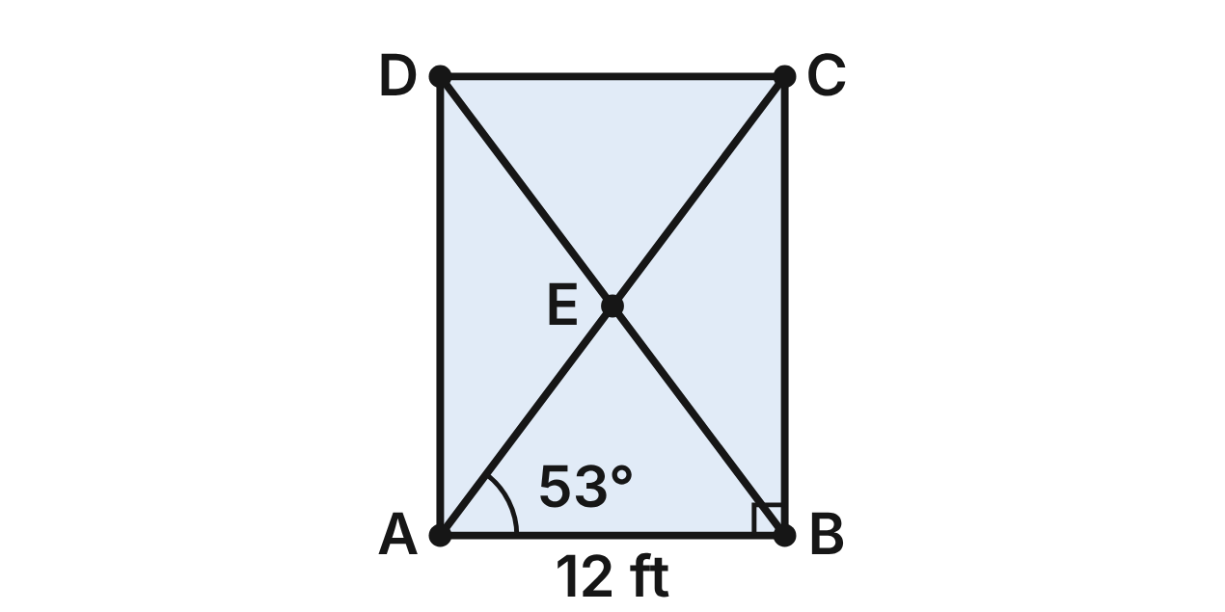
A stage flat ABCD is a rectangle 12 ft wide (AB = 12 ft). Braces AC and BD cross at E. AE = (2x + 4) ft, BD = (5x + 5) ft and m∠CAB ≈ 53°.
325. How long is brace BD?
A. 10 ft
B. 20 ft ✔
C. 3 ft
D. 40 ft
G.PC.1 · skill G.PC.1.3 (LOTS): Solve problems, including algebraic ones, using the properties of quadrilaterals
☐ Answer key correct ☐ Wording clear Notes: ________________________________
326. To the nearest degree, what is m∠ABD?
A. 53° ✔
B. 37°
C. 74°
D. 106°
G.PC.1 · skill G.PC.1.1 (LOTS): Identify the properties of parallelograms, rectangles, rhombi, squares, trapezoids and kites (sides, angles, diagonals)
☐ Answer key correct ☐ Wording clear Notes: ________________________________
327. To the nearest degree, what is m∠BEC?
A. 106° ✔
B. 74°
C. 53°
D. 127°
G.PC.1 · skill G.PC.1.3 (LOTS): Solve problems, including algebraic ones, using the properties of quadrilaterals
☐ Answer key correct ☐ Wording clear Notes: ________________________________
328. A builder knows that a second flat ABCD is a parallelogram. Which pair of tape measurements, by itself, proves it is a rectangle?
A. AB = 12 ft and DC = 12 ft
B. AC = 20 ft and BD = 20 ft ✔
C. AE = 10 ft and EC = 10 ft
D. AB = 12 ft and BC = 12 ft
G.PC.1 · skill G.PC.1.1 (LOTS): Identify the properties of parallelograms, rectangles, rhombi, squares, trapezoids and kites (sides, angles, diagonals)
☐ Answer key correct ☐ Wording clear Notes: ________________________________
329. How tall is the flat (the length of BC)?
A. 4√34 ft
B. 8 ft
C. 12 ft
D. 16 ft ✔
G.PC.1 · skill G.PC.1.3 (LOTS): Solve problems, including algebraic ones, using the properties of quadrilaterals
☐ Answer key correct ☐ Wording clear Notes: ________________________________
330. The crew wants a parallelogram flat whose braces are congruent AND perpendicular. What must that flat be?
A. a rectangle that is not a square
B. a rhombus that is not a square
C. a square ✔
D. an isosceles trapezoid
G.PC.1 · skill G.PC.1.1 (LOTS): Identify the properties of parallelograms, rectangles, rhombi, squares, trapezoids and kites (sides, angles, diagonals)
☐ Answer key correct ☐ Wording clear Notes: ________________________________

The Band Logo
Level 2 · Quadrilaterals · G.PC.1 · ID geo-pc1-ring-logo-grid
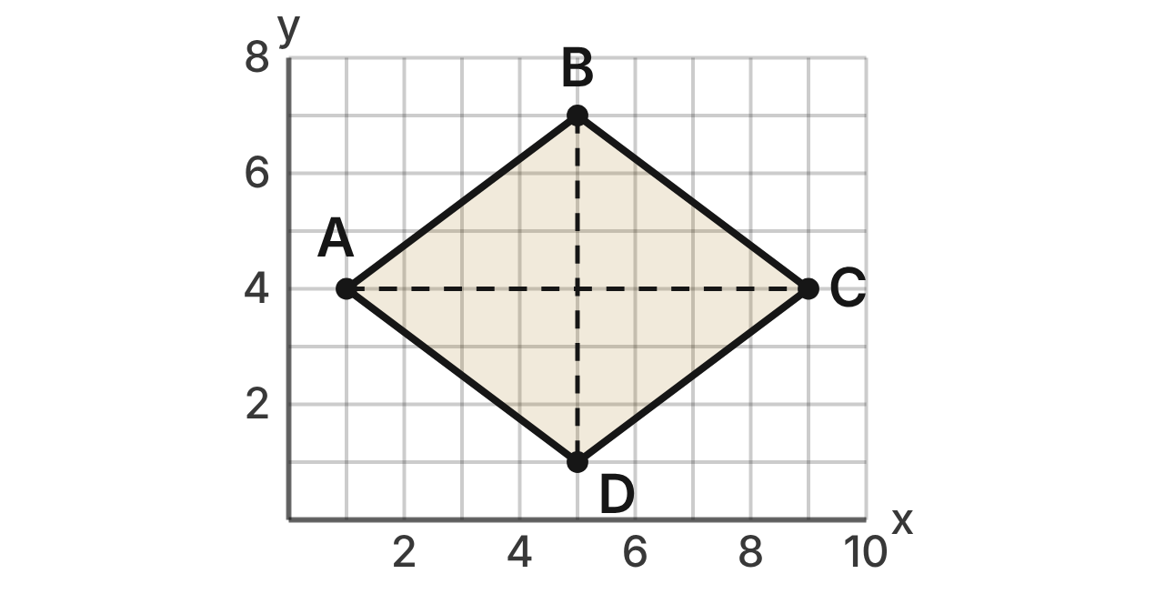
A designer draws a band logo, quadrilateral ABCD, on a grid with A(1, 4), B(5, 7), C(9, 4) and D(5, 1). Each grid unit is 1 cm.
331. What is the slope of side AB?
A. 4/3
B. −3/4
C. 3/4 ✔
D. 7/5
G.PC.1 · skill G.PC.1.2 (HOTS): Use coordinate methods (slope, distance, midpoint) to classify a quadrilateral or justify a property
☐ Answer key correct ☐ Wording clear Notes: ________________________________
332. How long is side AB?
A. 7 cm
B. 5 cm ✔
C. √7 cm
D. 25 cm
G.PC.1 · skill G.PC.1.2 (HOTS): Use coordinate methods (slope, distance, midpoint) to classify a quadrilateral or justify a property
☐ Answer key correct ☐ Wording clear Notes: ________________________________
333. What is the midpoint of diagonal AC?
A. (4, 0)
B. (10, 8)
C. (8, 0)
D. (5, 4) ✔
G.PC.1 · skill G.PC.1.2 (HOTS): Use coordinate methods (slope, distance, midpoint) to classify a quadrilateral or justify a property
☐ Answer key correct ☐ Wording clear Notes: ________________________________
334. Which fact, by itself, proves that ABCD is a rhombus?
A. All four sides are 5 units long. ✔
B. AC and BD bisect each other at (5, 4).
C. AB ∥ DC, since both slopes are 3/4.
D. Diagonals AC and BD are congruent.
G.PC.1 · skill G.PC.1.2 (HOTS): Use coordinate methods (slope, distance, midpoint) to classify a quadrilateral or justify a property
☐ Answer key correct ☐ Wording clear Notes: ________________________________
335. Is the logo a square? Choose the answer with the correct reason.
A. Yes: all four of its sides are congruent.
B. No: AB and BC have different lengths.
C. Yes: its diagonals are perpendicular.
D. No: slope AB · slope BC = −9/16, not −1. ✔
G.PC.1 · skill G.PC.1.2 (HOTS): Use coordinate methods (slope, distance, midpoint) to classify a quadrilateral or justify a property
☐ Answer key correct ☐ Wording clear Notes: ________________________________
336. The area of a rhombus is half the product of its diagonals. What is the area of the logo?
A. 48 cm²
B. 25 cm²
C. 24 cm² ✔
D. 14 cm²
G.PC.1 · skill G.PC.1.3 (LOTS): Solve problems, including algebraic ones, using the properties of quadrilaterals
☐ Answer key correct ☐ Wording clear Notes: ________________________________

The Hammered Dulcimer
Level 2 · Quadrilaterals · G.PC.1 · ID geo-pc1-ring-dulcimer
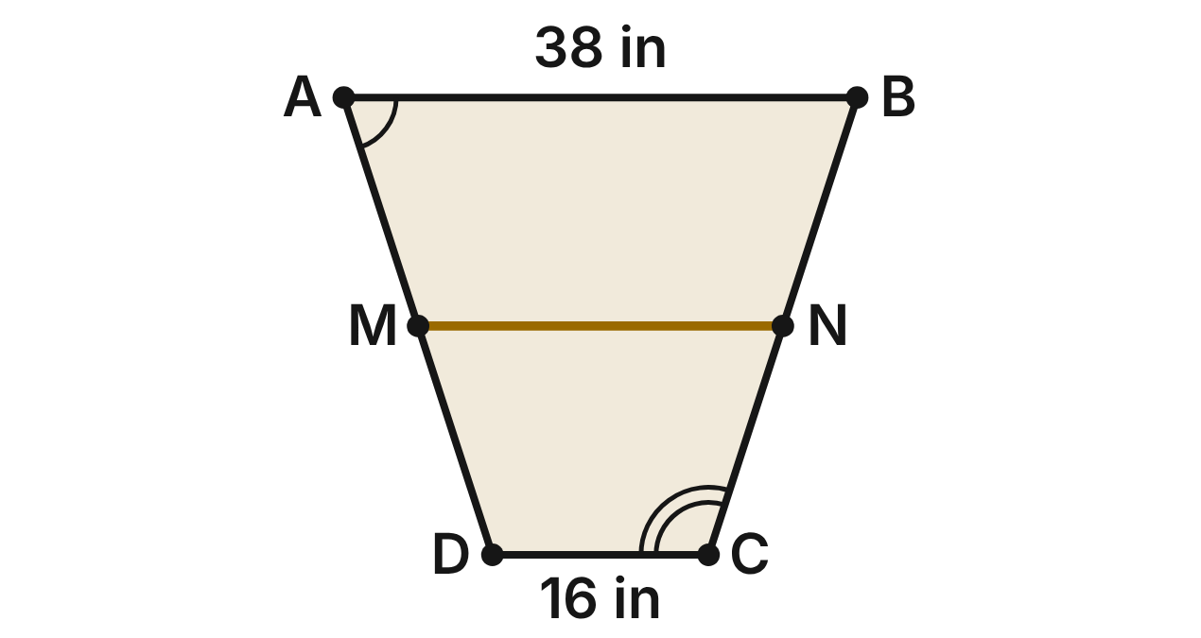
The top of a hammered dulcimer is isosceles trapezoid ABCD with AB ∥ DC, AB = 38 in, DC = 16 in and AD = BC. A trim strip MN joins the midpoints of the legs. m∠A = (3x + 12)° and m∠C = (5x + 8)°.
337. What is m∠A?
A. 18°
B. 108°
C. 72° ✔
D. 20°
G.PC.1 · skill G.PC.1.3 (LOTS): Solve problems, including algebraic ones, using the properties of quadrilaterals
☐ Answer key correct ☐ Wording clear Notes: ________________________________
338. Which angle must be congruent to ∠BCD?
A. ∠ADC ✔
B. ∠DAB
C. ∠ABC
D. ∠ACD
G.PC.1 · skill G.PC.1.1 (LOTS): Identify the properties of parallelograms, rectangles, rhombi, squares, trapezoids and kites (sides, angles, diagonals)
☐ Answer key correct ☐ Wording clear Notes: ________________________________
339. How long is the trim strip MN?
A. 22 in
B. 27 in ✔
C. 54 in
D. 11 in
G.PC.1 · skill G.PC.1.3 (LOTS): Solve problems, including algebraic ones, using the properties of quadrilaterals
☐ Answer key correct ☐ Wording clear Notes: ________________________________
340. Which statement is NOT true for every isosceles trapezoid?
A. Its legs are congruent.
B. Its diagonals are congruent.
C. Each pair of base angles is congruent.
D. Its opposite angles are congruent. ✔
G.PC.1 · skill G.PC.1.1 (LOTS): Identify the properties of parallelograms, rectangles, rhombi, squares, trapezoids and kites (sides, angles, diagonals)
☐ Answer key correct ☐ Wording clear Notes: ________________________________
341. A pearl inlay on the dulcimer is isosceles trapezoid PQRS with diagonals PR = (4y − 5) mm and QS = (2y + 21) mm. How long is PR?
A. 13 mm
B. 47 mm ✔
C. 94 mm
D. 27 mm
G.PC.1 · skill G.PC.1.3 (LOTS): Solve problems, including algebraic ones, using the properties of quadrilaterals
☐ Answer key correct ☐ Wording clear Notes: ________________________________
342. A builder says ABCD is a parallelogram because AD = BC. Which statement explains the error?
A. AD = BC, but AD is not parallel to BC. ✔
B. Opposite sides of a parallelogram are never equal.
C. AD and BC are not really the same length.
D. A parallelogram must have four right angles.
G.PC.1 · skill G.PC.1.1 (LOTS): Identify the properties of parallelograms, rectangles, rhombi, squares, trapezoids and kites (sides, angles, diagonals)
☐ Answer key correct ☐ Wording clear Notes: ________________________________

The Diamond Shelf
Level 3 · Quadrilaterals · G.PC.1 · ID geo-pc1-ring-woodshop-shelf
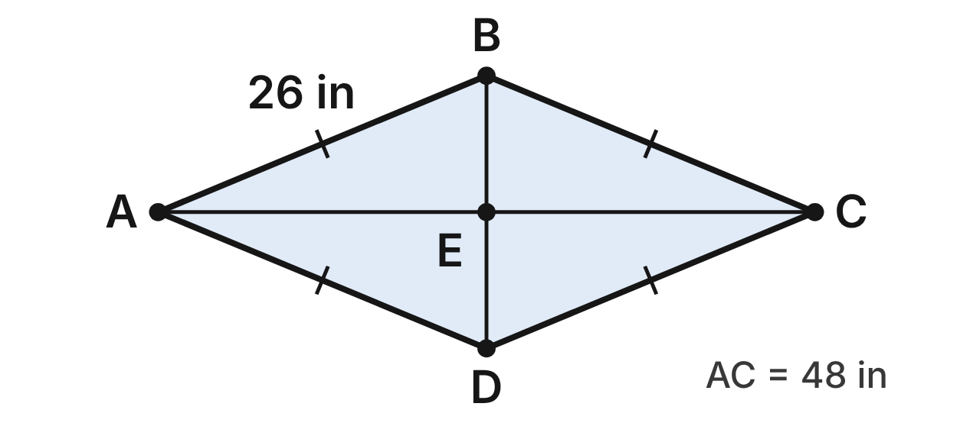
In woodshop, Rosa builds a diamond-shaped wall shelf. Its frame is rhombus ABCD made of four 26-inch boards. Braces AC = 48 in and BD cross at E.
343. How long is the short brace BD?
A. 20 in ✔
B. 10 in
C. 22 in
D. about 70.8 in
G.PC.1 · skill G.PC.1.3 (LOTS): Solve problems, including algebraic ones, using the properties of quadrilaterals
☐ Answer key correct ☐ Wording clear Notes: ________________________________
344. Which angle of the shelf must be a right angle?
A. ∠DAB
B. ∠ABC
C. ∠AEB ✔
D. ∠EAB
G.PC.1 · skill G.PC.1.1 (LOTS): Identify the properties of parallelograms, rectangles, rhombi, squares, trapezoids and kites (sides, angles, diagonals)
☐ Answer key correct ☐ Wording clear Notes: ________________________________
345. Rosa rebuilds the frame as a square, using the same four 26-inch boards. How long is brace AC now?
A. 52 in
B. 26 in
C. 13√2 in
D. 26√2 in ✔
G.PC.1 · skill G.PC.1.3 (LOTS): Solve problems, including algebraic ones, using the properties of quadrilaterals
☐ Answer key correct ☐ Wording clear Notes: ________________________________
346. A frame is known to be a parallelogram. Which single fact proves it is a rhombus?
A. Its diagonals are congruent.
B. Its diagonals are perpendicular. ✔
C. Its opposite angles are congruent.
D. One of its angles is a right angle.
G.PC.1 · skill G.PC.1.1 (LOTS): Identify the properties of parallelograms, rectangles, rhombi, squares, trapezoids and kites (sides, angles, diagonals)
☐ Answer key correct ☐ Wording clear Notes: ________________________________
347. How many inches of wood does the shelf use in all (four sides and both braces)?
A. 152 in
B. 162 in
C. 172 in ✔
D. 120 in
G.PC.1 · skill G.PC.1.3 (LOTS): Solve problems, including algebraic ones, using the properties of quadrilaterals
☐ Answer key correct ☐ Wording clear Notes: ________________________________
348. Which statement is true for the shelf but NOT true for every parallelogram?
A. Its diagonals bisect each other.
B. Its diagonals are congruent.
C. Its opposite angles are congruent.
D. Its diagonals bisect its angles. ✔
G.PC.1 · skill G.PC.1.1 (LOTS): Identify the properties of parallelograms, rectangles, rhombi, squares, trapezoids and kites (sides, angles, diagonals)
☐ Answer key correct ☐ Wording clear Notes: ________________________________

The Fondant Square
Level 3 · Quadrilaterals · G.PC.1 · ID geo-pc1-ring-cake-grid
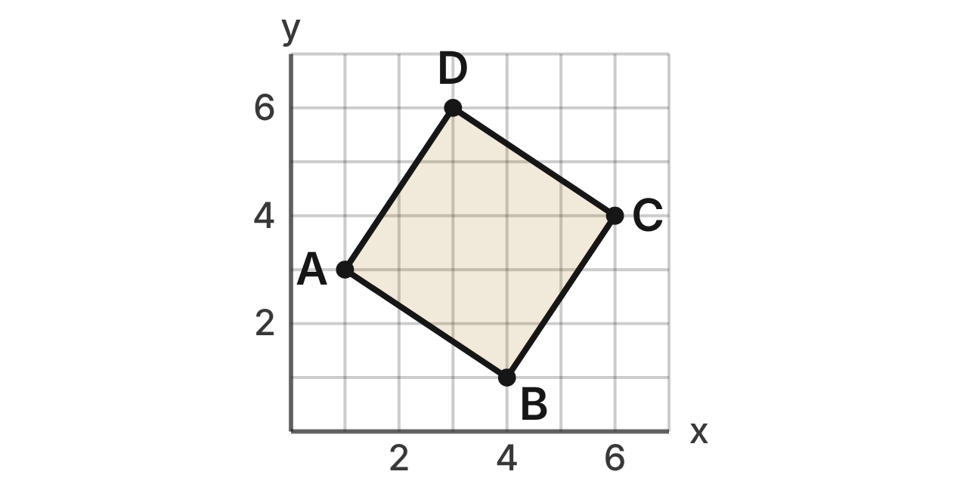
A cake decorator plans a fondant shape ABCD on a grid with A(1, 3), B(4, 1), C(6, 4) and D(3, 6). Each grid unit stands for 2 inches on the cake.
349. What is the slope of side BC?
A. 3/2 ✔
B. 2/3
C. −3/2
D. −2/3
G.PC.1 · skill G.PC.1.2 (HOTS): Use coordinate methods (slope, distance, midpoint) to classify a quadrilateral or justify a property
☐ Answer key correct ☐ Wording clear Notes: ________________________________
350. How long is side AB, in grid units?
A. 5 units
B. √13 units ✔
C. 13 units
D. √5 units
G.PC.1 · skill G.PC.1.2 (HOTS): Use coordinate methods (slope, distance, midpoint) to classify a quadrilateral or justify a property
☐ Answer key correct ☐ Wording clear Notes: ________________________________
351. What is the midpoint of diagonal BD?
A. (7, 7)
B. (3.5, 3.5) ✔
C. (−0.5, 2.5)
D. (−1, 5)
G.PC.1 · skill G.PC.1.2 (HOTS): Use coordinate methods (slope, distance, midpoint) to classify a quadrilateral or justify a property
☐ Answer key correct ☐ Wording clear Notes: ________________________________
352. Jada uses slopes and distances to show that AB ⊥ BC and AB = BC = √13. What else must she show to prove that ABCD is a square?
A. that diagonals AC and BD are perpendicular
B. that side AB is parallel to side DC
C. that ABCD is a parallelogram ✔
D. that diagonals AC and BD are congruent
G.PC.1 · skill G.PC.1.2 (HOTS): Use coordinate methods (slope, distance, midpoint) to classify a quadrilateral or justify a property
☐ Answer key correct ☐ Wording clear Notes: ________________________________
353. A ribbon goes once around the edge of the fondant shape. To the nearest tenth of an inch, how long is the ribbon?
A. 14.4 in
B. 40.0 in
C. 104.0 in
D. 28.8 in ✔
G.PC.1 · skill G.PC.1.3 (LOTS): Solve problems, including algebraic ones, using the properties of quadrilaterals
☐ Answer key correct ☐ Wording clear Notes: ________________________________
354. What is the area of the fondant shape on the cake, in square inches?
A. 52 in² ✔
B. 13 in²
C. 26 in²
D. 208 in²
G.PC.1 · skill G.PC.1.3 (LOTS): Solve problems, including algebraic ones, using the properties of quadrilaterals
☐ Answer key correct ☐ Wording clear Notes: ________________________________

G.PC.2 · Verify relationships and solve problems involving the number of sides and measures of angles of convex polygons.

The Rose Window
Level 1 · Polygons · G.PC.2 · ID geo-pc2-ring-rose-window
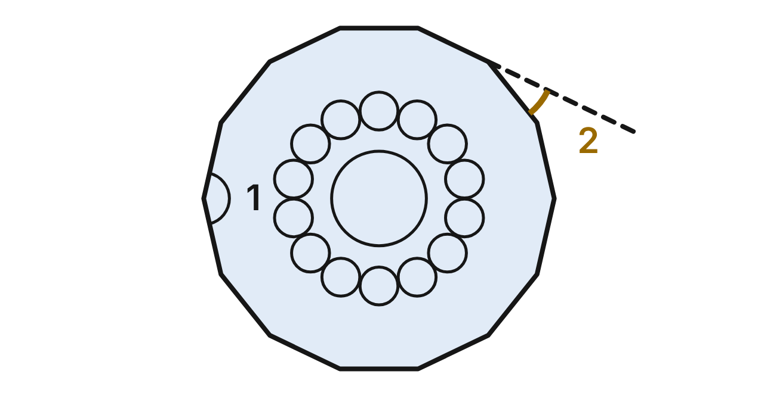
A stained-glass rose window has a frame shaped like a regular 14-gon (14 congruent sides and 14 congruent angles). ∠1 is an interior angle of the frame. One side is extended (dashed), and ∠2 is the exterior angle it makes.
355. What is the sum of the interior angles of the rose window's frame?
A. 2520°
B. 2160° ✔
C. 2340°
D. 1980°
G.PC.2 · skill G.PC.2.1 (LOTS): Find the sum of the interior angles, and the measure of each interior and exterior angle, of a convex or regular polygon
☐ Answer key correct ☐ Wording clear Notes: ________________________________
356. To the nearest tenth of a degree, what is m∠1?
A. 25.7°
B. 167.1°
C. 154.3° ✔
D. 141.4°
G.PC.2 · skill G.PC.2.1 (LOTS): Find the sum of the interior angles, and the measure of each interior and exterior angle, of a convex or regular polygon
☐ Answer key correct ☐ Wording clear Notes: ________________________________
357. To the nearest tenth of a degree, what is m∠2, the gold exterior angle?
A. 25.7° ✔
B. 154.3°
C. 12.9°
D. 27.7°
G.PC.2 · skill G.PC.2.1 (LOTS): Find the sum of the interior angles, and the measure of each interior and exterior angle, of a convex or regular polygon
☐ Answer key correct ☐ Wording clear Notes: ________________________________
358. A designer plans a regular window frame with twice as many sides. To the nearest tenth of a degree, what is each exterior angle of that frame?
A. 51.4°
B. 25.7°
C. 167.1°
D. 12.9° ✔
G.PC.2 · skill G.PC.2.1 (LOTS): Find the sum of the interior angles, and the measure of each interior and exterior angle, of a convex or regular polygon
☐ Answer key correct ☐ Wording clear Notes: ________________________________
359. A smaller rose window has a regular frame whose exterior angles each measure 14.4°. How many sides does that frame have?
A. 165.6
B. 25 ✔
C. 12.5
D. 27
G.PC.2 · skill G.PC.2.2 (LOTS): Find the number of sides of a regular polygon given the measure of an interior or exterior angle
☐ Answer key correct ☐ Wording clear Notes: ________________________________
360. A larger rose window has a regular frame whose interior angles each measure 175°. How many sides does that frame have?
A. 5
B. about 2.1
C. 72 ✔
D. 36
G.PC.2 · skill G.PC.2.2 (LOTS): Find the number of sides of a regular polygon given the measure of an interior or exterior angle
☐ Answer key correct ☐ Wording clear Notes: ________________________________

The Twelve-Sided Mirror Frame
Level 1 · Polygons · G.PC.2 · ID geo-pc2-ring-mirror-frame
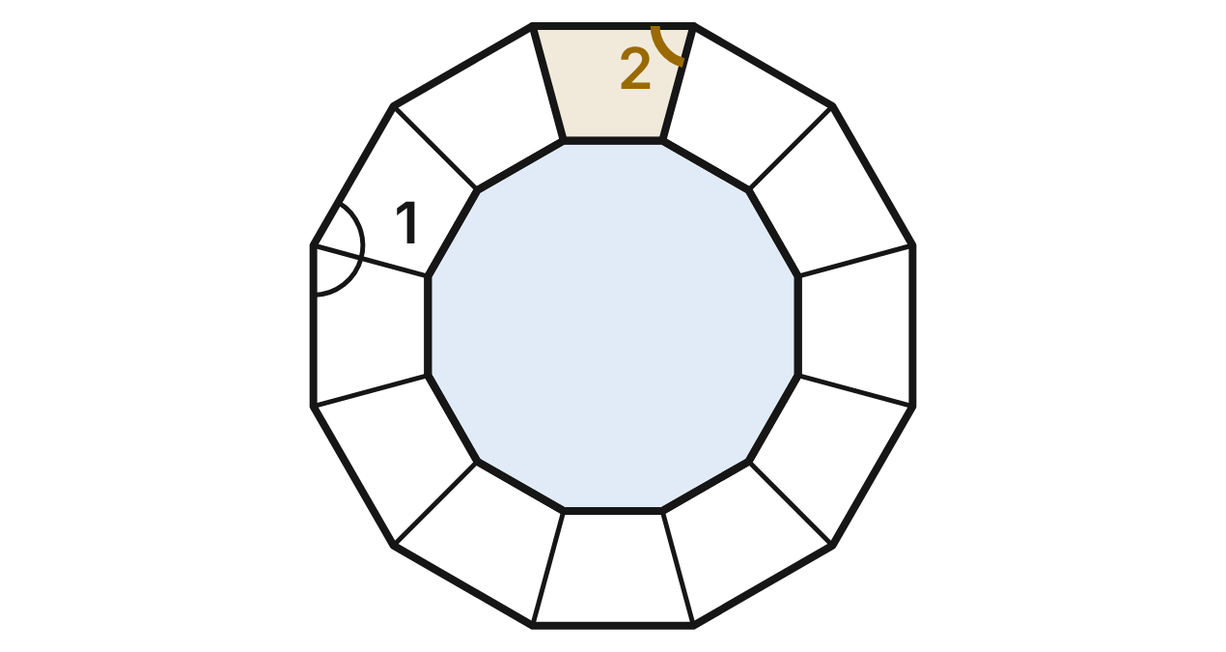
A mirror frame is made of 12 congruent wood strips. Its outer edge is a regular 12-gon. At each corner, two strips meet along a miter cut that splits the corner angle in half. ∠1 is a corner angle of the outer edge. ∠2 is the angle at one end of the gold strip, between its outer edge and the miter cut.
361. What is the sum of the corner angles of the frame's outer edge?
A. 1800° ✔
B. 2160°
C. 1980°
D. 360°
G.PC.2 · skill G.PC.2.1 (LOTS): Find the sum of the interior angles, and the measure of each interior and exterior angle, of a convex or regular polygon
☐ Answer key correct ☐ Wording clear Notes: ________________________________
362. What is m∠1, the corner angle of the outer edge?
A. 30°
B. 180°
C. 165°
D. 150° ✔
G.PC.2 · skill G.PC.2.1 (LOTS): Find the sum of the interior angles, and the measure of each interior and exterior angle, of a convex or regular polygon
☐ Answer key correct ☐ Wording clear Notes: ________________________________
363. What is m∠2, the angle of the miter cut at the end of the gold strip?
A. 150°
B. 15°
C. 75° ✔
D. 30°
G.PC.2 · skill G.PC.2.1 (LOTS): Find the sum of the interior angles, and the measure of each interior and exterior angle, of a convex or regular polygon
☐ Answer key correct ☐ Wording clear Notes: ________________________________
364. Which statement about the outer edge of the frame is NOT true?
A. Each exterior angle measures 30°.
B. Each corner angle is 12 times each exterior angle. ✔
C. The exterior angles add to 360°.
D. Each corner angle and its exterior angle add to 180°.
G.PC.2 · skill G.PC.2.1 (LOTS): Find the sum of the interior angles, and the measure of each interior and exterior angle, of a convex or regular polygon
☐ Answer key correct ☐ Wording clear Notes: ________________________________
365. For another regular frame, a framer cuts every miter at 84°, half of each corner angle. How many strips does that frame have?
A. 30 ✔
B. about 3.8
C. 60
D. 168
G.PC.2 · skill G.PC.2.2 (LOTS): Find the number of sides of a regular polygon given the measure of an interior or exterior angle
☐ Answer key correct ☐ Wording clear Notes: ________________________________
366. A nearly round mirror has a regular frame with corner angles of 177°. How many strips does that frame have?
A. 3
B. about 2.0
C. 60
D. 120 ✔
G.PC.2 · skill G.PC.2.2 (LOTS): Find the number of sides of a regular polygon given the measure of an interior or exterior angle
☐ Answer key correct ☐ Wording clear Notes: ________________________________

The Mosaic Backsplash
Level 2 · Polygons · G.PC.2 · ID geo-pc2-ring-mosaic-backsplash
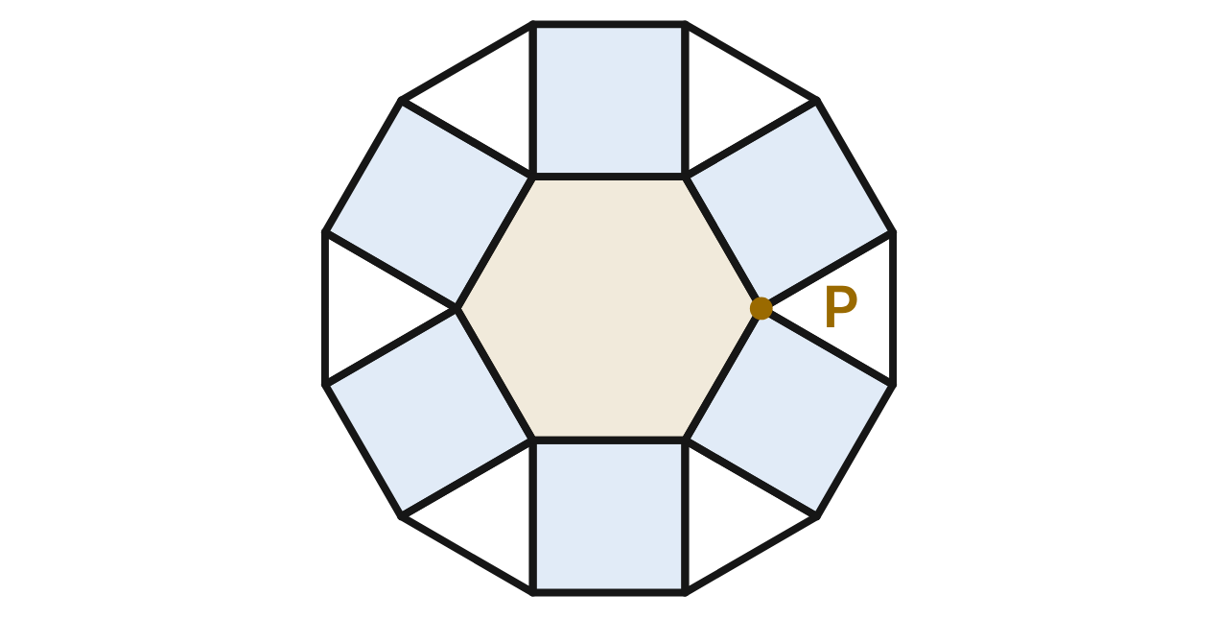
A mosaic backsplash uses tiles shaped like a regular hexagon, squares and equilateral triangles, all with equal sides. At each corner, such as P, one hexagon, two squares and one triangle meet with no gaps or overlaps.
367. Which calculation shows why the four tiles at P leave no gap?
A. 720° + 2(360°) + 180° = 1620°
B. 120° + 90° + 60° = 270°
C. 120° + 2(90°) + 60° = 360° ✔
D. 60° + 2(90°) + 60° = 300°
G.PC.2 · skill G.PC.2.1 (LOTS): Find the sum of the interior angles, and the measure of each interior and exterior angle, of a convex or regular polygon
☐ Answer key correct ☐ Wording clear Notes: ________________________________
368. Kim says, "Four tiles meet at P, so each of their angles at P must be 90°." Which is true?
A. No: the angles differ but add to 360°. ✔
B. Yes: 360° ÷ 4 = 90° for each tile.
C. No: the angles at P add to 720°.
D. Yes: the hexagon's angle at P is 90°.
G.PC.2 · skill G.PC.2.1 (LOTS): Find the sum of the interior angles, and the measure of each interior and exterior angle, of a convex or regular polygon
☐ Answer key correct ☐ Wording clear Notes: ________________________________
369. A tile setter tries a corner with only one hexagon, one square and one triangle. How large is the gap left at that corner?
A. 270°
B. 90° ✔
C. 150°
D. 210°
G.PC.2 · skill G.PC.2.1 (LOTS): Find the sum of the interior angles, and the measure of each interior and exterior angle, of a convex or regular polygon
☐ Answer key correct ☐ Wording clear Notes: ________________________________
370. At one point, a square, a regular pentagon and one other regular polygon fit with no gap or overlap. How many sides does the other polygon have?
A. 162
B. about 2.2
C. 10
D. 20 ✔
G.PC.2 · skill G.PC.2.2 (LOTS): Find the number of sides of a regular polygon given the measure of an interior or exterior angle
☐ Answer key correct ☐ Wording clear Notes: ________________________________
371. Omar says regular pentagon tiles alone could cover the wall, because 5 · 72° = 360°. What is his error?
A. Nothing: 5 · 72° = 360°, so they tile.
B. Each pentagon angle is 120°, not 72°.
C. 72° is the exterior angle; 360 ÷ 108 is not whole. ✔
D. Pentagons tile, but only with squares.
G.PC.2 · skill G.PC.2.1 (LOTS): Find the sum of the interior angles, and the measure of each interior and exterior angle, of a convex or regular polygon
☐ Answer key correct ☐ Wording clear Notes: ________________________________
372. A catalog tile is a regular polygon with exterior angles of 36°. Could these tiles alone cover the wall? Choose the answer with the correct reason.
A. No: its 144° angles do not divide 360°. ✔
B. Yes: 360 ÷ 36 = 10 is whole.
C. Yes: it has 10 sides, an even number.
D. No: it has 5 sides with 36° angles.
G.PC.2 · skill G.PC.2.2 (LOTS): Find the number of sides of a regular polygon given the measure of an interior or exterior angle
☐ Answer key correct ☐ Wording clear Notes: ________________________________

The Band Logo
Level 2 · Polygons · G.PC.2 · ID geo-pc2-ring-band-logo
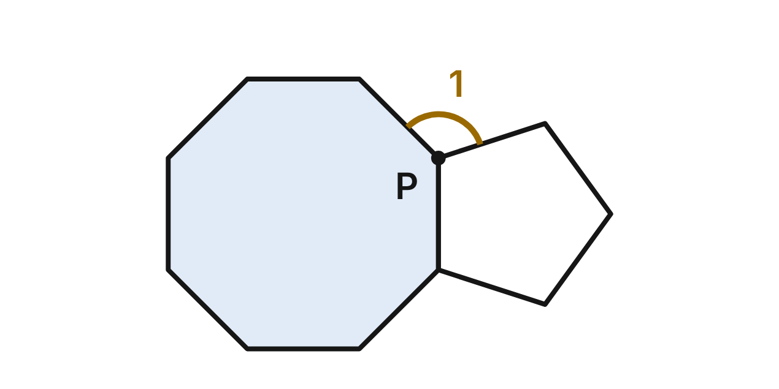
A band's logo is a regular octagon and a regular pentagon that share one side. P is the top end of that side. ∠1 (gold) is the angle at P between the other two sides that meet there.
373. What is the measure of each interior angle of the octagon in the logo?
A. 45°
B. 1080°
C. 157.5°
D. 135° ✔
G.PC.2 · skill G.PC.2.1 (LOTS): Find the sum of the interior angles, and the measure of each interior and exterior angle, of a convex or regular polygon
☐ Answer key correct ☐ Wording clear Notes: ________________________________
374. What is m∠1, the gold angle above P?
A. 243°
B. 117° ✔
C. 153°
D. 27°
G.PC.2 · skill G.PC.2.1 (LOTS): Find the sum of the interior angles, and the measure of each interior and exterior angle, of a convex or regular polygon
☐ Answer key correct ☐ Wording clear Notes: ________________________________
375. The designer swaps the pentagon for a regular hexagon with the same side length, placed the same way. What would m∠1 be then?
A. 105° ✔
B. 255°
C. 165°
D. 15°
G.PC.2 · skill G.PC.2.1 (LOTS): Find the sum of the interior angles, and the measure of each interior and exterior angle, of a convex or regular polygon
☐ Answer key correct ☐ Wording clear Notes: ________________________________
376. A new logo puts a regular octagon and a regular 12-gon (150° angles) side by side the same way. Could a regular polygon fill the angle left at P exactly? Choose the answer with the correct reason.
A. Yes: a square, since 75° is close to 90°.
B. No: no regular polygon has 75° angles. ✔
C. Yes: a triangle, since 75° is more than 60°.
D. No: the gap is 105°, and no polygon has it.
G.PC.2 · skill G.PC.2.2 (LOTS): Find the number of sides of a regular polygon given the measure of an interior or exterior angle
☐ Answer key correct ☐ Wording clear Notes: ________________________________
377. Which statement about the two shapes in the logo is true?
A. The octagon's exterior angles add to more than the pentagon's.
B. Each exterior angle of the pentagon is 108°.
C. The octagon's angles add to 1260°.
D. Each shape's exterior angles add to 360°. ✔
G.PC.2 · skill G.PC.2.1 (LOTS): Find the sum of the interior angles, and the measure of each interior and exterior angle, of a convex or regular polygon
☐ Answer key correct ☐ Wording clear Notes: ________________________________
378. A second logo uses a regular polygon whose interior angles are each 3 times its exterior angles. How many sides does it have?
A. 4
B. 6
C. 8 ✔
D. 135
G.PC.2 · skill G.PC.2.2 (LOTS): Find the number of sides of a regular polygon given the measure of an interior or exterior angle
☐ Answer key correct ☐ Wording clear Notes: ________________________________

The Jeweler's Chart
Level 2 · Polygons · G.PC.2 · ID geo-pc2-ring-jeweler-chart
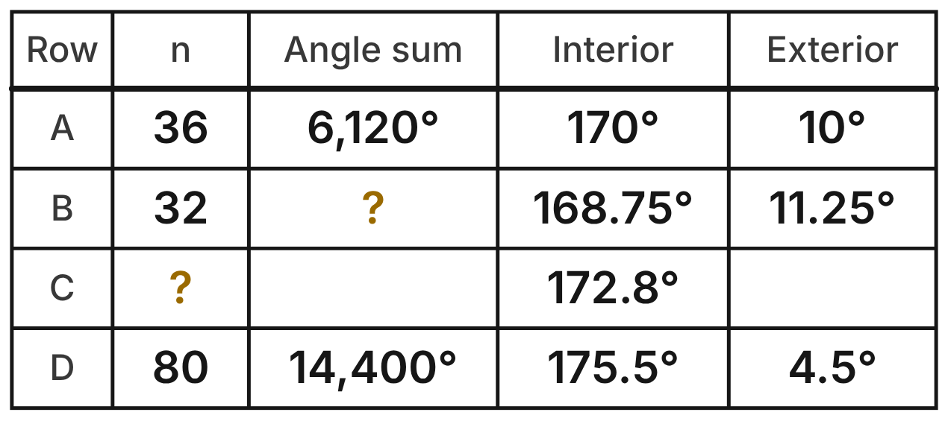
A jeweler keeps a chart of regular polygon outlines for gems. Each row is one regular polygon. A gold ? marks an entry to find. In row D, exactly one entry is wrong.
379. What angle sum belongs in row B of the chart?
A. 5,400° ✔
B. 5,760°
C. 5,580°
D. 5,220°
G.PC.2 · skill G.PC.2.1 (LOTS): Find the sum of the interior angles, and the measure of each interior and exterior angle, of a convex or regular polygon
☐ Answer key correct ☐ Wording clear Notes: ________________________________
380. How many sides does the gem outline in row C have?
A. about 2.1
B. 25
C. 50 ✔
D. 52
G.PC.2 · skill G.PC.2.2 (LOTS): Find the number of sides of a regular polygon given the measure of an interior or exterior angle
☐ Answer key correct ☐ Wording clear Notes: ________________________________
381. Which entry in row D is wrong, and what should it be?
A. the exterior angle; it should be 9°
B. the interior angle; it should be 177.75°
C. the angle sum; it should be 13,860°
D. the angle sum; it should be 14,040° ✔
G.PC.2 · skill G.PC.2.1 (LOTS): Find the sum of the interior angles, and the measure of each interior and exterior angle, of a convex or regular polygon
☐ Answer key correct ☐ Wording clear Notes: ________________________________
382. Which statement is true for every row of a correct chart like this one?
A. Interior angle + exterior angle = 360°
B. Interior angle + exterior angle = 180° ✔
C. The exterior angle is half the interior angle
D. The angle sum is the same in every row
G.PC.2 · skill G.PC.2.1 (LOTS): Find the sum of the interior angles, and the measure of each interior and exterior angle, of a convex or regular polygon
☐ Answer key correct ☐ Wording clear Notes: ________________________________
383. The jeweler adds a row for an outline with interior angles of 177.5°. How many sides does that outline have?
A. about 2.0
B. 144 ✔
C. 72
D. 146
G.PC.2 · skill G.PC.2.2 (LOTS): Find the number of sides of a regular polygon given the measure of an interior or exterior angle
☐ Answer key correct ☐ Wording clear Notes: ________________________________
384. The jeweler adds a column for the sum of the exterior angles. What goes in that column?
A. 180° in every row
B. n · 360° in each row
C. 360° in every row ✔
D. the same as the angle sum
G.PC.2 · skill G.PC.2.1 (LOTS): Find the sum of the interior angles, and the measure of each interior and exterior angle, of a convex or regular polygon
☐ Answer key correct ☐ Wording clear Notes: ________________________________

The Thrust Stage
Level 3 · Polygons · G.PC.2 · ID geo-pc2-ring-thrust-stage
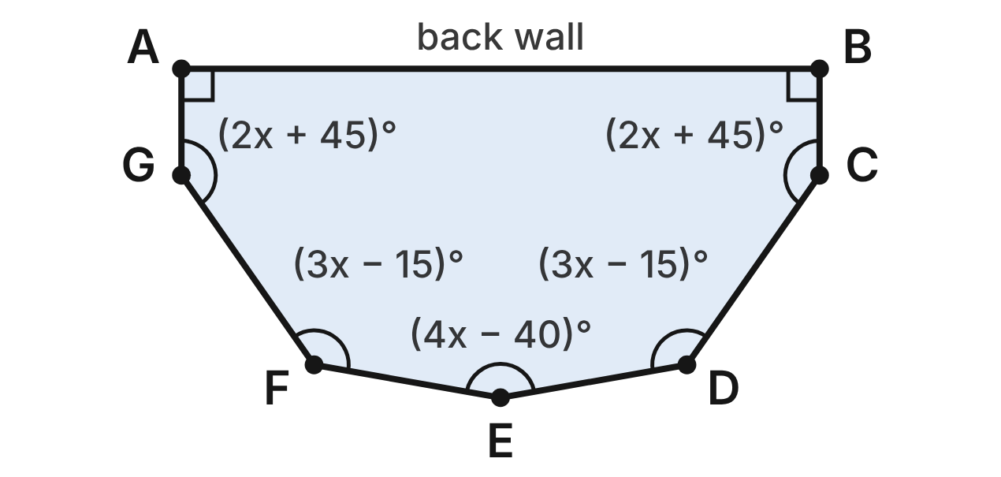
A thrust stage for a concert is the convex heptagon ABCDEFG. ∠A and ∠B are right angles. The other angle measures, in degrees, are shown in terms of x.
385. Which equation uses the stage's seven angles to find x?
A. 14x + 200 = 1080
B. 14x + 20 = 900
C. 14x + 200 = 360
D. 14x + 200 = 900 ✔
G.PC.2 · skill G.PC.2.1 (LOTS): Find the sum of the interior angles, and the measure of each interior and exterior angle, of a convex or regular polygon
☐ Answer key correct ☐ Wording clear Notes: ________________________________
386. Use the stage's angle sum to find the value of x.
A. 50 ✔
B. about 62.9
C. about 64.3
D. about 11.4
G.PC.2 · skill G.PC.2.1 (LOTS): Find the sum of the interior angles, and the measure of each interior and exterior angle, of a convex or regular polygon
☐ Answer key correct ☐ Wording clear Notes: ________________________________
387. What is m∠E, at the front of the stage?
A. 160° ✔
B. 200°
C. 20°
D. about 128.6°
G.PC.2 · skill G.PC.2.1 (LOTS): Find the sum of the interior angles, and the measure of each interior and exterior angle, of a convex or regular polygon
☐ Answer key correct ☐ Wording clear Notes: ________________________________
388. What is the measure of an exterior angle of the stage at corner D?
A. 135°
B. 225°
C. about 51.4°
D. 45° ✔
G.PC.2 · skill G.PC.2.1 (LOTS): Find the sum of the interior angles, and the measure of each interior and exterior angle, of a convex or regular polygon
☐ Answer key correct ☐ Wording clear Notes: ________________________________
389. Which statement about the stage floor is NOT true?
A. ∠C and ∠G are congruent.
B. Each of its angles is about 128.6°. ✔
C. Its exterior angles add to 360°.
D. Its interior angles add to 900°.
G.PC.2 · skill G.PC.2.1 (LOTS): Find the sum of the interior angles, and the measure of each interior and exterior angle, of a convex or regular polygon
☐ Answer key correct ☐ Wording clear Notes: ________________________________
390. On tour, the band uses a stage shaped like a regular polygon. Each interior angle is 140° more than each exterior angle. How many sides does that stage have?
A. 9
B. 20
C. 18 ✔
D. 160
G.PC.2 · skill G.PC.2.2 (LOTS): Find the number of sides of a regular polygon given the measure of an interior or exterior angle
☐ Answer key correct ☐ Wording clear Notes: ________________________________

The Bandstand Plan
Level 3 · Polygons · G.PC.2 · ID geo-pc2-ring-bandstand-plan
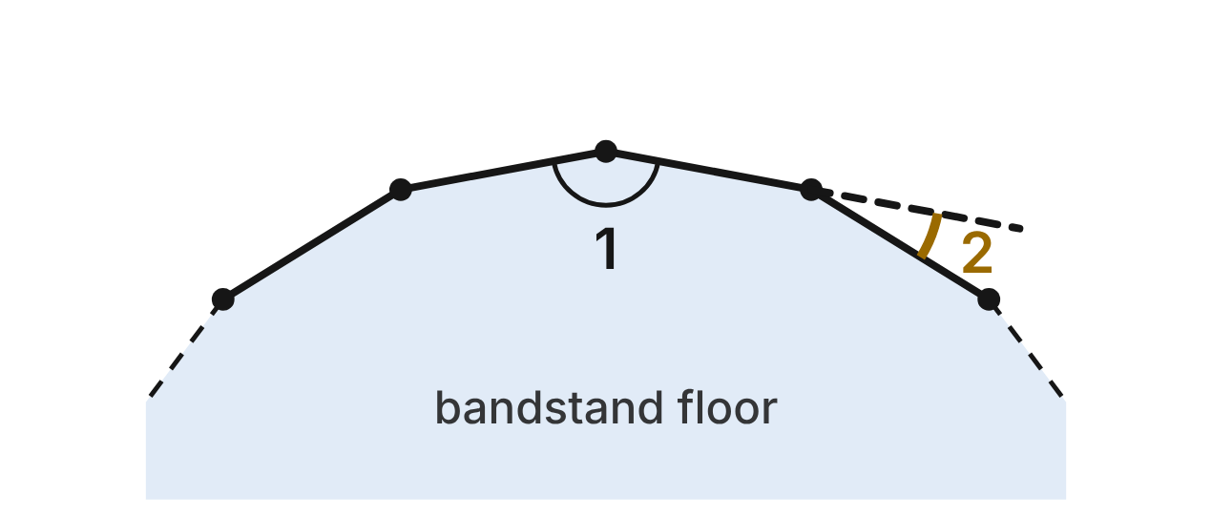
A town's new bandstand floor will be a regular polygon, with a post at each corner. The figure shows part of a plan. ∠1 is the angle inside the floor at a post, and ∠2 is the turn the railing makes at a post. The builders' rule: ∠1 must be at least 158°.
391. What is the fewest number of posts the bandstand can have and still meet the builders' rule?
A. 16
B. 3
C. 17 ✔
D. 9
G.PC.2 · skill G.PC.2.2 (LOTS): Find the number of sides of a regular polygon given the measure of an interior or exterior angle
☐ Answer key correct ☐ Wording clear Notes: ________________________________
392. One plan uses 15 posts. Does it meet the builders' rule? Choose the answer with the correct reason.
A. No: each ∠1 is 156°, less than 158°. ✔
B. No: each ∠1 is 24°, less than 158°.
C. Yes: each ∠1 is 168°, at least 158°.
D. Yes: each ∠1 is 180°, at least 158°.
G.PC.2 · skill G.PC.2.1 (LOTS): Find the sum of the interior angles, and the measure of each interior and exterior angle, of a convex or regular polygon
☐ Answer key correct ☐ Wording clear Notes: ________________________________
393. The builders' rule says ∠1 ≥ 158°. What is the greatest value ∠2 could have under this rule?
A. 158°
B. 22° ✔
C. 202°
D. 11°
G.PC.2 · skill G.PC.2.1 (LOTS): Find the sum of the interior angles, and the measure of each interior and exterior angle, of a convex or regular polygon
☐ Answer key correct ☐ Wording clear Notes: ________________________________
394. Each post added to a regular floor plan adds one side. By how much does that raise the sum of the angles inside the floor?
A. 360°
B. 158°
C. 0°
D. 180° ✔
G.PC.2 · skill G.PC.2.1 (LOTS): Find the sum of the interior angles, and the measure of each interior and exterior angle, of a convex or regular polygon
☐ Answer key correct ☐ Wording clear Notes: ________________________________
395. Which statement is NOT true for every regular floor that meets the builders' rule?
A. The turns add to 360°.
B. A floor with more posts has larger turns. ✔
C. ∠1 and ∠2 add to 180° at each post.
D. ∠1 is larger than ∠2 at each post.
G.PC.2 · skill G.PC.2.1 (LOTS): Find the sum of the interior angles, and the measure of each interior and exterior angle, of a convex or regular polygon
☐ Answer key correct ☐ Wording clear Notes: ________________________________
396. The town picks a plan in which every ∠1 measures exactly 171°. How many posts does that plan have?
A. 9
B. about 2.1
C. 40 ✔
D. 20
G.PC.2 · skill G.PC.2.2 (LOTS): Find the number of sides of a regular polygon given the measure of an interior or exterior angle
☐ Answer key correct ☐ Wording clear Notes: ________________________________

G.PC.3 · Solve problems, including contextual problems, by applying properties of circles.

The Pottery Wheel
Level 1 · Circles · G.PC.3 · ID geo-pc3-ring-pottery-wheel
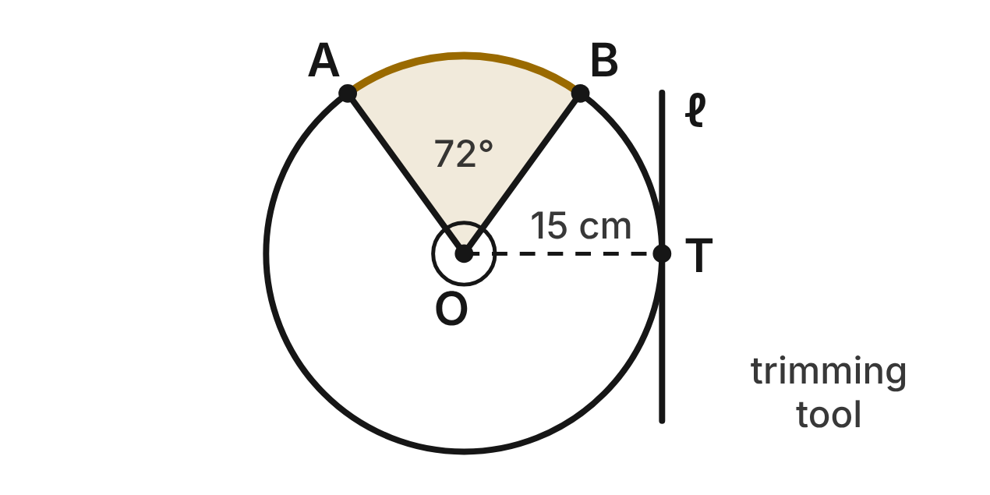
A potter's wheel head is a circle with center O and radius 15 cm. The shaded sector AOB is painted with slip, and m∠AOB = 72°. A trimming tool lies along line ℓ, which touches the rim only at T.
397. How long is arc AB, the curved edge of the painted sector? Give the answer in terms of π.
A. 3π cm
B. 12π cm
C. 45π cm
D. 6π cm ✔
G.PC.3 · skill G.PC.3.3 (LOTS): Find arc length and the area of a sector, or use them to find a radius or a central angle
☐ Answer key correct ☐ Wording clear Notes: ________________________________
398. What is the area of the painted sector AOB, to the nearest tenth of a square centimeter?
A. 9.4 cm²
B. 141.4 cm² ✔
C. 565.5 cm²
D. 706.9 cm²
G.PC.3 · skill G.PC.3.3 (LOTS): Find arc length and the area of a sector, or use them to find a radius or a central angle
☐ Answer key correct ☐ Wording clear Notes: ________________________________
399. Which statement about line ℓ and radius OT must be true?
A. OT ∥ ℓ, because both of them touch the rim at T.
B. ℓ passes through O, because it touches the rim at T.
C. OT ⊥ ℓ, because ℓ is tangent to the rim at T. ✔
D. ℓ meets OT at 45°, because ℓ touches the rim at one point.
G.PC.3 · skill G.PC.3.1 (LOTS): Use the angles formed by chords, secants and tangents (central, inscribed, and angles inside and outside a circle) and their arcs
☐ Answer key correct ☐ Wording clear Notes: ________________________________
400. Two other marks on this rim are 10π cm apart, measured along the rim. What central angle do they make?
A. 120° ✔
B. 240°
C. 60°
D. 16°
G.PC.3 · skill G.PC.3.3 (LOTS): Find arc length and the area of a sector, or use them to find a radius or a central angle
☐ Answer key correct ☐ Wording clear Notes: ________________________________
401. A lump of clay sits on the rim at A. The wheel turns 3.5 times. How far does the lump travel? Round to the nearest centimeter.
A. 330 cm ✔
B. 165 cm
C. 283 cm
D. 660 cm
G.PC.3 · skill G.PC.3.4 (HOTS): Model and solve a contextual problem with the properties of circles
☐ Answer key correct ☐ Wording clear Notes: ________________________________
402. A smaller round clay bat has a 40° sector with an area of 4π cm². What is the radius of the bat?
A. 36 cm
B. 6 cm ✔
C. 18 cm
D. 2 cm
G.PC.3 · skill G.PC.3.3 (LOTS): Find arc length and the area of a sector, or use them to find a radius or a central angle
☐ Answer key correct ☐ Wording clear Notes: ________________________________

The Dance Circle
Level 1 · Circles · G.PC.3 · ID geo-pc3-ring-dance-circle
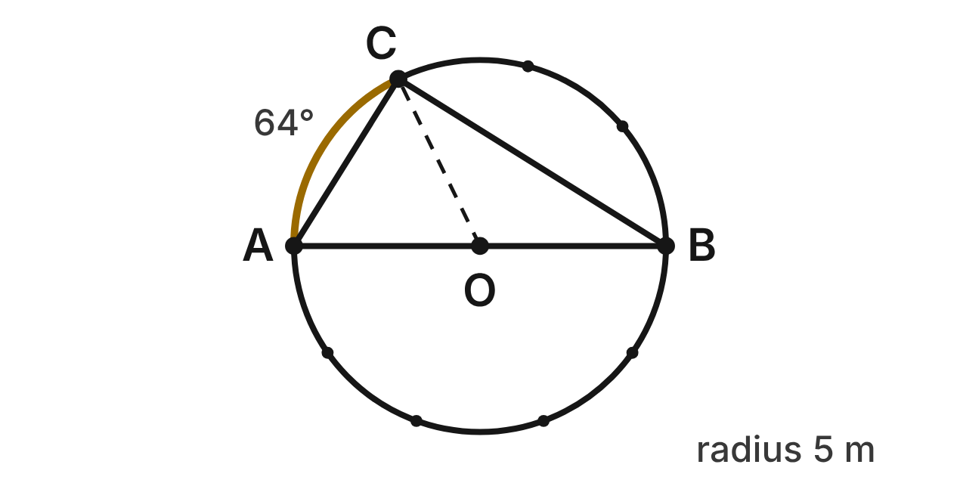
Dancers stand on a circle with center O and radius 5 m. A and B are at the ends of diameter AB. Dancer C is also on the circle, and m(arc AC) = 64°.
403. What is m∠ABC, the angle at B between the lines to A and C?
A. 64°
B. 32° ✔
C. 58°
D. 116°
G.PC.3 · skill G.PC.3.1 (LOTS): Use the angles formed by chords, secants and tangents (central, inscribed, and angles inside and outside a circle) and their arcs
☐ Answer key correct ☐ Wording clear Notes: ________________________________
404. What is m∠CAB, the angle at A between the lines to C and B?
A. 116°
B. 32°
C. 26°
D. 58° ✔
G.PC.3 · skill G.PC.3.1 (LOTS): Use the angles formed by chords, secants and tangents (central, inscribed, and angles inside and outside a circle) and their arcs
☐ Answer key correct ☐ Wording clear Notes: ________________________________
405. Which statement about ∠ACB is true?
A. It is a right angle, because AB is a diameter. ✔
B. It measures 64°, the same as arc AC.
C. It is acute, because arc AC is less than 90°.
D. It is obtuse, because AB is the longest chord.
G.PC.3 · skill G.PC.3.1 (LOTS): Use the angles formed by chords, secants and tangents (central, inscribed, and angles inside and outside a circle) and their arcs
☐ Answer key correct ☐ Wording clear Notes: ________________________________
406. C walks along the circle to A, on arc AC. How far does she walk? Round to the nearest tenth of a meter.
A. 2.8 m
B. 11.2 m
C. 10.1 m
D. 5.6 m ✔
G.PC.3 · skill G.PC.3.3 (LOTS): Find arc length and the area of a sector, or use them to find a radius or a central angle
☐ Answer key correct ☐ Wording clear Notes: ________________________________
407. The floor inside sector AOC is painted. To the nearest tenth of a square meter, what is its area?
A. 7.0 m²
B. 25.3 m²
C. 14.0 m² ✔
D. 55.9 m²
G.PC.3 · skill G.PC.3.3 (LOTS): Find arc length and the area of a sector, or use them to find a radius or a central angle
☐ Answer key correct ☐ Wording clear Notes: ________________________________
408. Tape is laid along the whole circle so the dancers know where to stand. To the nearest tenth of a meter, how much tape is needed?
A. 15.7 m
B. 78.5 m
C. 31.4 m ✔
D. 62.8 m
G.PC.3 · skill G.PC.3.4 (HOTS): Model and solve a contextual problem with the properties of circles
☐ Answer key correct ☐ Wording clear Notes: ________________________________

The Weaving Loom
Level 2 · Circles · G.PC.3 · ID geo-pc3-ring-weaving-loom
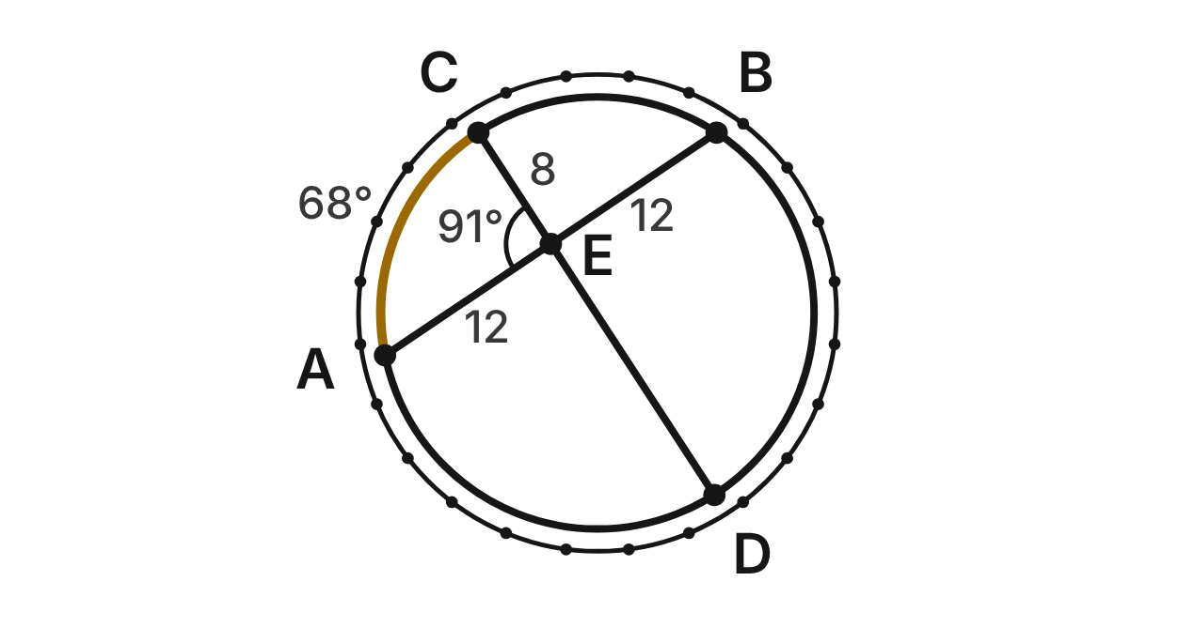
On a round loom with radius about 13 cm, two straight threads cross at E: thread AB and thread CD. AE = 12 cm, EB = 12 cm and CE = 8 cm. m∠AEC = 91° and m(arc AC) = 68°.
409. How long is ED, the other piece of thread CD?
A. 8 cm
B. 16 cm
C. 18 cm ✔
D. 144 cm
G.PC.3 · skill G.PC.3.2 (LOTS): Use the lengths of segments formed by intersecting chords, secants and tangents
☐ Answer key correct ☐ Wording clear Notes: ________________________________
410. Which equation is true for the pieces of the two threads?
A. 12 · 8 = 12 · ED
B. 12 + 12 = 8 + ED
C. 12 / 12 = 8 / ED
D. 12 · 12 = 8 · ED ✔
G.PC.3 · skill G.PC.3.2 (LOTS): Use the lengths of segments formed by intersecting chords, secants and tangents
☐ Answer key correct ☐ Wording clear Notes: ________________________________
411. What is m(arc BD), the arc cut off by the angle vertical to ∠AEC?
A. 23°
B. 91°
C. 114° ✔
D. 250°
G.PC.3 · skill G.PC.3.1 (LOTS): Use the angles formed by chords, secants and tangents (central, inscribed, and angles inside and outside a circle) and their arcs
☐ Answer key correct ☐ Wording clear Notes: ________________________________
412. What is m(arc AD) + m(arc CB)?
A. 89°
B. 178° ✔
C. 182°
D. 269°
G.PC.3 · skill G.PC.3.1 (LOTS): Use the angles formed by chords, secants and tangents (central, inscribed, and angles inside and outside a circle) and their arcs
☐ Answer key correct ☐ Wording clear Notes: ________________________________
413. How long is the gold arc AC along the loom? Round to the nearest tenth of a centimeter.
A. 15.4 cm ✔
B. 7.7 cm
C. 30.9 cm
D. 20.6 cm
G.PC.3 · skill G.PC.3.3 (LOTS): Find arc length and the area of a sector, or use them to find a radius or a central angle
☐ Answer key correct ☐ Wording clear Notes: ________________________________
414. On another loom, two threads cross. One is cut into pieces of 9 cm and 16 cm. The other thread is 30 cm long. How long are its two pieces?
A. 6 cm and 24 cm ✔
B. 12 cm and 18 cm
C. 15 cm and 15 cm
D. 9 cm and 21 cm
G.PC.3 · skill G.PC.3.4 (HOTS): Model and solve a contextual problem with the properties of circles
☐ Answer key correct ☐ Wording clear Notes: ________________________________

The Vinyl Record
Level 2 · Circles · G.PC.3 · ID geo-pc3-ring-vinyl-record
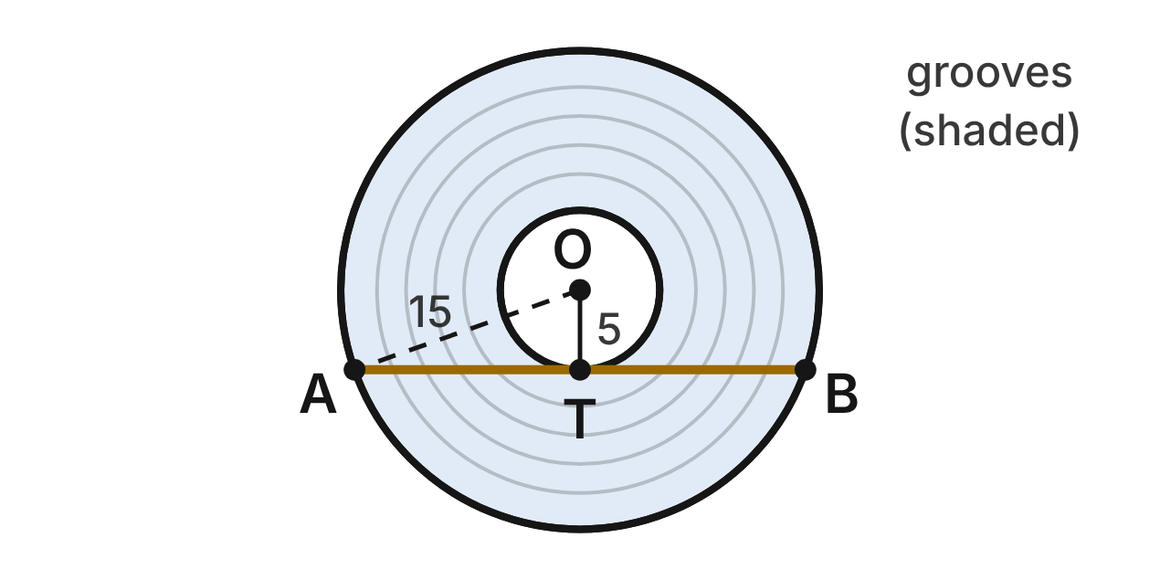
A vinyl record has center O. Its edge is a circle with radius 15 cm, and its label is a circle with radius 5 cm. Chord AB of the edge touches the label only at T. The shaded ring between the label and the edge holds the grooves.
415. Why is OT ⊥ AB?
A. AB is a diameter of the record, so it is ⊥ to every radius.
B. OA = OT, because both are radii of the record.
C. AB is tangent to the label at T, and a tangent is ⊥ to the radius there. ✔
D. ∠AOB is a right angle, because A and B are on the edge.
G.PC.3 · skill G.PC.3.1 (LOTS): Use the angles formed by chords, secants and tangents (central, inscribed, and angles inside and outside a circle) and their arcs
☐ Answer key correct ☐ Wording clear Notes: ________________________________
416. How long is chord AB?
A. 10√2 cm
B. 20 cm
C. 10√10 cm
D. 20√2 cm ✔
G.PC.3 · skill G.PC.3.2 (LOTS): Use the lengths of segments formed by intersecting chords, secants and tangents
☐ Answer key correct ☐ Wording clear Notes: ________________________________
417. What is the area of the shaded grooved ring? Give the answer in terms of π.
A. 200π cm² ✔
B. 100π cm²
C. 250π cm²
D. 20π cm
G.PC.3 · skill G.PC.3.3 (LOTS): Find arc length and the area of a sector, or use them to find a radius or a central angle
☐ Answer key correct ☐ Wording clear Notes: ________________________________
418. Use m∠AOB ≈ 141.1°. How long is minor arc AB of the record's edge? Round to the nearest tenth of a centimeter.
A. 18.5 cm
B. 12.3 cm
C. 57.3 cm
D. 36.9 cm ✔
G.PC.3 · skill G.PC.3.3 (LOTS): Find arc length and the area of a sector, or use them to find a radius or a central angle
☐ Answer key correct ☐ Wording clear Notes: ________________________________
419. The record turns at 33⅓ revolutions per minute. How far does a point on its edge travel in 3 minutes? Round to the nearest meter.
A. 47 m
B. 94 m ✔
C. 31 m
D. 188 m
G.PC.3 · skill G.PC.3.4 (HOTS): Model and solve a contextual problem with the properties of circles
☐ Answer key correct ☐ Wording clear Notes: ________________________________
420. A smaller record has radius 8.5 cm. A chord of its edge that just touches its label is 15 cm long. What is the radius of its label?
A. 1 cm
B. 4 cm ✔
C. 11.3 cm
D. 16 cm
G.PC.3 · skill G.PC.3.2 (LOTS): Use the lengths of segments formed by intersecting chords, secants and tangents
☐ Answer key correct ☐ Wording clear Notes: ________________________________

The Pendant
Level 2 · Circles · G.PC.3 · ID geo-pc3-ring-pendant
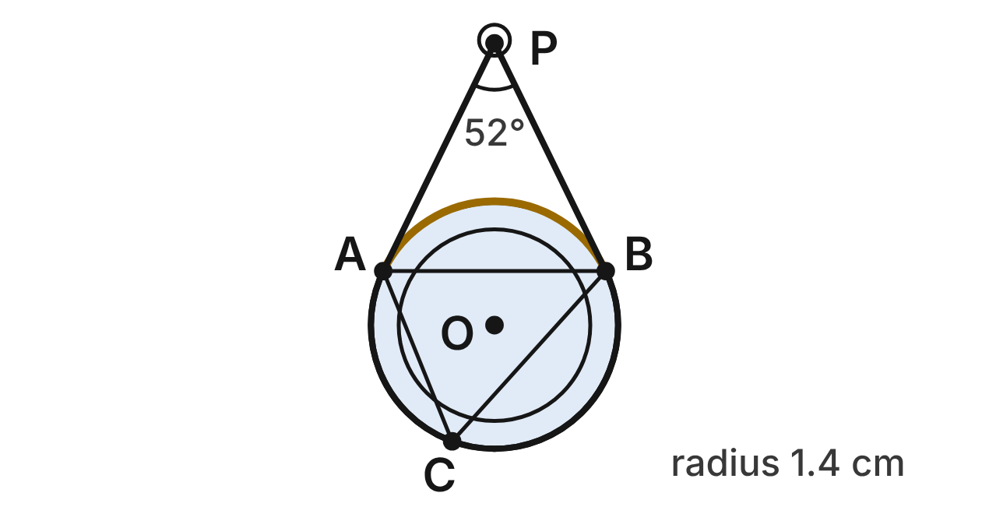
A round pendant with center O and radius 1.4 cm hangs from a clasp P. The straight sides of the chain, PA and PB, are tangent to the pendant at A and B, and m∠APB = 52°. A bead C is on the pendant's lower edge.
421. What is the measure of minor arc AB, the top edge of the pendant between A and B?
A. 52°
B. 104°
C. 128° ✔
D. 232°
G.PC.3 · skill G.PC.3.1 (LOTS): Use the angles formed by chords, secants and tangents (central, inscribed, and angles inside and outside a circle) and their arcs
☐ Answer key correct ☐ Wording clear Notes: ________________________________
422. What is m∠ACB, the angle at the bead between the lines to A and B?
A. 128°
B. 52°
C. 116°
D. 64° ✔
G.PC.3 · skill G.PC.3.1 (LOTS): Use the angles formed by chords, secants and tangents (central, inscribed, and angles inside and outside a circle) and their arcs
☐ Answer key correct ☐ Wording clear Notes: ________________________________
423. Which statement about the two sides of the chain must be true?
A. PA = AB, because △PAB is equilateral.
B. PA = OA, because both segments end at A.
C. PA ⊥ PB, because tangents from one point are perpendicular.
D. PA = PB, because tangent segments from one point are congruent. ✔
G.PC.3 · skill G.PC.3.2 (LOTS): Use the lengths of segments formed by intersecting chords, secants and tangents
☐ Answer key correct ☐ Wording clear Notes: ________________________________
424. What is m∠PAB, the angle between side PA of the chain and chord AB?
A. 64° ✔
B. 52°
C. 128°
D. 26°
G.PC.3 · skill G.PC.3.1 (LOTS): Use the angles formed by chords, secants and tangents (central, inscribed, and angles inside and outside a circle) and their arcs
☐ Answer key correct ☐ Wording clear Notes: ________________________________
425. Use right triangle OAP, where m∠APO = 26°. To the nearest tenth of a centimeter, how long is PA?
A. 2.9 cm ✔
B. 0.7 cm
C. 3.2 cm
D. 1.1 cm
G.PC.3 · skill G.PC.3.4 (HOTS): Model and solve a contextual problem with the properties of circles
☐ Answer key correct ☐ Wording clear Notes: ________________________________
426. The top edge of the pendant, minor arc AB, is trimmed with gold. To the nearest tenth of a centimeter, how long is the trim?
A. 5.7 cm
B. 3.1 cm ✔
C. 1.3 cm
D. 1.6 cm
G.PC.3 · skill G.PC.3.3 (LOTS): Find arc length and the area of a sector, or use them to find a radius or a central angle
☐ Answer key correct ☐ Wording clear Notes: ________________________________

String Art on a Hoop
Level 2 · Circles · G.PC.3 · ID geo-pc3-ring-string-art
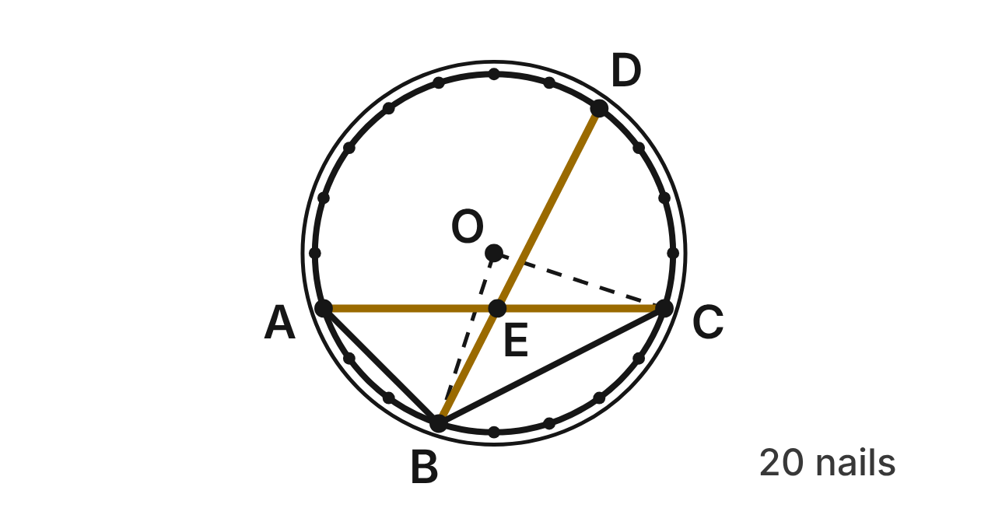
A hoop with center O and radius 25 cm has 20 nails equally spaced around it. Going around the hoop, there are 3 gaps from nail A to nail B, 5 from B to C, 4 from C to D and 8 from D back to A. Gold strings AC and BD cross at E.
427. What is m∠BOC, the central angle from nail B to nail C?
A. 45°
B. 100°
C. 180°
D. 90° ✔
G.PC.3 · skill G.PC.3.1 (LOTS): Use the angles formed by chords, secants and tangents (central, inscribed, and angles inside and outside a circle) and their arcs
☐ Answer key correct ☐ Wording clear Notes: ________________________________
428. What is m∠AEB, where the gold strings cross?
A. 126°
B. 63° ✔
C. 9°
D. 117°
G.PC.3 · skill G.PC.3.1 (LOTS): Use the angles formed by chords, secants and tangents (central, inscribed, and angles inside and outside a circle) and their arcs
☐ Answer key correct ☐ Wording clear Notes: ________________________________
429. What is m∠ABC, the angle at nail B between strings BA and BC?
A. 72°
B. 108° ✔
C. 216°
D. 90°
G.PC.3 · skill G.PC.3.1 (LOTS): Use the angles formed by chords, secants and tangents (central, inscribed, and angles inside and outside a circle) and their arcs
☐ Answer key correct ☐ Wording clear Notes: ________________________________
430. Jada writes m∠BEC = ½(144° − 90°) = 27°. What is her mistake?
A. She should add the arcs: ½(144° + 90°). ✔
B. She should not halve: 144° − 90° = 54°.
C. She should use only arc BC: ½(90°) = 45°.
D. She should double: 2(144° − 90°) = 108°.
G.PC.3 · skill G.PC.3.1 (LOTS): Use the angles formed by chords, secants and tangents (central, inscribed, and angles inside and outside a circle) and their arcs
☐ Answer key correct ☐ Wording clear Notes: ________________________________
431. How far apart are nails A and B along the hoop? Round to the nearest tenth of a centimeter.
A. 11.8 cm
B. 47.1 cm
C. 23.6 cm ✔
D. 7.9 cm
G.PC.3 · skill G.PC.3.3 (LOTS): Find arc length and the area of a sector, or use them to find a radius or a central angle
☐ Answer key correct ☐ Wording clear Notes: ________________________________
432. Arc BCD measures 162°. Use isosceles triangle BOD to find the length of string BD, to the nearest tenth of a centimeter.
A. 70.7 cm
B. 7.8 cm
C. 49.4 cm ✔
D. 24.7 cm
G.PC.3 · skill G.PC.3.4 (HOTS): Model and solve a contextual problem with the properties of circles
☐ Answer key correct ☐ Wording clear Notes: ________________________________

The Rose Window
Level 3 · Circles · G.PC.3 · ID geo-pc3-ring-rose-window
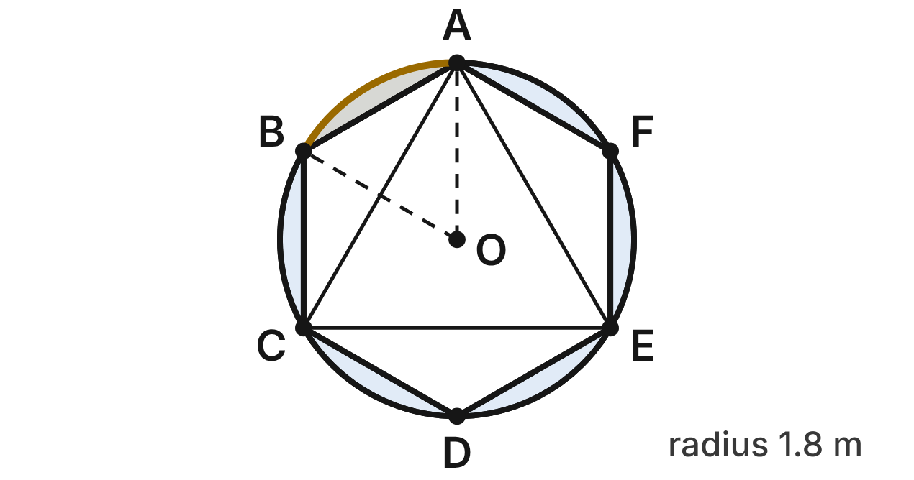
A round rose window has center O and radius 1.8 m. Lead lines form a regular hexagon ABCDEF with its vertices on the circle, and triangle ACE inside it. The hexagon is clear glass. The six pieces between the hexagon and the circle are blue glass; the gold one is between A and B.
433. What is m∠CAE, the angle at A between lead lines AC and AE?
A. 120°
B. 30°
C. 60° ✔
D. 90°
G.PC.3 · skill G.PC.3.1 (LOTS): Use the angles formed by chords, secants and tangents (central, inscribed, and angles inside and outside a circle) and their arcs
☐ Answer key correct ☐ Wording clear Notes: ________________________________
434. Why is side AB of the hexagon 1.8 m long?
A. OA = OB = 1.8 m and m∠AOB = 60°, so △AOB is equilateral. ✔
B. AB is a diameter, so it is as long as the radius.
C. Every chord of a circle is as long as its radius.
D. m∠AOB = 90°, so AB is as long as OA.
G.PC.3 · skill G.PC.3.1 (LOTS): Use the angles formed by chords, secants and tangents (central, inscribed, and angles inside and outside a circle) and their arcs
☐ Answer key correct ☐ Wording clear Notes: ________________________________
435. What is the area of sector AOB, to the nearest hundredth of a square meter?
A. 0.85 m²
B. 1.70 m² ✔
C. 6.79 m²
D. 10.18 m²
G.PC.3 · skill G.PC.3.3 (LOTS): Find arc length and the area of a sector, or use them to find a radius or a central angle
☐ Answer key correct ☐ Wording clear Notes: ________________________________
436. The area of △AOB is about 1.40 m². What is the area of the gold piece of glass, to the nearest tenth of a square meter?
A. 1.4 m²
B. 1.2 m²
C. 8.8 m²
D. 0.3 m² ✔
G.PC.3 · skill G.PC.3.4 (HOTS): Model and solve a contextual problem with the properties of circles
☐ Answer key correct ☐ Wording clear Notes: ________________________________
437. Lead came goes all the way around the gold piece: along arc AB and along side AB. To the nearest tenth of a meter, how long is it?
A. 3.7 m ✔
B. 1.9 m
C. 5.5 m
D. 2.7 m
G.PC.3 · skill G.PC.3.4 (HOTS): Model and solve a contextual problem with the properties of circles
☐ Answer key correct ☐ Wording clear Notes: ________________________________
438. What percent of the window's area is blue or gold glass (all six pieces), to the nearest percent?
A. 83%
B. 17% ✔
C. 3%
D. 21%
G.PC.3 · skill G.PC.3.4 (HOTS): Model and solve a contextual problem with the properties of circles
☐ Answer key correct ☐ Wording clear Notes: ________________________________

The Mandala Guide Lines
Level 3 · Circles · G.PC.3 · ID geo-pc3-ring-mandala
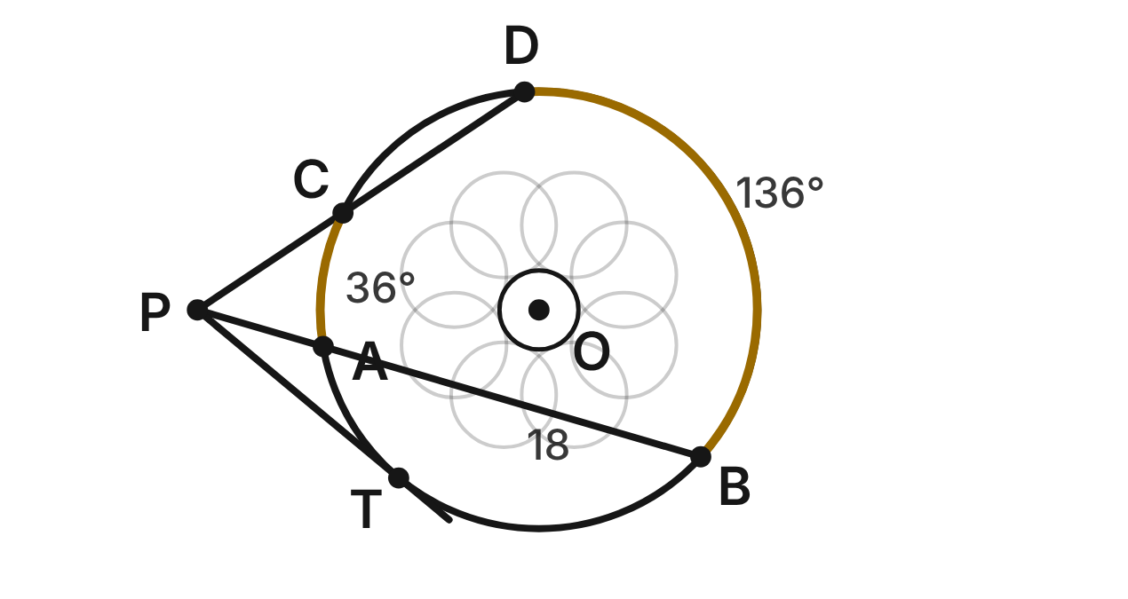
An artist draws a mandala on a circle with center O and radius 10 cm. From point P outside the circle she rules three guide lines. One crosses the circle at A and B, one crosses it at C and D, and one touches it only at T. PA = 6 cm, AB = 18 cm and PC = 8 cm. m(arc AC) = 36° and m(arc BD) = 136°.
439. How long is CD, the part of the second guide line inside the circle?
A. 13.5 cm
B. 18 cm
C. 14 cm
D. 10 cm ✔
G.PC.3 · skill G.PC.3.2 (LOTS): Use the lengths of segments formed by intersecting chords, secants and tangents
☐ Answer key correct ☐ Wording clear Notes: ________________________________
440. How long is PT, the guide line from P to the point where it touches the circle?
A. 6√3 cm
B. 12 cm ✔
C. 144 cm
D. 15 cm
G.PC.3 · skill G.PC.3.2 (LOTS): Use the lengths of segments formed by intersecting chords, secants and tangents
☐ Answer key correct ☐ Wording clear Notes: ________________________________
441. What is m∠APC, the angle between the first two guide lines?
A. 50° ✔
B. 86°
C. 100°
D. 68°
G.PC.3 · skill G.PC.3.1 (LOTS): Use the angles formed by chords, secants and tangents (central, inscribed, and angles inside and outside a circle) and their arcs
☐ Answer key correct ☐ Wording clear Notes: ________________________________
442. Which statement is NOT true?
A. PA · PB = PC · PD
B. PT² = PA · PB
C. m∠ADC = ½ · m(arc AC)
D. PC · CD = PA · AB ✔
G.PC.3 · skill G.PC.3.2 (LOTS): Use the lengths of segments formed by intersecting chords, secants and tangents
☐ Answer key correct ☐ Wording clear Notes: ________________________________
443. How long is the far arc BD? Round to the nearest tenth of a centimeter.
A. 6.3 cm
B. 11.9 cm
C. 23.7 cm ✔
D. 8.7 cm
G.PC.3 · skill G.PC.3.3 (LOTS): Find arc length and the area of a sector, or use them to find a radius or a central angle
☐ Answer key correct ☐ Wording clear Notes: ________________________________
444. She rules one more line from P to the center O. To the nearest tenth of a centimeter, how long is PO?
A. 22 cm
B. 6.6 cm
C. 15.6 cm ✔
D. 26.0 cm
G.PC.3 · skill G.PC.3.4 (HOTS): Model and solve a contextual problem with the properties of circles
☐ Answer key correct ☐ Wording clear Notes: ________________________________

G.PC.4 · Solve problems involving equations of circles.

The Round Sticker
Level 1 · Equations of circles · G.PC.4 · ID geo-pc4-ring-sticker
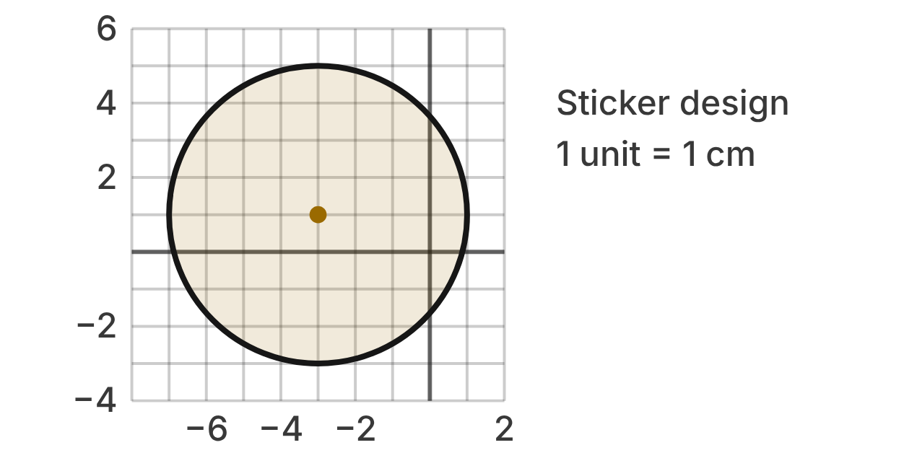
A designer draws a round sticker on a grid. Each unit is 1 cm. The shaded circle is the edge of the sticker, and the gold dot is its center.
445. What are the coordinates of the center of the sticker?
A. (3, −1)
B. (−3, 1) ✔
C. (1, −3)
D. (−3, 5)
G.PC.4 · skill G.PC.4.1 (LOTS): Identify the center and radius of a circle from its graph or from its equation in standard form
☐ Answer key correct ☐ Wording clear Notes: ________________________________
446. How wide is the sticker, measured straight across through its center?
A. 8 cm ✔
B. 4 cm
C. 16 cm
D. 2 cm
G.PC.4 · skill G.PC.4.1 (LOTS): Identify the center and radius of a circle from its graph or from its equation in standard form
☐ Answer key correct ☐ Wording clear Notes: ________________________________
447. Which equation describes the edge of the sticker?
A. (x − 3)² + (y + 1)² = 16
B. (x + 3)² + (y − 1)² = 4
C. (x + 3)² + (y − 1)² = 64
D. (x + 3)² + (y − 1)² = 16 ✔
G.PC.4 · skill G.PC.4.2 (LOTS): Write the equation of a circle from its center and radius, its center and a point, or the endpoints of a diameter
☐ Answer key correct ☐ Wording clear Notes: ________________________________
448. A small star is printed at (−1, 4). Where is it compared with the sticker? Choose the answer with the correct reason.
A. Outside: 2 + 3 = 5, more than 4
B. Outside: (−1 − 3)² + (4 + 1)² = 41, more than 16
C. Inside: 2² + 3² = 13, less than 16 ✔
D. Outside: 2² + 3² = 13, more than 4
G.PC.4 · skill G.PC.4.1 (LOTS): Identify the center and radius of a circle from its graph or from its equation in standard form
☐ Answer key correct ☐ Wording clear Notes: ________________________________
449. A right triangle has the radius from the center to a point (x, y) on the edge as its hypotenuse. Its legs follow the grid lines. Which expressions give the lengths of the legs?
A. |x + 3| and |y − 1| ✔
B. |x − 3| and |y + 1|
C. |x| and |y|
D. |x + 3| and |y + 1|
G.PC.4 · skill G.PC.4.3 (HOTS): Derive the equation of a circle with the Pythagorean Theorem or the distance formula
☐ Answer key correct ☐ Wording clear Notes: ________________________________
450. A second sticker has the edge (x − 5)² + (y + 6)² = 28. What are its center and radius?
A. (−5, 6); r = 2√7 cm
B. (5, −6); r = 28 cm
C. (5, −6); r = 14 cm
D. (5, −6); r = 2√7 cm ✔
G.PC.4 · skill G.PC.4.1 (LOTS): Identify the center and radius of a circle from its graph or from its equation in standard form
☐ Answer key correct ☐ Wording clear Notes: ________________________________

The Wall Clock
Level 1 · Equations of circles · G.PC.4 · ID geo-pc4-ring-wall-clock
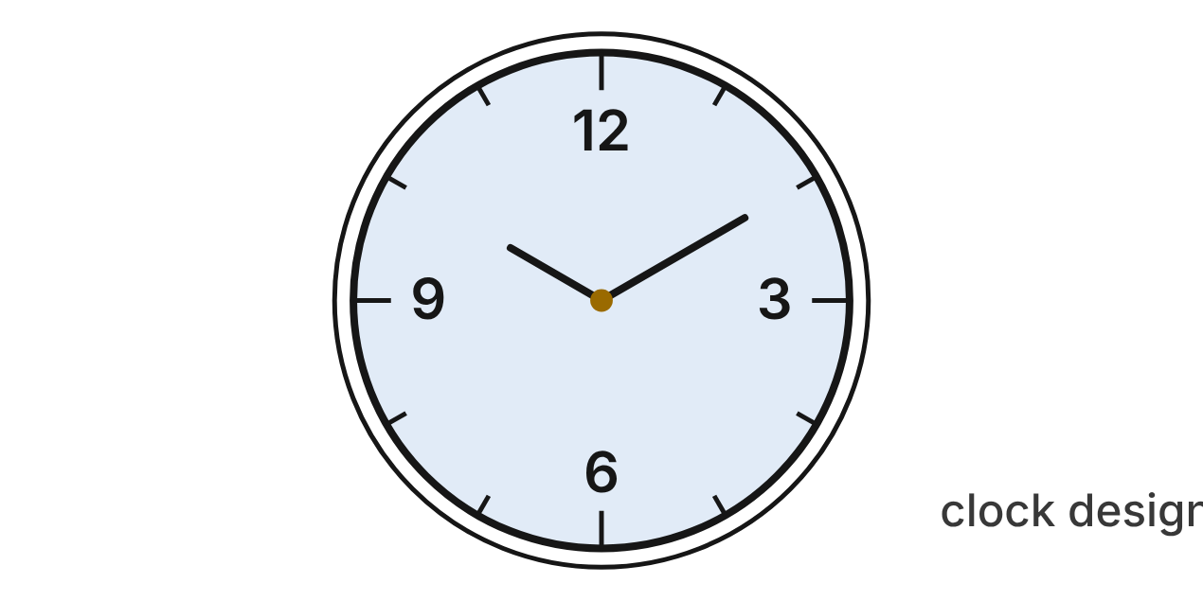
On a design plan in inches, the edge of a wall clock's face is (x − 4)² + (y + 5)² = 169. The hands are pinned at the center. The 12 is at the edge, straight above the center.
451. Where are the hands pinned? Give the coordinates of the center of the face.
A. (−4, 5)
B. (−4, −5)
C. (4, −5) ✔
D. (4, 5)
G.PC.4 · skill G.PC.4.1 (LOTS): Identify the center and radius of a circle from its graph or from its equation in standard form
☐ Answer key correct ☐ Wording clear Notes: ________________________________
452. A minute hand reaches from the center exactly to the edge of the face. How long is it?
A. 169 in
B. 26 in
C. 84.5 in
D. 13 in ✔
G.PC.4 · skill G.PC.4.1 (LOTS): Identify the center and radius of a circle from its graph or from its equation in standard form
☐ Answer key correct ☐ Wording clear Notes: ________________________________
453. The 12 is on the edge, straight above the center. What are its coordinates?
A. (4, 8) ✔
B. (4, −18)
C. (17, −5)
D. (4, 164)
G.PC.4 · skill G.PC.4.1 (LOTS): Identify the center and radius of a circle from its graph or from its equation in standard form
☐ Answer key correct ☐ Wording clear Notes: ________________________________
454. Which point is on the edge of the clock face?
A. (1, 17)
B. (9, 7) ✔
C. (9, 3)
D. (6, −2)
G.PC.4 · skill G.PC.4.1 (LOTS): Identify the center and radius of a circle from its graph or from its equation in standard form
☐ Answer key correct ☐ Wording clear Notes: ________________________________
455. A right triangle has its hypotenuse from the center of the face to the point (−8, 0), with one horizontal leg and one vertical leg. Which equation gives that distance d?
A. 4² + 5² = d²
B. 8² + 0² = d²
C. 12 + 5 = d
D. 12² + 5² = d² ✔
G.PC.4 · skill G.PC.4.3 (HOTS): Derive the equation of a circle with the Pythagorean Theorem or the distance formula
☐ Answer key correct ☐ Wording clear Notes: ________________________________
456. A desk clock has the same center and a diameter of 10 in. Which equation describes the edge of its face?
A. (x − 4)² + (y + 5)² = 25 ✔
B. (x − 4)² + (y + 5)² = 100
C. (x − 4)² + (y + 5)² = 5
D. (x + 4)² + (y − 5)² = 25
G.PC.4 · skill G.PC.4.2 (LOTS): Write the equation of a circle from its center and radius, its center and a point, or the endpoints of a diameter
☐ Answer key correct ☐ Wording clear Notes: ________________________________

The Stage Spotlight
Level 2 · Equations of circles · G.PC.4 · ID geo-pc4-ring-spotlight
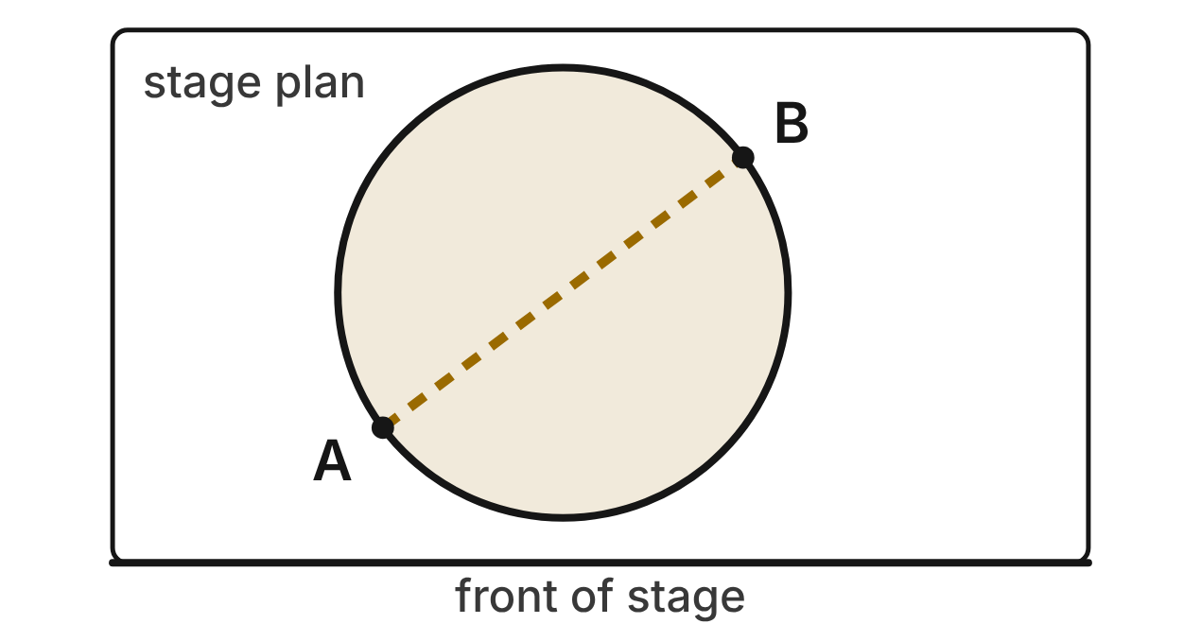
On a stage plan (units in feet), a spotlight lights a circle on the floor. Tape marks A(−5, 2) and B(3, 8) are the ends of a diameter of the lit circle.
457. Where should the light be aimed? Give the center of the lit circle.
A. (−1, 5) ✔
B. (−2, 10)
C. (4, 3)
D. (8, 6)
G.PC.4 · skill G.PC.4.2 (LOTS): Write the equation of a circle from its center and radius, its center and a point, or the endpoints of a diameter
☐ Answer key correct ☐ Wording clear Notes: ________________________________
458. What is the radius of the lit circle?
A. 10 ft
B. 25 ft
C. 5 ft ✔
D. 7 ft
G.PC.4 · skill G.PC.4.2 (LOTS): Write the equation of a circle from its center and radius, its center and a point, or the endpoints of a diameter
☐ Answer key correct ☐ Wording clear Notes: ________________________________
459. Which equation describes the edge of the lit circle?
A. (x − 1)² + (y + 5)² = 25
B. (x + 1)² + (y − 5)² = 25 ✔
C. (x + 1)² + (y − 5)² = 100
D. (x + 5)² + (y − 2)² = 25
G.PC.4 · skill G.PC.4.2 (LOTS): Write the equation of a circle from its center and radius, its center and a point, or the endpoints of a diameter
☐ Answer key correct ☐ Wording clear Notes: ________________________________
460. An actor stands at (1, 1). Is she in the light? Choose the answer with the correct reason.
A. No: (1 − 1)² + (1 + 5)² = 36, more than 25
B. No: 2 + 4 = 6 ft, more than 5 ft
C. No: (1 + 1)² + (1 − 5)² = 20, more than 5
D. Yes: (1 + 1)² + (1 − 5)² = 20, less than 25 ✔
G.PC.4 · skill G.PC.4.1 (LOTS): Identify the center and radius of a circle from its graph or from its equation in standard form
☐ Answer key correct ☐ Wording clear Notes: ________________________________
461. Rae checks that B is on the circle with a right triangle. Its hypotenuse runs from the center of the circle to B, and its legs are horizontal and vertical. How long are the legs?
A. 8 ft and 6 ft
B. 4 ft and 3 ft ✔
C. 3 ft and 8 ft
D. 4 ft and 13 ft
G.PC.4 · skill G.PC.4.3 (HOTS): Derive the equation of a circle with the Pythagorean Theorem or the distance formula
☐ Answer key correct ☐ Wording clear Notes: ________________________________
462. A small follow spot is centered at B. Its edge passes through (4, 5). Which equation describes its edge?
A. (x − 3)² + (y − 8)² = √10
B. (x + 3)² + (y + 8)² = 10
C. (x − 3)² + (y − 8)² = 10 ✔
D. (x − 4)² + (y − 5)² = 10
G.PC.4 · skill G.PC.4.2 (LOTS): Write the equation of a circle from its center and radius, its center and a point, or the endpoints of a diameter
☐ Answer key correct ☐ Wording clear Notes: ________________________________

The Drum Rug
Level 2 · Equations of circles · G.PC.4 · ID geo-pc4-ring-drum-rug
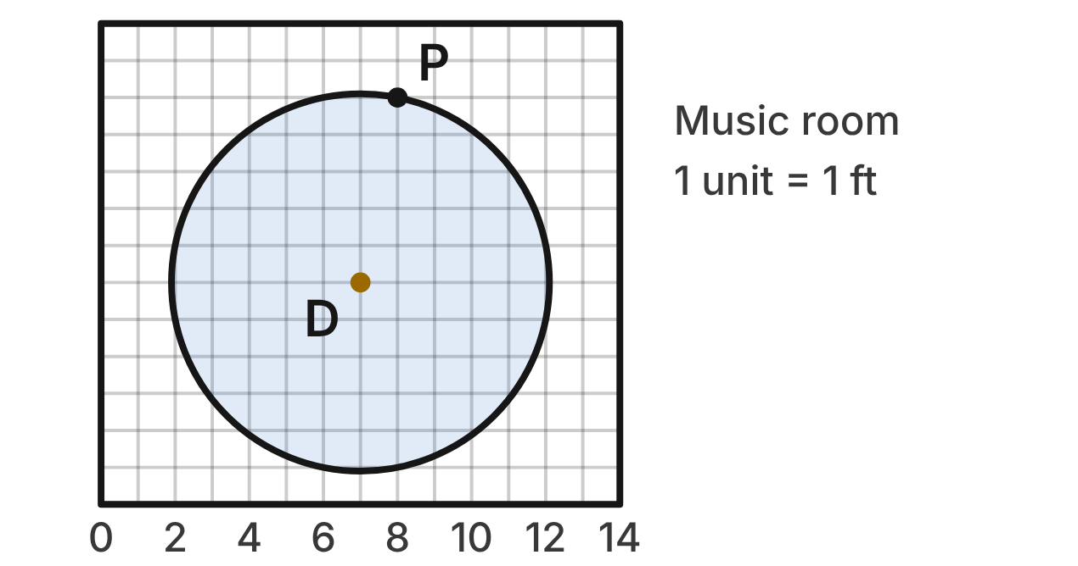
On a floor plan of a music room (units in feet), a round rug sits under the drum kit. Its center is D(7, 6), and P(8, 11) is on its edge.
463. Which expression gives the radius of the rug, using the distance formula?
A. √((8 + 7)² + (11 + 6)²)
B. (8 − 7)² + (11 − 6)²
C. √((8 − 7) + (11 − 6))
D. √((8 − 7)² + (11 − 6)²) ✔
G.PC.4 · skill G.PC.4.3 (HOTS): Derive the equation of a circle with the Pythagorean Theorem or the distance formula
☐ Answer key correct ☐ Wording clear Notes: ________________________________
464. Which equation describes the edge of the rug?
A. (x + 7)² + (y + 6)² = 26
B. (x − 7)² + (y − 6)² = 26 ✔
C. (x − 7)² + (y − 6)² = √26
D. (x − 8)² + (y − 11)² = 26
G.PC.4 · skill G.PC.4.2 (LOTS): Write the equation of a circle from its center and radius, its center and a point, or the endpoints of a diameter
☐ Answer key correct ☐ Wording clear Notes: ________________________________
465. To the nearest tenth of a foot, what is the radius of the rug?
A. 5.1 ft ✔
B. 6.0 ft
C. 13.0 ft
D. 10.2 ft
G.PC.4 · skill G.PC.4.1 (LOTS): Identify the center and radius of a circle from its graph or from its equation in standard form
☐ Answer key correct ☐ Wording clear Notes: ________________________________
466. Which statement about the rug is NOT true?
A. (2, 5) is on the edge of the rug.
B. (10, 9) is inside the rug.
C. (11, 2) is on the edge of the rug. ✔
D. (4, 3) is inside the rug.
G.PC.4 · skill G.PC.4.1 (LOTS): Identify the center and radius of a circle from its graph or from its equation in standard form
☐ Answer key correct ☐ Wording clear Notes: ________________________________
467. A smaller rug has the same center. Its edge passes through (7, 9). Which equation describes its edge?
A. (x − 7)² + (y − 6)² = 9 ✔
B. (x − 7)² + (y − 9)² = 9
C. (x − 7)² + (y − 6)² = 3
D. (x − 7)² + (y − 6)² = 81
G.PC.4 · skill G.PC.4.2 (LOTS): Write the equation of a circle from its center and radius, its center and a point, or the endpoints of a diameter
☐ Answer key correct ☐ Wording clear Notes: ________________________________
468. Lee says the edge of the rug is every point that is 26 ft from D. What is his mistake?
A. The edge is every point 26 ft from P.
B. 26 is r², so the edge is √26 ft from D. ✔
C. 26 is the diameter, so the edge is 13 ft from D.
D. The edge is 26² ft from D.
G.PC.4 · skill G.PC.4.3 (HOTS): Derive the equation of a circle with the Pythagorean Theorem or the distance formula
☐ Answer key correct ☐ Wording clear Notes: ________________________________

The Pottery Wheel
Level 2 · Equations of circles · G.PC.4 · ID geo-pc4-ring-pottery-wheel
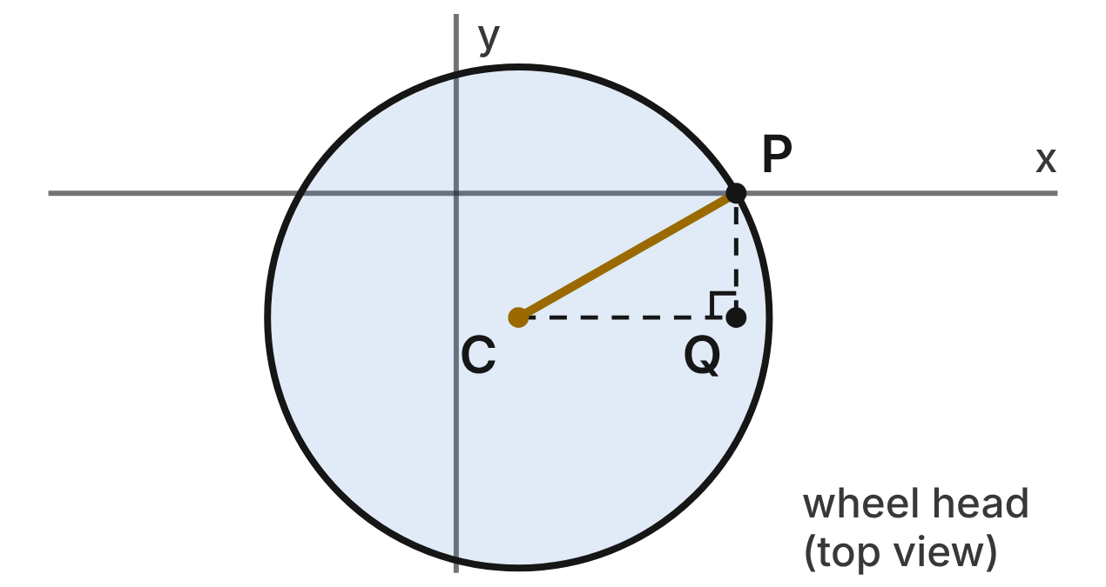
A potter's plan shows the round wheel head from above (units in inches). Its center is C(2, −4), and P(9, 0) is on its edge. Point Q(9, −4) makes right triangle CQP.
469. How long is leg CQ?
A. 11 in
B. 7 in ✔
C. 9 in
D. 4 in
G.PC.4 · skill G.PC.4.3 (HOTS): Derive the equation of a circle with the Pythagorean Theorem or the distance formula
☐ Answer key correct ☐ Wording clear Notes: ________________________________
470. Which equation does the Pythagorean theorem give for triangle CQP, where r = CP?
A. 7 + 4 = r
B. 7² − 4² = r²
C. 7² + 4² = r² ✔
D. 11² + 4² = r²
G.PC.4 · skill G.PC.4.3 (HOTS): Derive the equation of a circle with the Pythagorean Theorem or the distance formula
☐ Answer key correct ☐ Wording clear Notes: ________________________________
471. Which equation describes the edge of the wheel head?
A. (x − 2)² + (y + 4)² = 65 ✔
B. (x + 2)² + (y − 4)² = 65
C. (x − 2)² + (y + 4)² = 121
D. (x − 9)² + y² = 65
G.PC.4 · skill G.PC.4.2 (LOTS): Write the equation of a circle from its center and radius, its center and a point, or the endpoints of a diameter
☐ Answer key correct ☐ Wording clear Notes: ________________________________
472. To the nearest tenth of an inch, what is the radius of the wheel head?
A. 32.5 in
B. 11.0 in
C. 16.1 in
D. 8.1 in ✔
G.PC.4 · skill G.PC.4.1 (LOTS): Identify the center and radius of a circle from its graph or from its equation in standard form
☐ Answer key correct ☐ Wording clear Notes: ________________________________
473. Why does every point (x, y) on the edge of the wheel head fit (x − 2)² + (y + 4)² = 65?
A. It is 65 in from C; square the distance formula.
B. Its x and y distances from C add to √65 in.
C. It is √65 in from C; square the distance formula. ✔
D. It is √65 in from P; square the distance formula.
G.PC.4 · skill G.PC.4.3 (HOTS): Derive the equation of a circle with the Pythagorean Theorem or the distance formula
☐ Answer key correct ☐ Wording clear Notes: ________________________________
474. A trimming tool rests at (6, −9). Does it rest on the wheel head (inside or on its edge)? Choose the answer with the correct reason.
A. Yes: (6 − 2)² + (−9 + 4)² = 41, less than 65 ✔
B. No: 4 + 5 = 9 in, more than the radius
C. No: (6 + 2)² + (−9 − 4)² = 233, more than 65
D. No: 41 is more than √65, the radius
G.PC.4 · skill G.PC.4.1 (LOTS): Identify the center and radius of a circle from its graph or from its equation in standard form
☐ Answer key correct ☐ Wording clear Notes: ________________________________

The Record Design
Level 3 · Equations of circles · G.PC.4 · ID geo-pc4-ring-record
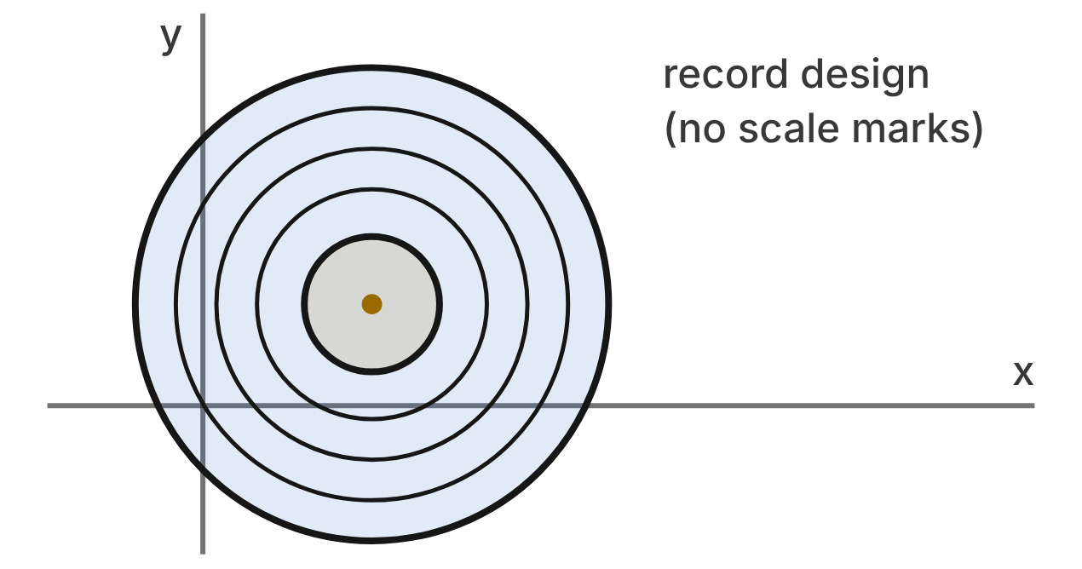
A design app draws a record (units in inches). The edge of the record is x² + y² − 10x − 6y − 15 = 0. The spindle hole is at the center.
475. Dee groups x² − 10x and y² − 6y. Which trinomial is a perfect square?
A. x² − 10x + 5
B. x² − 10x + 100
C. x² − 10x + 25 ✔
D. x² − 10x − 25
G.PC.4 · skill G.PC.4.1 (LOTS): Identify the center and radius of a circle from its graph or from its equation in standard form
☐ Answer key correct ☐ Wording clear Notes: ________________________________
476. What are the center and radius of the record?
A. (5, 3); r = 7 in ✔
B. (−5, −3); r = 7 in
C. (5, 3); r = 49 in
D. (5, 3); r = √15 in
G.PC.4 · skill G.PC.4.1 (LOTS): Identify the center and radius of a circle from its graph or from its equation in standard form
☐ Answer key correct ☐ Wording clear Notes: ________________________________
477. Omar writes (x − 5)² + (y − 3)² = −15 + 25 + 9 = 19. What is his mistake?
A. He should add 10 and 6, not 25 and 9.
B. He should subtract 25 and 9 on the right side.
C. He should write (x + 5)² + (y + 3)².
D. The −15 moves to the right side as +15. ✔
G.PC.4 · skill G.PC.4.1 (LOTS): Identify the center and radius of a circle from its graph or from its equation in standard form
☐ Answer key correct ☐ Wording clear Notes: ________________________________
478. The paper label is a circle with the same center as the record and a diameter of 4 in. Which equation describes its edge?
A. (x − 5)² + (y − 3)² = 16
B. (x − 5)² + (y − 3)² = 4 ✔
C. (x − 5)² + (y − 3)² = 2
D. (x + 5)² + (y + 3)² = 4
G.PC.4 · skill G.PC.4.2 (LOTS): Write the equation of a circle from its center and radius, its center and a point, or the endpoints of a diameter
☐ Answer key correct ☐ Wording clear Notes: ________________________________
479. A dust speck sits on the record at (1, 7). How far is it from the spindle hole?
A. 8 in
B. 32 in
C. 2√13 in
D. 4√2 in ✔
G.PC.4 · skill G.PC.4.1 (LOTS): Identify the center and radius of a circle from its graph or from its equation in standard form
☐ Answer key correct ☐ Wording clear Notes: ________________________________
480. A point (x, y) is on the record when its distance from the center is 7 in or less. Squaring the distance formula, which inequality says this?
A. (x − 5)² + (y − 3)² ≤ 7
B. (x − 5)² + (y − 3)² ≥ 49
C. (x − 5)² + (y − 3)² ≤ 49 ✔
D. (x + 5)² + (y + 3)² ≤ 49
G.PC.4 · skill G.PC.4.3 (HOTS): Derive the equation of a circle with the Pythagorean Theorem or the distance formula
☐ Answer key correct ☐ Wording clear Notes: ________________________________

The Speaker Cone
Level 3 · Equations of circles · G.PC.4 · ID geo-pc4-ring-speaker
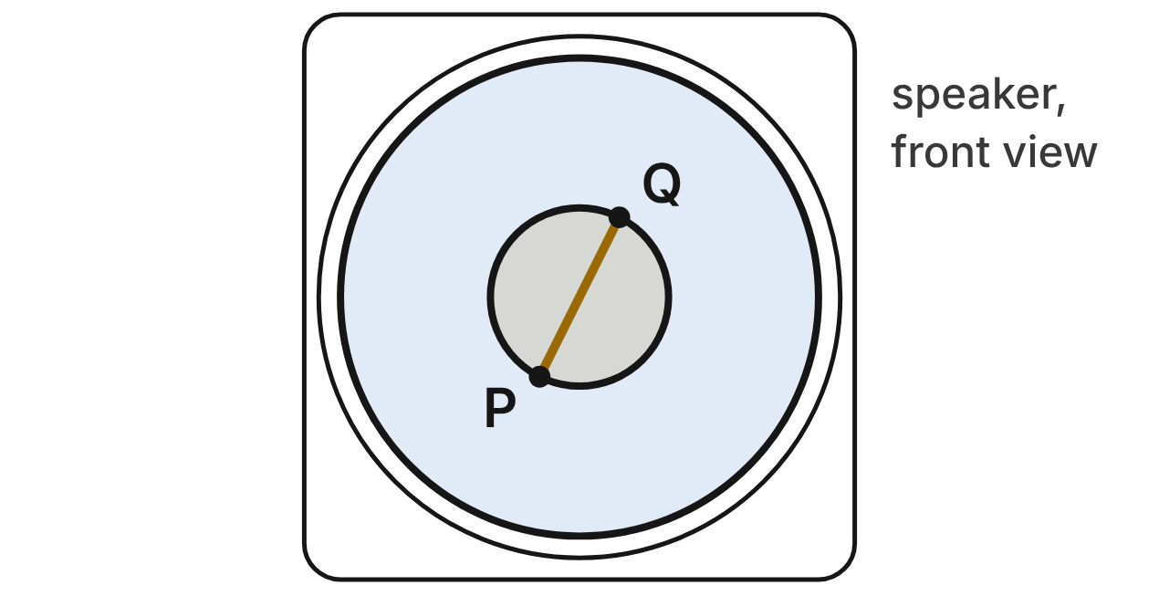
On a speaker design (units in cm), the edge of the cone is x² + y² + 4x − 12y + 4 = 0. The dust cap is a circle with diameter PQ, from P(−3, 4) to Q(−1, 8).
481. Kim completes the square for the cone: (x² + 4x + 4) + (y² − 12y + 36) = ____. What number goes in the blank?
A. 44
B. 36 ✔
C. 40
D. −4
G.PC.4 · skill G.PC.4.1 (LOTS): Identify the center and radius of a circle from its graph or from its equation in standard form
☐ Answer key correct ☐ Wording clear Notes: ________________________________
482. What are the center and radius of the cone?
A. (2, −6); r = 6 cm
B. (−2, 6); r = 36 cm
C. (−2, 6); r = 2 cm
D. (−2, 6); r = 6 cm ✔
G.PC.4 · skill G.PC.4.1 (LOTS): Identify the center and radius of a circle from its graph or from its equation in standard form
☐ Answer key correct ☐ Wording clear Notes: ________________________________
483. Which equation describes the edge of the dust cap?
A. (x + 2)² + (y − 6)² = 20
B. (x + 3)² + (y − 4)² = 5
C. (x + 2)² + (y − 6)² = 5 ✔
D. (x − 2)² + (y + 6)² = 5
G.PC.4 · skill G.PC.4.2 (LOTS): Write the equation of a circle from its center and radius, its center and a point, or the endpoints of a diameter
☐ Answer key correct ☐ Wording clear Notes: ________________________________
484. Which expression gives the length of PQ, the diameter of the dust cap?
A. √((−1 + 3)² + (8 − 4)²) ✔
B. √((−1 − 3)² + (8 − 4)²)
C. (−1 + 3)² + (8 − 4)²
D. √((−1 + 3)² − (8 − 4)²)
G.PC.4 · skill G.PC.4.3 (HOTS): Derive the equation of a circle with the Pythagorean Theorem or the distance formula
☐ Answer key correct ☐ Wording clear Notes: ________________________________
485. A felt dot is glued at (2, 9). Where is it? Choose the answer with the correct reason.
A. Off the cone: (2 − 2)² + (9 + 6)² = 225
B. On the cone, off the cap: 25 is between 5 and 36 ✔
C. Off the cone: 4 + 3 = 7 cm, more than 6 cm
D. Off the cone: 25 is more than 6
G.PC.4 · skill G.PC.4.1 (LOTS): Identify the center and radius of a circle from its graph or from its equation in standard form
☐ Answer key correct ☐ Wording clear Notes: ________________________________
486. A larger speaker uses the same center. Its cone's edge passes through (4, 13). Which equation describes that edge?
A. (x + 2)² + (y − 6)² = 85 ✔
B. (x − 4)² + (y − 13)² = 85
C. (x + 2)² + (y − 6)² = √85
D. (x − 2)² + (y + 6)² = 85
G.PC.4 · skill G.PC.4.2 (LOTS): Write the equation of a circle from its center and radius, its center and a point, or the endpoints of a diameter
☐ Answer key correct ☐ Wording clear Notes: ________________________________

3-D figures (G.DF)

G.DF.1 · Create models and solve problems, including those in context, involving surface area and volume of rectangular and triangular prisms, cylinders, cones, pyramids, and spheres.

The Pillar Candle
Level 1 · 3-D figures · G.DF.1 · ID geo-df1-ring-pillar-candle
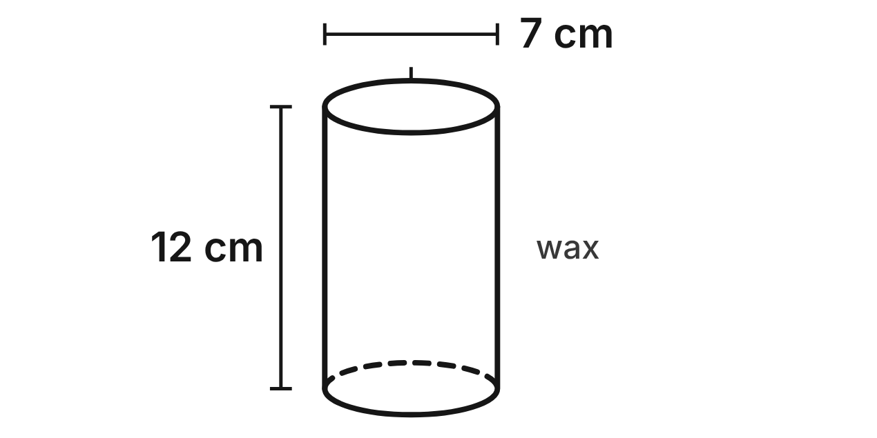
A candle maker pours melted wax into a mold to make a pillar candle. The candle is a cylinder 7 cm across and 12 cm tall.
487. How much wax is in the candle, in terms of π?
A. 42π cm³
B. 147π cm³ ✔
C. 588π cm³
D. 49π cm³
G.DF.1 · skill G.DF.1.2 (LOTS): Find the surface area and volume of prisms, cylinders, cones, pyramids and spheres
☐ Answer key correct ☐ Wording clear Notes: ________________________________
488. What is the total surface area of the candle, to the nearest tenth of a square centimeter?
A. 263.9 cm²
B. 835.7 cm²
C. 302.4 cm²
D. 340.9 cm² ✔
G.DF.1 · skill G.DF.1.2 (LOTS): Find the surface area and volume of prisms, cylinders, cones, pyramids and spheres
☐ Answer key correct ☐ Wording clear Notes: ________________________________
489. Which shape can NOT be a cross section of the candle?
A. a triangle ✔
B. a circle
C. an oval (ellipse)
D. a rectangle
G.DF.1 · skill G.DF.1.1 (LOTS): Identify the two-dimensional cross sections and nets of three-dimensional figures
☐ Answer key correct ☐ Wording clear Notes: ________________________________
490. A plane parallel to the top cuts the candle into two pieces. What is the area of the new flat face on one piece, to the nearest tenth of a square centimeter?
A. 38.5 cm² ✔
B. 84.0 cm²
C. 22.0 cm²
D. 153.9 cm²
G.DF.1 · skill G.DF.1.1 (LOTS): Identify the two-dimensional cross sections and nets of three-dimensional figures
☐ Answer key correct ☐ Wording clear Notes: ________________________________
491. The candle maker has a block of 2,400 cm³ of wax. How many whole candles like this one can she make from it?
A. 15
B. 18
C. 5 ✔
D. 6
G.DF.1 · skill G.DF.1.3 (HOTS): Solve multistep contextual problems with surface area and volume, including composite figures
☐ Answer key correct ☐ Wording clear Notes: ________________________________
492. Which statement about the candle is true?
A. It holds 2 times as much wax as a cone with the same base and height.
B. It holds 3 times as much wax as a cone with the same base and height. ✔
C. Its curved side has an area of π · 3.5 · 12 cm².
D. Its top has an area of 7π cm².
G.DF.1 · skill G.DF.1.2 (LOTS): Find the surface area and volume of prisms, cylinders, cones, pyramids and spheres
☐ Answer key correct ☐ Wording clear Notes: ________________________________

The Wooden Jewelry Box
Level 1 · 3-D figures · G.DF.1 · ID geo-df1-ring-jewelry-box
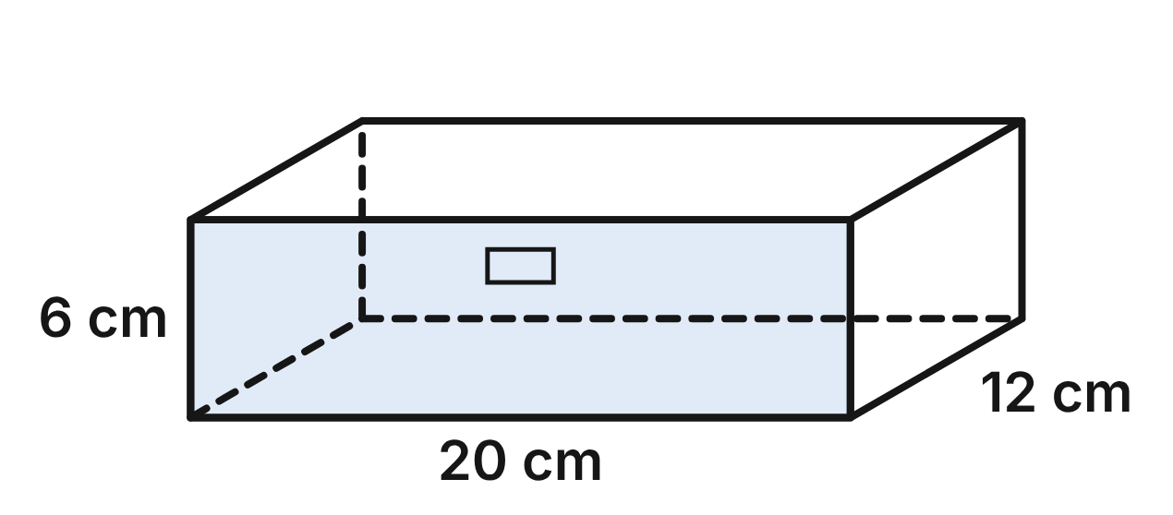
A wooden jewelry box is a rectangular prism 20 cm long, 12 cm deep and 6 cm tall. Ignore the thickness of the wood.
493. How much space is inside the jewelry box?
A. 432 cm³
B. 38 cm³
C. 1,440 cm³ ✔
D. 240 cm³
G.DF.1 · skill G.DF.1.2 (LOTS): Find the surface area and volume of prisms, cylinders, cones, pyramids and spheres
☐ Answer key correct ☐ Wording clear Notes: ________________________________
494. What is the total surface area of the jewelry box?
A. 432 cm²
B. 384 cm²
C. 624 cm²
D. 864 cm² ✔
G.DF.1 · skill G.DF.1.2 (LOTS): Find the surface area and volume of prisms, cylinders, cones, pyramids and spheres
☐ Answer key correct ☐ Wording clear Notes: ________________________________
495. Leave out the top of the box. The other five faces unfold into a net: the 20 cm by 12 cm bottom with the four sides laid flat around it. How long is the net, measured along the 20 cm edges?
A. 20 cm
B. 32 cm ✔
C. 26 cm
D. 24 cm
G.DF.1 · skill G.DF.1.1 (LOTS): Identify the two-dimensional cross sections and nets of three-dimensional figures
☐ Answer key correct ☐ Wording clear Notes: ________________________________
496. A plane parallel to the bottom cuts the box 2 cm below its top. What is the cross section?
A. a rectangle 20 cm by 12 cm ✔
B. a rectangle 20 cm by 6 cm
C. a rectangle 20 cm by 4 cm
D. a rectangle 18 cm by 10 cm
G.DF.1 · skill G.DF.1.1 (LOTS): Identify the two-dimensional cross sections and nets of three-dimensional figures
☐ Answer key correct ☐ Wording clear Notes: ________________________________
497. Velvet covers the outside of the four side faces, but not the top or the bottom. Velvet costs $0.02 per square centimeter. What does the velvet cost?
A. $17.28
B. $8.64
C. $7.68 ✔
D. $28.80
G.DF.1 · skill G.DF.1.3 (HOTS): Solve multistep contextual problems with surface area and volume, including composite figures
☐ Answer key correct ☐ Wording clear Notes: ________________________________
498. A tray that exactly fits the bottom of the box is 2 cm deep. What is the volume of the tray?
A. 608 cm³
B. 240 cm³
C. 960 cm³
D. 480 cm³ ✔
G.DF.1 · skill G.DF.1.2 (LOTS): Find the surface area and volume of prisms, cylinders, cones, pyramids and spheres
☐ Answer key correct ☐ Wording clear Notes: ________________________________

The Glass Paperweight
Level 2 · 3-D figures · G.DF.1 · ID geo-df1-ring-paperweight
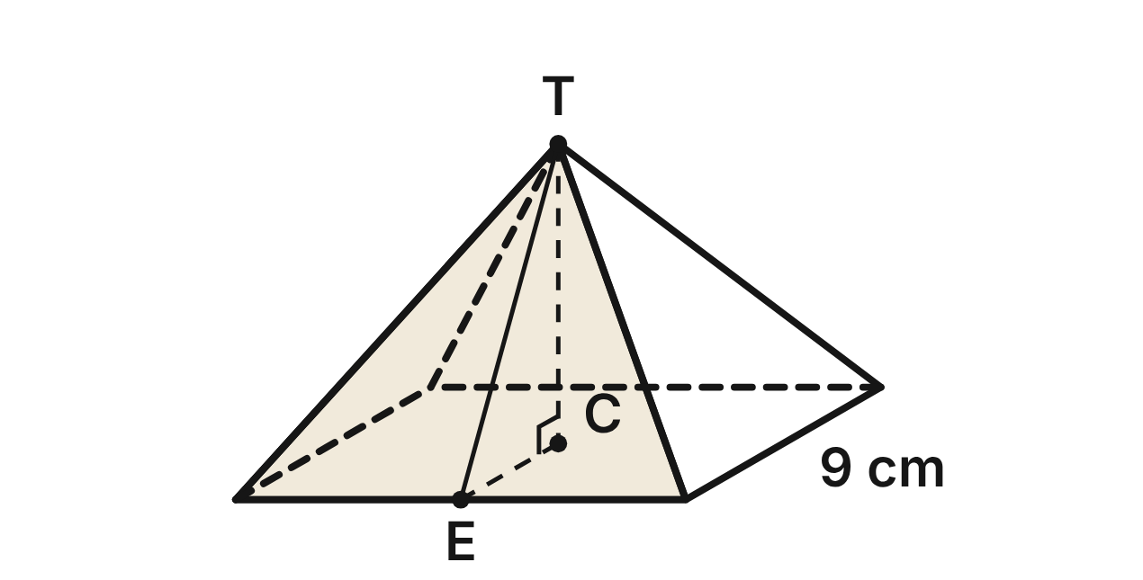
A glass paperweight is a solid square pyramid with base edges of 9 cm. T is its top, C the center of its base and E the midpoint of a base edge. The height TC is 6 cm and the slant height TE is 7.5 cm.
499. How much glass is in the paperweight?
A. 162 cm³ ✔
B. 486 cm³
C. 202.5 cm³
D. 243 cm³
G.DF.1 · skill G.DF.1.2 (LOTS): Find the surface area and volume of prisms, cylinders, cones, pyramids and spheres
☐ Answer key correct ☐ Wording clear Notes: ________________________________
500. What is the total surface area of the paperweight, base included?
A. 351 cm²
B. 216 cm² ✔
C. 135 cm²
D. 189 cm²
G.DF.1 · skill G.DF.1.2 (LOTS): Find the surface area and volume of prisms, cylinders, cones, pyramids and spheres
☐ Answer key correct ☐ Wording clear Notes: ________________________________
501. A net of the paperweight is a square with a triangle on each side. What is the area of one triangle in the net?
A. 33.75 cm² ✔
B. 135 cm²
C. 67.5 cm²
D. 27 cm²
G.DF.1 · skill G.DF.1.1 (LOTS): Identify the two-dimensional cross sections and nets of three-dimensional figures
☐ Answer key correct ☐ Wording clear Notes: ________________________________
502. A plane parallel to the base cuts the paperweight 2 cm below T. What is the area of the cross section?
A. 3 cm²
B. 81 cm²
C. 9 cm² ✔
D. 36 cm²
G.DF.1 · skill G.DF.1.1 (LOTS): Identify the two-dimensional cross sections and nets of three-dimensional figures
☐ Answer key correct ☐ Wording clear Notes: ________________________________
503. The glass has a mass of 2.5 g per cubic centimeter. What is the mass of the paperweight?
A. 64.8 g
B. 540 g
C. 405 g ✔
D. 1,215 g
G.DF.1 · skill G.DF.1.3 (HOTS): Solve multistep contextual problems with surface area and volume, including composite figures
☐ Answer key correct ☐ Wording clear Notes: ________________________________
504. The paperweight is packed in a box shaped like a cube with 9 cm edges. Foam fills the rest of the box. How much foam is needed?
A. 729 cm³
B. 513 cm³
C. 243 cm³
D. 567 cm³ ✔
G.DF.1 · skill G.DF.1.3 (HOTS): Solve multistep contextual problems with surface area and volume, including composite figures
☐ Answer key correct ☐ Wording clear Notes: ________________________________

The Gift Box with a Ribbon
Level 2 · 3-D figures · G.DF.1 · ID geo-df1-ring-gift-box
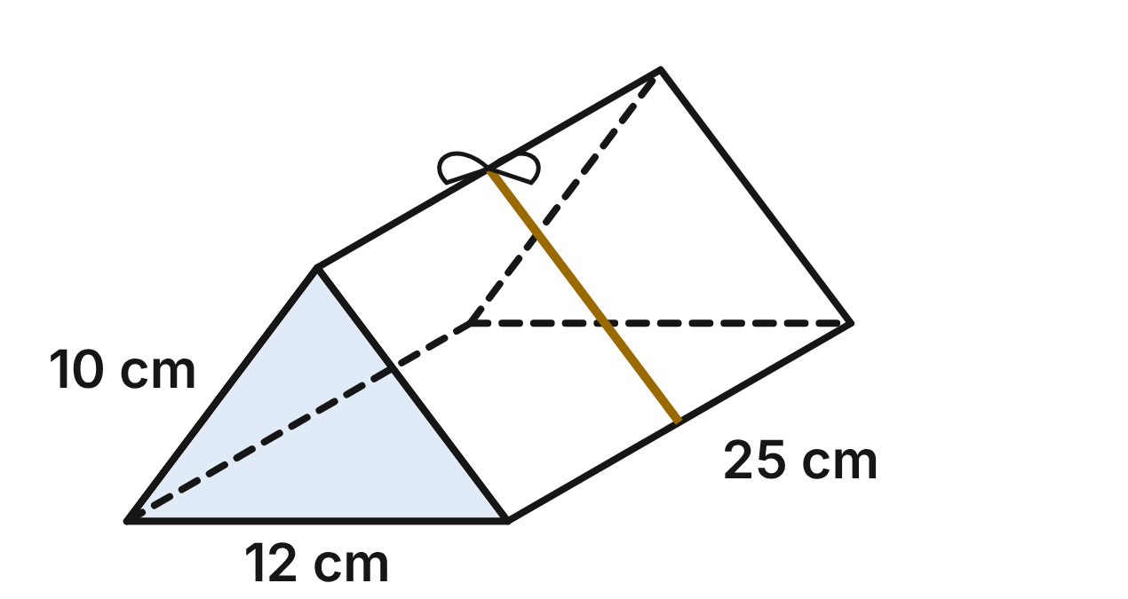
A gift box is a triangular prism lying on one rectangular face. Each end is an isosceles triangle with a 12 cm base, two 10 cm sides and a height of 8 cm. The box is 25 cm long. A ribbon goes once around the middle of the box.
505. What is the volume of the gift box?
A. 1,500 cm³
B. 400 cm³
C. 1,200 cm³ ✔
D. 2,400 cm³
G.DF.1 · skill G.DF.1.2 (LOTS): Find the surface area and volume of prisms, cylinders, cones, pyramids and spheres
☐ Answer key correct ☐ Wording clear Notes: ________________________________
506. What is the total surface area of the gift box?
A. 796 cm²
B. 992 cm²
C. 800 cm²
D. 896 cm² ✔
G.DF.1 · skill G.DF.1.2 (LOTS): Find the surface area and volume of prisms, cylinders, cones, pyramids and spheres
☐ Answer key correct ☐ Wording clear Notes: ________________________________
507. In a net of the box, the three rectangles are joined side by side in one strip, along their 25 cm edges. How wide is the strip, across all three rectangles?
A. 30 cm
B. 32 cm ✔
C. 28 cm
D. 22 cm
G.DF.1 · skill G.DF.1.1 (LOTS): Identify the two-dimensional cross sections and nets of three-dimensional figures
☐ Answer key correct ☐ Wording clear Notes: ________________________________
508. A plane parallel to the bottom face cuts the box 2 cm above the bottom. What is the cross section?
A. a rectangle 9 cm by 25 cm ✔
B. a rectangle 3 cm by 25 cm
C. a rectangle 10 cm by 25 cm
D. a rectangle 12 cm by 25 cm
G.DF.1 · skill G.DF.1.1 (LOTS): Identify the two-dimensional cross sections and nets of three-dimensional figures
☐ Answer key correct ☐ Wording clear Notes: ________________________________
509. The ribbon goes once around the box at the middle of its length, across the bottom and both sloped faces. Another 18 cm is used for the bow. How much ribbon is used?
A. 46 cm
B. 43 cm
C. 40 cm
D. 50 cm ✔
G.DF.1 · skill G.DF.1.3 (HOTS): Solve multistep contextual problems with surface area and volume, including composite figures
☐ Answer key correct ☐ Wording clear Notes: ________________________________
510. The whole box is covered in gift wrap, plus 20% extra for the overlaps. How much gift wrap is used, to the nearest square centimeter?
A. 916 cm²
B. 1,075 cm² ✔
C. 179 cm²
D. 960 cm²
G.DF.1 · skill G.DF.1.3 (HOTS): Solve multistep contextual problems with surface area and volume, including composite figures
☐ Answer key correct ☐ Wording clear Notes: ________________________________

The Cone Lampshade
Level 2 · 3-D figures · G.DF.1 · ID geo-df1-ring-lampshade
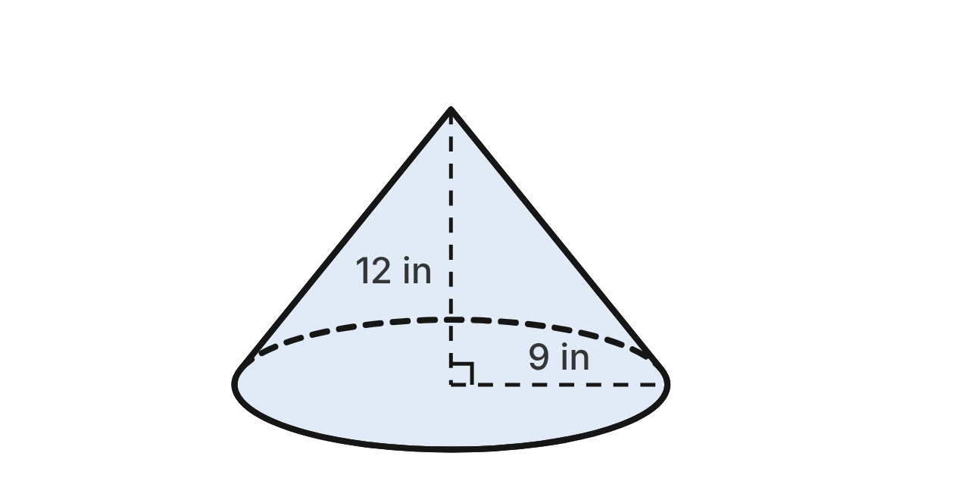
A lampshade is the curved surface of a cone, open at the bottom. Its bottom rim has a radius of 9 in, and the shade is 12 in tall from the center of the rim to the tip.
511. What is the slant height of the shade, from the tip to the rim?
A. 15 in ✔
B. about 21.6 in
C. about 7.9 in
D. 21 in
G.DF.1 · skill G.DF.1.2 (LOTS): Find the surface area and volume of prisms, cylinders, cones, pyramids and spheres
☐ Answer key correct ☐ Wording clear Notes: ________________________________
512. How much fabric covers the shade, in terms of π?
A. 216π in²
B. 135π in² ✔
C. 108π in²
D. 270π in²
G.DF.1 · skill G.DF.1.2 (LOTS): Find the surface area and volume of prisms, cylinders, cones, pyramids and spheres
☐ Answer key correct ☐ Wording clear Notes: ________________________________
513. The fabric is cut along a straight line from the tip and laid flat. It makes a sector of a circle. What is the central angle of the sector?
A. 216° ✔
B. 288°
C. 270°
D. 144°
G.DF.1 · skill G.DF.1.1 (LOTS): Identify the two-dimensional cross sections and nets of three-dimensional figures
☐ Answer key correct ☐ Wording clear Notes: ________________________________
514. Think of the shade as a solid cone. A level plane cuts it 4 in below the tip. What is the cross section?
A. a circle with radius 6 in
B. a circle with radius 9 in
C. a circle with radius 2.4 in
D. a circle with radius 3 in ✔
G.DF.1 · skill G.DF.1.1 (LOTS): Identify the two-dimensional cross sections and nets of three-dimensional figures
☐ Answer key correct ☐ Wording clear Notes: ________________________________
515. A roll of fabric covers 2,200 in². How many whole shades like this one can be covered from one roll?
A. 6
B. 2
C. 5 ✔
D. 3
G.DF.1 · skill G.DF.1.3 (HOTS): Solve multistep contextual problems with surface area and volume, including composite figures
☐ Answer key correct ☐ Wording clear Notes: ________________________________
516. How much space is under the shade, inside the cone, to the nearest cubic inch?
A. 3,054 in³
B. 1,272 in³
C. 113 in³
D. 1,018 in³ ✔
G.DF.1 · skill G.DF.1.2 (LOTS): Find the surface area and volume of prisms, cylinders, cones, pyramids and spheres
☐ Answer key correct ☐ Wording clear Notes: ________________________________

The Bronze Ball Sculpture
Level 2 · 3-D figures · G.DF.1 · ID geo-df1-ring-sculpture
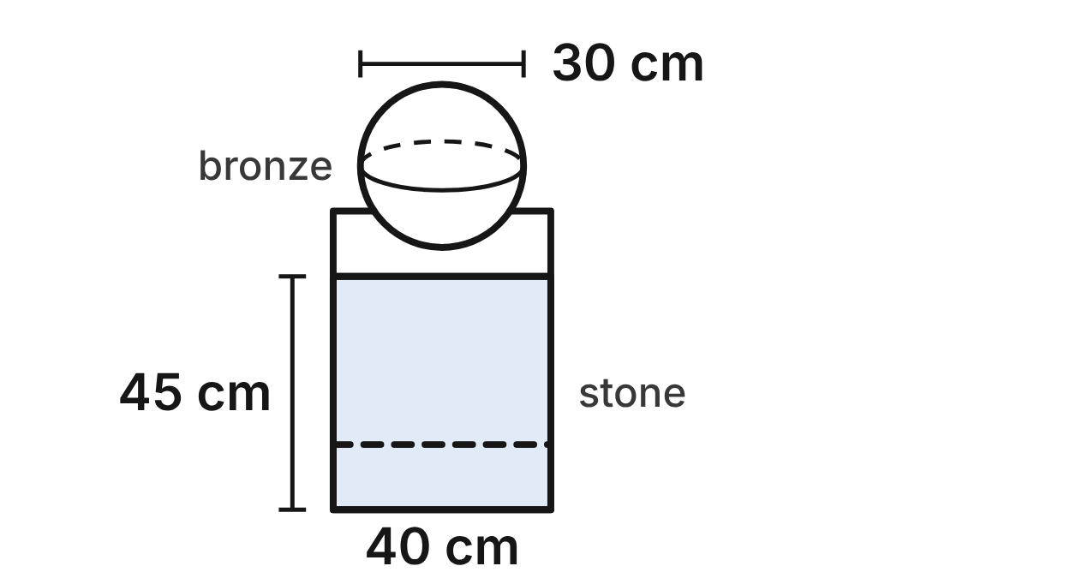
A sculpture is a solid bronze ball 30 cm across, resting on the center of a stone plinth. The plinth is a square prism with a 40 cm by 40 cm top and a height of 45 cm.
517. What is the volume of the bronze ball, in terms of π?
A. 36,000π cm³
B. 300π cm³
C. 4,500π cm³ ✔
D. 3,375π cm³
G.DF.1 · skill G.DF.1.2 (LOTS): Find the surface area and volume of prisms, cylinders, cones, pyramids and spheres
☐ Answer key correct ☐ Wording clear Notes: ________________________________
518. The ball is polished all over. What is its surface area, in terms of π?
A. 450π cm²
B. 900π cm² ✔
C. 225π cm²
D. 3,600π cm²
G.DF.1 · skill G.DF.1.2 (LOTS): Find the surface area and volume of prisms, cylinders, cones, pyramids and spheres
☐ Answer key correct ☐ Wording clear Notes: ________________________________
519. The four sides and the top of the plinth are painted, but not the bottom. What area is painted? Ignore the point where the ball touches.
A. 10,400 cm²
B. 7,200 cm²
C. 8,800 cm² ✔
D. 72,000 cm²
G.DF.1 · skill G.DF.1.3 (HOTS): Solve multistep contextual problems with surface area and volume, including composite figures
☐ Answer key correct ☐ Wording clear Notes: ________________________________
520. A level plane cuts the ball 9 cm above its center. What is the cross section?
A. a circle with radius 6 cm
B. a circle with radius 12 cm ✔
C. a circle with radius about 17.5 cm
D. a circle with radius 15 cm
G.DF.1 · skill G.DF.1.1 (LOTS): Identify the two-dimensional cross sections and nets of three-dimensional figures
☐ Answer key correct ☐ Wording clear Notes: ________________________________
521. A vertical plane cuts the plinth from top to bottom through two opposite vertical edges. What is the cross section?
A. a rectangle 40√2 cm by 45 cm ✔
B. a square 40 cm by 40 cm
C. a rectangle 40 cm by 45 cm
D. a rectangle 80 cm by 45 cm
G.DF.1 · skill G.DF.1.1 (LOTS): Identify the two-dimensional cross sections and nets of three-dimensional figures
☐ Answer key correct ☐ Wording clear Notes: ________________________________
522. Bronze costs $0.09 per cubic centimeter. To the nearest dollar, what does the bronze in the ball cost?
A. $954
B. $636
C. $10,179
D. $1,272 ✔
G.DF.1 · skill G.DF.1.3 (HOTS): Solve multistep contextual problems with surface area and volume, including composite figures
☐ Answer key correct ☐ Wording clear Notes: ________________________________

The Truffle Mold
Level 3 · 3-D figures · G.DF.1 · ID geo-df1-ring-chocolate-mold
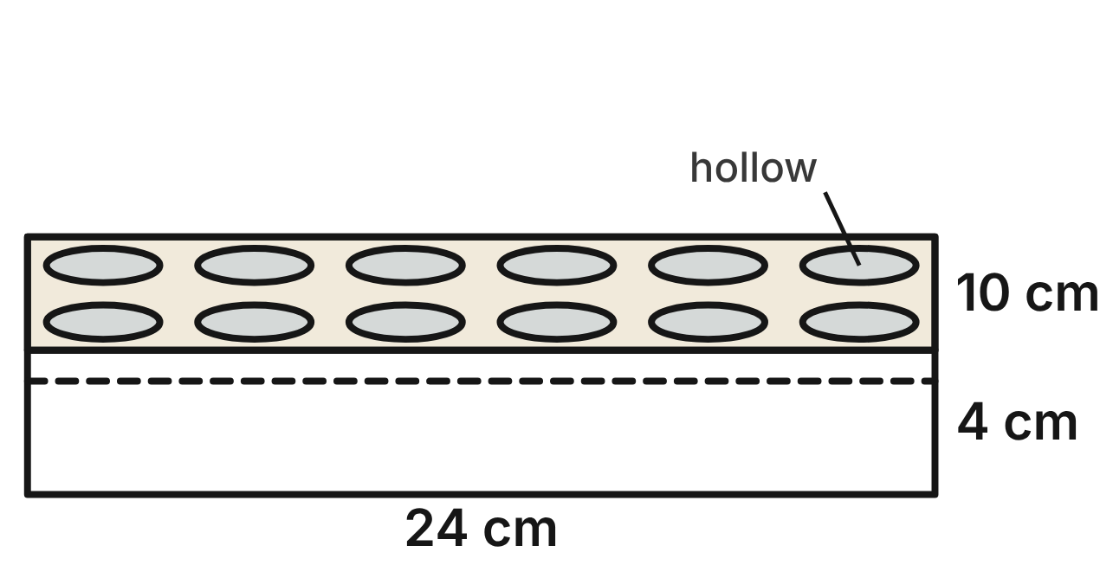
A silicone chocolate mold is a rectangular block 24 cm long, 10 cm wide and 4 cm thick. Its top has 12 hollows in two rows of 6. Each hollow is a hemisphere with a radius of 1.5 cm.
523. How much chocolate fills one hollow, in terms of π?
A. 2.25π cm³ ✔
B. 4.5π cm³
C. 18π cm³
D. 1.5π cm³
G.DF.1 · skill G.DF.1.2 (LOTS): Find the surface area and volume of prisms, cylinders, cones, pyramids and spheres
☐ Answer key correct ☐ Wording clear Notes: ________________________________
524. How much chocolate fills all 12 hollows, to the nearest cubic centimeter?
A. 170 cm³
B. 85 cm³ ✔
C. 7 cm³
D. 127 cm³
G.DF.1 · skill G.DF.1.3 (HOTS): Solve multistep contextual problems with surface area and volume, including composite figures
☐ Answer key correct ☐ Wording clear Notes: ________________________________
525. A chef melts 400 cm³ of chocolate. How many whole truffles can she make, one per hollow?
A. 57
B. 56 ✔
C. 177
D. 28
G.DF.1 · skill G.DF.1.3 (HOTS): Solve multistep contextual problems with surface area and volume, including composite figures
☐ Answer key correct ☐ Wording clear Notes: ________________________________
526. How much silicone is in the mold, to the nearest cubic centimeter?
A. 960 cm³
B. 1,045 cm³
C. 790 cm³
D. 875 cm³ ✔
G.DF.1 · skill G.DF.1.3 (HOTS): Solve multistep contextual problems with surface area and volume, including composite figures
☐ Answer key correct ☐ Wording clear Notes: ________________________________
527. A plane parallel to the top cuts the mold 0.9 cm below the top. In the cross section, what shape is each hole made by a hollow?
A. a circle with radius 1.2 cm ✔
B. a circle with radius 0.9 cm
C. a circle with radius 0.6 cm
D. a circle with radius 1.5 cm
G.DF.1 · skill G.DF.1.1 (LOTS): Identify the two-dimensional cross sections and nets of three-dimensional figures
☐ Answer key correct ☐ Wording clear Notes: ________________________________
528. A vertical plane parallel to the 24 cm edges cuts through the centers of the 6 hollows in one row. What is the cross section?
A. a 24 cm by 4 cm rectangle with 6 triangles cut from its top
B. a 24 cm by 10 cm rectangle with 6 half circles cut from its top
C. a 24 cm by 4 cm rectangle with 6 half circles cut from its top ✔
D. a 24 cm by 4 cm rectangle with 6 whole circles cut out
G.DF.1 · skill G.DF.1.1 (LOTS): Identify the two-dimensional cross sections and nets of three-dimensional figures
☐ Answer key correct ☐ Wording clear Notes: ________________________________

The Potter's Clay Vase
Level 3 · 3-D figures · G.DF.1 · ID geo-df1-ring-clay-vase
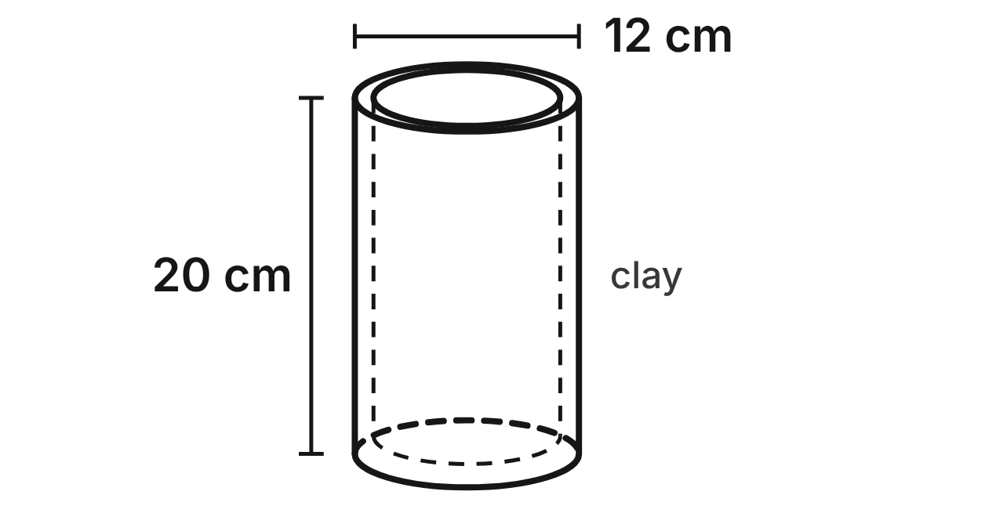
A potter makes a vase shaped like a cylinder, open at the top. Outside, it is 12 cm across and 20 cm tall. The walls and the base are 1 cm thick, so the inside is 10 cm across and 19 cm deep.
529. How much water can the vase hold, in terms of π?
A. 720π cm³
B. 500π cm³
C. 1,900π cm³
D. 475π cm³ ✔
G.DF.1 · skill G.DF.1.2 (LOTS): Find the surface area and volume of prisms, cylinders, cones, pyramids and spheres
☐ Answer key correct ☐ Wording clear Notes: ________________________________
530. How much clay is in the vase, to the nearest cubic centimeter?
A. 63 cm³
B. 2,262 cm³
C. 770 cm³ ✔
D. 691 cm³
G.DF.1 · skill G.DF.1.3 (HOTS): Solve multistep contextual problems with surface area and volume, including composite figures
☐ Answer key correct ☐ Wording clear Notes: ________________________________
531. How many liters of water does the full vase hold, to the nearest tenth? Use 1 L = 1,000 cm³.
A. 6.0 L
B. 1.5 L ✔
C. 0.5 L
D. 2.3 L
G.DF.1 · skill G.DF.1.3 (HOTS): Solve multistep contextual problems with surface area and volume, including composite figures
☐ Answer key correct ☐ Wording clear Notes: ________________________________
532. Glaze covers every surface of the vase except the bottom it stands on: the outside wall, the rim, the inside wall and the inside floor. What area is glazed, in terms of π?
A. 455π cm²
B. 516π cm²
C. 466π cm² ✔
D. 491π cm²
G.DF.1 · skill G.DF.1.3 (HOTS): Solve multistep contextual problems with surface area and volume, including composite figures
☐ Answer key correct ☐ Wording clear Notes: ________________________________
533. A level plane cuts the vase 10 cm above the table. What is the cross section of the clay?
A. a ring between circles of radius 6 cm and 7 cm
B. a circle with radius 6 cm
C. a circle with radius 5 cm
D. a ring between circles of radius 5 cm and 6 cm ✔
G.DF.1 · skill G.DF.1.1 (LOTS): Identify the two-dimensional cross sections and nets of three-dimensional figures
☐ Answer key correct ☐ Wording clear Notes: ________________________________
534. A vertical plane cuts the vase in half through its center line. What is the area of the clay in the cross section?
A. 50 cm² ✔
B. 52 cm²
C. 240 cm²
D. 40 cm²
G.DF.1 · skill G.DF.1.1 (LOTS): Identify the two-dimensional cross sections and nets of three-dimensional figures
☐ Answer key correct ☐ Wording clear Notes: ________________________________

G.DF.2 · Determine how changes in one or more dimensions affect perimeter, area, surface area, and volume, and solve problems with similar two- and three-dimensional figures.

From Photo Print to Poster
Level 1 · Changing dimensions · G.DF.2 · ID geo-df2-ring-photo-print
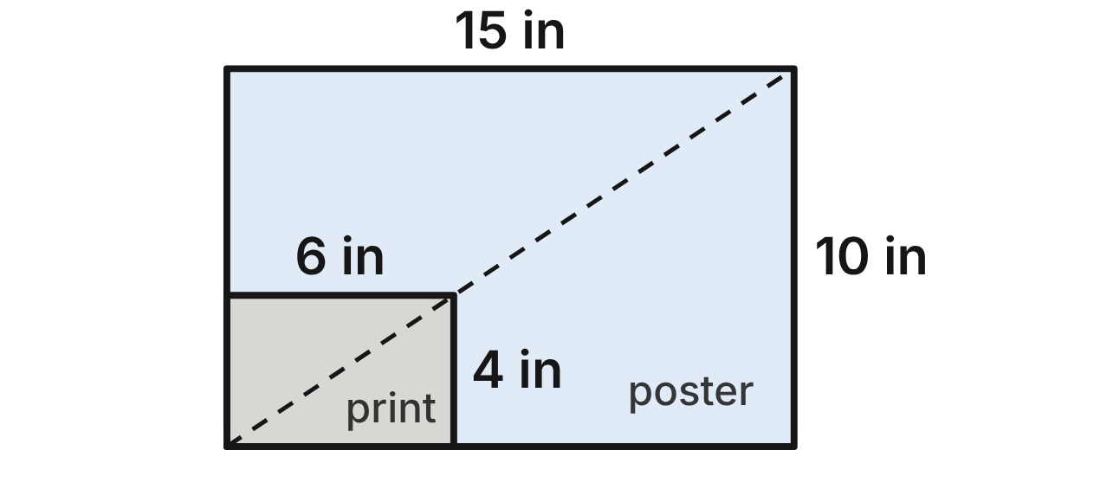
A photo print is 6 in wide and 4 in tall. Its perimeter is 20 in and its area is 24 in². A shop enlarges it to a poster 15 in wide and 10 in tall, so every length is multiplied by 2.5.
535. What is the area of the poster?
A. 375 in²
B. 150 in² ✔
C. 55.25 in²
D. 60 in²
G.DF.2 · skill G.DF.2.2 (LOTS): Use the ratios k, k² and k³ of similar figures to find lengths, areas and volumes
☐ Answer key correct ☐ Wording clear Notes: ________________________________
536. What is the perimeter of the poster?
A. 50 in ✔
B. 125 in
C. 25 in
D. 30 in
G.DF.2 · skill G.DF.2.2 (LOTS): Use the ratios k, k² and k³ of similar figures to find lengths, areas and volumes
☐ Answer key correct ☐ Wording clear Notes: ________________________________
537. A panorama print keeps the 4 in height but is 3 times as wide, 18 in. Which statement is true?
A. Its area is 9 times as large: 216 in².
B. Its perimeter is 3 times as large: 60 in.
C. It is similar to the 6 in by 4 in print.
D. Its area is 3 times as large: 72 in². ✔
G.DF.2 · skill G.DF.2.1 (LOTS): Describe how changing one or more dimensions of a figure changes its perimeter, area, surface area or volume
☐ Answer key correct ☐ Wording clear Notes: ________________________________
538. The shop also sells a print of the same photo cropped to 10 in wide and 8 in tall. Is it similar to the 6 in by 4 in print? Choose the answer with the correct reason.
A. Yes: its area is 2² = 4 times as large.
B. No: 10/6 = 1.5, but 8/4 = 2.
C. No: 10/6 ≈ 1.67, but 8/4 = 2. ✔
D. Yes: 10/6 = 8/4 = 2.
G.DF.2 · skill G.DF.2.3 (HOTS): Decide whether two figures are similar and justify the decision with ratios of corresponding measures
☐ Answer key correct ☐ Wording clear Notes: ________________________________
539. A wallet print is similar to the 6 in by 4 in print and has an area of 6 in². What are its width and height?
A. 3 in wide, 2 in tall ✔
B. 1.5 in wide, 1 in tall
C. √6 in wide, √6 in tall
D. 6 in wide, 1 in tall
G.DF.2 · skill G.DF.2.2 (LOTS): Use the ratios k, k² and k³ of similar figures to find lengths, areas and volumes
☐ Answer key correct ☐ Wording clear Notes: ________________________________
540. Which change to the 6 in by 4 in print gives a print with a perimeter of 40 in?
A. Double the width only.
B. Double both the width and the height. ✔
C. Multiply the width and the height by 4.
D. Add 4 in to the width and to the height.
G.DF.2 · skill G.DF.2.1 (LOTS): Describe how changing one or more dimensions of a figure changes its perimeter, area, surface area or volume
☐ Answer key correct ☐ Wording clear Notes: ________________________________

Three Tiers of Cake
Level 1 · Changing dimensions · G.DF.2 · ID geo-df2-ring-cake-tiers
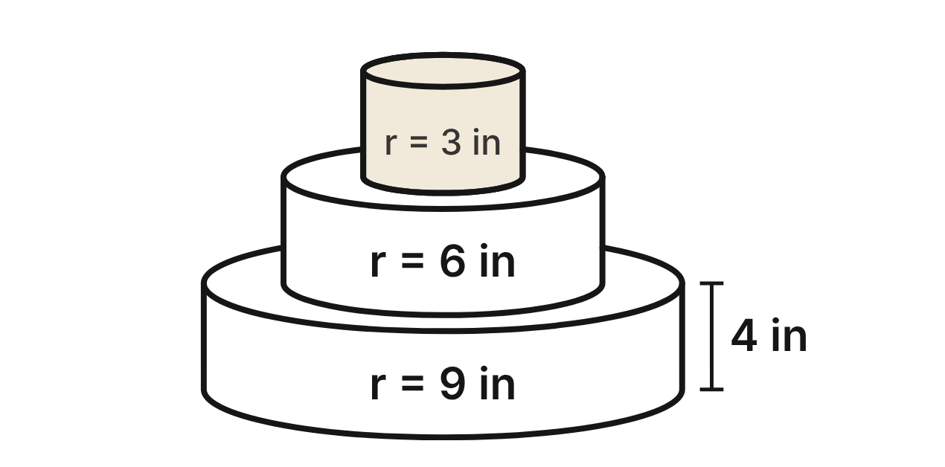
A cake has three round tiers, and every tier is 4 in tall. The radii are 3 in (top), 6 in (middle) and 9 in (bottom). The top tier holds 36π in³ of cake, and the whole cake holds 504π in³.
541. The bottom tier has 3 times the radius of the top tier and the same 4 in height. How much cake does the bottom tier hold?
A. 108π in³
B. 972π in³
C. 1,296π in³
D. 324π in³ ✔
G.DF.2 · skill G.DF.2.1 (LOTS): Describe how changing one or more dimensions of a figure changes its perimeter, area, surface area or volume
☐ Answer key correct ☐ Wording clear Notes: ________________________________
542. Frosting covers the curved side of each tier. Which statement compares the middle tier with the top tier correctly?
A. Its side has 2 times the area, and it holds 2 times as much cake.
B. Its side has 4 times the area, and it holds 4 times as much cake.
C. Its side has 2 times the area, and it holds 4 times as much cake. ✔
D. Its side has 4 times the area, and it holds 8 times as much cake.
G.DF.2 · skill G.DF.2.1 (LOTS): Describe how changing one or more dimensions of a figure changes its perimeter, area, surface area or volume
☐ Answer key correct ☐ Wording clear Notes: ________________________________
543. Are the top tier and the bottom tier similar cylinders? Choose the answer with the correct reason.
A. No: 9/3 = 3, but 4/4 = 1. ✔
B. Yes: 9/3 = 3 and 4/4 = 3.
C. Yes: all cylinders are similar.
D. No: the bottom tier holds 3 times as much cake.
G.DF.2 · skill G.DF.2.3 (HOTS): Decide whether two figures are similar and justify the decision with ratios of corresponding measures
☐ Answer key correct ☐ Wording clear Notes: ________________________________
544. A mini cake is similar to the top tier and is 2 in tall. How much cake does it hold?
A. 9π in³
B. 72π in³
C. 18π in³
D. 4.5π in³ ✔
G.DF.2 · skill G.DF.2.2 (LOTS): Use the ratios k, k² and k³ of similar figures to find lengths, areas and volumes
☐ Answer key correct ☐ Wording clear Notes: ________________________________
545. A baker makes a tier similar to the middle tier. The top of the new tier has an area of 81π in². How tall is the new tier?
A. 4 in
B. 6 in ✔
C. 13.5 in
D. 9 in
G.DF.2 · skill G.DF.2.2 (LOTS): Use the ratios k, k² and k³ of similar figures to find lengths, areas and volumes
☐ Answer key correct ☐ Wording clear Notes: ________________________________
546. The baker makes every tier 8 in tall instead of 4 in and keeps the same radii. How much cake does the whole cake hold?
A. 4,032π in³
B. 2,016π in³
C. 1,008π in³ ✔
D. 504π in³
G.DF.2 · skill G.DF.2.1 (LOTS): Describe how changing one or more dimensions of a figure changes its perimeter, area, surface area or volume
☐ Answer key correct ☐ Wording clear Notes: ________________________________

Nesting Gift Boxes
Level 2 · Changing dimensions · G.DF.2 · ID geo-df2-ring-gift-boxes
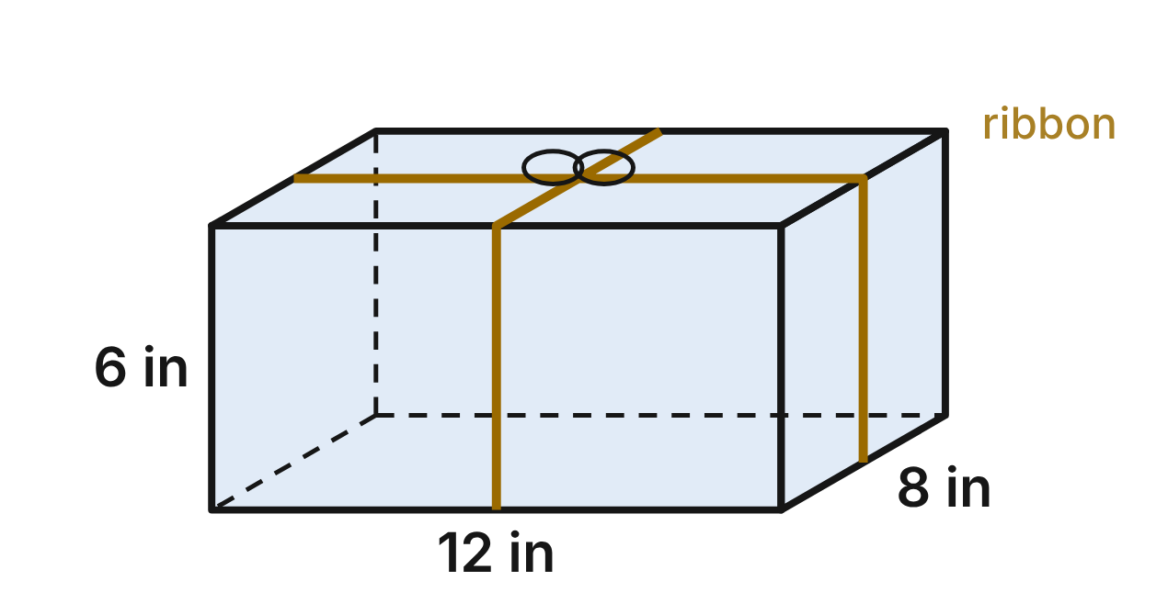
A set of nesting gift boxes are similar rectangular prisms. The medium box, shown, is 12 in long, 8 in wide and 6 in tall. It holds 576 in³, its outside surface is 432 in², and a ribbon tied in a cross around it (not counting the bow) is 64 in long.
547. The large box in the set is 18 in long. How much paper covers its outside surface?
A. 972 in² ✔
B. 1,458 in²
C. 1,296 in²
D. 648 in²
G.DF.2 · skill G.DF.2.2 (LOTS): Use the ratios k, k² and k³ of similar figures to find lengths, areas and volumes
☐ Answer key correct ☐ Wording clear Notes: ________________________________
548. The small box in the set is 9 in long. How long is the ribbon tied in a cross around it (not counting the bow)?
A. 27 in
B. 36 in
C. 48 in ✔
D. 61 in
G.DF.2 · skill G.DF.2.2 (LOTS): Use the ratios k, k² and k³ of similar figures to find lengths, areas and volumes
☐ Answer key correct ☐ Wording clear Notes: ________________________________
549. The small box in the set is 9 in long. How much does it hold?
A. 768 in³
B. 243 in³ ✔
C. 432 in³
D. 324 in³
G.DF.2 · skill G.DF.2.2 (LOTS): Use the ratios k, k² and k³ of similar figures to find lengths, areas and volumes
☐ Answer key correct ☐ Wording clear Notes: ________________________________
550. A shop sells another box that is 15 in long, 10 in wide and 8 in tall. Could it belong to this nesting set? Choose the answer with the correct reason.
A. No: 15/12 = 10/8 = 1.25, but 8/6 ≈ 1.33. ✔
B. Yes: 15/12 = 10/8 = 1.25, and 8/6 = 1.25.
C. Yes: every edge is 3 in longer.
D. No: 15/12 = 1.25, but 10/8 = 1.2.
G.DF.2 · skill G.DF.2.3 (HOTS): Decide whether two figures are similar and justify the decision with ratios of corresponding measures
☐ Answer key correct ☐ Wording clear Notes: ________________________________
551. A tall box keeps the medium box's 12 in by 8 in bottom but is 9 in tall. Which statement is true?
A. It holds 2.25 times as much: 1,296 in³.
B. It holds about 3.4 times as much: 1,944 in³.
C. It holds the same amount: 576 in³.
D. It holds 1.5 times as much: 864 in³. ✔
G.DF.2 · skill G.DF.2.1 (LOTS): Describe how changing one or more dimensions of a figure changes its perimeter, area, surface area or volume
☐ Answer key correct ☐ Wording clear Notes: ________________________________
552. A jumbo box is similar to the medium box and holds 4,608 in³. How long is it?
A. 20 in
B. 96 in
C. 24 in ✔
D. about 33.9 in
G.DF.2 · skill G.DF.2.2 (LOTS): Use the ratios k, k² and k³ of similar figures to find lengths, areas and volumes
☐ Answer key correct ☐ Wording clear Notes: ________________________________

The Tom and the Bass Drum
Level 2 · Changing dimensions · G.DF.2 · ID geo-df2-ring-drums
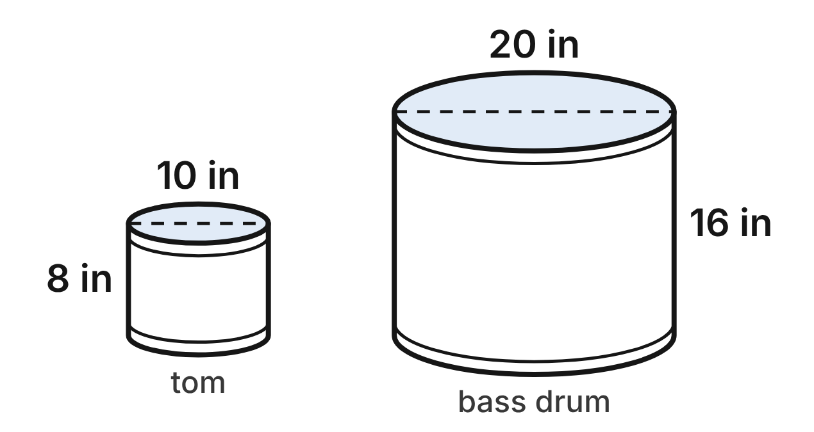
A drum maker builds two drums shaped like cylinders. The tom is 10 in across and 8 in deep. The bass drum is 20 in across and 16 in deep. The tom's drumhead (one circular face) has an area of 25π in².
553. Are the tom and the bass drum similar cylinders? Choose the answer with the correct reason.
A. No: the bass drum's head has 2 times the area.
B. Yes: all cylinders are similar.
C. No: 20/10 = 2, but 16/8 = 1.5.
D. Yes: 20/10 = 16/8 = 2. ✔
G.DF.2 · skill G.DF.2.3 (HOTS): Decide whether two figures are similar and justify the decision with ratios of corresponding measures
☐ Answer key correct ☐ Wording clear Notes: ________________________________
554. What is the area of the bass drum's head?
A. 400π in²
B. 100π in² ✔
C. 200π in²
D. 50π in²
G.DF.2 · skill G.DF.2.2 (LOTS): Use the ratios k, k² and k³ of similar figures to find lengths, areas and volumes
☐ Answer key correct ☐ Wording clear Notes: ________________________________
555. The tom's shell holds 200π in³ of air. How much air does the bass drum's shell hold?
A. 400π in³
B. 800π in³
C. 1,600π in³ ✔
D. 6,400π in³
G.DF.2 · skill G.DF.2.2 (LOTS): Use the ratios k, k² and k³ of similar figures to find lengths, areas and volumes
☐ Answer key correct ☐ Wording clear Notes: ________________________________
556. A floor tom is 16 in across and 14 in deep. Is it similar to the tom? Choose the answer with the correct reason.
A. No: 16/10 = 1.6, but 14/8 = 1.75. ✔
B. Yes: the floor tom's head has 1.6 times the area.
C. Yes: 16/10 = 14/8 = 1.6.
D. No: 16/10 = 1.6, but 14/8 = 1.5.
G.DF.2 · skill G.DF.2.3 (HOTS): Decide whether two figures are similar and justify the decision with ratios of corresponding measures
☐ Answer key correct ☐ Wording clear Notes: ________________________________
557. A builder keeps the tom's 10 in width but makes its shell 12 in deep instead of 8 in. How much wood veneer covers the new shell's curved side?
A. 240π in²
B. 120π in² ✔
C. 180π in²
D. 270π in²
G.DF.2 · skill G.DF.2.1 (LOTS): Describe how changing one or more dimensions of a figure changes its perimeter, area, surface area or volume
☐ Answer key correct ☐ Wording clear Notes: ________________________________
558. A toy drum is similar to the tom, and its head has an area of 4π in². How deep is the toy drum?
A. 1.28 in
B. 20 in
C. 0.512 in
D. 3.2 in ✔
G.DF.2 · skill G.DF.2.2 (LOTS): Use the ratios k, k² and k³ of similar figures to find lengths, areas and volumes
☐ Answer key correct ☐ Wording clear Notes: ________________________________

The Pencil Mural
Level 2 · Changing dimensions · G.DF.2 · ID geo-df2-ring-mural-grid
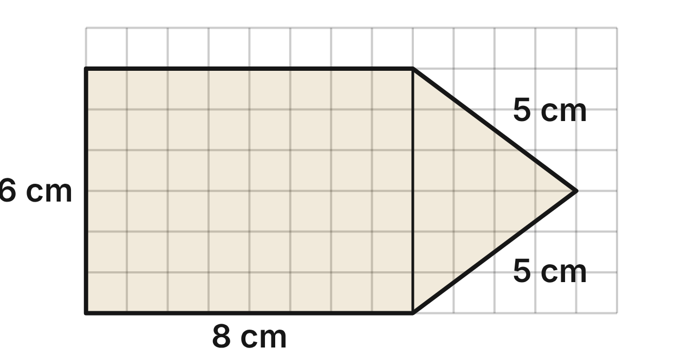
For a mural, Lena sketches a pencil on a grid of 1 cm squares. The sketch is a rectangle 8 cm by 6 cm with a triangle tip that sticks out 4 cm. The sketch has an area of 60 cm² and a perimeter of 32 cm. On the wall, each 1 cm grid square becomes a square 0.5 m on a side.
559. What is the area of the pencil on the wall?
A. 15 m² ✔
B. 120 m²
C. 7.5 m²
D. 30 m²
G.DF.2 · skill G.DF.2.2 (LOTS): Use the ratios k, k² and k³ of similar figures to find lengths, areas and volumes
☐ Answer key correct ☐ Wording clear Notes: ________________________________
560. How long is the outline of the pencil on the wall (its perimeter)?
A. 8 m
B. 32 m
C. 64 m
D. 16 m ✔
G.DF.2 · skill G.DF.2.2 (LOTS): Use the ratios k, k² and k³ of similar figures to find lengths, areas and volumes
☐ Answer key correct ☐ Wording clear Notes: ________________________________
561. Lena makes the pencil's body longer in her sketch: the rectangle becomes 14 cm long instead of 8 cm, and the tip stays the same. What is the new area of the sketch?
A. 105 cm²
B. 183.75 cm²
C. 96 cm² ✔
D. 66 cm²
G.DF.2 · skill G.DF.2.1 (LOTS): Describe how changing one or more dimensions of a figure changes its perimeter, area, surface area or volume
☐ Answer key correct ☐ Wording clear Notes: ________________________________
562. A classmate sketches a pencil whose rectangle is 16 cm long and 9 cm tall, with a tip that sticks out 6 cm. Is it similar to Lena's sketch? Choose the answer with the correct reason.
A. Yes: every pair of matching lengths has ratio 1.5.
B. No: 16/8 = 2, but 9/6 = 1.5. ✔
C. No: its area is 2 times as large.
D. Yes: 16/8 = 9/6 = 6/4 = 2.
G.DF.2 · skill G.DF.2.3 (HOTS): Decide whether two figures are similar and justify the decision with ratios of corresponding measures
☐ Answer key correct ☐ Wording clear Notes: ________________________________
563. A poster of the design is similar to Lena's sketch and has an area of 540 cm². How long is the poster's pencil, from its flat end to its tip?
A. 108 cm
B. about 23.2 cm
C. 4 cm
D. 36 cm ✔
G.DF.2 · skill G.DF.2.2 (LOTS): Use the ratios k, k² and k³ of similar figures to find lengths, areas and volumes
☐ Answer key correct ☐ Wording clear Notes: ________________________________
564. Lena doubles every length of the sketch. Which statement is true?
A. The perimeter becomes 64 cm and the area 240 cm². ✔
B. The perimeter becomes 64 cm and the area 120 cm².
C. The perimeter becomes 64 cm and the area 480 cm².
D. The perimeter becomes 128 cm and the area 240 cm².
G.DF.2 · skill G.DF.2.1 (LOTS): Describe how changing one or more dimensions of a figure changes its perimeter, area, surface area or volume
☐ Answer key correct ☐ Wording clear Notes: ________________________________

The Sculptor's Clay Model
Level 3 · Changing dimensions · G.DF.2 · ID geo-df2-ring-maquette
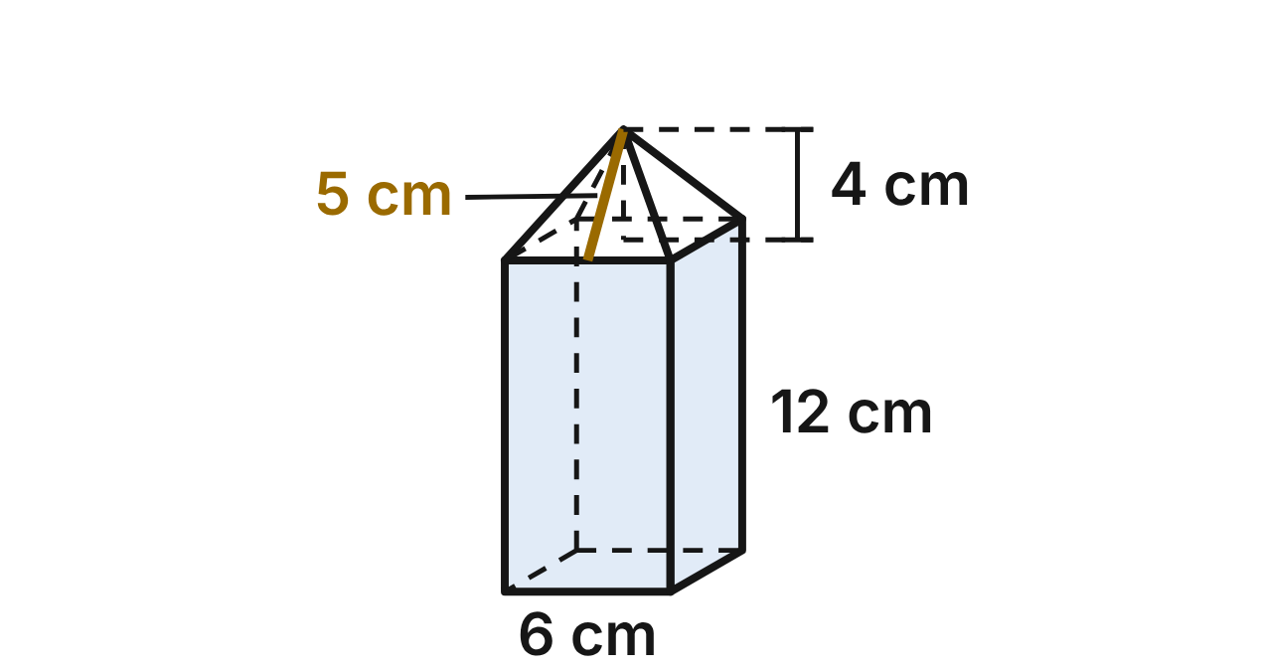
An artist makes a clay model of a stone sculpture: a square prism with a square pyramid on top. The prism has 6 cm base edges and is 12 cm tall. The pyramid is 4 cm tall, and its slant height is 5 cm. The model's volume is 480 cm³, and its outside, not counting the bottom, has an area of 348 cm². The sculpture will be similar to the model, with every length 25 times as long.
565. How tall will the sculpture be, from the ground to the tip of the pyramid?
A. 3 m
B. 40 m
C. 4 m ✔
D. 100 m
G.DF.2 · skill G.DF.2.2 (LOTS): Use the ratios k, k² and k³ of similar figures to find lengths, areas and volumes
☐ Answer key correct ☐ Wording clear Notes: ________________________________
566. The sculpture's outside, not counting the bottom, will be sealed. To the nearest tenth of a square meter, how much area needs sealer? (1 m² = 10,000 cm²)
A. 2.2 m²
B. 21.8 m² ✔
C. 0.9 m²
D. 543.8 m²
G.DF.2 · skill G.DF.2.2 (LOTS): Use the ratios k, k² and k³ of similar figures to find lengths, areas and volumes
☐ Answer key correct ☐ Wording clear Notes: ________________________________
567. The stone weighs 2,600 kg per cubic meter. How many kilograms will the sculpture weigh? (1 m³ = 1,000,000 cm³)
A. 780 kg
B. 17,550 kg
C. 31.2 kg
D. 19,500 kg ✔
G.DF.2 · skill G.DF.2.2 (LOTS): Use the ratios k, k² and k³ of similar figures to find lengths, areas and volumes
☐ Answer key correct ☐ Wording clear Notes: ________________________________
568. On a second model, the artist keeps the 6 cm base edges and the same pyramid but makes the prism 18 cm tall instead of 12 cm. What is the volume of the second model?
A. 1,620 cm³
B. 696 cm³ ✔
C. 720 cm³
D. 648 cm³
G.DF.2 · skill G.DF.2.1 (LOTS): Describe how changing one or more dimensions of a figure changes its perimeter, area, surface area or volume
☐ Answer key correct ☐ Wording clear Notes: ________________________________
569. A student's model has 9 cm base edges, a prism 18 cm tall and a pyramid 5 cm tall. Is it similar to the artist's model? Choose the answer with the correct reason.
A. No: 9/6 = 18/12 = 1.5, but 5/4 = 1.25. ✔
B. No: 9/6 = 1.5, but 18/12 = 2.
C. Yes: its volume is 1.5 times the model's volume.
D. Yes: all three ratios equal 1.5.
G.DF.2 · skill G.DF.2.3 (HOTS): Decide whether two figures are similar and justify the decision with ratios of corresponding measures
☐ Answer key correct ☐ Wording clear Notes: ________________________________
570. A small bronze copy is similar to the model and has a volume of 60 cm³. How tall is the copy, from its base to the tip of the pyramid?
A. 2 cm
B. 6 cm
C. 8 cm ✔
D. about 5.7 cm
G.DF.2 · skill G.DF.2.2 (LOTS): Use the ratios k, k² and k³ of similar figures to find lengths, areas and volumes
☐ Answer key correct ☐ Wording clear Notes: ________________________________

Cone Candles
Level 3 · Changing dimensions · G.DF.2 · ID geo-df2-ring-cone-candles
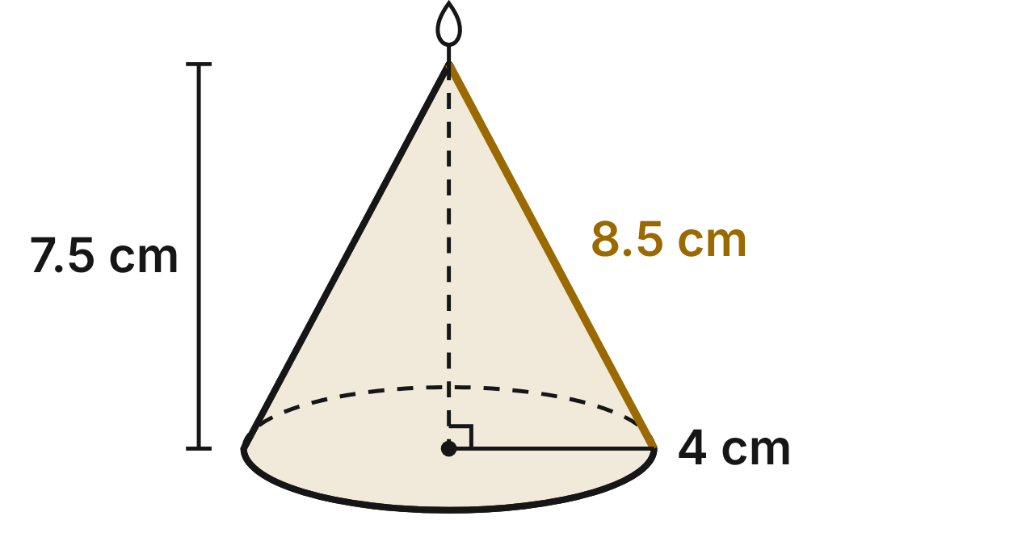
A candle maker pours cone-shaped candles. The standard candle has a base radius of 4 cm, a height of 7.5 cm and a slant height of 8.5 cm. It uses 40π cm³ of wax, and its sloped side has an area of 34π cm².
571. A large candle is similar to the standard one and has a base radius of 6 cm. How much wax does it use?
A. 405π cm³
B. 135π cm³ ✔
C. 90π cm³
D. 60π cm³
G.DF.2 · skill G.DF.2.2 (LOTS): Use the ratios k, k² and k³ of similar figures to find lengths, areas and volumes
☐ Answer key correct ☐ Wording clear Notes: ________________________________
572. The wax in a standard candle costs $3.20. A mini candle is similar to it and has a base radius of 3 cm. What does the wax in the mini candle cost?
A. $1.35 ✔
B. $7.59
C. $2.40
D. $1.80
G.DF.2 · skill G.DF.2.2 (LOTS): Use the ratios k, k² and k³ of similar figures to find lengths, areas and volumes
☐ Answer key correct ☐ Wording clear Notes: ________________________________
573. Paper wraps the sloped side of each candle. A candle similar to the standard one has a slant height of 17 cm. How much paper covers its sloped side?
A. 289π cm²
B. 272π cm²
C. 136π cm² ✔
D. 68π cm²
G.DF.2 · skill G.DF.2.2 (LOTS): Use the ratios k, k² and k³ of similar figures to find lengths, areas and volumes
☐ Answer key correct ☐ Wording clear Notes: ________________________________
574. The maker pours a wide candle with a base radius of 8 cm and the same 7.5 cm height. Which statement is true?
A. It uses 4 times as much wax: 160π cm³. ✔
B. It uses 8 times as much wax: 320π cm³.
C. It is similar to the standard candle.
D. It uses 2 times as much wax: 80π cm³.
G.DF.2 · skill G.DF.2.1 (LOTS): Describe how changing one or more dimensions of a figure changes its perimeter, area, surface area or volume
☐ Answer key correct ☐ Wording clear Notes: ________________________________
575. Which candle is similar to the standard candle?
A. base radius 6 cm, height 9.5 cm
B. base radius 6 cm, height 11.25 cm ✔
C. base radius 8 cm, height 7.5 cm
D. base radius 2 cm, height 5.5 cm
G.DF.2 · skill G.DF.2.3 (HOTS): Decide whether two figures are similar and justify the decision with ratios of corresponding measures
☐ Answer key correct ☐ Wording clear Notes: ________________________________
576. A giant display candle is similar to the standard one and uses 2,560π cm³ of wax. How tall is it?
A. 16 cm
B. 60 cm
C. 480 cm
D. 30 cm ✔
G.DF.2 · skill G.DF.2.2 (LOTS): Use the ratios k, k² and k³ of similar figures to find lengths, areas and volumes
☐ Answer key correct ☐ Wording clear Notes: ________________________________

Answer key
Pack | Question | Standard | Skill | Level | Answer
rlt1-ring-quilt-blocks | 1 | G.RLT.1 | G.RLT.1.1 LOTS | 1 | B
rlt1-ring-quilt-blocks | 2 | G.RLT.1 | G.RLT.1.2 LOTS | 1 | D
rlt1-ring-quilt-blocks | 3 | G.RLT.1 | G.RLT.1.2 LOTS | 1 | A
rlt1-ring-quilt-blocks | 4 | G.RLT.1 | G.RLT.1.2 LOTS | 1 | C
rlt1-ring-quilt-blocks | 5 | G.RLT.1 | G.RLT.1.3 HOTS | 1 | B
rlt1-ring-quilt-blocks | 6 | G.RLT.1 | G.RLT.1.3 HOTS | 1 | D
rlt1-ring-photo-contest | 7 | G.RLT.1 | G.RLT.1.4 LOTS | 1 | C
rlt1-ring-photo-contest | 8 | G.RLT.1 | G.RLT.1.4 LOTS | 1 | A
rlt1-ring-photo-contest | 9 | G.RLT.1 | G.RLT.1.4 LOTS | 1 | D
rlt1-ring-photo-contest | 10 | G.RLT.1 | G.RLT.1.1 LOTS | 1 | B
rlt1-ring-photo-contest | 11 | G.RLT.1 | G.RLT.1.4 LOTS | 1 | A
rlt1-ring-photo-contest | 12 | G.RLT.1 | G.RLT.1.2 LOTS | 1 | D
rlt1-ring-stair-light | 13 | G.RLT.1 | G.RLT.1.1 LOTS | 2 | B
rlt1-ring-stair-light | 14 | G.RLT.1 | G.RLT.1.1 LOTS | 2 | D
rlt1-ring-stair-light | 15 | G.RLT.1 | G.RLT.1.1 LOTS | 2 | C
rlt1-ring-stair-light | 16 | G.RLT.1 | G.RLT.1.2 LOTS | 2 | B
rlt1-ring-stair-light | 17 | G.RLT.1 | G.RLT.1.3 HOTS | 2 | A
rlt1-ring-stair-light | 18 | G.RLT.1 | G.RLT.1.3 HOTS | 2 | C
rlt1-ring-shop-tags | 19 | G.RLT.1 | G.RLT.1.3 HOTS | 2 | C
rlt1-ring-shop-tags | 20 | G.RLT.1 | G.RLT.1.3 HOTS | 2 | A
rlt1-ring-shop-tags | 21 | G.RLT.1 | G.RLT.1.3 HOTS | 2 | D
rlt1-ring-shop-tags | 22 | G.RLT.1 | G.RLT.1.3 HOTS | 2 | B
rlt1-ring-shop-tags | 23 | G.RLT.1 | G.RLT.1.2 LOTS | 2 | A
rlt1-ring-shop-tags | 24 | G.RLT.1 | G.RLT.1.1 LOTS | 2 | D
rlt1-ring-music-rosters | 25 | G.RLT.1 | G.RLT.1.4 LOTS | 2 | B
rlt1-ring-music-rosters | 26 | G.RLT.1 | G.RLT.1.4 LOTS | 2 | C
rlt1-ring-music-rosters | 27 | G.RLT.1 | G.RLT.1.4 LOTS | 2 | A
rlt1-ring-music-rosters | 28 | G.RLT.1 | G.RLT.1.2 LOTS | 2 | D
rlt1-ring-music-rosters | 29 | G.RLT.1 | G.RLT.1.3 HOTS | 2 | A
rlt1-ring-music-rosters | 30 | G.RLT.1 | G.RLT.1.3 HOTS | 2 | C
rlt1-ring-set-pieces | 31 | G.RLT.1 | G.RLT.1.3 HOTS | 3 | B
rlt1-ring-set-pieces | 32 | G.RLT.1 | G.RLT.1.3 HOTS | 3 | D
rlt1-ring-set-pieces | 33 | G.RLT.1 | G.RLT.1.3 HOTS | 3 | A
rlt1-ring-set-pieces | 34 | G.RLT.1 | G.RLT.1.2 LOTS | 3 | C
rlt1-ring-set-pieces | 35 | G.RLT.1 | G.RLT.1.3 HOTS | 3 | D
rlt1-ring-set-pieces | 36 | G.RLT.1 | G.RLT.1.1 LOTS | 3 | C
rlt1-ring-craft-fair | 37 | G.RLT.1 | G.RLT.1.4 LOTS | 3 | B
rlt1-ring-craft-fair | 38 | G.RLT.1 | G.RLT.1.4 LOTS | 3 | D
rlt1-ring-craft-fair | 39 | G.RLT.1 | G.RLT.1.4 LOTS | 3 | C
rlt1-ring-craft-fair | 40 | G.RLT.1 | G.RLT.1.4 LOTS | 3 | A
rlt1-ring-craft-fair | 41 | G.RLT.1 | G.RLT.1.3 HOTS | 3 | C
rlt1-ring-craft-fair | 42 | G.RLT.1 | G.RLT.1.3 HOTS | 3 | B
rlt2-ring-fanned-fret | 43 | G.RLT.2 | G.RLT.2.1 LOTS | 1 | B
rlt2-ring-fanned-fret | 44 | G.RLT.2 | G.RLT.2.3 LOTS | 1 | C
rlt2-ring-fanned-fret | 45 | G.RLT.2 | G.RLT.2.1 LOTS | 1 | A
rlt2-ring-fanned-fret | 46 | G.RLT.2 | G.RLT.2.3 LOTS | 1 | D
rlt2-ring-fanned-fret | 47 | G.RLT.2 | G.RLT.2.1 LOTS | 1 | B
rlt2-ring-fanned-fret | 48 | G.RLT.2 | G.RLT.2.2 HOTS | 1 | D
rlt2-ring-music-staff | 49 | G.RLT.2 | G.RLT.2.3 LOTS | 1 | A
rlt2-ring-music-staff | 50 | G.RLT.2 | G.RLT.2.1 LOTS | 1 | C
rlt2-ring-music-staff | 51 | G.RLT.2 | G.RLT.2.3 LOTS | 1 | D
rlt2-ring-music-staff | 52 | G.RLT.2 | G.RLT.2.1 LOTS | 1 | B
rlt2-ring-music-staff | 53 | G.RLT.2 | G.RLT.2.1 LOTS | 1 | A
rlt2-ring-music-staff | 54 | G.RLT.2 | G.RLT.2.2 HOTS | 1 | C
rlt2-ring-loom-twill | 55 | G.RLT.2 | G.RLT.2.1 LOTS | 2 | D
rlt2-ring-loom-twill | 56 | G.RLT.2 | G.RLT.2.3 LOTS | 2 | A
rlt2-ring-loom-twill | 57 | G.RLT.2 | G.RLT.2.3 LOTS | 2 | C
rlt2-ring-loom-twill | 58 | G.RLT.2 | G.RLT.2.3 LOTS | 2 | B
rlt2-ring-loom-twill | 59 | G.RLT.2 | G.RLT.2.2 HOTS | 2 | C
rlt2-ring-loom-twill | 60 | G.RLT.2 | G.RLT.2.1 LOTS | 2 | D
rlt2-ring-mural-stripes | 61 | G.RLT.2 | G.RLT.2.3 LOTS | 2 | B
rlt2-ring-mural-stripes | 62 | G.RLT.2 | G.RLT.2.2 HOTS | 2 | A
rlt2-ring-mural-stripes | 63 | G.RLT.2 | G.RLT.2.2 HOTS | 2 | D
rlt2-ring-mural-stripes | 64 | G.RLT.2 | G.RLT.2.3 LOTS | 2 | C
rlt2-ring-mural-stripes | 65 | G.RLT.2 | G.RLT.2.3 LOTS | 2 | B
rlt2-ring-mural-stripes | 66 | G.RLT.2 | G.RLT.2.1 LOTS | 2 | A
rlt2-ring-diamond-window | 67 | G.RLT.2 | G.RLT.2.3 LOTS | 2 | C
rlt2-ring-diamond-window | 68 | G.RLT.2 | G.RLT.2.1 LOTS | 2 | B
rlt2-ring-diamond-window | 69 | G.RLT.2 | G.RLT.2.3 LOTS | 2 | D
rlt2-ring-diamond-window | 70 | G.RLT.2 | G.RLT.2.3 LOTS | 2 | A
rlt2-ring-diamond-window | 71 | G.RLT.2 | G.RLT.2.2 HOTS | 2 | B
rlt2-ring-diamond-window | 72 | G.RLT.2 | G.RLT.2.1 LOTS | 2 | C
rlt2-ring-painters-easel | 73 | G.RLT.2 | G.RLT.2.1 LOTS | 3 | D
rlt2-ring-painters-easel | 74 | G.RLT.2 | G.RLT.2.3 LOTS | 3 | B
rlt2-ring-painters-easel | 75 | G.RLT.2 | G.RLT.2.3 LOTS | 3 | A
rlt2-ring-painters-easel | 76 | G.RLT.2 | G.RLT.2.3 LOTS | 3 | C
rlt2-ring-painters-easel | 77 | G.RLT.2 | G.RLT.2.2 HOTS | 3 | D
rlt2-ring-painters-easel | 78 | G.RLT.2 | G.RLT.2.1 LOTS | 3 | C
rlt2-ring-glass-wall-proof | 79 | G.RLT.2 | G.RLT.2.2 HOTS | 3 | A
rlt2-ring-glass-wall-proof | 80 | G.RLT.2 | G.RLT.2.2 HOTS | 3 | C
rlt2-ring-glass-wall-proof | 81 | G.RLT.2 | G.RLT.2.2 HOTS | 3 | D
rlt2-ring-glass-wall-proof | 82 | G.RLT.2 | G.RLT.2.1 LOTS | 3 | B
rlt2-ring-glass-wall-proof | 83 | G.RLT.2 | G.RLT.2.3 LOTS | 3 | D
rlt2-ring-glass-wall-proof | 84 | G.RLT.2 | G.RLT.2.2 HOTS | 3 | B
rlt3-ring-fabric-stamps | 85 | G.RLT.3 | G.RLT.3.1 LOTS | 1 | B
rlt3-ring-fabric-stamps | 86 | G.RLT.3 | G.RLT.3.1 LOTS | 1 | B
rlt3-ring-fabric-stamps | 87 | G.RLT.3 | G.RLT.3.1 LOTS | 1 | D
rlt3-ring-fabric-stamps | 88 | G.RLT.3 | G.RLT.3.1 LOTS | 1 | A
rlt3-ring-fabric-stamps | 89 | G.RLT.3 | G.RLT.3.1 LOTS | 1 | C
rlt3-ring-fabric-stamps | 90 | G.RLT.3 | G.RLT.3.3 HOTS | 1 | A
rlt3-ring-cross-stitch | 91 | G.RLT.3 | G.RLT.3.2 LOTS | 1 | D
rlt3-ring-cross-stitch | 92 | G.RLT.3 | G.RLT.3.2 LOTS | 1 | A
rlt3-ring-cross-stitch | 93 | G.RLT.3 | G.RLT.3.2 LOTS | 1 | D
rlt3-ring-cross-stitch | 94 | G.RLT.3 | G.RLT.3.2 LOTS | 1 | C
rlt3-ring-cross-stitch | 95 | G.RLT.3 | G.RLT.3.1 LOTS | 1 | B
rlt3-ring-cross-stitch | 96 | G.RLT.3 | G.RLT.3.3 HOTS | 1 | C
rlt3-ring-stage-turns | 97 | G.RLT.3 | G.RLT.3.2 LOTS | 2 | C
rlt3-ring-stage-turns | 98 | G.RLT.3 | G.RLT.3.2 LOTS | 2 | D
rlt3-ring-stage-turns | 99 | G.RLT.3 | G.RLT.3.3 HOTS | 2 | A
rlt3-ring-stage-turns | 100 | G.RLT.3 | G.RLT.3.3 HOTS | 2 | B
rlt3-ring-stage-turns | 101 | G.RLT.3 | G.RLT.3.1 LOTS | 2 | A
rlt3-ring-stage-turns | 102 | G.RLT.3 | G.RLT.3.2 LOTS | 2 | C
rlt3-ring-chevron-tile | 103 | G.RLT.3 | G.RLT.3.2 LOTS | 2 | B
rlt3-ring-chevron-tile | 104 | G.RLT.3 | G.RLT.3.3 HOTS | 2 | C
rlt3-ring-chevron-tile | 105 | G.RLT.3 | G.RLT.3.3 HOTS | 2 | B
rlt3-ring-chevron-tile | 106 | G.RLT.3 | G.RLT.3.1 LOTS | 2 | D
rlt3-ring-chevron-tile | 107 | G.RLT.3 | G.RLT.3.3 HOTS | 2 | D
rlt3-ring-chevron-tile | 108 | G.RLT.3 | G.RLT.3.2 LOTS | 2 | A
rlt3-ring-fabric-fold | 109 | G.RLT.3 | G.RLT.3.2 LOTS | 2 | C
rlt3-ring-fabric-fold | 110 | G.RLT.3 | G.RLT.3.2 LOTS | 2 | B
rlt3-ring-fabric-fold | 111 | G.RLT.3 | G.RLT.3.2 LOTS | 2 | D
rlt3-ring-fabric-fold | 112 | G.RLT.3 | G.RLT.3.3 HOTS | 2 | A
rlt3-ring-fabric-fold | 113 | G.RLT.3 | G.RLT.3.3 HOTS | 2 | D
rlt3-ring-fabric-fold | 114 | G.RLT.3 | G.RLT.3.1 LOTS | 2 | A
rlt3-ring-t-stencil | 115 | G.RLT.3 | G.RLT.3.2 LOTS | 2 | C
rlt3-ring-t-stencil | 116 | G.RLT.3 | G.RLT.3.2 LOTS | 2 | A
rlt3-ring-t-stencil | 117 | G.RLT.3 | G.RLT.3.2 LOTS | 2 | B
rlt3-ring-t-stencil | 118 | G.RLT.3 | G.RLT.3.3 HOTS | 2 | C
rlt3-ring-t-stencil | 119 | G.RLT.3 | G.RLT.3.1 LOTS | 2 | B
rlt3-ring-t-stencil | 120 | G.RLT.3 | G.RLT.3.3 HOTS | 2 | D
rlt3-ring-monogram | 121 | G.RLT.3 | G.RLT.3.3 HOTS | 3 | C
rlt3-ring-monogram | 122 | G.RLT.3 | G.RLT.3.3 HOTS | 3 | B
rlt3-ring-monogram | 123 | G.RLT.3 | G.RLT.3.2 LOTS | 3 | B
rlt3-ring-monogram | 124 | G.RLT.3 | G.RLT.3.2 LOTS | 3 | A
rlt3-ring-monogram | 125 | G.RLT.3 | G.RLT.3.3 HOTS | 3 | D
rlt3-ring-monogram | 126 | G.RLT.3 | G.RLT.3.1 LOTS | 3 | A
rlt3-ring-kaleidoscope | 127 | G.RLT.3 | G.RLT.3.1 LOTS | 3 | D
rlt3-ring-kaleidoscope | 128 | G.RLT.3 | G.RLT.3.1 LOTS | 3 | B
rlt3-ring-kaleidoscope | 129 | G.RLT.3 | G.RLT.3.3 HOTS | 3 | A
rlt3-ring-kaleidoscope | 130 | G.RLT.3 | G.RLT.3.2 LOTS | 3 | D
rlt3-ring-kaleidoscope | 131 | G.RLT.3 | G.RLT.3.2 LOTS | 3 | C
rlt3-ring-kaleidoscope | 132 | G.RLT.3 | G.RLT.3.3 HOTS | 3 | C
tr1-ring-hanging-mobile | 133 | G.TR.1 | G.TR.1.3 LOTS | 1 | B
tr1-ring-hanging-mobile | 134 | G.TR.1 | G.TR.1.1 LOTS | 1 | A
tr1-ring-hanging-mobile | 135 | G.TR.1 | G.TR.1.3 LOTS | 1 | D
tr1-ring-hanging-mobile | 136 | G.TR.1 | G.TR.1.3 LOTS | 1 | C
tr1-ring-hanging-mobile | 137 | G.TR.1 | G.TR.1.1 LOTS | 1 | B
tr1-ring-hanging-mobile | 138 | G.TR.1 | G.TR.1.2 LOTS | 1 | A
tr1-ring-folding-easel | 139 | G.TR.1 | G.TR.1.3 LOTS | 1 | D
tr1-ring-folding-easel | 140 | G.TR.1 | G.TR.1.3 LOTS | 1 | C
tr1-ring-folding-easel | 141 | G.TR.1 | G.TR.1.1 LOTS | 1 | D
tr1-ring-folding-easel | 142 | G.TR.1 | G.TR.1.1 LOTS | 1 | A
tr1-ring-folding-easel | 143 | G.TR.1 | G.TR.1.1 LOTS | 1 | C
tr1-ring-folding-easel | 144 | G.TR.1 | G.TR.1.2 LOTS | 1 | B
tr1-ring-quilt-piece | 145 | G.TR.1 | G.TR.1.1 LOTS | 2 | A
tr1-ring-quilt-piece | 146 | G.TR.1 | G.TR.1.1 LOTS | 2 | B
tr1-ring-quilt-piece | 147 | G.TR.1 | G.TR.1.2 LOTS | 2 | C
tr1-ring-quilt-piece | 148 | G.TR.1 | G.TR.1.2 LOTS | 2 | D
tr1-ring-quilt-piece | 149 | G.TR.1 | G.TR.1.3 LOTS | 2 | C
tr1-ring-quilt-piece | 150 | G.TR.1 | G.TR.1.3 LOTS | 2 | B
tr1-ring-a-frame-sign | 151 | G.TR.1 | G.TR.1.2 LOTS | 2 | D
tr1-ring-a-frame-sign | 152 | G.TR.1 | G.TR.1.3 LOTS | 2 | A
tr1-ring-a-frame-sign | 153 | G.TR.1 | G.TR.1.1 LOTS | 2 | C
tr1-ring-a-frame-sign | 154 | G.TR.1 | G.TR.1.1 LOTS | 2 | D
tr1-ring-a-frame-sign | 155 | G.TR.1 | G.TR.1.3 LOTS | 2 | B
tr1-ring-a-frame-sign | 156 | G.TR.1 | G.TR.1.3 LOTS | 2 | A
tr1-ring-tent-display | 157 | G.TR.1 | G.TR.1.1 LOTS | 2 | C
tr1-ring-tent-display | 158 | G.TR.1 | G.TR.1.1 LOTS | 2 | D
tr1-ring-tent-display | 159 | G.TR.1 | G.TR.1.1 LOTS | 2 | A
tr1-ring-tent-display | 160 | G.TR.1 | G.TR.1.2 LOTS | 2 | B
tr1-ring-tent-display | 161 | G.TR.1 | G.TR.1.3 LOTS | 2 | D
tr1-ring-tent-display | 162 | G.TR.1 | G.TR.1.3 LOTS | 2 | A
tr1-ring-shelf-bracket | 163 | G.TR.1 | G.TR.1.3 LOTS | 3 | C
tr1-ring-shelf-bracket | 164 | G.TR.1 | G.TR.1.3 LOTS | 3 | B
tr1-ring-shelf-bracket | 165 | G.TR.1 | G.TR.1.3 LOTS | 3 | D
tr1-ring-shelf-bracket | 166 | G.TR.1 | G.TR.1.1 LOTS | 3 | B
tr1-ring-shelf-bracket | 167 | G.TR.1 | G.TR.1.1 LOTS | 3 | C
tr1-ring-shelf-bracket | 168 | G.TR.1 | G.TR.1.2 LOTS | 3 | A
tr1-ring-stage-spotlights | 169 | G.TR.1 | G.TR.1.3 LOTS | 3 | B
tr1-ring-stage-spotlights | 170 | G.TR.1 | G.TR.1.3 LOTS | 3 | D
tr1-ring-stage-spotlights | 171 | G.TR.1 | G.TR.1.1 LOTS | 3 | A
tr1-ring-stage-spotlights | 172 | G.TR.1 | G.TR.1.1 LOTS | 3 | C
tr1-ring-stage-spotlights | 173 | G.TR.1 | G.TR.1.2 LOTS | 3 | B
tr1-ring-stage-spotlights | 174 | G.TR.1 | G.TR.1.3 LOTS | 3 | A
tr2-ring-stained-glass | 175 | G.TR.2 | G.TR.2.1 LOTS | 1 | C
tr2-ring-stained-glass | 176 | G.TR.2 | G.TR.2.3 LOTS | 1 | A
tr2-ring-stained-glass | 177 | G.TR.2 | G.TR.2.3 LOTS | 1 | D
tr2-ring-stained-glass | 178 | G.TR.2 | G.TR.2.3 LOTS | 1 | B
tr2-ring-stained-glass | 179 | G.TR.2 | G.TR.2.1 LOTS | 1 | A
tr2-ring-stained-glass | 180 | G.TR.2 | G.TR.2.2 HOTS | 1 | B
tr2-ring-earrings | 181 | G.TR.2 | G.TR.2.1 LOTS | 1 | C
tr2-ring-earrings | 182 | G.TR.2 | G.TR.2.1 LOTS | 1 | D
tr2-ring-earrings | 183 | G.TR.2 | G.TR.2.2 HOTS | 1 | A
tr2-ring-earrings | 184 | G.TR.2 | G.TR.2.3 LOTS | 1 | B
tr2-ring-earrings | 185 | G.TR.2 | G.TR.2.3 LOTS | 1 | B
tr2-ring-earrings | 186 | G.TR.2 | G.TR.2.1 LOTS | 1 | D
tr2-ring-guitar-picks | 187 | G.TR.2 | G.TR.2.3 LOTS | 2 | D
tr2-ring-guitar-picks | 188 | G.TR.2 | G.TR.2.2 HOTS | 2 | C
tr2-ring-guitar-picks | 189 | G.TR.2 | G.TR.2.1 LOTS | 2 | B
tr2-ring-guitar-picks | 190 | G.TR.2 | G.TR.2.3 LOTS | 2 | A
tr2-ring-guitar-picks | 191 | G.TR.2 | G.TR.2.3 LOTS | 2 | D
tr2-ring-guitar-picks | 192 | G.TR.2 | G.TR.2.1 LOTS | 2 | A
tr2-ring-stage-flat | 193 | G.TR.2 | G.TR.2.2 HOTS | 2 | A
tr2-ring-stage-flat | 194 | G.TR.2 | G.TR.2.2 HOTS | 2 | D
tr2-ring-stage-flat | 195 | G.TR.2 | G.TR.2.3 LOTS | 2 | B
tr2-ring-stage-flat | 196 | G.TR.2 | G.TR.2.3 LOTS | 2 | C
tr2-ring-stage-flat | 197 | G.TR.2 | G.TR.2.1 LOTS | 2 | C
tr2-ring-stage-flat | 198 | G.TR.2 | G.TR.2.3 LOTS | 2 | A
tr2-ring-origami-fold | 199 | G.TR.2 | G.TR.2.1 LOTS | 2 | B
tr2-ring-origami-fold | 200 | G.TR.2 | G.TR.2.1 LOTS | 2 | D
tr2-ring-origami-fold | 201 | G.TR.2 | G.TR.2.3 LOTS | 2 | C
tr2-ring-origami-fold | 202 | G.TR.2 | G.TR.2.3 LOTS | 2 | A
tr2-ring-origami-fold | 203 | G.TR.2 | G.TR.2.3 LOTS | 2 | C
tr2-ring-origami-fold | 204 | G.TR.2 | G.TR.2.2 HOTS | 2 | B
tr2-ring-logo | 205 | G.TR.2 | G.TR.2.2 HOTS | 3 | C
tr2-ring-logo | 206 | G.TR.2 | G.TR.2.2 HOTS | 3 | B
tr2-ring-logo | 207 | G.TR.2 | G.TR.2.3 LOTS | 3 | D
tr2-ring-logo | 208 | G.TR.2 | G.TR.2.3 LOTS | 3 | A
tr2-ring-logo | 209 | G.TR.2 | G.TR.2.2 HOTS | 3 | D
tr2-ring-logo | 210 | G.TR.2 | G.TR.2.2 HOTS | 3 | C
tr2-ring-framing-square | 211 | G.TR.2 | G.TR.2.2 HOTS | 3 | B
tr2-ring-framing-square | 212 | G.TR.2 | G.TR.2.2 HOTS | 3 | A
tr2-ring-framing-square | 213 | G.TR.2 | G.TR.2.3 LOTS | 3 | C
tr2-ring-framing-square | 214 | G.TR.2 | G.TR.2.3 LOTS | 3 | D
tr2-ring-framing-square | 215 | G.TR.2 | G.TR.2.1 LOTS | 3 | A
tr2-ring-framing-square | 216 | G.TR.2 | G.TR.2.2 HOTS | 3 | D
tr3-ring-pantograph | 217 | G.TR.3 | G.TR.3.1 LOTS | 1 | C
tr3-ring-pantograph | 218 | G.TR.3 | G.TR.3.1 LOTS | 1 | A
tr3-ring-pantograph | 219 | G.TR.3 | G.TR.3.3 LOTS | 1 | D
tr3-ring-pantograph | 220 | G.TR.3 | G.TR.3.3 LOTS | 1 | B
tr3-ring-pantograph | 221 | G.TR.3 | G.TR.3.3 LOTS | 1 | C
tr3-ring-pantograph | 222 | G.TR.3 | G.TR.3.2 HOTS | 1 | D
tr3-ring-sculpture-model | 223 | G.TR.3 | G.TR.3.1 LOTS | 1 | B
tr3-ring-sculpture-model | 224 | G.TR.3 | G.TR.3.1 LOTS | 1 | D
tr3-ring-sculpture-model | 225 | G.TR.3 | G.TR.3.3 LOTS | 1 | A
tr3-ring-sculpture-model | 226 | G.TR.3 | G.TR.3.3 LOTS | 1 | C
tr3-ring-sculpture-model | 227 | G.TR.3 | G.TR.3.2 HOTS | 1 | A
tr3-ring-sculpture-model | 228 | G.TR.3 | G.TR.3.3 LOTS | 1 | B
tr3-ring-quilt-patch | 229 | G.TR.3 | G.TR.3.2 HOTS | 2 | A
tr3-ring-quilt-patch | 230 | G.TR.3 | G.TR.3.1 LOTS | 2 | C
tr3-ring-quilt-patch | 231 | G.TR.3 | G.TR.3.3 LOTS | 2 | B
tr3-ring-quilt-patch | 232 | G.TR.3 | G.TR.3.3 LOTS | 2 | D
tr3-ring-quilt-patch | 233 | G.TR.3 | G.TR.3.3 LOTS | 2 | A
tr3-ring-quilt-patch | 234 | G.TR.3 | G.TR.3.3 LOTS | 2 | D
tr3-ring-camera-lens | 235 | G.TR.3 | G.TR.3.1 LOTS | 2 | B
tr3-ring-camera-lens | 236 | G.TR.3 | G.TR.3.3 LOTS | 2 | D
tr3-ring-camera-lens | 237 | G.TR.3 | G.TR.3.3 LOTS | 2 | C
tr3-ring-camera-lens | 238 | G.TR.3 | G.TR.3.3 LOTS | 2 | A
tr3-ring-camera-lens | 239 | G.TR.3 | G.TR.3.2 HOTS | 2 | A
tr3-ring-camera-lens | 240 | G.TR.3 | G.TR.3.3 LOTS | 2 | B
tr3-ring-stage-perspective | 241 | G.TR.3 | G.TR.3.1 LOTS | 2 | D
tr3-ring-stage-perspective | 242 | G.TR.3 | G.TR.3.3 LOTS | 2 | B
tr3-ring-stage-perspective | 243 | G.TR.3 | G.TR.3.3 LOTS | 2 | A
tr3-ring-stage-perspective | 244 | G.TR.3 | G.TR.3.3 LOTS | 2 | C
tr3-ring-stage-perspective | 245 | G.TR.3 | G.TR.3.2 HOTS | 2 | D
tr3-ring-stage-perspective | 246 | G.TR.3 | G.TR.3.3 LOTS | 2 | C
tr3-ring-grid-logo | 247 | G.TR.3 | G.TR.3.1 LOTS | 2 | A
tr3-ring-grid-logo | 248 | G.TR.3 | G.TR.3.3 LOTS | 2 | C
tr3-ring-grid-logo | 249 | G.TR.3 | G.TR.3.3 LOTS | 2 | B
tr3-ring-grid-logo | 250 | G.TR.3 | G.TR.3.2 HOTS | 2 | D
tr3-ring-grid-logo | 251 | G.TR.3 | G.TR.3.3 LOTS | 2 | B
tr3-ring-grid-logo | 252 | G.TR.3 | G.TR.3.3 LOTS | 2 | A
tr3-ring-easel-brace | 253 | G.TR.3 | G.TR.3.1 LOTS | 3 | B
tr3-ring-easel-brace | 254 | G.TR.3 | G.TR.3.1 LOTS | 3 | C
tr3-ring-easel-brace | 255 | G.TR.3 | G.TR.3.3 LOTS | 3 | A
tr3-ring-easel-brace | 256 | G.TR.3 | G.TR.3.2 HOTS | 3 | D
tr3-ring-easel-brace | 257 | G.TR.3 | G.TR.3.3 LOTS | 3 | A
tr3-ring-easel-brace | 258 | G.TR.3 | G.TR.3.3 LOTS | 3 | D
tr3-ring-mosaic-cut | 259 | G.TR.3 | G.TR.3.1 LOTS | 3 | C
tr3-ring-mosaic-cut | 260 | G.TR.3 | G.TR.3.1 LOTS | 3 | A
tr3-ring-mosaic-cut | 261 | G.TR.3 | G.TR.3.3 LOTS | 3 | D
tr3-ring-mosaic-cut | 262 | G.TR.3 | G.TR.3.3 LOTS | 3 | B
tr3-ring-mosaic-cut | 263 | G.TR.3 | G.TR.3.2 HOTS | 3 | C
tr3-ring-mosaic-cut | 264 | G.TR.3 | G.TR.3.3 LOTS | 3 | B
tr4-ring-miter-frame | 265 | G.TR.4 | G.TR.4.2 LOTS | 1 | B
tr4-ring-miter-frame | 266 | G.TR.4 | G.TR.4.2 LOTS | 1 | A
tr4-ring-miter-frame | 267 | G.TR.4 | G.TR.4.3 LOTS | 1 | D
tr4-ring-miter-frame | 268 | G.TR.4 | G.TR.4.1 LOTS | 1 | B
tr4-ring-miter-frame | 269 | G.TR.4 | G.TR.4.2 LOTS | 1 | C
tr4-ring-miter-frame | 270 | G.TR.4 | G.TR.4.2 LOTS | 1 | A
tr4-ring-picture-wire | 271 | G.TR.4 | G.TR.4.1 LOTS | 1 | C
tr4-ring-picture-wire | 272 | G.TR.4 | G.TR.4.3 LOTS | 1 | D
tr4-ring-picture-wire | 273 | G.TR.4 | G.TR.4.3 LOTS | 1 | A
tr4-ring-picture-wire | 274 | G.TR.4 | G.TR.4.1 LOTS | 1 | C
tr4-ring-picture-wire | 275 | G.TR.4 | G.TR.4.4 HOTS | 1 | B
tr4-ring-picture-wire | 276 | G.TR.4 | G.TR.4.1 LOTS | 1 | D
tr4-ring-piano-lid | 277 | G.TR.4 | G.TR.4.3 LOTS | 2 | A
tr4-ring-piano-lid | 278 | G.TR.4 | G.TR.4.3 LOTS | 2 | C
tr4-ring-piano-lid | 279 | G.TR.4 | G.TR.4.4 HOTS | 2 | B
tr4-ring-piano-lid | 280 | G.TR.4 | G.TR.4.3 LOTS | 2 | D
tr4-ring-piano-lid | 281 | G.TR.4 | G.TR.4.3 LOTS | 2 | C
tr4-ring-piano-lid | 282 | G.TR.4 | G.TR.4.1 LOTS | 2 | A
tr4-ring-stage-spotlight | 283 | G.TR.4 | G.TR.4.1 LOTS | 2 | D
tr4-ring-stage-spotlight | 284 | G.TR.4 | G.TR.4.4 HOTS | 2 | B
tr4-ring-stage-spotlight | 285 | G.TR.4 | G.TR.4.4 HOTS | 2 | A
tr4-ring-stage-spotlight | 286 | G.TR.4 | G.TR.4.4 HOTS | 2 | C
tr4-ring-stage-spotlight | 287 | G.TR.4 | G.TR.4.3 LOTS | 2 | B
tr4-ring-stage-spotlight | 288 | G.TR.4 | G.TR.4.2 LOTS | 2 | D
tr4-ring-model-roof | 289 | G.TR.4 | G.TR.4.1 LOTS | 2 | D
tr4-ring-model-roof | 290 | G.TR.4 | G.TR.4.3 LOTS | 2 | A
tr4-ring-model-roof | 291 | G.TR.4 | G.TR.4.3 LOTS | 2 | C
tr4-ring-model-roof | 292 | G.TR.4 | G.TR.4.4 HOTS | 2 | A
tr4-ring-model-roof | 293 | G.TR.4 | G.TR.4.2 LOTS | 2 | B
tr4-ring-model-roof | 294 | G.TR.4 | G.TR.4.1 LOTS | 2 | D
tr4-ring-stained-glass | 295 | G.TR.4 | G.TR.4.1 LOTS | 2 | C
tr4-ring-stained-glass | 296 | G.TR.4 | G.TR.4.1 LOTS | 2 | B
tr4-ring-stained-glass | 297 | G.TR.4 | G.TR.4.1 LOTS | 2 | D
tr4-ring-stained-glass | 298 | G.TR.4 | G.TR.4.3 LOTS | 2 | A
tr4-ring-stained-glass | 299 | G.TR.4 | G.TR.4.2 LOTS | 2 | B
tr4-ring-stained-glass | 300 | G.TR.4 | G.TR.4.2 LOTS | 2 | C
tr4-ring-theater-balcony | 301 | G.TR.4 | G.TR.4.4 HOTS | 3 | A
tr4-ring-theater-balcony | 302 | G.TR.4 | G.TR.4.4 HOTS | 3 | B
tr4-ring-theater-balcony | 303 | G.TR.4 | G.TR.4.3 LOTS | 3 | C
tr4-ring-theater-balcony | 304 | G.TR.4 | G.TR.4.3 LOTS | 3 | B
tr4-ring-theater-balcony | 305 | G.TR.4 | G.TR.4.4 HOTS | 3 | D
tr4-ring-theater-balcony | 306 | G.TR.4 | G.TR.4.1 LOTS | 3 | A
tr4-ring-camera-crane | 307 | G.TR.4 | G.TR.4.4 HOTS | 3 | D
tr4-ring-camera-crane | 308 | G.TR.4 | G.TR.4.3 LOTS | 3 | C
tr4-ring-camera-crane | 309 | G.TR.4 | G.TR.4.4 HOTS | 3 | B
tr4-ring-camera-crane | 310 | G.TR.4 | G.TR.4.4 HOTS | 3 | D
tr4-ring-camera-crane | 311 | G.TR.4 | G.TR.4.2 LOTS | 3 | A
tr4-ring-camera-crane | 312 | G.TR.4 | G.TR.4.1 LOTS | 3 | C
pc1-ring-quilt-patch | 313 | G.PC.1 | G.PC.1.1 LOTS | 1 | A
pc1-ring-quilt-patch | 314 | G.PC.1 | G.PC.1.1 LOTS | 1 | D
pc1-ring-quilt-patch | 315 | G.PC.1 | G.PC.1.3 LOTS | 1 | B
pc1-ring-quilt-patch | 316 | G.PC.1 | G.PC.1.1 LOTS | 1 | A
pc1-ring-quilt-patch | 317 | G.PC.1 | G.PC.1.3 LOTS | 1 | B
pc1-ring-quilt-patch | 318 | G.PC.1 | G.PC.1.1 LOTS | 1 | C
pc1-ring-stained-glass | 319 | G.PC.1 | G.PC.1.1 LOTS | 1 | D
pc1-ring-stained-glass | 320 | G.PC.1 | G.PC.1.3 LOTS | 1 | B
pc1-ring-stained-glass | 321 | G.PC.1 | G.PC.1.3 LOTS | 1 | A
pc1-ring-stained-glass | 322 | G.PC.1 | G.PC.1.1 LOTS | 1 | D
pc1-ring-stained-glass | 323 | G.PC.1 | G.PC.1.1 LOTS | 1 | C
pc1-ring-stained-glass | 324 | G.PC.1 | G.PC.1.3 LOTS | 1 | C
pc1-ring-stage-flat | 325 | G.PC.1 | G.PC.1.3 LOTS | 2 | B
pc1-ring-stage-flat | 326 | G.PC.1 | G.PC.1.1 LOTS | 2 | A
pc1-ring-stage-flat | 327 | G.PC.1 | G.PC.1.3 LOTS | 2 | A
pc1-ring-stage-flat | 328 | G.PC.1 | G.PC.1.1 LOTS | 2 | B
pc1-ring-stage-flat | 329 | G.PC.1 | G.PC.1.3 LOTS | 2 | D
pc1-ring-stage-flat | 330 | G.PC.1 | G.PC.1.1 LOTS | 2 | C
pc1-ring-logo-grid | 331 | G.PC.1 | G.PC.1.2 HOTS | 2 | C
pc1-ring-logo-grid | 332 | G.PC.1 | G.PC.1.2 HOTS | 2 | B
pc1-ring-logo-grid | 333 | G.PC.1 | G.PC.1.2 HOTS | 2 | D
pc1-ring-logo-grid | 334 | G.PC.1 | G.PC.1.2 HOTS | 2 | A
pc1-ring-logo-grid | 335 | G.PC.1 | G.PC.1.2 HOTS | 2 | D
pc1-ring-logo-grid | 336 | G.PC.1 | G.PC.1.3 LOTS | 2 | C
pc1-ring-dulcimer | 337 | G.PC.1 | G.PC.1.3 LOTS | 2 | C
pc1-ring-dulcimer | 338 | G.PC.1 | G.PC.1.1 LOTS | 2 | A
pc1-ring-dulcimer | 339 | G.PC.1 | G.PC.1.3 LOTS | 2 | B
pc1-ring-dulcimer | 340 | G.PC.1 | G.PC.1.1 LOTS | 2 | D
pc1-ring-dulcimer | 341 | G.PC.1 | G.PC.1.3 LOTS | 2 | B
pc1-ring-dulcimer | 342 | G.PC.1 | G.PC.1.1 LOTS | 2 | A
pc1-ring-woodshop-shelf | 343 | G.PC.1 | G.PC.1.3 LOTS | 3 | A
pc1-ring-woodshop-shelf | 344 | G.PC.1 | G.PC.1.1 LOTS | 3 | C
pc1-ring-woodshop-shelf | 345 | G.PC.1 | G.PC.1.3 LOTS | 3 | D
pc1-ring-woodshop-shelf | 346 | G.PC.1 | G.PC.1.1 LOTS | 3 | B
pc1-ring-woodshop-shelf | 347 | G.PC.1 | G.PC.1.3 LOTS | 3 | C
pc1-ring-woodshop-shelf | 348 | G.PC.1 | G.PC.1.1 LOTS | 3 | D
pc1-ring-cake-grid | 349 | G.PC.1 | G.PC.1.2 HOTS | 3 | A
pc1-ring-cake-grid | 350 | G.PC.1 | G.PC.1.2 HOTS | 3 | B
pc1-ring-cake-grid | 351 | G.PC.1 | G.PC.1.2 HOTS | 3 | B
pc1-ring-cake-grid | 352 | G.PC.1 | G.PC.1.2 HOTS | 3 | C
pc1-ring-cake-grid | 353 | G.PC.1 | G.PC.1.3 LOTS | 3 | D
pc1-ring-cake-grid | 354 | G.PC.1 | G.PC.1.3 LOTS | 3 | A
pc2-ring-rose-window | 355 | G.PC.2 | G.PC.2.1 LOTS | 1 | B
pc2-ring-rose-window | 356 | G.PC.2 | G.PC.2.1 LOTS | 1 | C
pc2-ring-rose-window | 357 | G.PC.2 | G.PC.2.1 LOTS | 1 | A
pc2-ring-rose-window | 358 | G.PC.2 | G.PC.2.1 LOTS | 1 | D
pc2-ring-rose-window | 359 | G.PC.2 | G.PC.2.2 LOTS | 1 | B
pc2-ring-rose-window | 360 | G.PC.2 | G.PC.2.2 LOTS | 1 | C
pc2-ring-mirror-frame | 361 | G.PC.2 | G.PC.2.1 LOTS | 1 | A
pc2-ring-mirror-frame | 362 | G.PC.2 | G.PC.2.1 LOTS | 1 | D
pc2-ring-mirror-frame | 363 | G.PC.2 | G.PC.2.1 LOTS | 1 | C
pc2-ring-mirror-frame | 364 | G.PC.2 | G.PC.2.1 LOTS | 1 | B
pc2-ring-mirror-frame | 365 | G.PC.2 | G.PC.2.2 LOTS | 1 | A
pc2-ring-mirror-frame | 366 | G.PC.2 | G.PC.2.2 LOTS | 1 | D
pc2-ring-mosaic-backsplash | 367 | G.PC.2 | G.PC.2.1 LOTS | 2 | C
pc2-ring-mosaic-backsplash | 368 | G.PC.2 | G.PC.2.1 LOTS | 2 | A
pc2-ring-mosaic-backsplash | 369 | G.PC.2 | G.PC.2.1 LOTS | 2 | B
pc2-ring-mosaic-backsplash | 370 | G.PC.2 | G.PC.2.2 LOTS | 2 | D
pc2-ring-mosaic-backsplash | 371 | G.PC.2 | G.PC.2.1 LOTS | 2 | C
pc2-ring-mosaic-backsplash | 372 | G.PC.2 | G.PC.2.2 LOTS | 2 | A
pc2-ring-band-logo | 373 | G.PC.2 | G.PC.2.1 LOTS | 2 | D
pc2-ring-band-logo | 374 | G.PC.2 | G.PC.2.1 LOTS | 2 | B
pc2-ring-band-logo | 375 | G.PC.2 | G.PC.2.1 LOTS | 2 | A
pc2-ring-band-logo | 376 | G.PC.2 | G.PC.2.2 LOTS | 2 | B
pc2-ring-band-logo | 377 | G.PC.2 | G.PC.2.1 LOTS | 2 | D
pc2-ring-band-logo | 378 | G.PC.2 | G.PC.2.2 LOTS | 2 | C
pc2-ring-jeweler-chart | 379 | G.PC.2 | G.PC.2.1 LOTS | 2 | A
pc2-ring-jeweler-chart | 380 | G.PC.2 | G.PC.2.2 LOTS | 2 | C
pc2-ring-jeweler-chart | 381 | G.PC.2 | G.PC.2.1 LOTS | 2 | D
pc2-ring-jeweler-chart | 382 | G.PC.2 | G.PC.2.1 LOTS | 2 | B
pc2-ring-jeweler-chart | 383 | G.PC.2 | G.PC.2.2 LOTS | 2 | B
pc2-ring-jeweler-chart | 384 | G.PC.2 | G.PC.2.1 LOTS | 2 | C
pc2-ring-thrust-stage | 385 | G.PC.2 | G.PC.2.1 LOTS | 3 | D
pc2-ring-thrust-stage | 386 | G.PC.2 | G.PC.2.1 LOTS | 3 | A
pc2-ring-thrust-stage | 387 | G.PC.2 | G.PC.2.1 LOTS | 3 | A
pc2-ring-thrust-stage | 388 | G.PC.2 | G.PC.2.1 LOTS | 3 | D
pc2-ring-thrust-stage | 389 | G.PC.2 | G.PC.2.1 LOTS | 3 | B
pc2-ring-thrust-stage | 390 | G.PC.2 | G.PC.2.2 LOTS | 3 | C
pc2-ring-bandstand-plan | 391 | G.PC.2 | G.PC.2.2 LOTS | 3 | C
pc2-ring-bandstand-plan | 392 | G.PC.2 | G.PC.2.1 LOTS | 3 | A
pc2-ring-bandstand-plan | 393 | G.PC.2 | G.PC.2.1 LOTS | 3 | B
pc2-ring-bandstand-plan | 394 | G.PC.2 | G.PC.2.1 LOTS | 3 | D
pc2-ring-bandstand-plan | 395 | G.PC.2 | G.PC.2.1 LOTS | 3 | B
pc2-ring-bandstand-plan | 396 | G.PC.2 | G.PC.2.2 LOTS | 3 | C
pc3-ring-pottery-wheel | 397 | G.PC.3 | G.PC.3.3 LOTS | 1 | D
pc3-ring-pottery-wheel | 398 | G.PC.3 | G.PC.3.3 LOTS | 1 | B
pc3-ring-pottery-wheel | 399 | G.PC.3 | G.PC.3.1 LOTS | 1 | C
pc3-ring-pottery-wheel | 400 | G.PC.3 | G.PC.3.3 LOTS | 1 | A
pc3-ring-pottery-wheel | 401 | G.PC.3 | G.PC.3.4 HOTS | 1 | A
pc3-ring-pottery-wheel | 402 | G.PC.3 | G.PC.3.3 LOTS | 1 | B
pc3-ring-dance-circle | 403 | G.PC.3 | G.PC.3.1 LOTS | 1 | B
pc3-ring-dance-circle | 404 | G.PC.3 | G.PC.3.1 LOTS | 1 | D
pc3-ring-dance-circle | 405 | G.PC.3 | G.PC.3.1 LOTS | 1 | A
pc3-ring-dance-circle | 406 | G.PC.3 | G.PC.3.3 LOTS | 1 | D
pc3-ring-dance-circle | 407 | G.PC.3 | G.PC.3.3 LOTS | 1 | C
pc3-ring-dance-circle | 408 | G.PC.3 | G.PC.3.4 HOTS | 1 | C
pc3-ring-weaving-loom | 409 | G.PC.3 | G.PC.3.2 LOTS | 2 | C
pc3-ring-weaving-loom | 410 | G.PC.3 | G.PC.3.2 LOTS | 2 | D
pc3-ring-weaving-loom | 411 | G.PC.3 | G.PC.3.1 LOTS | 2 | C
pc3-ring-weaving-loom | 412 | G.PC.3 | G.PC.3.1 LOTS | 2 | B
pc3-ring-weaving-loom | 413 | G.PC.3 | G.PC.3.3 LOTS | 2 | A
pc3-ring-weaving-loom | 414 | G.PC.3 | G.PC.3.4 HOTS | 2 | A
pc3-ring-vinyl-record | 415 | G.PC.3 | G.PC.3.1 LOTS | 2 | C
pc3-ring-vinyl-record | 416 | G.PC.3 | G.PC.3.2 LOTS | 2 | D
pc3-ring-vinyl-record | 417 | G.PC.3 | G.PC.3.3 LOTS | 2 | A
pc3-ring-vinyl-record | 418 | G.PC.3 | G.PC.3.3 LOTS | 2 | D
pc3-ring-vinyl-record | 419 | G.PC.3 | G.PC.3.4 HOTS | 2 | B
pc3-ring-vinyl-record | 420 | G.PC.3 | G.PC.3.2 LOTS | 2 | B
pc3-ring-pendant | 421 | G.PC.3 | G.PC.3.1 LOTS | 2 | C
pc3-ring-pendant | 422 | G.PC.3 | G.PC.3.1 LOTS | 2 | D
pc3-ring-pendant | 423 | G.PC.3 | G.PC.3.2 LOTS | 2 | D
pc3-ring-pendant | 424 | G.PC.3 | G.PC.3.1 LOTS | 2 | A
pc3-ring-pendant | 425 | G.PC.3 | G.PC.3.4 HOTS | 2 | A
pc3-ring-pendant | 426 | G.PC.3 | G.PC.3.3 LOTS | 2 | B
pc3-ring-string-art | 427 | G.PC.3 | G.PC.3.1 LOTS | 2 | D
pc3-ring-string-art | 428 | G.PC.3 | G.PC.3.1 LOTS | 2 | B
pc3-ring-string-art | 429 | G.PC.3 | G.PC.3.1 LOTS | 2 | B
pc3-ring-string-art | 430 | G.PC.3 | G.PC.3.1 LOTS | 2 | A
pc3-ring-string-art | 431 | G.PC.3 | G.PC.3.3 LOTS | 2 | C
pc3-ring-string-art | 432 | G.PC.3 | G.PC.3.4 HOTS | 2 | C
pc3-ring-rose-window | 433 | G.PC.3 | G.PC.3.1 LOTS | 3 | C
pc3-ring-rose-window | 434 | G.PC.3 | G.PC.3.1 LOTS | 3 | A
pc3-ring-rose-window | 435 | G.PC.3 | G.PC.3.3 LOTS | 3 | B
pc3-ring-rose-window | 436 | G.PC.3 | G.PC.3.4 HOTS | 3 | D
pc3-ring-rose-window | 437 | G.PC.3 | G.PC.3.4 HOTS | 3 | A
pc3-ring-rose-window | 438 | G.PC.3 | G.PC.3.4 HOTS | 3 | B
pc3-ring-mandala | 439 | G.PC.3 | G.PC.3.2 LOTS | 3 | D
pc3-ring-mandala | 440 | G.PC.3 | G.PC.3.2 LOTS | 3 | B
pc3-ring-mandala | 441 | G.PC.3 | G.PC.3.1 LOTS | 3 | A
pc3-ring-mandala | 442 | G.PC.3 | G.PC.3.2 LOTS | 3 | D
pc3-ring-mandala | 443 | G.PC.3 | G.PC.3.3 LOTS | 3 | C
pc3-ring-mandala | 444 | G.PC.3 | G.PC.3.4 HOTS | 3 | C
pc4-ring-sticker | 445 | G.PC.4 | G.PC.4.1 LOTS | 1 | B
pc4-ring-sticker | 446 | G.PC.4 | G.PC.4.1 LOTS | 1 | A
pc4-ring-sticker | 447 | G.PC.4 | G.PC.4.2 LOTS | 1 | D
pc4-ring-sticker | 448 | G.PC.4 | G.PC.4.1 LOTS | 1 | C
pc4-ring-sticker | 449 | G.PC.4 | G.PC.4.3 HOTS | 1 | A
pc4-ring-sticker | 450 | G.PC.4 | G.PC.4.1 LOTS | 1 | D
pc4-ring-wall-clock | 451 | G.PC.4 | G.PC.4.1 LOTS | 1 | C
pc4-ring-wall-clock | 452 | G.PC.4 | G.PC.4.1 LOTS | 1 | D
pc4-ring-wall-clock | 453 | G.PC.4 | G.PC.4.1 LOTS | 1 | A
pc4-ring-wall-clock | 454 | G.PC.4 | G.PC.4.1 LOTS | 1 | B
pc4-ring-wall-clock | 455 | G.PC.4 | G.PC.4.3 HOTS | 1 | D
pc4-ring-wall-clock | 456 | G.PC.4 | G.PC.4.2 LOTS | 1 | A
pc4-ring-spotlight | 457 | G.PC.4 | G.PC.4.2 LOTS | 2 | A
pc4-ring-spotlight | 458 | G.PC.4 | G.PC.4.2 LOTS | 2 | C
pc4-ring-spotlight | 459 | G.PC.4 | G.PC.4.2 LOTS | 2 | B
pc4-ring-spotlight | 460 | G.PC.4 | G.PC.4.1 LOTS | 2 | D
pc4-ring-spotlight | 461 | G.PC.4 | G.PC.4.3 HOTS | 2 | B
pc4-ring-spotlight | 462 | G.PC.4 | G.PC.4.2 LOTS | 2 | C
pc4-ring-drum-rug | 463 | G.PC.4 | G.PC.4.3 HOTS | 2 | D
pc4-ring-drum-rug | 464 | G.PC.4 | G.PC.4.2 LOTS | 2 | B
pc4-ring-drum-rug | 465 | G.PC.4 | G.PC.4.1 LOTS | 2 | A
pc4-ring-drum-rug | 466 | G.PC.4 | G.PC.4.1 LOTS | 2 | C
pc4-ring-drum-rug | 467 | G.PC.4 | G.PC.4.2 LOTS | 2 | A
pc4-ring-drum-rug | 468 | G.PC.4 | G.PC.4.3 HOTS | 2 | B
pc4-ring-pottery-wheel | 469 | G.PC.4 | G.PC.4.3 HOTS | 2 | B
pc4-ring-pottery-wheel | 470 | G.PC.4 | G.PC.4.3 HOTS | 2 | C
pc4-ring-pottery-wheel | 471 | G.PC.4 | G.PC.4.2 LOTS | 2 | A
pc4-ring-pottery-wheel | 472 | G.PC.4 | G.PC.4.1 LOTS | 2 | D
pc4-ring-pottery-wheel | 473 | G.PC.4 | G.PC.4.3 HOTS | 2 | C
pc4-ring-pottery-wheel | 474 | G.PC.4 | G.PC.4.1 LOTS | 2 | A
pc4-ring-record | 475 | G.PC.4 | G.PC.4.1 LOTS | 3 | C
pc4-ring-record | 476 | G.PC.4 | G.PC.4.1 LOTS | 3 | A
pc4-ring-record | 477 | G.PC.4 | G.PC.4.1 LOTS | 3 | D
pc4-ring-record | 478 | G.PC.4 | G.PC.4.2 LOTS | 3 | B
pc4-ring-record | 479 | G.PC.4 | G.PC.4.1 LOTS | 3 | D
pc4-ring-record | 480 | G.PC.4 | G.PC.4.3 HOTS | 3 | C
pc4-ring-speaker | 481 | G.PC.4 | G.PC.4.1 LOTS | 3 | B
pc4-ring-speaker | 482 | G.PC.4 | G.PC.4.1 LOTS | 3 | D
pc4-ring-speaker | 483 | G.PC.4 | G.PC.4.2 LOTS | 3 | C
pc4-ring-speaker | 484 | G.PC.4 | G.PC.4.3 HOTS | 3 | A
pc4-ring-speaker | 485 | G.PC.4 | G.PC.4.1 LOTS | 3 | B
pc4-ring-speaker | 486 | G.PC.4 | G.PC.4.2 LOTS | 3 | A
df1-ring-pillar-candle | 487 | G.DF.1 | G.DF.1.2 LOTS | 1 | B
df1-ring-pillar-candle | 488 | G.DF.1 | G.DF.1.2 LOTS | 1 | D
df1-ring-pillar-candle | 489 | G.DF.1 | G.DF.1.1 LOTS | 1 | A
df1-ring-pillar-candle | 490 | G.DF.1 | G.DF.1.1 LOTS | 1 | A
df1-ring-pillar-candle | 491 | G.DF.1 | G.DF.1.3 HOTS | 1 | C
df1-ring-pillar-candle | 492 | G.DF.1 | G.DF.1.2 LOTS | 1 | B
df1-ring-jewelry-box | 493 | G.DF.1 | G.DF.1.2 LOTS | 1 | C
df1-ring-jewelry-box | 494 | G.DF.1 | G.DF.1.2 LOTS | 1 | D
df1-ring-jewelry-box | 495 | G.DF.1 | G.DF.1.1 LOTS | 1 | B
df1-ring-jewelry-box | 496 | G.DF.1 | G.DF.1.1 LOTS | 1 | A
df1-ring-jewelry-box | 497 | G.DF.1 | G.DF.1.3 HOTS | 1 | C
df1-ring-jewelry-box | 498 | G.DF.1 | G.DF.1.2 LOTS | 1 | D
df1-ring-paperweight | 499 | G.DF.1 | G.DF.1.2 LOTS | 2 | A
df1-ring-paperweight | 500 | G.DF.1 | G.DF.1.2 LOTS | 2 | B
df1-ring-paperweight | 501 | G.DF.1 | G.DF.1.1 LOTS | 2 | A
df1-ring-paperweight | 502 | G.DF.1 | G.DF.1.1 LOTS | 2 | C
df1-ring-paperweight | 503 | G.DF.1 | G.DF.1.3 HOTS | 2 | C
df1-ring-paperweight | 504 | G.DF.1 | G.DF.1.3 HOTS | 2 | D
df1-ring-gift-box | 505 | G.DF.1 | G.DF.1.2 LOTS | 2 | C
df1-ring-gift-box | 506 | G.DF.1 | G.DF.1.2 LOTS | 2 | D
df1-ring-gift-box | 507 | G.DF.1 | G.DF.1.1 LOTS | 2 | B
df1-ring-gift-box | 508 | G.DF.1 | G.DF.1.1 LOTS | 2 | A
df1-ring-gift-box | 509 | G.DF.1 | G.DF.1.3 HOTS | 2 | D
df1-ring-gift-box | 510 | G.DF.1 | G.DF.1.3 HOTS | 2 | B
df1-ring-lampshade | 511 | G.DF.1 | G.DF.1.2 LOTS | 2 | A
df1-ring-lampshade | 512 | G.DF.1 | G.DF.1.2 LOTS | 2 | B
df1-ring-lampshade | 513 | G.DF.1 | G.DF.1.1 LOTS | 2 | A
df1-ring-lampshade | 514 | G.DF.1 | G.DF.1.1 LOTS | 2 | D
df1-ring-lampshade | 515 | G.DF.1 | G.DF.1.3 HOTS | 2 | C
df1-ring-lampshade | 516 | G.DF.1 | G.DF.1.2 LOTS | 2 | D
df1-ring-sculpture | 517 | G.DF.1 | G.DF.1.2 LOTS | 2 | C
df1-ring-sculpture | 518 | G.DF.1 | G.DF.1.2 LOTS | 2 | B
df1-ring-sculpture | 519 | G.DF.1 | G.DF.1.3 HOTS | 2 | C
df1-ring-sculpture | 520 | G.DF.1 | G.DF.1.1 LOTS | 2 | B
df1-ring-sculpture | 521 | G.DF.1 | G.DF.1.1 LOTS | 2 | A
df1-ring-sculpture | 522 | G.DF.1 | G.DF.1.3 HOTS | 2 | D
df1-ring-chocolate-mold | 523 | G.DF.1 | G.DF.1.2 LOTS | 3 | A
df1-ring-chocolate-mold | 524 | G.DF.1 | G.DF.1.3 HOTS | 3 | B
df1-ring-chocolate-mold | 525 | G.DF.1 | G.DF.1.3 HOTS | 3 | B
df1-ring-chocolate-mold | 526 | G.DF.1 | G.DF.1.3 HOTS | 3 | D
df1-ring-chocolate-mold | 527 | G.DF.1 | G.DF.1.1 LOTS | 3 | A
df1-ring-chocolate-mold | 528 | G.DF.1 | G.DF.1.1 LOTS | 3 | C
df1-ring-clay-vase | 529 | G.DF.1 | G.DF.1.2 LOTS | 3 | D
df1-ring-clay-vase | 530 | G.DF.1 | G.DF.1.3 HOTS | 3 | C
df1-ring-clay-vase | 531 | G.DF.1 | G.DF.1.3 HOTS | 3 | B
df1-ring-clay-vase | 532 | G.DF.1 | G.DF.1.3 HOTS | 3 | C
df1-ring-clay-vase | 533 | G.DF.1 | G.DF.1.1 LOTS | 3 | D
df1-ring-clay-vase | 534 | G.DF.1 | G.DF.1.1 LOTS | 3 | A
df2-ring-photo-print | 535 | G.DF.2 | G.DF.2.2 LOTS | 1 | B
df2-ring-photo-print | 536 | G.DF.2 | G.DF.2.2 LOTS | 1 | A
df2-ring-photo-print | 537 | G.DF.2 | G.DF.2.1 LOTS | 1 | D
df2-ring-photo-print | 538 | G.DF.2 | G.DF.2.3 HOTS | 1 | C
df2-ring-photo-print | 539 | G.DF.2 | G.DF.2.2 LOTS | 1 | A
df2-ring-photo-print | 540 | G.DF.2 | G.DF.2.1 LOTS | 1 | B
df2-ring-cake-tiers | 541 | G.DF.2 | G.DF.2.1 LOTS | 1 | D
df2-ring-cake-tiers | 542 | G.DF.2 | G.DF.2.1 LOTS | 1 | C
df2-ring-cake-tiers | 543 | G.DF.2 | G.DF.2.3 HOTS | 1 | A
df2-ring-cake-tiers | 544 | G.DF.2 | G.DF.2.2 LOTS | 1 | D
df2-ring-cake-tiers | 545 | G.DF.2 | G.DF.2.2 LOTS | 1 | B
df2-ring-cake-tiers | 546 | G.DF.2 | G.DF.2.1 LOTS | 1 | C
df2-ring-gift-boxes | 547 | G.DF.2 | G.DF.2.2 LOTS | 2 | A
df2-ring-gift-boxes | 548 | G.DF.2 | G.DF.2.2 LOTS | 2 | C
df2-ring-gift-boxes | 549 | G.DF.2 | G.DF.2.2 LOTS | 2 | B
df2-ring-gift-boxes | 550 | G.DF.2 | G.DF.2.3 HOTS | 2 | A
df2-ring-gift-boxes | 551 | G.DF.2 | G.DF.2.1 LOTS | 2 | D
df2-ring-gift-boxes | 552 | G.DF.2 | G.DF.2.2 LOTS | 2 | C
df2-ring-drums | 553 | G.DF.2 | G.DF.2.3 HOTS | 2 | D
df2-ring-drums | 554 | G.DF.2 | G.DF.2.2 LOTS | 2 | B
df2-ring-drums | 555 | G.DF.2 | G.DF.2.2 LOTS | 2 | C
df2-ring-drums | 556 | G.DF.2 | G.DF.2.3 HOTS | 2 | A
df2-ring-drums | 557 | G.DF.2 | G.DF.2.1 LOTS | 2 | B
df2-ring-drums | 558 | G.DF.2 | G.DF.2.2 LOTS | 2 | D
df2-ring-mural-grid | 559 | G.DF.2 | G.DF.2.2 LOTS | 2 | A
df2-ring-mural-grid | 560 | G.DF.2 | G.DF.2.2 LOTS | 2 | D
df2-ring-mural-grid | 561 | G.DF.2 | G.DF.2.1 LOTS | 2 | C
df2-ring-mural-grid | 562 | G.DF.2 | G.DF.2.3 HOTS | 2 | B
df2-ring-mural-grid | 563 | G.DF.2 | G.DF.2.2 LOTS | 2 | D
df2-ring-mural-grid | 564 | G.DF.2 | G.DF.2.1 LOTS | 2 | A
df2-ring-maquette | 565 | G.DF.2 | G.DF.2.2 LOTS | 3 | C
df2-ring-maquette | 566 | G.DF.2 | G.DF.2.2 LOTS | 3 | B
df2-ring-maquette | 567 | G.DF.2 | G.DF.2.2 LOTS | 3 | D
df2-ring-maquette | 568 | G.DF.2 | G.DF.2.1 LOTS | 3 | B
df2-ring-maquette | 569 | G.DF.2 | G.DF.2.3 HOTS | 3 | A
df2-ring-maquette | 570 | G.DF.2 | G.DF.2.2 LOTS | 3 | C
df2-ring-cone-candles | 571 | G.DF.2 | G.DF.2.2 LOTS | 3 | B
df2-ring-cone-candles | 572 | G.DF.2 | G.DF.2.2 LOTS | 3 | A
df2-ring-cone-candles | 573 | G.DF.2 | G.DF.2.2 LOTS | 3 | C
df2-ring-cone-candles | 574 | G.DF.2 | G.DF.2.1 LOTS | 3 | A
df2-ring-cone-candles | 575 | G.DF.2 | G.DF.2.3 HOTS | 3 | B
df2-ring-cone-candles | 576 | G.DF.2 | G.DF.2.2 LOTS | 3 | D

The standards and skills
The game's own list (js/standards-geo.js): each 2023 Geometry standard, summarized, and the skills its questions are tagged with. LOTS = lower-order thinking (identify, find, use); HOTS = higher-order (justify, prove, model, decide whether an argument is valid). Counts are questions in this pool.
Skill | LOTS / HOTS | What the question asks | Questions
G.RLT.1 |  | Translate logic statements, identify conditional statements, and use and interpret Venn diagrams.
G.RLT.1.1 | LOTS | Translate statements into symbols and words: negation (~p), conjunction (p ∧ q), disjunction (p ∨ q), conditional (p → q) and biconditional (p ↔ q) | 7
G.RLT.1.2 | LOTS | Identify the converse, inverse and contrapositive of a conditional statement and decide whether each is true | 8
G.RLT.1.3 | HOTS | Use deductive reasoning (the Law of Detachment and the Law of Syllogism) to decide whether a conclusion is valid | 16
G.RLT.1.4 | LOTS | Use and interpret Venn diagrams: union, intersection, subset and negation, including in context | 11
G.RLT.2 |  | Analyze, prove, and justify the relationships of parallel lines cut by a transversal.
G.RLT.2.1 | LOTS | Identify angle pairs formed by a transversal: corresponding, alternate interior, alternate exterior, same-side interior, vertical and linear pairs | 14
G.RLT.2.2 | HOTS | Prove or justify that two lines are parallel, or are not, from angle measures | 11
G.RLT.2.3 | LOTS | Solve problems, including algebraic ones, using the angles formed by parallel lines and a transversal | 17
G.RLT.3 |  | Solve problems, including contextual problems, involving symmetry and transformation.
G.RLT.3.1 | LOTS | Identify line symmetry and rotational symmetry of a figure | 13
G.RLT.3.2 | LOTS | Find the image of a figure on the coordinate plane under a translation, reflection, rotation or dilation | 19
G.RLT.3.3 | HOTS | Determine the transformation or composition that maps a preimage to an image, and whether it preserves size and shape | 16
G.TR.1 |  | Determine the relationships between the measures of angles and lengths of sides in triangles, including problems in context.
G.TR.1.1 | LOTS | Order the sides of a triangle by length given its angles, or its angles by size given its sides | 16
G.TR.1.2 | LOTS | Decide whether three lengths can form a triangle and find the range of possible lengths of the third side | 8
G.TR.1.3 | LOTS | Solve problems using the triangle angle sum and the exterior angle theorem | 18
G.TR.2 |  | Prove two triangles are congruent, using direct and indirect proofs, and solve problems involving measured attributes of congruent triangles.
G.TR.2.1 | LOTS | Identify the congruence criterion (SSS, SAS, ASA, AAS, HL) that the given information supports, and recognize when none does | 11
G.TR.2.2 | HOTS | Complete or justify a direct or indirect proof that two triangles are congruent | 13
G.TR.2.3 | LOTS | Solve problems, including algebraic ones, using corresponding parts of congruent triangles | 18
G.TR.3 |  | Prove two triangles are similar, using direct and indirect proofs, and solve problems involving measured attributes of similar triangles.
G.TR.3.1 | LOTS | Identify the similarity criterion (AA, SSS, SAS) that the given information supports | 12
G.TR.3.2 | HOTS | Justify that two triangles are similar, or are not, using angle measures or side ratios | 8
G.TR.3.3 | LOTS | Solve problems, including contextual ones, using proportional sides of similar triangles | 28
G.TR.4 |  | Model and solve problems, including those in context, involving trigonometry in right triangles and applications of the Pythagorean Theorem.
G.TR.4.1 | LOTS | Use the Pythagorean Theorem and its converse, including to classify a triangle as right, acute or obtuse | 13
G.TR.4.2 | LOTS | Use the relationships in 45°-45°-90° and 30°-60°-90° triangles | 9
G.TR.4.3 | LOTS | Use sine, cosine and tangent ratios to find a side length or an angle measure | 14
G.TR.4.4 | HOTS | Model a contextual problem (angles of elevation and depression, ramps, ladders, distances) with a right triangle and solve it | 12
G.PC.1 |  | Prove and justify theorems and properties of quadrilaterals, and verify and use properties of quadrilaterals to solve problems, including the relationships between the sides, angles, and diagonals.
G.PC.1.1 | LOTS | Identify the properties of parallelograms, rectangles, rhombi, squares, trapezoids and kites (sides, angles, diagonals) | 16
G.PC.1.2 | HOTS | Use coordinate methods (slope, distance, midpoint) to classify a quadrilateral or justify a property | 9
G.PC.1.3 | LOTS | Solve problems, including algebraic ones, using the properties of quadrilaterals | 17
G.PC.2 |  | Verify relationships and solve problems involving the number of sides and measures of angles of convex polygons.
G.PC.2.1 | LOTS | Find the sum of the interior angles, and the measure of each interior and exterior angle, of a convex or regular polygon | 29
G.PC.2.2 | LOTS | Find the number of sides of a regular polygon given the measure of an interior or exterior angle | 13
G.PC.3 |  | Solve problems, including contextual problems, by applying properties of circles.
G.PC.3.1 | LOTS | Use the angles formed by chords, secants and tangents (central, inscribed, and angles inside and outside a circle) and their arcs | 17
G.PC.3.2 | LOTS | Use the lengths of segments formed by intersecting chords, secants and tangents | 8
G.PC.3.3 | LOTS | Find arc length and the area of a sector, or use them to find a radius or a central angle | 13
G.PC.3.4 | HOTS | Model and solve a contextual problem with the properties of circles | 10
G.PC.4 |  | Solve problems involving equations of circles.
G.PC.4.1 | LOTS | Identify the center and radius of a circle from its graph or from its equation in standard form | 20
G.PC.4.2 | LOTS | Write the equation of a circle from its center and radius, its center and a point, or the endpoints of a diameter | 12
G.PC.4.3 | HOTS | Derive the equation of a circle with the Pythagorean Theorem or the distance formula | 10
G.DF.1 |  | Create models and solve problems, including those in context, involving surface area and volume of rectangular and triangular prisms, cylinders, cones, pyramids, and spheres.
G.DF.1.1 | LOTS | Identify the two-dimensional cross sections and nets of three-dimensional figures | 16
G.DF.1.2 | LOTS | Find the surface area and volume of prisms, cylinders, cones, pyramids and spheres | 17
G.DF.1.3 | HOTS | Solve multistep contextual problems with surface area and volume, including composite figures | 15
G.DF.2 |  | Determine how changes in one or more dimensions affect perimeter, area, surface area, and volume, and solve problems with similar two- and three-dimensional figures.
G.DF.2.1 | LOTS | Describe how changing one or more dimensions of a figure changes its perimeter, area, surface area or volume | 11
G.DF.2.2 | LOTS | Use the ratios k, k² and k³ of similar figures to find lengths, areas and volumes | 23
G.DF.2.3 | HOTS | Decide whether two figures are similar and justify the decision with ratios of corresponding measures | 8

