Sol's Labyrinth: Geometry — Root Worms questions
Virginia 2023 Geometry Standards of Learning · game version 5.20.0 · 96 question sets · 576 questions

How to read this list
These are the questions of one game mode, Root Worms: a level in this mode asks only these, and no other mode asks them (each mode has its own document). They are grouped by strand and standard. A question set is one figure and its given facts, then six questions about it. In the game, students see the figure before each question and keep it in the side panel while they play.
The correct answer is in bold with a check mark (✔). Under each question: its standard, its skill (from the game's standards list, at the end of this document) and whether that skill is lower-order (LOTS) or higher-order (HOTS) thinking.
Level 1 sets are one-step problems, level 2 two-step, level 3 multistep, proof or modeling problems. The game picks questions by level to match how each student is doing, and never asks a question again until the student has seen the rest.
The review line under each question is for checking: tick the boxes and write notes, then send the changes back to be made in the game. The standard statements are short summaries of the 2023 Geometry SOL; please check them and the skills against the VDOE document too.

What is in the pool
Strand | Standard | Question sets | Questions
Logic, lines and transformations | G.RLT.1 · Translate logic statements, identify conditional statements, and use and interpret Venn diagrams. | 7 | 42
 | G.RLT.2 · Analyze, prove, and justify the relationships of parallel lines cut by a transversal. | 7 | 42
 | G.RLT.3 · Solve problems, including contextual problems, involving symmetry and transformation. | 8 | 48
Triangles | G.TR.1 · Determine the relationships between the measures of angles and lengths of sides in triangles, including problems in context. | 7 | 42
 | G.TR.2 · Prove two triangles are congruent, using direct and indirect proofs, and solve problems involving measured attributes of congruent triangles. | 7 | 42
 | G.TR.3 · Prove two triangles are similar, using direct and indirect proofs, and solve problems involving measured attributes of similar triangles. | 8 | 48
 | G.TR.4 · Model and solve problems, including those in context, involving trigonometry in right triangles and applications of the Pythagorean Theorem. | 8 | 48
Polygons and circles | G.PC.1 · Prove and justify theorems and properties of quadrilaterals, and verify and use properties of quadrilaterals to solve problems, including the relationships between the sides, angles, and diagonals. | 7 | 42
 | G.PC.2 · Verify relationships and solve problems involving the number of sides and measures of angles of convex polygons. | 7 | 42
 | G.PC.3 · Solve problems, including contextual problems, by applying properties of circles. | 8 | 48
 | G.PC.4 · Solve problems involving equations of circles. | 7 | 42
3-D figures | G.DF.1 · Create models and solve problems, including those in context, involving surface area and volume of rectangular and triangular prisms, cylinders, cones, pyramids, and spheres. | 8 | 48
 | G.DF.2 · Determine how changes in one or more dimensions affect perimeter, area, surface area, and volume, and solve problems with similar two- and three-dimensional figures. | 7 | 42

Logic, lines and transformations (G.RLT)

G.RLT.1 · Translate logic statements, identify conditional statements, and use and interpret Venn diagrams.

Fire Rings at the Campground
Level 1 · Logic · G.RLT.1 · ID geo-rlt1-worms-campfire
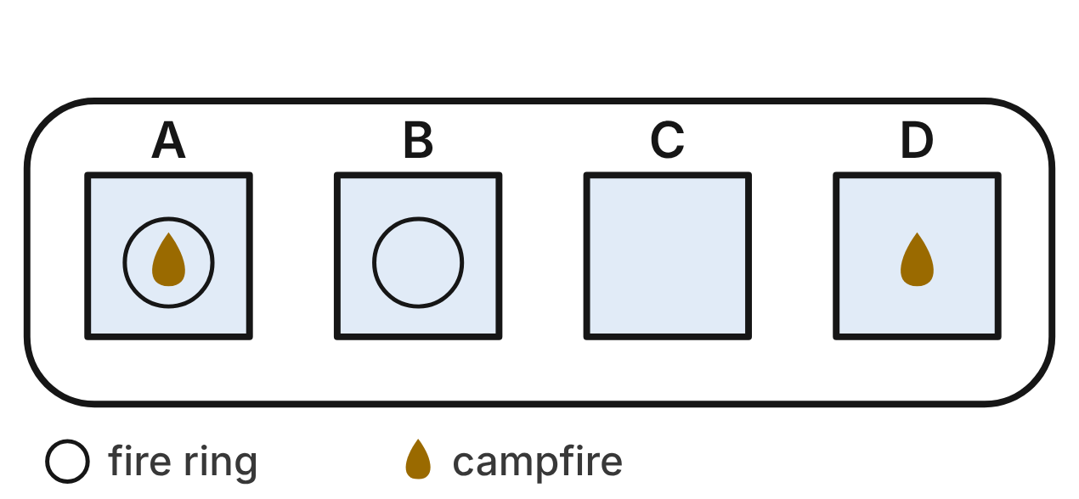
The campground rule is “If a site has a campfire, then the site has a fire ring.” Let f be “The site has a campfire” and r be “The site has a fire ring.” The map shows four sites one evening.
1. At which site is f → r false?
A. Site B
B. Site C
C. Site D ✔
D. Site A
G.RLT.1 · skill G.RLT.1.1 (LOTS): Translate statements into symbols and words: negation (~p), conjunction (p ∧ q), disjunction (p ∨ q), conditional (p → q) and biconditional (p ↔ q)
☐ Answer key correct ☐ Wording clear Notes: ________________________________
2. Which sentence is the converse of the campground rule?
A. If a site has a fire ring, then the site has a campfire. ✔
B. If a site has no campfire, then the site has no fire ring.
C. If a site has no fire ring, then the site has no campfire.
D. A site has a campfire if and only if it has a fire ring.
G.RLT.1 · skill G.RLT.1.2 (LOTS): Identify the converse, inverse and contrapositive of a conditional statement and decide whether each is true
☐ Answer key correct ☐ Wording clear Notes: ________________________________
3. Which site shows that the converse of the rule is false?
A. Site D
B. Site B ✔
C. Site C
D. Site A
G.RLT.1 · skill G.RLT.1.2 (LOTS): Identify the converse, inverse and contrapositive of a conditional statement and decide whether each is true
☐ Answer key correct ☐ Wording clear Notes: ________________________________
4. Which sentence is ~f ∧ r?
A. The site has a campfire, and it has no fire ring.
B. The site has no campfire, or it has a fire ring.
C. If the site has no campfire, then it has a fire ring.
D. The site has no campfire, and it has a fire ring. ✔
G.RLT.1 · skill G.RLT.1.1 (LOTS): Translate statements into symbols and words: negation (~p), conjunction (p ∧ q), disjunction (p ∨ q), conditional (p → q) and biconditional (p ↔ q)
☐ Answer key correct ☐ Wording clear Notes: ________________________________
5. Assume every site follows the rule. A ranger sees a campfire at site E. What can the ranger conclude?
A. Nothing can be concluded about site E.
B. Site E has no fire ring.
C. Site E has a fire ring. ✔
D. Every site with a fire ring has a campfire.
G.RLT.1 · skill G.RLT.1.3 (HOTS): Use deductive reasoning (the Law of Detachment and the Law of Syllogism) to decide whether a conclusion is valid
☐ Answer key correct ☐ Wording clear Notes: ________________________________
6. Assume every site follows the rule. Site F has a fire ring. Lu says, “So site F has a campfire.” Which describes Lu's reasoning?
A. Invalid: it assumes the converse of the rule ✔
B. Valid, by the Law of Detachment
C. Invalid: it assumes the inverse of the rule
D. Valid, by the contrapositive of the rule
G.RLT.1 · skill G.RLT.1.3 (HOTS): Use deductive reasoning (the Law of Detachment and the Law of Syllogism) to decide whether a conclusion is valid
☐ Answer key correct ☐ Wording clear Notes: ________________________________

Visitors to the Backyard Feeder
Level 1 · Logic · G.RLT.1 · ID geo-rlt1-worms-bird-feeder
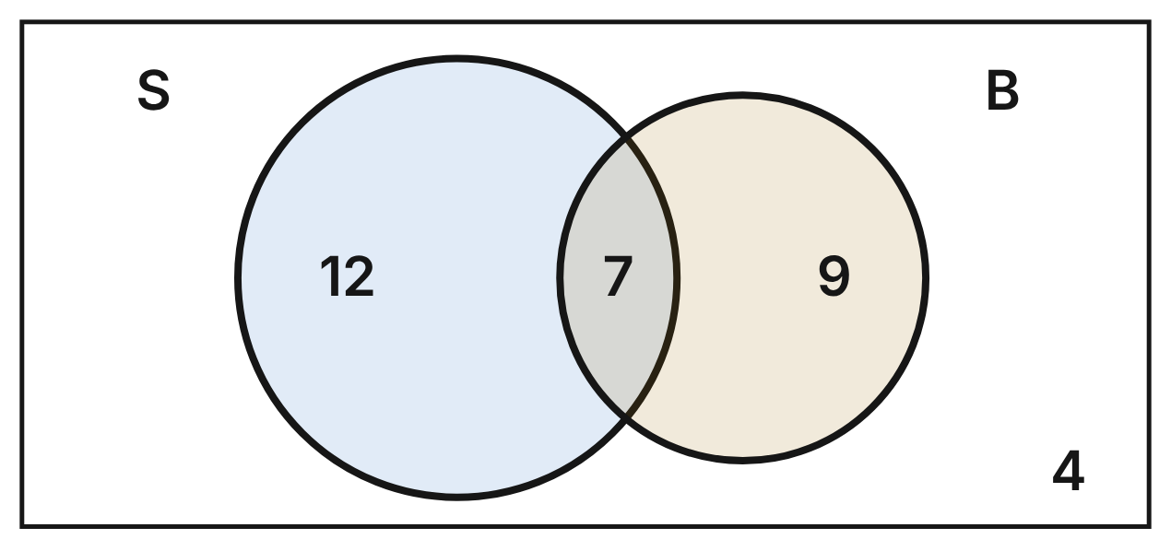
A family counted 32 birds one morning. S is the set of birds that ate seed from the feeder, and B is the set that used the birdbath. Each number is the number of birds in that region.
7. How many birds used the birdbath?
A. 9
B. 16 ✔
C. 7
D. 28
G.RLT.1 · skill G.RLT.1.4 (LOTS): Use and interpret Venn diagrams: union, intersection, subset and negation, including in context
☐ Answer key correct ☐ Wording clear Notes: ________________________________
8. How many birds are in S ∪ B?
A. 35
B. 21
C. 32
D. 28 ✔
G.RLT.1 · skill G.RLT.1.4 (LOTS): Use and interpret Venn diagrams: union, intersection, subset and negation, including in context
☐ Answer key correct ☐ Wording clear Notes: ________________________________
9. How many birds are in ~S?
A. 13 ✔
B. 19
C. 9
D. 4
G.RLT.1 · skill G.RLT.1.4 (LOTS): Use and interpret Venn diagrams: union, intersection, subset and negation, including in context
☐ Answer key correct ☐ Wording clear Notes: ________________________________
10. Which expression describes the birds that used the birdbath but did not eat seed?
A. S ∩ ~B
B. ~(S ∪ B)
C. ~S ∩ B ✔
D. ~S ∪ B
G.RLT.1 · skill G.RLT.1.1 (LOTS): Translate statements into symbols and words: negation (~p), conjunction (p ∧ q), disjunction (p ∨ q), conditional (p → q) and biconditional (p ↔ q)
☐ Answer key correct ☐ Wording clear Notes: ________________________________
11. Consider “If a bird ate seed, then it used the birdbath.” Is its converse true for these 32 birds? Choose the answer with the correct reason.
A. Yes; all 16 birds that used the birdbath ate seed.
B. No; 4 birds used the birdbath but did not eat seed.
C. No; 9 birds used the birdbath but did not eat seed. ✔
D. Yes; only 7 birds used the birdbath.
G.RLT.1 · skill G.RLT.1.2 (LOTS): Identify the converse, inverse and contrapositive of a conditional statement and decide whether each is true
☐ Answer key correct ☐ Wording clear Notes: ________________________________
12. Let s be “The bird ate seed” and b be “The bird used the birdbath.” Which statement is true for each of the 4 birds outside both circles?
A. s ∨ b
B. ~(s ∨ b) ✔
C. ~s ∧ b
D. s ↔ ~b
G.RLT.1 · skill G.RLT.1.1 (LOTS): Translate statements into symbols and words: negation (~p), conjunction (p ∧ q), disjunction (p ∨ q), conditional (p → q) and biconditional (p ↔ q)
☐ Answer key correct ☐ Wording clear Notes: ________________________________

The Park's Tree Key
Level 2 · Logic · G.RLT.1 · ID geo-rlt1-worms-tree-key
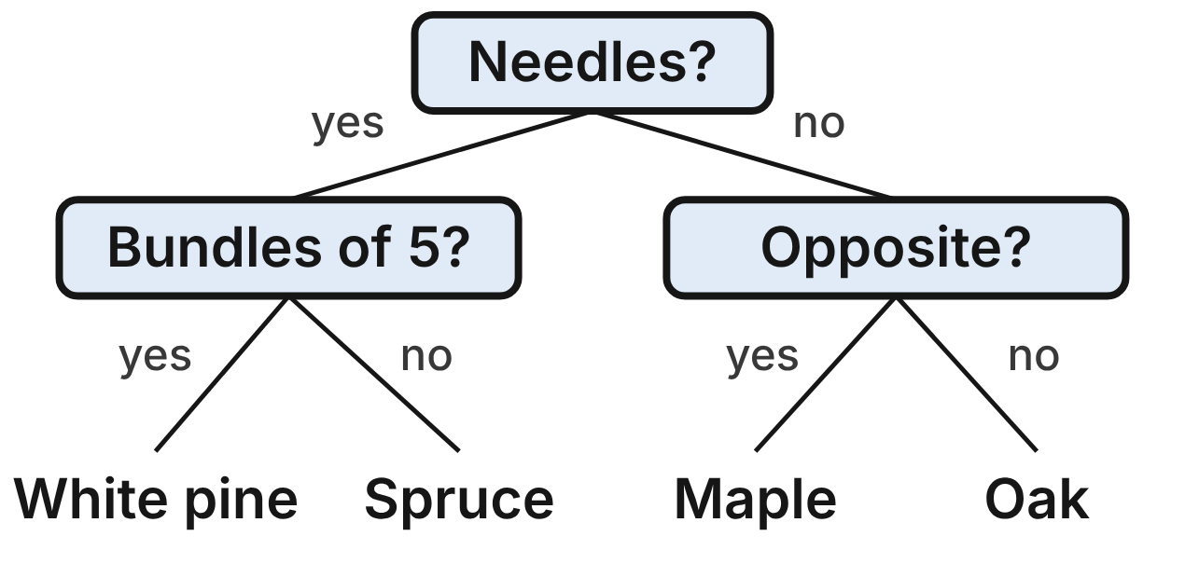
Every tree in a park is a white pine, a spruce, a maple or an oak, the park has trees of all four kinds, and this key names each one correctly. “Bundles of 5?” asks whether the needles grow in bundles of 5. “Opposite?” asks whether the leaves grow in opposite pairs. Let n be “The tree has needles,” f be “Its needles grow in bundles of 5” and o be “Its leaves grow in opposite pairs.”
13. A park tree has needles that grow in bundles of 5. Using the key, what can be concluded?
A. It is a spruce.
B. It is a pine or a spruce; the key cannot tell which.
C. It is a white pine. ✔
D. Its leaves grow in opposite pairs.
G.RLT.1 · skill G.RLT.1.3 (HOTS): Use deductive reasoning (the Law of Detachment and the Law of Syllogism) to decide whether a conclusion is valid
☐ Answer key correct ☐ Wording clear Notes: ________________________________
14. Which statement is true for every spruce in the park?
A. n ∧ f
B. n ∧ ~f ✔
C. ~n ∧ ~f
D. ~n ∨ f
G.RLT.1 · skill G.RLT.1.1 (LOTS): Translate statements into symbols and words: negation (~p), conjunction (p ∧ q), disjunction (p ∨ q), conditional (p → q) and biconditional (p ↔ q)
☐ Answer key correct ☐ Wording clear Notes: ________________________________
15. For which kind of tree is ~n ∧ ~o true?
A. Maple
B. Spruce
C. White pine
D. Oak ✔
G.RLT.1 · skill G.RLT.1.1 (LOTS): Translate statements into symbols and words: negation (~p), conjunction (p ∧ q), disjunction (p ∨ q), conditional (p → q) and biconditional (p ↔ q)
☐ Answer key correct ☐ Wording clear Notes: ________________________________
16. Which conditional is true for every tree in the park, but has a converse that is false?
A. If a tree has needles in bundles of 5, then it is a white pine.
B. If a tree has needles, then it is a spruce.
C. If a tree is an oak, then its leaves grow in opposite pairs.
D. If a tree is a spruce, then it has needles. ✔
G.RLT.1 · skill G.RLT.1.2 (LOTS): Identify the converse, inverse and contrapositive of a conditional statement and decide whether each is true
☐ Answer key correct ☐ Wording clear Notes: ________________________________
17. These are true in the park: “If a tree is a maple, then its leaves grow in opposite pairs.” “If a tree's leaves grow in opposite pairs, then it has no needles.” What follows by the Law of Syllogism?
A. If a tree is a maple, then it has no needles. ✔
B. If a tree has no needles, then it is a maple.
C. If a tree has needles, then it is a maple.
D. If a tree is not a maple, then it has needles.
G.RLT.1 · skill G.RLT.1.3 (HOTS): Use deductive reasoning (the Law of Detachment and the Law of Syllogism) to decide whether a conclusion is valid
☐ Answer key correct ☐ Wording clear Notes: ________________________________
18. Kai finds a park tree with no needles. He says, “It is not a spruce, so it must be a maple.” Which describes Kai's reasoning?
A. Valid: the key sends every tree with no needles to the maple
B. Valid, by the Law of Detachment
C. Invalid: the tree could be an oak ✔
D. Invalid: a tree with no needles could be a spruce
G.RLT.1 · skill G.RLT.1.3 (HOTS): Use deductive reasoning (the Law of Detachment and the Law of Syllogism) to decide whether a conclusion is valid
☐ Answer key correct ☐ Wording clear Notes: ________________________________

Sun and Water in the Garden
Level 2 · Logic · G.RLT.1 · ID geo-rlt1-worms-garden-grid
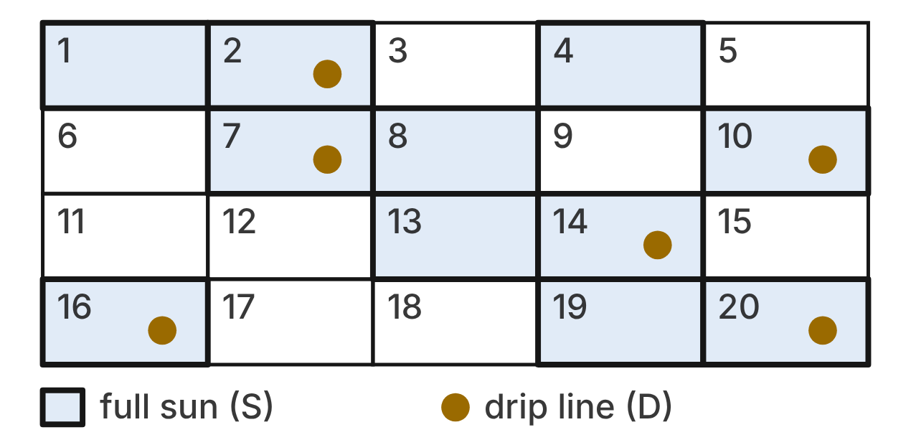
A community garden has 20 beds. A shaded bed gets full sun: these beds form set S. A bed with a gold dot has a drip line: these beds form set D.
19. How many beds are in S ∩ ~D?
A. 11
B. 6
C. 9
D. 5 ✔
G.RLT.1 · skill G.RLT.1.4 (LOTS): Use and interpret Venn diagrams: union, intersection, subset and negation, including in context
☐ Answer key correct ☐ Wording clear Notes: ________________________________
20. Which Venn diagram matches the garden?
A. Circle S drawn inside circle D
B. Circle D drawn inside circle S ✔
C. Circles S and D overlapping, with beds in all four regions
D. Circles S and D that do not meet
G.RLT.1 · skill G.RLT.1.4 (LOTS): Use and interpret Venn diagrams: union, intersection, subset and negation, including in context
☐ Answer key correct ☐ Wording clear Notes: ________________________________
21. Which conditional is true for all 20 beds?
A. If a bed gets full sun, then it has a drip line.
B. If a bed does not have a drip line, then it does not get full sun.
C. If a bed has a drip line, then it gets full sun. ✔
D. If a bed does not get full sun, then it has a drip line.
G.RLT.1 · skill G.RLT.1.2 (LOTS): Identify the converse, inverse and contrapositive of a conditional statement and decide whether each is true
☐ Answer key correct ☐ Wording clear Notes: ________________________________
22. The statement “If a bed has a drip line, then it gets full sun” is true. Which related statement must also be true?
A. If a bed gets full sun, then it has a drip line.
B. If a bed does not have a drip line, then it does not get full sun.
C. If a bed gets full sun, then it does not have a drip line.
D. If a bed does not get full sun, then it does not have a drip line. ✔
G.RLT.1 · skill G.RLT.1.2 (LOTS): Identify the converse, inverse and contrapositive of a conditional statement and decide whether each is true
☐ Answer key correct ☐ Wording clear Notes: ________________________________
23. The garden club adds a rule: “If a bed gets full sun, then it is planted with tomatoes.” Using the rule and the garden, which must be true?
A. Every bed with tomatoes has a drip line.
B. Every bed with a drip line is planted with tomatoes. ✔
C. Every bed without a drip line has no tomatoes.
D. Every bed with tomatoes gets full sun.
G.RLT.1 · skill G.RLT.1.3 (HOTS): Use deductive reasoning (the Law of Detachment and the Law of Syllogism) to decide whether a conclusion is valid
☐ Answer key correct ☐ Wording clear Notes: ________________________________
24. How many beds are in ~D?
A. 14 ✔
B. 6
C. 9
D. 11
G.RLT.1 · skill G.RLT.1.4 (LOTS): Use and interpret Venn diagrams: union, intersection, subset and negation, including in context
☐ Answer key correct ☐ Wording clear Notes: ________________________________

Who Was Seen at the Pond?
Level 2 · Logic · G.RLT.1 · ID geo-rlt1-worms-pond-sightings
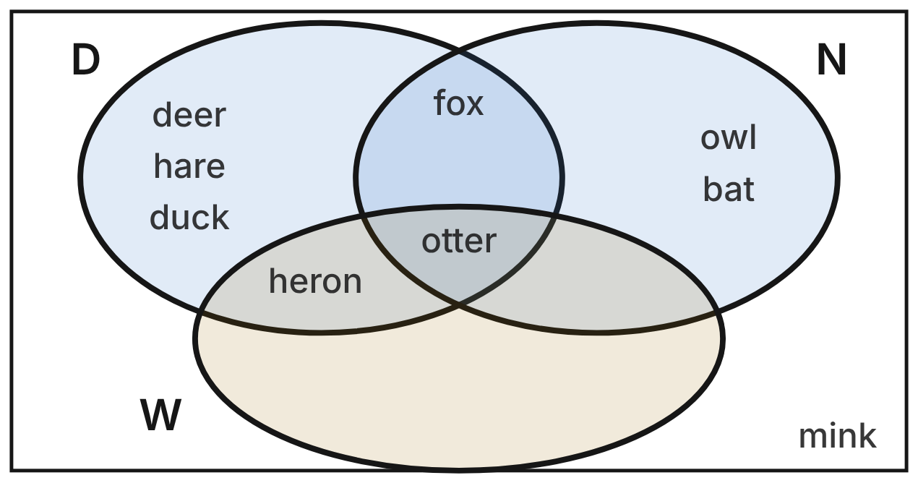
A nature camp's checklist has 9 animals. D is the set seen at the pond during the day, N the set seen there at night and W the set seen in the water. A region with no names holds no animals.
25. Which animals are in D ∩ W?
A. heron only
B. otter only
C. heron and otter ✔
D. deer, hare, duck and heron
G.RLT.1 · skill G.RLT.1.4 (LOTS): Use and interpret Venn diagrams: union, intersection, subset and negation, including in context
☐ Answer key correct ☐ Wording clear Notes: ________________________________
26. How many animals on the checklist are in N ∪ W?
A. 6
B. 5 ✔
C. 1
D. 4
G.RLT.1 · skill G.RLT.1.4 (LOTS): Use and interpret Venn diagrams: union, intersection, subset and negation, including in context
☐ Answer key correct ☐ Wording clear Notes: ________________________________
27. Which conditional is true for all 9 animals on the checklist?
A. If an animal was seen during the day, then it was seen in the water.
B. If an animal was seen at night, then it was not seen in the water.
C. If an animal was seen in the water, then it was seen during the day. ✔
D. If an animal was not seen in the water, then it was not seen during the day.
G.RLT.1 · skill G.RLT.1.2 (LOTS): Identify the converse, inverse and contrapositive of a conditional statement and decide whether each is true
☐ Answer key correct ☐ Wording clear Notes: ________________________________
28. A ranger says, “If an animal is seen in the water, then it is seen during the day” holds all summer. Next week a beaver is seen in the water. What can be concluded?
A. The beaver is seen at night.
B. The beaver is not seen during the day.
C. Nothing can be concluded about the beaver.
D. The beaver is seen during the day. ✔
G.RLT.1 · skill G.RLT.1.3 (HOTS): Use deductive reasoning (the Law of Detachment and the Law of Syllogism) to decide whether a conclusion is valid
☐ Answer key correct ☐ Wording clear Notes: ________________________________
29. Ella uses the statement “If an animal is seen in the water, then it is seen during the day.” She saw a hare during the day and says the hare must have been seen in the water. Which describes Ella's reasoning?
A. Invalid: it uses the converse of the statement ✔
B. Valid, by the Law of Detachment
C. Invalid: it uses the inverse of the statement
D. Valid: the hare is in circle D
G.RLT.1 · skill G.RLT.1.3 (HOTS): Use deductive reasoning (the Law of Detachment and the Law of Syllogism) to decide whether a conclusion is valid
☐ Answer key correct ☐ Wording clear Notes: ________________________________
30. Which expression names the region that holds the fox?
A. D ∩ N
B. D ∩ N ∩ ~W ✔
C. D ∩ N ∩ W
D. (D ∪ N) ∩ ~W
G.RLT.1 · skill G.RLT.1.1 (LOTS): Translate statements into symbols and words: negation (~p), conjunction (p ∧ q), disjunction (p ∨ q), conditional (p → q) and biconditional (p ↔ q)
☐ Answer key correct ☐ Wording clear Notes: ________________________________

The River Gauge at the Trailhead
Level 3 · Logic · G.RLT.1 · ID geo-rlt1-worms-river-gauge
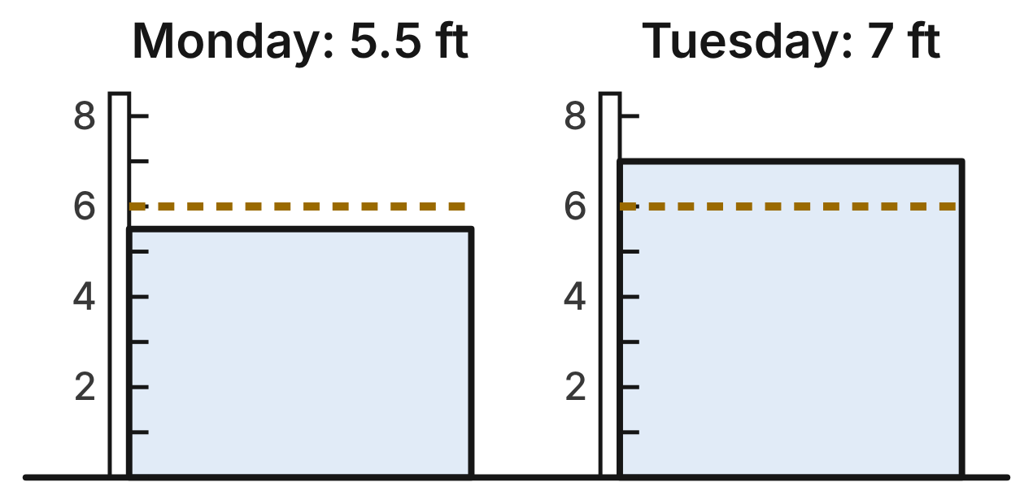
A park follows two true rules. Rule 1: If the river is above 6 ft, then the low trail is closed. Rule 2: The canoe launch is open if and only if the low trail is open. The gold dashed line on each gauge marks 6 ft. Let a be “The river is above 6 ft,” c be “The low trail is closed” and o be “The canoe launch is open.”
31. Using the gauges and the rules, what can be concluded for Tuesday?
A. The low trail is closed and the canoe launch is open.
B. Nothing can be concluded about the canoe launch.
C. The low trail is open and the canoe launch is open.
D. The low trail is closed and the canoe launch is closed. ✔
G.RLT.1 · skill G.RLT.1.3 (HOTS): Use deductive reasoning (the Law of Detachment and the Law of Syllogism) to decide whether a conclusion is valid
☐ Answer key correct ☐ Wording clear Notes: ________________________________
32. Ned reads Monday's gauge and says, “The river is not above 6 ft, so the low trail is open.” Which describes Ned's reasoning?
A. Valid, by the Law of Detachment with rule 1
B. Invalid: it assumes the inverse of rule 1 ✔
C. Valid, by the contrapositive of rule 1
D. Invalid: it assumes the converse of rule 1
G.RLT.1 · skill G.RLT.1.3 (HOTS): Use deductive reasoning (the Law of Detachment and the Law of Syllogism) to decide whether a conclusion is valid
☐ Answer key correct ☐ Wording clear Notes: ________________________________
33. On Wednesday the canoe launch is open. What can be concluded?
A. The river is above 6 ft.
B. The low trail is closed.
C. The river is not above 6 ft. ✔
D. Nothing can be concluded about the river.
G.RLT.1 · skill G.RLT.1.3 (HOTS): Use deductive reasoning (the Law of Detachment and the Law of Syllogism) to decide whether a conclusion is valid
☐ Answer key correct ☐ Wording clear Notes: ________________________________
34. Which shows rule 2 in symbols?
A. o ↔ ~c ✔
B. ~o ↔ ~c
C. o ∧ ~c
D. o → ~c
G.RLT.1 · skill G.RLT.1.1 (LOTS): Translate statements into symbols and words: negation (~p), conjunction (p ∧ q), disjunction (p ∨ q), conditional (p → q) and biconditional (p ↔ q)
☐ Answer key correct ☐ Wording clear Notes: ________________________________
35. Which conditional follows from rules 1 and 2?
A. If the river is above 6 ft, then the canoe launch is closed. ✔
B. If the canoe launch is closed, then the river is above 6 ft.
C. If the river is not above 6 ft, then the canoe launch is open.
D. If the river is above 6 ft, then the canoe launch is open.
G.RLT.1 · skill G.RLT.1.3 (HOTS): Use deductive reasoning (the Law of Detachment and the Law of Syllogism) to decide whether a conclusion is valid
☐ Answer key correct ☐ Wording clear Notes: ________________________________
36. Which sentence is the contrapositive of rule 1 about the river?
A. If the low trail is closed, then the river is above 6 ft.
B. If the river is not above 6 ft, then the low trail is open.
C. If the low trail is open, then the river is above 6 ft.
D. If the low trail is open, then the river is not above 6 ft. ✔
G.RLT.1 · skill G.RLT.1.2 (LOTS): Identify the converse, inverse and contrapositive of a conditional statement and decide whether each is true
☐ Answer key correct ☐ Wording clear Notes: ________________________________

Bloom, Fruit and Spray in the Orchard
Level 3 · Logic · G.RLT.1 · ID geo-rlt1-worms-orchard
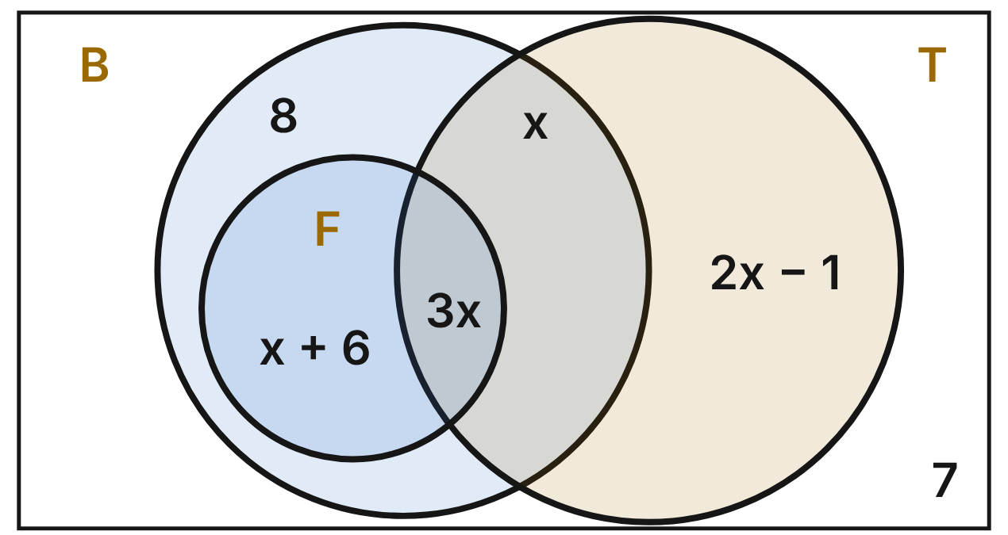
An orchard has 90 trees. B is the set of trees that bloomed this spring, F the set that produced fruit and T the set treated for pests. Circle F is drawn inside circle B. Each label gives the number of trees in that region.
37. What is the value of x in the orchard diagram?
A. 11
B. 10 ✔
C. 30
D. 16
G.RLT.1 · skill G.RLT.1.4 (LOTS): Use and interpret Venn diagrams: union, intersection, subset and negation, including in context
☐ Answer key correct ☐ Wording clear Notes: ________________________________
38. How many trees produced fruit?
A. 30
B. 64
C. 16
D. 46 ✔
G.RLT.1 · skill G.RLT.1.4 (LOTS): Use and interpret Venn diagrams: union, intersection, subset and negation, including in context
☐ Answer key correct ☐ Wording clear Notes: ________________________________
39. How many trees bloomed but did not produce fruit?
A. 18 ✔
B. 8
C. 34
D. 10
G.RLT.1 · skill G.RLT.1.4 (LOTS): Use and interpret Venn diagrams: union, intersection, subset and negation, including in context
☐ Answer key correct ☐ Wording clear Notes: ________________________________
40. Which conditional is true for all 90 trees?
A. If a tree bloomed, then it produced fruit.
B. If a tree did not produce fruit, then it did not bloom.
C. If a tree produced fruit, then it bloomed. ✔
D. If a tree was treated for pests, then it produced fruit.
G.RLT.1 · skill G.RLT.1.2 (LOTS): Identify the converse, inverse and contrapositive of a conditional statement and decide whether each is true
☐ Answer key correct ☐ Wording clear Notes: ________________________________
41. Tree 41 in the orchard did not bloom. What can be concluded?
A. Tree 41 was treated for pests.
B. Tree 41 produced fruit.
C. Nothing can be concluded about fruit on tree 41.
D. Tree 41 did not produce fruit. ✔
G.RLT.1 · skill G.RLT.1.3 (HOTS): Use deductive reasoning (the Law of Detachment and the Law of Syllogism) to decide whether a conclusion is valid
☐ Answer key correct ☐ Wording clear Notes: ________________________________
42. How many trees are in T ∪ F?
A. 105
B. 59
C. 75 ✔
D. 30
G.RLT.1 · skill G.RLT.1.4 (LOTS): Use and interpret Venn diagrams: union, intersection, subset and negation, including in context
☐ Answer key correct ☐ Wording clear Notes: ________________________________

G.RLT.2 · Analyze, prove, and justify the relationships of parallel lines cut by a transversal.

Rows in the Cornfield
Level 1 · Lines · G.RLT.2 · ID geo-rlt2-worms-corn-rows
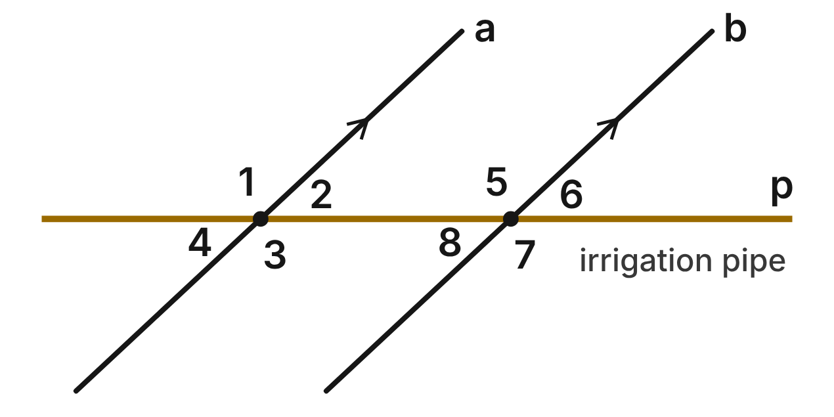
In a cornfield, crop rows a and b are parallel. A straight irrigation pipe, p, crosses both rows. m∠6 = 43°.
43. Which angle is a same-side interior angle with ∠2?
A. ∠8
B. ∠6
C. ∠5 ✔
D. ∠3
G.RLT.2 · skill G.RLT.2.1 (LOTS): Identify angle pairs formed by a transversal: corresponding, alternate interior, alternate exterior, same-side interior, vertical and linear pairs
☐ Answer key correct ☐ Wording clear Notes: ________________________________
44. What is m∠2, at row a?
A. 43° ✔
B. 137°
C. 47°
D. 86°
G.RLT.2 · skill G.RLT.2.3 (LOTS): Solve problems, including algebraic ones, using the angles formed by parallel lines and a transversal
☐ Answer key correct ☐ Wording clear Notes: ________________________________
45. What is m∠7, at row b?
A. 43°
B. 137° ✔
C. 47°
D. 223°
G.RLT.2 · skill G.RLT.2.3 (LOTS): Solve problems, including algebraic ones, using the angles formed by parallel lines and a transversal
☐ Answer key correct ☐ Wording clear Notes: ________________________________
46. Which two angles are alternate exterior angles?
A. ∠1 and ∠5
B. ∠2 and ∠8
C. ∠1 and ∠3
D. ∠1 and ∠7 ✔
G.RLT.2 · skill G.RLT.2.1 (LOTS): Identify angle pairs formed by a transversal: corresponding, alternate interior, alternate exterior, same-side interior, vertical and linear pairs
☐ Answer key correct ☐ Wording clear Notes: ________________________________
47. Which angle does NOT measure 43°?
A. ∠4
B. ∠5 ✔
C. ∠8
D. ∠2
G.RLT.2 · skill G.RLT.2.3 (LOTS): Solve problems, including algebraic ones, using the angles formed by parallel lines and a transversal
☐ Answer key correct ☐ Wording clear Notes: ________________________________
48. In another field, a pipe crosses two rows. The angles in the places of ∠4 and ∠6 both measure 49°. Which reason proves that those rows are parallel?
A. Converse of the Corresponding Angles Postulate
B. Alternate Exterior Angles Theorem
C. Converse of the Alternate Exterior Angles Theorem ✔
D. Vertical Angles Theorem
G.RLT.2 · skill G.RLT.2.2 (HOTS): Prove or justify that two lines are parallel, or are not, from angle measures
☐ Answer key correct ☐ Wording clear Notes: ________________________________

Ski Tracks and a Deer Trail
Level 1 · Lines · G.RLT.2 · ID geo-rlt2-worms-ski-tracks
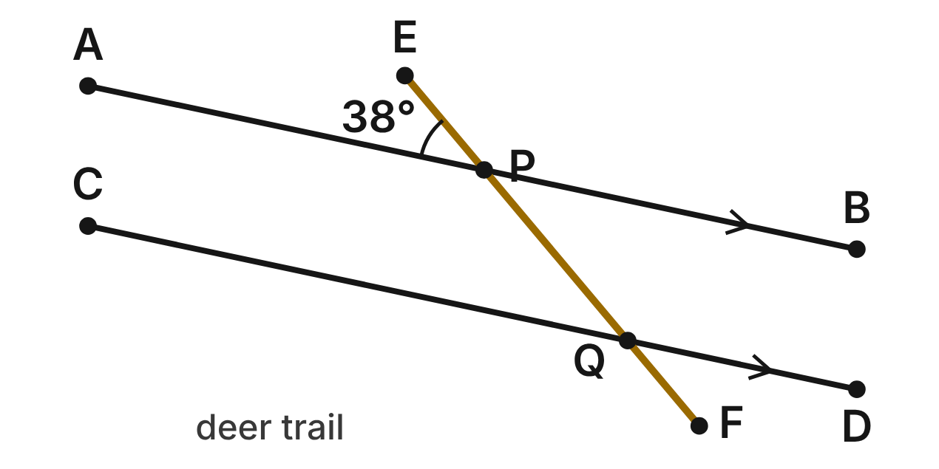
Two ski tracks in the snow, AB and CD, are parallel. A straight deer trail, EF, crosses AB at P and CD at Q. m∠APE = 38°.
49. Which angle corresponds to ∠BPE?
A. ∠DQP ✔
B. ∠CQF
C. ∠APQ
D. ∠CQP
G.RLT.2 · skill G.RLT.2.1 (LOTS): Identify angle pairs formed by a transversal: corresponding, alternate interior, alternate exterior, same-side interior, vertical and linear pairs
☐ Answer key correct ☐ Wording clear Notes: ________________________________
50. What is m∠DQF?
A. 142°
B. 52°
C. 322°
D. 38° ✔
G.RLT.2 · skill G.RLT.2.3 (LOTS): Solve problems, including algebraic ones, using the angles formed by parallel lines and a transversal
☐ Answer key correct ☐ Wording clear Notes: ________________________________
51. What kind of angle pair are ∠BPQ and ∠DQP?
A. Alternate interior angles
B. Same-side interior angles ✔
C. Corresponding angles
D. Alternate exterior angles
G.RLT.2 · skill G.RLT.2.1 (LOTS): Identify angle pairs formed by a transversal: corresponding, alternate interior, alternate exterior, same-side interior, vertical and linear pairs
☐ Answer key correct ☐ Wording clear Notes: ________________________________
52. What is m∠APQ?
A. 38°
B. 52°
C. 142° ✔
D. 218°
G.RLT.2 · skill G.RLT.2.3 (LOTS): Solve problems, including algebraic ones, using the angles formed by parallel lines and a transversal
☐ Answer key correct ☐ Wording clear Notes: ________________________________
53. Which angle forms a linear pair with ∠CQF?
A. ∠DQP
B. ∠APQ
C. ∠BPE
D. ∠CQP ✔
G.RLT.2 · skill G.RLT.2.1 (LOTS): Identify angle pairs formed by a transversal: corresponding, alternate interior, alternate exterior, same-side interior, vertical and linear pairs
☐ Answer key correct ☐ Wording clear Notes: ________________________________
54. A skier says, "The tracks are parallel because ∠APE ≅ ∠BPQ." Which statement about her reason is true? Choose the answer with the correct reason.
A. Valid; ∠APE and ∠BPQ are corresponding angles.
B. Not valid; vertical angles are always congruent. ✔
C. Valid; ∠APE and ∠BPQ are alternate exterior angles.
D. Not valid; ∠APE and ∠BPQ are not congruent.
G.RLT.2 · skill G.RLT.2.2 (HOTS): Prove or justify that two lines are parallel, or are not, from angle measures
☐ Answer key correct ☐ Wording clear Notes: ________________________________

The Orchard Path
Level 2 · Lines · G.RLT.2 · ID geo-rlt2-worms-orchard-path
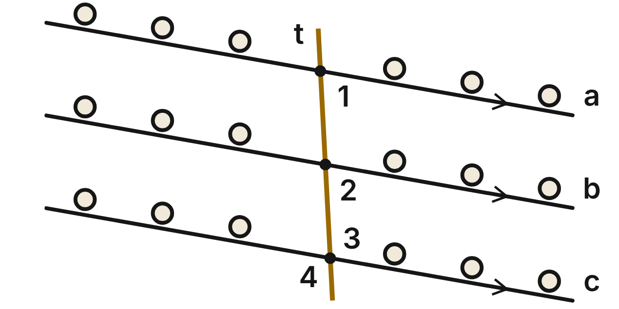
In an orchard, tree rows a, b and c are parallel. A straight tractor path, t, crosses all three. m∠1 = (3x − 4)⁠°, m∠2 = (2x + 23)⁠° and m∠3 = (2y + 33)°.
55. What is x for the tractor path?
A. 19
B. 27 ✔
C. 32.2
D. 77
G.RLT.2 · skill G.RLT.2.3 (LOTS): Solve problems, including algebraic ones, using the angles formed by parallel lines and a transversal
☐ Answer key correct ☐ Wording clear Notes: ________________________________
56. What is the value of y?
A. 35 ✔
B. 22
C. 68
D. 51.5
G.RLT.2 · skill G.RLT.2.3 (LOTS): Solve problems, including algebraic ones, using the angles formed by parallel lines and a transversal
☐ Answer key correct ☐ Wording clear Notes: ________________________________
57. What is m∠4, at row c?
A. 77°
B. 13°
C. 283°
D. 103° ✔
G.RLT.2 · skill G.RLT.2.3 (LOTS): Solve problems, including algebraic ones, using the angles formed by parallel lines and a transversal
☐ Answer key correct ☐ Wording clear Notes: ________________________________
58. Using rows a and c, what kind of angle pair are ∠1 and ∠3?
A. Corresponding angles
B. Alternate interior angles
C. Same-side interior angles ✔
D. Alternate exterior angles
G.RLT.2 · skill G.RLT.2.1 (LOTS): Identify angle pairs formed by a transversal: corresponding, alternate interior, alternate exterior, same-side interior, vertical and linear pairs
☐ Answer key correct ☐ Wording clear Notes: ________________________________
59. In another orchard, a path crosses two rows the same way it crosses rows b and c here. Which measures in the places of ∠2 and ∠3 would show that those two rows are NOT parallel?
A. m∠2 = 77° and m∠3 = 103°
B. m∠2 = 77° and m∠3 = 105° ✔
C. m∠2 = 75° and m∠3 = 105°
D. m∠2 = 81° and m∠3 = 99°
G.RLT.2 · skill G.RLT.2.2 (HOTS): Prove or justify that two lines are parallel, or are not, from angle measures
☐ Answer key correct ☐ Wording clear Notes: ________________________________
60. Which statement about the orchard angles is NOT true?
A. ∠1 and ∠2 are corresponding angles.
B. ∠2 and ∠3 are same-side interior angles.
C. ∠3 and ∠4 are vertical angles.
D. ∠1 and ∠2 are alternate interior angles. ✔
G.RLT.2 · skill G.RLT.2.1 (LOTS): Identify angle pairs formed by a transversal: corresponding, alternate interior, alternate exterior, same-side interior, vertical and linear pairs
☐ Answer key correct ☐ Wording clear Notes: ________________________________

Rain on the Hillside
Level 2 · Lines · G.RLT.2 · ID geo-rlt2-worms-rain-hillside
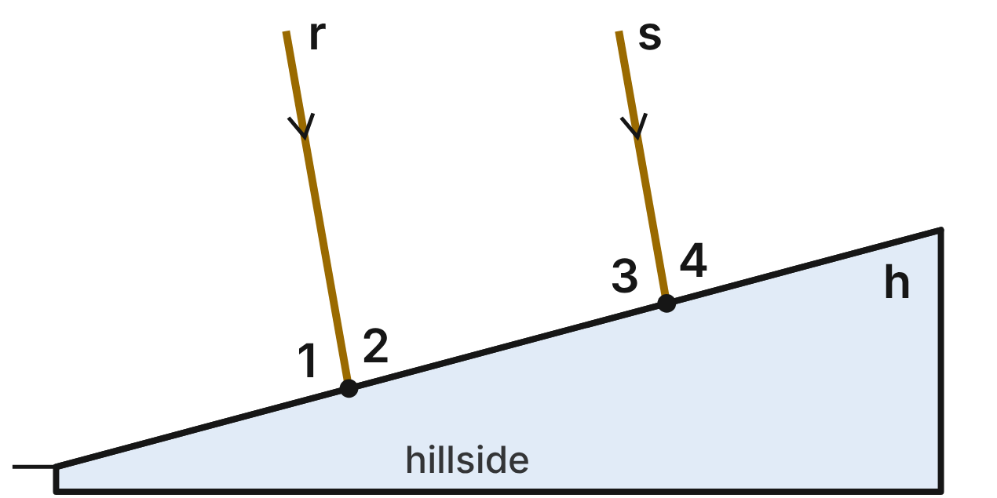
Wind makes the rain fall in slanted, parallel streaks. Streaks r and s are parallel, and they hit the straight hillside h. m∠2 = (2x + 29)⁠° and m∠3 = (3x + 11)⁠°.
61. Find the value of x for the rain streaks.
A. 44
B. 36
C. 28 ✔
D. 18
G.RLT.2 · skill G.RLT.2.3 (LOTS): Solve problems, including algebraic ones, using the angles formed by parallel lines and a transversal
☐ Answer key correct ☐ Wording clear Notes: ________________________________
62. What is m∠3, where streak s meets the hill?
A. 95° ✔
B. 85°
C. 84°
D. 65°
G.RLT.2 · skill G.RLT.2.3 (LOTS): Solve problems, including algebraic ones, using the angles formed by parallel lines and a transversal
☐ Answer key correct ☐ Wording clear Notes: ________________________________
63. ∠2 and ∠3 are what kind of angle pair?
A. Alternate interior angles
B. Corresponding angles
C. A linear pair
D. Same-side interior angles ✔
G.RLT.2 · skill G.RLT.2.1 (LOTS): Identify angle pairs formed by a transversal: corresponding, alternate interior, alternate exterior, same-side interior, vertical and linear pairs
☐ Answer key correct ☐ Wording clear Notes: ________________________________
64. Find m∠4 on the hillside.
A. 95°
B. 85° ✔
C. 5°
D. 170°
G.RLT.2 · skill G.RLT.2.3 (LOTS): Solve problems, including algebraic ones, using the angles formed by parallel lines and a transversal
☐ Answer key correct ☐ Wording clear Notes: ________________________________
65. Suppose no one knew that the streaks were parallel. Which fact alone would prove that r ∥ s?
A. ∠2 and ∠3 are supplementary. ✔
B. ∠2 ≅ ∠3.
C. ∠1 and ∠2 are supplementary.
D. ∠2 and ∠4 are supplementary.
G.RLT.2 · skill G.RLT.2.2 (HOTS): Prove or justify that two lines are parallel, or are not, from angle measures
☐ Answer key correct ☐ Wording clear Notes: ________________________________
66. Which statement about the rain angles is NOT true?
A. ∠1 and ∠3 are corresponding angles.
B. ∠2 and ∠4 are corresponding angles.
C. ∠1 and ∠4 are alternate exterior angles. ✔
D. ∠1 and ∠2 form a linear pair.
G.RLT.2 · skill G.RLT.2.1 (LOTS): Identify angle pairs formed by a transversal: corresponding, alternate interior, alternate exterior, same-side interior, vertical and linear pairs
☐ Answer key correct ☐ Wording clear Notes: ________________________________

Two Trails to the River
Level 2 · Lines · G.RLT.2 · ID geo-rlt2-worms-river-trails
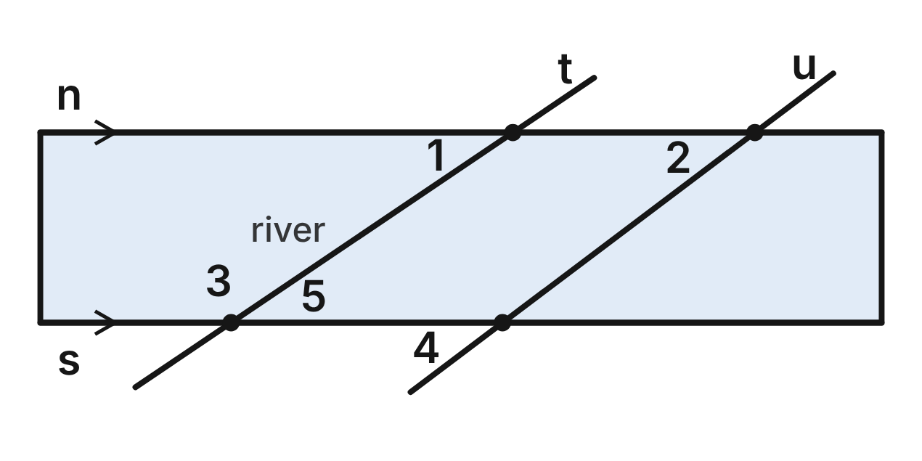
The banks of a river, n and s, are parallel. Two straight trails, t and u, cross the river at fords. m∠1 = 34°, m∠2 = 37° and m∠4 = (2x + 17)⁠°.
67. With bank n as the transversal of trails t and u, what kind of angle pair are ∠1 and ∠2?
A. Corresponding angles ✔
B. Alternate interior angles
C. Same-side interior angles
D. Vertical angles
G.RLT.2 · skill G.RLT.2.1 (LOTS): Identify angle pairs formed by a transversal: corresponding, alternate interior, alternate exterior, same-side interior, vertical and linear pairs
☐ Answer key correct ☐ Wording clear Notes: ________________________________
68. Are trails t and u parallel? Choose the answer with the correct reason.
A. Yes; both trails cross the parallel banks.
B. Yes; ∠1 and ∠2 are vertical angles.
C. No; corresponding angles ∠1 and ∠2 are not congruent. ✔
D. No; ∠1 and ∠2 should add to 180°.
G.RLT.2 · skill G.RLT.2.2 (HOTS): Prove or justify that two lines are parallel, or are not, from angle measures
☐ Answer key correct ☐ Wording clear Notes: ________________________________
69. What is m∠3, at the south bank?
A. 34°
B. 146° ✔
C. 37°
D. 124°
G.RLT.2 · skill G.RLT.2.3 (LOTS): Solve problems, including algebraic ones, using the angles formed by parallel lines and a transversal
☐ Answer key correct ☐ Wording clear Notes: ________________________________
70. Use ∠4 to find the value of x.
A. 8.5
B. 63
C. 27
D. 10 ✔
G.RLT.2 · skill G.RLT.2.3 (LOTS): Solve problems, including algebraic ones, using the angles formed by parallel lines and a transversal
☐ Answer key correct ☐ Wording clear Notes: ________________________________
71. A ranger plans a new trail that will be parallel to trail t and cross bank n east of trail u. What angle must it make below n and to the left of the new trail?
A. 37°
B. 146°
C. 34° ✔
D. 56°
G.RLT.2 · skill G.RLT.2.3 (LOTS): Solve problems, including algebraic ones, using the angles formed by parallel lines and a transversal
☐ Answer key correct ☐ Wording clear Notes: ________________________________
72. Which angle is congruent to ∠1 because they are alternate interior angles along trail t?
A. ∠5 ✔
B. ∠3
C. ∠2
D. ∠4
G.RLT.2 · skill G.RLT.2.1 (LOTS): Identify angle pairs formed by a transversal: corresponding, alternate interior, alternate exterior, same-side interior, vertical and linear pairs
☐ Answer key correct ☐ Wording clear Notes: ________________________________

The Hedgerows That Only Look Parallel
Level 3 · Lines · G.RLT.2 · ID geo-rlt2-worms-hedgerow-proof
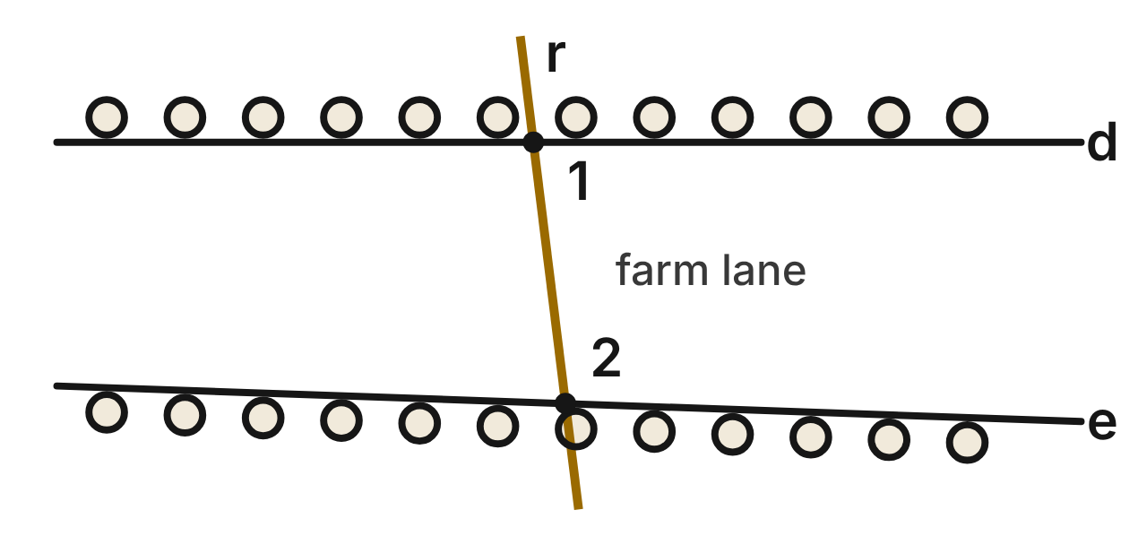
Two hedgerows, d and e, are crossed by a straight farm lane, r. A farmer measures m∠1 = 83° and m∠2 = 99°. Her indirect proof that d is not parallel to e has three blanks.
Assume that (a) ____. Then ∠1 and ∠2 are supplementary, by the (b) ____. So m∠1 + m∠2 = 180°. But 83° + 99° = 182°, which is a contradiction. So the assumption is false, and (c) ____.
73. In the hedgerow proof, what belongs in blank (a)?
A. d is not parallel to e
B. d ∥ e ✔
C. ∠1 ≅ ∠2
D. m∠1 + m∠2 = 182°
G.RLT.2 · skill G.RLT.2.2 (HOTS): Prove or justify that two lines are parallel, or are not, from angle measures
☐ Answer key correct ☐ Wording clear Notes: ________________________________
74. In the hedgerow proof, which theorem belongs in blank (b)?
A. Converse of the Same-Side Interior Angles Theorem
B. Alternate Interior Angles Theorem
C. Linear Pair Postulate
D. Same-Side Interior Angles Theorem ✔
G.RLT.2 · skill G.RLT.2.2 (HOTS): Prove or justify that two lines are parallel, or are not, from angle measures
☐ Answer key correct ☐ Wording clear Notes: ________________________________
75. In the hedgerow proof, what belongs in blank (c)?
A. d is not parallel to e ✔
B. d ∥ e
C. m∠1 + m∠2 = 180°
D. the measures 83° and 99° are wrong
G.RLT.2 · skill G.RLT.2.2 (HOTS): Prove or justify that two lines are parallel, or are not, from angle measures
☐ Answer key correct ☐ Wording clear Notes: ________________________________
76. ∠1 and ∠2 are what kind of angle pair?
A. Alternate interior angles
B. Corresponding angles
C. Same-side interior angles ✔
D. Alternate exterior angles
G.RLT.2 · skill G.RLT.2.1 (LOTS): Identify angle pairs formed by a transversal: corresponding, alternate interior, alternate exterior, same-side interior, vertical and linear pairs
☐ Answer key correct ☐ Wording clear Notes: ________________________________
77. The farmer replants hedgerow e so that it is parallel to d. The lane and m∠1 = 83° do not change. What must the angle in the place of ∠2 measure?
A. 83°
B. 97° ✔
C. 99°
D. 7°
G.RLT.2 · skill G.RLT.2.3 (LOTS): Solve problems, including algebraic ones, using the angles formed by parallel lines and a transversal
☐ Answer key correct ☐ Wording clear Notes: ________________________________
78. On another farm, a lane crosses two hedgerows. m∠1 = (7x + 15)⁠° and m∠2 = (5x + 33)⁠°, in the same places as in the figure. For what value of x are those hedgerows parallel?
A. 19
B. 15
C. 9
D. 11 ✔
G.RLT.2 · skill G.RLT.2.3 (LOTS): Solve problems, including algebraic ones, using the angles formed by parallel lines and a transversal
☐ Answer key correct ☐ Wording clear Notes: ________________________________

The Fence on the Hill
Level 3 · Lines · G.RLT.2 · ID geo-rlt2-worms-hill-fence
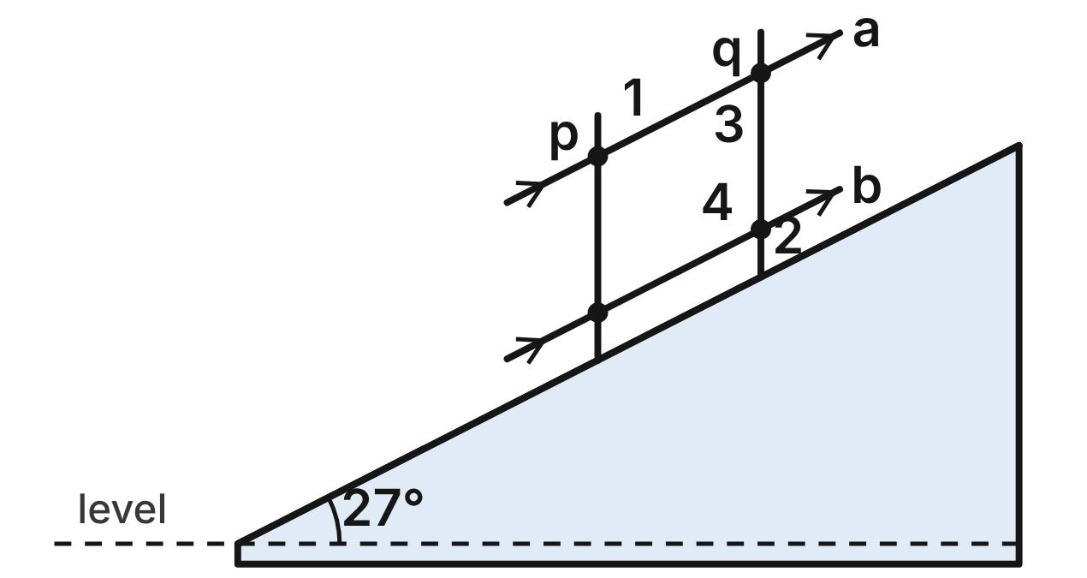
A hillside rises 27° from level. Fence posts p and q stand vertical, so each is perpendicular to level ground. Rails a and b are parallel to the hillside.
79. What is m∠1, between post p and rail a on the uphill side?
A. 27°
B. 117°
C. 63° ✔
D. 153°
G.RLT.2 · skill G.RLT.2.3 (LOTS): Solve problems, including algebraic ones, using the angles formed by parallel lines and a transversal
☐ Answer key correct ☐ Wording clear Notes: ________________________________
80. What is m∠2, at post q?
A. 63°
B. 27°
C. 153°
D. 117° ✔
G.RLT.2 · skill G.RLT.2.3 (LOTS): Solve problems, including algebraic ones, using the angles formed by parallel lines and a transversal
☐ Answer key correct ☐ Wording clear Notes: ________________________________
81. With post q as the transversal of rails a and b, what kind of angle pair are ∠3 and ∠4?
A. Same-side interior angles ✔
B. Alternate interior angles
C. Corresponding angles
D. Alternate exterior angles
G.RLT.2 · skill G.RLT.2.1 (LOTS): Identify angle pairs formed by a transversal: corresponding, alternate interior, alternate exterior, same-side interior, vertical and linear pairs
☐ Answer key correct ☐ Wording clear Notes: ________________________________
82. Why must posts p and q be parallel?
A. They each make a 27° angle with rail a.
B. They are both perpendicular to level ground. ✔
C. ∠3 and ∠4 are congruent.
D. ∠1 and ∠2 are vertical angles.
G.RLT.2 · skill G.RLT.2.2 (HOTS): Prove or justify that two lines are parallel, or are not, from angle measures
☐ Answer key correct ☐ Wording clear Notes: ________________________________
83. Higher up, the hill is steeper. There a vertical post and a rail parallel to the hillside make a 58° angle in the place of ∠1. How many degrees does that part of the hill rise from level?
A. 32° ✔
B. 58°
C. 122°
D. 148°
G.RLT.2 · skill G.RLT.2.3 (LOTS): Solve problems, including algebraic ones, using the angles formed by parallel lines and a transversal
☐ Answer key correct ☐ Wording clear Notes: ________________________________
84. A builder measures 63° above rail b and right of post p, and 63° below rail a and left of post p. Which reason proves that rail a ∥ rail b?
A. Converse of the Corresponding Angles Postulate
B. Alternate Interior Angles Theorem
C. Converse of the Alternate Interior Angles Theorem ✔
D. Converse of the Same-Side Interior Angles Theorem
G.RLT.2 · skill G.RLT.2.2 (HOTS): Prove or justify that two lines are parallel, or are not, from angle measures
☐ Answer key correct ☐ Wording clear Notes: ________________________________

G.RLT.3 · Solve problems, including contextual problems, involving symmetry and transformation.

Sketches from a Nature Walk
Level 1 · Transformations · G.RLT.3 · ID geo-rlt3-worms-nature-sketches
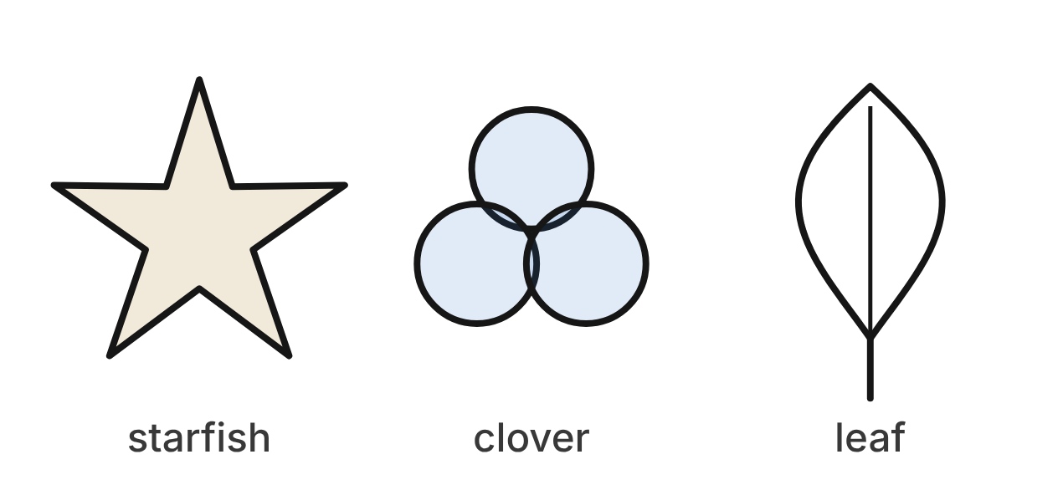
On a nature walk, a class sketches three things. The starfish has five identical arms, equally spaced. The clover has three identical round leaves, equally spaced around its center. The leaf has a stem and two matching halves.
85. How many lines of symmetry does the starfish have?
A. 5 ✔
B. 10
C. 1
D. 0
G.RLT.3 · skill G.RLT.3.1 (LOTS): Identify line symmetry and rotational symmetry of a figure
☐ Answer key correct ☐ Wording clear Notes: ________________________________
86. What is the smallest angle of rotation, about its center, that maps the starfish onto itself?
A. 36°
B. 108°
C. 72° ✔
D. 180°
G.RLT.3 · skill G.RLT.3.1 (LOTS): Identify line symmetry and rotational symmetry of a figure
☐ Answer key correct ☐ Wording clear Notes: ________________________________
87. What is the order of rotational symmetry of the clover?
A. 120
B. 6
C. 3 ✔
D. 1
G.RLT.3 · skill G.RLT.3.1 (LOTS): Identify line symmetry and rotational symmetry of a figure
☐ Answer key correct ☐ Wording clear Notes: ________________________________
88. Which describes the symmetry of the leaf, including its stem?
A. 2 lines of symmetry; rotational symmetry of order 2
B. 1 line of symmetry; no rotational symmetry ✔
C. No lines of symmetry; no rotational symmetry
D. 1 line of symmetry; rotational symmetry of order 2
G.RLT.3 · skill G.RLT.3.1 (LOTS): Identify line symmetry and rotational symmetry of a figure
☐ Answer key correct ☐ Wording clear Notes: ________________________________
89. Which rotation about its center does NOT map the starfish onto itself?
A. 144°
B. 216°
C. 288°
D. 120° ✔
G.RLT.3 · skill G.RLT.3.1 (LOTS): Identify line symmetry and rotational symmetry of a figure
☐ Answer key correct ☐ Wording clear Notes: ________________________________
90. A field guide prints the starfish 3 times as large, by a dilation with scale factor 3. Which is true of the picture?
A. Each arm is 3 times as long; the angles are unchanged. ✔
B. It is congruent to the starfish.
C. Each arm is 9 times as long; the angles are unchanged.
D. Each arm is 3 times as long; each angle is 3 times as large.
G.RLT.3 · skill G.RLT.3.3 (HOTS): Determine the transformation or composition that maps a preimage to an image, and whether it preserves size and shape
☐ Answer key correct ☐ Wording clear Notes: ________________________________

The Pine in the Pond
Level 1 · Transformations · G.RLT.3 · ID geo-rlt3-worms-pond-pine
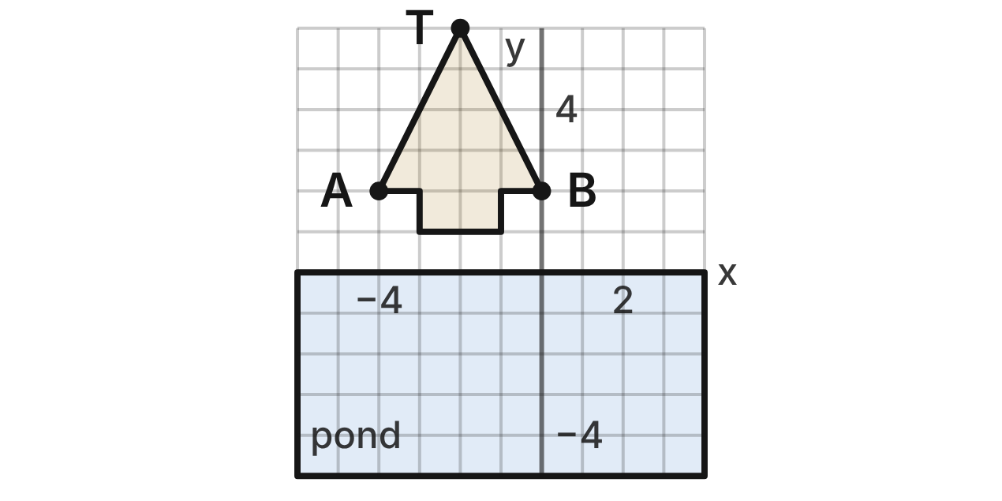
A pine tree stands at the edge of a still pond. On a grid, the pond's surface is the x-axis. The tree's outline has top T(−2, 6) and lower corners A(−4, 2) and B(0, 2), with a trunk from y = 1 to y = 2 between x = −3 and x = −1.
91. The pond reflects the tree over the x-axis. What is the image of T?
A. (2, 6)
B. (−2, −6) ✔
C. (2, −6)
D. (6, −2)
G.RLT.3 · skill G.RLT.3.2 (LOTS): Find the image of a figure on the coordinate plane under a translation, reflection, rotation or dilation
☐ Answer key correct ☐ Wording clear Notes: ________________________________
92. A second pine grows farther up the bank, where the first tree would land under (x, y) → (x + 7, y + 1). What is the image of A?
A. (3, 3) ✔
B. (−11, 1)
C. (−3, 9)
D. (3, 2)
G.RLT.3 · skill G.RLT.3.2 (LOTS): Find the image of a figure on the coordinate plane under a translation, reflection, rotation or dilation
☐ Answer key correct ☐ Wording clear Notes: ________________________________
93. A photo of the scene is turned a quarter turn, 90° counterclockwise about the origin. What is the image of A?
A. (2, 4)
B. (−2, −4) ✔
C. (4, −2)
D. (2, −4)
G.RLT.3 · skill G.RLT.3.2 (LOTS): Find the image of a figure on the coordinate plane under a translation, reflection, rotation or dilation
☐ Answer key correct ☐ Wording clear Notes: ________________________________
94. Which line is a line of symmetry of the tree?
A. y = 0
B. x = 0
C. y = 3
D. x = −2 ✔
G.RLT.3 · skill G.RLT.3.1 (LOTS): Identify line symmetry and rotational symmetry of a figure
☐ Answer key correct ☐ Wording clear Notes: ________________________________
95. Which single transformation maps the tree onto its image in the pond?
A. Rotation of 180° about the origin
B. Reflection over the y-axis
C. Reflection over the x-axis ✔
D. Translation 7 units down
G.RLT.3 · skill G.RLT.3.3 (HOTS): Determine the transformation or composition that maps a preimage to an image, and whether it preserves size and shape
☐ Answer key correct ☐ Wording clear Notes: ________________________________
96. Which is NOT the same for the tree and its image in the pond?
A. The height of the tree
B. The angle at the top
C. The area of the outline
D. The y-coordinate of the top ✔
G.RLT.3 · skill G.RLT.3.3 (HOTS): Determine the transformation or composition that maps a preimage to an image, and whether it preserves size and shape
☐ Answer key correct ☐ Wording clear Notes: ________________________________

Painting a Butterfly
Level 2 · Transformations · G.RLT.3 · ID geo-rlt3-worms-butterfly
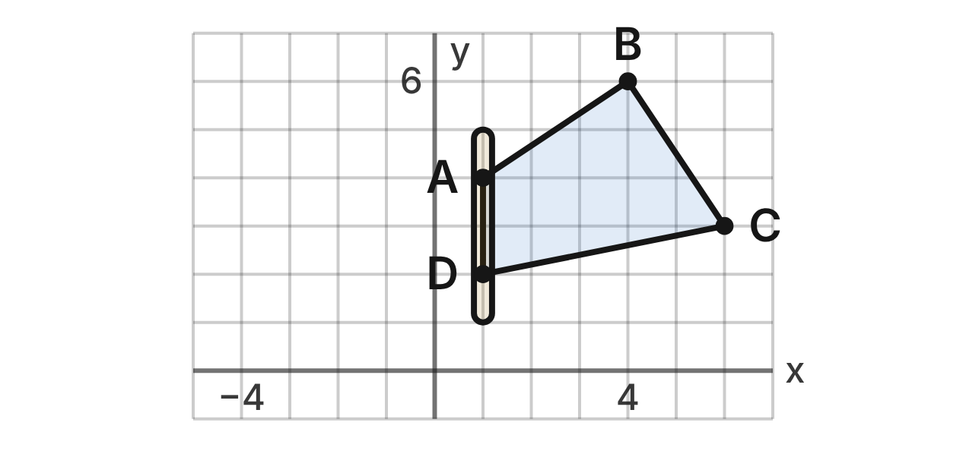
An artist paints a butterfly on a grid. The body lies along the line x = 1. The right wing is ABCD with A(1, 4), B(4, 6), C(6, 3) and D(1, 2). The left wing will be the mirror image of the right wing over the line x = 1.
97. What is the image of B on the left wing (its reflection over the line x = 1)?
A. (−2, 6) ✔
B. (−4, 6)
C. (−3, 6)
D. (4, −4)
G.RLT.3 · skill G.RLT.3.2 (LOTS): Find the image of a figure on the coordinate plane under a translation, reflection, rotation or dilation
☐ Answer key correct ☐ Wording clear Notes: ________________________________
98. A shadow of the right wing is drawn by reflecting it over the line y = −1. What is the image of C?
A. (6, −3)
B. (6, −5) ✔
C. (6, −4)
D. (−8, 3)
G.RLT.3 · skill G.RLT.3.2 (LOTS): Find the image of a figure on the coordinate plane under a translation, reflection, rotation or dilation
☐ Answer key correct ☐ Wording clear Notes: ________________________________
99. In a photo, the right wing appears as A′(−4, −1), B′(−6, −4), C′(−3, −6) and D′(−2, −1). Which single transformation maps ABCD to A′B′C′D′?
A. Rotation of 180° about the origin
B. Reflection over the line y = x
C. Reflection over the line y = −x ✔
D. Rotation of 90° clockwise about the origin
G.RLT.3 · skill G.RLT.3.3 (HOTS): Determine the transformation or composition that maps a preimage to an image, and whether it preserves size and shape
☐ Answer key correct ☐ Wording clear Notes: ________________________________
100. Which sequence also maps the right wing onto the left wing?
A. Reflect over the y-axis, then translate 1 unit right
B. Translate 2 units right, then reflect over the y-axis
C. Translate 2 units left, with no reflection
D. Reflect over the y-axis, then translate 2 units right ✔
G.RLT.3 · skill G.RLT.3.3 (HOTS): Determine the transformation or composition that maps a preimage to an image, and whether it preserves size and shape
☐ Answer key correct ☐ Wording clear Notes: ________________________________
101. Is the left wing congruent to the right wing? Choose the answer with the correct reason.
A. Yes; a reflection keeps all lengths and angle measures. ✔
B. No; a reflection reverses the wing, so its angles change.
C. No; the left wing covers a larger area.
D. Yes; every reflection is also a translation.
G.RLT.3 · skill G.RLT.3.3 (HOTS): Determine the transformation or composition that maps a preimage to an image, and whether it preserves size and shape
☐ Answer key correct ☐ Wording clear Notes: ________________________________
102. When both wings are painted, which transformation maps the whole butterfly onto itself?
A. Rotation of 180° about (1, 4)
B. Reflection over the y-axis
C. Reflection over the line y = 4
D. Reflection over the line x = 1 ✔
G.RLT.3 · skill G.RLT.3.1 (LOTS): Identify line symmetry and rotational symmetry of a figure
☐ Answer key correct ☐ Wording clear Notes: ________________________________

Planning the Flower Beds
Level 2 · Transformations · G.RLT.3 · ID geo-rlt3-worms-garden-beds
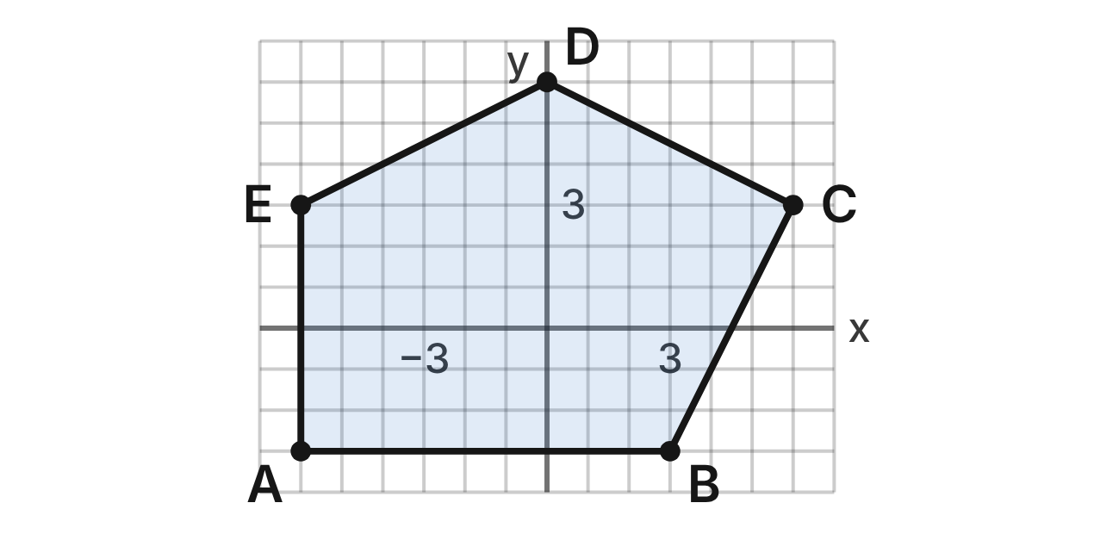
A garden plan uses a grid in meters. A flower bed is pentagon ABCDE with A(−6, −3), B(3, −3), C(6, 3), D(0, 6) and E(−6, 3). Its area is 81 square meters. Other beds are planned by dilations centered at the origin.
103. What is the image of C under a dilation with scale factor 2/3 centered at the origin?
A. (4, 2) ✔
B. (9, 4.5)
C. (4, 3)
D. (12, 6)
G.RLT.3 · skill G.RLT.3.2 (LOTS): Find the image of a figure on the coordinate plane under a translation, reflection, rotation or dilation
☐ Answer key correct ☐ Wording clear Notes: ________________________________
104. What is the area of the image of ABCDE under a dilation with scale factor 2/3 centered at the origin?
A. 54 square meters
B. 81 square meters
C. 36 square meters ✔
D. 24 square meters
G.RLT.3 · skill G.RLT.3.2 (LOTS): Find the image of a figure on the coordinate plane under a translation, reflection, rotation or dilation
☐ Answer key correct ☐ Wording clear Notes: ________________________________
105. A larger bed is made by a dilation with scale factor 4/3 centered at the origin. Which rule describes it?
A. (x, y) → (x + 4/3, y + 4/3)
B. (x, y) → ((4/3)x, (4/3)y) ✔
C. (x, y) → ((3/4)x, (3/4)y)
D. (x, y) → ((4/3)x, y)
G.RLT.3 · skill G.RLT.3.2 (LOTS): Find the image of a figure on the coordinate plane under a translation, reflection, rotation or dilation
☐ Answer key correct ☐ Wording clear Notes: ________________________________
106. A dilation centered at the origin maps E(−6, 3) to (−2, 1). What is its scale factor?
A. k = 3
B. k = 1/3 ✔
C. k = 4
D. k = 2
G.RLT.3 · skill G.RLT.3.3 (HOTS): Determine the transformation or composition that maps a preimage to an image, and whether it preserves size and shape
☐ Answer key correct ☐ Wording clear Notes: ________________________________
107. Which is NOT true of the image of ABCDE under a dilation with scale factor 2/3 centered at the origin?
A. Its angles have the same measures as those of ABCDE.
B. Each side is parallel to the matching side of ABCDE.
C. Its perimeter is 4/9 of the perimeter of ABCDE. ✔
D. The image of D is on the y-axis.
G.RLT.3 · skill G.RLT.3.3 (HOTS): Determine the transformation or composition that maps a preimage to an image, and whether it preserves size and shape
☐ Answer key correct ☐ Wording clear Notes: ________________________________
108. The gardener wants a bed with the same shape as ABCDE and one fourth of its area, made by a dilation centered at the origin. What scale factor should she use?
A. 1/4
B. 1/16
C. 1/8
D. 1/2 ✔
G.RLT.3 · skill G.RLT.3.3 (HOTS): Determine the transformation or composition that maps a preimage to an image, and whether it preserves size and shape
☐ Answer key correct ☐ Wording clear Notes: ________________________________

The Spinning Maple Seed
Level 2 · Transformations · G.RLT.3 · ID geo-rlt3-worms-maple-seed
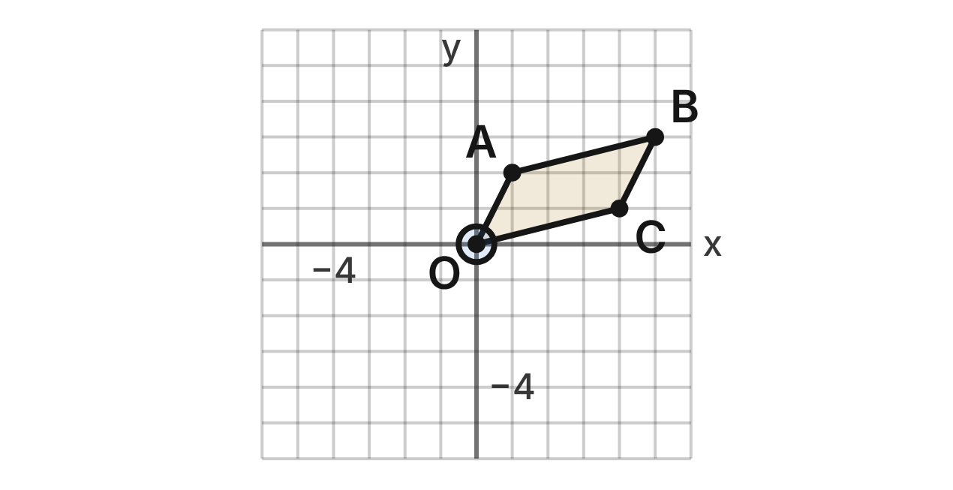
A maple seed spins as it falls. In a top view on a grid, the seed is at the origin O and its wing is quadrilateral OABC with A(1, 2), B(5, 3) and C(4, 1). As the seed spins, the wing turns about O.
109. What is the image of B after a rotation of 90° clockwise about O?
A. (3, −5) ✔
B. (−3, 5)
C. (−5, −3)
D. (3, 5)
G.RLT.3 · skill G.RLT.3.2 (LOTS): Find the image of a figure on the coordinate plane under a translation, reflection, rotation or dilation
☐ Answer key correct ☐ Wording clear Notes: ________________________________
110. What is the image of A after a rotation of 180° about O?
A. (−1, −2) ✔
B. (1, −2)
C. (−1, 2)
D. (−2, 1)
G.RLT.3 · skill G.RLT.3.2 (LOTS): Find the image of a figure on the coordinate plane under a translation, reflection, rotation or dilation
☐ Answer key correct ☐ Wording clear Notes: ________________________________
111. The wing turns 270° counterclockwise about O. What is the image of C?
A. (−1, 4)
B. (−4, −1)
C. (1, 4)
D. (1, −4) ✔
G.RLT.3 · skill G.RLT.3.2 (LOTS): Find the image of a figure on the coordinate plane under a translation, reflection, rotation or dilation
☐ Answer key correct ☐ Wording clear Notes: ________________________________
112. Later the wing is OA′B′C′ with A′(−2, 1), B′(−3, 5) and C′(−1, 4). Which single transformation maps OABC to OA′B′C′?
A. Rotation of 90° clockwise about O
B. Rotation of 90° counterclockwise about O ✔
C. Reflection over the line y = x
D. Reflection over the y-axis
G.RLT.3 · skill G.RLT.3.3 (HOTS): Determine the transformation or composition that maps a preimage to an image, and whether it preserves size and shape
☐ Answer key correct ☐ Wording clear Notes: ________________________________
113. The wing turns 90° clockwise about O three times in a row. Which single rotation about O has the same effect?
A. 270° counterclockwise
B. 90° counterclockwise ✔
C. 180°
D. 90° clockwise
G.RLT.3 · skill G.RLT.3.3 (HOTS): Determine the transformation or composition that maps a preimage to an image, and whether it preserves size and shape
☐ Answer key correct ☐ Wording clear Notes: ________________________________
114. Maple seeds grow in joined pairs. Model a pair as OABC together with its image under a rotation of 180° about O. Which describes the symmetry of the pair?
A. Rotational symmetry of order 2; 1 line of symmetry
B. Rotational symmetry of order 4; no lines of symmetry
C. Rotational symmetry of order 2; no lines of symmetry ✔
D. No rotational symmetry; 1 line of symmetry
G.RLT.3 · skill G.RLT.3.1 (LOTS): Identify line symmetry and rotational symmetry of a figure
☐ Answer key correct ☐ Wording clear Notes: ________________________________

Fox Tracks in the Snow
Level 2 · Transformations · G.RLT.3 · ID geo-rlt3-worms-fox-tracks
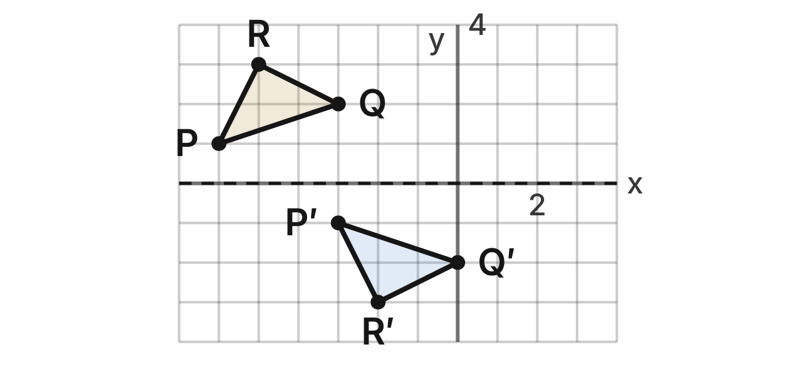
A fox walks along a straight trail in the snow. On a grid, the middle of the trail is the x-axis. Print 1 is △PQR with P(−6, 1), Q(−3, 2) and R(−5, 3). Print 2 is △P′Q′R′ with P′(−3, −1), Q′(0, −2) and R′(−2, −3).
115. Which sequence maps print 1 to print 2?
A. Reflect over the x-axis, then translate 3 units right ✔
B. Translate 3 units right and 2 units down
C. Reflect over the y-axis, then translate 3 units left
D. Reflect over the x-axis, with no translation
G.RLT.3 · skill G.RLT.3.3 (HOTS): Determine the transformation or composition that maps a preimage to an image, and whether it preserves size and shape
☐ Answer key correct ☐ Wording clear Notes: ________________________________
116. Print 3 is the image of print 2 under the same moves: reflect over the x-axis, then translate 3 units right. Where is the image of R′?
A. (1, −3)
B. (1, 3) ✔
C. (−2, 3)
D. (−5, 3)
G.RLT.3 · skill G.RLT.3.2 (LOTS): Find the image of a figure on the coordinate plane under a translation, reflection, rotation or dilation
☐ Answer key correct ☐ Wording clear Notes: ________________________________
117. Print 3 is print 2 reflected over the x-axis and then translated 3 units right. Which single transformation maps print 1 onto print 3?
A. Translation 3 units right
B. Reflection over the x-axis
C. Translation 6 units right ✔
D. Rotation of 180° about the origin
G.RLT.3 · skill G.RLT.3.3 (HOTS): Determine the transformation or composition that maps a preimage to an image, and whether it preserves size and shape
☐ Answer key correct ☐ Wording clear Notes: ________________________________
118. If print 1 is translated 3 units right first and then reflected over the x-axis, is the image still print 2? Choose the answer with the correct reason.
A. No; changing the order of two moves always changes the image.
B. No; reflecting last leaves the image above the x-axis.
C. Yes; the order of transformations never matters.
D. Yes; the slide runs along the mirror line, so the order does not matter here. ✔
G.RLT.3 · skill G.RLT.3.3 (HOTS): Determine the transformation or composition that maps a preimage to an image, and whether it preserves size and shape
☐ Answer key correct ☐ Wording clear Notes: ________________________________
119. A trail map is printed upside down, which rotates it 180° about the origin. What is the image of Q?
A. (−3, −2)
B. (3, 2)
C. (3, −2) ✔
D. (2, 3)
G.RLT.3 · skill G.RLT.3.2 (LOTS): Find the image of a figure on the coordinate plane under a translation, reflection, rotation or dilation
☐ Answer key correct ☐ Wording clear Notes: ________________________________
120. Which is NOT the same for print 1 and print 2?
A. Their side lengths
B. Their angle measures
C. Their areas
D. Their orientation ✔
G.RLT.3 · skill G.RLT.3.3 (HOTS): Determine the transformation or composition that maps a preimage to an image, and whether it preserves size and shape
☐ Answer key correct ☐ Wording clear Notes: ________________________________

Rules for a Flock of Geese
Level 3 · Transformations · G.RLT.3 · ID geo-rlt3-worms-geese-rules
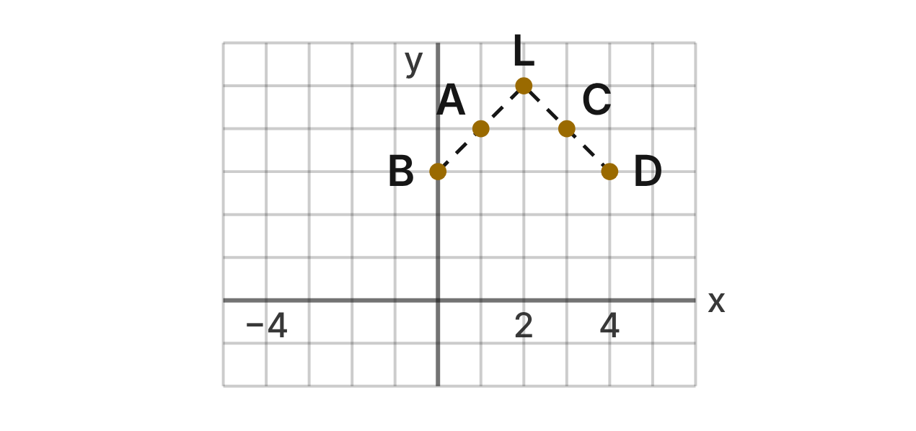
A biologist models a flock of geese flying in a V on a grid: L(2, 5), A(1, 4), B(0, 3), C(3, 4) and D(4, 3). Her model moves birds with four rules.
Rule 1: (x, y) → (y, −x)Rule 2: (x, y) → (−x, y)Rule 3: (x, y) → (x − 4, y + 1)Rule 4: (x, y) → (2x, 2y)
121. Which transformation does Rule 1 describe?
A. Rotation of 90° counterclockwise about the origin
B. Reflection over the line y = −x
C. Rotation of 90° clockwise about the origin ✔
D. Reflection over the line y = x
G.RLT.3 · skill G.RLT.3.3 (HOTS): Determine the transformation or composition that maps a preimage to an image, and whether it preserves size and shape
☐ Answer key correct ☐ Wording clear Notes: ________________________________
122. Bird B is moved by Rule 1 and then by Rule 3. Where does it end up?
A. (4, 4)
B. (3, 0)
C. (−7, 1)
D. (−1, 1) ✔
G.RLT.3 · skill G.RLT.3.2 (LOTS): Find the image of a figure on the coordinate plane under a translation, reflection, rotation or dilation
☐ Answer key correct ☐ Wording clear Notes: ________________________________
123. Which single transformation is the same as Rule 2 followed by Rule 1?
A. Reflection over the line y = −x
B. Reflection over the line y = x ✔
C. Rotation of 180° about the origin
D. Rotation of 90° clockwise about the origin
G.RLT.3 · skill G.RLT.3.3 (HOTS): Determine the transformation or composition that maps a preimage to an image, and whether it preserves size and shape
☐ Answer key correct ☐ Wording clear Notes: ________________________________
124. Which rules always keep the V the same size and shape?
A. Rule 3 only
B. Rules 1, 2, 3 and 4
C. Rules 1, 2 and 3 only ✔
D. Rules 1 and 3 only
G.RLT.3 · skill G.RLT.3.3 (HOTS): Determine the transformation or composition that maps a preimage to an image, and whether it preserves size and shape
☐ Answer key correct ☐ Wording clear Notes: ________________________________
125. Bird D is moved by Rule 1 four times in a row. Where does it end up?
A. (4, 3) ✔
B. (3, −4)
C. (−4, −3)
D. (−3, 4)
G.RLT.3 · skill G.RLT.3.2 (LOTS): Find the image of a figure on the coordinate plane under a translation, reflection, rotation or dilation
☐ Answer key correct ☐ Wording clear Notes: ________________________________
126. Which line is a line of symmetry of the V of geese?
A. x = 2 ✔
B. x = 0
C. y = 3
D. y = x + 3
G.RLT.3 · skill G.RLT.3.1 (LOTS): Identify line symmetry and rotational symmetry of a figure
☐ Answer key correct ☐ Wording clear Notes: ________________________________

The Fern Frond
Level 3 · Transformations · G.RLT.3 · ID geo-rlt3-worms-fern-frond
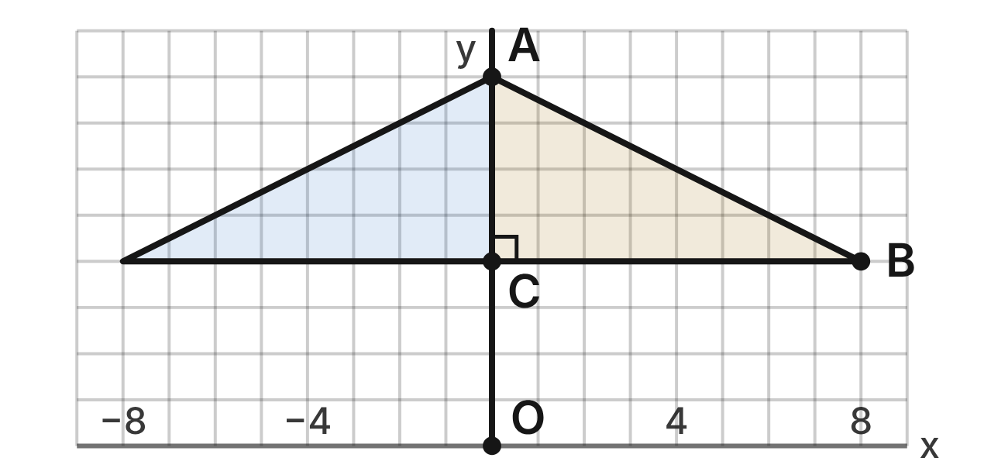
A fern frond is drawn on a grid with its tip O at the origin and its stem along the y-axis. Leaflet 1 is right triangle ABC with A(0, 8), B(8, 4) and C(0, 4); its area is 16 square units. Each leaflet has a mirror image across the stem. Leaflet 2 is leaflet 1 dilated by scale factor 1/2 about O; leaflet 2 and its mirror image are not drawn.
127. What is the image of B on leaflet 2?
A. (16, 8)
B. (4, 2) ✔
C. (7.5, 3.5)
D. (4, 4)
G.RLT.3 · skill G.RLT.3.2 (LOTS): Find the image of a figure on the coordinate plane under a translation, reflection, rotation or dilation
☐ Answer key correct ☐ Wording clear Notes: ________________________________
128. Leaflet 3 is leaflet 2 dilated by scale factor 1/2 about O. Which single dilation about O maps leaflet 1 to leaflet 3?
A. Scale factor 1
B. Scale factor 1/2
C. Scale factor 1/4 ✔
D. Scale factor 1/8
G.RLT.3 · skill G.RLT.3.3 (HOTS): Determine the transformation or composition that maps a preimage to an image, and whether it preserves size and shape
☐ Answer key correct ☐ Wording clear Notes: ________________________________
129. What is the area of leaflet 2?
A. 8 square units
B. 2 square units
C. 16 square units
D. 4 square units ✔
G.RLT.3 · skill G.RLT.3.3 (HOTS): Determine the transformation or composition that maps a preimage to an image, and whether it preserves size and shape
☐ Answer key correct ☐ Wording clear Notes: ________________________________
130. Which line is a line of symmetry of the frond drawn in the figure?
A. x = 4
B. y = x
C. y = 4
D. x = 0 ✔
G.RLT.3 · skill G.RLT.3.1 (LOTS): Identify line symmetry and rotational symmetry of a figure
☐ Answer key correct ☐ Wording clear Notes: ________________________________
131. Which sequence maps leaflet 1 onto the mirror image of leaflet 2 across the stem?
A. Dilate by 1/2 about O, then reflect over the y-axis ✔
B. Dilate by 1/2 about O, then reflect over the x-axis
C. Dilate by 2 about O, then reflect over the y-axis
D. Dilate by 1/2 about O, then rotate 180° about O
G.RLT.3 · skill G.RLT.3.3 (HOTS): Determine the transformation or composition that maps a preimage to an image, and whether it preserves size and shape
☐ Answer key correct ☐ Wording clear Notes: ________________________________
132. Max says leaflet 2 is congruent to leaflet 1 because their angles are the same. What is his error?
A. There is no error; equal angles mean congruent.
B. Equal angles show it is similar; its sides are 1/2 as long. ✔
C. Its angles are 1/2 as large, so it is not similar.
D. It is not similar, because it is closer to O.
G.RLT.3 · skill G.RLT.3.3 (HOTS): Determine the transformation or composition that maps a preimage to an image, and whether it preserves size and shape
☐ Answer key correct ☐ Wording clear Notes: ________________________________

Triangles (G.TR)

G.TR.1 · Determine the relationships between the measures of angles and lengths of sides in triangles, including problems in context.

Three Campsites
Level 1 · Triangles · G.TR.1 · ID geo-tr1-worms-three-campsites
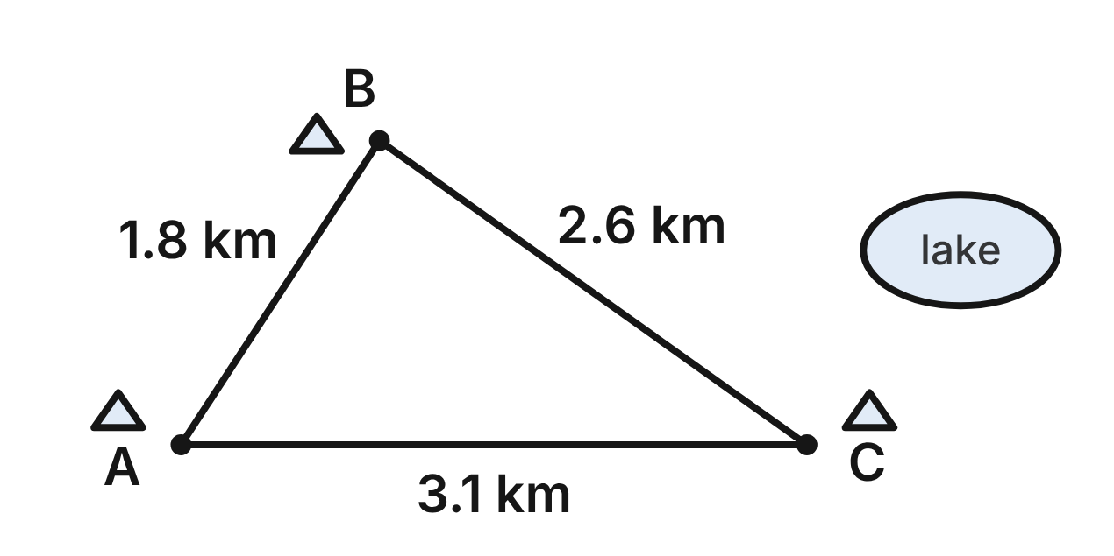
Straight trails join the campsites A, B and C: AB = 1.8 km, BC = 2.6 km and AC = 3.1 km.
133. Which angle of △ABC is the smallest?
A. ∠A
B. ∠B
C. ∠C ✔
D. ∠A and ∠C tie for smallest
G.TR.1 · skill G.TR.1.1 (LOTS): Order the sides of a triangle by length given its angles, or its angles by size given its sides
☐ Answer key correct ☐ Wording clear Notes: ________________________________
134. Which list orders the angles of △ABC from smallest to largest?
A. ∠B, ∠A, ∠C
B. ∠A, ∠C, ∠B
C. ∠C, ∠B, ∠A
D. ∠C, ∠A, ∠B ✔
G.TR.1 · skill G.TR.1.1 (LOTS): Order the sides of a triangle by length given its angles, or its angles by size given its sides
☐ Answer key correct ☐ Wording clear Notes: ________________________________
135. A ranger hikes from A to B and then from B to C. How does that route compare with the direct trail AC? Choose the answer with the correct reason.
A. It is the same, because both routes join A and C.
B. It is longer, because AB + BC is greater than AC. ✔
C. It is shorter, because it uses two trails.
D. It is longer, because AC is the shortest trail.
G.TR.1 · skill G.TR.1.2 (LOTS): Decide whether three lengths can form a triangle and find the range of possible lengths of the third side
☐ Answer key correct ☐ Wording clear Notes: ________________________________
136. Sam says a fourth campsite could be 1.2 km from A and 1.6 km from C. Why is Sam wrong?
A. 1.2 + 1.6 is less than AC, 3.1 km. ✔
B. 1.2 + 3.1 is less than 1.6.
C. A campsite must be farther from A than from C.
D. 1.6 km is more than AB, 1.8 km.
G.TR.1 · skill G.TR.1.2 (LOTS): Decide whether three lengths can form a triangle and find the range of possible lengths of the third side
☐ Answer key correct ☐ Wording clear Notes: ________________________________
137. A ranger measures m∠B ≈ 88° and m∠C ≈ 35°. What is m∠A, to the nearest degree?
A. 123°
B. 92°
C. 145°
D. 57° ✔
G.TR.1 · skill G.TR.1.3 (LOTS): Solve problems using the triangle angle sum and the exterior angle theorem
☐ Answer key correct ☐ Wording clear Notes: ________________________________
138. Rangers plan a triangular loop trail with two equal legs that meet at a 108° angle. What angle does each equal leg make with the third leg?
A. 72°
B. 108°
C. 36° ✔
D. 54°
G.TR.1 · skill G.TR.1.3 (LOTS): Solve problems using the triangle angle sum and the exterior angle theorem
☐ Answer key correct ☐ Wording clear Notes: ________________________________

The Nest in the Fork
Level 1 · Triangles · G.TR.1 · ID geo-tr1-worms-nest-fork
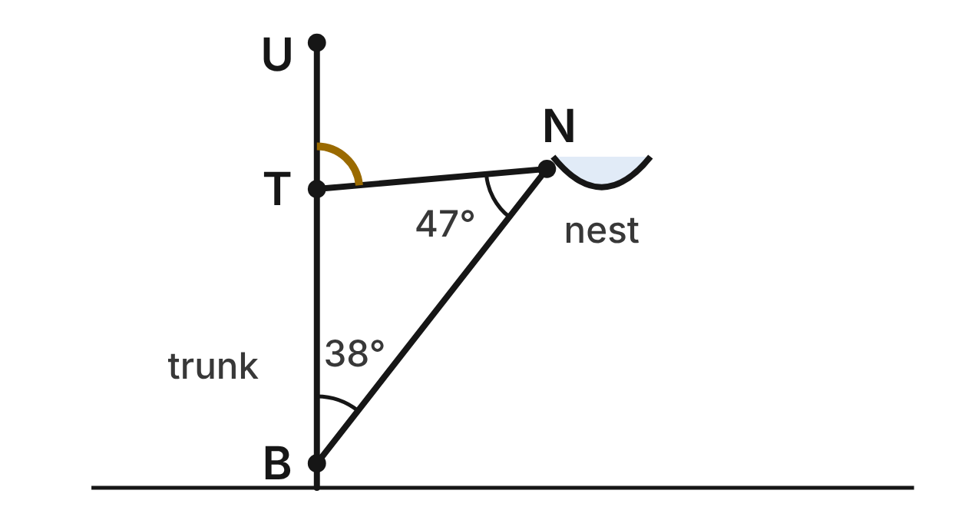
A nest sits at N, where a branch BN and a twig TN meet. B and T are on the straight, upright trunk, which continues above T to U. m∠TBN = 38° and m∠BNT = 47°.
139. What is m∠BTN, the angle between the trunk and the twig?
A. 85°
B. 95° ✔
C. 142°
D. 133°
G.TR.1 · skill G.TR.1.3 (LOTS): Solve problems using the triangle angle sum and the exterior angle theorem
☐ Answer key correct ☐ Wording clear Notes: ________________________________
140. What is m∠UTN, the angle between the twig and the trunk above T?
A. 85° ✔
B. 95°
C. 38°
D. 142°
G.TR.1 · skill G.TR.1.3 (LOTS): Solve problems using the triangle angle sum and the exterior angle theorem
☐ Answer key correct ☐ Wording clear Notes: ________________________________
141. Which side of △BTN is the longest?
A. the twig TN
B. the branch BN ✔
C. the trunk piece BT
D. BT and TN are the same length
G.TR.1 · skill G.TR.1.1 (LOTS): Order the sides of a triangle by length given its angles, or its angles by size given its sides
☐ Answer key correct ☐ Wording clear Notes: ________________________________
142. Which statement about △BTN is true?
A. The twig TN is shorter than the trunk piece BT. ✔
B. The trunk piece BT is shorter than the twig TN.
C. The branch BN is shorter than the twig TN.
D. The twig TN is the longest side.
G.TR.1 · skill G.TR.1.1 (LOTS): Order the sides of a triangle by length given its angles, or its angles by size given its sides
☐ Answer key correct ☐ Wording clear Notes: ________________________________
143. Another nest rests in a triangle of three twigs that are all the same length. What is the angle between any two of the twigs?
A. 180°
B. 120°
C. 90°
D. 60° ✔
G.TR.1 · skill G.TR.1.3 (LOTS): Solve problems using the triangle angle sum and the exterior angle theorem
☐ Answer key correct ☐ Wording clear Notes: ________________________________
144. A bird finds two twigs, 9 cm and 14 cm long. Which third twig could make a triangle with them?
A. 5 cm
B. 23 cm
C. 12 cm ✔
D. 4 cm
G.TR.1 · skill G.TR.1.2 (LOTS): Decide whether three lengths can form a triangle and find the range of possible lengths of the third side
☐ Answer key correct ☐ Wording clear Notes: ________________________________

The River Crossing
Level 2 · Triangles · G.TR.1 · ID geo-tr1-worms-river-crossing
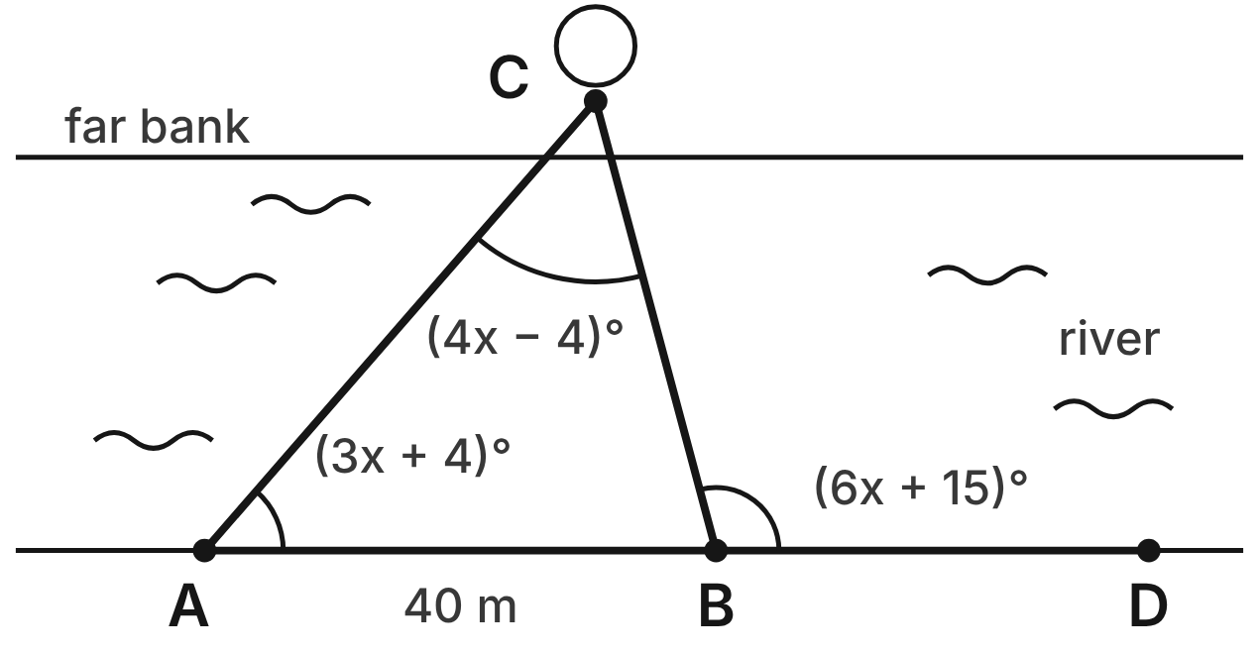
A and B are on the straight near bank of a river, and C is a tree on the far bank. The bank line continues past B to D. AB = 40 m, m∠CAB = (3x + 4)⁠°, m∠ACB = (4x − 4)⁠° and m∠CBD = (6x + 15)⁠°.
145. A student writes (3x + 4) + (4x − 4) + (6x + 15) = 180 to find x. What is the error?
A. ∠CBD is outside the triangle; it equals m∠CAB + m∠ACB. ✔
B. The three angles should add to 360°.
C. ∠CAB and ∠ACB should be set equal.
D. There is no error in the equation.
G.TR.1 · skill G.TR.1.3 (LOTS): Solve problems using the triangle angle sum and the exterior angle theorem
☐ Answer key correct ☐ Wording clear Notes: ________________________________
146. What is m∠ABC, the angle inside the triangle at B?
A. 105°
B. 15°
C. 124°
D. 75° ✔
G.TR.1 · skill G.TR.1.3 (LOTS): Solve problems using the triangle angle sum and the exterior angle theorem
☐ Answer key correct ☐ Wording clear Notes: ________________________________
147. Which crossing to the tree is shorter, AC or BC? Choose the answer with the correct reason.
A. AC, because it is opposite the smaller angle, ∠ABC.
B. BC, because it is opposite the smaller angle, ∠CAB. ✔
C. BC, because ∠ABC is the smallest angle.
D. AC, because ∠ACB is the largest angle.
G.TR.1 · skill G.TR.1.1 (LOTS): Order the sides of a triangle by length given its angles, or its angles by size given its sides
☐ Answer key correct ☐ Wording clear Notes: ________________________________
148. Which list orders AB, BC and AC from longest to shortest?
A. BC, AB, AC
B. AB, AC, BC
C. AC, AB, BC ✔
D. AC, BC, AB
G.TR.1 · skill G.TR.1.1 (LOTS): Order the sides of a triangle by length given its angles, or its angles by size given its sides
☐ Answer key correct ☐ Wording clear Notes: ________________________________
149. A stake E is 65 m from A. A, B and E are not on one line. Which inequality gives all possible distances BE, in meters?
A. 40 < BE < 65
B. 0 < BE < 105
C. 25 ≤ BE ≤ 105
D. 25 < BE < 105 ✔
G.TR.1 · skill G.TR.1.2 (LOTS): Decide whether three lengths can form a triangle and find the range of possible lengths of the third side
☐ Answer key correct ☐ Wording clear Notes: ________________________________
150. Which statement must be true?
A. BC is less than 40 m. ✔
B. BC is more than 40 m.
C. AC is less than 40 m.
D. BC and AC are the same length.
G.TR.1 · skill G.TR.1.1 (LOTS): Order the sides of a triangle by length given its angles, or its angles by size given its sides
☐ Answer key correct ☐ Wording clear Notes: ________________________________

The Tent and Its Guy Line
Level 2 · Triangles · G.TR.1 · ID geo-tr1-worms-tent-guy-line
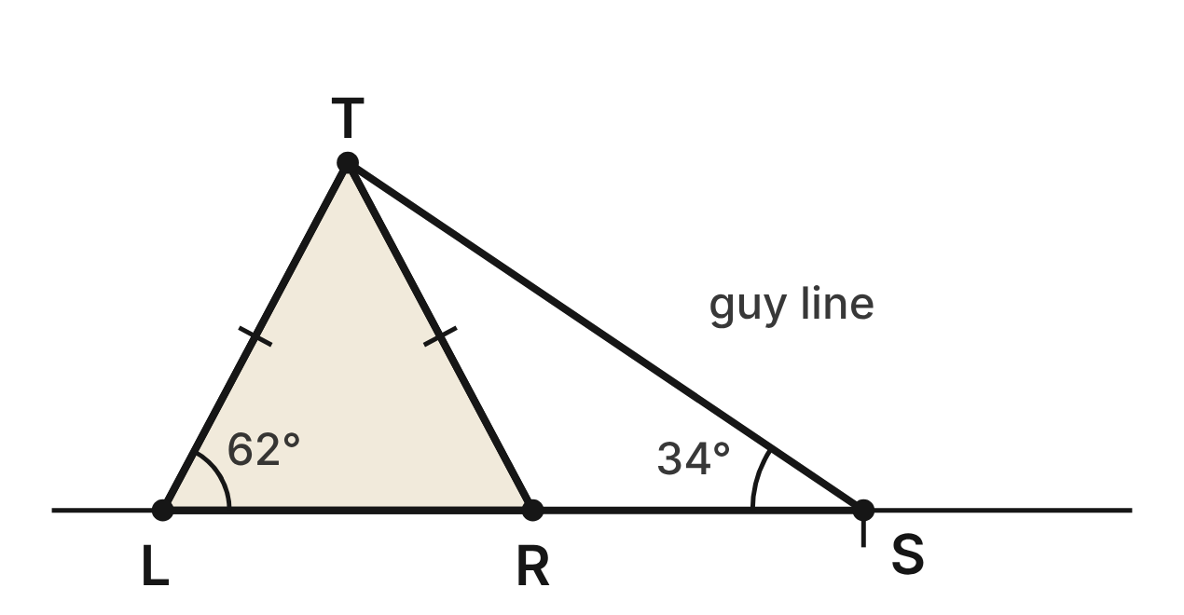
The front of a tent is the triangle TLR, with TL ≅ TR. A guy line runs from the top T to a stake S, and L, R and S lie on the level ground line. m∠TLR = 62° and m∠TSR = 34°.
151. What is m∠LTR, the angle at the peak of the tent?
A. 118°
B. 62°
C. 56° ✔
D. 28°
G.TR.1 · skill G.TR.1.3 (LOTS): Solve problems using the triangle angle sum and the exterior angle theorem
☐ Answer key correct ☐ Wording clear Notes: ________________________________
152. What is m∠TRS, the angle between the tent side TR and the ground RS?
A. 62°
B. 118° ✔
C. 124°
D. 146°
G.TR.1 · skill G.TR.1.3 (LOTS): Solve problems using the triangle angle sum and the exterior angle theorem
☐ Answer key correct ☐ Wording clear Notes: ________________________________
153. What is m∠RTS, the angle between the tent side TR and the guy line?
A. 28° ✔
B. 34°
C. 84°
D. 62°
G.TR.1 · skill G.TR.1.3 (LOTS): Solve problems using the triangle angle sum and the exterior angle theorem
☐ Answer key correct ☐ Wording clear Notes: ________________________________
154. Which statement about the tent is NOT true?
A. TS is longer than TL.
B. LR is shorter than TL.
C. TR is longer than TS. ✔
D. RS is shorter than TR.
G.TR.1 · skill G.TR.1.1 (LOTS): Order the sides of a triangle by length given its angles, or its angles by size given its sides
☐ Answer key correct ☐ Wording clear Notes: ________________________________
155. Which list orders the sides of △TRS from shortest to longest?
A. TS, TR, RS
B. TR, RS, TS
C. RS, TS, TR
D. RS, TR, TS ✔
G.TR.1 · skill G.TR.1.1 (LOTS): Order the sides of a triangle by length given its angles, or its angles by size given its sides
☐ Answer key correct ☐ Wording clear Notes: ________________________________
156. A smaller tent has sides of 1.4 m and a guy line 2.3 m long. The top, a bottom corner and the stake form a triangle. Which could be the distance from that corner to the stake?
A. 0.9 m
B. 1.2 m ✔
C. 3.7 m
D. 4.6 m
G.TR.1 · skill G.TR.1.2 (LOTS): Decide whether three lengths can form a triangle and find the range of possible lengths of the third side
☐ Answer key correct ☐ Wording clear Notes: ________________________________

Animal Paths in the Meadow
Level 2 · Triangles · G.TR.1 · ID geo-tr1-worms-meadow-paths
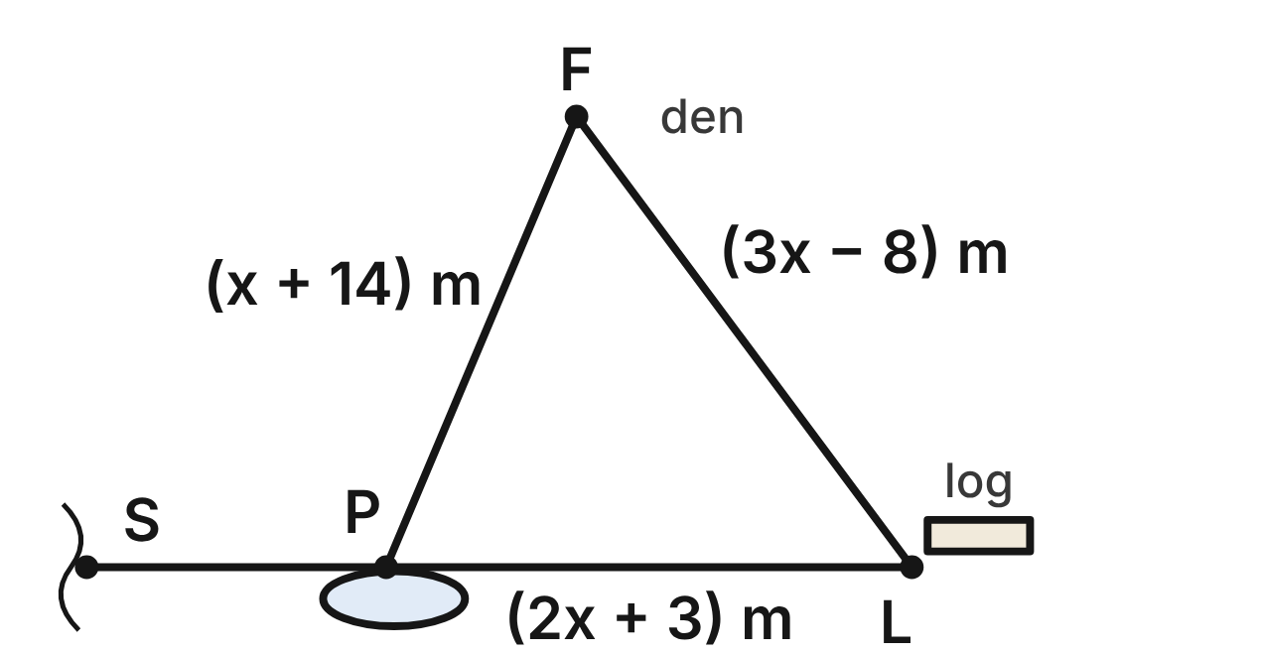
Animal paths join a fox den F, a pond P and a hollow log L. FP = (x + 14) m, PL = (2x + 3) m and FL = (3x − 8) m. A ranger measures FL = 31 m. The path from L to P continues straight past P to a stream crossing S.
157. How long is the path PL?
A. 29 m ✔
B. 27 m
C. 13 m
D. 65 m
G.TR.1 · skill G.TR.1.1 (LOTS): Order the sides of a triangle by length given its angles, or its angles by size given its sides
☐ Answer key correct ☐ Wording clear Notes: ________________________________
158. Which angle of △FPL is the largest?
A. ∠F
B. ∠P ✔
C. ∠L
D. You cannot tell without a protractor.
G.TR.1 · skill G.TR.1.1 (LOTS): Order the sides of a triangle by length given its angles, or its angles by size given its sides
☐ Answer key correct ☐ Wording clear Notes: ________________________________
159. Which list orders the angles of △FPL from smallest to largest?
A. ∠P, ∠F, ∠L
B. ∠F, ∠L, ∠P
C. ∠L, ∠P, ∠F
D. ∠L, ∠F, ∠P ✔
G.TR.1 · skill G.TR.1.1 (LOTS): Order the sides of a triangle by length given its angles, or its angles by size given its sides
☐ Answer key correct ☐ Wording clear Notes: ________________________________
160. Three other paths would be (x + 14) m, (2x + 3) m and (3x − 8) m long, with x = 4. Could they form a triangle? Choose the answer with the correct reason.
A. Yes, because 18 + 11 is greater than 4.
B. Yes, because every path has a positive length.
C. No, because 11 + 4 is less than 18. ✔
D. No, because 4 + 18 is less than 11.
G.TR.1 · skill G.TR.1.2 (LOTS): Decide whether three lengths can form a triangle and find the range of possible lengths of the third side
☐ Answer key correct ☐ Wording clear Notes: ________________________________
161. Another meadow has three paths of (x + 14) m, (2x + 3) m and (3x − 8) m, labeled FP, PL and FL as in this figure, with x = 8. Which angle of that triangle would be the largest?
A. ∠P
B. ∠F
C. ∠F and ∠P would tie
D. ∠L ✔
G.TR.1 · skill G.TR.1.1 (LOTS): Order the sides of a triangle by length given its angles, or its angles by size given its sides
☐ Answer key correct ☐ Wording clear Notes: ________________________________
162. The ranger measures m∠F ≈ 60° and m∠L ≈ 53°. What is m∠FPS, to the nearest degree?
A. 67°
B. 113° ✔
C. 120°
D. 127°
G.TR.1 · skill G.TR.1.3 (LOTS): Solve problems using the triangle angle sum and the exterior angle theorem
☐ Answer key correct ☐ Wording clear Notes: ________________________________

Peaks from the Ridge Trail
Level 3 · Triangles · G.TR.1 · ID geo-tr1-worms-ridge-trail
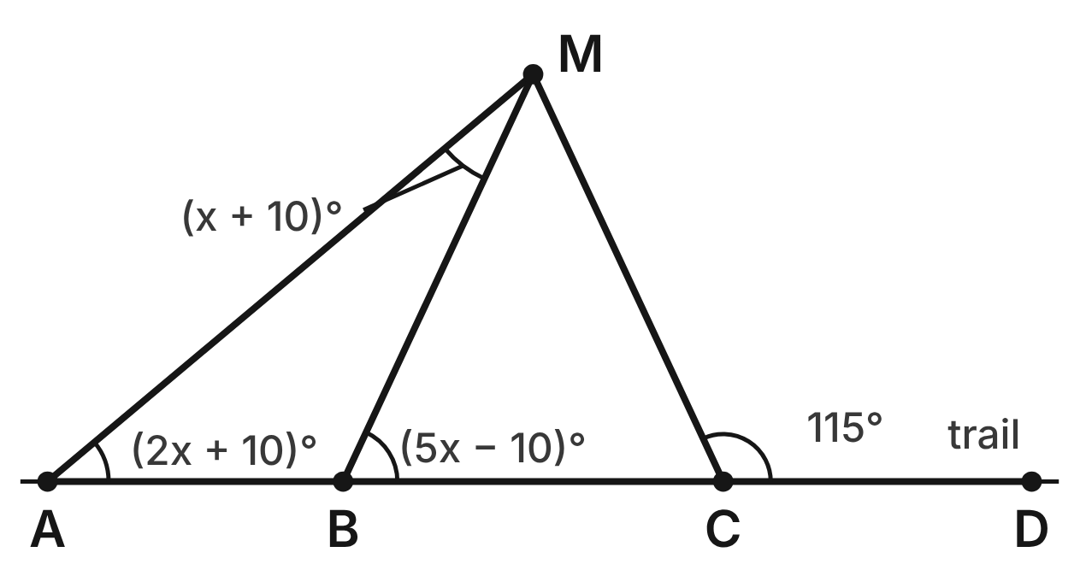
A straight trail passes A, B, C and D, in that order. From each point a hiker sights the peak M. m∠MAB = (2x + 10)⁠°, m∠AMB = (x + 10)⁠°, m∠MBC = (5x − 10)⁠° and m∠MCD = 115°.
163. Use △ABM and the angle at B outside it to find x.
A. 20/3
B. 21.25
C. 15 ✔
D. 65
G.TR.1 · skill G.TR.1.3 (LOTS): Solve problems using the triangle angle sum and the exterior angle theorem
☐ Answer key correct ☐ Wording clear Notes: ________________________________
164. What is m∠BMC, the angle at the peak between the sightlines from B and C?
A. 50° ✔
B. 65°
C. 130°
D. 25°
G.TR.1 · skill G.TR.1.3 (LOTS): Solve problems using the triangle angle sum and the exterior angle theorem
☐ Answer key correct ☐ Wording clear Notes: ________________________________
165. Which two sightlines are the same length? Choose the answer with the correct reason.
A. MA and MB, because both meet the trail.
B. MB and MC, because ∠MBC ≅ ∠MCB. ✔
C. MA and MC, because ∠MAB ≅ ∠MCD.
D. MB and MC, because ∠BMC is a right angle.
G.TR.1 · skill G.TR.1.1 (LOTS): Order the sides of a triangle by length given its angles, or its angles by size given its sides
☐ Answer key correct ☐ Wording clear Notes: ________________________________
166. Which list orders the sides of △ABM from shortest to longest?
A. AM, BM, AB
B. BM, AB, AM
C. AB, AM, BM
D. AB, BM, AM ✔
G.TR.1 · skill G.TR.1.1 (LOTS): Order the sides of a triangle by length given its angles, or its angles by size given its sides
☐ Answer key correct ☐ Wording clear Notes: ________________________________
167. Which statement about the sightlines is NOT true?
A. MA is longer than MC.
B. AB is shorter than MB.
C. MC is longer than MA. ✔
D. BC is shorter than MB.
G.TR.1 · skill G.TR.1.1 (LOTS): Order the sides of a triangle by length given its angles, or its angles by size given its sides
☐ Answer key correct ☐ Wording clear Notes: ________________________________
168. From the peak, one lake is 4.2 km away and another is 6.5 km away. The peak and the lakes are not on one line. What are the least and greatest whole numbers of kilometers the lakes could be apart?
A. 3 km and 10 km ✔
B. 2 km and 11 km
C. 3 km and 11 km
D. 2.3 km and 10.7 km
G.TR.1 · skill G.TR.1.2 (LOTS): Decide whether three lengths can form a triangle and find the range of possible lengths of the third side
☐ Answer key correct ☐ Wording clear Notes: ________________________________

The Crossed Fishing Lines
Level 3 · Triangles · G.TR.1 · ID geo-tr1-worms-crossed-lines
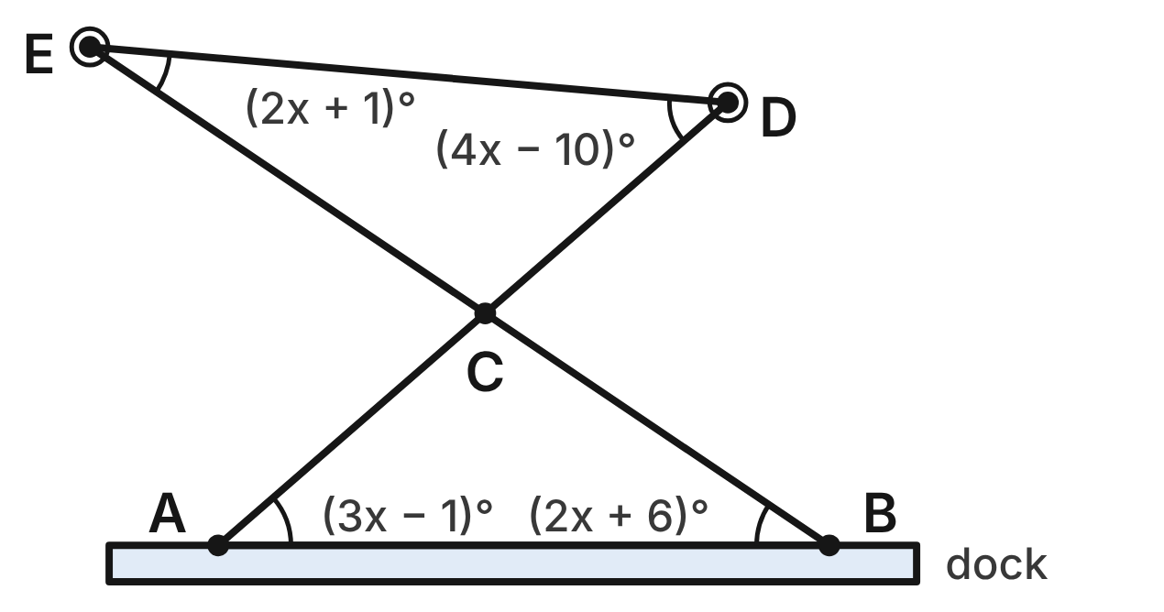
Anglers at A and B stand on a straight dock. Their straight lines run to the buoys D and E and cross at C. A rope DE joins the buoys. m∠CAB = (3x − 1)⁠°, m∠CBA = (2x + 6)⁠°, m∠CDE = (4x − 10)⁠° and m∠CED = (2x + 1)⁠°.
169. The angles at C are vertical angles. What is the value of x?
A. 14 ✔
B. 9
C. 17
D. 105
G.TR.1 · skill G.TR.1.3 (LOTS): Solve problems using the triangle angle sum and the exterior angle theorem
☐ Answer key correct ☐ Wording clear Notes: ________________________________
170. What is m∠ACB, the angle between the two lines at C?
A. 75°
B. 105° ✔
C. 41°
D. 285°
G.TR.1 · skill G.TR.1.3 (LOTS): Solve problems using the triangle angle sum and the exterior angle theorem
☐ Answer key correct ☐ Wording clear Notes: ________________________________
171. What is m∠BCD?
A. 105°
B. 46°
C. 34°
D. 75° ✔
G.TR.1 · skill G.TR.1.3 (LOTS): Solve problems using the triangle angle sum and the exterior angle theorem
☐ Answer key correct ☐ Wording clear Notes: ________________________________
172. Which list orders the sides of △DCE from shortest to longest?
A. DE, CE, CD
B. CE, CD, DE
C. CD, CE, DE ✔
D. CD, DE, CE
G.TR.1 · skill G.TR.1.1 (LOTS): Order the sides of a triangle by length given its angles, or its angles by size given its sides
☐ Answer key correct ☐ Wording clear Notes: ________________________________
173. Which statement is true?
A. BC is the longest side of △ABC.
B. CE is shorter than CD.
C. DE is shorter than CE.
D. AC is the shortest side of △ABC. ✔
G.TR.1 · skill G.TR.1.1 (LOTS): Order the sides of a triangle by length given its angles, or its angles by size given its sides
☐ Answer key correct ☐ Wording clear Notes: ________________________________
174. Three ropes on the dock are (n + 1) ft, (n + 4) ft and 2n ft long. They will form a triangle. Which inequality gives all possible values of n?
A. n > 3/2 ✔
B. 3/2 < n < 5
C. n > −3/2
D. n > 0
G.TR.1 · skill G.TR.1.2 (LOTS): Decide whether three lengths can form a triangle and find the range of possible lengths of the third side
☐ Answer key correct ☐ Wording clear Notes: ________________________________

G.TR.2 · Prove two triangles are congruent, using direct and indirect proofs, and solve problems involving measured attributes of congruent triangles.

Wires for a Young Tree
Level 1 · Triangles · G.TR.2 · ID geo-tr2-worms-tree-wires
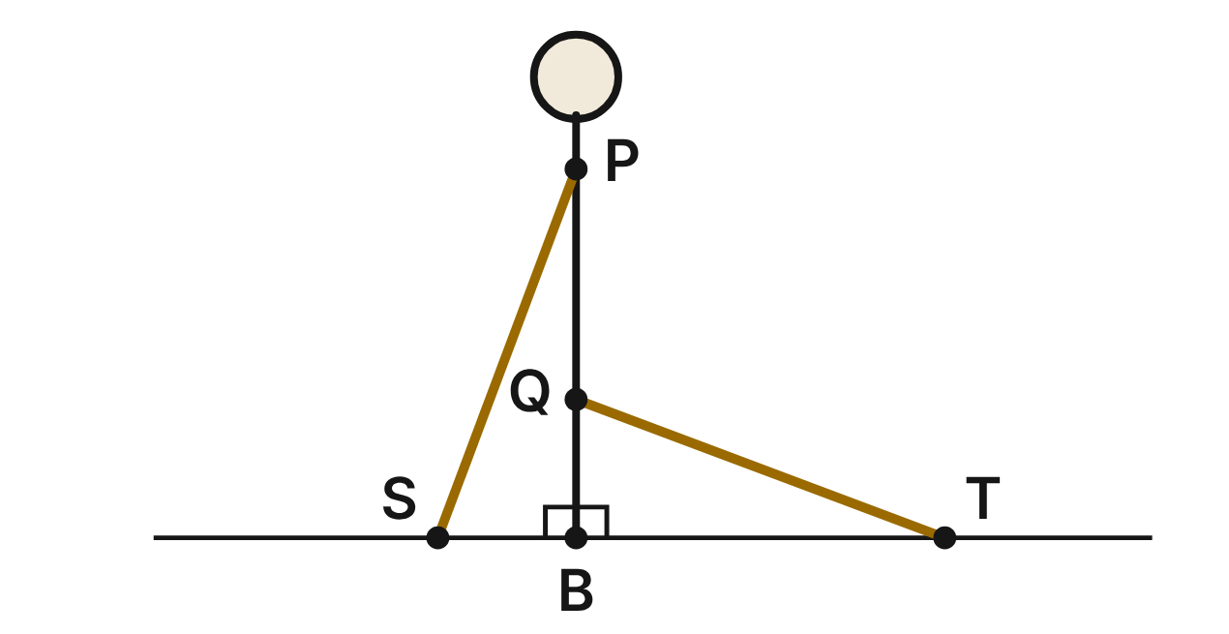
A young tree stands straight up at B on level ground. Wire PS runs from P, 8 ft up the trunk, to a stake S 3 ft from the tree. Wire QT runs from Q, 3 ft up the trunk, to a stake T 8 ft from the tree.
175. Using only the given distances and the right angles at B, which criterion proves △PBS ≅ △TBQ directly?
A. HL
B. SAS ✔
C. SSA
D. ASA
G.TR.2 · skill G.TR.2.1 (LOTS): Identify the congruence criterion (SSS, SAS, ASA, AAS, HL) that the given information supports, and recognize when none does
☐ Answer key correct ☐ Wording clear Notes: ________________________________
176. To the nearest tenth of a foot, how long is wire QT?
A. 11.0 ft
B. 7.4 ft
C. 5.0 ft
D. 8.5 ft ✔
G.TR.2 · skill G.TR.2.3 (LOTS): Solve problems, including algebraic ones, using corresponding parts of congruent triangles
☐ Answer key correct ☐ Wording clear Notes: ________________________________
177. m∠BSP ≈ 69.4°. To the nearest tenth of a degree, what is m∠BQT?
A. 20.6°
B. 110.6°
C. 69.4° ✔
D. 34.7°
G.TR.2 · skill G.TR.2.3 (LOTS): Solve problems, including algebraic ones, using corresponding parts of congruent triangles
☐ Answer key correct ☐ Wording clear Notes: ________________________________
178. Suppose you knew only that BP = BT and that both angles at B are right angles. Which one more fact would prove △PBS ≅ △TBQ by HL?
A. BS = BQ
B. ∠BPS ≅ ∠BTQ
C. ∠BSP ≅ ∠BQT
D. PS = TQ ✔
G.TR.2 · skill G.TR.2.1 (LOTS): Identify the congruence criterion (SSS, SAS, ASA, AAS, HL) that the given information supports, and recognize when none does
☐ Answer key correct ☐ Wording clear Notes: ________________________________
179. Which statement must be true?
A. ∠BPS ≅ ∠BTQ ✔
B. ∠BPS ≅ ∠BQT
C. PS ∥ QT
D. ∠BSP ≅ ∠BTQ
G.TR.2 · skill G.TR.2.3 (LOTS): Solve problems, including algebraic ones, using corresponding parts of congruent triangles
☐ Answer key correct ☐ Wording clear Notes: ________________________________
180. Jo writes △PBS ≅ △QBT. What is wrong with her statement?
A. Nothing; any order of letters works
B. S should match T, since both are stakes
C. P should match T, since BP = BT ✔
D. The triangles are only similar
G.TR.2 · skill G.TR.2.2 (HOTS): Complete or justify a direct or indirect proof that two triangles are congruent
☐ Answer key correct ☐ Wording clear Notes: ________________________________

The Butterfly's Wings
Level 1 · Triangles · G.TR.2 · ID geo-tr2-worms-butterfly
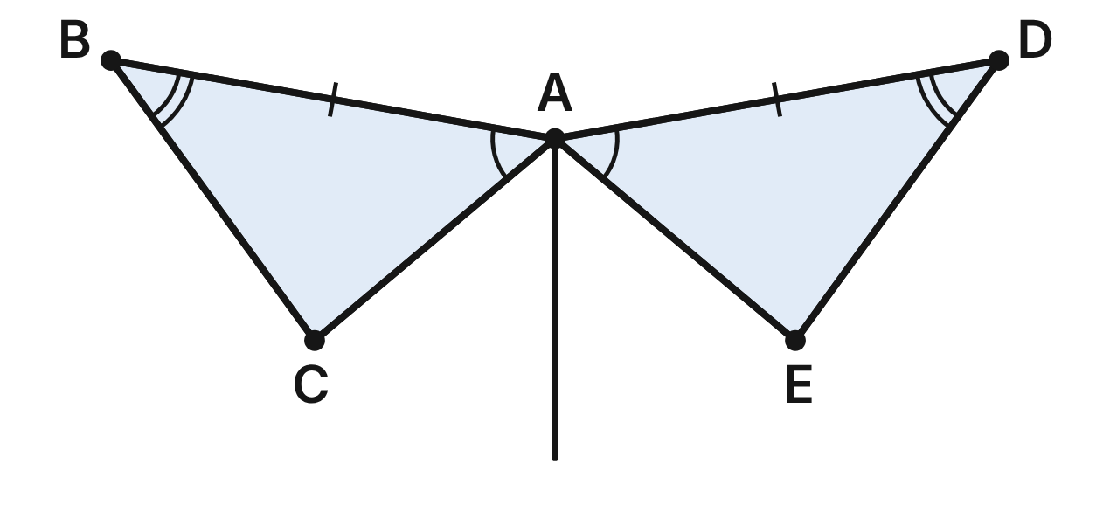
A butterfly's two wings are shaped like △ABC and △ADE. They meet at A, at the top of the body. The marks show AB ≅ AD, ∠BAC ≅ ∠DAE and ∠ABC ≅ ∠ADE.
181. Which criterion do the marks directly support for △ABC ≅ △ADE?
A. ASA ✔
B. AAS
C. SAS
D. SSA
G.TR.2 · skill G.TR.2.1 (LOTS): Identify the congruence criterion (SSS, SAS, ASA, AAS, HL) that the given information supports, and recognize when none does
☐ Answer key correct ☐ Wording clear Notes: ________________________________
182. The wing edge BC is 3.2 cm long. Which other edge must also be 3.2 cm long?
A. AE
B. AD
C. DE ✔
D. AC
G.TR.2 · skill G.TR.2.3 (LOTS): Solve problems, including algebraic ones, using corresponding parts of congruent triangles
☐ Answer key correct ☐ Wording clear Notes: ________________________________
183. m∠ABC = (5k + 4)° and m∠ADE = (3k + 20)°. What is m∠ADE?
A. 8°
B. 44° ✔
C. 88°
D. 136°
G.TR.2 · skill G.TR.2.3 (LOTS): Solve problems, including algebraic ones, using corresponding parts of congruent triangles
☐ Answer key correct ☐ Wording clear Notes: ________________________________
184. Suppose only AB ≅ AD and ∠BAC ≅ ∠DAE were marked. Which one more fact would prove △ABC ≅ △ADE by SAS?
A. ∠ABC ≅ ∠ADE
B. BC ≅ DE
C. ∠ACB ≅ ∠AED
D. AC ≅ AE ✔
G.TR.2 · skill G.TR.2.1 (LOTS): Identify the congruence criterion (SSS, SAS, ASA, AAS, HL) that the given information supports, and recognize when none does
☐ Answer key correct ☐ Wording clear Notes: ________________________________
185. In a proof that △ABC ≅ △ADE, which statement can come only after the triangles are proved congruent?
A. AB ≅ AD
B. BC ≅ DE ✔
C. ∠BAC ≅ ∠DAE
D. ∠ABC ≅ ∠ADE
G.TR.2 · skill G.TR.2.2 (HOTS): Complete or justify a direct or indirect proof that two triangles are congruent
☐ Answer key correct ☐ Wording clear Notes: ________________________________
186. A larger butterfly has a wing △PQR whose angles match ∠BAC, ∠ABC and ∠ACB exactly. Which statement is true?
A. It is congruent by AAA
B. It is congruent by ASA
C. It is similar, not congruent ✔
D. It is neither similar nor congruent
G.TR.2 · skill G.TR.2.1 (LOTS): Identify the congruence criterion (SSS, SAS, ASA, AAS, HL) that the given information supports, and recognize when none does
☐ Answer key correct ☐ Wording clear Notes: ________________________________

Leaf Prints in the Nature Journal
Level 2 · Triangles · G.TR.2 · ID geo-tr2-worms-leaf-prints
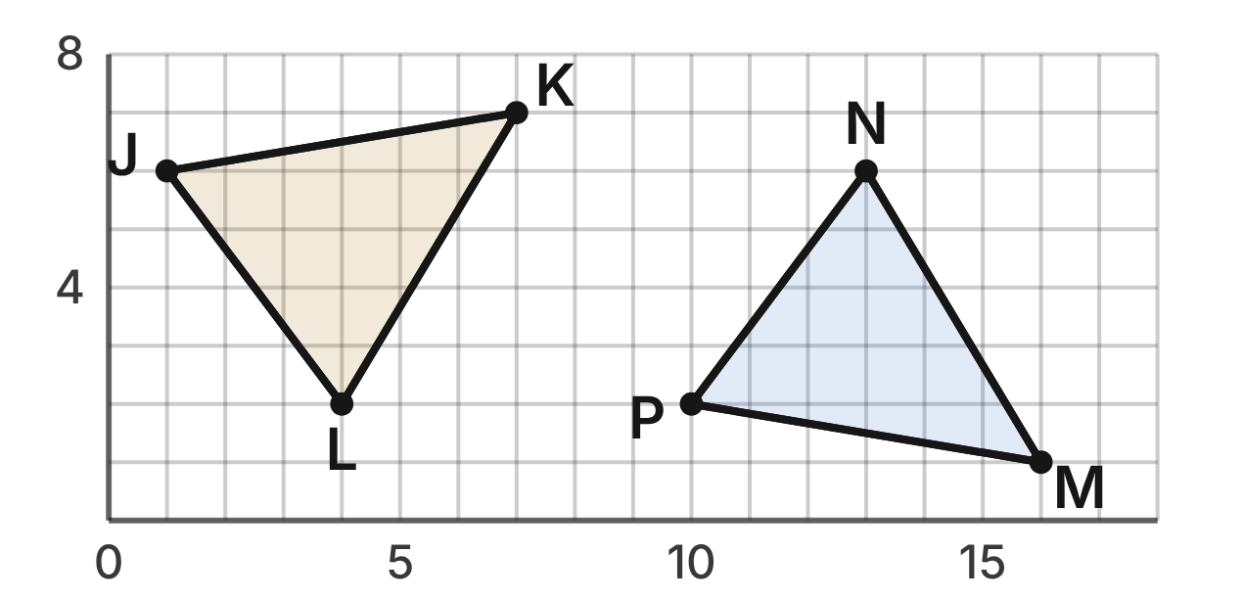
A nature journal has a grid with 1 cm squares. A leaf print △JKL was flipped and slid to make a second print with corners M, N and P: J(1, 6), K(7, 7), L(4, 2), P(10, 2), M(16, 1) and N(13, 6).
187. How long is JL?
A. 7 cm
B. 5 cm ✔
C. 25 cm
D. √7 cm
G.TR.2 · skill G.TR.2.3 (LOTS): Solve problems, including algebraic ones, using corresponding parts of congruent triangles
☐ Answer key correct ☐ Wording clear Notes: ________________________________
188. Which congruence statement matches the corners of the two prints?
A. △JKL ≅ △MNP
B. △JKL ≅ △NPM
C. △JKL ≅ △PNM
D. △JKL ≅ △PMN ✔
G.TR.2 · skill G.TR.2.3 (LOTS): Solve problems, including algebraic ones, using corresponding parts of congruent triangles
☐ Answer key correct ☐ Wording clear Notes: ________________________________
189. Gus finds PN = √((13 − 10)² + (6 − 2)²) = 3 + 4 = 7. What is his error?
A. √(9 + 16) is 5, not 3 + 4 ✔
B. He subtracted in the wrong order
C. He should add the coordinates
D. He mixed up x and y
G.TR.2 · skill G.TR.2.2 (HOTS): Complete or justify a direct or indirect proof that two triangles are congruent
☐ Answer key correct ☐ Wording clear Notes: ________________________________
190. Pia knows JL = PN and KL = MN. Which one more fact would prove the prints congruent by SAS?
A. ∠J ≅ ∠P
B. ∠L ≅ ∠N ✔
C. ∠K ≅ ∠M
D. JK = PM
G.TR.2 · skill G.TR.2.1 (LOTS): Identify the congruence criterion (SSS, SAS, ASA, AAS, HL) that the given information supports, and recognize when none does
☐ Answer key correct ☐ Wording clear Notes: ________________________________
191. What is the area of △PMN, in square centimeters?
A. 27.0
B. 30.0
C. 15.2
D. 13.5 ✔
G.TR.2 · skill G.TR.2.3 (LOTS): Solve problems, including algebraic ones, using corresponding parts of congruent triangles
☐ Answer key correct ☐ Wording clear Notes: ________________________________
192. Which statement about the two leaf prints is NOT true?
A. PN = 5 cm
B. ∠L ≅ ∠N
C. KL = PN ✔
D. JK = PM
G.TR.2 · skill G.TR.2.3 (LOTS): Solve problems, including algebraic ones, using corresponding parts of congruent triangles
☐ Answer key correct ☐ Wording clear Notes: ________________________________

Two Trails Down the Mountain
Level 2 · Triangles · G.TR.2 · ID geo-tr2-worms-mountain-trails
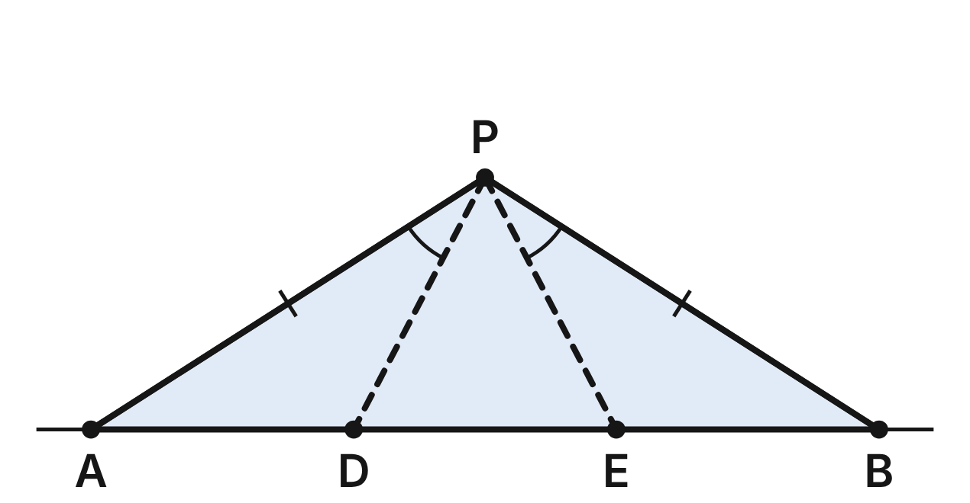
Ridges PA and PB run from the peak P down to a straight valley road, with PA ≅ PB. Trails PD and PE reach the road at D and E, with ∠APD ≅ ∠BPE.
193. Why is ∠PAD ≅ ∠PBE?
A. They are vertical angles
B. PD ≅ PE, so the angles opposite them match
C. They are corresponding angles of parallel lines
D. PA ≅ PB, so the angles opposite them match ✔
G.TR.2 · skill G.TR.2.2 (HOTS): Complete or justify a direct or indirect proof that two triangles are congruent
☐ Answer key correct ☐ Wording clear Notes: ________________________________
194. Using PA ≅ PB, ∠APD ≅ ∠BPE and ∠PAD ≅ ∠PBE directly, which criterion proves △PAD ≅ △PBE?
A. SAS
B. ASA ✔
C. AAS
D. SSS
G.TR.2 · skill G.TR.2.1 (LOTS): Identify the congruence criterion (SSS, SAS, ASA, AAS, HL) that the given information supports, and recognize when none does
☐ Answer key correct ☐ Wording clear Notes: ________________________________
195. △PAD and △PAE share side PA and the angle at A, and PD = PE. Are △PAD and △PAE congruent? Choose the answer with the correct reason.
A. Yes, by SAS, since ∠A is between PA and PD
B. Yes, by HL, since PD and PE are hypotenuses
C. No; SSA fits two triangles here, with AD ≠ AE ✔
D. No; the two triangles do not share an angle
G.TR.2 · skill G.TR.2.1 (LOTS): Identify the congruence criterion (SSS, SAS, ASA, AAS, HL) that the given information supports, and recognize when none does
☐ Answer key correct ☐ Wording clear Notes: ________________________________
196. PD = (3m + 50) m and PE = (5m − 350) m. How long is trail PE?
A. 650 m ✔
B. 200 m
C. 1,300 m
D. 400 m
G.TR.2 · skill G.TR.2.3 (LOTS): Solve problems, including algebraic ones, using corresponding parts of congruent triangles
☐ Answer key correct ☐ Wording clear Notes: ________________________________
197. The road from A to B is 1,800 m long, and DE = 600 m. How far is D from A?
A. 600 m ✔
B. 1,200 m
C. 900 m
D. 300 m
G.TR.2 · skill G.TR.2.3 (LOTS): Solve problems, including algebraic ones, using corresponding parts of congruent triangles
☐ Answer key correct ☐ Wording clear Notes: ________________________________
198. m∠PDA ≈ 117.5°. To the nearest tenth of a degree, what is m∠PEB?
A. 62.5°
B. 58.8°
C. 27.5°
D. 117.5° ✔
G.TR.2 · skill G.TR.2.3 (LOTS): Solve problems, including algebraic ones, using corresponding parts of congruent triangles
☐ Answer key correct ☐ Wording clear Notes: ________________________________

Pipes Between the Square Pens
Level 2 · Triangles · G.TR.2 · ID geo-tr2-worms-square-pens
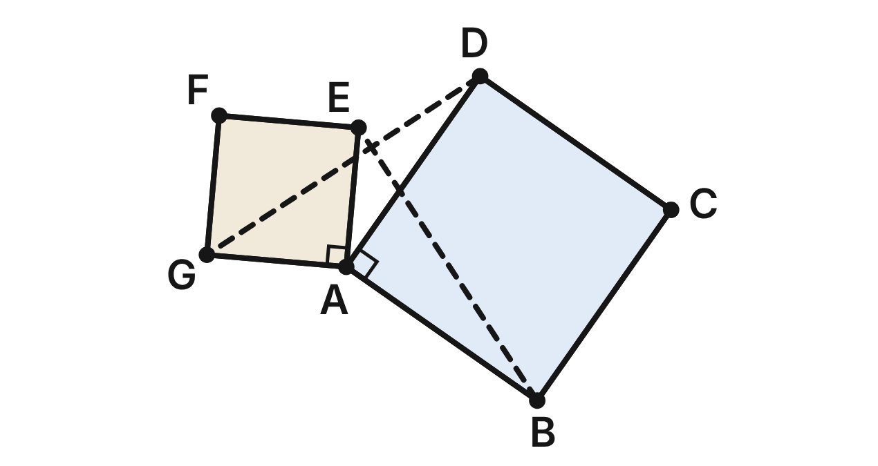
Two square pens on a farm, ABCD and AEFG, share the corner post A. Water pipes BE and DG run between them. Prove that BE ≅ DG.
Statement | Reason
1. ABCD and AEFG are squares | Given
2. AB ≅ AD; AE ≅ AG | (a) ____
3. m∠BAD = m∠EAG = 90° | Definition of a square
4. m∠BAE = m∠DAG | Angle Addition: each is 90° + m∠DAE
5. △BAE ≅ △DAG | (b) ____
6. BE ≅ DG | CPCTC

199. Which reason justifies step 2, AB ≅ AD and AE ≅ AG (blank a)?
A. Diagonals of a square are congruent
B. Reflexive property of congruence
C. Corresponding parts of congruent triangles
D. All sides of a square are congruent ✔
G.TR.2 · skill G.TR.2.2 (HOTS): Complete or justify a direct or indirect proof that two triangles are congruent
☐ Answer key correct ☐ Wording clear Notes: ________________________________
200. Which reason justifies step 5, △BAE ≅ △DAG (blank b)?
A. SAS ✔
B. SSS
C. ASA
D. HL
G.TR.2 · skill G.TR.2.2 (HOTS): Complete or justify a direct or indirect proof that two triangles are congruent
☐ Answer key correct ☐ Wording clear Notes: ________________________________
201. BE = (3c − 2) m and DG = (c + 4) m. How long is pipe DG?
A. 3 m
B. 14 m
C. 7 m ✔
D. 5 m
G.TR.2 · skill G.TR.2.3 (LOTS): Solve problems, including algebraic ones, using corresponding parts of congruent triangles
☐ Answer key correct ☐ Wording clear Notes: ________________________________
202. m∠AEB ≈ 38.2°. To the nearest tenth of a degree, what is m∠AGD?
A. 21.8°
B. 38.2° ✔
C. 51.8°
D. 141.8°
G.TR.2 · skill G.TR.2.3 (LOTS): Solve problems, including algebraic ones, using corresponding parts of congruent triangles
☐ Answer key correct ☐ Wording clear Notes: ________________________________
203. With AB ≅ AD, which pair of facts would NOT prove △BAE ≅ △DAG?
A. AE ≅ AG and ∠BAE ≅ ∠DAG
B. AE ≅ AG and BE ≅ DG
C. AE ≅ AG and ∠ABE ≅ ∠ADG ✔
D. ∠BAE ≅ ∠DAG and ∠ABE ≅ ∠ADG
G.TR.2 · skill G.TR.2.1 (LOTS): Identify the congruence criterion (SSS, SAS, ASA, AAS, HL) that the given information supports, and recognize when none does
☐ Answer key correct ☐ Wording clear Notes: ________________________________
204. Step 4 says each angle is 90° + m∠DAE. If m∠DAE = 30°, what is m∠BAE?
A. 120° ✔
B. 60°
C. 150°
D. 90°
G.TR.2 · skill G.TR.2.2 (HOTS): Complete or justify a direct or indirect proof that two triangles are congruent
☐ Answer key correct ☐ Wording clear Notes: ________________________________

Braces in the Birdhouse
Level 3 · Triangles · G.TR.2 · ID geo-tr2-worms-birdhouse
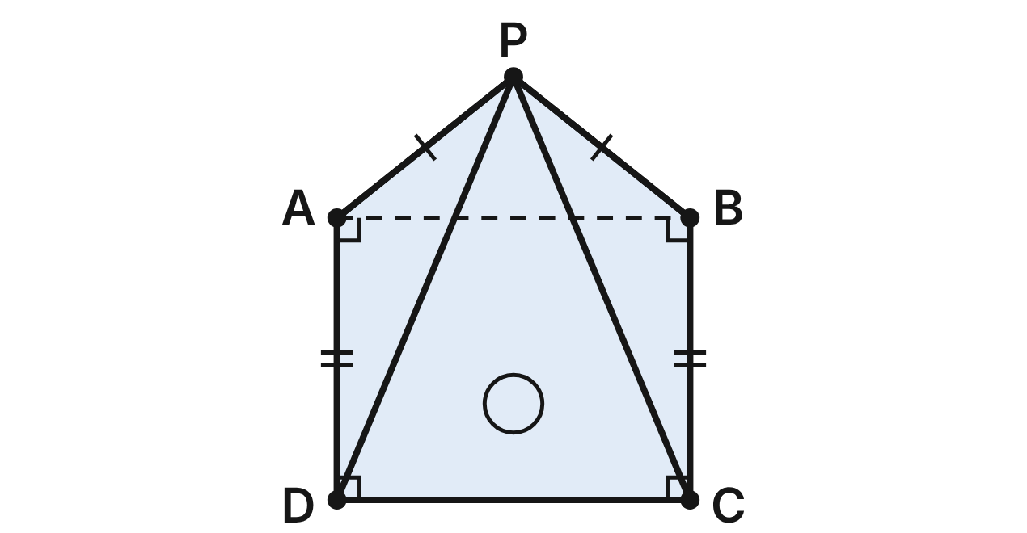
The front of a birdhouse is the pentagon PADCB: ABCD is a rectangle and the roof edges are congruent, PA ≅ PB. Braces PD and PC run inside from the peak. Prove that PD ≅ PC.
Statement | Reason
1. ABCD is a rectangle; PA ≅ PB | Given
2. ∠PAB ≅ ∠PBA | (a) ____
3. ∠BAD ≅ ∠ABC | All right angles are congruent
4. m∠PAD = m∠PBC | (b) ____
5. AD ≅ BC | Opposite sides of a rectangle are congruent
6. △PAD ≅ △PBC | (c) ____
7. PD ≅ PC | CPCTC

205. Which reason justifies step 2, ∠PAB ≅ ∠PBA (blank a)?
A. Converse of the Isosceles Triangle Theorem
B. Third Angles Theorem
C. Isosceles Triangle Theorem ✔
D. Vertical Angles Theorem
G.TR.2 · skill G.TR.2.2 (HOTS): Complete or justify a direct or indirect proof that two triangles are congruent
☐ Answer key correct ☐ Wording clear Notes: ________________________________
206. Which reason justifies step 4, m∠PAD = m∠PBC (blank b)?
A. Angle Addition Postulate ✔
B. Linear Pair Postulate
C. Vertical Angles Theorem
D. Third Angles Theorem
G.TR.2 · skill G.TR.2.2 (HOTS): Complete or justify a direct or indirect proof that two triangles are congruent
☐ Answer key correct ☐ Wording clear Notes: ________________________________
207. Which reason justifies step 6, △PAD ≅ △PBC (blank c)?
A. SSA
B. ASA
C. HL
D. SAS ✔
G.TR.2 · skill G.TR.2.2 (HOTS): Complete or justify a direct or indirect proof that two triangles are congruent
☐ Answer key correct ☐ Wording clear Notes: ________________________________
208. PD = (3r + 1) in. and PC = (5r − 7) in. How long is brace PD?
A. 4 in.
B. 13 in. ✔
C. 26 in.
D. 10 in.
G.TR.2 · skill G.TR.2.3 (LOTS): Solve problems, including algebraic ones, using corresponding parts of congruent triangles
☐ Answer key correct ☐ Wording clear Notes: ________________________________
209. m∠PAB ≈ 38.7°. To the nearest tenth of a degree, what is m∠PBC?
A. 38.7°
B. 51.3°
C. 128.7° ✔
D. 141.3°
G.TR.2 · skill G.TR.2.3 (LOTS): Solve problems, including algebraic ones, using corresponding parts of congruent triangles
☐ Answer key correct ☐ Wording clear Notes: ________________________________
210. Another birdhouse front is also a rectangle ABCD with a roof peak P above AB, but PD = 13 in. and PC = 14 in. Lou assumes PA ≅ PB. How should his indirect proof end?
A. PD ≅ PC follows, so PA ≅ PB is proved
B. PD ≅ PC follows, which is false; so PA ≇ PB ✔
C. 13 ≠ 14, so ABCD is not a rectangle
D. PD ≠ PC, so ∠PAB ≅ ∠PBA is proved
G.TR.2 · skill G.TR.2.2 (HOTS): Complete or justify a direct or indirect proof that two triangles are congruent
☐ Answer key correct ☐ Wording clear Notes: ________________________________

Guy Lines on the Campsite Tarp
Level 3 · Triangles · G.TR.2 · ID geo-tr2-worms-tarp-lines
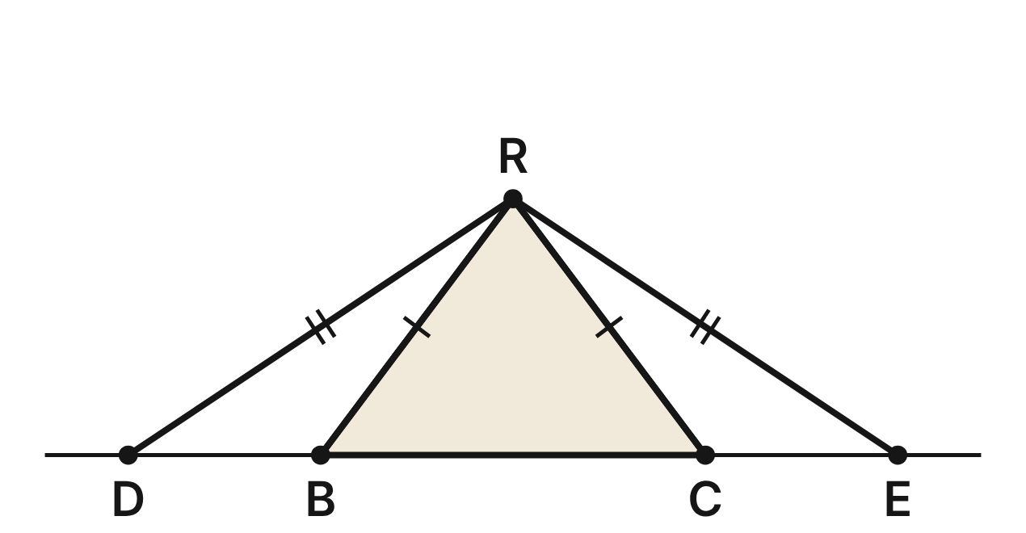
The end of an A-frame tarp is the triangle RBC, with RB ≅ RC. Guy lines RD and RE are the same length. D, B, C and E lie in a line on level ground. Prove that DB ≅ CE.
Statement | Reason
1. RB ≅ RC; RD ≅ RE | Given
2. ∠RBC ≅ ∠RCB; ∠D ≅ ∠E | Base angles of an isosceles triangle are congruent
3. ∠RBD ≅ ∠RCE | (a) ____
4. △RBD ≅ △RCE | (b) ____
5. DB ≅ CE | CPCTC

211. Which reason justifies step 3, ∠RBD ≅ ∠RCE (blank a)?
A. Congruent Supplements Theorem ✔
B. Congruent Complements Theorem
C. Vertical Angles Theorem
D. Reflexive property
G.TR.2 · skill G.TR.2.2 (HOTS): Complete or justify a direct or indirect proof that two triangles are congruent
☐ Answer key correct ☐ Wording clear Notes: ________________________________
212. Which reason justifies step 4, △RBD ≅ △RCE (blank b), using the parts in steps 1, 2 and 3?
A. ASA
B. SAS
C. AAS ✔
D. SSA
G.TR.2 · skill G.TR.2.2 (HOTS): Complete or justify a direct or indirect proof that two triangles are congruent
☐ Answer key correct ☐ Wording clear Notes: ________________________________
213. RB = 5 ft, BC = 6 ft and DB = 3 ft. To the nearest tenth of a foot, how long is each guy line?
A. 8.0 ft
B. 7.2 ft ✔
C. 6.0 ft
D. 5.0 ft
G.TR.2 · skill G.TR.2.3 (LOTS): Solve problems, including algebraic ones, using corresponding parts of congruent triangles
☐ Answer key correct ☐ Wording clear Notes: ________________________________
214. DB = (2q − 5) ft, CE = (q − 1) ft and BC = 6 ft. How far apart are stakes D and E?
A. 4 ft
B. 9 ft
C. 3 ft
D. 12 ft ✔
G.TR.2 · skill G.TR.2.3 (LOTS): Solve problems, including algebraic ones, using corresponding parts of congruent triangles
☐ Answer key correct ☐ Wording clear Notes: ________________________________
215. At another campsite, the guy lines were not measured, but DB ≅ CE and RB ≅ RC. Which criterion proves △RBD ≅ △RCE?
A. SAS ✔
B. AAS
C. SSS
D. HL
G.TR.2 · skill G.TR.2.1 (LOTS): Identify the congruence criterion (SSS, SAS, ASA, AAS, HL) that the given information supports, and recognize when none does
☐ Answer key correct ☐ Wording clear Notes: ________________________________
216. At another campsite, RB = RC, but stake D is 3 ft from B and stake E is 4 ft from C. To prove indirectly that guy lines RD and RE are not the same length, what should you assume first?
A. RD ≠ RE
B. DB = CE
C. RB ≠ RC
D. RD = RE ✔
G.TR.2 · skill G.TR.2.2 (HOTS): Complete or justify a direct or indirect proof that two triangles are congruent
☐ Answer key correct ☐ Wording clear Notes: ________________________________

G.TR.3 · Prove two triangles are similar, using direct and indirect proofs, and solve problems involving measured attributes of similar triangles.

The Mirror Under the Oak
Level 1 · Triangles · G.TR.3 · ID geo-tr3-worms-mirror-oak
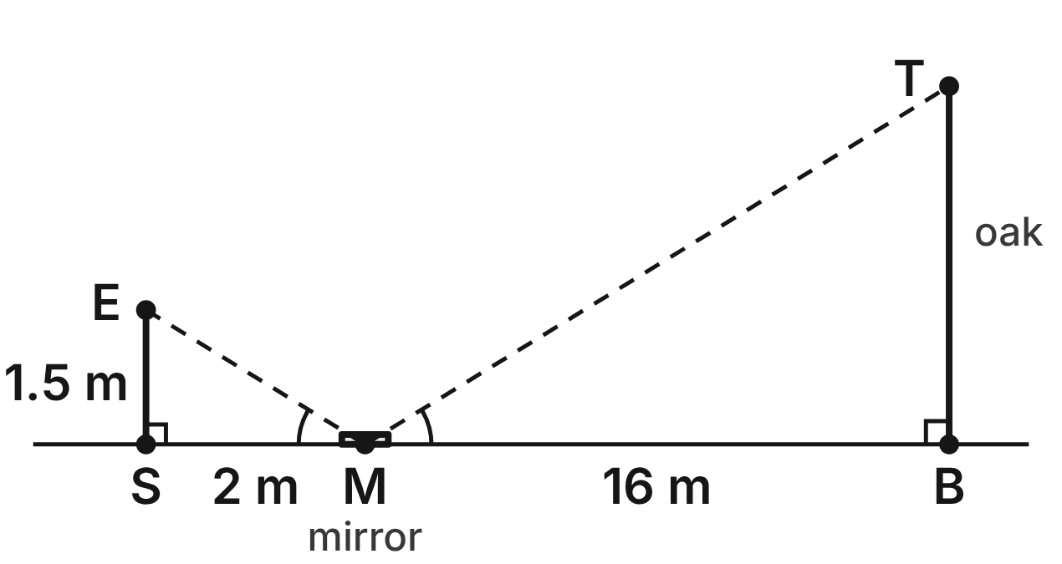
Not drawn to scale
Mira lays a mirror M flat on level ground, 16 m from the base B of an oak. She stands at S, 2 m from the mirror, and sees the top T of the oak in it. Her eyes E are 1.5 m above the ground. ES and TB are vertical, and the mirror makes ∠EMS ≅ ∠TMB.
217. Which criterion shows that △ESM ∼ △TBM?
A. AA ✔
B. SAS∼
C. SSS∼
D. HL
G.TR.3 · skill G.TR.3.1 (LOTS): Identify the similarity criterion (AA, SSS, SAS) that the given information supports
☐ Answer key correct ☐ Wording clear Notes: ________________________________
218. How tall is the oak?
A. about 21.3 m
B. 15.5 m
C. 12 m ✔
D. 8 m
G.TR.3 · skill G.TR.3.3 (LOTS): Solve problems, including contextual ones, using proportional sides of similar triangles
☐ Answer key correct ☐ Wording clear Notes: ________________________________
219. Mira's brother, whose eyes are 1.2 m above the ground, uses the same mirror spot. How far from the mirror must he stand to see the top of the oak?
A. 2.5 m
B. 1.6 m ✔
C. 1.7 m
D. 2 m
G.TR.3 · skill G.TR.3.3 (LOTS): Solve problems, including contextual ones, using proportional sides of similar triangles
☐ Answer key correct ☐ Wording clear Notes: ________________________________
220. Which reason proves that ∠MES ≅ ∠MTB?
A. They are vertical angles.
B. They are alternate interior angles.
C. They are both right angles.
D. The other two angle pairs are congruent. ✔
G.TR.3 · skill G.TR.3.2 (HOTS): Justify that two triangles are similar, or are not, using angle measures or side ratios
☐ Answer key correct ☐ Wording clear Notes: ________________________________
221. Later, Mira's eyes are 1.4 m up and she stands 1.75 m from a mirror. She says she sees the top of a 10-m pine whose base is 12 m from the mirror. Is that possible? Choose the answer with the correct reason.
A. Yes; 1.4/1.75 = 10/12
B. Yes; 1.4/10 = 1.75/12
C. No; 1.4/1.75 ≠ 10/12 ✔
D. No; 1.75/1.4 = 12/10
G.TR.3 · skill G.TR.3.2 (HOTS): Justify that two triangles are similar, or are not, using angle measures or side ratios
☐ Answer key correct ☐ Wording clear Notes: ________________________________
222. What is the scale factor from Mira's triangle to the oak's triangle?
A. 8 ✔
B. 1/8
C. 14
D. 4/3
G.TR.3 · skill G.TR.3.3 (LOTS): Solve problems, including contextual ones, using proportional sides of similar triangles
☐ Answer key correct ☐ Wording clear Notes: ________________________________

Shadows in the Meadow
Level 1 · Triangles · G.TR.3 · ID geo-tr3-worms-meadow-shadows
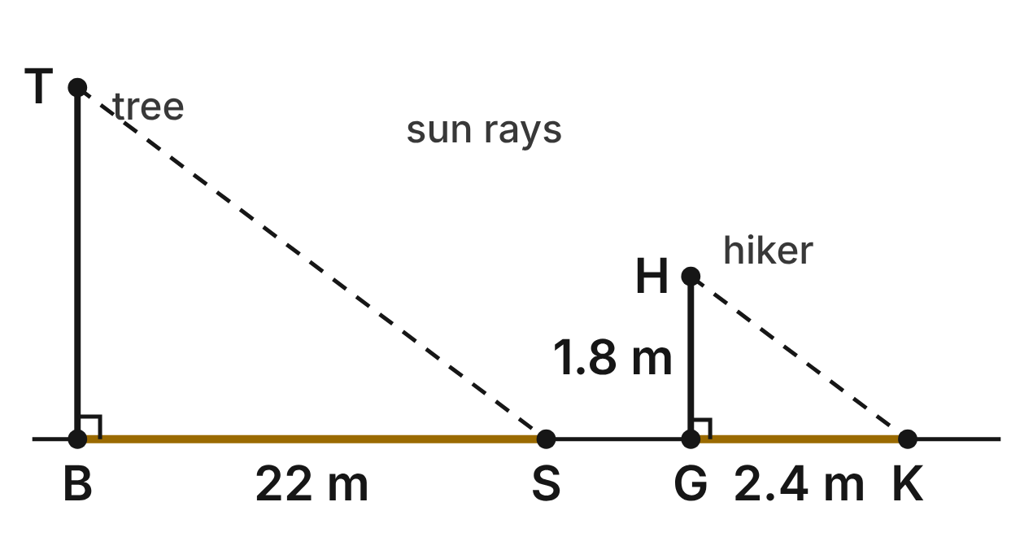
Not drawn to scale
At the same moment, a hiker HG, 1.8 m tall, casts a shadow GK 2.4 m long, and a tree TB casts a shadow BS 22 m long. Both stand straight up on level ground, and the sun's rays HK and TS are parallel.
223. Why is the hiker's triangle similar to the tree's triangle?
A. SSS∼: all three sides of each are known
B. AA: right angles, and equal angles of the sun's rays ✔
C. HL: both are right triangles
D. AA: each triangle has a 45° angle
G.TR.3 · skill G.TR.3.1 (LOTS): Identify the similarity criterion (AA, SSS, SAS) that the given information supports
☐ Answer key correct ☐ Wording clear Notes: ________________________________
224. How tall is the tree?
A. about 29.3 m
B. 21.4 m
C. 39.6 m
D. 16.5 m ✔
G.TR.3 · skill G.TR.3.3 (LOTS): Solve problems, including contextual ones, using proportional sides of similar triangles
☐ Answer key correct ☐ Wording clear Notes: ________________________________
225. An hour later, the hiker's shadow is 3 m long. How long is the tree's shadow then?
A. 27.5 m ✔
B. 22.6 m
C. 17.6 m
D. 22 m
G.TR.3 · skill G.TR.3.3 (LOTS): Solve problems, including contextual ones, using proportional sides of similar triangles
☐ Answer key correct ☐ Wording clear Notes: ________________________________
226. Which similarity statement pairs the hiker's triangle with the tree's?
A. △HGK ∼ △BTS
B. △GHK ∼ △TBS
C. △HGK ∼ △TBS ✔
D. △HKG ∼ △TBS
G.TR.3 · skill G.TR.3.1 (LOTS): Identify the similarity criterion (AA, SSS, SAS) that the given information supports
☐ Answer key correct ☐ Wording clear Notes: ________________________________
227. A 1.2-m fence post nearby has a 1.5-m shadow at the same moment. Is that possible? Choose the answer with the correct reason.
A. Yes; 1.2/1.5 = 1.8/2.4
B. Yes; 1.5 − 1.2 = 2.4 − 1.8
C. No; its shadow should be 1.8 m
D. No; 1.2/1.5 ≠ 1.8/2.4 ✔
G.TR.3 · skill G.TR.3.2 (HOTS): Justify that two triangles are similar, or are not, using angle measures or side ratios
☐ Answer key correct ☐ Wording clear Notes: ________________________________
228. Which equation gives the tree's height h, in meters?
A. h/22 = 2.4/1.8
B. h/22 = 1.8/2.4 ✔
C. h/2.4 = 1.8/22
D. h − 1.8 = 22 − 2.4
G.TR.3 · skill G.TR.3.3 (LOTS): Solve problems, including contextual ones, using proportional sides of similar triangles
☐ Answer key correct ☐ Wording clear Notes: ________________________________

The Sapling and Its Stake
Level 2 · Triangles · G.TR.3 · ID geo-tr3-worms-sapling-stake
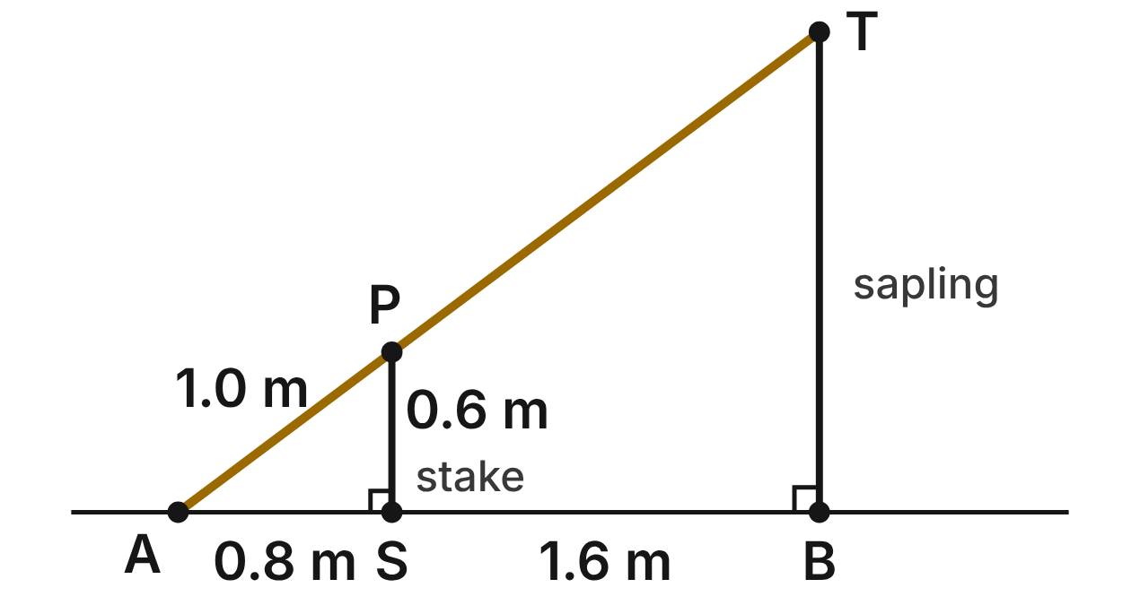
A rope runs straight from the top T of a sapling to an anchor A on level ground. It rests on the top P of a stake SP. The sapling TB and the stake are vertical. AS = 0.8 m, SB = 1.6 m, SP = 0.6 m and AP = 1.0 m.
229. Which criterion shows that △ASP ∼ △ABT?
A. SAS∼
B. SSS∼
C. HL
D. AA ✔
G.TR.3 · skill G.TR.3.1 (LOTS): Identify the similarity criterion (AA, SSS, SAS) that the given information supports
☐ Answer key correct ☐ Wording clear Notes: ________________________________
230. How tall is the sapling TB?
A. 1.2 m
B. 1.8 m ✔
C. 2.2 m
D. 0.2 m
G.TR.3 · skill G.TR.3.3 (LOTS): Solve problems, including contextual ones, using proportional sides of similar triangles
☐ Answer key correct ☐ Wording clear Notes: ________________________________
231. How long is the rope AT?
A. 3 m ✔
B. 2 m
C. 2.6 m
D. about 0.3 m
G.TR.3 · skill G.TR.3.3 (LOTS): Solve problems, including contextual ones, using proportional sides of similar triangles
☐ Answer key correct ☐ Wording clear Notes: ________________________________
232. A second stake, 1.5 m tall, will also touch the rope. How far from A should it stand?
A. 1.125 m
B. 2.3 m
C. 2 m ✔
D. 1.2 m
G.TR.3 · skill G.TR.3.3 (LOTS): Solve problems, including contextual ones, using proportional sides of similar triangles
☐ Answer key correct ☐ Wording clear Notes: ________________________________
233. Which statement about the rope and the stake is NOT true?
A. △ASP ∼ △ABT
B. AS/AB = SP/BT
C. SP/BT = SB/AB ✔
D. AP/PT = AS/SB
G.TR.3 · skill G.TR.3.2 (HOTS): Justify that two triangles are similar, or are not, using angle measures or side ratios
☐ Answer key correct ☐ Wording clear Notes: ________________________________
234. In another garden, a 0.5-m stake stands 0.7 m from the anchor, and a 2-m sapling stands 2.8 m from the anchor, on the same side. Can one straight rope from the sapling's top to the anchor rest on the stake's top? Choose the answer with the correct reason.
A. No; 0.5/0.7 ≠ 2/2.8
B. Yes; 2.8 − 0.7 = 2 − 0.5
C. No; 0.5/2 ≠ 0.7/2.8
D. Yes; 0.5/0.7 = 2/2.8 ✔
G.TR.3 · skill G.TR.3.2 (HOTS): Justify that two triangles are similar, or are not, using angle measures or side ratios
☐ Answer key correct ☐ Wording clear Notes: ________________________________

Across the Canyon
Level 2 · Triangles · G.TR.3 · ID geo-tr3-worms-canyon-width
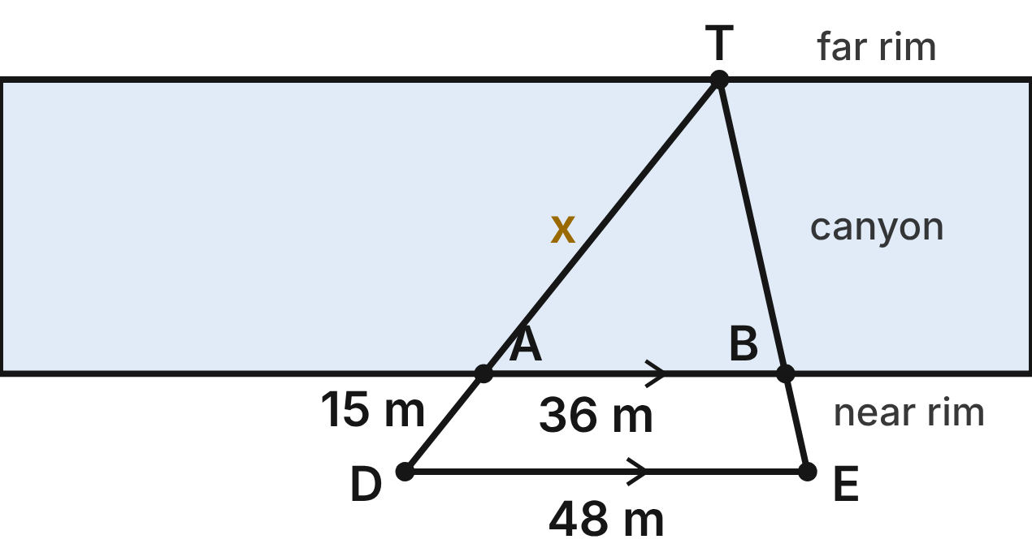
A ranger picks a rock T on the far rim of a canyon. She stakes A and B on the near rim, then D and E farther back so that T, A, D and T, B, E are on straight lines and AB ∥ DE. AB = 36 m, DE = 48 m and AD = 15 m. Let x = TA.
235. Which criterion shows that △TAB ∼ △TDE?
A. SAS∼
B. AA ✔
C. SSS∼
D. HL
G.TR.3 · skill G.TR.3.1 (LOTS): Identify the similarity criterion (AA, SSS, SAS) that the given information supports
☐ Answer key correct ☐ Wording clear Notes: ________________________________
236. Which equation can be used to find x?
A. x/(x + 15) = 36/48 ✔
B. x/15 = 36/48
C. x/(x + 15) = 48/36
D. x/48 = 15/36
G.TR.3 · skill G.TR.3.3 (LOTS): Solve problems, including contextual ones, using proportional sides of similar triangles
☐ Answer key correct ☐ Wording clear Notes: ________________________________
237. How far is it from A across the canyon to T?
A. 11.25 m
B. 60 m
C. 45 m ✔
D. 20 m
G.TR.3 · skill G.TR.3.3 (LOTS): Solve problems, including contextual ones, using proportional sides of similar triangles
☐ Answer key correct ☐ Wording clear Notes: ________________________________
238. The ranger also measures BE = 14 m. How far is it from B to T?
A. 56 m
B. 10.5 m
C. about 18.7 m
D. 42 m ✔
G.TR.3 · skill G.TR.3.3 (LOTS): Solve problems, including contextual ones, using proportional sides of similar triangles
☐ Answer key correct ☐ Wording clear Notes: ________________________________
239. Which statement must be true because AB ∥ DE?
A. ∠TAB ≅ ∠TED
B. TA = AD
C. ∠TAB ≅ ∠TDE ✔
D. ∠TBA ≅ ∠TDE
G.TR.3 · skill G.TR.3.2 (HOTS): Justify that two triangles are similar, or are not, using angle measures or side ratios
☐ Answer key correct ☐ Wording clear Notes: ________________________________
240. What is the scale factor from △TAB to △TDE?
A. 3/4
B. 4/3 ✔
C. 12
D. 5/4
G.TR.3 · skill G.TR.3.3 (LOTS): Solve problems, including contextual ones, using proportional sides of similar triangles
☐ Answer key correct ☐ Wording clear Notes: ________________________________

Three Fern Fronds
Level 2 · Triangles · G.TR.3 · ID geo-tr3-worms-fern-fronds
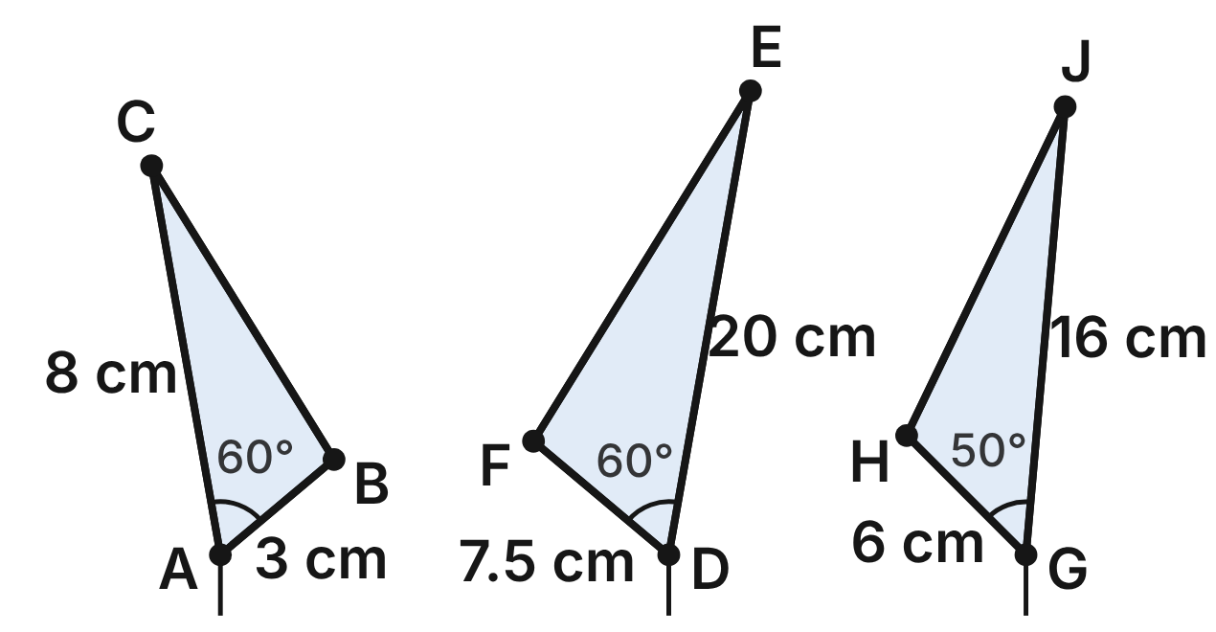
Not drawn to scale
A botanist traces three fern fronds as triangles. Frond 1, △ABC: AB = 3 cm, AC = 8 cm, m∠A = 60° and BC = 7 cm. Frond 2, △DEF: DF = 7.5 cm, DE = 20 cm and m∠D = 60°. Frond 3, △GHJ: GH = 6 cm, GJ = 16 cm and m∠G = 50°.
241. Which criterion shows that frond 1 is similar to frond 2?
A. AA
B. SSS∼
C. SAS∼ ✔
D. SAS
G.TR.3 · skill G.TR.3.1 (LOTS): Identify the similarity criterion (AA, SSS, SAS) that the given information supports
☐ Answer key correct ☐ Wording clear Notes: ________________________________
242. Is frond 3 similar to frond 1? Choose the answer with the correct reason.
A. No; m∠G ≠ m∠A ✔
B. Yes; 6/3 = 16/8 and m∠G = m∠A
C. No; 6/3 ≠ 16/8
D. Yes; 16 − 6 = 8 − 3
G.TR.3 · skill G.TR.3.2 (HOTS): Justify that two triangles are similar, or are not, using angle measures or side ratios
☐ Answer key correct ☐ Wording clear Notes: ________________________________
243. How long is side EF of frond 2?
A. 19 cm
B. 43.75 cm
C. 2.8 cm
D. 17.5 cm ✔
G.TR.3 · skill G.TR.3.3 (LOTS): Solve problems, including contextual ones, using proportional sides of similar triangles
☐ Answer key correct ☐ Wording clear Notes: ________________________________
244. What is the scale factor from frond 1 to frond 2?
A. 2/5
B. 5/2 ✔
C. 12
D. 8/3
G.TR.3 · skill G.TR.3.3 (LOTS): Solve problems, including contextual ones, using proportional sides of similar triangles
☐ Answer key correct ☐ Wording clear Notes: ________________________________
245. Which similarity statement is correct for fronds 1 and 2?
A. △ABC ∼ △DFE ✔
B. △ABC ∼ △DEF
C. △ABC ∼ △EDF
D. △ABC ∼ △FDE
G.TR.3 · skill G.TR.3.1 (LOTS): Identify the similarity criterion (AA, SSS, SAS) that the given information supports
☐ Answer key correct ☐ Wording clear Notes: ________________________________
246. What is the perimeter of frond 2?
A. 112.5 cm
B. 7.2 cm
C. 30 cm
D. 45 cm ✔
G.TR.3 · skill G.TR.3.3 (LOTS): Solve problems, including contextual ones, using proportional sides of similar triangles
☐ Answer key correct ☐ Wording clear Notes: ________________________________

The Fence Post on the Hillside
Level 2 · Triangles · G.TR.3 · ID geo-tr3-worms-hillside-post
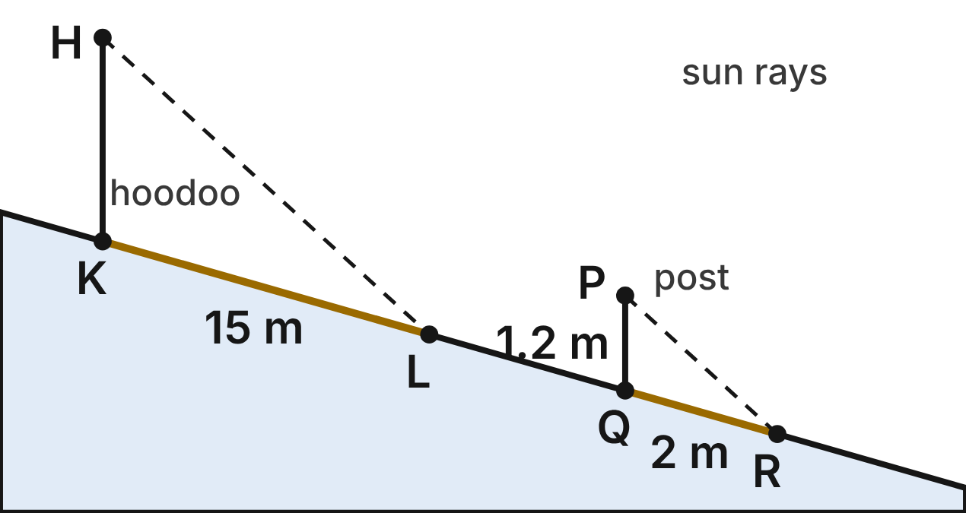
Not drawn to scale
A fence post PQ and a rock spire (a hoodoo) HK stand straight up on a straight, sloping hillside. At the same moment, their shadows QR and KL lie down the slope. The sun's rays PR and HL are parallel. PQ = 1.2 m, QR = 2 m and KL = 15 m.
247. Why is the post's triangle similar to the hoodoo's triangle?
A. AA: the post and hoodoo are parallel, and so are the rays ✔
B. AA: both have right angles where they meet the ground
C. SSS∼: all three sides of each are known
D. SAS∼: the shadows are in proportion, with right angles
G.TR.3 · skill G.TR.3.1 (LOTS): Identify the similarity criterion (AA, SSS, SAS) that the given information supports
☐ Answer key correct ☐ Wording clear Notes: ________________________________
248. How tall is the hoodoo?
A. 14.2 m
B. 25 m
C. 9 m ✔
D. 18 m
G.TR.3 · skill G.TR.3.3 (LOTS): Solve problems, including contextual ones, using proportional sides of similar triangles
☐ Answer key correct ☐ Wording clear Notes: ________________________________
249. A hiker says ∠PQR is a right angle because the post is vertical. Is she right? Choose the answer with the correct reason.
A. Yes; a vertical post always makes a right angle with the ground
B. No; the post is vertical, but the ground slopes ✔
C. Yes; PQ ⊥ QR because PR ∥ HL
D. No; ∠PQR is an acute angle
G.TR.3 · skill G.TR.3.2 (HOTS): Justify that two triangles are similar, or are not, using angle measures or side ratios
☐ Answer key correct ☐ Wording clear Notes: ________________________________
250. A trail sign 2.1 m tall stands straight up on the same hillside. How long is its shadow down the slope at the same moment?
A. 1.26 m
B. 2.9 m
C. 4.2 m
D. 3.5 m ✔
G.TR.3 · skill G.TR.3.3 (LOTS): Solve problems, including contextual ones, using proportional sides of similar triangles
☐ Answer key correct ☐ Wording clear Notes: ________________________________
251. Which similarity statement pairs the post's triangle with the hoodoo's?
A. △PQR ∼ △KHL
B. △QPR ∼ △HKL
C. △PQR ∼ △HKL ✔
D. △PRQ ∼ △HKL
G.TR.3 · skill G.TR.3.1 (LOTS): Identify the similarity criterion (AA, SSS, SAS) that the given information supports
☐ Answer key correct ☐ Wording clear Notes: ________________________________
252. The sun's ray from P to R is 2.6 m long. How long is the ray from H to L?
A. 15.6 m
B. 19.5 m ✔
C. about 0.3 m
D. 32.5 m
G.TR.3 · skill G.TR.3.3 (LOTS): Solve problems, including contextual ones, using proportional sides of similar triangles
☐ Answer key correct ☐ Wording clear Notes: ________________________________

How Tall Is the Waterfall?
Level 3 · Triangles · G.TR.3 · ID geo-tr3-worms-waterfall
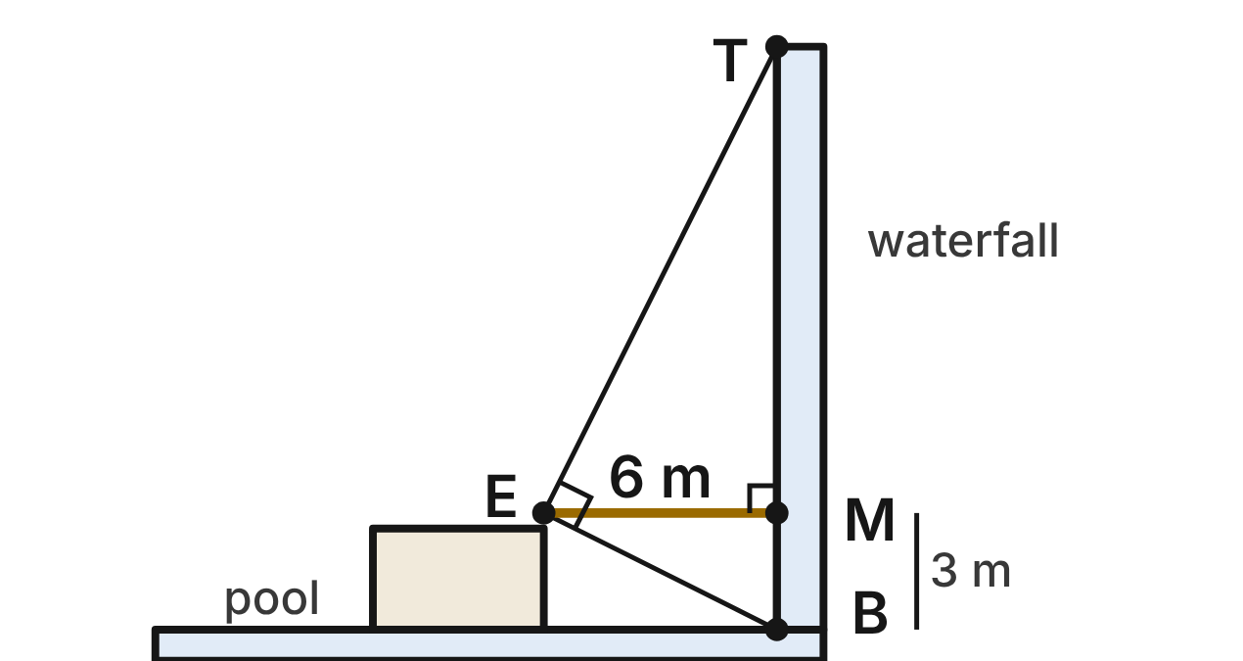
Jo stands on a rock ledge across a pool from a waterfall TB. She holds a carpenter's square at her eye E: one edge points to the top T and the other to the bottom B, so ∠TEB = 90°. Her eye is level with M on the falls, and EM ⊥ TB. EM = 6 m and MB = 3 m.
253. Which criterion shows that the two right triangles that meet at M are similar?
A. SAS∼
B. AA ✔
C. SSS∼
D. HL
G.TR.3 · skill G.TR.3.1 (LOTS): Identify the similarity criterion (AA, SSS, SAS) that the given information supports
☐ Answer key correct ☐ Wording clear Notes: ________________________________
254. Which similarity statement is correct for the upper and lower right triangles?
A. △TME ∼ △BME
B. △TEM ∼ △EMB
C. △TME ∼ △EMB ✔
D. △TME ∼ △MEB
G.TR.3 · skill G.TR.3.1 (LOTS): Identify the similarity criterion (AA, SSS, SAS) that the given information supports
☐ Answer key correct ☐ Wording clear Notes: ________________________________
255. How far is it from M up to the top T?
A. 12 m ✔
B. 18 m
C. 1.5 m
D. 6 m
G.TR.3 · skill G.TR.3.3 (LOTS): Solve problems, including contextual ones, using proportional sides of similar triangles
☐ Answer key correct ☐ Wording clear Notes: ________________________________
256. How tall is the waterfall TB?
A. 12 m
B. 9 m
C. 21 m
D. 15 m ✔
G.TR.3 · skill G.TR.3.3 (LOTS): Solve problems, including contextual ones, using proportional sides of similar triangles
☐ Answer key correct ☐ Wording clear Notes: ________________________________
257. Which statement about the two sight lines is true?
A. ET = 4 · EB
B. EB = 2 · ET
C. ET = EB + 9
D. ET = 2 · EB ✔
G.TR.3 · skill G.TR.3.3 (LOTS): Solve problems, including contextual ones, using proportional sides of similar triangles
☐ Answer key correct ☐ Wording clear Notes: ________________________________
258. At another waterfall, Jo's eye is 8 m from the falls and 4 m above the pool, with the same right angle at her eye. A guide says the falls are 20 m tall. Could that be right? Choose the answer with the correct reason.
A. No; 8/4 ≠ 16/8, so the angle is not 90°
B. Yes; 16/8 = 8/4 and 16 + 4 = 20 ✔
C. Yes; 8 · 4 = 20 − 4, so the parts fit
D. No; 20 − 4 ≠ 8 · 2, so TM is too long
G.TR.3 · skill G.TR.3.2 (HOTS): Justify that two triangles are similar, or are not, using angle measures or side ratios
☐ Answer key correct ☐ Wording clear Notes: ________________________________

The Nest Across the Gorge
Level 3 · Triangles · G.TR.3 · ID geo-tr3-worms-gorge-nest
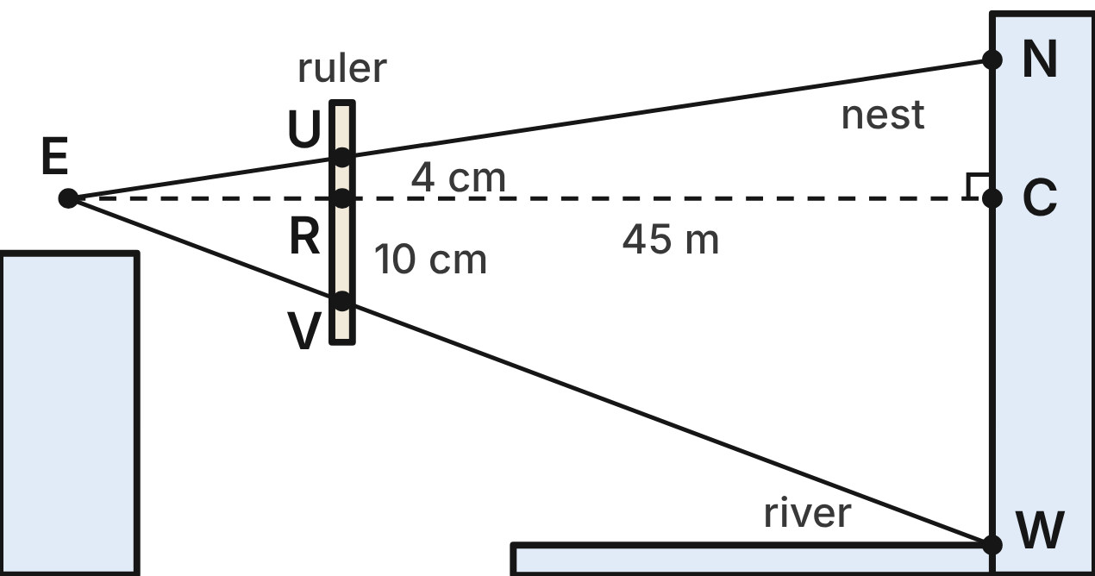
Not drawn to scale
A hiker holds a ruler upright 0.6 m from her eye E (ER = 0.6 m). A cliff across the gorge is 45 m from her eye (EC = 45 m). R and C are level with E, and the ruler and cliff are vertical. A bird's nest N lines up with U, 4 cm above R. The river W at the cliff's foot lines up with V, 10 cm below R.
259. Which criterion shows that △ERU ∼ △ECN?
A. SAS∼
B. SSS∼
C. AA ✔
D. HL
G.TR.3 · skill G.TR.3.1 (LOTS): Identify the similarity criterion (AA, SSS, SAS) that the given information supports
☐ Answer key correct ☐ Wording clear Notes: ________________________________
260. How high above her eye level is the nest (the length CN)?
A. 3 m ✔
B. 300 m
C. 1.8 m
D. 7.5 m
G.TR.3 · skill G.TR.3.3 (LOTS): Solve problems, including contextual ones, using proportional sides of similar triangles
☐ Answer key correct ☐ Wording clear Notes: ________________________________
261. How high above the river is the nest?
A. 4.5 m
B. 7.5 m
C. 6.3 m
D. 10.5 m ✔
G.TR.3 · skill G.TR.3.3 (LOTS): Solve problems, including contextual ones, using proportional sides of similar triangles
☐ Answer key correct ☐ Wording clear Notes: ________________________________
262. Which statement about the ruler and the cliff is NOT true?
A. RU ∥ CN
B. RU/RV = CW/CN ✔
C. △ERV ∼ △ECW
D. ER/EC = RU/CN
G.TR.3 · skill G.TR.3.2 (HOTS): Justify that two triangles are similar, or are not, using angle measures or side ratios
☐ Answer key correct ☐ Wording clear Notes: ________________________________
263. She walks straight back from the gorge to a spot 60 m from the cliff, on the same level ground, and holds the ruler 0.6 m from her eye again. How many centimeters above R does the nest line up now?
A. 4 cm
B. about 5.3 cm
C. 3 cm ✔
D. 2.25 cm
G.TR.3 · skill G.TR.3.3 (LOTS): Solve problems, including contextual ones, using proportional sides of similar triangles
☐ Answer key correct ☐ Wording clear Notes: ________________________________
264. What is the scale factor from the ruler's small triangle ERU to the cliff's triangle ECN?
A. 75 ✔
B. 1/75
C. 750
D. 44.4
G.TR.3 · skill G.TR.3.3 (LOTS): Solve problems, including contextual ones, using proportional sides of similar triangles
☐ Answer key correct ☐ Wording clear Notes: ________________________________

G.TR.4 · Model and solve problems, including those in context, involving trigonometry in right triangles and applications of the Pythagorean Theorem.

The Cardinal on the Branch
Level 1 · Triangles · G.TR.4 · ID geo-tr4-worms-cardinal
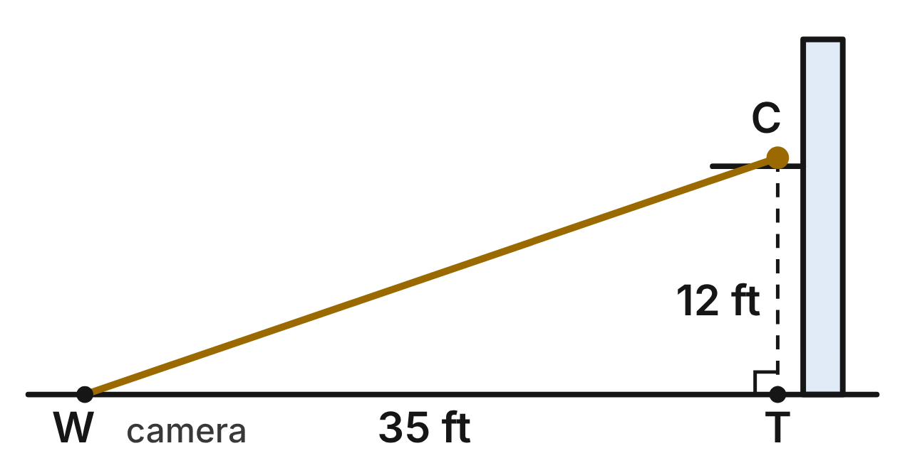
A cardinal C sits on a branch, 12 ft directly above point T on level ground. A birder's camera rests on the ground at W, 35 ft from T.
265. How far is the camera from the cardinal (the length of WC)?
A. 47 ft
B. about 32.9 ft
C. 37 ft ✔
D. 1,369 ft
G.TR.4 · skill G.TR.4.1 (LOTS): Use the Pythagorean Theorem and its converse, including to classify a triangle as right, acute or obtuse
☐ Answer key correct ☐ Wording clear Notes: ________________________________
266. Which ratio is equal to the tangent of the angle of elevation from W to C?
A. 12/35 ✔
B. 35/12
C. 12/37
D. 35/37
G.TR.4 · skill G.TR.4.3 (LOTS): Use sine, cosine and tangent ratios to find a side length or an angle measure
☐ Answer key correct ☐ Wording clear Notes: ________________________________
267. The cardinal hops to a branch 20 ft above T. To the nearest degree, what is the angle of elevation from W to the bird now?
A. 60°
B. 35°
C. 55°
D. 30° ✔
G.TR.4 · skill G.TR.4.3 (LOTS): Use sine, cosine and tangent ratios to find a side length or an angle measure
☐ Answer key correct ☐ Wording clear Notes: ________________________________
268. From C, the cardinal spots a worm on the ground at a 52° angle of depression. How far is the worm from T, to the nearest tenth of a foot?
A. 9.4 ft ✔
B. 15.4 ft
C. 7.4 ft
D. 19.5 ft
G.TR.4 · skill G.TR.4.4 (HOTS): Model a contextual problem (angles of elevation and depression, ramps, ladders, distances) with a right triangle and solve it
☐ Answer key correct ☐ Wording clear Notes: ________________________________
269. From W, the angle of elevation to a nest directly above T is 45°. How far is it from W straight to the nest? Give the exact answer.
A. 35 ft
B. 35√2 ft ✔
C. 70 ft
D. 35√3 ft
G.TR.4 · skill G.TR.4.2 (LOTS): Use the relationships in 45°-45°-90° and 30°-60°-90° triangles
☐ Answer key correct ☐ Wording clear Notes: ________________________________
270. From W, the angle of elevation to a woodpecker hole directly above T is 30°. How high is the hole above T? Give the exact answer.
A. 35√3 ft
B. 17.5 ft
C. 35√3/3 ft ✔
D. 70√3/3 ft
G.TR.4 · skill G.TR.4.2 (LOTS): Use the relationships in 45°-45°-90° and 30°-60°-90° triangles
☐ Answer key correct ☐ Wording clear Notes: ________________________________

The Pup Tent
Level 1 · Triangles · G.TR.4 · ID geo-tr4-worms-pup-tent
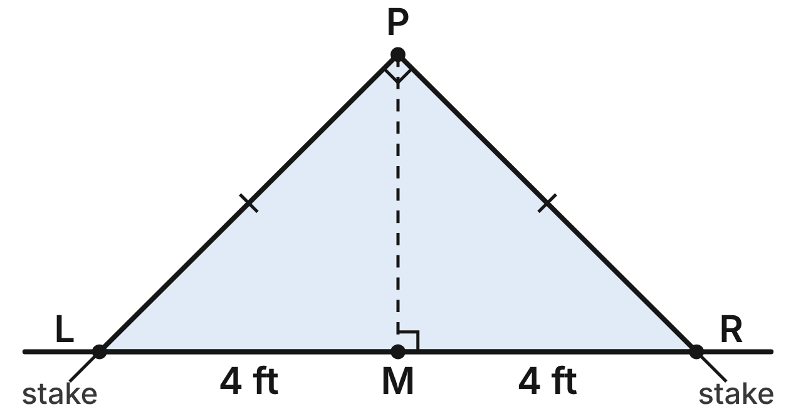
The front of a pup tent is triangle LPR. The walls PL and PR are equal and meet at a right angle at the peak P. The tent is staked at L and R, 8 ft apart on level ground, and M is the midpoint of LR.
271. How long is each wall, such as PL? Give the exact answer.
A. 8√2 ft
B. 4√2 ft ✔
C. 4 ft
D. 2√2 ft
G.TR.4 · skill G.TR.4.2 (LOTS): Use the relationships in 45°-45°-90° and 30°-60°-90° triangles
☐ Answer key correct ☐ Wording clear Notes: ________________________________
272. Which statement about the tent is NOT true?
A. m∠PLM = 45°
B. PM = LM
C. LR = PL·√2
D. PL = 2·PM ✔
G.TR.4 · skill G.TR.4.2 (LOTS): Use the relationships in 45°-45°-90° and 30°-60°-90° triangles
☐ Answer key correct ☐ Wording clear Notes: ________________________________
273. A larger tent's walls each make a 60° angle with the ground, and each wall is 7 ft long. How tall is that tent? Give the exact answer.
A. 3.5 ft
B. 7√3 ft
C. 7√3/2 ft ✔
D. 7√2/2 ft
G.TR.4 · skill G.TR.4.2 (LOTS): Use the relationships in 45°-45°-90° and 30°-60°-90° triangles
☐ Answer key correct ☐ Wording clear Notes: ________________________________
274. A lean-to tarp runs straight from the top of a 3-ft pole down to the ground and makes a 30° angle with the ground. How long is the tarp?
A. 3√3 ft
B. 6 ft ✔
C. 3√2 ft
D. 1.5 ft
G.TR.4 · skill G.TR.4.2 (LOTS): Use the relationships in 45°-45°-90° and 30°-60°-90° triangles
☐ Answer key correct ☐ Wording clear Notes: ________________________________
275. In △PLM, what is sin ∠PLM?
A. √2/2 ✔
B. √3/2
C. √2
D. 1/2
G.TR.4 · skill G.TR.4.3 (LOTS): Use sine, cosine and tangent ratios to find a side length or an angle measure
☐ Answer key correct ☐ Wording clear Notes: ________________________________
276. A dome tent's floor is a rectangle 7 ft by 9 ft. How long is its diagonal, to the nearest tenth of a foot?
A. 16.0 ft
B. 5.7 ft
C. 130 ft
D. 11.4 ft ✔
G.TR.4 · skill G.TR.4.1 (LOTS): Use the Pythagorean Theorem and its converse, including to classify a triangle as right, acute or obtuse
☐ Answer key correct ☐ Wording clear Notes: ________________________________

Across the River
Level 2 · Triangles · G.TR.4 · ID geo-tr4-worms-river-width
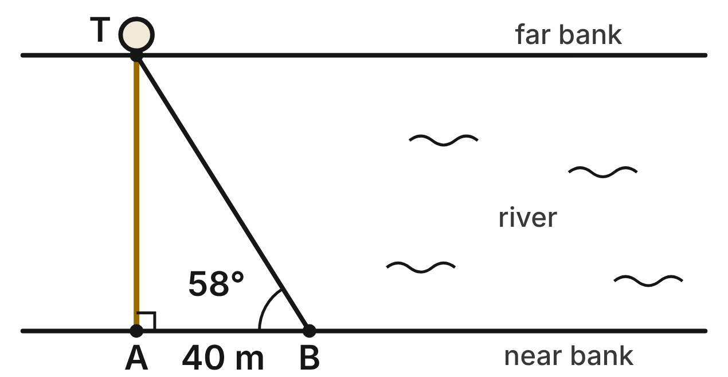
The banks of a river are parallel. A and B are on the near bank, 40 m apart. A tree T on the far bank is directly across from A, so AT is perpendicular to the banks. From B, the sight line to T makes a 58° angle with the bank (m∠ABT = 58°).
277. How wide is the river (AT), to the nearest tenth of a meter?
A. 25.0 m
B. 64.0 m ✔
C. 33.9 m
D. 21.2 m
G.TR.4 · skill G.TR.4.3 (LOTS): Use sine, cosine and tangent ratios to find a side length or an angle measure
☐ Answer key correct ☐ Wording clear Notes: ________________________________
278. Which expression gives BT?
A. 40/cos 58° ✔
B. 40·cos 58°
C. 40/sin 58°
D. 40·tan 58°
G.TR.4 · skill G.TR.4.3 (LOTS): Use sine, cosine and tangent ratios to find a side length or an angle measure
☐ Answer key correct ☐ Wording clear Notes: ________________________________
279. Upstream, the river is 50 m wide. A hiker stands on the near bank, 30 m from the point directly across from a rock on the far bank. To the nearest degree, what angle does her sight line to the rock make with the bank?
A. 31°
B. 53°
C. 59° ✔
D. 37°
G.TR.4 · skill G.TR.4.4 (HOTS): Model a contextual problem (angles of elevation and depression, ramps, ladders, distances) with a right triangle and solve it
☐ Answer key correct ☐ Wording clear Notes: ________________________________
280. At a fishing spot the river is 45 m wide. A kayaker aims straight across, but the current carries her 28 m downstream. How far does she travel in a straight line?
A. 73 m
B. about 35.2 m
C. 17 m
D. 53 m ✔
G.TR.4 · skill G.TR.4.1 (LOTS): Use the Pythagorean Theorem and its converse, including to classify a triangle as right, acute or obtuse
☐ Answer key correct ☐ Wording clear Notes: ________________________________
281. Which statement about △ABT is true?
A. tan B = AT/AB ✔
B. sin B = AT/AB
C. cos B = AB/AT
D. tan T = AT/AB
G.TR.4 · skill G.TR.4.3 (LOTS): Use sine, cosine and tangent ratios to find a side length or an angle measure
☐ Answer key correct ☐ Wording clear Notes: ________________________________
282. The team walks 40 m farther along the bank from B, to C, so AC = 80 m. To the nearest degree, what is m∠ACT?
A. 29°
B. 39° ✔
C. 51°
D. 53°
G.TR.4 · skill G.TR.4.4 (HOTS): Model a contextual problem (angles of elevation and depression, ramps, ladders, distances) with a right triangle and solve it
☐ Answer key correct ☐ Wording clear Notes: ________________________________

The Ridge Trail
Level 2 · Triangles · G.TR.4 · ID geo-tr4-worms-trail-grade
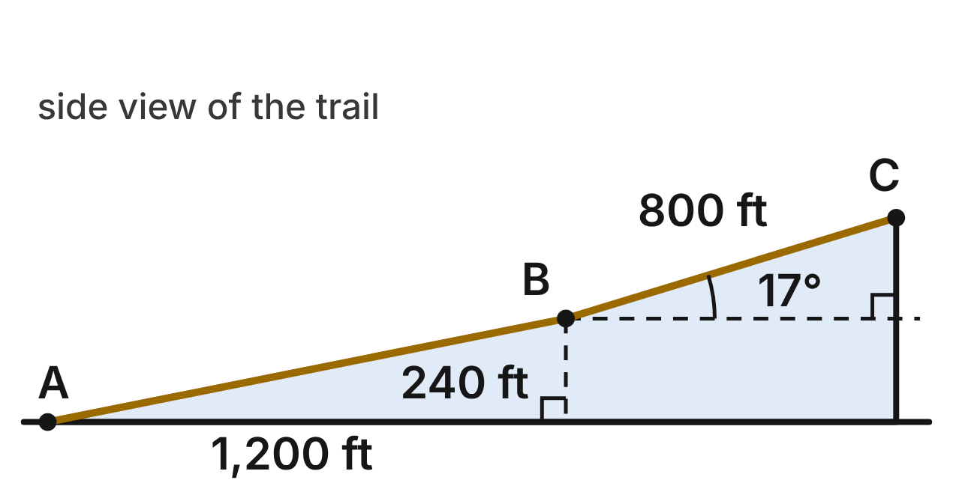
This is a side view of a trail. From the trailhead A, section AB rises 240 ft over a horizontal run of 1,200 ft. Section BC is 800 ft long, measured along the trail, and climbs at a 17° angle with the horizontal to C.
283. A trail's grade is its rise divided by its horizontal run, written as a percent. What is the grade of AB?
A. about 19.6%
B. 500%
C. 20% ✔
D. 0.2%
G.TR.4 · skill G.TR.4.4 (HOTS): Model a contextual problem (angles of elevation and depression, ramps, ladders, distances) with a right triangle and solve it
☐ Answer key correct ☐ Wording clear Notes: ________________________________
284. To the nearest degree, what angle does AB make with the horizontal?
A. 79°
B. 20°
C. 0.2°
D. 11° ✔
G.TR.4 · skill G.TR.4.3 (LOTS): Use sine, cosine and tangent ratios to find a side length or an angle measure
☐ Answer key correct ☐ Wording clear Notes: ________________________________
285. How many feet does section BC rise, to the nearest tenth of a foot?
A. 765.0 ft
B. 233.9 ft ✔
C. 244.6 ft
D. 2,736.2 ft
G.TR.4 · skill G.TR.4.3 (LOTS): Use sine, cosine and tangent ratios to find a side length or an angle measure
☐ Answer key correct ☐ Wording clear Notes: ________________________________
286. What is the total rise from A to C, to the nearest foot?
A. 234 ft
B. 1,005 ft
C. 474 ft ✔
D. 485 ft
G.TR.4 · skill G.TR.4.4 (HOTS): Model a contextual problem (angles of elevation and depression, ramps, ladders, distances) with a right triangle and solve it
☐ Answer key correct ☐ Wording clear Notes: ________________________________
287. How long is section AB, measured along the trail, to the nearest foot?
A. 1,224 ft ✔
B. 1,440 ft
C. 1,176 ft
D. 1,200 ft
G.TR.4 · skill G.TR.4.1 (LOTS): Use the Pythagorean Theorem and its converse, including to classify a triangle as right, acute or obtuse
☐ Answer key correct ☐ Wording clear Notes: ________________________________
288. A trail guide calls a section steep if its grade is more than 30%. Is BC steep? Choose the answer with the correct reason.
A. No, because its grade is sin 17° ≈ 29.2%.
B. No, because its grade is 17%, the same as its angle.
C. Yes, because its grade is cos 17° ≈ 95.6%.
D. Yes, because its grade is tan 17° ≈ 30.6%. ✔
G.TR.4 · skill G.TR.4.4 (HOTS): Model a contextual problem (angles of elevation and depression, ramps, ladders, distances) with a right triangle and solve it
☐ Answer key correct ☐ Wording clear Notes: ________________________________

Planting on the Hillside
Level 2 · Triangles · G.TR.4 · ID geo-tr4-worms-hill-slope
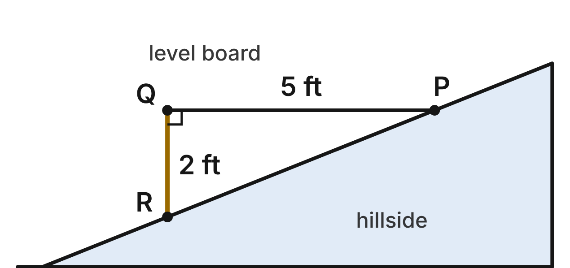
To measure a hillside's slope, a gardener holds a level board PQ, 5 ft long, out from point P on the slope. A plumb line hangs straight down from Q and touches the slope at R, 2 ft below Q.
289. To the nearest degree, what angle does the hillside make with the horizontal (m∠QPR)?
A. 22° ✔
B. 68°
C. 24°
D. 66°
G.TR.4 · skill G.TR.4.3 (LOTS): Use sine, cosine and tangent ratios to find a side length or an angle measure
☐ Answer key correct ☐ Wording clear Notes: ________________________________
290. How long is PR, measured along the slope, to the nearest tenth of a foot?
A. 7.0 ft
B. 4.6 ft
C. 5.4 ft ✔
D. 29.0 ft
G.TR.4 · skill G.TR.4.1 (LOTS): Use the Pythagorean Theorem and its converse, including to classify a triangle as right, acute or obtuse
☐ Answer key correct ☐ Wording clear Notes: ________________________________
291. On a hillside that slopes at 22°, bean rows are planted 3 ft apart, measured along the slope. How far apart are they horizontally, to the nearest tenth of a foot?
A. 1.1 ft
B. 3.2 ft
C. 7.4 ft
D. 2.8 ft ✔
G.TR.4 · skill G.TR.4.4 (HOTS): Model a contextual problem (angles of elevation and depression, ramps, ladders, distances) with a right triangle and solve it
☐ Answer key correct ☐ Wording clear Notes: ________________________________
292. A gardener builds a level terrace 6 ft wide (measured horizontally) on a 22° slope. Its uphill edge meets the slope, and a wall holds up its downhill edge. How tall is the wall, to the nearest tenth of a foot?
A. 2.2 ft
B. 5.6 ft
C. 2.4 ft ✔
D. 14.9 ft
G.TR.4 · skill G.TR.4.4 (HOTS): Model a contextual problem (angles of elevation and depression, ramps, ladders, distances) with a right triangle and solve it
☐ Answer key correct ☐ Wording clear Notes: ________________________________
293. A steep patch of the hill slopes at 30°. A path climbs 40 ft along this slope. How far does it go horizontally? Give the exact answer.
A. 20 ft
B. 20√3 ft ✔
C. 40√3 ft
D. 20√2 ft
G.TR.4 · skill G.TR.4.2 (LOTS): Use the relationships in 45°-45°-90° and 30°-60°-90° triangles
☐ Answer key correct ☐ Wording clear Notes: ________________________________
294. Mia lays out a string triangle with sides 15 ft, 20 ft and 24 ft for a garden bed. She says: "15² + 20² = 625 and 24² = 576. These are close, so the corner between the 15-ft and 20-ft sides is a right angle." Which statement is correct?
A. She is wrong: 24² is less than 15² + 20², so the corner is acute. ✔
B. She is wrong: 24² is less than 15² + 20², so the corner is obtuse.
C. She is right: a difference of 49 is small enough to call it 90°.
D. She is wrong: she should compare 15 + 20 with 24, so the corner is obtuse.
G.TR.4 · skill G.TR.4.1 (LOTS): Use the Pythagorean Theorem and its converse, including to classify a triangle as right, acute or obtuse
☐ Answer key correct ☐ Wording clear Notes: ________________________________

Measuring the Sycamore
Level 2 · Triangles · G.TR.4 · ID geo-tr4-worms-sycamore
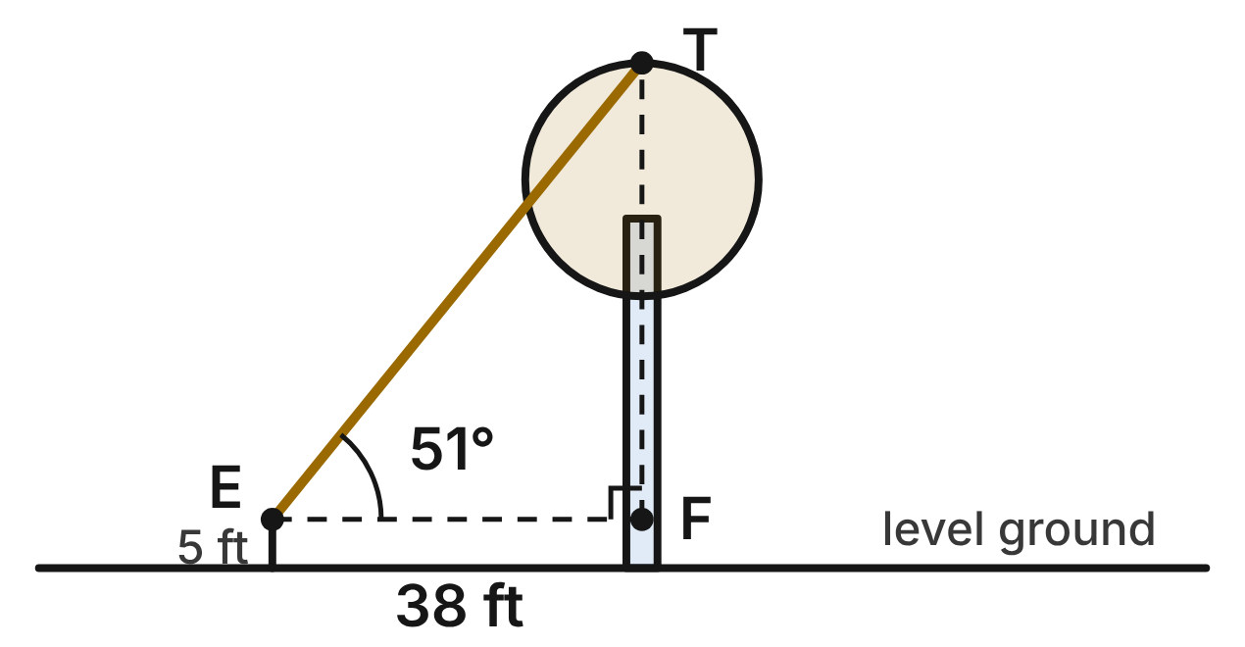
Ava's eyes E are 5 ft above level ground, 38 ft from the trunk of a sycamore. F is the point on the trunk level with her eyes, and T is the top of the tree, directly above F. The angle of elevation from E to T is 51°.
295. How tall is the tree, to the nearest tenth of a foot?
A. 46.9 ft
B. 34.5 ft
C. 35.8 ft
D. 51.9 ft ✔
G.TR.4 · skill G.TR.4.4 (HOTS): Model a contextual problem (angles of elevation and depression, ramps, ladders, distances) with a right triangle and solve it
☐ Answer key correct ☐ Wording clear Notes: ________________________________
296. Which equation can be used to find FT?
A. sin 51° = FT/38
B. tan 51° = FT/38 ✔
C. tan 51° = 38/FT
D. cos 51° = FT/38
G.TR.4 · skill G.TR.4.3 (LOTS): Use sine, cosine and tangent ratios to find a side length or an angle measure
☐ Answer key correct ☐ Wording clear Notes: ________________________________
297. Foresters use a trick: stand where the angle of elevation to the treetop is 45°. Then the tree's height above eye level equals the distance to the trunk. Why does this work?
A. The hypotenuse of a 45°-45°-90° triangle is twice each leg.
B. Because sin 45° = 1, the height equals the sight line.
C. The two legs of a 45°-45°-90° triangle are equal. ✔
D. Every right triangle has two equal legs.
G.TR.4 · skill G.TR.4.2 (LOTS): Use the relationships in 45°-45°-90° and 30°-60°-90° triangles
☐ Answer key correct ☐ Wording clear Notes: ________________________________
298. For a white pine, the angle of elevation from Ava's eyes to the top is 30°, and she stands 45 ft from the trunk. How far above her eyes is the top? Give the exact answer.
A. 15√3 ft ✔
B. 45√3 ft
C. 22.5 ft
D. 45√3/2 ft
G.TR.4 · skill G.TR.4.2 (LOTS): Use the relationships in 45°-45°-90° and 30°-60°-90° triangles
☐ Answer key correct ☐ Wording clear Notes: ________________________________
299. How long is the line of sight ET, to the nearest tenth of a foot?
A. 48.9 ft
B. 23.9 ft
C. 46.9 ft
D. 60.4 ft ✔
G.TR.4 · skill G.TR.4.3 (LOTS): Use sine, cosine and tangent ratios to find a side length or an angle measure
☐ Answer key correct ☐ Wording clear Notes: ________________________________
300. Ava steps back so she is 60 ft from the trunk, with her eyes still 5 ft up. To the nearest degree, what is the angle of elevation to T now?
A. 32°
B. 38° ✔
C. 52°
D. 41°
G.TR.4 · skill G.TR.4.4 (HOTS): Model a contextual problem (angles of elevation and depression, ramps, ladders, distances) with a right triangle and solve it
☐ Answer key correct ☐ Wording clear Notes: ________________________________

The Waterfall from the Lookout
Level 3 · Triangles · G.TR.4 · ID geo-tr4-worms-waterfall
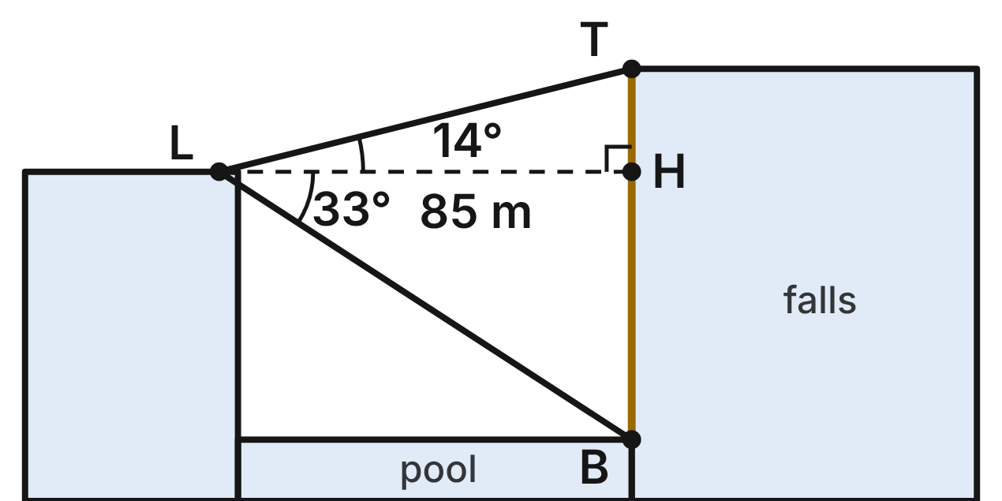
A lookout L on a cliff faces a waterfall 85 m away, measured horizontally. H is the point on the falls level with L. From L, the angle of elevation to the top of the falls, T, is 14°, and the angle of depression to its base, B, at the pool is 33°. TB is vertical.
301. How high is the lookout above the pool (HB), to the nearest tenth of a meter?
A. 55.2 m ✔
B. 46.3 m
C. 130.9 m
D. 71.3 m
G.TR.4 · skill G.TR.4.3 (LOTS): Use sine, cosine and tangent ratios to find a side length or an angle measure
☐ Answer key correct ☐ Wording clear Notes: ________________________________
302. Which equation gives TH?
A. TH = 85·sin 14°
B. TH = 85/tan 14°
C. TH = 85·cos 14°
D. TH = 85·tan 14° ✔
G.TR.4 · skill G.TR.4.3 (LOTS): Use sine, cosine and tangent ratios to find a side length or an angle measure
☐ Answer key correct ☐ Wording clear Notes: ________________________________
303. How tall is the waterfall (TB), to the nearest tenth of a meter?
A. 91.2 m
B. 76.4 m ✔
C. 34.0 m
D. 55.2 m
G.TR.4 · skill G.TR.4.4 (HOTS): Model a contextual problem (angles of elevation and depression, ramps, ladders, distances) with a right triangle and solve it
☐ Answer key correct ☐ Wording clear Notes: ________________________________
304. Which statement about the angle of elevation from B up to L is true?
A. It is 57°, because it is the complement of the 33° angle at L.
B. It is 14°, because it matches the angle above the level line through L.
C. It is 47°, because it is the sum of the two angles marked at L.
D. It is 33°, because the level line through L is parallel to the pool. ✔
G.TR.4 · skill G.TR.4.4 (HOTS): Model a contextual problem (angles of elevation and depression, ramps, ladders, distances) with a right triangle and solve it
☐ Answer key correct ☐ Wording clear Notes: ________________________________
305. How long is the sight line from L to the top of the falls, to the nearest tenth of a meter?
A. 82.5 m
B. 351.4 m
C. 87.6 m ✔
D. 106.2 m
G.TR.4 · skill G.TR.4.4 (HOTS): Model a contextual problem (angles of elevation and depression, ramps, ladders, distances) with a right triangle and solve it
☐ Answer key correct ☐ Wording clear Notes: ________________________________
306. Downstream, a smaller waterfall is seen from a ledge level with its top, 30 m away horizontally. The angle of depression from the ledge to the base of these falls is 60°. How tall are they? Give the exact answer.
A. 30√3 m ✔
B. 10√3 m
C. 60 m
D. 15√3 m
G.TR.4 · skill G.TR.4.2 (LOTS): Use the relationships in 45°-45°-90° and 30°-60°-90° triangles
☐ Answer key correct ☐ Wording clear Notes: ________________________________

Fishing from the Dock
Level 3 · Triangles · G.TR.4 · ID geo-tr4-worms-fishing-rod
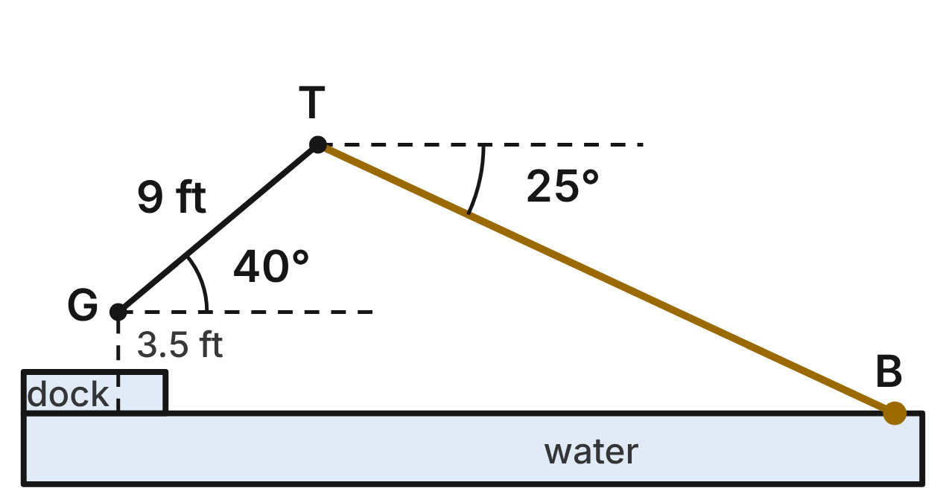
An angler on a dock holds a 9-ft fishing rod at its grip G, 3.5 ft above the water. The rod GT makes a 40° angle with the horizontal. The line runs straight from the tip T to the bobber B on the water, at a 25° angle of depression from T.
307. How far above G is the tip T, to the nearest tenth of a foot?
A. 6.9 ft
B. 5.8 ft ✔
C. 7.6 ft
D. 14.0 ft
G.TR.4 · skill G.TR.4.3 (LOTS): Use sine, cosine and tangent ratios to find a side length or an angle measure
☐ Answer key correct ☐ Wording clear Notes: ________________________________
308. How high above the water is the tip T, to the nearest tenth of a foot?
A. 5.8 ft
B. 10.4 ft
C. 9.3 ft ✔
D. 2.3 ft
G.TR.4 · skill G.TR.4.4 (HOTS): Model a contextual problem (angles of elevation and depression, ramps, ladders, distances) with a right triangle and solve it
☐ Answer key correct ☐ Wording clear Notes: ________________________________
309. How long is the fishing line from T to the bobber, to the nearest tenth of a foot?
A. 22.0 ft ✔
B. 13.7 ft
C. 10.2 ft
D. 19.9 ft
G.TR.4 · skill G.TR.4.4 (HOTS): Model a contextual problem (angles of elevation and depression, ramps, ladders, distances) with a right triangle and solve it
☐ Answer key correct ☐ Wording clear Notes: ________________________________
310. How far is the bobber from G, measured horizontally, to the nearest tenth of a foot?
A. 19.9 ft
B. 26.8 ft ✔
C. 28.9 ft
D. 25.7 ft
G.TR.4 · skill G.TR.4.4 (HOTS): Model a contextual problem (angles of elevation and depression, ramps, ladders, distances) with a right triangle and solve it
☐ Answer key correct ☐ Wording clear Notes: ________________________________
311. If the angler raises the 9-ft rod to a 60° angle with the horizontal, how far above G is the tip? Give the exact answer.
A. 4.5 ft
B. 9√3 ft
C. 9√2/2 ft
D. 9√3/2 ft ✔
G.TR.4 · skill G.TR.4.2 (LOTS): Use the relationships in 45°-45°-90° and 30°-60°-90° triangles
☐ Answer key correct ☐ Wording clear Notes: ________________________________
312. Three dock posts are joined by ropes 7 ft, 10 ft and 13 ft long, forming a triangle. Which describes the triangle? Choose the answer with the correct reason.
A. Acute, because 13² is less than 7² + 10².
B. Right, because 7² + 10² = 13².
C. Obtuse, because 13² is greater than 7² + 10². ✔
D. It is not a triangle, because 7 + 10 is less than 13.
G.TR.4 · skill G.TR.4.1 (LOTS): Use the Pythagorean Theorem and its converse, including to classify a triangle as right, acute or obtuse
☐ Answer key correct ☐ Wording clear Notes: ________________________________

Polygons and circles (G.PC)

G.PC.1 · Prove and justify theorems and properties of quadrilaterals, and verify and use properties of quadrilaterals to solve problems, including the relationships between the sides, angles, and diagonals.

The Beehive Frame
Level 1 · Quadrilaterals · G.PC.1 · ID geo-pc1-worms-beehive-frame
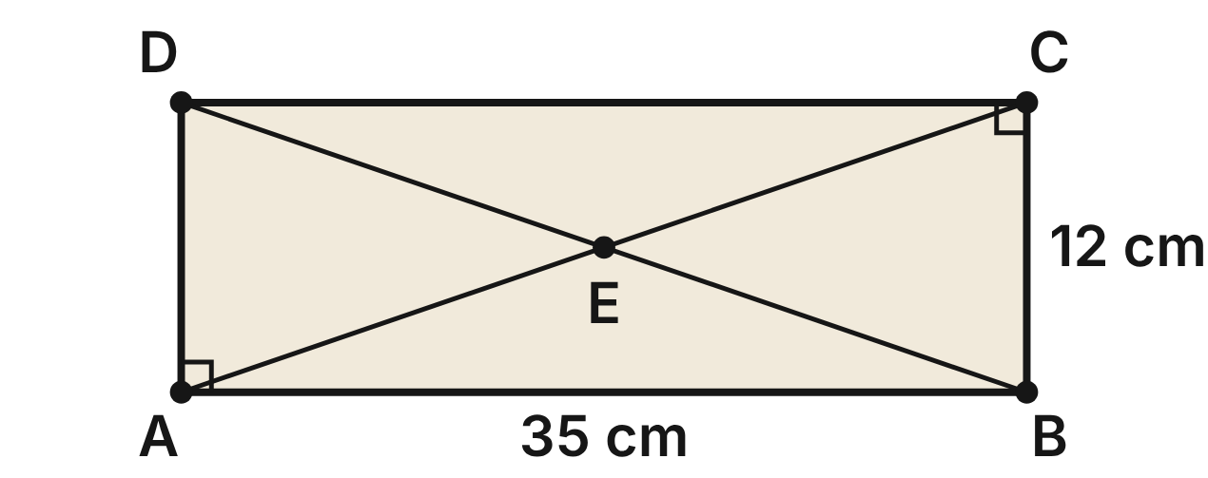
A beehive frame ABCD is a rectangle 35 cm long and 12 cm tall. Two support wires run along its diagonals AC and BD and cross at E.
313. How long is wire AC?
A. 47 cm
B. about 32.9 cm
C. 37 cm ✔
D. 23 cm
G.PC.1 · skill G.PC.1.3 (LOTS): Solve problems, including algebraic ones, using the properties of quadrilaterals
☐ Answer key correct ☐ Wording clear Notes: ________________________________
314. How far is the crossing point E from corner B?
A. 37 cm
B. 17.5 cm
C. 6 cm
D. 18.5 cm ✔
G.PC.1 · skill G.PC.1.3 (LOTS): Solve problems, including algebraic ones, using the properties of quadrilaterals
☐ Answer key correct ☐ Wording clear Notes: ________________________________
315. Which angle must be congruent to ∠EAB?
A. ∠EBC
B. ∠EBA ✔
C. ∠AEB
D. ∠EAD
G.PC.1 · skill G.PC.1.1 (LOTS): Identify the properties of parallelograms, rectangles, rhombi, squares, trapezoids and kites (sides, angles, diagonals)
☐ Answer key correct ☐ Wording clear Notes: ________________________________
316. Which statement is true for every rectangle but NOT for every parallelogram?
A. Its diagonals are congruent. ✔
B. Its diagonals are perpendicular.
C. Its opposite sides are congruent.
D. Its diagonals bisect each other.
G.PC.1 · skill G.PC.1.1 (LOTS): Identify the properties of parallelograms, rectangles, rhombi, squares, trapezoids and kites (sides, angles, diagonals)
☐ Answer key correct ☐ Wording clear Notes: ________________________________
317. A second frame is a parallelogram whose diagonals are (3x + 7) cm and (5x − 9) cm. The beekeeper finds that they are equal. How long is each diagonal?
A. 8 cm
B. 62 cm
C. 31 cm ✔
D. 15.5 cm
G.PC.1 · skill G.PC.1.3 (LOTS): Solve problems, including algebraic ones, using the properties of quadrilaterals
☐ Answer key correct ☐ Wording clear Notes: ________________________________
318. Which statement is NOT true for frame ABCD?
A. AE = DE
B. ∠ABC and ∠BCD are supplementary.
C. AD ∥ BC
D. AC bisects ∠DAB. ✔
G.PC.1 · skill G.PC.1.1 (LOTS): Identify the properties of parallelograms, rectangles, rhombi, squares, trapezoids and kites (sides, angles, diagonals)
☐ Answer key correct ☐ Wording clear Notes: ________________________________

The Diamond Lawn
Level 1 · Quadrilaterals · G.PC.1 · ID geo-pc1-worms-park-lawn
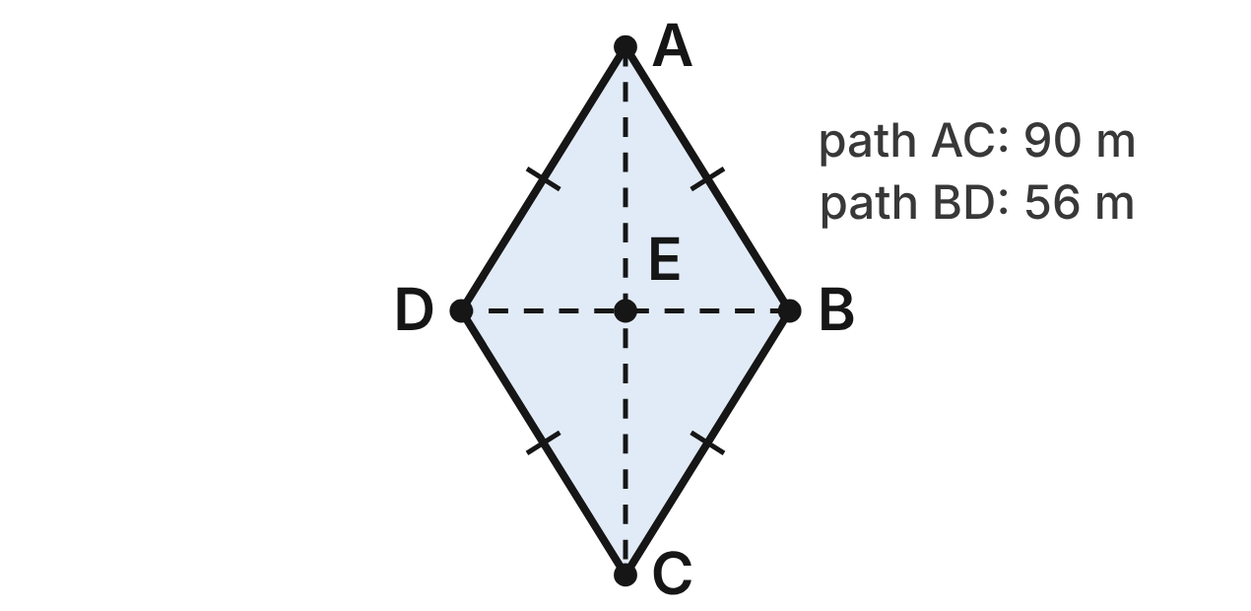
A park lawn is rhombus ABCD. Two straight paths run along its diagonals: AC = 90 m and BD = 56 m. They cross at E.
319. How long is each edge of the lawn?
A. 73 m
B. 53 m ✔
C. 106 m
D. about 35.2 m
G.PC.1 · skill G.PC.1.3 (LOTS): Solve problems, including algebraic ones, using the properties of quadrilaterals
☐ Answer key correct ☐ Wording clear Notes: ________________________________
320. Which angle of the lawn must be congruent to ∠BAE?
A. ∠BCE ✔
B. ∠ABE
C. ∠AEB
D. ∠ADB
G.PC.1 · skill G.PC.1.1 (LOTS): Identify the properties of parallelograms, rectangles, rhombi, squares, trapezoids and kites (sides, angles, diagonals)
☐ Answer key correct ☐ Wording clear Notes: ________________________________
321. A low fence will run around the whole edge of the lawn. How long is the fence?
A. 106 m
B. 146 m
C. 292 m
D. 212 m ✔
G.PC.1 · skill G.PC.1.3 (LOTS): Solve problems, including algebraic ones, using the properties of quadrilaterals
☐ Answer key correct ☐ Wording clear Notes: ________________________________
322. Another lawn is rhombus PQRS with m∠PQR = (3x + 20)° and m∠QRS = (5x − 8)°. What is m∠QRS?
A. 62°
B. 97° ✔
C. 83°
D. 21°
G.PC.1 · skill G.PC.1.3 (LOTS): Solve problems, including algebraic ones, using the properties of quadrilaterals
☐ Answer key correct ☐ Wording clear Notes: ________________________________
323. A worker says the lawn is also a parallelogram. Is she right? Choose the answer with the correct reason.
A. Yes: both pairs of opposite sides are parallel. ✔
B. Yes: its diagonals are congruent.
C. No: a parallelogram needs a right angle.
D. No: its sides are not all congruent.
G.PC.1 · skill G.PC.1.1 (LOTS): Identify the properties of parallelograms, rectangles, rhombi, squares, trapezoids and kites (sides, angles, diagonals)
☐ Answer key correct ☐ Wording clear Notes: ________________________________
324. A second lawn is a parallelogram. Which single fact proves it is a square?
A. Its diagonals are perpendicular.
B. Its diagonals bisect each other.
C. Its diagonals are congruent and perpendicular. ✔
D. Its four sides are congruent.
G.PC.1 · skill G.PC.1.1 (LOTS): Identify the properties of parallelograms, rectangles, rhombi, squares, trapezoids and kites (sides, angles, diagonals)
☐ Answer key correct ☐ Wording clear Notes: ________________________________

The Cabin Tent
Level 2 · Quadrilaterals · G.PC.1 · ID geo-pc1-worms-cabin-tent
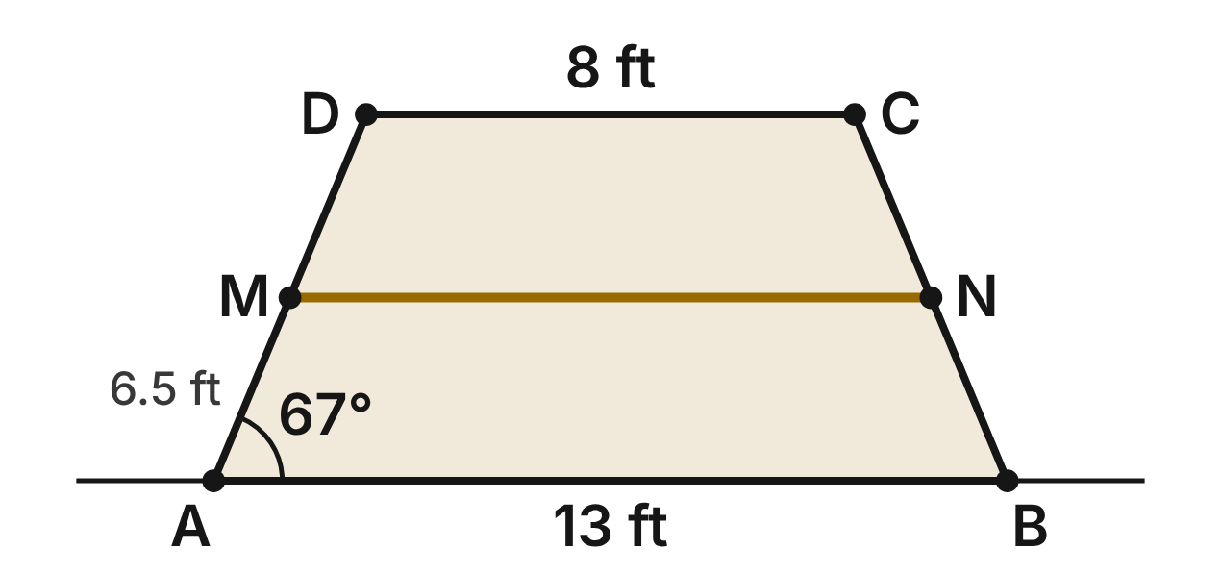
The end wall of a cabin tent is isosceles trapezoid ABCD with AB ∥ DC, AB = 13 ft, DC = 8 ft and poles AD = BC = 6.5 ft. A gear line MN joins the midpoints of the poles. m∠DAB ≈ 67°.
325. How tall is the tent (the distance between DC and AB)?
A. about 7.0 ft
B. 6 ft ✔
C. 5 ft
D. about 4.2 ft
G.PC.1 · skill G.PC.1.3 (LOTS): Solve problems, including algebraic ones, using the properties of quadrilaterals
☐ Answer key correct ☐ Wording clear Notes: ________________________________
326. How long is the gear line MN?
A. 21 ft
B. 5 ft
C. 2.5 ft
D. 10.5 ft ✔
G.PC.1 · skill G.PC.1.3 (LOTS): Solve problems, including algebraic ones, using the properties of quadrilaterals
☐ Answer key correct ☐ Wording clear Notes: ________________________________
327. To the nearest degree, what is m∠ADC?
A. 67°
B. 23°
C. 113° ✔
D. 157°
G.PC.1 · skill G.PC.1.1 (LOTS): Identify the properties of parallelograms, rectangles, rhombi, squares, trapezoids and kites (sides, angles, diagonals)
☐ Answer key correct ☐ Wording clear Notes: ________________________________
328. Which segment must be congruent to diagonal AC?
A. AB
B. AD
C. MN
D. BD ✔
G.PC.1 · skill G.PC.1.1 (LOTS): Identify the properties of parallelograms, rectangles, rhombi, squares, trapezoids and kites (sides, angles, diagonals)
☐ Answer key correct ☐ Wording clear Notes: ________________________________
329. Another tent wall is a trapezoid with bases (y + 4) ft and (3y − 2) ft. The segment joining the midpoints of its legs is 13 ft. How long is the longer base?
A. 10 ft
B. 6 ft
C. 16 ft ✔
D. 6.25 ft
G.PC.1 · skill G.PC.1.3 (LOTS): Solve problems, including algebraic ones, using the properties of quadrilaterals
☐ Answer key correct ☐ Wording clear Notes: ________________________________
330. Which statement is true of tent wall ABCD but NOT of every trapezoid?
A. Its diagonals are congruent. ✔
B. It has a pair of parallel sides.
C. Its diagonals bisect each other.
D. Its angles add up to 360°.
G.PC.1 · skill G.PC.1.1 (LOTS): Identify the properties of parallelograms, rectangles, rhombi, squares, trapezoids and kites (sides, angles, diagonals)
☐ Answer key correct ☐ Wording clear Notes: ________________________________

The Farm Field Map
Level 2 · Quadrilaterals · G.PC.1 · ID geo-pc1-worms-farm-field
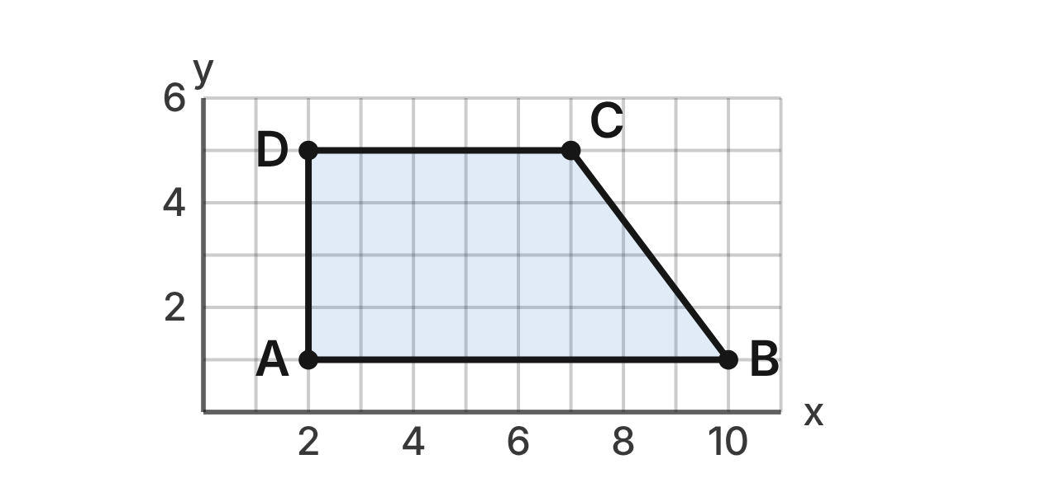
On a farm map, field ABCD has corners A(2, 1), B(10, 1), C(7, 5) and D(2, 5). Each grid unit is 10 m. A fence MN will join the midpoints of AD and BC.
331. What is the slope of the slanted side BC?
A. −3/4
B. 4/3
C. −4/3 ✔
D. 3/4
G.PC.1 · skill G.PC.1.2 (HOTS): Use coordinate methods (slope, distance, midpoint) to classify a quadrilateral or justify a property
☐ Answer key correct ☐ Wording clear Notes: ________________________________
332. Which fact shows that ∠DAB is a right angle?
A. AB is horizontal and AD is vertical. ✔
B. AB and DC are both horizontal.
C. AD and BC are the same length.
D. Diagonals AC and BD are perpendicular.
G.PC.1 · skill G.PC.1.2 (HOTS): Use coordinate methods (slope, distance, midpoint) to classify a quadrilateral or justify a property
☐ Answer key correct ☐ Wording clear Notes: ________________________________
333. How long is side BC, in grid units?
A. 5 units ✔
B. 7 units
C. √7 units
D. 25 units
G.PC.1 · skill G.PC.1.2 (HOTS): Use coordinate methods (slope, distance, midpoint) to classify a quadrilateral or justify a property
☐ Answer key correct ☐ Wording clear Notes: ________________________________
334. N is the midpoint of BC. What are the coordinates of N?
A. (17, 6)
B. (8.5, 3) ✔
C. (−1.5, 2)
D. (−3, 4)
G.PC.1 · skill G.PC.1.2 (HOTS): Use coordinate methods (slope, distance, midpoint) to classify a quadrilateral or justify a property
☐ Answer key correct ☐ Wording clear Notes: ________________________________
335. How long will fence MN be, in meters?
A. 130 m
B. 6.5 m
C. 30 m
D. 65 m ✔
G.PC.1 · skill G.PC.1.3 (LOTS): Solve problems, including algebraic ones, using the properties of quadrilaterals
☐ Answer key correct ☐ Wording clear Notes: ________________________________
336. A farmer says field ABCD is an isosceles trapezoid. Which result shows that he is wrong?
A. AB = 8 units but DC = 5 units.
B. AD = 4 units but BC = 5 units. ✔
C. AB and DC both have slope 0.
D. AC and BD bisect each other.
G.PC.1 · skill G.PC.1.2 (HOTS): Use coordinate methods (slope, distance, midpoint) to classify a quadrilateral or justify a property
☐ Answer key correct ☐ Wording clear Notes: ________________________________

The Sagging Garden Gate
Level 2 · Quadrilaterals · G.PC.1 · ID geo-pc1-worms-garden-gate
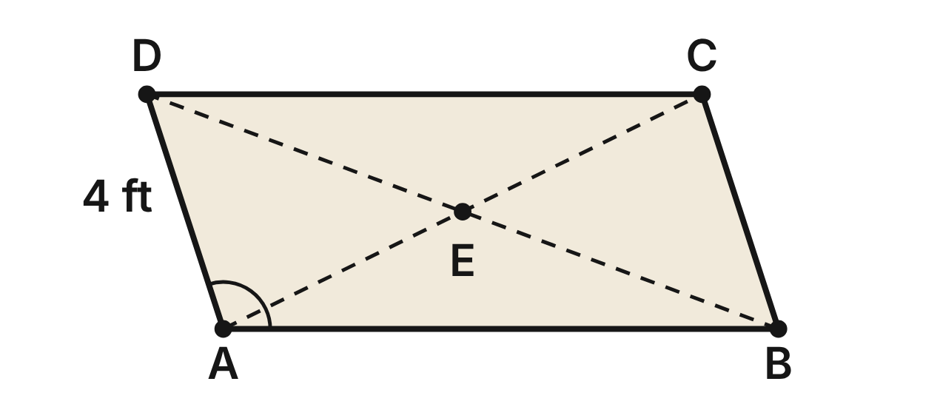
A garden gate has sagged into parallelogram ABCD. AD = 4 ft, AB = (2y + 3) ft and DC = (5y − 6) ft. m∠DAB = (4x − 4)° and m∠ABC = (2x + 16)°. Braces AC and BD meet at E.
337. What is m∠DAB?
A. 36°
B. 72°
C. 28°
D. 108° ✔
G.PC.1 · skill G.PC.1.3 (LOTS): Solve problems, including algebraic ones, using the properties of quadrilaterals
☐ Answer key correct ☐ Wording clear Notes: ________________________________
338. How long is the edge of the gate all the way around (its perimeter)?
A. 13 ft
B. 22 ft
C. 18 ft
D. 26 ft ✔
G.PC.1 · skill G.PC.1.3 (LOTS): Solve problems, including algebraic ones, using the properties of quadrilaterals
☐ Answer key correct ☐ Wording clear Notes: ________________________________
339. Which statement about the braces must be true?
A. AE = EC ✔
B. AC = BD
C. AE = BE
D. AC ⊥ BD
G.PC.1 · skill G.PC.1.1 (LOTS): Identify the properties of parallelograms, rectangles, rhombi, squares, trapezoids and kites (sides, angles, diagonals)
☐ Answer key correct ☐ Wording clear Notes: ________________________________
340. The gardener fixes the gate. It is still a parallelogram. Which single fact proves it is now a rectangle?
A. ∠DAB ≅ ∠BCD
B. AB ∥ DC
C. ∠DAB ≅ ∠ABC ✔
D. AC ⊥ BD
G.PC.1 · skill G.PC.1.1 (LOTS): Identify the properties of parallelograms, rectangles, rhombi, squares, trapezoids and kites (sides, angles, diagonals)
☐ Answer key correct ☐ Wording clear Notes: ________________________________
341. Which statement is NOT true for gate ABCD?
A. ∠ABC and ∠BCD are supplementary.
B. ∠DAB and ∠BCD are supplementary. ✔
C. AD = BC
D. BE = ED
G.PC.1 · skill G.PC.1.1 (LOTS): Identify the properties of parallelograms, rectangles, rhombi, squares, trapezoids and kites (sides, angles, diagonals)
☐ Answer key correct ☐ Wording clear Notes: ________________________________
342. Which pair of angles must be congruent because DC ∥ AB?
A. ∠CDB and ∠CBD
B. ∠DAB and ∠ADC
C. ∠CDB and ∠ABD ✔
D. ∠ADB and ∠ABD
G.PC.1 · skill G.PC.1.1 (LOTS): Identify the properties of parallelograms, rectangles, rhombi, squares, trapezoids and kites (sides, angles, diagonals)
☐ Answer key correct ☐ Wording clear Notes: ________________________________

The Kite-Shaped Pond
Level 3 · Quadrilaterals · G.PC.1 · ID geo-pc1-worms-pond-kite
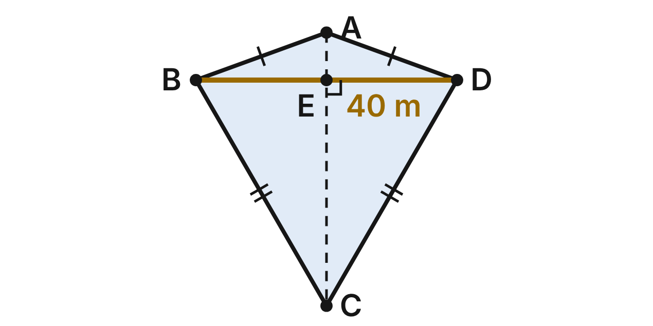
A pond is shaped like kite ABCD with AB = AD and CB = CD. A footbridge BD, 40 m long, crosses the path AC at E. m∠BAD = 140°, m∠ABC = (4x)° and m∠ADC = (3x + 20)°.
343. What is m∠ABC?
A. 80° ✔
B. 20°
C. 40°
D. 140°
G.PC.1 · skill G.PC.1.3 (LOTS): Solve problems, including algebraic ones, using the properties of quadrilaterals
☐ Answer key correct ☐ Wording clear Notes: ________________________________
344. What is m∠BCD?
A. 60° ✔
B. 140°
C. 100°
D. 30°
G.PC.1 · skill G.PC.1.3 (LOTS): Solve problems, including algebraic ones, using the properties of quadrilaterals
☐ Answer key correct ☐ Wording clear Notes: ________________________________
345. Path AC bisects which angles of the pond?
A. ∠ABC and ∠ADC
B. all four angles
C. ∠BAD and ∠BCD ✔
D. none of the angles
G.PC.1 · skill G.PC.1.1 (LOTS): Identify the properties of parallelograms, rectangles, rhombi, squares, trapezoids and kites (sides, angles, diagonals)
☐ Answer key correct ☐ Wording clear Notes: ________________________________
346. How long is side CB of the pond?
A. 20 m
B. 40 m ✔
C. 20√3 m
D. 80 m
G.PC.1 · skill G.PC.1.3 (LOTS): Solve problems, including algebraic ones, using the properties of quadrilaterals
☐ Answer key correct ☐ Wording clear Notes: ________________________________
347. To the nearest tenth of a meter, how far is it from C to the bridge at E?
A. 11.5 m
B. 34.6 m ✔
C. 17.3 m
D. 44.7 m
G.PC.1 · skill G.PC.1.3 (LOTS): Solve problems, including algebraic ones, using the properties of quadrilaterals
☐ Answer key correct ☐ Wording clear Notes: ________________________________
348. Ben says AE = EC, because the diagonals of a kite are perpendicular. Which statement explains his error?
A. The diagonals of a kite are not perpendicular.
B. AC is bisected, but BD is not bisected.
C. AE = EC only when a kite has a right angle.
D. Only BD is bisected; AC is not cut in half. ✔
G.PC.1 · skill G.PC.1.1 (LOTS): Identify the properties of parallelograms, rectangles, rhombi, squares, trapezoids and kites (sides, angles, diagonals)
☐ Answer key correct ☐ Wording clear Notes: ________________________________

The Orchard Plot
Level 3 · Quadrilaterals · G.PC.1 · ID geo-pc1-worms-orchard-plot
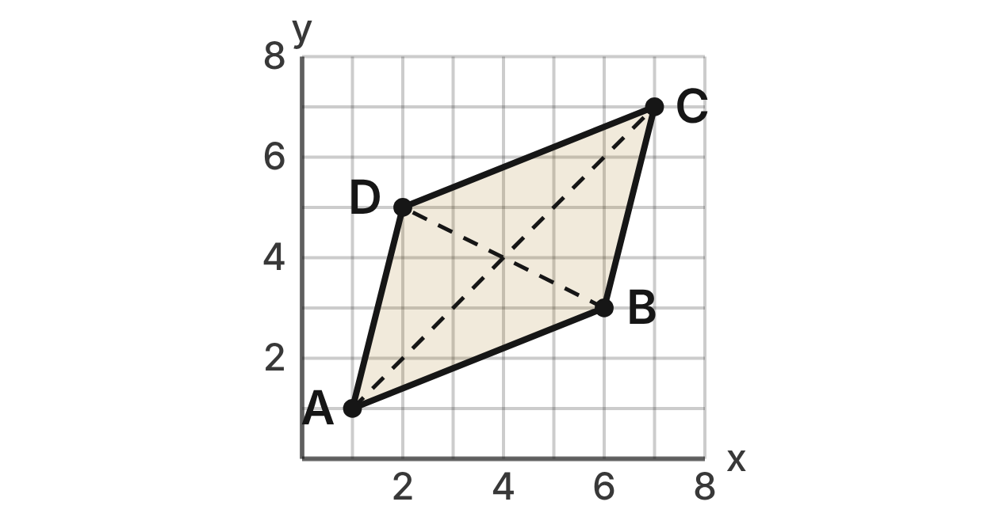
Four apple trees mark the corners of orchard plot ABCD: A(1, 1), B(6, 3), C(7, 7) and D(2, 5). Each grid unit is 10 m.
349. Which result, by itself, proves that ABCD is a parallelogram?
A. AB ∥ DC, since both slopes are 2/5
B. AB = AD and CB = CD
C. AC ⊥ BD, since the slopes multiply to −1
D. AB ∥ DC (slope 2/5) and AD ∥ BC (slope 4) ✔
G.PC.1 · skill G.PC.1.2 (HOTS): Use coordinate methods (slope, distance, midpoint) to classify a quadrilateral or justify a property
☐ Answer key correct ☐ Wording clear Notes: ________________________________
350. What are the coordinates of the midpoint of diagonal AC?
A. (3, 3)
B. (8, 8)
C. (6, 6)
D. (4, 4) ✔
G.PC.1 · skill G.PC.1.2 (HOTS): Use coordinate methods (slope, distance, midpoint) to classify a quadrilateral or justify a property
☐ Answer key correct ☐ Wording clear Notes: ________________________________
351. How long is diagonal BD, in grid units?
A. 6 units
B. 2√5 units ✔
C. 20 units
D. 8√2 units
G.PC.1 · skill G.PC.1.2 (HOTS): Use coordinate methods (slope, distance, midpoint) to classify a quadrilateral or justify a property
☐ Answer key correct ☐ Wording clear Notes: ________________________________
352. Is ABCD a rectangle? Choose the answer with the correct reason.
A. No: AB is not parallel to DC.
B. Yes: slope AB · slope BC = −1.
C. No: AC = 6√2 but BD = 2√5. ✔
D. Yes: AC and BD are both 6√2.
G.PC.1 · skill G.PC.1.2 (HOTS): Use coordinate methods (slope, distance, midpoint) to classify a quadrilateral or justify a property
☐ Answer key correct ☐ Wording clear Notes: ________________________________
353. To the nearest meter, how long is a fence that runs once around the plot?
A. 190 m ✔
B. 95 m
C. 19 m
D. 240 m
G.PC.1 · skill G.PC.1.3 (LOTS): Solve problems, including algebraic ones, using the properties of quadrilaterals
☐ Answer key correct ☐ Wording clear Notes: ________________________________
354. A second plot has corners A(1, 1), B(6, 3) and C(4, 8), and ∠ABC is a right angle. Where must corner D go so that ABCD is a rectangle?
A. (9, 10)
B. (3, −4)
C. (−1, 6) ✔
D. (1, 6)
G.PC.1 · skill G.PC.1.2 (HOTS): Use coordinate methods (slope, distance, midpoint) to classify a quadrilateral or justify a property
☐ Answer key correct ☐ Wording clear Notes: ________________________________

G.PC.2 · Verify relationships and solve problems involving the number of sides and measures of angles of convex polygons.

The Sun Star
Level 1 · Polygons · G.PC.2 · ID geo-pc2-worms-sun-star
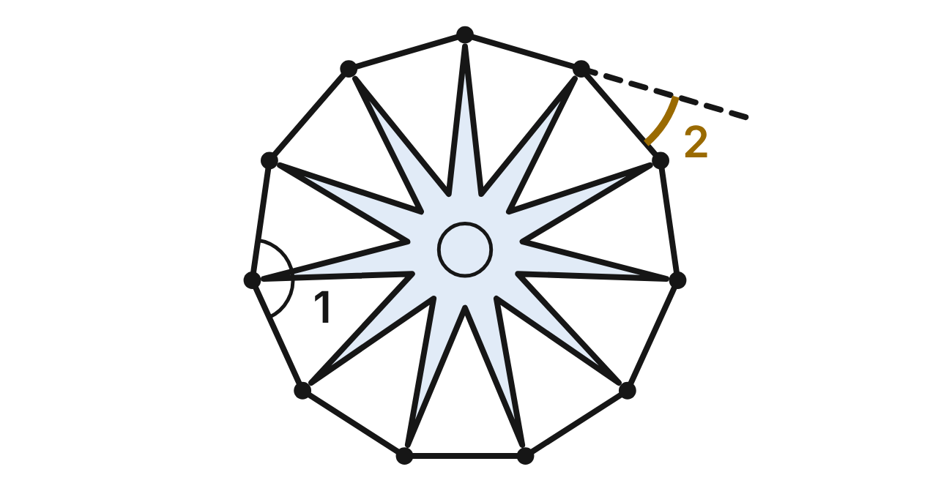
A sun star (a kind of sea star) has 11 arms of equal length, evenly spaced. Segments join the tips of neighboring arms to form a regular 11-gon. ∠1 is an interior angle of the 11-gon. One side is extended (dashed), and ∠2 is the exterior angle it makes.
355. What is the sum of the interior angles of the 11-gon around the sun star?
A. 1620° ✔
B. 1980°
C. 1800°
D. 360°
G.PC.2 · skill G.PC.2.1 (LOTS): Find the sum of the interior angles, and the measure of each interior and exterior angle, of a convex or regular polygon
☐ Answer key correct ☐ Wording clear Notes: ________________________________
356. To the nearest tenth of a degree, what is m∠1 at the tip of an arm?
A. 32.7°
B. 163.6°
C. 130.9°
D. 147.3° ✔
G.PC.2 · skill G.PC.2.1 (LOTS): Find the sum of the interior angles, and the measure of each interior and exterior angle, of a convex or regular polygon
☐ Answer key correct ☐ Wording clear Notes: ________________________________
357. To the nearest tenth of a degree, what is m∠2, the exterior angle of the 11-gon?
A. 32.7° ✔
B. 147.3°
C. 16.4°
D. 36.0°
G.PC.2 · skill G.PC.2.1 (LOTS): Find the sum of the interior angles, and the measure of each interior and exterior angle, of a convex or regular polygon
☐ Answer key correct ☐ Wording clear Notes: ________________________________
358. Picture an exterior angle like ∠2 at each of the 11 tips. Which statement about those 11 angles is true?
A. They add to 1620°.
B. They add to 1980°.
C. They add to 180°.
D. They add to 360°. ✔
G.PC.2 · skill G.PC.2.1 (LOTS): Find the sum of the interior angles, and the measure of each interior and exterior angle, of a convex or regular polygon
☐ Answer key correct ☐ Wording clear Notes: ________________________________
359. The tips of a different sea star's arms form a regular polygon with exterior angles of 8°. How many arms does it have?
A. 172
B. 45 ✔
C. 22.5
D. 47
G.PC.2 · skill G.PC.2.2 (LOTS): Find the number of sides of a regular polygon given the measure of an interior or exterior angle
☐ Answer key correct ☐ Wording clear Notes: ________________________________
360. The arm tips of a common sea star form a regular polygon with interior angles of 108°. How many arms does it have?
A. 72
B. about 3.3
C. 5 ✔
D. 2.5
G.PC.2 · skill G.PC.2.2 (LOTS): Find the number of sides of a regular polygon given the measure of an interior or exterior angle
☐ Answer key correct ☐ Wording clear Notes: ________________________________

The Turtle Shell Scute
Level 1 · Polygons · G.PC.2 · ID geo-pc2-worms-turtle-scute
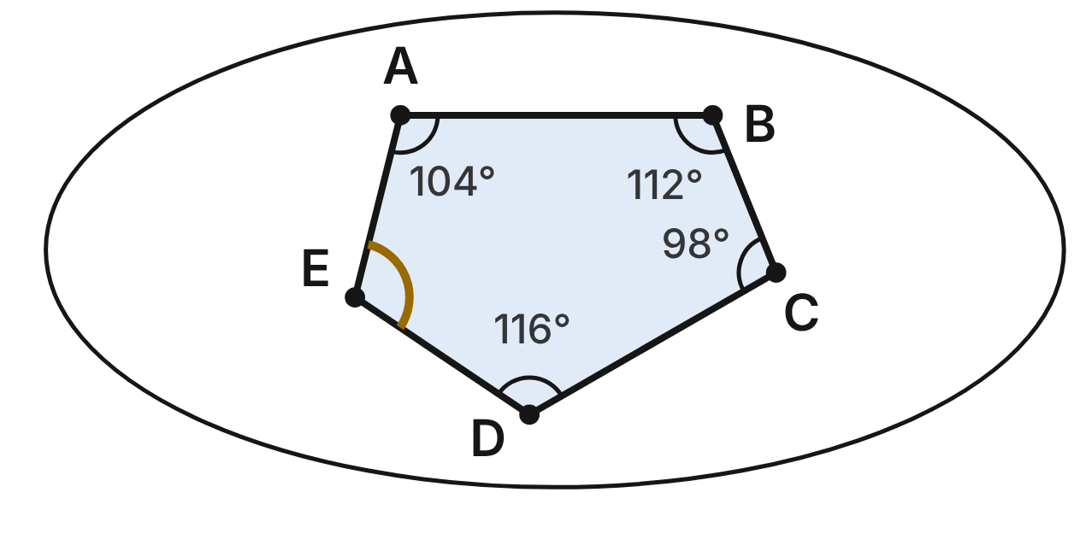
One scute (bony plate) on a turtle's shell is the convex pentagon ABCDE. Four of its angle measures are shown. The gold arc marks ∠E.
361. What is the sum of the interior angles of the scute?
A. 900°
B. 720°
C. 540° ✔
D. 360°
G.PC.2 · skill G.PC.2.1 (LOTS): Find the sum of the interior angles, and the measure of each interior and exterior angle, of a convex or regular polygon
☐ Answer key correct ☐ Wording clear Notes: ________________________________
362. What is m∠E, the angle with the gold arc?
A. 108°
B. 110° ✔
C. 70°
D. 290°
G.PC.2 · skill G.PC.2.1 (LOTS): Find the sum of the interior angles, and the measure of each interior and exterior angle, of a convex or regular polygon
☐ Answer key correct ☐ Wording clear Notes: ________________________________
363. What is the measure of an exterior angle of the scute at corner C?
A. 98°
B. 262°
C. 72°
D. 82° ✔
G.PC.2 · skill G.PC.2.1 (LOTS): Find the sum of the interior angles, and the measure of each interior and exterior angle, of a convex or regular polygon
☐ Answer key correct ☐ Wording clear Notes: ________________________________
364. Which statement about the exterior angles of the scute, one at each corner, is true?
A. They add to 360°. ✔
B. They add to 540°.
C. Each one measures 72°.
D. They add to 900°.
G.PC.2 · skill G.PC.2.1 (LOTS): Find the sum of the interior angles, and the measure of each interior and exterior angle, of a convex or regular polygon
☐ Answer key correct ☐ Wording clear Notes: ________________________________
365. At which corner of the scute is the exterior angle largest?
A. at C ✔
B. at D
C. at E
D. at B
G.PC.2 · skill G.PC.2.1 (LOTS): Find the sum of the interior angles, and the measure of each interior and exterior angle, of a convex or regular polygon
☐ Answer key correct ☐ Wording clear Notes: ________________________________
366. A naturalist models the round edge of a shell as a regular polygon with interior angles of 176°. How many sides does the model have?
A. 4
B. 90 ✔
C. about 2.0
D. 45
G.PC.2 · skill G.PC.2.2 (LOTS): Find the number of sides of a regular polygon given the measure of an interior or exterior angle
☐ Answer key correct ☐ Wording clear Notes: ________________________________

The Honeycomb
Level 2 · Polygons · G.PC.2 · ID geo-pc2-worms-honeycomb
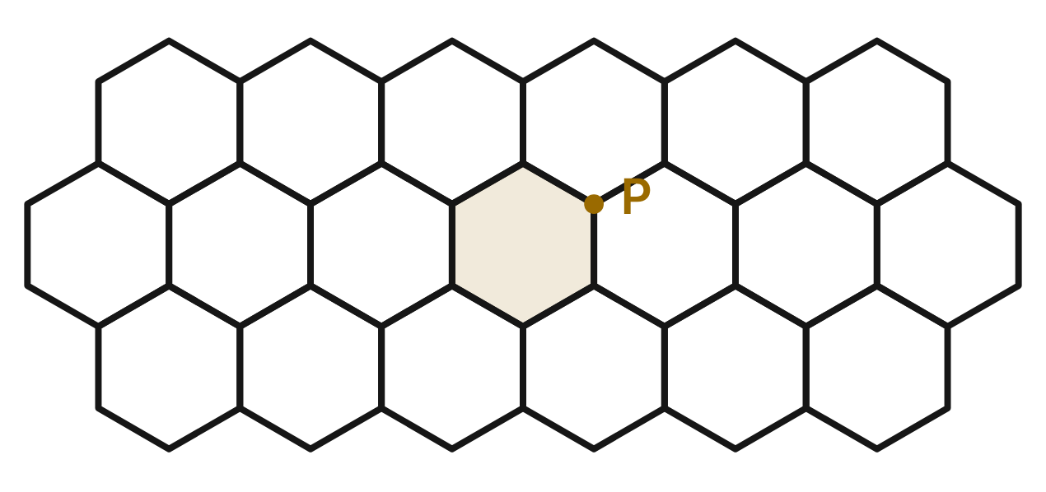
Bees build wax cells shaped like regular hexagons. The cells cover the comb with no gaps or overlaps. At each corner, such as P, three cells meet.
367. Which calculation gives the measure of each angle of one cell?
A. 360° ÷ 6
B. 6 · 180° ÷ 6
C. (6 − 2) · 180° ÷ 6 ✔
D. (6 − 2) · 180° ÷ 4
G.PC.2 · skill G.PC.2.1 (LOTS): Find the sum of the interior angles, and the measure of each interior and exterior angle, of a convex or regular polygon
☐ Answer key correct ☐ Wording clear Notes: ________________________________
368. Suppose the cells were regular octagons. If three octagon cells met around one point, how much would they overlap?
A. 405°
B. 90°
C. 135°
D. 45° ✔
G.PC.2 · skill G.PC.2.1 (LOTS): Find the sum of the interior angles, and the measure of each interior and exterior angle, of a convex or regular polygon
☐ Answer key correct ☐ Wording clear Notes: ________________________________
369. Could five congruent regular cells meet around one point with no gap or overlap? Choose the answer with the correct reason.
A. No: no regular polygon has 72° angles. ✔
B. Yes: regular pentagons, as 5 · 72° = 360°.
C. Yes: 360 ÷ 5 = 72 is a whole number.
D. No: an odd number of cells never fits.
G.PC.2 · skill G.PC.2.2 (LOTS): Find the number of sides of a regular polygon given the measure of an interior or exterior angle
☐ Answer key correct ☐ Wording clear Notes: ________________________________
370. What is the largest number of sides a regular polygon can have and still cover a flat surface by itself? Choose the answer with the correct reason.
A. 8: its 135° angle is the largest that fits.
B. 4: only 90° angles fill 360° exactly.
C. 6: at least 3 must meet, so angles are ≤ 120°. ✔
D. 12: two of its 150° angles fill 360°.
G.PC.2 · skill G.PC.2.1 (LOTS): Find the sum of the interior angles, and the measure of each interior and exterior angle, of a convex or regular polygon
☐ Answer key correct ☐ Wording clear Notes: ________________________________
371. Ari says, "Each cell angle is 360° ÷ 6 = 60°, so six cells meet at P." What is his error?
A. Nothing: six cells meet at each corner.
B. He should divide 720° by 3 cells: 240°.
C. He should use 180° ÷ 6 = 30° instead.
D. 360° ÷ 6 is the exterior angle; each angle is 120°. ✔
G.PC.2 · skill G.PC.2.1 (LOTS): Find the sum of the interior angles, and the measure of each interior and exterior angle, of a convex or regular polygon
☐ Answer key correct ☐ Wording clear Notes: ________________________________
372. A student draws a regular polygon whose exterior angles each equal one angle of an equilateral triangle. How many sides does it have?
A. 3
B. 6 ✔
C. 120
D. 12
G.PC.2 · skill G.PC.2.2 (LOTS): Find the number of sides of a regular polygon given the measure of an interior or exterior angle
☐ Answer key correct ☐ Wording clear Notes: ________________________________

The Orb Web
Level 2 · Polygons · G.PC.2 · ID geo-pc2-worms-orb-web
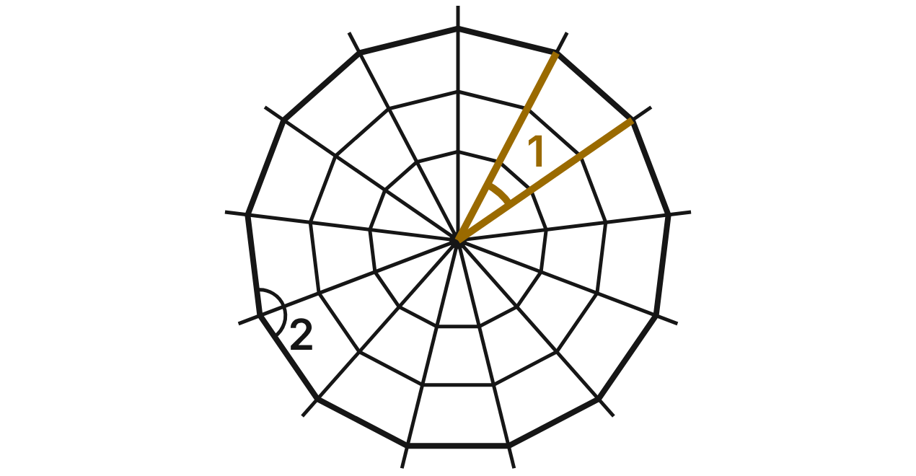
An orb spider's web has 13 evenly spaced spokes from its hub. Each ring joins neighboring spokes with straight threads, so each ring is a regular 13-gon. ∠1 is the angle between two neighboring spokes. ∠2 is an interior angle of the outer ring (the whole angle between two ring threads; the spoke splits it in half).
373. What is the sum of the interior angles of the web's outer ring?
A. 2340°
B. 2160°
C. 1800°
D. 1980° ✔
G.PC.2 · skill G.PC.2.1 (LOTS): Find the sum of the interior angles, and the measure of each interior and exterior angle, of a convex or regular polygon
☐ Answer key correct ☐ Wording clear Notes: ________________________________
374. To the nearest tenth of a degree, what is m∠1, the angle between two neighboring spokes?
A. 27.7° ✔
B. 152.3°
C. 13.8°
D. 30.0°
G.PC.2 · skill G.PC.2.1 (LOTS): Find the sum of the interior angles, and the measure of each interior and exterior angle, of a convex or regular polygon
☐ Answer key correct ☐ Wording clear Notes: ________________________________
375. To the nearest tenth of a degree, what is m∠2?
A. 27.7°
B. 152.3° ✔
C. 166.2°
D. 138.5°
G.PC.2 · skill G.PC.2.1 (LOTS): Find the sum of the interior angles, and the measure of each interior and exterior angle, of a convex or regular polygon
☐ Answer key correct ☐ Wording clear Notes: ________________________________
376. Which statement about ∠1 is true?
A. It equals each interior angle of the ring.
B. It is half of each exterior angle of the ring.
C. It equals each exterior angle of the ring. ✔
D. It is twice each exterior angle of the ring.
G.PC.2 · skill G.PC.2.1 (LOTS): Find the sum of the interior angles, and the measure of each interior and exterior angle, of a convex or regular polygon
☐ Answer key correct ☐ Wording clear Notes: ________________________________
377. How do the angles of the smallest ring compare with the angles of the outer ring?
A. They are smaller, since the ring is smaller.
B. They are equal: both rings are regular 13-gons. ✔
C. They are larger, since they are closer to the hub.
D. They add to less, since the ring is smaller.
G.PC.2 · skill G.PC.2.1 (LOTS): Find the sum of the interior angles, and the measure of each interior and exterior angle, of a convex or regular polygon
☐ Answer key correct ☐ Wording clear Notes: ________________________________
378. Another orb web has rings that are regular polygons with interior angles of 156°. How many spokes does that web have?
A. 24
B. about 2.3
C. 7.5
D. 15 ✔
G.PC.2 · skill G.PC.2.2 (LOTS): Find the number of sides of a regular polygon given the measure of an interior or exterior angle
☐ Answer key correct ☐ Wording clear Notes: ________________________________

The Meadow Trail
Level 2 · Polygons · G.PC.2 · ID geo-pc2-worms-meadow-trail
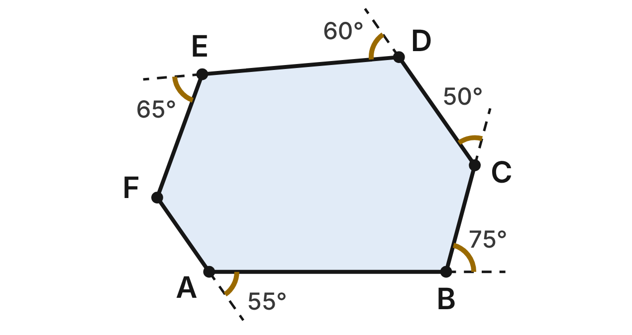
A trail around a meadow is the convex hexagon ABCDEF. A hiker walks it once, turning left at each corner. The gold arcs show her turns (exterior angles) at A, B, C, D and E. The turn at F is not shown.
379. How many degrees does the hiker turn at F?
A. 55° ✔
B. 415°
C. 235°
D. 125°
G.PC.2 · skill G.PC.2.1 (LOTS): Find the sum of the interior angles, and the measure of each interior and exterior angle, of a convex or regular polygon
☐ Answer key correct ☐ Wording clear Notes: ________________________________
380. What is the angle inside the trail at corner C?
A. 50°
B. 310°
C. 130° ✔
D. 230°
G.PC.2 · skill G.PC.2.1 (LOTS): Find the sum of the interior angles, and the measure of each interior and exterior angle, of a convex or regular polygon
☐ Answer key correct ☐ Wording clear Notes: ________________________________
381. What is the sum of the six angles inside the trail?
A. 360°
B. 720° ✔
C. 1080°
D. 900°
G.PC.2 · skill G.PC.2.1 (LOTS): Find the sum of the interior angles, and the measure of each interior and exterior angle, of a convex or regular polygon
☐ Answer key correct ☐ Wording clear Notes: ________________________________
382. At which corner is the angle inside the trail the smallest?
A. at B ✔
B. at C
C. at F
D. at E
G.PC.2 · skill G.PC.2.1 (LOTS): Find the sum of the interior angles, and the measure of each interior and exterior angle, of a convex or regular polygon
☐ Answer key correct ☐ Wording clear Notes: ________________________________
383. Mo says the trail is a regular hexagon. Which is true? Choose the answer with the correct reason.
A. Yes: every turn of the trail is 60°.
B. Yes: its angles add to 720°, so each is 120°.
C. No: a regular hexagon's turns add to 720°.
D. No: its turns are not all equal. ✔
G.PC.2 · skill G.PC.2.1 (LOTS): Find the sum of the interior angles, and the measure of each interior and exterior angle, of a convex or regular polygon
☐ Answer key correct ☐ Wording clear Notes: ________________________________
384. A second trail is a regular polygon with a turn of 22.5° at each corner. How many corners does it have?
A. 8
B. 157.5
C. 16 ✔
D. 18
G.PC.2 · skill G.PC.2.2 (LOTS): Find the number of sides of a regular polygon given the measure of an interior or exterior angle
☐ Answer key correct ☐ Wording clear Notes: ________________________________

The Basalt Columns
Level 3 · Polygons · G.PC.2 · ID geo-pc2-worms-basalt-columns
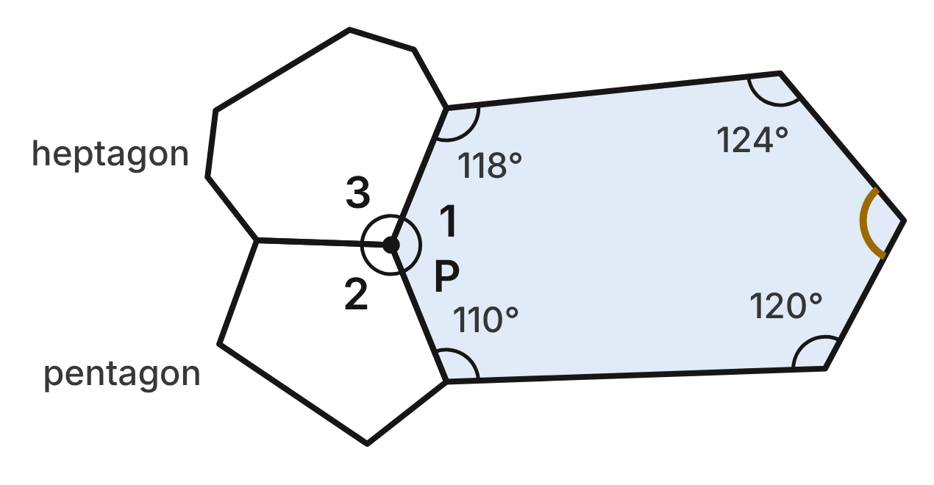
Basalt columns are tall stone pillars whose tops are convex polygons that fit together with no gaps. At point P, a hexagon, a pentagon and a heptagon meet. Their angles at P are m∠1 = (3x − 8)°, m∠2 = (2x + 18)° and m∠3 = (2x + 14)°. A gold arc marks one angle of the hexagon.
385. Which equation uses the three angles at P to find x?
A. 7x + 24 = 180
B. 7x + 24 = 360 ✔
C. 7x + 24 = 720
D. 7x + 24 = 540
G.PC.2 · skill G.PC.2.1 (LOTS): Find the sum of the interior angles, and the measure of each interior and exterior angle, of a convex or regular polygon
☐ Answer key correct ☐ Wording clear Notes: ________________________________
386. What is m∠1, the hexagon's angle at P?
A. 144°
B. 120°
C. 224°
D. 136° ✔
G.PC.2 · skill G.PC.2.1 (LOTS): Find the sum of the interior angles, and the measure of each interior and exterior angle, of a convex or regular polygon
☐ Answer key correct ☐ Wording clear Notes: ________________________________
387. What is the measure of the hexagon angle marked with the gold arc?
A. 248°
B. 104°
C. 112° ✔
D. 120°
G.PC.2 · skill G.PC.2.1 (LOTS): Find the sum of the interior angles, and the measure of each interior and exterior angle, of a convex or regular polygon
☐ Answer key correct ☐ Wording clear Notes: ________________________________
388. What is the measure of the pentagon's exterior angle at P?
A. 66° ✔
B. 114°
C. 246°
D. 72°
G.PC.2 · skill G.PC.2.1 (LOTS): Find the sum of the interior angles, and the measure of each interior and exterior angle, of a convex or regular polygon
☐ Answer key correct ☐ Wording clear Notes: ________________________________
389. Which statement explains why the three column tops fit around P with no gap or overlap?
A. Their angles at P are all equal.
B. Their angle sums add to 360°.
C. Each of their angles at P is 120°.
D. Their angles at P add to 360°. ✔
G.PC.2 · skill G.PC.2.1 (LOTS): Find the sum of the interior angles, and the measure of each interior and exterior angle, of a convex or regular polygon
☐ Answer key correct ☐ Wording clear Notes: ________________________________
390. A geologist sketches a regular polygon in which each interior angle is 11 times each exterior angle. How many sides does it have?
A. 12
B. 15
C. 24 ✔
D. 22
G.PC.2 · skill G.PC.2.2 (LOTS): Find the number of sides of a regular polygon given the measure of an interior or exterior angle
☐ Answer key correct ☐ Wording clear Notes: ________________________________

The Pond Decks
Level 3 · Polygons · G.PC.2 · ID geo-pc2-worms-pond-decks
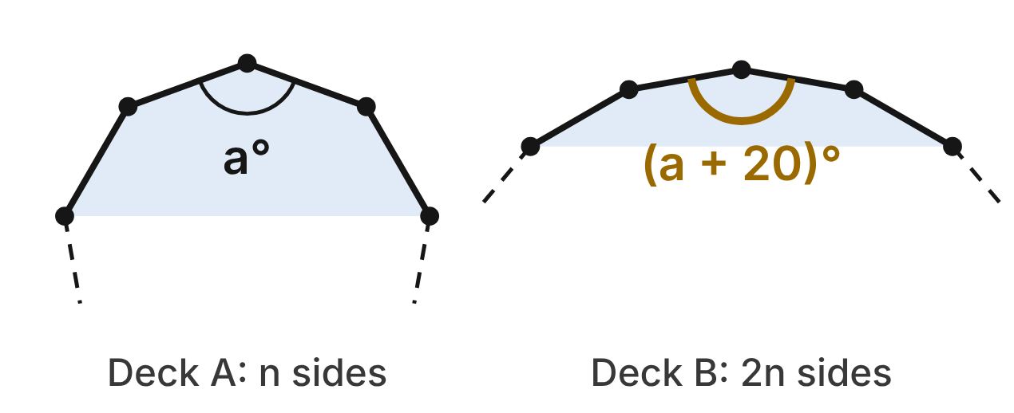
Two ponds have decks shaped like regular polygons. Deck A has n sides, and deck B has 2n sides. Each angle of deck B is 20° more than each angle of deck A.
391. Which expression gives each exterior angle of deck B?
A. 360° ÷ n
B. 360° ÷ (2n) ✔
C. 180° ÷ (2n)
D. (2n − 2) · 180°
G.PC.2 · skill G.PC.2.1 (LOTS): Find the sum of the interior angles, and the measure of each interior and exterior angle, of a convex or regular polygon
☐ Answer key correct ☐ Wording clear Notes: ________________________________
392. How many sides does deck A have?
A. 9 ✔
B. 18
C. 27
D. 4.5
G.PC.2 · skill G.PC.2.2 (LOTS): Find the number of sides of a regular polygon given the measure of an interior or exterior angle
☐ Answer key correct ☐ Wording clear Notes: ________________________________
393. What is the measure of each angle of deck B?
A. 140°
B. 20°
C. 160° ✔
D. 2,880°
G.PC.2 · skill G.PC.2.1 (LOTS): Find the sum of the interior angles, and the measure of each interior and exterior angle, of a convex or regular polygon
☐ Answer key correct ☐ Wording clear Notes: ________________________________
394. How much greater is the sum of the angles of deck B than the sum of the angles of deck A?
A. 1,620° ✔
B. 180°
C. 2,880°
D. 0°
G.PC.2 · skill G.PC.2.1 (LOTS): Find the sum of the interior angles, and the measure of each interior and exterior angle, of a convex or regular polygon
☐ Answer key correct ☐ Wording clear Notes: ________________________________
395. Which statement about the two decks is NOT true?
A. Both decks' exterior angles add to 360°.
B. Deck B's angle sum is twice deck A's. ✔
C. Deck A's exterior angles are twice deck B's.
D. Each angle of deck B is less than 180°.
G.PC.2 · skill G.PC.2.1 (LOTS): Find the sum of the interior angles, and the measure of each interior and exterior angle, of a convex or regular polygon
☐ Answer key correct ☐ Wording clear Notes: ________________________________
396. A third regular deck, C, has angles that are each 10° more than each angle of deck B. How many sides does deck C have?
A. 18
B. about 2.1
C. 10
D. 36 ✔
G.PC.2 · skill G.PC.2.2 (LOTS): Find the number of sides of a regular polygon given the measure of an interior or exterior angle
☐ Answer key correct ☐ Wording clear Notes: ________________________________

G.PC.3 · Solve problems, including contextual problems, by applying properties of circles.

The Circular Garden Bed
Level 1 · Circles · G.PC.3 · ID geo-pc3-worms-garden-bed
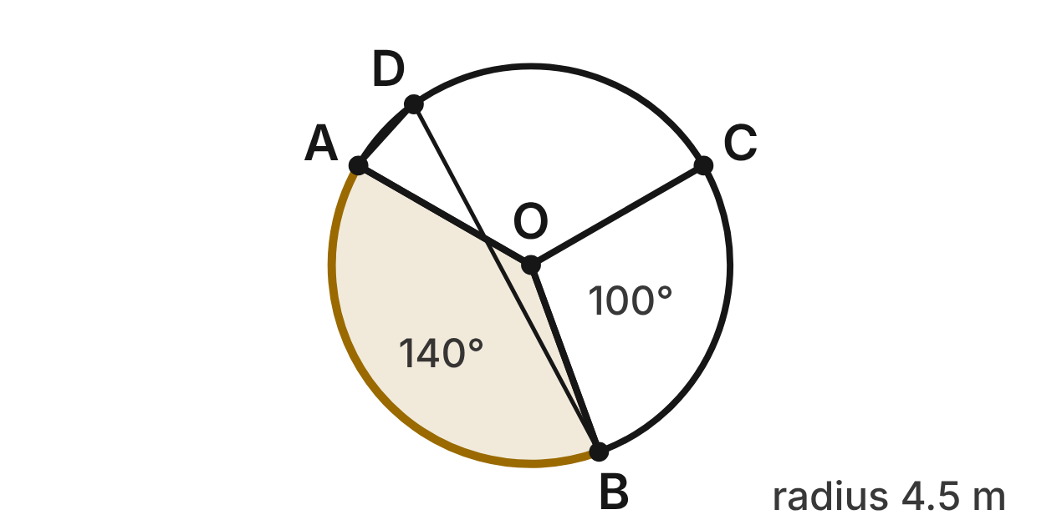
A circular garden has center O and radius 4.5 m. Straight paths run from O to A, B and C on the edge, making three beds. m∠AOB = 140° and m∠BOC = 100°. A lantern stands at D on the edge, between C and A.
397. What is m∠COA, the angle of the third bed?
A. 120° ✔
B. 240°
C. 40°
D. 220°
G.PC.3 · skill G.PC.3.1 (LOTS): Use the angles formed by chords, secants and tangents (central, inscribed, and angles inside and outside a circle) and their arcs
☐ Answer key correct ☐ Wording clear Notes: ________________________________
398. Edging is laid along arc AB, the gold curved edge of the shaded bed. How long is it? Give the answer in terms of π.
A. 1.75π m
B. 7π m
C. 3.5π m ✔
D. 7.875π m
G.PC.3 · skill G.PC.3.3 (LOTS): Find arc length and the area of a sector, or use them to find a radius or a central angle
☐ Answer key correct ☐ Wording clear Notes: ________________________________
399. What is the area of bed BOC, to the nearest tenth of a square meter?
A. 7.9 m²
B. 70.7 m²
C. 63.6 m²
D. 17.7 m² ✔
G.PC.3 · skill G.PC.3.3 (LOTS): Find arc length and the area of a sector, or use them to find a radius or a central angle
☐ Answer key correct ☐ Wording clear Notes: ________________________________
400. From the lantern at D, what is m∠ADB, the angle between the lines to A and B?
A. 140°
B. 70° ✔
C. 110°
D. 35°
G.PC.3 · skill G.PC.3.1 (LOTS): Use the angles formed by chords, secants and tangents (central, inscribed, and angles inside and outside a circle) and their arcs
☐ Answer key correct ☐ Wording clear Notes: ________________________________
401. One bag of mulch covers 2 m². How many bags are needed to cover the shaded bed AOB?
A. 13 bags ✔
B. 12 bags
C. 25 bags
D. 6 bags
G.PC.3 · skill G.PC.3.4 (HOTS): Model and solve a contextual problem with the properties of circles
☐ Answer key correct ☐ Wording clear Notes: ________________________________
402. A new bed in this garden will have an edge arc 2π m long. What central angle should it have?
A. 160°
B. 40°
C. 80° ✔
D. about 35.6°
G.PC.3 · skill G.PC.3.3 (LOTS): Find arc length and the area of a sector, or use them to find a radius or a central angle
☐ Answer key correct ☐ Wording clear Notes: ________________________________

The Tree Stump
Level 1 · Circles · G.PC.3 · ID geo-pc3-worms-tree-stump
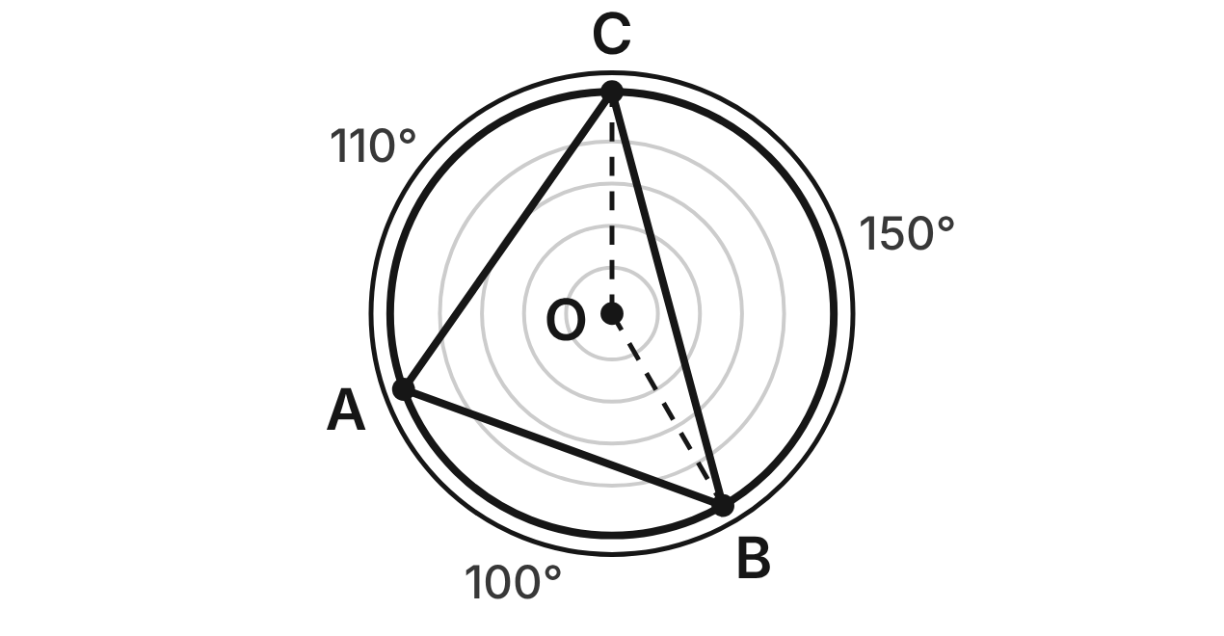
The top of a tree stump is a circle with center O and radius 30 cm. A woodworker draws triangle ABC with its vertices on the edge. m(arc AB) = 100°, m(arc BC) = 150° and m(arc CA) = 110°.
403. What is m∠ACB?
A. 100°
B. 25°
C. 55°
D. 50° ✔
G.PC.3 · skill G.PC.3.1 (LOTS): Use the angles formed by chords, secants and tangents (central, inscribed, and angles inside and outside a circle) and their arcs
☐ Answer key correct ☐ Wording clear Notes: ________________________________
404. What is m∠BAC?
A. 150°
B. 75° ✔
C. 50°
D. 105°
G.PC.3 · skill G.PC.3.1 (LOTS): Use the angles formed by chords, secants and tangents (central, inscribed, and angles inside and outside a circle) and their arcs
☐ Answer key correct ☐ Wording clear Notes: ________________________________
405. Which statement about △ABC is true?
A. ∠ACB is its largest angle, because arc AB is the smallest arc.
B. All three angles are equal, because A, B and C are on one circle.
C. ∠BAC is its largest angle, because arc BC is the largest arc. ✔
D. m∠ABC = 110°, because it cuts off arc CA.
G.PC.3 · skill G.PC.3.1 (LOTS): Use the angles formed by chords, secants and tangents (central, inscribed, and angles inside and outside a circle) and their arcs
☐ Answer key correct ☐ Wording clear Notes: ________________________________
406. What is m∠BOC, the central angle between the dashed radii?
A. 75°
B. 150° ✔
C. 210°
D. 30°
G.PC.3 · skill G.PC.3.1 (LOTS): Use the angles formed by chords, secants and tangents (central, inscribed, and angles inside and outside a circle) and their arcs
☐ Answer key correct ☐ Wording clear Notes: ________________________________
407. How long is arc BC of the stump's edge? Give the answer in terms of π.
A. 25π cm ✔
B. 12.5π cm
C. 50π cm
D. 375π cm
G.PC.3 · skill G.PC.3.3 (LOTS): Find arc length and the area of a sector, or use them to find a radius or a central angle
☐ Answer key correct ☐ Wording clear Notes: ________________________________
408. Ten years before the tree was cut, its radius was 26 cm. How much longer is the edge of the stump (its circumference) than the edge was then? Round to the nearest tenth of a centimeter.
A. 4.0 cm
B. 12.6 cm
C. 703.7 cm
D. 25.1 cm ✔
G.PC.3 · skill G.PC.3.4 (HOTS): Model and solve a contextual problem with the properties of circles
☐ Answer key correct ☐ Wording clear Notes: ________________________________

The Campfire Ring
Level 2 · Circles · G.PC.3 · ID geo-pc3-worms-campfire-ring
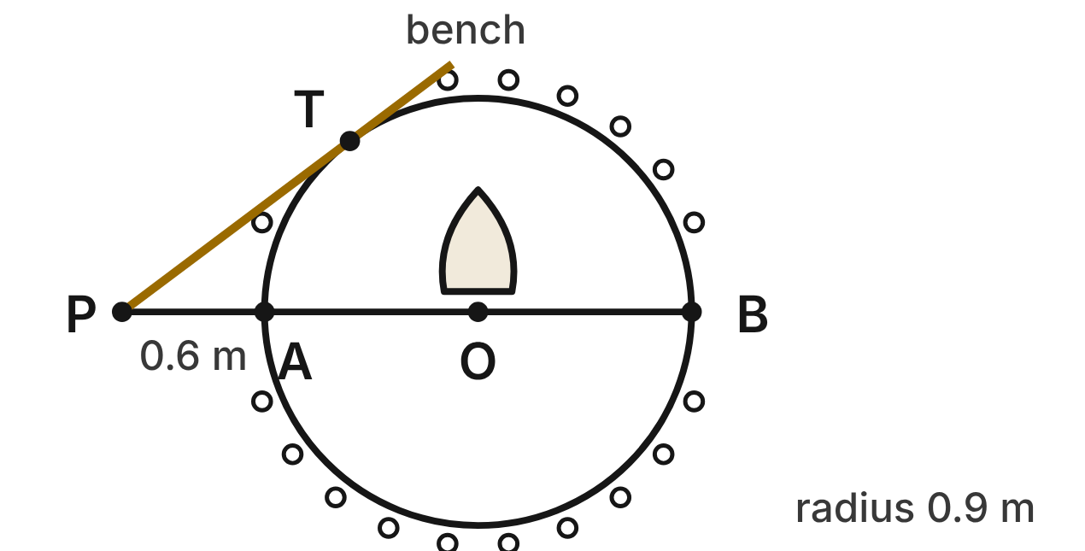
A campfire ring is a circle with center O and radius 0.9 m. A log bench lies along line PT, which touches the ring only at T. A straight path from P passes through O; it meets the ring at A and B. PA = 0.6 m.
409. How long is PT, from P to where the bench line touches the ring?
A. about 1.0 m
B. 1.44 m
C. 1.2 m ✔
D. 1.5 m
G.PC.3 · skill G.PC.3.2 (LOTS): Use the lengths of segments formed by intersecting chords, secants and tangents
☐ Answer key correct ☐ Wording clear Notes: ________________________________
410. Why is ∠OTP a right angle?
A. OT = PT, so the angle at T is 90°.
B. T is the midpoint of PB.
C. ∠TOP is 90°, because O is the center.
D. PT is tangent at T, so PT ⊥ radius OT. ✔
G.PC.3 · skill G.PC.3.1 (LOTS): Use the angles formed by chords, secants and tangents (central, inscribed, and angles inside and outside a circle) and their arcs
☐ Answer key correct ☐ Wording clear Notes: ________________________________
411. Which equation is true for triangle OTP?
A. OT² + PO² = PT²
B. OT² + PT² = PO² ✔
C. OT + PT = PO
D. PA² + PT² = PO²
G.PC.3 · skill G.PC.3.4 (HOTS): Model and solve a contextual problem with the properties of circles
☐ Answer key correct ☐ Wording clear Notes: ________________________________
412. m(arc TA) ≈ 53.1° and m(arc TB) ≈ 126.9°. What is m∠TPB, the angle between the bench line and the path?
A. 36.9° ✔
B. 90°
C. 73.8°
D. 53.1°
G.PC.3 · skill G.PC.3.1 (LOTS): Use the angles formed by chords, secants and tangents (central, inscribed, and angles inside and outside a circle) and their arcs
☐ Answer key correct ☐ Wording clear Notes: ________________________________
413. Use m(arc TB) ≈ 126.9°. How long is arc TB of the ring? Round to the nearest hundredth of a meter.
A. 1.00 m
B. 0.83 m
C. 3.99 m
D. 1.99 m ✔
G.PC.3 · skill G.PC.3.3 (LOTS): Find arc length and the area of a sector, or use them to find a radius or a central angle
☐ Answer key correct ☐ Wording clear Notes: ________________________________
414. Flat stones 0.25 m wide are set side by side around the ring's edge (the stones in the picture are not to scale). How many whole stones fit?
A. 22 stones ✔
B. 23 stones
C. 11 stones
D. 10 stones
G.PC.3 · skill G.PC.3.4 (HOTS): Model and solve a contextual problem with the properties of circles
☐ Answer key correct ☐ Wording clear Notes: ________________________________

The Spider Web
Level 2 · Circles · G.PC.3 · ID geo-pc3-worms-spider-web
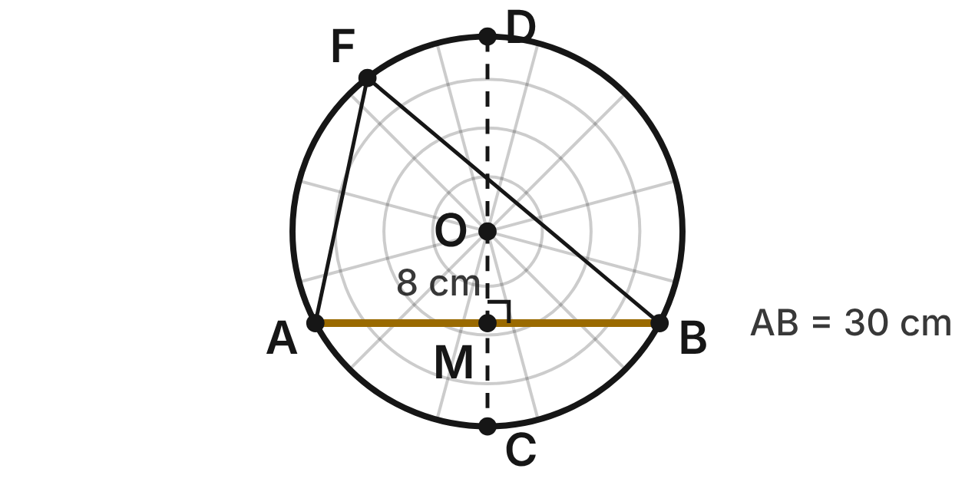
A spider's web fills a round frame with center O, the hub. A straight thread AB of the frame is 30 cm long. The hub is 8 cm from it: OM = 8 cm, with OM ⊥ AB at M. Line OM meets the frame at C and D. A fly is caught at F on the frame.
415. Why is AM = MB?
A. OM ⊥ AB, and a line from the center ⊥ to a chord bisects it. ✔
B. M is on the frame of the web, so it must split AB in half.
C. OA = AB, so △OAB is equilateral and M is a midpoint.
D. AM = OM, because △OMA is an isosceles right triangle.
G.PC.3 · skill G.PC.3.2 (LOTS): Use the lengths of segments formed by intersecting chords, secants and tangents
☐ Answer key correct ☐ Wording clear Notes: ________________________________
416. What is the radius of the frame?
A. 23 cm
B. 17 cm ✔
C. 15 cm
D. about 31 cm
G.PC.3 · skill G.PC.3.4 (HOTS): Model and solve a contextual problem with the properties of circles
☐ Answer key correct ☐ Wording clear Notes: ________________________________
417. Chords AB and CD cross at M. Which equation is true?
A. 15 · 15 = OM · MD
B. 15 · 15 = CM · MD ✔
C. 15 + 15 = CM + MD
D. 30 · 15 = CM · MD
G.PC.3 · skill G.PC.3.2 (LOTS): Use the lengths of segments formed by intersecting chords, secants and tangents
☐ Answer key correct ☐ Wording clear Notes: ________________________________
418. To the nearest degree, what is m∠AOB?
A. 62°
B. 56°
C. 124° ✔
D. 28°
G.PC.3 · skill G.PC.3.1 (LOTS): Use the angles formed by chords, secants and tangents (central, inscribed, and angles inside and outside a circle) and their arcs
☐ Answer key correct ☐ Wording clear Notes: ________________________________
419. Another web's round frame has radius 20 cm. One straight thread cuts off an 81° arc of it. To the nearest tenth of a centimeter, how long is that arc?
A. 14.1 cm
B. 56.5 cm
C. 282.7 cm
D. 28.3 cm ✔
G.PC.3 · skill G.PC.3.3 (LOTS): Find arc length and the area of a sector, or use them to find a radius or a central angle
☐ Answer key correct ☐ Wording clear Notes: ________________________________
420. Which statement about ∠AFB, the angle at the fly between the lines to A and B, is true?
A. m∠AFB = m∠AOB
B. m∠AFB = 2 · m∠AOB
C. m∠AFB = ½ · m∠AOB ✔
D. m∠AFB + m∠AOB = 90°
G.PC.3 · skill G.PC.3.1 (LOTS): Use the angles formed by chords, secants and tangents (central, inscribed, and angles inside and outside a circle) and their arcs
☐ Answer key correct ☐ Wording clear Notes: ________________________________

The Sunflower Head
Level 2 · Circles · G.PC.3 · ID geo-pc3-worms-sunflower
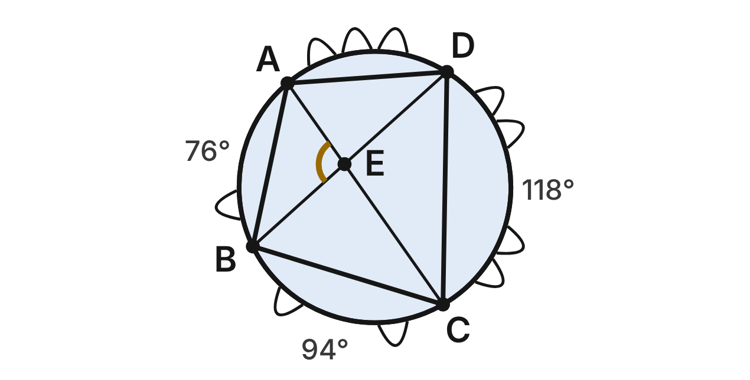
A sunflower head is a circle with radius 12 cm. A ladybug walks straight from A to B to C to D and back to A, all on the edge of the head. m(arc AB) = 76°, m(arc BC) = 94° and m(arc CD) = 118°. Diagonals AC and BD cross at E.
421. What is m(arc DA)?
A. 288°
B. 72° ✔
C. 190°
D. 90°
G.PC.3 · skill G.PC.3.1 (LOTS): Use the angles formed by chords, secants and tangents (central, inscribed, and angles inside and outside a circle) and their arcs
☐ Answer key correct ☐ Wording clear Notes: ________________________________
422. What is m∠ABC?
A. 85°
B. 190°
C. 47°
D. 95° ✔
G.PC.3 · skill G.PC.3.1 (LOTS): Use the angles formed by chords, secants and tangents (central, inscribed, and angles inside and outside a circle) and their arcs
☐ Answer key correct ☐ Wording clear Notes: ________________________________
423. Which statement about quadrilateral ABCD is NOT true?
A. m∠ABC = m∠BCD ✔
B. m∠ABC + m∠ADC = 180°
C. m∠BAD = 106°
D. m∠BCD = 74°
G.PC.3 · skill G.PC.3.1 (LOTS): Use the angles formed by chords, secants and tangents (central, inscribed, and angles inside and outside a circle) and their arcs
☐ Answer key correct ☐ Wording clear Notes: ________________________________
424. What is m∠AEB, the gold angle where the diagonals cross?
A. 97° ✔
B. 194°
C. 21°
D. 83°
G.PC.3 · skill G.PC.3.1 (LOTS): Use the angles formed by chords, secants and tangents (central, inscribed, and angles inside and outside a circle) and their arcs
☐ Answer key correct ☐ Wording clear Notes: ________________________________
425. How long is arc AB of the sunflower's edge? Round to the nearest tenth of a centimeter.
A. 8.0 cm
B. 31.8 cm
C. 15.9 cm ✔
D. 95.5 cm
G.PC.3 · skill G.PC.3.3 (LOTS): Find arc length and the area of a sector, or use them to find a radius or a central angle
☐ Answer key correct ☐ Wording clear Notes: ________________________________
426. A week ago the head's radius was 12 cm. Now it is 14 cm. By how much did the area of the head grow? Round to the nearest square centimeter.
A. 13 cm²
B. 163 cm² ✔
C. 616 cm²
D. 653 cm²
G.PC.3 · skill G.PC.3.4 (HOTS): Model and solve a contextual problem with the properties of circles
☐ Answer key correct ☐ Wording clear Notes: ________________________________

The Crater Lake
Level 2 · Circles · G.PC.3 · ID geo-pc3-worms-crater-lake
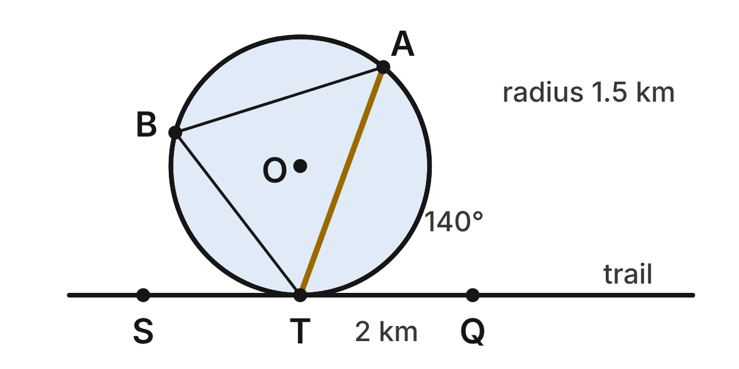
A round crater lake has center O and radius 1.5 km. A straight trail through S, T and Q touches the shore only at T, and TQ = 2 km. A boat route runs straight from T to A on the shore. Arc TA on Q's side of the lake measures 140°. B is a campsite on the far shore.
427. What is m∠QTA, the angle between the trail toward Q and the boat route?
A. 140°
B. 70° ✔
C. 110°
D. 35°
G.PC.3 · skill G.PC.3.1 (LOTS): Use the angles formed by chords, secants and tangents (central, inscribed, and angles inside and outside a circle) and their arcs
☐ Answer key correct ☐ Wording clear Notes: ________________________________
428. What is m∠STA, the angle between the trail toward S and the boat route?
A. 220°
B. 70°
C. 40°
D. 110° ✔
G.PC.3 · skill G.PC.3.1 (LOTS): Use the angles formed by chords, secants and tangents (central, inscribed, and angles inside and outside a circle) and their arcs
☐ Answer key correct ☐ Wording clear Notes: ________________________________
429. Which statement is true?
A. m∠TBA = m∠QTA, because both are half of arc TA. ✔
B. m∠TBA = m∠TOA, because both cut off arc TA.
C. m∠QTA = 90°, because the trail is tangent at T.
D. m∠TBA = 140°, because it cuts off arc TA.
G.PC.3 · skill G.PC.3.1 (LOTS): Use the angles formed by chords, secants and tangents (central, inscribed, and angles inside and outside a circle) and their arcs
☐ Answer key correct ☐ Wording clear Notes: ________________________________
430. How long is the shoreline along arc TA on Q's side? Round to the nearest tenth of a kilometer.
A. 1.8 km
B. 7.3 km
C. 3.7 km ✔
D. 5.8 km
G.PC.3 · skill G.PC.3.3 (LOTS): Find arc length and the area of a sector, or use them to find a radius or a central angle
☐ Answer key correct ☐ Wording clear Notes: ________________________________
431. Use isosceles triangle TOA, with m∠TOA = 140°. How long is the boat route TA, to the nearest tenth of a kilometer?
A. 1.0 km
B. 3.0 km
C. 2.8 km ✔
D. 1.4 km
G.PC.3 · skill G.PC.3.4 (HOTS): Model and solve a contextual problem with the properties of circles
☐ Answer key correct ☐ Wording clear Notes: ________________________________
432. A hiker stands at Q. How far is she from the center of the lake, O?
A. 3.5 km
B. about 1.3 km
C. 6.25 km
D. 2.5 km ✔
G.PC.3 · skill G.PC.3.4 (HOTS): Model and solve a contextual problem with the properties of circles
☐ Answer key correct ☐ Wording clear Notes: ________________________________

The Lily Pond in the Triangle
Level 3 · Circles · G.PC.3 · ID geo-pc3-worms-lily-pond
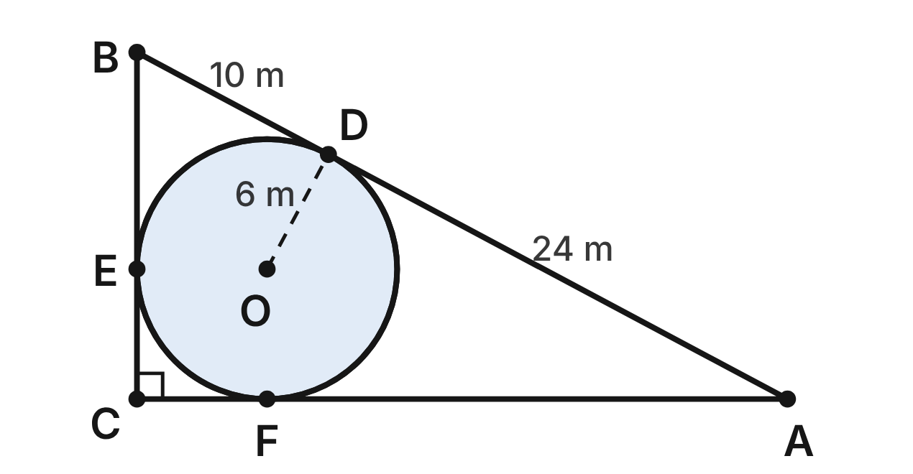
Three straight paths form right triangle ABC, with m∠C = 90°. A round pond with center O and radius 6 m touches each path at one point: D on AB, E on BC and F on CA. AD = 24 m and BD = 10 m.
433. How long is AF?
A. 10 m
B. 18 m
C. 24 m ✔
D. 30 m
G.PC.3 · skill G.PC.3.2 (LOTS): Use the lengths of segments formed by intersecting chords, secants and tangents
☐ Answer key correct ☐ Wording clear Notes: ________________________________
434. How long are the three paths all together (the perimeter of △ABC)?
A. 40 m
B. 68 m
C. 80 m ✔
D. 74 m
G.PC.3 · skill G.PC.3.2 (LOTS): Use the lengths of segments formed by intersecting chords, secants and tangents
☐ Answer key correct ☐ Wording clear Notes: ________________________________
435. Which expression equals m∠DOF?
A. 180° − m∠A ✔
B. 90° + m∠A
C. 90° − m∠A
D. 2 · m∠A
G.PC.3 · skill G.PC.3.1 (LOTS): Use the angles formed by chords, secants and tangents (central, inscribed, and angles inside and outside a circle) and their arcs
☐ Answer key correct ☐ Wording clear Notes: ________________________________
436. Why is CE equal to the pond's radius?
A. C is the center of the pond, so CE is a radius.
B. CE = BE, because tangent segments are congruent.
C. △OEC is equilateral, so all of its sides are equal.
D. OECF has four right angles and OE = OF, so it is a square. ✔
G.PC.3 · skill G.PC.3.4 (HOTS): Model and solve a contextual problem with the properties of circles
☐ Answer key correct ☐ Wording clear Notes: ________________________________
437. How long is the pond's shore along the 90° arc EF near corner C? Give the answer in terms of π.
A. 3π m ✔
B. 1.5π m
C. 9π m
D. 6π m
G.PC.3 · skill G.PC.3.3 (LOTS): Find arc length and the area of a sector, or use them to find a radius or a central angle
☐ Answer key correct ☐ Wording clear Notes: ________________________________
438. The rest of the triangle is lawn. To the nearest tenth of a square meter, what is the area of the lawn?
A. 353.1 m²
B. 126.9 m² ✔
C. 202.3 m²
D. 366.9 m²
G.PC.3 · skill G.PC.3.4 (HOTS): Model and solve a contextual problem with the properties of circles
☐ Answer key correct ☐ Wording clear Notes: ________________________________

Two Fairy Rings
Level 3 · Circles · G.PC.3 · ID geo-pc3-worms-fairy-rings
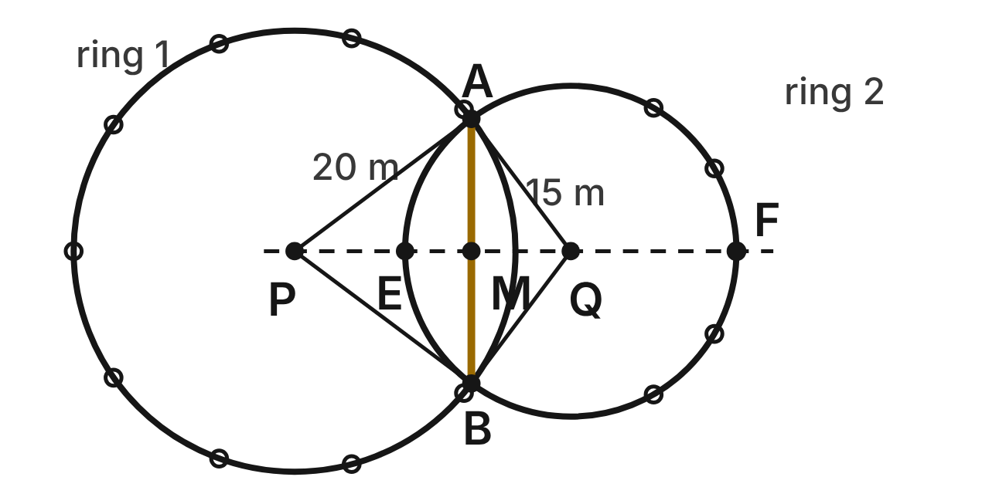
Mushrooms grow in two circular fairy rings. Ring 1 has center P and radius 20 m. Ring 2 has center Q and radius 15 m. PQ = 25 m. The rings cross at A and B, and AB crosses line PQ at M. Line PQ meets ring 2 at E and F.
439. Which statement about line QA is true? Choose the answer with the correct reason.
A. It is tangent to ring 1, because 15² + 20² = 25², so QA ⊥ PA. ✔
B. It is tangent to ring 1, because QA = PA.
C. It is not tangent to ring 1, because it crosses ring 1 twice.
D. It passes through P, because P, A and Q are collinear.
G.PC.3 · skill G.PC.3.4 (HOTS): Model and solve a contextual problem with the properties of circles
☐ Answer key correct ☐ Wording clear Notes: ________________________________
440. In ring 2, diameter EF is ⊥ to chord AB at M, so AM = MB. EM = 6 m and MF = 24 m. How long is AB?
A. 12 m
B. 30 m
C. 144 m
D. 24 m ✔
G.PC.3 · skill G.PC.3.2 (LOTS): Use the lengths of segments formed by intersecting chords, secants and tangents
☐ Answer key correct ☐ Wording clear Notes: ________________________________
441. PM = 16 m, and PM ⊥ AB. Use right triangle PMA to find m∠APB, to the nearest tenth of a degree.
A. 36.9°
B. 106.3°
C. 73.7° ✔
D. 77.3°
G.PC.3 · skill G.PC.3.4 (HOTS): Model and solve a contextual problem with the properties of circles
☐ Answer key correct ☐ Wording clear Notes: ________________________________
442. A third fairy ring has radius 12 m. Its mushrooms grow only along a 150° arc of it. How long is that arc? Give the answer in terms of π.
A. 5π m
B. 10π m ✔
C. 20π m
D. 60π m
G.PC.3 · skill G.PC.3.3 (LOTS): Find arc length and the area of a sector, or use them to find a radius or a central angle
☐ Answer key correct ☐ Wording clear Notes: ________________________________
443. The grass inside ring 2 is mowed. To the nearest square meter, what area is mowed?
A. 94 m²
B. 2,827 m²
C. 1,257 m²
D. 707 m² ✔
G.PC.3 · skill G.PC.3.3 (LOTS): Find arc length and the area of a sector, or use them to find a radius or a central angle
☐ Answer key correct ☐ Wording clear Notes: ________________________________
444. Which statement about ∠AFB, at point F on ring 2, is true?
A. m∠AFB = m∠AQB
B. m∠AFB = ½ · m∠AQB ✔
C. m∠AFB = 2 · m∠AQB
D. m∠AFB + m∠AQB = 180°
G.PC.3 · skill G.PC.3.1 (LOTS): Use the angles formed by chords, secants and tangents (central, inscribed, and angles inside and outside a circle) and their arcs
☐ Answer key correct ☐ Wording clear Notes: ________________________________

G.PC.4 · Solve problems involving equations of circles.

The Garden Sprinkler
Level 1 · Equations of circles · G.PC.4 · ID geo-pc4-worms-sprinkler
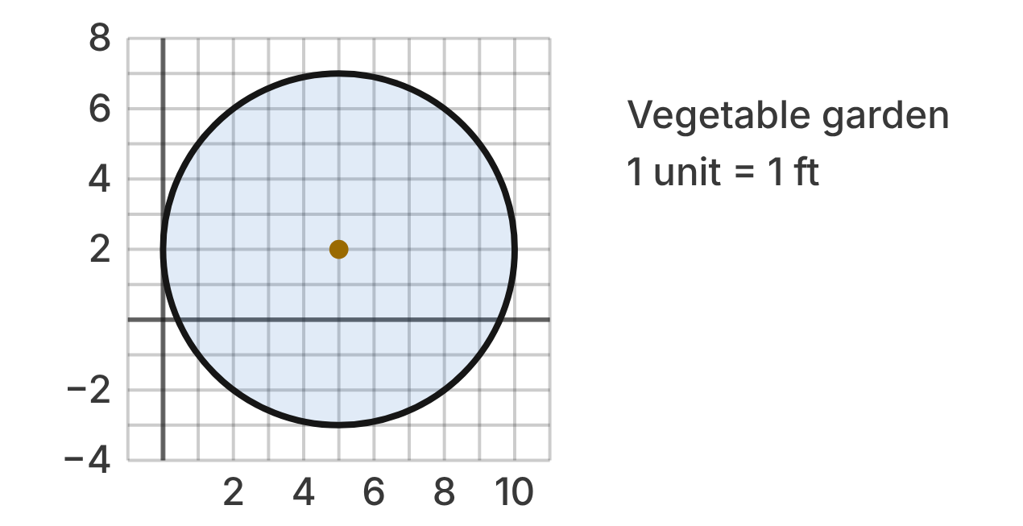
A sprinkler sits in a vegetable garden drawn on a grid. Each unit is 1 ft. The shaded circle is the ground it wets, and the gold dot is the sprinkler.
445. What are the coordinates of the sprinkler?
A. (2, 5)
B. (5, 7)
C. (10, 2)
D. (5, 2) ✔
G.PC.4 · skill G.PC.4.1 (LOTS): Identify the center and radius of a circle from its graph or from its equation in standard form
☐ Answer key correct ☐ Wording clear Notes: ________________________________
446. How far does the water reach from the sprinkler?
A. 10 ft
B. 5 ft ✔
C. 25 ft
D. 2.5 ft
G.PC.4 · skill G.PC.4.1 (LOTS): Identify the center and radius of a circle from its graph or from its equation in standard form
☐ Answer key correct ☐ Wording clear Notes: ________________________________
447. Which equation describes the edge of the wet circle?
A. (x − 5)² + (y − 2)² = 25 ✔
B. (x + 5)² + (y + 2)² = 25
C. (x − 5)² + (y − 2)² = 5
D. (x − 2)² + (y − 5)² = 25
G.PC.4 · skill G.PC.4.2 (LOTS): Write the equation of a circle from its center and radius, its center and a point, or the endpoints of a diameter
☐ Answer key correct ☐ Wording clear Notes: ________________________________
448. Which plant is inside the wet circle?
A. Pepper at (1, 6)
B. Bean at (9, −2)
C. Tomato at (8, 5) ✔
D. Squash at (10, 4)
G.PC.4 · skill G.PC.4.1 (LOTS): Identify the center and radius of a circle from its graph or from its equation in standard form
☐ Answer key correct ☐ Wording clear Notes: ________________________________
449. A right triangle has its hypotenuse from the sprinkler to the point (8, 6), with one horizontal leg and one vertical leg. Which equation gives that distance d?
A. 3² + 4² = d² ✔
B. 8² + 6² = d²
C. 3 + 4 = d
D. 4² − 3² = d²
G.PC.4 · skill G.PC.4.3 (HOTS): Derive the equation of a circle with the Pythagorean Theorem or the distance formula
☐ Answer key correct ☐ Wording clear Notes: ________________________________
450. A second sprinkler is at (−3, 4). It sprays water up to 7 ft away. Which equation describes the edge of its wet circle?
A. (x + 3)² + (y − 4)² = 7
B. (x + 3)² + (y − 4)² = 196
C. (x + 3)² + (y − 4)² = 49 ✔
D. (x − 3)² + (y + 4)² = 49
G.PC.4 · skill G.PC.4.2 (LOTS): Write the equation of a circle from its center and radius, its center and a point, or the endpoints of a diameter
☐ Answer key correct ☐ Wording clear Notes: ________________________________

The Fairy Ring
Level 1 · Equations of circles · G.PC.4 · ID geo-pc4-worms-fairy-ring
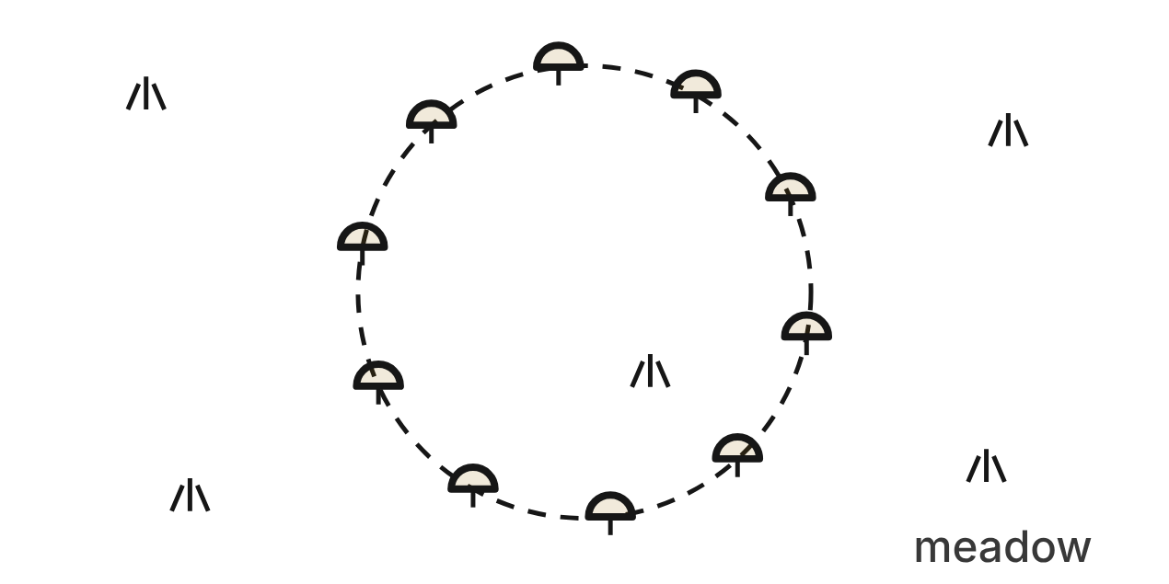
Mushrooms in a meadow grow in a circle called a fairy ring. On a map of the meadow (units in meters), the ring is (x + 1)² + (y + 6)² = 100.
451. What are the coordinates of the center of the fairy ring?
A. (1, 6)
B. (−6, −1)
C. (−1, −6) ✔
D. (−1, 6)
G.PC.4 · skill G.PC.4.1 (LOTS): Identify the center and radius of a circle from its graph or from its equation in standard form
☐ Answer key correct ☐ Wording clear Notes: ________________________________
452. How wide is the fairy ring, measured straight across through its center?
A. 20 m ✔
B. 10 m
C. 100 m
D. 50 m
G.PC.4 · skill G.PC.4.1 (LOTS): Identify the center and radius of a circle from its graph or from its equation in standard form
☐ Answer key correct ☐ Wording clear Notes: ________________________________
453. Which point is on the fairy ring?
A. (7, 14)
B. (5, 2) ✔
C. (9, 4)
D. (3, 0)
G.PC.4 · skill G.PC.4.1 (LOTS): Identify the center and radius of a circle from its graph or from its equation in standard form
☐ Answer key correct ☐ Wording clear Notes: ________________________________
454. Which expression gives the distance from the center of the ring to a mushroom at (−7, 2)?
A. √((−7 − 1)² + (2 − 6)²)
B. (−7 + 1)² + (2 + 6)²
C. √((−7 + 1) + (2 + 6))
D. √((−7 + 1)² + (2 + 6)²) ✔
G.PC.4 · skill G.PC.4.3 (HOTS): Derive the equation of a circle with the Pythagorean Theorem or the distance formula
☐ Answer key correct ☐ Wording clear Notes: ________________________________
455. The ring grows outward 1 m each year, and its center stays put. Which equation describes the ring 2 years from now?
A. (x + 1)² + (y + 6)² = 102
B. (x + 1)² + (y + 6)² = 104
C. (x + 1)² + (y + 6)² = 144 ✔
D. (x + 1)² + (y + 6)² = 12
G.PC.4 · skill G.PC.4.2 (LOTS): Write the equation of a circle from its center and radius, its center and a point, or the endpoints of a diameter
☐ Answer key correct ☐ Wording clear Notes: ________________________________
456. A hiker sets her pack down at (7, −8). Where is it? Choose the answer with the correct reason.
A. Outside: (7 − 1)² + (−8 − 6)² = 232
B. Inside: (7 + 1)² + (−8 + 6)² = 68, less than 100 ✔
C. On the ring: it is 8 + 2 = 10 m from the center
D. Outside: 68 is more than 10
G.PC.4 · skill G.PC.4.1 (LOTS): Identify the center and radius of a circle from its graph or from its equation in standard form
☐ Answer key correct ☐ Wording clear Notes: ________________________________

The Oak Canopy
Level 2 · Equations of circles · G.PC.4 · ID geo-pc4-worms-oak-canopy
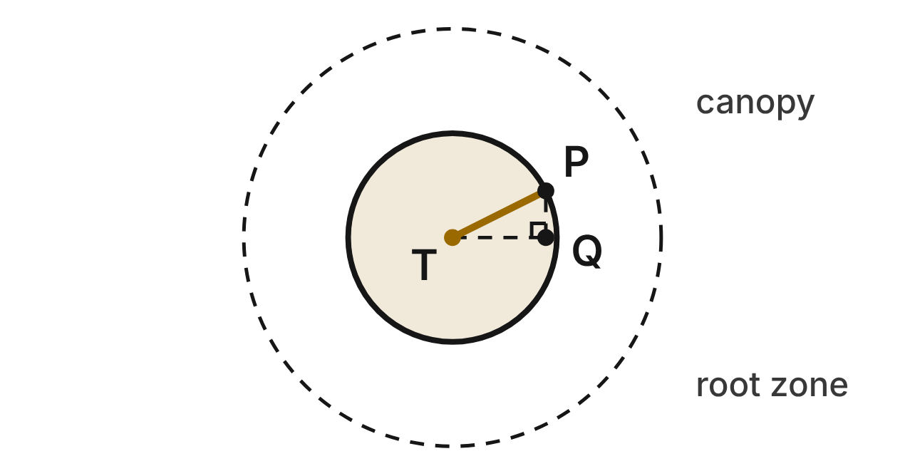
On a park map (units in meters), an oak's trunk is at T(−5, 1). Its canopy is a circle centered at T, and P(1, 4) is on its edge. Point Q(1, 1) makes right triangle TQP. The roots reach twice as far from T as the canopy does (dashed circle).
457. Which equation applies the Pythagorean theorem to triangle TQP to find the radius r of the canopy?
A. 6² + 3² = r² ✔
B. 6 + 3 = r
C. 6² − 3² = r²
D. 4² + 3² = r²
G.PC.4 · skill G.PC.4.3 (HOTS): Derive the equation of a circle with the Pythagorean Theorem or the distance formula
☐ Answer key correct ☐ Wording clear Notes: ________________________________
458. What is the radius of the canopy, in simplest radical form?
A. 9 m
B. 45 m
C. 3√3 m
D. 3√5 m ✔
G.PC.4 · skill G.PC.4.1 (LOTS): Identify the center and radius of a circle from its graph or from its equation in standard form
☐ Answer key correct ☐ Wording clear Notes: ________________________________
459. Which equation describes the edge of the canopy?
A. (x − 5)² + (y + 1)² = 45
B. (x + 5)² + (y − 1)² = 45 ✔
C. (x + 5)² + (y − 1)² = 3√5
D. (x − 1)² + (y − 4)² = 45
G.PC.4 · skill G.PC.4.2 (LOTS): Write the equation of a circle from its center and radius, its center and a point, or the endpoints of a diameter
☐ Answer key correct ☐ Wording clear Notes: ________________________________
460. Which equation describes the edge of the root zone?
A. (x + 5)² + (y − 1)² = 90
B. (x + 5)² + (y − 1)² = 6√5
C. (x + 5)² + (y − 1)² = 180 ✔
D. (x + 5)² + (y − 1)² = 2025
G.PC.4 · skill G.PC.4.2 (LOTS): Write the equation of a circle from its center and radius, its center and a point, or the endpoints of a diameter
☐ Answer key correct ☐ Wording clear Notes: ________________________________
461. A bench is at (−9, 6). Is it under the canopy? Choose the answer with the correct reason.
A. Yes: its distance squared from T is 41, less than 45 ✔
B. No: it is 4 + 5 = 9 m from T, more than 3√5 m
C. No: (−9 − 5)² + (6 + 1)² = 245, more than 45
D. No: its distance squared from T, 41, is more than 3√5
G.PC.4 · skill G.PC.4.1 (LOTS): Identify the center and radius of a circle from its graph or from its equation in standard form
☐ Answer key correct ☐ Wording clear Notes: ________________________________
462. Which statement about the canopy is NOT true?
A. (1, −2) is on the edge of the canopy.
B. (−5, 7) is under the canopy.
C. (−11, 1) is outside the canopy. ✔
D. (−8, −5) is on the edge of the canopy.
G.PC.4 · skill G.PC.4.1 (LOTS): Identify the center and radius of a circle from its graph or from its equation in standard form
☐ Answer key correct ☐ Wording clear Notes: ________________________________

The Campfire Circle
Level 2 · Equations of circles · G.PC.4 · ID geo-pc4-worms-campfire
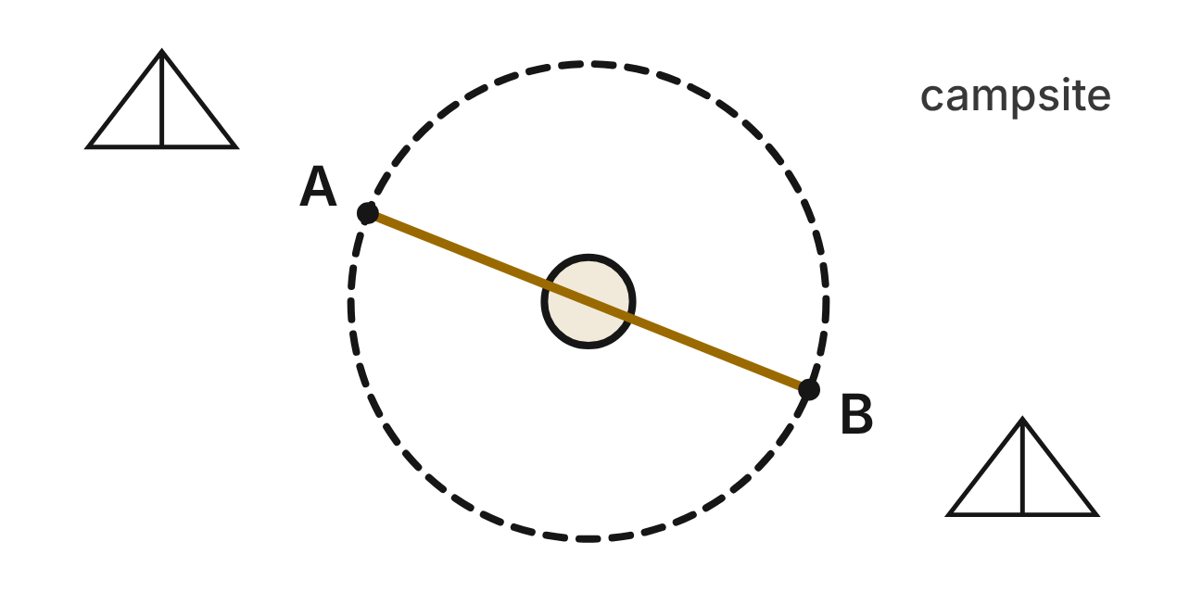
At a campsite (units in meters), no one may sit inside the safety circle around the fire pit. A rope from stake A(−7, 2) to stake B(3, −2) is a diameter of the safety circle. The fire pit has the same center.
463. What are the coordinates of the center of the fire pit?
A. (−4, 0)
B. (−2, 0) ✔
C. (5, −2)
D. (10, −4)
G.PC.4 · skill G.PC.4.2 (LOTS): Write the equation of a circle from its center and radius, its center and a point, or the endpoints of a diameter
☐ Answer key correct ☐ Wording clear Notes: ________________________________
464. Which equation describes the safety circle?
A. (x − 2)² + y² = 29
B. (x + 2)² + y² = 116
C. (x + 2)² + y² = √29
D. (x + 2)² + y² = 29 ✔
G.PC.4 · skill G.PC.4.2 (LOTS): Write the equation of a circle from its center and radius, its center and a point, or the endpoints of a diameter
☐ Answer key correct ☐ Wording clear Notes: ________________________________
465. To the nearest tenth of a meter, what is the radius of the safety circle?
A. 5.4 m ✔
B. 10.8 m
C. 7.0 m
D. 14.5 m
G.PC.4 · skill G.PC.4.1 (LOTS): Identify the center and radius of a circle from its graph or from its equation in standard form
☐ Answer key correct ☐ Wording clear Notes: ________________________________
466. A log seat L is at (0, 5). Which equation uses the Pythagorean theorem to find the distance d from the center of the fire pit to L?
A. 0² + 5² = d²
B. 2 + 5 = d
C. 2² + 5² = d² ✔
D. 5² − 2² = d²
G.PC.4 · skill G.PC.4.3 (HOTS): Derive the equation of a circle with the Pythagorean Theorem or the distance formula
☐ Answer key correct ☐ Wording clear Notes: ________________________________
467. Campers may sit only outside the safety circle. Which spot is allowed?
A. (2, 3)
B. (−5, −4)
C. (−7, −1)
D. (1, −5) ✔
G.PC.4 · skill G.PC.4.1 (LOTS): Identify the center and radius of a circle from its graph or from its equation in standard form
☐ Answer key correct ☐ Wording clear Notes: ________________________________
468. The fire pit is a circle with a diameter of 2 m. Which equation describes its edge?
A. (x + 2)² + y² = 1 ✔
B. (x + 2)² + y² = 4
C. (x + 2)² + y² = 2
D. (x − 2)² + y² = 1
G.PC.4 · skill G.PC.4.2 (LOTS): Write the equation of a circle from its center and radius, its center and a point, or the endpoints of a diameter
☐ Answer key correct ☐ Wording clear Notes: ________________________________

The Irrigation Pivot
Level 2 · Equations of circles · G.PC.4 · ID geo-pc4-worms-pivot
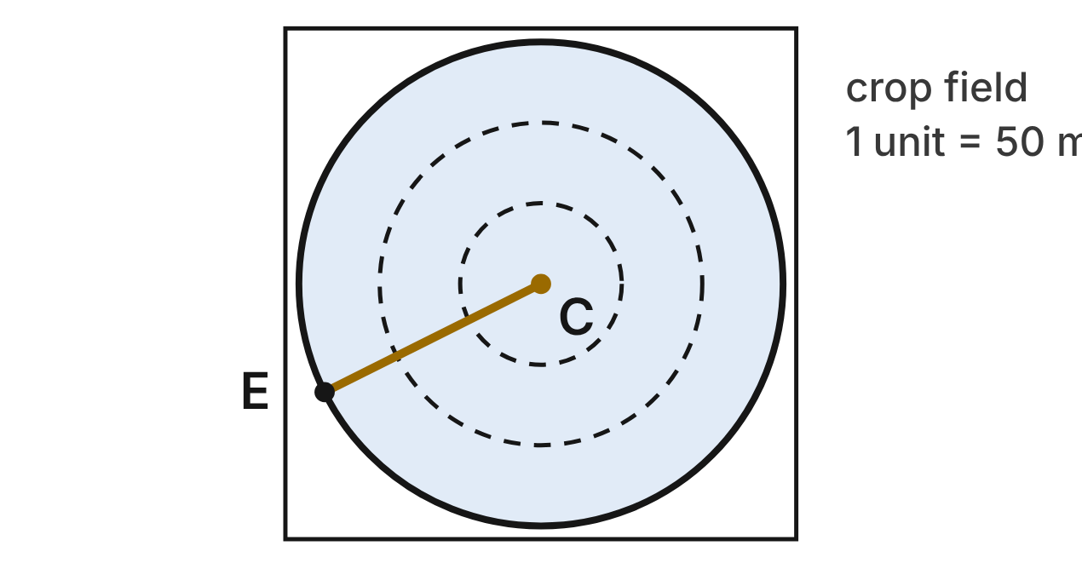
A center-pivot sprinkler turns around C(3, 4) on a farm map (1 unit = 50 m). The end of its arm is at E(−5, 0), so the arm sweeps a circle with radius CE.
469. Which expression gives the length of the arm CE, in map units?
A. √((−5 + 3)² + (0 + 4)²)
B. (−5 − 3)² + (0 − 4)²
C. √((−5 − 3)² + (0 − 4)²) ✔
D. √((−5 − 3) + (0 − 4))
G.PC.4 · skill G.PC.4.3 (HOTS): Derive the equation of a circle with the Pythagorean Theorem or the distance formula
☐ Answer key correct ☐ Wording clear Notes: ________________________________
470. How long is the arm in map units, in simplest radical form?
A. 12 units
B. 4√5 units ✔
C. 4√3 units
D. 16√5 units
G.PC.4 · skill G.PC.4.1 (LOTS): Identify the center and radius of a circle from its graph or from its equation in standard form
☐ Answer key correct ☐ Wording clear Notes: ________________________________
471. To the nearest meter, how long is the arm?
A. 894 m
B. 600 m
C. 4000 m
D. 447 m ✔
G.PC.4 · skill G.PC.4.1 (LOTS): Identify the center and radius of a circle from its graph or from its equation in standard form
☐ Answer key correct ☐ Wording clear Notes: ________________________________
472. Pat writes √((x − 3)² + (y − 4)²) = 4√5 for a point (x, y) on the edge of the watered circle. Which equation should come next?
A. (x − 3)² + (y − 4)² = 80 ✔
B. (x − 3)² + (y − 4)² = 20
C. (x − 3)² + (y − 4)² = 4√5
D. (x − 3) + (y − 4) = 80
G.PC.4 · skill G.PC.4.3 (HOTS): Derive the equation of a circle with the Pythagorean Theorem or the distance formula
☐ Answer key correct ☐ Wording clear Notes: ________________________________
473. Which point on the map gets water from the pivot?
A. (12, 5)
B. (8, 9) ✔
C. (−3, 11)
D. (11, 9)
G.PC.4 · skill G.PC.4.1 (LOTS): Identify the center and radius of a circle from its graph or from its equation in standard form
☐ Answer key correct ☐ Wording clear Notes: ________________________________
474. A second pivot turns around E. Its arm reaches exactly to C. Which equation describes the edge of its circle?
A. (x − 5)² + y² = 80
B. (x − 3)² + (y − 4)² = 80
C. (x + 5)² + y² = 4√5
D. (x + 5)² + y² = 80 ✔
G.PC.4 · skill G.PC.4.2 (LOTS): Write the equation of a circle from its center and radius, its center and a point, or the endpoints of a diameter
☐ Answer key correct ☐ Wording clear Notes: ________________________________

The Duck Pond
Level 3 · Equations of circles · G.PC.4 · ID geo-pc4-worms-duck-pond
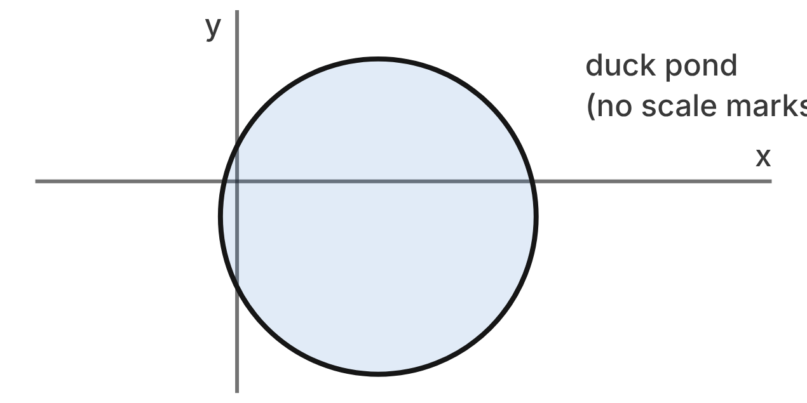
On a park map (units in meters), the edge of a round duck pond is x² + y² − 8x + 2y − 3 = 0.
475. Which equation do you get by completing the square?
A. (x − 4)² + (y + 1)² = 20 ✔
B. (x − 4)² + (y + 1)² = 3
C. (x + 4)² + (y − 1)² = 20
D. (x − 4)² + (y + 1)² = 14
G.PC.4 · skill G.PC.4.1 (LOTS): Identify the center and radius of a circle from its graph or from its equation in standard form
☐ Answer key correct ☐ Wording clear Notes: ________________________________
476. What are the center and radius of the pond?
A. (−4, 1); r = 2√5 m
B. (4, −1); r = 20 m
C. (4, −1); r = 2√5 m ✔
D. (4, −1); r = √3 m
G.PC.4 · skill G.PC.4.1 (LOTS): Identify the center and radius of a circle from its graph or from its equation in standard form
☐ Answer key correct ☐ Wording clear Notes: ________________________________
477. Ty writes (x² − 8x + 64) + (y² + 2y + 4) = 3 + 64 + 4. What is his mistake?
A. He should subtract 64 and 4 on the right side.
B. He should use −3 on the right side, not 3.
C. He should add 8 and 2, not their squares.
D. He should square half of 8 and 2: 16 and 1. ✔
G.PC.4 · skill G.PC.4.1 (LOTS): Identify the center and radius of a circle from its graph or from its equation in standard form
☐ Answer key correct ☐ Wording clear Notes: ________________________________
478. Where is a reed at (6, 3)? Choose the answer with the correct reason.
A. Outside: it is 2 + 4 = 6 m from the center
B. On the edge: (6 − 4)² + (3 + 1)² = 20 ✔
C. Outside: (6 + 4)² + (3 − 1)² = 104
D. Outside: 20 is more than 2√5
G.PC.4 · skill G.PC.4.1 (LOTS): Identify the center and radius of a circle from its graph or from its equation in standard form
☐ Answer key correct ☐ Wording clear Notes: ________________________________
479. A duck lands at the center of the pond. Its ripple is a circle that grows until its edge reaches a lily pad at (5, 1). Which equation describes the ripple then?
A. (x − 5)² + (y − 1)² = 5
B. (x − 4)² + (y + 1)² = √5
C. (x − 4)² + (y + 1)² = 5 ✔
D. (x + 4)² + (y − 1)² = 5
G.PC.4 · skill G.PC.4.2 (LOTS): Write the equation of a circle from its center and radius, its center and a point, or the endpoints of a diameter
☐ Answer key correct ☐ Wording clear Notes: ________________________________
480. Which statement is true for every point (x, y) on the edge of the pond?
A. It is 20 m from (4, −1).
B. It is 2√5 m from (4, −1). ✔
C. It is 2√5 m from (−4, 1).
D. It is √3 m from the origin.
G.PC.4 · skill G.PC.4.3 (HOTS): Derive the equation of a circle with the Pythagorean Theorem or the distance formula
☐ Answer key correct ☐ Wording clear Notes: ________________________________

Two Bird Feeders
Level 3 · Equations of circles · G.PC.4 · ID geo-pc4-worms-bird-feeders
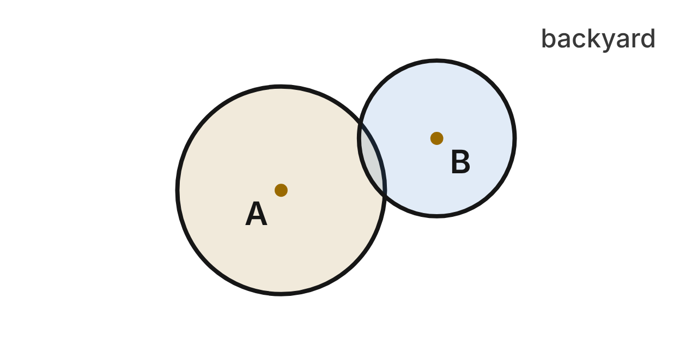
Birds visit a feeder from anywhere inside or on its range circle. On a yard map (units in meters), the edge of feeder A's range is x² + y² + 10x − 4y + 13 = 0. Feeder B is at (1, 4), and birds come to it from up to 3 m away.
481. What are the center and radius of feeder A's range?
A. (5, −2); r = 4 m
B. (−5, 2); r = 4 m ✔
C. (−5, 2); r = 16 m
D. (−5, 2); r = √13 m
G.PC.4 · skill G.PC.4.1 (LOTS): Identify the center and radius of a circle from its graph or from its equation in standard form
☐ Answer key correct ☐ Wording clear Notes: ________________________________
482. Which point is on the edge of feeder A's range?
A. (−9, 2) ✔
B. (9, −2)
C. (−1, 6)
D. (−5, 18)
G.PC.4 · skill G.PC.4.1 (LOTS): Identify the center and radius of a circle from its graph or from its equation in standard form
☐ Answer key correct ☐ Wording clear Notes: ________________________________
483. Which equation describes the edge of feeder B's range?
A. (x + 1)² + (y + 4)² = 9
B. (x − 1)² + (y − 4)² = 3
C. (x − 1)² + (y − 4)² = 9 ✔
D. (x − 1)² + (y − 4)² = 36
G.PC.4 · skill G.PC.4.2 (LOTS): Write the equation of a circle from its center and radius, its center and a point, or the endpoints of a diameter
☐ Answer key correct ☐ Wording clear Notes: ________________________________
484. Which expression gives the distance between the two feeders?
A. √((1 − 5)² + (4 − 2)²)
B. (1 + 5)² + (4 − 2)²
C. √((1 + 5) + (4 − 2))
D. √((1 + 5)² + (4 − 2)²) ✔
G.PC.4 · skill G.PC.4.3 (HOTS): Derive the equation of a circle with the Pythagorean Theorem or the distance formula
☐ Answer key correct ☐ Wording clear Notes: ________________________________
485. A birdbath is at (−3, 4). Whose range is it in? Choose the answer with the correct reason.
A. Neither: 8 is more than 4, and 16 is more than 3
B. A's only: 8 is less than 16, but 16 is more than 9 ✔
C. Neither: 100 is more than 16, and 16 is more than 9
D. Both: √8 is less than 4, and √16 is less than 9
G.PC.4 · skill G.PC.4.1 (LOTS): Identify the center and radius of a circle from its graph or from its equation in standard form
☐ Answer key correct ☐ Wording clear Notes: ________________________________
486. A third feeder goes at the midpoint between feeders A and B. The edge of its range passes exactly through feeder B. Which equation describes that edge?
A. (x + 4)² + (y − 6)² = 10
B. (x + 2)² + (y − 3)² = 40
C. (x − 2)² + (y + 3)² = 10
D. (x + 2)² + (y − 3)² = 10 ✔
G.PC.4 · skill G.PC.4.2 (LOTS): Write the equation of a circle from its center and radius, its center and a point, or the endpoints of a diameter
☐ Answer key correct ☐ Wording clear Notes: ________________________________

3-D figures (G.DF)

G.DF.1 · Create models and solve problems, including those in context, involving surface area and volume of rectangular and triangular prisms, cylinders, cones, pyramids, and spheres.

The Round Hay Bale
Level 1 · 3-D figures · G.DF.1 · ID geo-df1-worms-hay-bale
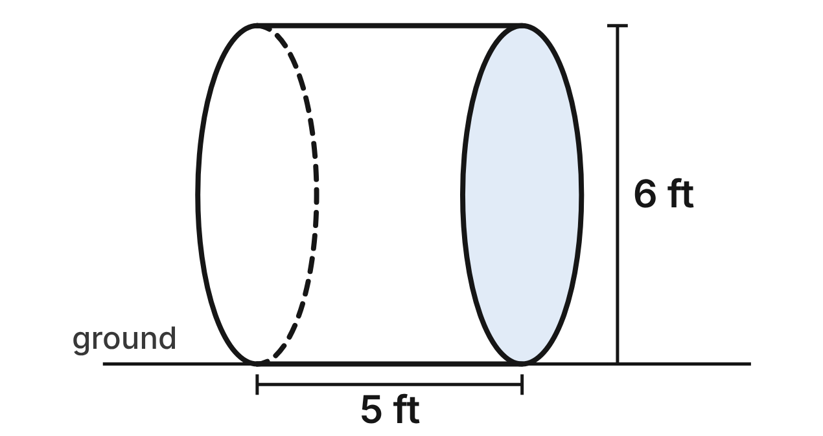
A round hay bale lies on its curved side in a field. It is a cylinder 6 ft across and 5 ft wide from one flat end to the other.
487. What is the volume of the bale, to the nearest tenth of a cubic foot?
A. 141.4 ft³ ✔
B. 565.5 ft³
C. 47.1 ft³
D. 45.0 ft³
G.DF.1 · skill G.DF.1.2 (LOTS): Find the surface area and volume of prisms, cylinders, cones, pyramids and spheres
☐ Answer key correct ☐ Wording clear Notes: ________________________________
488. Net wrap covers the curved surface of the bale but not its flat ends. How much net wrap is that, in terms of π?
A. 60π ft²
B. 15π ft²
C. 30π ft² ✔
D. 48π ft²
G.DF.1 · skill G.DF.1.2 (LOTS): Find the surface area and volume of prisms, cylinders, cones, pyramids and spheres
☐ Answer key correct ☐ Wording clear Notes: ________________________________
489. A plane cuts the bale from its top straight down to the ground, through the centers of both flat ends. What is the cross section?
A. a rectangle 3 ft by 5 ft
B. a rectangle 6 ft by 5 ft ✔
C. a rectangle 6π ft by 5 ft
D. a circle 6 ft across
G.DF.1 · skill G.DF.1.1 (LOTS): Identify the two-dimensional cross sections and nets of three-dimensional figures
☐ Answer key correct ☐ Wording clear Notes: ________________________________
490. In a net of the bale, the curved surface unrolls into a rectangle. What are its length and width?
A. 6π ft by 5 ft ✔
B. 3π ft by 5 ft
C. 6 ft by 5 ft
D. 9π ft by 5 ft
G.DF.1 · skill G.DF.1.1 (LOTS): Identify the two-dimensional cross sections and nets of three-dimensional figures
☐ Answer key correct ☐ Wording clear Notes: ________________________________
491. A farmer needs 3,000 ft³ of hay for the winter. How many bales like this one must he make?
A. 6
B. 67
C. 22 ✔
D. 21
G.DF.1 · skill G.DF.1.3 (HOTS): Solve multistep contextual problems with surface area and volume, including composite figures
☐ Answer key correct ☐ Wording clear Notes: ________________________________
492. The hay weighs about 11 lb per cubic foot. About how much does the bale weigh, to the nearest pound?
A. 518 lb
B. 6,220 lb
C. 495 lb
D. 1,555 lb ✔
G.DF.1 · skill G.DF.1.3 (HOTS): Solve multistep contextual problems with surface area and volume, including composite figures
☐ Answer key correct ☐ Wording clear Notes: ________________________________

The Ant Mound
Level 1 · 3-D figures · G.DF.1 · ID geo-df1-worms-anthill
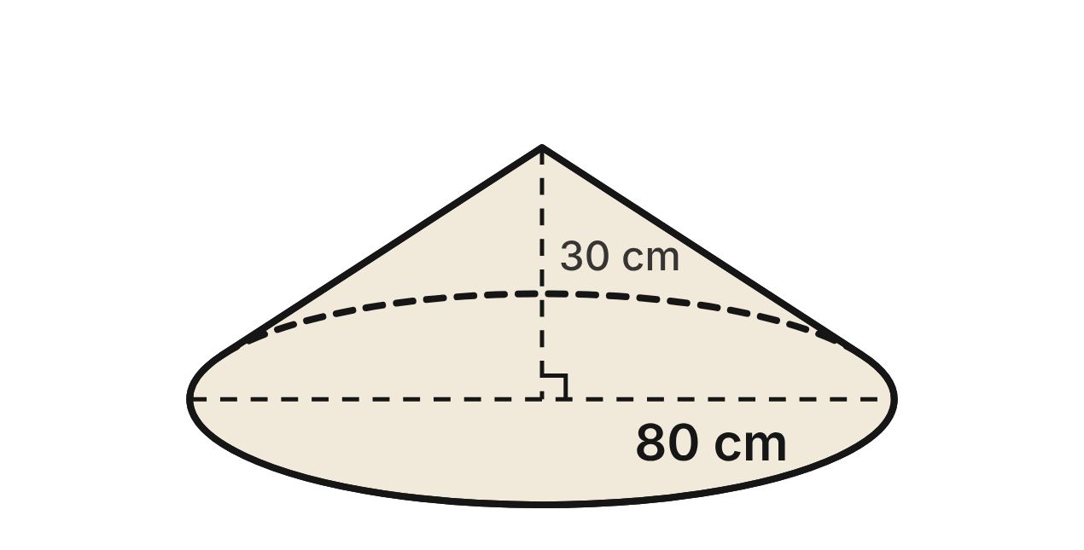
An ant mound in a meadow is shaped like a cone. Its base is 80 cm across, and it is 30 cm tall.
493. What is the volume of the mound, in terms of π?
A. 16,000π cm³ ✔
B. 64,000π cm³
C. 24,000π cm³
D. 48,000π cm³
G.DF.1 · skill G.DF.1.2 (LOTS): Find the surface area and volume of prisms, cylinders, cones, pyramids and spheres
☐ Answer key correct ☐ Wording clear Notes: ________________________________
494. What is the slant height of the mound, from its top down to the edge of its base?
A. 70 cm
B. 50 cm ✔
C. about 8.4 cm
D. 110 cm
G.DF.1 · skill G.DF.1.2 (LOTS): Find the surface area and volume of prisms, cylinders, cones, pyramids and spheres
☐ Answer key correct ☐ Wording clear Notes: ________________________________
495. A vertical plane cuts the mound through its top and the center of its base. What is the area of the cross section?
A. 2,000 cm²
B. 2,400 cm²
C. 1,200 cm² ✔
D. 600 cm²
G.DF.1 · skill G.DF.1.1 (LOTS): Identify the two-dimensional cross sections and nets of three-dimensional figures
☐ Answer key correct ☐ Wording clear Notes: ________________________________
496. A level plane cuts the mound 12 cm above the ground. What is the cross section?
A. a circle with radius 40 cm
B. a circle with radius 24 cm ✔
C. a circle with radius 28 cm
D. a circle with radius 16 cm
G.DF.1 · skill G.DF.1.1 (LOTS): Identify the two-dimensional cross sections and nets of three-dimensional figures
☐ Answer key correct ☐ Wording clear Notes: ________________________________
497. What is the area of the mound's sloping surface, not counting the ground under it, in terms of π?
A. 3,600π cm²
B. 1,200π cm²
C. 4,000π cm²
D. 2,000π cm² ✔
G.DF.1 · skill G.DF.1.2 (LOTS): Find the surface area and volume of prisms, cylinders, cones, pyramids and spheres
☐ Answer key correct ☐ Wording clear Notes: ________________________________
498. About 45% of the mound's volume is tunnels and rooms; the rest is soil. How much soil is in the mound, to the nearest liter? Use 1 L = 1,000 cm³.
A. 46 L
B. 83 L
C. 23 L
D. 28 L ✔
G.DF.1 · skill G.DF.1.3 (HOTS): Solve multistep contextual problems with surface area and volume, including composite figures
☐ Answer key correct ☐ Wording clear Notes: ________________________________

The Beehive Box
Level 2 · 3-D figures · G.DF.1 · ID geo-df1-worms-beehive
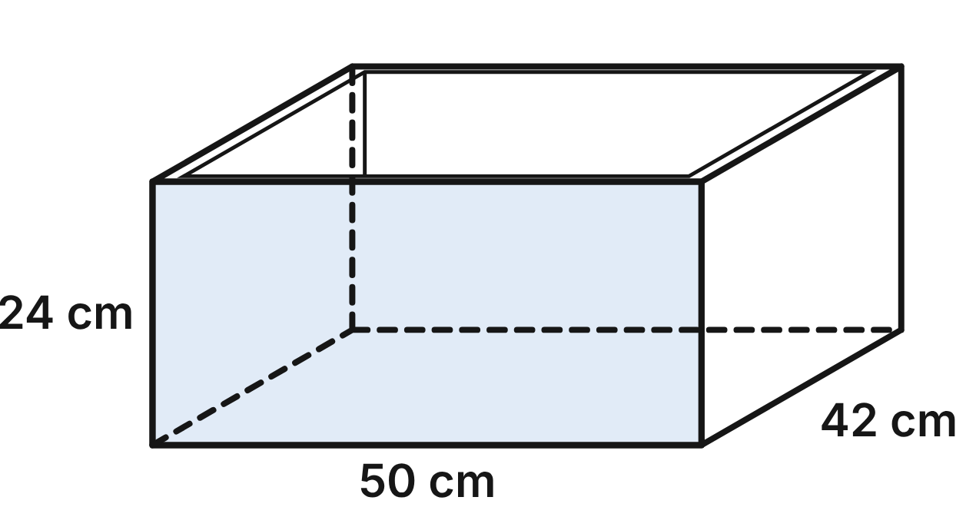
A beehive box is a wooden frame with four walls and no top or bottom. Outside, it is 50 cm long, 42 cm wide and 24 cm tall. The walls are 2 cm thick.
499. What is the area of the four outside walls of the box?
A. 8,616 cm²
B. 50,400 cm²
C. 2,208 cm²
D. 4,416 cm² ✔
G.DF.1 · skill G.DF.1.2 (LOTS): Find the surface area and volume of prisms, cylinders, cones, pyramids and spheres
☐ Answer key correct ☐ Wording clear Notes: ________________________________
500. Ignore the thickness of the walls. Which shapes make up a net of the outside of the box?
A. 6 rectangles: two 50 by 24 cm, two 42 by 24 cm, two 50 by 42 cm
B. 4 rectangles: two 50 by 42 cm and two 42 by 24 cm
C. 4 rectangles: two 50 by 24 cm and two 50 by 42 cm
D. 4 rectangles: two 50 by 24 cm and two 42 by 24 cm ✔
G.DF.1 · skill G.DF.1.1 (LOTS): Identify the two-dimensional cross sections and nets of three-dimensional figures
☐ Answer key correct ☐ Wording clear Notes: ________________________________
501. How much space is inside the box, between its walls?
A. 34,960 cm³
B. 41,952 cm³ ✔
C. 50,400 cm³
D. 46,080 cm³
G.DF.1 · skill G.DF.1.2 (LOTS): Find the surface area and volume of prisms, cylinders, cones, pyramids and spheres
☐ Answer key correct ☐ Wording clear Notes: ________________________________
502. How much wood is in the four walls?
A. 8,448 cm³ ✔
B. 4,320 cm³
C. 8,832 cm³
D. 15,440 cm³
G.DF.1 · skill G.DF.1.3 (HOTS): Solve multistep contextual problems with surface area and volume, including composite figures
☐ Answer key correct ☐ Wording clear Notes: ________________________________
503. A level plane cuts the box halfway up. What is the cross section?
A. a 50 cm by 42 cm rectangle with a 46 cm by 38 cm hole ✔
B. a 50 cm by 42 cm rectangle with no hole
C. a 50 cm by 24 cm rectangle
D. a 50 cm by 42 cm rectangle with a 48 cm by 40 cm hole
G.DF.1 · skill G.DF.1.1 (LOTS): Identify the two-dimensional cross sections and nets of three-dimensional figures
☐ Answer key correct ☐ Wording clear Notes: ________________________________
504. A beekeeper paints the four outside walls of 3 boxes like this one. One can of paint covers 6,000 cm². How many cans must she buy?
A. 5
B. 1
C. 3 ✔
D. 2
G.DF.1 · skill G.DF.1.3 (HOTS): Solve multistep contextual problems with surface area and volume, including composite figures
☐ Answer key correct ☐ Wording clear Notes: ________________________________

The Snowman
Level 2 · 3-D figures · G.DF.1 · ID geo-df1-worms-snowman
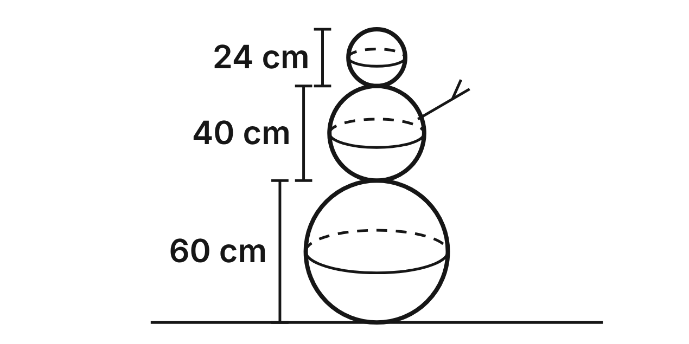
A snowman is made of three balls of snow, each a sphere. From the bottom up, their diameters are 60 cm, 40 cm and 24 cm.
505. What is the volume of the bottom ball, in terms of π?
A. 36,000π cm³ ✔
B. 27,000π cm³
C. 3,600π cm³
D. 288,000π cm³
G.DF.1 · skill G.DF.1.2 (LOTS): Find the surface area and volume of prisms, cylinders, cones, pyramids and spheres
☐ Answer key correct ☐ Wording clear Notes: ________________________________
506. How much snow is in the whole snowman, to the nearest liter? Use 1 L = 1,000 cm³.
A. 998 L
B. 1,231 L
C. 154 L ✔
D. 115 L
G.DF.1 · skill G.DF.1.3 (HOTS): Solve multistep contextual problems with surface area and volume, including composite figures
☐ Answer key correct ☐ Wording clear Notes: ________________________________
507. Another snowball, also 60 cm across, has its top sliced off flat. The flat face is a circle with a radius of 18 cm. How far is that flat face from the center of the ball?
A. 6 cm
B. 12 cm
C. 24 cm ✔
D. about 35.0 cm
G.DF.1 · skill G.DF.1.1 (LOTS): Identify the two-dimensional cross sections and nets of three-dimensional figures
☐ Answer key correct ☐ Wording clear Notes: ________________________________
508. What is the surface area of the head, the top ball, in terms of π?
A. 288π cm²
B. 144π cm²
C. 2,304π cm²
D. 576π cm² ✔
G.DF.1 · skill G.DF.1.2 (LOTS): Find the surface area and volume of prisms, cylinders, cones, pyramids and spheres
☐ Answer key correct ☐ Wording clear Notes: ________________________________
509. A sled carries 18 L of packed snow per trip. How many trips bring enough snow for the whole snowman? Use 1 L = 1,000 cm³.
A. 8
B. 9 ✔
C. 69
D. 7
G.DF.1 · skill G.DF.1.3 (HOTS): Solve multistep contextual problems with surface area and volume, including composite figures
☐ Answer key correct ☐ Wording clear Notes: ________________________________
510. Which statement about cross sections of the snowballs is true?
A. A plane through the center of the middle ball makes a circle with radius 40 cm.
B. Every plane that cuts through a ball makes a circle. ✔
C. A slanted plane cuts a ball in an oval that is not a circle.
D. A cut 25 cm from the bottom ball's center makes a bigger circle than a cut 15 cm from it.
G.DF.1 · skill G.DF.1.1 (LOTS): Identify the two-dimensional cross sections and nets of three-dimensional figures
☐ Answer key correct ☐ Wording clear Notes: ________________________________

The Corner Planter
Level 2 · 3-D figures · G.DF.1 · ID geo-df1-worms-corner-planter
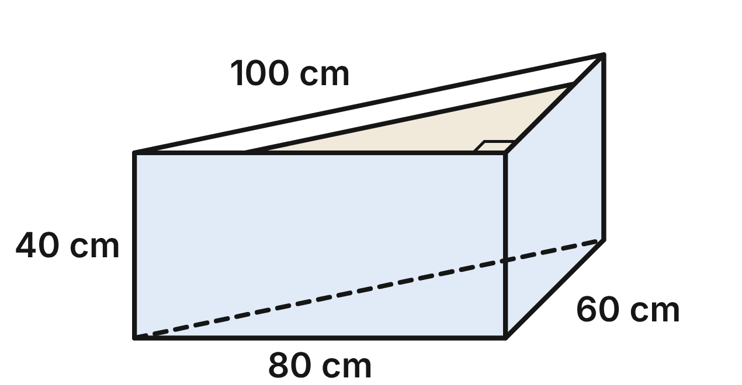
A corner planter is a prism with no top. Its floor is a right triangle: the two walls that meet at the right-angled corner are 60 cm and 80 cm long, and the third wall is 100 cm long. The walls are 40 cm tall. Ignore the thickness of the boards. Soil fills it to 5 cm below the top.
511. How much soil would fill the planter to the very top?
A. 96,000 cm³ ✔
B. 192,000 cm³
C. 160,000 cm³
D. 2,400 cm³
G.DF.1 · skill G.DF.1.2 (LOTS): Find the surface area and volume of prisms, cylinders, cones, pyramids and spheres
☐ Answer key correct ☐ Wording clear Notes: ________________________________
512. Potting soil comes in 25 L bags. How many bags are needed to fill the planter to 5 cm below the top? Use 1 L = 1,000 cm³.
A. 3
B. 7
C. 4 ✔
D. 6
G.DF.1 · skill G.DF.1.3 (HOTS): Solve multistep contextual problems with surface area and volume, including composite figures
☐ Answer key correct ☐ Wording clear Notes: ________________________________
513. Which shapes make up a net of the planter, which has no top?
A. 2 right triangles and 3 rectangles
B. 1 right triangle and 3 rectangles ✔
C. 1 right triangle and 2 rectangles
D. 3 right triangles and 1 rectangle
G.DF.1 · skill G.DF.1.1 (LOTS): Identify the two-dimensional cross sections and nets of three-dimensional figures
☐ Answer key correct ☐ Wording clear Notes: ________________________________
514. How much board makes the three walls and the floor?
A. 12,000 cm² ✔
B. 8,000 cm²
C. 14,400 cm²
D. 9,600 cm²
G.DF.1 · skill G.DF.1.2 (LOTS): Find the surface area and volume of prisms, cylinders, cones, pyramids and spheres
☐ Answer key correct ☐ Wording clear Notes: ________________________________
515. A vertical plane parallel to the 60 cm wall cuts the planter halfway along the 80 cm wall. What is the cross section?
A. a rectangle 50 cm by 40 cm
B. a rectangle 40 cm by 40 cm
C. a rectangle 60 cm by 40 cm
D. a rectangle 30 cm by 40 cm ✔
G.DF.1 · skill G.DF.1.1 (LOTS): Identify the two-dimensional cross sections and nets of three-dimensional figures
☐ Answer key correct ☐ Wording clear Notes: ________________________________
516. Which statement about the planter is NOT true?
A. The 100 cm wall has more area than either of the other walls.
B. The 100 cm wall has the same area as the other two walls together. ✔
C. The floor and the top rim are congruent triangles.
D. A level plane cuts it in a right triangle with legs 60 cm and 80 cm.
G.DF.1 · skill G.DF.1.2 (LOTS): Find the surface area and volume of prisms, cylinders, cones, pyramids and spheres
☐ Answer key correct ☐ Wording clear Notes: ________________________________

The Termite Mound
Level 2 · 3-D figures · G.DF.1 · ID geo-df1-worms-termite-mound
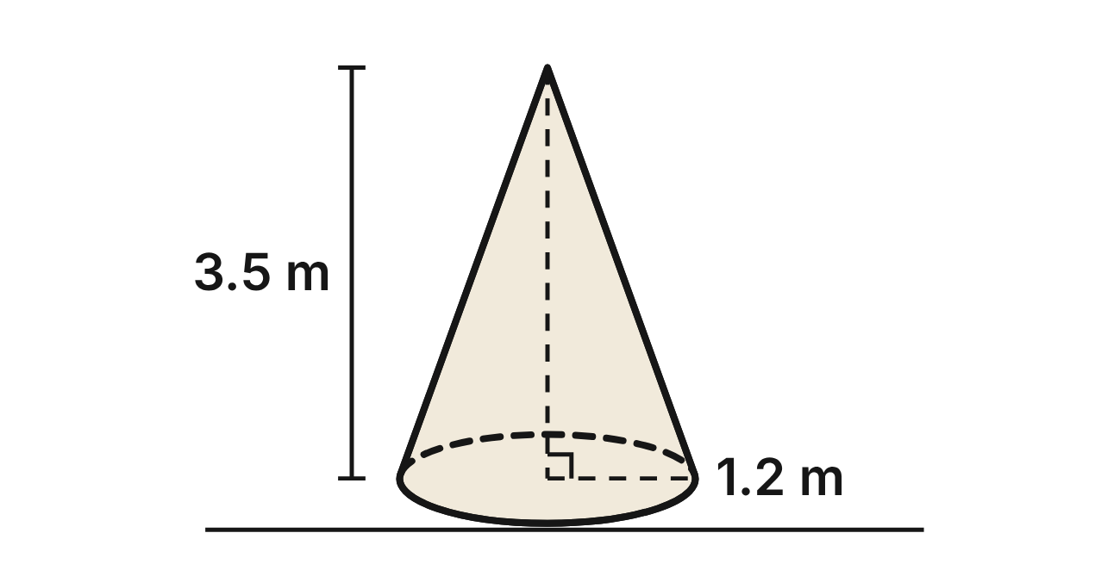
A termite mound on the savanna is shaped like a cone. Its base has a radius of 1.2 m, and it is 3.5 m tall.
517. What is the slant height of the termite mound?
A. about 3.3 m
B. 2.3 m
C. 4.7 m
D. 3.7 m ✔
G.DF.1 · skill G.DF.1.2 (LOTS): Find the surface area and volume of prisms, cylinders, cones, pyramids and spheres
☐ Answer key correct ☐ Wording clear Notes: ________________________________
518. What is the volume of the mound, to the nearest tenth of a cubic meter?
A. 15.8 m³
B. 21.1 m³
C. 5.6 m³
D. 5.3 m³ ✔
G.DF.1 · skill G.DF.1.2 (LOTS): Find the surface area and volume of prisms, cylinders, cones, pyramids and spheres
☐ Answer key correct ☐ Wording clear Notes: ________________________________
519. A vertical plane cuts the mound through its top and the center of its base. What is the cross section?
A. a circle with radius 1.2 m
B. a triangle with base 1.2 m and height 3.5 m
C. a triangle with base 2.4 m and height 3.5 m ✔
D. a rectangle 2.4 m by 3.5 m
G.DF.1 · skill G.DF.1.1 (LOTS): Identify the two-dimensional cross sections and nets of three-dimensional figures
☐ Answer key correct ☐ Wording clear Notes: ________________________________
520. A level plane cuts the mound 2.1 m above the ground. What is the radius of the cross section?
A. 0.6 m
B. 0.48 m ✔
C. 0.72 m
D. 1.2 m
G.DF.1 · skill G.DF.1.1 (LOTS): Identify the two-dimensional cross sections and nets of three-dimensional figures
☐ Answer key correct ☐ Wording clear Notes: ________________________________
521. What is the area of the mound's curved outer surface, in terms of π?
A. 4.44π m² ✔
B. 4.2π m²
C. 8.88π m²
D. 5.88π m²
G.DF.1 · skill G.DF.1.2 (LOTS): Find the surface area and volume of prisms, cylinders, cones, pyramids and spheres
☐ Answer key correct ☐ Wording clear Notes: ________________________________
522. Dried mound mud has a mass of about 1,400 kg per cubic meter. What is the mass of the mound, to the nearest 100 kg?
A. 7,800 kg
B. 11,100 kg
C. 7,400 kg ✔
D. 22,200 kg
G.DF.1 · skill G.DF.1.3 (HOTS): Solve multistep contextual problems with surface area and volume, including composite figures
☐ Answer key correct ☐ Wording clear Notes: ________________________________

The Fallen Tree Trunk
Level 3 · 3-D figures · G.DF.1 · ID geo-df1-worms-tree-trunk
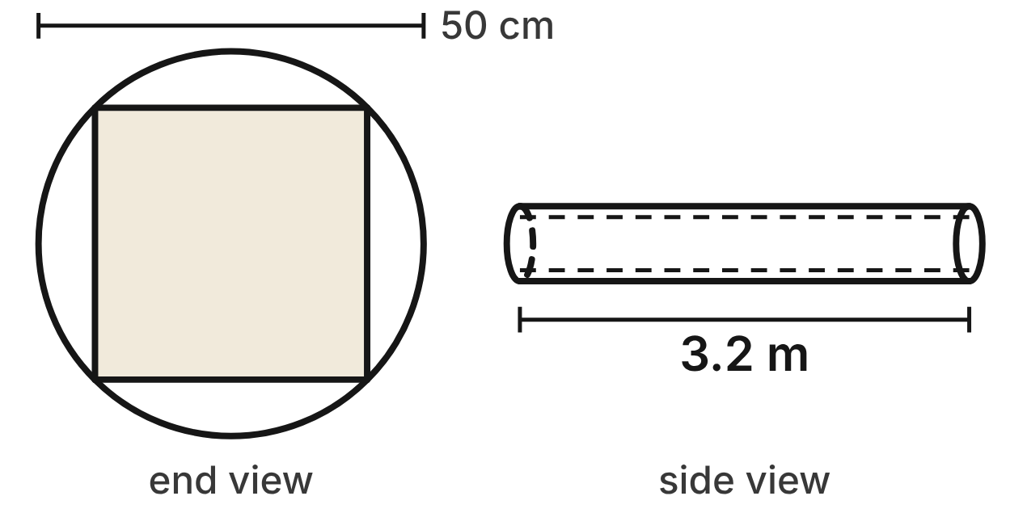
Not drawn to scale
A fallen tree trunk is a cylinder 50 cm across and 3.2 m long. A sawmill cuts the largest possible square beam from it: the beam runs the whole length, and the corners of its square ends lie on the circular ends of the trunk.
523. How long is each side of the beam's square end?
A. 50 cm
B. 25√2 cm ✔
C. 25 cm
D. 50√2 cm
G.DF.1 · skill G.DF.1.1 (LOTS): Identify the two-dimensional cross sections and nets of three-dimensional figures
☐ Answer key correct ☐ Wording clear Notes: ________________________________
524. What is the volume of the trunk, to the nearest hundredth of a cubic meter?
A. 0.21 m³
B. 5.03 m³
C. 2.51 m³
D. 0.63 m³ ✔
G.DF.1 · skill G.DF.1.2 (LOTS): Find the surface area and volume of prisms, cylinders, cones, pyramids and spheres
☐ Answer key correct ☐ Wording clear Notes: ________________________________
525. What is the volume of the beam, to the nearest hundredth of a cubic meter?
A. 0.20 m³
B. 1.60 m³
C. 0.40 m³ ✔
D. 0.80 m³
G.DF.1 · skill G.DF.1.2 (LOTS): Find the surface area and volume of prisms, cylinders, cones, pyramids and spheres
☐ Answer key correct ☐ Wording clear Notes: ________________________________
526. What percent of the trunk's wood is cut away when the beam is made, to the nearest percent?
A. 68%
B. 64%
C. 36% ✔
D. 57%
G.DF.1 · skill G.DF.1.3 (HOTS): Solve multistep contextual problems with surface area and volume, including composite figures
☐ Answer key correct ☐ Wording clear Notes: ________________________________
527. Bark covers the curved surface of the trunk. What is the area of the bark, to the nearest tenth of a square meter?
A. 5.0 m² ✔
B. 5.4 m²
C. 2.5 m²
D. 0.4 m²
G.DF.1 · skill G.DF.1.2 (LOTS): Find the surface area and volume of prisms, cylinders, cones, pyramids and spheres
☐ Answer key correct ☐ Wording clear Notes: ________________________________
528. A plane cuts the beam along its whole length, through two opposite long edges. What is the cross section?
A. a rectangle 50 cm by 3.2 m ✔
B. a rectangle 50√2 cm by 3.2 m
C. a square with sides of 50 cm
D. a rectangle 25 cm by 3.2 m
G.DF.1 · skill G.DF.1.1 (LOTS): Identify the two-dimensional cross sections and nets of three-dimensional figures
☐ Answer key correct ☐ Wording clear Notes: ________________________________

The Woodpile
Level 3 · 3-D figures · G.DF.1 · ID geo-df1-worms-woodpile
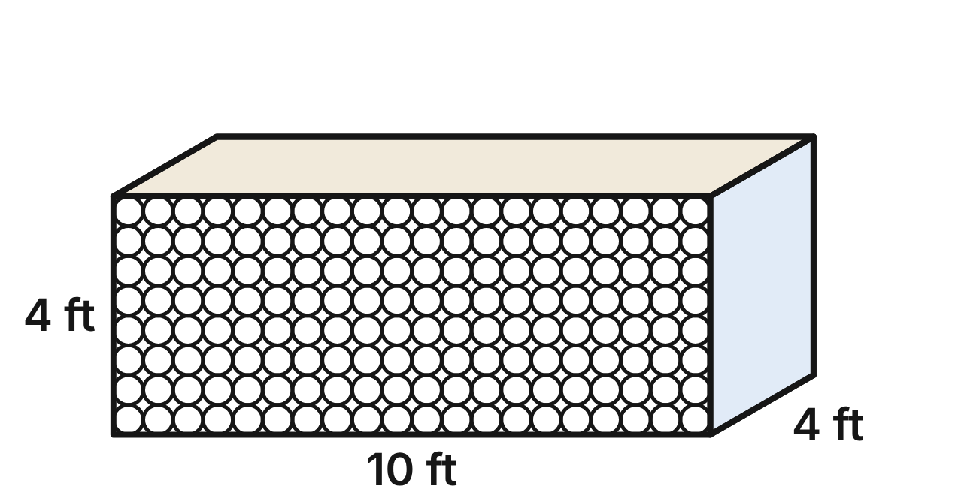
A woodpile is shaped like a rectangular prism 10 ft long, 4 ft tall and 4 ft deep. Each log is a cylinder 6 in across and 4 ft long. The logs are stacked in straight rows and columns, touching each other and filling the pile from edge to edge. Use 1 ft = 12 in.
529. What is the volume of one log, in terms of π?
A. 2π ft³
B. π ft³
C. 36π ft³
D. 0.25π ft³ ✔
G.DF.1 · skill G.DF.1.2 (LOTS): Find the surface area and volume of prisms, cylinders, cones, pyramids and spheres
☐ Answer key correct ☐ Wording clear Notes: ________________________________
530. A vertical plane parallel to the front of the pile cuts through it 1 ft behind the front. What does the cross section look like?
A. 160 circles, each 6 in across ✔
B. 160 rectangles, each 6 in by 4 ft
C. one 10 ft by 4 ft rectangle
D. 160 circles, each 3 in across
G.DF.1 · skill G.DF.1.1 (LOTS): Identify the two-dimensional cross sections and nets of three-dimensional figures
☐ Answer key correct ☐ Wording clear Notes: ________________________________
531. How much of the pile's space is wood, to the nearest cubic foot?
A. 160 ft³
B. 126 ft³ ✔
C. 34 ft³
D. 503 ft³
G.DF.1 · skill G.DF.1.3 (HOTS): Solve multistep contextual problems with surface area and volume, including composite figures
☐ Answer key correct ☐ Wording clear Notes: ________________________________
532. Dry oak weighs about 40 lb per cubic foot of solid wood. What do the logs weigh, to the nearest 10 lb?
A. 1,370 lb
B. 5,030 lb ✔
C. 20,110 lb
D. 6,400 lb
G.DF.1 · skill G.DF.1.3 (HOTS): Solve multistep contextual problems with surface area and volume, including composite figures
☐ Answer key correct ☐ Wording clear Notes: ________________________________
533. Bark covers the curved side of every log. What is the total area of the bark, to the nearest square foot?
A. 503 ft²
B. 1,068 ft²
C. 1,005 ft² ✔
D. 2,011 ft²
G.DF.1 · skill G.DF.1.2 (LOTS): Find the surface area and volume of prisms, cylinders, cones, pyramids and spheres
☐ Answer key correct ☐ Wording clear Notes: ________________________________
534. A wood stove burns 0.9 ft³ of wood a day. For how many full days will the logs last?
A. 177
B. 38
C. 140
D. 139 ✔
G.DF.1 · skill G.DF.1.3 (HOTS): Solve multistep contextual problems with surface area and volume, including composite figures
☐ Answer key correct ☐ Wording clear Notes: ________________________________

G.DF.2 · Determine how changes in one or more dimensions affect perimeter, area, surface area, and volume, and solve problems with similar two- and three-dimensional figures.

Building a Snowman
Level 1 · Changing dimensions · G.DF.2 · ID geo-df2-worms-snowman
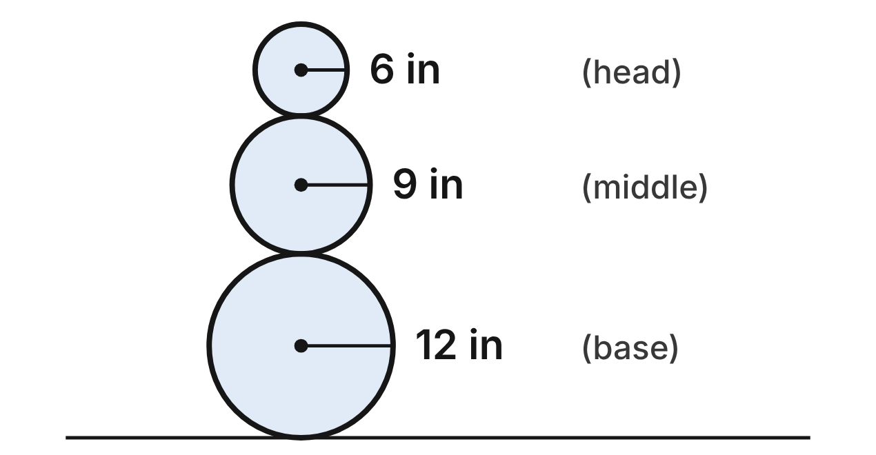
A snowman is made of three snowballs, each a sphere. Their radii are 6 in (head), 9 in (middle) and 12 in (base). The head has a surface area of 144π in² and a volume of 288π in³.
535. The base has twice the radius of the head. What is the volume of the base?
A. 1,728π in³
B. 1,152π in³
C. 2,304π in³ ✔
D. 576π in³
G.DF.2 · skill G.DF.2.2 (LOTS): Use the ratios k, k² and k³ of similar figures to find lengths, areas and volumes
☐ Answer key correct ☐ Wording clear Notes: ________________________________
536. What is the ratio of the middle snowball's surface area to the head's surface area?
A. 27 : 8
B. 3 : 2
C. 4 : 9
D. 9 : 4 ✔
G.DF.2 · skill G.DF.2.2 (LOTS): Use the ratios k, k² and k³ of similar figures to find lengths, areas and volumes
☐ Answer key correct ☐ Wording clear Notes: ________________________________
537. Which statement about the three snowballs is true?
A. Only the head and the base are similar, because 12/6 is a whole number.
B. Any two of them are similar, because all spheres are similar. ✔
C. The head and the base are similar, with a volume ratio of 2.
D. None of them are similar, because their radii are different.
G.DF.2 · skill G.DF.2.3 (HOTS): Decide whether two figures are similar and justify the decision with ratios of corresponding measures
☐ Answer key correct ☐ Wording clear Notes: ________________________________
538. A mini snowman is similar to this one, and its base has a radius of 3 in. What is the radius of its head?
A. 0.375 in
B. 0.75 in
C. 1.5 in ✔
D. 6 in
G.DF.2 · skill G.DF.2.2 (LOTS): Use the ratios k, k² and k³ of similar figures to find lengths, areas and volumes
☐ Answer key correct ☐ Wording clear Notes: ________________________________
539. Kids roll the head in more snow until its radius is 9 in. How much more snow is in the head now than before?
A. 684π in³ ✔
B. 144π in³
C. 972π in³
D. 360π in³
G.DF.2 · skill G.DF.2.1 (LOTS): Describe how changing one or more dimensions of a figure changes its perimeter, area, surface area or volume
☐ Answer key correct ☐ Wording clear Notes: ________________________________
540. The head's widest circumference is 12π in. What is the widest circumference of the base?
A. 48π in
B. 96π in
C. 144π in
D. 24π in ✔
G.DF.2 · skill G.DF.2.2 (LOTS): Use the ratios k, k² and k³ of similar figures to find lengths, areas and volumes
☐ Answer key correct ☐ Wording clear Notes: ________________________________

The Raised Garden Bed
Level 1 · Changing dimensions · G.DF.2 · ID geo-df2-worms-raised-bed
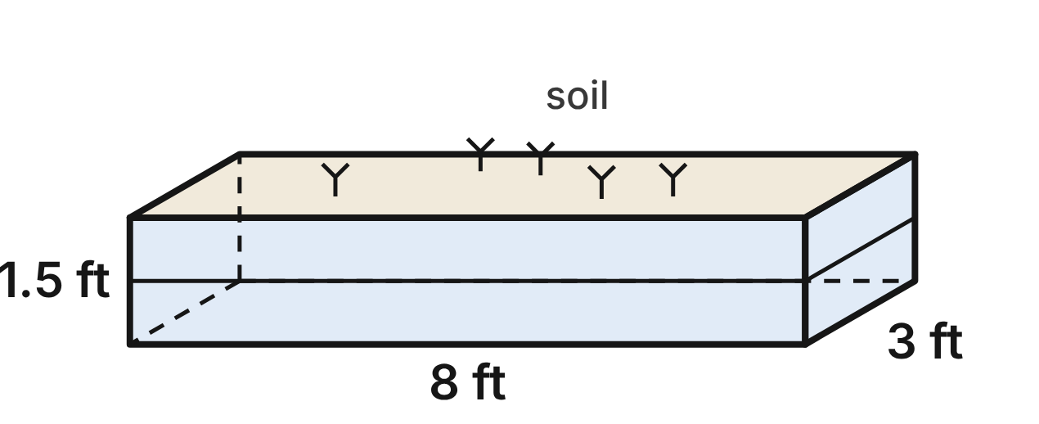
A raised garden bed is a wooden frame with no top or bottom, 8 ft long, 3 ft wide and 1.5 ft deep. It holds 36 ft³ of soil. Its four wooden sides have an area of 33 ft², and its top is 24 ft² of planting space.
541. A second bed is 16 ft long, 3 ft wide and 1.5 ft deep. How much soil does it hold?
A. 72 ft³ ✔
B. 44 ft³
C. 288 ft³
D. 144 ft³
G.DF.2 · skill G.DF.2.1 (LOTS): Describe how changing one or more dimensions of a figure changes its perimeter, area, surface area or volume
☐ Answer key correct ☐ Wording clear Notes: ________________________________
542. The gardener makes the bed 3 ft deep instead of 1.5 ft, with the same 8 ft length and 3 ft width. What is the area of its four wooden sides?
A. 264 ft²
B. 33 ft²
C. 66 ft² ✔
D. 132 ft²
G.DF.2 · skill G.DF.2.1 (LOTS): Describe how changing one or more dimensions of a figure changes its perimeter, area, surface area or volume
☐ Answer key correct ☐ Wording clear Notes: ________________________________
543. A kids' bed is similar to this bed, with every length half as long. How much soil does it hold?
A. 9 ft³
B. 72 ft³
C. 18 ft³
D. 4.5 ft³ ✔
G.DF.2 · skill G.DF.2.2 (LOTS): Use the ratios k, k² and k³ of similar figures to find lengths, areas and volumes
☐ Answer key correct ☐ Wording clear Notes: ________________________________
544. A bed kit is 12 ft long, 4.5 ft wide and 2 ft deep. Is it similar to this bed? Choose the answer with the correct reason.
A. Yes: 12/8 = 4.5/3 = 2/1.5 = 1.5.
B. Yes: its planting space is 1.5 times as large.
C. No: 12/8 = 4.5/3 = 1.5, but 2/1.5 ≈ 1.33. ✔
D. No: 12/8 = 1.5, but 4.5/3 = 1.4.
G.DF.2 · skill G.DF.2.3 (HOTS): Decide whether two figures are similar and justify the decision with ratios of corresponding measures
☐ Answer key correct ☐ Wording clear Notes: ________________________________
545. Which change to the bed gives it room for 4 times as much soil?
A. Add 4 ft to the length; keep the width and the depth.
B. Double the length and the width; keep the depth. ✔
C. Double the length, the width and the depth.
D. Double the length; keep the width and the depth.
G.DF.2 · skill G.DF.2.1 (LOTS): Describe how changing one or more dimensions of a figure changes its perimeter, area, surface area or volume
☐ Answer key correct ☐ Wording clear Notes: ________________________________
546. A bigger bed is similar to this bed and has 96 ft² of planting space on top. How deep is it?
A. 3 ft ✔
B. 12 ft
C. 4 ft
D. 6 ft
G.DF.2 · skill G.DF.2.2 (LOTS): Use the ratios k, k² and k³ of similar figures to find lengths, areas and volumes
☐ Answer key correct ☐ Wording clear Notes: ________________________________

The Backyard Fish Pond
Level 2 · Changing dimensions · G.DF.2 · ID geo-df2-worms-fish-pond
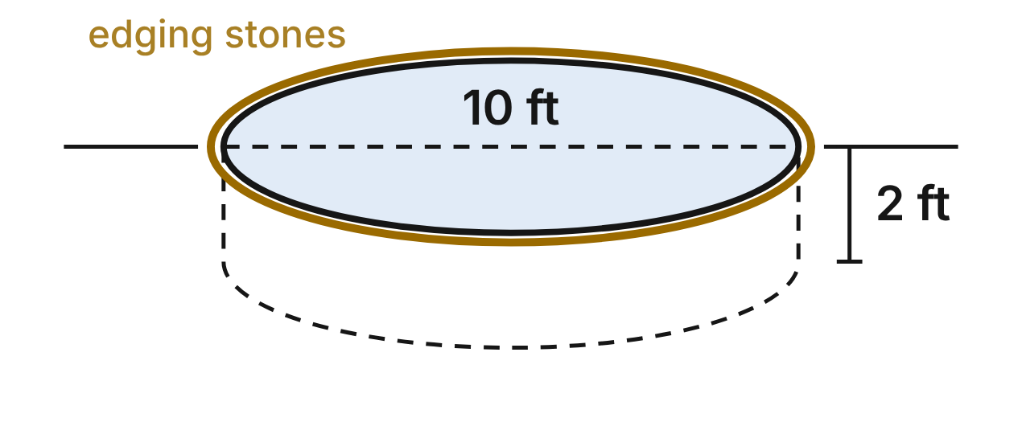
A backyard fish pond is a cylinder 10 ft across (radius 5 ft) and 2 ft deep. It holds 50π ft³ of water. Its liner covers the floor and the side: 45π ft². A ring of edging stones runs around its rim, 10π ft long.
547. The owner digs the pond deeper, 3 ft instead of 2 ft, and keeps the 10 ft width. How much water does it hold?
A. 168.75π ft³
B. 75π ft³ ✔
C. 112.5π ft³
D. 300π ft³
G.DF.2 · skill G.DF.2.1 (LOTS): Describe how changing one or more dimensions of a figure changes its perimeter, area, surface area or volume
☐ Answer key correct ☐ Wording clear Notes: ________________________________
548. The owner widens the pond to 20 ft across and keeps it 2 ft deep. How much liner does it need for the floor and the side?
A. 90π ft²
B. 360π ft²
C. 180π ft²
D. 140π ft² ✔
G.DF.2 · skill G.DF.2.1 (LOTS): Describe how changing one or more dimensions of a figure changes its perimeter, area, surface area or volume
☐ Answer key correct ☐ Wording clear Notes: ________________________________
549. A small patio pond is similar to this pond and is 6 ft across. How much water does it hold?
A. 10.8π ft³ ✔
B. 30π ft³
C. 18π ft³
D. 43.2π ft³
G.DF.2 · skill G.DF.2.2 (LOTS): Use the ratios k, k² and k³ of similar figures to find lengths, areas and volumes
☐ Answer key correct ☐ Wording clear Notes: ________________________________
550. A neighbor's pond is a cylinder 8 ft across and 1.5 ft deep. Is it similar to this pond? Choose the answer with the correct reason.
A. Yes: both are cylinders, so they are similar.
B. No: 8/10 = 0.8, but 1.5/2 = 0.75. ✔
C. No: 8/10 = 0.8, but 1.5/2 = 0.5.
D. Yes: 8/10 = 1.5/2 = 0.8.
G.DF.2 · skill G.DF.2.3 (HOTS): Decide whether two figures are similar and justify the decision with ratios of corresponding measures
☐ Answer key correct ☐ Wording clear Notes: ________________________________
551. A larger pond is similar to this pond, and its ring of edging stones is 25π ft long. How deep is it?
A. 12.5 ft
B. 31.25 ft
C. 5 ft ✔
D. 4.5 ft
G.DF.2 · skill G.DF.2.2 (LOTS): Use the ratios k, k² and k³ of similar figures to find lengths, areas and volumes
☐ Answer key correct ☐ Wording clear Notes: ________________________________
552. Another pond is similar to this pond and holds 400π ft³ of water. How wide is it across?
A. 10 ft
B. about 28.3 ft
C. 80 ft
D. 20 ft ✔
G.DF.2 · skill G.DF.2.2 (LOTS): Use the ratios k, k² and k³ of similar figures to find lengths, areas and volumes
☐ Answer key correct ☐ Wording clear Notes: ________________________________

Eggs at the Nature Center
Level 2 · Changing dimensions · G.DF.2 · ID geo-df2-worms-bird-eggs
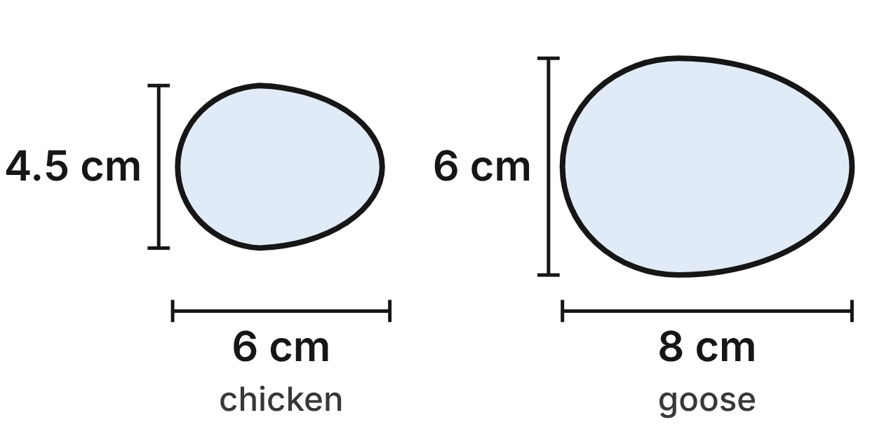
A nature center shows bird eggs. Eggs with the same shape are similar solids. A chicken egg is 6 cm long and 4.5 cm wide. Its shell has an area of 63 cm², and it holds 54 cm³. A goose egg has the same shape: it is 8 cm long and 6 cm wide.
553. Only one of these eggs could have the same shape as the chicken egg. Which one?
A. 9 cm long and 6 cm wide
B. 5 cm long and 3.5 cm wide
C. 6 cm long and 3 cm wide
D. 4.8 cm long and 3.6 cm wide ✔
G.DF.2 · skill G.DF.2.3 (HOTS): Decide whether two figures are similar and justify the decision with ratios of corresponding measures
☐ Answer key correct ☐ Wording clear Notes: ________________________________
554. How much does the goose egg hold?
A. 128 cm³ ✔
B. 40.5 cm³
C. 72 cm³
D. 96 cm³
G.DF.2 · skill G.DF.2.2 (LOTS): Use the ratios k, k² and k³ of similar figures to find lengths, areas and volumes
☐ Answer key correct ☐ Wording clear Notes: ________________________________
555. What is the ratio of the goose egg's shell area to the chicken egg's shell area?
A. 64 : 27
B. 16 : 9 ✔
C. 4 : 3
D. 9 : 16
G.DF.2 · skill G.DF.2.2 (LOTS): Use the ratios k, k² and k³ of similar figures to find lengths, areas and volumes
☐ Answer key correct ☐ Wording clear Notes: ________________________________
556. A duck egg is 7.5 cm long and 5 cm wide. Is it similar to the chicken egg? Choose the answer with the correct reason.
A. Yes: each length is 1.5 cm more.
B. Yes: 7.5/6 = 5/4.5 = 1.25.
C. No: 7.5/6 = 1.25, but 5/4.5 = 0.9.
D. No: 7.5/6 = 1.25, but 5/4.5 ≈ 1.11. ✔
G.DF.2 · skill G.DF.2.3 (HOTS): Decide whether two figures are similar and justify the decision with ratios of corresponding measures
☐ Answer key correct ☐ Wording clear Notes: ________________________________
557. A robin's egg has the same shape as the chicken egg and holds 6.75 cm³. How long is it?
A. about 2.1 cm
B. 0.75 cm
C. 3 cm ✔
D. 12 cm
G.DF.2 · skill G.DF.2.2 (LOTS): Use the ratios k, k² and k³ of similar figures to find lengths, areas and volumes
☐ Answer key correct ☐ Wording clear Notes: ________________________________
558. A turkey egg has the same shape as the chicken egg, and its shell has an area of 90.72 cm². How wide is it?
A. 5.4 cm ✔
B. 6.48 cm
C. 3.75 cm
D. 7.2 cm
G.DF.2 · skill G.DF.2.2 (LOTS): Use the ratios k, k² and k³ of similar figures to find lengths, areas and volumes
☐ Answer key correct ☐ Wording clear Notes: ________________________________

The Garden Shed
Level 2 · Changing dimensions · G.DF.2 · ID geo-df2-worms-garden-shed
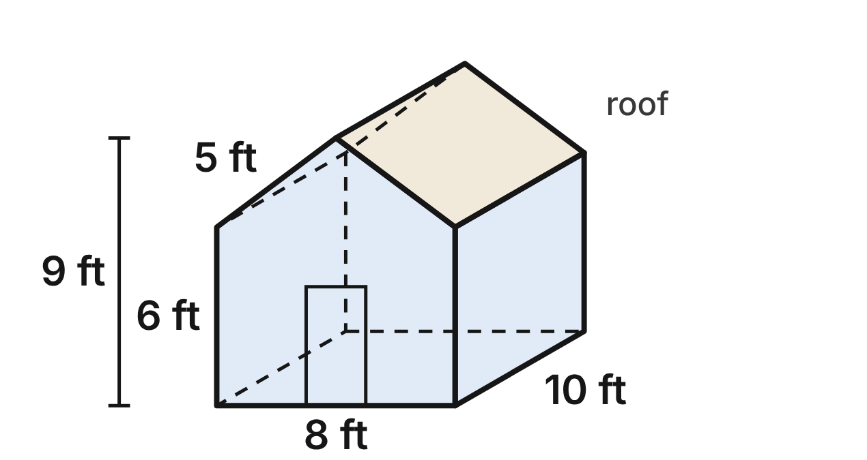
A garden shed is a pentagonal prism. Its front is a rectangle 8 ft wide and 6 ft tall with a triangle on top. The peak is 9 ft above the ground, and each roof slope is 5 ft long. The shed is 10 ft deep. Its front has an area of 60 ft², it encloses 600 ft³, and its two roof panels have an area of 100 ft².
559. A longer shed has the same front but is 15 ft deep. What is its volume?
A. 300 ft³
B. 1,350 ft³
C. 900 ft³ ✔
D. 2,025 ft³
G.DF.2 · skill G.DF.2.1 (LOTS): Describe how changing one or more dimensions of a figure changes its perimeter, area, surface area or volume
☐ Answer key correct ☐ Wording clear Notes: ________________________________
560. A taller shed keeps the 8 ft width, the 10 ft depth and the same roof triangle, but its walls are 8 ft tall instead of 6 ft. What is its volume?
A. 800 ft³
B. 760 ft³ ✔
C. 640 ft³
D. 840 ft³
G.DF.2 · skill G.DF.2.1 (LOTS): Describe how changing one or more dimensions of a figure changes its perimeter, area, surface area or volume
☐ Answer key correct ☐ Wording clear Notes: ________________________________
561. A playhouse is similar to the shed at a scale of 1 : 2. How much space does it enclose?
A. 75 ft³ ✔
B. 150 ft³
C. 300 ft³
D. 1,200 ft³
G.DF.2 · skill G.DF.2.2 (LOTS): Use the ratios k, k² and k³ of similar figures to find lengths, areas and volumes
☐ Answer key correct ☐ Wording clear Notes: ________________________________
562. A barn is similar to the shed, and its front has an area of 540 ft². How tall is the barn at its peak?
A. 12 ft
B. 18 ft
C. 27 ft ✔
D. 81 ft
G.DF.2 · skill G.DF.2.2 (LOTS): Use the ratios k, k² and k³ of similar figures to find lengths, areas and volumes
☐ Answer key correct ☐ Wording clear Notes: ________________________________
563. A shed kit has a front 12 ft wide with 9 ft walls and a peak 13.5 ft above the ground, and it is 16 ft deep. Is it similar to this shed? Choose the answer with the correct reason.
A. No: 12/8 = 1.5, but 9/6 = 1.6.
B. Yes: the fronts are similar, so the sheds are similar.
C. Yes: every ratio is 1.5.
D. No: the front ratios are all 1.5, but 16/10 = 1.6. ✔
G.DF.2 · skill G.DF.2.3 (HOTS): Decide whether two figures are similar and justify the decision with ratios of corresponding measures
☐ Answer key correct ☐ Wording clear Notes: ________________________________
564. The owner wants a shed with twice as much space as this one. Which plan works?
A. Make the walls 12 ft tall with the same roof.
B. Make it 20 ft deep with the same front. ✔
C. Double every length of the shed.
D. Double the width and the depth.
G.DF.2 · skill G.DF.2.1 (LOTS): Describe how changing one or more dimensions of a figure changes its perimeter, area, surface area or volume
☐ Answer key correct ☐ Wording clear Notes: ________________________________

The Silo and the Hay Bales
Level 3 · Changing dimensions · G.DF.2 · ID geo-df2-worms-silo-bales
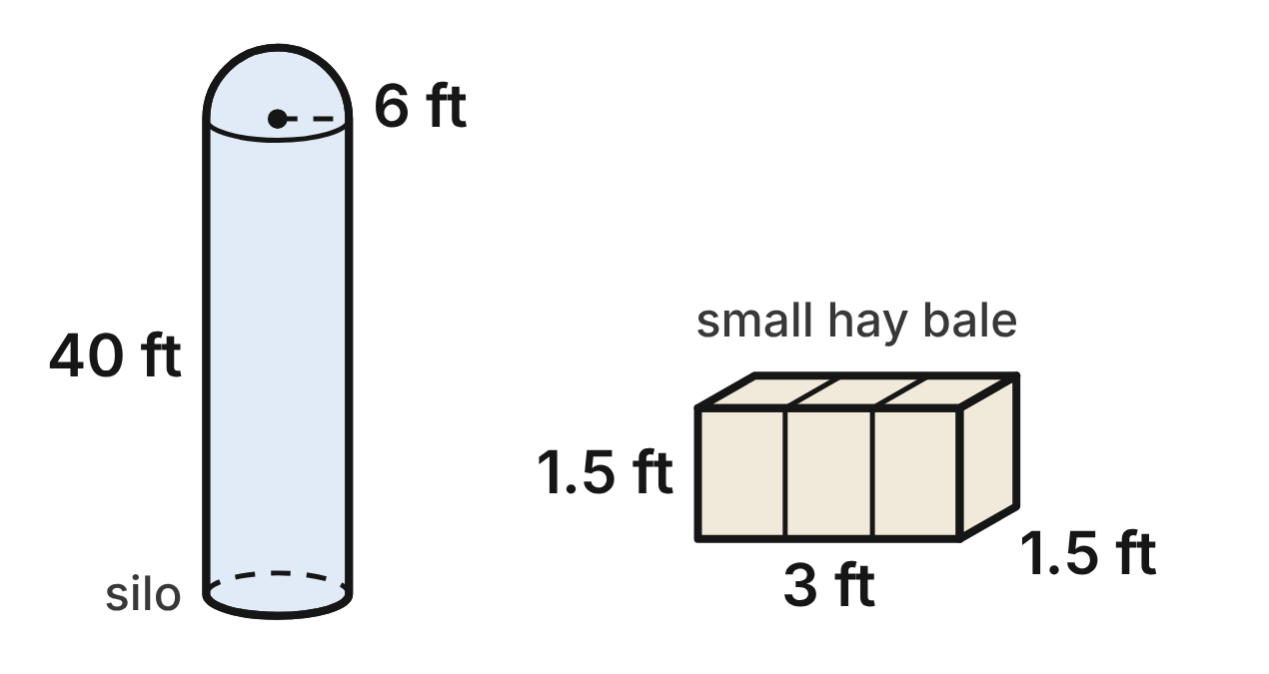
The silo and the bale are not drawn to the same scale.
A farm stores grain in a silo: a cylinder with a radius of 6 ft and walls 40 ft tall, topped by a half-sphere dome. The silo holds 1,584π ft³, and its painted outside (side and dome) is 552π ft². A small hay bale is a box 3 ft long, 1.5 ft wide and 1.5 ft tall.
565. A smaller silo is similar to this one and is 23 ft tall from the ground to the top of its dome. How much does it hold?
A. 198π ft³ ✔
B. 396π ft³
C. 792π ft³
D. 864π ft³
G.DF.2 · skill G.DF.2.2 (LOTS): Use the ratios k, k² and k³ of similar figures to find lengths, areas and volumes
☐ Answer key correct ☐ Wording clear Notes: ________________________________
566. The farmer builds the silo's walls 10 ft higher, to 50 ft, with the same radius and dome. How much more grain does it hold now?
A. 396π ft³
B. 360π ft³ ✔
C. 1,944π ft³
D. 120π ft³
G.DF.2 · skill G.DF.2.1 (LOTS): Describe how changing one or more dimensions of a figure changes its perimeter, area, surface area or volume
☐ Answer key correct ☐ Wording clear Notes: ________________________________
567. A big hay bale is a box 8 ft long, 4 ft wide and 3 ft tall. Is it similar to the small bale? Choose the answer with the correct reason.
A. Yes: both bales are boxes, so they are similar.
B. Yes: every ratio is about 2.67.
C. No: 8/3 ≈ 2.67, but 4/1.5 = 2.
D. No: 8/3 = 4/1.5 ≈ 2.67, but 3/1.5 = 2. ✔
G.DF.2 · skill G.DF.2.3 (HOTS): Decide whether two figures are similar and justify the decision with ratios of corresponding measures
☐ Answer key correct ☐ Wording clear Notes: ________________________________
568. A display bale at a fall festival is similar to the small bale and holds 182.25 ft³ of hay. How long is it?
A. 81 ft
B. 9 ft ✔
C. about 15.6 ft
D. 27 ft
G.DF.2 · skill G.DF.2.2 (LOTS): Use the ratios k, k² and k³ of similar figures to find lengths, areas and volumes
☐ Answer key correct ☐ Wording clear Notes: ________________________________
569. A small bale weighs 45 lb and costs $6. A bale similar to it, with every length doubled, costs $40. Which is the better buy per pound of hay?
A. They cost the same per pound, since every length is doubled.
B. The small bale: the doubled bale costs about 6.7 times as much but holds 4 times as much.
C. The doubled bale: it costs about 6.7 times as much but holds 8 times as much. ✔
D. The small bale: the doubled bale costs about 6.7 times as much but holds 2 times as much.
G.DF.2 · skill G.DF.2.2 (LOTS): Use the ratios k, k² and k³ of similar figures to find lengths, areas and volumes
☐ Answer key correct ☐ Wording clear Notes: ________________________________
570. A similar silo has a radius of 4.5 ft. Paint costs $0.40 per square foot. To the nearest dollar, what does it cost to paint its side and dome?
A. $390 ✔
B. $293
C. $694
D. $520
G.DF.2 · skill G.DF.2.2 (LOTS): Use the ratios k, k² and k³ of similar figures to find lengths, areas and volumes
☐ Answer key correct ☐ Wording clear Notes: ________________________________

Logs from One Tree
Level 3 · Changing dimensions · G.DF.2 · ID geo-df2-worms-logs
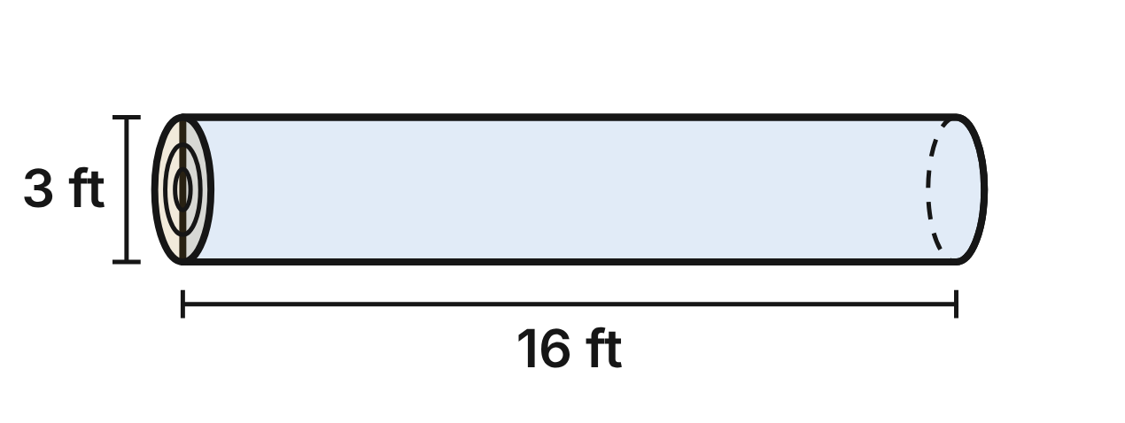
A logger cuts a tree trunk into logs. Treat each log as a cylinder. The first log is 3 ft across (radius 1.5 ft) and 16 ft long. It has 36π ft³ of wood, and its bark (the curved side) covers 48π ft².
571. A log from higher up the tree is 1.5 ft across and still 16 ft long. How much wood does it have?
A. 4.5π ft³
B. 36π ft³
C. 18π ft³
D. 9π ft³ ✔
G.DF.2 · skill G.DF.2.1 (LOTS): Describe how changing one or more dimensions of a figure changes its perimeter, area, surface area or volume
☐ Answer key correct ☐ Wording clear Notes: ________________________________
572. The logger cuts the first log into two logs, each 8 ft long. What is the total bark area of the two shorter logs? (Count only the curved sides.)
A. 12π ft²
B. 24π ft²
C. 48π ft² ✔
D. 96π ft²
G.DF.2 · skill G.DF.2.1 (LOTS): Describe how changing one or more dimensions of a figure changes its perimeter, area, surface area or volume
☐ Answer key correct ☐ Wording clear Notes: ________________________________
573. Which log is similar to the first log?
A. 1.5 ft across and 4 ft long
B. 2.25 ft across and 12 ft long ✔
C. 2 ft across and 15 ft long
D. 3 ft across and 8 ft long
G.DF.2 · skill G.DF.2.3 (HOTS): Decide whether two figures are similar and justify the decision with ratios of corresponding measures
☐ Answer key correct ☐ Wording clear Notes: ________________________________
574. A short log is similar to the first log and has 4.5π ft³ of wood. How long is it?
A. 8 ft ✔
B. about 5.7 ft
C. 4 ft
D. 2 ft
G.DF.2 · skill G.DF.2.2 (LOTS): Use the ratios k, k² and k³ of similar figures to find lengths, areas and volumes
☐ Answer key correct ☐ Wording clear Notes: ________________________________
575. A log similar to the first log is 6 ft across. The wood weighs 40 lb per cubic foot. To the nearest hundred pounds, how much does the log weigh?
A. 18,100 lb
B. 9,000 lb
C. 4,500 lb
D. 36,200 lb ✔
G.DF.2 · skill G.DF.2.2 (LOTS): Use the ratios k, k² and k³ of similar figures to find lengths, areas and volumes
☐ Answer key correct ☐ Wording clear Notes: ________________________________
576. Mia says a log similar to the first log, but 3 times as long, has 3 times as much bark, 144π ft². Which statement is true?
A. Mia is right: 144π ft².
B. It has 27 times as much bark: 1,296π ft².
C. It has 9 times as much bark: 432π ft². ✔
D. It has 6 times as much bark: 288π ft².
G.DF.2 · skill G.DF.2.2 (LOTS): Use the ratios k, k² and k³ of similar figures to find lengths, areas and volumes
☐ Answer key correct ☐ Wording clear Notes: ________________________________

Answer key
Pack | Question | Standard | Skill | Level | Answer
rlt1-worms-campfire | 1 | G.RLT.1 | G.RLT.1.1 LOTS | 1 | C
rlt1-worms-campfire | 2 | G.RLT.1 | G.RLT.1.2 LOTS | 1 | A
rlt1-worms-campfire | 3 | G.RLT.1 | G.RLT.1.2 LOTS | 1 | B
rlt1-worms-campfire | 4 | G.RLT.1 | G.RLT.1.1 LOTS | 1 | D
rlt1-worms-campfire | 5 | G.RLT.1 | G.RLT.1.3 HOTS | 1 | C
rlt1-worms-campfire | 6 | G.RLT.1 | G.RLT.1.3 HOTS | 1 | A
rlt1-worms-bird-feeder | 7 | G.RLT.1 | G.RLT.1.4 LOTS | 1 | B
rlt1-worms-bird-feeder | 8 | G.RLT.1 | G.RLT.1.4 LOTS | 1 | D
rlt1-worms-bird-feeder | 9 | G.RLT.1 | G.RLT.1.4 LOTS | 1 | A
rlt1-worms-bird-feeder | 10 | G.RLT.1 | G.RLT.1.1 LOTS | 1 | C
rlt1-worms-bird-feeder | 11 | G.RLT.1 | G.RLT.1.2 LOTS | 1 | C
rlt1-worms-bird-feeder | 12 | G.RLT.1 | G.RLT.1.1 LOTS | 1 | B
rlt1-worms-tree-key | 13 | G.RLT.1 | G.RLT.1.3 HOTS | 2 | C
rlt1-worms-tree-key | 14 | G.RLT.1 | G.RLT.1.1 LOTS | 2 | B
rlt1-worms-tree-key | 15 | G.RLT.1 | G.RLT.1.1 LOTS | 2 | D
rlt1-worms-tree-key | 16 | G.RLT.1 | G.RLT.1.2 LOTS | 2 | D
rlt1-worms-tree-key | 17 | G.RLT.1 | G.RLT.1.3 HOTS | 2 | A
rlt1-worms-tree-key | 18 | G.RLT.1 | G.RLT.1.3 HOTS | 2 | C
rlt1-worms-garden-grid | 19 | G.RLT.1 | G.RLT.1.4 LOTS | 2 | D
rlt1-worms-garden-grid | 20 | G.RLT.1 | G.RLT.1.4 LOTS | 2 | B
rlt1-worms-garden-grid | 21 | G.RLT.1 | G.RLT.1.2 LOTS | 2 | C
rlt1-worms-garden-grid | 22 | G.RLT.1 | G.RLT.1.2 LOTS | 2 | D
rlt1-worms-garden-grid | 23 | G.RLT.1 | G.RLT.1.3 HOTS | 2 | B
rlt1-worms-garden-grid | 24 | G.RLT.1 | G.RLT.1.4 LOTS | 2 | A
rlt1-worms-pond-sightings | 25 | G.RLT.1 | G.RLT.1.4 LOTS | 2 | C
rlt1-worms-pond-sightings | 26 | G.RLT.1 | G.RLT.1.4 LOTS | 2 | B
rlt1-worms-pond-sightings | 27 | G.RLT.1 | G.RLT.1.2 LOTS | 2 | C
rlt1-worms-pond-sightings | 28 | G.RLT.1 | G.RLT.1.3 HOTS | 2 | D
rlt1-worms-pond-sightings | 29 | G.RLT.1 | G.RLT.1.3 HOTS | 2 | A
rlt1-worms-pond-sightings | 30 | G.RLT.1 | G.RLT.1.1 LOTS | 2 | B
rlt1-worms-river-gauge | 31 | G.RLT.1 | G.RLT.1.3 HOTS | 3 | D
rlt1-worms-river-gauge | 32 | G.RLT.1 | G.RLT.1.3 HOTS | 3 | B
rlt1-worms-river-gauge | 33 | G.RLT.1 | G.RLT.1.3 HOTS | 3 | C
rlt1-worms-river-gauge | 34 | G.RLT.1 | G.RLT.1.1 LOTS | 3 | A
rlt1-worms-river-gauge | 35 | G.RLT.1 | G.RLT.1.3 HOTS | 3 | A
rlt1-worms-river-gauge | 36 | G.RLT.1 | G.RLT.1.2 LOTS | 3 | D
rlt1-worms-orchard | 37 | G.RLT.1 | G.RLT.1.4 LOTS | 3 | B
rlt1-worms-orchard | 38 | G.RLT.1 | G.RLT.1.4 LOTS | 3 | D
rlt1-worms-orchard | 39 | G.RLT.1 | G.RLT.1.4 LOTS | 3 | A
rlt1-worms-orchard | 40 | G.RLT.1 | G.RLT.1.2 LOTS | 3 | C
rlt1-worms-orchard | 41 | G.RLT.1 | G.RLT.1.3 HOTS | 3 | D
rlt1-worms-orchard | 42 | G.RLT.1 | G.RLT.1.4 LOTS | 3 | C
rlt2-worms-corn-rows | 43 | G.RLT.2 | G.RLT.2.1 LOTS | 1 | C
rlt2-worms-corn-rows | 44 | G.RLT.2 | G.RLT.2.3 LOTS | 1 | A
rlt2-worms-corn-rows | 45 | G.RLT.2 | G.RLT.2.3 LOTS | 1 | B
rlt2-worms-corn-rows | 46 | G.RLT.2 | G.RLT.2.1 LOTS | 1 | D
rlt2-worms-corn-rows | 47 | G.RLT.2 | G.RLT.2.3 LOTS | 1 | B
rlt2-worms-corn-rows | 48 | G.RLT.2 | G.RLT.2.2 HOTS | 1 | C
rlt2-worms-ski-tracks | 49 | G.RLT.2 | G.RLT.2.1 LOTS | 1 | A
rlt2-worms-ski-tracks | 50 | G.RLT.2 | G.RLT.2.3 LOTS | 1 | D
rlt2-worms-ski-tracks | 51 | G.RLT.2 | G.RLT.2.1 LOTS | 1 | B
rlt2-worms-ski-tracks | 52 | G.RLT.2 | G.RLT.2.3 LOTS | 1 | C
rlt2-worms-ski-tracks | 53 | G.RLT.2 | G.RLT.2.1 LOTS | 1 | D
rlt2-worms-ski-tracks | 54 | G.RLT.2 | G.RLT.2.2 HOTS | 1 | B
rlt2-worms-orchard-path | 55 | G.RLT.2 | G.RLT.2.3 LOTS | 2 | B
rlt2-worms-orchard-path | 56 | G.RLT.2 | G.RLT.2.3 LOTS | 2 | A
rlt2-worms-orchard-path | 57 | G.RLT.2 | G.RLT.2.3 LOTS | 2 | D
rlt2-worms-orchard-path | 58 | G.RLT.2 | G.RLT.2.1 LOTS | 2 | C
rlt2-worms-orchard-path | 59 | G.RLT.2 | G.RLT.2.2 HOTS | 2 | B
rlt2-worms-orchard-path | 60 | G.RLT.2 | G.RLT.2.1 LOTS | 2 | D
rlt2-worms-rain-hillside | 61 | G.RLT.2 | G.RLT.2.3 LOTS | 2 | C
rlt2-worms-rain-hillside | 62 | G.RLT.2 | G.RLT.2.3 LOTS | 2 | A
rlt2-worms-rain-hillside | 63 | G.RLT.2 | G.RLT.2.1 LOTS | 2 | D
rlt2-worms-rain-hillside | 64 | G.RLT.2 | G.RLT.2.3 LOTS | 2 | B
rlt2-worms-rain-hillside | 65 | G.RLT.2 | G.RLT.2.2 HOTS | 2 | A
rlt2-worms-rain-hillside | 66 | G.RLT.2 | G.RLT.2.1 LOTS | 2 | C
rlt2-worms-river-trails | 67 | G.RLT.2 | G.RLT.2.1 LOTS | 2 | A
rlt2-worms-river-trails | 68 | G.RLT.2 | G.RLT.2.2 HOTS | 2 | C
rlt2-worms-river-trails | 69 | G.RLT.2 | G.RLT.2.3 LOTS | 2 | B
rlt2-worms-river-trails | 70 | G.RLT.2 | G.RLT.2.3 LOTS | 2 | D
rlt2-worms-river-trails | 71 | G.RLT.2 | G.RLT.2.3 LOTS | 2 | C
rlt2-worms-river-trails | 72 | G.RLT.2 | G.RLT.2.1 LOTS | 2 | A
rlt2-worms-hedgerow-proof | 73 | G.RLT.2 | G.RLT.2.2 HOTS | 3 | B
rlt2-worms-hedgerow-proof | 74 | G.RLT.2 | G.RLT.2.2 HOTS | 3 | D
rlt2-worms-hedgerow-proof | 75 | G.RLT.2 | G.RLT.2.2 HOTS | 3 | A
rlt2-worms-hedgerow-proof | 76 | G.RLT.2 | G.RLT.2.1 LOTS | 3 | C
rlt2-worms-hedgerow-proof | 77 | G.RLT.2 | G.RLT.2.3 LOTS | 3 | B
rlt2-worms-hedgerow-proof | 78 | G.RLT.2 | G.RLT.2.3 LOTS | 3 | D
rlt2-worms-hill-fence | 79 | G.RLT.2 | G.RLT.2.3 LOTS | 3 | C
rlt2-worms-hill-fence | 80 | G.RLT.2 | G.RLT.2.3 LOTS | 3 | D
rlt2-worms-hill-fence | 81 | G.RLT.2 | G.RLT.2.1 LOTS | 3 | A
rlt2-worms-hill-fence | 82 | G.RLT.2 | G.RLT.2.2 HOTS | 3 | B
rlt2-worms-hill-fence | 83 | G.RLT.2 | G.RLT.2.3 LOTS | 3 | A
rlt2-worms-hill-fence | 84 | G.RLT.2 | G.RLT.2.2 HOTS | 3 | C
rlt3-worms-nature-sketches | 85 | G.RLT.3 | G.RLT.3.1 LOTS | 1 | A
rlt3-worms-nature-sketches | 86 | G.RLT.3 | G.RLT.3.1 LOTS | 1 | C
rlt3-worms-nature-sketches | 87 | G.RLT.3 | G.RLT.3.1 LOTS | 1 | C
rlt3-worms-nature-sketches | 88 | G.RLT.3 | G.RLT.3.1 LOTS | 1 | B
rlt3-worms-nature-sketches | 89 | G.RLT.3 | G.RLT.3.1 LOTS | 1 | D
rlt3-worms-nature-sketches | 90 | G.RLT.3 | G.RLT.3.3 HOTS | 1 | A
rlt3-worms-pond-pine | 91 | G.RLT.3 | G.RLT.3.2 LOTS | 1 | B
rlt3-worms-pond-pine | 92 | G.RLT.3 | G.RLT.3.2 LOTS | 1 | A
rlt3-worms-pond-pine | 93 | G.RLT.3 | G.RLT.3.2 LOTS | 1 | B
rlt3-worms-pond-pine | 94 | G.RLT.3 | G.RLT.3.1 LOTS | 1 | D
rlt3-worms-pond-pine | 95 | G.RLT.3 | G.RLT.3.3 HOTS | 1 | C
rlt3-worms-pond-pine | 96 | G.RLT.3 | G.RLT.3.3 HOTS | 1 | D
rlt3-worms-butterfly | 97 | G.RLT.3 | G.RLT.3.2 LOTS | 2 | A
rlt3-worms-butterfly | 98 | G.RLT.3 | G.RLT.3.2 LOTS | 2 | B
rlt3-worms-butterfly | 99 | G.RLT.3 | G.RLT.3.3 HOTS | 2 | C
rlt3-worms-butterfly | 100 | G.RLT.3 | G.RLT.3.3 HOTS | 2 | D
rlt3-worms-butterfly | 101 | G.RLT.3 | G.RLT.3.3 HOTS | 2 | A
rlt3-worms-butterfly | 102 | G.RLT.3 | G.RLT.3.1 LOTS | 2 | D
rlt3-worms-garden-beds | 103 | G.RLT.3 | G.RLT.3.2 LOTS | 2 | A
rlt3-worms-garden-beds | 104 | G.RLT.3 | G.RLT.3.2 LOTS | 2 | C
rlt3-worms-garden-beds | 105 | G.RLT.3 | G.RLT.3.2 LOTS | 2 | B
rlt3-worms-garden-beds | 106 | G.RLT.3 | G.RLT.3.3 HOTS | 2 | B
rlt3-worms-garden-beds | 107 | G.RLT.3 | G.RLT.3.3 HOTS | 2 | C
rlt3-worms-garden-beds | 108 | G.RLT.3 | G.RLT.3.3 HOTS | 2 | D
rlt3-worms-maple-seed | 109 | G.RLT.3 | G.RLT.3.2 LOTS | 2 | A
rlt3-worms-maple-seed | 110 | G.RLT.3 | G.RLT.3.2 LOTS | 2 | A
rlt3-worms-maple-seed | 111 | G.RLT.3 | G.RLT.3.2 LOTS | 2 | D
rlt3-worms-maple-seed | 112 | G.RLT.3 | G.RLT.3.3 HOTS | 2 | B
rlt3-worms-maple-seed | 113 | G.RLT.3 | G.RLT.3.3 HOTS | 2 | B
rlt3-worms-maple-seed | 114 | G.RLT.3 | G.RLT.3.1 LOTS | 2 | C
rlt3-worms-fox-tracks | 115 | G.RLT.3 | G.RLT.3.3 HOTS | 2 | A
rlt3-worms-fox-tracks | 116 | G.RLT.3 | G.RLT.3.2 LOTS | 2 | B
rlt3-worms-fox-tracks | 117 | G.RLT.3 | G.RLT.3.3 HOTS | 2 | C
rlt3-worms-fox-tracks | 118 | G.RLT.3 | G.RLT.3.3 HOTS | 2 | D
rlt3-worms-fox-tracks | 119 | G.RLT.3 | G.RLT.3.2 LOTS | 2 | C
rlt3-worms-fox-tracks | 120 | G.RLT.3 | G.RLT.3.3 HOTS | 2 | D
rlt3-worms-geese-rules | 121 | G.RLT.3 | G.RLT.3.3 HOTS | 3 | C
rlt3-worms-geese-rules | 122 | G.RLT.3 | G.RLT.3.2 LOTS | 3 | D
rlt3-worms-geese-rules | 123 | G.RLT.3 | G.RLT.3.3 HOTS | 3 | B
rlt3-worms-geese-rules | 124 | G.RLT.3 | G.RLT.3.3 HOTS | 3 | C
rlt3-worms-geese-rules | 125 | G.RLT.3 | G.RLT.3.2 LOTS | 3 | A
rlt3-worms-geese-rules | 126 | G.RLT.3 | G.RLT.3.1 LOTS | 3 | A
rlt3-worms-fern-frond | 127 | G.RLT.3 | G.RLT.3.2 LOTS | 3 | B
rlt3-worms-fern-frond | 128 | G.RLT.3 | G.RLT.3.3 HOTS | 3 | C
rlt3-worms-fern-frond | 129 | G.RLT.3 | G.RLT.3.3 HOTS | 3 | D
rlt3-worms-fern-frond | 130 | G.RLT.3 | G.RLT.3.1 LOTS | 3 | D
rlt3-worms-fern-frond | 131 | G.RLT.3 | G.RLT.3.3 HOTS | 3 | A
rlt3-worms-fern-frond | 132 | G.RLT.3 | G.RLT.3.3 HOTS | 3 | B
tr1-worms-three-campsites | 133 | G.TR.1 | G.TR.1.1 LOTS | 1 | C
tr1-worms-three-campsites | 134 | G.TR.1 | G.TR.1.1 LOTS | 1 | D
tr1-worms-three-campsites | 135 | G.TR.1 | G.TR.1.2 LOTS | 1 | B
tr1-worms-three-campsites | 136 | G.TR.1 | G.TR.1.2 LOTS | 1 | A
tr1-worms-three-campsites | 137 | G.TR.1 | G.TR.1.3 LOTS | 1 | D
tr1-worms-three-campsites | 138 | G.TR.1 | G.TR.1.3 LOTS | 1 | C
tr1-worms-nest-fork | 139 | G.TR.1 | G.TR.1.3 LOTS | 1 | B
tr1-worms-nest-fork | 140 | G.TR.1 | G.TR.1.3 LOTS | 1 | A
tr1-worms-nest-fork | 141 | G.TR.1 | G.TR.1.1 LOTS | 1 | B
tr1-worms-nest-fork | 142 | G.TR.1 | G.TR.1.1 LOTS | 1 | A
tr1-worms-nest-fork | 143 | G.TR.1 | G.TR.1.3 LOTS | 1 | D
tr1-worms-nest-fork | 144 | G.TR.1 | G.TR.1.2 LOTS | 1 | C
tr1-worms-river-crossing | 145 | G.TR.1 | G.TR.1.3 LOTS | 2 | A
tr1-worms-river-crossing | 146 | G.TR.1 | G.TR.1.3 LOTS | 2 | D
tr1-worms-river-crossing | 147 | G.TR.1 | G.TR.1.1 LOTS | 2 | B
tr1-worms-river-crossing | 148 | G.TR.1 | G.TR.1.1 LOTS | 2 | C
tr1-worms-river-crossing | 149 | G.TR.1 | G.TR.1.2 LOTS | 2 | D
tr1-worms-river-crossing | 150 | G.TR.1 | G.TR.1.1 LOTS | 2 | A
tr1-worms-tent-guy-line | 151 | G.TR.1 | G.TR.1.3 LOTS | 2 | C
tr1-worms-tent-guy-line | 152 | G.TR.1 | G.TR.1.3 LOTS | 2 | B
tr1-worms-tent-guy-line | 153 | G.TR.1 | G.TR.1.3 LOTS | 2 | A
tr1-worms-tent-guy-line | 154 | G.TR.1 | G.TR.1.1 LOTS | 2 | C
tr1-worms-tent-guy-line | 155 | G.TR.1 | G.TR.1.1 LOTS | 2 | D
tr1-worms-tent-guy-line | 156 | G.TR.1 | G.TR.1.2 LOTS | 2 | B
tr1-worms-meadow-paths | 157 | G.TR.1 | G.TR.1.1 LOTS | 2 | A
tr1-worms-meadow-paths | 158 | G.TR.1 | G.TR.1.1 LOTS | 2 | B
tr1-worms-meadow-paths | 159 | G.TR.1 | G.TR.1.1 LOTS | 2 | D
tr1-worms-meadow-paths | 160 | G.TR.1 | G.TR.1.2 LOTS | 2 | C
tr1-worms-meadow-paths | 161 | G.TR.1 | G.TR.1.1 LOTS | 2 | D
tr1-worms-meadow-paths | 162 | G.TR.1 | G.TR.1.3 LOTS | 2 | B
tr1-worms-ridge-trail | 163 | G.TR.1 | G.TR.1.3 LOTS | 3 | C
tr1-worms-ridge-trail | 164 | G.TR.1 | G.TR.1.3 LOTS | 3 | A
tr1-worms-ridge-trail | 165 | G.TR.1 | G.TR.1.1 LOTS | 3 | B
tr1-worms-ridge-trail | 166 | G.TR.1 | G.TR.1.1 LOTS | 3 | D
tr1-worms-ridge-trail | 167 | G.TR.1 | G.TR.1.1 LOTS | 3 | C
tr1-worms-ridge-trail | 168 | G.TR.1 | G.TR.1.2 LOTS | 3 | A
tr1-worms-crossed-lines | 169 | G.TR.1 | G.TR.1.3 LOTS | 3 | A
tr1-worms-crossed-lines | 170 | G.TR.1 | G.TR.1.3 LOTS | 3 | B
tr1-worms-crossed-lines | 171 | G.TR.1 | G.TR.1.3 LOTS | 3 | D
tr1-worms-crossed-lines | 172 | G.TR.1 | G.TR.1.1 LOTS | 3 | C
tr1-worms-crossed-lines | 173 | G.TR.1 | G.TR.1.1 LOTS | 3 | D
tr1-worms-crossed-lines | 174 | G.TR.1 | G.TR.1.2 LOTS | 3 | A
tr2-worms-tree-wires | 175 | G.TR.2 | G.TR.2.1 LOTS | 1 | B
tr2-worms-tree-wires | 176 | G.TR.2 | G.TR.2.3 LOTS | 1 | D
tr2-worms-tree-wires | 177 | G.TR.2 | G.TR.2.3 LOTS | 1 | C
tr2-worms-tree-wires | 178 | G.TR.2 | G.TR.2.1 LOTS | 1 | D
tr2-worms-tree-wires | 179 | G.TR.2 | G.TR.2.3 LOTS | 1 | A
tr2-worms-tree-wires | 180 | G.TR.2 | G.TR.2.2 HOTS | 1 | C
tr2-worms-butterfly | 181 | G.TR.2 | G.TR.2.1 LOTS | 1 | A
tr2-worms-butterfly | 182 | G.TR.2 | G.TR.2.3 LOTS | 1 | C
tr2-worms-butterfly | 183 | G.TR.2 | G.TR.2.3 LOTS | 1 | B
tr2-worms-butterfly | 184 | G.TR.2 | G.TR.2.1 LOTS | 1 | D
tr2-worms-butterfly | 185 | G.TR.2 | G.TR.2.2 HOTS | 1 | B
tr2-worms-butterfly | 186 | G.TR.2 | G.TR.2.1 LOTS | 1 | C
tr2-worms-leaf-prints | 187 | G.TR.2 | G.TR.2.3 LOTS | 2 | B
tr2-worms-leaf-prints | 188 | G.TR.2 | G.TR.2.3 LOTS | 2 | D
tr2-worms-leaf-prints | 189 | G.TR.2 | G.TR.2.2 HOTS | 2 | A
tr2-worms-leaf-prints | 190 | G.TR.2 | G.TR.2.1 LOTS | 2 | B
tr2-worms-leaf-prints | 191 | G.TR.2 | G.TR.2.3 LOTS | 2 | D
tr2-worms-leaf-prints | 192 | G.TR.2 | G.TR.2.3 LOTS | 2 | C
tr2-worms-mountain-trails | 193 | G.TR.2 | G.TR.2.2 HOTS | 2 | D
tr2-worms-mountain-trails | 194 | G.TR.2 | G.TR.2.1 LOTS | 2 | B
tr2-worms-mountain-trails | 195 | G.TR.2 | G.TR.2.1 LOTS | 2 | C
tr2-worms-mountain-trails | 196 | G.TR.2 | G.TR.2.3 LOTS | 2 | A
tr2-worms-mountain-trails | 197 | G.TR.2 | G.TR.2.3 LOTS | 2 | A
tr2-worms-mountain-trails | 198 | G.TR.2 | G.TR.2.3 LOTS | 2 | D
tr2-worms-square-pens | 199 | G.TR.2 | G.TR.2.2 HOTS | 2 | D
tr2-worms-square-pens | 200 | G.TR.2 | G.TR.2.2 HOTS | 2 | A
tr2-worms-square-pens | 201 | G.TR.2 | G.TR.2.3 LOTS | 2 | C
tr2-worms-square-pens | 202 | G.TR.2 | G.TR.2.3 LOTS | 2 | B
tr2-worms-square-pens | 203 | G.TR.2 | G.TR.2.1 LOTS | 2 | C
tr2-worms-square-pens | 204 | G.TR.2 | G.TR.2.2 HOTS | 2 | A
tr2-worms-birdhouse | 205 | G.TR.2 | G.TR.2.2 HOTS | 3 | C
tr2-worms-birdhouse | 206 | G.TR.2 | G.TR.2.2 HOTS | 3 | A
tr2-worms-birdhouse | 207 | G.TR.2 | G.TR.2.2 HOTS | 3 | D
tr2-worms-birdhouse | 208 | G.TR.2 | G.TR.2.3 LOTS | 3 | B
tr2-worms-birdhouse | 209 | G.TR.2 | G.TR.2.3 LOTS | 3 | C
tr2-worms-birdhouse | 210 | G.TR.2 | G.TR.2.2 HOTS | 3 | B
tr2-worms-tarp-lines | 211 | G.TR.2 | G.TR.2.2 HOTS | 3 | A
tr2-worms-tarp-lines | 212 | G.TR.2 | G.TR.2.2 HOTS | 3 | C
tr2-worms-tarp-lines | 213 | G.TR.2 | G.TR.2.3 LOTS | 3 | B
tr2-worms-tarp-lines | 214 | G.TR.2 | G.TR.2.3 LOTS | 3 | D
tr2-worms-tarp-lines | 215 | G.TR.2 | G.TR.2.1 LOTS | 3 | A
tr2-worms-tarp-lines | 216 | G.TR.2 | G.TR.2.2 HOTS | 3 | D
tr3-worms-mirror-oak | 217 | G.TR.3 | G.TR.3.1 LOTS | 1 | A
tr3-worms-mirror-oak | 218 | G.TR.3 | G.TR.3.3 LOTS | 1 | C
tr3-worms-mirror-oak | 219 | G.TR.3 | G.TR.3.3 LOTS | 1 | B
tr3-worms-mirror-oak | 220 | G.TR.3 | G.TR.3.2 HOTS | 1 | D
tr3-worms-mirror-oak | 221 | G.TR.3 | G.TR.3.2 HOTS | 1 | C
tr3-worms-mirror-oak | 222 | G.TR.3 | G.TR.3.3 LOTS | 1 | A
tr3-worms-meadow-shadows | 223 | G.TR.3 | G.TR.3.1 LOTS | 1 | B
tr3-worms-meadow-shadows | 224 | G.TR.3 | G.TR.3.3 LOTS | 1 | D
tr3-worms-meadow-shadows | 225 | G.TR.3 | G.TR.3.3 LOTS | 1 | A
tr3-worms-meadow-shadows | 226 | G.TR.3 | G.TR.3.1 LOTS | 1 | C
tr3-worms-meadow-shadows | 227 | G.TR.3 | G.TR.3.2 HOTS | 1 | D
tr3-worms-meadow-shadows | 228 | G.TR.3 | G.TR.3.3 LOTS | 1 | B
tr3-worms-sapling-stake | 229 | G.TR.3 | G.TR.3.1 LOTS | 2 | D
tr3-worms-sapling-stake | 230 | G.TR.3 | G.TR.3.3 LOTS | 2 | B
tr3-worms-sapling-stake | 231 | G.TR.3 | G.TR.3.3 LOTS | 2 | A
tr3-worms-sapling-stake | 232 | G.TR.3 | G.TR.3.3 LOTS | 2 | C
tr3-worms-sapling-stake | 233 | G.TR.3 | G.TR.3.2 HOTS | 2 | C
tr3-worms-sapling-stake | 234 | G.TR.3 | G.TR.3.2 HOTS | 2 | D
tr3-worms-canyon-width | 235 | G.TR.3 | G.TR.3.1 LOTS | 2 | B
tr3-worms-canyon-width | 236 | G.TR.3 | G.TR.3.3 LOTS | 2 | A
tr3-worms-canyon-width | 237 | G.TR.3 | G.TR.3.3 LOTS | 2 | C
tr3-worms-canyon-width | 238 | G.TR.3 | G.TR.3.3 LOTS | 2 | D
tr3-worms-canyon-width | 239 | G.TR.3 | G.TR.3.2 HOTS | 2 | C
tr3-worms-canyon-width | 240 | G.TR.3 | G.TR.3.3 LOTS | 2 | B
tr3-worms-fern-fronds | 241 | G.TR.3 | G.TR.3.1 LOTS | 2 | C
tr3-worms-fern-fronds | 242 | G.TR.3 | G.TR.3.2 HOTS | 2 | A
tr3-worms-fern-fronds | 243 | G.TR.3 | G.TR.3.3 LOTS | 2 | D
tr3-worms-fern-fronds | 244 | G.TR.3 | G.TR.3.3 LOTS | 2 | B
tr3-worms-fern-fronds | 245 | G.TR.3 | G.TR.3.1 LOTS | 2 | A
tr3-worms-fern-fronds | 246 | G.TR.3 | G.TR.3.3 LOTS | 2 | D
tr3-worms-hillside-post | 247 | G.TR.3 | G.TR.3.1 LOTS | 2 | A
tr3-worms-hillside-post | 248 | G.TR.3 | G.TR.3.3 LOTS | 2 | C
tr3-worms-hillside-post | 249 | G.TR.3 | G.TR.3.2 HOTS | 2 | B
tr3-worms-hillside-post | 250 | G.TR.3 | G.TR.3.3 LOTS | 2 | D
tr3-worms-hillside-post | 251 | G.TR.3 | G.TR.3.1 LOTS | 2 | C
tr3-worms-hillside-post | 252 | G.TR.3 | G.TR.3.3 LOTS | 2 | B
tr3-worms-waterfall | 253 | G.TR.3 | G.TR.3.1 LOTS | 3 | B
tr3-worms-waterfall | 254 | G.TR.3 | G.TR.3.1 LOTS | 3 | C
tr3-worms-waterfall | 255 | G.TR.3 | G.TR.3.3 LOTS | 3 | A
tr3-worms-waterfall | 256 | G.TR.3 | G.TR.3.3 LOTS | 3 | D
tr3-worms-waterfall | 257 | G.TR.3 | G.TR.3.3 LOTS | 3 | D
tr3-worms-waterfall | 258 | G.TR.3 | G.TR.3.2 HOTS | 3 | B
tr3-worms-gorge-nest | 259 | G.TR.3 | G.TR.3.1 LOTS | 3 | C
tr3-worms-gorge-nest | 260 | G.TR.3 | G.TR.3.3 LOTS | 3 | A
tr3-worms-gorge-nest | 261 | G.TR.3 | G.TR.3.3 LOTS | 3 | D
tr3-worms-gorge-nest | 262 | G.TR.3 | G.TR.3.2 HOTS | 3 | B
tr3-worms-gorge-nest | 263 | G.TR.3 | G.TR.3.3 LOTS | 3 | C
tr3-worms-gorge-nest | 264 | G.TR.3 | G.TR.3.3 LOTS | 3 | A
tr4-worms-cardinal | 265 | G.TR.4 | G.TR.4.1 LOTS | 1 | C
tr4-worms-cardinal | 266 | G.TR.4 | G.TR.4.3 LOTS | 1 | A
tr4-worms-cardinal | 267 | G.TR.4 | G.TR.4.3 LOTS | 1 | D
tr4-worms-cardinal | 268 | G.TR.4 | G.TR.4.4 HOTS | 1 | A
tr4-worms-cardinal | 269 | G.TR.4 | G.TR.4.2 LOTS | 1 | B
tr4-worms-cardinal | 270 | G.TR.4 | G.TR.4.2 LOTS | 1 | C
tr4-worms-pup-tent | 271 | G.TR.4 | G.TR.4.2 LOTS | 1 | B
tr4-worms-pup-tent | 272 | G.TR.4 | G.TR.4.2 LOTS | 1 | D
tr4-worms-pup-tent | 273 | G.TR.4 | G.TR.4.2 LOTS | 1 | C
tr4-worms-pup-tent | 274 | G.TR.4 | G.TR.4.2 LOTS | 1 | B
tr4-worms-pup-tent | 275 | G.TR.4 | G.TR.4.3 LOTS | 1 | A
tr4-worms-pup-tent | 276 | G.TR.4 | G.TR.4.1 LOTS | 1 | D
tr4-worms-river-width | 277 | G.TR.4 | G.TR.4.3 LOTS | 2 | B
tr4-worms-river-width | 278 | G.TR.4 | G.TR.4.3 LOTS | 2 | A
tr4-worms-river-width | 279 | G.TR.4 | G.TR.4.4 HOTS | 2 | C
tr4-worms-river-width | 280 | G.TR.4 | G.TR.4.1 LOTS | 2 | D
tr4-worms-river-width | 281 | G.TR.4 | G.TR.4.3 LOTS | 2 | A
tr4-worms-river-width | 282 | G.TR.4 | G.TR.4.4 HOTS | 2 | B
tr4-worms-trail-grade | 283 | G.TR.4 | G.TR.4.4 HOTS | 2 | C
tr4-worms-trail-grade | 284 | G.TR.4 | G.TR.4.3 LOTS | 2 | D
tr4-worms-trail-grade | 285 | G.TR.4 | G.TR.4.3 LOTS | 2 | B
tr4-worms-trail-grade | 286 | G.TR.4 | G.TR.4.4 HOTS | 2 | C
tr4-worms-trail-grade | 287 | G.TR.4 | G.TR.4.1 LOTS | 2 | A
tr4-worms-trail-grade | 288 | G.TR.4 | G.TR.4.4 HOTS | 2 | D
tr4-worms-hill-slope | 289 | G.TR.4 | G.TR.4.3 LOTS | 2 | A
tr4-worms-hill-slope | 290 | G.TR.4 | G.TR.4.1 LOTS | 2 | C
tr4-worms-hill-slope | 291 | G.TR.4 | G.TR.4.4 HOTS | 2 | D
tr4-worms-hill-slope | 292 | G.TR.4 | G.TR.4.4 HOTS | 2 | C
tr4-worms-hill-slope | 293 | G.TR.4 | G.TR.4.2 LOTS | 2 | B
tr4-worms-hill-slope | 294 | G.TR.4 | G.TR.4.1 LOTS | 2 | A
tr4-worms-sycamore | 295 | G.TR.4 | G.TR.4.4 HOTS | 2 | D
tr4-worms-sycamore | 296 | G.TR.4 | G.TR.4.3 LOTS | 2 | B
tr4-worms-sycamore | 297 | G.TR.4 | G.TR.4.2 LOTS | 2 | C
tr4-worms-sycamore | 298 | G.TR.4 | G.TR.4.2 LOTS | 2 | A
tr4-worms-sycamore | 299 | G.TR.4 | G.TR.4.3 LOTS | 2 | D
tr4-worms-sycamore | 300 | G.TR.4 | G.TR.4.4 HOTS | 2 | B
tr4-worms-waterfall | 301 | G.TR.4 | G.TR.4.3 LOTS | 3 | A
tr4-worms-waterfall | 302 | G.TR.4 | G.TR.4.3 LOTS | 3 | D
tr4-worms-waterfall | 303 | G.TR.4 | G.TR.4.4 HOTS | 3 | B
tr4-worms-waterfall | 304 | G.TR.4 | G.TR.4.4 HOTS | 3 | D
tr4-worms-waterfall | 305 | G.TR.4 | G.TR.4.4 HOTS | 3 | C
tr4-worms-waterfall | 306 | G.TR.4 | G.TR.4.2 LOTS | 3 | A
tr4-worms-fishing-rod | 307 | G.TR.4 | G.TR.4.3 LOTS | 3 | B
tr4-worms-fishing-rod | 308 | G.TR.4 | G.TR.4.4 HOTS | 3 | C
tr4-worms-fishing-rod | 309 | G.TR.4 | G.TR.4.4 HOTS | 3 | A
tr4-worms-fishing-rod | 310 | G.TR.4 | G.TR.4.4 HOTS | 3 | B
tr4-worms-fishing-rod | 311 | G.TR.4 | G.TR.4.2 LOTS | 3 | D
tr4-worms-fishing-rod | 312 | G.TR.4 | G.TR.4.1 LOTS | 3 | C
pc1-worms-beehive-frame | 313 | G.PC.1 | G.PC.1.3 LOTS | 1 | C
pc1-worms-beehive-frame | 314 | G.PC.1 | G.PC.1.3 LOTS | 1 | D
pc1-worms-beehive-frame | 315 | G.PC.1 | G.PC.1.1 LOTS | 1 | B
pc1-worms-beehive-frame | 316 | G.PC.1 | G.PC.1.1 LOTS | 1 | A
pc1-worms-beehive-frame | 317 | G.PC.1 | G.PC.1.3 LOTS | 1 | C
pc1-worms-beehive-frame | 318 | G.PC.1 | G.PC.1.1 LOTS | 1 | D
pc1-worms-park-lawn | 319 | G.PC.1 | G.PC.1.3 LOTS | 1 | B
pc1-worms-park-lawn | 320 | G.PC.1 | G.PC.1.1 LOTS | 1 | A
pc1-worms-park-lawn | 321 | G.PC.1 | G.PC.1.3 LOTS | 1 | D
pc1-worms-park-lawn | 322 | G.PC.1 | G.PC.1.3 LOTS | 1 | B
pc1-worms-park-lawn | 323 | G.PC.1 | G.PC.1.1 LOTS | 1 | A
pc1-worms-park-lawn | 324 | G.PC.1 | G.PC.1.1 LOTS | 1 | C
pc1-worms-cabin-tent | 325 | G.PC.1 | G.PC.1.3 LOTS | 2 | B
pc1-worms-cabin-tent | 326 | G.PC.1 | G.PC.1.3 LOTS | 2 | D
pc1-worms-cabin-tent | 327 | G.PC.1 | G.PC.1.1 LOTS | 2 | C
pc1-worms-cabin-tent | 328 | G.PC.1 | G.PC.1.1 LOTS | 2 | D
pc1-worms-cabin-tent | 329 | G.PC.1 | G.PC.1.3 LOTS | 2 | C
pc1-worms-cabin-tent | 330 | G.PC.1 | G.PC.1.1 LOTS | 2 | A
pc1-worms-farm-field | 331 | G.PC.1 | G.PC.1.2 HOTS | 2 | C
pc1-worms-farm-field | 332 | G.PC.1 | G.PC.1.2 HOTS | 2 | A
pc1-worms-farm-field | 333 | G.PC.1 | G.PC.1.2 HOTS | 2 | A
pc1-worms-farm-field | 334 | G.PC.1 | G.PC.1.2 HOTS | 2 | B
pc1-worms-farm-field | 335 | G.PC.1 | G.PC.1.3 LOTS | 2 | D
pc1-worms-farm-field | 336 | G.PC.1 | G.PC.1.2 HOTS | 2 | B
pc1-worms-garden-gate | 337 | G.PC.1 | G.PC.1.3 LOTS | 2 | D
pc1-worms-garden-gate | 338 | G.PC.1 | G.PC.1.3 LOTS | 2 | D
pc1-worms-garden-gate | 339 | G.PC.1 | G.PC.1.1 LOTS | 2 | A
pc1-worms-garden-gate | 340 | G.PC.1 | G.PC.1.1 LOTS | 2 | C
pc1-worms-garden-gate | 341 | G.PC.1 | G.PC.1.1 LOTS | 2 | B
pc1-worms-garden-gate | 342 | G.PC.1 | G.PC.1.1 LOTS | 2 | C
pc1-worms-pond-kite | 343 | G.PC.1 | G.PC.1.3 LOTS | 3 | A
pc1-worms-pond-kite | 344 | G.PC.1 | G.PC.1.3 LOTS | 3 | A
pc1-worms-pond-kite | 345 | G.PC.1 | G.PC.1.1 LOTS | 3 | C
pc1-worms-pond-kite | 346 | G.PC.1 | G.PC.1.3 LOTS | 3 | B
pc1-worms-pond-kite | 347 | G.PC.1 | G.PC.1.3 LOTS | 3 | B
pc1-worms-pond-kite | 348 | G.PC.1 | G.PC.1.1 LOTS | 3 | D
pc1-worms-orchard-plot | 349 | G.PC.1 | G.PC.1.2 HOTS | 3 | D
pc1-worms-orchard-plot | 350 | G.PC.1 | G.PC.1.2 HOTS | 3 | D
pc1-worms-orchard-plot | 351 | G.PC.1 | G.PC.1.2 HOTS | 3 | B
pc1-worms-orchard-plot | 352 | G.PC.1 | G.PC.1.2 HOTS | 3 | C
pc1-worms-orchard-plot | 353 | G.PC.1 | G.PC.1.3 LOTS | 3 | A
pc1-worms-orchard-plot | 354 | G.PC.1 | G.PC.1.2 HOTS | 3 | C
pc2-worms-sun-star | 355 | G.PC.2 | G.PC.2.1 LOTS | 1 | A
pc2-worms-sun-star | 356 | G.PC.2 | G.PC.2.1 LOTS | 1 | D
pc2-worms-sun-star | 357 | G.PC.2 | G.PC.2.1 LOTS | 1 | A
pc2-worms-sun-star | 358 | G.PC.2 | G.PC.2.1 LOTS | 1 | D
pc2-worms-sun-star | 359 | G.PC.2 | G.PC.2.2 LOTS | 1 | B
pc2-worms-sun-star | 360 | G.PC.2 | G.PC.2.2 LOTS | 1 | C
pc2-worms-turtle-scute | 361 | G.PC.2 | G.PC.2.1 LOTS | 1 | C
pc2-worms-turtle-scute | 362 | G.PC.2 | G.PC.2.1 LOTS | 1 | B
pc2-worms-turtle-scute | 363 | G.PC.2 | G.PC.2.1 LOTS | 1 | D
pc2-worms-turtle-scute | 364 | G.PC.2 | G.PC.2.1 LOTS | 1 | A
pc2-worms-turtle-scute | 365 | G.PC.2 | G.PC.2.1 LOTS | 1 | A
pc2-worms-turtle-scute | 366 | G.PC.2 | G.PC.2.2 LOTS | 1 | B
pc2-worms-honeycomb | 367 | G.PC.2 | G.PC.2.1 LOTS | 2 | C
pc2-worms-honeycomb | 368 | G.PC.2 | G.PC.2.1 LOTS | 2 | D
pc2-worms-honeycomb | 369 | G.PC.2 | G.PC.2.2 LOTS | 2 | A
pc2-worms-honeycomb | 370 | G.PC.2 | G.PC.2.1 LOTS | 2 | C
pc2-worms-honeycomb | 371 | G.PC.2 | G.PC.2.1 LOTS | 2 | D
pc2-worms-honeycomb | 372 | G.PC.2 | G.PC.2.2 LOTS | 2 | B
pc2-worms-orb-web | 373 | G.PC.2 | G.PC.2.1 LOTS | 2 | D
pc2-worms-orb-web | 374 | G.PC.2 | G.PC.2.1 LOTS | 2 | A
pc2-worms-orb-web | 375 | G.PC.2 | G.PC.2.1 LOTS | 2 | B
pc2-worms-orb-web | 376 | G.PC.2 | G.PC.2.1 LOTS | 2 | C
pc2-worms-orb-web | 377 | G.PC.2 | G.PC.2.1 LOTS | 2 | B
pc2-worms-orb-web | 378 | G.PC.2 | G.PC.2.2 LOTS | 2 | D
pc2-worms-meadow-trail | 379 | G.PC.2 | G.PC.2.1 LOTS | 2 | A
pc2-worms-meadow-trail | 380 | G.PC.2 | G.PC.2.1 LOTS | 2 | C
pc2-worms-meadow-trail | 381 | G.PC.2 | G.PC.2.1 LOTS | 2 | B
pc2-worms-meadow-trail | 382 | G.PC.2 | G.PC.2.1 LOTS | 2 | A
pc2-worms-meadow-trail | 383 | G.PC.2 | G.PC.2.1 LOTS | 2 | D
pc2-worms-meadow-trail | 384 | G.PC.2 | G.PC.2.2 LOTS | 2 | C
pc2-worms-basalt-columns | 385 | G.PC.2 | G.PC.2.1 LOTS | 3 | B
pc2-worms-basalt-columns | 386 | G.PC.2 | G.PC.2.1 LOTS | 3 | D
pc2-worms-basalt-columns | 387 | G.PC.2 | G.PC.2.1 LOTS | 3 | C
pc2-worms-basalt-columns | 388 | G.PC.2 | G.PC.2.1 LOTS | 3 | A
pc2-worms-basalt-columns | 389 | G.PC.2 | G.PC.2.1 LOTS | 3 | D
pc2-worms-basalt-columns | 390 | G.PC.2 | G.PC.2.2 LOTS | 3 | C
pc2-worms-pond-decks | 391 | G.PC.2 | G.PC.2.1 LOTS | 3 | B
pc2-worms-pond-decks | 392 | G.PC.2 | G.PC.2.2 LOTS | 3 | A
pc2-worms-pond-decks | 393 | G.PC.2 | G.PC.2.1 LOTS | 3 | C
pc2-worms-pond-decks | 394 | G.PC.2 | G.PC.2.1 LOTS | 3 | A
pc2-worms-pond-decks | 395 | G.PC.2 | G.PC.2.1 LOTS | 3 | B
pc2-worms-pond-decks | 396 | G.PC.2 | G.PC.2.2 LOTS | 3 | D
pc3-worms-garden-bed | 397 | G.PC.3 | G.PC.3.1 LOTS | 1 | A
pc3-worms-garden-bed | 398 | G.PC.3 | G.PC.3.3 LOTS | 1 | C
pc3-worms-garden-bed | 399 | G.PC.3 | G.PC.3.3 LOTS | 1 | D
pc3-worms-garden-bed | 400 | G.PC.3 | G.PC.3.1 LOTS | 1 | B
pc3-worms-garden-bed | 401 | G.PC.3 | G.PC.3.4 HOTS | 1 | A
pc3-worms-garden-bed | 402 | G.PC.3 | G.PC.3.3 LOTS | 1 | C
pc3-worms-tree-stump | 403 | G.PC.3 | G.PC.3.1 LOTS | 1 | D
pc3-worms-tree-stump | 404 | G.PC.3 | G.PC.3.1 LOTS | 1 | B
pc3-worms-tree-stump | 405 | G.PC.3 | G.PC.3.1 LOTS | 1 | C
pc3-worms-tree-stump | 406 | G.PC.3 | G.PC.3.1 LOTS | 1 | B
pc3-worms-tree-stump | 407 | G.PC.3 | G.PC.3.3 LOTS | 1 | A
pc3-worms-tree-stump | 408 | G.PC.3 | G.PC.3.4 HOTS | 1 | D
pc3-worms-campfire-ring | 409 | G.PC.3 | G.PC.3.2 LOTS | 2 | C
pc3-worms-campfire-ring | 410 | G.PC.3 | G.PC.3.1 LOTS | 2 | D
pc3-worms-campfire-ring | 411 | G.PC.3 | G.PC.3.4 HOTS | 2 | B
pc3-worms-campfire-ring | 412 | G.PC.3 | G.PC.3.1 LOTS | 2 | A
pc3-worms-campfire-ring | 413 | G.PC.3 | G.PC.3.3 LOTS | 2 | D
pc3-worms-campfire-ring | 414 | G.PC.3 | G.PC.3.4 HOTS | 2 | A
pc3-worms-spider-web | 415 | G.PC.3 | G.PC.3.2 LOTS | 2 | A
pc3-worms-spider-web | 416 | G.PC.3 | G.PC.3.4 HOTS | 2 | B
pc3-worms-spider-web | 417 | G.PC.3 | G.PC.3.2 LOTS | 2 | B
pc3-worms-spider-web | 418 | G.PC.3 | G.PC.3.1 LOTS | 2 | C
pc3-worms-spider-web | 419 | G.PC.3 | G.PC.3.3 LOTS | 2 | D
pc3-worms-spider-web | 420 | G.PC.3 | G.PC.3.1 LOTS | 2 | C
pc3-worms-sunflower | 421 | G.PC.3 | G.PC.3.1 LOTS | 2 | B
pc3-worms-sunflower | 422 | G.PC.3 | G.PC.3.1 LOTS | 2 | D
pc3-worms-sunflower | 423 | G.PC.3 | G.PC.3.1 LOTS | 2 | A
pc3-worms-sunflower | 424 | G.PC.3 | G.PC.3.1 LOTS | 2 | A
pc3-worms-sunflower | 425 | G.PC.3 | G.PC.3.3 LOTS | 2 | C
pc3-worms-sunflower | 426 | G.PC.3 | G.PC.3.4 HOTS | 2 | B
pc3-worms-crater-lake | 427 | G.PC.3 | G.PC.3.1 LOTS | 2 | B
pc3-worms-crater-lake | 428 | G.PC.3 | G.PC.3.1 LOTS | 2 | D
pc3-worms-crater-lake | 429 | G.PC.3 | G.PC.3.1 LOTS | 2 | A
pc3-worms-crater-lake | 430 | G.PC.3 | G.PC.3.3 LOTS | 2 | C
pc3-worms-crater-lake | 431 | G.PC.3 | G.PC.3.4 HOTS | 2 | C
pc3-worms-crater-lake | 432 | G.PC.3 | G.PC.3.4 HOTS | 2 | D
pc3-worms-lily-pond | 433 | G.PC.3 | G.PC.3.2 LOTS | 3 | C
pc3-worms-lily-pond | 434 | G.PC.3 | G.PC.3.2 LOTS | 3 | C
pc3-worms-lily-pond | 435 | G.PC.3 | G.PC.3.1 LOTS | 3 | A
pc3-worms-lily-pond | 436 | G.PC.3 | G.PC.3.4 HOTS | 3 | D
pc3-worms-lily-pond | 437 | G.PC.3 | G.PC.3.3 LOTS | 3 | A
pc3-worms-lily-pond | 438 | G.PC.3 | G.PC.3.4 HOTS | 3 | B
pc3-worms-fairy-rings | 439 | G.PC.3 | G.PC.3.4 HOTS | 3 | A
pc3-worms-fairy-rings | 440 | G.PC.3 | G.PC.3.2 LOTS | 3 | D
pc3-worms-fairy-rings | 441 | G.PC.3 | G.PC.3.4 HOTS | 3 | C
pc3-worms-fairy-rings | 442 | G.PC.3 | G.PC.3.3 LOTS | 3 | B
pc3-worms-fairy-rings | 443 | G.PC.3 | G.PC.3.3 LOTS | 3 | D
pc3-worms-fairy-rings | 444 | G.PC.3 | G.PC.3.1 LOTS | 3 | B
pc4-worms-sprinkler | 445 | G.PC.4 | G.PC.4.1 LOTS | 1 | D
pc4-worms-sprinkler | 446 | G.PC.4 | G.PC.4.1 LOTS | 1 | B
pc4-worms-sprinkler | 447 | G.PC.4 | G.PC.4.2 LOTS | 1 | A
pc4-worms-sprinkler | 448 | G.PC.4 | G.PC.4.1 LOTS | 1 | C
pc4-worms-sprinkler | 449 | G.PC.4 | G.PC.4.3 HOTS | 1 | A
pc4-worms-sprinkler | 450 | G.PC.4 | G.PC.4.2 LOTS | 1 | C
pc4-worms-fairy-ring | 451 | G.PC.4 | G.PC.4.1 LOTS | 1 | C
pc4-worms-fairy-ring | 452 | G.PC.4 | G.PC.4.1 LOTS | 1 | A
pc4-worms-fairy-ring | 453 | G.PC.4 | G.PC.4.1 LOTS | 1 | B
pc4-worms-fairy-ring | 454 | G.PC.4 | G.PC.4.3 HOTS | 1 | D
pc4-worms-fairy-ring | 455 | G.PC.4 | G.PC.4.2 LOTS | 1 | C
pc4-worms-fairy-ring | 456 | G.PC.4 | G.PC.4.1 LOTS | 1 | B
pc4-worms-oak-canopy | 457 | G.PC.4 | G.PC.4.3 HOTS | 2 | A
pc4-worms-oak-canopy | 458 | G.PC.4 | G.PC.4.1 LOTS | 2 | D
pc4-worms-oak-canopy | 459 | G.PC.4 | G.PC.4.2 LOTS | 2 | B
pc4-worms-oak-canopy | 460 | G.PC.4 | G.PC.4.2 LOTS | 2 | C
pc4-worms-oak-canopy | 461 | G.PC.4 | G.PC.4.1 LOTS | 2 | A
pc4-worms-oak-canopy | 462 | G.PC.4 | G.PC.4.1 LOTS | 2 | C
pc4-worms-campfire | 463 | G.PC.4 | G.PC.4.2 LOTS | 2 | B
pc4-worms-campfire | 464 | G.PC.4 | G.PC.4.2 LOTS | 2 | D
pc4-worms-campfire | 465 | G.PC.4 | G.PC.4.1 LOTS | 2 | A
pc4-worms-campfire | 466 | G.PC.4 | G.PC.4.3 HOTS | 2 | C
pc4-worms-campfire | 467 | G.PC.4 | G.PC.4.1 LOTS | 2 | D
pc4-worms-campfire | 468 | G.PC.4 | G.PC.4.2 LOTS | 2 | A
pc4-worms-pivot | 469 | G.PC.4 | G.PC.4.3 HOTS | 2 | C
pc4-worms-pivot | 470 | G.PC.4 | G.PC.4.1 LOTS | 2 | B
pc4-worms-pivot | 471 | G.PC.4 | G.PC.4.1 LOTS | 2 | D
pc4-worms-pivot | 472 | G.PC.4 | G.PC.4.3 HOTS | 2 | A
pc4-worms-pivot | 473 | G.PC.4 | G.PC.4.1 LOTS | 2 | B
pc4-worms-pivot | 474 | G.PC.4 | G.PC.4.2 LOTS | 2 | D
pc4-worms-duck-pond | 475 | G.PC.4 | G.PC.4.1 LOTS | 3 | A
pc4-worms-duck-pond | 476 | G.PC.4 | G.PC.4.1 LOTS | 3 | C
pc4-worms-duck-pond | 477 | G.PC.4 | G.PC.4.1 LOTS | 3 | D
pc4-worms-duck-pond | 478 | G.PC.4 | G.PC.4.1 LOTS | 3 | B
pc4-worms-duck-pond | 479 | G.PC.4 | G.PC.4.2 LOTS | 3 | C
pc4-worms-duck-pond | 480 | G.PC.4 | G.PC.4.3 HOTS | 3 | B
pc4-worms-bird-feeders | 481 | G.PC.4 | G.PC.4.1 LOTS | 3 | B
pc4-worms-bird-feeders | 482 | G.PC.4 | G.PC.4.1 LOTS | 3 | A
pc4-worms-bird-feeders | 483 | G.PC.4 | G.PC.4.2 LOTS | 3 | C
pc4-worms-bird-feeders | 484 | G.PC.4 | G.PC.4.3 HOTS | 3 | D
pc4-worms-bird-feeders | 485 | G.PC.4 | G.PC.4.1 LOTS | 3 | B
pc4-worms-bird-feeders | 486 | G.PC.4 | G.PC.4.2 LOTS | 3 | D
df1-worms-hay-bale | 487 | G.DF.1 | G.DF.1.2 LOTS | 1 | A
df1-worms-hay-bale | 488 | G.DF.1 | G.DF.1.2 LOTS | 1 | C
df1-worms-hay-bale | 489 | G.DF.1 | G.DF.1.1 LOTS | 1 | B
df1-worms-hay-bale | 490 | G.DF.1 | G.DF.1.1 LOTS | 1 | A
df1-worms-hay-bale | 491 | G.DF.1 | G.DF.1.3 HOTS | 1 | C
df1-worms-hay-bale | 492 | G.DF.1 | G.DF.1.3 HOTS | 1 | D
df1-worms-anthill | 493 | G.DF.1 | G.DF.1.2 LOTS | 1 | A
df1-worms-anthill | 494 | G.DF.1 | G.DF.1.2 LOTS | 1 | B
df1-worms-anthill | 495 | G.DF.1 | G.DF.1.1 LOTS | 1 | C
df1-worms-anthill | 496 | G.DF.1 | G.DF.1.1 LOTS | 1 | B
df1-worms-anthill | 497 | G.DF.1 | G.DF.1.2 LOTS | 1 | D
df1-worms-anthill | 498 | G.DF.1 | G.DF.1.3 HOTS | 1 | D
df1-worms-beehive | 499 | G.DF.1 | G.DF.1.2 LOTS | 2 | D
df1-worms-beehive | 500 | G.DF.1 | G.DF.1.1 LOTS | 2 | D
df1-worms-beehive | 501 | G.DF.1 | G.DF.1.2 LOTS | 2 | B
df1-worms-beehive | 502 | G.DF.1 | G.DF.1.3 HOTS | 2 | A
df1-worms-beehive | 503 | G.DF.1 | G.DF.1.1 LOTS | 2 | A
df1-worms-beehive | 504 | G.DF.1 | G.DF.1.3 HOTS | 2 | C
df1-worms-snowman | 505 | G.DF.1 | G.DF.1.2 LOTS | 2 | A
df1-worms-snowman | 506 | G.DF.1 | G.DF.1.3 HOTS | 2 | C
df1-worms-snowman | 507 | G.DF.1 | G.DF.1.1 LOTS | 2 | C
df1-worms-snowman | 508 | G.DF.1 | G.DF.1.2 LOTS | 2 | D
df1-worms-snowman | 509 | G.DF.1 | G.DF.1.3 HOTS | 2 | B
df1-worms-snowman | 510 | G.DF.1 | G.DF.1.1 LOTS | 2 | B
df1-worms-corner-planter | 511 | G.DF.1 | G.DF.1.2 LOTS | 2 | A
df1-worms-corner-planter | 512 | G.DF.1 | G.DF.1.3 HOTS | 2 | C
df1-worms-corner-planter | 513 | G.DF.1 | G.DF.1.1 LOTS | 2 | B
df1-worms-corner-planter | 514 | G.DF.1 | G.DF.1.2 LOTS | 2 | A
df1-worms-corner-planter | 515 | G.DF.1 | G.DF.1.1 LOTS | 2 | D
df1-worms-corner-planter | 516 | G.DF.1 | G.DF.1.2 LOTS | 2 | B
df1-worms-termite-mound | 517 | G.DF.1 | G.DF.1.2 LOTS | 2 | D
df1-worms-termite-mound | 518 | G.DF.1 | G.DF.1.2 LOTS | 2 | D
df1-worms-termite-mound | 519 | G.DF.1 | G.DF.1.1 LOTS | 2 | C
df1-worms-termite-mound | 520 | G.DF.1 | G.DF.1.1 LOTS | 2 | B
df1-worms-termite-mound | 521 | G.DF.1 | G.DF.1.2 LOTS | 2 | A
df1-worms-termite-mound | 522 | G.DF.1 | G.DF.1.3 HOTS | 2 | C
df1-worms-tree-trunk | 523 | G.DF.1 | G.DF.1.1 LOTS | 3 | B
df1-worms-tree-trunk | 524 | G.DF.1 | G.DF.1.2 LOTS | 3 | D
df1-worms-tree-trunk | 525 | G.DF.1 | G.DF.1.2 LOTS | 3 | C
df1-worms-tree-trunk | 526 | G.DF.1 | G.DF.1.3 HOTS | 3 | C
df1-worms-tree-trunk | 527 | G.DF.1 | G.DF.1.2 LOTS | 3 | A
df1-worms-tree-trunk | 528 | G.DF.1 | G.DF.1.1 LOTS | 3 | A
df1-worms-woodpile | 529 | G.DF.1 | G.DF.1.2 LOTS | 3 | D
df1-worms-woodpile | 530 | G.DF.1 | G.DF.1.1 LOTS | 3 | A
df1-worms-woodpile | 531 | G.DF.1 | G.DF.1.3 HOTS | 3 | B
df1-worms-woodpile | 532 | G.DF.1 | G.DF.1.3 HOTS | 3 | B
df1-worms-woodpile | 533 | G.DF.1 | G.DF.1.2 LOTS | 3 | C
df1-worms-woodpile | 534 | G.DF.1 | G.DF.1.3 HOTS | 3 | D
df2-worms-snowman | 535 | G.DF.2 | G.DF.2.2 LOTS | 1 | C
df2-worms-snowman | 536 | G.DF.2 | G.DF.2.2 LOTS | 1 | D
df2-worms-snowman | 537 | G.DF.2 | G.DF.2.3 HOTS | 1 | B
df2-worms-snowman | 538 | G.DF.2 | G.DF.2.2 LOTS | 1 | C
df2-worms-snowman | 539 | G.DF.2 | G.DF.2.1 LOTS | 1 | A
df2-worms-snowman | 540 | G.DF.2 | G.DF.2.2 LOTS | 1 | D
df2-worms-raised-bed | 541 | G.DF.2 | G.DF.2.1 LOTS | 1 | A
df2-worms-raised-bed | 542 | G.DF.2 | G.DF.2.1 LOTS | 1 | C
df2-worms-raised-bed | 543 | G.DF.2 | G.DF.2.2 LOTS | 1 | D
df2-worms-raised-bed | 544 | G.DF.2 | G.DF.2.3 HOTS | 1 | C
df2-worms-raised-bed | 545 | G.DF.2 | G.DF.2.1 LOTS | 1 | B
df2-worms-raised-bed | 546 | G.DF.2 | G.DF.2.2 LOTS | 1 | A
df2-worms-fish-pond | 547 | G.DF.2 | G.DF.2.1 LOTS | 2 | B
df2-worms-fish-pond | 548 | G.DF.2 | G.DF.2.1 LOTS | 2 | D
df2-worms-fish-pond | 549 | G.DF.2 | G.DF.2.2 LOTS | 2 | A
df2-worms-fish-pond | 550 | G.DF.2 | G.DF.2.3 HOTS | 2 | B
df2-worms-fish-pond | 551 | G.DF.2 | G.DF.2.2 LOTS | 2 | C
df2-worms-fish-pond | 552 | G.DF.2 | G.DF.2.2 LOTS | 2 | D
df2-worms-bird-eggs | 553 | G.DF.2 | G.DF.2.3 HOTS | 2 | D
df2-worms-bird-eggs | 554 | G.DF.2 | G.DF.2.2 LOTS | 2 | A
df2-worms-bird-eggs | 555 | G.DF.2 | G.DF.2.2 LOTS | 2 | B
df2-worms-bird-eggs | 556 | G.DF.2 | G.DF.2.3 HOTS | 2 | D
df2-worms-bird-eggs | 557 | G.DF.2 | G.DF.2.2 LOTS | 2 | C
df2-worms-bird-eggs | 558 | G.DF.2 | G.DF.2.2 LOTS | 2 | A
df2-worms-garden-shed | 559 | G.DF.2 | G.DF.2.1 LOTS | 2 | C
df2-worms-garden-shed | 560 | G.DF.2 | G.DF.2.1 LOTS | 2 | B
df2-worms-garden-shed | 561 | G.DF.2 | G.DF.2.2 LOTS | 2 | A
df2-worms-garden-shed | 562 | G.DF.2 | G.DF.2.2 LOTS | 2 | C
df2-worms-garden-shed | 563 | G.DF.2 | G.DF.2.3 HOTS | 2 | D
df2-worms-garden-shed | 564 | G.DF.2 | G.DF.2.1 LOTS | 2 | B
df2-worms-silo-bales | 565 | G.DF.2 | G.DF.2.2 LOTS | 3 | A
df2-worms-silo-bales | 566 | G.DF.2 | G.DF.2.1 LOTS | 3 | B
df2-worms-silo-bales | 567 | G.DF.2 | G.DF.2.3 HOTS | 3 | D
df2-worms-silo-bales | 568 | G.DF.2 | G.DF.2.2 LOTS | 3 | B
df2-worms-silo-bales | 569 | G.DF.2 | G.DF.2.2 LOTS | 3 | C
df2-worms-silo-bales | 570 | G.DF.2 | G.DF.2.2 LOTS | 3 | A
df2-worms-logs | 571 | G.DF.2 | G.DF.2.1 LOTS | 3 | D
df2-worms-logs | 572 | G.DF.2 | G.DF.2.1 LOTS | 3 | C
df2-worms-logs | 573 | G.DF.2 | G.DF.2.3 HOTS | 3 | B
df2-worms-logs | 574 | G.DF.2 | G.DF.2.2 LOTS | 3 | A
df2-worms-logs | 575 | G.DF.2 | G.DF.2.2 LOTS | 3 | D
df2-worms-logs | 576 | G.DF.2 | G.DF.2.2 LOTS | 3 | C

The standards and skills
The game's own list (js/standards-geo.js): each 2023 Geometry standard, summarized, and the skills its questions are tagged with. LOTS = lower-order thinking (identify, find, use); HOTS = higher-order (justify, prove, model, decide whether an argument is valid). Counts are questions in this pool.
Skill | LOTS / HOTS | What the question asks | Questions
G.RLT.1 |  | Translate logic statements, identify conditional statements, and use and interpret Venn diagrams.
G.RLT.1.1 | LOTS | Translate statements into symbols and words: negation (~p), conjunction (p ∧ q), disjunction (p ∨ q), conditional (p → q) and biconditional (p ↔ q) | 8
G.RLT.1.2 | LOTS | Identify the converse, inverse and contrapositive of a conditional statement and decide whether each is true | 9
G.RLT.1.3 | HOTS | Use deductive reasoning (the Law of Detachment and the Law of Syllogism) to decide whether a conclusion is valid | 13
G.RLT.1.4 | LOTS | Use and interpret Venn diagrams: union, intersection, subset and negation, including in context | 12
G.RLT.2 |  | Analyze, prove, and justify the relationships of parallel lines cut by a transversal.
G.RLT.2.1 | LOTS | Identify angle pairs formed by a transversal: corresponding, alternate interior, alternate exterior, same-side interior, vertical and linear pairs | 13
G.RLT.2.2 | HOTS | Prove or justify that two lines are parallel, or are not, from angle measures | 10
G.RLT.2.3 | LOTS | Solve problems, including algebraic ones, using the angles formed by parallel lines and a transversal | 19
G.RLT.3 |  | Solve problems, including contextual problems, involving symmetry and transformation.
G.RLT.3.1 | LOTS | Identify line symmetry and rotational symmetry of a figure | 10
G.RLT.3.2 | LOTS | Find the image of a figure on the coordinate plane under a translation, reflection, rotation or dilation | 16
G.RLT.3.3 | HOTS | Determine the transformation or composition that maps a preimage to an image, and whether it preserves size and shape | 22
G.TR.1 |  | Determine the relationships between the measures of angles and lengths of sides in triangles, including problems in context.
G.TR.1.1 | LOTS | Order the sides of a triangle by length given its angles, or its angles by size given its sides | 18
G.TR.1.2 | LOTS | Decide whether three lengths can form a triangle and find the range of possible lengths of the third side | 8
G.TR.1.3 | LOTS | Solve problems using the triangle angle sum and the exterior angle theorem | 16
G.TR.2 |  | Prove two triangles are congruent, using direct and indirect proofs, and solve problems involving measured attributes of congruent triangles.
G.TR.2.1 | LOTS | Identify the congruence criterion (SSS, SAS, ASA, AAS, HL) that the given information supports, and recognize when none does | 10
G.TR.2.2 | HOTS | Complete or justify a direct or indirect proof that two triangles are congruent | 14
G.TR.2.3 | LOTS | Solve problems, including algebraic ones, using corresponding parts of congruent triangles | 18
G.TR.3 |  | Prove two triangles are similar, using direct and indirect proofs, and solve problems involving measured attributes of similar triangles.
G.TR.3.1 | LOTS | Identify the similarity criterion (AA, SSS, SAS) that the given information supports | 12
G.TR.3.2 | HOTS | Justify that two triangles are similar, or are not, using angle measures or side ratios | 10
G.TR.3.3 | LOTS | Solve problems, including contextual ones, using proportional sides of similar triangles | 26
G.TR.4 |  | Model and solve problems, including those in context, involving trigonometry in right triangles and applications of the Pythagorean Theorem.
G.TR.4.1 | LOTS | Use the Pythagorean Theorem and its converse, including to classify a triangle as right, acute or obtuse | 7
G.TR.4.2 | LOTS | Use the relationships in 45°-45°-90° and 30°-60°-90° triangles | 11
G.TR.4.3 | LOTS | Use sine, cosine and tangent ratios to find a side length or an angle measure | 14
G.TR.4.4 | HOTS | Model a contextual problem (angles of elevation and depression, ramps, ladders, distances) with a right triangle and solve it | 16
G.PC.1 |  | Prove and justify theorems and properties of quadrilaterals, and verify and use properties of quadrilaterals to solve problems, including the relationships between the sides, angles, and diagonals.
G.PC.1.1 | LOTS | Identify the properties of parallelograms, rectangles, rhombi, squares, trapezoids and kites (sides, angles, diagonals) | 15
G.PC.1.2 | HOTS | Use coordinate methods (slope, distance, midpoint) to classify a quadrilateral or justify a property | 10
G.PC.1.3 | LOTS | Solve problems, including algebraic ones, using the properties of quadrilaterals | 17
G.PC.2 |  | Verify relationships and solve problems involving the number of sides and measures of angles of convex polygons.
G.PC.2.1 | LOTS | Find the sum of the interior angles, and the measure of each interior and exterior angle, of a convex or regular polygon | 32
G.PC.2.2 | LOTS | Find the number of sides of a regular polygon given the measure of an interior or exterior angle | 10
G.PC.3 |  | Solve problems, including contextual problems, by applying properties of circles.
G.PC.3.1 | LOTS | Use the angles formed by chords, secants and tangents (central, inscribed, and angles inside and outside a circle) and their arcs | 19
G.PC.3.2 | LOTS | Use the lengths of segments formed by intersecting chords, secants and tangents | 6
G.PC.3.3 | LOTS | Find arc length and the area of a sector, or use them to find a radius or a central angle | 11
G.PC.3.4 | HOTS | Model and solve a contextual problem with the properties of circles | 12
G.PC.4 |  | Solve problems involving equations of circles.
G.PC.4.1 | LOTS | Identify the center and radius of a circle from its graph or from its equation in standard form | 22
G.PC.4.2 | LOTS | Write the equation of a circle from its center and radius, its center and a point, or the endpoints of a diameter | 12
G.PC.4.3 | HOTS | Derive the equation of a circle with the Pythagorean Theorem or the distance formula | 8
G.DF.1 |  | Create models and solve problems, including those in context, involving surface area and volume of rectangular and triangular prisms, cylinders, cones, pyramids, and spheres.
G.DF.1.1 | LOTS | Identify the two-dimensional cross sections and nets of three-dimensional figures | 15
G.DF.1.2 | LOTS | Find the surface area and volume of prisms, cylinders, cones, pyramids and spheres | 20
G.DF.1.3 | HOTS | Solve multistep contextual problems with surface area and volume, including composite figures | 13
G.DF.2 |  | Determine how changes in one or more dimensions affect perimeter, area, surface area, and volume, and solve problems with similar two- and three-dimensional figures.
G.DF.2.1 | LOTS | Describe how changing one or more dimensions of a figure changes its perimeter, area, surface area or volume | 12
G.DF.2.2 | LOTS | Use the ratios k, k² and k³ of similar figures to find lengths, areas and volumes | 22
G.DF.2.3 | HOTS | Decide whether two figures are similar and justify the decision with ratios of corresponding measures | 8

