**Quiz 3**

1. Write if/else ruby statement in only one line

**Ans:** Syntax :condition ? true_expression : false_expression.

Print “username:”

Puts username == ”anil” ? “Welcome anil !!” : “wrong password!!”

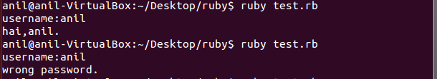

2. Ruby program that calculatesthe sum of all the numbers between 0 and 100 that are divisible by both 3 and 5?

Ans:@sum = 0

For n in 0 .. 100

If n%3==0 and n%5 ==0 then

a=[ ]

a << n

@sum +=n

End

End

Puts @sum

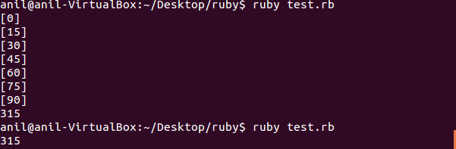

3. Write a Ruby program to convert user input to upper, lower and capital letters

Ans: a= “hello world”

Puts a.upcase

Puts a.downcase

Puts a.capitalize

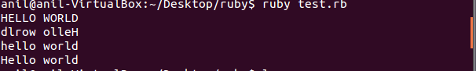

4. File Operations with Ruby

write your own ruby program that :

creates a file and writes some text into it, then closes it,

open the same file, and print all lines inside that file,

then, delete that file

ans:writeing text into a file

#!/usr/bin/ruby

file = File.new(“file.rb”,”w”)

if file

file.syswrite(“welcome anil!!”)

else

puts “unable to open file”

end

##opening and reading the file data

file = File.open(“file.rb”,”r”)

If file

Content = file .sysread(20)

Puts content

Else

Puts “unable to open file”

End



#to close file we can call method like this

file.close

#todelete that file

File.delete(“file.rb”)

5. write your own Ruby program that converts a array to yml and loads the yml output and print array using:

load()

dump()

ans: require ‘yaml’

names= %w[anil hari raj bargav]

#converting an array into yaml using dump()

yaml_exmp1 = YAML::dump(names)

puts yaml_exmp1

#loding back yaml into array using : load()

Array_exmp = YAML::load(yaml_exmp1)

Puts array_exmple

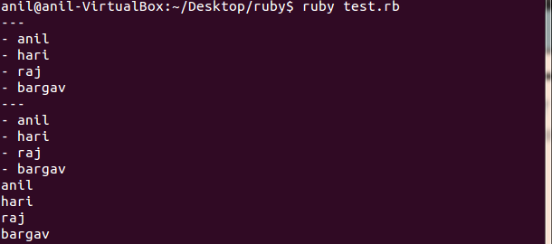

6.write a ruby program that converts a array in to json, now parse your json looking for a specific array element

Ans:require ‘rubygems’

require ‘json’

names= %w[anil hari raj bargav]

puts JSON.generate(names)



7. Write a Ruby program to generate json using  pretty

Ans: require ‘json’

my_json = { :array => [1,2,3 { :sample => “hash”}], :foo =>”bar” }

puts JSON.pretty_generate(my_json)

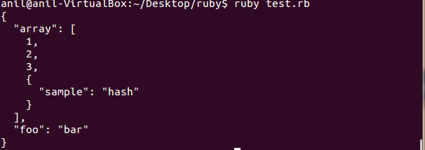

8. Write aRuby program that connects to MySQL Database in your pc and executes a select query