**Quiz 4**

1. Ruby Program that prints the Time in different time zones

2. Write a program that iterates over an array and builds a new array that is the result of incrementing each value in the original array by a value of 2. You should have two arrays at the end of this program,

The original array and the new array you've created.Print both arrays to the screen using the p method instead of puts.

Ans:a =[1,2,3,4]

p a.map{|item| item+2}

p a

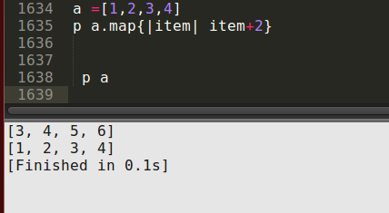

3. Ruby program to find the leap year when start and end year are given.

Ans:

puts "enter the starting year"

starting_year =gets.to_i

puts "enter the ending year"

ending_year =gets.to_i

(starting_year..ending_year).each do |year|

next if year % 4 != 0

next if year % 100 == 0 && year % 400 != 0

puts year

end

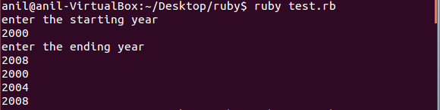

4. Ruby program that takes a numerical value and give the output as Roman number

ans: roman_map = Hash[ 1000 => "M", 900 => "CM", 500 => "D", 400 => "CD", 100 => "C", 90 => "XC", 50 => "L", 40 => "XL", 10 => "X", 9 => "IX", 5 => "V", 4 => "IV", 1 => "I"]

print "Enter number "

arabic = gets.to_i

if arabic < 10000

roman_map.keys.sort{ |a,b| b <=> a }.each do

|n|

while arabic >= n

arabic = arabic-n

print roman_map[n]

end

end

else

puts "Please enter number lower than 3999."

end

gets

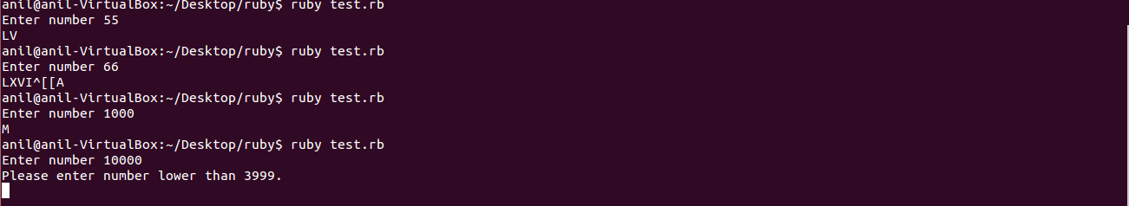

5. Write a your own ruby program that uses a Queue

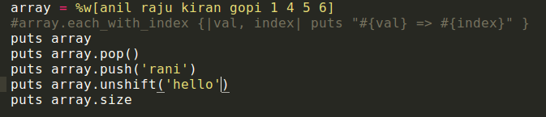

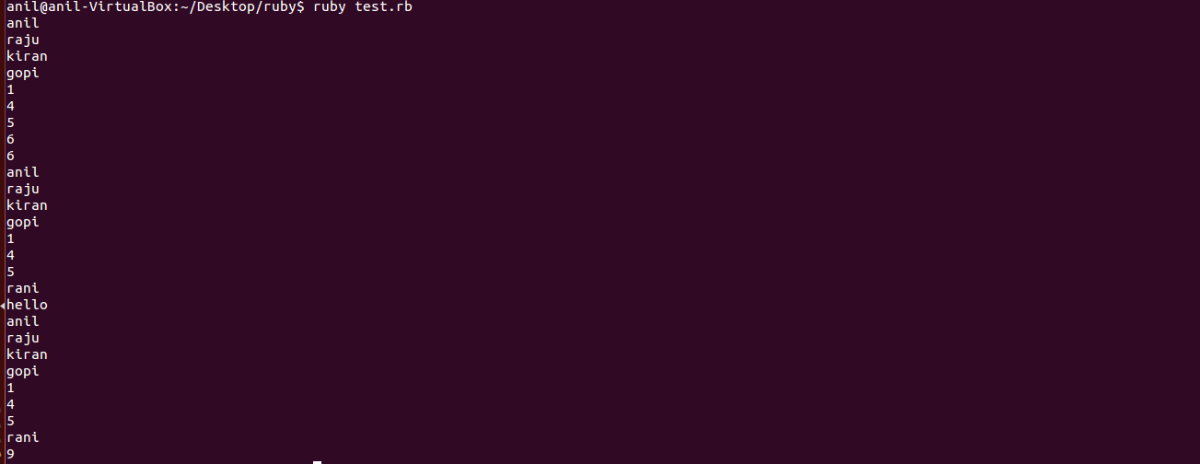

6. Write your own ruby program that uses each_with_index method to iterate through an array that prints each index and value

ans: array = %w[anil raju kiran gopi 1 4 5 6]

array.each_with_index {|val, index| puts "#{val} => #{index}" }

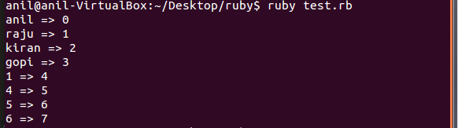

7. Ruby Program that prints if duplicates existing in a array

ans:a = ["A", "B", "C", "B", "A" ,"ani" ,"ani"]

puts a.select{|item| a.count(item) > 1}.uniq

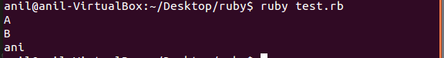

8. Write a Ruby program that prints pascal triangle

def pascal(n)  
 raise ArgumentError, "must be positive." if n < 1  
 yield ar = [1]  
 (n-1).times do  
 ar.unshift(0).push(0) # tack a zero on both ends  
 yield ar = ar.each_cons(2).map{|a, b| a + b }   
 end  
end  
   
pascal(5){|row| puts row.join(" ").center(20)}

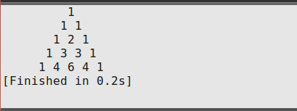

9. Write a Ruby program that prints the length of the common string when two strings are compared.

puts "enter 1'st string: "

str1=gets.chomp

puts "enter 2'nd string:"

str2 = gets.chomp

if str1==str2

puts "the length of the both strings are:" , str1.length

else

puts  "the strings are #{str1}, #{str2}"

end

