**Quiz 2 Abhinav Ponnala**

1. Ruby program when that accepts a date in a month and prints it out the appropriate suffix. For example, for 1 as input, print 1st, 2 as input 2nd, 3 as input 3rdetc

2. Write your own ruby program using a case statement.

Code: #!usr/bin/env ruby

print " Enter the Fruit : "

Fruit = gets.chomp

case Fruit

when "red"

puts " Apple "

when "yellow"

puts " Banana "

when "Green"

puts " Grapes "

else

puts "Entered Invalid Name"

end

gets

Output:

Enter Your Fruit :

red

Apple

3. Ruby Program that iterates numbers with upto loop

Code:

#!usr/bin/env ruby

3.upto (7) {|i|puts " #{i}"}

Output: 3

4

5

6

7

4. Write a Ruby program to print numbers from 1 to 50 and also in reverse order

Code:

#!usr/bin/env ruby

1.upto(50) {|i| puts i}

50.downto(1) {|j| puts j}

Output:

12345……50

504948…….1

5. Write your own Ruby program using loops and iterators. Explain the difference between loops, iterators and blocks

Code:

forloop:

#!usr/bin/env ruby

for a in 0..10

puts a

end

Output:

012345…10

until loop:

#!usr/bin/env ruby

a=0

until a==100

puts a

a+=2

end

Output:

02468…..9698

while loop:

#!usr/bin/env ruby

a = 1

while a<10

print a,"\n"

a += 1

end

Output:

123456789

Iterators:

#!usr/bin/env ruby

names = ["Audi","BMW","Benz","Honda"]

names.each do |i|

puts i

end

Output:

Audi

BMW

Benz

Honda

Blocks:

#!usr/bin/env ruby

def test( )

puts " Inside the test method"

yield

end

test {

puts "Inside the test block"

}

Output:

Inside the test method

Inside the test block

6. Write a Ruby program that loops through a array and checks if a pattern existsin the array elements

Code:

#!usr/bin/env ruby

mobiles = ["Iphone","samsung","motorola"]

mobiles.include?("Iphone")

Output:

true

7. Write your own Ruby program using a Hash that loops through :

Print all Values while looping with Keys

Print all Keys while looping through Values

Print Keys, Values as pair.

Code:

#!usr/bin/env ruby

countries = {

"in"=>"india",

"us"=>"United States of America",

"uk"=>"united kingdom"

}

puts countries.keys.inspect

puts countries.values.inspect

countries.each {|k,v| puts "key : #{k}, Value : #{v}" }

Output:

["in", "us", "uk"]

["india", "United States of America", "united kingdom"]

key : in, Value : india

key : us, Value : United States of America

key : uk, Value : united kingdom

8. Write a Ruby program that takes number as input and recursively calculates the power of 2 until the calculated number is less than 10000 and prints the maximum power for that number.

9. Ruby program to convert Celsius temperature to Fahrenheit

code:

#!usr/bin/env ruby

puts "Enter the temperature in celsius:"

c=gets.chomp.to_i

F= 9/5*c+32

puts "Temperature in Faranheit #{F}"

gets

Output:

Enter the temperature in celsius

100

Temperature in Faranheit 132

10. Write a program to create a Calculator class with add(), substract(), multiply() and divide(), then take two numbers and choice of operation from user and display output using objects

Code:

#!usr/bin/env ruby

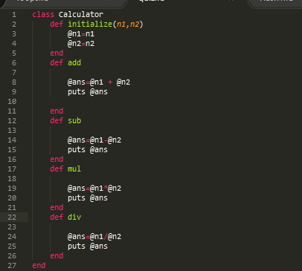

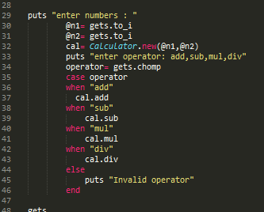

Output:

