**Quiz 3**

1. Write if/else ruby statement in only one line.

Code:

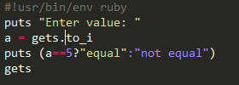

Output:



1. Ruby program that calculatesthe sum of all the numbers between 0 and 100 that are divisible by both 3 and 5?

Code:

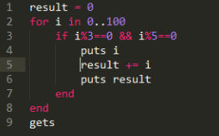

Output:

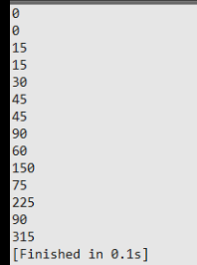

1. Write a Ruby program to convert user input to upper, lower and capital letters

Code:

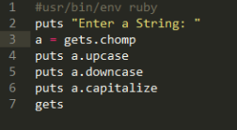

Output:

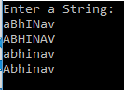

4. File Operations with Ruby

write your own ruby program that :

creates a file and writes some text into it, then closes it,

open the same file, and print all lines inside that file,

then, delete that file

output:

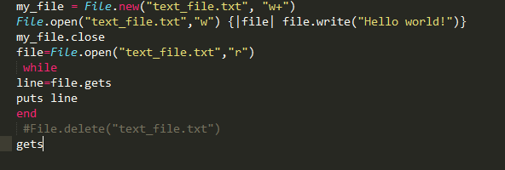

**Output:**



5. write your own Ruby program that converts a array to yml and loads the yml output and print array using:

load()

dump()

code:

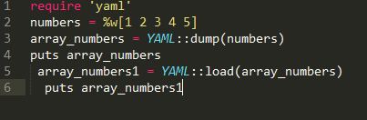

Output:



6. Write a Ruby program that converts a array into json, now parse your json looking for a specific array element

Code:

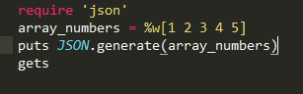

Output:



7. Write a Rubyprogram to generate json using  pretty

Code:

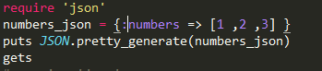

Output:

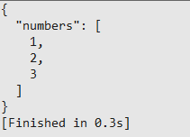

8. Write aRuby program that connects to MySQL Database in your pc and executes a select query