**Quiz 4**

1. Ruby Program that prints the Time in different time zones

Code:

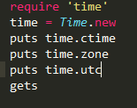

Output:

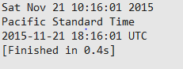

2. Write a program that iterates over an array and builds a new array that is the result of incrementing each value in the original array by a value of 2. You should have two arrays at the end of this program,

The original array and the new array you've created.Print both arrays to the screen using the p method instead of puts.

Code:

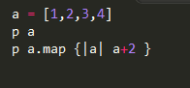

Output:



1. Ruby program to find the leap year when start and end year are given.

Code:

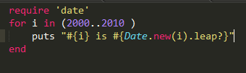

Output:

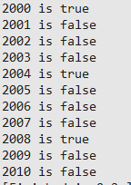

4. Ruby program that takes a numerical value and give the output as Roman number

Code:

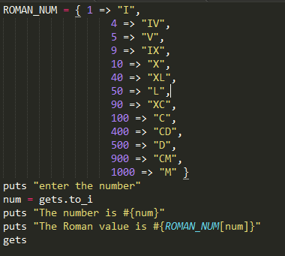

Output:

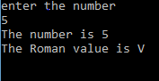

5.Write a your own ruby program that uses a Queue

Code:

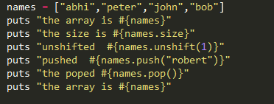

Output:

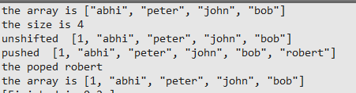

6. Write your own ruby program that uses each_with_index method to iterate through an array that prints each index and value

Code:

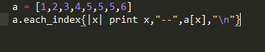

Output:

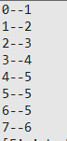

7. Ruby Program that prints if duplicates existing in a array

Code:

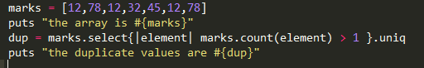

Output:



8. Write a Ruby program that prints pascal triangle.

9. Write a Ruby program that prints the length of the common string when two strings are compared.

Code:

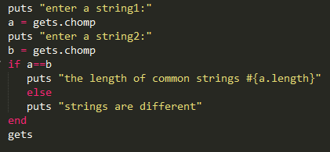

Output:

